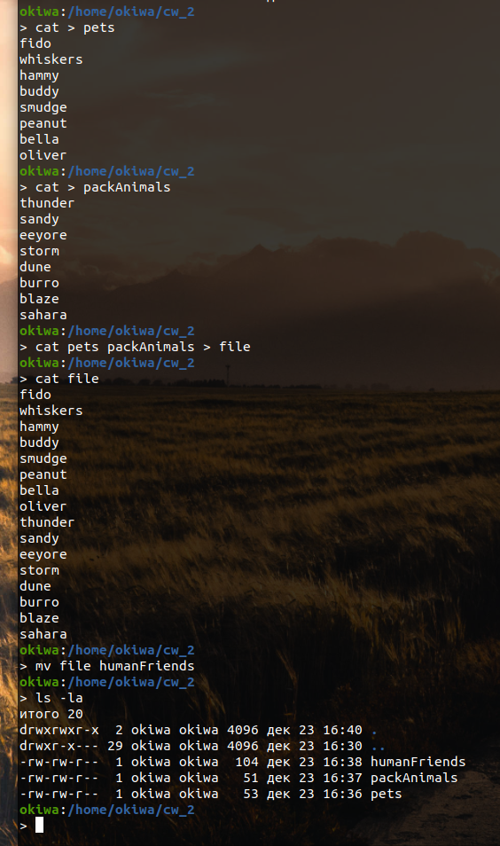

1. wget -c <https://dev.mysql.com/get/mysql-apt-config_0.8.10-1_all.deb>

sudo dpkg -i mysql-apt-config_0.8.10-1_all.deb

sudo apt update

sudo apt install mysql-server mysql-client

1. Dpkg -I zoom_amd64.deb

Dpkg -r zoom

1. mysql -u root -p

create database human_friends;

use human_friends;

1. create table pets ( id int primary key auto_increment, type_id int not null);

create table home_animals (id int primary key auto_increment, type_id int not null);

create table pack_animals (id int primary key auto_increment, type_id int not null);

create table **cat** (

-> id int primary key auto_increment,

-> name varchar(20) not null,

-> birthdate date not null,

-> commands text);

create table **dog** (

-> id int primary key auto_increment,

-> name varchar(20) not null,

-> birthdate date not null,

-> commands text);

create table **hamster** (

-> id int primary key auto_increment,

-> name varchar(20) not null,

-> birthdate date not null,

-> commands text);

create table **horse** (

-> id int primary key auto_increment,

-> name varchar(20) not null,

-> birthdate date not null,

-> commands text);

create table **camel** (

-> id int primary key auto_increment,

-> name varchar(20) not null,

-> birthdate date not null,

-> commands text);

create table **donkey** (

-> id int primary key auto_increment,

-> name varchar(20) not null,

-> birthdate date not null,

-> commands text);

1. insert into cat (name, birthdate, commands) values

-> ('Whiskers','2019-05-15', 'Sit, Pounce'),

-> ('Smudge','2020-02-20','Sit, Pounce, Scratch'),

-> ('Oliver','2020-06-30','Meow, Scratch. Jump');

insert into dog (name, birthdate, commands) values

-> ('Fido','2020-01-01','Sit, Stay, Fetch'),

-> ('Buddy','2018-12-10','Sit, Paw, Bark'),

-> ('Bella','2019-11-11','Sit, Stay, Roll');

insert into hamster (name, birthdate, commands) values

-> ('Hammy','2021-03-10','Roll, Hide'),

-> ('Peanut','2021-08-01','Roll, Spin');

insert into horse (name, birthdate, commands) values

-> ('Thunder','2015-07-21','Trot, Canter, Gallop'),

-> ('Storm','2014-05-05','Trot, Canter'),

-> ('Blaze','2016-02-29','Trot, Jump, Gallop');

insert into camel (name, birthdate, commands) values

-> ('Sandy','2016-11-03','Walk, Carry Load'),

-> ('Dune','2018-12-12','Walk, Sit'),

-> ('Sahara','2015-08-14','Walk, Run');

insert into donkey (name, birthdate, commands) values

-> ('Eeyore','2017-09-18','Walk, Carry Load, Bray'),

-> ('Burro','2019-01-23','Walk, Bray, Kick');

1. delete from camel;

create table horses_and_donkeys (

id int primary key auto_increment,

name varchar(20) not null,

birthdate date not null,

commands text);

insert into horses_and_donkeys (name, birthdate, commands) select name, birthdate, commands from horse union select name, birthdate, commands from donkey;

1. create table young_animals (

id int primary key auto_increment,

name varchar(20) not null,

birthdate date not null,

commands text,

age varchar(50));

insert into young_animals (name, birthdate, commands, age)

select *, concat(timestampdiff(year, birthdate, curdate()) ,' years ', timestampdiff(year,

birthdate, curdate()) mod 12, ' months') as age

from (select name, birthdate, commands from cat union select name, birthdate, commands

from dog union select name, birthdate, commands from hamster union select name,

birthdate, commands from horses_and_donkeys) as tmp

where timestampdiff(month, birthdate, curdate()) between 12 and 36;

1. create table all_animals (

id int primary key auto_increment,

old_id int not null,

name varchar(20) not null,

birthdate date not null,

commands text,

age varchar(50),

old_table varchar(30) not null);

insert into all_animals (old_id,name,birthdate,commands,age,old_table)

select id as old_id,name,birthdate,commands, null,'cat' as old_table from cat

union

select id as old_id,name,birthdate,commands, null,'dog' as old_table from dog

union

select id as old_id,name,birthdate,commands, null,'hamster' as old_table from hamster

union

select id as old_id,name,birthdate,commands, null,'horse' as old_table from horse

union

select id as old_id,name,birthdate,commands, null,'donkey' as old_table from donkey

union

select id as old_id,name,birthdate,commands, age,'young_animals' as old_table from young_animals;

