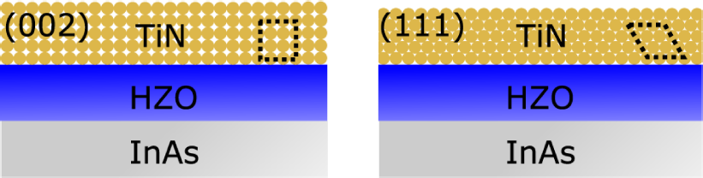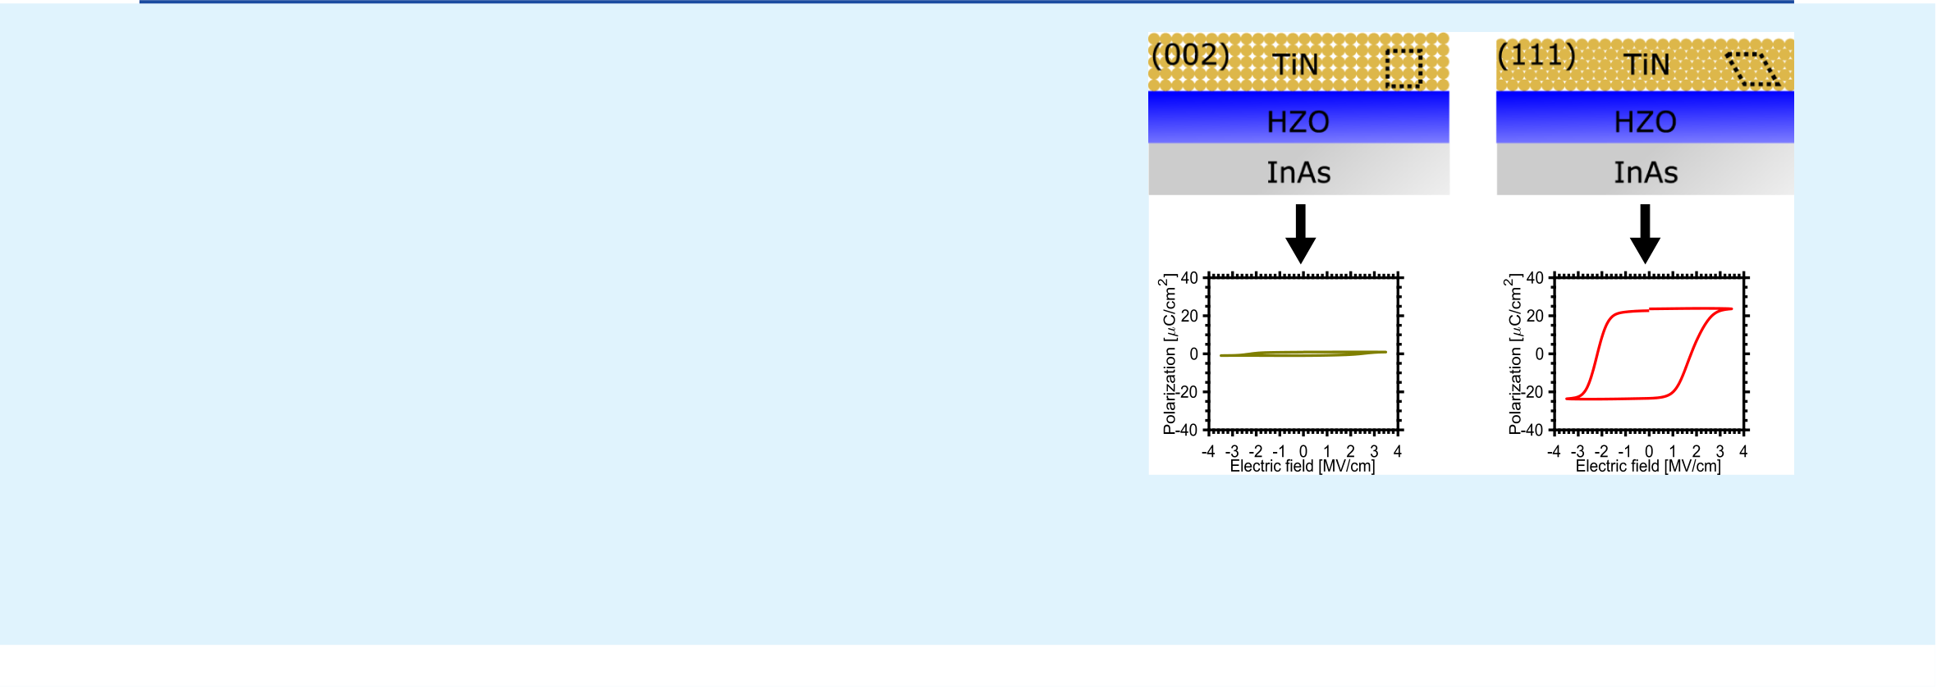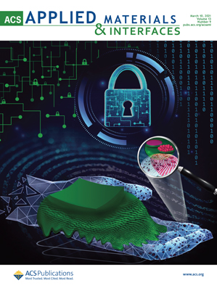



|  |  |  |  |
| --- | --- | --- | --- |
|  |  |  |  |
| www.acsami.org | Research Article | | |

Effects of TiN Top Electrode Texturing on Ferroelectricity in Hf1−xZrxO2   
[Robin Athle,](https://pubs.acs.org/action/doSearch?field1=Contrib&text1="Robin+Athle"&field2=AllField&text2=&publication=&accessType=allContent&Earliest=&ref=pdf)* [Anton E. O. Persson,](https://pubs.acs.org/action/doSearch?field1=Contrib&text1="Anton+E.+O.+Persson"&field2=AllField&text2=&publication=&accessType=allContent&Earliest=&ref=pdf) [Austin Irish,](https://pubs.acs.org/action/doSearch?field1=Contrib&text1="Austin+Irish"&field2=AllField&text2=&publication=&accessType=allContent&Earliest=&ref=pdf) [Heera Menon,](https://pubs.acs.org/action/doSearch?field1=Contrib&text1="Heera+Menon"&field2=AllField&text2=&publication=&accessType=allContent&Earliest=&ref=pdf) [Rainer Timm,](https://pubs.acs.org/action/doSearch?field1=Contrib&text1="Rainer+Timm"&field2=AllField&text2=&publication=&accessType=allContent&Earliest=&ref=pdf) [and Mattias Borg](https://pubs.acs.org/action/doSearch?field1=Contrib&text1="Mattias+Borg"&field2=AllField&text2=&publication=&accessType=allContent&Earliest=&ref=pdf)*

|  |  |  |  |  |  |  |  |  |  |  |  |
| --- | --- | --- | --- | --- | --- | --- | --- | --- | --- | --- | --- |
|  | Cite This: [ACS Appl. Mater. Interfaces 2021, 13, 11089−11095](https://pubs.acs.org/action/showCitFormats?doi=10.1021/acsami.1c01734&ref=pdf) | | | | [Read Online](https://pubs.acs.org/doi/10.1021/acsami.1c01734?ref=pdf) | | | | | | |
| Downloaded via 73.106.214.190 on April 4, 2021 at 05:29:51 (UTC).  See https://pubs.acs.org/sharingguidelines for options on how to legitimately share published articles. | ACCESS |  | [Metrics & More](https://pubs.acs.org/doi/10.1021/acsami.1c01734?goto=articleMetrics&ref=pdf) | | | [Article Recommendations](https://pubs.acs.org/doi/10.1021/acsami.1c01734?goto=recommendations&?ref=pdf) | | | | * | [Supporting Information](https://pubs.acs.org/doi/10.1021/acsami.1c01734?goto=supporting-info&ref=pdf) |
| ABSTRACT: Ferroelectric memories based on hafnium oxide are an attractive alternative to conventional memory technologies due to their scalability and energy efficiency. However, there are still many open questions regarding the optimal material stack and processing conditions for reliable device performance. Here, we report on the impact of the sputtering process conditions of the commonly used TiN top electrode on the ferroelectric properties of Hf1−xZrxO2. By manipulating the deposition pressure and chemistry, we control the preferential orientation of the TiN grains between (111) and (002). We observe that (111) textured TiN is superior to (002) texturing for achieving high remanent polarization (Pr). Furthermore, we find that additional nitrogen supply during TiN deposition leads to >5× greater endurance, possibly by limiting the scavenging of oxygen from the Hf1−xZrxO2 film. These results help explain the large Pr variation reported in the literature for Hf1−xZrxO2/TiN and highlights the necessity of tuning the top electrode of the ferroelectric stack for successful device implementation.  KEYWORDS: hafnium oxide, III−V, ferroelectric FET, ferroelectric tunnel junction, thin films, CMOS integration | | | | | | | | | | |
| ■INTRODUCTION  Ferroelectricity in HfO2 has since its discovery in 20111been attracting strong interest for applications in nonvolatile memories and negative-capacitance transistors due to its strong remanent polarization (Pr ∼ 20−30 μC/cm2) and high coercive field (Ec ∼ 1−2 MV/cm2), as well as being compatible with and already used in complementary metal-oxide semiconductor technology. In addition, ferroelectric (FE) HfO2 can exhibit memristive behavior in ferroelectric tunnel junctions2(FTJs) and ferroelectric field effect transistors (FeFETs),3which indicates its potential for | | | | | appropriate TE can thus enhance the FE properties of HfO2. There has since been extensive research exploring various TEs such as Pt,6Mo,7W,8TaN,9and RuO2,10but reactively sputtered TiN is prominent.1,2,5,11Even so, reports are scarce on the effect of varying its microstructure. Deposition  conditions such as plasma power, pressure, and gas mixture can strongly influence the microstructure of metals deposited by reactive sputtering, which in turn can affect the strain in the film.  In this work, we study the impact of processing conditions  for reactively sputtered TiN, when used as a TE for FE | | | | | |
| application in neuromorphic computation. The ferroelectricity in HfO2 is believed to originate from a noncentrosymmetric orthorhombic phase (o-phase) Pca21, formed when a thin HfO2 film is crystallized under the appropriate stress and annealing conditions. It has been demonstrated that a tensile in-plane stress in the HfO2 induces a transition from the tetragonal phase (t-phase) to the preferred o-phase, thus leading to ferroelectricity.4This is commonly achieved by doping the HfO2 and has been accomplished with a wide variety of dopants, with Zr being the most common due to its wide range of doping concentrations, yielding FE properties.5 Apart from suitable doping, Böscke et al. highlighted the importance of the top electrode (TE) and its capping ability in achieving the o-phase.1It is believed that similar to the | | | | | Hf1−xZrxO2. By employing a combination of electrical characterization and grazing incidence X-ray diffraction (GIXRD), we reveal the importance of (111) textured TiN in achieving FE Hf1−xZrxO2. We further use X-ray photo-electron spectroscopy (XPS) and near-edge X-ray absorption fine structure to strengthen our findings. A deepened understanding of the impact of the TE will provide improved reproducibility and performance of HfO2-based FE devices. | | | | | |
| Received: | January 26, 2021 | | | | |
| Accepted: | | February 14, 2021 | | | |
| Published: February 24, 2021 | | | | | |
| addition of dopants, the TE induces stress on the underlying  Hf1−xZrxO2 film during annealing. The choice of an | | | | | | | | | | |
|  | | | © 2021 The Authors. Published by American Chemical Society | 11089 | | | | [https://dx.doi.org/10.1021/acsami.1c01734](https://dx.doi.org/10.1021/acsami.1c01734?ref=pdf) ACS App[l. Mater. Interfaces 2021, 13, 11089−11095](https://dx.doi.org/10.1021/acsami.1c01734?ref=pdf) | | |

|  |  |  |  |  |  |  |
| --- | --- | --- | --- | --- | --- | --- |
| ACS Applied Materials & Interfaces■EXPERIMENTAL SECTION  Metal−insulator−semiconductor (MIS) capacitors were fabricated on  an InAs(100) substrate (ρ = 3 × 10−4Ω cm) with a 100 nm thick | | | |  | www.acsami.org | Research Article |
|  |  | |
| unintentionally n-doped InAs epilayer by metal-organic vapor-phase | | | |
| epitaxy. The native oxide was removed using BOE (1:10) immediately | | | |
| before loading the samples into a Picosun Sunale R-100 atomic layer deposition (ALD) chamber to deposit 12 cycles of Al2O3, (∼1.2 nm) using TMAl and water as precursors, followed by 100 cycles (∼10 | | | |
| nm) Hf1−xZrxO2 deposited by alternating cycles of TEMA(Zr) and TDMA(Hf) in order to achieve a Hf/Zr ratio of 1:1, with water as the | | | |
| oxidizing precursor. All ALD depositions were carried out at a temperature of 200 °C. The use of Al2O3 as an interfacial layer reduces the native oxide of InAs and decreases interface defect density.12Subsequently, a 10 nm thick TiN TE was deposited using | | | |
|  | |
| RF magnetron sputtering, with a quartz crystal microbalance thickness | | | |
| meter, to control the deposited layer thickness. The deposition was | | | |
|  | |
| carried out without a temperature controller at a power of 150 W in | | | |
| an AJA Orion system using a TiN target with 99.5% purity at varying | | | |
| chamber pressures and Ar plasmas. The deposition pressure used was varied in the range 1.3−4.0 mTorr (samples A−C). At a pressure of 4.0 mTorr, two additional samples (samples D−E) were fabricated with the addition of N2 into the gas flow during deposition, 6.25 and 12.5%, respectively. The N2 gas is inserted at the top of the chamber, in close proximity to the sample. For readability, the samples will be denoted A−E; see deposition conditions summarized in Table 1. After | | | |
| Table 1. Deposition Conditions of TE TiN Samples | | | |  |
| sample | pressure [mTorr] | Ar flow [sccm] | N2 flow [sccm, (%)] |  |
|  | |
| A | 1.3 | 5 | |  |
| B | 2.6 | 9 | |
|  | |
| C | 4.0 | 14 | |
| D | 4.0 | 12 | 0.75(6.25%) |
| E | 4.0 | 12 | 1.5(12.5%) |
| deposition, the samples were annealed using a rapid thermal processing system at 440 °C for 30 s, followed by an additional device pad definition via lift-off of electron beam-evaporated Ti/Pd/ | | | |  |
| Au (1/5/200 nm). Finally, the TiN between devices was removed using a NaOH4/H2O2/H2O (1:2:5) wet etch for 30 s at 60 °C. Electrical characterization was performed using a Keysight B1500A | | | |
| parameter analyzer equipped with a B1530A waveform generator fast | | | |
| measurement unit for pulsed measurements. The conventional | | | |
| positive-up-negative-down (PUND) technique was implemented to measure the polarization versus electric field at a frequency of 1 kHz. The electric field in this paper refers to the electric field applied across | | | |  | |
| the bilayered structure of Al2O3/Hf1−xZrxO2. The PUND measure-ment was always carried out post wake-up cycling of 1000 times using | | | | Figure 1. (a) P−E hysteresis curves at 3.5 V for samples deposited at different pressures and with additional nitrogen, (b) evolution of the PE curve of sample E at increasing electric field, (c) evolution of the  remanent polarization Pr + as a function of the applied electric field for | |
| the same voltage used for the PUND measurement. Cycling | | | |
| measurements were implemented using rectangular pulses at a | | | |
| frequency of 10 kHz at various voltages. For CV measurements, an | | | | all samples. | |
| Agilent 4294A impedance analyzer was used, keeping the oscillation | | | |
| 11090 | ■RESULTS AND DISCUSSION  The polarization−electric field (P−E) characteristics at 3.5 MV/cm of samples with differently deposited TiN TEs are presented in Figure 1a. The evolution of the P−E with increasing field for sample E is presented in Figure 1b. The corresponding data and current−voltage characteristics of samples A−E are provided in the Supporting Information, | |
| amplitude at 50 mV at frequencies between 10 kHz and 10 MHz. For structural characterization, a Bruker D8 diffractometer with a Cu Kα | | | |
| X-ray source was used for GIXRD measurements with an incidence angle of 0.3−0.5° to determine the crystallographic texturing. A | | | |
| ZEISS Gemini 500 scanning electron microscope with an energy- | | | |
| dispersive X-ray spectroscopy (EDX) detector was used to determine | | | |
| the stoichiometry of the TiN TEs. | | | |
| Furthermore, the samples were examined using two synchrotron-based X-ray techniques, XPS and near-edge X-ray absorption fine | | | |
| structure (NEXAFS), at the FlexPES beamline of the MAX IV | | | |
| [Figure S2](http://pubs.acs.org/doi/suppl/10.1021/acsami.1c01734/suppl_file/am1c01734_si_001.pdf). In Figure 1c, the progression of the remanent polarization at increasing electric field of all samples is | |
| Laboratory in Lund, Sweden. XPS was performed for O 1s, Ti 2p, N | | | |
| 1s, Zr 3d, and Hf 4f core levels at varying kinetic energies for | | | |
| summarized. The Pr values in Figure 1c are extracted from the P−E curves presented in the Supporting Information, | |
| characterization within the top 2 nm. Looking deeper with NEXAFS | | | |
| (<10 nm), N K- and Ti L-edge absorption spectra of total and partial | | | |
| [Figure S2](http://pubs.acs.org/doi/suppl/10.1021/acsami.1c01734/suppl_file/am1c01734_si_001.pdf). The observed leakage currents are much smaller | |
| electron yield were measured by recording electrical current from the | | | |
| sample. | | | | than the switching currents for all the samples, facilitating | |
| [https://dx.doi.org/10.1021/acsami.1c01734](https://dx.doi.org/10.1021/acsami.1c01734?ref=pdf) ACS App[l. Mater. Interfaces 2021, 13, 11089−11095](https://dx.doi.org/10.1021/acsami.1c01734?ref=pdf) | |

|  |  |  |
| --- | --- | --- |
| ACS Applied Materials & Interfaces | www.acsami.org | Research Article |

precise extraction of P−E characteristics (Supporting In-formation, [Figure S1](http://pubs.acs.org/doi/suppl/10.1021/acsami.1c01734/suppl_file/am1c01734_si_001.pdf)). From this data, the crucial impact of the TE deposition conditions is evident. Sample A with a TE deposited at the lowest deposition pressure of 1.3 mTorr exhibits a remanent polarization of 14 μC/cm2at a maximum electric field of 4 MV/cm (Figure 1c). Increasing the pressure to 2.6 mTorr (sample B) leads to a strong improvement of Pr up to 30 μC/cm2. However, further increasing the chamber pressure during TiN deposition (sample C) severely decreases Pr again to 10 μC/cm2. Interestingly, upon the addition of a low N2 flow of 6.25% at 4.0 mTorr deposition pressure, the polarization almost vanishes (sample D). Furthermore, with the N2 flow increased to 12.5%, the magnitude of Pr increases again to 17 μC/cm2(sample E).

To gain insights into the large differences in the electrical data for the various TEs their crystal structure was investigated by means of GIXRD. Figure 2a compares the measured reflections of TiN films deposited directly on Si substrates under the same conditions as used for the MIS samples (see Table 1). Sputtered TiN tends to have a preferential grain orientation (texturing) either with (111) or (002) aligned to the sample surface normal depending on the processing conditions.13The (111) and (002) reflections for cubic TiN are found at 2θ = 36.5° and 2θ = 42.5°, respectively.14The measured data in Figure 2a indicate that both (111) and (002) reflections are present in the films to different extents depending on the sputtering parameters used. Due to the limited diffraction signal of thin polycrystalline films in the regular Bragg geometry, we are forced to utilize GIXRD geometry here, in which the measured (111) and (002) planes are inclined at 18.25 and 21.25° with respect to the surface normal. The similar inclinations of the two reflections allow us to obtain an indication of the preferential grain orientation from the relative peak intensities. A clear trend is observed with increasing chamber pressure. For sample A deposited with the lowest pressure of 1.3 mTorr, both (111) and (002) grain orientations are present. However, when the pressure is increased to 2.6 mTorr (sample B), the (002) reflection is reduced. Finally, for sample C with the highest deposition pressure of 4.0 mTorr, there is no longer a distinct reflection from (002) oriented grains, and the (111) reflection is lower in intensity compared to A and B, indicating lower degree of overall TiN crystallinity. This corresponds well with previously reported trends for TiN sputtering in literature and can be explained by a decreased ion energy with higher deposition pressures.13The preferred texturing of TiN is decided by overall energy minimization, which for TiN becomes a competition between the low strain energy of the (111) plane and low surface energy of the (002) plane.15At low ion energy (high pressure), the strain energy dominates and (111) texturing is thus preferred, while at higher ion energy (low pressure), surface energy dominates, favoring (002) textur-ing.13Interestingly, for samples D and E where a N2 flow is introduced, the (002) reflection is predominant. To under-stand this, it is important to note that the TiN (111) plane is fully nitrogen-terminated, whereas the (002) plane is stoichiometric. With the addition of N2 flow during deposition we obtain a surplus of N adatoms at the surface, which strongly decreases the mean free path of Ti adatoms on the (001) surface and promotes the growth on these planes, resulting in a preferred (002) texturing.13   
 GIXRD data of the Hf1−xZrxO2 layer in the MIS samples after annealing, presented in Figure 2b, highlights the impact of

11091 [https://dx.doi.org/10.1021/acsami.1c01734](https://dx.doi.org/10.1021/acsami.1c01734?ref=pdf)

|  |  |  |
| --- | --- | --- |
| ACS Applied Materials & Interfaces | www.acsami.org | Research Article |

correlation between the peak height of the o-(111) reflection and the remanent polarization Pr magnitude. By accounting for the TiN TE, we provide further insights, revealing the additional interplay between the strength of the TiN (111) texturing and the strength of the Hf1−xZrxO2 o-(111) reflection. This correlation is highlighted in Figure 2c. For information regarding the calculation of the relative peak intensities, we refer to the [Supporting Information](http://pubs.acs.org/doi/suppl/10.1021/acsami.1c01734/suppl_file/am1c01734_si_001.pdf).

It is important to understand why the conditions yielding predominant (111) texturing of the TiN also lead to a strong FE response of the Hf1−xZrxO2 film, while the FE response diminishes with stronger (002) texturing. A possible explanation for this lies in the induced strain from the TiN on the Hf1−xZrxO2 during the crystallization process. For TiN with (002) texturing, there will be compressive stress (up to−0.7 GPa) acting on the underlying Hf1−xZrxO2, whereas in the case of (111) texturing, a tensile stress (up to 1.4 GPa) is present instead.13Indeed, we here extract a ∼1% out-of-plane tensile strain from the TiN peak positions in samples A−C, confirmed by wafer curvature measurements. In samples D and E, we instead observe ∼1% compressive strain (Supporting Information, [Figures S3 and S4](http://pubs.acs.org/doi/suppl/10.1021/acsami.1c01734/suppl_file/am1c01734_si_001.pdf)). Thus for samples A−C, we expect the out-of-plane tensile strain in the TiN to induce an in-plane tensile stress in the underlying Hf1−xZrxO2 layer. There are many reports of in-plane tensile stress enhancing the out-of-plane FE properties since it allows for the trans-formation between the c-axis of the tetragonal phase into the a-axis of the orthorhombic FE phase.4,16−20It is worth noting that despite having predominantly (002) texturing, sample E with TiN deposited with 12.5% N2 exhibits a relatively strong o-(111) reflection and in turn, a Pr = 17 μC/cm2at 4 V bias. Clearly, for this sample, the TiN texturing cannot explain the presence of the FE Hf1−xZrxO2 phase and has therefore been excluded in Figure 2c. We believe that the origin of Pr in sample E is due to the high level of added nitrogen during deposition of TiN, as was previously observed by Luo et al.11 Complementing the electrical measurements, NEXAFS and XPS were conducted to investigate compositional differences between samples. MIS structures with 2 nm thin TiN layers were processed using the same deposition conditions as before (see Table 1) to accommodate the surface sensitivity of these techniques. Figure 3 shows X-ray absorption spectra (XAS) comparing the nitrogen K-edges of samples with varying N2

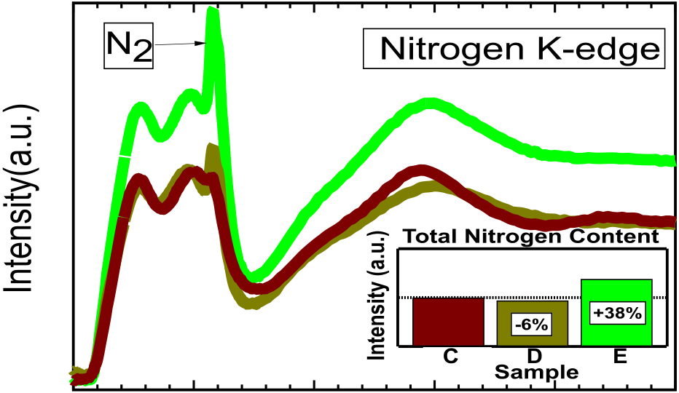

|  |  |  |  |  |  |
| --- | --- | --- | --- | --- | --- |
|  |  |  |  |  |  |



Figure 3. XAS and integrated intensity of nitrogen K-edges. Spectra are of TiN deposited with (C) 0% N2, 100% Ar flow (dark red), (D) 6.25% N2 flow (dark green), and (E) 12.5% N2 flow (bright green).

11092 [https://dx.doi.org/10.1021/acsami.1c01734](https://dx.doi.org/10.1021/acsami.1c01734?ref=pdf)

|  |  |  |
| --- | --- | --- |
| ACS Applied Materials & Interfaces | www.acsami.org | Research Article |

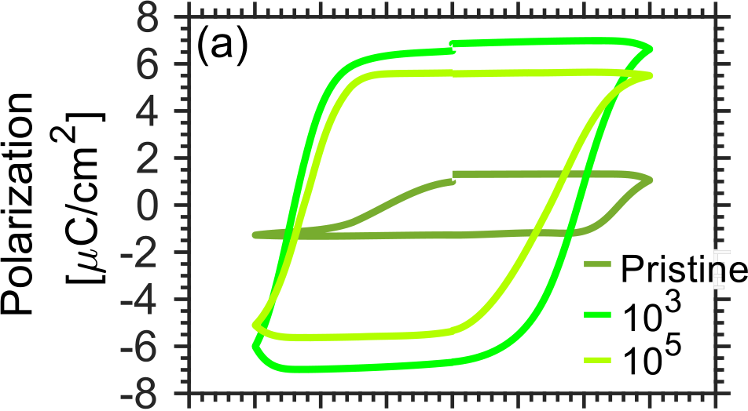

 

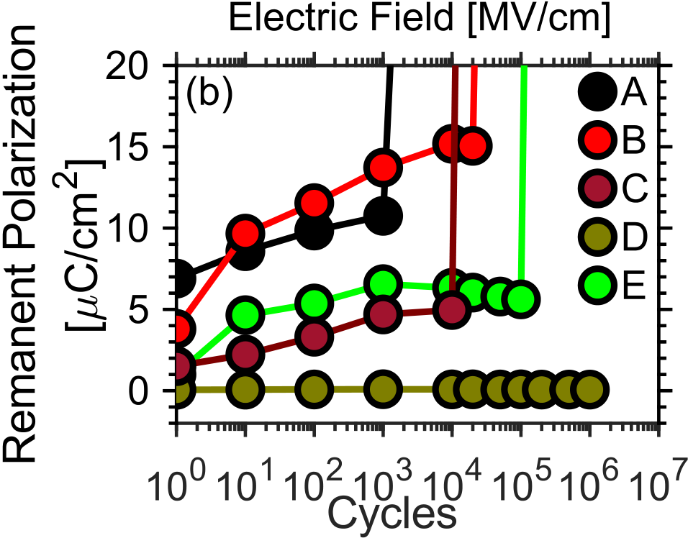

Figure 4. (a) Evolution of the PE curve of sample E at 3 V during cycling from pristine to 105cycles and (b) cycling endurance at 3 V at a frequency of 10 kHz displaying the changes in the remanent polarization Pr as a function of switching cycles.

the superior endurance of sample D could be explained by the combination of added N2 together with a very low remanent polarization.

It is a common explanation that one of the limiting factors for cycling endurance in Hf1−xZrxO2-based FE devices is generation and accumulation of oxygen vacancy defects, which ultimately lead to hard breakdown of the oxide.24Titanium is a known oxygen scavenger which drives this effect.25Thus, N deficiencies in the TiN TE may negatively influence the FE endurance by scavenging oxygen from the Hf1−xZrxO2. In support of this, Lin et al. recently indicated an increase of oxygen vacancies together with the breakage of Hf−O bonds when exposing a TiN/HfO2 structure to electrical stress.26It can therefore be beneficial to deposit a N-rich TiN TE to minimize the oxygen scavenging effect, especially when endurance is of importance. Thus, we propose that the extended endurance observed with added N2 during TiN deposition is a result of increased nitrogen incorporation in the TiN film, leading to less oxygen scavenging. EDX analysis supports this, as a higher nitrogen content was found for samples D (57.2 at. %) and E (59.3 at. %) when compared to sample C (55.1 at. %) (Supporting Information, [Table S1 and Figure S7](http://pubs.acs.org/doi/suppl/10.1021/acsami.1c01734/suppl_file/am1c01734_si_001.pdf)). Moreover, XPS data from samples C, D, and E corroborate the observations, showing increased nitrogen incorporation with gas flow. The Ti 2p core level was monitored for chemical shifts over an incident X-ray energy varying from 550 to 1150 eV, corresponding to an inelastic

11093 [https://dx.doi.org/10.1021/acsami.1c01734](https://dx.doi.org/10.1021/acsami.1c01734?ref=pdf)

|  |  |  |  |  |  |  |  |  |  |  |  |  |  |  |
| --- | --- | --- | --- | --- | --- | --- | --- | --- | --- | --- | --- | --- | --- | --- |
| ACS Applied Materials & Interfaces | | | | | | | www.acsami.org | | | | | | Research Article | |
|  | | | | | | |  | | | | | | | |
|  |  |  | | |  |  |  |  |  |  |  | |  |  |
|  | | | | | | | |
|  | | | | | | |
|  |  |  |  |  |  |  |
|  | | | | | | |
| Figure 5. Capacitance−voltage characteristics between −3 and 3 V for frequencies between 10 kHz and 10 MHz for samples B (a), D (b) and E (c). The arrows below the curves indicate the sweeping direction of the measurement. In (d), the frequency dispersion per decade of the | | | | | | | | | | | | | | |
| corresponding samples is presented. | | | | | | | ■AUTHOR INFORMATION  Corresponding Authors   Robin Athle − Electrical and Information Technology, Lund University, 22 100 Lund, Sweden; NanoLund Lund | | | | | | | |
| regard to the magnitude of remanent polarization, ranging from 1030to 26 μC/cm2,31obtained with essentially the same  material stack, could be a result of varying processing conditions for the TiN electrodes, rather than differences of  Hf1−xZrxO2 itself.  ■ASSOCIATED CONTENT  * sı Supporting Information  The Supporting Information is available free of charge at  [https://pubs.acs.org/doi/10.1021/acsami.1c01734](https://pubs.acs.org/doi/10.1021/acsami.1c01734?goto=supporting-info). | | | | | | |
| University, 22 100 Lund, Sweden; | | | |  | [orcid.org/0000-0002-](http://orcid.org/0000-0002-5741-7259) | | |
| [5741-7259](http://orcid.org/0000-0002-5741-7259); Email: [robin.atle@eit.lth.se](mailto:robin.atle@eit.lth.se)  Mattias Borg − Electrical and Information Technology, Lund  University, 22 100 Lund, Sweden; NanoLund Lund | | | | | | | |
| University, 22 100 Lund, Sweden; | | | |  | [orcid.org/0000-0003-](http://orcid.org/0000-0003-1217-369X) | | |
| [1217-369X](http://orcid.org/0000-0003-1217-369X); Email: [mattias.borg@eit.lth.se](mailto:mattias.borg@eit.lth.se) | | | | | | | |

Measured current voltage characteristics of PUND measurements and corresponding P−V and I−V curves of samples A−E; extraction procedure of bar height in Figure 2c; microstrain calculations derived from the measured GIXRD data of the TiN(111) and (002) reflection; stress determination by wafer curvature measurements; vibrational oscillations of molecular nitrogen in NEXAFS results; cycling endurance comparison between MIM and MIS structures (sample B); relative compositional changes of the TiN TE in samples C−E derived from the EDX data; and deconvolution of the XPS data and relative peak components of samples C−E for Ti 2p ([PDF](http://pubs.acs.org/doi/suppl/10.1021/acsami.1c01734/suppl_file/am1c01734_si_001.pdf))

11094 [https://dx.doi.org/10.1021/acsami.1c01734](https://dx.doi.org/10.1021/acsami.1c01734?ref=pdf)

|  |  |  |
| --- | --- | --- |
| ACS Applied Materials & Interfaces | www.acsami.org | Research Article |

Complete contact information is available at: [https://pubs.acs.org/10.1021/acsami.1c01734](https://pubs.acs.org/doi/10.1021/acsami.1c01734?ref=pdf)

Funding   
This work was supported financially by the Swedish Research Council (VR) grant nos. 2016-6186, 2017-4108, and 2018-05379 along with the NanoLund Centre for Nanoscience at Lund University.

Notes   
The authors declare no competing financial interest.

■ACKNOWLEDGMENTS   
The authors take this opportunity to acknowledge Johannes Svensson for the epilayer growth and Lars-Erik Wernersson for helpful discussion. Furthermore, the authors would like to thank Alexei Preobrajenski (MAX IV).

■REFERENCES   
(1) Böscke, T. S.; Müller, J.; Bräuhaus, D.; Schröder, U.; Böttger, U. [Ferroelectricity in Hafnium Oxide Thin Films.](https://dx.doi.org/10.1063/1.3634052) Appl. Phys. Lett. 2011, 99, 102903.

(2) Mikheev, V.; Chouprik, A.; Lebedinskii, Y.; Zarubin, S.; Matveyev, Y.; Kondratyuk, E.; Kozodaev, M. G.; Markeev, A. M.; Zenkevich, A.; Negrov, D. [Ferroelectric Second-Order Memristor.](https://dx.doi.org/10.1021/acsami.9b08189) ACS Appl. Mater. Interfaces 2019, 11, 32108[−](https://dx.doi.org/10.1021/acsami.9b08189)32114.

(3) Oh, S.; Kim, T.; Kwak, M.; Song, J.; Woo, J.; Jeon, S.; Yoo, I. K.; Hwang, H. [HfZrOx-Based Ferroelectric Synapse Device with 32 Levels of Conductance States for Neuromorphic Applications.](https://dx.doi.org/10.1109/led.2017.2698083) IEEE Electron Device Lett. 2017, 38, 732[−](https://dx.doi.org/10.1109/led.2017.2698083)735.

(4) Shiraishi, T.; Katayama, K.; Yokouchi, T.; Shimizu, T.; Oikawa, T.; Sakata, O.; Uchida, H.; Imai, Y.; Kiguchi, T.; Konno, T. J.; Funakubo, H. [Impact of Mechanical Stress on Ferroelectricity in (Hf0.5Zr0.5)O2 Thin Films.](https://dx.doi.org/10.1063/1.4954942) Appl. Phys. Lett. 2016, 108, 262904. (5) Müller, J.; Böscke, T. S.; Schröder, U.; Mueller, S.; Bräuhaus, D.; Böttger, U.; Frey, L.; Mikolajick, T. [Ferroelectricity in Simple Binary ZrO 2 and HfO 2.](https://dx.doi.org/10.1021/nl302049k) Nano Lett. 2012, 12, 4318[−](https://dx.doi.org/10.1021/nl302049k)4323.

(6) Lin, Y.-C.; McGuire, F.; Franklin, A. D. [Realizing Ferroelectric Hf 0.5 Zr 0.5 O 2 with Elemental Capping Layers.](https://dx.doi.org/10.1116/1.5002558) J. Vac. Sci. Technol., B: Nanotechnol. Microelectron.: Mater., Process., Meas., Phenom. 2018, 36, 011204.

(7) Chen, K. T.; Liao, C. Y.; Lo, C.; Chen, H. Y.; Siang, G. Y.; Liu, S.; Chang, S. C.; Liao, M. H.; Chang, S. T.; Lee, M. H. Improvement on Ferroelectricity and Endurance of Ultra-Thin HfZrO2 Capacitor with Molybdenum Capping Electrode. 2019 Electron Devices Technology and Manufacturing Conference, EDTM 2019, 2019; pp 62−64.

(8) Karbasian, G.; Dos Reis, R.; Yadav, A. K.; Tan, A. J.; Hu, C.; Salahuddin, S. [Stabilization of Ferroelectric Phase in Tungsten Capped Hf0.8Zr0.2O2.](https://dx.doi.org/10.1063/1.4993739) Appl. Phys. Lett. 2017, 111, 022907.

(9) Lomenzo, P. D.; Takmeel, Q.; Zhou, C.; Fancher, C. M.; Lambers, E.; Rudawski, N. G.; Jones, J. L.; Moghaddam, S.; Nishida, T. [TaN Interface Properties and Electric Field Cycling Effects on Ferroelectric Si-Doped HfO2 Thin Films.](https://dx.doi.org/10.1063/1.4916715) J. Appl. Phys. 2015, 117, 134105.

(10) Park, M. H.; Kim, H. J.; Kim, Y. J.; Jeon, W.; Moon, T.; Hwang, C. S. [Ferroelectric Properties and Switching Endurance of Hf0.5Zr0.5O2 Films on TiN Bottom and TiN or RuO2 Top Electrodes.](https://dx.doi.org/10.1002/pssr.201409017) Phys. Status Solidi RRL 2014, 8, 532[−](https://dx.doi.org/10.1002/pssr.201409017)535.

(11) Luo, J.-D.; Yeh, Y.-T.; Lai, Y.-Y.; Wu, C.-F.; Chung, H.-T.; Li, Y.-S.; Chuang, K.-C.; Li, W.-S.; Chen, P.-G.; Lee, M.-H.; Cheng, H.-C. [Correlation between Ferroelectricity and Nitrogen Incorporation of Undoped Hafnium Dioxide Thin Films.](https://dx.doi.org/10.1016/j.vacuum.2020.109317) Vacuum 2020, 176, 109317. (12) Timm, R.; Fian, A.; Hjort, M.; Thelander, C.; Lind, E.; Andersen, J. N.; Wernersson, L. E.; Mikkelsen, A. [Reduction of Native Oxides on InAs by Atomic Layer Deposited Al 2O3 and HfO2.](https://dx.doi.org/10.1063/1.3495776) Appl. Phys. Lett. 2010, 97, 132904.

11095 [https://dx.doi.org/10.1021/acsami.1c01734](https://dx.doi.org/10.1021/acsami.1c01734?ref=pdf)