

**Evolution of phases and ferroelectric properties of thin Hf0.5Zr0.5O2 films according to**

**the thickness and annealing temperature**

[Min Hyuk Park](http://scitation.aip.org/search?value1=Min+Hyuk+Park&option1=author), [Han Joon Kim](http://scitation.aip.org/search?value1=Han+Joon+Kim&option1=author), [Yu Jin Kim](http://scitation.aip.org/search?value1=Yu+Jin+Kim&option1=author), [Woongkyu Lee](http://scitation.aip.org/search?value1=Woongkyu+Lee&option1=author), [Taehwan Moon](http://scitation.aip.org/search?value1=Taehwan+Moon&option1=author), and [Cheol Seong Hwang](http://scitation.aip.org/search?value1=Cheol+Seong+Hwang&option1=author)

Citation: [Applied Physics Letters](http://scitation.aip.org/content/aip/journal/apl?ver=pdfcov) **102**, 242905 (2013); doi: 10.1063/1.4811483

View online: <http://dx.doi.org/10.1063/1.4811483>

View Table of Contents: <http://scitation.aip.org/content/aip/journal/apl/102/24?ver=pdfcov>

Published by the [AIP Publishing](http://scitation.aip.org/content/aip?ver=pdfcov)

**[Articles you may be interested in](http://scitation.aip.org/content/aip/journal/apl/106/11/10.1063/1.4915336?ver=pdfcov)**   
[Contribution of oxygen vacancies to the ferroelectric behavior of Hf0.5Zr0.5O2 thin films](http://scitation.aip.org/content/aip/journal/apl/106/11/10.1063/1.4915336?ver=pdfcov) Appl. Phys. Lett. **106**, 112904 (2015); 10.1063/1.4915336

[The effects of crystallographic orientation and strain of thin Hf0.5Zr0.5O2 film on its ferroelectricity](http://scitation.aip.org/content/aip/journal/apl/104/7/10.1063/1.4866008?ver=pdfcov) Appl. Phys. Lett. **104**, 072901 (2014); 10.1063/1.4866008

[Effect of forming gas annealing on the ferroelectric properties of Hf0.5Zr0.5O2 thin films with and without Pt electrodes](http://scitation.aip.org/content/aip/journal/apl/102/11/10.1063/1.4798265?ver=pdfcov)   
Appl. Phys. Lett. **102**, 112914 (2013); 10.1063/1.4798265

[Piezoresponse and ferroelectric properties of lead-free [ Bi 0.5 ( Na 0.7 K 0.2 Li 0.1 ) 0.5 ] Ti O 3 thin films by pulsed laser deposition](http://scitation.aip.org/content/aip/journal/apl/92/22/10.1063/1.2938364?ver=pdfcov)   
Appl. Phys. Lett. **92**, 222909 (2008); 10.1063/1.2938364

[Structure evolution and ferroelectric and dielectric properties of Bi 3.5 Nd 0.5 Ti 3 O 12 thin films under a moderate temperature annealing](http://scitation.aip.org/content/aip/journal/apl/85/23/10.1063/1.1834731?ver=pdfcov)   
Appl. Phys. Lett. **85**, 5661 (2004); 10.1063/1.1834731



This artic[le is copyrighted as indicated in the article. Reuse of AIP content is subject to the terms at: http://scitation.aip.org/termsconditions. Downloaded to IP](http://oasc12039.247realmedia.com/RealMedia/ads/click_lx.ads/www.aip.org/pt/adcenter/pdfcover_test/L-37/1613261058/x01/AIP-PT/APL_ArticleDL_0815/AIP-APL_Photonics_Launch_1640x440_general_PDF_ad.jpg/6c527a6a713149424c326b414477302f?x): 128.32.44.63

On: Mon, 24 Aug 2015 18:50:35



APPLIED PHYSICS LETTERS 102, 242905 (2013) 

[Evolution of phases and ferroelectric properties of thin Hf0.5Zr0.5O2 films according to the thickness and annealing temperature](http://dx.doi.org/10.1063/1.4811483)

Min Hyuk Park, Han Joon Kim, Yu Jin Kim, Woongkyu Lee, Taehwan Moon,   
and Cheol Seong Hwanga)   
WCU Hybrid Materials Program, Department of Material Science & Engineering and Inter-university Semiconductor Research Center, Seoul National University, Seoul 151-744, South Korea

(Received 17 April 2013; accepted 2 June 2013; published online 18 June 2013)

The effects of annealing temperature (Tanneal) and film thickness (tf) on the crystal structure and ferroelectric properties of Hf0.5Zr0.5O2 films were examined. The Hf0.5Zr0.5O2 films consist of tetragonal, orthorhombic, and monoclinic phases. The orthorhombic phase content, which is responsible for the ferroelectricity in this material, is almost independent of Tanneal, but decreases with increasing tf. In contrast, increasing Tanneal and tf monotonically increases (decreases) the amount of monoclinic (tetragonal) phase, which coincides with the variations in the dielectric constant. The remanant polarization was determined by the content of orthorhombic phase as well as the spatial distribution of other phases. V   
C 2013 AIP Publishing LLC. [<http://dx.doi.org/10.1063/1.4811483>]

Recently, it was reported that HfO2 thin films can be fer-roelectric when they are doped with various elements, such as Si, Y, Al, and Zr.1–5Recently, the authors reported that Hf0.5Zr0.5O2 (HZO) film grown by atomic layer deposition (ALD) technique has a strong resistance to the degradation by hydrogen annealing,5which is a great merit of this material for its application to ferroelectric random access memory. The ferroelectricity of HfO2-based films is believed to result from the formation of non-centrosymmetric Pbc21 orthorhom-bic phase (o-phase).1–5However, the formation of the o-phase in thin HZO film is not trivial, since it is stable only under cer-tain high-pressure (or anisotropic-strain) circumstances,6–9 while the metastability of tetragonal phase (P42/nmc, t-phase) over the stable monoclinic phase (P21/c, m-phase) is well known from surface energy arguments.10–15Lowther et al. reported that the application of a hydrostatic pressure of 3–4 GPa to m-phase HfO2 can induce the transition to o-phase using theoretical modelling work.6However, thin film sys-tems can hardly experience hydrostatic pressure due to its two-dimensional nature, and thus, the possible transition of the HZO film to the o-phase by the hydrostatic pressure effect can be neglected. In contrast, HZO films can be subjected to a

from the structures of the t- and o-phases. Table I summarizes the 2c/(aþb) ratio of t- and o-phases of HfO2, ZrO2, and HZO. The o-phase has a ratio of 1.038–1.042, depending on the composition, while those of the t-phase of HfO2 and ZrO2 are only 1.028 and 1.015, respectively. Therefore, the aniso-tropic stress facilitates the t- to o-phase transition.

The direct transition between m- and o-phases is usually hindered due to the largely different crystalline structures of the two phases,22which may explain the absence of o-phase in pure HfO2 and ZrO2.4Also, pure polycrystalline HfO2 films have hardly any t-phase, since the grain size is usually over the critical size for the transition to the t-phase (�7-10 nm),13so these films almost always have m-phase. In con-trast, polycrystalline ZrO2 easily shows t-phase, especially on TiN, since its grain size is usually smaller than the critical value (� 30 nm).10–12However, the 2 c/(aþb) ratio of t-phase ZrO2 is too small compared with that of o-phase to induce the transition to o-phase (Table I). Therefore, HZO might have an appropriate grain size to induce the t-phase, which could be transformed to the o-phase as the stress evolves with the film growth or heat-treatment, and could also have a 2 c/(aþb) ra-tio close enough to that of the o-phase to induce the phase

two-dimensional compressive or tensile stress, depending on transition.

the process conditions and substrates, due to local lattice and thermal expansion mismatches with the substrate. Amorphous or polycrystalline HfO2 and ZrO2 films grown by ALD on Si

|  |
| --- |
| substrates are usually under tensile stress, due to thermal |

expansion mismatch.16,17Meanwhile, Kisi reported on the transition of t-phase ZrO2 grains with lenticular shape embed-ded in bulk cubic-phase ZrO2, which was stabilized by MgO doping. The transition from the t-phase to o-phase was facili-tated by compressive stress along the a-b plane and tensile stress along the c-axis direction.7The necessary stress was only �760 MPa tensile and �50 MPa compressive,7which can be readily achieved in HZO thin films. Such a phase tran-

TABLE I. Experimental and theoretical structural parameters and 2 c/(aþb) ratio for the HfO2, ZrO2, and HZO polymorphs. Because the longest lattice parameter in the o-phase is along the a-axis, it was regarded as the c-axis, and the lattice parameters of double-sized t-phase unit cell were used here for easy comparison between o- and t-phase.

|  |  |  |  |  |  |
| --- | --- | --- | --- | --- | --- |
|  | a (A˚ ) | b (A˚ ) | c (A˚ ) | 2c/(aþb) | Data type and reference |
| t-HfO2 | 5.150 |  | 5.295 |  | Experiment, Ref. 18 |
| 1.028 |
| t-ZrO2 | 5.175 | 5.325 | 1.029 | Experiment, Ref. 19 |
| 5.059 | 5.200 | 1.028 | Theory, Ref. 20 |
| 5.094 | 5.177 | 1.016 | Experiment, Ref. 21 |
| 5.132 | 5.207 | 1.015 | Theory, Ref. 20 |

|  |  |  |  |  |  |  |  |
| --- | --- | --- | --- | --- | --- | --- | --- |
| sition under the anisotropic stress can be easily understood | | o-HfO2 | 5.11 | 5.10 | 5.30 | 1.038 | Theory, Ref. 6 |
| o-ZrO2 | | | 5.07 | 5.08 | 5.26 | 1.036 | Theory, Ref. 6 |
| o-HZO | | | 5.01 | 5.05 | 5.24 | 1.042 | Experiment, Ref. 4 |
| a)Electronic mail: [cheolsh@snu.ac.kr](mailto:cheolsh@snu.ac.kr) | | |
|  | | |  |  |  | V C 2013 AIP Publishing LLC | |
| 0003-6951/2013/102(24)/242905/5/$30.00 | 102, 242905-1 | |

This article is copyrighted as indicated in the article. Reuse of AIP content is subject to the terms at: http://scitation.aip.org/termsconditions. Downloaded to IP: 128.32.44.63 On: Mon, 24 Aug 2015 18:50:35

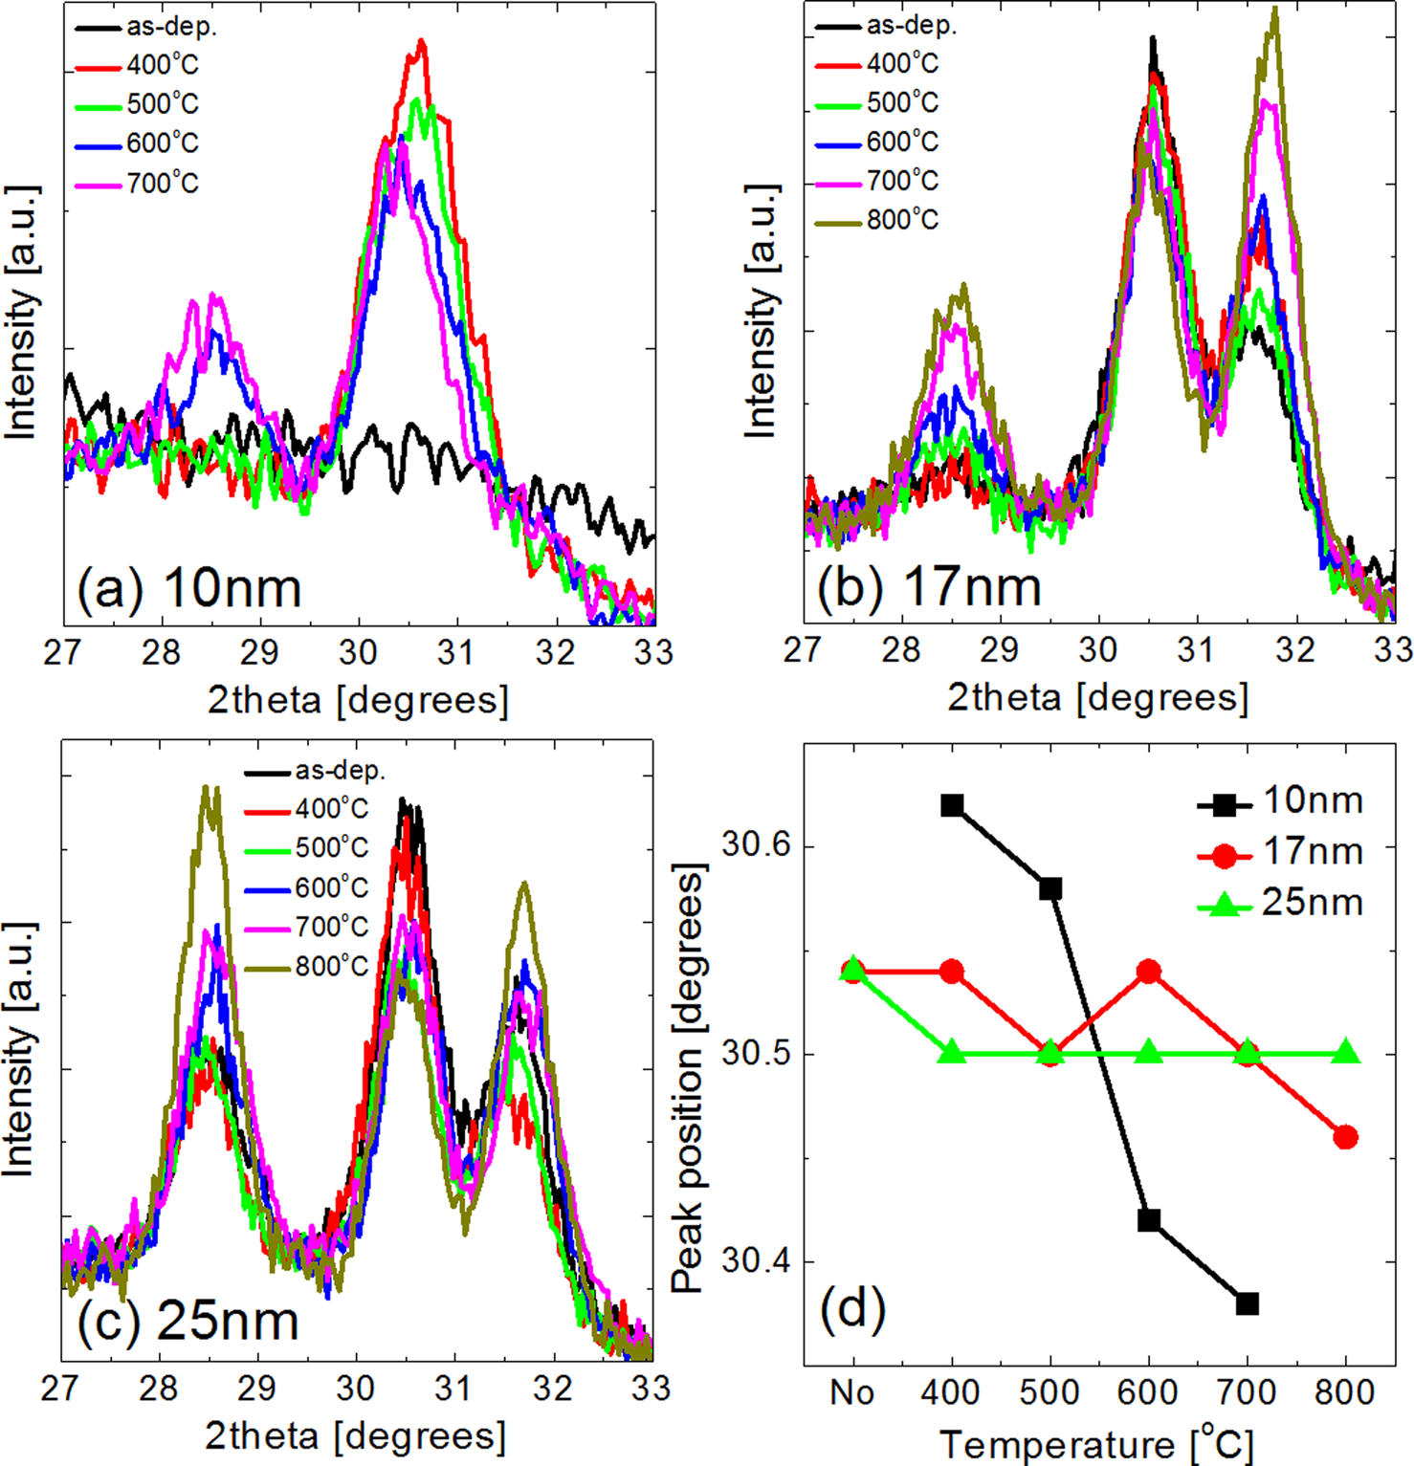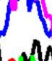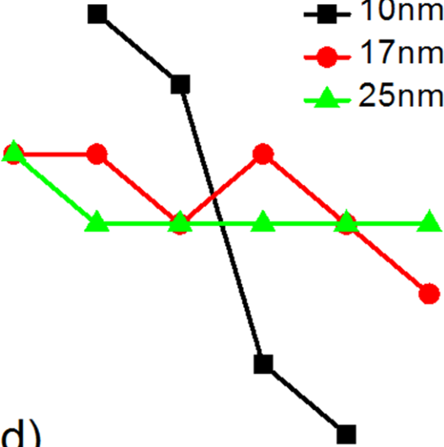

|  |  |  |
| --- | --- | --- |
| 242905-2 | Park et al. | Appl. Phys. Lett. 102, 242905 (2013) |

|  |
| --- |
| 5.5-, 10-, 17-, and 25-nm-thick HZO films were depos- |

ited on sputtered-TiN/Si substrate using thermal ALD at a

|  |  |  |  |  |  |
| --- | --- | --- | --- | --- | --- |
| wafer | temperature | of | 280�C | using | Hf[N(C2H5)CH3]4, |

Zr[N(C2H5)CH3]4, and ozone, as the Hf-precursor, Zr-precur-sor, and oxygen source, respectively. Under the given ALD conditions, HZO films with a Hf:Zr ratio of 0.5:0.5 were de-posited using HfO2:ZrO2 ALD cycle ratio of 1:1. For the electrical characterization, Pt (60 nm)/TiN (20 nm) top elec-trodes (TE) were deposited using DC sputtering through a shadow mask with a hole diameter of 300 lm (TiN contacts HZO films). After TE deposition, rapid thermal annealing was performed for 30 s at 400–800�C in a N2 atmosphere. The cation composition and tf were examined using X-ray fluorescence (Quant’X, Thermo SCIENTIFIC) and ellipsom-etry (L-116d, Gaetner), respectively. The evolution of the crystallographic phase of the films according to tf and anneal-ing temperature (Tanneal) was examined by grazing-angle inci-dence X-ray diffraction (GAXRD, Pananalytical X-pert Pro, Cuka radiation with an X-ray wavelength of 0.15405 nm). For electrical characterization, the polarization-voltage (P-V), capacitance-voltage (C-V), and current-voltage characteris-tics (I-V) were measured at room temperature using a ferro-electric tester (TF analyzer 2000, Aixacct systems), an impedance analyzer (4194A, HP), and a semiconductor pa-rameter analyzer (4145B, HP), respectively.

Figures 1(a)–1(c) show the detailed GAXRD spectra in the 2h range of 27�-33�for 10-, 17-, and 25-nm-thick HZO





films, respectively.23Unambiguous identification of the m-,

o-, and t-phases in an HfO2-ZrO2 system using a laboratory X-ray system is quite challenging due to the proximity of the

diffraction peaks from the different phases. The discrimina-

tion of o- and t-phases is especially challenging due to their

structural similarity. Nevertheless, the diffraction peaks near a 2h of 30.5�are very useful to discern these two phases. Peaks ascribed to the m-phase can be identified quite easily, since there are characteristic peaks near 2h values of 28.5�and 31.6�. For the case of 5.5-nm-thick films, the GAXRD spectra were smeared due to their small tf. The peaks at�28.5�, �30.5�, and �31.6�could be assigned as m(�111), o(111)/t(011), and m(111), respectively. The intensity near 30.5�originates from the overlapped o(111) and t(011) peaks. B€oscke et al. reported that 2h value of t(011) peak is slightly larger than that of o(111) peak for the case of Si-doped HfO2 films.22The GAXRD peaks of the 27.5�–33�region were, therefore, simulated using Gaussian functions with fixed peak locations at 28.54�, 30.40�, 30.80�, and 31.64�for m(-111), o(111), t(011), and m(111), respectively. The assignment of o(111) peak location to 30.40�was based on the lattice parameters of HZO film suggested by Mueller et al.4However, (011) peak position of t-phase HZO cannot be found from literature. The only data that could be found

were on the (011) positions for t-phase HfO2 (Ref. 14) and t-phase ZrO2 (Ref. 20). Considering that these two phases form a complete solid solution, and have similar structures,

FIG. 1. Grazing-angle incidence X-ray   
diffraction spectra with 2h range of   
27�–33�of (a) 10-nm-thick, (b) 17-  
nm-thick, and (c) 25-nm-thick HZO   
films with annealing temperature of   
400-800�C. (d) The peak position of   
superimposed o(111) and t(011) peaks   
as a function of annealing temperature.

|  |  |  |
| --- | --- | --- |
| 242905-3 | Park et al. | Appl. Phys. Lett. 102, 242905 (2013) |

the Vegard’s law could be used to determine the (011) peak position of t-phase HZO, and the result was 30.8�. For the case of 10-nm-thick films, the as-deposited film is amor-phous. After annealing at 400 and 500�C, a peak at 30.5�can be clearly seen, which indicates that the film first crystal-

lizes into a mixture of o- and t-phase. When the film was annealed at 600 and 700�C, a peak at 28.5�appeared, while the intensity of the peak at 30.5�decreased slightly. This means that further crystallization of the amorphous film by

the annealing at higher Tanneal results in the formation of monoclinic phase, and a possible transformation of some

portion of the o/t-phases into m-phase. For the case of 17-

and 25-nm-thick films, the as-deposited films show a strong peak at 30.5�and weak peaks at 28.5�and 31.6�, suggesting that the films were already crystallized with a mixture of m-

and o/t-phases. Increasing Tanneal decreases the intensity of the peak at 30.5�, while the intensities of the peaks at 28.5�and 31.6�increase, which suggests that the annealing at higher temperature increases and decreases the portion of

m-, and o/t phases, respectively. In addition, the position of the peak near 30.5�shifted toward the low 2h region with increasing Tanneal for 10- and 17-nm-thick films. However, such a shift was not observed for the peaks near 28.5�and 31.6�. Figure 1(d) shows the variations in the location of the maximum point of the peak near 30.5�as a function of Tanneal. Interestingly, the peak near 30.5�of the 25-nm-thick sample did not show such a change, as shown in Fig. 1(d).

The diffraction peaks near a 2h of 30.5�were deconvo-luted assuming that the peaks are composed of two

components with peak locations at 30.4�(o-phase) and 30.8�(t-phase), with Gaussian shapes. In addition, the peaks located at 28.54�and 31.64�, both corresponding to the m-phase, are also simulated using the same Gaussian functions to compare the relative area ratio of the peaks. The variations in the relative ratio of the integrated area of the peaks of each phase to the sum of them are shown in the lower panels of Figs. 2(b)–2(d) for the 10-, 17-, and 25-nm-thick films, as a function of Tanneal.23Post-deposition annealing can influ-ence the film structure by densification and crystallization. However, as can be understood from Fig. 1, the peak posi-tions corresponding to m-phase hardly show any change by the annealing, whereas the peaks near 2h of 30.5�show sub-stantial change depending on the thickness and annealing temperature. This suggests that the post-annealing and thickness-induced crystallization mainly influence the phase composition not the stress or densification.

Several trends in the phase evolution with the tf and Tanneal can be found in these figures. First, the portion of the o-phase is the highest in the thinner 10-nm-thick film. Second, the m-phase certainly increases with the increasing tf and Tanneal. Third, the variation in the o-phase with the Tanneal is relatively small compared with that in other phases, which is the most obvious for the 10-nm-thick film. The followings are suggested for such trends. The film starts to grow with the amorphous (or even nano-crystalline) structure, and becomes crystallized as its tf increases (�10–15 nm) with the accom-panying increase in grain size.23Figures 1(a) and 2(b) clearly reveal that the first crystallization mostly starts with the

|  |  |
| --- | --- |
|  | FIG. 2. The change of 2Pr and er (upper panel) and that of the relative ratio of o-, t-, and m-phases (lower panel) as a function of annealing tem-perature of (a) 5.5-nm-thick, (b) 10-nm-thick, (c) 17-nm-thick, and (d) 25-nm-thick HZO films. |

|  |  |  |
| --- | --- | --- |
| 242905-4 | Park et al. | Appl. Phys. Lett. 102, 242905 (2013) |

formation of the t-phase, some of which then transform into the o-phase, possibly due to the two-dimensional stress effect. As the Tanneal or tf increases, the grain size increases and the portion of m-phase increases. Figure 2(a) reveals that the t- to m-phase transition is mostly responsible for such transition for the 10-nm-thick film. In contrast, the thicker films appear to involve a more complicated o-phase ! t-phase ! m-phase transition in addition to the t-phase ! m-phase transi-tion. The reason for such variation with tf is not clearly under-stood yet, but it may have some correlation with the change in the stress state. The almost parallel lines for the t- and o-phases in Fig. 2(d) explain the invariant peak position of the 25-nm-thick sample in Fig. 1(d).

Now, the electrical properties of the films, double the remanant polarization (2Pr) and the dielectric constant (er, measured at 10 kHz), are compared with the GAXRD data. The P-V curves of each sample are included in Fig. 3.23For the P-V measurement, electric field cycling was performed before the measurement to make the samples free from the wake-up effect in HfO2-based ferroelectrics.23,24The number of cycles needed for the stabilization of P-V hysteresis decreases with increasing Tanneal, and the films annealed at�600�C were free from the wake-up effect. The upper panels of Figs. 2(a)–2(d) show the variation in 2Pr and er of the 5.5-, 10-, 17-, and 25-nm-thick films as a function of Tanneal. The variation in er can be understood more easily from the changes in the crystallographic structures than that in 2Pr. Up to a Tanneal of 500�C, it generally increases due to the overall

improvement in the crystallization. In the Tanneal region of >500�C, it generally decreases with increasing Tanneal, which can be attributed to the increased portion of m-phase, of

which the dielectric constant is 17–20, and the decrease of

the t-phase, of which the dielectric constant is 35–40. The

small variation in the o-phase may not have a strong impact

on such variations, although it has an intermediate er value (�30).4The er of the as-deposited 5.5- and 10-nm-thick films is only �17. The highest er values of the 5.5-nm-thick film af-ter the annealing at Tanneal > 400�C suggest that the film is mostly crystallized into the t-phase, but the still rather high 2Pr value (�27 lC/cm2) suggests that the o-phase formation is not negligible even in this case. The slight increase in 2Pr and decrease in er with increasing Tanneal suggest that the thin-nest film develops more o-phase as the Tanneal increases. This is a rather different situation from the other thicker films.

The 2Pr value of the thicker films generally shows more complicated variations with Tanneal. First, the thicker films generally have lower 2Pr values, suggesting a higher portion of non-ferroelectric t- and m-phases. Yurchuk et al. also

reported that thick Si:HfO2 film is already crystalized during deposition, which increased the amount of m-phase and accordingly reduced Pr of the layer.25This is a critically dif-ferent aspect of this specific ferroelectric film compared with

Pb(Zr,Ti)O3 and BaTiO3, which suggests that the HZO films are mixtures of ferroelectric and non-ferroelectric phases.

The Pr of a ferroelectric material can be approximately esti-mated using the ionic displacements in a unit cell.26Based

|  |  |
| --- | --- |
|  | FIG. 3. Polarization-voltage character-istics of (a) 5.5-nm-thick, (b) 10-nm-thick, (c) 17-nm-thick, and (d) 25-nm-thick HZO films with annealing tem-perature of 400-800�C. |

|  |  |  |
| --- | --- | --- |
| 242905-5 | Park et al. | Appl. Phys. Lett. 102, 242905 (2013) |

on the ionic locations of o-phase reported by Lowther et al.6 and Kisi and Howard,8the Pr values of o-ZrO2 and o-HfO2 are �51-53 lC/cm2. Even though this value is smaller than that of PbTiO3 (�75–85 lC/cm2),26,27it is still large enough for their application to the ferroelectric memories. This sug-gests that even the HZO film showing the highest Pr value (�16 lC/cm2, Tanneal ¼ 600�C for 10-nm-thick film) has a mixed phase, which coincides with the GAXRD result.

The variations in 2Pr with Tanneal of the 10-, 17-, and 25-nm-thick films compared with the GAXRD results suggest the following. The non-linear correlation between the 2Pr and relative ratio of o-phase peak intensity reveals that the ferroelectric and non-ferroelectric phases are present with a complicated distribution along the film thickness direction and parallel direction to the film plane. If they were clearly distinguished from each other and were present in parallel along the film plane, the 2Pr would have to be proportional to the o-phase intensity, which is certainly not the case. It can be inferred from the generally increasing m-phase por-tion with the increasing tf for almost all Tanneal values that the m-phase grows on top of the t- and o-phases, which must be a reasonable consequence of increasing grain size with increasing tf and lower volumetric free energy of m-phase compared with other phases. The highest 2Pr of the 10-nm-thick film can be understood from the lower amount of non-ferroelectric m-phase over the o-phase grains. Meanwhile, the 5.5-nm-thick film may suffer from the deleterious interfa-cial effects with the TiN electrode, such as the dead-layer effect,28which eventually decreases 2Pr compared with 10-nm-thick film.

With a non-ferroelectric phase on top of the ferroelectric phase, the effective electric field applied to the ferroelectric phase is decreased, which is further aggravated as the er of the non-ferroelectric phase decreases. This can explain the generally decreasing 2Pr with the increasing Tanneal when it is >600�C for the 10- and 17-nm thick films, as the m-phase intensity largely increased in that Tanneal range; a certain por-tion of the t-phase present on top of the o-phase possibly transforms into the m-phase, while the o-phase peak inten-sities are almost invariant. In contrast, the 2Pr values increase with increasing Tanneal up to 600�C, even though the m-phase peak also increases in that region for the 10-and 17-nm-thick films. This must be understood from the improvement of the crystalline quality of the o-phase itself with the increasing Tanneal. For the 25-nm-thick film, the dominance of the m-phase peak and generally small 2Pr val-ues strongly suggest that the whole area of the film is a double-layer structure composed of o/t-phases at the bottom and m-phase at the top surface region. Therefore, the increas-ing Tanneal for this case does not severely alter the voltage

|  |  |  |  |  |  |  |
| --- | --- | --- | --- | --- | --- | --- |
| distribution | between | the | ferroelectric | and | the | non- |

ferroelectric phases, while the improvement in the crystalline

quality of the o-phase can explain the slight increase in 2Pr

in the whole range of Tanneal with increasing Tanneal, although its 2Pr values are generally suppressed.

This work was supported by the Converging Research

Center Program (2012K001299) and the Global Research

Laboratory Program (2012040157) through the National

Research Foundation (NRF) of Korea.

1T. S. B€oscke, J. M€uller, D. Br€auhaus, U. Schr€oder, and U. B€ottger, [Appl.](http://dx.doi.org/10.1063/1.3634052)

[Phys. Lett.](http://dx.doi.org/10.1063/1.3634052) 99, 102903 (2011).

2J. M€uller, U. Schr€oder, T. S. B€oscke, I. M€uller, U. B€ottger, L. Wilde, J.

Sundqvist, M. Lemberger, P. K€ucher, T. Mikolajick, and L. Frey, [J. Appl.](http://dx.doi.org/10.1063/1.3667205)

[Phys.](http://dx.doi.org/10.1063/1.3667205) 110, 114113 (2011).

3S. Mueller, J. Mueller, A. Singh, S. Riedel, J. Sundqvist, U. Schroeder,

and T. Mikolajick, [Adv. Funct. Mater.](http://dx.doi.org/10.1002/adfm.201103119) 22, 2412 (2012).

4J. M€uller, T. S. B€oscke, U. Schr€oder, S. Mueller, D. Br€auhaus, U. B€ottger,

L. Frey, and T. Mikolajick, [Nano Lett.](http://dx.doi.org/10.1021/nl302049k) 12, 4318 (2012).

5M. H. Park, H. J. Kim, Y. J. Kim, W. Lee, H. K. Kim, and C. S. Hwang,

[Appl. Phys. Lett.](http://dx.doi.org/10.1063/1.4798265) 102, 112914 (2013).

6J. E. Lowther, J. K. Dewhurst, J. M. Leger, and J. Haines, [Phys. Rev. B](http://dx.doi.org/10.1103/PhysRevB.60.14485) 60,

14485 (1999).

7E. H. Kisi, [J. Am. Ceram. Soc.](http://dx.doi.org/10.1111/j.1151-2916.1998.tb02402.x) 81, 741 (1998).

8E. H. Kisi and C. J. Howard, [J. Am. Ceram. Soc.](http://dx.doi.org/10.1111/j.1151-2916.1989.tb06322.x) 72, 1757 (1989).

9C. J. Howard and E. H. Kisi, [J. Am. Ceram. Soc.](http://dx.doi.org/10.1111/j.1151-2916.1990.tb06682.x) 73, 2828 (1990).

10R. C. Garvie, [J. Phys. Chem.](http://dx.doi.org/10.1021/j100888a024) 69, 1238 (1965).

11R. C. Garvie, [J. Phys. Chem.](http://dx.doi.org/10.1021/j100491a016) 82, 218 (1978).

12M. W. Pitcher, S. V. Ushakov, A. Navrotsky, B. F. Woodfield, G. Li, J.

Boerio-Goates, and B. M. Tissue, [J. Am. Ceram. Soc.](http://dx.doi.org/10.1111/j.1551-2916.2004.00031.x) 88, 160 (2005).

13M. Shandalov and P. C. Mclntyre, [J. Appl. Phys.](http://dx.doi.org/10.1063/1.3243077) 106, 084322 (2009). 14D.-Y. Cho, H. S. Jung, I.-H. Yu, J. H. Yoon, H. K. Kim, S. Y. Lee, S. H.

Jeon, S. W. Han, J. H. Kim, T. J. Park, B.-G. Park, and C. S. Hwang,

[Chem. Mater.](http://dx.doi.org/10.1021/cm3001199) 24, 3534 (2012).

15S. K. Kim and C. S. Hwang, [Electrochem. Solid State Lett.](http://dx.doi.org/10.1149/1.2825763) 11, G9 (2008). 16T. J. Park, J. H. Kim, J. H. Jang, C.-K. Lee, K. D. Na, S. Y. Lee, H.-S.

Jung, M. Kim, S. Han, and C. S. Hwang, [Chem. Mater.](http://dx.doi.org/10.1021/cm100620x) 22, 4175 (2010). 17W. Weinreich, L. Wilde, J. M€uller, J. Sundqvist, E. Erben, J. Heitmann,

M. Lemberger, and A. J. Bauer, [J. Vac. Sci. Technol. A](http://dx.doi.org/10.1116/1.4765047) 31, 01A119

(2013).

18M. V. Nevitt, Y. Fang, and S. K. Chan, [J. Am. Ceram. Soc.](http://dx.doi.org/10.1111/j.1151-2916.1990.tb07619.x) 73, 2502

(1990).

19T. Tojo, T. Atake, T. Mori, and H. Yamamura, [J. Chem. Thermodyn.](http://dx.doi.org/10.1006/jcht.1998.0481) 31,

831 (1999).

20J. E. Jaffe, R. A. Bachorz, and M. Gutowski, [Phys. Rev. B](http://dx.doi.org/10.1103/PhysRevB.72.144107) 72, 144107

(2005).

21P. Simoncic and A. Navrosky, [J. Mater. Res.](http://dx.doi.org/10.1557/jmr.2007.0133) 22, 876 (2007).

22T. S. B€oscke, St. Teichert, D. Br€auhaus, J. M€uller, U. Schr€oder, U.

|  |  |
| --- | --- |
| B€ottger, and T. Mikolajick, [Appl. Phys. Lett.](http://dx.doi.org/10.1063/1.3636434) 99, 112904 (2011). 23See supplementary material at <http://dx.doi.org/10.1063/1.4811483> | for |

the GAXRD spectra over a wider 2h range, detailed data for the deconvo-

lution and simulation, SEM images and grain sizes, C-V and I-V charac-

teristics, and change of 2Pr as a function of number of electric field cycling.

24S. Mueller, J. M€uller, U. Schroeder, and T. Mikolajick, [IEEE Trans.](http://dx.doi.org/10.1109/TDMR.2012.2216269)

[Device Mater. Reliab.](http://dx.doi.org/10.1109/TDMR.2012.2216269) 13, 93 (2013).

25E. Yurchuk, J. M€uller, S. Knebel, J. Sundqvist, A. P. Graham, T. Melde,

U. Schr€oder, and T. Mikolajick, [Thin Solid Films](http://dx.doi.org/10.1016/j.tsf.2012.11.125) 533, 88 (2013).

26R. J. Nelmes and W. F. Kuhs, [Solid State Commun.](http://dx.doi.org/10.1016/0038-1098(85)90595-2) 54, 721 (1985). 27M. J. Haun, E. Furman, S. J. Jang, and L. E. Cross, [Ferroelectrics](http://dx.doi.org/10.1080/00150198908221440) 99, 63

(1989).

28Y. S. Kim, D. H. Kim, J. D. Kim, Y. J. Chang, T. W. Noh, J. H. Kong, K.

Char, Y. D. Park, S. D. Bu, J.-G. Yoon, and J.-S. Chung, [Appl. Phys. Lett.](http://dx.doi.org/10.1063/1.1880443)

86, 102907 (2005).