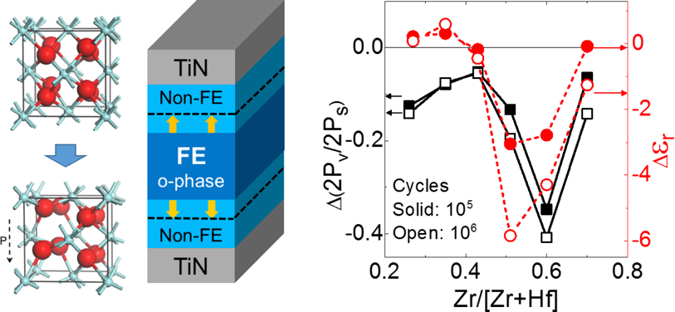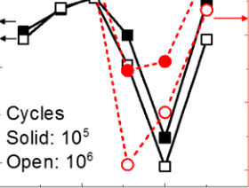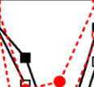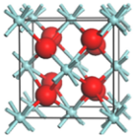

Research Article

www.acsami.org

Effect of Zr Content on the Wake-Up Effect in Hf1−xZrxO2 Films Min Hyuk Park,†,‡Han Joon Kim,†Yu Jin Kim,†Young Hwan Lee,†Taehwan Moon,†Keum Do Kim,†Seung Dam Hyun,†Franz Fengler,‡Uwe Schroeder,‡and Cheol Seong Hwang*,†

†Department of Materials Science and Engineering, and Inter-University Semiconductor Research Center, Seoul National University, Seoul 151-744, Republic of Korea  
‡NaMLab gGmbH, Noethnitzer Strasse 64, 01187 Dresden, Germany

|  |  |
| --- | --- |
| ABSTRACT: In this study, the changes in the structural and electrical properties of ferroelectric Hf1−xZrxO2 films with various Zr contents (0.26−0.70) were systematically examined during electric field cycling, resulting in a “wake-up” effect. To quantify the degree of wake-up effect, a“variable” polarization as the difference between remanent and saturation  polarization was suggested as a new parameter, which could be calculated | |
| by excluding the linear dielectric contribution from the total electric |  |
| displacement. Here, the variable polarization value could be minimized for    an optimized Zr content of 0.43, which was slightly lower than the value  for the largest remanent polarization. The polymorphism in Hf1−xZrxO2 thin films is known to be complicated due to the relatively small energy differences between various phases, such as the monoclinic, tetragonal, and orthorhombic phases. The variations in the polarization-electric field characteristics and dielectric constant values could be qualitatively and quantitatively  understood based on the competition of various polymorphs that are dependent on the Zr content. Furthermore, a schematic model for the spatial distribution of mixed phases was suggested for Hf1−xZrxO2 films with various Zr contents based on the experimental observations. | |

|  |  |
| --- | --- |
| KEYWORDS: hafnium oxide, ferroelectrics, wake-up, endurance, nonvolatile memory | |
| ■INTRODUCTION  The ferroelectricity and antiferroelectricity (more precisely, field-induced ferroelectricity in this case) of doped HfO2 films and Hf1−xZrxO2 (x = 0.0−1.0) films have been intensively studied since they were first reported in the early 2010s.1−5The ferroelectricity of the Hf1−xZrxO2 thin film could be observed with the Zr composition range near x = 0.5, which could be  ascribed to the emergence of the non-centrosymmetric  orthorhombic phase (o-phase; space group, Pca21), while antiferroelectricity could be observed when x is larger than∼0.7.2,3,6,7Recently, an interesting two-step polarization  switching procedure involving an intermediate nonpolar  tetragonal phase (t-phase; space group, P42/nmc) was also reported for the Hf0.40Zr0.60O2 film.8In that report, the effect of the composition on the polarization-electric field (P−E) characteristics of the film could be understood based on the classical first-order phase transition theory, and it was elucidated that the Zr contents strongly affected the transition temperature of the Hf1−xZrxO2 film.8The Hf0.5Zr0.5O2 film could have a remanent polarization (Pr) larger than ∼20 μC/ cm29,10and could endure up to 109switching cycles with an electric pulse height of 2.5 MV/cm.11,12The Hf0.5Zr0.5O2 films are highly promising for ferroelectric memory applications due  to their Si compatibility, mature deposition processes including | the current dynamic random access memory when it is operated using a relatively low electric field.14They also  reported that a subthreshold swing smaller than 60 mV/dec could be achieved by utilizing a Hf0.65Zr0.35O2 film as a negative capacitor,15although the effective operation of negative  capacitance from the ferroelectric layer is currently being debated.16−19For ferroelectric HfO2 films doped with other dopants, the application as a capacitive layer of the one-  transistor-one-capacitor-type memory and as a gate oxide of the  one-transistor-type ferroelectric random access memory was also reported.20,21The antiferroelectric Zr-richer Hf1−xZrxO2 (x > 0.7) films, on the other hand, are considered promising for  various applications, such as for electrostatic energy storage, pyroelectric energy harvesting, and electrocaloric cooling.5,6,22 Recently, Hoffmann et al. also reported a similar application of Si-doped HfO2 films.23   For the ferroelectric Hf0.5Zr0.5O2 films, pre-electric cycle treatment is required to exploit their full Pr value due to the so-called “wake-up effect”.9−11,24−26The wake-up effect can be observed not only in the Hf1−xZrxO2 films but also in HfO2 films doped with other dopants.9−11,24−28In the pristine state, the shape of the P−E hysteresis is usually pinched, showing relatively smaller Pr and coercive field (Ec) values.9−11,24−28 After a certain number of repetitive polarization switching |

atomic layer deposition (ALD), large electric band gap, and strong resistivity to hydrogen-induced degradation.5,13Cheng and Chin reported that the ferroelectric field effect transistor

with Hf0.5Zr0.5O2 gate oxide can be utilized as a replacement of

|  |  |
| --- | --- |
| Received: Accepted: | March 24, 2016  May 30, 2016 |

Published: May 30, 2016

|  |  |  |  |
| --- | --- | --- | --- |
|  | © 2016 American Chemical Society | 15466 | DOI: [10.1021/acsami.6b03586](http://dx.doi.org/10.1021/acsami.6b03586) ACS Appl. Mater. Interface[s 2016, 8, 15466−15475](http://dx.doi.org/10.1021/acsami.6b03586) |

|  |  |  |
| --- | --- | --- |
| ACS Applied Materials & Interfaces | |  | | --- | | Research Article | |

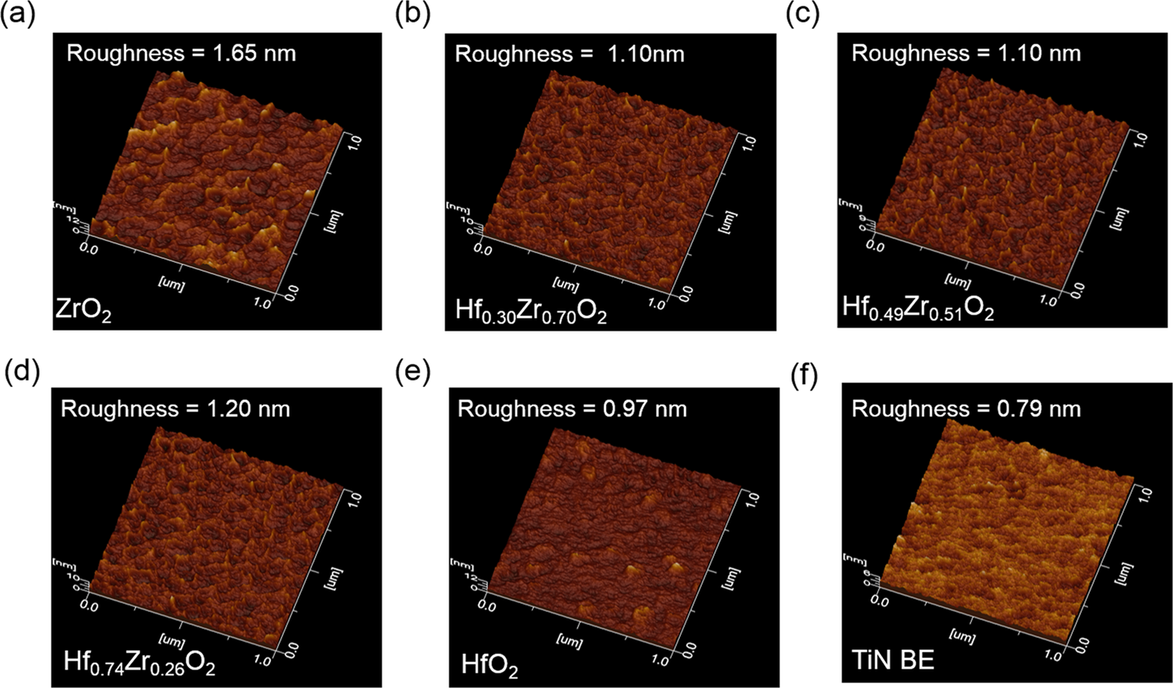

Figure 1. Topography images analyzed using an atomic force microscope for 9.2 nm thick (a) ZrO2, (b) Hf0.30Zr0.70O2, (c) Hf0.49Zr0.51O2, (d) Hf0.74Zr0.26O2, and (e) HfO2 films, respectively, on a TiN/Ti/SiO2/Si substrate and (f) a TiN/Ti/SiO2/Si substrate.

cycles, however, the P−E loop is recovered from the pinching, and the ferroelectric films have larger Pr values compared to those in a pristine state.9−11,24−28The possible origins of the wake-up effect were reported to be the depinning of pinned

|  |
| --- |
| domains and/or nonferroelectric-to-ferroelectric phase tran- |

|  |
| --- |
| sitions especially near the interface region with the electro- |

des.9−11,24−28Zhou et al. first examined the wake-up effect in Si-doped HfO2 films and suggested that the wake-up effect might result from the depinning of the domains pinned by defects in Si:HfO2 films.24Martin et al. reported that the monoclinic phase (m-phase; space group, P21/c) could be transformed into o-phase during the wake-up process of Si-doped HfO2 films based on a transmission electron microscope (TEM) study.27Lomenzo et al. suggested that the t- to o-phase transition might be the reason for the wake-up effect,28and this was recently reconfirmed by the authors using pulse switching measurement.9In the authors’ previous work, the thickness of the t-phase interfacial layer was estimated to be ∼1.2 nm in the pristine state, which became almost negligible after >105-time wake-up field cycling.9

As both the requirement of pretreatment and the change in

the Pr value during the repetitive write/erase process are unfavorable for the ferroelectric memories, an already woken-up state is necessary for pristine films. There have been only a

handful of reports on this issue, however, which may be ascribed to the short history of the field. It has already been reported that the polymorphism of Hf1−xZrxO2 films is highly complicated, and that the problem of which phase will emerge is affected by various factors. In addition, the direct structural

analysis of this complicated nanoscale behavior between the various polymorphs is very difficult even with the use of the state-of-the-art structural analysis method.29As such, the examination of the wake-up effect in a nanoscale thin film should be highly challenging.9−11,24−28In this study, the evolutions of the P−E curves with ferroelectric switching cycles from the various Hf1−xZrxO2 films with Zr contents (x value) ranging from 0.26 to 0.70 were examined. Such evolutions were used to elucidate the probable structural changes in the films

with cycling, which will contribute to the more detailed

understanding of the ferroelectric nature of this new class of functional materials.

■RESULTS AND DISCUSSION   
Before the wake-up effect in the Hf1−xZrxO2 films are examined, new parameters that could quantify the degree of wake-up effect were defined. Up to now, the changes in the Pr and Ec values have been considered parameters that can quantify the degree of wake-up effect.9−11,24−28This work, however, adopted more refined parameters, as shown below, to more quantitatively and accurately reveal the variation in the Pr value with the wake-up cycles. From the careful review of the previous reports on the wake-up effect of doped HfO2 or Hf1−xZrxO2 films by the authors and other groups,9−11,24,30an interesting common observation was found. During the wake-up process, the changes in the maximum polarization (more precisely, maximum electric displacement) value of Hf1−xZrxO2 or doped HfO2 films were lower than ∼5% while those in the Pr value were higher than ∼30%. This appears reasonable because the maximum polarization under the maximum electric field condition includes the contributions from the Pr, which must be largely influenced by the wake-up process, and the dielectric displacement from the field-induced polarization of the lattice (the background dielectric constant (εr) is responsible for this component), which has little relevance to the wake-up process. From the pulse switching measurement of Hf0.5Zr0.5O2 films in the authors’ previous study, it was suggested that interfacial t-phase materials are present near the top and bottom TiN electrodes, and that the thicknesses of these interfacial layers decreased during the wake-up field cycling.9−11This nonferro-electric interfacial layer should form a large depolarization field, and a part of the film could be depolarized when the electric field is removed. If the interfacial t-phase is diminished by the field cycling, the depolarization effect disappears, and the wake-up effect can be induced. On the other hand, the t-phase can be transformed to a ferroelectric o-phase under sufficiently high electric field, and changed back to a t-phase after removal of electric field. Thus, this field-induced phase transition may also vary during wake-up cycling.

|  |  |
| --- | --- |
| 15467 | DOI: [10.1021/acsami.6b03586](http://dx.doi.org/10.1021/acsami.6b03586) ACS Appl. Mater. Interface[s 2016, 8, 15466−15475](http://dx.doi.org/10.1021/acsami.6b03586) |

|  |  |  |
| --- | --- | --- |
| ACS Applied Materials & Interfaces | |  | | --- | | Research Article | |

To accurately and quantitatively estimate such effects related

to the interfacial layers, the contribution of the εr of the Hf1−xZrxO2 ferroelectric films to the estimated P−E curves must be removed. Although the εr value of a ferroelectric Hf1−xZrxO2 film (∼30) is smaller than those of perovskite ferroelectrics such as Pb(Zr,Ti)O3 by an order of magnitude, the electric field for P−E measurement is much higher than those of perovskite ferroelectrics.5As a result, the dielectric contribution to electric displacement becomes significant while the Pr value of Hf1−xZrxO2 films is relatively smaller than that of Pb(Zr,Ti)O3, making the relative contribution of the dielectric portion to the P−E curve rather significant. Therefore, the real P−E curves, free from the influence of the linear dielectric

contribution, were estimated from the experimentally measured P−E curves (D−E, in fact, where D is the total displacement)

using eq 1. By contrast, the depolarization and reverse phase

transition from o- to t-phase can be estimated using eq 2, which

is called variable polarization (Pv) in this work and plays a role as a useful measure of the wake-up effect, when the wake-up effect is assumed to originate from the removal of the depolarization effect according to the t- to o-phase transition

of the interfacial layers.

|  |  |  |  |  |  |  |  |  |  |  |  |  |  |  |
| --- | --- | --- | --- | --- | --- | --- | --- | --- | --- | --- | --- | --- | --- | --- |
| 2 *P* | = | 2 *D* | − | 2 0 r *ε ε* | | *E* | *E* max | − | 2 *P* r | = | 2 *P* s | − | 2 *P* r | (1) |
| 2 *P* v | = | 2 *D* max | | (2) |
| − | 2 *ε ε* 0 r | |

where ε0, Dmax, Ps, and Emax are the permittivity of vacuum, maximum D, saturation polarization, and maximum electric field, respectively. The Pv could result from the polarization change both from the transition between ferroelectric and

nonferroelectric phase and depolarization of ferroelectric phase. In fact, E must take into account the different εr values of the ferroelectric bulk layer and nonferroelectric interfacial layers, but as they are not much different, E was simply calculated by dividing the applied voltage by the total film thickness.3When the depolarization effect disappears during the wake-up process, the 2Pv value may become almost zero after the wake-up field cycling. The relative ratio of 2Pv compared to 2Ps can be used to quantify the degree of wake-up effect, and as such, by using

this normalized 2Pv value with respect to the 2Ps value (2Pv,nor = 2Pv/2Ps), the degrees of wake-up effect of ferroelectric Hf1−xZrxO2 films with different 2Ps values could be fairly compared.

Figure 1a−e shows the atomic force microscopy (AFM) topography images of the Hf1−xZrxO2 films with Zr contents of 1.00, 0.70, 0.51, 0.26, and 0.00, respectively, deposited on a TiN

bottom electrode, whereas Figure 1f shows the topography

image of the TiN bottom electrode before the deposition of Hf1−xZrxO2 films. The root-mean-square (RMS) roughness of the TiN bottom electrode and the Hf1−xZrxO2 films were 0.79 and 0.97−1.65 nm, respectively, confirming the uniform and conformal growth of the Hf1−xZrxO2 films. The relatively high RMS roughness of ZrO2 might have resulted from the partial crystallization of the ZrO2 film due to its relatively low crystallization temperature compared to that of the Hf-richer films. Figure 2a shows the grazing incidence X-ray diffraction (GIXRD) patterns of the ∼9.2 nm thick Hf1−xZrxO2 films with various Zr contents (x = 0.26−0.70). For a Zr content of 0.51,

which is known to have the strongest ferroelectric properties with the largest Pr value, the diffraction peaks from the m-phase could be hardly observed while the diffraction peaks from the o-

phase had high intensities. For a Zr content of 0.43, the diffraction peak from the (111) and (−111) planes of the m-

15468 DOI: [10.1021/acsami.6b03586](http://dx.doi.org/10.1021/acsami.6b03586)

|  |  |  |
| --- | --- | --- |
| ACS Applied Materials & Interfaces | |  | | --- | | Research Article | |

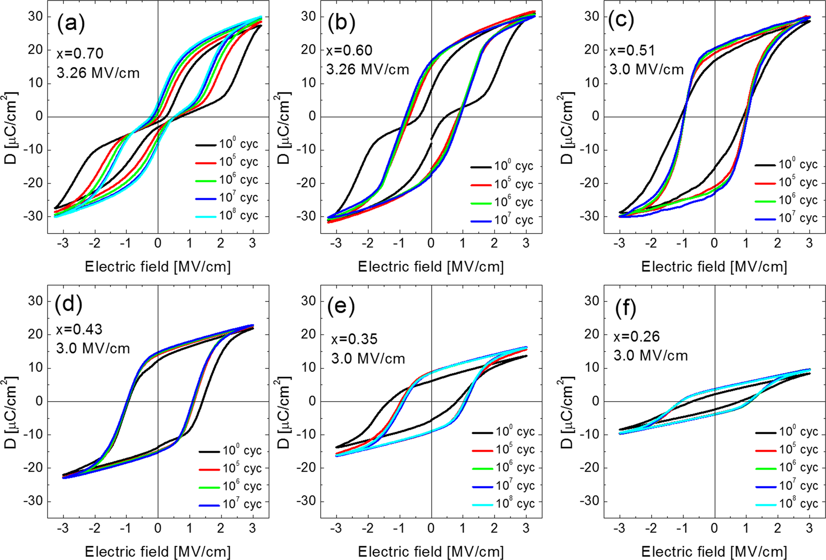

Figure 3. Total electrical displacement (D)−electric field curves of the Hf1−xZrxO2 films for (a) 0.70, (b) 0.60, (c) 0.51, (d) 0.43, (e) 0.35, and (f) 0.26 Zr contents (x), respectively.

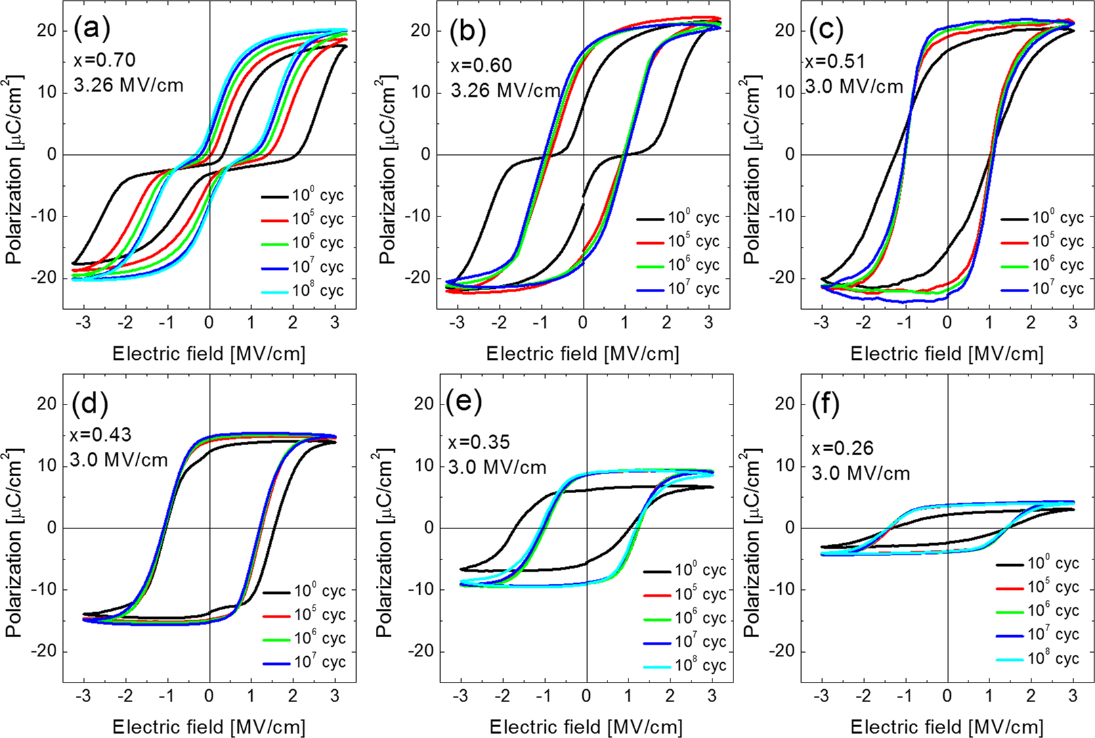

Figure 4. Polarization−electric field curves of the Hf1−xZrxO2 films for (a) 0.70, (b) 0.60, (c) 0.51, (d) 0.43, (e) 0.35, and (f) 0.26 Zr contents (x), respectively.

Pr value rapidly decreased, and the slope of the D−E curve in the pristine state also decreased, as can be seen in Figure 3e,f. The film eventually became a linear dielectric at x = 0 (data not shown).3These trends in the D−E characteristics with varying x values were consistent with the previous study results.3

15469 DOI: [10.1021/acsami.6b03586](http://dx.doi.org/10.1021/acsami.6b03586)

|  |  |  |
| --- | --- | --- |
| ACS Applied Materials & Interfaces | |  | | --- | | Research Article | |

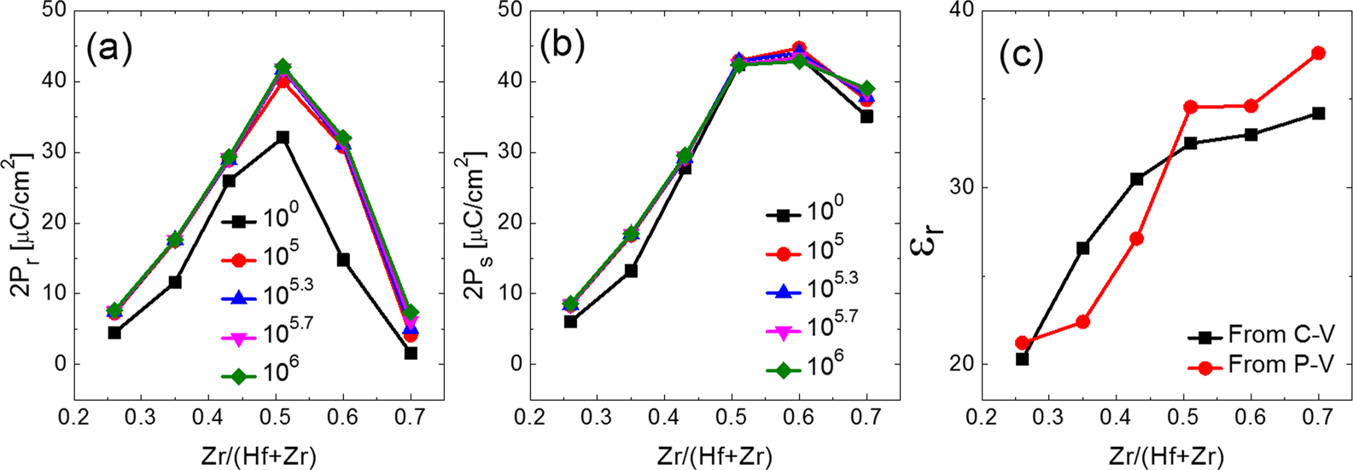

Figure 5. Variations in (a) double remanent polarization (2Pr) and (b) double saturation polarization (2Ps) as a function of the number of electric field cycles. (c) Variations in dielectric constant (εr) extracted from capacitance−voltage and polarization−voltage measurements with varying Zr content.

4a−f shows the results for the same samples shown in Figure 3.

As the linear dielectric contribution was eliminated, plateau

regions could be found in the top and bottom portions of the

curves while the general features of the P−E curves for the

different samples were mostly retained. The variations in the

wake-up behaviors could be grouped into three according to

the x values: for x = 0.51 and 0.43, the films were ferroelectric-

like; for x = 0.35 and 0.26, they were still ferroelectric-like, but

their Pr values were significantly decreased; and for x = 0.70 and 0.60, the films showed severely distorted P−E curves. As for the

Hf0.49Zr0.51O2 film (see Figure 4c), the slope of the P−E curve near Ec significantly increased with the increasing number of wake-up cycles while the change in the slope of the P−E curve

of the Hf0.57Zr0.43O2 film was negligible (Figure 4d). Moreover, the relative changes in the 2Pr value during the wake-up field cycling were much larger in the Hf0.49Zr0.51O2 film than in the Hf0.57Zr0.43O2 film. These differences mean that there exist significant differences between the wake-up processes of the

Hf0.49Zr0.51O2 and Hf0.57Zr0.43O2 films despite the relatively small composition difference. When the Zr contents were

further decreased to 0.35 and 0.26, however, the changes in the

Pr and Ps values were very different from those in the Hf0.49Zr0.51O2 and Hf0.57Zr0.43O2 films. For the Hf0.65Zr0.35O2 and Hf0.74Zr0.26O2 films, both the Pr and Ps values significantly increased during the wake-up field cycling, although the

magnitude of Pr even in the woken-up state was still much lower than that in the Hf0.49Zr0.51O2 film (Figure 4e,f). The Hf0.40Zr0.60O2 film showed an almost ferroelectric-like P−E

curve after only 105cycles while it showed a distorted P−E

curve in the pristine state. In contrast, the Hf0.30Zr0.70O2 film still showed a distorted P−E curve even after 108field cycles

while the degree of distortion slightly decreased with the

increasing number of wake-up cycles.

Figure 5a,b shows the changes in the 2Pr and 2Ps values of the Hf1−xZrxO2 films as a function of the x-value for the pristine

and variously cycled cases. In the pristine state, the 2Pr value of the Hf0.49Zr0.51O2 film was the largest (∼32.1 μC/cm2), which

further increased to 40.0, 41.7, 41.8, and 42.1 μC/cm2after 105,

105.3, 105.7, and 106field cycles, respectively. The 2Ps value of the Hf0.49Zr0.51O2 film in the pristine state was 40.1 μC/cm2,

which is larger than the 2Pr value by 8.0 μC/cm2, meaning that∼20% of the Ps at the high electric field was depolarized after the removal of the electric field (2Pv ∼ 8.0 μC/cm2). With the

increasing number of wake-up cycles, however, the 2Pv value significantly decreased, and it became almost zero after 106time

field cycling. With the increasing Zr contents from 0.51 to 0.70,

15470 DOI: [10.1021/acsami.6b03586](http://dx.doi.org/10.1021/acsami.6b03586)

|  |  |  |
| --- | --- | --- |
| ACS Applied Materials & Interfaces | |  | | --- | | Research Article | |

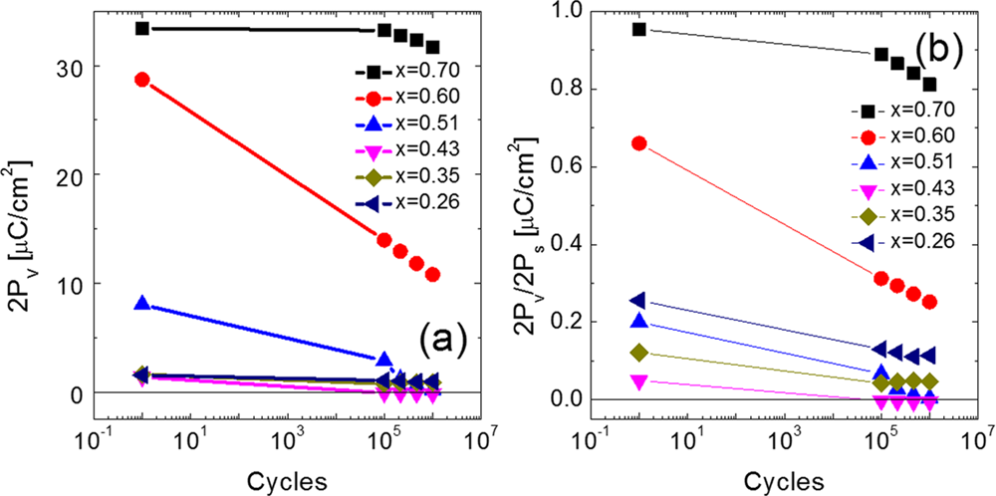

Figure 6. Variations in the (a) double variable polarization (2Pv) and (b) normalized 2Pv(2Pv/2Ps) as a function of the electric field cycles.

μC/cm2in the pristine state, which is ∼66% of 2Ps, but it decreased to 14.0, 12.9, 11.8, and 10.8 μC/cm2after 105, 105.3, 105.7, and 106time electric field cycling, respectively. The normalized 2Pv decreased from ∼66 to ∼25% after 106time electric field cycling. The difference between the changes in the 2Pv values of the Hf0.30Zr0.70O2 and Hf0.40Zr0.60O2 films could be understood based on the phase transition during wake-up field

cycling. From the 2Pr values in the pristine state, it could be estimated that a substantial portion of the films existed in t-phase both for the Hf0.30Zr0.70O2 and Hf0.40Zr0.60O2 films under zero external field. This estimation stems from the double-loop-shaped P−E hysteresis curve. At a low E, the t-phase has the

lowest energy among the three phases, which shows an almost

nonferroelectric property where the c/a ratio of the crystal lattice (1.015−1.029) is smaller than the 2a/(b + c) of the o-phase (1.036−1.042). It should be noted that the longest axes

of the t- and o-phases are the c- and a-axes, respectively. Under a high enough E, the electrostatic energy (P·E) overcomes the energy difference between the t- and o-phases, and the film

transforms to o-phase, which induces large Ps values. When the E is removed, the stable t-phase is recovered, and small Pr values are generally achieved. From the difference in the magnitude of the electric field required for field-induced phase transition, it could be noticed that the energy difference between the o- and t-phases in the Hf0.30Zr0.70O2 film was larger than that in the Hf0.40Zr0.60O2 film, which is also consistent with the results of the previous theoretical works.32This energy difference should affect the permanent phase transition during

the wake-up process as well as the reversible phase transition

between the t- and o-phases, which can be noted from the double P−E hysteresis curve.32The significant decrease in the 2Pv and 2Pv,nor values for the Hf0.40Zr0.60O2 film shown in the figures suggest that the transition from t- to o-phase during the wake-up process in the Hf0.40Zr0.60O2 film should be much stronger than that in the Hf0.30Zr0.70O2 film.

The 2Pv value of the Hf0.49Zr0.51O2 film (∼8.0 μC/cm2) in the pristine state was much smaller compared to the Zr-richer films, but it was still ∼20% of the 2Ps value. After 105, 105.3, 105.7, and 106time wake-up field cycling, the 2Pv (2Pv,nor) value decreased to 2.9 μC/cm2(6.7%), 1.2 μC/cm2(2.8%), 0.6 μC/ cm2(1.4%), and 0.2 μC/cm2(0.5%), respectively. From the quite large 2Pv value in the pristine state, the Hf0.49Zr0.51O2 film contained a certain portion of t-phase, but its relative portion should be much smaller than that in the Hf0.40Zr0.60O2 film. The almost zero values of 2Pv (2Pv,nor) in the full wake-up state (106 cycles) suggest that almost the entire nonferroelectric phase

was transformed to the ferroelectric phase, which is consistent

with the results of the previous work based on the pulse

15471 DOI: [10.1021/acsami.6b03586](http://dx.doi.org/10.1021/acsami.6b03586)

|  |  |  |
| --- | --- | --- |
| ACS Applied Materials & Interfaces | |  | | --- | | Research Article | |

that for the samples with x = 0.60 and 0.70 was the t-phase. Therefore, the Hf1−xZrxO2 films might change to o-phase for the samples with x = 0.26−0.51 when they are cooled down to room temperature, while the Hf0.40Zr0.60O2 and Hf0.30Zr0.70O2 films still exist in t-phase. These expected phase changes after crystallization annealing, however, were different from the experimental observations for the Hf-rich samples. These differences might have originated from the overestimated surface energy effect due to the underestimated grain size of the Hf1−xZrxO2 films. Park et al. and Kim et al. reported that the average grain sizes of a ∼10 nm thick Hf0.5Zr0.5O2 film were 14.4 and 14.2 nm, respectively.4,31These values are relatively larger than 9 nm, which was used by Materlik et al.32When the larger grain size is considered, the relative free energy of the m-phase can decrease by ∼9 meV/f.u. for the Hf0.74Zr0.26O2 film when the hexagonal columnar grain is considered.32Moreover, there should be a certain grain size distribution, which strongly affects the free energy of each phase. It should be noted that the energy differences between the m- and o-phases for the Hf0.74Zr0.26O2 and Hf0.65Zr0.35O2 films were smaller than 12 meV/f.u., and that those between the t- and o-phases in all the samples were smaller than 7 meV/f.u.

The oxygen vacancies can also affect the polymorphism in Hf1−xZrxO2 films.34Hoffmann et al. reported that based on their computational calculations, the presence of oxygen vacancies further stabilizes the t-phase compared to the o-phase.34They also suggested that oxygen vacancies might be formed in the HfO2-based dielectric layers due to a reduction by reactive metal electrodes such as TiN and TaN.34It was also reported that the surface energy of the t-phase is lower than that of the o-phase, meaning that the interfacial region should favor the t-phase.32Therefore, the interfacial region in Hf1−xZrxO2 films tends to form a t-phase even when the bulk region of the film forms an o-phase. The oxygen vacancy formation energy of HfO2 is higher than that of ZrO2 due to the stronger bond between Hf and O compared with that between Zr and O. Therefore, as the Zr concentration decreases (as the Hf concentration increases), the tendency to have oxygen vacancies within the interfacial region diminishes, which in turn results in decreased t-phase formation at the interface. This can explain the decreased depolarization effect when x = 0.43 compared with the case where x = 0.51. Nevertheless, the further decreased Zr concentration induced higher m-phase formation within the bulk region, decreasing the Pr and Ps values. The variations in the properties for the films with x = 0.35 and 0.26 can be understood from the same line of reasoning. As the Zr content further decreased, the depolarization effect could have also been further diminished due to the even thinner interfacial t-phase formation. The 2Pv values in Figure 6a, however, were in fact slightly higher than those in the case with x = 0.43. This may indicate that the interfacial region actually became slightly thicker, which may be ascribed to the increased m-phase formation at such composition. The m-phase content of the bulk portion must have been much higher, and the overall Pr and Ps values must have been the smallest among the six samples. The higher 2Pv,nor value of the sample shown in Figure 6b compared to that of x = 0.43 was due to the largely decreased 2Ps value. Martin et al. reported the m- to o-phase transition during the wake-up process based on a TEM study.27This can consistently explain the wake-up effect in the aforementioned sample in this study. It should be noted that the existence of t-phase in Hf0.74Zr0.26O2 and Hf0.65Zr0.35O2 films cannot be totally excluded. From the

15472 DOI: [10.1021/acsami.6b03586](http://dx.doi.org/10.1021/acsami.6b03586)

|  |  |  |
| --- | --- | --- |
| ACS Applied Materials & Interfaces | |  | | --- | | Research Article | |

films with various compositions in the pristine state, which were

deduced from the discussion above.

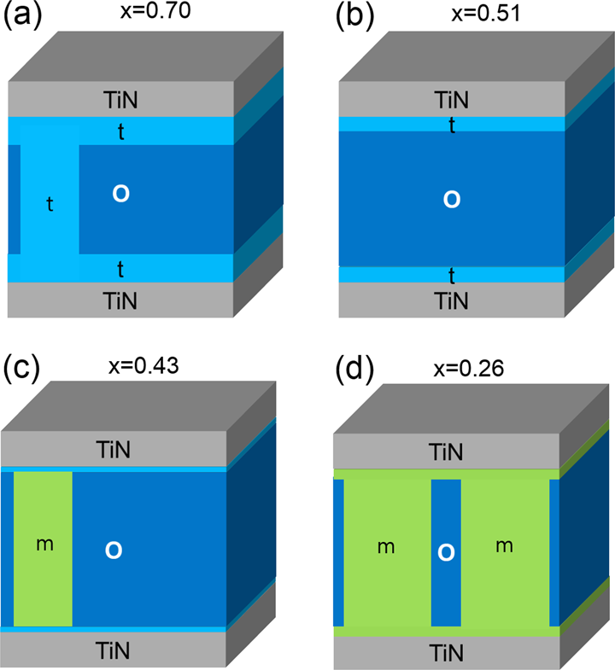

Figure 8. Schematic structure of the Hf1−xZrxO2 films with various Zr contents (x): (a) 0.70, (b) 0.51, (c) 0.43, and (d) 0.35, respectively.

To further prove the suggested phase transition mechanism during the wake-up process, the change in εr with an increasing number of electric field cycles was examined. Figure 9a shows

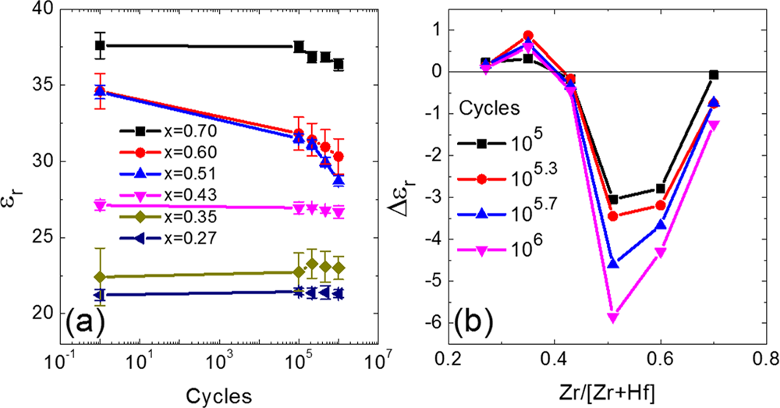

Figure 9. Variations in the (a) dielectric constant (εr) as a function of the electric field cycles. (b) Changes in εr (Δεr) as a function of the Zr content vs the number of electric field cycles.

the change in εr with respect to the pristine values as a function of the number of wake-up cycles. The εr values were extracted from the highest electric field regions of P−E curves when the electric field magnitude decreases. The εr values of the m-, o-, and t-phases of most HfO2-based dielectric films are known to be ∼17−20, 25−30, and 35−40, respectively.5For the Hf0.30Zr0.70O2 film in this study, the εr value in the pristine state was 37.6, and it decreased to 37.5 and 36.3 after 105and 106wake-up cycles, respectively, meaning that the variation was negligible. For the Hf0.40Zr0.60O2/Hf0.49Zr0.51O2 films, on the other hand, the initial εr value of 34.6/34.5 decreased to 31.8/ 31.5 and 30.3/28.7 after the occurrence of the same number of wake-up cycles. This is consistent with the large changes in the Pr and Pv values shown in Figures 5a and 6a. For the Hf0.57Zr0.43O2 film, on the other hand, the variation in the εr value was relatively small. The pristine εr value of 27.1 decreased to 27.0 and 26.7 after 105and 106time electric field cycling, respectively. It was also consistent with the relatively small change in the Pr and Pv values shown in Figures 5a and

15473 DOI: [10.1021/acsami.6b03586](http://dx.doi.org/10.1021/acsami.6b03586)

|  |  |  |  |  |
| --- | --- | --- | --- | --- |
| ACS Applied Materials & Interfaces |  | |  |  | | --- | --- | | |  | | --- | | Research Article | | |
| ■CONCLUSION | 15474 | elsewhere.4−10To electrically characterize the Hf1−xZrxO2 films, a Pt(30 nm)/TiN(5 nm) top electrode was deposited via direct-current |
| In this study, the effect of a different Zr content on the wake-up process in Hf1−xZrxO2 films was systematically examined. For the Hf0.30Zr0.70O2 and Hf0.40Zr0.60O2 films, an antiferroelectric-like double and broken P−E hysteresis behavior was shown in the pristine state. With an increasing number of wake-up field cycles, the electric field required for the nonferroelectric → |
| sputtering through a shadow mask with a 300 μm hole diameter (the TiN contacted the Hf1−xZrxO2 film). After the top-electrode deposition, postmetallization annealing was performed for 30 s at 500 °C in an N2 atmosphere under 100 Torr pressure, using rapid thermal annealing, for the crystallization of the films. The composition and thickness of the Hf1−xZrxO2 films were examined using X-ray fluorescence (Quant’X, Thermo SCIENTIFIC) and spectroscopic |
| ferroelectric phase transition decreased. This phenomenon can |
| ellipsometry (ESM-300, J.A. Woolam), respectively. The topography |
| be ascribed to the decreasing oxygen vacancy concentration |
| of the samples was analyzed with an AFM (JSPM-5200, JEOL), using the contact mode. The crystal structure of the Hf1−xZrxO2 films was examined via GIXRD, using an X-ray diffractometer (X’pert Pro, Panalytical). The incidence angle was fixed at 0.5°. The P−E |
| near the electrodes, which may induce a decrease in the critical nuclei size for field-induced phase transition. Moreover, it |
| appears that a portion of the metastable t-phase changed to o- |
| phase during the wake-up cycling, resulting in a decrease in the | characteristics were measured using a ferroelectric tester (TF Analyzer 2000, Aixacct Systems). The capacitance−voltage characteristics were |
| εr value and an increase in the Pr value. For the Hf0.49Zr0.51O2 film, the deformed P−E hysteresis in the pristine state is |
| measured using an impedance analyzer (4194A, HP) to achieve the εr−E characteristics. For all the electric characterizations, the top |
| believed to have resulted from the existence of an interfacial nonferroelectric t-phase, which induced the significant depola-rization effect. This interfacial layer became negligible after the wake-up field cycling. When the Zr content was slightly further decreased to 0.43, the changes in the P−E characteristics with wake-up cycling significantly decreased, suggesting a decrease in |
| electrode was biased while the bottom electrode was grounded during |
| the measurements.  ■AUTHOR INFORMATION |
| Corresponding Author |
| the thickness of the interfacial t-phase. Therefore, adopting a film with such Zr content can effectively suppress the wake-up effect, although a slight decrease in the 2Pr value due to m-phase formation is a trade-off. Therefore, this composition of Hf0.57Zr0.43O2 would be beneficial for the memory application with improved reliability with reasonable Pr value.  In this study, when the Zr content was further decreased to | *E-mail: [cheolsh@snu.ac.kr](mailto:cheolsh@snu.ac.kr). |
| Author Contributions |
| The manuscript was written through contributions of all authors. All authors have given approval to the final version of |
| the manuscript. |
| Notes |
| 0.35 and 0.26, it appeared that the m-phase portions in both the interfacial layer and the bulk region increased, and the P−E | The authors declare no competing financial interest.■ACKNOWLEDGMENTS |
| curve was largely degraded in the pristine state, which could |
| have been improved by a possible m- to o-phase transition |
| The authors wish to thank Prof. A. Kersch and his group for the |
| during wake-up cycling. This variation was accompanied by an |
| valuable discussions the authors had with them. This work was |
| increase both in the εr and Pr values. Consequently, the wake-up effect of Hf1−xZrxO2 films may originate from the phase  transition from the nonferroelectric to the ferroelectric phase |
| supported by the Global Research Laboratory Program |
| (2012K1A1A2040157) of the Ministry of Science, ICT, and |
| Future Planning of the Republic of Korea, and by a National |
| both in the interface and in the bulk regions. The relatively small differences in free energy of various phases with strong surface and grain boundary energy effects and a large magnitude of applicable electric field in HfO2-based ferro-electric materials result in quite strong wake-up effects during electric field cycling. This has not been the case for the conventional ferroelectric films, such as PZT. The high-enough strength of the electric field to induce the diffusion of mobile charged defects such as oxygen vacancies also affects the spatial |
| Research Foundation of Korea (NRF) grant funded by the |
| South Korean government (MSIP) (2014R1A2A1A10052979).■REFERENCES |
| (1) Böscke, T. S.; Müller, J.; Bräuhaus, D.; Schroeder, U.; Böttger, U. |
| Ferroelectricity in Hafnium Oxide Thin Films. Appl. Phys. Lett. 2011, |
| 99, 102903. |
| (2) Müller, J.; Böscke, T. S.; Bräuhaus, D.; Schroeder, U.; Böttger, U.; |
| Sundqvist, J.; Kücher, P.; Mikolajick, T.; Frey, L. Ferroelectric |
| distribution and competition of various phases in the nanoscale |
| Zr0.5Hf0.5O2 Thin Films for Nonvolatile Memory Applications. Appl. Phys. Lett. 2011, 99, 112901. |
| ferroelectric materials system. |
| Although the optimization of the composition of Hf1−xZrxO2 film could not totally suppress the wake-up effect, it  significantly weakened the wake-up effect. Moreover, there |
| (3) Müller, J.; Böscke, T. S.; Schröder, U.; Mueller, S.; Bräuhaus, D.; |
| Böttger, U.; Frey, L.; Mikolajick, T. Ferroelectricity in Simple Binary ZrO2 and HfO2. Nano Lett. 2012, 12, 4318−4323.  (4) Park, M. H.; Kim, H. J.; Kim, Y. J.; Lee, W.; Moon, T.; Hwang, C. |
| might be several other control knobs that can further weaken the wake-up effect besides composition control, such as varying |
| S. Evolution of Phases and Ferroelectric Properties of Thin |
| the process conditions, including the ALD temperature change, | Hf0.5Zr0.5O2 Films According to the Thickness and Annealing Temperature. Appl. Phys. Lett. 2013, 102, 242905. |
| annealing temperature change, precursor/oxygen source |
| (5) Park, M. H.; Lee, Y. H.; Kim, H. J.; Kim, Y. J.; Moon, T.; Kim, K. |
| replacements, and electrode materials change.■EXPERIMENTAL PROCEDURES  Hf1−xZrxO2 films were deposited on a TiN substrate, which also played  the role of the bottom electrode for the electrical tests, via thermal  ALD at a substrate temperature of 280 °C, using Hf[N(C2H5)CH3]4  (TEMA−Hf), Zr[N(C2H5)CH3]4 (TEMA−Zr), and ozone (170 g  m−3concentration) as the Hf precursor, Zr precursor, and oxygen  source, respectively. The details of the film growth were reported |
| D.; Müller, J.; Kersch, A.; Schroeder, U.; Mikolajick, T.; Hwang, C. S. |
| Ferroelectricity and Antiferroelectricity of Doped Thin HfO2-Based Films. Adv. Mater. 2015, 27, 1811−1831. |
| (6) Park, M. H.; Kim, H. J.; Kim, Y. J.; Moon, T.; Kim, K. D.; Hwang, |
| C. S. Thin HfxZr1‑xO2 Films: A New Lead-Free System for Electrostatic Supercapacitors with Large Energy Storage Density and |
| Robust Thermal Stability. Adv. Energy Mater. 2014, 4, 1400610. |
| (7) Park, M. H.; Kim, H. J.; Kim, Y. J.; Moon, T.; Kim, K. D.; Hwang, |
| C. S. Toward a Multifunctional Monolithic Device Based on |
| DOI: [10.1021/acsami.6b03586](http://dx.doi.org/10.1021/acsami.6b03586) ACS Appl. Mater. Interface[s 2016, 8, 15466−15475](http://dx.doi.org/10.1021/acsami.6b03586) |

|  |  |  |
| --- | --- | --- |
| ACS Applied Materials & Interfaces | |  | | --- | | Research Article | |

Pyroelectricity and the Electrocaloric Effect of Thin Antiferroelectric HfxZr1‑xO2 Films. Nano Energy 2015, 12, 131−140.

(8) Park, M. H.; Kim, H. J.; Lee, Y. H.; Kim, Y. J.; Moon, T.; Kim, K. D.; Hyun, S. D.; Hwang, C. S. Two-Step Polarization Switching Mediated by a Nonpolar Intermediate Phase in Hf0.4Zr0.6O2 Thin Films. Nanoscale 2016, DOI: [10.1039/C5NR08346J](http://dx.doi.org/10.1039/C5NR08346J).

(9) Kim, H. J.; Park, M. H.; Kim, Y. J.; Lee, Y. H.; Moon, T.; Kim, K. D.; Hyun, S. D.; Hwang, C. S. A Study on the Wake-up Effect of Ferroelectric Hf0.5Zr0.5O2 Films by Pulse-Switching Measurement. Nanoscale 2016, 8, 1383−1389.

(10) Park, M. H.; Kim, H. J.; Kim, Y. J.; Lee, Y. H.; Moon, T.; Kim, K. D.; Hyun, S. D.; Hwang, C. S. Study on the Size Effect in Hf0.5Zr0.5O2 Films Thinner Than 8 nm Before and After Wakeup Field Cycling. Appl. Phys. Lett. 2015, 107, 192907.

(11) Park, M. H.; Kim, H. J.; Kim, Y. J.; Moon, T.; Kim, K. D.; Lee, Y. H.; Hyun, S. D.; Hwang, C. S. Study on the Internal Field and Conduction Mechanism of Atomic Layer Deposited Ferroelectric Hf0.5Zr0.5O2 Thin Films. J. Mater. Chem. C 2015, 3, 6291.

(12) Park, M. H.; Kim, H. J.; Kim, Y. J.; Jeon, W.; Moon, T.; Hwang, C. S. Ferroelectric Properties and Switching Endurance of Hf0.5Zr0.5O2 Films on TiN Bottom and TiN or RuO2 Top Electrodes. Phys. Status Solidi RRL 2014, 8, 532−535.

(13) Park, M. H.; Kim, H. J.; Kim, Y. J.; Lee, W.; Kim, H. K.; Hwang, C. S. Effect of Forming Gas Annealing on the Ferroelectric Properties of Hf0.5Zr0.5O2 Thin Films With and Without Pt Electrodes. Appl. Phys. Lett. 2013, 102, 112914.

(14) Cheng, C.-H.; Chin, A. Low-Voltage Steep Turn-On pMOSFET Using Ferroelectric High-κ Gate Dielectric. IEEE Electron Device Lett. 2014, 35, 274−276.

(15) Cheng, C.-H.; Chin, A. Low-Leakage-Current DRAM-Like Memory Using a One-Transistor Ferroelectric MOSFET With a Hf-Based Gate Dielectric. IEEE Electron Device Lett. 2014, 35, 138−140. (16) Salahuddin, S.; Datta, S. Use of Negative Capacitance to Provide Voltage Amplification for Low Power Nanoscale Devices. Nano Lett. 2008, 8, 405−410.

(17) Cano, A.; Jiménez, D. Multidomain Ferroelectricity as a Limiting Factor for Voltage Amplification in Ferroelectric Field-Effect Transistors. Appl. Phys. Lett. 2010, 97, 133509.

(18) Khan, A. I.; Chatterjee, K.; Wang, B.; Drapcho, S.; You, L.; Serrao, C.; Bakaul, S. R.; Ramesh, R.; Salahuddin, S. Negative Capacitance in a Ferroelectric Capacitor. Nat. Mater. 2015, 14, 182−186.

(19) Song, S. J.; Kim, Y. J.; Park, M. H.; Lee, Y. H.; Kim, H. J.; Moon, T.; Kim, K. D.; Choi, J.-H.; Chen, Z.; Jiang, A.; Hwang, C. S. Alternative Interpretations for Decreasing Voltage with Increasing Charge in Ferroelectric Capacitors. Sci. Rep. 2016, 6, 20825.

(20) Mueller, S.; Müller, J.; Schroeder, U.; Mikolajick, T. Reliability Characteristics of Ferroelectric Si:HfO2 Thin Films for Memory Applications. IEEE Trans. Device Mater. Reliab. 2013, 13, 93−97. (21) Müller, J.; Polakowski, P.; Mueller, S.; Mikolajick, T. Ferroelectric Hafnium Oxide Based Materials and Devices: Assessment of Current Status and Future Prospects. ECS J. Solid State Sci. Technol. 2015, 4, N30−N35.

(22) Park, M. H.; Kim, H. J.; Kim, Y. J.; Moon, T.; Kim, K. D.;

(26) Schenk, T.; Hoffmann, M.; Ocker, J.; Pešić, M.; Mikolajick, T.; Schroeder, U. Complex Internal Bias Fields in Ferroelectric Hafnium Oxide. ACS Appl. Mater. Interfaces 2015, 7, 20224−20233.

(27) Martin, D.; Müller, J.; Schenk, T.; Arruda, T. M.; Kumar, A.; Strelcov, E.; Yurchuk, E.; Müller, S.; Pohl, D.; Schröder, U.; Kalinin, S. V.; Mikolajick, T. Ferroelectricity in Si-Doped HfO2 Revealed: A Binary Lead-Free Ferroelectric. Adv. Mater. 2014, 26, 8198−8202. (28) Lomenzo, P. D.; Takmeel, Q.; Zhou, C.; Fancher, C. M.; Lambers, E.; Rudawski, N. G.; Jones, J. L.; Moghaddam, S.; Nishida, T. TaN Interface Properties and Electric Field Cycling Effects on Ferroelectric Si-doped HfO2 Thin Films. J. Appl. Phys. 2015, 117, 134105.

(29) Sang, X.; Grimley, E. D.; Schenk, T.; Schroeder, U.; LeBeau, J. M. On the Structural Origins of Ferroelectricity in HfO2 Thin Films. Appl. Phys. Lett. 2015, 106, 162905.

(30) Mueller, S.; Müller, J. J.; Hoffmann, R.; Yurchuk, E.; Schlösser, T.; Boschke, R.; Paul, J.; Goldbach, M.; Herrmann, T.; Zaka, A.; Schroeder, U.; Mikolajick, T. From MFM Capacitors Toward Ferroelectric Transistors: Endurance and Disturb Characteristics of HfO2-Based FeFET Devices. IEEE Trans. Electron Devices 2013, 60, 4199−4205.

(31) Kim, H. J.; Park, M. H.; Kim, Y. J.; Lee, Y. H.; Jeon, W.; Gwon, T.; Moon, T.; Kim, K. D.; Hwang, C. S. Grain Size Engineering for Ferroelectric Hf0.5Zr0.5O2 Films by an Insertion of Al2O3 Interlayer. Appl. Phys. Lett. 2014, 105, 192903.

(32) Materlik, R.; Künneth, C.; Kersch, A. The Origin of Ferroelectricity in Hf1−xZrxO2: A Computational Investigation and a Surface Energy Model. J. Appl. Phys. 2015, 117, 134109.

(33) Tagantsev, A. K.; Landivar, M.; Colla, E.; Setter, N. Identification of Passive Layer in Ferroelectric Thin Films from Their Switching Parameters. J. Appl. Phys. 1995, 78, 2623.

(34) Hoffmann, M.; Schroeder, U.; Schenk, T.; Shimizu, T.; Funakubo, H.; Sakata, O.; Pohl, D.; Drescher, M.; Adelmann, C.; Materlik, R.; Kersch, A.; Mikolajick, T. Stabilizing the Ferroelectric Phase in Doped Hafnium Oxide. J. Appl. Phys. 2015, 118, 072006. (35) Pešić, M.; Fengler, F.; Larcher, L.; Padovani, A.; Grimley, E. D.; Sang, X.; LeBeau, J. M.; Slesazeck, S.; Schroeder, U.; Mikolajick, T.; Schenk, T. Physical Mechanisms behind the Field-Cycling Behavior of HfO[2](http://dx.doi.org/10.1002/adfm.201600590)-Based Ferroelectric Capacitors. Adv. Funct. Mater. 2016, [DOI: 10.1002/adfm.201600590](http://dx.doi.org/10.1002/adfm.201600590).

(36) Starschich, S.; Menzel, S.; Böttger, U. Evidence for Oxygen Vacancies Movement during Wake-up in Ferroelectric Hafnium Oxide. Appl. Phys. Lett. 2016, 108, 032903.

Hwang, C. S. Effect of the Annealing Temperature of Thin   
Hf0.3Zr0.7O2 Films on Their Energy Storage Behavior. Phys. Status   
Solidi RRL 2014, 8, 857−861.

(23) Hoffmann, M.; Schroeder, U.; Künneth, C.; Kersch, A.;   
Starschich, S.; Böttger, U.; Mikolajick, T. Ferroelectric Phase   
Transitions in Nanoscale HfO2 Films Enable Giant Pyroelectric   
Energy Conversion and Highly Efficient Supercapacitors. Nano Energy   
2015, 18, 154−164.

(24) Zhou, D.; Xu, J.; Li, Q.; Guan, Y.; Cao, F.; Dong, X.; Müller, J.;   
Schenk, T.; Schröder, U. Wake-up Effects in Si-doped Hafnium Oxide   
Ferroelectric Thin Films. Appl. Phys. Lett. 2013, 103, 192904.

(25) Schenk, T.; Schroeder, U.; Pešić, M.; Popovici, M.; Pershin, Y.   
V.; Mikolajick, T. Electric Field Cycling Behavior of Ferroelectric   
Hafnium Oxide. ACS Appl. Mater. Interfaces 2014, 6, 19744−19751.

|  |  |
| --- | --- |
| 15475 | DOI: [10.1021/acsami.6b03586](http://dx.doi.org/10.1021/acsami.6b03586) ACS Appl. Mater. Interface[s 2016, 8, 15466−15475](http://dx.doi.org/10.1021/acsami.6b03586) |