

This article has been accepted for inclusion in a future issue of this journal. Content is final as presented, with the exception of pagination.

IEEE TRANSACTIONS ON ELECTRON DEVICES 1



Energy-Efficient Versatile Memories With Ferroelectric Negative Capacitance by Gate-Strain Enhancement   
Yu-Chien Chiu, Chun-Hu Cheng, Member, IEEE, Guan-Lin Liou,

and Chun-Yen Chang, Life Fellow, IEEE

***Abstract— In this brief, we reported a ferroelectric versatile***  ***memory***  ***with***  ***strained-gate***  ***engineering. The***  ***versatile***  ***memory***  ***with***  ***high-strain-gate***  ***showed a >40% improvement on ferroelectric hysteresis window, compared***  ***to***  ***low-strain***  ***case.***  ***The***  ***high***  ***compressive stress induced from high nitrogen-content TaN enhances monoclinic-to-orthorhombic***  ***phase***  ***transition***  ***to***  ***reach stronger ferrolectric polarization and lower depolarization field. The versatile memory featuring ferroelectric negative capacitance exhibited excellent transfer characteristics of the sub-60-mVdec subthreshold swing, ultralow off-state leakage***  ***of***   
 ***<1fA/µm***  ***and***  ***>108***  ***on/off***  ***current***  ***ratio. Furthermore, the ferroelectric versatile memory can be switched by* ±*5 V under 20-ns speed for a long endurance cycling (*∼*1012cycles). The low-power operation can be ascribed to the amplification of the surface potential to reach the strong inversion and fast domain polarization at the correspondingly low program/erase voltages.***

***Index Terms— Charge trpapping, ferroelectric, multilevel, nonvolatile memory.***

I. INTRODUCTION   
**T** of dynamic random access memory (DRAM) and HE ferroelectric memory combining the switching speed

one-transistor memory structure of flash nonvolatile mem-

ory has widely been investigated [1]–[5]. However, the real

hot topic attracting more attention is the negative capaci-

tance effect through ferroelectric and antiferroelectric switch-

ing [6]–[11]. The ferroelectric negative capacitance effect can

be well defined and described by the Landau theory [12]–[15]

and also expected to be applied for CMOS technology beyond

sub-10-nm node. Another research topic worthy of acad-

emic study is energy-efficient ferroelectric memory. In this

Manuscript received May 9, 2017; revised May 23, 2017; accepted June 2, 2017. This work was supported by the National Science Council Taiwan, China, under Contract NSC 105-2221-E-003-022. The review of this brief was arranged by Editor J. Kang. (Corresponding author: Chun-Hu Cheng.)   
 Y.-C. Chiu and C.-Y. Chang are with the Department of Electronics Engineering, National Chiao Tung University, Hsinchu 30010, Taiwan.

C.-H. Cheng and G.-L. Liou are with the Department of Mechatronic Engineering, National Taiwan Normal University, Taipei 10610, Taiwan (e-mail: chcheng@ntnu.edu.tw).

Color versions of one or more of the figures in this paper are available online at http://ieeexplore.ieee.org.

Digital Object Identifier 10.1109/TED.2017.2712709

brief, our versatile memory with the introduction of charge trapping storage based on a gate injection mechanism had been demonstrated. Our one-transistor ferroelectric versatile memory reached the steep sub-60-mV/dec switching and fast program/erase speeds (20 ns) that were more favorable to reduce the dynamic power consumption. To clarify the neg-ative capacitance effect on the switching speed and repeated cycling stability of memory, the flicker noise measurement and long endurance tests were performed here.

II. EXPERIMENTS

In this brief, the ferroelectric versatile memory was implemented by using a *p*-channel MOSFET with a combined storage scheme employing ferroelectric HfZrO (HZO) and charge-trapped ZrSiO (ZSO) layers. Then, fabrication proce-dure of *p*-channel ferroelectric MOSFET was described below. First, a 3.5-nm SiO2 was grown by vertical furnace as a buffer oxide on *n*-type silicon substrate. Then, the 23-nm-thick HZO ferroelectric layer and 5-nm-thick ZSO trapping layer were deposited by evaporation and sputter systems. The stacked dielectric was then annealed at 400 °C. Subsequently, the 3-nm SiO2 was deposited as a top tunnel oxide to form final gate-stack structure. The TaN metals with various nitrogen contents were then patterned as gate electrodes. The source and drain regions are followed by a self-aligned BF2+implantation and activated by an RTA. Finally, Al metals were evaporated as source/drain contacts. The fabricated ferroelectric versatile memory has a gate length and width of 10 and 100 *μ*m, respectively. To make a performance comparison, the control ferroelectric memories using a single-layer ferroelectric HfZrO with the same dielectric thickness, thermal annealing, and gate-strain process were simultaneously fabricated.

III. RESULTS AND DISCUSSION

Our previous studies reported that the strain-gate effect on ferroelectric HfZrO dielectric can be simulated by the first-principle calculation (FPC) approach [16]. The atomic structures of monoclinic and orthorhombic crystallinities are shown in Fig. 1(a). The formation of orthorhombic phase is very important for the ferroelectricity in HfZrO dielectric. The schematic of strain-induced phase transition is shown

0018-9383 © 2017 IEEE. Personal use is permitted, but republication/redistribution requires IEEE permission. See http://www.ieee.org/publications_standards/publications/rights/index.html for more information.

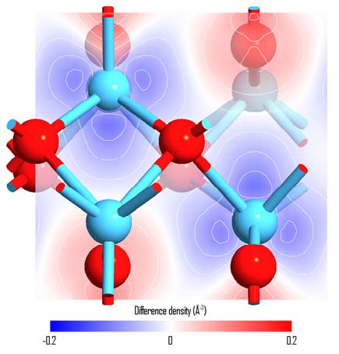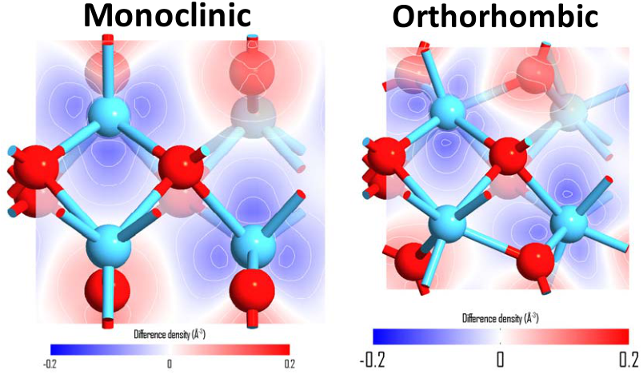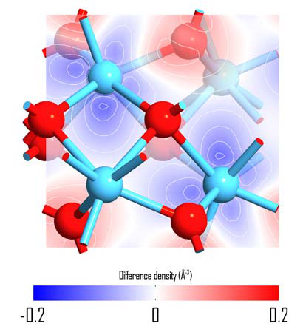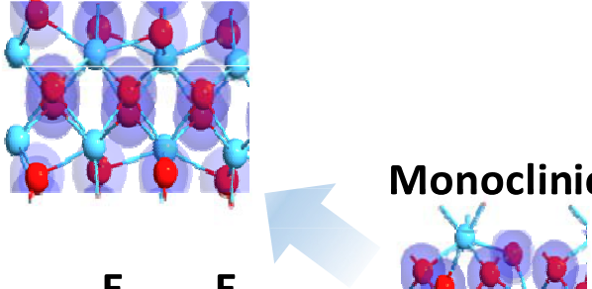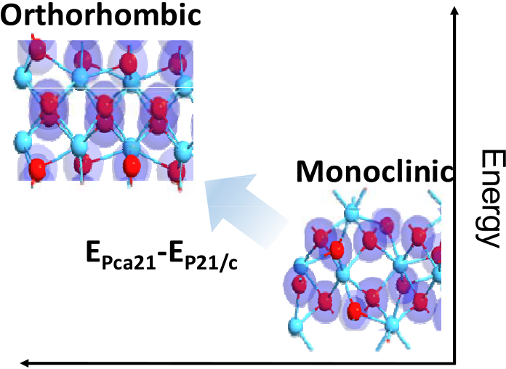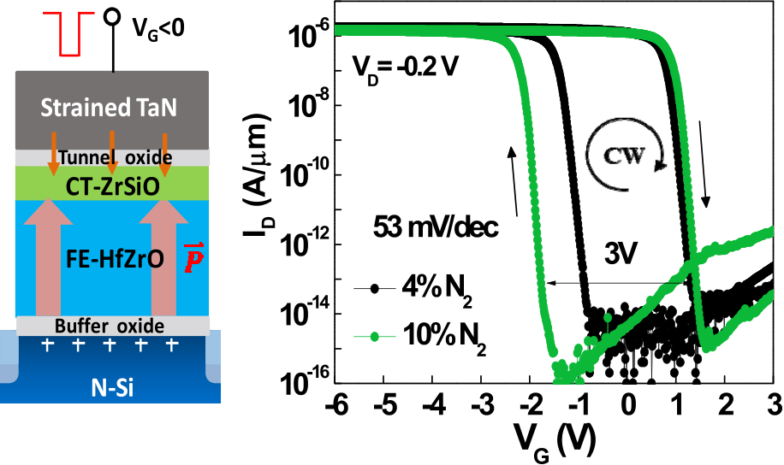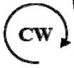

This article has been accepted for inclusion in a future issue of this journal. Content is final as presented, with the exception of pagination.

2 IEEE TRANSACTIONS ON ELECTRON DEVICES







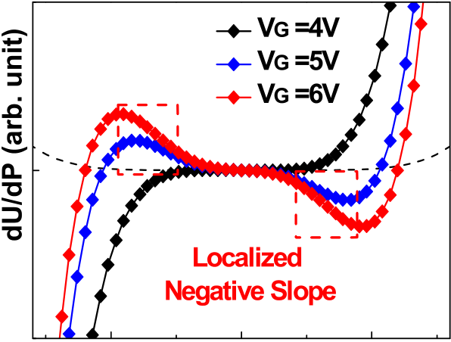





Fig. 1. (a) Atomic structure of monoclinic and orthorhombic crystallinities. (b) Schematic of strain-induced phase transition from monoclinic-to-orthorhombic phase.

in Fig. 1(b). Our FPC simulation has demonstrated that the increased gate strain can enhance the phase transition from low-strain energy monoclinic to high-strain energy the metal gate strain with a locally compressive stress can assist and accelerate the low-energy P21/c monoclinic polar phase to overcome the energy barrier (EPca21−EP21*/*c*)* of monoclinic-to-orthorhombic phase transition. In this brief, the strain-gate engineering was further applied on ferroelectric versatile memory with a combined storage scheme. The electric char-acteristic, the ferroelectric negative capacitance effect, and related physical mechanism are described below.

To further improve memory characteristics, we proposed a new storage mechanism of combining the charge trapping and ferroelectric domain. The top thin ZrSiO trapping layer creating an aligned dipoles at ZrSiO/HfZrO interface can effectively reduce the migration effect of charged oxygen vacancies [17], [18]. According to our new experimental result of Fig. 2(a), the TaN gate with high-nitrogen content of 10% shows a larger ferroelectric hysteresis than that of low nitro-gen content. This suggests that the high compressive stress induced from high-nitrogen-content TaN enhances monoclinic-to-orthorhombic phase transition to reach a large ferroelectric





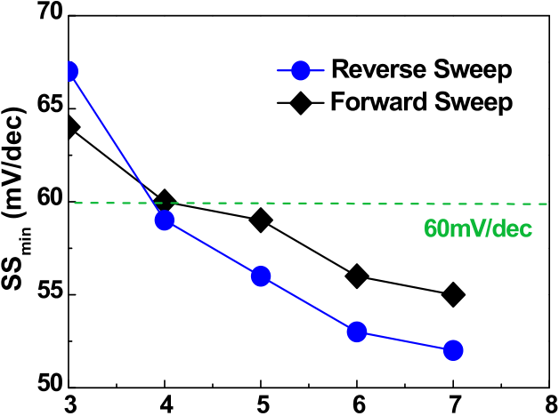





Fig. 2. (a) Transistor characteristics. (b) Derivate dU/dP under various gate votalges. (c) SSmin as a function of gate voltage of ferroelectric versatile memory with strain gate.

ascribed to steep subthreshold swing (SS) characteristic with the lowest 53 mV/dec under ±6 V dc sweep. The Gibb’s free energy with double well energy landscape was simulated, as shown in Fig. 2(b). The derivate *dU/dP* exhibits a negative slope in a bi-stable well potential, con-firming the existence of negative capacitance effect dur-ing gate voltage sweep. Fig. 2(c) shows that the SSmin of sub-60-mV/dec becomes smaller with the increase of gate voltages. It implies that the negative capacitance effect is significantly affected by the polarization and depolarization of ferroelectric switching along the direction of vertical electric

memory window of 3 V. In addition, the transfer characteristics field.

of ferroelectric versatile memory were also improved owing to the advantage of ferroelectric negative capacitance. Under the influence of negative capacitance supported by the Landau model [12]–[15], the measured OFF-state current (*I*OFF*)* can be significantly reduced to below 1fA/*μ*m, which is mainly

To further investigate the negative capacitance effect in gate dielectric stack, gate bias dependence of flicker noise characteristics was applied for examining the difference of conventional HZO FeRAM and ferroelectric versatile memory with an additional introduction of top ZSO trapping layer.

This article has been accepted for inclusion in a future issue of this journal. Content is final as presented, with the exception of pagination.

CHIU et al.: ENERGY-EFFICIENT VERSATILE MEMORIES 3



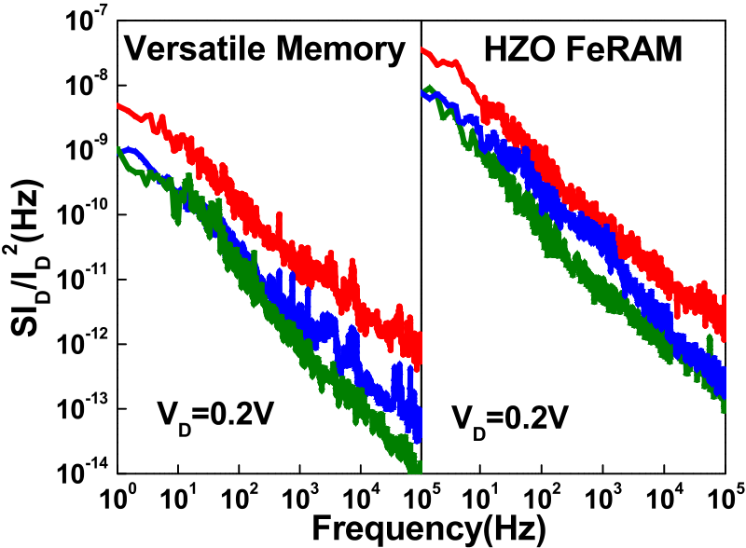

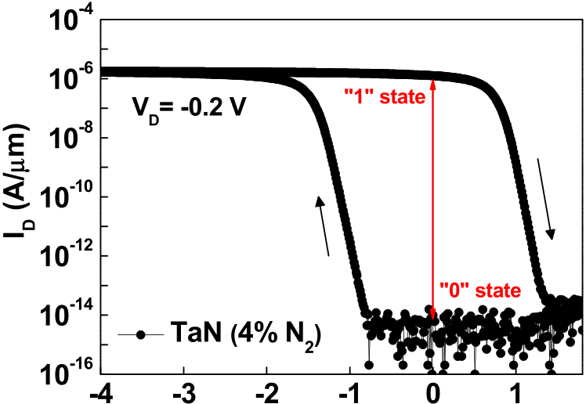



 

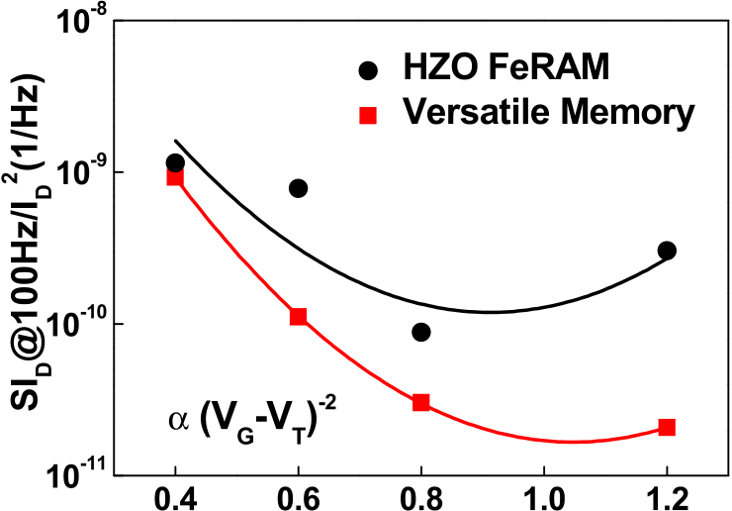





Fig. 3. (a) Normalized current power spectral densities (SID*/*I2 D). (b) Normalized SId for control HfZrO FeRAM and ferroelectric versatile memory.

The measured flicker noise is shown in Fig. 3(a) and the relation between normalized 1*/f* noise (SI*D/I*2 *D)* and gate overdrive (*VG* − *VT )* is shown in Fig. 3(b). The normalized 1*/f* noise of ferroelectric versatile memory with significant sub-60mV/dec swing is lower than that of control HZO FeRAM. The flicker noise results reveal that the subthreshold characteristics of versatile memory are less influenced by gate-stack traps. Thus, the gate dielectric stack dominated by ferroelectric negative capacitance is more favorable for enhancing the stability of ferroelectric switching.

The high-speed endurance test was also tested for ferroelec-tric versatile memories with low- and high-nitrogen-content TaN gates. A read scheme using *I*ON*/I*OFF ratio is adopted to define sense margin and monitor ON/OFF switching states. As shown in Fig. 4(a), the “0” state and “1” state can be identified by OFF-state and ON-state currents of transistor transfer char-acteristic. In Fig. 4(b), the fast drain-current response reveals that the speed of ferroelectric–antiferroelectric transition can be reached at 20 ns for both program and erase operation. The fast ferroelectric domain switching like static random access memory and DRAM can be used for cache and main memory.

For one-transistor memory device, the read and write scheme has been proposed [19]. The sense margin is defined by *I*OFF*/I*ON ratio under program and erase states. Fig. 4(c) depicts the *I*OFF*/I*ON and SS dependence of endurance char-acteristics under the program/erase voltages of ±5 V. For high-strain-gate with 10% N2, the much lower *I*OFF*/I*ON ratio

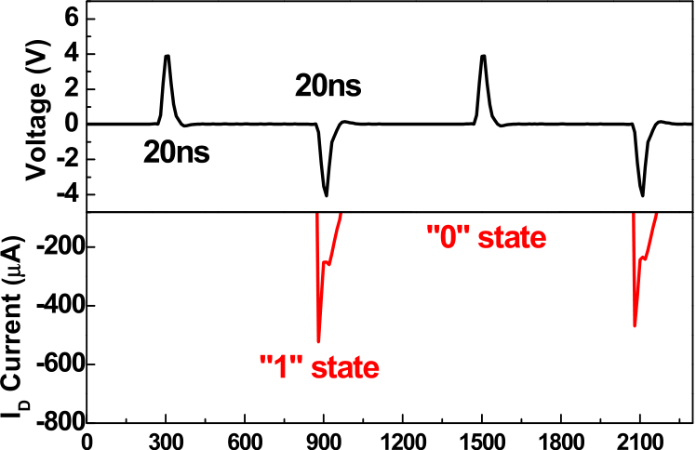





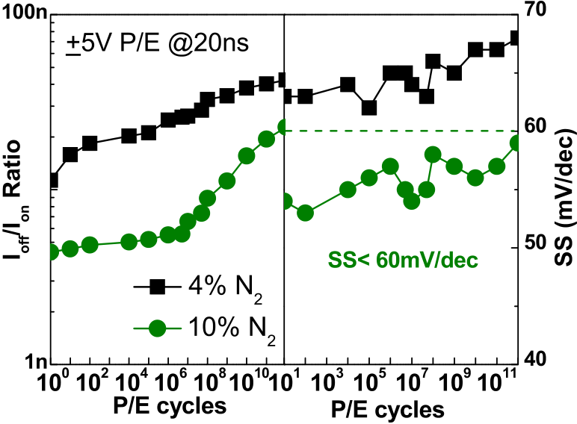



Fig. 4. (a) Transistor transfer characteristic curve. (b) 20-ns ID response current waveforms. (c) IOFF*/*ION and SS dependence of P/E cycling of ferroelectric versatile memory with strain gate.

than low strain one can obtain an energy-efficient ferroelectric switching, according to simplified energy model: E ∝ *V*2 *I*OFF*/I*ON*)* [20]. The *I*OFF*/I*ON must be as low as possible in DD*(ξ*+

order to obtain small *V*DD for power saving. It is worth noting that both *I*OFF and *I*OFF*/I*ON keep stable without significant degradation before 106cycles, indicating the gate-stack suffer small damage during program/erase cycling. Furthermore, the high-strain-gate case with a steeper sub-60 mV/dec SS exhibits a better fatigue endurance over 1012cycles than that of low-strain-gate case. This is because the high-strain-gate case is accompanied with stronger ferroelectric polarization and lower depolarization field. Thus, the sub-60 mV/dec SS characteristics originated from the negative capacitance effect

This article has been accepted for inclusion in a future issue of this journal. Content is final as presented, with the exception of pagination.

4 IEEE TRANSACTIONS ON ELECTRON DEVICES



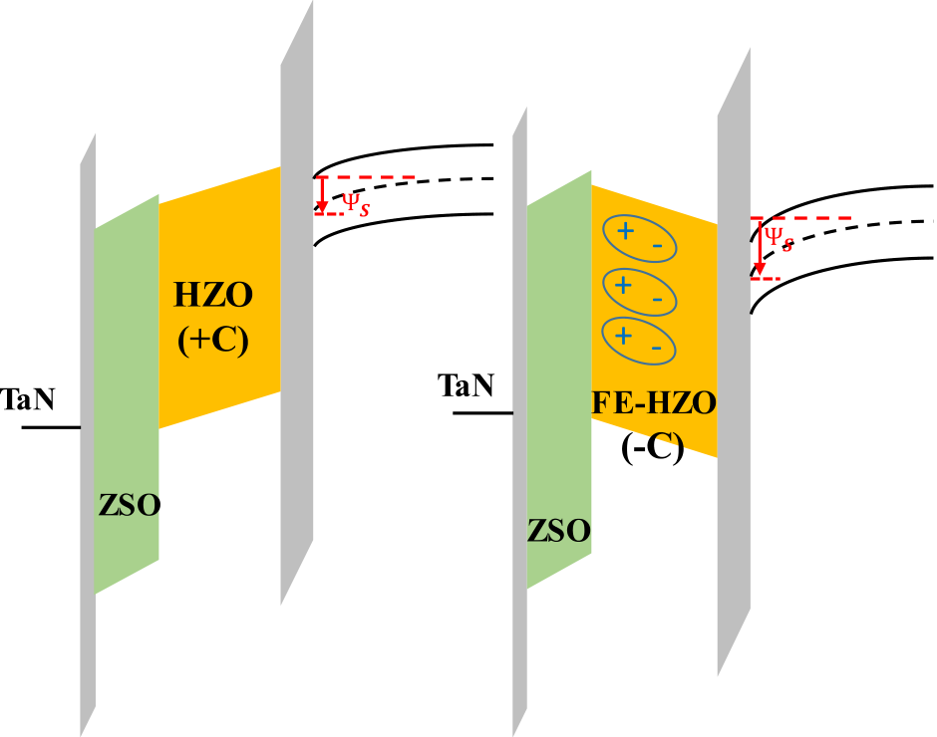

Fig. 5. Schematic band diagrams of gate-stack using control HZO dielectric (positive capacitance) and ferroelectric HZO dielectric (negative capacitance).

can effectively suppress the *I*OFF (*I*OFF ∝ 10−VT*/*SS*)* and thus stabilize the *I*OFF*/I*ON ratio.

To explain the energy-efficient ferroelectric switching behavior in versatile memory, the schematic band diagram illustrating the operation mechanism is shown in Fig. 5. Com-pared to traditional HZO dielectric with positive capacitance, the ferroelectric negative capacitance of orthorhombic-phase HZO dielectric can amplify the surface potential (*ψs)* to reach the strong inversion and fast domain polarization at a corre-spondingly low driving voltage. Thus, the program and erase voltages can be prominently reduced to lower memory switch-ing energy. Besides, the fast ferroelectric negative capaci-tance switching also enhances the electron tunneling efficiency through gate injection mechanism under negative gate voltage. This part has been verified by fast pulse endurance test with a 20-ns speed in Fig. 4. Therefore, this versatile memory achieves not only the ferroelectric polarization enhancement by strain-gate technique, but also the energy-efficient switch-ing through a negative capacitance effect.

IV. CONCLUSION

The negative capacitance effect is critical for improving pro-gram/erase efficiency and lowering switching energy in strain-gate versatile memory. Based on our best results, we believed that the strain-gate versatile memory with fast speed of 20 ns and long endurance of 1012cycles can be functionalized as one-transistor capacitorless DRAM and have the potential for next-generation memory applications.

ACKNOWLEDGMENT

The authors would like to thank Dr. Y.-T. Tang and Dr. M.-C. Chen from the National Nano Device Laboratories, Hsinchu, Taiwan, for their discussions.

REFERENCES

[1] S. R. Rajwade, K. Auluck, T. A. Naoi, K. Jayant, and E. C. Kan,

|  |  |  |  |  |  |  |  |
| --- | --- | --- | --- | --- | --- | --- | --- |
| “Dynamic | modeling | of | dual | speed | ferroelectric | and | charge |

hybrid memory,” *IEEE Trans. Electron Devices*, vol. 60, no. 10, pp. 3378–3383, Oct. 2013.

[2] N. Rodriguez, C. Navarro, F. Gamiz, F. Andrieu, O. Faynot, and S. Cristoloveanu, “Experimental demonstration of capacitorless A2RAM cells on silicon-on-insulator,” *IEEE Electron Device Lett.*, vol. 33, no. 12, pp. 1717–1719, Dec. 2012.

[3] J.-W. Han, D.-I. Moon, D.-H. Kim, and Y.-K. Choi, “Parasitic BJT read method for high-performance capacitorless 1T-DRAM mode in unified RAM,” *IEEE Electron Device Lett.*, vol. 30, no. 10, pp. 1108–1110, Oct. 2010.

[4] D.-I. Moon, J.-Y. Kim, J.-B. Moon, D.-O. Kim, and Y.-K. Choi,“Evolution of unified-RAM: 1T-DRAM and BE-SONOS built on a highly scaled vertical channel,” *IEEE Trans. Electron Devices*, vol. 61, no. 1, pp. 60–65, Jan. 2014.

[5] M. Aoulaiche *et al.*, “Endurance of one transistor floating body RAM on UTBOX SOI,” *IEEE Trans. Electron Devices*, vol. 61, no. 3, pp. 801–805, Mar. 2014.

[6] J. Müller *et al.*, “Ferroelectricity in simple binary ZrO2 and HfO2,” *Nano Lett.*, vol. 12, no. 8, pp. 4318–4323, Jul. 2012.

[7] C. H. Cheng and A. Chin, “Low-voltage steep turn-on p-MOSFET using ferroelectric high-*κ* gate dielectric,” *IEEE Electron Device Lett.*, vol. 35, no. 2, pp. 274–276, Feb. 2014.

[8] M. H. Park, H. J. Kim, Y. J. Kim, W. Lee, T. Moon, and C. S. Hwang,“Evolution of phases and ferroelectric properties of thin Hf0*.*5Zr0*.*5O2 films according to the thickness and annealing temperature,” *Appl. Phys. Lett.*, vol. 102, no. 24, p. 242905, Jun. 2013.

[9] M. H. Lee *et al.*, “Steep slope and near non-hysteresis of FETs with antiferroelectric-like HfZrO for low-power electronics,” *IEEE Electron Device Lett.*, vol. 36, no. 4, pp. 294–296, Apr. 2015.

[10] S. Mueller *et al.*, “Incipient ferroelectricity in Al-doped HfO2 thin films,” *Adv. Funct. Mater.*, vol. 12, no. 11, pp. 2412–2417, Jun. 2012. [11] A. I. Khan, C. W. Yeung, C. Hu, and S. Salahuddin, “Ferroelectric negative capacitance MOSFET: Capacitance tuning & antiferroelectric operation,” in *IEDM Tech. Dig.*, Dec. 2011, pp. 11.3.1–11.3.4.

[12] S. Salahuddin and S. Datta, “Can the subthreshold swing in a classical FET be lowered below 60 mV/decade?” in *IEDM Tech. Dig.*, Dec. 2008, pp. 1–4.

[13] J. Jo and C. Shin, “Impact of temperature on negative capacitance field-effect transistor,” *Electron. Lett.*, vol. 51, no. 1, pp. 106–108, Jan. 2015. [14] A. I. Khan *et al.*, “Experimental evidence of ferroelectric negative capacitance in nanoscale heterostructures,” *Appl. Phys. Lett.*, vol. 99, no. 11, p. 113501, 2011.

[15] A. I. Khan *et al.*, “Negative capacitance in short-channel FinFETs exter-nally connected to an epitaxial ferroelectric capacitor,” *IEEE Electron Device Lett.*, vol. 37, no. 1, pp. 111–114, Jan. 2016.

[16] Y.-C. Chiu, C.-H. Cheng, C.-Y. Chang, M.-H. Lee, H.-H. Hsu, and S.-S. Yen, “Low power 1T DRAM/NVM versatile memory featur-ing steep sub-60-mV/decade operation, fast 20-ns speed, and robust 85 °C-extrapolated 1016endurance,” in *Proc. Symp. VLSI Technol. (VLSI Technology)*, Jun. 2015, pp. T184–T185.

[17] Y.-C. Chiu, C.-H. Cheng, C.-Y. Chang, Y.-T. Tang, and M.-C. Chen,“Investigation of strain-induced phase transformation in ferroelectric transistor using metal-nitride gate electrode,” *Phys. Status Solidi- Rapid Res. Lett.*, vol. 11, no. 3, p. 1600368, Mar. 2017.

[18] C. H. Park and D. J. Chadi, “Microscopic study of oxygen-vacancy defects in ferroelectric perovskites,” *Phys. Rev. B, Condens. Matter*, vol. 57, no. 22, pp. 13961–13964, Jun. 1998.

[19] D. I. Moon *et al.*, “A novel FinFET with high-speed and prolonged retention for dynamic memory,” *IEEE Electron Device Lett.*, vol. 35, no. 12, pp. 1236–1238, Dec. 2014.

[20] M. Kobayashi and T. Hiramoto, “On device design for steep-slope negative-capacitance field-effect-transistor operating at sub-0.2 V supply voltage with ferroelectric HfO2 thin film,” *AIP Adv.*, vol. 6, no. 2, p. 025113, Feb. 2016.

Authors’ photographs and biographies not available at the time of publication.