

IEEE ELECTRON DEVICE LETTERS, VOL. 43, NO. 1, JANUARY 2022 13



Effects of High-Pressure Annealing on the

Low-Frequency Noise Characteristics

in Ferroelectric FET

Wonjun Shin[,](https://orcid.org/0000-0002-2962-2458) Jong-Ho Bae, Sihyun Kim, Kitae Lee, Dongs[eo](https://orcid.org/0000-0003-3559-9802)k Kwon,

Byung-Gook Park, Fellow, IEEE, Daewoong Kwon, and Jong-Ho Lee, Fellow, IEEE

***Abstract— In this work, the low-frequency noise (LFN) characteristics of hafnium-zirconium oxide (HZO) ferro-electric field-effect transistors (FeFETs) with and without high-pressure forming gas annealing (HPA) treatment are investigated. The origin of 1****/****f noise in the FeFET without HPA is changed from carrier number fluctuation to Hooge’s mobility fluctuation after wake-up due to the remote phonon scattering from the polarized HZO. Also, Hooge’s parameter is increased by the program****/****erase (P****/****E) cycling-induced stress. On the contrary, only the correlated mobility fluc-tuation is increased after the wake-up in the FeFET with HPA. Furthermore, the LFN of the FeFET with HPA shows robustness to P****/****E cycling-inducedstress after the wake-up, showing superb endurance performance.***

***Index Terms— Endurance, ferroelectric FET (FeFET), high-pressure annealing (HPA), low-frequency noise (LFN), wake-up.***

I. INTRODUCTION   
**R** sistors (FeFETs) have attracted extensive attention as ECENTLY, hafnium-based ferroelectric field-effect tran-

memory devices thanks to their CMOS compatibility and

high speed/low voltage operation compared to conventional

flash memories [1]–[3]. However, FeFETs suffer from poor

endurance performance due to the bulk charge-trapping

and interfacial layer breakdown, which results in premature

device failure [4]–[6]. Also, the spontaneous polarization

change with an initial field cycling, the so-called wake-up

effect, is another problem that degrades the reliability of

Manuscript received September 26, 2021; revised November 2, 2021; accepted November 3, 2021. Date of publication Novem-ber 10, 2021; date of current version December 29, 2021. This work was supported in part by the National Research Foundation of Korea under Grant NRF-2021R1A2C3009069 and Grant NRF-2016R1A5A1012920, in part by the Brain Korea 21Plus Project, ICT under Grant 2020M3F3A2A01081670, and in part by Samsung Elec-tronics Co., Ltd. under Grant IO210518-08644-01. The review of this letter was arranged by Editor H. Wu. (Wonjun Shin and Jong-Ho Bae contributed equally to this work.) (Corresponding authors: Daewoong Kwon; Jong-Ho Lee.)   
 Wonjun Shin, Sihyun Kim, Kitae Lee, Dongseok Kwon, Byung-Gook Park, and Jong-Ho Lee are with the Department of Electrical and Computer Engineering and the Inter-University Semiconductor Research Center (ISRC), Seoul National University, Seoul 08826, South Korea (e-mail: jhl@snu.ac.kr).

Jong-Ho Bae is with the School of Electrical Engineering, Kookmin University, Seoul 02707, South Korea.

Daewoong Kwon is with the Department of Electrical Engineering, Inha University, Incheon 22212, South Korea (e-mail: dw79kwon@inha.ac.kr).

Color versions of one or more figures in this letter are available at https://doi.org/10.1109/LED.2021.3127175.

Digital Object Identifier 10.1109/LED.2021.3127175

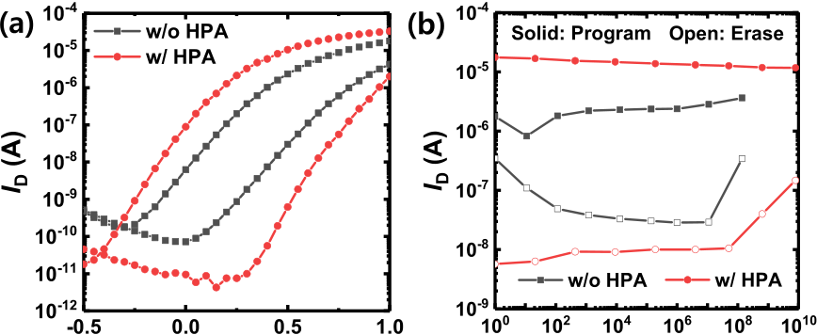

 

Fig. 1. (a) Transfer characteristics (ID-VGS) of the FeFETs with and without the HPA. (b) Endurance performance of the FeFETs with and without the HPA.

FeFETs [7]–[9]. Recently, it has been reported that high-pressure forming gas annealing (HPA) improves both the wake-up effect and endurance without sacrificing the mem-ory window of FeFETs [10]. Despite the importance of understanding the mechanism and physics of the wake-up effect, cycling endurance, and effect of HPA, those were only observed and explained by indirect methods, such as polarization-electric field and current-voltage curves [10].

Various methods have been used to evaluate the reliability of FeFETs, including charge pumping technique [5], [6]. However, previous studies to characterize the reliability of FeFETs adopted the charge pumping technique that extracts the trap density at the channel-gate oxide interface (fast trap), making it impossible to investigate traps inside the gate oxide [6]. On the contrary, low-frequency noise (LFN) analysis reflects the dynamic trapping/detrapping process inside the gate oxide [11]–[15]. An applied frequency range in LFN measurement can monitor oxide trap density along the gate stacks. This allows to extract a depth profile of trap density and quantify its magnitude as well, making it possible to monitor the impact of HPA and program/erase (P/E) cycling-induced stress (wake-up and endurance) on ferroelectric mate-rials. As such, in this letter, we systematically investigate and compare the LFN characteristics of hafnium-zirconium oxide (HZO) FeFET depending on the device status and whether HPA is done or not.

II. EXPERIMENTAL

The device used in this work is the same FeFET as demon-strated in [10]. The device is partially depleted silicon-on-insulator MOSFET with buried oxide and channel thicknesses of 375 and 100 nm, respectively. The gate insulator consists of∼1.0 nm chemical oxide (SiO2*)* and 5.7 nm ferroelectric HZO film deposited by ALD at 250◦C, and ∼100 nm TiN is used

0741-3106 © 2021 IEEE. Personal use is permitted, but republication/redistribution requires IEEE permission. See https://www.ieee.org/publications/rights/index.html for more information.

Authorized licensed use limited to: Georgia Institute of Technology. Downloaded on August 19,2022 at 13:17:45 UTC from IEEE Xplore. Restrictions apply.



14 IEEE ELECTRON DEVICE LETTERS, VOL. 43, NO. 1, JANUARY 2022



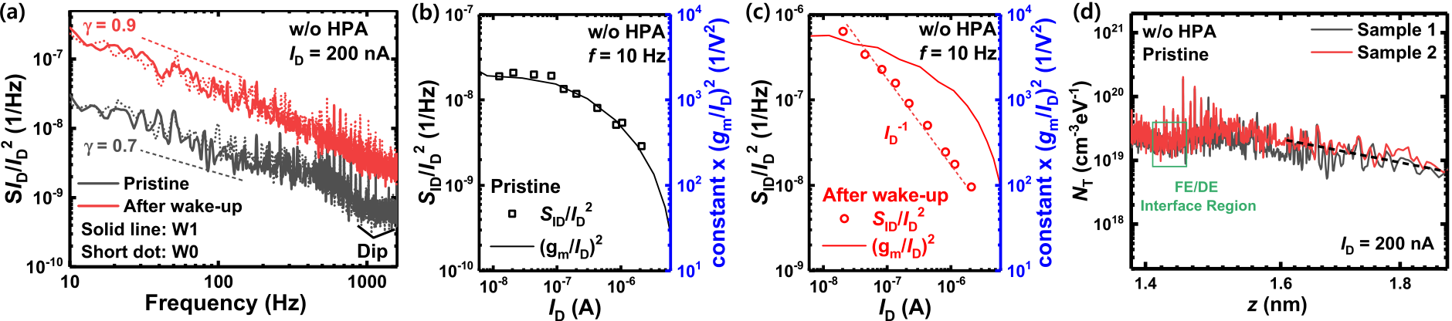

Fig. 2. (a) Normalized drain current noise power spectral density (SID*/*I2 D) of the pristine and after wake-up FeFETs without HPA measured at an ID of ∼ 200 nA. Note that there is no difference in 1/f noise behavior between the program (W0) and erase states (W1). SID*/*I2 Dsampled at 10 Hz and (gm/ID)2versus ID of the (b) pristine and (c) after wake-up FeFETs without HPA. (d) Volume trap density (NT) of the two independent FeFETs before the wake-up as a function of the vertical depth (z).

as a gate metal. After the TiN gate formation, the devices are subjected to an RTA at 500◦C for 30 s in a N2 ambience to crystallize the HZO. The width and length of the channel are 80 and 5 *μ*m, respectively. Note that the HPA is conducted for 1 hour at 450◦C under forming gas (Ar 96 % and H2 4 %).

Fig. 1(a) shows the transfer characteristics (*I*D-*V*GS*)* of the FeFETs with and without HPA. The FeFET with HPA shows the steeper subthreshold swing and larger drain current than those of the FeFET without HPA, which indicates the reduced effects of defect states. Also, the HPA causes a transition of HZO from tetragonal-phase to orthorhombic phase [16], increasing remanent polarization and thus memory window. In addition, after the HPA, wake-up-free behavior and the robustness against P/E cycling-induced memory window

Fig. 2(b) and (c) show the *S*ID/*I*2 Dand (*g*m/*I*D*)*2 versus *I*D of the pristine and after wake-up FeFETs without HPA, respectively. The *S*ID/*I*2 Dis sampled at 10 Hz. In the pristine device, the *S*ID/*I*2 Dand (*g*m/*I*D*)*2 show the same tendency with respect to change of *I*D, indicating that the 1/ *f* noise stems from the CNF referring to (1). However, after wake-up, the origin of 1/ *f* noise is changed to HMF (slope of−1 in Fig. 2(c)). After wake-up, the HZO is polarized, and thereby the mobility of the inversion channel is strongly affected by the remote phonon scattering induced by the HZO. It has been reported that soft bonds in highly polarizable materials are related to a low-energy optical phonon, and they induce additional carrier mobility scattering [19]. Therefore, the magnitude of 1/ *f* noise significantly increases after the

degradation are obtained (Fig. 1(b)). wake-up.

For LFN measurement, the low noise current amplifier (SR570) and signal analyzer (35670A) are used. Power spec-tral densities are measured in five independent FeFETs with and without HPA to ensure the reproducibility of the results. The LFN characteristics of both devices are investigated under various device conditions: pristine, after wake-up, and after 106cycling stress.

III. RESULTS AND DISCUSSION

Fig. 2(a) shows the normalized drain current noise power spectral densities (*S*ID/*I*2 Ds) of the pristine and after wake-up FeFET without HPA. The FeFETs show 1/ *fγ*  (*γ*  =−*∂*ln*SI D/∂*ln *f )* noise behavior, which can be explained either by the carrier number fluctuation (CNF) [17] or Hooge’s mobility fluctuation (HMF) model [18]. The CNF model is represented as [17]:

|  |  |  |  |  |
| --- | --- | --- | --- | --- |
| *SI D* | = *(gm* | 2 | *SV f b* | (1) |
| *)* |
| *I*2 *D* |

where *g*m is transconductance and *S*Vfb is flat-band voltage noise. *S*Vfb can be expressed as

*SV f b* =*q*2*kBT NT λ*  (2)

where *N*T is volume trap density, *λ* is tunneling attenuation coefficient, *C*ox is gate oxide capacitance per unit area, and *f* is frequency. On the other hand, the HMF model is given as [18]:

In Fig. 2(a), there is another important point: the difference of *γ* between the pristine and wake-up FeFETs. The *γ* contains information about the spatial distribution of traps in the SiO2 (dielectric: DE) and HZO (ferroelectric: FE). The frequency-domain of the power spectral density can be converted to the vertical distance from Si/SiO2 interface (*z)* by the following equation [20]:

*z* = *λ* ln�

2*π f τ*0� (4)   
 1

where *τ*0 is the time for tunneling into a trap state at the interface (*z* = 0). Fig. 2(d) shows the spatial distribution of *N*T as a function of *z* in two independent samples. The *N*T is obtained at an *I*D of ∼200 nA.

charges trapped in deep-level states near the interface between The dip observed at *z* ≈ 1.45 nm is caused by the immobile

FE and DE, which do not contribute to the CNF [21]. Note that

(FE/DE) interface, considering an inversion layer thickness *z* ≈ 1.45 nm is the location corresponding to the HZO/SiO2

in Si is ∼5 Å and the DE thickness is ∼8–10 Å. It is also observed that the pristine HZO film, which is not fully polarized, does not cause serious scattering in Fig. 2(a). This can be verified by the *γ* value smaller than 1 (0.65), indicating that the *N*T decreases in the HZO region (z *>* 1.45 nm). An increase in *γ* (∼0.91) after the wake-up demonstrates that scattering sources in the HZO are activated. Also, the dip disappears after the wake-up (Fig. 2(a)). It seems that the increased remote phonon scattering makes the dip invisible.

|  |  |  |  |
| --- | --- | --- | --- |
| *SI D*  *I*2 *D* | =*αHμef f* 2*kT* | (3) | Note that there is no difference in 1/ *f* noise behavior between |
| the program (W0) and erase states (W1) after the wake-up in |
| Fig. 2(a), meaning that the effect of defects on LFN are not |
| where *α*H is Hooge’s parameter. | | different in both W1 and W0 states. |

Authorized licensed use limited to: Georgia Institute of Technology. Downloaded on August 19,2022 at 13:17:45 UTC from IEEE Xplore. Restrictions apply.

SHIN et al.: EFFECTS OF HIGH-PRESSURE ANNEALING ON LFN CHARACTERISTICS IN FERROELECTRIC FET 15



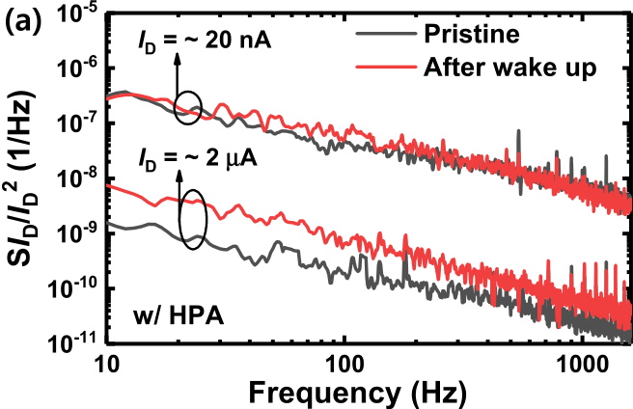

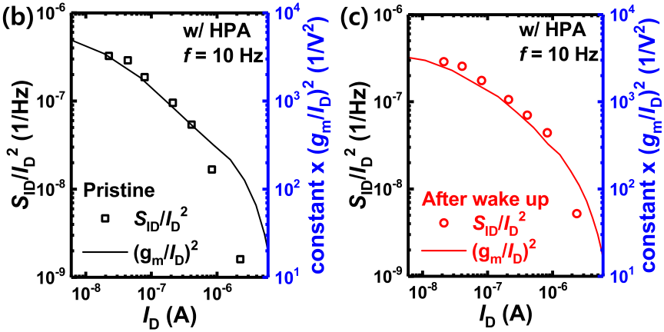

Fig. 3. (a) SID/I2 Dof the pristine and after wake-up FeFET with HPA. The SID/I2 Dis measured at ∼ 20 nA and 2 *μ*A. SID*/*I 2 Dsampled at 10 Hz and (gm/ID)2versus ID of the (b) pristine and (c) after wake-up FeFETs with HPA.

Fig. 3(a) shows the *S*ID/*I*2 Ds of the pristine and after wake-up FeFETs with HPA. For the FeFETs with HPA, there is no wake-up effect as aforementioned (Fig. 1(b)). The data from the FeFET with HPA after wake-up indicates that the data was obtained after applying the same bias stress for measuring the FeFET without HPA after wake-up. At an *I*Dof 20 nA, the Dshows no difference before and after wake-up, whereas *S*ID/*I*2 the *γ* and the magnitude of the 1/ *f* noise slightly increase after the wake-up at *I*D = ∼2 *μ*A. Fig. 3(b) and (c) show the *S*ID/*I*2 Dand (*g*m/*I*D*)*2 versus *I*D of the FeFETs with HPA before and after applying the wake-up stress, respectively. In both cases, the 1/ *f* noises of both states follow eq. (1), implying Dhas the that LFN is generated by the CNF. However, the *S*ID/*I*2 same magnitude in the low *I*D region, while the *S*ID/*I*2 Dafter the wake-up becomes larger than that of the pristine device in the high *I*D region. This can be explained as follows. The correlated mobility fluctuation (CMF) after the wake-up and the scattering related to CMF increase proportionally to the *I*D/*g*m, so it has a greater impact in the high *I*D region [22]. The results show that the damage caused by wake-up is much smaller in the FeFET with HPA due to the improved HZO quality [10].

Finally, the effects of P/E cycling-induced stress on the LFN characteristics of the FeFETs are investigated after the wake-up. Fig. 4(a) and (b) show the transconductance efficiency (*g*m/*I*D*)* before and after 106P/E cyclings. While there is a degradation of *g*m/*I*D after the P/E cycling in the FeFET without the HPA, that of FeFET with HPA is negligible. Similarly, the *S*ID/*I*2 Dincreases by two times in the FeFET without HPA after applying the P/E cycling stress (Fig. 4(c)), whereas it remains almost unchanged in FeFET with HPA (Fig. 4(d)). The *α*H and *S*Vfb (insets of Fig. 4(c) and (d), respectively) are the main parameters that determine the *S*Vfb does not change before and after applying the cycling D. The *α*H increases by ∼2 times, and the amplitude of *S*ID/*I*2

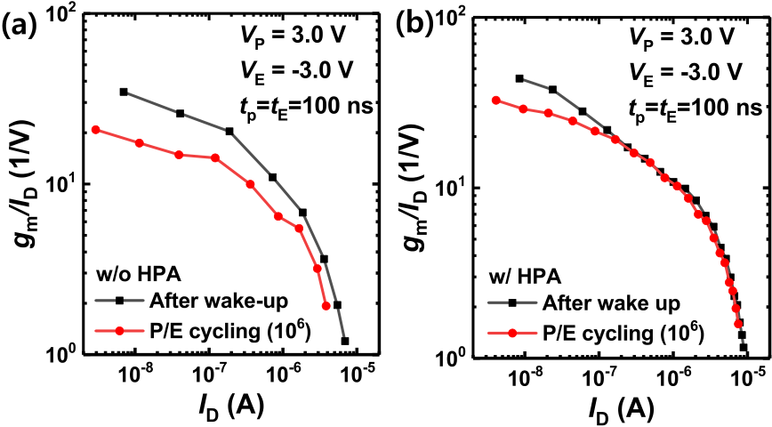

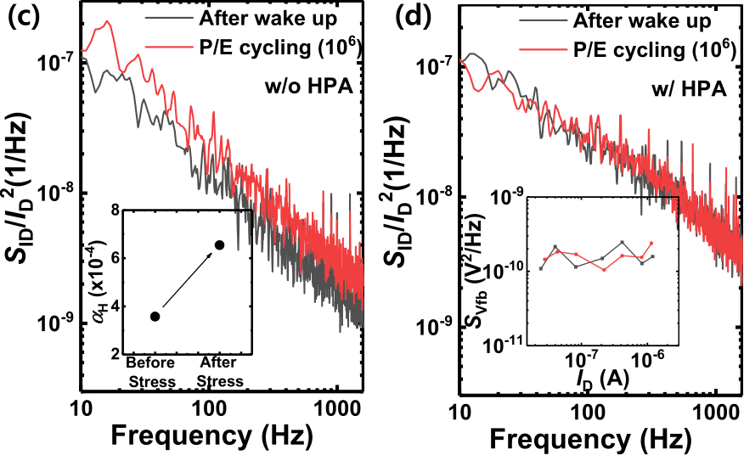

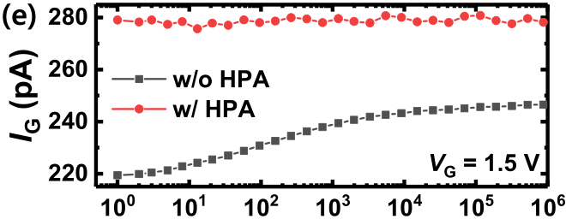



Fig. 4. Transconductance efficiency (gm/ID) versus ID of the FeFETs (a) with and (b) without the HPA before and after the 106times of program/erase (P/E) cycling. The P/E biases (VP/VE) and P/E times (tP/tE) are denoted in figures. SID*/*I2 Ds of the FeFET (c) with and (d) without HPA before and after the 106times of P/E cycling. The insets of Fig. 4(c) and (d) shows *α*H and SVfb of the FeFET without and with HPA, respectively. (e) Gate current (IG) of the FeFETs with and without HPA as a function of the number of P/E cycles. The IG is measured at VG = 1.5 V.

stresses. Fig. 4(e) shows the gate current (*I*G*)* of the FeFETs with and without HPA as a function of the number of P/E cycles. While the *I*G of the latter shows a gradual increase with P/E cycles, that of the former does not change. Note that the FeFET with HPA shows the larger *I*G due to the counter-clockwise hysteresis that stems from the polarization enhancement. The results demonstrate that the HPA treatment enhances the robustness against the P/E cycling-induced stress and improves the endurance characteristics of FeFETs.

IV. CONCLUSION

We have investigated the LFN characteristics of the FeFETs with and without HPA. In both cases, 1/ *f* noise is generated by the CNF before the wake-up. In the FeFETs without HPA, 1/ *f* noise significantly increases, and the origin of the noise is changed from CNF to HMF after wake-up. On the contrary, the FeFETs with HPA show no difference in 1/ *f* noise after the wake-up in the low *I*D region and an increase in 1/ *f* noise in the high *I*D region due to the increased CMF. Also, the FeFETs with HPA show robustness to P/E cycling-induced stress and better endurance performance.

Authorized licensed use limited to: Georgia Institute of Technology. Downloaded on August 19,2022 at 13:17:45 UTC from IEEE Xplore. Restrictions apply.

16 IEEE ELECTRON DEVICE LETTERS, VOL. 43, NO. 1, JANUARY 2022



REFERENCES

[1] T. Ali, P. Polakowski, S. Riedel, T. Büttner, T. Kämpfe, M. Rudolph,

B. Pätzold, K. Seidel, D. Löhr, R. Hoffmann, M. Czernohorsky,

K. Kühnel, P. Steinke, J. Calvo, K. Zimmermann, and J. Müller,

“High endurance ferroelectric hafnium oxide-based FeFET memory

without retention penalty,” *IEEE Trans. Electron Devices*, vol. 65, no. 9,

pp. 3769–3774, Sep. 2018, doi: [10.1109/TED.2018.2856818](http://dx.doi.org/10.1109/TED.2018.2856818).

[2] H, Mulaosmanovic, J. Ocker, S. Müller, M. Noack, J. Müller,

P. Polakowski, and S. Slesazeck, “Novel ferroelectric FET based synapse

for neuromorphic systems,” in *Proc. Symp. VLSI Technol.*, Jun. 2017,

pp. T176–T177, doi: [10.23919/VLSIT.2017.7998165](http://dx.doi.org/10.23919/VLSIT.2017.7998165).

[3] S. Beyer, S. Dünkel, M. Trentzsch, J. Müller, A. Hellmich, D. Utess,

J. Paul, D. Kleimaier, J. Pellerin, S. Müller, J. Ocker, A. Benoist,

H. Zhou, M. Mennenga, M. Schuster, F. Tassan, M. Noack, A. Pourkera-

mati, F. Müller, M. Lederer, T. Ali, R. Hoffmann, T. Kämpfe, K. Seidel,

H. Mulaosmanovic, E. T. Breyer, T. Mikolajick, and S. Slesazeck,

“FeFET: A versatile CMOS compatible device with game-changing

potential,” in *Proc. IEEE Int. Memory Workshop (IMW)*, May 2020,

pp. 1–4, doi: [10.1109/IMW48823.2020.9108150](http://dx.doi.org/10.1109/IMW48823.2020.9108150).

[4] B. Zeng, M. Liao, J. Liao, W. Xiao, Q. Peng, S. Zheng, and

Y. Zhou, “Program/erase cycling degradation mechanism of HfO2-based

FeFET memory devices,” *IEEE Electron Device Lett.*, vol. 40, no. 5,

pp. 710–713, May 2019, doi: [10.1109/LED.2019.2908084](http://dx.doi.org/10.1109/LED.2019.2908084).

[5] N. Gong and T.-P. Ma, “A study of endurance issues in HfO2-based

ferroelectric field effect transistors: Charge trapping and trap generation,”

*IEEE Electron Device Lett.*, vol. 39, no. 1, pp. 15–18, Jan. 2018, doi:

[10.1109/LED.2017.2776263](http://dx.doi.org/10.1109/LED.2017.2776263).

[6] E. Yurchuk, S. Mueller, D. Martin, S. Slesazeck, U. Schroeder,

T. Mikolajick, J. Müller, J. Paul, R. Hoffmann, J. Sundqvist,

T. Schlosser, R. Boschke, R. van Bentum, and M. Trentzsch, “Origin

of the endurance degradation in the novel HfO2-based 1T ferroelectric

non-volatile memories,” in *Proc. IEEE Int. Rel. Phys. Symp.*, Jun. 2014,

pp. 2E.5.1–2E.5.5, doi: [10.1109/IRPS.2014.6860603](http://dx.doi.org/10.1109/IRPS.2014.6860603).

[7] D. Zhou, J. Xu, Q. Li, Y. Guan, F. Cao, X. Dong, J. Müller, T. Schenk,

and U. Schröder, “Wake-up effects in Si-doped hafnium oxide ferro-

electric thin films,” *Appl. Phys. Lett.*, vol. 103, no. 19, Nov. 2013,

Art. no. 192904, doi: [10.1063/1.4829064](http://dx.doi.org/10.1063/1.4829064).

[8] S. Starschich, S. Menzel, and U. Böttger, “Evidence for oxygen

vacancies movement during wake-up in ferroelectric hafnium oxide,”

*Appl. Phys. Lett.*, vol. 108, no. 3, Jan. 2016, Art. no. 032903, doi:

[10.1063/1.4940370](http://dx.doi.org/10.1063/1.4940370).

[9] H. J. Kim, M. H. Park, Y. J. Kim, Y. H. Lee, T. Moon, K. D. Kim,

S. D. Hyun, and C. S. Hwang, “A study on the wake-up effect

of ferroelectric Hf0*.*5Zr0*.*5O2 films by pulse-switching measure-

ment,” *Nanoscale*, vol. 8, no. 3, pp. 1383–1389, 2016, doi: [10.1039/](http://dx.doi.org/10.1039/C5NR05339K)

[C5NR05339K](http://dx.doi.org/10.1039/C5NR05339K).

[10] M.-C. Nguyen, S. Kim, K. Lee, J.-Y. Yim, R. Choi, and D. Kwon,

“Wakeup-free and endurance-robust ferroelectric field-effect tran-

sistor memory using high pressure annealing,” *IEEE*  *Electron*

*Device*  *Lett.*, vol. 42, no. 9, pp. 1295–1298, Sep. 2021, doi:

[10.1109/LED.2021.3096248](http://dx.doi.org/10.1109/LED.2021.3096248).

[11] G. Liu, S. Rumyantsev, M. S. Shur, and A. A. Balandin, “Origin of 1/f noise in graphene multilayers: Surface vs. volume,” *Appl. Phys.*

*Lett.*, vol. 102, no. 9, Mar. 2013, Art. no. 093111, doi: [10.1063/ 1.4794843](http://dx.doi.org/10.1063/1.4794843).

[12] W. Shin, S. Hong, G. Jung, Y. Jeong, J. Park, D. Kim, D. Jang, B.-G. Park, and J.-H. Lee, “Improved signal-to-noise-ratio of FET-type gas sensors using body bias control and embedded micro-heater,”*Sens. Actuators B, Chem.*, vol. 329, Feb. 2021, Art. no. 129166, doi: [10.1016/j.snb.2020.129166](http://dx.doi.org/10.1016/j.snb.2020.129166).

[13] G. Liu, S. Rumyantsev, M. A. Bloodgood, T. T. Salguero, M. Shur, and A. A. Balandin, “Low-frequency electronic noise in quasi-1D TaSe3 van der Waals nanowires,” *Nano Lett.*, vol. 17, no. 1, pp. 377–383, Jan. 2017, doi: [10.1021/acs.nanolett.6b04334](http://dx.doi.org/10.1021/acs.nanolett.6b04334).

[14] J.-M. Yu, J.-Y. Park, T. J. Yoo, J.-K. Han, D.-H. Yun, G.-B. Lee, J. Hur, B.-H. Lee, S.-Y. Kim, B. H. Lee, and Y.-K. Choi, “Quantitative analy- sis of high-pressure deuterium annealing effects on vertically stacked gate-all-around SONOS memory,” *IEEE Trans. Electron Devices*, vol. 67, no. 9, pp. 3903–3907, Sep. 2020, doi: [10.1109/TED.2020.](http://dx.doi.org/10.1109/TED.2020.3008882)  [3008882](http://dx.doi.org/10.1109/TED.2020.3008882).

[15] W. Shin, G. Jung, S. Hong, Y. Jeong, J. Park, D. Jang, B.-G. Park, and J.-H. Lee, “Low frequency noise characteristics of resistor- and Si MOSFET-type gas sensors fabricated on the same Si wafer with In2O3 sensing layer,” *Sens. Actuators B, Chem.*, vol. 318, Sep. 2020, Art. no. 128087, doi: [10.1016/j.snb.2020.128087](http://dx.doi.org/10.1016/j.snb.2020.128087).

[16] T. Kim and S. Jeon, “Pulse switching study on the HfZrO ferro-electric films with high pressure annealing,” *IEEE Electron Device Lett.*, vol. 65, no. 5, pp. 1771–1773, May 2018, doi: [10.1109/ted.2018. 2816968](http://dx.doi.org/10.1109/ted.2018.2816968).

[17] G. Ghibaudo, “On the theory of carrier number fluctuations in MOS devices,” *Solid State Electron*, vol. 32, no. 7, pp. 563–565, Jul. 1989, doi: [10.1016/0038-1101(89)90113-5](http://dx.doi.org/10.1016/0038-1101(89)90113-5).

[18] L. K. J. Vandamme and F. N. Hooge, “What do we certainly know about 1/f noise in MOSTs?” *IEEE Trans. Electron Devices*, vol. 55, no. 11, pp. 3070–3085, Nov. 2008, doi: [10.1109/TED.2008.2005167](http://dx.doi.org/10.1109/TED.2008.2005167).

[19] M. V. Fischetti, D. A. Neumayer, and E. A. Cartier, “Effective elec-tron mobility in Si inversion layers in metal–oxide–semiconductor systems with a high-*κ* insulator: The role of remote phonon scatter-ing,” *J. Appl. Phys.*, vol. 90, no. 9, pp. 4587–4608, Nov. 2001, doi: [10.1063/1.1405826](http://dx.doi.org/10.1063/1.1405826).

[20] E. Simoen, D. H. C. Lin, A. Alian, G. Brammertz, C. Merckling, J. Mitard, and C. Claeys, “Border traps in Ge/III-V channel devices: Analysis and reliability aspects,” *IEEE Trans. Device Mater. Rel.*, vol. 13, no. 4, pp. 444–455, Dec. 2013, doi: [10.1109/TDMR.2013. 2275917](http://dx.doi.org/10.1109/TDMR.2013.2275917).

[21] H. Bae, S. G. Nam, T. Moon, and Y. J. Heo, “Sub-ns polarization switch-ing in 25nm FE FinFET toward post CPU and spatial-energetic mapping of traps for enhanced endurance,” in *IEDM Tech. Dig.*, Dec. 2020, pp. 31–33, doi: [10.1109/IEDM13553.2020.9372076](http://dx.doi.org/10.1109/IEDM13553.2020.9372076).

[22] G. Ghibaudo, O. Roux, C. Nguyen-Duc, F. Balestra, and J. Brini,“Improved analysis of low frequency noise in field-effect MOS transis-tors,” *Phys. Status Solidi (A)*, vol. 124, no. 2, pp. 571–581, Apr. 1991, doi: [10.1002/pssa.2211240225](http://dx.doi.org/10.1002/pssa.2211240225).

Authorized licensed use limited to: Georgia Institute of Technology. Downloaded on August 19,2022 at 13:17:45 UTC from IEEE Xplore. Restrictions apply.