**Formation of (111) orientation-controlled ferroelectric orthorhombic HfO2 thin films from solid phase via annealing**

[Takanori Mimura](http://aip.scitation.org/author/Mimura%2C+Takanori), [Kiliha Katayama](http://aip.scitation.org/author/Katayama%2C+Kiliha), [Takao Shimizu](http://aip.scitation.org/author/Shimizu%2C+Takao), [Hiroshi Uchida](http://aip.scitation.org/author/Uchida%2C+Hiroshi), [Takanori Kiguchi](http://aip.scitation.org/author/Kiguchi%2C+Takanori), [Akihiro Akama](http://aip.scitation.org/author/Akama%2C+Akihiro), [Toyohiko J. Konno](http://aip.scitation.org/author/Konno%2C+Toyohiko+J), [Osami Sakata](http://aip.scitation.org/author/Sakata%2C+Osami), and [Hiroshi Funakubo](http://aip.scitation.org/author/Funakubo%2C+Hiroshi)[,](http://aip.scitation.org/author/Shimizu%2C+Takao)

Citation: Appl. Phys. Lett.**109**, 052903 (2016); doi: 10.1063/1.4960461

View online: <http://dx.doi.org/10.1063/1.4960461>

View Table of Contents: <http://aip.scitation.org/toc/apl/109/5>

Published by the [American Institute of Physics](http://aip.scitation.org/publisher/)

**Articles you may be interested in**

Growth of (111)-oriented epitaxial and textured ferroelectric Y-doped HfO2 films for downscaled devices Appl. Phys. Lett. **109**, 112901112901 (2016); 10.1063/1.4962431

Orientation control and domain structure analysis of {100}-oriented epitaxial ferroelectric orthorhombic HfO2-based thin films   
Appl. Phys. Lett. **119**, 134101134101 (2016); 10.1063/1.4945029

Fully ALD-grown TiN/Hf0.5Zr0.5O2/TiN stacks: Ferroelectric and structural properties Appl. Phys. Lett. **109**, 192903192903 (2016); 10.1063/1.4966219

Enhancing ferroelectricity in dopant-free hafnium oxide   
Appl. Phys. Lett. **110**, 022903022903 (2017); 10.1063/1.4973928

The origin of ferroelectricity in Hf1-xZrxO2: A computational investigation and a surface energy model Appl. Phys. Lett. **117**, 134109134109 (2015); 10.1063/1.4916707

Ferroelectric properties of full plasma-enhanced ALD TiN/La:HfO2/TiN stacks Appl. Phys. Lett. **108**, 242905242905 (2016); 10.1063/1.4953787



APPLIED PHYSICS LETTERS 109, 052903 (2016) 

[Formation of (111) orientation-controlled ferroelectric orthorhombic HfO2](http://dx.doi.org/10.1063/1.4960461)

[thin films from solid phase via annealing](http://dx.doi.org/10.1063/1.4960461)

Takanori Mimura,1Kiliha Katayama,1Takao Shimizu,2Hiroshi Uchida,3Takanori Kiguchi,4 Akihiro Akama,4Toyohiko J. Konno,4Osami Sakata,5and Hiroshi Funakubo1,2,6,a) 1Department of Innovative and Engineered Materials, Tokyo Institute of Technology, Yokohama 226-8502,

Japan   
2Materials Research Center for Element Strategy, Tokyo Institute of Technology, Yokohama 226-8503, Japan 3Department of Materials and Life Sciences, Sophia University, Tokyo 102-8554, Japan   
4Institute for Materials Research, Tohoku University, Sendai 980-8577, Japan   
5Synchrotron X-ray Station at SPring-8 and Synchrotron X-ray Group, National Institute for Materials

Science, Sayo, Hyogo 679-5148, Japan   
6School of Materials and Chemical Technology, Tokyo Institute of Technology, Yokohama 226-8502, Japan

(Received 2 June 2016; accepted 23 July 2016; published online 4 August 2016)

0.07YO1.5-0.93HfO2 (YHO7) films were prepared on various substrates by pulse laser deposition at

room temperature and subsequent heat treatment to enable a solid phase reaction. (111)-oriented 10

wt. % Sn-doped In2O3(ITO)//(111) yttria-stabilized zirconia, (111)Pt/TiOx/SiO2/(001)Si substrates,

and (111)ITO/(111)Pt/TiOx/SiO2/(001)Si substrates were employed for film growth. In this study,

X-ray diffraction measurements including h–2h measurements, reciprocal space mappings, and

pole figure measurements were used to study the films. The film on (111)ITO//(111)yttria-stabilized

zirconia was an (111)-orientated epitaxial film with ferroelectric orthorhombic phase; the film on

(111)ITO/(111)Pt/TiOx/SiO2/(001)Si was an (111)-oriented uniaxial textured film with ferroelectric

orthorhombic phase; and no preferred orientation was observed for the film on the (111)Pt/TiOx/

SiO2/(001)Si substrate, which does not contain ITO. Polarization–hysteresis measurements con-

firmed that the films on ITO covered substrates had saturated ferroelectric hysteresis loops. A remanent polarization (Pr) of 9.6 and 10.8 lC/cm2and coercive fields (Ec) of 1.9 and 2.0 MV/cm

were obtained for the (111)-oriented epitaxial and uniaxial textured YHO7 films, respectively.

|  |
| --- |
| These results demonstrate that the (111)-oriented ITO bottom electrodes play a key role in control- |

|  |
| --- |
| ling the orientation and ferroelectricity of the phase formation of the solid films deposited at room |

temperature. Published by AIP Publishing. [<http://dx.doi.org/10.1063/1.4960461>]

HfO2-based thin films have been widely investigated for use as high-k gate dielectrics in Si-based complementary metal-oxide-semiconductor devices because of their good compatibility with Si technology and superior properties compared with conventional SiO2 gate dielectrics, such as their higher relative permittivity.1,2Moreover, HfO2 thin films can be prepared by chemical vapor deposition, includ-ing atomic layer deposition, which is suitable for the minute-ness of semiconductor devices.1–4   
 In 2011, B€oscke and M€uller et al. discovered ferroelec-tricity in HfO2-based thin films.5,6Their studies showed that this ferroelectricity originates from a metastable non-centrosymmetric orthorhombic phase (Pca21) in some HfO2-based thin films.5,7–9Notable features of ferroelectricity in HfO2-based thin films are their good stability against forming-gas treatment and appearance of ferroelectricity down to 2.5 nm in thickness; both these properties are not found in conventionally used ferroelectric films, such as tetragonal Pb(Zr, Ti)O3 and SrBiTa2O9.10–13These features open the door for the realization of devices that are scaled down to nanometer-size using ferroelectric thin films, such as ferroelectric tunnel junctions and piezoelectric transistors, which are very difficult to realize using conventional ferro-

To realize scaled-down ferroelectric devices using ferro-electric HfO2 films on Si substrates, orientation control of fer-roelectric films is a critical issue because film’s ferroelectric and piezoelectric properties strongly depend on its orienta-tion.14,15For example, {100}-oriented films, i.e., films with mixed orientations of (100), (010), and (001), require precise control over the volume fraction of (001) orientation to control the ferroelectricity because of the spontaneous polarization of orthorhombic HfO2 phase along the c-axis; i.e., (001)-oriented films have the largest ferroelectricity, while (100)- and (010)-oriented ones have no ferroelectricity.

Previous studies demonstrate the epitaxial growth of an orthorhombic 0.07YO1.5-0.93HfO2 (YHO7) film on (100) yttria-stabilized zirconia (YSZ) and 10 wt. % Sn-doped In2O3 (ITO)-covered (100) YSZ substrates by direct deposi-tion of the crystallized thin films at high temperature.7,16 However, phase formation via annealing after deposition at low temperature, ideally room temperature, would be more beneficial because it could be applied for various deposition techniques including the practically used atomic layer depo-sition as well as for chemical solution deposition, which allows the optimization of ferroelectric properties by allow-ing a more complicate composition. To obtain well-oriented

electric films. epitaxial or uniaxial textured films through post-deposition

a)Email: [funakubo.h.aa@m.titech.ac.jp](mailto:funakubo.h.aa@m.titech.ac.jp)

annealing, the buffer layer that aids the crystallization of the film plays an essential role.17Moreover, it is more practical

|  |  |  |
| --- | --- | --- |
| 0003-6951/2016/109(5)/052903/4/$30.00 | 109, 052903-1 | Published by AIP Publishing. |

|  |  |  |
| --- | --- | --- |
| 052903-2 | Mimura et al. | Appl. Phys. Lett. 109, 052903 (2016) |

for the buffer layer to have a good conductivity because it can also act as the bottom electrode in ferroelectric applica-tions. ITO is a promising candidate because of its good con-ductivity and similar crystal structure to YHO7, providing both a bottom electrode and an appropriate seed for growth of the YHO7 layer.

In this letter, we demonstrate the growth of both (111)-oriented epitaxial and uniaxial textured ferroelectric YHO7 thin films on ITO-covered (111)YSZ and (111)Pt/TiOx/SiO2/ (001)Si substrates by means of a post-deposition annealing method. Our results show that the inserted ITO layer dramat-ically improved the degree of orientation for uniaxial tex-tured films. Both the epitaxial and textured films exhibited almost equivalent ferroelectricity.

We prepared 14-nm-thick YHO7 thin films by pulsed and a fluence of 3 mJ/cm2), which provided a deposition rate laser deposition (PLD) using a KrF excimer laser (k ¼ 246 nm of 0.28 nm/min. The substrate temperature and atmosphere were maintained at room temperature and 10 mTorr O2, respectively. (111)-oriented epitaxial and uniaxial textured ITO layers, which were deposited on (111)YSZ and (111)Pt/ TiOx/SiO2/(001)Si by PLD, were used as underlying layers for the growth of (111)-oriented epitaxial and uniaxial textured films. The thicknesses of the ITO, Pt, TiOx, and SiO2 layers were 28 nm, 110 nm, 30 nm, and 100 nm, respectively. In the literature, orientation-controlled YHO7 films were directly grown at 700�C on these substrate materials by PLD from the vapor phase.16However, here we deposited the films at room temperature and we then annealed them by rapid thermal annealing in a furnace at 1000�C for 10 s under N2 flow (the heating rate was 25�C/s and the cooling rate was �8�C/s). Film thicknesses were ascertained by X-ray reflection measurements (X’Pert-MRD, Philips). Meanwhile, the crystal structures of these films were investigated by X-ray diffraction (XRD) h–2h and reciprocal space mapping using a laboratory machine (X’Pert-MRD, Philips and D8 DISCOVER, Bruker) and synchrotron facilities (SPring8, BL15). To clarify the in-plane orientations of these films, XRD pole figure measure-ments were performed. To characterize the microstructure and local structure in detail, cross-sectional high angle annular

|  |  |  |  |  |  |  |
| --- | --- | --- | --- | --- | --- | --- |
| dark-field | scanning | | transmission | electron | microscopy | |
| (HAADF-STEM) | | was | employed. | Diffractograms | | were |

obtained from the TEM images through Fourier transforms. Electron beam evaporation was used to deposit 100 nm-thick Pt top electrodes on the thin film surfaces at room temperature under vacuum (note that the Pt top electrodes were not annealed after the deposition). Then, their ferroelectricity was measured at room temperature under 10 kHz via their polari-zation–hysteresis (P–E) curves.

Fig. 1(a) shows the XRD h–2h pattern of the Pt/YHO7// (111)ITO//(111)YSZ stack structure. The peaks originating from the YHO7 film were barely observable. This is similar to previous reports on YHO7 films crystallized directly from the vapor phase, which suggests that the YSZ and YHO7 peaks both overlap owing to their similar out-of-plane lattice

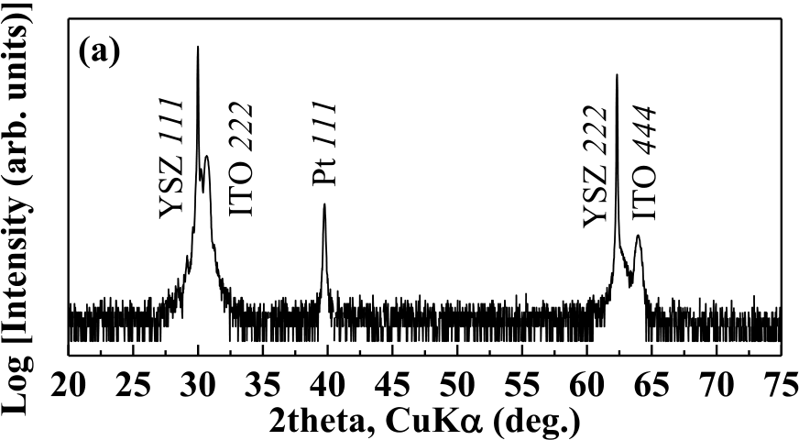



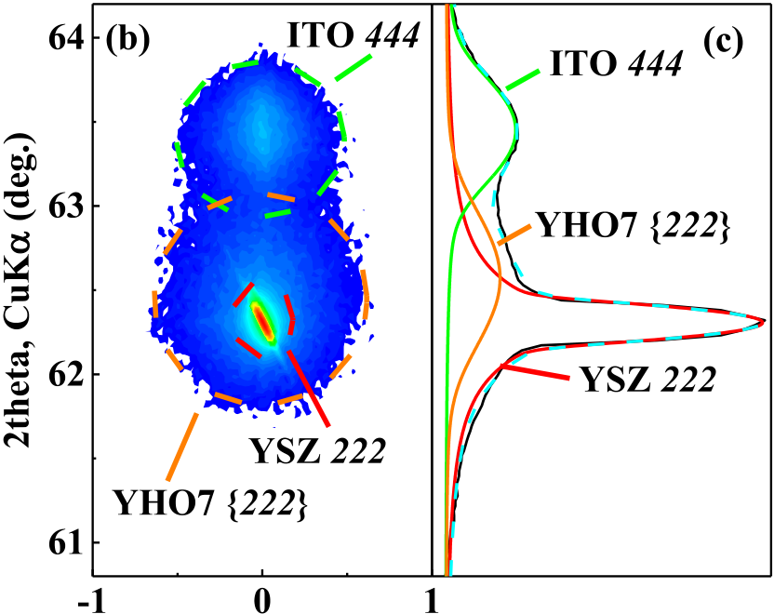



FIG. 1. XRD h–2h pattern of (a) Pt/YHO7//(111)ITO//(111)YSZ, (b) XRD reciprocal space mapping of YHO7//(111)ITO//(111)YSZ near YSZ around the 222 spot, and (c) results of peak fitting of the integrated X-ray intensity pattern along the omega axis.

YHO7//(111)ITO//(111)YSZ near YSZ 222. The XRD spec-trogram shown in Fig. 1(c) was obtained from reciprocal space mapping of the data shown in Fig. 1(b) by integrating along the omega direction. The peaks can be divided into three sets of peaks, namely, ITO 444, YHO7 {222}, and YSZ 222, as shown in Fig. 1(c), via peak fitting analysis and by comparison with the data for the (111)ITO//(111)YSZ substrates. This demonstrates the out-of-plane (111) orienta-tion of YHO7 films on (111)ITO//(111)YSZ substrates.

Fig. 2 shows the XRD h–2h patterns of YHO7 films deposited on (111)Pt/TiOx/SiO2/(001)Si substrates with and without an (111) ITO underlying layer. Only diffraction peaks from Pt and Si are visible in Fig. 2(a), suggesting that the YHO7 film did not crystallize with any preferred orientation. Conversely, a peak at 2h ¼ 62.9�originating from YHO7 {222} can be observed in Fig. 2(b) along with the ITO 444 dif-fraction peaks. Moreover, a careful deconvolution of the peak at around 2h ¼ 30.6�suggests that this peak consists of ITO 222 and YHO7 {222}, as shown in Fig. 2(c). These results demonstrate that out-of-plane (111)-oriented YHO7 films were also obtained on (111)ITO/(111)Pt/TiOx/SiO2/(001)Si substrates with the help of the inserted ITO layer. Further, these results show that YHO7 films on both (111)ITO//

spacing. (111)YSZ and (111)ITO/(111)Pt/TiOx/SiO2/(001)Si crystal-

The XRD reciprocal space mapping measurement ena-bles us to check for the possibility of peak overlapping through a more detailed analysis of the crystal structure. Fig. 1(b) shows the XRD reciprocal space mapping of

lized with an out-of-plane (111) orientation.

In the next step, we tried to identify the phase symmetry of the obtained films. Among various symmetries in the fluo-rite structure, the monoclinic phase was excluded from our

|  |  |  |
| --- | --- | --- |
| 052903-3 | Mimura et al. | Appl. Phys. Lett. 109, 052903 (2016) |

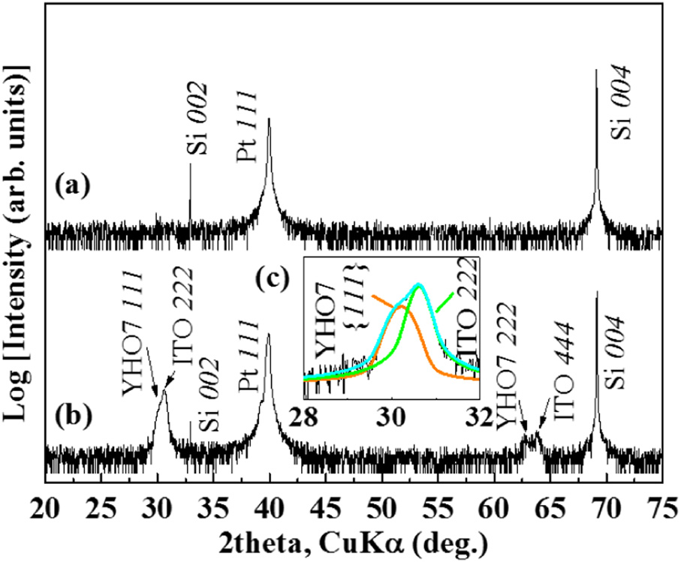

FIG. 2. XRD h�2h patterns of (a) Pt/YHO7/(111)Pt/TiOx/SiO2/(001)Si and (b) Pt/YHO7/(111)ITO/(111)Pt/TiOx/SiO2/(001)Si stack structures.

considerations because {111} peaks must split into two peaks owing to the different lattice spacing between (111) and (�111) of the monoclinic phase; however, no such split-ting was observed in Figs. 1 and 2. This suggests that YHO7 films on both (111)ITO//(111)YSZ and (111)ITO/(111)Pt/ TiOx/SiO2/(001)Si substrates did not contain any monoclinic phase.

The 110 diffraction peak of the orthorhombic phase is very useful because this peak does not appear in other higher symmetry phases, tetragonal, and cubic phases; therefore, it can be used to identify the existence of the ferroelectric orthorhombic phase.7In addition, this peak can be observed without it overlapping with peaks from the ITO and YSZ substrates.

Figs. 3(a) and 3(b) show the 2h patterns near YHO7 110 of the orthorhombic phase located at the inclination angle,

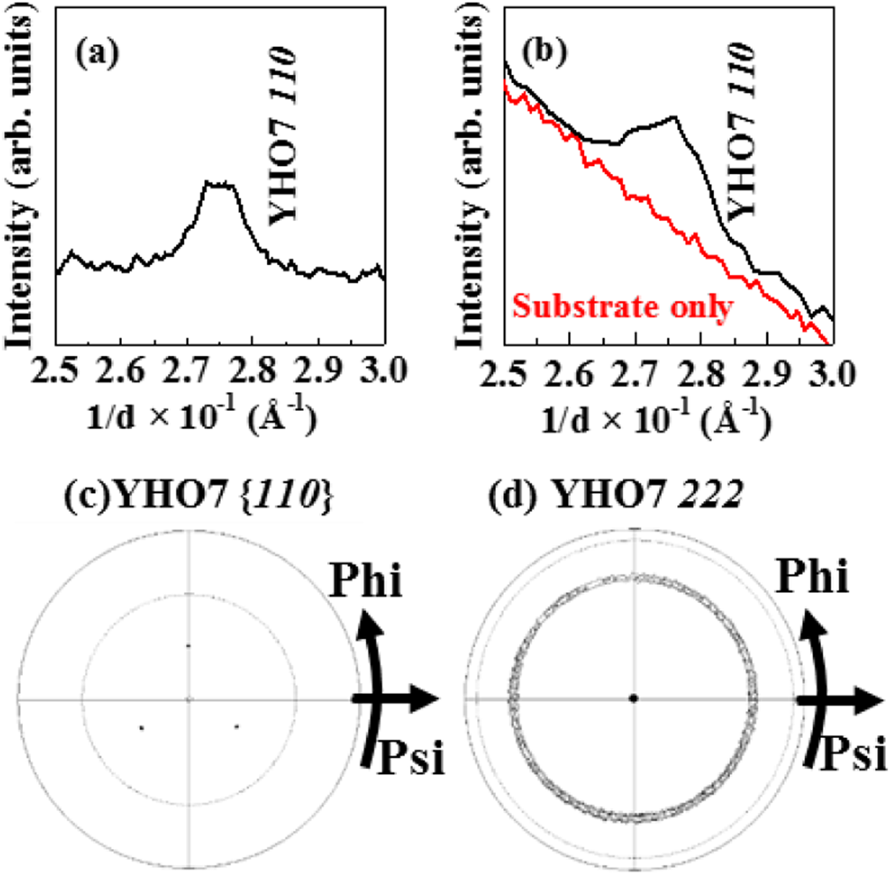

FIG. 3. (a), (b) XRD h�2h patterns and (c, d) XRD pole figure plots fixed at 2h angle corresponding to YHO7 110 and 222 for YHO7 films prepared on (a), (c) (111)ITO//(111)YSZ and (b), (d) (111)ITO/(111)Pt/TiOx/SiO2/ (001)Si substrates, respectively.

psi, of about 35�for the films on (111)ITO//(111)YSZ and (111)ITO/(111)Pt/TiOx/SiO2/(001)Si substrates, respectively. The diffraction patterns shown in Fig. 3(b) were measured using a synchrotron X-ray source; the diffraction patterns of the (111)ITO/(111)Pt/TiOx/SiO2/(001)Si substrates are also shown for reference. The YHO7 110 diffraction peaks of the orthorhombic phase were clearly observed for both films, sug-gesting that the films consisted of the material in a ferroelec-tric orthorhombic phase.

To confirm the in-plane orientation of this ferroelectric phase, XRD pole figure measurements were performed with a fixed 2h angle corresponding to the YHO7 110 and 222 dif-fraction peaks of the orthorhombic phase on (111)ITO//

|  |  |  |  |
| --- | --- | --- | --- |
| (111)YSZ | and | (111)ITO/(111)Pt/TiOx/SiO2/(001)Si | sub- |

strates, respectively. Three fold spots from YHO7 110, which corresponds to the orthorhombic phase, located at an angle psi of about 35�were confirmed for the YHO7 film on the (111)ITO//(111)YSZ substrate. The azimuthal angle, phi, of the spots is shown in Fig. 3(c); it is the same as that of YSZ 220 (not shown here), suggesting the epitaxial growth of a ferroelectric orthorhombic phase with the fol-

|  |  |  |  |
| --- | --- | --- | --- |
| lowing | epitaxial | relationships: | [11�2]YHO7//[11�2]ITO// |

[11�2]YSZ. Conversely, a ring spot located at an angle psi of about 71�originating from YHO7 222 of the ortho-rhombic phase was observed for the YHO7 film on the (111)ITO/(111)Pt/TiOx/SiO2/(001)Si substrate. This demon-strates that the film prepared on the (111)ITO/(111)Pt/TiOx/ SiO2/(001)Si substrate consisted of the ferroelectric ortho-rhombic phase with an out-of-plane (111) orientation but an in-plane random orientation, i.e., a uniaxial textured orienta-tion. Based on the results given above, (111)-oriented epitaxial and uniaxial textured ferroelectric films were grown on (111)ITO//(111)YSZ and (111)ITO/(111)Pt/TiOx/SiO2/(001)Si substrates, respectively.

Fig. 4(a) shows the HAADF-STEM images of the YHO7 film on the (111)ITO//(111)YSZ substrate. A dense film with-out obvious voids was ascertained. Fig. 4(b) shows a HAADF-STEM image near the interface between YHO7 and ITO. The atomic columns of YHO7 have a coherent interface with those of ITO without any misfit dislocations. Figs. 4(c) and 4(d) show the diffractograms of a YHO7 film and an ITO substrate obtained from the area enclosed by a dashed line and a dotted line in Fig. 4(b), respectively. These results are in good agree-ment with that of an orthorhombic (Pca21) material, and the atomic arrangement of YHO7 is found to match with that of ITO, suggesting epitaxial growth of the YHO7 films.

Figs. 5(a) and 5(b) show the P–E loops for the same

|  |  |  |  |  |  |
| --- | --- | --- | --- | --- | --- |
| films | prepared | on | (111)ITO//(111)YSZ | and | (111)ITO/ |

(111)Pt/TiOx/SiO2/(001)Si substrates, respectively, using the post-deposition annealing method. Well-saturated hysteresis loops associated with ferroelectricity were observed for both films. The remanent polarization (Pr) and the coercive fields (Ec) at a maximum applied electric field of 5.3 MV/cm were 9.6 lC/cm2and 1.9 MV/cm, and 10.8 lC/cm2and 2.0 MV/ cm, respectively, for Pt/YHO7//(111)ITO//(111)YSZ and Pt/

|  |  |  |
| --- | --- | --- |
| YHO7/(111)ITO/(111)Pt/TiOx/SiO2/(001)Si | stacks. | These |

results with their similar ferroelectric properties indicate that the insertion of an (111)-oriented ITO bottom electrode con-tributes to stable ferroelectricity through orientation control.

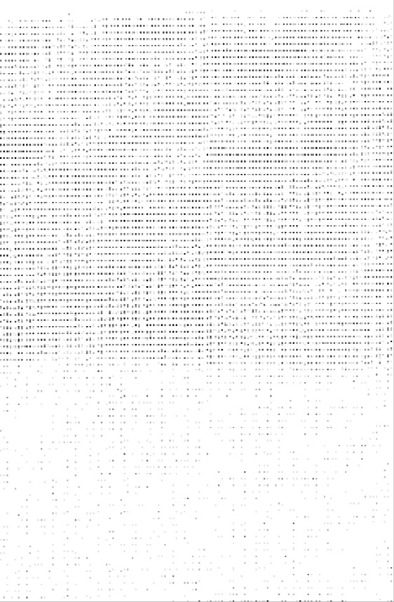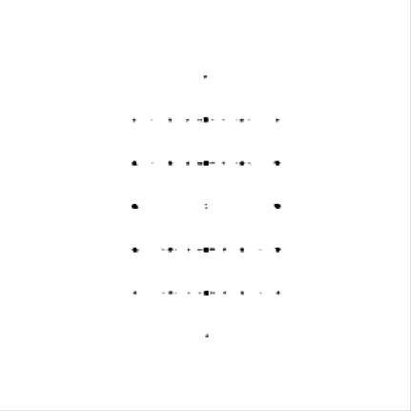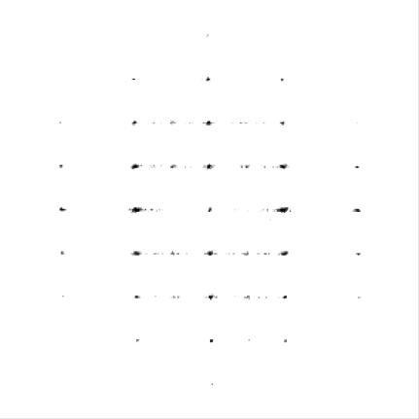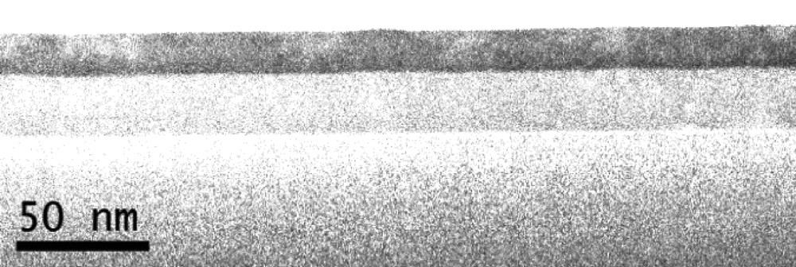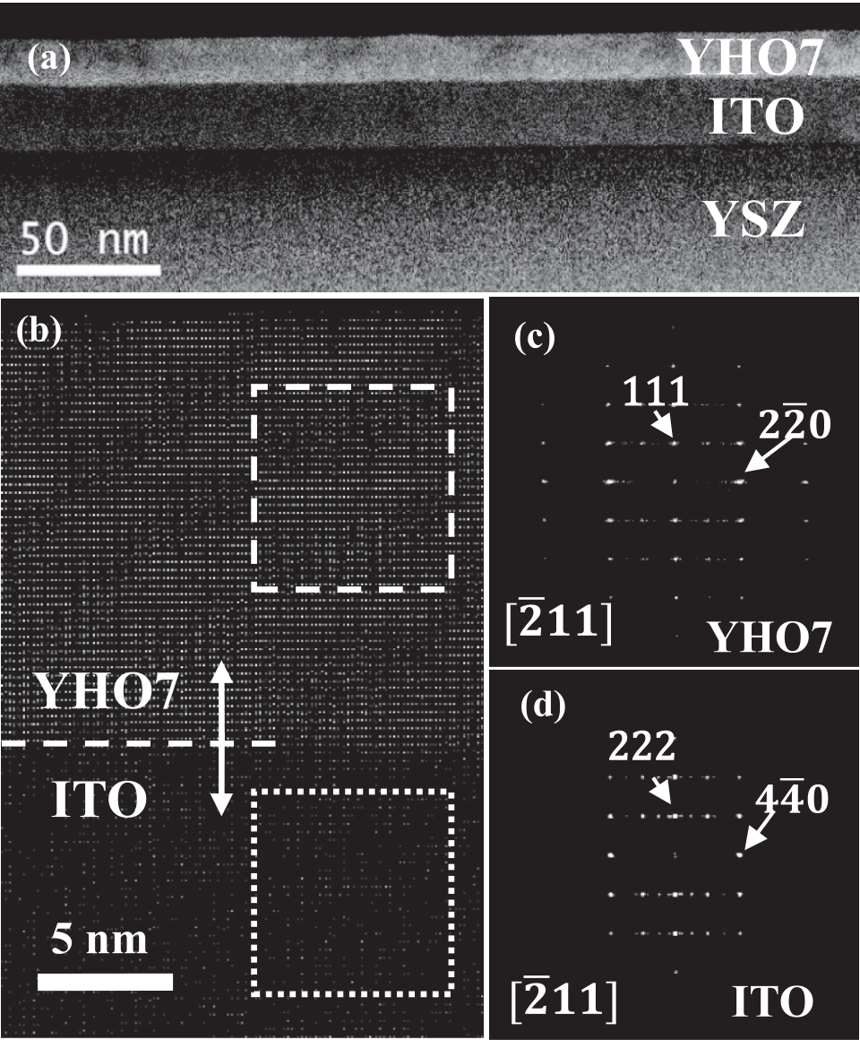

|  |  |  |
| --- | --- | --- |
| 052903-4 | Mimura et al. | Appl. Phys. Lett. 109, 052903 (2016) |

In summary, (111)-oriented epitaxial and uniaxial tex-  
tured YHO7 films were prepared on (111)ITO//(111)YSZ and   
(111)ITO/(111)Pt/TiOx/SiO2/(001)Si substrates, respectively,   
by a combination of deposition by PLD at room temperature   
and subsequent heat treatment. Inserting a (111)-oriented ITO   
bottom electrode greatly improved the orientation of YHO7   
films. Well-saturated ferroelectricity loops were confirmed   
for both films with almost the same Pr and Ec. These results   
demonstrate orientation and ferroelectricity control by insert-  
ing an appropriate underlying layer for phase formation from   
solid using an annealing process after room temperature   
deposition.

This work was partially funded by the Ministry of   
Education, Culture, Sports, Science and Technology of Japan   
(MEXT) Elements Strategy Initiative to Form Core Research   
Center, JSPS KAKENHI Grant No. 16K14380, and MEXT   
KAKENHI Grant Nos. 26106509, and 16H00882. Part of this   
work was also supported by the Center for Integrated   
Nanotechnology Support at Tohoku University and by the   
Nanotechnology Network Project of MEXT. The synchrotron   
radiation experiments were performed at the BL15XU with the   
approval of NIMS (Proposal Nos. 2014A4703, 2014B4704,   
2015A4702, 2015B4702).

FIG. 4. (a) Cross-sectional HAADF-STEM image of YHO7//(111)ITO// (111)YSZ, (b) enlarged image of (a) near the interface between YHO7 and ITO, and HAADF-STEM diffractogram of (c) a YHO7 film shown in dashed line and (d) ITO substrate shown in dotted line in (b), respectively.

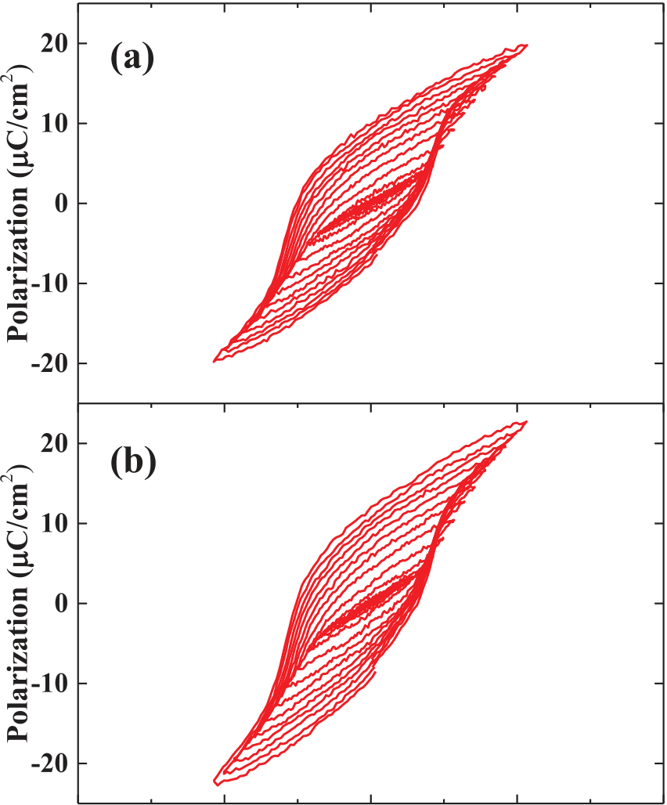

|  |  |  |  |  |
| --- | --- | --- | --- | --- |
|  |  |  |  |  |



FIG. 5. Room-temperature P–E hysteresis loops measured at 10 kHz for (a) Pt/YHO7//(111)ITO//(111)YSZ and (b) Pt/YHO7/(111)ITO/(111)Pt/TiOx/

1J. A. Kittl, K. Opsomer, M. Popovici, N. Menou, B. Kaczer, X. P. Wang, C. Adelmann, M. A. Pawlak, K. Tomida, A. Rothschild, B. Govoreanu, R. Degraeve, M. Schaekers, M. Zahid, A. Delabie, J. Meersschaut, W. Polspoel, S. Clima, G. Pourtois, W. Knaepen, C. Detavernier, V. V. Afanas’ev, T. Blomberg, D. Pierreux, J. Swerts, P. Fischer, J. W. Maes, D. Manger, W. Vandervorst, T. Conard, A. Franquet, P. Favia, H. Bender, B. Brijs, S. Van Elshocht, M. Jurczak, J. Van Houdt, and D. J. Wouters, [Microelectron. Eng.](http://dx.doi.org/10.1016/j.mee.2009.03.045) 86, 1789 (2009).

2J. H. Choi, Y. Mao, and J. P. Chang, [Mater. Sci. Eng., R](http://dx.doi.org/10.1016/j.mser.2010.12.001) 72, 97 (2011). 3K.-J. Choi, W.-C. Shin, and S.-G. Yoon, [J. Electrochem. Soc.](http://dx.doi.org/10.1149/1.1450617) 149, F18 (2002).

4X. Liu, S. Ramanathan, A. Longdergan, A. Srivastava, E. Lee, T. E. Seidel, J. T. Barton, D. Pang, and R. G. Gordon, [J. Electrochem. Soc.](http://dx.doi.org/10.1149/1.1859631) 152, G213 (2005).

5T. S. B€oscke, J. M€uller, D. Br€auhaus, U. Schr€oder, and U. B€ottger, [Appl. Phys. Lett.](http://dx.doi.org/10.1063/1.3634052) 99, 102903 (2011).

6J. M€uller, T. S. B€oscke, D. Br€auhaus, U. Schr€oder, U. B€ottger, J. Sundqvist, P. Kcher, T. Mikolajick, and L. Frey, [Appl. Phys. Lett.](http://dx.doi.org/10.1063/1.3636417) 99, 112901 (2011).

7T. Shimizu, K. Katayama, T. Kiguchi, A. Akama, T. J. Konno, and H. Funakubo, [Appl. Phys. Lett.](http://dx.doi.org/10.1063/1.4927450) 107, 032910 (2015).

8T. D. Huan, V. Sharma, G. A. Rossetti, and R. Ramprasad, [Phys. Rev. B](http://dx.doi.org/10.1103/PhysRevB.90.064111) 90, 064111 (2014).

9X. Sang, E. D. Grimley, T. Schenk, U. Schroeder, and J. M. Lebeau, [Appl. Phys. Lett.](http://dx.doi.org/10.1063/1.4919135) 106, 162905 (2015).

10A. Chernikova, M. Kozodaev, A. Markeev, D. Negrov, M. Spiridonov, S. Zarubin, O. Bak, P. Buragohain, H. Lu, E. Suvorova, A. Gruverman, and A. Zenkevich, [ACS Appl. Mater. Interfaces](http://dx.doi.org/10.1021/acsami.5b11653) 8, 7232 (2016).

11J. M€uller, P. Polakowski, S. Mueller, and T. Mikolajick, [ECS J. Solid](http://dx.doi.org/10.1149/2.0081505jss)  [State Sci. Technol.](http://dx.doi.org/10.1149/2.0081505jss) 4, N30 (2015).

12O. Dahl, J. K. Grepstad, and T. Tybell, [J. Appl. Phys.](http://dx.doi.org/10.1063/1.3240331) 106, 084104 (2009). 13J. Celinska, V. Joshi, S. Narayan, L. McMillan, and C. Paz de Araujo, [Appl. Phys. Lett.](http://dx.doi.org/10.1063/1.1579559) 82, 3937 (2003).

14Z. Yu, R. Guo, and S. Bhalla, [Appl. Phys. Lett.](http://dx.doi.org/10.1063/1.1308276) 77, 1535 (2000).

15K. Nagashima, M. Aratani, and H. Funakubo, [J. Appl. Phys.](http://dx.doi.org/10.1063/1.1355718) 89, 4517 (2001).

16K. Katayama, T. Shimizu, O. Sakata, T. Shiraishi, S. Nakamura, T. Kiguchi, A. Akama, T. J. Konno, H. Uchida, and H. Funakubo, [J. Appl. Phys.](http://dx.doi.org/10.1063/1.4945029) 119, 134101 (2016).

17H. Ohta, K. Nomura, M. Orita, M. Hirano, and K. Ueda, [Adv. Funct.](http://dx.doi.org/10.1002/adfm.200390020)

SiO2/(001)Si stack structures. [Mater.](http://dx.doi.org/10.1002/adfm.200390020) 13, 139 (2003).