**Orientation control and domain structure analysis of {100}-oriented epitaxial ferroelectric orthorhombic HfO2-based thin films**

[Kiliha Katayama](http://aip.scitation.org/author/Katayama%2C+Kiliha), [Takao Shimizu](http://aip.scitation.org/author/Shimizu%2C+Takao), [Osami Sakata](http://aip.scitation.org/author/Sakata%2C+Osami), [Takahisa Shiraishi](http://aip.scitation.org/author/Shiraishi%2C+Takahisa), [Shogo Nakamura](http://aip.scitation.org/author/Nakamura%2C+Shogo), [Takanori Kiguchi](http://aip.scitation.org/author/Kiguchi%2C+Takanori), [Akihiro Akama](http://aip.scitation.org/author/Akama%2C+Akihiro), [Toyohiko J. Konno](http://aip.scitation.org/author/Konno%2C+Toyohiko+J), [Hiroshi Uchida](http://aip.scitation.org/author/Uchida%2C+Hiroshi), and [Hiroshi Funakubo](http://aip.scitation.org/author/Funakubo%2C+Hiroshi)[,](http://aip.scitation.org/author/Shiraishi%2C+Takahisa)

Citation: Journal of Applied Physics**119**, 134101 (2016); doi: 10.1063/1.4945029

View online: <http://dx.doi.org/10.1063/1.4945029>

View Table of Contents: <http://aip.scitation.org/toc/jap/119/13>

Published by the [American Institute of Physics](http://aip.scitation.org/publisher/)

**Articles you may be interested in**

Formation of (111) orientation-controlled ferroelectric orthorhombic HfO2 thin films from solid phase via annealing Journal of Applied Physics **109**, 052903052903 (2016); 10.1063/1.4960461

Ferroelectricity in hafnium oxide thin films   
Journal of Applied Physics **99**, 102903102903 (2011); 10.1063/1.3634052

Ferroelectric properties of full plasma-enhanced ALD TiN/La:HfO2/TiN stacks Journal of Applied Physics **108**, 242905242905 (2016); 10.1063/1.4953787

On the structural origins of ferroelectricity in HfO2 thin films   
Journal of Applied Physics **106**, 162905162905 (2015); 10.1063/1.4919135

Stabilizing the ferroelectric phase in doped hafnium oxide   
Journal of Applied Physics **118**, 072006072006 (2015); 10.1063/1.4927805

Enhancing ferroelectricity in dopant-free hafnium oxide   
Journal of Applied Physics **110**, 022903022903 (2017); 10.1063/1.4973928



JOURNAL OF APPLIED PHYSICS 119, 134101 (2016) 

[Orientation control and domain structure analysis of {100}-oriented epitaxial ferroelectric orthorhombic HfO2-based thin films](http://dx.doi.org/10.1063/1.4945029)

Kiliha Katayama,1Takao Shimizu,2Osami Sakata,3Takahisa Shiraishi,4Shogo Nakamura,4 Takanori Kiguchi,4Akihiro Akama,4Toyohiko J. Konno,4Hiroshi Uchida,5   
and Hiroshi Funakubo1,2,a)   
1Department of Innovative and Engineered Materials, Tokyo Institute of Technology, 4259 Nagatsuta, Midori-ku, Yokohama 226-8502, Japan   
2Materials Research Center for Element Strategy, Tokyo Institute of Technology, 4259 Nagatsuta, Midori-ku, Yokohama 226-8503, Japan   
3Synchrotron X-ray Station at SPring-8, National Institute for Materials Science (NIMS), 1-1-1 Kouto, Sayo-cho, Sayo-gun, Hyogo 679-5148, Japan   
4Institute for Materials Research, Tohoku University, 2-1-1 Katahira, Aoba-ku, Sendai 980-8577, Japan 5Department of Materials and Life Sciences, Sophia University, Chiyoda, Tokyo 102-8554, Japan

(Received 9 February 2016; accepted 18 March 2016; published online 1 April 2016)

Orientation control of {100}-oriented epitaxial orthorhombic 0.07YO1.5-0.93HfO2 films grown by pulsed laser deposition was investigated. To achieve in-plane lattice matching, indium tin oxide (ITO) and yttria-stabilized zirconia (YSZ) were selected as underlying layers. We obtained (100)-and (001)/(010)-oriented films on ITO and YSZ, respectively. Ferroelastic domain formation was confirmed for both films by X-ray diffraction using the superlattice diffraction that appeared only for the orthorhombic symmetry. The formation of ferroelastic domains is believed to be induced by the tetragonal–orthorhombic phase transition upon cooling the films after deposition. The present results demonstrate that the orientation of HfO2-based ferroelectric films can be controlled in the same manner as that of ferroelectric films composed of conventional perovskite-type material such as Pb(Zr, Ti)O3 and BiFeO3. V C 2016 AIP Publishing LLC. [<http://dx.doi.org/10.1063/1.4945029>]

I. INTRODUCTION

The discovery of ferroelectric behavior in HfO2-based thin films1has triggered intensive research efforts to realize ferroelectric field effect transistors (FeFETs) and improve commercial ferroelectric random access memory (FeRAM). Compared with conventional ferroelectrics such as lead zir-conate titanate and strontium bismuth tantalate, which have relatively poor interface properties with silicon, and face severe scaling limitations, HfO2-based ferroelectric thin films have excellent compatibility with complementary met-al–oxide–semiconductor technology. In addition, these films show stable ferroelectricity down to a thickness of just 5 nm,2 demonstrating potential for scale down. Demonstrations of FeFETs and FeRAM with ferroelectric HfO2-based thin films have already been reported,2as well as investigations of forming gas annealing3and fatigue en-durance,4which are crucial for these applications.

In contrast to these extensive application-oriented stud-ies, the fundamental properties of ferroelectric HfO2 thin films including their crystal structure, spontaneous polariza-tion, and domain structure have not been still elucidated sufficiently. This is because of the polycrystalline character-istics of the deposited films as well as the presence of multi-ple phases in previously reported films.1–8This situation has continued since ferroelectricity in a HfO2-based thin film was first reported for a Si-doped HfO2 polycrystalline film in 2011.1

a)E-mail: [funakubo.h.aa@m.titech.ac.jp](mailto:funakubo.h.aa@m.titech.ac.jp)

To improve the fundamental understanding of HfO2-based ferroelectric films, the investigation of epitaxial films is essential. We recently achieved epitaxial growth of 0.07YO1.5–0.93HfO2 (YHO-7) films composed of the non-centrosymmetric orthorhombic Pca21 phase on (100)-oriented yttria-stabilized zirconia (YSZ) single-crystal sub-strates by pulsed laser deposition (PLD).9This phase was noted as the structural origin of ferroelectricity of HfO2-based films grown in previous reports.1,5–8While previously reported crystallization methods involved post-annealing of amorphous films after the deposition of top electrodes and provided polycrystalline films, our method is the high-temperature direct growth of highly crystalline epitaxial films. The crystallographic orientation and domain structure of these highly oriented ferroelectric epitaxial films are of both scientific and practical interest.

In our previous study of epitaxial orthorhombic YHO-7 films,9phase transition from orthorhombic to tetragonal phase was observed above 450�C with increasing temperature, which is considered to be the Curie temperature (TC) of the films. Considering the deposition temperature was 700�C, which is higher than the observed TC, the deposited films con-sist of paraelectric tetragonal phase during film deposition and then transform to the ferroelectric orthorhombic phase during the cooling process after deposition. From this perspective, it is highly probable that the orientation of the tetragonal phase at the deposition temperature determines that of the ortho-rhombic phase at room temperature. In addition, ferroelastic (non-180�) domains are expected to exist for the orthorhombic films. This is because the paraelectric–ferroelectric phase

|  |  |  |
| --- | --- | --- |
| 0021-8979/2016/119(13)/134101/7/$30.00 | 119, 134101-1 | V C 2016 AIP Publishing LLC |

|  |  |  |
| --- | --- | --- |
| 134101-2 | Katayama et al. | J. Appl. Phys. 119, 134101 (2016) |

transition upon cooling induces the formation of ferroelastic domains to lower the mechanical stress in typical ferroelectric materials. Domain structure in ferroelectric thin films, espe-cially ferroelastic domains, is recognized as an important fac-tor to achieve large piezoelectricity10and is one of the major characteristics of ferroelectrics used for a wide variety of applications including sensors, actuators, and energy-harvesting devices.11However, the orientation control and ex-istence of ferroelastic domains in ferroelectric HfO2-based thin films have been hardly discussed so far despite their

through the phase transition, the longer cT transforms into the longest aO, while the shorter aT transforms into the shorter bO and/or cO (see Fig. 1). Consequently, each tetrago-nal variant produces two types of ferroelectric orthorhombic orientations, resulting in six types of orthorhombic orienta-tions, which are denoted as o1, o2, o3, o4, o5, and o6 in Fig. 1. Note that for simplicity, the polarization direction for each orthorhombic orientation is not discussed here. Two ortho-rhombic orientations generated from the same tetragonal var-iant are expected to form ferroelastic domains (o1/o2, o3/o4,

importance. and o5/o6), as indicated in Fig. 1.

In this work, we investigate orientation control of epi-

taxial orthorhombic YHO-7 films on the basis of the lattice matching of the tetragonal phase and a substrate at the depo-sition temperature. Ferroelastic domains similar to those of conventional perovskite-based ferroelectrics are found to exist for both (100)- and (010)/(001)-oriented orthorhombic films by X-ray diffraction (XRD) analysis using superlattice diffraction that appear only for the orthorhombic symmetry. Our findings suggest that the ferroelastic domains are gener-ated by the phase transformation from tetragonal to ortho-rhombic during the cooling process after film deposition.

II. PHASE TRANSITION MODEL

Figure 1 shows the possible relationship of the crystallo-graphic orientations between the high-temperature tetragonal phase of YHO-7 and the low-temperature orthorhombic one. To allow easy comparison of these two phases, a double-sized tetragonal unit cell was used here (the original tetrago-nal unit cell has a lattice parameter of aT0¼ aT= previous studies.12,13The high-temperature tetragonal phase has a longer c-axis (cT) and shorter a-axes (aT).13Therefore, p ffiffiffi ), like in

when a (100)- or (001)-oriented tetragonal phase is epitax-ially grown on the substrate, formation of three types of tet-ragonal variants (t1, t2, and t3 in Fig. 1) is possible, where t1 and t2 are rotated in-plane by 90�with respect to each other. In contrast, the low-temperature orthorhombic phase has the longest a-axis (aO), and shorter b- (bO) and c-axes (cO). It must be noted that cO is slightly longer than bO, and sponta-neous polarization appears along the c-axis.6,14–16Thus,

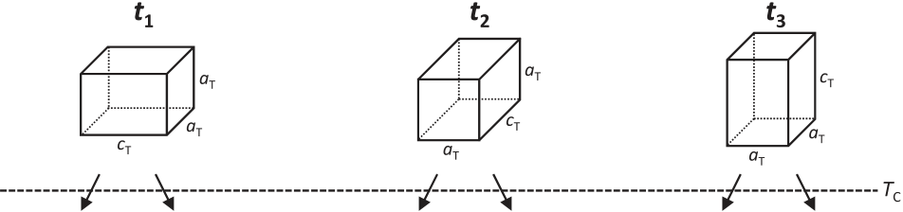

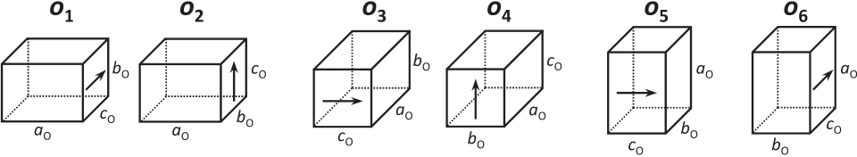

|  |  |  |
| --- | --- | --- |
|  |  |  |

FIG. 1. Possible domains of epitaxial ferroelectric orthorhombic HfO2 thin films obtained by the phase transition at Curie temperature, TC, from non-ferroelectric tetragonal phases during the cooling process after film deposition.

III. EXPERIMENTAL

A. Selection of substrates for orientation-controlled film growth

Considering the crystallographic relationship between the tetragonal and orthorhombic phases described in Section II, orientation control of the tetragonal phase is expected to also lead to that of the orthorhombic phase. When we grow the tetragonal phase with the shorter aT-axis perpendicular to the substrate surface (t1 and t2) during deposition, subsequent phase transformation upon cooling will produce the ortho-rhombic phase with the shorter bO- and/or cO-axis perpendic-ular to the substrate surface (o1, o2, o3, and o4). In the same way, when we grow the tetragonal phase with the longer cT-axis perpendicular to the substrate surface (t3) during deposition, subsequent phase transformation produces the orthorhombic phase with the longest aO-axis perpendicular to the substrate surface (o5 and o6). Therefore, the selective growth of tetragonal phase consisting of t1 and/or t2 variants, and t3 variant is the first step to achieve orientation control of the orthorhombic phase.

For the selective growth of t1 and/or t2 and t3, the sub-strate surface must be selected so that its lattice matches with the in-plane lattice parameter of the tetragonal phase. To grow the t3 variant, out-of-plane cT-axis oriented tetrago-nal films, a substrate surface with a lattice that matches aT at the growth temperature is required. Conversely, for the growth of t1 and/or t2 variants, the two lattice parameters aT and cT of the tetragonal phase must match with those of the substrate. However, finding a substrate with a rectangular surface that matches these two lattice parameters is generally difficult. For this reason, we used a different approach based on the case of (100)-oriented tetragonal PbTiO3 epitaxial films grown on cubic (001) KTaO3 substrates. In this case, the a- and c-axes of the tetragonal PbTiO3 are aligned along directions and diagonal lattice matching is in-plane   
obtained.17Based on this result, we consider that the lattice matching between the diagonal of the square surface of the cubic substrate and that of the rectangular surface of the aT-axis oriented tetragonal phase also induces the selective growth of the out-of-plane aT-axis oriented tetragonal phase.

On the basis of the above consideration, we used cubic (001) YSZ and (001)-oriented epitaxial indium tin oxide (ITO)-coated cubic (001) YSZ, (001) ITO//(001) YSZ, as substrates for the growth of o1, o2, o3, and/or o4, and o5, and/ or o6. Figure 2(a) shows the estimated lattice parameters of

|  |  |  |  |  |  |  |  |
| --- | --- | --- | --- | --- | --- | --- | --- |
| the | tetragonal | phase | and | substrates | at | a | deposition |

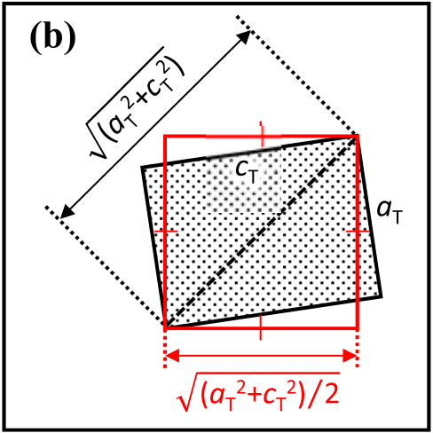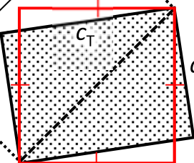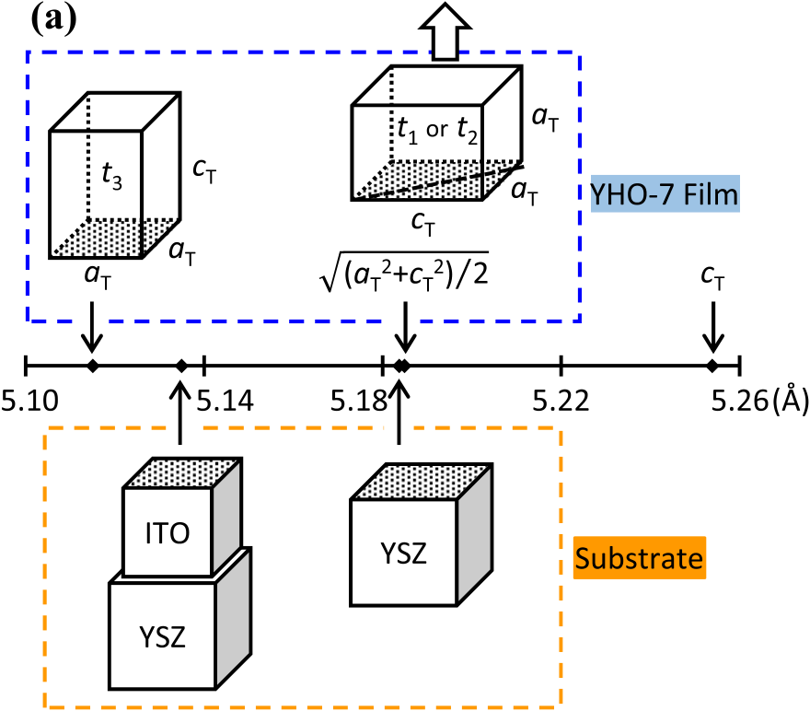

|  |  |  |
| --- | --- | --- |
| 134101-3 | Katayama et al. | J. Appl. Phys. 119, 134101 (2016) |

temperature of 700�C and oxygen pressure of 10 mTorr.   
Prior to the deposition of the YHO-7 films, an epitaxial ITO   
buffer layer with a thickness of 150 nm was also prepared on   
the (001) YSZ substrate by PLD to prepare the (001) ITO//   
(001) YSZ substrates.

Structural characterization of the deposited films was   
carried out at room temperature. The thickness of the YHO-7   
films and ITO buffer layer was examined by X-ray reflectiv-  
ity (X’pert MRD, Panalytical) and touch-probe scanning   
measurement (AlphaStep, Tencor), respectively. XRD h–2h   
and in-plane scans were performed using a high-resolution   
diffractometer (SmartLab, Rigaku). XRD pole figure meas-

|  |  |  |  |  |  |
| --- | --- | --- | --- | --- | --- |
| urements | and | out-of-plane | reciprocal | space | mappings |

(RSMs) were conducted using an X-ray diffractometer (D8-  
discover, Bruker) equipped with a large-area two-dimen-  
sional detector (Vantec-500).

IV. RESULTS AND DISCUSSION

A. Film growth on (001) YSZ and (001) ITO//(001) YSZ   
substrates

Figures 3(a) and 3(d) show out-of-plane XRD h–2h   
scans obtained for the YHO-7 films deposited on (001) YSZ   
and (001) ITO//(001) YSZ substrates, respectively. A series   
diffraction peaks from YHO-7 including {100}, {200},   
{300}, and {400} were observed for the film on a (001) YSZ   
substrate (Fig. 3(a)), corresponding to {100} orientation of

FIG. 2. (a) Estimated lattice parameters at a deposition temperature of 700�C for a 0.07YO1.5-0.93HfO2 film and substrates. (b) Top view of an out-of-plane aO-axis-oriented tetragonal 0.07YO1.5-0.93HfO2 film.

temperature of 700�C. To determine the diagonal matching

|  |
| --- |
| of the aT-axis oriented tetragonal phase, the value of q of the side of the square whose diagonal length is ffiffiffiffiffiffiffiffiffiffiffiffiffiffiffi is also shown (Fig. 2(b)). This value is the length  p tangular surface of the aT-axis oriented tetragonal phase. The ffiffiffiffiffiffiffiffiffiffiffiffiffiffiffiffiffiffiffiffiffiffiffi   , which corresponds to the diagonal of the rec-  lattice parameters of the tetragonal phase at the deposition |

temperature were estimated from the values reported for YHO-7 ceramic at room temperature and the thermal expan-sion coefficient of tetragonal ZrO2.13,18Note that half of the original lattice parameter is used here for ITO, because its

bixbyite structure, described as an oxygen-deficient fluorite (both HfO2 and ZrO2 are fluorites), has a unit cell parameter twice that of fluorite. The lattice mismatch between (001)

|  |
| --- |
| YSZ and the out-of-plane aT-axis oriented tetragonal phase ( for (001) YSZ and the aT-axis oriented tetragonal phase, q ffiffiffiffiffiffiffiffiffiffiffiffiffiffiffi ) is estimated to be þ0.02% (5.184 and 5.185 A˚ |

respectively), while that between (001) ITO and the cT-axis oriented tetragonal phase is estimated to be �0.39% (5.135 and 5.115 A˚ for (001) ITO and the cT-axis oriented tetrago-nal phase, respectively). These mismatches are small enough

to expect epitaxial growth of the YHO-7 films.

B. Film growth and characterization

YHO-7 films with a thickness of 9 nm were prepared by PLD using a KrF excimer laser (k ¼ 248 nm) at a substrate

the YHO-7 film. In this sample, diffraction angles of the {200}pc and {400}pc peaks of YHO-7 were higher than those of the 002 and 004 peaks of the YSZ substrate, respectively, indicating the possibility that these peaks originate from the shorter bO- and/or cO-axis out-of-plane orientations of the orthorhombic phase. In contrast, only {200} and {400} dif-fraction peaks of YHO-7 were observed for the film grown on a (001) ITO//(001) YSZ substrate; {100}pc and {300}pc diffraction peaks were not observed (Fig. 3(d)). The reason for this is discussed below. In this sample, the diffraction angles of the {200} and {400} peaks of YHO-7 were lower than those of the 002 and 004 peaks of the YSZ substrate, respectively, suggesting that these peaks may result from the longer aO-axis out-of-plane orientation of the orthorhombic phase.

Figures 3(b) and 3(e) show the rocking curves of YHO-7 {400} diffraction peaks for the YHO-7 films deposited on (001) YSZ and (001) ITO//(001) YSZ substrates; their full width at half-maximum (FWHM) values were 0.12�and 0.52�, respectively. This difference probably originates from the difference of the orientation perfection of the substrates, because the rocking-curve FWHM value of YSZ 004 was 0.015�for a (001) YSZ substrate, whereas that of ITO 008 was 0.30�for a (001) ITO//(001) YSZ substrate (data not shown in the figure). Nevertheless, because of the structural similarity between YHO-7, YSZ, and ITO, both YHO-7 films were highly {100}-oriented.

Figures 3(c) and 3(f) show the results of XRD pole fig-ure measurements of the YHO-7 {220} diffraction peak for YHO-7 films deposited on (001) YSZ and (001) ITO//(001) YSZ substrates, respectively. In this figure, W represents the inclination angle from the substrate surface normal, while /

|  |  |  |
| --- | --- | --- |
| 134101-4 | Katayama et al. | J. Appl. Phys. 119, 134101 (2016) |

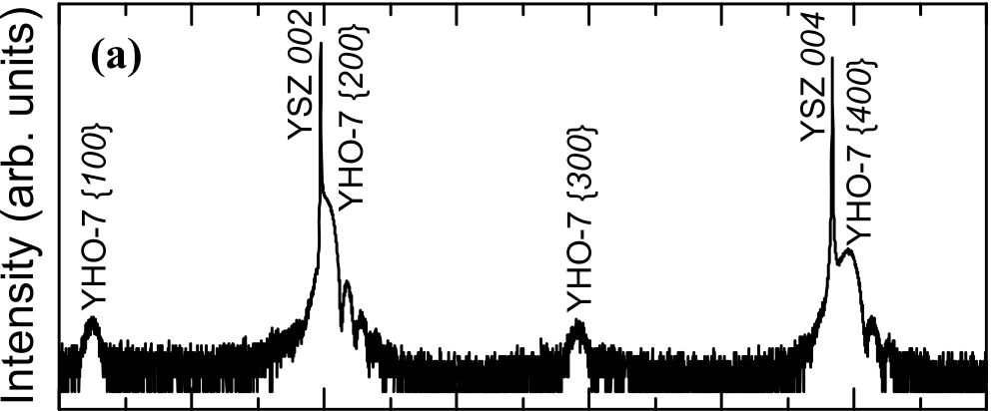

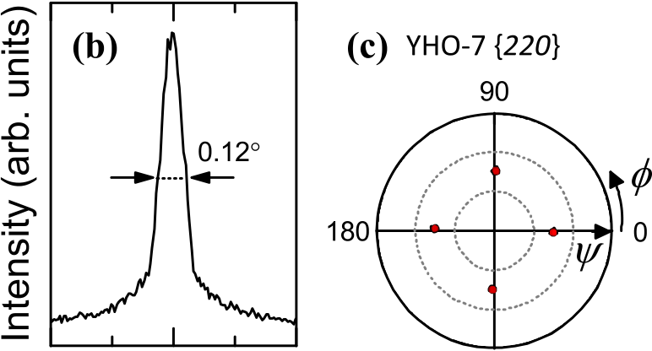

|  |  |  |  |  |
| --- | --- | --- | --- | --- |
|  |  |  |  |  |

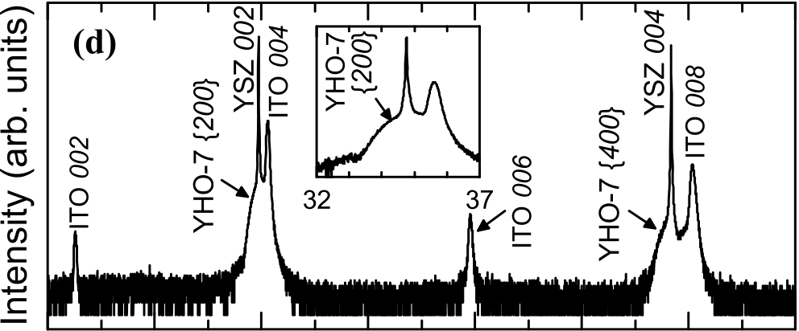

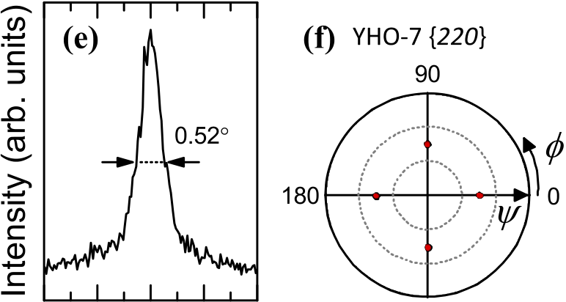

|  |  |  |  |
| --- | --- | --- | --- |
|  |  |  |  |
|  |

FIG. 3. (a), (d) XRD h-2h profiles, (b), (e) x-scan rocking curves of the 0.07YO1.5-0.93HfO2 {400} diffraction, and (c), (f) pole figures measured at the angle corresponding to the 0.07YO1.5-0.93HfO2 {220} diffraction for 0.07YO1.5-0.93HfO2 films deposited on (a), (b), (c) (001) YSZ, and (d), (e), (f) (001) ITO// (001) YSZ substrates.

represents the in-plane sample rotation angle around the sub-strate surface normal direction. Note that the / ¼ 0�is paral-lel to YSZ [100]. For both YHO-7 films, {220} diffraction spots with four-fold symmetry are observed at W of about 45�. These results indicate {100}-oriented epitaxial growth for both YHO-7 films. The observed orientation relationships

are {100} YHO-7//(100) YSZ and {100} YHO-7//(100)

orientations (o1 and o3), both 010 and 110 diffraction spots are located along out-of-plane directions (Figs. 4(b) and

4(d)). In contrast, for the out-of-plane cO-axis orientations (o2 and o4), both 010 and 110 diffraction spots are located along in-plane directions (Figs. 4(c) and 4(e)). For the aO-axis out-of-plane orientations (o5 and o6), 110 is located along an out-of-plane direction, while 010 is along an in-

ITO//(100) YSZ. plane direction (Figs. 4(f) and 4(g)).

B. Characterization of the orientation of orthorhombic C. Crystal structure characterization of YHO-7 films

films deposited on (001) YSZ substrates

Next, the symmetry and orientation of the deposited films were examined. To identify the specific orientation of the {100}-oriented YHO-7 films, various out-of-plane and in-plane XRD measurements were performed. In general, diffraction with mixed even/odd indices is forbidden for ideal fluorite structures such as cubic ZrO2 and HfO2. However, for ferroelectric orthorhombic HfO2, diffraction with mixed even/odd indices such as 010 and 110 could be permitted because of the displacements of the constituent atoms from the regular positions of the cubic fluorite struc-ture. Fortunately, these characteristic diffractions of the orthorhombic phase occur only for certain indices, so they are useful for identifying a specific orientation. We used the 010 and 110 diffraction, which are the only ones allowed

As mentioned above, for the YHO-7 films on the (001)

YSZ substrates, the out-of-plane XRD h–2h scan (Fig. 3(a)) indicates shorter bO- and/or cO-axis out-of-plane orientation of the orthorhombic phase. Note that the h–2h scan con-tained the {100} diffraction peak, where the h–2h scan corre-sponds to the scan along Qz in Fig. 4. Only o1 and o3 have the {100} diffraction spot along Qz in Fig. 4, namely, the 010 diffraction spot along Qz (Figs. 4(b) and 4(d)), whereas other orientations lack the {100} diffraction spots along Qz. Therefore, the {100} diffraction peak observed in the h–2h scan (Fig. 3(a)) can be assigned as the 010 diffraction peak,

signifying the presence of the bO-axis out-of-plane-oriented orthorhombic phase (o1 and/or o3). In the same way, the {300} diffraction peak in Fig. 3(a) can be assigned as the

among the 100, 010, 001, 110, 101, and 011 diffraction. 030 diffraction peak.

Figure 4 summarizes the positions of the 010 and 110 diffraction spots in reciprocal space for each orthorhombic orientation shown in Fig. 1. Here, Qx, Qy, and Qz axes are defined as shown in Fig. 4(a), where Qz is the out-of-plane

|  |  |  |  |  |  |  |  |
| --- | --- | --- | --- | --- | --- | --- | --- |
| axis | along | [001] | YSZ. | For | the | bO-axis | out-of-plane |

Figures 4(b) and 4(d) reveal that o1 and/or o3 also have the characteristic 110 diffraction spot along an out-of-plane direction. This 110 spot can be detected in the XRD-RSM data around the out-of-plane YSZ 202 or YSZ 022 diffrac-tion spots with W ¼ 45�and / ¼ 0�or 90�. The results shown

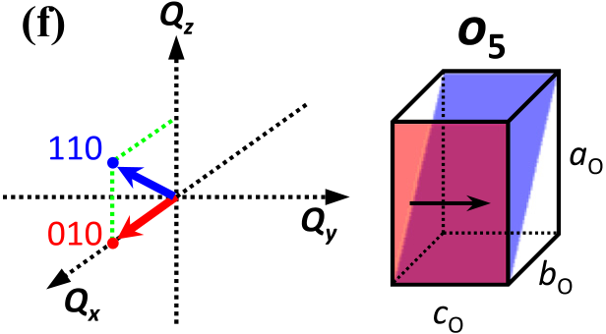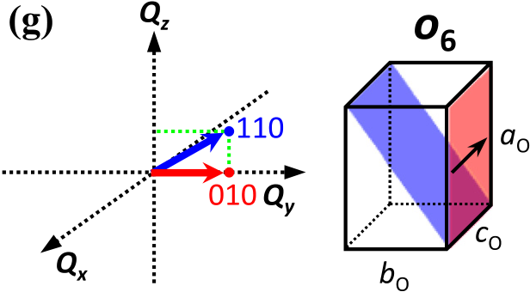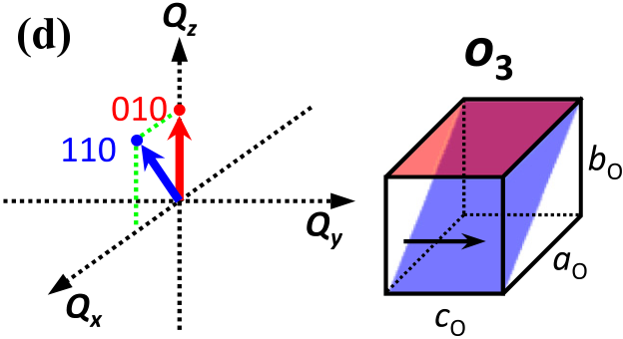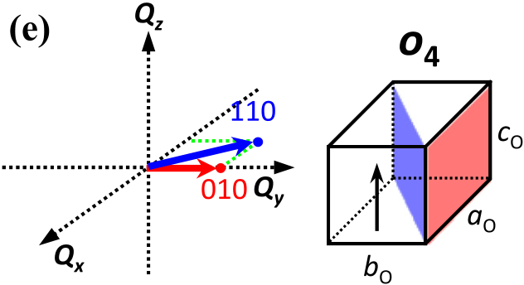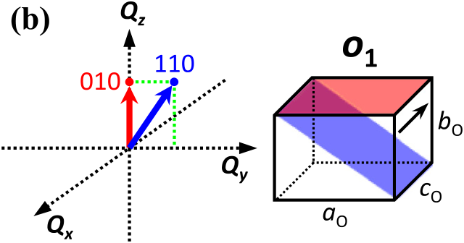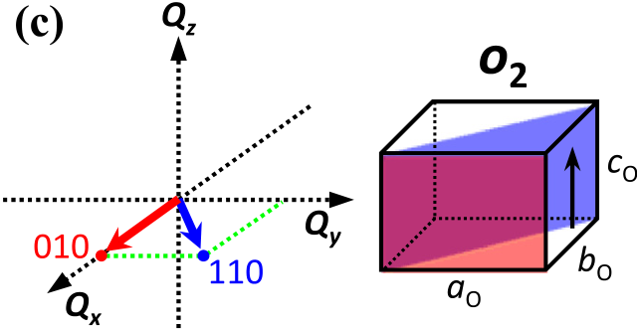

|  |  |  |
| --- | --- | --- |
| 134101-5 | Katayama et al. | J. Appl. Phys. 119, 134101 (2016) |



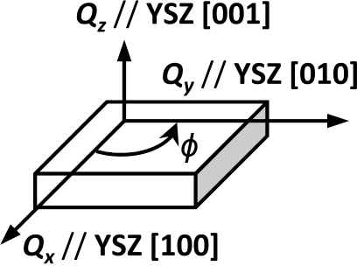

FIG. 4. (a) Definition of the axis, and geometry of 010 and 110 diffraction of orthorhombic orientations (b) o1, (c) o2, (d) o3, (e) o4, (f) o5, and (g) o6 in recipro-

cal space.

in Fig. 5(a) exhibited the 110 diffraction spot of YHO-7. This is further evidence of the presence of o1. Note that the coordinates of the 110 diffraction spot in the XRD-RSMs coincide with the rectangular lattice that has larger in-plane

and smaller out-of-plane lattice parameters, proving that this diffraction results from a bO-axis orientation not an aO-axis oriented one. The XRD pole figure measurement of the

YHO-7 110 diffraction (Fig. 5(b)) shows four distinct dif-fraction spots that are 90�apart from each other along the in-plane rotation axis. This result indicates the presence of the epitaxially grown bO-axis orientation in two different in-plane orientations with the aO-axis perpendicular to each other; that is, the presence of both o1 and o3.

The existence of the bO-axis out-of-plane orientation (o1 and o3) indicates the possibility of the presence of the cO-axis orientation (o2 and o4), because o1 and o2 are generated from the same tetragonal variant t1, and o3 and o4 are gener-ated from the same tetragonal variant t2, as shown in Fig. 1.

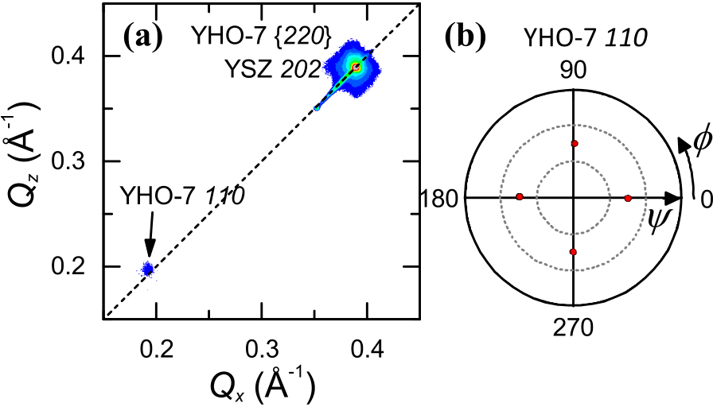

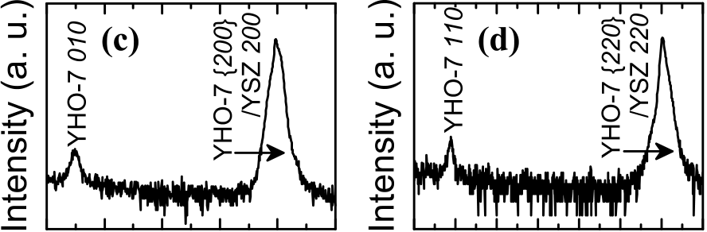

 

|  |  |  |
| --- | --- | --- |
| However, the out-of-plane cO-axis orientations cannot be |  |  |

identified from the out-of-plane XRD scan depicted in Fig. 3(a), because the {400} diffraction peak was not split into two recognizable 040 and 004 peaks. This may be because of the similarity of the lattice parameters of bO and cO.

To confirm the presence of the out-of-plane cO-axis ori-entation (o2 and/or o4), we conducted in-plane XRD meas-urements, because both 010 and 110 spots are located along in-plane directions for o2 and o4 (see Figs. 4(c) and 4(e)). Figures 5(c) and 5(d) show the in-plane 2h profiles at around / ¼ 0�and 45�. Both 010 and 110 diffraction peaks are observed in these scans, revealing the presence of the out-of-plane cO-axis orientations in the film. In addition, an XRD in-plane / scan of the 110 diffraction shows four distinct

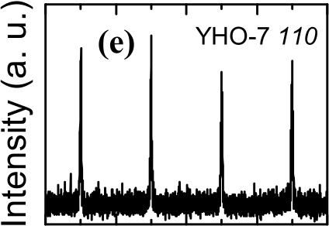





FIG. 5. XRD analysis results for YHO-7 films grown on (001) YSZ sub-strates. (a) Reciprocal space mapping around the asymmetrical out-of-plane YSZ 220 diffraction at around / ¼ 45�, (b) pole figure measurement at the fixed 2h angle corresponding to orthorhombic 110, and in-plane 2h profiles along (c) / ¼ 0�and (d) / ¼ 45�.

|  |  |  |
| --- | --- | --- |
| 134101-6 | Katayama et al. | J. Appl. Phys. 119, 134101 (2016) |

diffraction peaks 90�apart from each other along the in-plane rotation, as illustrated in Fig. 5(e). This result clearly indicates the presence of the epitaxially grown out-of-plane cO-axis orientation in four different in-plane orientations 90�apart from each other, in other words, the presence of both

o2 and o4.

Consequently, the YHO-7 films grown on the (001)

YSZ substrates contain four types of orientations: o1, o2, o3, and o4. This indicates the possibility of the existence of the ferroelastic domains o1/o2 and o3/o4 (see Fig. 1). This result is in good agreement with our expectation that the YHO-7 films on (001) YSZ substrates consist of t1 and t2 during high-temperature growth and transform into o1, o2, o3, and o4 upon cooling.

D. Crystal structure characterization of YHO-7 films deposited on (001) ITO//(001) YSZ substrates

Here we discuss the structure of the YHO-7 films grown on the (001) ITO//(001) YSZ substrates. The out-of-plane XRD h–2h scan (Fig. 3(d)) contains the YHO-7 {200} and {400} diffraction peaks at lower angles than those of the YSZ 002 and 004 diffraction peaks, respectively. This indi-cates the possibility of the existence of the longest out-of-

plane aO-axis orientation (o5 and/or o6). In addition, this scan did not contain YHO-7 {100} and {300} diffraction peaks, in other words, 010 and 030 diffraction peaks, sug-gesting the absence of the out-of-plane bO-axis orientation (o1 and o3).

Out-of-plane aO-axis orientations o5 and o6 have a char-acteristic 110 diffraction spot along out-of-plane directions (see Figs. 4(f) and 4(g)) the same as that of the out-of-plane bO-axis orientations o1 and o3 (Figs. 4(b) and 4(d)). Because the out-of-plane bO-axis orientations are excluded as dis-cussed above, the observation of the 110 diffraction spot is crucial to identify the out-of-plane aO-axis orientation. The XRD-RSM around the out-of-plane YSZ 202 diffraction spot in Fig. 6(a) contains the 110 diffraction spot of the YHO-7 film. Moreover, the coordinates of the 110 diffraction spot coincide with the rectangular lattice that has smaller in-plane and larger out-of-plane lattice parameters, proving that the

film contains the out-of-plane aO-axis orientation and not the out-of-plane bO-axis orientation. The XRD pole figure mea-surement of the YHO-7 110 diffraction (Fig. 6(b)) shows four distinct diffraction spots that are 90�apart from each

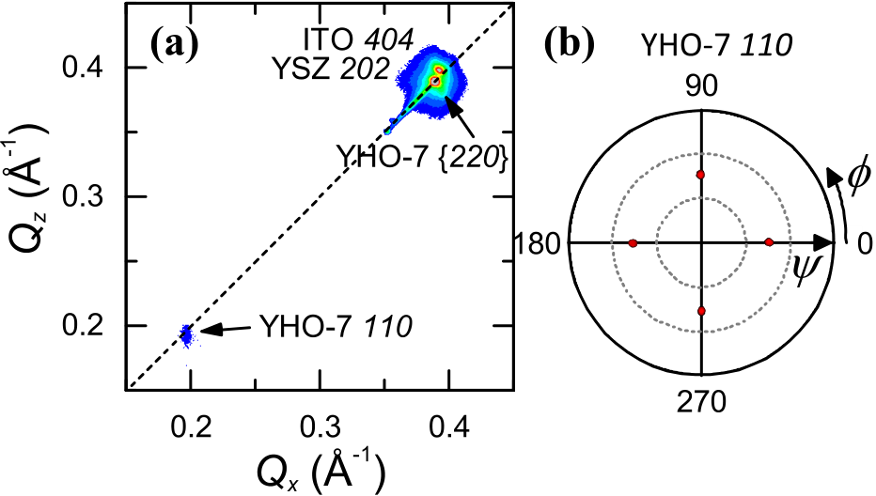

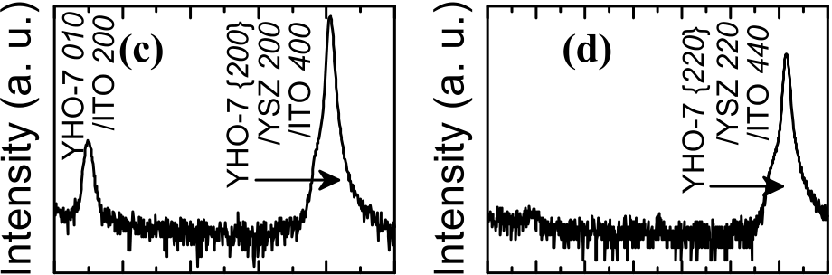

 

 

FIG. 6. XRD analysis results for YHO-7 films grown on (001) ITO//(001) YSZ substrates. (a) Reciprocal space mapping around the asymmetrical out-of-plane YSZ 220 diffraction at around / ¼ 45�, (b) pole figure measure-ment at the fixed 2h angle corresponding to orthorhombic 110, and in-plane 2h profiles along (c) / ¼ 0�and (d) / ¼ 45�.

Consequently, the YHO-7 films grown on (100) ITO// (100) YSZ substrates consist of two types of orientations: o5 and o6. This indicates the possibility of the existence of the ferroelastic domain o5/o6. These results are in good agreement with our expectation that the YHO-7 films on (001) ITO// (001) YSZ substrates consist of t3 during high-temperature growth, which then transforms into o5 and o6 upon cooling.

The present results demonstrate that the orientation of HfO2-based ferroelectric films can be controlled in the same way as the orientation of conventional perovskite-type ferro-electric films composed of materials such as Pb(Zr, Ti)O3 and BiFeO3.19This is very advantageous since many charac-teristics of the ferroelectric films, such as remnant polariza-tion and piezoelectricity, depend on the orientation of the films. In addition, the present results indicate the formation of ferroelastic domains, which are recognized as an impor-tant factor to achieve large piezoelectricity. We are currently using transmission electron microscopy to investigate the detailed structures of the ferroelastic domains.

|  |  |
| --- | --- |
| other along the in-plane rotation axis. This result indicates the presence of the epitaxially grown aO-axis out-of-plane | V. CONCLUSION |

orientation in four different in-plane orientations, indicating the presence of both o5 and o6.

To characterize these films in more detail, in-plane orien-tation must be investigated because 010 and 110 spots appear only along the in-plane direction in the case of out-of-plane cO-axis orientations o2 and o4 (see Figs. 4(c) and 4(e)). Figures 6(c) and 6(d) show the in-plane 2h profiles along YHO-7 film were observed in Fig. 6(c), whereas the 110 dif-/ ¼ 0�and 45�, respectively. The 010 diffraction peaks of the fraction was not in Fig. 6(d). These results correspond to the absence of the out-of-plane cO-axis and out-of-plane bO-axis orientations, i.e., the absence of o1, o2, o3 and o4.

Orientation control of epitaxial {100}-oriented ortho-rhombic 0.07YO1.5–0.93HfO2 films was achieved by select-ing proper underlying layers for different orientations of the tetragonal films. Substrates were selected to obtain lattice matching at the deposition temperature, and then the films underwent phase transition at TC during the cooling process after deposition. We grew {100}-oriented epitaxial ortho-rhombic 0.07YO1.5–0.93HfO2 films by PLD on (001) YSZ and (001) ITO//(001) YSZ substrates. Careful XRD-RSM analysis revealed that (010)/(001) and (100) out-of-plane-ori-ented films grew on (001) YSZ and (001) ITO//(001) YSZ substrates, respectively, because of the in-plane lattice

|  |  |  |
| --- | --- | --- |
| 134101-7 | Katayama et al. | J. Appl. Phys. 119, 134101 (2016) |

parameter of the underlying layers. The present results dem-onstrate that orientation control of HfO2-based ferroelectric films is possible using suitable substrates.

ACKNOWLEDGMENTS

This work was partially funded by the MEXT Elements Strategy Initiative to Form Core Research Center, JSPS KAKENHI Grant No. 25889024, and MEXT KAKENHI Grant No. 26106509. Part of this work was also supported by the Center for Integrated Nanotechnology Support at Tohoku University and Nanotechnology Network Project of MEXT of the Japanese Government. The synchrotron radiation experiments were performed at beamlines BL13XU of SPring-8 with the approval of the Japan Synchrotron

|  |  |  |  |  |  |  |  |  |
| --- | --- | --- | --- | --- | --- | --- | --- | --- |
| Radiation | Research | | Institute | (JASRI) | | (Proposal | | Nos. |
| 2014A1290 | and | 2014B1779) | | and | BL15XU | | with | the |

approval of NIMS (Proposal No. 2013B4702, 2014B4704, 2014A4703, 2014B4704, 2015A4702, and 2015B4702).

1T. S. B€oscke, J. M€uller, D. Br€auhaus, U. Schr€oder, and U. B€ottger, [Appl.](http://dx.doi.org/10.1063/1.3634052)

5S. Clima, D. J. Wouters, C. Adelmann, T. Schenk, U. Schroeder, M. Jurczak, and G. Pourtois, [Appl. Phys. Lett.](http://dx.doi.org/10.1063/1.4867975) 104, 092906 (2014).

6T. D. Huan, V. Sharma, G. A. Rossetti, and R. Ramprasad, [Phys. Rev. B](http://dx.doi.org/10.1103/PhysRevB.90.064111) 90, 064111 (2014).

7R. Materlik, C. K€unneth, and A. Kersch, [J. Appl. Phys.](http://dx.doi.org/10.1063/1.4916707) 117, 134109 (2015).

8T. Shimizu, T. Yokouchi, T. Oikawa, T. Shiraishi, T. Kiguchi, A. Akama, T. J. Konno, A. Gruverman, and H. Funakubo, [Appl. Phys. Lett.](http://dx.doi.org/10.1063/1.4915336) 106, 112904 (2015).

9T. Shimizu, K. Katayama, T. Kiguchi, A. Akama, T. J. Konno, and H. Funakubo, [Appl. Phys. Lett.](http://dx.doi.org/10.1063/1.4927450) 107, 032910 (2015).

10M. Nakajima, A. Wada, T. Yamada, Y. Ehara, T. Kobayashi, and H. Funakubo, [J. Appl. Phys.](http://dx.doi.org/10.1063/1.4898321) 116, 194102 (2014).

11N. Setter, D. Damjanovic, L. Eng, G. Fox, S. Gevorgian, S. Hong, A. Kingon, H. Kohlstedt, N. Y. Park, G. B. Stephenson, I. Stolitchnov, A. K. Taganstev, D. V. Taylor, T. Yamada, and S. Streiffer, [J. Appl. Phys.](http://dx.doi.org/10.1063/1.2336999) 100, 051606 (2006).

12M. H. Park, H. J. Kim, Y. J. Kim, W. Lee, T. Moon, and C. S. Hwang, [Appl. Phys. Lett.](http://dx.doi.org/10.1063/1.4811483) 102, 242905 (2013).

13E. H. Kisi and C. J. Howard, [Key Eng. Mater.](http://dx.doi.org/10.4028/www.scientific.net/KEM.153-154.1) 153–154, 1 (1998).

14Q. Zeng, A. R. Oganov, A. O. Lyakhov, C. Xie, X. Zhang, J. Zhang, Q. Zhu, B. Wei, I. Grigorenko, L. Zhang, and L. Cheng, [Acta Crystallogr., Sect. C: Struct. Chem.](http://dx.doi.org/10.1107/S2053229613027861) 70, 76 (2014).

15J. M€uller, T. S. B€oscke, U. Schr€oder, S. Mueller, D. Br€auhaus, U. B€ottger, L. Frey, and T. Mikolajick, [Nano Lett.](http://dx.doi.org/10.1021/nl302049k) 12, 4318 (2012).

16E. H. Kisi, C. J. Howard, and R. J. Hill, [J. Am. Ceram. Soc.](http://dx.doi.org/10.1111/j.1151-2916.1989.tb06322.x) 72, 1757

|  |  |  |  |  |  |  |  |  |  |  |
| --- | --- | --- | --- | --- | --- | --- | --- | --- | --- | --- |
| [Phys. Lett.](http://dx.doi.org/10.1063/1.3634052) 99, 102903 (2011). | (1989). | | T. | Yamada, | A. | K. | Tagantsev, | R. | Ikariyama, | T. |
| 2J. Muller, P. Polakowski, S. Mueller, and T. Mikolajick, [ECS J. Solid](http://dx.doi.org/10.1149/2.0081505jss) | 17H. | Morioka, |

[State Sci. Technol.](http://dx.doi.org/10.1149/2.0081505jss) 4, N30 (2015).

3M. H. Park, H. J. Kim, Y. J. Kim, W. Lee, H. K. Kim, and C. S. Hwang,

[Appl. Phys. Lett.](http://dx.doi.org/10.1063/1.4798265) 102, 112914 (2013).

4P. Polakowski, S. Riedel, W. Weinreich, M. Rudolf, J. Sundqvist, K.

Seidel, and J. Muller, in 2014 IEEE 6th International Memory Workshop

(2014), p. 1.

Nagasaki, T. Kurosawa, and H. Funakubo, [Appl. Phys. Lett.](http://dx.doi.org/10.1063/1.4906861) 106,

042905 (2015).

18M. Yashima, H. Takahashi, K. Ohtake, T. Hirose, M. Kakihana, H. Arashi,

Y. Ikuma, Y. Suzuki, and M. Yoshimura, [J. Phys. Chem. Solids](http://dx.doi.org/10.1016/0022-3697(95)00268-5) 57, 289

(1996).

19K. Lee and S. Baik, [Annu. Rev. Mater. Res.](http://dx.doi.org/10.1146/annurev.matsci.36.090804.094613) 36, 81 (2006).