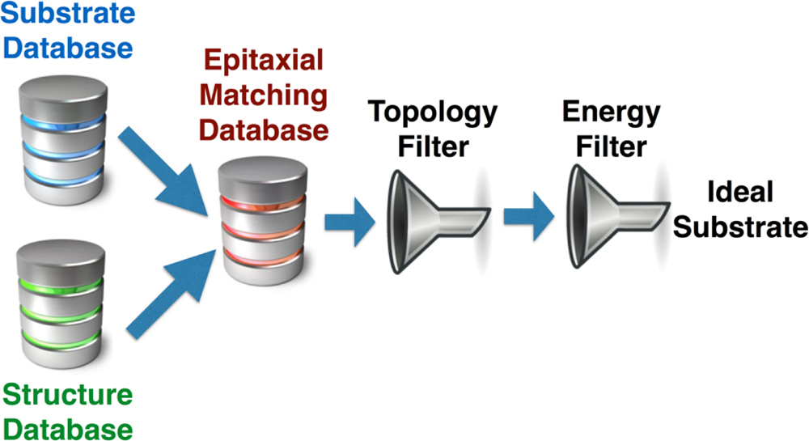

Research Article   
 www.acsami.org

Computational Approach for Epitaxial Polymorph Stabilization through Substrate Selection   
Hong Ding,†Shyam S. Dwaraknath,†Lauren Garten,‡Paul Ndione,‡David Ginley,‡  
and Kristin A. Persson*,†,§  
†Energy Technologies, Lawrence Berkeley National Laboratory, Berkeley, California 94720, United States  
‡Materials Chemistry Science and Technology, National Renewable Energy Laboratory, Golden, Colorado 80401, United States§Department of Materials Science and Engineering, University of California Berkeley, Berkeley, California 94704, United States

|  |  |  |  |  |  |  |  |  |
| --- | --- | --- | --- | --- | --- | --- | --- | --- |
| GEORGIA INST OF TECHNOLOGY on August 3, 2021 at 19:44:37 (UTC).  .org/sharingguidelines for options on how to legitimately share published articles. | ABSTRACT: With the ultimate goal of finding new | | |  | |  |  | |
| polymorphs through targeted synthesis conditions and  techniques, we outline a computational framework to select  optimal substrates for epitaxial growth using first principle  calculations of formation energies, elastic strain energy, and  topological information. To demonstrate the approach, we  study the stabilization of metastable VO2 compounds which  provides a rich chemical and structural polymorph space. We  find that common polymorph statistics, lattice matching, and  energy above hull considerations recommends homostructural  growth on TiO2 substrates, where the VO2 brookite phase  would be preferentially grown on the a−c TiO2 brookite plane    while the columbite and anatase structures favor the a−b plane  on the respective TiO2 phases. Overall, we find that a model which incorporates a geometric unit cell area matching between the substrate and the target film as well as the resulting strain energy density of the film provide qualitative agreement with experimental observations for the heterostructural growth of known VO2 polymorphs: rutile, A and B phases. The minimal interfacial geometry matching and estimated strain energy criteria provide several suggestions for substrates and substrate−film orientations for the heterostructural growth of the hitherto hypothetical anatase, brookite, and columbite polymorphs. These criteria serve as a preliminary guidance for the experimental efforts stabilizing new materials and/or polymorphs through epitaxy. The current screening algorithm is being integrated within the Materials Project online framework and data and hence publicly available.  KEYWORDS: epitaxy, substrate selection, topology, elastic energy, homoepitaxy, heteroepitaxy | | | | | | | |
| Downloaded via  See https://pubs.acs | 1. INTRODUCTION | | invention of efficient blue-light-emitting diodes based on | | | | | |
| Discovery and synthesis of new functional materials is essential in materials research to enable breakthrough technologies in energy storage, delivery, and utilization. Although computa-tional approaches to predicting novel materials are becoming increasingly popular,1the ability to theoretically predict the preferred synthesis conditions of a target new material is less routine. In this context, synthesis of highly textured or epitaxial filmsthe natural or artificial growth of crystals on a crystalline substrateprovides an ideal platform as it allows for many control variables such as substrate selection, temperature, interfacial chemistry, and deposition rates, etc., to favor a specific local minimum in the free-energy landscape2 corresponding to the target material. Among the variable conditions for epitaxy, the substrate selection is particularly important as it can decrease the nucleation energy of a given target, specifically metastable, phase which can exhibit dramatically different physical or chemical properties compared to the ground state.3This is beautifully illustrated by the recent | | | | epitaxially stabilized cubic GaN on a (001)-GaAs substrate.4 An extensive overview of the applications, physics, and challenges in epitaxial growth, partially concerning transition-metal oxide heterointerfaces, can be found in references 5 and 6.  Usually, an epitaxial substrate is manually selected from a pool of common candidates using visualization software to select an appropriate surface, a rough lattice parameter matching, and intuition.7To broadly explore new functional polymorphs using epitaxy, a more systematic, efficient, and rational screening methodology of substrates is desirable. Several recent experimental combinatorial efforts8,9highlight the need to correctly identify a suitable substrate and the experimental conditions for high-throughput epitaxial film growth. Computationally, Mehta et al.10used ionic substitution | | | |
|  | Received: | | | February 6, 2016 |
| Accepted: | | | May 4, 2016 |
| 2014 Nobel Prize in Physics, which was awarded for the | | Published: May 4, 2016 | | | | | |
|  | © 2016 American Chemical Society | 13086 | | | | | DOI: [10.1021/acsami.6b01630](http://dx.doi.org/10.1021/acsami.6b01630) ACS Appl. Mater. Interface[s 2016, 8, 13086−13093](http://dx.doi.org/10.1021/acsami.6b01630) |

|  |  |  |
| --- | --- | --- |
| ACS Applied Materials & Interfaces | |  | | --- | | Research Article | |

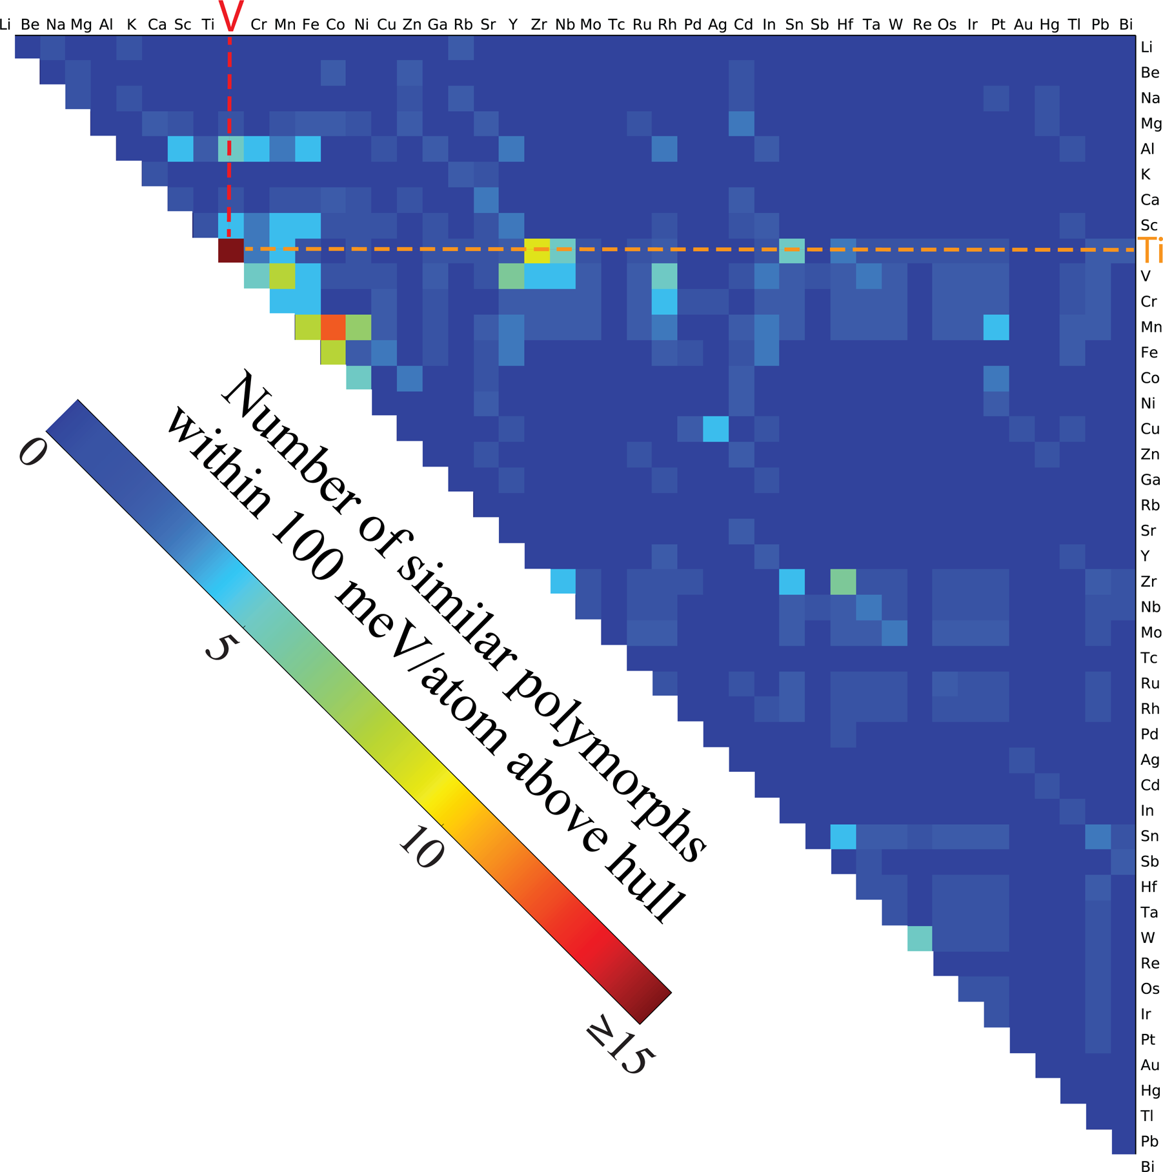

Figure 1. Illustration of the number of conformal oxide polymorphs within 100 meV/atom of the hull between two elements. Reddish color

indicates a high number of shared polymorphs, indicating that the two elements would be ideal for oxide homoepitaxy. The data are taken from the Materials Project Database, which contains mainly experimentally verified compounds from the ICSD33but also an increasing number of

“hypothetical” structures created by ionic substitution, removal of ions, and structure prediction methods, etc. To obtain a measure of chemical similarity, the structures considered here were filtered on the “energy above Hull” less than 100 meV/atom, which provides a reasonable upper bound of accessible metastability.34

to evaluate polymorph metastability within several metal dioxide systems where, not surprisingly, the calculated formation energy of the target compound was found to be a guiding but inconclusive criteria to predict the resulting epitaxial phase. To include an approximate effect of the substrate, the bulk modulus of each polymorph was computed to construct a free energy substrate−film model to evaluate the accessibility of the target phase. It is worth noticing that the work by Mehta et al.10focused on which polymorph is accessible through epitaxial growth, but did not address the reverse question: given a particular target material/polymorph, what is the optimal substrate selection and resulting epitaxial orientation?

To facilitate the synthesis of novel functional metastable materials, the goal of this work is to propose and implement an efficient and general computational screening approach for

13087 DOI: [10.1021/acsami.6b01630](http://dx.doi.org/10.1021/acsami.6b01630)

|  |  |  |
| --- | --- | --- |
| ACS Applied Materials & Interfaces | |  | | --- | | Research Article | |

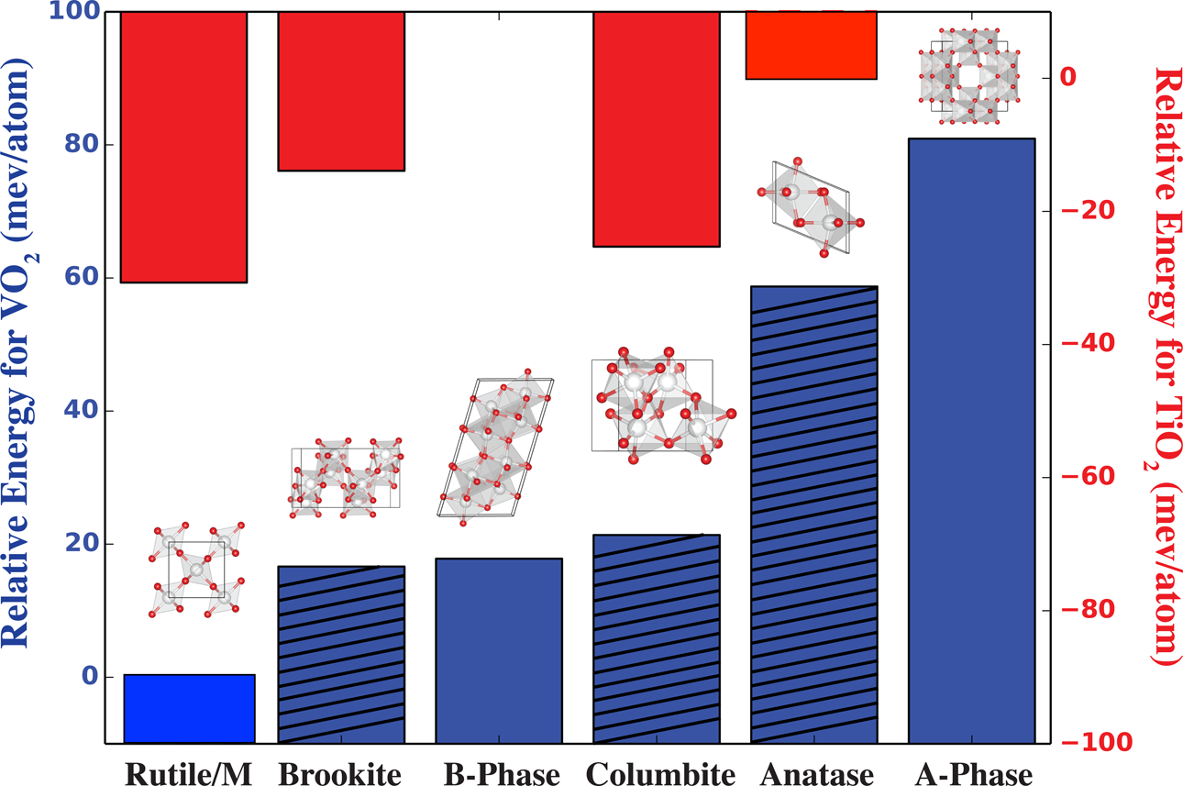

Figure 2. To estimate the accessible window of metastability we compare the calculated relative formation energies of various polymorphs in TiO2 (red) and VO2 (blue). The lowest-energy structure (anatase for TiO2 and rutile for VO2) is used as the reference state. Dashed bars indicate the polymorphs that have not been synthesized.

distorted semiconducting monoclinic structure (M1). Addi-tionally, two other structures, the A and B phases, have been synthesized under hydrothermal and/or physical vapor deposition conditions,14,15while other structures such as anatase, brookite, and columbite seen in TiO2 have not yet been observed for VO2. Hence, we are especially interested in finding recommendations for growing these hitherto unseen VO2 polymorphs.

2. METHODOLOGY

2.1. Computational. We aim to provide a fast and efficient model to preselect substrates from a given pool for epitaxial growth of a target polymorph/material. Here we investigate two different approaches and a variety of criteria associated with each. In the following we present analyses, benchmarking, and recommendations for the following:

• Homostructural epitaxy. where a chemically and structurally similar substrate material is selected based on common polymorph statistics, lattice matching, and energy above the hull. In this model the optimal orientation relationship between the film and the substrate is chosen as the smallest lattice mismatch between the common structures.

• Heterostructural epitaxy. where the pool of candidate substrates can generally comprise any chemical system and the orientation relationship between the film and the substrate is obtained through a set of criteria based on the minimal interfacial geometry matching and estimated strain energy as a function of the substrate−film pair.

Both models are explored and implemented within the infrastructure of the Materials Project and benchmarked using available literature references for the case of VO2 polymorph stabilization. We emphasize that a detailed investigation of interfacial chemical interactionswhile beyond this workmay be critical in some cases and can be performed using slab calculations as an added, albeit more time-consuming, computational approach. For a comprehensive collection of candidate substrates, we used the Materials Project database16as an“a priori” calculated data set to search representative structures and evaluate the corresponding polymorph thermodynamic stability. Density-functional-theory (DFT) calculations were performed as necessary using the projector augmented wave (PAW) method17,18 as implemented in the Vienna Ab Initio Simulation Package (VASP)19,20within the Perdew−Burke−Enzerhof (PBE) Generalized Gradient Approximation (GGA) formulation of the exchange-

13088 DOI: [10.1021/acsami.6b01630](http://dx.doi.org/10.1021/acsami.6b01630)

|  |  |  |
| --- | --- | --- |
| ACS Applied Materials & Interfaces | |  | | --- | | Research Article | |

Ni, Co−Fe, and Zr−Ti, which all exhibit more than five similar polymorph structures within the given energy range. The binary titanium oxides show an exceptionally high degree of common polymorphism with VO2, although we caution that this result may be somewhat skewed by the high degree of interest in these systems (e.g., more structures reported and explored) due to their electronic and magnetic versatility as a function of small structural changes. Given the large number of similar structures common to the titanium and vanadium oxides, we select the TiO2 system as a basis for homostructural growth, as well as a good benchmark. In natural minerals, TiO2 has three well-known polymorphs, i.e., anatase, rutile, and brookite. The columbite structure of TiO2 is also found in suevite from the Nördlinger Ries crater which was likely formed under impact-induced high-pressure conditions.

Using DFT, we computationally relaxed the aforementioned high-symmetry polymorphs of interest for VO2 and TiO2: rutile, A and B phases (experimentally observed for VO2), as well as anatase, brookite, and columbite (experimentally observed for TiO2 but not VO2). First, to obtain a sense of the accessible energy scale through various synthesis techniques we compare the calculated thermodynamic stability with available evidence of successful synthesis, for both VO2 and TiO2. Figure 2 shows the relative bulk formation energies (at T = 0) for the various VO2 structures and TiO2. For TiO2, PBE-DFT erroneously predicts anatase (−3.51 eV/atom) as the ground state at zero pressure. This is well within the standard DFT error on formation energies for oxides which is normally distributed with a mean of zero and a standard deviation of 25 meV/atom.27The other three naturally occurring TiO2 polymorphs, i.e., rutile, brookite, and columbite, are close in energy, about 15−30 meV/atom higher than anatase. These results are consistent with previous examinations of the TiO2 system.28We now turn to the VO2 family of polymorphs. Because the strong lattice correspondence between the rutile and M1 phase and the small lattice expansion observed (1%),29 we will in this work consider them as one system, referred to as the “R/M” phase. Among the polymorphs considered for the VO2 system, the R/M phase exhibits the lowest formation energy (−2.48 eV/atom). Brookite and columbite VO2 have comparable formation energies, which are about 20 meV/atom higher than that of the R/M phase, whereas anatase has a higher relative energy (about 60 meV/atom). These results are also consistent with previous studies, which assessed the VO2 formation energies in different prototype structures10for a range of different functionals.30,31To further evaluate the correlation between accessibility (e.g., successful synthesis) and the calculated zero Kelvin energy difference, we also present the results of the A and B phases. Our calculations show that the B phase is similar in energy to the brookite and columbite structures, while the energy of the A phase is higher than all other structures considered here (about 80 meV/atom higher than the rutile structure). Comparing the energy range of the polymorph space with evidence of successful synthesis (at some conditions) provides us with a estimated “accessible energy”scale. For example, we note that the metastable A phase has been successfully synthesized using hydrothermal14and physical vapor deposition techniques.32Hence, the present results indicate, rather encouragingly, that a large exploration energy window of metastability (up to 80 meV/atom including potential inaccuracies in DFT) may be overcome using customized synthesis techniques and conditions. Specifically, we note that any failure of DFT to obtain the correct ground

13089 DOI: [10.1021/acsami.6b01630](http://dx.doi.org/10.1021/acsami.6b01630)

|  |  |  |
| --- | --- | --- |
| ACS Applied Materials & Interfaces | |  | | --- | | Research Article | |

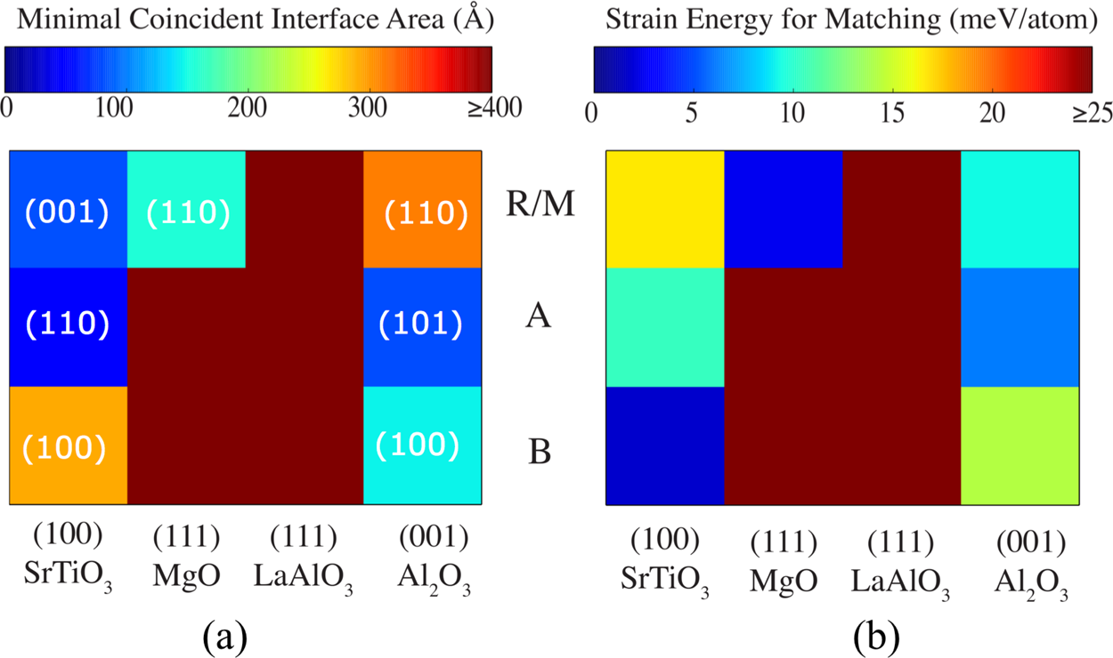

Figure 3. (a) Calculated minimal coincident interface area for substrate and VO2 polymorph pairs and (b) corresponding film strain energy. The orientation of the target film is labeled with the corresponding Miller index in (a).

lattices within a given strain constraint. This approach is an improvement from traditional lattice parameter matching, which is is not applicable for systems where the epitaxial layer has a different orientation, or a completely different crystal structure, than the substrate. Additionally, while devoid of any chemical interaction between the target film and substrate, the model provides a rapid and robust geometrical screening and we select it for implementation in pymatgen39(the open python-based analysis software adopted for MP) and dissemination within the Materials Project Design environ-ment. In this process, we take advantage of existing surface modules and symmetry operations within pymatgen to generate all possible surface orientations of Miller index (hkl) below a certain cutoff and terminations.34,39The candidate substrates can be automatically selected from the Materials Project or generated from an external list. To accommodate a lattice match within the Zur and McGill model, the film is considered to be strained within the epitaxial plane. Hereafter, we will refer to this epitaxial plane as the x−y plane. If we assume the substrate surface is rigid with no structural relaxation perpendicular to the x−y plane, the strain energy (ΔEs) imposed on the film can be expressed as ΔEs = V · ex−y, where V is the volume of the film per atom and ex−yis the film strain energy density induced in the x−y plane. Here, we adopt the recently developed elastic constant (Cijkl) high-throughput computation framework22within the Materials Project which allows for an easy estimate of ex−yas

|  |  |  |  |  |  |  |  |  |  |  |  |  |  |
| --- | --- | --- | --- | --- | --- | --- | --- | --- | --- | --- | --- | --- | --- |
| *e* | *x* | − | *y* | = | *V* | · | 1 | *C ijkl ij* * ϵ *x* | − | *y* | ϵ *kl x*− | *y* | (1) |
| 2 |

where Cijkl* is obtained by the transformation of the fourth-order tensor Cijkl into the new lattice orientation correspondence between the substrate and the film. Through this procedure, we can preliminarily identify appropriate substrates and the lattice orientations that geometrically fit the target polymorph film as a function of the film strain energy. We note that there is a DFT error affecting the energy ordering of systems as previously witnessed in the formation energies for VO2 and TiO2. The DFT evaluations of the elastic tensor are relatively accurate, within 15% of the experimental value,22and will at worst contain a systematic error that should have a small effect in the overall ranking of different substrates for epitaxy.

13090 DOI: [10.1021/acsami.6b01630](http://dx.doi.org/10.1021/acsami.6b01630)

|  |  |  |
| --- | --- | --- |
| ACS Applied Materials & Interfaces | |  | | --- | | Research Article | |

substrate through pulsed laser deposition and that the obtained phase selectivity depended on the oxygen pressure and laser frequency. Considering the next substrate, (111)-MgO, we find only large MCIA (495 and 449 Å2) for the A or B phases, respectively, while the R/M phase yields relatively low values of MCIA (155 Å2) and strain energyΔEs (3 meV/atom). This is again corroborated by available experiments: radio frequency sputtering techniques were utilized to deposit VO2 on (111)-MgO and (111)-LaAlO3 followed by annealing, which both present R/M structured epitaxial films.40For (111)-LaAlO3, our results suggest that none of the three polymorphs can be easily grown epitaxially due to relatively large values of MICA and strain energy. Experimentally,40the R/M phase was observed which could either be a result of a small interfacial buffer phase, or an indication of limiting factors (surface defects, interfacial chemistry) in the current model. Lastly, our model predicts that a (0001)-Al2O3 (sapphire) substrate should favor epitaxial growth of a VO2 A phase film, however R/M is frequently41found. Interestingly, it is worth noticing that Zhou et al.41did observe a transition or buffer layer at the VO2/ (0001)-Al2O3 interface, indicating that a direct epitaxial relationship may not exist between the substrate and the epitaxially grown film. A buffer layer is likely to favor the ground state, in this case the R/M phase, which explains the apparent mismatch between the theoretical prediction and experimental results. Overall, we find that the current model which incorporates a geometric unit cell area matching between the substrate and the target film as well as the resulting strain energy density of the film provide qualitative agreement with experimental observations, though a detailed nature of the lattice−substrate interface, e.g., the atomic orientation, termination preference, and chemical character etc., requires further research efforts.

Finally, with the ultimate goal of finding new polymorphs through targeted synthesis conditions and techniques, the aforementioned approach can also act as a preliminary substrate selector for any target phase and any given pool of substrate materials. In the case of VO2, we are interested in finding appropriate substrates for growing the hitherto hypothetical anatase, brookite, and columbite polymorphs. Hence, we collected and screened 66 commonly used single-crystalline substrates (as listed in Table 2), where the lattice information is taken from the calculated compounds in the Materials Project. Figure 4 maps the MCIA and the corresponding elastic strain energy for all possible orientation relationships between the A phase VO2 and the 66 considered substrates. First of all, we

Table 2. All Heteroepitaxy Substrates Considered and Analyzed for the Growth of VO2 Polymorphs

|  |  |  |  |  |
| --- | --- | --- | --- | --- |
| La2Be2O5 | BaAl2O4 | ZnO | KTiAsO5 | Y3Al5O12 |
| Fe2O3 | CdTe | SrTiO3 | LaAlO3 | TiO2 |
| YVO4 | Li2B4O7 | Ba(NO3)2 | Au | AlN |
| Bi2Te3 | CaF2 | CdS | BaTiO3 | Ge(Bi3O5)4 |
| MoSe2 | MgF2 | KTaO3 | GaN | Ge3(BiO3)4 |
| LiNbO3 | PbS | Gd3Ga5O12 | Ge | MgAl2O4 |
| PbWO4 | CaAs | YAlO3 | LiTaO3 | Fe3O4 |
| GaSb | GaP | ZnTe | KI | LiAlO2 |
| Mg2SiO4 | CaTiO3 | Ba2YCu3O7 | GdScO3 | KBr |
| AlNi | TbScO3 | DyScO3 | LiF | LaF3 |
| BaF2 | KCl | ZnGeP2 | InP | Cu |
| NaCl | ZnSe | Ni | CdWO4 | LiGaO2 |
| Bi2Se3 | Ag | MoS2 | Al2O3 | InSb |

13091 DOI: [10.1021/acsami.6b01630](http://dx.doi.org/10.1021/acsami.6b01630)

|  |  |  |
| --- | --- | --- |
| ACS Applied Materials & Interfaces | |  | | --- | | Research Article | |

search would identify the substrate, and ideally the plane, that induces the largest strain energy difference between the desired phase and ground state. Considering the 66 substrates in Table 2, the most suitable substrate can be narrowed down to (011)-YAlO3. Figure 5 shows the total energy as a function of the

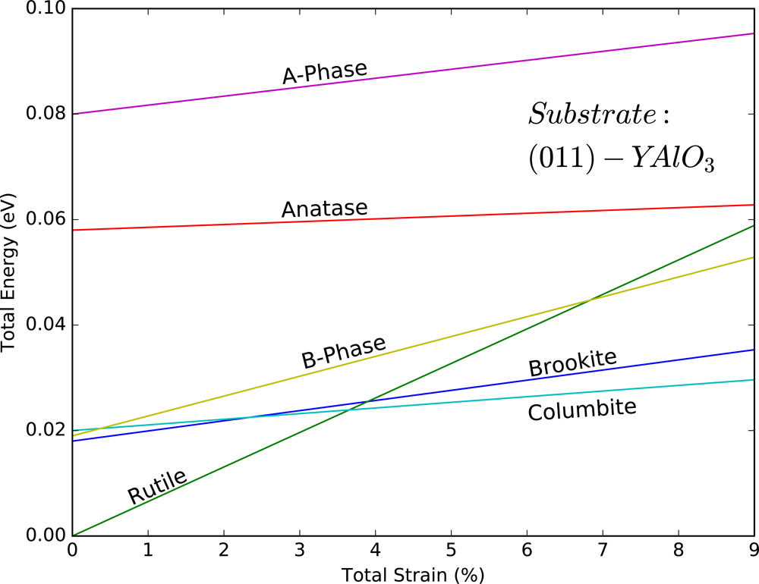

Figure 5. Total energy of VO2 polymorphs as strained on (110)-YAlO3 referenced to the unstrained rutile formation energy. The total energy is the sum of the formation energy and the elastic strain energy.

Dashed red lines highlight one example of superlattice grouping.

epitaxial strain for the six polymorphs of VO2 considered in this study on (011)-YAlO3. The rutile phase is the lowest energy phase up to 3.6% strain, above which columbite exhibits the lowest energy. Hence, we predict that the (011)-YAlO3 substrate enables a phase-stability cross over at a modest strain of 3.6%, where columbite is promoted over the rutile VO2 ground state. While the epitaxial constrain preferentially stabilizes the columbite phase among the considered phases, we also note that the energy difference between columbite and brookite is very small even up to 9% total strain, which may limit the phase selectivity.

4. CONCLUSION

In summary, driven by the need for rational polymorph selection during synthesis, we present a computational framework involving a combination of first-principles calcu-lations of formation energy, elastic strain energy, and topological lattice matching. Using the outlined framework, we prescreen a set of optimal substrates for epitaxial growth, given a target material and/or polymorph. In a simple scenario we examine using homostructural growth selecting a chemically similar system based on common polymorph statistics, lattice matching, and energy above hull. Specifically, for VO2 polymorphs, we findnot surprisinglythat TiO2 substrates, where the VO2 brookite phase would be preferentially grown on the a−c plane while the columbite and anatase structures favor growth on the a−b plane. To support a more general selection scenario, we consider heterostructural growth, where the pool of candidate substrates can generally comprise any chemical system and the orientation relationship between the film and the substrate is obtained through a set of criteria based on the minimal interfacial geometry matching and estimated strain energy as a function of the substrate−film pair. Specifically, for the test case of VO2 polymorphs we find that

13092 DOI: [10.1021/acsami.6b01630](http://dx.doi.org/10.1021/acsami.6b01630)

|  |  |  |
| --- | --- | --- |
| ACS Applied Materials & Interfaces | |  | | --- | | Research Article | |

method for determining phase and orientation relationships and its application to BiFeO3/TiO2 heterostructures. Acta Mater. 2012, 60, 6486−6493.

(9) Havelia, S.; Wang, S.; Balasubramaniam, K.; Schultz, A. M.; Rohrer, G. S.; Salvador, P. A. Combinatorial substrate epitaxy: a new approach to growth of complex metastable compounds. CrystEng-Comm 2013, 15, 5434−5441.

(10) Mehta, P.; Salvador, P. A.; Kitchin, J. R. Identifying Potential BO2 Oxide Polymorphs for Epitaxial Growth Candidates. ACS Appl. Mater. Interfaces 2014, 6, 3630−3639.

(11) Qazilbash, M. M.; Brehm, M.; Chae, B.-G.; Ho, P.-C.; Andreev, G. O.; Kim, B.-J.; Yun, S. J.; Balatsky, A.; Maple, M.; Keilmann, F.; et al. Mott transition in VO2 revealed by infrared spectroscopy and nano-imaging. Science 2007, 318, 1750−1753.

(12) Appavoo, K.; Lei, D. Y.; Sonnefraud, Y.; Wang, B.; Pantelides, S. T.; Maier, S. A.; Haglund, R. F., Jr. Role of defects in the phase transition of VO2 nanoparticles probed by plasmon resonance spectroscopy. Nano Lett. 2012, 12, 780−786.

(13) Kim, M.-W.; Jung, W.-G.; Cho, H.; Bae, T.-S.; Chang, S.-J.; Jang, J.-S.; Hong, W.-K.; Kim, B.-J. Substrate-mediated strain effect on the role of thermal heating and electric field on metal-insulator transition in vanadium dioxide nanobeams. Sci. Rep. 2015, 5, 10861.

(14) Theobald, F. Etude hydrothermale du systme VO2-VO2,5-H2O. J. Less-Common Met. 1977, 53, 55−71. cited by 46.

(15) Oka, Y.; Ohtani, T.; Yamamoto, N.; Takada, T. Phase Transition and Electrical Properties of VO2 (A). Nippon Seramikkusu Kyokai Gakujutsu Ronbunshi 1989, 97, 1134−1137.

(16) Jain, A.; Ong, S. P.; Hautier, G.; Chen, W.; Richards, W. D.; Dacek, S.; Cholia, S.; Gunter, D.; Skinner, D.; Ceder, G.; Persson, K. a. The Materials Project: A materials genome approach to accelerating materials innovation. APL Mater. 2013, 1, 011002.

(17) Blöchl, P. E. Projector augmented-wave method. Phys. Rev. B: Condens. Matter Mater. Phys. 1994, 50, 17953−17979.

(18) Kresse, G.; Joubert, D. From ultrasoft pseudopotentials to the projector augmented-wave method. Phys. Rev. B: Condens. Matter Mater. Phys. 1999, 59, 1758−1775.

(19) Kresse, G.; Hafner, J. Ab initio molecular dynamics for liquid metals. Phys. Rev. B: Condens. Matter Mater. Phys. 1993, 47, 558. (20) Kresse, G.; Furthmüller, J. Efficient iterative schemes for ab initio total-energy calculations using a plane-wave basis set. Phys. Rev. B: Condens. Matter Mater. Phys. 1996, 54, 11169.

(21) Perdew, J. P.; Burke, K.; Ernzerhof, M. Generalized Gradient Approximation Made Simple. Phys. Rev. Lett. 1996, 77, 3865−3868. (22) de Jong, M.; Chen, W.; Angsten, T.; Jain, A.; Notestine, R.; Gamst, A.; Sluiter, M.; Krishna Ande, C.; van der Zwaag, S.; Plata, J. J.; et al. Charting the complete elastic properties of inorganic crystalline compounds. Sci. Data 2015, 2, 150009.

(23) Bavykin, D. V.; Friedrich, J. M.; Walsh, F. C. Protonated titanates and TiO2 nanostructured materials: synthesis, properties, and applications. Adv. Mater. 2006, 18, 2807−2824.

(24) Lin, H.; Li, L.; Zhao, M.; Huang, X.; Chen, X.; Li, G.; Yu, R. Synthesis of high-quality brookite TiO2 single-crystalline nanosheets with specific facets exposed: Tuning catalysts from inert to highly reactive. J. Am. Chem. Soc. 2012, 134, 8328−8331.

(25) Di Paola, A.; Bellardita, M.; Palmisano, L. Brookite, the least known TiO2 photocatalyst. Catalysts 2013, 3, 36−73.

(26) Ping Ong, S.; Wang, L.; Kang, B.; Ceder, G. Li- Fe- P- O2 phase diagram from first principles calculations. Chem. Mater. 2008, 20, 1798−1807.

(27) Hautier, G.; Ong, S. P.; Jain, A.; Moore, C. J.; Ceder, G. Accuracy of density functional theory in predicting formation energies of ternary oxides from binary oxides and its implication on phase stability. Phys. Rev. B: Condens. Matter Mater. Phys. 2012, 85, 155208. (28) Shirley, R.; Kraft, M.; Inderwildi, O. R. Electronic and optical properties of aluminium-doped anatase and rutile TiO2 from ab initio calculations. Phys. Rev. B: Condens. Matter Mater. Phys. 2010, 81, 075111.

(29) Eyert, V. The metal-insulator transitions of VO2: A band theoretical approach. Ann. Phys. 2002, 11, 650−704.

13093 DOI: [10.1021/acsami.6b01630](http://dx.doi.org/10.1021/acsami.6b01630)