**Stabilization of ferroelectric phase in tungsten capped Hf0.8Zr0.2O2**   
[Golnaz Karbasian](http://aip.scitation.org/author/Karbasian%2C+Golnaz), [Roberto dos Reis](http://aip.scitation.org/author/Dos+Reis%2C+Roberto), [Ajay K. Yadav](http://aip.scitation.org/author/Yadav%2C+Ajay+K), [Ava J. Tan](http://aip.scitation.org/author/Tan%2C+Ava+J), [Chenming Hu](http://aip.scitation.org/author/Hu%2C+Chenming), and [Sayeef Salahuddin](http://aip.scitation.org/author/Salahuddin%2C+Sayeef)

Citation: Appl. Phys. Lett.**111**, 022907 (2017);   
View online: <https://doi.org/10.1063/1.4993739>  
View Table of Contents: <http://aip.scitation.org/toc/apl/111/2>Published by the [American Institute of Physics](http://aip.scitation.org/publisher/)

**Articles you may be interested in**  
 [Enhancing ferroelectricity in dopant-free hafnium oxide](http://aip.scitation.org/doi/abs/10.1063/1.4973928)   
[Applied Physics Letters](http://aip.scitation.org/doi/abs/10.1063/1.4973928) **[110](http://aip.scitation.org/doi/abs/10.1063/1.4973928)**[, 022903 (2017); 10.1063/1](http://aip.scitation.org/doi/abs/10.1063/1.4973928).4973928  
 [Ferroelectric and piezoelectric properties of Hf1-xZrxO2 and pure ZrO2 films](http://aip.scitation.org/doi/abs/10.1063/1.4983031)   
Applied Physics Letters **110**, 182905 (2017); 10.1063/1.4983031   
[Ferroelectricity in hafnium oxide thin films](http://aip.scitation.org/doi/abs/10.1063/1.3634052)   
[Applied Physics Letters](http://aip.scitation.org/doi/abs/10.1063/1.3634052) **[99](http://aip.scitation.org/doi/abs/10.1063/1.3634052)**[, 102903 (2011](http://aip.scitation.org/doi/abs/10.1063/1.3634052)); 10.1063/1.3634052  
 [The impact of charge compensated and uncompensated strontium defects on the stabilization of the ferroelectric phase in HfO2](http://aip.scitation.org/doi/abs/10.1063/1.4993110)   
Applied Physics Letters **111**, 082902 (2017); 10.1063/1.4993110   
[Ferroelectric transistors with monolayer molybdenum disulfide and ultra-thin aluminum-doped hafnium oxide Applied Physics Letters](http://aip.scitation.org/doi/abs/10.1063/1.4991877) **[111](http://aip.scitation.org/doi/abs/10.1063/1.4991877)**[, 013103 (2017); 10.1063/1.4991877](http://aip.scitation.org/doi/abs/10.1063/1.4991877)  
 [Understanding ferroelectric Al:HfO2 thin films with Si-based electrodes for 3D applications](http://aip.scitation.org/doi/abs/10.1063/1.4984068)   
Journal of Applied Physics **121**, 204103 (2017); 10.1063/1.4984068

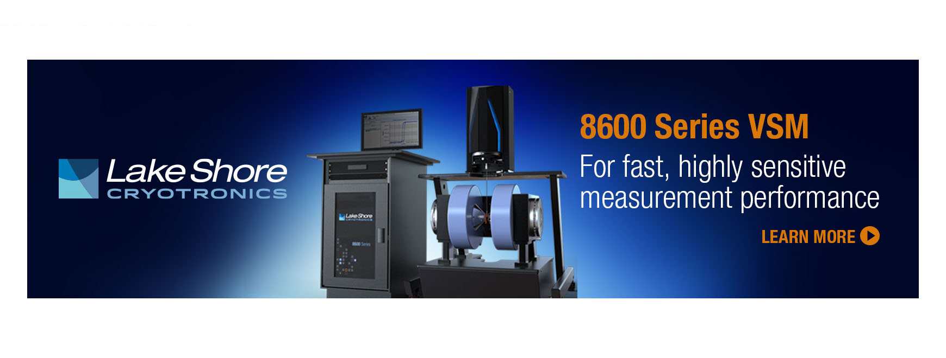

APPLIED PHYSICS LETTERS 111, 022907 (2017) 

[Stabilization of ferroelectric phase in tungsten capped Hf0.8Zr0.2O2](http://dx.doi.org/10.1063/1.4993739)

Golnaz Karbasian,1Roberto dos Reis,2Ajay K. Yadav,1Ava J. Tan,1Chenming Hu,1 and Sayeef Salahuddin1,3,a)   
1Department of Electrical Engineering and Computer Sciences, University of California, Berkeley, California 94720, USA   
2National Center for Electron Microscopy, Molecular Foundry, Lawrence Berkeley National Laboratory, Berkeley, California 94720, USA   
3Energy Storage and Distributed Resources Division, Lawrence Berkeley National Laboratory, 1 Cyclotron Rd, Berkeley, California 94720, USA

(Received 16 May 2017; accepted 23 June 2017; published online 13 July 2017)

We report on the stabilization of the ferroelectric phase in Hf0.8Zr0.2O2 with a tungsten capping layer. Ferroelectricity is obtained in both metal-insulator-metal (MIM) and metal-insulator-semiconductor (MIS) capacitors with highly-doped Si serving as the bottom electrode in the MIS structure. Ferroelectricity is confirmed from both the electrical polarization-voltage (P-V) measure-ment and X-Ray Diffraction analysis that shows the presence of an orthorhombic phase. High-resolution Transmission Electron Microscopy and Energy Dispersive X-ray spectroscopy show minimal diffusion of W into the underlying Hf0.8Zr0.2O2 after the crystallization anneal. This is in contrast to significant Ti and N diffusion observed in ferroelectric HfxZr1-xO2 commonly capped with TiN. Published by AIP Publishing. [<http://dx.doi.org/10.1063/1.4993739>]

Recently, ferroelectric HfO2 films have gained significant interest due to their potential to achieve ultrasmall, non-volatile ferroelectric-gate memory transistors and low voltage transis-tors through the negative capacitance effect.1–20The ferroelec-tric properties of HfO2 films doped with Si, Al, Y, and Zr have been comprehensively studied, and it has been shown that the lack of inversion symmetry in crystals belonging to the ortho-rhombic space group Pca21 (#29) may be responsible for the observed ferroelectricity in these films. The mechanical con-finement by a metal capping layer is believed to stabilize the orthorhombic phase in doped HfO2 films under appropriate annealing conditions. Top layers of TiN, TaN, Pt, and Ir have been shown to result in ferroelectricity in the underlying doped HfO2 films after rapid thermal annealing (RTA). Here, we report on the observation of ferroelectricity in Hf0.8Zr0.2O2 with a W capping layer (hereafter referred to as W-HZO).

The properties of W-HZO in metal-insulator-semiconduc-tor (MIS) and metal-insulator-metal (MIM) structures have been studied and compared with the conventional TiN-HZO stack by polarization-voltage (PV) hysteresis measurement and positive up negative down (PUND) measurement. Grazing Incident X-ray Diffraction (GIXRD) has been used to study the crystallographic structure of HZO films, while the interaction of the top metal with the underlying ferroelectric film has been

|  |  |  |  |  |  |
| --- | --- | --- | --- | --- | --- |
| investigated | by | high | resolution | Transmission | Electron |

Microscopy (TEM) and Energy Dispersive X-ray (EDX) spec-troscopy. Our results show that W is a promising capping layer for the stabilization of the ferroelectric phase in HZO with high remanent polarization and negligible metal-oxide inter-mixing.

For MIS structures, a heavily (1019/cm3) P-doped Si(100) substrate is first oxidized in O2 ambient during an RTA step at 900�C for 20 s, forming 2nm of thermal SiO2 on Si. Later, 100 cycles of Hf0.8Zr0.2O2 is deposited at 250�C using an Ultratech Fiji G2 atomic layer deposition (ALD) tool, providing a 10nm-

a)Electronic mail: [sayeef@berkeley.edu](mailto:sayeef@berkeley.edu).

thick amorphous HZO film. A 4:1 ratio between the HfO2 mono-layer and the ZrO2 mono-layer determines the stoichiom-etry of the deposited HZO. Next, 10 nm of W or TiN is depos-ited on the stack followed by a 30s-RTA step in N2 at 500�C to crystallize the HZO. Finally, a stack of Ti/TiN/Al is sput-tered on the sample, 60nm each, and the top electrodes are defined by subsequent photolithography and reactive ion etch-ing. For MIM capacitors with W or TiN electrodes, the Si sub-strate is first coated with 100 nm of the chosen electrode (W or TiN) followed by deposition of 10nm HZO and 100nm of the same electrode. Next, the stack is annealed under similar condi-tions mentioned above (500�C and 30s), and top electrodes are further defined by lithography and etching. Two methods for TiN deposition have been investigated: DC sputtering at room temperature and ALD at 400�C. In contrast, only DC sputter-ing has been used for deposition of W films reported here.

The PV and PUND measurements described here are performed using a Radiant Precision Multiferroic analyzer. Figures 1(a) and 1(b) show the PUND and PV measurements on MIS structures. The highest (23 lC/cm2) and lowest (5 lC/cm2) remanent polarization (Pr) values in HZO films are observed with W and ALD TiN capping, respectively. The lower Pr for ALD TiN capping (5lC/cm2) compared to sput-tered TiN (12 lC/cm2) is most likely due to prolonged expo-sure (�1 h) of HZO to a temperature of 400�C at which atomic layer deposition of TiN takes place. This temperature is sufficient to initiate the crystallization of the HZO, and par-ticularly during the sample loading and initial cycles of TiN deposition can modify the stabilized phases in the film.21 Crystallization of the HZO film with no capping is expected to result in the stabilization of a non-polar monoclinic phase, and therefore, ALD TiN-capped HZO is expected to be less ferroelectric than the sputtered TiN-capped film.1,21   
 The DC current measurement on MIS capacitors, Fig. S1 in the [supplementary material](ftp://ftp.aip.org/epaps/appl_phys_lett/E-APPLAB-111-015729), shows comparable leakage current for different electrodes.

|  |  |  |
| --- | --- | --- |
| 0003-6951/2017/111(2)/022907/4/$30.00 | 111, 022907-1 | Published by AIP Publishing. |

|  |  |  |
| --- | --- | --- |
| 022907-2 | Karbasian et al. | Appl. Phys. Lett. 111, 022907 (2017) |

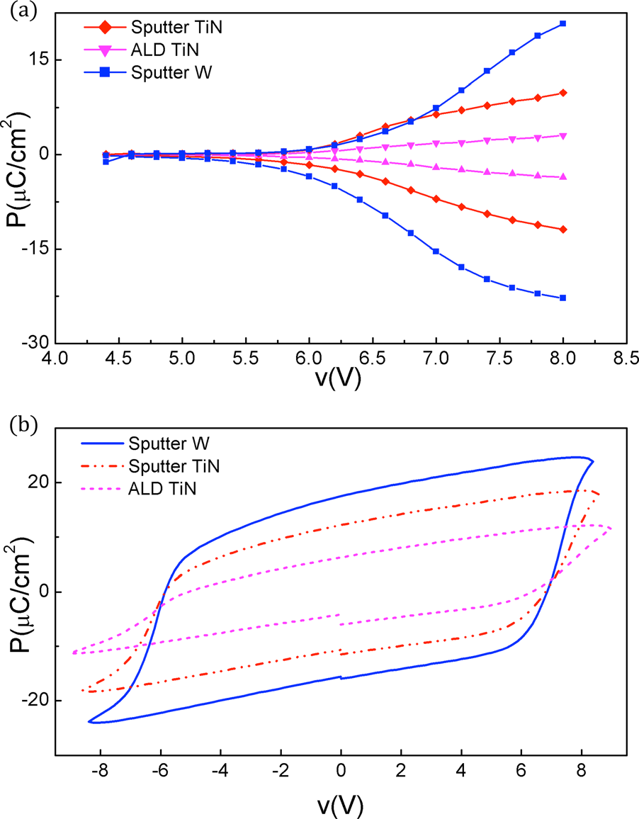

FIG. 1. (a) Remanent polarization as a function of voltage for 10 nm

Hf0.8Zr0.2O2 atop a 2 nm thermal SiO2 layer on a Si substrate capped by sputtered TiN (red), W (blue), and ALD TiN (magenta) crystallized in N2 for 30 s at 500�C. (b) PV hysteresis loops of the same samples: sputtered TiN (red), W (blue), and ALD TiN (magenta).

Similar to MIS structures, MIM capacitors with sput-tered W exhibit higher remanent polarization (10 lC/cm2) than those with TiN (5 lC/cm2), as demonstrated in Figs. 2(a) and 2(b). The lower Pr in MIM capacitors compared to

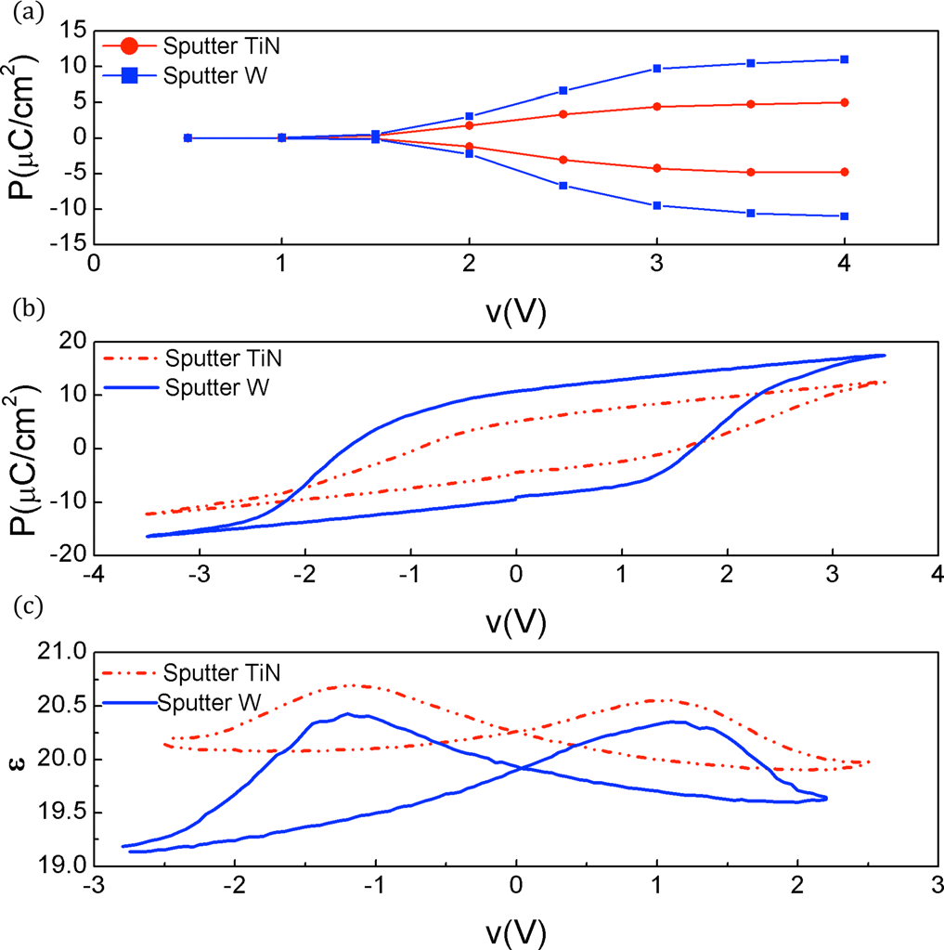

FIG. 2. (a) Remanent polarization as a function of voltage for a 10 nm

Hf0.8Zr0.2O2 sandwiched layer between two 100 nm-thick sputtered TiN (red) and W (blue) films crystallized in N2 for 30 s at 500�C. (b) PV hystere-sis loops of the same samples: TiN (red) and W(blue). (c) Permittivity of the

HZO in the same samples: TiN (red) and W(blue).

MIS has been reported before and was attributed to a weak (111) orientation of the bottom polycrystalline metal elec-trode which slightly suppresses the formation of the ortho-rhombic phase in the top HZO and results in lower Pr in MIM capacitors.11The larger coercive voltage in MIS struc-tures is due to the presence of SiO2 in series with the HZO film, which effectively decreases the voltage drop across the HZO. The permittivity of the HZO film as a function of volt-age, derived from the C-V measurement in MIM structures, shows the typical “butterfly” profile [Fig. 2(c)], indicative of the ferroelectric switching.22   
 Following the crystallization anneal, the top electrode of MIS capacitors is chemically etched in NH4OH:H2O2:H2O in the ratio of 1:1:10 at temperatures above 40�C, and the GIXRD on the underlying HZO is performed [Fig. 3(a)]. The ferroelectric behavior in thin HZO films has been attributed to the stabilization of the orthorhombic phase.23In our syn-thesized HZO films, a mixture of orthorhombic (at 30.4�)

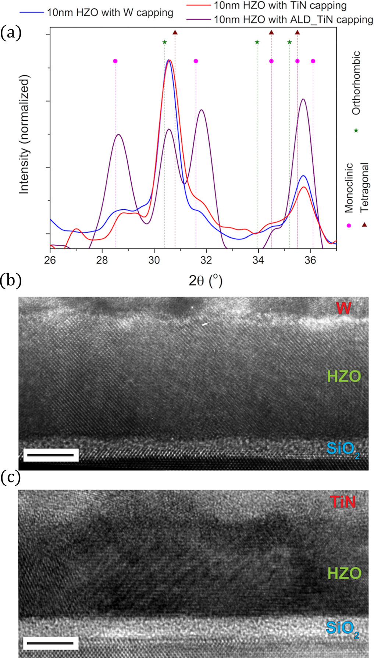

FIG. 3. (a) GIXRD diffractograms, with an incident angle of 0.35�, of 10 nm crystallized HZO films in MIS structures under sputtered TiN (red), sput-tered W (blue), and ALD TiN (purple) capping. [(b) and (c)] The cross-sectional TEM image of W-HZO (b) and TiN-HZO (c) stacks on Si (scale bar, 5 nm). Both stacks present a high crystalline grain size of about 10 nm.

|  |  |  |
| --- | --- | --- |
| 022907-3 | Karbasian et al. | Appl. Phys. Lett. 111, 022907 (2017) |

TABLE I. Summary of elemental analysis of W-HZO and TiN-HZO layers. Atomic % for each element was extracted by averaging values obtained using the

P/B-ZAF standardless method within different layers in the MIS stack. The quantification error (r) is about 1% for all elements except O, which is 3%.

|  |  |  |  |  |  |  |  |
| --- | --- | --- | --- | --- | --- | --- | --- |
| Sample | Layer | Element | Concentration (%) | Sample | Layer | Element | Concentration (%) |
| W/HZO | W | W | 100 | TiN/HZO | TiN | Ti | 53.14 |
| HZO | Hf | 32.31 | HZO | N | 46.86 |
| Hf | 38.18 |
| HZO | Zr | 8.64 | HZO | Zr | 8.13 |
| HZO | O | 59.15 | HZO | O | 30.85 |
| HZO | W | … | HZO | Ti | 12.92 |
| Si | Si | 100 | HZO | N | 9.92 |
| Si | Si | 100 |

and tetragonal (at 30.8�) phase is observed.23For W-HZO, the peak is closer to the theoretical orthorhombic peak com-pared to TiN-HZO (both sputtered and ALD deposited TiN). In addition, the W-HZO film shows an XRD peak with smaller FWHM compared to TiN-HZO, indicating a more textured structure [along the (111) direction]. Note here that the ALD TiN capped HZO film is qualitatively different from the other two films as partial crystallization occurs dur-ing the ALD growth of TiN at 400�C before the RTA annealing. (Sputtered) TiN-HZO and W-HZO MIS capaci-tors were studied in detail by TEM. Thin cross-sectional foils were prepared by mechanical polishing at a 0.5�wedge fol-lowed by Ar ion milling with a starting energy of 3 keV down to a final cleaning energy of 200 eV. High Resolution TEM (HR-TEM) and EDX were performed on an FEI-Titan instrument operating at an acceleration voltage of 200 kV. Elemental maps were acquired in the ChemSTEM mode using a Bruker EDS windowless Silicon Drift Detector (SDD) concurrently with High-Angle Annular Dark-Field (HAADF) images. Figures 3(b) and 3(c) show the cross-sectional TEM image of MIS W-HZO and TiN-HZO, respectively. A 1.9 nm thick SiO2 layer separates the HZO layer from the Si substrate, relaxing the epitaxial strain

between these layers. Considering the TEM images of Figs. 3(b) and 3(c), one can notice a clear boundary at the W-HZO interface, while the TiN-HZO boundary is smeared, indicat-ing an intermixing of TiN and underlying HZO.

In order to investigate the diffusion of elements from the metal cap layer into the HZO, the EDX elemental analysis is performed, and the point spectrum (shown in Fig. S2 in the [supplementary material](ftp://ftp.aip.org/epaps/appl_phys_lett/E-APPLAB-111-015729)) was collected from the Si substrate, the HZO layer, and the metal cap independently. All elements possible to be present in the HZO layer were con-sidered for a final quantification, which is summarized in Table I. A summary of the elemental analysis is plotted as a 2-D false color map in Fig. 4 along with HAADF images for a better visualization of the layers.

While there is a clear trace of the TiN capping layer in the underlying HZO, the EDX measurements given in Fig. 4(a) and Table I show the absence of W in HZO. Based on these measurements, it becomes evident that annealing of TiN-HZO promotes diffusion of Ti and N atoms into the HZO film, which further confirms the smeared TiN-HZO interface. In contrast, the intact W-HZO interface indicates the negligible interaction of W with HZO during the high temperature treatments. It has been previously reported that

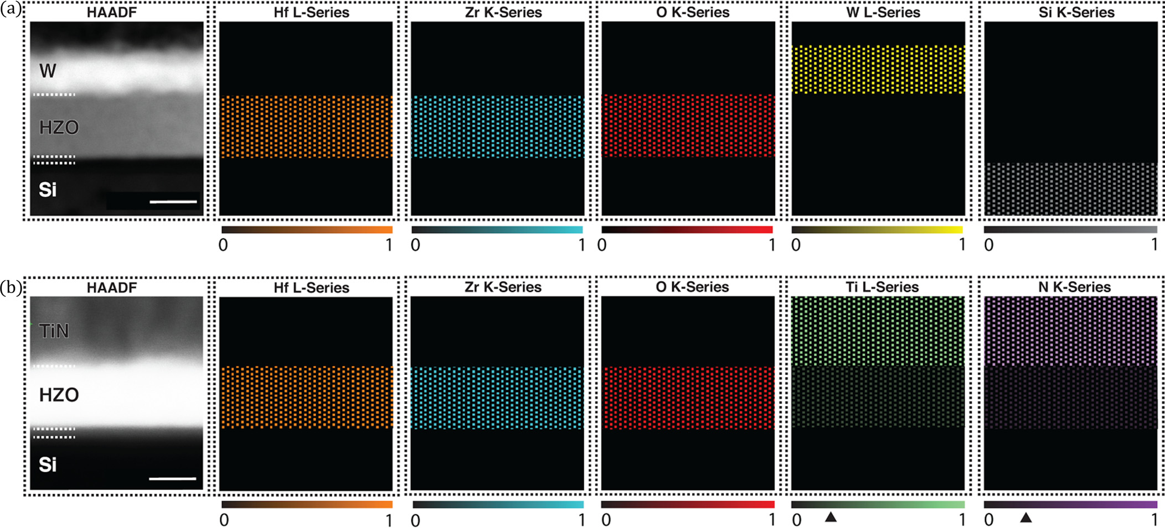

FIG. 4. False colored EDX maps representing the averaged composition of (a) W-HZO and (b) TiN-HZO layers along with HAADF images (scale bar, 10 nm). The color bar for each element represents the average concentration normalized by the highest concentration of that element within the whole stack. For example, 1 represents the highest measured concentration and 0 the absence of the element. Ti and N concentrations within HZO normalized by those con-centrations in the top TiN layer are denoted by the arrowhead.

|  |  |  |
| --- | --- | --- |
| 022907-4 | Karbasian et al. | Appl. Phys. Lett. 111, 022907 (2017) |

the presence of N atoms in the HfO2 films creates positively charged oxygen vacancies2,24,25and the formed vacancies are believed to help stabilize the orthorhombic phase in doped HfO2.7However, our results show that a similar (and even stronger) ferroelectric behavior can be achieved for W-HZO, where no nitrogen is present in the underlying HZO film. This shows that the presence of N and its diffusion are not critical factors to achieve ferroelectricity. Importantly, diffusion of Ti and/or N could lead to increased leakage,25 especially in ultra-thin films, which is undesirable for elec-tronic applications. In that context, the ferroelectric W-capped HZO reported in this work could be more effective.

In conclusion, we have shown that a W capping layer can be used to stabilize the ferroelectric phase in Hf0.8Zr0.2O2. Compared to widely used TiN-capped Hf0.8Zr0.2O2 films, W-capped HZO shows superior properties in terms of remanent polarization and metal-oxide intermixing. HR-TEM and EDX analyses show minimal W diffusion into the HZO film as opposed to significant Ti and N diffusion found in TiN capped samples. The stronger ferroelectricity in W-capped films is somewhat surprising, as the presence of N in the HZO films has often been considered as a catalyst for oxygen vacancy formation that leads to ferroelectricity in HZO. Nevertheless, our results indicate that a high quality ferroelectric film can be obtained with W capping without introducing structural defects coming from cap metal diffusion. Further studies will have to focus on understanding the formation and behavior of oxygen vacancies in such W-capped films.

See [supplementary material](ftp://ftp.aip.org/epaps/appl_phys_lett/E-APPLAB-111-015729) for the data on DC leakage current of MIS capacitors and for the full EDX spectrum of W-HZO and TiN-HZO structures.

This research was funded by Berkeley Center for Negative Capacitance Transistors (BCNCT). The work at the Molecular Foundry was supported by the Office of Science, Office of Basic Energy Sciences, of the U.S. Department of Energy under Contract No. DE-AC0205CH11231.

1J. M€uller, T. S. B€oscke, U. Schr€oder, S. Mueller, D. Br€auhaus, U. B€ottger, L. Frey, and T. Mikolajick, [Nano Lett.](http://dx.doi.org/10.1021/nl302049k) 12, 4318 (2012).

2P. D. Lomenzo, Q. Takmeel, C. Zhou, C. M. Fancher, E. Lambers, N. G. Rudawski, J. L. Jones, S. Moghaddam, and T. Nishida, [J. Appl. Phys.](http://dx.doi.org/10.1063/1.4916715) 117,

3T. S. B€oscke, J. M€uller, D. Br€auhaus, U. Schr€oder, and U. B€ottger, [Appl. Phys. Lett.](http://dx.doi.org/10.1063/1.3634052) 99, 102903 (2011).

4S. Mueller, J. Mueller, A. Singh, S. Riedel, J. Sundqvist, U. Schroeder, and T. Mikolajick, [Adv. Funct. Mat.](http://dx.doi.org/10.1002/adfm.201103119) 22, 2412 (2012).

5T. Shimizu, K. Katayama, T. Kiguchi, A. Akama, T. J. Konno, O. Sakata, and H. Funakubo, [Sci. Rep.](http://dx.doi.org/10.1038/srep32931) 6, 32931 (2016).

6X. Sang, E. D. Grimley, T. Schenk, U. Schroeder, and J. M. LeBeau, [Appl. Phys. Lett.](http://dx.doi.org/10.1063/1.4919135) 106, 162905 (2015).

7M. H. Park, Y. H. Lee, H. J. Kim, Y. J. Kim, T. Moon, K. D. Kim, J. M€uller, A. Kersch, U. Schroeder, T. Mikolajick, and C. S. Hwang, [Adv. Mater.](http://dx.doi.org/10.1002/adma.201404531) 27, 1811 (2015).

8T. D. Huan, V. Sharma, G. A. Rossetti, and R. Ramprasad, [Phys. Rev. B](http://dx.doi.org/10.1103/PhysRevB.90.064111) 90, 064111 (2014).

9M. Hoffmann, U. Schroeder, T. Schenk, T. Shimizu, H. Funakubo, O. Sakata, D. Pohl, M. Drescher, C. Adelmann, R. Materlik, A. Kersch, and T. Mikolajick, [J. Appl. Phys.](http://dx.doi.org/10.1063/1.4927805) 118, 072006 (2015).

10M. H. Park, H. J. Kim, Y. J. Kim, W. Lee, H. K. Kim, and C. S. Hwang, [App. Phys. Lett.](http://dx.doi.org/10.1063/1.4798265) 102, 112914 (2013).

11P. D. Lomenzo, P. Zhao, Q. Takmeel, S. Moghaddam, T. Nishida, M. Nelson, C. M. Fancher, E. D. Grimley, X. Sang, J. M. LeBeau, and J. L. Jones, [J. Vac. Sci. Technol.](http://dx.doi.org/10.1116/1.4873323) 32, 03D123 (2014).

12K. Katayama, T. Shimizu, O. Sakata, T. Shiraishi, S. Nakamura, T. Kiguchi, A. Akama, T. J. Konno, H. Uchida, and H. Funakubo, [J. Appl. Phys.](http://dx.doi.org/10.1063/1.4945029) 119, 134101 (2016).

13L. Xu, T. Nishimura, S. Shibayama, T. Yajima, S. Migita, and A. Toriumi, [Appl. Phys. Exp.](http://dx.doi.org/10.7567/APEX.9.091501) 9, 091501 (2016).

14T. Nishimura, L. Xu, S. Shibayama, T. Yajima, S. Migita, and A. Toriumi, [Jpn. J. Appl. Phys.](http://dx.doi.org/10.7567/JJAP.55.08PB01) 55, 08PB01 (2016).

15A. Pal, V. K. Narasimhan, S. Weeks, K. Littau, D. Pramanik, and T. Chiang, [App. Phys. Lett.](http://dx.doi.org/10.1063/1.4973928) 110, 022903 (2017).

16S. Salahuddin and S. Datta, [Nano lett.](http://dx.doi.org/10.1021/nl071804g) 8, 405 (2008).

17A. I. Khan, D. Bhowmik, P. Yu, S. J. Kim, X. Pan, R. Ramesh, and S. Salahuddin, [Appl. Phys. Lett.](http://dx.doi.org/10.1063/1.3634072) 99, 113501 (2011).

18K. S. Li, P. G. Chen, T. Y. Lai, C. H. Lin, C. C. Cheng, C. C. Chen, Y. J. Wei, Y. F. Hou, M. H. Liao, M. H. Lee, M. C. Chen, J. M. Sheih, W. K. Yeh, F. L. Yang, S. Salahuddin, and C. Hu, in IEEE International Electron

|  |  |  |  |  |  |  |
| --- | --- | --- | --- | --- | --- | --- |
| Devices | Meeting | (IEDM) | Technical | Digest | on | Sub-60mV-Swing |

Negative-Capacitance FinFET without Hysteresis 2015, Washington DC, USA, 7–9 December 2015.

19M. Hoffmann, M. Pe�si’c, K. Chatterjee, A. I. Khan, S. Salahuddin, S. Slesazeck, U. Schroeder, and T. Mikolajick, [Adv. Funct. Mater.](http://dx.doi.org/10.1002/adfm.201602869) 26, 8643 (2016).

20R. Materlik, C. K€unneth, and A. Kersch, [J. Appl. Phys.](http://dx.doi.org/10.1063/1.4916707) 117, 134109 (2015).

21C. Zhao, G. Roebben, M. Heyns, and O. V. D. Biest, [Key Eng. Mater.](http://dx.doi.org/10.4028/www.scientific.net/KEM.206-213.1285)  206–213, 1285 (2002).

22W. Choi, S. Kim, Y. W. Jin, S. Y. Lee, and T. D. Sands, [Appl. Phys. Lett.](http://dx.doi.org/10.1063/1.3561751)  98, 102901 (2011).

23M. H. Park, H. J. Kim, Y. J. Kim, W. Lee, T. Moon, and C. S. Hwang, [Appl. Phys. Lett.](http://dx.doi.org/10.1063/1.4811483) 102, 242905 (2013).

24N. Umezawa, K. Shiraishi, T. Ohno, H. Watanabe, T. Chikyow, K. Torii, K. Yamabe, K. Yamada, H. Kitajima, and T. Arikado, [Appl. Phys. Lett.](http://dx.doi.org/10.1063/1.1899232) 86, 143507 (2005).

25D. Zhou, J. M€uller, J. Xu, S. Knebel, D. Br€auhaus, and U. Schr€oder, [Appl.](http://dx.doi.org/10.1063/1.3688915)

134105 (2015). [Phys. Lett.](http://dx.doi.org/10.1063/1.3688915) 100, 082905 (2012).