**Stabilizing the ferroelectric phase in doped hafnium oxide**

[M. Hoffma](http://aip.scitation.org/author/Adelmann%2C+C)[n](http://aip.scitation.org/author/Hoffmann%2C+M)[n, U. Schr](http://aip.scitation.org/author/Materlik%2C+R)[o](http://aip.scitation.org/author/Schroeder%2C+U)[eder, T. Sc](http://aip.scitation.org/author/Kersch%2C+A)[henk](http://aip.scitation.org/author/Schenk%2C+T)[, T. Shimizu,](http://aip.scitation.org/author/Mikolajick%2C+T) [H. Funakubo](http://aip.scitation.org/author/Funakubo%2C+H), [O. Sakata](http://aip.scitation.org/author/Sakata%2C+O), [D. Pohl](http://aip.scitation.org/author/Pohl%2C+D), [M. Drescher](http://aip.scitation.org/author/Drescher%2C+M), [C. Adelmann](http://aip.scitation.org/author/Adelmann%2C+C)[,](http://aip.scitation.org/author/Hoffmann%2C+M) [R. Materlik](http://aip.scitation.org/author/Materlik%2C+R), [A. Kersch](http://aip.scitation.org/author/Kersch%2C+A), and [T. Mikolajick](http://aip.scitation.org/author/Mikolajick%2C+T)

Citation: Journal of Applied Physics**118**, 072006 (2015);

View online: <https://doi.org/10.1063/1.4927805>

View Table of Contents: <http://aip.scitation.org/toc/jap/118/7>

Published by the [American Institute of Physics](http://aip.scitation.org/publisher/)

**Articles you may be interested in**

[The origin of ferroelectricity in Hf1-xZrxO2: A computational investigation and a surface energy model](http://aip.scitation.org/doi/abs/10.1063/1.4916707) Journal of Applied Physics **117**, 134109 (2015); 10.1063/1.4916707

[Ferroelectricity in hafnium oxide thin films](http://aip.scitation.org/doi/abs/10.1063/1.3634052)   
[Applied Physics Letters](http://aip.scitation.org/doi/abs/10.1063/1.3634052) **[99](http://aip.scitation.org/doi/abs/10.1063/1.3634052)**[, 102903 (2011](http://aip.scitation.org/doi/abs/10.1063/1.3634052)); 10.1063/1.3634052

[On the structural origins of ferroelectricity in HfO2 thin films](http://aip.scitation.org/doi/abs/10.1063/1.4919135) Applied Physics Letters **106**, 162905 (2015); 10.1063/1.4919135

[Evidence for oxygen vacancies movement during wake-up in ferroelectric hafnium oxide Applied Physics Letters](http://aip.scitation.org/doi/abs/10.1063/1.4940370) **[108](http://aip.scitation.org/doi/abs/10.1063/1.4940370)**[, 032903 (2016); 10.1063/1.4940370](http://aip.scitation.org/doi/abs/10.1063/1.4940370)

[Enhancing ferroelectricity in dopant-free hafnium oxide](http://aip.scitation.org/doi/abs/10.1063/1.4973928)   
[Applied Physics Letters](http://aip.scitation.org/doi/abs/10.1063/1.4973928) **[110](http://aip.scitation.org/doi/abs/10.1063/1.4973928)**[, 022903 (2017); 10.1063/1](http://aip.scitation.org/doi/abs/10.1063/1.4973928).4973928

[Ferroelectricity in undoped hafnium oxide](http://aip.scitation.org/doi/abs/10.1063/1.4922272)   
[Applied Physics Letters](http://aip.scitation.org/doi/abs/10.1063/1.4922272) **[106](http://aip.scitation.org/doi/abs/10.1063/1.4922272)**[, 232905 (201](http://aip.scitation.org/doi/abs/10.1063/1.4922272)5); 10.1063/1.4922272



JOURNAL OF APPLIED PHYSICS 118, 072006 (2015) 

[Stabilizing the ferroelectric phase in doped hafnium oxide](http://dx.doi.org/10.1063/1.4927805)

M. Hoffmann,1U. Schroeder,1T. Schenk,1T. Shimizu,2H. Funakubo,2,3O. Sakata,2,4 D. Pohl,5M. Drescher,6C. Adelmann,7R. Materlik,8A. Kersch,8and T. Mikolajick1,9 1NaMLab gGmbH, Noethnitzer Str. 64, D-01187 Dresden, Germany   
2Materials Research Center for Element Strategy, Tokyo Institute of Technology, Yokohama 226-8503, Japan 3Department of Innovative and Engineered Materials, Tokyo Institute of Technology, Yokohama 226-8502,

Japan   
4Synchrotron X-ray Station at SPring-8, National Institute for Materials Science (NIMS), Sayo,

Hyogo 679-5148, Japan   
5Leibniz IFW Dresden, Helmholtzstr.20, D-01171 Dresden, Germany   
6Fraunhofer IPMS-CNT, Koenigsbruecker Str. 180, D-01099 Dresden, Germany 7Imec, Kapeldreef 75, B-3001 Leuven, Belgium   
8Munich University of Applied Sciences, Loth Str. 34, D-80335 Munich, Germany 9Chair of Nanoelectronic Materials, TU Dresden, D-01062 Dresden, Germany

(Received 7 October 2014; accepted 7 February 2015; published online 19 August 2015)

The ferroelectric properties and crystal structure of doped HfO2 thin films were investigated for

different thicknesses, electrode materials, and annealing conditions. Metal-ferroelectric-metal

capacitors containing Gd:HfO2 showed no reduction of the polarization within the studied

thickness range, in contrast to hafnia films with other dopants. A qualitative model describing the

influence of basic process parameters on the crystal structure of HfO2 was proposed. The influence

of different structural parameters on the field cycling behavior was examined. This revealed the

wake-up effect in doped HfO2 to be dominated by interface induced effects, rather than a field

induced phase transition. TaN electrodes were shown to considerably enhance the stabilization of

the ferroelectric phase in HfO2 compared to TiN electrodes, yielding a Pr of up to 35 lC/cm2. This

effect was attributed to the interface oxidation of the electrodes during annealing, resulting in a dif-

ferent density of oxygen vacancies in the Gd:HfO2 films. Ab initio simulations confirmed the influ-

ence of oxygen vacancies on the phase stability of ferroelectric HfO2. V C 2015 AIP Publishing LLC.

[<http://dx.doi.org/10.1063/1.4927805>]

I. INTRODUCTION

Ferroelectricity has recently been discovered to occur in Si doped HfO2.1Various other dopants2–6also have been reported to stabilize the non-centrosymmetric orthorhombic phase of space group Pbc21 that is believed to be the origin of this previously unexpected behavior.1The crystallization of the, at room temperature stable, monoclinic P21/c phase was impeded by mechanical encapsulation with a thin elec-trode layer.7Whereas, the higher symmetry tetragonal (P42/ nmc) or cubic (Fm3m) phases were present in most ferro-electric HfO2 films.8The mechanisms that stabilize the ferro-electric phase of HfO2 are still not completely understood. The same applies to the electric field cycling behavior9 including wake-up10–12and fatigue effects.13,14Therefore, several influencing factors on the properties of ferroelectric Gd:HfO2 are investigated in this paper, such as film thick-ness,15annealing conditions,16and electrode interfaces.17 Possible structural causes for ferroelectricity and field cy-cling effects in doped HfO2, like grain sizes,18oxygen vacancies,19and potentially field induced phase transitions,20

as a gate dielectric in modern field-effect transistors (FETs) for many years.22Mature deposition techniques like atomic

layer deposition (ALD) enable new 3D integration schemes for FRAM capacitors.23Additionally, ferroelectric FETs

(FeFETs) have already been fabricated in a 28 nm high-k

metal gate technology demonstrating the potential of doped HfO2 for highly scaled memory devices.24The current International Technology Roadmap for Semiconductors

(ITRS) also states this material system to be a promising can-didate for future downscaling of FeFETs.21

Classical ferroelectrics like PZT initially faced severe

problems with polarization fatigue while using Pt electro-des.25This problem was then solved by adopting new elec-trode materials like Ir or IrO2.26Typically, TiN electrodes

were applied in combination with ferroelectric HfO2 show-ing similar fatigue behavior.13,14Therefore, different elec-

trode materials have been investigated recently, including RuO2,27Pt,17,28and Ir.18,29,30Although all of these electro-

des were able to stabilize the ferroelectric phase, no

improvement compared to TiN was reported so far. In this

|  |  |  |  |  |  |
| --- | --- | --- | --- | --- | --- |
| are discussed. | ferroelectric | random | access | memory | study, Gd:HfO2 capacitors with different combinations of |
| Non-volatile | TiN and TaN electrodes as well as various annealing condi- |

(FRAM) based on classical perovskite ferroelectrics such as lead zirconate titanate (PZT) or strontium bismuth tantalate (SBT) are not easily integrated into current silicon technol-ogy and face severe scaling limitations.21HfO2 on the other hand is a lead-free simple binary oxide that has been applied

tions were investigated. The influence on the electrical and structural characteristics is reported. TiN and TaN electrodes are especially of interest, since they are widely used in cur-rent high-k metal gate process integration21and, therefore, have great potential for future FeFET applications.

|  |  |  |
| --- | --- | --- |
| 0021-8979/2015/118(7)/072006/9/$30.00 | 118, 072006-1 | V C 2015 AIP Publishing LLC |

|  |  |  |
| --- | --- | --- |
| 072006-2 | Hoffmann et al. | J. Appl. Phys. 118, 072006 (2015) |

II. EXPERIMENTAL

Planar metal-ferroelectric-metal (MFM) capacitors were fabricated on p-doped Si (100) substrates. Initially, either TiN or TaN bottom electrodes (BEs) of 10 nm thickness were formed by reactive sputtering at room temperature. Thermal ALD at 300�C was then used to deposit Gd doped HfO2 films from HfCl4, Gd(iPrCp)3 and H2O precursors. An ALD cycle ratio of 27:1 (Hf to Gd precursor pulses) was applied to achieve a Gd content of 3.4 cat% (cationic ratio of Gd/[Gd þ Hf]) in the HfO2 layers as confirmed by elastic recoil detection analysis. By adjusting the number of ALD cycles, 10 nm to 27 nm thin films were fabricated as verified by X-ray reflectivity (XRR) measurements. Similar to the BEs, 10 nm thick TiN or TaN top electrodes (TEs) were de-posited by reactive sputtering at room temperature, whereby the TaN TEs were only used on samples that also had a TaN BE. The previously amorphous Gd:HfO2 films were then crystallized by a post metallization anneal (PMA) in an N2 ambient with different annealing conditions: 450�C for 10 min, 650�C for 20 s, 650�C for 10 min, and 800�C for 20 s. Finally, a Ti adhesion layer of 10 nm and a Pt layer of 50 nm were deposited by evaporation through a shadow mask to create circular contact pads of 200 lm diameter. These Pt dots also served as a hard mask during the subse-quent removal of the TiN or TaN TE in an etch solution con-taining NH4OH, H2O2, and H2O.

XRR and grazing incidence X-ray diffraction (GIXRD) measurements were carried out on a Bruker D8 Discover (Cu-Ka radiation, k ¼ 0.154 nm) for structural analysis of the samples. Also, micro-spot XRD was measured at beam-line BL15XU, SPring-8. The few lm wide rectangular X-ray beam (k ¼ 0.10004 nm), concentrated through a two-dimensional lens, enabled us to characterize single contact pads before and after electric field cycling. Additionally, bright and dark field high resolution transmission electron microscopy (TEM) was performed on a FEI Titan3 80–300 microscope operated at 300 kV (equipped with a field emis-sion gun, CEOS CetCor CS-image corrector and a high angle annular dark field detector). Depth profiles of the elemental composition of the MFM stacks were obtained by time-of-flight secondary ion mass spectrometry (ToF-SIMS) on a TOF.SIMS 300R tool from ION-TOF GmbH. For the sput-tering beam, Csþions with an energy of 1 keV were used, while the analysis beam consisted of Biþions with 25 keV.

|  |  |  |  |  |  |
| --- | --- | --- | --- | --- | --- |
| Electric | polarization | and | fatigue | measurements | were |

conducted using a TF Analyzer 3000 with FE-Module (aixACCT Systems) at 10 kHz with the BE on ground poten-tial. Triangular and rectangular voltage signals were used for

|  |  |  |  |
| --- | --- | --- | --- |
| dynamic | hysteresis | measurements and | fatigue cycling, |

respectively. Small signal capacitance-voltage measurements were carried out on a 4200-SCS Parameter Analyzer (Keithley Instruments) to obtain the relative permittivity k of the Gd:HfO2 films at 10 kHz and 30 mV small signal ampli-tude (rms).

Using ab initio calculations conducted by the software package Abinit,31,32the total energies (Etot) of the mono-clinic, tetragonal, cubic as well as the orthorhombic Pbc21

|  |  |  |  |  |  |
| --- | --- | --- | --- | --- | --- |
| HfO2-phases | were | calculated. | The | calculations | were |

performed with a 24 atomic cell using a 3 � 6 � 6 k-Point grid and Troullier-Martins-pseudo potentials at an energy cutoff of 816 meV. One or two oxygen atoms were deleted from the 24 atomic cells to create vacancy concentrations corresponding to 6.25% and 12.5%. Calculations with vacan-cies were performed for both threefold and fourfold coordi-nated oxygen atoms deleted, as well as a mixture of both. Oxygen vacancies were calculated charge neutral, since it was assumed that the charge is compensated within the cal-culated supercell.

III. RESULTS AND DISCUSSION

A. Impact of layer thickness and wake-up effect

When measuring the polarization P vs the electric field E (P-E curves) on fresh Gd:HfO2 samples, a constricted hysteresis is obtained, corresponding to more than one dis-tinct current density peak in the J-E curves, as can be seen in Fig. 1 for 27 nm films annealed at 650�C for 20 s. After elec-tric field cycling, the current peaks merge into one distinct maximum, resulting in a broadening of the P-E hysteresis. This so called wake-up behavior has been reported for both perovskite11,12,33and doped HfO2 ferroelectrics.8This effect has to be taken into account especially for FRAM applica-tions, since remanent polarization Pr and coercive field Ec increase during field cycling. If not stated otherwise, Pr and Ec values given in the text or figures always refer to the posi-tive values, which are in most cases almost identical to the negative ones.

The wake-up behavior previously reported for 10 nm Gd:HfO2 samples showed that more than 1000 field cycles were necessary to achieve a coalescence of switching current peaks.3,16In contrast, Fig. 1 shows that only about 5 cycles are sufficient to achieve a similar peak merging in 27 nm thick films. The root cause of this behavior in doped HfO2 is still not fully understood. One explanation is the occurrence of a field-induced phase transition during cycling, that

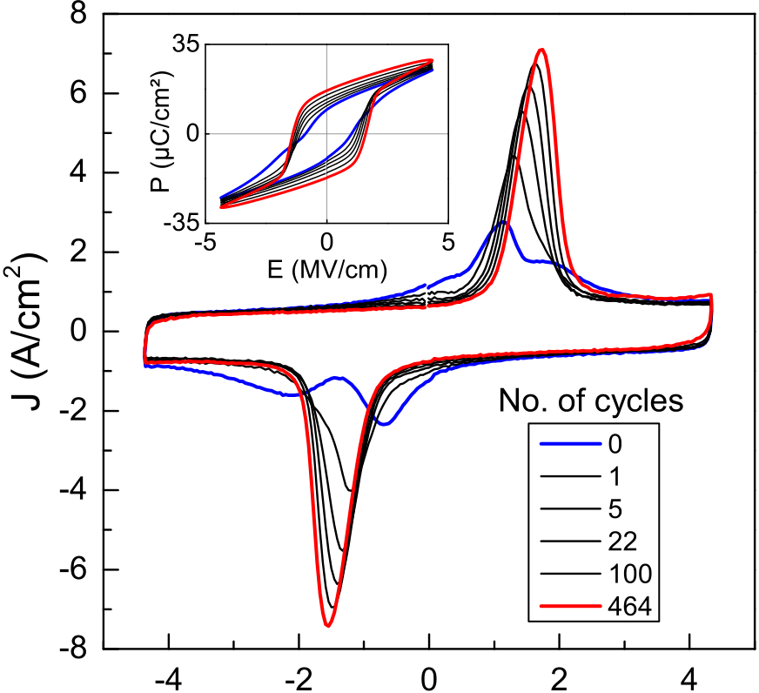



FIG. 1. Wake-up effect in 27 nm Gd:HfO2 with TiN electrodes cycled at 4.4 MV/cm.

|  |  |  |
| --- | --- | --- |
| 072006-3 | Hoffmann et al. | J. Appl. Phys. 118, 072006 (2015) |

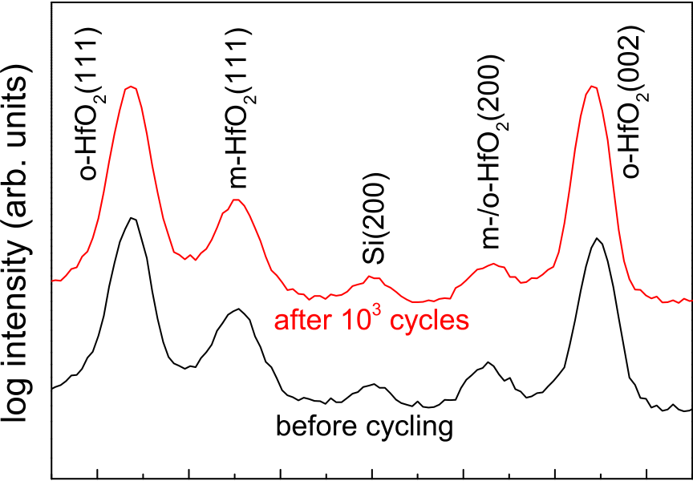

|  |  |  |  |  |  |  |
| --- | --- | --- | --- | --- | --- | --- |
|  |  |  |  |  |  |  |



FIG. 2. Micro-spot XRD on single MFM capacitors before and after cycling.

promotes a transformation from the paraelectric tetragonal/ cubic or monoclinic phases into the ferroelectric orthorhom-bic phase.20A different mechanism was proposed by Zhou et al., which involves the de-trapping of charged defects (like oxygen vacancies) from interfacial states near the electrode-ferroelectric junctions.10These defects suppress the nucleation of domains of the opposite polarity rather than pinning domain walls as seen in other bulk ferroelec-trics.25,34The origin of such defects in MFM stacks with TiN electrodes was assumed to be the formation of TiOxNy due to oxidation of TiN during HfO2 ALD and TE deposi-tion, resulting in a substantial aggregation of oxygen vacan-cies near the electrode interface.10,27The PMA especially favors further interface oxidation of TiN electrodes in MFM stacks.35   
 To further investigate the possibility of a field induced phase transition, micro-spot XRD was measured on single MFM capacitors before and after 1000 switching cycles. Fig. 2 shows the results with the intensity peaks assigned to the respective phases of HfO2. The slight difference in peak intensities does not point to a possible phase transition, since the diffractograms had to be measured on different contact pads, whereas the peak positions were used to determine the lattice parameters a, b, and c for the orthorhombic phase before and after cycling. Assuming that the (200) peak at 34.3�belongs to the orthorhombic pattern, three peaks were available to calculate the lattice constants given in Table I. The calculated values are in good agreement with the

TABLE I. Orthorhombic lattice parameters calculated from XRD peak posi-tions in Fig. 2.

|  |  |  |  |  |  |  |  |  |
| --- | --- | --- | --- | --- | --- | --- | --- | --- |
|  | Lattice plane distance (A˚ ) | | | Lattice constants (A˚ ) | | | | |
| Measured/Reference | (111) | (200) | (002) | a | b | | c | |
| Before cycling | 2.941 | 2.614 | 2.530 | 5.228 | | 5.003 | | 5.059 |
| After 103cycles | 2.941 | 2.615 | 2.534 | 5.229 | | 4.994 | | 5.067 |
| Reference 32 | — | — | — | 5.23 | 5.01 | | 5.07 | |

previously reported ones for the orthorhombic Pbc21 phase in Gd:HfO2 (Ref. 36) where the c-axis is the polar axis. The diffractogram of the micro-spot XRD was converted to a 2#-scale in Fig. 2 to enable a comparison to the GIXRD results presented later (Figs. 4 and 8). The change in lattice con-stants through field cycling is quite small and suggests that a field induced phase transition is not the dominant mechanism causing the wake-up effect in these ferroelectric thin films. Therefore, the de-trapping effect discussed earlier, which depends on the electrode interfaces, appears to be more likely.

Fig. 3(a) shows a dark field TEM of a 27 nm sample with TiN electrodes. Single grains are clearly visible on the left side with lateral dimensions of about 30 nm. This coin-cides with reports of 20–30 nm big grains in other HfO2 based ferroelectrics.8,37Thus, it seems typical for these ferro-electric HfO2 films that grain boundaries are mostly oriented perpendicular to the capacitor surface at least up to a film thickness of about 30 nm. Since dark field TEM is able to detect grains with the same orientation, it is likely that mainly single grain domains exist in Gd:HfO2. A recent pie-zoresponse force microscopy study20has also shown that fer-roelectric domains in Si:HfO2 typically contain about one to three grains. A closer look at the interface between the Gd:HfO2 and the TiN BE is given in the TEM in Fig. 3(b). The polycrystalline structure of the BE influences the growth and orientation of grains during the PMA. The irregularity of the TiN BE highlighted by the arrow on the right side in Fig. 3(b) for example coincides with the grain boundary of the Gd:HfO2 film directly above. The interface is also not atomically abrupt, presumably due to the formation of a TiOxNy layer between TiN and Gd:HfO2.10,27This reinforces the view that the crystalline structure of these ferroelectric

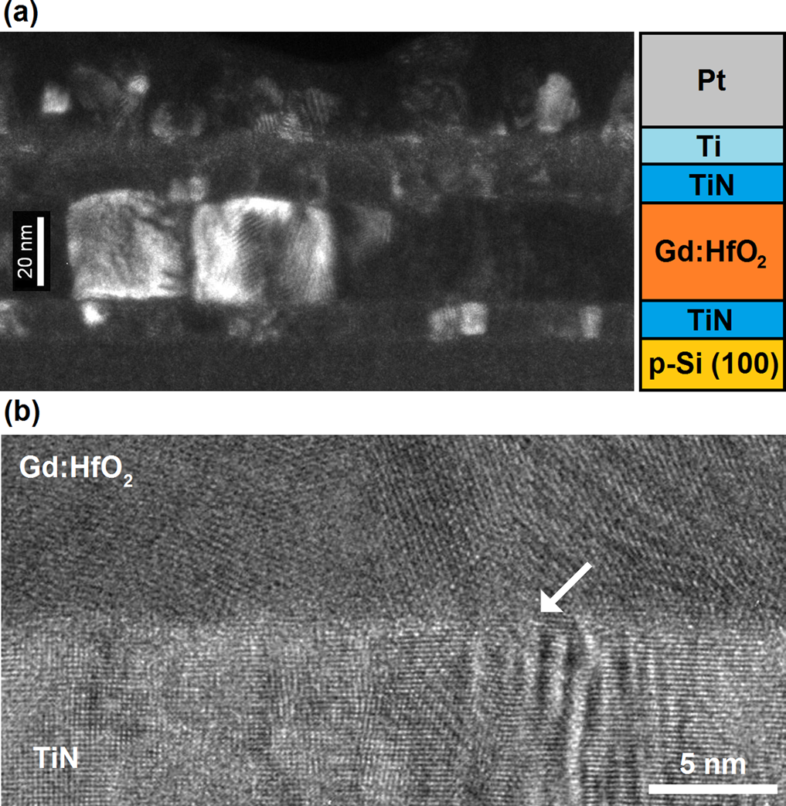

|  |  |  |  |  |  |  |  |
| --- | --- | --- | --- | --- | --- | --- | --- |
| Reference 4 | — | — | — | 5.24 | 5.01 | 5.05 | FIG. 3. (a) Dark field TEM shows Gd:HfO2 grain sizes of about 30 nm. (b) |
| (Hf0.5Zr0.5O2) | Bright field TEM of the BE interface. The arrow indicates a Gd:HfO2 grain |

boundary which coincides with a TiN boundary.

|  |  |  |
| --- | --- | --- |
| 072006-4 | Hoffmann et al. | J. Appl. Phys. 118, 072006 (2015) |

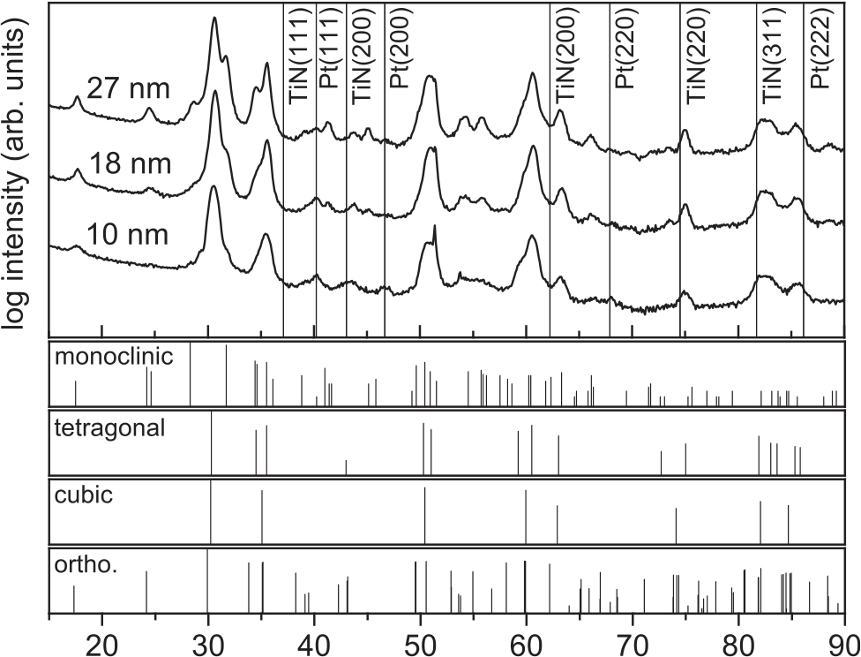



FIG. 4. GIXRD patterns for different Gd:HfO2 film thicknesses and refer-ence patterns for the different reported phases of HfO2.

films can depend strongly on the quality of the electrode interfaces and the applied materials. All of the ferroelectric films investigated here were polycrystalline and showed no preferred texture.

A more detailed insight into the crystal structure of Gd:HfO2 films with various thicknesses can be obtained from the GIXRD patterns in Fig. 4. Since all samples showed clear ferroelectric properties, the existence of a significant amount of the non-centrosymmetric orthorhombic Pbc21 phase can be expected. However, it is difficult to deduce this from the GIXRD patterns alone, since almost all orthorhom-bic peaks are superimposed by the patterns of the other phases. While the 10 nm sample shows mostly a tetragonal/ cubic structure, an increase in film thickness yields a higher fraction of monoclinic grains, as can be clearly seen from the increasing peak intensities at 25�, 28�, 32�, 45�, and 56�. This is in accordance with other recent reports on the thick-ness dependence of the crystal structure of HfO2 based ferro-electrics.15,38Moreover, an increase of the monoclinic phase fraction was also observed for higher thermal budget PMAs.15,16,38Those trends are in good agreement, since the crystallization temperature decreases for thicker films.15 The trend of less tetragonal/cubic and more monoclinic phase fraction with increasing thickness is also consistent with the decreasing relative permittivity k of the films, as can

be seen in Fig. 5(a). The higher symmetry phases also have higher k-values (tetragonal k � 32–40,8,38cubic k � 40–50 (Refs. 40 and 41)) compared to the monoclinic (k � 17–20 (Refs. 38 and 41)) and the orthorhombic phase (k � 30 (Refs. 4 and 41)). Contrary to previous reports,18,38no drop in Pr occurred for thicker films, which was argued to originate from the lower k-value of the monoclinic phase as a separate layer that lowers the effective field seen by the ferroelectric.38 Since the k-value for 27 nm is still close to 30, it is reasonable to assume that the monoclinic phase fraction is too low to induce such effects here. It is also important that the doped HfO2 films are amorphous before PMA, since crystallization during TE deposition results in a strong reduction of Pr.15In this work, even a small increase in Pr can be seen in Fig. 5, which is likely attributed to a slightly higher field E that was applied to the thicker samples while measuring the P-E curves.19Nevertheless, the absence of a degradation of Pr even for 27 nm films suggests that Gd is especially suited to stabilize the ferroelectric phase for a wide range of layer thicknesses and, as reported before, annealing conditions.16 For Gd:HfO2, ferroelectricity is caused for a wider range of dopant concentration compared to Si:HfO2,8which might

|  |  |  |  |  |  |
| --- | --- | --- | --- | --- | --- |
| explain | the | above | mentioned | thickness | characteristics. |

Similarly to Pr, an increase of Ec with the layer thickness is apparent from Fig. 5(a). A higher Ec was also reported for higher thermal budget PMA (Ref. 16) and likely depends on the grain sizes of the films and also the electrode interfaces as will be discussed Section III C. Fig. 5(b) shows the Pr vs thickness dependence of the samples investigated in this work, compared to previous reported thickness trends for HfO2 based ferroelectrics. It can be expected that Gd:HfO2 follows a similar trend of decreasing Pr when going to even thicker films beyond 30 nm. Bigger grains lead to less influ-ence of the surface energy that in general favors the higher symmetry phases such as the tetragonal phase reported in HfO2 thin films.42Therefore, the monoclinic phase fractions in the films will increase further and degrade the ferroelectric properties. However, the critical thickness at which this occurs for Gd:HfO2 may be even higher than for Y:HfO2, while also achieving a higher Pr. The ferroelectricity drops more drastically for Hf0.5Zr0.5O2 due to a deposition tempera-ture close to the crystallization temperature of the layer43and for Si:HfO2 since the thicker films crystallized already during TiN TE deposition.15Both of these process conditions favor the monoclinic phase.

|  |  |  |  |  |  |  |
| --- | --- | --- | --- | --- | --- | --- |
|  | | FIG. 5. (a) Relative permittivity k, re-manent polarization Pr, and coercive field Ec as a function of Gd:HfO2 thickness. (b) Thickness dependence of Pr for different dopants (Gd:HfO2: this | | | | |
| work, | Hf0.5Zr0.5O2: | Ref. | 37, | and |
| Si:HfO2: Ref. 15, Y:HfO2 samples were prepared as described in Ref. 39). | | | | |
|  |  |

|  |  |  |
| --- | --- | --- |
| 072006-5 | Hoffmann et al. | J. Appl. Phys. 118, 072006 (2015) |

The preliminary findings show some general trends that corroborate the current understanding of how phase transi-tions in doped HfO2 thin films can be influenced by basic process parameters. Combining these results, we propose a qualitative model describing the dependence of the film crys-tallinity on the thermal budget, dopant concentration, and film thickness as can be seen in Fig. 6. While a higher ther-mal budget, a lower dopant concentration or a higher film thickness leads to more monoclinic films, the opposite leads to more tetragonal/cubic films. The ferroelectric orthorhom-bic phase exists somewhere at the phase boundary between those paraelectric phases. Depending on the dopant used, the influence of these parameters can be different. Gd:HfO2, for example, shows no degradation of the ferroelectric properties over a wide range of thicknesses and annealing conditions.16 While the process window for Si:HfO2 appears to be much smaller in this regard.15Generally, dopants with a higher ionic radius seem to have a wider process window regarding stabilization of the ferroelectric phase.6,8

B. Impact of electrode material and annealing conditions

The interface between the electrodes and the ferroelec-tric is not only important for the crystallization of the films during the PMA, but arguably also for the wake-up behavior as discussed in Section III A. Therefore, different electrode configurations in combination with different PMAs were investigated. MFM stacks containing 10 nm Gd:HfO2 films with TE/BE configurations TiN/TaN and TaN/TaN interest-ingly showed very different ferroelectric properties com-pared to their TiN/TiN counterparts. Fig. 7 shows the corresponding Pr and k-values for different annealing conditions.

The use of TaN as an electrode material introduces a strong temperature dependence regarding Pr and k. Pr increases from 13 lC/cm2for TiN/TaN with the 450�C PMA to more than 35 lC/cm2for TaN/TaN with the 800�C anneal. Compared to the TiN/TiN samples (see Fig. 5), a twice as high Pr can be achieved just by replacing TiN with TaN. So far, this is the second highest value reported for HfO2 based ferroelectrics next to La:HfO2.8However, it is interesting to note that the Pr for TiN/TaN at 450�C is lower

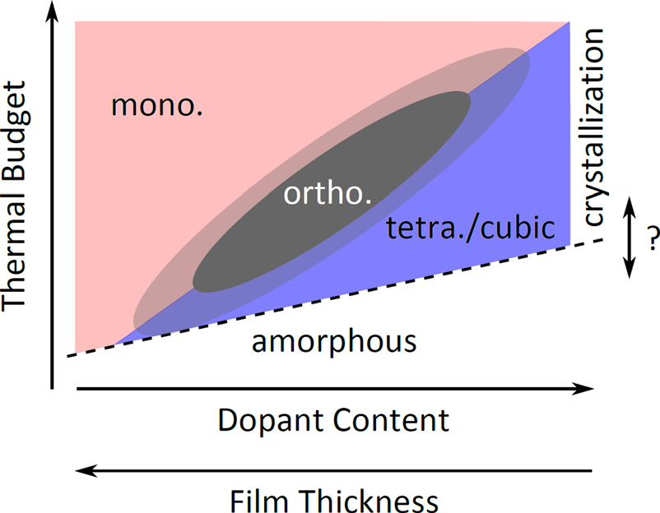

FIG. 6. Qualitative model of the phase transitions of HfO2 influenced by the

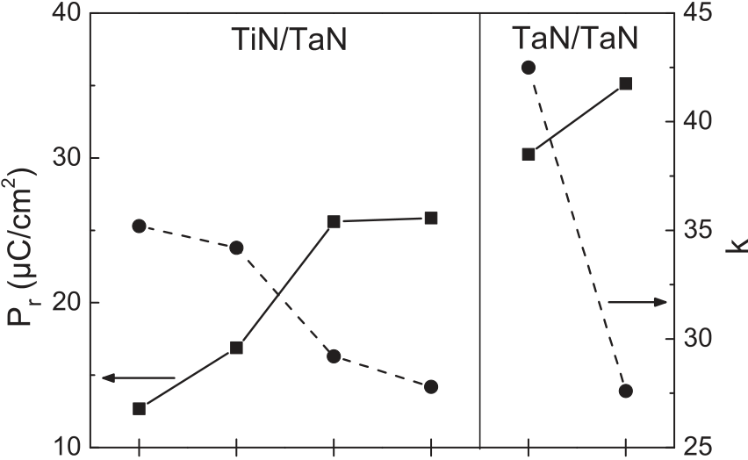

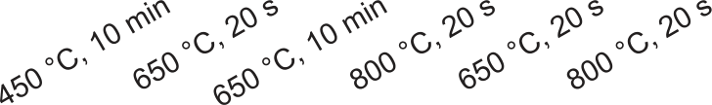

FIG. 7. Relative permittivity k and remanent polarization Pr for different TE/BE configurations and annealing conditions.

than the value for the corresponding TiN/TiN stack (Pr ¼ 15 lC/cm2(Ref. 16)). Consistently with the previous results,16k decreases for higher thermal budget PMAs. The k-value of 43 for TaN/TaN annealed at 650�C is very high compared to previously reported values for HfO2 based fer-roelectrics and hints at a considerable amount of the cubic phase in this sample. To further elucidate this, Fig. 8 shows the GIXRD patterns of all samples with TaN electrode(s).

From the k-values discussed before, one might expect an increasing monoclinic phase fraction for a higher thermal budget PMA as seen in the thickness dependence. However, in contrast to Fig. 4, there are now much fewer peaks with increased intensity corroborating this view. Again, there is a slight increase at 56�, but most other monoclinic peaks are superimposed by orthorhombic peaks, which should also increase with the annealing temperature as expected from

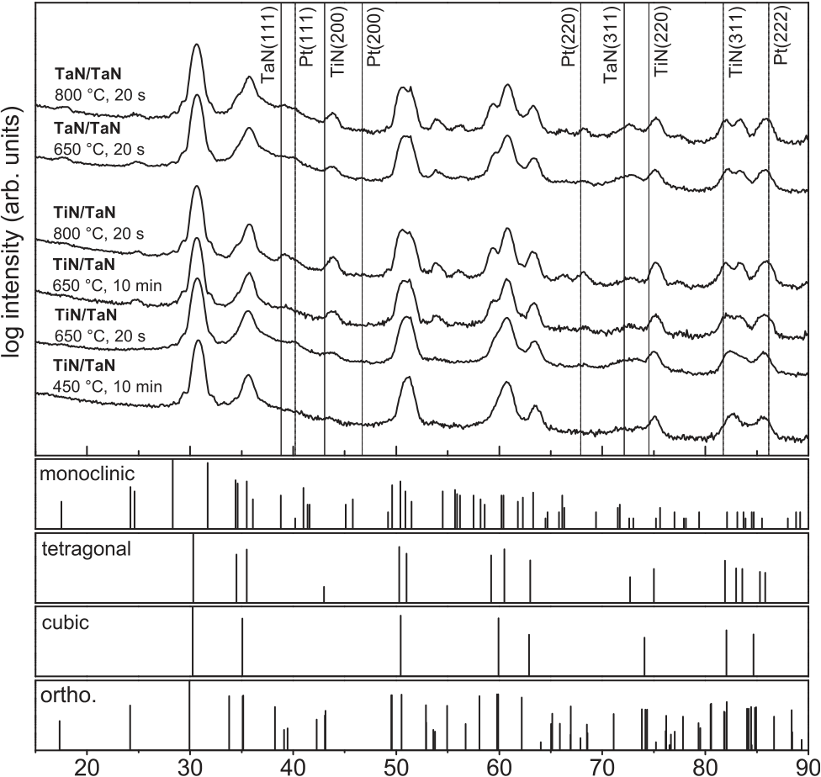



FIG. 8. GIXRD patterns for different electrode configurations and annealing conditions. Reference patterns for the different reported phases of HfO2 are

most important process parameters. given below.

|  |  |  |
| --- | --- | --- |
| 072006-6 | Hoffmann et al. | J. Appl. Phys. 118, 072006 (2015) |

the rise in Pr (see Fig. 7). Comparing the 18 nm and 27 nm film patterns from Figs. 4 to 8 gives the impression that MFM stacks with TaN electrode(s) generally have a lower monoclinic phase fraction than TiN/TiN stacks. This is con-sistent with the extracted k-values for all samples with the 650�C, 20 s PMA. If the monoclinic phase fraction does not significantly increase with the thermal budget, the other pos-sibility left is a transformation of the tetragonal/cubic phases into the orthorhombic phase. This would account for the decreasing k-values as well as for the increase in Pr and leads to the conclusion, that mainly the orthorhombic phase frac-tion increases, while the tetragonal/cubic phase fractions decrease with higher thermal budget PMA. Especially, the three peaks between 80�and 90�have been used in previous studies to identify the orthorhombic phase.2An absence of three distinct peaks does not imply an absence of ferroelec-tricity, but the better they can be distinguished, the higher the orthorhombic phase fraction appears to be. This is also consistent with the model proposed in Fig. 6. By using TaN electrodes, the samples are closer to the boundary between the tetragonal/cubic and the ferroelectric phase, so that a higher thermal budget can still increase the orthorhombic phase fraction without increasing the monoclinic one.

C. Fatigue and wake-up revisited

For the targeted application of ferroelectric thin films in FRAM capacitors, not only the wake-up, but especially the fatigue behavior is of importance for reliability assessments. Fatigue describes in this case the continuous reduction of Pr

through a sufficient amount of electric field cycling. This effect has also been a problem in perovskite based ferroelec-trics, but could be overcome by adopting electrodes like Ir or IrO2 in the case of PZT.26In this regard, a direct comparison of the three different electrode configurations TiN/TiN, TiN/ TaN, and TaN/TaN is of interest. Figs. 9(a)–9(c) show the wake-up behavior of the different electrode configurations for the 650�C, 20 s PMA.

The J-E curves show obvious differences between the electrode materials. For two identical electrodes, the J-E and P-E curves are quite symmetrical, whereas the mixed elec-trodes in Fig. 9(a) result in an asymmetric hysteresis. This stems from the difference in Ec for both TiN (�1.5 MV/cm) and TaN (�2 MV/cm) electrodes. The positive Ec of the TiN/TaN sample is closer to the TiN-value, and the negative one correspondingly is closer to the TaN-value. Since the work functions of TiN and TaN are quite similar,33,44they cannot account for this difference. Thus, the quality of the interfacial layer between electrode and ferroelectric could be one of the main influences on Ec beside the grain size.36The wake-up procedure for all three samples is considerably slower compared to the 27 nm TiN/TiN sample from Fig. 1. This seems plausible regarding the report that the wake-up effect also decreases in ferroelectric Hf0.5Zr0.5O2 films for higher PMA temperatures.38The amount of the tetragonal phase fraction seems to play an important role, looking at the GIXRD data in Figs. 4 and 8. Gd:HfO2 films appear to show a more pronounced wake-up behavior when they exhibit a higher tetragonal phase fraction. This would also explain the faster wake-up for the 27 nm sample in Fig. 1, since the

|  |  |  |  |  |  |  |  |  |  |  |  |
| --- | --- | --- | --- | --- | --- | --- | --- | --- | --- | --- | --- |
|  | | | | | | | | | | | FIG. 9. Wake-up behavior of 10 nm samples with (a) TiN/TaN, (b) TiN/ TiN, and (c) TaN/TaN electrodes. (d) Shows the remanent polarizations for all three configurations over the num-ber of applied field cycles with 4 MV/ cm. |
|  |  |  |  |  | |  |  |  |  |  |
|  | | | | | | | | | | |
|  |  |  |  |  |  | | | | | |
|  | | |  | | | | | | | |

|  |  |  |
| --- | --- | --- |
| 072006-7 | Hoffmann et al. | J. Appl. Phys. 118, 072006 (2015) |

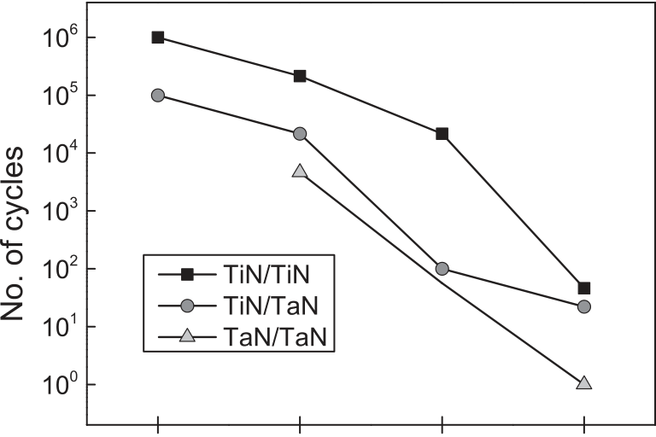

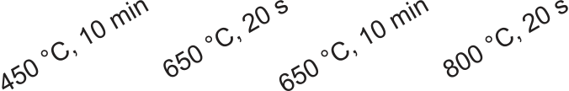



FIG. 10. Number of field cycles (4.5 MV/cm) before breakdown for differ-ent electrode configurations and PMAs.

tetragonal phase was reduced in favor of an increase in the monoclinic phase. However, a field induced phase transition seems unlikely as the main wake-up mechanism due to the results presented in Fig. 2. A more reasonable argument could involve the increasing influence of the electrode inter-faces for thinner films, leading to a pronounced wake-up effect. Oxidation of the electrodes leads to oxygen vacancies in the Gd:HfO2 films. If these defects influence the field cy-cling behavior as proposed in Ref. 9, effects on thicker films will be obviously smaller, since the bulk of the ferroelectric is significantly bigger compared to the interface regions. Fig. 9(d) shows the evolution of the positive and negative Pr-values (Prþ and Pr�) with the number of applied field cycles. The TiN/TiN sample shows a typical wake-up behavior up to 104cycles, when fatigue sets in and Pr decreases again.

For the TaN samples, no fatigue is visible before hard break-down occurs. Also in the TaN/TaN samples, the dielectric breakdown occurs earlier than in TiN/TaN samples, which is an indication for the amount of defects in the films.14A strong asymmetry of the TiN/TaN sample is also visible in the Prþ and Pr� evolution shown in Fig. 9(d).

It is reasonable to assume that the formation of different interfacial layers between Gd:HfO2 and different electrodes is of importance in this behavior. The annealing temperature and time have a very pronounced effect on Pr and on the field cy-cling behavior for samples with a TaN electrode, which was not observed for TiN/Gd:HfO2/TiN stacks before.16Assuming TaN electrodes are more inclined to form an oxynitride45,46at the Gd:HfO2 interface compared to TiN,47,48more oxygen vacancies would be present in the ferroelectric samples with TaN electrodes. This would explain the earlier breakdown for TaN samples in Fig. 9(d), since oxygen vacancies are known to facilitate breakdown mechanisms in HfO2.14This can be substantiated by the data shown in Fig. 10. Not only is the breakdown behavior consistently the best for TiN/TiN and the worst for TaN/TaN samples but the trend of earlier breakdown for higher thermal budget PMA can also be explained in a similar fashion. A higher annealing temperature or time leads to a stronger oxidation of the electrodes, effectively scaveng-ing O from the Gd:HfO2 layer and thus creating more oxygen vacancies that lead to earlier breakdown of the films.14 Correlating an earlier breakdown behavior with the higher Pr values seen for higher thermal budget in Fig. 7, oxygen vacan-cies may also play an important role in stabilizing the ferro-electric orthorhombic phase in doped HfO2. Leakage currents of the different samples were comparable, indicating that the difference in oxygen vacancy density was too low to be discri-minated by the measurements so far.

|  |  |  |  |  |  |  |  |  |
| --- | --- | --- | --- | --- | --- | --- | --- | --- |
|  | | | | | | | | FIG. 11. ToF-SIMS results for (a) TiN/TiN, (b) TiN/TaN, and (c) TaN/ TaN samples annealed at 650�C for 20 s. Bars on the y-axis indicate a fac-tor of 10 in intensity ratio. |
|  |  |  |  |  |  |  |  |



|  |  |  |
| --- | --- | --- |
| 072006-8 | Hoffmann et al. | J. Appl. Phys. 118, 072006 (2015) |

To further investigate the oxide formation at the elec-trode interfaces, ToF-SIMS measurements were performed on TiN/TiN, TiN/TaN, and TaN/TaN samples annealed at 650�C for 20 s. The results are shown in Fig. 11. There are some artifacts in the data related to the measurement proce-dure itself. The steps in the TiN�signal in the middle of the TiN electrodes are one example. It is also important to men-tion that HfO2  
�, TaO2�, and TaN� ions have very similar mass, resulting in the false TaO2�- and TaN�-signals in the Gd:HfO2 stack with TiN/TiN electrodes in Fig. 11(a). The same can be seen as a false HfO2�-signal at the surface of

total energy resulting from changes in the vacancy concen-tration appears to be almost linear. Calculations with 18.75% vacancy concentration did no longer follow this trend. The cause of this breakdown may be strong interactions between the individual vacancies or that the calculated cells under-went phase transitions due to the high amount of vacancies. These results are in agreement with the experimental results discussed before, stating that TaN electrodes with their tend-ency to form more oxygen vacancies in HfO2 than TiN elec-trodes show a higher fraction of cubic and tetragonal phases as well as a higher polarization and less polarization fatigue

the TaN/TaN sample in Fig. 11(c). Despite these effects, ox- during field cycling.

ide formation at all electrode interfaces can be concluded

from Fig. 11. However, it is much more difficult to extract IV. CONCLUSIONS

parameters like interfacial layer thicknesses, because of the aforementioned problems in ion discrimination. Still, there appears to be a difference in the interfaces of TiN and TaN electrodes. Subtracting the TaO2�-background-signal of Fig. 11(a) from Fig. 11(c), there still seems to be TaO2 left throughout the whole HfO2 layer. This would point to a larger interface oxidation of TaN compared to TiN electro-des, but measurement artifacts, like sputtering of Ta into the HfO2 film, cannot be ruled out completely. It is interesting to note, however, that the CN�-signal in the Gd:HfO2 is lower for TaN/TaN compared to the other samples. This might be due to the excellent diffusion barrier behavior of TaN as it is used in the fabrication of copper interconnects.21Regarding the effect of oxygen vacancies on the ferroelectric properties of the films, the ToF-SIMS and leakage current measure-ments were not sufficient to undoubtedly prove the impor-tance of these defects in doped HfO2 so far.

Therefore, ab initio simulations on the influence of oxy-gen vacancies on the phase stability of HfO2 were carried out. Fig. 12 shows the change in the total energy difference between the various phases compared to the monoclinic phase as a function of oxygen vacancy concentration, aver-aged over all calculated vacancy positions for a given con-centration. The tetragonal and the cubic phase gain the most in terms of total energy change, closely followed by the fer-roelectric Pbc21 phase. In the observed range, the change in

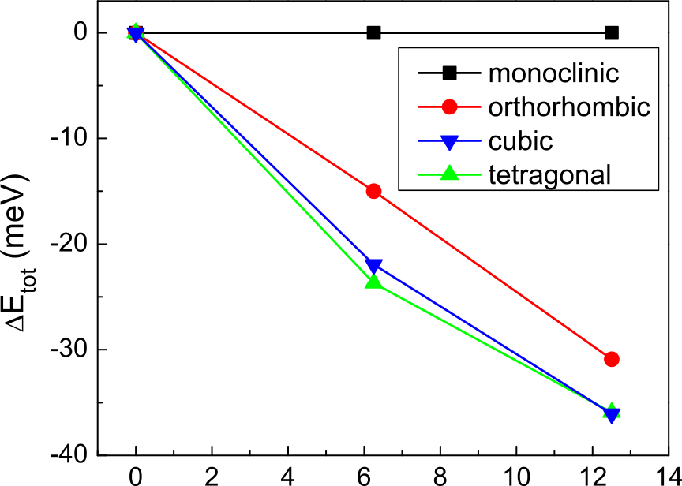



FIG. 12. Average change in the total energy difference between the various phases of HfO2 compared to the monoclinic phase as a function of the oxy-gen vacancy concentration.

Ferroelectric HfO2 has many advantages over classical perovskite materials and a great potential for future highly scaled memory devices.21However, the origins of the forma-tion of the proposed orthorhombic Pbc21 phase and the influ-ence of different process parameters were still unclear. Therefore, the ferroelectric properties of Gd doped HfO2 MFM stacks with different thicknesses, electrode materials, and annealing conditions were investigated in this study. While thinner films showed more of a mixture of tetragonal/ cubic and orthorhombic phases, thicker films up to 27 nm exhibited increasing monoclinic phase fractions in addition to the orthorhombic phase in accordance with a reduction of permittivity values. Surprisingly, no degradation of Pr with increasing film thickness was observed, suggesting that Gd is particularly suited to stabilize the ferroelectric phase even in thicker HfO2 layers at the investigated doping concentration of 3.4 cat%. In accordance with previous results, a qualita-tive model was proposed, describing the influence of basic process parameters on the phase composition of the doped HfO2. Additionally, lattice constants of the orthorhombic Pbc21 phase were calculated from micro-spot XRD patterns matching previously reported values. The structural origin of the wake-up behavior of different MFM stacks was investi-gated, concluding that a field induced phase transition as the main mechanism is unlikely. Moreover, the electrode inter-face formation and thus the density of oxygen vacancies appear to have an important influence on the wake-up effect.

TaN electrodes were shown to considerably enhance the stabilization of the ferroelectric phase in HfO2 compared to TiN, yielding a Pr of up to 35 lC/cm2, one of the highest val-ues reported so far. In general, MFM stacks with TaN elec-trodes exhibited lower monoclinic and higher tetragonal/ cubic phase fractions compared to TiN electrodes, as con-

|  |  |  |  |  |  |
| --- | --- | --- | --- | --- | --- |
| firmed | by | GIXRD | and | permittivity | measurements. |

Additionally, the TaN samples showed less signs of polariza-tion fatigue during field cycling, and also earlier breakdown. In contrast to samples with TiN electrodes, Pr and break-down field strength were strongly dependent on the anneal-ing conditions during PMA for samples with TaN electrodes. These effects were attributed to a higher amount of oxygen vacancies in the films, originating from an increased inter-face oxidation compared to TiN samples and for higher ther-mal budget annealing. Ab initio simulations revealed that the total energy of the orthorhombic, tetragonal, and cubic

|  |  |  |
| --- | --- | --- |
| 072006-9 | Hoffmann et al. | J. Appl. Phys. 118, 072006 (2015) |

phases can be reduced compared to the monoclinic phase by incorporation of oxygen vacancies in the lattice. Overall, the stabilization of the ferroelectric phase seems to be favored in a certain thickness range correlated to a high surface energy of the grains and by a certain amount of oxygen vacancies.

ACKNOWLEDGMENTS

U.S., M.H., M.D., and T.M. acknowledge the Free State of Saxony for funding this research. A.K. and R.M. acknowledge the “Abinit Group” for free use of their software as well as the “Leibniz Rechenzentrum der Bayerischen Akademie der Wissenschaften” for allowing them the use of the Supermuc system to perform their calculations. The German Research Foundation (Deutsche Forschungsgemeinschaft) is acknowledged by T.S., A.K., and R.M. for funding the research in the frame of the“Inferox” project (MI 1247/11-1).

1T. S. B€oscke, J. M€uller, D. Br€auhaus, U. Schr€oder, and U. B€ottger, [Appl. Phys. Lett.](http://dx.doi.org/10.1063/1.3634052) 99, 102903 (2011).

2S. Mueller, J. Mueller, A. Singh, S. Riedel, J. Sundqvist, U. Schroeder, and T. Mikolajick, [Adv. Funct. Mater.](http://dx.doi.org/10.1002/adfm.201103119) 22, 2412 (2012).

3S. Mueller, C. Adelmann, A. Singh, S. Van Elshocht, U. Schroeder, and T. Mikolajick, [ECS J. Solid State Sci. Technol.](http://dx.doi.org/10.1149/2.002301jss) 1, N123 (2012).

4J. M€uller, T. S. B€oscke, U. Schr€oder, S. Mueller, D. Br€auhaus, U. B€ottger, L. Frey, and T. Mikolajick, [Nano Lett.](http://dx.doi.org/10.1021/nl302049k) 12, 4318 (2012).

5J. M€uller, U. Schr€oder, T. S. B€oscke, I. M€uller, U. B€ottger, L. Wilde, J. Sundqvist, M. Lemberger, P. K€ucher, T. Mikolajick, and L. Frey, [J. Appl. Phys.](http://dx.doi.org/10.1063/1.3667205) 110, 114113 (2011).

6T. Schenk, S. Mueller, U. Schroeder, R. Materlik, A. Kersch, M. Popovici, C. Adelmann, S. Van Elshocht, and T. Mikolajick, in Proceedings of the

|  |  |  |  |  |  |
| --- | --- | --- | --- | --- | --- |
| European | Solid-State | Device | Research | Conference | (ESSDERC), |

Bucharest, Romania, 16–20 September 2013, pp. 260–263.

7T. S. B€oscke, St. Teichert, D. Br€auhaus, J. M€uller, U. Schr€oder, U. B€ottger, and T. Mikolajick, [Appl. Phys. Lett.](http://dx.doi.org/10.1063/1.3636434) 99, 112904 (2011).

8U. Schroeder, E. Yurchuk, J. M€uller, D. Martin, T. Schenk, P. Polakowski, C. Adelmann, M. I. Popovici, S. V. Kalinin, and T. Mikolajick, [Jpn. J. Appl. Phys.](http://dx.doi.org/10.7567/JJAP.53.08LE02) 53, 08LE02 (2014).

9T. Schenk, U. Schroeder, M. Pe�sic´, M. Popovici, Y. V. Pershin, and T. Mikolajick, [ACS Appl. Mater. Interfaces](http://dx.doi.org/10.1021/am504837r) 6(22), 19744 (2014).

10D. Zhou, J. Xu, Q. Li, Y. Guan, F. Cao, X. Dong, J. M€uller, T. Schenk, and U. Schr€oder, [Appl. Phys. Lett.](http://dx.doi.org/10.1063/1.4829064) 103, 192904 (2013).

11N. Menou, Ch. Muller, I. S. Baturin, V. Ya. Shur, and J.-L. Hodeau, [J. Appl. Phys.](http://dx.doi.org/10.1063/1.1870098) 97, 064108 (2005).

12V. Ya. Shur, I. S. Baturin, and E. L. Rumyantsev, [Ferroelectrics](http://dx.doi.org/10.1080/00150190701260967) 349, 163 (2007).

13S. Mueller, S. R. Summerfelt, J. M€uller, U. Schroeder, and T. Mikolajick, [IEEE Electron Device Lett.](http://dx.doi.org/10.1109/LED.2012.2204856) 33, 1300 (2012).

14S. Mueller, J. M€uller, U. Schroeder, and T. Mikolajick, [IEEE Trans.](http://dx.doi.org/10.1109/TDMR.2012.2216269)  [Device Mater. Reliab.](http://dx.doi.org/10.1109/TDMR.2012.2216269) 13, 93 (2013).

15E. Yurchuk, J. M€uller, S. Knebel, J. Sundqvist, A. P. Graham, T. Melde, U. Schr€oder, and T. Mikolajick, [Thin Solid Films](http://dx.doi.org/10.1016/j.tsf.2012.11.125) 533, 88 (2013).

16M. Hoffmann, T. Schenk, I. Kulemanov, C. Adelmann, M. Popovici, U. Schroeder, and T. Mikolajick, [Ferroelectrics](http://dx.doi.org/10.1080/00150193.2015.1012401) 480, 16 (2015).

17M. H. Park, H. J. Kim, Y. J. Kim, W. Lee, H. K. Kim, and C. S. Hwang, [Appl. Phys. Lett.](http://dx.doi.org/10.1063/1.4798265) 102, 112914 (2013).

18M. H. Park, H. J. Kim, Y. J. Kim, W. Lee, T. Moon, K. D. Kim, and C. S. Hwang, [Appl. Phys. Lett.](http://dx.doi.org/10.1063/1.4893376) 105, 072902 (2014).

19D. Zhou, J. M€uller, J. Xu, S. Knebel, D. Br€auhaus, and U. Schr€oder, [Appl.](http://dx.doi.org/10.1063/1.3688915)  [Phys. Lett.](http://dx.doi.org/10.1063/1.3688915) 100, 082905 (2012).

20D. Martin, J. Mueller, T. Schenk, T. M. Arruda, A. Kumar, E. Strelcov, E. Yurchuk, S. Mueller, D. Pohl, A. Kersch, U. Schroeder, S. V. Kalinin, and T. Mikolajick, [Adv. Mater.](http://dx.doi.org/10.1002/adma.201403115) 26(48), 8198 (2014).

21The International Technology Roadmap for Semiconductors (ITRS), see <http://www.itrs.net/Links/2013ITRS/2013Chapters/2013ERD.pdf> for Emerging Research Devices, 2013.

22M. T. Bohr, R. S. Chau, T. Ghani, and K. Mistry, [IEEE Spectrum](http://dx.doi.org/10.1109/MSPEC.2007.4337663) 44, 29 (2007).

23P. Polakowski, S. Riedel, W. Weinreich, M. Rudolf, J. Sundqvist, K. Seidel, and J. M€uller, in 2014 IEEE 6th International Memory Workshop (IMW), Taipei, Taiwan, 18–21 May 2014, pp. 1–4.

24J. M€uller, E. Yurchuk, T. Schl€osser, J. Paul, R. Hoffmann, S. M€uller, D. Martin, S. Slesazeck, P. Polakowski, J. Sundqvist, M. Czernohorsky, K. Seidel, P. K€ucher, R. Boschke, M. Trentzsch, K. Gebauer, U. Schr€oder, and T. Mikolajick, in 2012 Symposium on VLSI Technology (VLSIT), Honolulu, USA, 12–14 June 2012, pp. 25–26.

25N. Setter, D. Damjanovic, L. Eng, G. Fox, S. Gevorgian, S. Hong, A. Kingon, H. Kohlstedt, N. Y. Park, G. B. Stephenson, I. Stolitchnov, A. K. Taganstev, D. V. Taylor, T. Yamada, and S. Streiffer, [J. Appl. Phys.](http://dx.doi.org/10.1063/1.2336999) 100, 051606 (2006).

26T. Nakamura, Y. Nakao, A. Kamisawa, and H. Takasu, [Appl. Phys. Lett.](http://dx.doi.org/10.1063/1.112031)  65, 1522 (1994).

27M. H. Park, H. J. Kim, Y. J. Kim, W. Jeon, T. Moon, and C. S. Hwang, [Phys. Status Solidi RLL](http://dx.doi.org/10.1002/pssr.201409017) 8, 532 (2014).

28S. Starschich, D. Griesche, T. Schneller, R. Waser, and U. B€ottger, [Appl.](http://dx.doi.org/10.1063/1.4879283)  [Phys. Lett.](http://dx.doi.org/10.1063/1.4879283) 104, 202903 (2014).

29P. D. Lomenzo, P. Zhao, Q. Takmeel, S. Moghaddam, and T. Nishida, [J. Vac. Sci. Technol. B](http://dx.doi.org/10.1116/1.4873323) 32, 03D123 (2014).

30T. Shimizu, T. Yokouchi, T. Shiraishi, T. Oikawa, P. S. Sankara Rama Krishnan, and H. Funakubo, [Jpn. J. Appl. Phys.](http://dx.doi.org/10.7567/JJAP.53.09PA04) 53, 09PA04 (2014).

31X. Gonze, B. Amadon, P.-M. Anglade, J.-M. Beuken, F. Bottin, P. Boulanger, F. Bruneval, D. Caliste, R. Caracas, M. Cote, T. Deutsch, L. Genovese, Ph. Ghosez, M. Giantomassi, S. Goedecker, D. R. Hamann, P. Hermet, F. Jollet, G. Jomard, S. Leroux, M. Mancini, S. Mazevet, M. J. T. Oliveira, G. Onida, Y. Pouillon, T. Rangel, G.-M. Rignanese, D. Sangalli, R. Shaltaf, M. Torrent, M. J. Verstraete, G. Zerah, and J. W. Zwanziger, [Comput. Phys. Commun.](http://dx.doi.org/10.1016/j.cpc.2009.07.007) 180, 2582 (2009).

32X. Gonze, G.-M. Rignanese, M. Verstraete, J.-M. Beuken, Y. Pouillon, R. Caracas, F. Jollet, M. Torrent, G. Zerah, M. Mikami, Ph. Ghosez, M. Veithen, J.-Y. Raty, V. Olevano, F. Bruneval, L. Reining, R. Godby, G.

Onida, D. R. Hamann, and D. C. Allan, Z. Kristallogr. 220, 558 (2005). 33K. Carl and K. H. Hardtl, [Ferroelectrics](http://dx.doi.org/10.1080/00150197808236770) 17, 473 (1977).

34I. Stolichnov, A. K. Tagantsev, E. Colla, N. Setter, and J. S. Cross, [J. Appl. Phys.](http://dx.doi.org/10.1063/1.2112174) 98, 084106 (2005).

35W. Weinreich, R. Reiche, M. Lemberger, G. Jegert, J. M€uller, L. Wilde, S. Teichert, J. Heitmann, E. Erben, L. Oberbeck, U. Schr€oder, A. J. Bauer, and H. Ryssel, [Microelectron. Eng.](http://dx.doi.org/10.1016/j.mee.2009.03.070) 86, 1826 (2009).

36S. Clima, D. J. Wouters, C. Adelmann, T. Schenk, U. Schroeder, M. Jurczak, and G. Pourtois, [Appl. Phys. Lett.](http://dx.doi.org/10.1063/1.4867975) 104, 092906 (2014).

37M. H. Park, H. J. Kim, Y. J. Kim, T. Moon, and C. S. Hwang, [Appl. Phys.](http://dx.doi.org/10.1063/1.4866008)  [Lett.](http://dx.doi.org/10.1063/1.4866008) 104, 072901 (2014).

38M. H. Park, H. J. Kim, Y. J. Kim, W. Lee, T. Moon, and C. S. Hwang, [Appl. Phys. Lett.](http://dx.doi.org/10.1063/1.4811483) 102, 242905 (2013).

39T. Olsen, U. Schr€oder, S. M€uller, A. Krause, D. Martin, A. Singh, J. M€uller, M. Geidel, and T. Mikolajick, [Appl. Phys. Lett.](http://dx.doi.org/10.1063/1.4747209) 101, 082905 (2012).

40S. Migita, Y. Watanabe, H. Ota, H. Ito, Y. Kamimuta, T. Nabatame, and A. Toriumi, in 2008 Symposium on VLSI Technology, Honolulu, USA, 17–19 June 2008, pp. 152–153.

41Y. Watanabe, H. Ota, S. Migita, Y. Kamimuta, K. Iwamoto, M. Takahashi, A. Ogawa, H. Ito, T. Nabatame, and A. Toriumi, [ECS Trans.](http://dx.doi.org/10.1149/1.2779546) 11, 35 (2007).

42R. C. Garvie, [J. Phys. Chem.](http://dx.doi.org/10.1021/j100888a024) 69, 1238 (1965).

43J. M€uller, T. S. B€oscke, U. Schr€oder, L. Oberbeck, K. Reinicke, D. Zhou, M. Lemberger, and L. Frey, [Microelectron. Eng.](http://dx.doi.org/10.1016/j.mee.2009.03.076) 86, 1818 (2009).

44H. Kai, M. Xueli, Y. Hong, and W. Wenwu, [J. Semicond.](http://dx.doi.org/10.1088/1674-4926/34/7/076003) 34, 076003 (2013).

45C. Gaumer, E. Martinez, S. Lhostis, C. Wiemer, M. Perego, V. Loup, D. Lafond, and J.-M. Fabbri, [ECS Trans.](http://dx.doi.org/10.1149/1.2981591) 16, 99 (2008).

46T. Conard, T. Schram, A. Akheyar, K. Arstila, G. Zschaetzsch, W. Vandervorst, S. De Gendt, V. Paraschiv, B. Brijs, Z. X. Jiang, J. Lerma, V. Kaushik, L. Ragnarsson, and D. Brunco, [ECS Trans.](http://dx.doi.org/10.1149/1.2355708) 3, 159 (2006).

47Z. X. Jiang, K. Kim, J. Lerma, D. Sieloff, H. Tseng, R. I. Hedge, T. Y. Luo, J. Y. Yang, D. H. Triyoso, and P. J. Tobin, [Appl. Surf. Sci.](http://dx.doi.org/10.1016/j.apsusc.2006.02.092) 252, 7172 (2006).

48Ch. Wenger, M. Lukosius, G. Weidner, H.-J. M€ussig, S. Pasko, and Ch. Lohe, [Thin Solid Films](http://dx.doi.org/10.1016/j.tsf.2009.02.074) 517, 6334 (2009).