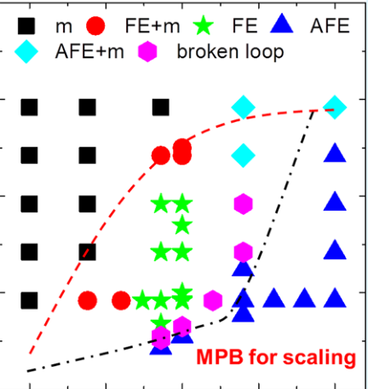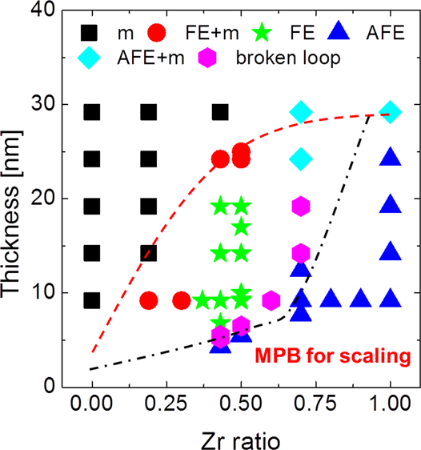

Research Article

Cite This: [ACS Appl. Mater. Interfaces 2018, 10, 42666−42673](http://pubs.acs.org/action/showCitFormats?doi=10.1021/acsami.8b15576)  www.acsami.org

Morphotropic Phase Boundary of Hf1−xZrxO2 Thin Films for Dynamic Random Access Memories

Min Hyuk Park,†Young Hwan Lee,‡Han Joon Kim,‡Yu Jin Kim,‡Taehwan Moon,‡Keum Do Kim,‡Seung Dam Hyun,‡and Cheol Seong Hwang*,‡

†School of Materials Science and Engineering, College of Engineering, Pusan National University, 2 Busandaehak-ro, 63 Beon-gil, Geumjeong-gu, Busan 46241, Republic of Korea  
‡Department of Materials Science and Engineering and Inter-University Semiconductor Research Center, College of Engineering, Seoul National University, Seoul 151-744, Republic of Korea

|  |  |  |  |
| --- | --- | --- | --- |
| TC).  rticles. | * S Supporting Information | | |
| Downloaded via GEORGIA INST OF TECHNOLOGY on August 28, 2019 at 17:15:32 (UTC).  See https://pubs.acs.org/sharingguidelines for options on how to legitimately share published articles. | ABSTRACT: The utilization of the morphotropic phase boundary (MPB) between the newly found ferroelectric orthorhombic phase and the tetragonal phase in an HfO2−ZrO2 solid solution is suggested for a high-capacitance dielectric capacitor. Being different from other high-k dielectrics, where the k value decreases with decreasing film thickness, these films (Hf/Zr ratio = 6:4, 5:5, 3:7) showed increasing k values with decreasing film thicknesses in the ∼5−20 nm range. Among them, Hf0.5Zr0.5O2 and Hf0.3Zr0.7O2 films showed 47 and 43 peak k values at 6.5 and 9.2 nm thicknesses, respectively, suggesting the  involvement of the MPB phenomenon. For the systematic understanding of this peculiar phenomenon, the phase evolution of the HfO2−ZrO2 solid solution is presented based on experimental observations. The detailed electrical tests of the films with different | |  |
| compositions and thicknesses demonstrated that the characteristic feature of this material  system is consistent with the involvement of the MPB depending on the composition and    thickness. Through the optimization of the annealing process for crystallization, a 0.62 nm  minimum equivalent oxide thickness was reported for the 6.5 nm thick Hf0.5Zr0.5O2 film,  which is highly promising for the future dynamic random access memories. This work provided a breakthrough method for overcoming the fundamental limitation of a decreasing k value with a decreasing film thickness of other high-k dielectrics.  KEYWORDS: ferroelectricity, DRAM, doped hafnium oxide, scaling, capacitor | | |
| ■INTRODUCTION  With ever-increasing data to be stored and processed, the memory technology has undergone significant advancement in the past several decades.1−3Dynamic random access memory  (DRAM) has been the main memory in computers for some  time now and will likely keep this role in the future as there are  currently no emerging memories that seem to hold the promise of replacing it.1−3No memory device other than DRAM has been confirmed to simultaneously have high density (>several tens of gigabit), high speed (∼20 ns), unlimited endurance (>1016cycles), and a low fabrication cost.1−3The performance  and productivity of spin-transfer torque RAM were enormously improved in the past several years (switching time ≈ 10 ns, endurance ≈ 1016), but its still large cell area (>10F2, where F means the minimum feature size; the DRAM cell size is 6F2) inhibits its adoption as the main memory.4  DRAM is composed of one transistor and one capacitor (1T−1C), where 1T plays the role of the memory cell selector  and 1C stores the charge, which represents the digital data. To achieve a sufficient signal margin against the thermal noise and | DRAM).1,3Such a decrease in Cs is attributed to the technical difficulty of confirming the high cell capacitance, while the decrease in the bit-line capacitance allowed reliable memory operation with such small Cs. The technical difficulty mainly results from the complexity of the process of sustaining the extremely tall bottom electrodes (BEs) without collapse during the entire process. For the state-of-the-art DRAM technology, Al-doped ZrO2 (AZO) is utilized as a high-k dielectric material within a three-dimensional (3D) cylindrical structure.1,3The high-k capacitor dielectric used to be the ZrO2/Al2O3/ZrO2 (ZAZ) structure at DRAMs with a higher design rule, but the intervening extremely thin Al2O3 layer dissolved into the ZrO2 layer as its thickness became lower than <∼0.5 nm and therefore it is now AZO. Both the top electrode (TE) and BE materials are TiN. Such a structure (TiN/AZO/TiN) has been very successful in providing the required cell capacitance at each technology node because of its structural robustness (TiN is a ceramic material) and the minimized interfacial reaction between the high-k dielectric layer and the electrodes.1,3As | |

other parasitic circuit capacitance, the cell capacitance (Cs) used to be 25 fF/cell down to the ∼40 nm design rule, but it has decreased to below 10 fF (7−8 fF for 20 nm design-rule

Received: September 7, 2018

Accepted: November 23, 2018

Published: November 23, 2018

|  |  |  |  |
| --- | --- | --- | --- |
|  | © 2018 American Chemical Society | 42666 | DOI: [10.1021/acsami.8b15576](http://dx.doi.org/10.1021/acsami.8b15576) ACS Appl. Mater. Interfaces [2018, 10, 42666−42673](http://dx.doi.org/10.1021/acsami.8b15576) |

|  |  |
| --- | --- |
| ACS Applied Materials & Interfaces | Research Article |

AZO has a much higher oxidation potential than TiN, the interfacial TiOx layer formation can be minimized even when a highly reactive oxygen source, such as O3, is pulsed during the AZO film growth through atomic layer deposition (ALD).1,3 The achievable minimum equivalent oxide thickness (tox = tphy× (3.9/k) + tox i , where tphy is the physical thickness and tox corresponds to the additional tox from any interfacial layer) from this structure appears to be limited to ∼0.6−0.7 nm.1,3 An even smaller tox, however, will soon be necessary for further scaled DRAMs.

To cope with such a requirement, higher-k dielectrics, such as rutile-structured TiO2 (k ≈ 100−140), Al-doped TiO2 (k ≈60−100), and SrTiO3 (k ≈ 150−200) have been actively researched on.1−3,5−8The abovementioned reports have shown that a minimum achievable tox with a stable leakage current [<10−7A cm−2at the capacitor operation voltage (∼half of the device voltage)] can be as small as 0.35−0.4 nm, which appears to be highly promising. The most significant problem of these new materials, however, is that they cannot adopt TiN as the electrode mainly because of the interfacial reaction to form the low-k interfacial layer and the insufficient crystallization due to the absence of a lattice match with TiN.1−3Thus, the exotic materials Ru, RuO2, and even SrRuO3 have been adopted as the BE and TE, which is highly unfavorable if these higher-k materials are to be used immediately.1−3On the other hand, the aforementioned electrode materials have a work function higher than TiN, so they can further decrease the leakage current density because the high work function electrode may induce a higher Schottky barrier height at the interface with the HZO film.9,10Another critical problem is the rapidly decreasing k value with the decreasing film thickness, for which reason the scaling of the physical thickness, which is accompanied by a drastic increase in the leakage current, does not necessarily decrease tox as intended.11This higher-k film could not be made sufficiently thin physically (≪10 nm) to be used in such an extremely 3D structure. Therefore, there is still a need to further improve the high-k capacitance performance of the ZrO2-based dielectric film assuming that TiN will still be used down to the design rule of 15 nm or even lower.

In this regard, the recently highlighted HfO2−ZrO2 solid solution [(Hf,Zr)O2 or HZO], which was reported to show ferroelectric (FE) or antiferroelectric (AFE) properties in thin-film form, must be promising in terms of further decreasing tox with TiN still used as electrodes.12−20The deposition processes of both materials (HfO2 and ZrO2) are highly matured in the semiconductor fabrication process, where the former is a base material for the high-k gate dielectric layer in the logic transistor and the latter is the capacitor dielectric, as discussed above. Because of its rather large band gap (>5.5 eV), moreover, the leakage current through TiN/HZO/TiN capacitors can be sufficiently low to meet the requirement even for a 5.5 nm thick DRAM capacitor.21Furthermore, with appropriate dopants, the endurance of HZO films can be increased even up to 1011, with a fatigue pulse height of 2.3 MV/cm.22It should be noted that this field (1.15 V for 5 nm thick films) is ∼43% higher than that (∼0.8 V) required for the state-of-the-art DRAM operation, suggesting that the endur-ance can be further improved as DRAM capacitors. On the other hand, Pešić et al. suggested that HfO2-based antiferro-electrics can be utilized for nonvolatile memories by shifting their characteristic double polarization−electric field (P−E) hysteresis curve along the voltage axis.21,22By this approach,

42667 DOI: [10.1021/acsami.8b15576](http://dx.doi.org/10.1021/acsami.8b15576)

|  |  |
| --- | --- |
| ACS Applied Materials & Interfaces | Research Article |

hold time of 1.0 s), and an impedance analyzer (4194A, HP, at the 10 kHz ac bias frequency). The crystal structure of the HZO films was analyzed using an X-ray diffractometer (X’pert Pro, PANalytical), via grazing angle incidence X-ray diffraction (GAXRD) with a 0.5° incidence angle.

■RESULTS AND DISCUSSION   
Figure 1 shows the schematic phase diagram based on the experiment results in the authors’ previous and present

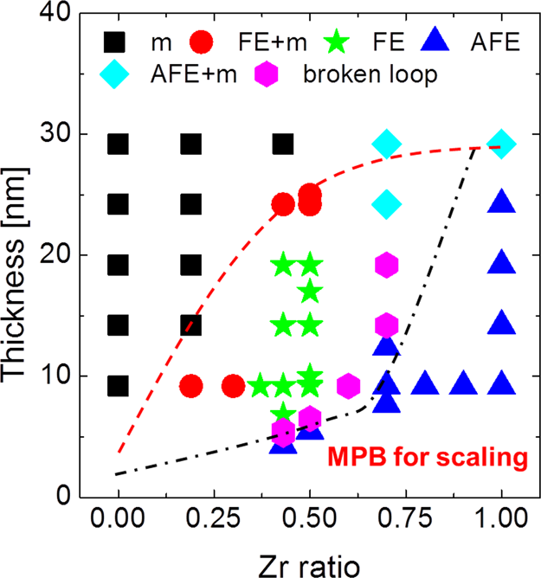

Figure 1. Schematic phase diagram of the Hf1−xZrxO2 films with various thicknesses and Zr contents.

works.26,37For the construction of this phase diagram, HZO films with various compositions and thicknesses were deposited via the thermal ALD mentioned above on a TiN

BE and were annealed at 500 °C in a N2 atmosphere for 30 s with the TiN (5 nm)/Pt (50 nm) TE being deposited. Then, polarization−voltage (P−V) curves were achieved (see the Experiment section). Representative P−V loops for the m-

phase (a low-k dielectric phase) and the FE, FE + m, AFE,

broken loop, and AFE + m-phases are included in Figure S1 of

[Supporting Information](http://pubs.acs.org/doi/suppl/10.1021/acsami.8b15576/suppl_file/am8b15576_si_001.pdf). It should be mentioned that the precise phase identi[f](http://pubs.acs.org/doi/suppl/10.1021/acsami.8b15576/suppl_file/am8b15576_si_001.pdf)ication can be different depending on the detailed film deposition and annealing conditions in other experiments adopting different processing techniques. In this

schematic diagram, the m-phase corresponds to the cases where the P−V loop shows a Pr value smaller than 3 μC cm−2, and in such cases, the dominant presence of the m-phase can be confirmed through GAXRD. The FE phase corresponds to the cases where the Pr value was >12 μC cm−2, and the intensities of the X-ray diffraction (XRD) peaks from the m-

phase are negligible for such cases. The FE + m region,

therefore, corresponds to the cases where the Pr value was higher than 3 μC cm−2but lower than 12 μC cm−2, and the coexistence of the m- and o-phase can be confirmed from the

GAXRD patterns. The AFE phase showed typical double-hysteretic P−V loops at highly positive and negative biases while the Pr value was ∼0 μC cm−2. The origin of the AFE-like double hysteresis is known as a field-induced phase transition between the t- and o-phases.16,25,38,39The stable crystalline phase at zero electric field is the t-phase, but the small energy difference between the t- and o-phase can be readily overcome by the sufficiently high electric field. For the broken loop, which is known as a sign of first-order phase transition, the physical circumstance is different from the aforementioned AFE loop.40,41In this case, the metastable polar phase can remain even at zero electric field, but during polarization

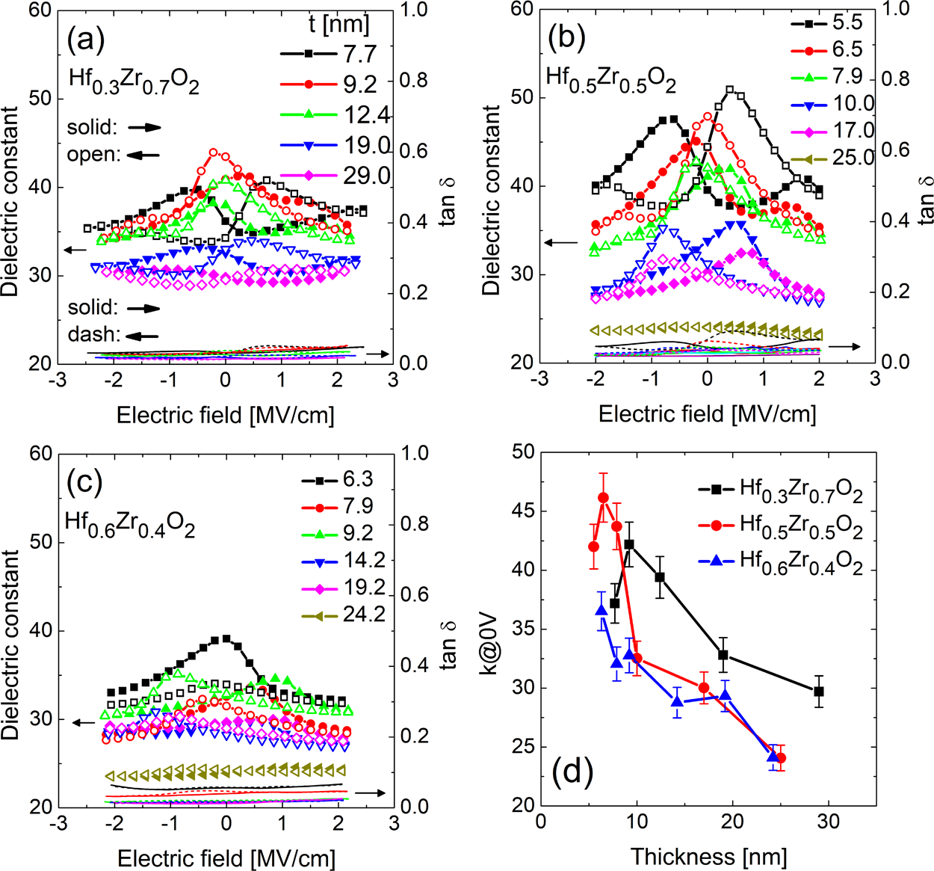

Figure 2. k−E curves (left y-axis, symbol and curves) and electrics loss−electric field curves (right y-axis, lines) of the (a) Hf0.3Zr0.7O2, (b) Hf0.5Zr0.5O2, and (c) Hf0.6Zr0.4O2 films with various thicknesses. (d) Change in the k value at 0 V for the Hf0.3Zr0.7O2, Hf0.5Zr0.5O2, and Hf0.6Zr0.4O2 films with various thicknesses.

|  |  |
| --- | --- |
| 42668 | DOI: [10.1021/acsami.8b15576](http://dx.doi.org/10.1021/acsami.8b15576) ACS Appl. Mater. Interfaces [2018, 10, 42666−42673](http://dx.doi.org/10.1021/acsami.8b15576) |

|  |  |
| --- | --- |
| ACS Applied Materials & Interfaces | Research Article |

switching, an intermediate nonpolar phase can be temporarily formed in a specific electric field range. As a result, interesting

two-step polarization switching can be observed, as previously studied by Park et al.41   
 The emergence of broken and AFE P−V loops near the Hf/ Zr ratio from ∼0.6:0.4 to ∼0.3:0.7 and the tphy range from ∼5 to ∼15 nm indicates that the MPB is located between these

two phases because it usually occurs at the boundary between

the FE and AFE phases. Therefore, these composition and

thickness regions are the promising areas where the enhanced

k value can be achieved. One interesting trend is that the

critical Hf/Zr ratio for the phase transition is thickness-dependent, which is different from the perovskite system (e.g.,

Pb(Zr,Ti)O3), whose MPB composition is independent of the film thickness. Instead, the MPB composition of the perovskite system is generally governed by stress and strain.42In HZO,

the FE and AFE phase formation can be related to the

composition-dependent bulk free energy and interface/grain

boundary energy, which were intensively studied in several previous studies.25,26The exact mechanism, however, is still under debate and requires further studies.26−28   
 Figure 2a−c shows the dielectric constant-electric field (k−

E) curves of the Hf0.3Zr0.7O2, Hf0.5Zr0.5O2, and Hf0.6Zr0.4O2 thin films, respectively, with various thicknesses. The k−E curves were derived from the capacitance−voltage (C−V)

measurements and the tphy values of each sample. The GAXRD patterns of the examined HZO films in Figure 2a−c are

included in Figure S2 of [Supporting Information](http://pubs.acs.org/doi/suppl/10.1021/acsami.8b15576/suppl_file/am8b15576_si_001.pdf). For the cases of the Hf0.3Zr0.7O2 films, the k[−](http://pubs.acs.org/doi/suppl/10.1021/acsami.8b15576/suppl_file/am8b15576_si_001.pdf)E curves showed AFE-like hysteretic behaviors, especially for the thinner films. Different from linear dielectric materials, the k values are electric field-

dependent, and the peak k values can be observed during both the upward and downward voltage sweeps. For AFE films,

generally, the peak k values can be achieved before reaching zero electric field during both the upward and downward voltage sweeps. For the cases of the FE films, in contrast, the peak k values are generally observed after zero electric field, as shown in the k−E curves of the 7.9−17 nm thick Hf0.5Zr0.5O2 thin films in Figure 2b. For the DRAM capacitor applications, high k values near zero electric field are required, and as such, both FE and AFE films are not optimal for this application. At

the MPB between the FE and AFE phases, however, the maximum k values can be achieved at ∼zero electric field,

suggesting that this MPB can be highly useful for DRAM

capacitor applications.

As previously mentioned, typical FE-like k−E curves can be achieved for 7.9−17 nm thick Hf0.5Zr0.5O2 films. The thickest Hf0.5Zr0.5O2 film (25 nm thick) showed almost no FE-like hysteresis and no k value voltage dependence because it had a high m-phase fraction, as confirmed via GAXRD (see Figure

S2b in [Supporing Information](http://pubs.acs.org/doi/suppl/10.1021/acsami.8b15576/suppl_file/am8b15576_si_001.pdf)). On the other hand, unlike the Hf0.5Zr0.5O2 [f](http://pubs.acs.org/doi/suppl/10.1021/acsami.8b15576/suppl_file/am8b15576_si_001.pdf)ilms thicker than 7.9 nm, the thinnest Hf0.5Zr0.5O2 film (5.5 nm thick) showed AFE-like hysteresis. Thus, with decreasing film thickness, the k−E curve shape changes from FE- to AFE-like at a ∼6.5 nm transition thickness. Interestingly, the k value showed ∼47 near zero electric field

at this tphy, which means that 6.5 nm corresponds to the MPB at this composition.

For the case of the Hf0.6Zr0.4O2 films, they showed slightly FE-like behaviors for all thicknesses, but their k values were

generally lower compared to the Hf0.5Zr0.5O2 and Hf0.3Zr0.7O2 thin films. This is consistent with the phase identification results obtained through the P−V tests shown in Figure 1. In

42669 DOI: [10.1021/acsami.8b15576](http://dx.doi.org/10.1021/acsami.8b15576)

|  |  |
| --- | --- |
| ACS Applied Materials & Interfaces | Research Article |

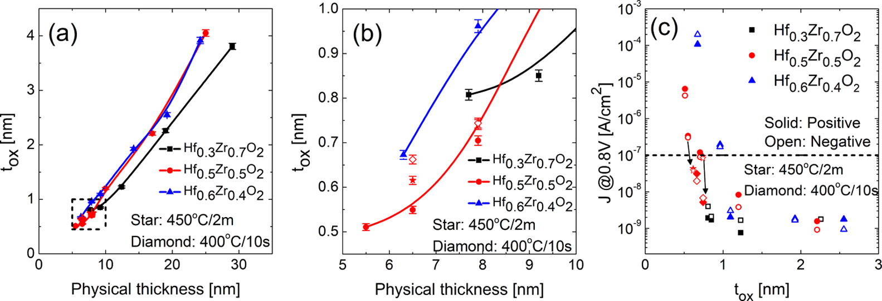

Figure 3. (a) tox physical thickness curves for the HZO films. (b) Enlarged short-dashed rectangular image in (a). (c) Relationship between J at an applied voltage of 0.8 V and tox for the HZO films.

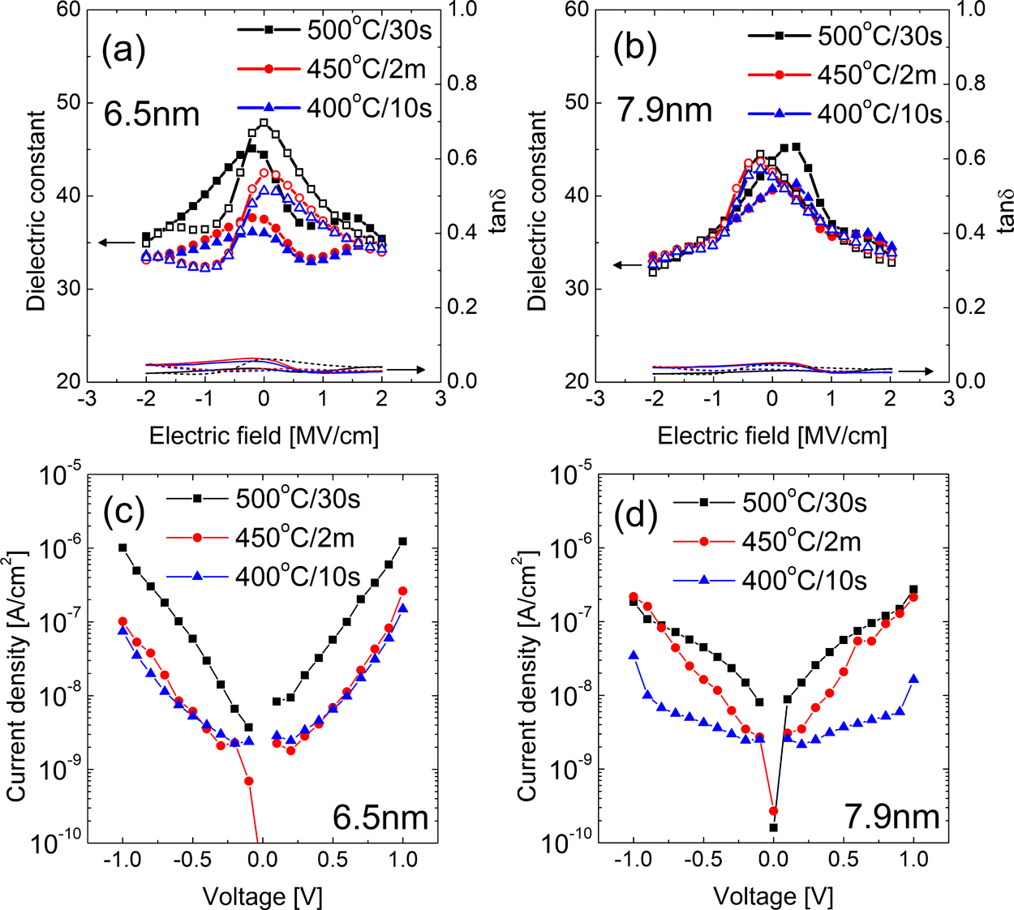

Figure 4. k−E curves (left y-axis, symbol and curves) and electrics loss−electric field curves (right y-axis, lines) of the (a) 6.5 and (b) 7.9 nm thick Hf0.5Zr0.5O2 films under various annealing conditions. J−E curves of the (c) 6.5 and (d) 7.9 nm thick Hf0.5Zr0.5O2 films under various annealing conditions.

perovskite-based high-k dielectrics (∼3−3.5 eV), however, makes the use of a thinner film probable. The possible use of a lower thickness is in fact even more important than the marginal improvement of the electrical performance for making the extremely 3D-structured DRAM capacitor. If the thickness is not lower than ∼one-third of the design rule, it cannot be physically fit into the 3D capacitor structure no matter how high the k value is.

The data shown in Figure 2d could be converted to tox versus tphy plots, as shown in Figure 3a,b, which are more convenient for estimating the performance of the dielectric layer as the DRAM capacitor. Furthermore, the leakage current density (J) estimated at ±0.8 V, which is actually higher than the capacitor voltage for sub 20 nm design-rule DRAMs, can be plotted as a function of tox for different Hf/Zr ratios, as shown in Figure 3c. This is the most critical plot for the evaluation of the DRAM capacitor dielectrics, by which the minimum achievable tox can be determined.

42670 DOI: [10.1021/acsami.8b15576](http://dx.doi.org/10.1021/acsami.8b15576)

|  |  |
| --- | --- |
| ACS Applied Materials & Interfaces | Research Article |

with different Hf/Zr ratios because of the involvement of the MPB at a lower tphy (6.5 nm), which was accompanied by the highest k value. The slower decrease in tox with the further decrease in tphy to 5.5 nm reflected the decrease in the k value at this thickness. The Hf0.6Zr0.4O2 films had generally higher tox values in this region, which were in accordance with the generally lower k value of this film composition. Therefore, these films showed less promising scaling behavior in this lower thickness region because of their lack of MPB.

Figure 3c showed the J−tox performances of the three types of films. The minimum tox (tphy) values, which met the J requirement of the Hf0.5Zr0.5O2, Hf0.3Zr0.7O2, and Hf0.6Zr0.4O2 films, were 0.70 (7.9), 0.81 (7.7), and 1.09 (9.2) nm, respectively. For the case of the Hf0.3Zr0.7O2 films, the leakage current through the 7.7 nm thick film was also lower than the requirement for DRAM application. Because of the decrease in the k value with the further decreasing tphy, however, a further decrease in film thickness may not increase the capacitance density, as expected from the highest k value. The scaling limit of the Hf0.3Zr0.7O2 films may be similar to that of the ZrO2 capacitors because of the relatively low k value (∼35 at 7.7 nm).

Although the minimum tox of 0.71 nm for the case of the Hf0.5Zr0.5O2 film is already promising compared with the currently available minimum tox of ZAZ (∼0.7 nm) considering the uncontrolled laboratory environment, the performance can be further improved by optimizing the PMA condition. Figure 4a,b shows the k−E curves of the 6.5 and 7.9 nm thick Hf0.5Zr0.5O2 films under various PMA conditions (temperature and time), and Figure 4c,d shows the corresponding J−E curves. For the case of the 5.5 nm thick film, it was found that the 500 °C/30 s condition was necessary to crystalize it (450°C/2 min could not crystalize it). For the case of the 6.5 nm thick films, the k (tox) value decreased (increased) from 46 (∼0.55 nm) to ∼41 (∼0.62 nm) and 38 (∼0.66 nm) when the PMA condition was changed from 500 °C/30 s to 450 °C/2 min and to 400 °C/10 s. For the case of the 7.9 nm thick films, the k (tox) value decreased (increased) from 44 (∼0.70 nm) to∼41 (∼0.74 nm) and ∼41 (∼0.74 nm) with the same change in the PMA condition. Therefore, the milder PMA condition (lower temperature and/or shorter annealing time) slightly increased the tox values because of the lower crystallization and accompanying decrease in k value. The leakage current was largely decreased by more than 1 order of magnitude, however, as can be seen in Figure 4c,d, from the same change in the PMA condition. Therefore, the J−tox performance can actually be improved by such a change in the PMA condition, and the improved results are also included in Figure 4c, for the cases of the 6.5 and 7.9 nm thick Hf0.5Zr0.5O2 films. The best tox value of 0.62 nm with a stable leakage current can be achieved even from such a laboratory-level experiment.

Theoretically, the high k value at the MPB of single crystals can be understood based on the flattening of the free energy−polarization curve. The k value is inversely proportional to the curvature of the free energy−polarization curve. It should be noted that the polycrystalline HZO films investigated in this study might be different from the single crystals. As guessed from Figure 1, HZO thin films are the mixture of several different crystalline phases. Therefore, even at the MPB conditions, there exist several different crystalline phases, and some of grains or sub grains should be related to the MPB behavior. Another potential factor which can contribute to the high k value of the polycrystalline HZO thin films is the field-

42671 DOI: [10.1021/acsami.8b15576](http://dx.doi.org/10.1021/acsami.8b15576)

|  |  |
| --- | --- |
| ACS Applied Materials & Interfaces | Research Article |

thickness within a thickness range of <∼10 nm. This is accompanied by the MPB between the two phases, which showed the peak dielectric constant. Because of the involvement of such a peculiar effect in this HfO2−ZrO2 solid solution system, which is mainly due to the competition between the bulk and surface free-energy effects, the k value showed a peak value as high as ∼50 within a 6−10 nm thickness range depending on the Hf/Zr ratio. This is in stark contrast to other high-k dielectric films, whose k value usually decays with decreasing thickness because of the presence of an interfacial low-k layer, and is detrimental to many electronic applications. These findings are in agreement with the theoretical model of phase evolution based on the recent first-principles calculation results. On the basis of this understanding, the material was tested for the optimized capacitor dielectric layer for the next-generation DRAM. Even with the conventional TiN electrodes, a minimum tox of 0.62 nm was achieved from the 6.5 nm thick Hf0.5Zr0.5O2 film, which will enable the extension of the presently available mass production technology to the next-generation devices.

■ASSOCIATED CONTENT   
* Supporting Information   
The Supporting Information is available free of charge on the [ACS Publications website](http://pubs.acs.org) at DOI: [10.1021/acsami.8b15576](http://pubs.acs.org/doi/abs/10.1021/acsami.8b15576).

Polarization−electric field curves and grazing incidence XRD patterns ([PDF](http://pubs.acs.org/doi/suppl/10.1021/acsami.8b15576/suppl_file/am8b15576_si_001.pdf))  
■AUTHOR INFORMATION   
Corresponding Author   
*E-mail: [cheolsh@snu.ac.kr](mailto:cheolsh@snu.ac.kr).

ORCID

Cheol Seong Hwang: [0000-0002-6254-9758](http://orcid.org/0000-0002-6254-9758)

Author Contributions   
The manuscript was written through contributions of all authors. All authors have given approval to the final version of the manuscript.

Funding   
This work was supported by Samsung Science & Technology Foundation (SRFC-TA1703-02).

Notes   
The authors declare no competing financial interest.

■REFERENCES   
(1) Hwang, C. S. Prospective of Semiconductor Memory Devices: from Memory System to Materials. Adv. Electron. Mater. 2015, 1, 1400056.

(2) Kim, S. K.; Lee, S. W.; Han, J. H.; Lee, B.; Han, S.; Hwang, C. S. Capacitors with an Equivalent Oxide Thickness of <0.5 nm for Nanoscale Electronic Semiconductor Memory. Adv. Funct. Mater. 2010, 20, 2989−3003.

(3) Kim, S. K.; Popovici, M. Future of Dynamic Random-Access Memory as Main Memory. MRS Bull. 2018, 43, 334−339.

(4) Yuasa, S.; Hono, K.; Hu, G.; Worledge, D. C. Materials for Spin-Transfer-Torque Magnetoresistive Random-Access Memory. MRS Bull. 2018, 43, 352−357.

(5) Kim, S. K.; Choi, G.-J.; Lee, S. Y.; Seo, M.; Lee, S. W.; Han, J. H.; Ahn, H.-S.; Han, S.; Hwang, C. S. Al-Doped TiO2 Films with Ultralow Leakage Currents for Next Generation DRAM Capacitors. Adv. Mater. 2008, 20, 1429−1435.

(6) Jeon, W.; Yoo, S.; Kim, H. K.; Lee, W.; An, C. H.; Chung, M. J.; Cho, C. J.; Kim, S. K.; Hwang, C. S. Evaluating the Top Electrode Material for Achieving an Equivalent Oxide Thickness Smaller than

42672 DOI: [10.1021/acsami.8b15576](http://dx.doi.org/10.1021/acsami.8b15576)

|  |  |
| --- | --- |
| ACS Applied Materials & Interfaces | Research Article |

(22) Chernikova, A. G.; Kozodaev, M. G.; Negrov, D. V.; Korostylev, E. V.; Park, M. H.; Schroeder, U.; Hwang, C. S.; Markeev, A. M. Improved Ferroelectric Switching Endurance of La-Doped Hf0.5Zr0.5O2 Thin Films. ACS Appl. Mater. Interfaces 2018, 10, 2701−2708.

(23) Pešić, M.; Hoffmann, M.; Richter, C.; Mikolajick, T.; Schroeder, U. Nonvolatile Random Access Memory and Energy Storage Based on Antiferroelectric Like Hysteresis in ZrO2. Adv. Funct. Mater. 2016, 26, 7486−7494.

(24) Pešić, M.; Hoffmann, M.; Richter, C.; Slesazeck, S.; Kämpfe, T.; Eng, L. M.; Mokolajick, M.; Schroeder, U. Anti-ferroelectric ZrO2, an Enabler for Low Power Non-volatile 1T-1C and 1T Random Access Memories. 2017 47th European Solid-State Device Research Conference (ESSDERC): Leuven, 2017; pp 160−163.

(25) Materlik, R.; Künneth, C.; Kersch, A. The Origin of Ferroelectricity in Hf1−xZrxO2: A Computational Investigation and a Surface Energy Model. J. Appl. Phys. 2015, 117, 134109.

(26) Park, M. H.; Lee, Y. H.; Kim, H. J.; Schenk, T.; Lee, W.; Kim, K. D.; Fengler, F. P. G.; Mikolajick, T.; Schroeder, U.; Hwang, C. S. Surface and Grain Boundary Energy as the Key Enabler of Ferroelectricity in Nanoscale Hafnia-Zirconia: a Comparison of Model and Experiment. Nanoscale 2017, 9, 9973−9986.

(27) Park, M. H.; Lee, Y. H.; Kim, H. J.; Kim, Y. J.; Moon, T.; Kim, K. D.; Hyun, S. D.; Mikolajick, T.; Schroeder, U.; Hwang, C. S. Understanding the Formation of the Metastable Ferroelectric Phase in Hafnia−Zirconia Solid Solution Thin Films. Nanoscale 2018, 10, 716−725.

(28) Park, M. H.; Lee, Y. H.; Mikolajick, T.; Schroeder, U.; Hwang, C. S. On the Thermodynamic and Kinetic Origins of Ferroelectricity in Fluorite Structure Oxides. Adv. Electron. Mater. accepted.

(29) Lin, Y.; Lee, J.-S.; Wang, H.; Li, Y.; Foltyn, S. R.; Jia, Q. X.; Collis, G. E.; Burrell, A. K.; McCleskey, T. M. Structural and Dielectric Properties of Epitaxial Ba1−xSrxTiO3 Films Grown on LaAlO3 Substrates by Polymer-Assisted Deposition. Appl. Phys. Lett. 2004, 85, 5007−5009.

(30) Ahart, M.; Somayazulu, M.; Cohen, R. E.; Ganesh, P.; Dera, P.; Mao, H.-k.; Hemley, R. J.; Ren, Y.; Liermann, P.; Wu, Z. Origin of Morphotropic Phase Boundaries in Ferroelectrics. Nature 2008, 451, 545−548.

(31) Du, X.-h.; Zheng, J.; Belegundu, U.; Uchino, K. Crystal Orientation Dependence of Piezoelectric Properties of Lead Zirconate Titanate near the Morphotropic Phase Boundary. Appl. Phys. Lett. 1998, 72, 2421−2423.

(32) Jo, W.; Daniels, J. E.; Jones, J. L.; Tan, X.; Thomas, P. A.; Damjanovic, D.; Rödel, J. Evolving Morphotropic Phase Boundary in Lead-Free (Bi1/2Na1/2)TiO3−BaTiO3 Piezoceramics. J. Appl. Phys. 2011, 109, 014110.

(33) Daniels, J. E.; Jo, W.; Roedel, J.; Jones, J. L. Electric-Field-Induced Phase Transformation at a Lead-Free Morphotropic Phase Boundary: Case Study in a Piezoelectric 93% (Bi0.5Na0.5)TiO3-7% BaTiO3 Ceramic. Appl. Phys. Lett. 2009, 95, 032904.

(34) Yao, Z.; Liu, H.; Chen, L.; Cao, M. Morphotropic Phase Boundary and Piezoelectric Properties of (Bi1/2Na1/2)1 − x-(Bi1/2K1/2)xTiO3−0.03(Na0.5K0.5)NbO3 Ferroelectric Ceramics. Mater. Lett. 2009, 63, 547−550.

(35) Zeches, R. J.; Rossell, M. D.; Zhang, J. X.; Hatt, A. J.; He, Q.; Yang, C.-H.; Kumar, A.; Wang, C. H.; Melville, A.; Adamo, C.; Sheng, G.; Chu, Y.-H.; Ihlefeld, J. F.; Erni, R.; Ederer, C.; Gopalan, V.; Chen, L. Q.; Schlom, D. G.; Spaldin, N. A.; Martin, L. W.; Ramesh, R. A Strain-Driven Morphotropic Phase Boundary in BiFeO3. Science 2009, 326, 977−980.

(36) Damjanovic, D. A Morphotropic Phase Boundary System Based on Polarization Rotation and Polarization Extension. Appl. Phys. Lett. 2010, 97, 062906.

(37) Park, M. H. Additive manufacturing of flexible piezoelectric energy harvester using ceramic-elastomer composite. Ph.D. Thesis, Seoul National University, 2014.

(38) Park, M. H.; Kim, H. J.; Kim, Y. J.; Moon, T.; Kim, K. D.; Hwang, C. S. Toward a Multifunctional Monolithic Device Based on

42673 DOI: [10.1021/acsami.8b15576](http://dx.doi.org/10.1021/acsami.8b15576)