

1092 IEEE ELECTRON DEVICE LETTERS, VOL. 40, NO. 7, JULY 2019

Improved Endurance of HfO2-Based Metal-

Ferroelectric-Insulator-Silicon Structure by

High-Pressure Hydrogen Annealing

Seungyeol Oh, Jeonghwan Song, In Kyeong Yoo, and Hyunsang Hwang

***Abstract— We investigate the effects of high-pressure hydrogen***  ***annealing***  ***(HPHA)***  ***on***  ***W/ferroelectric Al:HfO2/interface layer (IL)/Si stacks. With HPHA, degra-dation in remnant polarization is observed in the pristine state due to ferroelectric domain pinning. However, after wake-up, a comparable remnant polarization is observed by domain de-pinning. In addition, HPHA improves the quality current and low interface trap density are maintained up to 107cycles. As a result, the endurance improves up to 109 cycles and a stable retention is achieved up to 104s at 85*◦*C. These results show that the HPHA can be a crucial process for ferroelectric HfO2-based transistor applications.***

***Index***  ***Terms— HPHA,***  ***MFIS,***  ***ferroelectric***  ***domain, endurance.***

I. INTRODUCTION   
**S** INCE the discovery of ferroelectric HfO2, ferroelec-tric field effect transistors (FeFETs) have been stud-ied vigorously, even in integrated arrays, owing to their

scalability, low power consumption, and fast operation speed [1]. Many studies have reported improvements in

polarization or memory window (MW) in metal-ferroelectric-insulator-semiconductor (MFIS) structures [2]–[4]. However,

the poor endurance of ferroelectric HfO2 on Si remains as a drawback, and some strategies have been proposed for improvement [5]. However, there was no specific strategy

for interfacial layer (IL), although several reports suggested that the IL is important for endurance [5]–[7]. Endurance

degradation occurs due to IL degradation by charge trapping induced by repetitive bipolar pulses [6]–[8]. Based on these

results, recently, an improved endurance was achieved using a SiGe substrate that has a thinner sub-oxide IL with better

quality [9]. However, limitation remains for the Si substrate, which is widely used in state-of-the-art technologies.

In this work, based on the report that high-pressure hydrogen annealing (HPHA) improves the IL quality [10],

Manuscript received April 9, 2019; accepted April 27, 2019. Date of publication May 6, 2019; date of current version June 26, 2019. This work was supported in part by the Future semiconductor Device Technology Development Program through the Ministry of Trade, Industry and Energy (MOTIE), in part by the Korea Semiconductor Research Consortium (KSRC) under Grant 10067794, and in part by MOTIE under Grant 10067764. The review of this letter was arranged by Editor C. V. Mouli.

(Corresponding author: Hyunsang Hwang.)   
 The authors are with the Department of Materials Science and Engi-neering, Pohang University of Science and Technology, Pohang 790-784, South Korea (e-mail: hwanghs@postech.ac.kr).

Color versions of one or more of the figures in this letter are available online at http://ieeexplore.ieee.org.

Digital Object Identifier 10.1109/LED.2019.2914700

the effects of HPHA were investigated for a ferroelectric HfO2-based MFIS structure. First, the change in remnant polarization (Pr*)* was investigated at various HPHA tem-peratures. Second, by performing endurance test, a robust endurance of up to 109was achieved, which resulted from the passivation of trap site near the HfO2/IL interface as well as the IL/Si interface.

II. EXPERIMENTS

For the MFIS structure, a heavily (1019cm−3*)* P-doped Si substrate was etched using a HF solution (1:50) for 1 min to remove native oxide. After DI cleaning, Al:HfO2 (1.03 wt%) was deposited on a Si substrate by the atomic layer deposition process. Al is used for dopant to facilitate the formation of ferroelectric phase. An 80-nm-thick W top electrode with an area of 30×30 *μ*m2, serving as capping for ferroelectricity, was then deposited by sputtering. Post-metallization annealing was performed at 650◦C in N2 ambient for 30 s to crystallize the Al:HfO2 film for ferroelectricity. Then, high-pressure annealing in pure (100%) hydrogen ambient was performed under 10 atm for 30 min. To confirm annealing temperature dependency, high-pressure annealing was performed at 100, 200, and 300◦C, respectively. The same process was per-formed for a metal-ferroelectric-metal (MFM) structure and a lightly (1015cm−3*)* P-doped Si substrate to compare the effect of IL and extract the interface trap density (Dit*)*, respectively.

III. RESULTS AND DISCUSSION

Fig. 1(a) and 1(b) show the high-resolution transmission electron microscopy (HR-TEM) images and polarization ver-sus voltage (P-V) curves of MFM and MFIS structures. The HR-TEM images and diffraction pattern (inset) show that a 15-nm-thick poly crystalline Al:HfO2 thin film was deposited. Due to the symmetry of the stack, the P–V curve of the MFM structure exhibits a symmetric hysteresis loop of 2Pr   
 = 23 *μ*C/cm2in the wake-up state. For wake-up, bipolar pulses of 300 cycles under ±6 V/100 Hz were applied. Unlike the MFM structure, the MFIS structure has an asymmetric hysteresis loop due to the difference in the work functions of top and bottom electrodes [11] and the 1.5-nm-thick IL between the Al:HfO2 film and Si substrate (Fig. 1(b)), which resulted in an increase in coercive voltage by the voltage drop in the IL. In addition, the MFIS structure shows poorer endurance than that of the MFM structure due to degradation of IL (Fig. 1(c)) [6], [7]. In the endurance test, memory reduction of MFIS is not observed compared to

0741-3106 © 2019 IEEE. Personal use is permitted, but republication/redistribution requires IEEE permission. See http://www.ieee.org/publications_standards/publications/rights/index.html for more information.

Authorized licensed use limited to: Georgia Institute of Technology. Downloaded on August 19,2022 at 13:19:48 UTC from IEEE Xplore. Restrictions apply.

OH et al.: IMPROVED ENDURANCE OF HfO2-BASED METAL-FERROELECTRIC-INSULATOR-SILICON STRUCTURE BY HPHA 1093



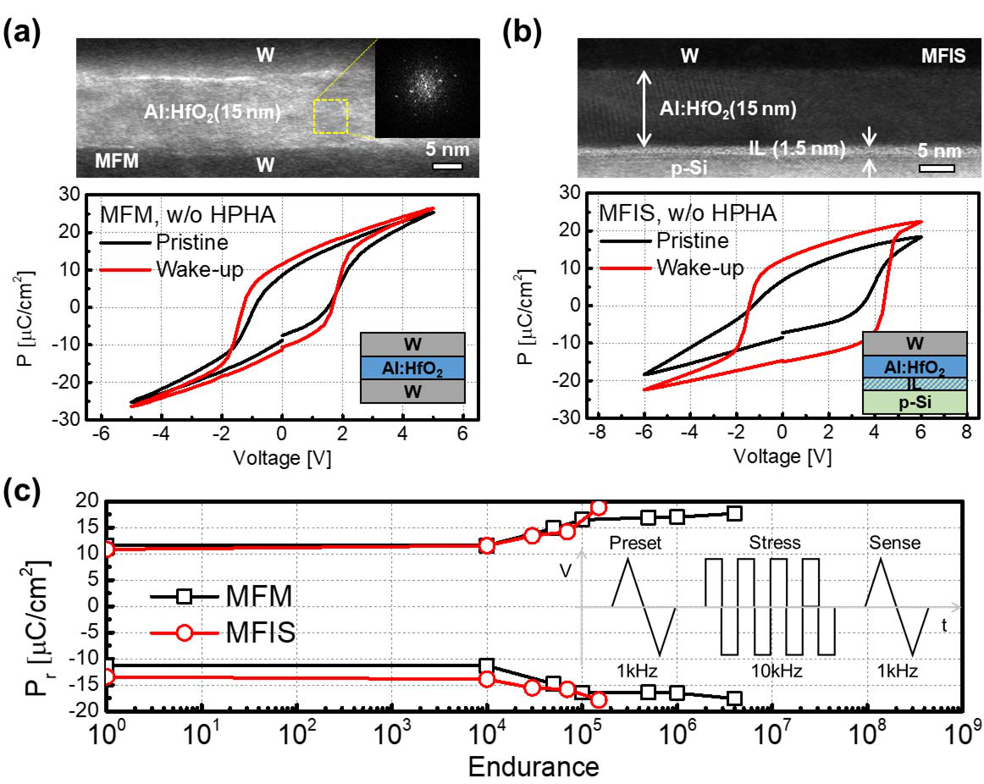

Fig. 1. HR-TEM images and P-V curves of (a) MFM structure and (b) MFIS structure. (c) Endurance property of MFM structure and MFIS structure under ±6 V bipolar pulses of 10 kHz.

FeFET devices in other literatures [6], [7], because threshold voltage (Vth*)*, which is read signal of FeFET device, is sensitive to charge trapping.

To improve the quality of IL in the MFIS structure, HPHA was performed on the MFIS structure at various temperatures. First, the effect of HPHA on Pr was investigated by measuring the P-V curve of each sample before and after wake-up, as shown in Fig 2(a) and 2(b). Before wake-up, the Pr degraded with increasing HPHA temperature. However, after wake-up, the Pr of each sample exhibited a comparable value of 2Pr = 23 degraded with increasing HPHA temperature. Fig. 2(c) shows∼ 27 *μ*C/cm2although the Pr only slightly

66% degradation before wake-up, while recovery of Pr is observed after wake up, which shows a degradation in Pr of only 16%. Fig. 2(d) shows a schematic diagram to explain the degradation in Pr by HPHA and the recovery of Pr by wake-up. Without HPHA, ferroelectric domain pinning occurs due to oxygen vacancies [12]. On the other hand, when HPHA is performed, H-related positive charges are formed [13], [14] and cause strong ferroelectric domain pinning with oxygen vacancies, which leads to the degradation in Pr. After wake-up, ferroelectric domain de-pinning occurs by the redistribution of oxygen vacancies and H-related positive charges, resulting in recovery of Pr. Nevertheless, with HPHA, the Pr slightly degrades due to strong pinning by the H-related positive charges. In this explanation, hydrogen does not seem to affect the formation of orthorhombic phase, because HPHA was performed after crystallization and HPHA temperature is too low to re-crystallize HfO2.

Fig. 2(e) shows that the coercive voltage decreases as the HPHA temperature increases due to a built-in field within the stack. Several reports suggested that, in the pristine state, atomic defects within the stack form a built-in field, resulting in a reduction of coercive voltage [15], [16]. Therefore, when HPHA is performed, the H-related defects form more built-in fields within the stack, which show a decrease in coercive voltage before wake-up. After wake-up, the coercive voltage increased due to the disappearance of the built-in field by redistribution of atomic defects (Fig. 2(b)) [15], [16]. However,

it should be further investigated that the coercive voltage increases as HPHA temperature increases after wake-up. Next, after wake-up, endurance test was performed for each sample under ±6 V bipolar pulses of various frequencies (Fig. 3(a)). For each frequency, the endurance enhanced with increasing HPHA temperature. Particularly, at 100 kHz, the effect of HPHA is remarkable. In case of HPHA at 300◦C, a low leakage current was maintained up to 107cycles, which led to improved endurance up to 109cycles. Besides, Pr was maintained without degradation. On the other hand, without HPHA, the leakage current increased quickly with an increase in the number of cycles, which explains the increase in mea-sured Pr [17]. Fig. 3(b) shows the P-V curves and switching current versus voltage (I-V) curves of samples without and with HPHA at 300◦C under 100 kHz for different number of cycles. Without HPHA, a blown up hysteresis is observed due to a high leakage current after only 3×105cycles [17]. In addition, the switching current peak reduced after cycling, indicating a reduction in the ferroelectric response [18]. On the other hand, with HPHA, a stable hysteresis and low leakage current were maintained after 108cycles, and the switching current peak did not reduce after cycling. In this endurance test, ±6 V bipolar pulses were used to compare the effect of HPHA on endurance. However, for endurance, negative pulse of less than −6 V can be used due to low negative coercive voltage of −2 V. The endurance properties of the MFM and MFIS structures were compared at various HPHA temperature as shown in Fig 3(c). The MFIS structure showed an improvement in endurance with increasing HPHA temperature, whereas the endurance of the MFM structure is independent of HPHA temperature. This indicates that the endurance property is not only related to the IL, but also depends on the quality of the IL. To estimate the quality of IL, Dit was extracted using the conductance method [19]. Fig. 4(a) shows the capacitance ver-sus voltage (C-V) curve and the inset shows the conductance versus voltage (G-V) curve. The reduction in conductance loss peak was attributed to interface passivation [20]. Fig. 4(b) shows that the Dit and hysteresis decrease with a decrease in HPHA temperature due to trap passivation by hydrogen, which leads to an improvement in the quality of the IL. In addition, based on previous reports, fast traps or border traps near the HfO2/IL interface seem to be passivated by hydrogen [10], which results in a dramatic improvement in the endurance. Furthermore, Fig. 4(c) shows Dit depending on the number of cycles. Without HPHA, Dit increases to over 1*.*5 × 1012eV−1cm−2after only 105cycles at 100 kHz, which imply an increase in leakage current due to IL degra-dation [6]. On the other hand, with HPHA, a low Dit value of 5×1011eV−1cm−2is maintained at 107cycles, which shows better resistivity from endurance. In addition, retention test was performed for 104s at 25◦C and 85◦C (Fig. 4(d)), which showed a stable retention property.

Table 1 presents a comparison of the ferroelectric device fabricated in this work with other ferroelectric devices reported in literature. Although the MFIS structures on Ge and Si0*.*56Ge0*.*44 substrates show good endurance, the Si substrate based MFIS structure shows poor endurance (*<* 105cycles). In this Table, FeFET structure was not considered, because direct comparison between FeFET and MFIS structure can

Authorized licensed use limited to: Georgia Institute of Technology. Downloaded on August 19,2022 at 13:19:48 UTC from IEEE Xplore. Restrictions apply.

1094 IEEE ELECTRON DEVICE LETTERS, VOL. 40, NO. 7, JULY 2019



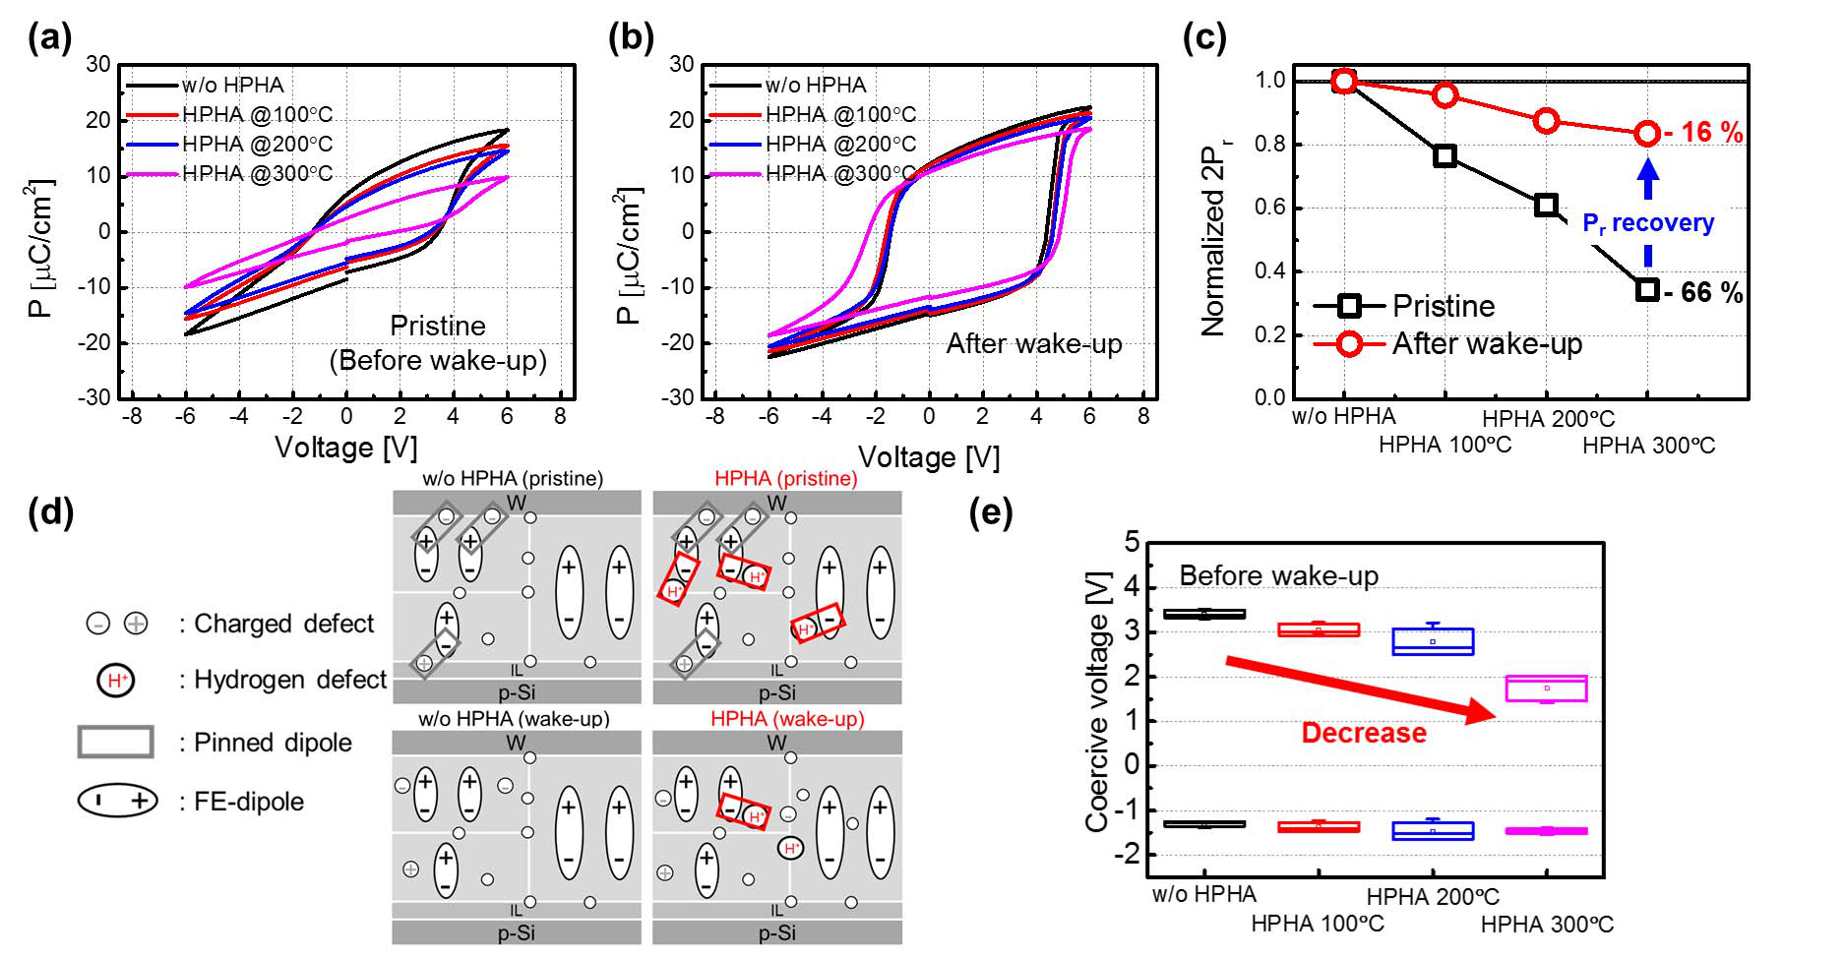

Fig. 2. P-V curves of MFIS structure depending on HPHA temperature (a) before wake-up and (b) after wake-up. (c) Change in normalized 2Pr with

HPHA temperature. (d) Schematic diagram of two different stages of samples with and without HPHA. (e) Change in coercive voltage with HPHA

temperature.

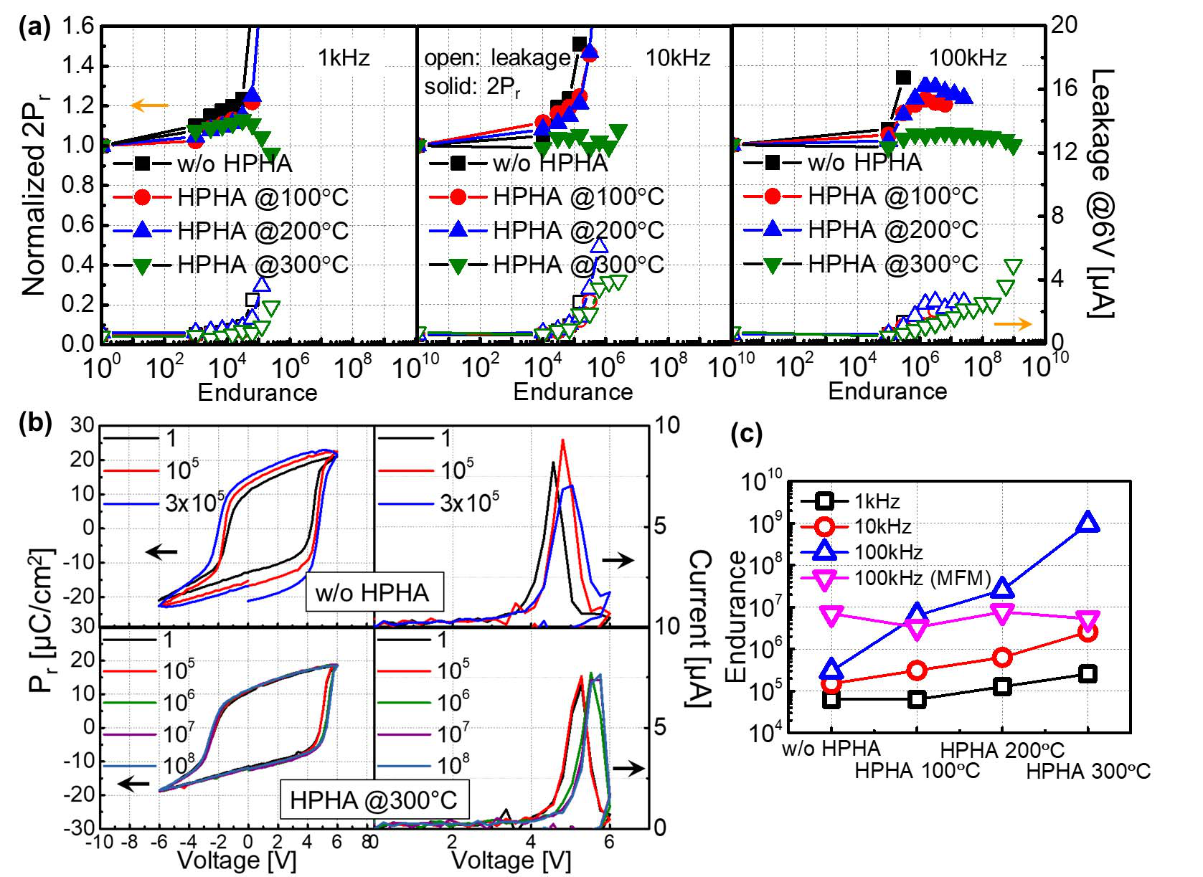

Fig. 3. (a) Endurance properties annealed at different HPHA temper-atures with various frequencies. (b) P-V curves and I-V curves after cycling for samples without and with HPHA at 300◦C. (c) Comparison of endurance properties of MFM and MFIS structures with various frequencies and HPHA temperatures.

TABLE I   
COMPARISON OF DEVICE FABRICATED IN THIS WORK WITH OTHER FERROELECTRIC DEVICES REPROTED IN LITERATURE

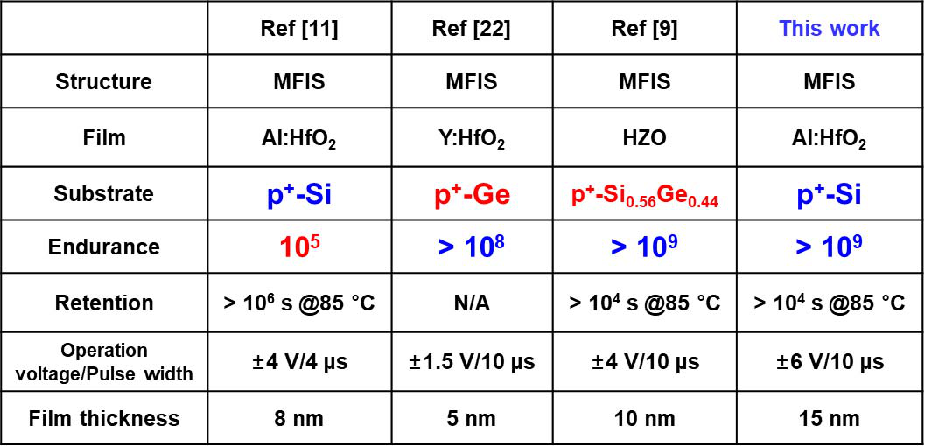

be controversial due to Vth instability by charge trapping. Nevertheless, it is noticed that endurance higher than 109 cycles was achieved even on a Si substrate when HPHA was performed. In this work, the effects of HPHA were investigated

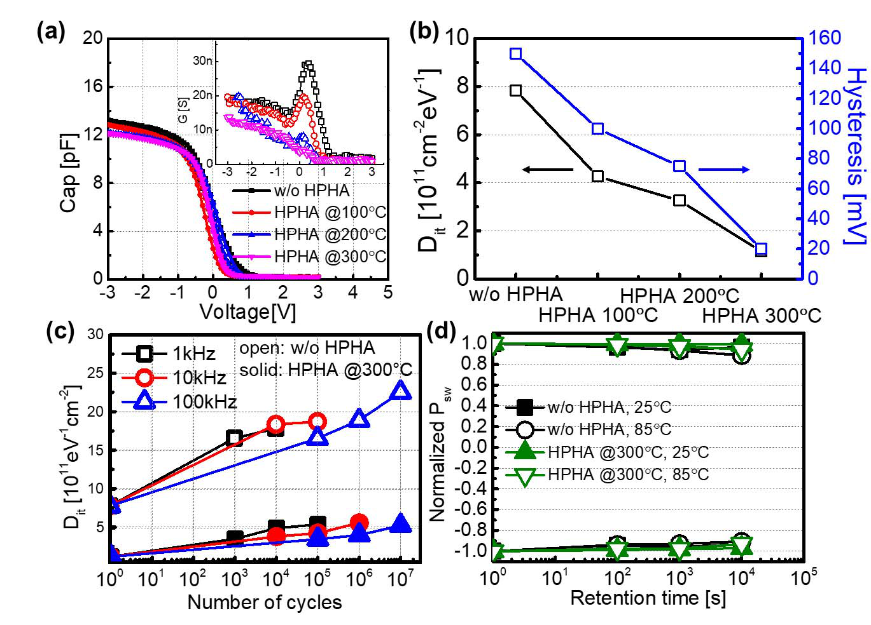

Fig. 4. (a) C-V curves and G-V curves (inset) of MFIS structure at various HPHA temperatures. (b) Extracted Dit and hysteresis at various HPHA temperatures. (c) Extracted Dit as a function of number of cycles at various frequencies for samples without and with HPHA at 300◦C.

(d) Retention property of samples without and with HPHA at 300◦C.

by varying HPHA temperature at constant pressure of 10 atm. However, based on the previous report, IL quality can be improved as HPHA pressure increases [10]. Therefore, better endurance is expected by modulating HPHA pressure.

IV. CONCLUSION

In this study, we investigated the effects of HPHA on a ferroelectric HfO2-based MFIS structure. The HPHA sam-ples showed degradation in Pr due to ferroelectric domain pinning by H-related charges. However, after wake-up, a comparable Pr value was recovered due to domain de-pinning even though the Pr slightly degraded due to strong domain pinning. In the endurance test, the sample without HPHA showed poor endurance up to 105cycles, whereas with HPHA, the endurance improved (*>* 109cycles) by more than 104times due to better quality of the IL by passivation of trap sites near the HfO2/IL interface as well as the IL/Si interface. On the basis of achieved results, high-pressure hydrogen annealing shows promise for ferroelectric HfO2-based applications.

Authorized licensed use limited to: Georgia Institute of Technology. Downloaded on August 19,2022 at 13:19:48 UTC from IEEE Xplore. Restrictions apply.

OH et al.: IMPROVED ENDURANCE OF HfO2-BASED METAL-FERROELECTRIC-INSULATOR-SILICON STRUCTURE BY HPHA 1095



REFERENCES

[1] S. Dünkel, M. Trentzsch, R. Richter, P. Moll, C. Fuchs, O. Gehring,

M. Majer, S. Wittek, B. Müller, T. Melde, H. Mulaosmanovic,

S. Slesazeck, S. Müller, J. Ocker, M. Noack, D.-A. Löhr, P. Polakowski,

J. Müller, T. Mikolajick, J. Höntschel, B. Rice, J. Pellerin, and S. Beyer,

“A FeFET based super-low-power ultra-fast embedded NVM technol-

ogy for 22nm FDSOI and beyond,” in *IEDM Tech. Dig.*, Dec. 2017,

pp. 19.7.1–19.7.4. doi: [10.1109/IEDM.2017.8268425](http://dx.doi.org/10.1109/IEDM.2017.8268425).

[2] J. Müller, E. Yurchuk, T. Schlösser, J. Paul, R. Hoffmann, S. Müller,

D. Martin, S. Slesazeck, P. Polakowski, J. Sundqvist, M. Czernohorsky,

|  |  |  |  |  |  |  |  |
| --- | --- | --- | --- | --- | --- | --- | --- |
| K. | Seidel, | P. | Kücher, | R. | Boschke, | M. Trentzsch, | K. Gebauer, |

U. Schroder, and T. Mikolajick, “Ferroelectricity in HfO2 enables

nonvolatile data storage in 28 nm HKMG,” in *Proc. IEEE Symp. VLSI*

*Technol.*, Jun. 2012, pp. 25–26. doi: [10.1109/VLSIT.2012.6242443](http://dx.doi.org/10.1109/VLSIT.2012.6242443).

[3] Y.-C. Chiu, C.-H. Cheng, C.-Y. Chang, Y.-T. Tang, and M.-C. Chen,

“One-transistor ferroelectric versatile memory: Strained-gate engineer-

ing for realizing energy-efficient switching and fast negative-capacitance

operation,” in *Proc. IEEE Symp. VLSI Technol.*, Jun. 2016, pp. 150–151.

doi: [10.1109/VLSIT.2016.7573414](http://dx.doi.org/10.1109/VLSIT.2016.7573414).

[4] W. Chung, M. Si, and P. D. Ye, “Hysteresis-free negative

capacitance germanium CMOS FinFETs with bi-directional Sub-

60 mV/dec,” in *IEDM Tech. Dig.*, Dec. 2017, pp. 15.3.1–15.3.4.

doi: [10.1109/IEDM.2017.8268395](http://dx.doi.org/10.1109/IEDM.2017.8268395).

[5] J. Müller, P. Polakowski, S. Müller, H. Mulaosmanovic, J. Ocker,

T. Mikolajick, S. Slesazeck, S. Müller, J. Ocker, T. Mikolajick,

S. Flachowsky, and M. Trentzsch, “High endurance strategies for

hafnium oxide based ferroelectric field effect transistor,” in *Proc. IEEE*

*Non-Volatile Memory Technol. Symp. (NVMTS)*, Oct. 2016, pp. 1–7.

doi: [10.1109/NVMTS.2016.7781517](http://dx.doi.org/10.1109/NVMTS.2016.7781517).

[6] E. Yurchuk, S. Mueller, D. Martin, S. Slesazeck, U. Schroeder,

T. Mikolajick, J. Müller, J. Paul, R. Hoffmann, J. Sundqvist,

T. Schlösser, R. Boschke, R. van Bentum, and M. Trentzsch, “Origin of

the endurance degradation in the novel HfO2-based 1T ferroelectric non-

volatile memories,” in *Proc. IEEE IRPS*, Jun. 2014, pp. 2E.5.1–2E.5.5.

doi: [10.1109/IRPS.2014.6860603](http://dx.doi.org/10.1109/IRPS.2014.6860603).

[7] N. Gong and T.-P. Ma, “A study of endurance issues in HfO2-based

ferroelectric field effect transistors: Charge trapping and trap generation,”

*IEEE Electron Device Lett.*, vol. 39, no. 1, pp. 15–18, Jan. 2018.

doi: [10.1109/LED.2017.2776263](http://dx.doi.org/10.1109/LED.2017.2776263).

[8] E. Yurchuk, J. Müller, S. Müller, J. Paul, M. Pesic, R. Bentum,

U. Schroeder, and T. Mikolajick, “Charge-trapping phenomena

in HfO2-based FeFET-type nonvolatile memories,” *IEEE*  *Trans.*

*Electron*  *Devices*, vol. 63, no. 9, pp. 3501–3507, Sep. 2016.

doi: [10.1109/TED.2016.2588439](http://dx.doi.org/10.1109/TED.2016.2588439).

[9] K.-Y. Chen, Y.-H. Huang, R.-W. Kao, Y.-X. Lin, and Y.-H. Wu,

“Dependence of reliability of ferroelectric HfZrO*x* on epitaxial sige film

with various ge content,” in *Proc. IEEE Symp. VLSI Technol.*, Jun. 2018,

pp. 119–120. doi: [10.1109/VLSIT.2018.8510643](http://dx.doi.org/10.1109/VLSIT.2018.8510643).

|  |  |  |  |  |  |  |  |  |  |  |  |
| --- | --- | --- | --- | --- | --- | --- | --- | --- | --- | --- | --- |
| [10] H. | Park, | M. | S. | Rahman, | M. | Chang, | B. | H. | Lee, | R. | Choi, |

C. D. Young, and H. Hwang, “Improved Interface Quality and Charge-

TrappingCharacteristics of MOSFETs With High-*κ*Gate Dielectric,”

*IEEE Electron Device Lett.*, vol. 26, no. 10, pp. 725–727, Oct. 2005.

doi: [10.1109/LED.2005.855422](http://dx.doi.org/10.1109/LED.2005.855422).

[11] K. Florent, S. Lavizzari, L. D. Piazza, M. Popovici, J. Duan, G. Groeseneken, and J. V. Houdt, “Reliability study of ferroelec- tric Al:HfO2thin films for DRAM and NAND applications,” *IEEE*  *Trans. Electron Devices*, vol. 64, no. 10, pp. 4091–4098, Oct. 2017. doi: [10.1109/TED.2017.2742549](http://dx.doi.org/10.1109/TED.2017.2742549).

|  |  |  |  |  |  |  |  |  |  |
| --- | --- | --- | --- | --- | --- | --- | --- | --- | --- |
| [12] P. | Buragohain, | C. | Richter, | T. | Schenk, | H. | Lu, | T. | Mikolajick, |

U. Schroeder, and A. Gruverman, “Nanoscopic studies of domain structure dynamics in ferroelectric La:HfO2 capacitors,” *Appl. Phys.*

*Lett.*, vol. 112, no. 22, May 2018, Art. no. 222901. doi: [10.1063/1. 5030562](http://dx.doi.org/10.1063/1.5030562).

[13] J. Kang, E. C. Lee, K. J. Chang, and Y. G. Jin, “H-related defect complexes in HfO2: A model for positive fixed charge defects,”*Appl. Phys. Lett.*, vol. 84, no. 19, pp. 3894–3896, May 2004. doi: [10.1063/1.1738946](http://dx.doi.org/10.1063/1.1738946).

[14] P. W. Peacock and J. Robertson, “Behavior of hydrogen in high dielectric constant oxide gate insulators,” *Appl. Phys. Lett.*, vol. 83, no. 10, pp. 2025–2027, Sep. 2003. doi: [10.1063/1.1609245](http://dx.doi.org/10.1063/1.1609245).

[15] M. Peši´c, F. P. G. Fengler, L. Larcher, A. Padovani, T. Schenk, E. D. Grimley, X. Sang, J. M. Lebeau, S. slesazeck, U. Schroeder, and T. Mikolajick, “Physical mechanisms behind the field-cycling behavior of HfO2-based ferroelectric capacitors,” *Adv. Funct. Mater.*, vol. 26, no. 25, pp. 4601–4612, Jul. 2016. doi: [10.1002/adfm. 201600590](http://dx.doi.org/10.1002/adfm.201600590).

[16] D. Zhou, J. Xu, Q. Li, Y. Guan, F. Cao, X. Dong, J. Müller, T. Schenk, and U. Schröder, “Wake-up effects in Si-doped hafnium oxide ferroelectric thin films,” *Appl. Phys. Lett.*, vol. 103, no. 19, Nov. 2013, Art. no. 192904. doi: [10.1063/1.4829064](http://dx.doi.org/10.1063/1.4829064).

[17] T. Schenk, E. Yurchuk, S. Mueller, U. Schroeder, S. Starschich, U. Bottger, and T. Mikolajick, “About the deformation of ferroelectric hystereses,” *Appl. Phys. Rev.*, vol. 1, no. 4, Dec. 2014, Art. no. 41103. doi: [10.1063/1.4902396](http://dx.doi.org/10.1063/1.4902396).

[18] S. Starschich, S. Menzel, and U. Bottger, “Pulse wake-up and breakdown investigation of ferroelectric yttrium doped HfO[2](http://dx.doi.org/10.1063/1.4981893),” *J. Appl. Phys.*, vol. 121, no. 15, Apr. 2017, Art. no. 154102. doi: [10.1063/1.4981893](http://dx.doi.org/10.1063/1.4981893).

|  |  |  |  |  |  |  |  |  |  |  |  |
| --- | --- | --- | --- | --- | --- | --- | --- | --- | --- | --- | --- |
| [19] H. | Yang, | Y. | Son, | S. | Choi, | and | H. | Hwang, | | “Improved | |
| conductance | | method | | for | determining | | interface | | trap | density | of |
| metal–oxide–semiconductor | | | | | device | with | high | series | | resistance,” | |

*Jpn. J. Appl. Phys.*, vol. 44, no. 48, pp. L1460–L1462, Nov. 2005. doi: [10.1143/JJAP.44.L1460](http://dx.doi.org/10.1143/JJAP.44.L1460).

[20] S. V. J. Chandra, M. -. Jeong, Y.-C. Park, J.-W. Yoon, and C.-J. Choi,“Effect of annealing ambient on structural and electrical properties of ge metal-oxide-semiconductor capacitors with pt gate electrode and Hfo2 gate dielectric,” *Mater. Trans.*, vol. 52, no. 1, pp. 118–123, Jan. 2011.

[21] K. Chatterjee, S. Kim, G. Karbasian, A. J. Tan, A. K. Yadav, A. I. Khan, C. Hu, and S. Salahuddin, “Self-aligned, gate last, FDSOI, ferroelectric gate memory device with 5.5-nm Hf0*.*8Zr0*.*2O2, high endurance and breakdown recovery,” *IEEE Electron Device Lett.*, vol. 38, no. 10, pp. 1379–1382, Oct. 2017. doi: [10.1109/LED.2017.2748992](http://dx.doi.org/10.1109/LED.2017.2748992).

[22] X. Tian, L. Xu, S. Shibayama, T. Nishimura, T. Yajima, S. Migita, and A. Toriumi, “Sub-nm EOT ferroelectric HfO2on p+Ge with highly reliable field cycling properties,” in *IEDM*  *Tech.*

pp. 37.1.1–37.1.4. doi: [10.1109/IEDM.2017.](http://dx.doi.org/10.1109/IEDM.2017.8268508) *Dig.*, Dec. 2017,   
[8268508](http://dx.doi.org/10.1109/IEDM.2017.8268508).

Authorized licensed use limited to: Georgia Institute of Technology. Downloaded on August 19,2022 at 13:19:48 UTC from IEEE Xplore. Restrictions apply.