**Al-, Y-, and La-doping effects favoring intrinsic and field induced ferroelectricity in HfO2: A first principles study**

[Robin Materlik](http://aip.scitation.org/author/Materlik%2C+Robin), [Christopher Künneth](http://aip.scitation.org/author/K%C3%BCnneth%2C+Christopher), [Max Falkowski](http://aip.scitation.org/author/Falkowski%2C+Max), [Thomas Mikolajick](http://aip.scitation.org/author/Mikolajick%2C+Thomas), and [Alfred Kersch](http://aip.scitation.org/author/Kersch%2C+Alfred)

Citation: Journal of Applied Physics**123**, 164101 (2018); doi: 10.1063/1.5021746

View online: <https://doi.org/10.1063/1.5021746>

View Table of Contents: <http://aip.scitation.org/toc/jap/123/16>

Published by the [American Institute of Physics](http://aip.scitation.org/publisher/)

**Articles you may be interested in**

[Evolution of ferroelectric HfO2 in ultrathin region down to 3nm](http://aip.scitation.org/doi/abs/10.1063/1.5017094) Applied Physics Letters **112**, 102902 (2018); 10.1063/1.5017094

[Ferroelectricity in hafnium oxide thin films](http://aip.scitation.org/doi/abs/10.1063/1.3634052)   
[Applied Physics Letters](http://aip.scitation.org/doi/abs/10.1063/1.3634052) **[99](http://aip.scitation.org/doi/abs/10.1063/1.3634052)**[, 102903 (2011](http://aip.scitation.org/doi/abs/10.1063/1.3634052)); 10.1063/1.3634052

[Interplay between ferroelectric and resistive switching in doped crystalline HfO2](http://aip.scitation.org/doi/abs/10.1063/1.5015985) Journal of Applied Physics **123**, 134102 (2018); 10.1063/1.5015985

[Stabilizing the ferroelectric phase in doped hafnium oxide](http://aip.scitation.org/doi/abs/10.1063/1.4927805)   
[Journal of Applied Physics](http://aip.scitation.org/doi/abs/10.1063/1.4927805) **[118](http://aip.scitation.org/doi/abs/10.1063/1.4927805)**[, 072006 (2015); 10.1063/](http://aip.scitation.org/doi/abs/10.1063/1.4927805)1.4927805

[Ferroelectric and piezoelectric properties of Hf1-xZrxO2 and pure ZrO2 films](http://aip.scitation.org/doi/abs/10.1063/1.4983031) Applied Physics Letters **110**, 182905 (2017); 10.1063/1.4983031

[Enhancing ferroelectricity in dopant-free hafnium oxide](http://aip.scitation.org/doi/abs/10.1063/1.4973928)   
[Applied Physics Letters](http://aip.scitation.org/doi/abs/10.1063/1.4973928) **[110](http://aip.scitation.org/doi/abs/10.1063/1.4973928)**[, 022903 (2017); 10.1063/1](http://aip.scitation.org/doi/abs/10.1063/1.4973928).4973928



JOURNAL OF APPLIED PHYSICS 123, 164101 (2018) 

[Al-, Y-, and La-doping effects favoring intrinsic and field induced ferroelectricity in HfO2: A first principles study](https://doi.org/10.1063/1.5021746)

Robin Materlik,1Christopher K€unneth,1Max Falkowski,1Thomas Mikolajick,2,3   
and Alfred Kersch1,a)   
1Department of Applied Sciences and Mechatronics, Munich University of Applied Sciences, Lothstr. 34, 80335 Munich, Germany   
2NaMLab gGmbH, Noethnitzer Strasse 64, 01187 Dresden, Germany   
3Chair of Nanoelectronic Materials, Technische Universit€at Dresden, Noethnitzer Strasse 64, 01187 Dresden, Germany

(Received 8 January 2018; accepted 31 March 2018; published online 24 April 2018)

III-valent dopants have shown to be most effective in stabilizing the ferroelectric, crystalline phase in atomic layer deposited, polycrystalline HfO2 thin films. On the other hand, such dopants are commonly used for tetragonal and cubic phase stabilization in ceramic HfO2. This difference in the impact has not been elucidated so far. The prospect is a suitable doping to produce ferroelectric HfO2 ceramics with a technological impact. In this paper, we investigate the impact of Al, Y, and La doping, which have experimentally proven to stabilize the ferroelectric Pca21 phase in HfO2, in a comprehensive first-principles study. Density functional theory calculations reveal the structure, formation energy, and total energy of various defects in HfO2. Most relevant are substitutional elec-tronically compensated defects without oxygen vacancy, substitutional mixed compensated defects paired with a vacancy, and ionically compensated defect complexes containing two substitutional dopants paired with a vacancy. The ferroelectric phase is strongly favored with La and Y in the substi-tutional defect. The mixed compensated defect favors the ferroelectric phase as well, but the strongly favored cubic phase limits the concentration range for ferroelectricity. We conclude that a reduction of oxygen vacancies should significantly enhance this range in Y doped HfO2 thin films. With Al, the substitutional defect hardly favors the ferroelectric phase before the tetragonal phase becomes strongly favored with the increasing concentration. This could explain the observed field induced ferroelectric-ity in Al-doped HfO2. Further Al defects are investigated, but do not favor the f-phase such that the current explanation remains incomplete for Al doping. According to the simulation, doping alone shows clear trends, but is insufficient to replace the monoclinic phase as the ground state. To explain this fact, some other mechanism is needed. Published by AIP Publishing. <https://doi.org/10.1063/1.5021746>

I. INTRODUCTION

Ferroelectricity has been observed in nanocrystalline doped HfO2 thin films produced by atomic layer deposition (ALD),1–8chemical solution deposition (CSD),9or other methods.10,11Two orthorhombic, noncentrosymmetric space groups Pca21 and Pmn21 have been conjectured as the sour-ces of ferroelectricity in HfO2.1,12The Pca21 phase has since been identified in a recent electron diffraction study13as the most likely source of ferroelectricity and, henceforth, will be referred to as the f-phase in this publication. In the same study, the Pmn21 phase was successfully ruled out and, therefore, is not included in this work. Pure HfO2 occurs nat-urally in the monoclinic P21/c phase (m-phase) and trans-forms into the tetragonal P42/mnc phase (t-phase) followed by the cubic Fm�3m phase (c-phase) by increasing the tem-perature.14Besides the two noncentrosymmetric orthorhom-bic phases, a third orthorhombic but centrosymmetric phase with the space group Pbca (o-phase) was found. Given the equilibrium phase diagram of HfO2,12the orthorhombic phases are not stabilized with increasing temperature. In con-trast, high pressure can promote orthorhombic phases to the

a)Electronic mail: [alfred.kersch@hm.edu](mailto:alfred.kersch@hm.edu)

thermodynamic equilibrium.15,16Furthermore, electric fields E applied for the reversal of the polarization P favor the f-phase relative to all other phases from the E � P interaction. The appearance of antiferroelectric double hysteresis loops has been explained as a reversible, electric field induced phase transformation starting from the t-phase.17   
 Different Density Functional Theory (DFT) studies con-sistently calculated the total energy of the o-phase as the sec-ond most stable after the m-phase, followed by the f-, t-, and c-phases. Additionally, DFT was able to reproduce the ther-mally driven phase transformation,12,18giving credibility to the used DFT methods. In search of the mechanism to disad-vantage the energy of the m-phase and in the same manner the structurally similar o-phase, several factors favoring the f-phase have been proposed to explain the ferroelectric phe-nomenon. These commonly include stress, surface, or inter-face energy due to grains, entropy, electric field, doping, and combinations.19–22Based on DFT calculations, doping alone is not sufficient to stabilize the f-phase20,23nor entropy, stress, or electric field.18,22However, the size effect,64i.e., ferroelectricity decreases or disappears with the increasing film thickness in HfO2,24strongly supports a surface or inter-face dependence. Typical grain sizes for ferroelectricity are in the range of film thicknesses from 5 mm to 30 nm,25–28

|  |  |  |
| --- | --- | --- |
| 0021-8979/2018/123(16)/164101/11/$30.00 | 123, 164101-1 | Published by AIP Publishing. |

|  |  |  |
| --- | --- | --- |
| 164101-2 | Materlik et al. | J. Appl. Phys. 123, 164101 (2018) |

depending on the type and concentration of the dopants. The surface and interface energy have been studied in the Hf1– xZrxO2 system by Materlik et al.18and K€unneth et al.,29 demonstrating that in principle the excess energy created by interfaces or surfaces alone can stabilize the f-phase for all values of x as observed in experiments. Besides the grained structure of the films, doping effects have shown to signifi-cantly influence the crystallographic phase. It is expected that the doping effects simply add to the size effects and do not interfere, as the size effect is related to interface energy between regions of different phases, which should only

concentration window was extended up to 20 f.u.%. The dis-crepancy between Chernikova et al. and Schr€oder et al. in the reported ferroelectric process window might be caused by differences in the ALD process. Chernikova et al. used an O2-plasma as an oxygen source, while Schr€oder et al. used H2O as a precursor. O2-plasma deposited HfO2 films are known to have a lower density and higher leakage current density and therefore a higher oxygen vacancy concentration compared to films deposited with H2O.40This might explain the observed difference. Kozodaev et al.41managed to stabi-lize the ferroelectric phase in only 1 mol. % La-doped HfO2

weakly depend on the kind of dopants. A complementary in 10 nm thin films.

explanation for the suppression of the m-phase was recently given by Park et al.30by an exceptionally large thermody-

namic energy barrier from both the t-phase and the f-phase

to the ground state. Also, such a barrier should not depend

In order to compare simulation and experiments, the fer-roelectric windows for thin ALD and CSD films are assumed to be 1.5 f.u.% to 4.5 f.u.% for Al, 3 f.u.% to 9 f.u.% for Y, and 1 f.u.% to 20 f.u.% for La based on these experimental

on the kind of doping. results.

Experimentally confirmed dopants promoting the f-phase in thin ALD HfO2 films are Si, Zr, Sr, Al, Y, La, Sc, and Gd.7 Antiferroelectric behavior has been found for Si and Al dop-ing at the high end of the ferroelectric concentration range but not for Y and La doping. In this work, we limit ourselves to the III-valent Al, Y, and La with increasing crystal radii 53 pm, 104 pm, and 117 pm.31The ferroelectric phase in Al-doped HfO2 was first found by Mueller2in 16 nm thick ALD films on TiN. The dopant concentration was given as 4.3 f.u.% for a ferroelectric film and 8.5 f.u.% for an antifer-roelectric film considered to be the t-phase. The values for the absolute Al concentration were tentative. In a recent sys-tematic study by Park et al.32about 10 nm ALD films, no numbers for the concentration were given, and only the ALD cycle ratio was given. The ferroelectric window was found between 2 and 4 cycles per 100 Hf cycles. For larger Al con-centrations, the tetragonal phase was verified.

The ferroelectric phase in Y doped HfO2 was first found by Mueller et al.33in 10 nm thick ALD films in a concentra-tion range of 3 f.u.% to 9 f.u.%. For larger concentrations, the c-phase has been found in the range of 4 f.u.% to 17 f.u.%, depending on the film thickness.34It has to be stressed

Besides the investigation of the phase stability in Hf1–xZrxO2 with DFT,18,29,42studies about the stabilization of the t-phase and the c-phase only in HfO2 with IV-valent dopants43and III-valent dopants44have been carried out in ear-lier times. Lee et al.44calculated the effect of substitutional doping and found Al to favor the t-phase in contrast to Y, which favored the cubic phase. However, the doping concen-tration was only 3 f.u.%. Concerning the f-phase, there has been a recent investigation about the effect of Sr doping.20Sr was found to favor the f-phase with the increasing doping con-centration although not sufficient for a full explanation. To come to this conclusion, it was necessary to discuss the forma-tion energy and the charge state of various defects.

As there is a wealth of experimental results for III-valent doped HfO2 thin films but no comprehensive compu-tational study, in this paper, we investigate systematically the effect of dopants on the stability of relevant phases from first principles. After describing the computational methods used and the defect structure generation, we analyze the results for the formation energies and the total energies of the investigated phases for several types of Al, Y, and La related defects. We describe the most likely scenarios for the

|  |  |  |  |  |  |  |  |  |
| --- | --- | --- | --- | --- | --- | --- | --- | --- |
| that it has been found difficult in X-ray diffraction to dis- | generation | of | different | defects | and | conclude | with | a |
| criminate between the t-phase with the c/a ratio close to one |
| discussion. |

and the c-phase. Therefore, the findings are often named

pseudo-cubic. For 45 nm thick HfO2 films on platinum pro-duced with CSD, Starschich et al.35found the f-phase around 5.2 f.u.% and signatures of the c-phase at elevated tempera-tures. Shimizu et al.10found thickness independent ferro-electric HfO2 in a 7 f.u.% Y-doped epitaxial film on a specifically prepared substrate. In physical vapor deposited (PVD) HfO2, the f-phase concentration window of range 0.9 f.u.% to 1.9 f.u.% is lower than in ALD produced films.11 The ferroelectric phase in La doped HfO2 was first reported by Mueller et al.36More detailed results were recently published for 10 nm ALD films by Chernikova et al.,37with a concentration in the range of 2.1 at. % to 3.7 at. % in the f-phase and presumably the c-phase for larger concentration values. For CSD, Starschich and Boettger38 found the f-phase in 42 nm thick films with the 5.2 f.u.% dopant concentration and the c-phase for larger concentra-tions. In a publication by Schr€oder et al.,39the ferroelectric

II. METHODS

A. Computational methods

DFT calculations were performed with the ABINIT code,45–47using the Local Density Approximation (LDA) and Projector Augmented Wave (PAW)48pseudopotentials (PPs) from the GBRV library.49,50Related investigations of some doped HfO2 structures have been done by Lee et al.44 for Al and Y with the generalized gradient approximation (GGA) PW91 functional, by Batra et al.23for Y and La with

the GGA Perdew-Burke-Ernzerhof (PBE) functional, and by K€unneth et al.51for Si in a comparison of LDA, GGA PBE,

and HSE06 functionals. A comparison of the results shows

generally larger energy differences for GGA than for LDA in

both the doped and the undoped phases. The energetic order

is always maintained, and the structural data are consistent.

HSE06 gives values energetically between GGA and LDA.

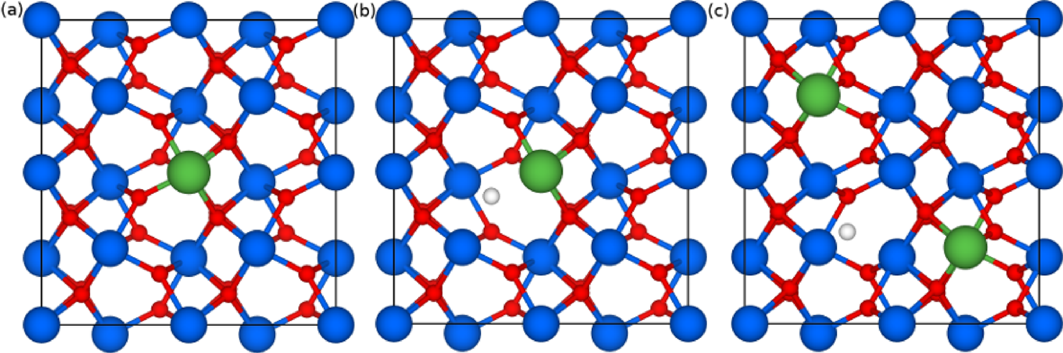

|  |  |  |  |  |  |
| --- | --- | --- | --- | --- | --- |
| 164101-3 | Materlik et al. | J. Appl. Phys. 123, 164101 (2018) | | | |
| FIG. | 1. (a) | Electronically | compen- |

sated, (b) mixed compensated, and (c)   
ionically compensated defects. Blue:   
Hf, red: O, green: dopant M, and   
white: vacancy.

From this comparison, no significantly different results are expected for GGA compared to LDA, concerning the ques-tion of phase stability. The stopping criterion for the elec-tronic convergence was a force criterion of 1 � 10–6Ha/h, and the stopping criterion for the structural convergence was a force criterion of 1 � 10–5Ha/h. Some calculations were repeated with the all-electron code “Fritz Haber Institute ab initio molecular simulations” (FHI-AIMS)52for validation of the PPs. FHI-AIMS is based upon numeric, atom-centered orbitals. These calculations used numerical orbitals (NOs) in tight settings with first and second tiers enabled with stop-ping criteria for the electronic convergence of 1 � 10–4eV/A˚and 1 � 10–3eV/A˚ for the structural convergence. In the remainder of this work, we will refer to those two methods as plane waves (PWs) and numerical orbitals (NOs), respec-tively. The k-point grid in ABINIT is based on the 4 � 4 � 4 Monkhorst-Pack grid divided by the number of unit cells in each corresponding direction. The same method was used with FHI-AIMS but with a 6 � 6 � 6 Monkhorst-Pack grid. The plane wave cutoff for ABINIT is 18 Ha, and the PAW cutoff is 22 Ha, in accordance with a convergence study.

oxygen partial pressure, the electronically compensated defect MHf is preferred when the charge is not compensated with lattice defects but with holes, lowering the Fermi level. For low oxygen partial pressure, the mixed compensated defect MHf VO is preferred when the charge is compensated with oxygen vacancies and electrons shifting the Fermi level up. The equilibrium concentration of these defects depends on the oxygen partial pressure.

The question of the associated charge of these defects requires some consideration. Usually, the charge of a defect depends on its defect structure and defect species and the position of the defect level within the band structure and the Fermi level. A MHf with a II- or III-valent dopant is expected 20,53 to create a defect level close to the valence band of HfO2 and, therefore, to be occupied by an electron carrying a nega-tive charge. This assumes that the Fermi level is not signifi-cantly affected by the presence of the defect, which is the case for sufficiently dilute defects. However, the doping con-centration of ferroelectric HfO2 with an order of magnitude of 1021/cm3is too large for this approximation to be reason-able. Due to the large concentration of the defects of at least

|  |  |
| --- | --- |
| B. Defects | 1=32 of the cations, we consider the majority of defects to be charge neutral and the Fermi level adapted. This is illustrated |

Al, Y, and La are III-valent atoms and form metal oxides of type M2O3. For the purpose of this work, these dopants are considered to substitute Hf. The three most important defects calculated for all dopant species are the electronically compensated MHf, the mixed compensated MHf VO, and the ionically compensated (2MHf)VO defects, which differ in the number of associated O vacancies. Examples of these defect structures in a f-phase are dis-played in Fig. 1. In Kr€oger-Vink notation, these defects are represented as follows: the ionically compensated defect (2MHf)VO

M2O3 ! 2M0 Hfþ 3OO þ V••O; (1)

the electronically compensated defect MHf

1=2O2 þ M2O3 ! 2M0 Hfþ 4OO þ 2h•; (2)

and the mixed compensated defect MHf VO

M2O3 ! 2M0 Hfþ 2OO þ 2V••Oþ 2e0 þ 1=2O2: (3)

In ceramic materials, the ionically compensated defect (2MHf)VO is assumed as the preferred structure because of charge compensation without electronic defects. For high

in Fig. 2. The remaining charge in the thin film is compen-sated by charges on the near electrodes, leading to an electric field in the film.54   
 To obtain a more thorough picture of the defect states, we include the results for an unpaired oxygen vacancy VO, based on the most favorable position of oxygen vacancies within the crystal structure. Mobile VO created during the

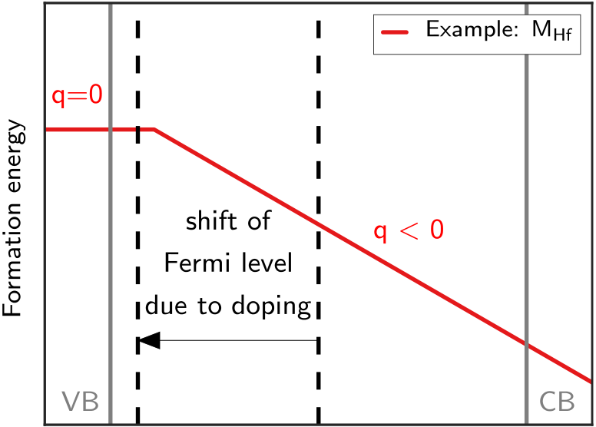



FIG. 2. Sketch of the mechanism leading to charge neutral defects using a MHf defect as an example. The large concentration of defects leads to a significant shift in the Fermi level until the majority of defects are no longer charged.

|  |  |  |
| --- | --- | --- |
| 164101-4 | Materlik et al. | J. Appl. Phys. 123, 164101 (2018) |

production of the film or during field cycling may diffuse to MHf and react to MHf VO . A more detailed description of all defect structures can be found in Sec. III of this work.

For Y and La, interstitial defects are unlikely because of dopant size. However, for Al, we include the three interstitial defects AlI, (2AlI)VHf, and (2AlI)VHf VO and O substitution AlO . The reason is the small size of Al, and the computa-tional results suggest that further defect types are needed to explain Al doping effects.

All defect structures have undergone a complete relaxa-tion of lattice constants and atomic positions. The structural results of the calculations were carefully checked for phase transitions by visual inspection. This was done by comparing the relaxed atomic positions of atoms away from the defect site with a list of symmetry conditions. Particularly, the oxy-gen sublattice is sensitive to both the presence of defects and characteristic for each phase, enabling us to judge whether a phase transformation had occurred or not. If a specific struc-ture transformed into another phase, we repeated the calcula-tion under enforcement of specific constraints, usually the

VO, AlI, (2AlI)VHf, (2AlI)VHf VO, AlO} . The chemical

potential and the number of defect atoms of each species are

given by li and ni, respectively. The chemical potentials are

tabulated in Table I along with the total energy of the materi-

als in the most stable configuration used to calculate them.

The chemical potential of Hf was set to the total

energy of hcp Hf. For the chemical potential of oxygen,

two cases are considered: oxygen rich and oxygen

poor.55,56In the oxygen rich case, lO was calculated by

lO2=2. Ferroelectric HfO2 is often deposited on TiN elec-

trodes1,4,13,25–28,57,58which can exist in a partially oxidized

state. The oxygen chemical potential lO for the deficient

conditions uses Ti precipitation into anatase TiO2. In simi-

lar studies,59precipitation into SiO2 has been used adapt-

ing to a Si substrate. Both assumptions, however, lead to

very similar formation enthalpies. Therefore, we calculate

lO ¼ ðlTiO2 � lTiÞ=2 for the oxygen poor case. The chemi-cal potential of the dopants was calculated from the total

energy of M2O3 as lM ¼ ðlM2O3 � 3lOÞ=2.

symmetry function of ABINIT. If this did not improve the sit- III. RESULTS

uation, the results were excluded from further consideration.

Due to the different nature of these defects, a unified defi-nition of the defect concentration is needed. This definition ensures that structures of equal size and an equal amount of dopant atoms have the same value for the defect concentration attributed to them. For example, the 96-atomic cells with one (2AlHf)VO, (2AlI)VHf, and (2AlI)VHf VO defect each have two Al atoms and therefore must be of equal concentration. The following definition of the defect concentration based upon formula units (f.u.) of HfO2 is used: Each dopant atom is assumed to affect one formula unit of HfO2, regardless where it is placed. A 96-atomic supercell has 32 formula units, and therefore, one dopant atom equals 3.125 f.u.% (¼1 dopant/32 formula units). A 48-atomic cell with 16 formula units and one dopant atom corresponds to 6.25 f.u.% (¼1 defect/16 for-mula units). Vacancies are thought to be associated with a dopant atom and, therefore, do not increase the value of the defect concentration, unless there is no dopant atom to pair up with. However, this is only the case with the VO defect.

C. Formation energies

The results of total energies U presented in this work will be given as the total energy difference of any phase and the m-phase per formula unit. Positive values indicate that a given phase is higher in energy than in the m-phase, and neg-ative values indicate that it is lower. The total energies of the undoped structures are 0 meV for the m-, 52.4 meV for the f-, 26.6 meV for the o-, 114.0 meV for the t-, and 167.0 meV for the c-phase. The total energy results for the defect struc-tures shown here always represent the lowest value of all calculated structures of that particular defect. The defect for-mation energy Ef is calculated as an absolute value

Ef X ð Þ ¼ U X ð Þ � U pure Þ �X nili X ð Þ (4)

with U(pure) the DFT total energy of pure HfO2 and U(X) the total energy with a defect X 2 {MHf, MHf VO, (2MHf)VO,

A. Electronically compensated defects

Substitutional defects of the type MHf comprise one dop-ant substituting one Hf and no oxygen vacancy. The charge is compensated electronically. The generation of these structures is straightforward, and the calculations are performed using 24-, 48-, and 96-atomic supercells with a single dopant.

The total energy differences as a function of the defect concentration of MHf defects are shown in Fig. 3 with Al in subplot (a), Y in (b), and La in (c). The energy differences of the f-phase decrease with the dopant concentration increas-ing up to 12.5 f.u.% for Y and La, whereas Al doping shows no effect. The effect is stronger for La with a decrease to 7.7 meV/f.u. than for Y with a decrease to only 26.1 meV/f.u. It has been previously suggested that the ability of a dopant to favor the f-phase in HfO2 is related to the size (crystal radius) of the dopant.8,23This fits the data presented here, as La is the largest and Al the smallest of the three dopants. The experimentally observed range of dopant concentrations

TABLE I. Total energies and the resulting chemical potentials used in this work. The first value for the chemical potential of each species represents oxygen-rich and the second value below oxygen-poor conditions. The values of the material total energy are included for the sake of reproducibility and are not necessary physical meaningful due to the limitations of DFT.

|  |  |  |  |
| --- | --- | --- | --- |
| Material | Total energy | Species | Chem. potential |
| Al2O3 | �1442.96 eV | Al | �67.32 eV �58.88 eV �1068.06 eV�1059.62 eV�885.71 eV�877.27 eV�436.11 eV�441.73 eV�1380.34 eV |
| Y 2O3 | �3444.44 eV | Y |
| La2O3 | �3079.75 eV | La |
| O2 | �872.21 eV | O |
| Hf | �1380.34 eV�2481.60 eV�1598.13 eV | Hf |
| TiO2 |
| Ti |

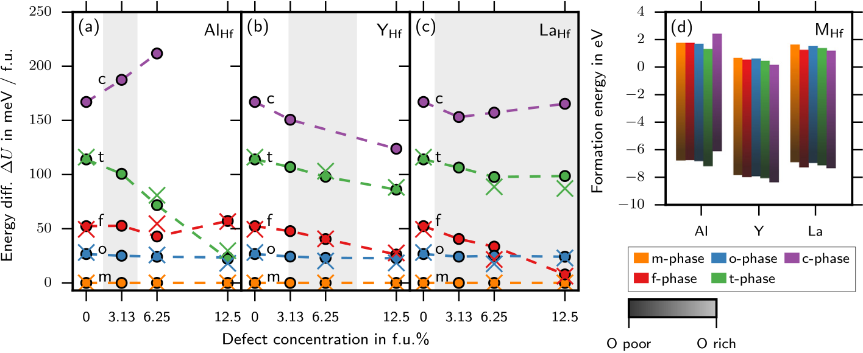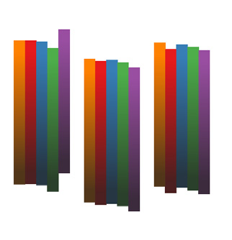

|  |  |  |
| --- | --- | --- |
| 164101-5 | Materlik et al. | J. Appl. Phys. 123, 164101 (2018) |

FIG. 3. Effect of electronically com-  
pensated substitutional defects MHf on   
the total energy differences of HfO2   
polymorphs relative to the m-phase.   
Subplot (a) displays the results for Al,   
(b) for Y, and (c) for La dopants. The   
experimentally observed range of dop-  
ant concentrations for ferroelectricity   
is highlighted by the grey area. The   
cross-marks show the results of FHI-  
AIMS calculations. The coloured bars   
in (d) indicate the formation energy of   
these defects as a function of oxygen   
chemical potential, ranging from rich   
(bright) to poor (dark).

for ferroelectricity as described earlier is indicated in the subplots for each dopant. The f-phase competes with the other phases in terms of energy decrease. The o-phase is gen-erally unaffected by either dopant. The t-phase shows a decrease in energy for all three dopants. The effect is large for Al and small for Y and La. This is remarkable since Al-doped HfO2 has been found to exhibit antiferroelectric-like behavior, attributed to a reversible phase change from the t-phase to the f-phase under an applied external electric field.19This requires the t-phase to be lower in energy than the f-phase. Since the energy of the t-phase in Y- and La-doped HfO2 never comes close to the f-phase, this result could explain the absence of antiferroelectric behavior in experimental observations. The c-phase shows an increase in energy with Al doping and an insignificant decrease for Y. For the sake of clarity, the graph is limited to 250 meV/f.u. One data point above that limit is therefore omitted from Fig. 3(a). The data point is 286.7 meV/f.u. for the c-phase at

However, doping alone is insufficient, and an additional favoring effect like an energy contribution from a surface or interface energy is needed. In contrast to Y and La, Al dop-ing realized as MHf does not contribute to the stabilization of the f-phase. However, the appearance of the t-phase as a pre-requisite of antiferroelectric behavior is consistent with the computational results.

B. Mixed compensated defects

Defects of the type MHf VO consist of a substituted metal ion, one oxygen vacancy, and one electron for com-pensation. Calculations were performed using 24-, 48-, and

TABLE II. Formation energy in eV of all defects in all phases. The first value of each defect represents oxygen rich and the second one below oxy-gen poor conditions.

|  |  |  |  |  |
| --- | --- | --- | --- | --- |
| m-phase | f-phase | o-phase | t-phase | c-phase |

|  |  |  |  |  |  |  |
| --- | --- | --- | --- | --- | --- | --- |
| a defect concentration of 12.5 f.u.%. | AlHf | 1.73 | 1.74 | 1.68 | 1.31 | 2.38 |
| For La, the doping has no effect on the c-phase. The | YHf | �6.71  0.68 | �6.70 0.53 | �6.76 0.60 | �7.14 0.45 | �6.06 0.15 |
| non-monotonous trend in some curves is possibly a hint to a |
| LaHf | �7.77  1.60 | �7.91 1.22 | �7.84 1.53 | �7.99 1.36 | �8.29 1.16 |
| dopant-to-dopant interaction for large concentrations not |
| investigated in this study. |
| AlHf VO | �6.84 | �7.22 | �6.92 | �7.08 | �7.29 |
| In addition to the results obtained with the ABINIT code |
| 6.00 | 5.71 | 5.85 | 5.24 | 3.98 |
| (circles), results obtained with the all-electron code FHI-AIMS |
| �8.07  4.87 | �8.36 4.60 | �8.22 4.79 | �8.83 4.27 | �10.09 3.17 |
| are shown (crosses) for validation of the used pseudo potentials | YHf VO |
| from the GBRV library. Both codes are in excellent agreement. |
| �9.20  5.35 | �9.47 4.82 | �9.28 5.20 | �9.80 4.72 | �10.90 3.88 |
| The formation energy of the electronically compensated | LaHf VO |
| defects is illustrated in Fig. 3(d) and tabulated in Table II. | �8.72 | �9.25 | �8.87 | �9.35 | �10.19 |
| (2AlHf)VO |
| Under oxygen-rich conditions, these defects have the lowest |
| 5.00 | 4.87 | 4.69 | 2.86 |
| formation energy compared to the MHf VO and (2MHf)VO | (2YHf)VO | �17.51 2.46 | �17.64 2.03 | �17.83 2.41 | �19.65 0.16 | 12.83 |
| defects but the highest under oxygen-poor conditions (see |
| Table II). In a previous publication20concerning the defect | �20.05 4.09 | �20.48 3.06 | �20.10 4.30 | �22.35 0.37 |
| (2LaHf)VO |
| formation energy of Sr defects in ferroelectric HfO2, we |
| �18.42 | �19.45 | �18.21 | �22.14 |
| argued that the production process must correspond to |
| AlI |
| oxygen-rich conditions. Our reasoning was that only under | 13.76 | 14.60 | 13.61 | 13.54 |

oxygen-rich conditions, the SrHf defect can form, which is the only Sr related defect we found favoring the ferroelectric

phase. Assuming that the production process of ferroelectric

HfO2 does not depend on the dopant used, it is reasonable that during the production and early life cycle of III-valent

doped ferroelectric HfO2, similar oxygen-rich conditions persist.

To conclude, similar to SrHf,20the YHf and LaHf defects contribute significantly to the stabilization of the f-phase.

|  |  |  |  |  |  |
| --- | --- | --- | --- | --- | --- |
| (2AlI)VHf | 5.32 | 6.16 | 5.17 | 5.09 | 4.39 |
| 10.24 | 10.84 | 10.34 | 9.60 | 11.36 |
| (2AlI)VHf VO | �6.64  16.57 | �6.04 17.34 | �6.54 17.55 | �7.29 17.24 | �5.53 15.43 |
| �5.94 | �5.17 | �4.96 | �5.28 | �7.09 |
| AlO |
| 18.66 | 19.48 | 18.59 | 21.16 | 19.56 |
| VO | 4.59 | 5.41 | 4.52 | 7.09 | 5.49 |
| 7.56 | 7.36 | 7.58 | 7.27 | 7.33 |
| 1.93 | 1.74 | 1.95 | 1.65 | 1.70 |

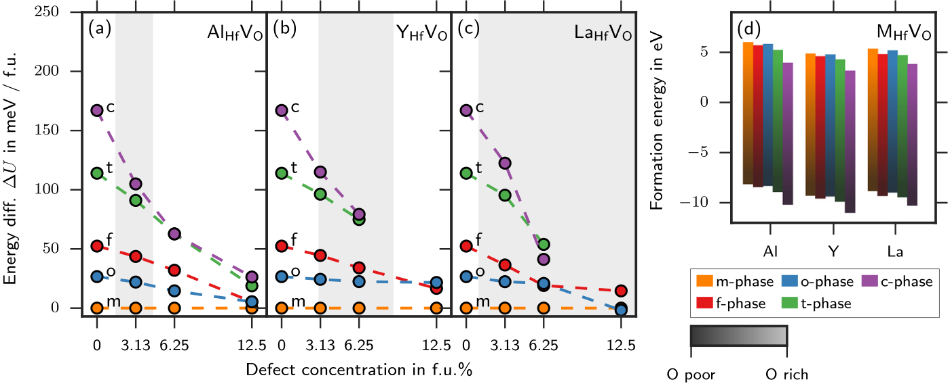

|  |  |  |
| --- | --- | --- |
| 164101-6 | Materlik et al. | J. Appl. Phys. 123, 164101 (2018) |

96-atomic supercells. Systematically, each of the eight near-est oxygen neighbors of the dopants was replaced by an oxy-gen vacancy, and the result for the position with the lowest energy was chosen. The supercells included only a single defect complex. For 12.5 f.u.%, the structure was too dis-torted to be uniquely identified as a t- or c-phase for Y- and La-doped HfO2. The computed results were therefore omitted.

Figure 4 displays the energy differences for the mixed compensated MHf VO defects, with Al in subplot (a), Y in (b), and La in (c). The f-phase energy difference shows a decrease for all three dopants with the strength of the effect increasing with dopant size. As in the case of the electroni-cally compensated defects, the o-phase energy shows little effect with doping, except for 12.5 f.u.% with Al and La, where the results are somewhat unreliable because of the small cell size. In the small supercells, a significant fraction of the volume is consumed by the distortion of the oxygen sublattice, which might affect the results by a distortion com-municated self-interaction of the defects across the boundary of the super cell. Both the t-phase and c-phase energies are strongly favored by the MHf VO defect for all three dopants, with the c-phase stronger supported than the t-phase. However, for Al, the effect is not strong enough to enable the t-phase within 12.5 f.u.%. Also, for Y, the effect seems to be insufficient to enable the t-phase or the c-phase within this concentration range. For La doping, the computed results do not exclude a stable c-phase in the investigated range. Antiferroelectric behavior has never been observed in Y- or La-doped HfO2. The occurrence of the c-phase has been reported in ALD-films37,39and CSD-films.38   
 From the calculated defect formation energy in Fig. 4(d) and Table II, it follows that the mixed compensated MHf VO defect in all phases is energetically unfavorable compared to the MHf and the (2MHf)VO defect under oxygen-rich condi-tions (see Table II). Taking into account that the (2MHf)VO defect includes two dopant atoms in comparison to the MHf VO defect, which includes one dopant, does not change this preference. The formation energy of the (2MHf)VO defect divided by two is still more favorable than the formation energy of the MHf VO defect under both oxygen-rich and

oxygen-poor conditions. Nevertheless, the MHf VO defect might still form under oxygen-poor conditions since it does not require special placement of dopant atoms, unlike the (2MHf)VO defect, which depends on a next-next-neighbor configuration of dopants and vacancy.60,61   
 To conclude, the mixed compensated defect MHf VO has a high formation energy compared to the ionically compen-sated (2MHf)VO under oxygen-rich conditions. The total energy trend for the f-phase in Al-doped HfO2 is favorable but not sufficient within the narrow ferroelectric concentra-tion range. The t-phase energy required for the observed

|  |  |  |  |  |  |  |
| --- | --- | --- | --- | --- | --- | --- |
| antiferroelectric | behavior | is | never | below | the | f-phase. |

However, the c-phase may become the energetically most favorable phase within a concentration range for Y and La above 6.25 f.u.%.

C. Ionically compensated defects

Ionically compensated defects are defect structures where the charge compensation is achieved without elec-tronic defects and the stoichiometric 2/3-ratio of metal and oxygen atoms is realized. However, the defect structure is intricate. These defects are calculated as type (2MHf)VO, and only 96-atomic supercells are used with either one or two defects in the DFT calculations. The 96 possible atom posi-tions of the supercells allow for a large number of configura-tions of the individual dopants and vacancies. To remain within computational time limits, only a subset of all possi-ble configurations has been calculated. This subset is gener-ated for each of the five investigated space groups in the same way. Parkes et al.60,61have determined the energeti-cally most favorable placement of atoms and vacancies of one or two (2MHf)VO defects within a 96-atomic supercell of cubic ZrO2. We have mapped the placement of defects in these cubic structures to the corresponding positions in the other four space groups. Considering all possible assign-ments of lattice constants between the cubic and the other space groups, as well as all rotations, we obtained up to six structural nonequivalent structures for calculation. In our opinion, at least one of the derived structures is a good

FIG. 4. Effect of mixed compensated defects MHf VO on the total energy differences of HfO2 polymorphs relative to the m-phase. Subplot (a) depicts the results for Al, (b) for Y, and (c) for La dopants. The defects consist of one dopant on a Hf site with a vacancy neighbouring O site. Only results for the energet-ically most favourable nearest neighbour vacancy position are shown. The experimentally observed range of dopant concentrations for ferroelectricity is highlighted by the grey area. The coloured bars in (d) indicate the formation energy of these defects as a function of oxygen chemical potential, ranging from rich (bright) to poor (dark).

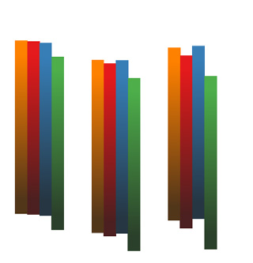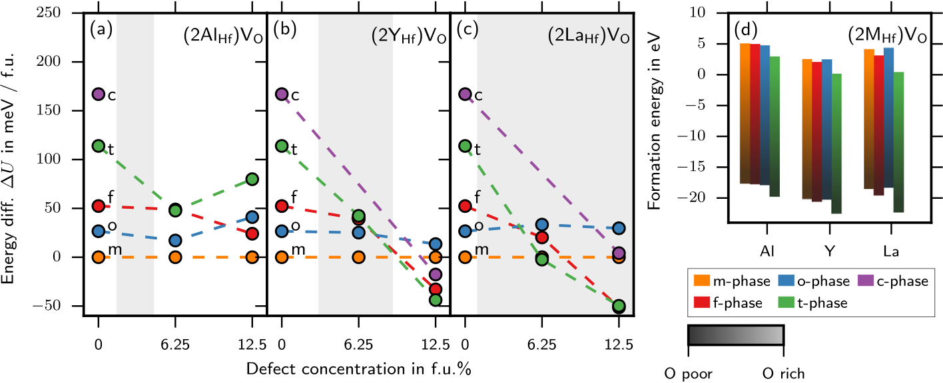

|  |  |  |
| --- | --- | --- |
| 164101-7 | Materlik et al. | J. Appl. Phys. 123, 164101 (2018) |

FIG. 5. Effect of ionically compensated defects (2MHf)VO on the total energy differences of HfO2 polymorphs relative to the m-phase. Subplot (a) displays the results for Al, (b) for Y, and (c) for La dopants. Only results of the energetically most favourable nearest neighbour vacancy position are shown. The experi-mentally observed range of dopant concentrations for ferroelectricity is highlighted by the grey area. The coloured bars in (d) indicate the formation energy of these defects as a function of oxygen chemical potential ranging from rich (bright) to poor (dark).

|  |  |  |  |  |  |  |
| --- | --- | --- | --- | --- | --- | --- |
| approximation | of | the | energetically | most | favorable | To conclude, the formation energy of the (2MHf)VO |
| configuration. | defect under oxygen-rich conditions is large. For Al-doping, |

Figure 5 displays the effect of the ionically compensated defects on the total energy differences, with Al in subplot (a), Y in (b), and La in (c). The c-phase was found to be unstable for 6.25 f.u.% Y and La doping but was strongly supported for 12.5 f.u.%. A stable cubic or pseudo-cubic phase is observed in the well-known 10 f.u.% Y stabilized ZrO2 and HfO2 ceramic materials.14,62According to the computation, however, the t-phase and the f-phase are strongly favored as well and are in close competition with the c-phase in the 6 f.u.% to 12 f.u.% range. Since the t-phase is slightly in advantage for the highest concentration, one could expect antiferroelectric behavior which has not been observed for either dopant. To clarify the situation, a more detailed investigation in the 12 f.u.% concentration range for competing phases is necessary, which has only been done for cubic ZrO2.63   
 For Al-doping, no clear trend is visible, which could be an indication that the limited number of calculated defect structures is not sufficient to find the energetic optimum. The reason might be the much smaller size of Al compared to Y and La, which could lead to favorable structures other than found by Parkes et al. In the DFT calculations, the c-phase always transformed into the t-phase for Al doping and for 6.25 f.u.% Y and La doping. However, at 12.5 f.u.%, the c-phase was preserved for Y and La.

Under oxygen-poor conditions, the (2MHf)VO defect is the most stable defect. HfO2 thin films generate oxygen vacancies when repeatedly field cycled, which leads to an oxygen deficient film.57Therefore, it is reasonable to assume that this defect forms in the ceramic process or at the end of the life cycle of a ferroelectric capacitor. Since the t-phase is energetically more favorable than the f-phase, this defect is unlikely to promote ferroelectric behavior. This means that the formation of (2MHf)VO defects over time could contrib-ute to fatigue. However, the defect requires the placement of two dopant atoms in close proximity to each other. If the mobility of dopant atoms within the HfO2 matrix is low and the distance of dopant atoms is large, the formation of this

the investigated structures do not explain ferro- or antiferro-electric behavior. For Y and La doping, the defects lead to a competition of the c-phase, f-phase, and t-phase for the high concentration. This is compatible with observations, but more work is needed for clarification.

D. Interstitial Al defects

Since neither of the three previously discussed defects offered a satisfying explanation of the observed ferroelectric-ity of Al-doped HfO2, additional Al defects were considered. Using 96-atomic supercells, five possible positions of the interstitial were considered for each phase. These were placed in-plane with four Hf atoms on volume centric posi-tions of the O sublattice. Three interstitial Al defects are con-sidered in this work. As the first defect, a simple Al interstitial (AlI) was considered. Owing to the space require-ments of the interstitials, the other two interstitial considered defects ((2AlI)VHf and (2AlI)VHf VO) include a Hf vacancy paired with two interstitial Al dopants. In addition, one of the defects includes an oxygen vacancy. The two interstitials are initially placed close to the Hf vacancy site and are moved slightly off-site upwards and downwards along the z-direction of the supercell. The dopants did not move signif-icantly off the starting position after ionic relaxation. All oxygen sites in proximity to either interstitial were consid-ered for the placement of an oxygen vacancy.

Figure 6 summarizes the total energy differences of the interstitial Al defects and pure undoped HfO2 for compari-son. Due to the nature of the interstitial defects, the defect concentration of the AlI defect is 3.125 f.u.%, while for (2AlI)VHf and (2AlI)VHf VO, the defect concentration is 6.25 f.u.%. The total energy differences of the f-phase increase for all three defects compared to pure HfO2. The o-phase shows little effect with the exception of (2AlI)VHf VO, where the total energy differences increases. The total energy of the t-phase decreases for AlI and (2AlI)VHf and increases for (2AlI)VHf VO . The c-phase shows a decrease in AlI and (2AlI)VHf VO doped structures but an increase in (2AlI)VHf

defect might be suppressed in favor of the MHf VO defect. structures.

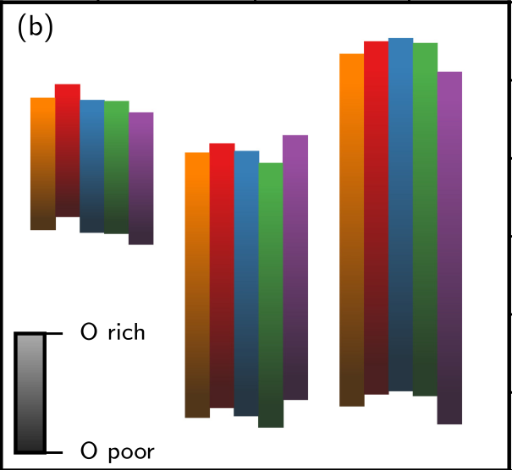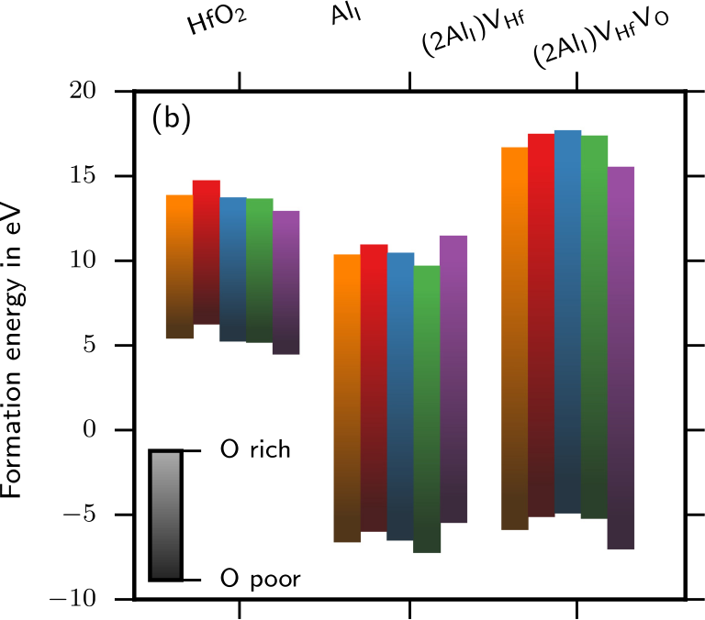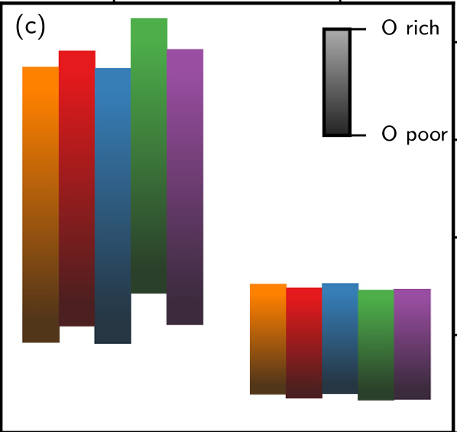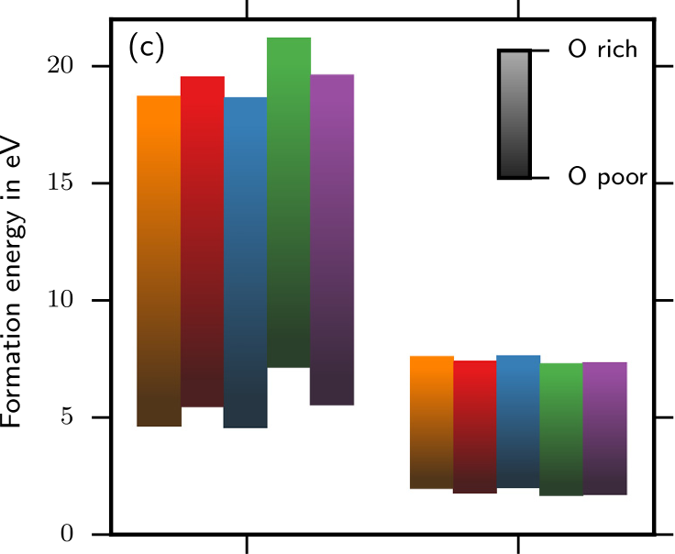

|  |  |  |
| --- | --- | --- |
| 164101-8 | Materlik et al. | J. Appl. Phys. 123, 164101 (2018) |

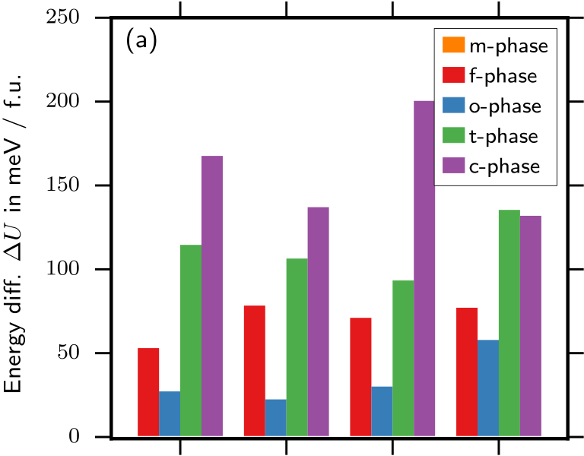

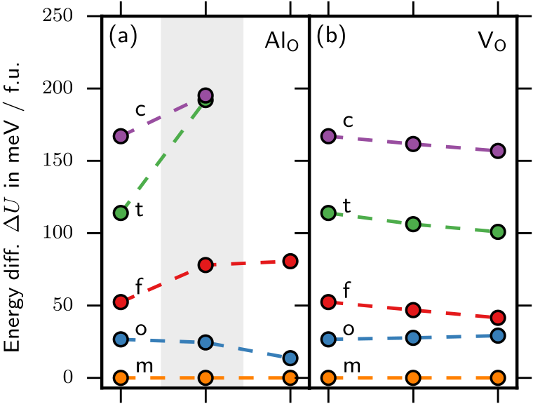

 



|  |  |  |  |
| --- | --- | --- | --- |
|  |  |  |  |
|  | |

FIG. 6. Effect of interstitial Al defects on the total energy differences of HfO2 polymorphs in relation to the m-phase. The figure displays left to right undoped HfO2, AlI, (2AlI)VHf, and (2AlI)VHf VO. The dopant concentration of the AlI defect is 3.125 f.u.%, while the bar plots of (2AlI)VHf and (2AlI)VHf VO correspond to a dopant concentration of 6.25 f.u.%. The bars in (d) indicate the range of the formation energies of interstitial defects as a function of oxygen chemical potential from oxygen rich (bright) to oxygen poor (dark).

Analyzing the defect formation energies of the three interstitial Al defects tabulated in Table II, it is revealed that the formation energy is generally large compared to the sub-stitutional defects, making their realization in HfO2 thin films unlikely. Furthermore, since the f-phase is always ener-getically disadvantaged compared to the m-phase, interstitial defects cannot explain ferroelectricity in Al-doped HfO2.

E. Oxygen site defects

In addition to interstitial defects, we also tested Al on an oxygen position AlO as a possible stabilization mechanism for the f-phase. The generation of these defect structures is straightforward; however, multiple oxygen positions need to be considered. Calculations were performed using 48- and 96-atomic cells.

The effect of the AlO defect on the total energy differ-ences is displayed in Fig. 7 as a function of the defect con-centration. The o-phase shows a decrease in the total energy. The f-phase shows a moderate and the t- and c-phase show a strong increase in the total energy. For the sake of clarity, the graph is limited to 250 meV/f.u. Therefore, two data

FIG. 7. Effect of oxygen site defects on the total energy differences of HfO2 polymorphs in relation to the m-phase. Subplot (a) displays the results for Al on an oxygen site and (b) for a simple oxygen vacancy. Only results of the energetically most favourable configuration of each phase are shown. In (a), the experimentally observed range of dopant concentrations for ferroelec-tricity is highlighted by the grey area. The bars in (d) indicate the range of the formation energies of oxygen site defects as a function of oxygen chemi-cal potential from oxygen rich (bright) to oxygen poor (dark).

points above that limit are omitted in Fig. 7(a). These data points are 263.4 meV/f.u. for the t-phase and 498.7 meV/f.u. for the c-phase at a defect concentration of 6.25 f.u.%. VO defects have no significant effect on their own but favor slightly higher symmetric phases over phases with lower symmetry. However, VO defects might have an influence in combination with other effects, like dopants or surface or interface energies.

The formation energy of VO defects is below 7.5 eV for oxygen-rich and below 2 eV for oxygen-poor conditions. Pe�sic´et al.57investigated the VO defects experimentally and found an increasing number of vacancies with field cycling. Furthermore, the mobility of oxygen vacancies is high in HfO2 and ZrO2, making a reaction with MHf defects more likely. A reaction would release an energy of 3 eV to 4 eV depending on the crystal phase and the dopant. The formation energy of AlO defects is very high, making them unlikely to occur.

For reference, the formation energies of all defects for oxygen rich and oxygen poor conditions are provided in Table II. The results are consistent with those of other publications.65,66

|  |  |  |
| --- | --- | --- |
| 164101-9 | Materlik et al. | J. Appl. Phys. 123, 164101 (2018) |

IV. CONCLUSION

We have investigated the influence of the III-valent dop-ants Al, Y, and La on the phase stability of the five common HfO2 phases. Special attention was given to the stabilization of the ferroelectric Pca21 phase. We calculated the total energy differences and formation energy for three different defects, the electronically compensated MHf, the mixed com-pensated MHf VO, and the ionically compensated (2MHf)VO dopant for all three Al, Y, and La. We found that for Y- and La-doping, all three defects favor the f-phase in comparison to the m-phase. However, the t- and c-phase are also strongly favored for the MHf VO and (2MHf)VO defects, rendering the effective stabilization of the f-phase more difficult or impos-sible to achieve. Experimentally, the stabilization of the t-phase, or possibly also the c-phase, over the f-phase should become evident as an antiferroelectric hysteresis loop,19 which has not been observed for Y- and La-doping. Therefore, to be consistent with experimental results, the MHf defect is most likely responsible for the observed ferro-electric behavior of doped HfO2 although the MHf VO defect might contribute within a limited concentration range. We have observed the same effect in II-valent Sr-doped HfO2,20 where the introduction of vacancies in combination with the dopant atoms destabilizes the f-phase. This interpretation is supported by the fact that the MHf defect has the lowest formation energy of all three defect structures, given suffi-ciently oxygen-rich conditions. These oxygen-rich condi-tions are probably provided by the introduction of the oxygen-precursor at high temperatures during the ALD pro-duction process or rapid thermal annealing at even higher temperatures. The observed antiferroelectricity in Al-doped HfO2 is consistent with the AlHf defect, which strongly favors the t-phase.

Further insights into the realized defect structure might be gained by comparing the different concentration ranges for ferroelectricity in La-doped HfO2. Mueller et al.,36 Chernikova et al.,37and Starschich and Boettger38all found a range for ferroelectricity with its upper limit around 5 f.u.%, while Schr€oder et al.39report an upper limit of around 20 f.u.%. Based on the results presented here, we suggest that the reason for this vast difference is the concentration of oxygen vacancies in the defect complexes. The three earlier studies possibly had a high amount of ionically compensated or mixed compensated defects, while in the later study, elec-tronically compensated defects possibly dominated. This is further supported by the fact that Chernikova et al. used O2-plasma as an oxygen source. This process is known to result in lower density and higher leakage current density and therefore a higher oxygen vacancy concentration than the H2O process described by Schr€oder et al.40We therefore predict that it is possible to extend the concentration range of Y-doped ferroelectric HfO2 in a similar manner to La if it is possible to produce a film with a very low concentration of oxygen vacancies.

Al-doping did not favour the f-phase significantly, which is why we investigated additional interstitial and O-site defects for Al. However, none of these defects pro-vided any substantial benefit for the f-phase. As of now, the

question why Al promotes ferroelectric behaviour in a very narrow concentration window as observed in experiments remains unanswered. The reason why Al behaves so differ-ently from Y and La is probably the substantial difference in size. The small size could lead to dopant clustering, which has not been investigated here. The absence of a (partially) occupied d-orbital found in both Y and La and in Gd might also contribute. Comparing all three investigated dopants, we found La to be the most effective for producing ferroelec-tricity in HfO2.

ACKNOWLEDGMENTS

The authors thank U. Schr€oder, T. Schenk, and Min Hyuk Park from NamLab/SNU and U. B€ottger and S. Starschich from RWTH Aachen for discussions. The German Research Foundation (Deutsche Forschungsgemeinschaft) is acknowledged for funding this research in the frame of the project Inferox (Project No. MI 1247/111). The authors gratefully acknowledge the Gauss Centre for Supercomputing e.V. ([www.gauss-centre.eu](http://www.gauss-centre.eu)) for funding this project by providing computing time on the GCS Supercomputer SuperMUC at the Leibniz Supercomputing Center (LRZ, [www.lrz.de](http://www.lrz.de)).

1T. S. B€oscke, J. M€uller, D. Br€auhaus, U. Schr€oder, and U. B€ottger,“Ferroelectricity in hafnium oxide thin films,” [Appl. Phys. Lett.](https://doi.org/10.1063/1.3634052) 99, 102903 (2011).

2S. Mueller, J. Mueller, A. Singh, S. Riedel, J. Sundqvist, U. Schroeder, and T. Mikolajick, “Incipient ferroelectricity in Al-doped HfO2 thin films,” [Adv. Funct. Mater.](https://doi.org/10.1002/adfm.201103119) 22, 2412–2417 (2012).

3S. Mueller, C. Adelmann, A. Singh, S. Van Elshocht, U. Schroeder, and T. Mikolajick, “Ferroelectricity in Gd-doped HfO2 thin films,” [ECS J. Solid State Sci. Technol.](https://doi.org/10.1149/2.002301jss) 1, N123–N126 (2012).

4J. M€uller, T. S. B€oscke, U. Schr€oder, S. Mueller, D. Br€auhaus, U. B€ottger, L. Frey, and T. Mikolajick, “Ferroelectricity in simple binary ZrO2 and HfO2,” [Nano Lett.](https://doi.org/10.1021/nl302049k) 12, 4318–4323 (2012).

5M. H. Park, H. J. Kim, Y. J. Kim, W. Lee, H. K. Kim, and C. S. Hwang,“Effect of forming gas annealing on the ferroelectric properties of Hf0.5Zr0.5O2 thin films with and without Pt electrodes,” [Appl. Phys. Lett.](https://doi.org/10.1063/1.4798265) 102, 112914 (2013).

6P. D. Lomenzo, Q. Takmeel, C. Zhou, Y. Liu, C. M. Fancher, J. L. Jones, S. Moghaddam, and T. Nishida, “The effects of layering in ferroelectric Si-doped HfO2 thin films,” [Appl. Phys. Lett.](https://doi.org/10.1063/1.4893738) 105, 072906 (2014).

7M. H. Park, Y. H. Lee, H. J. Kim, Y. J. Kim, T. Moon, K. D. Kim, J. M€uller, A. Kersch, U. Schroeder, T. Mikolajick, and C. S. Hwang,“Ferroelectricity and antiferroelectricity of doped thin HfO2-based films,”[Adv. Mater.](https://doi.org/10.1002/adma.201404531) 27, 1811–1831 (2015).

8U. Schroeder, E. Yurchuk, J. M€uller, D. Martin, T. Schenk, P. Polakowski, C. Adelmann, M. I. Popovici, S. V. Kalinin, and T. Mikolajick, “Impact of different dopants on the switching properties of ferroelectric hafnium oxide,” [Jpn. J. Appl. Phys., Part 2](https://doi.org/10.7567/JJAP.53.08LE02) 53, 08LE02 (2014).

9S. Starschich, T. Schenk, U. Schroeder, and U. Boettger, “Ferroelectric and piezoelectric properties of Hf1–xZrxO2 and pure ZrO2 films,” [Appl. Phys. Lett.](https://doi.org/10.1063/1.4983031) 110, 182905 (2017).

10T. Shimizu, K. Katayama, T. Kiguchi, A. Akama, T. J. Konno, O. Sakata, and H. Funakubo, “The demonstration of significant ferroelectricity in epi-taxial Y-doped HfO2 film,” [Sci. Rep.](https://doi.org/10.1038/srep32931) 6, 32931 (2016).

11T. Olsen, U. Schr€oder, S. M€uller, A. Krause, D. Martin, A. Singh, J. M€uller, M. Geidel, and T. Mikolajick, “Co-sputtering yttrium into hafnium oxide thin films to produce ferroelectric properties,” [Appl. Phys. Lett.](https://doi.org/10.1063/1.4747209) 101, 082905 (2012).

12T. D. Huan, V. Sharma, G. A. Rossetti, and R. Ramprasad, “Pathways towards ferroelectricity in hafnia,” [Phys. Rev. B](https://doi.org/10.1103/PhysRevB.90.064111) 90, 064111 (2014).

13X. Sang, E. D. Grimley, T. Schenk, U. Schroeder, and J. M. LeBeau, “On the structural origins of ferroelectricity in HfO2 thin films,” [Appl. Phys. Lett.](https://doi.org/10.1063/1.4919135) 106, 162905 (2015).

|  |  |  |
| --- | --- | --- |
| 164101-10 | Materlik et al. | J. Appl. Phys. 123, 164101 (2018) |

14J. Wang, H. P. Li, and R. Stevens, “Hafnia and hafnia-toughened ceram- ics,” [J. Mater. Sci.](https://doi.org/10.1007/BF00541601) 27, 5397–5430 (1992).

15L.-G. Liu, “New high pressure phases of ZrO2 and HfO2,” [J. Phys. Chem.](https://doi.org/10.1016/0022-3697(80)90205-X)  [Solids](https://doi.org/10.1016/0022-3697(80)90205-X) 41, 331–334 (1980).

16C. J. Howard, E. H. Kisi, and O. Ohtaka, “Crystal structures of two ortho- rhombic zirconias,” [J. Am. Ceram. Soc.](https://doi.org/10.1111/j.1151-2916.1991.tb08307.x) 74, 2321–2323 (1991).

17C. Richter, T. Schenk, M. H. Park, F. A. Tscharntke, E. D. Grimley, J. M. LeBeau, C. Zhou, C. M. Fancher, J. L. Jones, T. Mikolajick, and U. Schroeder, “Si doped hafnium oxide—A “fragile” ferroelectric system,”[Adv. Electron. Mater.](https://doi.org/10.1002/aelm.201700131) 3, 1700131 (2017).

18R. Materlik, C. K€unneth, and A. Kersch, “The origin of ferroelectricity in Hf1– xZrxO2: A computational investigation and a surface energy model,”[J. Appl. Phys.](https://doi.org/10.1063/1.4916707) 117, 134109 (2015).

19S. E. Reyes-Lillo, K. F. Garrity, and K. M. Rabe, “Antiferroelectricity in thin-film ZrO2 from first principles,” [Phys. Rev. B](https://doi.org/10.1103/PhysRevB.90.140103) 90, 140103 (2014). 20R. Materlik, C. K€unneth, T. Mikolajick, and A. Kersch, “The impact of charge compensated and uncompensated strontium defects on the stabili- zation of the ferroelectric phase in HfO2,” [Appl. Phys. Lett.](https://doi.org/10.1063/1.4993110) 111, 082902 (2017).

21R. Batra, H. D. Tran, and R. Ramprasad, “Stabilization of metastable phases in hafnia owing to surface energy effects,” [Appl. Phys. Lett.](https://doi.org/10.1063/1.4947490) 108, 172902 (2016).

22R. Batra, T. D. Huan, J. L. Jones, G. Rossetti, and R. Ramprasad, “Factors favoring ferroelectricity in hafnia: A first-principles computational study,”[J. Phys. Chem. C](https://doi.org/10.1021/acs.jpcc.6b11972) 121, 4139–4145 (2017).

23R. Batra, T. D. Huan, G. A. Rossetti, and R. Ramprasad, “Dopants promot-ing ferroelectricity in hafnia: Insights from a comprehensive chemical space exploration,” [Chem. Mater.](https://doi.org/10.1021/acs.chemmater.7b02835) 29, 9102–9109 (2017).

24M. Hoffmann, U. Schroeder, T. Schenk, T. Shimizu, H. Funakubo, O. Sakata, D. Pohl, M. Drescher, C. Adelmann, R. Materlik, A. Kersch, and T. Mikolajick, “Stabilizing the ferroelectric phase in doped hafnium oxide,” [J. Appl. Phys.](https://doi.org/10.1063/1.4927805) 118, 072006 (2015).

25P. Polakowski and J. M€uller, “Ferroelectricity in undoped hafnium oxide,” [Appl. Phys. Lett.](https://doi.org/10.1063/1.4922272) 106, 232905 (2015).

26M. H. Park, H. J. Kim, Y. J. Kim, Y. H. Lee, T. Moon, K. D. Kim, S. D. Hyun, and C. S. Hwang, “Study on the size effect in Hf0.5Zr0.5O2 films thinner than 8 nm before and after wake-up field cycling,” [Appl. Phys. Lett.](https://doi.org/10.1063/1.4935588) 107, 192907 (2015).

27M. H. Park, H. J. Kim, Y. J. Kim, W. Lee, T. Moon, and C. S. Hwang,“Evolution of phases and ferroelectric properties of thin Hf0.5Zr0.5O2 films according to the thickness and annealing temperature,” [Appl. Phys. Lett.](https://doi.org/10.1063/1.4811483) 102, 242905 (2013).

28H. J. Kim, M. H. Park, Y. J. Kim, Y. H. Lee, W. Jeon, T. Gwon, T. Moon, K. D. Kim, and C. S. Hwang, “Grain size engineering for ferroelectric Hf0.5Zr0.5O2 films by an insertion of Al2O3 interlayer,” [Appl. Phys. Lett.](https://doi.org/10.1063/1.4902072) 105, 192903 (2014).

29C. K€unneth, R. Materlik, and A. Kersch, “Modeling ferroelectric film xZrxO2 properties and size effects from tetragonal interlayer in Hf1–  
 grains,” [J. Appl. Phys.](https://doi.org/10.1063/1.4983811) 121, 205304 (2017).

30M. H. Park, Y. H. Lee, H. J. Kim, Y. J. Kim, T. Moon, K. D. Kim, S. D. Hyun, T. Mikolajick, U. Schroeder, and C. S. Hwang, “Understanding the formation of the metastable ferroelectric phase in hafnia-zirconia solid solution thin films,” [Nanoscale](https://doi.org/10.1039/C7NR06342C) 10, 716–725 (2018).

31R. D. Shannon, “Revised effective ionic radii and systematic studies of interatomic distances in halides and chalcogenides,” [Acta Crystallogr. Sect. A](https://doi.org/10.1107/S0567739476001551) 32, 751–767 (1976).

32M. H. Park, T. Schenk, C. M. Fancher, E. D. Grimley, C. Zhou, C. Richter, J. M. LeBeau, J. L. Jones, T. Mikolajick, and U. Schroeder, “A comprehensive study on the structural evolution of HfO2 thin films doped with various dopants,” [J. Mater. Chem. C](https://doi.org/10.1039/C7TC01200D) 5, 4677 (2017).

33J. M€uller, U. Schr€oder, T. S. B€oscke, I. M€uller, U. B€ottger, L. Wilde, J. Sundqvist, M. Lemberger, P. K€ucher, T. Mikolajick, and L. Frey,“Ferroelectricity in yttrium-doped hafnium oxide,” [J. Appl. Phys.](https://doi.org/10.1063/1.3667205) 110, 114113 (2011).

34K. Kita, K. Kyuno, and A. Toriumi, “Permittivity increase of yttrium-doped HfO2 through structural phase transformation,” [Appl. Phys. Lett.](https://doi.org/10.1063/1.1880436) 86, 102906 (2005).

35S. Starschich, D. Griesche, T. Schneller, and U. B€ottger, “Chemical solu-tion deposition of ferroelectric hafnium oxide for future lead free ferro-electric devices,” [ECS J. Solid State Sci. Technol.](https://doi.org/10.1149/2.0061512jss) 4, P419 (2015).

36J. M€uller, T. S. B€oscke, S. M€uller, E. Yurchuk, P. Polakowski, J. Paul, D. Martin, T. Schenk, K. Khullar, A. Kersch, W. Weinreich, S. Riedel, K. Seidel, A. Kumar, T. M. Arruda, S. V. Kalinin, T. Schl€osser, R. Boschke, R. van Bentum, U. Schr€oder, and T. Mikolajick, “Ferroelectric hafnium

oxide: A cmos-compatible and highly scalable approach to future ferro-electric memories,” in Proceedings of the IEEE International Electron Devices Meeting (2013), pp. 10.8.1–10.8.4.

37A. G. Chernikova, D. S. Kuzmichev, D. V. Negrov, M. G. Kozodaev, S. N. Polyakov, and A. M. Markeev, “Ferroelectric properties of full plasma-enhanced ALD TiN/La:HfO2/TiN stacks,” [Appl. Phys. Lett.](https://doi.org/10.1063/1.4953787) 108, 242905 (2016).

38S. Starschich and U. Boettger, “An extensive study of the influence of dop-ants on the ferroelectric properties of HfO2,” [J. Mater. Chem. C](https://doi.org/10.1039/C6TC04807B) 5, 333 (2017).

39U. Schroeder, C. Richter, M. H. Park, T. Schenk, M. Pei, M. Hoffmann, F. P. G. Fengler, D. Pohl, B. Rellinghaus, C. Zhou, C.-C. Chung, J. L. Jones, and T. Mikolajick, “Lanthanum-doped hafnium oxide: A robust ferroelec-tric material,” [Inorg. Chem.](https://doi.org/10.1021/acs.inorgchem.7b03149) 57, 2752–2765 (2018).

40C. Richter, T. Schenk, U. Schroeder, and T. Mikolajick, “Film properties of low temperature HfO2 grown with H2O, O3, or remote O2-plasma,”[J. Vac. Sci. Technol. A](https://doi.org/10.1116/1.4842675) 32, 01A117 (2014).

41M. G. Kozodaev, A. G. Chernikova, E. V. Korostylev, M. H. Park, U. Schroeder, C. S. Hwang, and A. M. Markeev, “Ferroelectric properties of lightly doped la: Hfo2 thin films grown by plasma-assisted atomic layer deposition,” [Appl. Phys. Lett.](https://doi.org/10.1063/1.4999291) 111, 132903 (2017).

42S. V. Barabash, D. Pramanik, Y. Nishi, B. Magyari-Kope, and Y. Zhai,“Ferroelectric switching pathways and energetics in (Hf,Zr)O2,” [ECS Trans.](https://doi.org/10.1149/07532.0107ecst) 75, 107–121 (2017).

43D. Fischer and A. Kersch, “Stabilization of the high-k tetragonal phase in HfO2: The influence of dopants and temperature from ab initio simu-lations,” [J. Appl. Phys.](https://doi.org/10.1063/1.2999352) 104, 084104 (2008).

44C.-K. Lee, E. Cho, H.-S. Lee, C. S. Hwang, and S. Han, “First-principles study on doping and phase stability of HfO2,” [Phys. Rev. B](https://doi.org/10.1103/PhysRevB.78.012102) 78, 012102 (2008).

45X. Gonze, B. Amadon, P.-M. Anglade, J.-M. Beuken, F. Bottin, P. Boulanger, F. Bruneval, D. Caliste, R. Caracas, M. Ct, T. Deutsch, L. Genovese, P. Ghosez, M. Giantomassi, S. Goedecker, D. Hamann, P. Hermet, F. Jollet, G. Jomard, S. Leroux, M. Mancini, S. Mazevet, M. Oliveira, G. Onida, Y. Pouillon, T. Rangel, G.-M. Rignanese, D. Sangalli, R. Shaltaf, M. Torrent, M. Verstraete, G. Zerah, and J. Zwanziger,“Abinit: First-principles approach to material and nanosystem properties,”[Comput. Phys. Commun.](https://doi.org/10.1016/j.cpc.2009.07.007) 180, 2582–2615 (2009).

46X. Gonze, F. Jollet, F. A. Araujo, D. Adams, B. Amadon, T. Applencourt, C. Audouze, J.-M. Beuken, J. Bieder, A. Bokhanchuk, E. Bousquet, F. Bruneval, D. Caliste, M. Ct, F. Dahm, F. D. Pieve, M. Delaveau, M. D. Gennaro, B. Dorado, C. Espejo, G. Geneste, L. Genovese, A. Gerossier, M. Giantomassi, Y. Gillet, D. Hamann, L. He, G. Jomard, J. L. Janssen, S. L. Roux, A. Levitt, A. Lherbier, F. Liu, I. Lukaevi, A. Martin, C. Martins, M. Oliveira, S. Ponc, Y. Pouillon, T. Rangel, G.-M. Rignanese, A. Romero, B. Rousseau, O. Rubel, A. Shukri, M. Stankovski, M. Torrent, M. V. Setten, B. V. Troeye, M. Verstraete, D. Waroquiers, J. Wiktor, B. Xu, A. Zhou, and J. Zwanziger, “Recent developments in the ABINIT software package,” [Comput. Phys. Commun.](https://doi.org/10.1016/j.cpc.2016.04.003) 205, 106–131 (2016).

47M. Torrent, F. Jollet, F. Bottin, G. Z�erah, and X. Gonze, “Implementation

|  |  |  |  |  |  |  |  |  |
| --- | --- | --- | --- | --- | --- | --- | --- | --- |
| of | the | projector | augmented-wave | method | in | the | ABINIT | code: |

Application to the study of iron under pressure,” [Comput. Mater. Sci.](https://doi.org/10.1016/j.commatsci.2007.07.020) 42, 337–351 (2008).

48P. E. Bl€ochl, “Projector augmented-wave method,” [Phys. Rev. B](https://doi.org/10.1103/PhysRevB.50.17953) 50, 17953–17979 (1994).

49K. F. Garrity, J. W. Bennett, K. M. Rabe, and D. Vanderbilt, “GBRV high-throughput pseudopotentials,” see <https://www.physics.rutgers.edu/gbrv/>(2017).

50K. F. Garrity, J. W. Bennett, K. M. Rabe, and D. Vanderbilt,“Pseudopotentials for high-throughput DFT calculations,” [Comput. Mater. Sci.](https://doi.org/10.1016/j.commatsci.2013.08.053) 81, 446–452 (2014).

51C. Knneth, R. Materlik, M. Falkowski, and A. Kersch, “Impact of four- valent doping on the crystallographic phase formation for ferroelectric hfo2 from first-principles: Implications for ferroelectric memory and energy-related applications,” [ACS Appl. Nano Mater.](https://doi.org/10.1021/acsanm.7b00124) 1, 254–264 (2018). 52V. Blum, R. Gehrke, F. Hanke, P. Havu, V. Havu, X. Ren, K. Reuter, and M. Scheffler, “Ab initio molecular simulations with numeric atom- centered orbitals,” [Comput. Phys. Commun.](https://doi.org/10.1016/j.cpc.2009.06.022) 180, 2175–2196 (2009).

53W. Zhang and Z. F. Hou, “Interplay between gadolinium dopants and oxy-gen vacancies in HfO2: A density functional theory plus hubbard U inves-tigation,” [J. Appl. Phys.](https://doi.org/10.1063/1.4869539) 115, 124104 (2014).

54F. P. G. Fengler, M. Pei, S. Starschich, T. Schneller, C. K€unneth, U. B€ottger, H. Mulaosmanovic, T. Schenk, M. H. Park, R. Nigon, P. Muralt,

|  |  |  |
| --- | --- | --- |
| 164101-11 | Materlik et al. | J. Appl. Phys. 123, 164101 (2018) |

T. Mikolajick, and U. Schroeder, “Domain pinning: Comparison of hafnia and PZT based ferroelectrics,” [Adv. Electron. Mater.](https://doi.org/10.1002/aelm.201600505) 3, 1600505 (2017). 55C. Tang and R. Ramprasad, “Point defect chemistry in amorphous HfO2: Density functional theory calculations,” [Phys. Rev. B](https://doi.org/10.1103/PhysRevB.81.161201) 81, 161201 (2010). 56J. Lyons, A. Janotti, and C. V. de Walle, “The role of oxygen-related defects and hydrogen impurities in HfO2 and ZrO2,” [Microelectron. Eng.](https://doi.org/10.1016/j.mee.2011.03.099)  88, 1452–1456 (2011).

57M. Pe�sic´, F. P. G. Fengler, L. Larcher, A. Padovani, T. Schenk, E. D. Grimley, X. Sang, J. M. LeBeau, S. Slesazeck, U. Schroeder, and T. Mikolajick,“Physical mechanisms behind the field-cycling behavior of HfO2-based ferro-electric capacitors,” [Adv. Funct. Mater.](https://doi.org/10.1002/adfm.201600590) 26, 4601–4612 (2016).

58T. Schenk, S. Mueller, U. Schroeder, R. Materlik, A. Kersch, M. Popovici, C. Adelmann, S. V. Elshocht, and T. Mikolajick, “Strontium doped haf-nium oxide thin films: Wide process window for ferroelectric memories,”in Proceedings of the European Solid-State Device Research Conference (ESSDERC) (2013), pp. 260–263.

59N. Umezawa, “Effects of barium incorporation into HfO2 gate dielectrics on reduction in charged defects: First-principles study,” [Appl. Phys. Lett.](https://doi.org/10.1063/1.3070534) 94, 022903 (2009).

60M. A. Parkes, K. Refson, M. dAvezac, G. J. Offer, N. P. Brandon, and N. M. Harrison, “Chemical descriptors of yttria-stabilized zirconia at low

defect concentration: An ab initio study,” [J. Phys. Chem. A](https://doi.org/10.1021/acs.jpca.5b02031) 119, 6412–6420 (2015).

61M. A. Parkes, D. A. Tompsett, M. d’Avezac, G. J. Offer, N. P. Brandon, and N. M. Harrison, “The atomistic structure of yttria stabilised zirconia at

|  |  |  |  |  |  |  |  |  |
| --- | --- | --- | --- | --- | --- | --- | --- | --- |
| 6.7 | mol%: An | ab | initio study,” | [Phys.](https://doi.org/10.1039/C6CP04694K) | [Chem.](https://doi.org/10.1039/C6CP04694K) | [Chem.](https://doi.org/10.1039/C6CP04694K) | [Phys.](https://doi.org/10.1039/C6CP04694K) | 18, |

31277–31285 (2016).

62P. Li and I. W. Chen, “Effect of dopants on zirconia stabilization-an x-ray absorption study: I. trivalent dopants,” [J. Am. Ceram. Soc.](https://doi.org/10.1111/j.1151-2916.1994.tb06964.x) 77, 118 (1994).

63A. Predith, G. Ceder, C. Wolverton, K. Persson, and T. Mueller, “Ab initio prediction of ordered ground-state structures in ZrO2-Y2O3,” [Phys. Rev. B](https://doi.org/10.1103/PhysRevB.77.144104) 77, 144104 (2008).

64R. C. Garvie, “The occurrence of metastable tetragonal zirconia as a crys- tallite size effect,” [J. Phys. Chem.](https://doi.org/10.1021/j100888a024) 69, 1238–1243 (1965).

65Z. F. Hou, X. G. Gong, and Q. Li, “Energetics and electronic structure of aluminum point defects in hfo2: A first-principles study,” [J. Appl. Phys.](https://doi.org/10.1063/1.3109206) 106, 014104 (2009).

66E. Nadimi, R. €Ottking, P. Pl€anitz, M. Trentzsch, T. Kelwing, R. Carter, M. Schreiber, and C. Radehaus, “Interaction of oxygen vacancies and lantha-num in hf-based high-k dielectrics: An ab initio investigation,” [J. Phys.: Condens. Matter](https://doi.org/10.1088/0953-8984/23/36/365502) 23, 365502 (2011).