APPLIED PHYSICS LETTERS 99, 112904 (2011)

[Phase transitions in ferroelectric silicon doped hafnium oxide](http://dx.doi.org/10.1063/1.3636434)

T. S. Bo¨scke,1,2,a),b)St. Teichert,3,b)D. Bra¨uhaus,4J. Mu¨ller,5U. Schro¨der,2,b)U. Bo¨ttger,4 and T. Mikolajick2,6   
1Lo¨berwallgraben 2, 99096 Erfurt, Germany   
2Namlab gGmbH, 01187 Dresden, Germany   
3UAS Jena, Department of SciTec, 07745 Jena, Germany   
4RWTH Aachen, Institut fu¨r Werkstoffe der Elektrotechnik, 52062 Aachen, Germany   
5Fraunhofer Center Nanoelectronic Technologies (CNT), 01099 Dresden, Germany   
6Department of Nanoelectronic Materials, University of Technology Dresden, 01062 Dresden, Germany

(Received 18 July 2011; accepted 19 August 2011; published online 15 September 2011)

We investigated phase transitions in ferroelectric silicon doped hafnium oxide (FE-Si:HfO2) by

temperature dependent polarization and x-ray diffraction measurements. If heated under

mechanical confinement, the orthorhombic ferroelectric phase reversibly transforms into a phase

with antiferroelectric behavior. Without confinement, a transformation into a monoclinic/tetragonal

phase mixture is observed during cooling. These results suggest the existence of a common higher

symmetry parent phase to the orthorhombic and monoclinic phases, while transformation between

these phases appears to be inhibited by an energy barrier. V C 2011 American Institute of Physics.

[doi:[10.1063/1.3636434](http://dx.doi.org/10.1063/1.3636434)]

Electronic devices based on ferroelectric (FE) thin films have enjoyed the attention of the research community for decades.1A number of device concepts based on a direct fer-roelectric/silicon junction have been proposed.2,3However, most of the well behaved ferroelectrics, such as strontium bismuth tantalate (SBT) and lead zirconium titanate (PZT) constitute elements that easily react with silicon and silicon oxide during high temperature steps and are, therefore, not suited for device applications where the ferroelectric thin film is in direct contact with silicon. Therefore, the practical realization has been limited to devices with thick interlayers between ferroelectric and silicon and reduced thermal budget to avoid degradation of the interface.

Recently, we reported the discovery of a FE crystalline phase in silicon doped hafnium oxide.4Hafnium oxide is one of only few metal oxides which are both thermodynamically stable on silicon and SiO2 and offer a sufficient band gap to function5as a low leakage dielectric insulator. It is, there-fore, ideally suited for electronic devices which require direct ferroelectric/silicon junctions.

Thin films of HfO2 crystallize in a mixture of tetragonal and monoclinic grains.6The fraction of the tetragonal phase can be controlled by doping with silicon,7,8zirconium,9rare earth elements,10and other metal oxides. If HfO2 based thin films, at a composition where the tetragonal phase is not yet stable, are crystallized in presence of a cap, the formation of a FE orthorhombic phase is observed.4For slightly higher levels of doping, antiferroelectric (AFE) polarization loops

Si:HfO2 was deposited by a metal organic atomic layer deposition process based on Tetrakis-(ethylmethylamino)-haf-nium (TEMA-Hf), Tetrakis-dimethylamino-silane (4DMAS), metalorganic precursors, and ozone. The silicon content was defined by varying the cycle ratio of the precursors and moni-tored by secondary ion mass spectrometry and elastic recoil detection analysis on samples without thermal treatment. The crystallization temperature of all films in the used thickness (7-12 nm) and composition range (2.5-6 mol. % SiO2) was above 500�C. Titanium nitride electrodes were deposited by a chemical vapor deposition process based on TiCl4 and NH3. Crystallization of the Si:HfO2 thin films was induced by a 1000�C/20 s anneal after (“cap”) or before (“no cap”) top electrode deposition. All measurements were performed on metal-insulator-metal (MIM) capacitors with TiN top and bot-tom electrodes and on blanket wafers for physical measure-ments. Grazing-incidence x-ray diffractograms (GI-XRDs) of Si:HfO2 thin films were measured on a Brucker D8 Discover equipped with a Goebel mirror using Cu-Ka radiation. The temperature dependent measurements were performed at a heating rate of 3 K/min in a N2 atmosphere. Polarization hys-tereses were characterized using an aixACCT TF Analyzer 2000 system at a frequency of 1000 Hz. To investigate the influence of polarization changes with respect to sample tem-perature, the samples were heated and cooled in a range between �60�C and 180�C. To improve the sensitivity of the XRD-measurements, wet chemical etching was used to remove the TiN cap of

were found. films that were crystallized in presence of a cap. Apart from

The application of FE-HfO2 in electronic devices requires a detailed understanding of its formation and control of its properties. We investigated the behavior of FE Si:HfO2 close to the FE phase boundary.

a)Author to whom correspondence should be addressed. Electronic mail: t.boescke@ieee.org.

b)These authors were with Qimonda Dresden, Dresden, Germany while the initial experimental work was performed.

an improvement in signal to noise ratio, no change of the spectrum was observed, indicating that the crystalline phases were retained without a cap.

Fig. 1 shows room temperature polarization loops of capped Si:HfO2 MIM capacitors in dependence of silicon ox-ide admixture. At the lowest SiO2 admixture, 3.1 mol. %, FE polarization was observed. A gradual transition to AFE polarization loops occurred for increased SiO2 content at approximately 4 mol. % SiO2, suggesting the transition into

|  |  |  |
| --- | --- | --- |
| 0003-6951/2011/99(11)/112904/3/$30.00 | 99, 112904-1 | V C 2011 American Institute of Physics |

|  |  |  |
| --- | --- | --- |
| 112904-2 | Bo¨scke et al. | Appl. Phys. Lett. 99, 112904 (2011) |

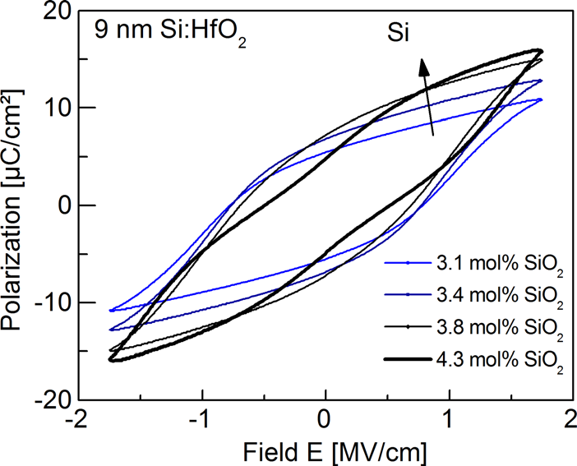

FIG. 1. (Color online) Polarization hystereses of a set of capped-Si:HfO2 MIM capacitors with different SiO2 content. The insulator thickness is approximately 9 nm.

a different crystalline phase. We investigated Si:HfO2 thin films with a composition close to the phase boundary by GI-XRD (Fig. 2). The spectrum of the 3.8 mol. % SiO2 film showed clear evidence for the formation of the orthorhombic Pbc21 phase (o), which was previously connected to the occurrence of the ferroelectricity.4This is most evident from the observation of (022)/(220) reflex splitting in the absence of (111) splitting, which indicates the formation of an or-thogonal phase with large c/a ratio and similar a and b dimensions. The (022)/(220) peak splitting disappeared when crystallized without a cap and the formation of a small fraction of monoclinic phase (m) is observed. No (022)/(220)

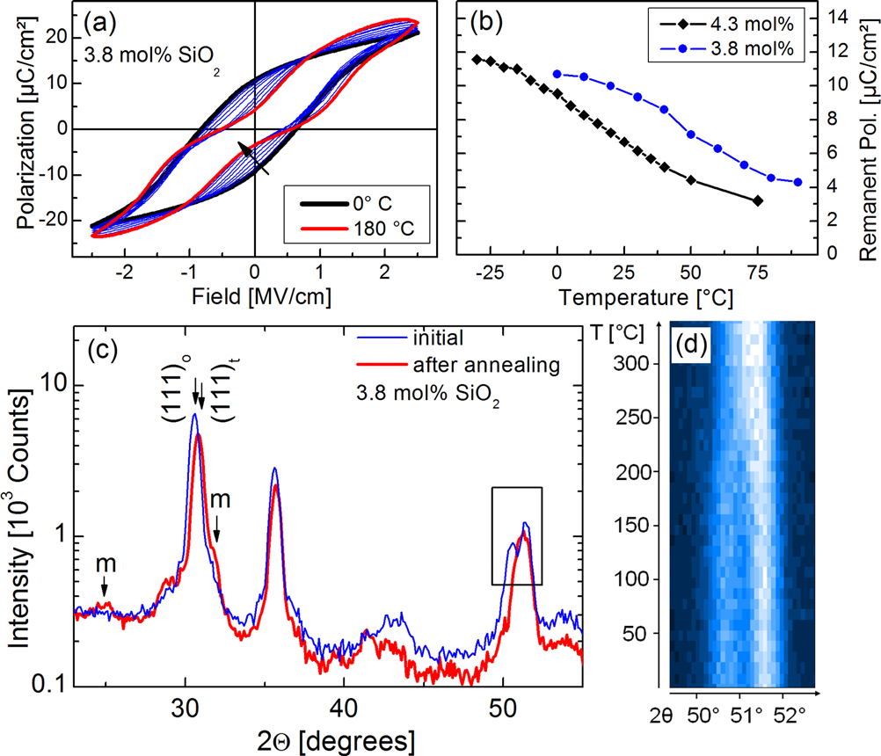

FIG. 3. (Color online) (a) Temperature dependent polarization measure-ments of a Si:HfO2 MIM capacitors with 3.8 mol. % SiO2 (b) Variation of the remanent polarization with temperature for capacitors with two different compositions. (c) XRD measurement of the 3.8 mol. % Si:HfO2 samples before and after temperature ramping up to 340�C. The TiN cap was removed prior to the measurement. (d) Evolution of the (022)/(220) peak splitting with temperature.

the FE phase into a phase with AFE properties. The addition of SiO2 allows to control the transition temperature. If the SiO2 content is sufficiently high, the AFE phase is stable at

splitting is observed at 4.3 mol. % SiO2, where AFE behav- room temperature.

ior emerged, suggesting the formation of a phase with lower c/a ratio, the tetragonal phase (t). The scans confirmed the presence of all dominant diffraction peaks. A strong prefer-ential orientation can, therefore, be ruled out within the lim-its of the GI-XRD technique.

To further understand the relation between the FE and the AFE behavior, we performed temperature dependent polarization measurements. As shown in Fig. 3(a), a fully re-versible transition from FE to AFE polarization loops is observed at increased temperature. Increasing the silicon content leads to an offset in the temperature dependence, as evident from the relation between polarization and tempera-ture for different compositions (Fig. 3(b)). Both observations imply a temperature dependent phase transformation from

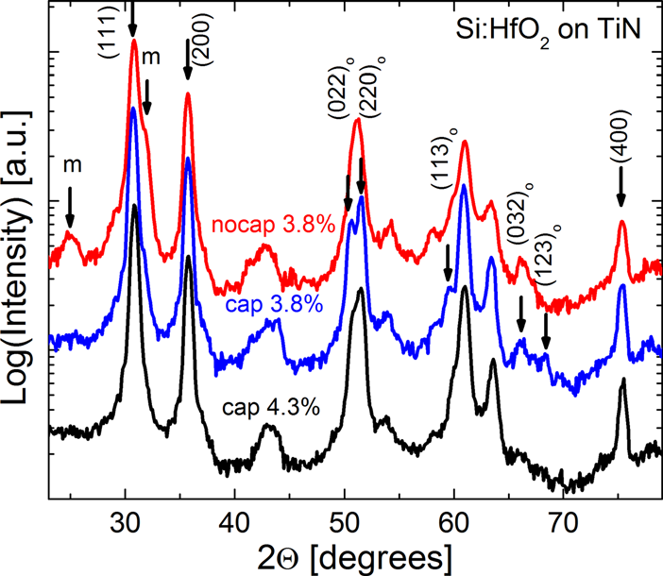

FIG. 2. (Color online) XRD measurements of capped and uncapped Si:HfO2 samples with compositions that exhibited ferroelectric (3.8 mol. %) and anti-ferroelectric (4.3 mol. %) polarization loops.

These findings were corroborated by temperature de-pendent XRD measurements on films having the same com-position (Figs. 3(c) and 3(d)). A reduction of the (022)/(220) splitting is found for increasing temperature, suggesting a transition into the t-phase, similar to the effect of increased SiO2 content. Interestingly, the (022)/(220) split was not restored upon cooling down. Instead, the emergence of monoclinic reflexes has been observed. This implies the for-mation of a m/t phase mixture as found for uncapped films. In contrast to MIM capacitors, where the film was capped during the temperature cycle, the cap was removed prior to the XRD measurement. Removal of the cap alone did not lead to the disappearance of the o-phase. This indicates the existence of an energy barrier between the o- and the m-phase, which prevents a direct transition. Mechanical con-finement (“capping”) is necessary during the formation of the metastable o-phase and not a requirement for the pres-ence of this phase. Since a temperature cycle through the t phase induced formation of the m phase, it can be concluded that both phases emerge by transformation from the t phase.

This conclusion is reinforced by previous research on phase relations in ZrO2, whose crystal chemistry is almost identical to that of HfO2.11Previous investigations report a direct and reversible transformation between the orthorhombic Pbc21 and the tetragonal phase.12,13The orthorhombic phase can only be formed in ZrO2 at much lower temperatures, due to higher stability of the tetragonal phase compared to HfO2.14 It is also well established that the monoclinic phase emerges during cooling from the metastable tetragonal phase. The so-lution of SiO2 in the HfO2 matrix leads to the gradual stabili-zation of a metastable tetragonal phase and allows controlling

|  |  |  |
| --- | --- | --- |
| 112904-3 | Bo¨scke et al. | Appl. Phys. Lett. 99, 112904 (2011) |

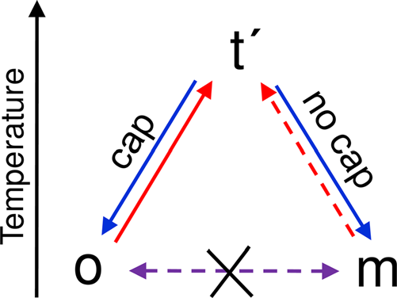

that could be controlled by the film composition. If the AFE phase was mechanically confined during cooling, it reversi-bly transformed back into the orthorhombic ferroelectric phase. Without confinement, a monoclinic/tetragonal phase mixture was formed. We conclude that there is a common higher symmetry parent phase to both the orthorhombic FE and the monoclinic phase. An energy barrier between the o-and m-phase prevents direct transformations between those

|  |  |
| --- | --- |
| FIG. 4. (Color online) Schematic representation of the observed transitions | phases. |

between the o-phase (FE), the t-phase (AFE), and the m-phase.

the transformability, therefore influencing the transition tem-perature to the two lower symmetry phases.

The tetragonal phase is clearly related to the AFE behavior. The AFE polarization loops may potentially emerge due to a field driven transformation to the ortho-rhombic FE phase. However, as pointed out by Kisi and Howard,15no direct phase relationship between the t and the o phases exists and the transformation takes place via an in-termediate phase, speculated to be of space group Pbcm. This suggests the microscopic origin of the AFE behavior to be rather complex. Further studies are required to understand the exact mechanism.

Fig. 4 summarizes our current understanding of the phase relations in the investigated material system.

In conclusion, we used a combination of temperature de-pendent polarization and XRD measurements to elucidate the nature of the ferroelectric phase transition. For our exper-imental conditions, the ferroelectric phase was present at room temperature in samples having less than 4 mol. % SiO2. The phase was stable after removal of the capping layer. Upon heating, a transformation into a phase with anti-ferroelectric characteristics was observed at a temperature

The work for this paper was partially supported within

the scope of technology development by the EFRE fund of

the European Community and by funding of the Free State

of Saxony (Project MERLIN).

1J. R. Anderson, Ferro Electric-materials as Storage Elements for Digital

Computers and Switching Systems (ACM, USA, 1952), p. 81.

2N. Setter, D. Damjanovic, L. Eng, G. Fox, S. Gevorgian, S. Hong, A.

Kingon, H. Kohlstedt, N. Y. Park, G. B. Stephenson, I. Stolitchnov, A. K.

Taganstev, D. V. Taylor, T. Yamada, and S. Streiffer, [J. Appl. Phys.](http://dx.doi.org/10.1063/1.2336999) 100,

051606 (2006).

3S.-A. Wu, [IEEE Trans. Electron Devices](http://dx.doi.org/10.1109/T-ED.1974.17955) 21, 499 (1974).

4T. S. Bo¨scke, J. Mu¨ller, D. Bra¨uhaus, U. Schro¨der, and U. Bo¨ttger, [Appl.](http://dx.doi.org/10.1063/1.3634052)

[Phys. Lett.](http://dx.doi.org/10.1063/1.3634052) 99, 102903 (2011).

5K. J. Hubbard and D. G. Schlom, [J. Mater. Res.](http://dx.doi.org/10.1557/JMR.1996.0350) 11, 2757 (1996).

6K. Tomida, K. Kita, and A. Toriumi, [Appl. Phys. Lett.](http://dx.doi.org/10.1063/1.2355471) 89, 142902 (2006). 7T. S. Bo¨scke, S. Govindarajan, P. D. Kirsch, P. Y. Hung, C. Krug, B.-H.

Lee, J. Heitmann, U. Schro¨der, G. Pant, B. E. Gnade, and W. H. Krautsch-

neider, [Appl. Phys. Lett.](http://dx.doi.org/10.1063/1.2771376) 91, 072902 (2007).

8D. Fischer and A. Kersch, [Microelectron. Eng.](http://dx.doi.org/10.1016/j.mee.2007.04.006) 84, 2039 (2007).

9T. S. Bo¨scke, P. Y. Hung, P. D. Kirsch, M. a. Quevedo-Lopez, and

R. Ramı´rez-Bon, [Appl. Phys. Lett.](http://dx.doi.org/10.1063/1.3195623) 95, 052904 (2009).

10K. Kita, K. Kyuno, and A. Toriumi, [Appl. Phys. Lett.](http://dx.doi.org/10.1063/1.1880436) 86, 102906 (2005). 11J. Wang, H. P. Li, and R. Stevens, [J. Mater. Sci.](http://dx.doi.org/10.1007/BF00541601) 27, 5397 (1992).

12E. H. Kisi, [J. Am. Ceram. Soc.](http://dx.doi.org/10.1111/j.1151-2916.1998.tb02402.x) 81, 741 (1998).

13C. J. Howard, E. H. Kisi, R. B. Roberts, and R. J. Hill, [J. Am. Ceram. Soc.](http://dx.doi.org/10.1111/j.1151-2916.1990.tb06682.x)

73, 2828 (1990).

14A. Navrotsky, [J. Mater. Chem.](http://dx.doi.org/10.1039/b417143h) 15, 1883 (2005).

15E. H. Kisi and C. J. Howard, [Key Eng. Mater.](http://dx.doi.org/10.4028/www.scientific.net/KEM.153-154.1) 153, 1 (1998).