

|  |  |  |
| --- | --- | --- |
| **FULL PAPER** | **www.afm-journal.de** | **www.MaterialsViews.com** |
| **Incipient Ferroelectricity in Al-Doped HfO 2 Thin Films** *Stefan Mueller , * Johannes Mueller , Aarti Singh , Stefan Riedel , Jonas Sundqvist , Uwe Schroeder , and Thomas Mikolajick* | |

caused by lattice mismatches between thin

|  |  |
| --- | --- |
| **Incipient ferroelectricity is known to occur in perovskites such as SrTiO 3 , KTaO 3 , and CaTiO 3 . For the fi rst time it is shown that the intensively researched HfO 2 thin fi lms (16 nm) also possess ferroelectric properties when aluminium is incorporated into the host lattice. Polarization measure-**  **ments on Al:HfO 2 based metal–insulator–metal capacitors show an antifer-roelectric-to-ferroelectric phase transition depending on annealing conditions**  **and aluminium content. Structural investigation of the electrically character-**  **ized capacitors by grazing incidence X-ray diffraction is presented in order**  **to gain further insight on the potential origin of ferroelectricity. The non-**  **centrosymmetry of the elementary cell, which is essential for ferroelectricity,**  **is assumed to originate from an orthorhombic phase of space group Pbc2 1 stabilized for low Al doping in HfO 2 . The ferroelectric properties of the modi-fi ed HfO 2 thin fi lms yield high potential for various ferroelectric, piezoelectric, and pyroelectric applications. Furthermore, due to the extensive knowledge**  **accumulated by various research groups regarding the HfO 2 dielectric, an immediate relevance of ferroelectric hafnium oxide thin fi lms is anticipated by**  **the authors.** | fi lm and substrate. The above-mentioned stabilization conditions affect the thermo-dynamic free energy and can therefore contribute to a ferroelectric phase forma-tion. A theoretical description of this free energy modifi cation is given by Landau–Ginzburg–Devonshire theory. [11] It is plau-sible that mechanical stress can infl uence ferroelectric phases in thin fi lms, since it already affects bulk ferroelectrictiy signifi cantly. [12,13]  As previous studies have shown, incip-ient ferroelectricity not only exists for ABO 3 -type perovskite materials but is also anticipated for oxides such as TiO 2 . [14–16] Only recently, ferroelectricity for HfO 2 was discovered for the fi rst time. [17–19] The authors showed that doping HfO 2 thin fi lms with silicon, zirconium, or yttrium combined with an additional annealing |

step induces a crystalline phase that has   
(anti-)ferroelectric characteristics. Hence,

**1. Introduction**

The most prominent examples for incipient ferroelectrics are strontium and calcium titanate as well as potassium tantalate which, as bulk materials, maintain their paraelectric properties down to temperatures close to absolute zero. [1–3] Hence, incip-ient ferroelectric materials are actually paraelectric in the fi rst place; however, a ferroelectric phase can be stabilized under cer-tain conditions. Mechanical confi nement, [4] doping, [5] defects, [6] stoichiometry variations, [7] or exchange of (oxygen) isotopes [8] have been shown to induce ferroelectricity for previously para-electric materials. [9] Hence, the originally paraelectric phase, which is assumed to be stabilized by quantum fl uctuations, [10] transforms to a ferroelectric phase. For SrTiO 3 thin fi lms in par-ticular, ferroelectricity can be provoked by mechanical stress [4]

|  |  |
| --- | --- |
| S. Mueller , Dr. A. Singh , Dr. U. Schroeder , Prof. T. Mikolajick | |
| NaMLab gGmbH  Dresden University of Technology  Noethnitzerstraße 64, 01187 Dresden, Germany E-mail: stefan.mueller@namlab.com  J. Mueller , S. Riedel , Dr. J. Sundqvist  Fraunhofer Center Nanoelectronic Technologies  Koenigsbrueckerstraße 180, 01099 Dresden, Germany |  |

**DOI: 10.1002/adfm.201103119**

hafnium oxide represents an additional compound belonging to the class of incipient ferroelectrics.

In this study we show for the fi rst time that, by using tri-valent aluminium, which is smaller than hafnium in terms of atomic radius, as a cation-substituting species within the HfO 2 lattice, it is possible to induce ferroelectricity without the sup-port of a mechanically confi ning top electrode. From an applica-tion point of view, these fi ndings are of signifi cant importance since they eliminate the perception that it is only possible to induce ferroelectricity in uncapped HfO 2 by using rare-earth dopants like yttrium.

We support our fi ndings with polarization measurements as well as by the identifi cation of a possibly orthorhombic phase of space group Pbc2 1 , whose non-centrosymmetry would explain the origin of ferroelectricity.

**2. Results and Discussion**

Metal–insulator–metal (MIM) capacitors were manufactured in order to investigate the electrical properties of the Al:HfO 2 thin fi lms. The thin fi lm layers were formed on a highly doped silicon substrate in order to allow for a low resistive backside contact during electrical measurements. First, an approximately 12 nm TiN bottom electrode was deposited by pulsed chemical vapor deposition (CVD) at 450 ° C. The 16 nm Al:HfO 2 layer

|  |  |  |  |
| --- | --- | --- | --- |
| **2412** | **wileyonlinelibrary.com** | © 2012 WILEY-VCH Verlag GmbH & Co. KGaA, Weinheim | *Adv. Funct.Mater.***2012**, *22*, 2412–2417 |

|  |  |  |  |  |  |  |
| --- | --- | --- | --- | --- | --- | --- |
| **www.MaterialsViews.com** | | | | |  | **www.afm-journal.de** |
| (a) | 20 | | | |  |
| AlO1.5 content[mol%] | 15  10  5  0 | | | |
| 0.00 | | | 0.05 | 0.10 | 0.15 |  |
| (b) | | ALD cycle ratio [Al/(Al+Hf)] | | | **Figure 2 .**  PMA versus PDA process fl ow. For the PMA samples, a CVD-TiN |
| top electrode is deposited which creates an additional mechanical con- |
| fi nement of the aluminium-doped HfO 2 . The PMA process fl ow uses the |
| platinum contact as a hard mask for etching the TiN top electrode. |

step was performed after the TiN top electrode had been depos-  
ited. Finally, platinum contacts were formed by physical vapor   
deposition (evaporation) using a shadow mask. The layout of   
the shadow mask was such as to deposit platinum dot sizes of   
110, 200, 280, and 450 μ m in diameter. The platinum dots were   
also used as a hard mask for wet chemical etching of the TiN   
top electrode down to the Al:HfO 2 layer. The quality of depo-  
sition and annealing processes was investigated by transmis-  
sion electron microscopy (TEM, Figure 1 b). The polycrystalline   
nature of both electrodes and the Al:HfO 2 thin fi lm is shown   
for a 1000 ° C PMA sample. Furthermore, for another batch   
of samples, the formation of a TiN top electrode was omitted   
and the platinum contacts were deposited directly on top of   
the Al:HfO 2 thin fi lm. Since the annealing step was performed   
after the dielectric/ferroelectric layer formation, these samples 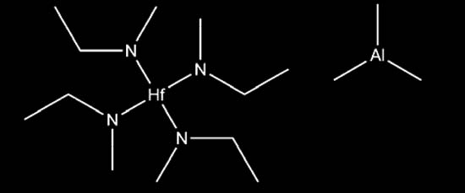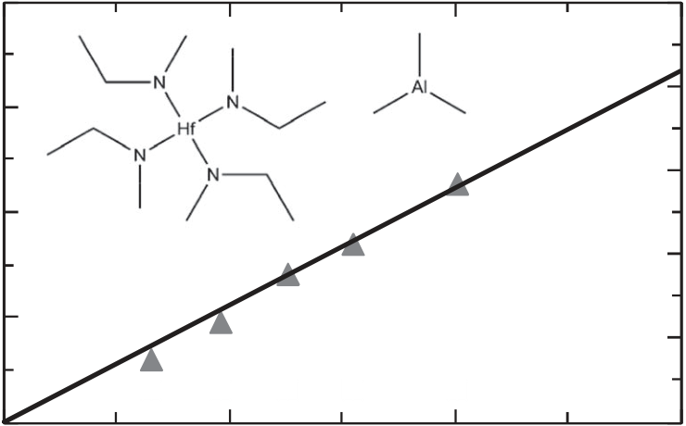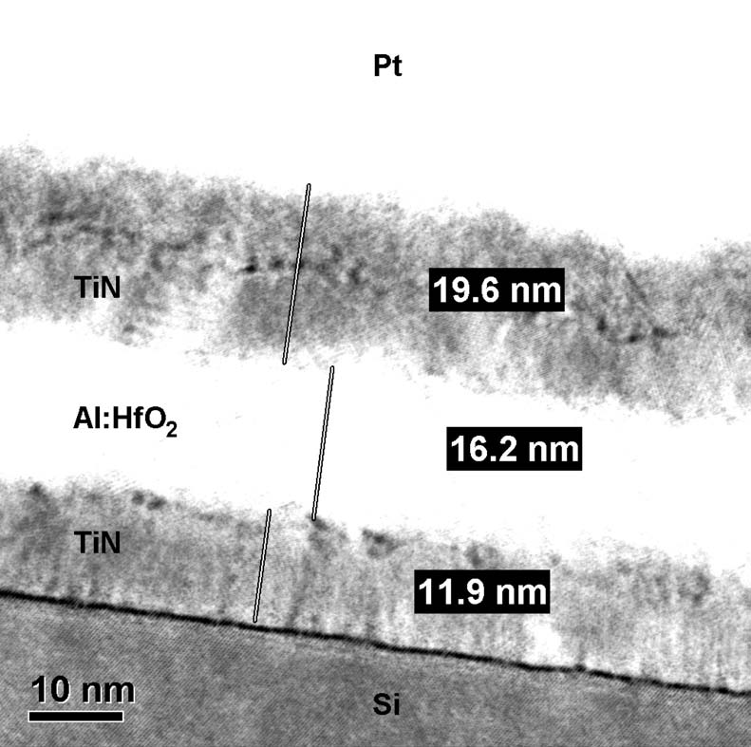

**Figure 1 .**  a) Incorporated AlO 1.5 content within the HfO 2 host lattice according to XPS characterization. Using tetrakis(ethylmethylamino)haf-nium and trimethylaluminium (chemical formulae shown as inset) for ALD deposition, an almost ideal linear behavior could be achieved for the chosen cycle ratios. b) EM image of an MIM capacitor used within these studies. The structure consists of a platinum contact situated on top of the aluminium-doped HfO 2 sandwiched between TiN electrodes. Even though a hydrogen fl uoride dip was used before bottom electrode formation, a very thin amorphous interface is still visible (bright interface between TiN and Si).

was deposited afterwards by atomic layer deposition (ALD, 300 ° C substrate temperature). Different ALD supercycles of the precursor gases (see the Experimental Section) were used in order to realize various molar concentrations of aluminium within the HfO 2 lattice. An almost ideal linear relationship between molar percentage of aluminium in HfO 2 and cycle ratio could be achieved, which indicates a very controlled depo-sition process ( **Figure1** a). A TiN top electrode of approximately 20 nm thickness was deposited on top of the hafnium oxide again using pulsed CVD (450 ° C). After top electrode formation, samples were exposed to rapid thermal annealing (RTA) for either 20 s at 800 ° C or for 1 s at 1000 ° C in a nitrogen environ-ment. In the following, these samples will be abbreviated PMA samples (post-metallization annealing) since the annealing

will be abbreviated PDA samples (post-deposition annealing). The process fl ow for PMA and PDA samples is summarized in **Figure2** .

The surface morphology and the quality of the Al:HfO 2 thin fi lm was characterized by atomic force microscopy (AFM; **Figure3** ). The root mean square (RMS) surface roughness of the PMA samples is signifi cantly smaller than for the PDA samples. Hence, the vertical grain growth during annealing is homogenized by depositing a TiN cap between platinum contact and the doped hafnium oxide. Moreover, an increased surface roughness was also refl ected by the leakage current and break-down characteristics of the capacitors, i.e., the PDA process led to increased leakage currents and smaller breakdown voltages. The effects of TiN capping have been extensively investigated for pure HfO 2 , with similar conclusions being reached. [20] Polarization measurements were performed in order to investigate a potential hysteretic behavior of *P* – *E* characteris-tics ( **Figure4** ). By applying a triangular AC voltage signal to the samples, a ferroelectric capacitor would switch into the respec-tive polarization state. The written state can only be reversed if a certain voltage (larger than the coercive voltage) of opposite polarity is again applied to the capacitor.

Large amounts of aluminium inside the host lattice lead to antiferroelectric polarization loops. The antiferroelectric phase might be considered a relaxor phase, in which ferroelectric

|  |  |  |  |
| --- | --- | --- | --- |
| *Adv. Funct. Mater.***2012**, *22*, 2412–2417 | © 2012 WILEY-VCH Verlag GmbH & Co. KGaA, Weinheim | **wileyonlinelibrary.com** | **2413** |

|  |  |  |
| --- | --- | --- |
| **FULL PAPER** | **www.afm-journal.de** | **www.MaterialsViews.com** |
| antiferroelectric tendency. At 1000 ° C PMA the ferroelectric |
| behavior is most pronounced. |
| Generally, dielectric permittivity increases for higher alu- |
| minium contents and shows a maximum for antiferroelectric |
| capacitors (Figure 4 d). However, compared to traditional ferroe- |
| lectrics like lead zirconate titanate (Pb[Zr *x* Ti 1- *x* ]O 3 ; PZT), which |
| can possess relative permittivities even above 200, the tendency |
| for dielectric polarization is signifi cantly smaller for doped haf- |

nium oxide. Furthermore, it is interesting to see that the highest   
remanent polarization is actually achieved for samples with   
7.1 mol% aluminium content even though the polarization   
loops are not as ideal as for samples having 4.8 mol% incor-  
poration of aluminium (compare Figure 4 a,c). This again indi-  
cates that, for this composition, the capacitors possess antifer-  
roelectric as well as ferroelectric domains. 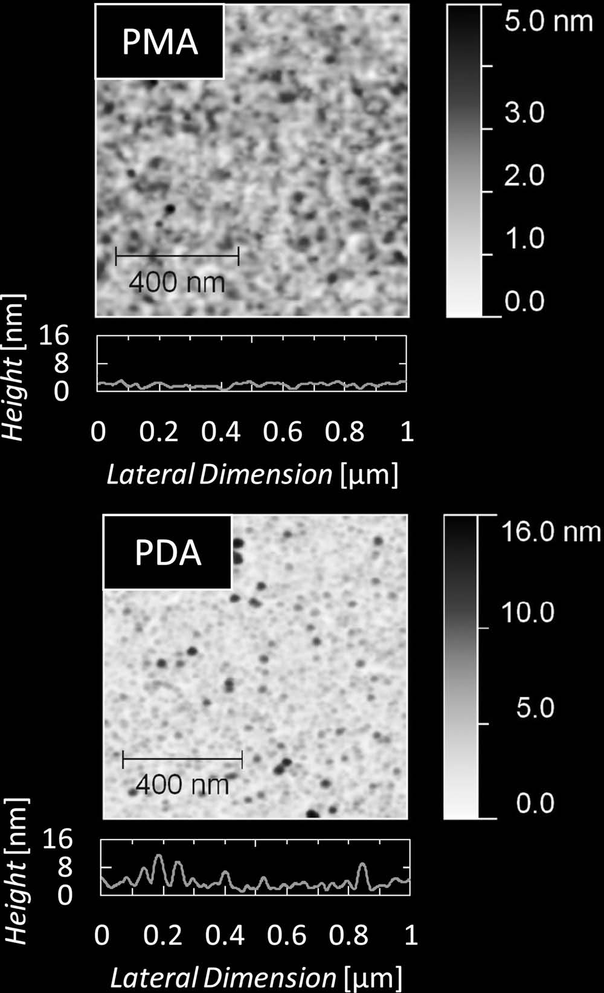

In order to prove that the ferroelectric behavior might not   
only be fi eld induced, the crystal structures of the samples were   
physically characterized using grazing incidence X-ray diffrac-  
tion analysis (GI-XRD). The acquired diffractrograms were   
used to identify the respective crystalline phases, as well as   
non-centrosymmetric phase which would be responsible for the   
ferroelectric phenomena ( **Figure5** a).

Under atmospheric pressure and increasing temperature,   
hafnium oxide transforms from a monoclinic to a tetragonal   
and fi nally to a cubic lattice structure. [22] However, it has been   
shown that the tetragonal and cubic phases in HfO 2 and ZrO 2   
can be stabilized by incorporation of nano-crystallites and   
nitrogen respectively. [23,24] For the material system at hand, the   
acquired X-ray diffraction patterns show that, for increasing alu-  
minium concentration, a transition from the monoclinic phase   
towards a cubic lattice structure occurs. That is, the cubic phase   
is stabilized if aluminium is used as a substituting element.   
This stabilization can best be observed in the interval between   
80 ° and 90 ° where the monoclinic peaks observed for pure HfO 2   
convert into two sharp refl ections, which are characteristic of   
the cubic phase. For 4.8 mol% aluminium the diffractogram is

**Figure 3 .**  AFM RMS surface roughness measurements for PMA and PDA samples. Both graphs were measured directly on the surface of the fer-roelectric, i.e., in between the structured MIM capacitors. The mechanical confi nement of the TiN top electrode signifi cantly reduces the surface roughness.

clusters of different polarization directions exist within a para-electric matrix. [21] However, by reducing the aluminium con-tent, the antiferroelectric behavior transforms to ferroelectric characteristics (Figure 4 a). Molar concentrations of 4.8% show saturated ferroelectric responses having remanent polariza-tions of around 5 μ C cm − 2 and coercive fi elds of approximately 1 MV cm − 1 .

Remarkably, omitting the TiN top electrode does not inhibit ferroelectricity (Figure 4 b) as it is the case in silicon-doped hafnium oxide. [17] Even though the remanent polarization is reduced, a ferroelectric hysteresis loop is clearly observable for PDA-samples. Furthermore, ferroelectricity seems to be more pronounced for samples which are annealed at higher tempera-tures (Figure 4 c). It is noteworthy that already the as-deposited sample having 7.1 mol% aluminium concentration shows

compared to the diffraction pattern of a previously derived non-centrosymmetric orthorhombic phase of space group Pbc2 1 . [17] This phase was originally derived from manganese-stabilized zirconium oxide [25,26] since all known orthorhombic phases for HfO 2 are centrosymmetric (space groups Pbca and Pbcm). The non-centrosymmetric orthorhombic phase of space group Pbc2 1 is assumed to be applicable also to the HfO 2 host lattice when isotropic rescaling is applied. [17] It is however diffi cult to unambiguously identify the existence of this phase, since there is no peak which is unique to the orthorhombic phase. Peaks which appear to be unique for the orthorhombic phase overlap with refl ections originating from the TiN top and bottom elec-trodes at 36.7 ° , 42.6 ° , and 61.8 ° . However, the existence of the orthorhombic phase seems justifi ed if the refl ections in the interval between 80 ° and 90 ° (Figure 5 b) are analyzed. Simply superimposing monoclinic and cubic diffraction patterns will not yield refl ections observed for 4.8 mol% of aluminium concentration. Hence, there has to be a non-centrosymmetric transition phase since this is a prerequisite for the ferroelectric characteristics observed in electrical measurements. In sum-mary, the authors suggest the existence of an orthorhombic phase of space group Pbc2 1 causing the ferroelectric nature of Al:HfO 2 .

|  |  |  |  |
| --- | --- | --- | --- |
| **2414** | **wileyonlinelibrary.com** | © 2012 WILEY-VCH Verlag GmbH & Co. KGaA, Weinheim | *Adv. Funct.Mater.***2012**, *22*, 2412–2417 |

|  |  |  |  |  |  |  |  |  |  |  |  |  |  |  |  |  |  |  |  |  |  |  |  |  |
| --- | --- | --- | --- | --- | --- | --- | --- | --- | --- | --- | --- | --- | --- | --- | --- | --- | --- | --- | --- | --- | --- | --- | --- | --- |
| **www.MaterialsViews.com** | | | hPMA | | | | | | )c( | | 40  20  0 -20-40 | | |  | | --- | | hPMA 7.1 mol% | | | | | | | | |  |  | **www.afm-journal.de** |
| ( a ) | 40 | |
| Polarization [µC/cm 2] | |  |  |  |
| Polarization[µC/cm2] | 20  0 -20-40 | |
| 450 °C | | | | | | | |
| 8.5 mol% | | | | | |
| 4.8 mol% | | | | | | 800 °C | | | | | | | |
| HfO 2 | | | | | | 1000 °C | | | | | | | |
| -5 -4 -3 -2 -1 | 0 | 1 | 2 | 3 | 4 | -5 -4 -3 -2 -1 | | | 0 | 1 | 2 | 3 | 4 | 5 |  |  |
| 5 | | | |
| (b) | | 20 | Electric Field [MV/cm] | | | | | |  | Rem. Polarization[µC/cm2] | |  | Electric Field [MV/cm] | | | | | | | |
| hPDA | | | | | | (d) | 8 |  | | | | | | | | 40 | Relative Permittivity [1] |  |
| Polarization [µC/cm2] | 10  0 -10-20 | | 5 | 6 | 35 |
| 30 |
| 4 |
| 8.5 mol% | | | | | |
| 25 |
| 2 |
| 4.8 mol% | | | | | | 20 |
| HfO2 | | | | | |
| 0 |
| 15 |
| -5 -4 -3 -2 -1 | 0 | 1 | 2 | 3 | 4 |
| 3.1 | 4.8 | 7.1 | | 8.5 | 11.4 | | |
| Electric Field [MV/cm] | | | | | | Aluminum Concentration [mol%] | | | | | | | |

**Figure 4 .**  a) Polarization hysteresis for PMA samples annealed at 1000 ° C for 20 s. Decreasing aluminium concentration yields an antiferroelectric-to-ferroelectric transition whereas the pure hafnium oxide is paraelectric, as expected. b) Polarization hysteresis for PDA samples annealed at 1000 ° C for 20 s. The same antiferroelectric-to-ferroelectric transition as for the PMA samples can be observed but the remanent polarization is signifi cantly lower. c) Polarization hysteresis of a HfO 2 MIM capacitor with 7.1 mol% of incorporated aluminium for different annealing temperatures. A transition towards ferroelectric behavior can be observed if higher temperatures are used for the PMA. d) Remanent polarization and relative permittivity versus amount of incorporated aluminium for PMA capacitors annealed at 1000 ° C for 20 s. 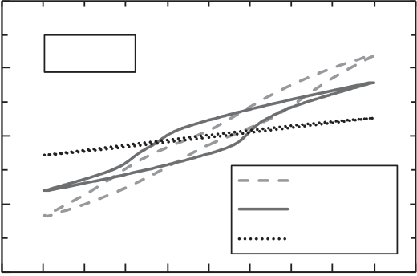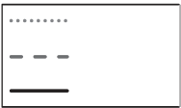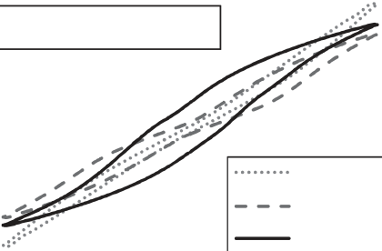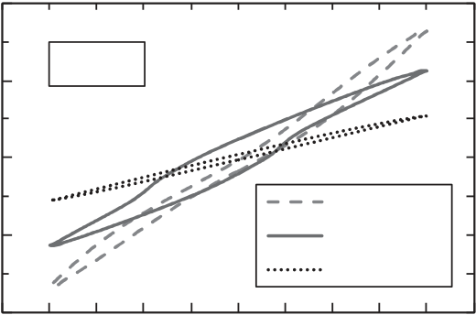

**3. Conclusions**

Thin fi lms of aluminium-doped HfO 2 of 16 nm thickness were investigated. Electrical characterization showed the incipient antiferroelectric and ferroelectric nature of the material system due to the incorporation of aluminium into the host lattice. Electrical permittivities reached maximum values of around 35 for samples in which antiferroelectricity had been provoked. GI-XRD analysis indicated that the necessary non-centrosym-metry of the elementary cell can most likely be assigned to an orthorhombic Pbc2 1 phase located in the vicinity of the transi-tion from purely monoclinic HfO 2 to the cubic lattice of highly doped HfO 2 .

The recently discovered ferroelectric properties of this mate-rial system are advantageous not only because of the extensive industrial expertise regarding HfO 2 -based dielectrics but also because of the CMOS-integratability of both hafnium oxide and aluminium. The authors anticipate that HfO 2 ferroelec-tric thin fi lms of only 16 nm thickness might be of interest to various research and industry communities, especially because its properties are highly tunable (through the doping concen-tration, annealing conditions, and mechanical confi nement). Applications like ferroelectric random access memories, piezo-electric applications or ferroelectric fi eld effect transistors [27–30] might be envisioned. Furthermore, the fact that all ferroelectric materials show pyroelectric as well as piezoelectric properties [31] extends the area of potential applications. The ferroelectricity

of HfO 2 might also help in advancing novel electronic devices, like negative capacitance fi eld-effect transistors. [32,33] Moreover, the fact that ferroelectricity can be provoked at annealing tem-peratures of up to 1000 ° C demonstrates the viability for a wide range of applications.

**4. Experimental Section**

The fabrication and characterization of the Pt/TiN/Al:HfO 2 /TiN capacitor stack investigated within this study will be described in the following. A JEL Eureka single wafer ALD reactor was used for manufacturing the ferroelectric layers, whereas TiN top and bottom electrodes were deposited in an ASM A412 batch furnace. The annealing steps were performed using a single wafer Mattson RTP tool. Platinum dots were deposited in a Bestec/Ferrotec EVM6 evaporation chamber. Physical characterization was performed using a Bruker D8 Discover X-ray diffractometer and a Veeco Dimension 3100 AFM. The *P* – *E* hysteresis measurements were obtained on an Aixacct TF Analyzer 1000.

*Atomic Layer Deposition* : Aluminium-doped HfO 2 thin fi lms were deposited by atomic layer deposition on 300 mm Si substrates. The silicon substrate received a HF clean in order to minimize the native oxide thickness between substrate and bottom electrode. Prior to dielectric deposition, the 12 nm bottom electrode was chemically vapor deposited (TiCl 4 /NH 3 ) in a batch furnace. The ALD process was based on the commercially available metal organic precursors tetrakis(ethylmethylamino)hafnium (TEMAH) and trimethylaluminium (TMA). Ozone was used as the oxidant and argon as the purge and carrier gas. The Al 2 O 3 content in HfO 2 ranged from 3.1 to 11.4 mol-% and was defi ned by varying the cycle ratio of the metal precursors and

|  |  |  |  |
| --- | --- | --- | --- |
| *Adv. Funct. Mater.***2012**, *22*, 2412–2417 | © 2012 WILEY-VCH Verlag GmbH & Co. KGaA, Weinheim | **wileyonlinelibrary.com** | **2415** |

|  |  |  |  |  |  |  |  |  |  |  |  |
| --- | --- | --- | --- | --- | --- | --- | --- | --- | --- | --- | --- |
| **FULL PAPER** | **www.afm-journal.de** | ( a ) | **HfO2** | **TiN** | **TiN** | ( b ) | -124m | 133m | -241m | -304m | **www.MaterialsViews.com** |
| 313m |
| **Intensity [a.u.]** | **3.1 mol%** | sity[a.u.] | HfO2 | | | |
| **4.8 mol%** |
| 331o | 133o | 421o | |
| **7.1 mol%** |
|  |  | **Int** | **8.5 mol %** |  |  | Inten | 4.8 mol% | | | |  |
| **11.4 mol%** | 331c | | 420c | |

11.4 mol%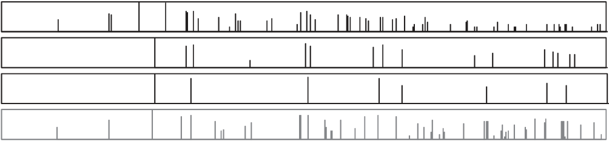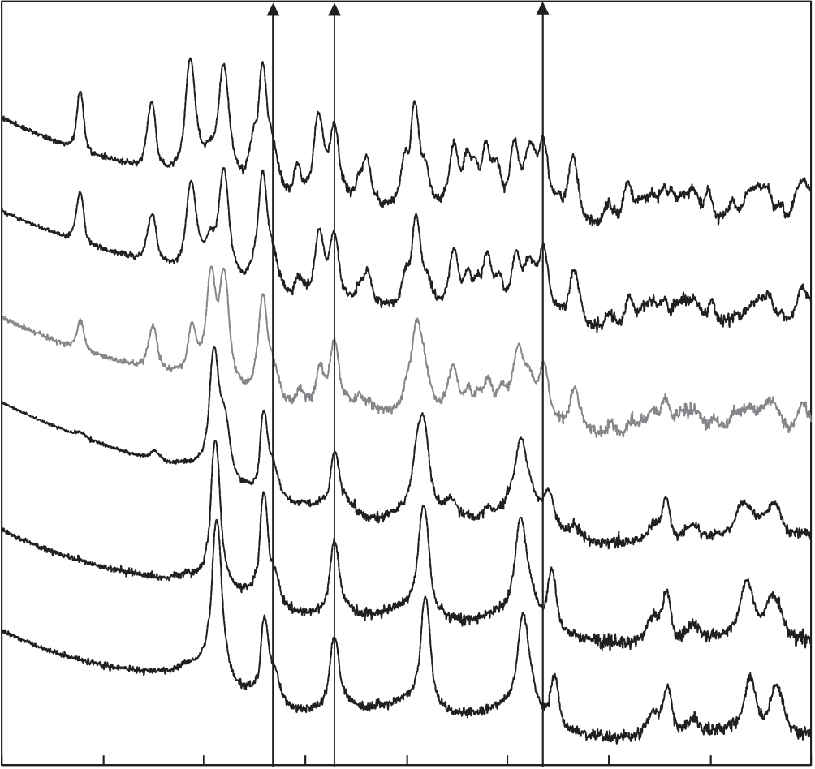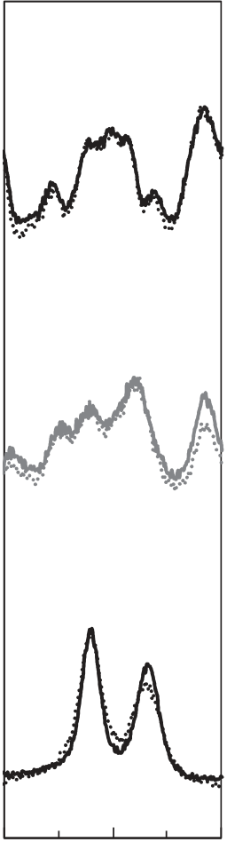

|  |  |  |  |  |  |  |  |  |  |  |  |
| --- | --- | --- | --- | --- | --- | --- | --- | --- | --- | --- | --- |
| monoclinic  **d**   10 20 | | 30 | 40 | 50 | 60 | 70 | 80 | 90 | 80 | 85 | 90 |
| tetragonal  **d**  10 20 | | 30 | 40 | **2**θ **[°]** 50 | 60 | 70 | 80 | 90 | 2θ [°] |
| cubic  **d**  10 | 20 | 30 | 40 | **2**θ **[°]** | 60 | 70 | 80 | 90 |
| orthorombic  **d**  10 20 | | 30 | 40 | **2**θ **[°]** | 60 | 70 | 80 | 90 |
| 10 | 20 | 30 | 40 | **2**θ **[°]** | 60 | 70 | 80 | 90 |

2θ [°]

**Figure 5 .**  a) GI-XRD diffractograms for PMA samples having different aluminium concentrations. A monoclinic-to-cubic phase transition is clearly

visible for increasing aluminium content. The powder diffraction patterns as well as the calculated orthorhombic Pbc2 1 reference pattern are shown

below the diffractograms. The composition which possesses the purest ferroelectric properties is highlighted in blue. b) Enlarged 2 θscans from 80 °

to 90 ° for paraelectric HfO 2 containing no aluminium, ferroelectric HfO 2 containing 4.8 mol% aluminium, and, again, paraelectric HfO 2 containing

11.8 mol% aluminium. The diffractogram of the ferroelectric composition shows a triplet which would not be expected for monoclinic, tetragonal, or

cubic phases. The dotted lines show results for PDA samples of the same composition.

monitored by inline X-ray photoelectron spectroscopy (XPS). A constant thickness of 16 nm for all fi lms was achieved by adjusting the number of Hf:Al super cycles, and was confi rmed by inline spectral ellipsometry and high resolution transmission electron microscopy (HR-TEM). Crystallization of the as deposited amorphous Al:HfO 2 thin fi lms was induced by a 800 ° C/20 s/N 2 or 1000 ° C/20 s/N 2 rapid thermal annealing (RTA) step, referred to in the text as PDA. Samples annealed after chemical vapor deposited 20 nm TiN top electrode are referred to in the text as samples treated with PMA.

*GI-XRD Characterization* : Since a thin fi lm capacitor stack was used for our study, XRD characterization was performed under very small incident angles (grazing incidence). An incident angle of 0.45 ° was found to yield the highest intensity refl ections for pure HfO 2 and was used for all measurements described. Furthermore, a Göbel mirror and a 0.2 mm slit were used on the primary side and a Soller mount on the detector side. For acquisition of the diffractograms, an integration time of 35 s per step and an angular resolution of 0.05 ° were chosen for the 10 ° to 90 ° interval of 2 θ. For additional measurements in the interval 80 ° to 90 ° , the integration time was increased to 250 s. Separate samples without platinum dots were used for each of the acquired diffractograms.

*Electrical Characterization* : The polarization versus electric fi eld

amplifi er (Aixacct TF Analyzer 1000). Capacitors of 200 μ m diameter were used for all measurements and a current range of 100 μ A provided the best signal-to-noise ratio. A frequency of 1 kHz was used for hysteresis measurements with amplitudes ranges of 4.8, 5.6, and 6.4 V in order to produce electric fi elds of 3, 3.5, and 4 MV cm − 1 . Before carrying out any type of electrical characterization, the samples were cycled at least 1000 times in order to provide reproducible switching behavior. Even though leakage currents can also be incorporated in a hysteresis measurement, a dynamic leakage current compensation (DLCC) [34] showed that the leakage currents during *P* – *E* measurements were negligible.

**Acknowledgements**

D. Martin is acknowledged for AFM images. The authors would like to thank Dr. U. Böttger for helpful discussions and Prof. A. Kersch for graphical illustrations. The work for this paper was supported within the scope of technology development by the EFRE fund of the European Community and by funding from the Free State of Saxony (Project HEIKO). The authors are responsible for the content of the paper.

|  |  |  |  |
| --- | --- | --- | --- |
| **2416** | measurements were derived from integrating the displacement current | | Received: December 22, 2011 |
| for an applied triangular AC voltage signal using a virtual ground | | Published online: March 15, 2012 |
| **wileyonlinelibrary.com** | © 2012 WILEY-VCH Verlag GmbH & Co. KGaA, Weinheim | *Adv. Funct.Mater.***2012**, *22*, 2412–2417 |

|  |  |
| --- | --- |
| **www.MaterialsViews.com**  [ 1 ] K. A. Muller , H. Burkard , *Phys. Rev. B***1979** , *19* , 3593 .  [ 2 ] A. R. Akbarzadeh , L. Bellaiche , K. Leung , J. Iniguez , D. Vanderbilt , *Phys. Rev. B***2004** , *70* , 54103/1 .  [ 3 ] V. V. Lemanov , A. V. Sotnikov , E. P. Smirnova , M. Weihnacht , R. Kunze , *Solid State Commun.***1999** , *110* , 611 .  [ 4 ] J. H. Haeni , P. Irvin , W. Chang , R. Uecker , P. Reiche , Y. L. Li , S. Choudhury , W. Tian , M. E. Hawley , B. Craigo , A. K. Tagantsev , X. Q. Pan , S. K. Streiffer , L. Q. Chen , S. W. Kirchoefer , J. Levy , D. G. Schlom , *Nature***2004** , *430* , 758 .  [ 5 ] T. Mitsui , W. B. Westphal , *Phys. Rev.***1961** , *124* , 1354 .  [ 6 ] Y. S. Kim , D. J. Kim , T. H. Kim , T. W. Noh , J. S. Choi , B. H. Park , J. G. Yoon , *Appl. Phys. Lett.***2007** , *91* , 42908/1 .  [ 7 ] D. A. Tenne , A. K. Farrar , C. M. Brooks , T. Heeg , J. Schubert , H. W. Jang , C. W. Bark , C. M. Folkman , C. B. Eom , D. G. Schlom , *Appl. Phys. Lett.***2010** , *97* , 142901/1 .  [ 8 ] M. Itoh , R. Wang , Y. Inaguma , T. Yamaguchi , Y. J. Shan , T. Nakamura , *Phys. Rev. Lett.***1999** , *82* , 3540 .  [ 9 ] A. K. Tagantsev , V. O. Sherman , K. F. Astafi ev , J. Venkatesh , N. Setter , | **www.afm-journal.de**  [ 17 ] T. S. Boescke , J. Mueller , D. Braeuhaus , U. Schroeder , U. Boettger , *Appl. Phys. Lett.***2011** , *99* , 102903 .  [ 18 ] J. Müller , U. Schröder , T. S. Böscke , I. Müller , U. Böttger , L. Wilde , J. Sundqvist , M. Lemberger , P. Kücher , T. Mikolajick , L. Frey , *J. Appl. Phys.***2011** , *110* , 114113 .  [ 19 ] J. Müller , T. S. Böscke , D. Bräuhaus , U. Schröder , U. Böttger , J. Sundqvist , P. Kücher , T. Mikolajick , L. Frey , *Appl. Phys. Lett.***2011** , *99* , 112901 .  [ 20 ] D. H. Triyoso , P. J. Tobin , B. E. White , Jr. , *Appl. Phys. Lett.***2006** , *89* , 132903 .  [ 21 ] F. Chu , N. Setter , A. K. Tagantsev , *J. Appl. Phys.***1993** , *74* , 5129 . [ 22 ] J. Wang , H. P. Li , R. Stevens , *J. Mater. Sci.***1992** , *27* , 5397 .  [ 23 ] R. C. Garvie , *J. Phys. Chem.***1965** , *69* , 1238 .  [ 24 ] N. Claussen , R. Wagner , L. J. Gauckler , G. Petzow , *J. Am. Ceram.*  *Soc.***1978** , *61* , 369 .  [ 25 ] D. B. Marshall , M. R. Jarnes , J. R. Porter , *J. Am. Ceram. Soc.***1989** , *72* , 218 . [ 26 ] E. H. Kisi , S. J. Kennedy , C. J. Howard , *J. Am. Ceram. Soc.***1997** , *80* , 621 . |



*J. Electroceram.***2003** , *11* , 5 .

[ 10 ] W. Zhong , D. Vanderbilt , *Phys. Rev. B***1996** , *53* , 5047 .

[ 11 ] N. A. Pertsev , A. K. Tagantsev , N. Setter , *Phys. Rev. B***2000** , *61* ,

[ 27 ] D. H. Looney , *US 2791758***1957** .

[ 28 ] N. Setter , D. Damjanovic , L. Eng , G. Fox , S. Gevorgian , S. Hong , A. Kingon , H. Kohlstedt , N. Y. Park , G. B. Stephenson , I. Stolitchnov ,

R825 . A. K. Taganstev , D. V. Taylor , T. Yamada , S. Streiffer , *J. Appl. Phys.*

[ 12 ] N. A. Pertsev , A. G. Zembilgotov , A. K. Tagantsev , *Ferroelectrics***1999** , **2006** , *100* , 51606 .

*223* , 79 . [ 29 ] S. Y. Wu , *IEEE Trans. Electron Devices***1974** , *ED-21* , 499 .

[ 13 ] K. J. Choi , M. Biegalski , Y. L. Li , A. Sharan , J. Schubert , [ 30 ] J. Hoffman , X. Pan , J. W. Reiner , F. J. Walker , J. P. Han , C. H. Ahn ,

R. Uecker , P. Reiche , Y. B. Chen , X. Q. Pan , V. Gopalan , L. Q. Chen , *Adv. Mater.***2010** , *22* , 2957 .

D. G. Schlom , C. B. Eom , *Science***2004** , *306* , 1005 .

[ 14 ] G. A. Samara , P. S. Peercy , *Phys. Rev. B***1973** , *7* , 1131 .

[ 15 ] F. Gervais , W. Kress , *Phys. Rev. B***1983** , *28* , 2962 .

[ 16 ] P. D. Mitev , K. Hermansson , B. Montanari , K. Refson , *Phys. Rev. B*

[ 31 ] J. F. Scott , *Science***2007** , *315* , 954 .

[ 32 ] S. Salahuddin , S. Datta , *Nano Lett.***2008** , *8* , 405 .

[ 33 ] V. V. Zhirnov , R. K. Cavin , *Nat. Nanotechnol.***2008** , *3* , 77 .

[ 34 ] R. Meyer , R. Waser , K. Prume , T. Schmitz , S. Tiedke , *Appl. Phys. Lett.*

|  |  |  |  |
| --- | --- | --- | --- |
| **2010** , *81* , 134303/1 . | **2005** , *86* , 142907 . |  |  |
| *Adv. Funct. Mater.***2012**, *22*, 2412–2417 | **wileyonlinelibrary.com** | **2417** |
| © 2012 WILEY-VCH Verlag GmbH & Co. KGaA, Weinheim |