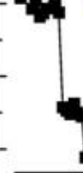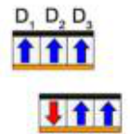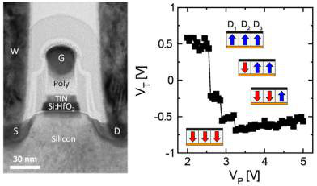

Research Article   
 www.acsami.org

Switching Kinetics in Nanoscale Hafnium Oxide Based Ferroelectric Field-Effect Transistors   
Halid Mulaosmanovic,*,†Johannes Ocker,†Stefan Müller,†Uwe Schroeder,†Johannes Müller,‡Patrick Polakowski,‡Stefan Flachowsky,§Ralf van Bentum,§Thomas Mikolajick,†,∥and Stefan Slesazeck*,††NaMLab gGmbH, 01187 Dresden, Germany  
‡Fraunhofer IPMS-CNT, 01099 Dresden, Germany  
§GLOBALFOUNDRIES, 01109 Dresden, Germany  
∥Chair of Nanoelectronic Materials, TU Dresden, 01062 Dresden, Germany

|  |  |
| --- | --- |
| * S Supporting Information |  |
| ABSTRACT: The recent discovery of ferroelectricity in thin hafnium oxide films has led to a resurgence of interest in ferroelectric memory devices. Although both experimental and theoretical studies on this new ferroelectric system have been undertaken, much remains to be unveiled regarding its domain landscape and switching kinetics. Here we demonstrate that the switching of single domains can be directly observed in ultrascaled ferroelectric field effect transistors. Using models of ferroelectric domain nucleation we explain the time, field and temperature dependence of polarization reversal. A simple stochastic model is proposed as well, relating nucleation processes to the observed statistical switching behavior. Our results suggest novel opportunities for hafnium oxide based ferroelectrics in nonvolatile memory devices. | |  |  |  |  |  |  |  |  |  |  | | --- | --- | --- | --- | --- | --- | --- | --- | --- | --- | | |  |  |  | | --- | --- | --- | |  |  |  | |  | |  | |  | |  | |  | |  | | |

|  |
| --- |
| KEYWORDS: ferroelectric switching, hafnium oxide, domain, nucleation, field-effect transistor |

1. INTRODUCTION

The relentless scaling process in the semiconductor industry, driven by ever increasing demand for cheaper and densely integrated devices, has pushed main-stream flash memory technology to its physical limits and at the same time brought to light a multitude of emerging memory concepts. Among them, ferroelectric capacitors and transistors appear to be particularly attractive thanks to a stable and switchable electrical polarization typical for ferroelectric materials.1The recent discovery of ferroelectricity in hafnium oxide (HfO2) films2has triggered a renewed research activity in order to investigate the origin and properties of this novel ferroelectric system. Despite a vast list of applications for which this material was proposed (steep subthreshold slope transistors including negative capacitance3,4and tunnel5FETs; pyroelectric and energy harvesting;6electrocaloric cooling, electrostatic energy storage, and thermal imaging sensors;7ferroelectric tunnel junctions),8 memory devices based on HfO2 films seem to be the most promising ones at the moment. This is mainly due to the fact that the material is already well-known in microelectronics and the nonvolatile memory operation was reproducibly demon-strated in a fully integrated large memory array.9In this regard, ferroelectric field-effect transistors (FeFET)10as memory elements have the key advantages due to their nondestructive

placed in series with a thin linear dielectric, which forms the well-defined interface to the silicon substrate. As a result, the ferroelectric enables to tune the conductivity of the channel by its polarization surface charge. The two states of remanent polarization encode the binary information.

However, a reliable memory operation urges careful assessment of the ferroelectric material. Although the correlation between the ferroelectricity and the existence of a noncentrosymmetric orthorhombic phase in thin HfO2 films is generally accepted,11much remains to be understood regarding its switching behavior and domain landscape. Various studies of polarization switching, mainly performed by macroscopic electrical characterizations12−14but also including piezores-ponse force microscopy (PFM)15,16and the correlation of macroscopic switching with transmission electron microscopy (TEM),14shed new light on ferroelectric properties of large-area films. Nevertheless, observations of switching processes at domain level have so far been elusive, precluding the possibility of an in-depth investigation of the polarization reversal at nanoscale. Here we show that switching of single or a few domains can be sensed in 10 nm thick polycrystalline ferroelectric films when incorporated in the ultrascaled FeFET devices. Unlike large-area capacitors, these unique

|  |  |  |
| --- | --- | --- |
| read operation, relatively low operating voltages, and high | Received: | October 30, 2016 |

scaling potential. In this work, the ferroelectric replaces the high-k layer of the standard high-k metal-gate stack. Thus, it is

Accepted: January 10, 2017

Published: January 10, 2017

|  |  |  |  |
| --- | --- | --- | --- |
|  | © 2017 American Chemical Society | 3792 | DOI: [10.1021/acsami.6b13866](http://dx.doi.org/10.1021/acsami.6b13866) ACS Appl. Mater. Interf[aces 2017, 9, 3792−3798](http://dx.doi.org/10.1021/acsami.6b13866) |

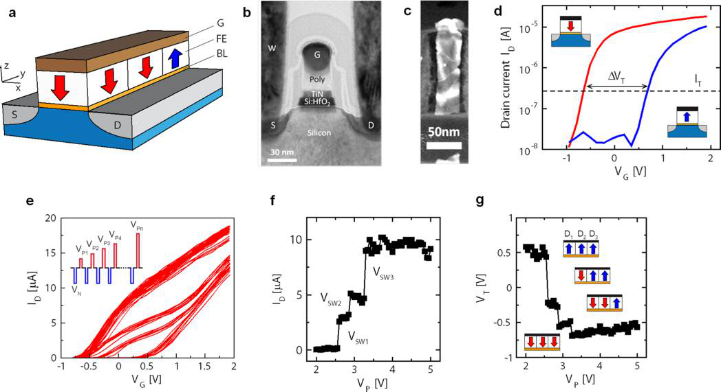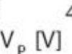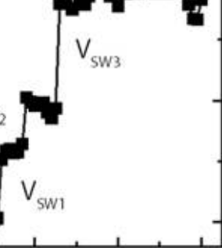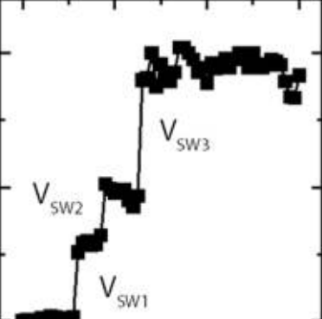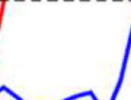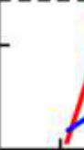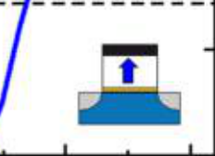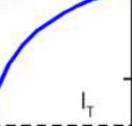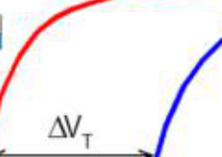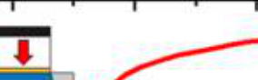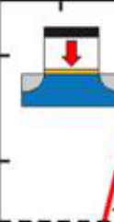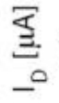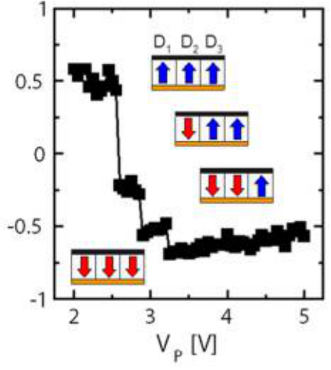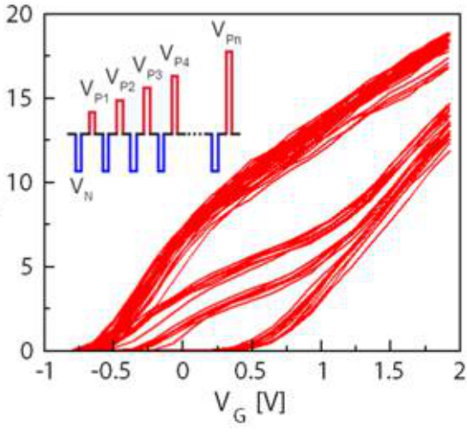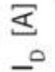

|  |  |  |
| --- | --- | --- |
| ACS Applied Materials & Interfaces | |  | | --- | | Research Article | |

|  |  |  |
| --- | --- | --- |
| |  |  | | --- | --- | |  |  | |

Figure 1. Nanoscale ferroelectric FET and its abrupt switching events. (a) Schematic illustration of a FeFET structure, indicating source (S), drain (D), gate (G), ferroelectric (FE), and buffer layer (BL) and having for illustrative purpose 3 domains (two of which have the “down” and one “up”

polarization). (b) Cross-sectional TEM image (taken parallel to the xz plane) of a silicon-doped HfO2 FeFET device with L = 30 nm. (c) Top-down TEM image (taken parallel to the xy plane) showing the ferroelectric HfO2 after the gate electrode was removed. It reveals the presence of only a few grains. (d) ID−VG transfer characteristics of a 30 nm long device after a positive (VP) and a negative (VN) gate pulse, which correspond to polarization down (P↓, red curve) and up (P↑, blue curve) of all present ferroelectric domains, respectively. (e) ID−VG curves read-out after each of the progressively increasing VP pulses in the inset. (f) Drain current from e, extracted for the sake of clarity at VG = 0.36 V vs the corresponding VP, showing four different current levels. (g) Threshold voltage extracted from e, vs the corresponding VP. Three discrete and abrupt VT shifts correspond to separate switching of three domains within the stack (inset). Panels b, c, and d−g refer to three different devices, respectively.

Reproduced in part with permission from ref 41. Copyright 2016 IEEE.

structures allow for detection of abrupt threshold voltage (VT) shifts which we argue are caused by a discrete polarization reversal of domains. Such a detection is possible due to the intrinsic amplifying effect of transistors making them extremely sensitive to small charge variations within the gate stack. This seemingly unconventional investigation tool has indeed already been used in the past to study ferroelectric and super-conducting properties of materials in an accurate manner.17,18 Moreover, we report electrical measurements as a function of pulse amplitude, pulse duration, and temperature in order to explore the polarization switching kinetics. Our analysis not only confirms the statistical nature of ferroelectric domain switching, which we model using the simple Poisson process, but also indicates that the polarization reversal in this ferroelectric system is nucleation-dominated.

2. RESULTS AND DISCUSSION

Our FeFET devices comprise a polysilicon/TiN (8 nm)/HfO2 (10 nm)/SiON (1.2 nm) gate stack and W = 80 nm and L = 30 nm of channel width and length, respectively (see schematic and TEM images in Figure 1a−c). It should be noted that the SiON layer acts here as the standard buffer layer (BL) between the high-k ferroelectric and silicon substrate (see Experimental Section). Typically, in state-of-the-art high-k metal gate technologies, the buffer layer forms a well-controlled interface to the silicon substrate, thus reducing interface trap states to a minimum and avoiding channel mobility degradation. This

3793 DOI: [10.1021/acsami.6b13866](http://dx.doi.org/10.1021/acsami.6b13866)

|  |  |  |
| --- | --- | --- |
| ACS Applied Materials & Interfaces | |  | | --- | | Research Article | |

|  |
| --- |
|  |

Figure 2. Stochastic ferroelectric switching and intermediate VT states. (a) Oscillatory behavior of the single domain polarization in proximity of the coercive voltage (VP = 3.15 V). (b) Switching probability of the device in function of VP, (c) VT vs VP graph obtained with procedure in Figure 1e (inset) for a device exhibiting a large ΔVT. (d) Oscillatory switching between intermediate VT states for the device in c, revealing the presence of at least two domains in the ferroelectric layer. VP was varied from 2 to 2.5 V with a step of 10 mV.

means of displacement current response is practically impossible for our small area devices. As discussed in [Supporting Information Section 2](http://pubs.acs.org/doi/suppl/10.1021/acsami.6b13866/suppl_file/am6b13866_si_001.pdf), these currents are too small to be detected; therefore, the classical polarization−voltage (P−V) hysteresis cannot be used for the analysis. Moreover, in comparison with our previous studies in which large-area devices contained a multitude of domains within the gate stack,23the ultrascaled devices are inevitably influenced by the granularity of the ferroelectric layer. Indeed, the nanoscale gate area ensures the presence of only a few grains and ferroelectric domains in the gate stack, which is exemplarily shown in Figure 1c.

To gain insight into the influence of the domain granularity on the ferroelectric switching, we apply short (tPW = 500 ns) write voltage pulses (of amplitude VP > 0 or VN < 0) to the gate electrode (inset Figure 1e), keeping the other three terminals (source, drain, and bulk) grounded. Subsequently, the polar-ization state is determined assessing the VT level reading the transfer characteristics at a drain voltage of VD = 100 mV. When the VP amplitude is increased progressively form 2 to 5 V while keeping VN at a constant reference value of −5 V (in order to program the device always in the same high VT state prior the VP pulse), a set of ID−VG curves shown in Figure 1e is obtained. Only curves after a VP pulse are depicted for simplicity. Here, four different and separate current branches can be readily observed. To better visualize this point, the current levels in the region of maximum separation between the current branches (VG = 0.36 V was chosen here to extract ID levels) and the VT levels corresponding to each VP pulse are extracted from Figure 1e and are shown in Figure 1f,g, respectively. Interestingly, the switching behavior sensed both as a current level or VT shift is very abrupt. This finding is in strong contrast to a rather gradual switching observed in large-area FeFETs we had reported in the past23(see [Supporting Information Section 3](http://pubs.acs.org/doi/suppl/10.1021/acsami.6b13866/suppl_file/am6b13866_si_001.pdf)). Furthermore, while some devices exhibit only a single abrupt

3794 DOI: [10.1021/acsami.6b13866](http://dx.doi.org/10.1021/acsami.6b13866)

|  |  |  |
| --- | --- | --- |
| ACS Applied Materials & Interfaces | |  | | --- | | Research Article | |

|  |
| --- |
|  |

Figure 3. Switching voltage dependence on excitation pulse width. (a) VT vs VP graph and (b) VT vs |VN| graph for pulse widths ranging from 100 ns to 10 ms. The reduction of ΔVT shift with increasing pulse width tPW in b is due to a strong trapping of holes coming from the silicon substrate.23,28

|  |
| --- |
|  |

Figure 4. Field, time, and temperature dependence of ferroelectric switching in a nucleation-limited scenario. (a) Gate voltage waveform with

logarithmically increasing pulse width tPW. After each pulse, a fast read out of a transfer curve is carried out. (b) VT vs tPW graph corresponding to 20 repetitions of procedure in a, shown for four different VP levels. For VP = [2.8, 2.6, 2.4] V, the measurement was truncated at tPW = 100 μs, in order

not to stress the device for longer pulse widths. (c) Standard deviation vs mean value of switching time tSW extracted from b. (d) Fitting of switching probability curves corresponding to four different VP levels used in b. (e) Experimental mean switching time tSW vs switching voltage for two different temperatures is in agreement with nucleation dominated switching model.38

carried out with VP. This sequence was performed 50 times for each considered VP. Figure 2a shows the resulting VT cycles of a device exhibiting only one abrupt ΔVT shift at VSW = 3.2 V (see inset Figure 2a). For VP = 3.15 V an oscillation between the two VT states is clearly visible, indicating the impossibility to switch the domain at every trial. When, instead VP = 4 V ≫VSW, the domain is always switched into the P↓ state. As a result, each VP amplitude can be associated with a certain probability to switch the polarization state, which leads to a

strongly bias-dependent switching probability curve shown in

Figure 2b. Interestingly, by repeating this experiment on a device with a remarkably large single ΔVT shift (Figure 2c) and adopting a very fine step for increasing VP levels, an oscillatory behavior between few intermediate VT states can be identified. Figure 2d reveals the existence of two intermediate VT levels which are only randomly accessible, thus indicating the presence of at least two domains within the ferroelectric film

3795 DOI: [10.1021/acsami.6b13866](http://dx.doi.org/10.1021/acsami.6b13866)



ACS Applied Materials & Interfaces Research Article

reversed domains.30Here, VC follows the simple power-law relationship VC ∝ fβand has been successfully applied for bulk crystals and clean epitaxial films.31However, polycrystalline disordered ferroelectrics strongly deviate from this relation,32

|  |  |  |  |  |  |  |
| --- | --- | --- | --- | --- | --- | --- |
| and several domain nucleation limiting models have been | | | | | | |
| ther  mov  Du−desc  switc by a over  Land the  expr  ([Sup](http://pubs.acs.org/doi/suppl/10.1021/acsami.6b13866/suppl_file/am6b13866_si_001.pdf)  *τ* | efo  em  C  rib  hi  n co  au  fra  ess  [po](http://pubs.acs.org/doi/suppl/10.1021/acsami.6b13866/suppl_file/am6b13866_si_001.pdf)  = | re  en  hen in  ng.  at  me  er3 me ion [rti](http://pubs.acs.org/doi/suppl/10.1021/acsami.6b13866/suppl_file/am6b13866_si_001.pdf)  *τ* 0 | pro  t is n mo g fiel It a tracti . Fo 5for work for t [ng In](http://pubs.acs.org/doi/suppl/10.1021/acsami.6b13866/suppl_file/am6b13866_si_001.pdf)  exp⎛⎜⎝ | posed.32,3 eglected c del33ap d- and ssumes th ve potent llowing a the free of the he averag [formation](http://pubs.acs.org/doi/suppl/10.1021/acsami.6b13866/suppl_file/am6b13866_si_001.pdf)  *k T V* B  *α* · 1  SW  2 | Here, the tim ompared to the n pears to be part temperature-depe e existence of a ial which nucleat similar approac energy of domai classical nucleatio e nucleation waitin [Section 4](http://pubs.acs.org/doi/suppl/10.1021/acsami.6b13866/suppl_file/am6b13866_si_001.pdf)): ⎞⎟⎠ | e of domain wall ucleation time. The icularly suitable in ndent polarization critical size defined ing domains must h of Merz34and n nucleation within n theory, a simple g time can be found  (1) |

where τ0 is the shortest nucleation time possible, α is a parameter related to intrinsic material properties including domain wall energy and the portion of a switched polarization by the nucleus, kB is the Boltzmann’s constant, and T is the temperature.

Aiming at a statistical study of the time and field dependence of switching in more detail, the VN−read−VP−read sequence with logarithmically increasing tPW of the VP pulse was adopted (Figure 4a). The procedure was repeated 20 times for each considered VP level. As evident in Figure 4b, the switching time for a fixed VP spreads over approximately one decade, and its mean value decreases with increasing VP. Reporting the experimental standard deviation σtSW as a function of the average switching time <tSW> in a log−log graph (Figure 4c), the unity slope over several decades can be clearly identified. This strongly hints at the stochastic switching ruled by a Poisson process.

It is known that the domain wall motion in ultrathin films is extremely slow (e.g., about 1 nm/s under electric field of 1 MV/cm in PZT).36Therefore, we model the switching behavior in our thin films with a purely nucleation-limited scenario. Given the small size of grains, it is to be expected they contain only one domain37(see [Supporting Information Section 1](http://pubs.acs.org/doi/suppl/10.1021/acsami.6b13866/suppl_file/am6b13866_si_001.pdf)). We start by supposing that the switching is initiated when a relatively small number of critical nuclei are generated within one grain upon the application of the electric field, with the generation rate given by λ = 1/τ in eq 1. Within this picture, the polarization of the grain is considered reversed when a certain critical number n of generated nuclei merge together into a single domain occupying the entire grain. Assuming the nucleation to be the Poisson process, which has already been reported for the classical ferroelectrics27and supported by Figure 4c for our ferroelectric system, the time elapsing between each critical nucleus generation ΔTi will be exponentially distributed as

|  |  |  |  |  |
| --- | --- | --- | --- | --- |
| *p* Δ *T i* | = | *λ* | e− Δ *T i* | (2) |

where pΔTi is the probability density function of ΔTi. Thus, the overall grain/domain switching time will be given by the sum of n individual ΔTi intervals corresponding to the number of critical nuclei necessary to form the domain:

3796 DOI: [10.1021/acsami.6b13866](http://dx.doi.org/10.1021/acsami.6b13866)

|  |  |  |
| --- | --- | --- |
| ACS Applied Materials & Interfaces | |  | | --- | | Research Article | |

domains. It was proven that these states are stable both in time and upon cycling, making FeFETs suitable candidates for a multilevel nonvolatile storage. In addition, negative capacitance-based transistors exploiting the ferroelectric switching in a FeFET structure appear to be a promising solution for ever increasing leakage issues in ultrascaled electronic devices caused by the Boltzmann limit.42However, only a precise control of polarization switching transients can ensure the negative capacitance effect, which is known to be intrinsically unstable under ordinary conditions.43

4. EXPERIMENTAL SECTION

Si:HfO2-based metal ferroelectric insulator semiconductor FETs (MFIS-FETs) featuring a TiN/Si:HfO2/SiON/Si gate stack were fabricated utilizing the standard high-k metal-gate (HKMG) process flow in a conventional gate first approach.20A 1.2 nm thick interfacial nitrided SiO2 layer (SiON) was grown on the HF-last active area followed by a 10 nm Si:HfO2 layer grown from HfCl4 and SiCl4 in a water-based ALD process at 300 °C. PVD-TiN served as metal gate and was contacted with poly-Si. The thermal budget for the complete gate stack reached a maximum temperature of 1050 °C at a spike activation anneal resulting in a fully crystalline Si:HfO2 ferroelectric. Electrical characterization of the FeFET devices was performed on a fully automatic prober UF3000 Accretech equipped with a Keithley 4200-SCS Semiconductor Analyzer; 4225 PMU (pulse measurement unit) was adopted for fast transient ID−VG characterization. Here, each curve was acquired applying a gate voltage sweep in the range from −1 to 2 V with the total sweep duration of 500 μs. Drain voltage was kept at 100 mV.

■ASSOCIATED CONTENT   
* Supporting Information

The Supporting Information is available free of charge on the [ACS Publications website](http://pubs.acs.org) at DOI: [10.1021/acsami.6b13866](http://pubs.acs.org/doi/abs/10.1021/acsami.6b13866).

Additional data concerning the polycrystalline nature of ferroelectric hafnium oxide, abrupt switching in FeFETs and modeling of nucleation driven polarization reversal ([PDF](http://pubs.acs.org/doi/suppl/10.1021/acsami.6b13866/suppl_file/am6b13866_si_001.pdf))  
■AUTHOR INFORMATION   
Corresponding Authors   
*E-mail: [halid.mulaosmanovic@namlab.com](mailto:halid.mulaosmanovic@namlab.com).

*E-mail: [stefan.slesazeck@namlab.com](mailto:stefan.slesazeck@namlab.com).

ORCID

Halid Mulaosmanovic: [0000-0001-9524-5112](http://orcid.org/0000-0001-9524-5112)

Notes   
The authors declare no competing financial interest.

■ACKNOWLEDGMENTS   
We acknowledge helpful discussions with Min Hyuk Park. This work was founded by the Free State of Saxony.

■REFERENCES   
(1) Scott, J. F. Applications of Modern Ferroelectrics. [Science](http://pubs.acs.org/action/showLinks?pmid=17303745&crossref=10.1126%2Fscience.1129564&coi=1%3ACAS%3A528%3ADC%252BD2sXhs1Cks7o%253D&citationId=p_n_1_1) 2007, 315, 954−959.

[(2) Bo](http://pubs.acs.org/action/showLinks?crossref=10.1063%2F1.3634052&citationId=p_n_4_1)̈[scke, T. S.; Mu](http://pubs.acs.org/action/showLinks?crossref=10.1063%2F1.3634052&citationId=p_n_4_1)̈[ller, J.; Bra](http://pubs.acs.org/action/showLinks?crossref=10.1063%2F1.3634052&citationId=p_n_4_1)̈[uhaus, D.; Schro](http://pubs.acs.org/action/showLinks?crossref=10.1063%2F1.3634052&citationId=p_n_4_1)̈[der, U.; Bo](http://pubs.acs.org/action/showLinks?crossref=10.1063%2F1.3634052&citationId=p_n_4_1)̈[tt](http://pubs.acs.org/action/showLinks?crossref=10.1063%2F1.3634052&citationId=p_n_4_1)ger, U. [Ferroelectricity in Hafnium Oxide Thin Films. Appl. Phys. Lett](http://pubs.acs.org/action/showLinks?crossref=10.1063%2F1.3634052&citationId=p_n_4_1). 2011, 99, 102903.

(3) Lee, M. H.; Wei, Y. T.; Chu, K. Y.; Huang, J. J.; Chen, C. W.; Cheng, C. C.; Chen, M.-J.; Lee, H.-Y.; Chen, Y.-S.; Lee, L.-H.; Tsai, M.-J. Steep Slope and Near Non-Hysteresis of [FETs with Antiferro-elec](http://pubs.acs.org/action/showLinks?crossref=10.1109%2FLED.2015.2402517&coi=1%3ACAS%3A528%3ADC%252BC2MXntVGnur0%253D&citationId=p_n_5_1)tric-like HfZrO for Low-Power Electronics. [IEEE Electron Device Lett](http://pubs.acs.org/action/showLinks?crossref=10.1109%2FLED.2015.2402517&coi=1%3ACAS%3A528%3ADC%252BC2MXntVGnur0%253D&citationId=p_n_5_1). 2015, 36 (4), 294−296.

3797 DOI: [10.1021/acsami.6b13866](http://dx.doi.org/10.1021/acsami.6b13866)

|  |  |  |
| --- | --- | --- |
| ACS Applied Materials & Interfaces | |  | | --- | | Research Article | |

(21) Böscke, T. S.; Müller, J.; Bräuhaus, D.; Schröder, U.; Böttger, U. Ferroelectricity in Hafnium Oxide: CMOS Compatible Ferroelectric Field Effect Transistors. 2011 IEEE Int. Electron Devices Meet. 2011, 24.5.1.

(22) JEDEC Standard JESD28-A, Procedure for Measuring N-Channel MOSFET Hot-Carrier-Induced Degradation under DC Stress; JEDEC Solid State Technology Association: Arlington, VA, 2001; p 10. (23) Müller, J.; Böscke, T. S.; Schröder, U.; Hoffmann, R.; Mikolajick, T.; Frey, L. Nanosecond Polarization Switching and [Long Retention in a No](http://pubs.acs.org/action/showLinks?crossref=10.1109%2FLED.2011.2177435&citationId=p_n_45_1)vel MFIS-FET Based on Ferroelectric HfO2. [IEEE Electron Device Lett](http://pubs.acs.org/action/showLinks?crossref=10.1109%2FLED.2011.2177435&citationId=p_n_45_1). 2012, 33 (2), 185−187.

(24) Tan, Y.; Zhang, J.; Wu, Y.; Wang, C.; Koval, V.; Shi, B.; Ye, H.; McKinnon, R.; Viola, G.; Yan, H. Unf[olding](http://pubs.acs.org/action/showLinks?pmid=25951408&crossref=10.1038%2Fsrep09953&coi=1%3ACAS%3A528%3ADC%252BC2MXhtFOrsLnP&citationId=p_n_46_1) Grain Size Effects in Barium Titanate Ferroelectric Ceramics. [Sci. Rep](http://pubs.acs.org/action/showLinks?pmid=25951408&crossref=10.1038%2Fsrep09953&coi=1%3ACAS%3A528%3ADC%252BC2MXhtFOrsLnP&citationId=p_n_46_1). 2015, 5, 9953. (25) Jin, Y.; Lu, X.; Zhang, J.; Kan, Y.; Bo, H.; Huang, F.; Xu, T.; Du, Y.; Xiao, S.; Zhu, J. Studying the Polarization Switching in [Polycry](http://pubs.acs.org/action/showLinks?pmid=26192555&crossref=10.1038%2Fsrep12237&coi=1%3ACAS%3A528%3ADC%252BC2MXhtlWgsrvO&citationId=p_n_47_1)stalline BiFeO3 Films by 2D Piezoresponse Force Microscopy. [Sci. Rep](http://pubs.acs.org/action/showLinks?pmid=26192555&crossref=10.1038%2Fsrep12237&coi=1%3ACAS%3A528%3ADC%252BC2MXhtlWgsrvO&citationId=p_n_47_1). 2015, 5, 12237.

(26) Gruverman, A.; Ikeda, Y. Characterization and Control of

[for](http://pubs.acs.org/action/showLinks?crossref=10.1109%2FIEDM.2015.7409777&citationId=p_n_73_1) Multi-Level FeFET Memory Cells. 2015 [IEEE Int. Electron Devices Meet](http://pubs.acs.org/action/showLinks?crossref=10.1109%2FIEDM.2015.7409777&citationId=p_n_73_1). 2015, 26.8.1.

(42) Salahuddin, S.; Datta, S. Use of Negative Capacitance [to Provide](http://pubs.acs.org/action/showLinks?system=10.1021%2Fnl071804g&coi=1%3ACAS%3A528%3ADC%252BD2sXhtlynu7fE&citationId=p_n_74_1) Voltage Amplification for Low Power Nanoscale Devices. [Nano Lett](http://pubs.acs.org/action/showLinks?system=10.1021%2Fnl071804g&coi=1%3ACAS%3A528%3ADC%252BD2sXhtlynu7fE&citationId=p_n_74_1). 2008, 8, 405−410.

(43) Khan, A. I.; Chatterjee, K.; Wang, B.; Drapcho, S.; You, L.; Serrao, C.; Bakaul, S. R.; Ramesh, R.; [Salahuddi](http://pubs.acs.org/action/showLinks?pmid=25502099&crossref=10.1038%2Fnmat4148&citationId=p_n_77_1)n, S. Negative Capacitance in a Ferroelectric Capacitor. [Nat. Mater](http://pubs.acs.org/action/showLinks?pmid=25502099&crossref=10.1038%2Fnmat4148&citationId=p_n_77_1). 2014, 14 (2), 182−186.

Domain Str[ucture in SrBi2T](http://pubs.acs.org/action/showLinks?crossref=10.1143%2FJJAP.37.L939&coi=1%3ACAS%3A528%3ADyaK1cXls1ajtro%253D&citationId=p_n_48_1)a2O9 Thin Films by Scanning Force   
Microscopy. [Jpn. J. Appl. Phys](http://pubs.acs.org/action/showLinks?crossref=10.1143%2FJJAP.37.L939&coi=1%3ACAS%3A528%3ADyaK1cXls1ajtro%253D&citationId=p_n_48_1). 1998, 37, L939.

(27) Shin, Y.; Grinberg, I.; Chen, I.; Rappe, A. M. Nucleati[on and](http://pubs.acs.org/action/showLinks?pmid=17922002&crossref=10.1038%2Fnature06165&coi=1%3ACAS%3A528%3ADC%252BD2sXhtFOjt7bF&citationId=p_n_49_1)   
Growth Mechanism of Ferroelectric Domain-Wall Motion. [Nature](http://pubs.acs.org/action/showLinks?pmid=17922002&crossref=10.1038%2Fnature06165&coi=1%3ACAS%3A528%3ADC%252BD2sXhtFOjt7bF&citationId=p_n_49_1)   
2007, 449, 881−884.

(28) Lu, W. T.; Lin, P. C.; Huang, T. Y.; Chien, C. H.; Yang, M. J.;   
Huang, I. J.; Lehnen, P. The Characteristics of Ho[le Trapping in](http://pubs.acs.org/action/showLinks?crossref=10.1063%2F1.1808228&coi=1%3ACAS%3A528%3ADC%252BD2cXovFWgtLg%253D&citationId=p_n_52_1)   
HfO2/SiO2 Gate Dielectrics with TiN Gate Electrode. [Appl. Phys. Lett](http://pubs.acs.org/action/showLinks?crossref=10.1063%2F1.1808228&coi=1%3ACAS%3A528%3ADC%252BD2cXovFWgtLg%253D&citationId=p_n_52_1).   
2004, 85 (16), 3525−3527.

(29) Scott, J. F.; Kammerdiner, L.; Parris, M.; Traynor, S.;   
Ottenbacher, V.; Shawabkeh, A.; Oliver, W. F; Switching Kin[etics of](http://pubs.acs.org/action/showLinks?crossref=10.1063%2F1.341925&coi=1%3ACAS%3A528%3ADyaL1cXlt1SrtL4%253D&citationId=p_n_53_1)   
[Lead](http://pubs.acs.org/action/showLinks?crossref=10.1063%2F1.341925&coi=1%3ACAS%3A528%3ADyaL1cXlt1SrtL4%253D&citationId=p_n_53_1) Zirconate Titanate Submicron Thin-Film Memories. [J. Appl.](http://pubs.acs.org/action/showLinks?crossref=10.1063%2F1.341925&coi=1%3ACAS%3A528%3ADyaL1cXlt1SrtL4%253D&citationId=p_n_53_1)   
[Phys](http://pubs.acs.org/action/showLinks?crossref=10.1063%2F1.341925&coi=1%3ACAS%3A528%3ADyaL1cXlt1SrtL4%253D&citationId=p_n_53_1). 1988, 64 (2), 787−792.

(30) Orihara, H.; Hashimoto, S.; Ishibashi, [Y. A Theory](http://pubs.acs.org/action/showLinks?crossref=10.1143%2FJPSJ.63.1031&coi=1%3ACAS%3A528%3ADyaK2cXisFyrtb8%253D&citationId=p_n_54_1) of DE   
Hysteresis Loop Based on the Avrami Model. [J. Phys. Soc. Jpn](http://pubs.acs.org/action/showLinks?crossref=10.1143%2FJPSJ.63.1031&coi=1%3ACAS%3A528%3ADyaK2cXisFyrtb8%253D&citationId=p_n_54_1). 1994,   
63, 1031−1035.

(31) So, Y. W.; Kim, D. J.; Noh, T. W.; Yoon, J. G.; Song, T. K.   
Polariz[ation Switchin](http://pubs.acs.org/action/showLinks?crossref=10.1063%2F1.1870126&coi=1%3ACAS%3A528%3ADC%252BD2MXis1ykt74%253D&citationId=p_n_57_1)g Kinetics of Epitaxial Pb(Zr0.4Ti0. 6)O3 Thin   
Films. [Appl. Phys. Lett](http://pubs.acs.org/action/showLinks?crossref=10.1063%2F1.1870126&coi=1%3ACAS%3A528%3ADC%252BD2MXis1ykt74%253D&citationId=p_n_57_1). 2005, 86, 092905.

(32) Tagantsev, A. K.; Stolichnov, I.; Setter, N.; Cross, J. S.; Tsukada,   
M. No[n-Kolmogorov-Avrami Switching Kinetics](http://pubs.acs.org/action/showLinks?crossref=10.1103%2FPhysRevB.66.214109&coi=1%3ACAS%3A528%3ADC%252BD3sXhvFCguw%253D%253D&citationId=p_n_58_1) in Ferroelectric Thin   
Films. [Phys. Rev. B: Condens. Matter Mater. Phys](http://pubs.acs.org/action/showLinks?crossref=10.1103%2FPhysRevB.66.214109&coi=1%3ACAS%3A528%3ADC%252BD3sXhvFCguw%253D%253D&citationId=p_n_58_1). 2002, 66, 214109.   
(33) Du, X.; Chen, I. W. Fre[quency Spectra of Fati](http://pubs.acs.org/action/showLinks?crossref=10.1557%2FPROC-493-311&citationId=p_n_59_1)gue of PZT and   
other Ferroelectric Thin Films. [MRS Online Proc. Libr](http://pubs.acs.org/action/showLinks?crossref=10.1557%2FPROC-493-311&citationId=p_n_59_1). 1997, 493, 311.   
(34) Merz, W. J. Domain Formation [and Do](http://pubs.acs.org/action/showLinks?crossref=10.1103%2FPhysRev.95.690&coi=1%3ACAS%3A528%3ADyaG2cXntVamtQ%253D%253D&citationId=p_n_60_1)main Wall Motions in   
Ferroelectric BaTiO3 Single Crystals. [Phys. Rev](http://pubs.acs.org/action/showLinks?crossref=10.1103%2FPhysRev.95.690&coi=1%3ACAS%3A528%3ADyaG2cXntVamtQ%253D%253D&citationId=p_n_60_1). 1954, 95, 690−698.   
(35) Landauer, R. Electrostatic Consid[erations in](http://pubs.acs.org/action/showLinks?crossref=10.1063%2F1.1722712&coi=1%3ACAS%3A528%3ADyaG2sXjslGnsQ%253D%253D&citationId=p_n_63_1) BaTiO3 Domain   
Formation During Polarization Reversal. [J. Appl. Phys](http://pubs.acs.org/action/showLinks?crossref=10.1063%2F1.1722712&coi=1%3ACAS%3A528%3ADyaG2sXjslGnsQ%253D%253D&citationId=p_n_63_1). 1957, 28, 227−  
234.

(36) Tybell, T.; Paruch, P.; Giamarchi, T.; Triscone, J. M. Domain   
[Wall Creep i](http://pubs.acs.org/action/showLinks?crossref=10.1103%2FPhysRevLett.89.097601&coi=1%3ACAS%3A528%3ADC%252BD38Xmt1Ggu78%253D&citationId=p_n_64_1)n Epitaxial Ferroelectric Pb(Zr0.2Ti0.8)O3 Thin Films.   
[Phys. Rev. Lett](http://pubs.acs.org/action/showLinks?crossref=10.1103%2FPhysRevLett.89.097601&coi=1%3ACAS%3A528%3ADC%252BD38Xmt1Ggu78%253D&citationId=p_n_64_1). 2002, 89 (9), 097601.

(37) Roelofs, A.; Schneller, T.; Szot, K.; Waser, R. Piezoresponse   
Force Microscopy of Lea[d Titanate Nan](http://pubs.acs.org/action/showLinks?crossref=10.1063%2F1.1534412&coi=1%3ACAS%3A528%3ADC%252BD38XpvVaqsb8%253D&citationId=p_n_65_1)ograins Possibly Reaching the   
Limit of Ferroelectricity. [Appl. Phys. Lett](http://pubs.acs.org/action/showLinks?crossref=10.1063%2F1.1534412&coi=1%3ACAS%3A528%3ADC%252BD38XpvVaqsb8%253D&citationId=p_n_65_1). 2002, 81, 5231−5233.   
(38) Jung, D. J.; Dawber, M.; Scott, J. F.; Sinnamon, L. J.; Gregg, J.   
M. Swit[ching Dynamics](http://pubs.acs.org/action/showLinks?crossref=10.1080%2F10584580215437&coi=1%3ACAS%3A528%3ADC%252BD38XpsV2nsLw%253D&citationId=p_n_68_1) in Ferroelectric Thin Films: An Experimental   
Survey. [Integr. Ferroelectr](http://pubs.acs.org/action/showLinks?crossref=10.1080%2F10584580215437&coi=1%3ACAS%3A528%3ADC%252BD38XpsV2nsLw%253D&citationId=p_n_68_1). 2002, 48, 59−68.

(39) Nam, S. M.; Kil, Y. B.; Wada, S.; Tsurumi, T. [Domain Switching](http://pubs.acs.org/action/showLinks?crossref=10.1143%2FJJAP.42.L1519&coi=1%3ACAS%3A528%3ADC%252BD2cXhsFan&citationId=p_n_71_1)   
Kinetics of Lead Zirconate Titinate Thin Films. [Jpn. J. Appl. Phys](http://pubs.acs.org/action/showLinks?crossref=10.1143%2FJJAP.42.L1519&coi=1%3ACAS%3A528%3ADC%252BD2cXhsFan&citationId=p_n_71_1).   
2003, 42, L1519.

(40) Mueller, S.; Summerfelt, S. R.; Müller, J.; Schroeder, U.;   
Mikolajick, T. Ten-Nano[meter Ferroelectric Film](http://pubs.acs.org/action/showLinks?crossref=10.1109%2FLED.2012.2204856&coi=1%3ACAS%3A528%3ADC%252BC38XhsVOhtLvO&citationId=p_n_72_1)s for Next-Gener-  
ation FRAM Capacitors. [IEEE Electron Device Lett](http://pubs.acs.org/action/showLinks?crossref=10.1109%2FLED.2012.2204856&coi=1%3ACAS%3A528%3ADC%252BC38XhsVOhtLvO&citationId=p_n_72_1). 2012, 33, 1300−  
1302.

(41) Mulaosmanovic, H.; Slesazeck, S.; Ocker, J.; Pesic, M.; Müller,   
S.; Flachowsky, S.; Müller, J.; Polakowski, P.; Paul, J.; Jansen, S.;   
Kolodinski, S.; Richter, C.; Piontek, S.; Schenk, T.; Kersch, A.;   
Künneth, C.; van Bentum, R.; Schröder, U.; Mikolajick, T. Evidence of   
Single Domain Switching in Hafnium Oxide based FeFETs: Enabler

|  |  |
| --- | --- |
| 3798 | DOI: [10.1021/acsami.6b13866](http://dx.doi.org/10.1021/acsami.6b13866) ACS Appl. Mater. Interf[aces 2017, 9, 3792−3798](http://dx.doi.org/10.1021/acsami.6b13866) |