**Ferroelectricity in undoped hafnium oxide**   
[Patrick Polakowski](http://aip.scitation.org/author/Polakowski%2C+Patrick) and [Johannes Müller](http://aip.scitation.org/author/M%C3%BCller%2C+Johannes)

Citation: Appl. Phys. Lett.**106**, 232905 (2015); doi: 10.1063/1.4922272 View online: <http://dx.doi.org/10.1063/1.4922272>  
View Table of Contents: <http://aip.scitation.org/toc/apl/106/23>  
Published by the [American Institute of Physics](http://aip.scitation.org/publisher/)

**Articles you may be interested in**   
[Ferroelectricity in hafnium oxide thin films](http://aip.scitation.org/doi/abs/10.1063/1.3634052)   
[Applied Physics Letters](http://aip.scitation.org/doi/abs/10.1063/1.3634052) **[99](http://aip.scitation.org/doi/abs/10.1063/1.3634052)**[, 102903 (2011](http://aip.scitation.org/doi/abs/10.1063/1.3634052)); 10.1063/1.3634052  
 [Enhancing ferroelectricity in dopant-free hafnium oxide](http://aip.scitation.org/doi/abs/10.1063/1.4973928)   
[Applied Physics Letters](http://aip.scitation.org/doi/abs/10.1063/1.4973928) **[110](http://aip.scitation.org/doi/abs/10.1063/1.4973928)**[, 022903 (2017); 10.1063/1](http://aip.scitation.org/doi/abs/10.1063/1.4973928).4973928   
[Ferroelectricity in yttrium-doped hafnium oxide](http://aip.scitation.org/doi/abs/10.1063/1.3667205)   
[Journal of Applied Physics](http://aip.scitation.org/doi/abs/10.1063/1.3667205) **[110](http://aip.scitation.org/doi/abs/10.1063/1.3667205)**[, 114113 (2011)](http://aip.scitation.org/doi/abs/10.1063/1.3667205); 10.1063/1.3667205   
[Stabilizing the ferroelectric phase in doped hafnium oxide](http://aip.scitation.org/doi/abs/10.1063/1.4927805)   
[Journal of Applied Physics](http://aip.scitation.org/doi/abs/10.1063/1.4927805) **[118](http://aip.scitation.org/doi/abs/10.1063/1.4927805)**[, 072006 (2015); 10.1063/](http://aip.scitation.org/doi/abs/10.1063/1.4927805)1.4927805   
[The origin of ferroelectricity in Hf1-xZrxO2: A computational investigation and a surface energy model](http://aip.scitation.org/doi/abs/10.1063/1.4916707) Journal of Applied Physics **117**, 134109 (2015); 10.1063/1.4916707   
[On the structural origins of ferroelectricity in HfO2 thin films](http://aip.scitation.org/doi/abs/10.1063/1.4919135)   
Applied Physics Letters **106**, 162905 (2015); 10.1063/1.4919135



APPLIED PHYSICS LETTERS 106, 232905 (2015) 

[Ferroelectricity in undoped hafnium oxide](http://dx.doi.org/10.1063/1.4922272)

Patrick Polakowski and Johannes M€uller   
Fraunhofer Institute for Photonic Microsystems IPMS - Business Unit Center Nanoelectronic Technologies CNT, Dresden 01099, Germany

(Received 15 April 2015; accepted 23 May 2015; published online 10 June 2015)

We report the observation of ferroelectric characteristics in undoped hafnium oxide thin films in a thickness range of 4–20 nm. The undoped films were fabricated using atomic layer deposition (ALD) and embedded into titanium nitride based metal-insulator-metal (MIM) capacitors for electrical evaluation. Structural as well as electrical evidence for the appearance of a ferroelectric phase in pure hafnium oxide was collected with respect to film thickness and thermal budget applied during titanium nitride electrode formation. Using grazing incidence X-Ray diffraction (GIXRD) analysis, we observed an enhanced suppression of the monoclinic phase fraction in favor of an orthorhombic, potentially, ferroelectric phase with decreasing thickness/grain size and for a titanium nitride electrode formation below crystallization temperature. The electrical presence of ferroelectricity was confirmed using polarization measurements. A remanent polarization Pr of up to 10 lC cm�2as well as a read/write endurance of 1.6 � 105cycles was measured for the pure oxide. The experimental results reported here strongly support the intrinsic nature of the ferroelec-tric phase in hafnium oxide and expand its applicability beyond the doped systems. V C 2015 AIP Publishing LLC. [<http://dx.doi.org/10.1063/1.4922272>]

Already, since the mid-19th century, HfO2 and ZrO2 have experienced intense study and research activities as a ce-ramic material. Only in the last decade, however, they have been rediscovered as a dielectric layer for complementary metal-oxide-semiconductor (CMOS) applications, triggering enormous development activities in the field of thin film depo-sition. Whereas the research of the HfO2 and ZrO2 based ceramics was primarily aimed for toughening the material,1in CMOS application, the stabilization of a higher-k phase as suitable replacement for the no longer scaling gate or node dielectrics was focused on.2,3Nevertheless, during both research periods, one of the prior interests was the investiga-tion and control of the polymorphism of these transition metal oxides. In the HfO2 bulk system, three different crystal phases can be distinguished at normal pressure. At room temperature a monoclinic phase, above 1700�C a tetragonal phase, and above 2600�C a cubic phase can be observed.4However, in the course of the aforementioned research on bulk ceramics and CMOS-compatible dielectric thin films, several material and process parameters besides temperature were identified to influence crystalline phase stability in HfO2 systems. The sta-bilization of the high temperature phases at room temperature was found to depend on doping,5,6thermal treatments,7–9dep-osition methodology/chemistry, and growth temperature,10,11 surface energy effects and strain given by grain size and film thickness,8,9as well as on the mechanical encapsulation pro-vided by the electrodes.12   
 In 2011, B€oscke et al.13revealed deviations from the previously mentioned and commonly known polymorphism of HfO2. During this study of silicon doped HfO2, a non-centrosymmetric, orthorhombic phase was observed. This orthorhombic phase was first postulated and identified in ZrO2 by Kisi et al.14in 1989. Based on this non-centrosymmetric structure, two stable states in the unit cell can be switched by an external electric field. Therewith, a

CMOS compatible, highly scalable, and manufacturable HfO2 based ferroelectric material has been established, sig-nificantly expanding the material choice for ferroelectric CMOS devices15and non-volatile memories like ferroelec-tric field effect transistors (FeFET) or the capacitor based ferroelectric random access memory (FRAM).16   
 Since the first discovery of ferroelectric behavior in sili-con doped HfO2, several dopants have been identified to evoke ferroelectricity in a similar manner.17,18However, de-spite the numerous parameters affecting phase stability in HfO2, so far no other pathways besides doping to achieve fer-roelectric phase stability have been reported. In this letter, we present experimental proof that depending on film thickness/ grain size and the adjustment of thermal budget a ferroelectric phase in HfO2 can be achieved without the utilization of a dopant.

For this study, MIM capacitors were prepared with a 10 nm TiN bottom electrode deposited by thermal atomic layer deposition at 450�C, utilizing titan(IV)-chlorid (TiCl4) and ammonia (NH3). The HfO2 layers were deposited in a thickness range of 4–20 nm using an ALD hot wall reactor at 300�C. Hafnium(IV)-chlorid (HfCl4) and water (H2O) were used as precursor and oxidant. All samples were covered with a 10 nm physical vapor deposited (PVD) top electrode at a process temperature below the crystallization tempera-ture of the HfO2 films. In comparison to previous results,16 an additional MIM capacitor has been processed with a chemical vapor deposited (CVD) top electrode at 500�C from TiCl4 and NH3. A rapid thermal spike process at 650�C was utilized after top electrode deposition to crystal-lize the HfO2 layers. To achieve lowest thermal stress, a heating rate of 250 K s�1and a maximum cooling rate were applied. For the electrical characterization of the MIM layer stack, individual capacitor structures were formed using simple wet etch processes. For this purpose, 5 nm titanium

|  |  |  |
| --- | --- | --- |
| 0003-6951/2015/106(23)/232905/5/$30.00 | 106, 232905-1 | V C 2015 AIP Publishing LLC |

|  |  |  |
| --- | --- | --- |
| 232905-2 | P. Polakowski and J. M€uller | Appl. Phys. Lett. 106, 232905 (2015) |

adhesion layer and 50 nm platinum were deposited in an electron beam evaporator using a shadow mask. The result-ing circular probing pads served as etch mask during the wet etch process of the TiN based top electrode. As etch chemis-try for the selective removal of the top TiN, a solution of H2O:H2O2:NH4OH (SC1) was used in a ratio of 40:2:1 at 50�C for an etch time of 5 min. A Bruker D8 Discover X-Ray diffraction (XRD) system was used for the grazing incidence XRD scans of the samples to determine the crystal-lographic phase composition of the films. The polarization-voltage (P-V) hysteresis and cycling endurance measurements were conducted using an aixACCT TF Analyzer 3000 mea-surement setup, and the small signal capacitance-voltage (C-V) characteristics were recorded with an Agilent E4980A LCR-Meter. All P-V measurements were performed with a tri-angular voltage sweep at a frequency of 1 kHz. C-V hysteresis was measured at a frequency of 30 kHz with a superimposed small signal amplitude of 50 mV. For a consistent comparison of the hysteresis loops, all samples were pre-cycled electri-cally. This conditioning was found to be necessary to “wake up” the full polarization response and is frequently observed in the doped HfO2 systems as well as in other ferroelectrics.19 Hence, all samples, except the 20 nm samples, received 10 k switching cycles at 10kHz with an amplitude of 2.5 MV cm�1. Due to a higher leakage current, the cycling amplitude for the 20 nm sample was reduced to 1.5 MV cm�1. The higher leakage level is related to a premature and partial crys-tallization of the 20 nm film during the deposition process. Crystallization during the deposition process affects the roughness of the film and causes therewith a higher defect density as well as a higher monoclinic phase fraction.20,21 In order to implement HfO2 based ferroelectrics into future memories or CMOS devices, the influencing parame-ters of ferroelectric phase stability have to be identified. Besides numerous studies concerned with the effect of various dopants on the ferroelectric properties, little is known about secondary parameters such as HfO2 film thickness, deposition temperature, or the influence of the thermal budget during electrode formation. However, it should be noted that already in the pioneering work by B€oscke et al.,13the covering TiN top electrode as well as the film thickness was hinted to play a key role in the stabilization process of ferroelectric HfO2. Therefore, in a first attempt, we investigated the influence of the top electrode process, which directly followed the ALD of a 10 nm undoped HfO2 film. In order to reduce the thermal budget during top electrode formation to a minimum, a PVD TiN deposited at room temperature was utilized. For a consist-ent comparison to prior art, an identical prepared HfO2 film was coated with the usually utilized CVD-TiN top electrode at 500�C. Figure 1 illustrates the structural (GIXRD) and electrical results (P-V) of this comparison. The different top electrode processes showed a strong influence on the occur-rence of ferroelectric properties in the resulting MIM capaci-tors. A distinct ferroelectric P-V hysteresis can be observed for the PVD-capped sample, whereas the CVD-capped sample shows a linear capacitance behavior and therewith a non-ferroelectric response. This difference is similarly reflected in the GIXRD results. A higher stabilization of the presumably orthorhombic phase and a lower amount of monoclinic phase

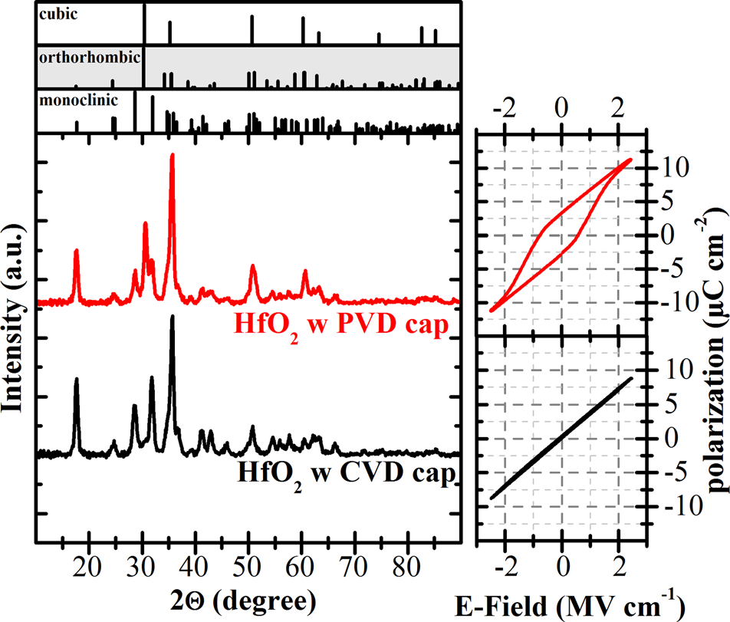

FIG. 1. GIXRD and P-V hysteresis measurements of 10 nm HfO2 films capped with a CVD-TiN electrode at 500�C and a PVD-TiN electrode de-posited at room temperature. The latter system shows structural as well as electrical indications of a partial ferroelectric phase stabilization.

can be observed for the PVD capped sample, as compared to the CVD capped sample.

In order to explain the observed phenomena in the con-text of the non-ferroelectric, pure HfO2 in prior art, the crystallization temperature of the HfO2 thin films has to be considered. Utilizing a PVD-TiN top electrode deposited at room temperature allows for an encapsulation of the films in an amorphous state. Therewith, a premature crystalliza-tion of the HfO2 layer during the top electrode deposition can be avoided and a defined crystallization anneal via RTP can be conducted in a fully encapsulated state. During the CVD-TiN process at 500�C, on the other hand, a crystalli-zation of the HfO2 layers occurs. In this context, the CVD process can be interpreted as a long post deposition anneal of the HfO2 thin films, which does not allow the quenching of metastable phases and causes the formation of a large monoclinic phase fraction. Additionally, the phase stabiliz-ing effect of an encapsulated crystallization, as described in Refs. 12 and 13 is not accessed due to the premature crys-tallization. Consequently, a distinct ferroelectric behavior in undoped HfO2 utilizing a TiN encapsulation above crys-tallization temperature has never been observed. The addi-tional phase stabilizing effect of the TiN encapsulation observed in the doped HfO2 systems using CVD-TiN elec-

|  |  |  |  |  |  |  |
| --- | --- | --- | --- | --- | --- | --- |
| trodes | was | therewith | supported | by | the | simultaneous |

increase in crystallization temperature induced by the dopant. This raised crystallization temperature is frequently observed in doped HfO2 and ZrO2 based systems.8 However, a clear differentiation has to be made between the effect of dopants on the one side and the effect of thick-ness controlled grain size and encapsulation on the other side. As shown in literature for the doped systems and as these results show for the pure oxide, both are capable of inducing ferroelectricity independently of one another. We therefore argue that the appearance of ferroelectricity in pure HfO2 is intrinsic in nature and that a previous report by Olsen et al.,22showing the first indications of ferroelec-tricity in pure HfO2 in completely sputtered TiN/HfO2/TiN

|  |  |  |
| --- | --- | --- |
| 232905-3 | P. Polakowski and J. M€uller | Appl. Phys. Lett. 106, 232905 (2015) |

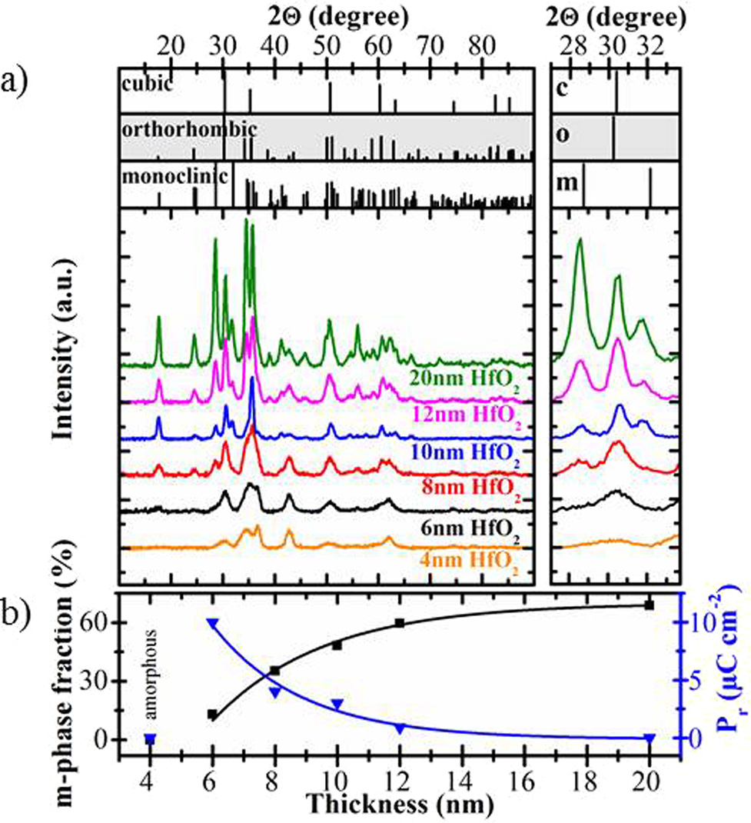

FIG. 2. (a) GIXRD data for a thickness series of pure HfO2 crystallized in the presence of a PVD-TiN top electrode. The inset shows an enlargement of the prominent reflexes for the monoclinic, orthorhombic, and cubic phase structure, which were used for the calculation of the monoclinic phase fraction. (b) Calculated monoclinic phase fraction and corresponding values of remanent polarization Pr as a function of film thickness. Suppression of the monoclinic phase and stabilization of a ferroelectric phase is clearly observed.

is not related to parasitic stabilization effects due to resid-ual contaminations.

To further investigate the ferroelectric behavior in undoped HfO2, we deposited capacitors with different HfO2 thicknesses in a range of 4–20 nm. To confirm the crystalli-zation of the films and to investigate the crystal structure of the films, GIXRD measurements were conducted. As shown in Figure 2(a), a gradual destabilization of the presumably orthorhombic phase in favor of the monoclinic phase is observed with increasing thickness. The 4 nm sample stayed amorphous after the thermal treatment and will not be con-sidered further. All films below a thickness of 12 nm showed

a low amount of the monoclinic phase and matched to the diffraction pattern of the orthorhombic phase. For the 20 nm film, the monoclinic crystal structure appeared as the pre-dominant phase. As proposed in Ref. 23, a monoclinic phase fraction was calculated to allow a quantification of the phase stabilization effect deemed responsible for the appearance of ferroelectricity in HfO2. Hence, as illustrated in the inset of Figure 2(a), the ratio of the integral intensities of the main reflexes of the monoclinic, and the presumably orthorhombic phase was calculated. The resulting monoclinic phase frac-tion is plotted (black line) as a function of film thicknesses in Figure 2(b), confirming the gradual increase of the mono-clinic phase towards higher film thicknesses.

Furthermore, the corresponding remanent polarization values (blue line) are additionally shown in Figure 2(b). A strong correlation between a decreasing monoclinic phase

|  |  |  |  |  |  |  |
| --- | --- | --- | --- | --- | --- | --- |
| fraction | and | enhanced | ferroelectric | properties | can | be |

observed. This increasing ferroelectric phase fraction with decreasing film thickness is further illustrated in the P-V-hysteresis loops (used for Pr extraction in Figure 2) and small signal capacitance measurements shown in Figure 3.

The highest remanent polarization of 10.6 lC cm�2and the highest permittivity of approximately 34 were observed for the MIM-capacitor with an HfO2 thickness of 6 nm. Additionally, the non-linearity of the C-V behavior, which is characteristic for ferroelectric materials, was pronounced strongest in this sample. For the capacitors with 8 nm and 10 nm HfO2 thickness, a smaller but distinct polarization loop and C-V non-linearity was observed. For the 12 and 20 nm thick films, the permittivity significantly dropped to approximately 24 and approached the frequently observed <20 permittivity of the monoclinic phase.24For those sam-ples, a nearly linear C-V and P-V behavior was observed.

In Figure 3(b), transmission electron microscopy (TEM) micrographs are shown for the 6 nm and the 20 nm thick HfO2 layers. Both layers exhibit a polycrystalline structure containing multiple grains. The grains are extending from the bottom to the top electrode without any additional hori-zontal interruption. Additionally, the lateral grain growth appears to be related to the vertical extension of the grains and therewith stays in the same order of magnitude. Based on this observation, film thickness and grain size are directly

|  |  |  |  |  |  |  |
| --- | --- | --- | --- | --- | --- | --- |
|  | FIG. 3. (a) P-V and C-V hysteresis loops for a thickness series of pure HfO2 thin films crystallized in the pres-ence of a PVD-TiN top electrode and (b) TEM micrograph comparison of | | | | | |
| the | 6 nm | and | 20 nm | HfO2 | films. |
| Considering these electrical results and the direct link between film thickness and grain dimension, a size induced ferroelectric phase transition becomes apparent. | | | | | |

|  |  |  |
| --- | --- | --- |
| 232905-4 | P. Polakowski and J. M€uller | Appl. Phys. Lett. 106, 232905 (2015) |

linked. With this link, the surface to volume ratio of the crys-tallites and therewith phase stability can readily be influ-enced by a simple variation of film thickness. This phase stabilizing effect depending on the surface energy to bulk energy ratio of the individual crystal phases has extensively been discussed in the context of the HfO2 and ZrO2 polymor-phism.8,25A size induced monoclinic to tetragonal transition has been reported in powders26and thin films.20,27Hence, in the context of the data presented here, it appears likely that the grain sizes reduction with decreasing film thickness allows for a stabilization of the ferroelectric phase in a simi-lar manner and is comparable to the findings in the HfO2-ZrO2 solid solution.28As a consequence, it can be assumed that the surface energy of the orthorhombic phase is lower than the surface energy of the monoclinic phase. Supportive of this argumentation is a recent ab initio study by Materlik et al.29introducing surface energy effects as a key parameter in the stabilization effect of ferroelectric HfO2 and predicting the appearance of ferroelectricity in ultra-thin films of the

Afterwards, a series of rectangular pulses at various stress levels was applied with a cycling frequency of 10 kHz (inset of Figure 4). With this voltage cycling, a continuous read/write memory operation of the ferroelectric capacitor was emulated. Between these pulse trains, a hysteresis mea-surement was performed to determine the evolution of the ferroelectric behavior of the capacitor with increasing num-ber of cycles. The highest read/write endurance for a satu-rated and therewith retention stable30hysteresis loop was measured with 1.6 � 105cycles at 2.5 MV cm�1. When low-ering the stress amplitude to 2.1 MV cm�1, a sub-loop operation of the ferroelectric HfO2 and polarization fatigue was observed. An increase of the stress voltage above 2.5 MV cm�1resulted in an early dielectric breakdown of the film. These results obtained for undoped ferroelectric HfO2 are within reach of the endurance data presented for doped HfO2 layers.31However, in order to reach more than 106endurance cycles as shown for Si doped HfO2 layers and to meet FRAM requirements, further material and pro-

pure oxide. cess optimization will be required.

Additionally, it should be noted that thicker films are more prone to premature crystallization during the long ther-mal budget of ALD than thinner films and therewith contain a higher volume fraction of monoclinic phase and cannot be encapsulated in a purely amorphous state. Based on these results, the appearance of ferroelectricity in pure HfO2 can be understood as result of phase manipulation by grain size and mechanical encapsulation.

When targeting the usage of ferroelectric HfO2 in FeFET or FRAM applications, a highly durable and electri-cally stable ferroelectric behavior is required. Especially, in the case of the classical capacitor based FRAM concepts, a high endurance of the applied material is required. In this work, cycling endurance measurements were performed for the 6 nm sample exhibiting the highest Pr value. The results are shown in Figure 4. To guarantee equal starting conditions for all applied stress levels, the capacitors under test were pre-cycled with 10 k cycles at 2.5 MV cm�1.

In conclusion, a thickness series of undoped HfO2 thin films was fabricated using ALD processing. P-V, C-V, and GIXRD measurements were utilized to investigate the struc-tural and dielectric properties of the films when embedded into TiN-based MIM capacitors. It was demonstrated that undoped ferroelectric HfO2 deposited by ALD exhibits a dis-tinct ferroelectric behavior when encapsulated in an amor-phous state prior to crystallization. The stabilization effect was found to further strengthen with decreasing film thick-ness and grain size, suggesting a size induced phase transi-tion governed by surface energy effects. The endurance measurements for the pure HfO2 showed promising results reaching up to 1.6 � 105switching cycles. With further opti-mization of the material system and the process parameters, it should be possible to achieve ferroelectric characteristics comparable to doped HfO2. Replacing doped HfO2 in the application case would greatly simplify the deposition pro-cess and allow for a much easier process control.

|  |  |
| --- | --- |
|  | FIG. 4. Endurance measurements of 6 nm pure HfO2 thin films embedded into TiN-based MIM capacitors. Read/ write operation is emulated for different operation voltages showing a maximum endurance of 1.6 � 105for saturated P-V-hysteresis at 2.5 MVcm�1. |

|  |  |  |
| --- | --- | --- |
| 232905-5 | P. Polakowski and J. M€uller | Appl. Phys. Lett. 106, 232905 (2015) |

Katrin Zimmermann is acknowledged for the TEM

analysis and Joachim Metzger for supporting the PVD top

electrode process. This work was financially supported within

the EFRE fund of the European Community and by the Free

State of Saxony (Cool Memory, Artemis).

1R. C. Garvie, R. H. J. Hannink, and R. T. Pascoe, [Nature](http://dx.doi.org/10.1038/258703a0) 258, 703 (1975).

2J. H. Choi, Y. Mao, and J. P. Chang, [Mater. Sci. Eng., R](http://dx.doi.org/10.1016/j.mser.2010.12.001) 72, 97 (2011). 3J. A. Kittl, K. Opsomer, M. Popovici, N. Menou, B. Kaczer, X. P. Wang,

C. Adelmann, M. A. Pawlak, K. Tomida, A. Rothschild, B. Govoreanu, R.

Degraeve, M. Schaekers, M. Zahid, A. Delabie, J. Meersschaut, W.

Polspoel, S. Clima, G. Pourtois, W. Knaepen, C. Detavernier, V. V.

Afanas’ev, T. Blomberg, D. Pierreux, J. Swerts, P. Fischer, J. W. Maes, D.

Manger, W. Vandervorst, T. Conard, A. Franquet, P. Favia, H. Bender, B.

Brijs, S. van Elshocht, M. Jurczak, J. van Houdt, and D. J. Wouters,

[Microelectron. Eng.](http://dx.doi.org/10.1016/j.mee.2009.03.045) 86, 1789 (2009).

4J. Wang, H. P. Li, and R. Stevens, [J. Mater. Sci.](http://dx.doi.org/10.1007/BF00541601) 27, 5397 (1992).

5C.-K. Lee, E. Cho, H.-S. Lee, C. S. Hwang, and S. Han, [Phys. Rev. B](http://dx.doi.org/10.1103/PhysRevB.78.012102) 78,

12102 (2008).

6D. Fischer and A. Kersch, [Appl. Phys. Lett.](http://dx.doi.org/10.1063/1.2828696) 92, 12908 (2008).

7M.-Y. Ho, H. Gong, G. D. Wilk, B. W. Busch, M. L. Green, P. M. Voyles,

D. A. Muller, M. Bude, W. H. Lin, A. See, M. E. Loomans, S. K. Lahiri,

and P. I. Raisanen, [J. Appl. Phys.](http://dx.doi.org/10.1063/1.1534381) 93, 1477 (2003).

8S. V. Ushakov, A. Navrotsky, Y. Yang, S. Stemmer, K. Kukli, M. Ritala,

M. A. Leskel€a, P. Fejes, A. Demkov, C. Wang, B. Y. Nguyen, D. Triyoso,

and P. Tobin, [Phys. Status Solidi B](http://dx.doi.org/10.1002/pssb.200404935) 241, 2268 (2004).

9C. Zhao, G. Roebben, M. Heyns, and O. van der Biest, [Key Eng. Mater.](http://dx.doi.org/10.4028/www.scientific.net/KEM.206-213.1285)

206–213, 1285 (2002).

10K. Kukli, J. Aarik, M. Ritala, T. Uustare, T. Sajavaara, J. Lu, J. Sundqvist,

A. Aidla, L. Pung, A. Ha˚rsta, and M. Leskel€a, [J. Appl. Phys.](http://dx.doi.org/10.1063/1.1796513) 96, 5298

(2004).

11N. Nikolaou, P. Dimitrakis, P. Normand, V. Ioannou-Sougleridis, K.

Giannakopoulos, K. Mergia, K. Kukli, J. Niinist€o, M. Ritala, and M.

Leskel€a, [Solid State Electron.](http://dx.doi.org/10.1016/j.sse.2011.09.016) 68, 38 (2012).

12D. H. Triyoso, P. J. Tobin, B. E. White, Jr., R. Gregory, and X. D. Wang,

[Appl. Phys. Lett.](http://dx.doi.org/10.1063/1.2357032) 89, 132903 (2006).

13T. S. B€oscke, J. M€uller, D. Br€auhaus, U. Schr€oder, and U. B€ottger, [Appl.](http://dx.doi.org/10.1063/1.3634052)

[Phys. Lett.](http://dx.doi.org/10.1063/1.3634052) 99, 102903 (2011).

14E. H. Kisi, C. J. Howard, and R. J. Hill, [J. Am. Ceram. Soc.](http://dx.doi.org/10.1111/j.1151-2916.1989.tb06322.x) 72, 1757

(1989).

15C. H. Cheng and A. Chin, [IEEE Electron Device Lett.](http://dx.doi.org/10.1109/LED.2013.2291560) 35, 274 (2014).

16J. M€uller, T. S. B€oscke, S. M€uller, E. Yurchuk, P. Polakowski, J. Paul, D. Martin, T. Schenk, K. Khullar, A. Kersch, W. Weinreich, S. Riedel, K. Seidel, A. Kumar, T. M. Arruda, S. V. Kalinin, T. Schl€osser, R. Boschke, R. van Bentum, U. Schr€oder, and T. Mikolajick, in IEEE International Electron Devices Meeting (IEDM) (IEEE, 2013.), pp. 10.8.1–10.8.4.

17J. M€uller, P. Polakowski, S. Mueller, and T. Mikolajick, [ECS J. Solid](http://dx.doi.org/10.1149/2.0081505jss)  [State Sci. Technol.](http://dx.doi.org/10.1149/2.0081505jss) 4, N30–N35 (2015).

18M. H. Park, Y. H. Lee, H. J. Kim, Y. J. Kim, T. Moon, K. D. Kim, J. M€uller, A. Kersch, U. Schroeder, T. Mikolajick, and C. S. Hwang, [Adv. Mater.](http://dx.doi.org/10.1002/adma.201404531) 27, 1811 (2015).

19D. Zhou, J. Xu, Q. Li, Y. Guan, F. Cao, X. Dong, J. M€uller, T. Schenk, and U. Schr€oder, [Appl. Phys. Lett.](http://dx.doi.org/10.1063/1.4829064) 103, 192904 (2013).

20J. M€uller, T. S. B€oscke, U. Schr€oder, M. Reinicke, L. Oberbeck, D. Zhou, W. Weinreich, P. K€ucher, M. Lemberger, and L. Frey, [Microelectron. Eng.](http://dx.doi.org/10.1016/j.mee.2009.03.076) 86, 1818 (2009).

21E. Yurchuk, J. M€uller, S. Knebel, J. Sundqvist, A. P. Graham, T. Melde, U. Schr€oder, and T. Mikolajick, [Thin Solid Films](http://dx.doi.org/10.1016/j.tsf.2012.11.125) 533, 88 (2013).

22T. Olsen, U. Schr€oder, S. M€uller, A. Krause, D. Martin, A. Singh, J. M€uller, M. Geidel, and T. Mikolajick, [Appl. Phys. Lett.](http://dx.doi.org/10.1063/1.4747209) 101, 82905 (2012).

23J. M€uller, U. Schr€oder, T. S. B€oscke, I. M€uller, U. B€ottger, L. Wilde, J. Sundqvist, M. Lemberger, P. K€ucher, T. Mikolajick, and L. Frey, [J. Appl. Phys.](http://dx.doi.org/10.1063/1.3667205) 110, 114113 (2011).

24X. Zhao and D. Vanderbilt, [Phys. Rev. B](http://dx.doi.org/10.1103/PhysRevB.65.233106) 65, 233106 (2002).

25W. Zhou, S. V. Ushakov, T. Wang, J. G. Ekerdt, A. A. Demkov, and A. Navrotsky, [J. Appl. Phys.](http://dx.doi.org/10.1063/1.3435317) 107, 123514 (2010).

26M. W. Pitcher, S. V. Ushakov, A. Navrotsky, B. F. Woodfield, G. Li, J. Boerio-Goates, and B. M. Tissue, [J. Am. Ceram. Soc.](http://dx.doi.org/10.1111/j.1551-2916.2004.00031.x) 88, 160 (2005).

27M. Shandalov and P. C. McIntyre, [J. Appl. Phys.](http://dx.doi.org/10.1063/1.3243077) 106, 84322 (2009). 28H. J. Kim, M. H. Park, Y. J. Kim, Y. H. Lee, W. Jeon, T. Gwon, T. Moon, K. D. Kim, and C. S. Hwang, [Appl. Phys. Lett.](http://dx.doi.org/10.1063/1.4902072) 105, 192903 (2014); M. H. Park, H. J. Kim, Y. J. Kim, W. Lee, T. Moon, and C. S. Hwang, [Appl.](http://dx.doi.org/10.1063/1.4811483)  [Phys. Lett.](http://dx.doi.org/10.1063/1.4811483) 102, 242905 (2013); J. M€uller, T. S. B€oscke, U. Schr€oder, S. M€uller, D. Br€auhaus, U. B€ottger, L. Frey, and T. Mikolajick, [Nano Lett.](http://dx.doi.org/10.1021/nl302049k)  12, 4318 (2012).

29R. Materlik, C. K€unneth, and A. Kersch, [J. Appl. Phys.](http://dx.doi.org/10.1063/1.4916707) 117, 134109 (2015).

30S. M€uller, J. M€uller, U. Schr€oder, and T. Mikolajick, [IEEE Trans. Device](http://dx.doi.org/10.1109/TDMR.2012.2216269)  [Mater. Reliab.](http://dx.doi.org/10.1109/TDMR.2012.2216269) 13, 93 (2013).

31S. M€uller, S. R. Summerfelt, J. M€uller, U. Schr€oder, and T. Mikolajick, [IEEE Electron Device Lett.](http://dx.doi.org/10.1109/LED.2012.2204856) 33, 1300 (2012).