**Ferroelectric Hafnium Oxide: A CMOS-compatible and highly scalable approach to future ferroelectric memories** J. Müller, T.S. Bösckee, S. Müllera, E. Yurchuka, P. Polakowski, J. Paul, D. Martina, T. Schenka, K. Khullara, A. Kerschd, W. Weinreich, S. Riedel, K. Seidel, A. Kumarf, T.M. Arrudaf, S.V. Kalininf, T. Schlösserc, R. Boschkec, R. van Bentumc, U. Schrödera, T. Mikolajicka,b Fraunhofer IPMS-CNT, aNaMLab gGMBH, bIHM TU-Dresden, cGLOBALFOUNDRIES, Dresden, Germany,   
dFH-München, München, Germany, eBosch Solar Energy, Erfurt, Germany, fORNL, Oak Ridge, TN, U.S.A.

Email: johannes.mueller@ieee.org

**Abstract** With the ability to engineer ferroelectricity in HfO2 thin films, manufacturable and highly scaled MFM capacitors and MFIS-FETs can be implemented into a CMOS-environment. NVM properties of the resulting devices are discussed and contrasted to existing perovskite based FRAM.

**Introduction** Beingamong the first emerging NVM concepts to transition from development to production, FRAM has successfully claimed its niche on the embedded and standalone memory market. Compared to current-driven NVM concepts (e.g. MRAM, RRAM, PCRAM) the low power consumption of the field-driven memory operation in FRAM remains unchallenged. Nevertheless, state of the art FRAM based on complex perovskite systems still suffers from insufficient scalability and limited BEOL and FEOL compatibility; e.g. due to H2 diffusion barriers, lead-based materials, oxide electrodes, and thermal budget requirements (1-2). Utilizing the ferroelectric phase in HfO2 (FE-HfO2) on the other hand, a high-k dielectric well established in memory and logic devices, offers a much simpler approach. Compared to conventional FRAM, the implementation of FE-HfO2 reveals a new perspective for manufacturability and scalability of future 1T and 1T/1C ferroelectric memories.

**Ferroelectric Hafnium Oxide** The crystalline phases and the underlying polymorphism of HfO2 and ZrO2 are well studied and have proven crucial to utilization of those transition metal oxides. Especially the ability to control the monoclinic-tetragonal-cubic phase transition by the admixture of suitable dopants or the confinement of small crystallites has enabled highly specialized ceramics. Only later, in the strive to find a suitable high-k gate and capacitor dielectric, the stabilization of high temperature, higher-k polymorphs in HfO2- and ZrO2-based thin films was adopted by microelectronic engineering. As a consequence, the electrical properties of doped HfO2 thin films were extensively studied. In the course of this development an intermediate FE-phase at the monoclinic-tetragonal phase boundary in Si:HfO2 was discovered (3). Since then, ferroelectricity in HfO2 was confirmed for several dopants known to provoke a similar kind of transition; e.g. < 10 mol% Y (4), Al (5), Gd (6), Sr (7), and with this paper La in HfO2 (Fig 1). Due to the free and surface energy differences of the polymorphs of HfO2 and ZrO2, a monoclinic-tetragonal transition, and consequently FE-properties can be observed in thin films of HfO2-ZrO2 solid solutions as well (8).

Based on macroscopic and mesoscopic electrical and electromechanical observations,as well as onstructural data and fundamental considerations, a genuine, intrinsic origin of ferroelectricity in HfO2 is assumed. As opposed to artificial FE-behavior caused by parasitic effects (e.g. charge trapping), the P-E-hysteresis of FE-HfO2 is frequency independent and is reflected in a characteristic, non-linear small signal C-E-response (Fig. 2a). Piezoelectric activity, another mandatory property of all ferroelectrics, is demonstrated on macroscopic (interferometry, Fig 2a) as well as on mesoscopic scale (piezoresponse force microscopy, PFM, Fig 2b). The tight distribution of FE-activity on the film surface of FE-HfO2, as

further revealed by PFM, is essential for the realization of highly area scaled ferroelectric devices. In addition to electrical data, detailed structural investigations at the monoclinic-tetragonal phase transition reveal the existence of an intermediate orthorhombic phase best matched to the diffraction pattern of the non-centrosymmetric and thereby potentially ferroelectric space group *Pbc21* (3-8, Fig 3). This observation is supported by free energy considerations on phase stability in HfO2-ZrO2 (Fig 4). Consistent with experimental findings the appearance of the polar Pbc21 phase in HfZrO4 solid solution is energetically favored.

**Capacitor-based FRAM** In the 1T/1C device concept the stored information is represented by the polarization state of a FE-capacitor which can be accessed via a cell transistor. Write operation and destructive read out is achieved by applying voltage pulses in the nanosecond range and sensing the displacement current. Besides this fast and highly energy efficient operation mode, excellent endurance and retention properties of capacitor based FRAM has been demonstrated (1,9, table Fig 5). However, utilizing perovskite-based ferroelectrics has fundamentally slowed scaling of 1T/1C FRAM and limits its manufacturability and CMOS-compatibility. Further scaling is predicted to rely on a significant reduction of FE-layer thickness dFE and the ability to integrate 3-dimensional capacitors (1). Both aspects are not provided by the commonly used perovskite systems, which lack sufficiently conformal deposition technologies and suffer from degradation of FE-properties at reduced thickness. HfO2- and ZrO2-based systems on the other hand have proven their applicability to high aspect ratio structures in DRAM (10) and as demonstrated here for the first time maintain their planar Pr value when integrated as a 10 nm thin layer into an array of 1.6 µm deep trenches with an aspect ratio of 13:1(Fig 5).

The FRAM operation principle of a planar MFM capacitor based on 10 nm thin FE-HfO2 and TiN electrodes can further be mimicked by a pulsed characterization methodology (inset Fig. 6). A switchable polarization PSW ~ 2*Pr, representing the sensing of the memory state,as well as an RC-time limited polarization reversal in the nanosecond range can be demonstrated (11, Fig 6). The underlying switching kinetics follows the typical field and time dependence of FE-polarization reversal and was found to be nucleation limited (12). Due to the high thermal stability of the FE-phase in HfO2, memory operation can be guaranteed over a broad temperature range (P-E inset Fig. 7). Even though the magnitude of polarization decreases with increasing temperature, a memory window can still be obtained at operating temperatures as high as 185°C (12, Fig. 7). Data retention measurements during 103 hours of bake time at 125°C further prove the longevity of the saturated memory state, while at the same time maintaining sufficient stability of the opposite state (13, Fig. 8). This imprint related degradation mechanism is crucial to FRAM operation (9). When lowering operation voltage to a memory state provided by unsaturated polarization loops, generally expected to be more prone to thermal depolarization, a severe

|  |  |  |
| --- | --- | --- |
| 978-1-4799-2306-9/13/$31.00 ©2013 IEEE | 10.8.1 | IEDM13-280 |

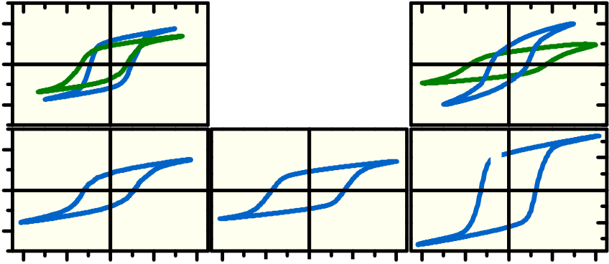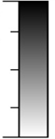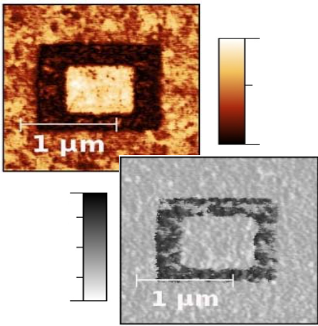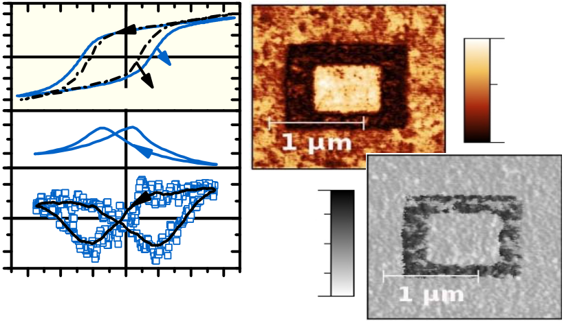

retention penalty has to be taken into account. The dependence of the endurance characteristics on the operating voltage is depicted in Fig 9 (13). At the lowest excitation signal which still provides saturated PE-hysteresis, FE-HfO2 shows the characteristic fatigue behavior of FE-materials. For slightly higher voltages a hard break down becomes the limiting factor. The endurance characteristics of FE-HfO2 can further be correlated to the static leakage current properties of the film, which are affected by the thermal budget during manufacturing. Lowering the crystallization anneal by 350°C improves endurance by two orders of magnitude. However, even with the best result obtained, 108-1010 switching cycles, the almost unlimited endurance of the PZT / oxide electrode stack has yet to be demonstrated (1-2,9, table Fig 5).

**Ferroelectric Field Effect Transistor (1T FRAM)** Half a century has passed since the concept of a NVM based on a FE gate oxide was first proposed in 1963 (14). This first FRAM concept offers minimum cell size and non-destructive read out and has therefore been extensively researched. Excellent endurance has been demonstrated for the MFIS-FET, the most common FeFET configuration. Earlier limitations of data retention were overcome by the introduction of high-k buffer layers and the utilization of FE-materials of rather low permittivity (15, table Fig 10). At the same time, however, fundamental scaling limitations of the FeFET surfaced, diminishing its full potential and slowing development compared to its NVM competitors. In order to maintain manufacturability of the gate stack while shrinking gate length, a significant thickness reduction of the FE material is required (16, Fig 11). Besides difficulties in scaling the FE layer thickness dFE, an additional memory window (MW) reduction has to be considered (MW~2*Ec*dFE). However, with its high coercive field Ec of 1 MV/cm and stable FE-properties below 10 nm, FE-HfO2 can overcome this scaling dilemma; aligning FeFET and HKMG scaling at the 28 nm node (16, Fig 12). Counterclockwise IdVg-hysteresis as opposed to the clockwise hysteresis of charge trapping devices indicates the presence of FE-switching in FE-HfO2 based MFIS-FETs (Fig 10). In order to allow for the resulting FE-MW to dominate over the parasitic Vt-shift induced by charge injection, the FE-phase stability has to be precisely tuned by composition control (Fig 13). Furthermore, the fast FE-switching in the nanosecond range can be utilized to minimize the influence of this competing Vt-shift. Considering   
 the time and field dependence of charge injection as well as the FE switching kinetics already observed in MFM capacitors, a narrow window for optimal memory operation can be derived (16, Fig 14). A nondestructive read out window was found for a Vdd/3 scheme assuming AND architecturedue to the high Ec of FE-HfO2 (Fig. 15). Vdd/2 operation, however, requires further improvement. In terms of data retention, the rather low k-value of FE-HfO2 and the thin interfacial layer utilized in this HKMG approach are highly beneficial, resulting in a low depolarization field across the FE-HfO2. This enables a residual, extrapolated MW after 10 years for testing conditions as high as 210°C (17, Fig 16). Possibly due to charge injection caused by high fields across the gate stack, the endurance of the device is currently limited to 104-105 cycles (Fig 17). Hence, the high Ec of FE-HfO2 is not only key to the renewed scaling potential of the FeFET and robustness to disturb, but also its biggest reliability concern. Lowering the thermal budget (� gate last) as well as balancing the

internal field distribution in the stack by increasing the interface capacitance could improve endurance characteristics. A pulsed characterization of fast transient charging effects in FE-HfO2 based FeFETs further shows that the FE-MW is not instantly present due to superimposed electron trapping and only revealed after detrapping (Fig 18). Pulse time extrapolation of the clockwise Vt-shift caused by charge injection suggests that FE-Switching without any kind of charge injection might only be possible in the sub-nanosecond regime. Further material and interface engineering is required to reduce this parasitic effect also for longer pulse width.

**Conclusion** The implementation of FE-HfO2 into device structures similar to state of the art DRAM storage capacitors or HKMG transistors yields highly competitive 1T/1C and 1T FRAM solutions. Excellent retention and fast switching has been demonstrated. The improvement of the endurance characteristic of the material remains an open challenge for broadening the scope of potential memory applications.

**Acknowledgement** This work was funded by the Free State of Saxony (projects: MERLIN, Heiko and Cool Memory)

[1] K.R. Udayakumar et al., Jpn. J. Appl. Phys., vol. 47, No. 4, (2008)   
[2] K. Kim et al., Microelectronic Engineering, vol. 84, No. 9-10, (2007) [3] T.S. Böscke et al., IEEE IEDM, pp.24.5.1-24.5.4, (2011)   
[4] J. Müller et al., J. Appl. Phys., vol. 110, p. 114113, (2011)   
[5] S. Müller et al., Adv. Func. Mater., vol. 22, pp. 2412-2417, (2012)   
[6] S. Müller et al., ECS JSS, vol. 1, No. 6, N123-N126, (2012)   
[7] T. Schenk et al., ESSDERC, Session B6L-C, (2013)   
[8] J. Müller et al., Nano Letters, vol. 12, No. 8, pp 4318–4323, (2012) [9] J. Rodriguez et al., IEEE IRPS, p. 750, (2010)   
[10] K.H. Küsters et al., Adv. Eng. Mater., vol. 11, No. 6, pp. 513–514 (2009) [11] J. Müller et al., IEEE EDL, vol. 33, No.2, pp.185-187, (2012)   
[12] S. Müller et al., IEEE EDL, vol. 33, No.9, pp. 1300 - 1302, (2012) [13] S. Müller et al., IEEE TDMR, vol. 13, No.1, pp. 93-97 (2013)   
[14] J.L. Moll and Y. Tarui, IEEE TED, vol. ED-10, No. 5, p. 338, (1963) [15] L.V. Hai et al., IEEE IMW, (2011)   
[16] J. Müller et al., IEEE VLSI-TE, pp. 25-26, (2012)   
[17] E. Yurchuck et al., IEE IMW, (2012)   
[18] M.H. Park et al., Appl. Phys Lett., vol. 102, p. 112914 (2013)

|  |  |  |  |  |  |  |  |  |  |  |  |
| --- | --- | --- | --- | --- | --- | --- | --- | --- | --- | --- | --- |
| 2) | 40 | **HfZrO4** | 0 | **Si:HfO2** | | **FE-HfO2** | | **Gd:HfO2** | | | |
| Polarization (μC/cm |
| 0 |
| suitable dopants | | **Al:HfO2** | | | |
| -40 |
| 50 | **Y:HfO2** | 2 | 4 | **Sr:HfO2** | | **La:HfO2** | | | |
| 0 |
| -50 | -4 -2 | -4 -2 E (MV/cm) 0 2 | 4 | -4 -2 | 0 | 2 | 4 |

**Fig. 1** PE-hystereses of TiN / 8-10 nm X:HfO2 or HfZrO4 / TiN capacitors reveal FE-properties for various dopants X (<10 mol% in HfO2). A maximum Pr of ~ 45 µC/cm2 is obtained for thin films of La:HfO2.

|  |  |  |  |  |  |  |  |  |  |
| --- | --- | --- | --- | --- | --- | --- | --- | --- | --- |
| 2) P (μC/cm | 30  15  0 -15-30 | HfZrO4 | | | | **poling:**  **-5.5V** | | Si:HfO2  **0.9** | |
| **2 kHz**  **quasi static** | | | | **+5.5V** | | | a.u. |
| ε**r** | 50 40 | -3 -2 -1 0 | 1 | 2 | 3 | **0.0** | | | |
| **-180°** | | **phase angle** | |
| S3 (pm) | 10  0 -10 |
| **0°** | | | |
| **(b)** | **180°** | | |
| **(a)** | |
| E (MV/cm) | | | |

**Fig. 2** (a) Frequency dependent P-E, small signal C-E and piezoelectric response (d=displacement) of 10 nm HfZrO4 follow the characteristic hysteretic behavior of FE-materials (b) Patterns of opposite polarity can be written onto the surface of Si:HfO2 utilizing piezoresponse force microscopy.

IEDM13-281 10.8.2

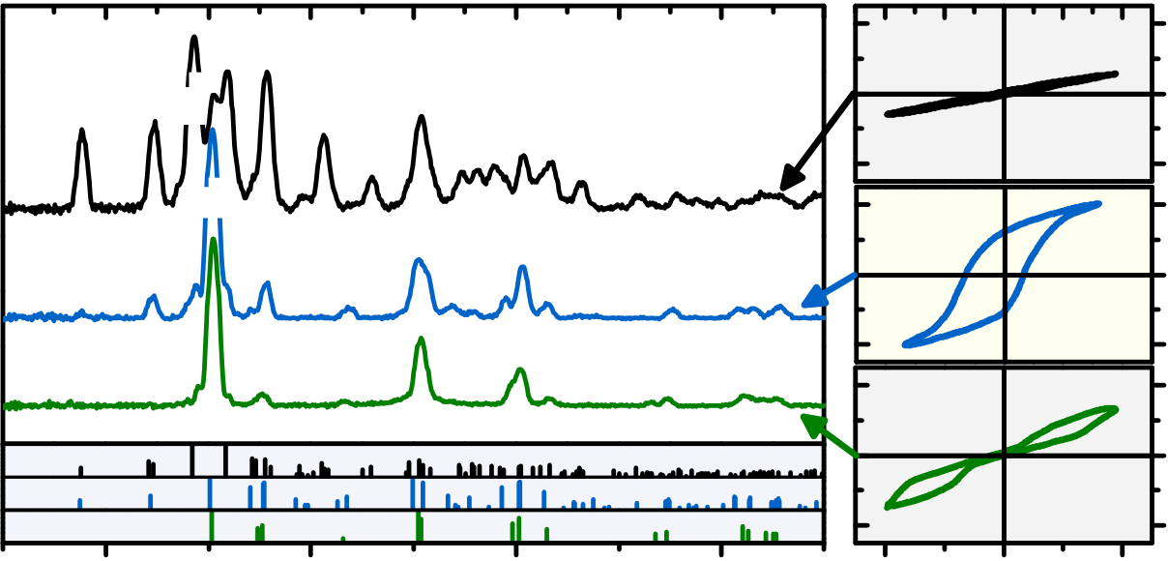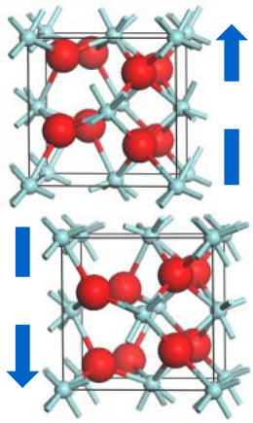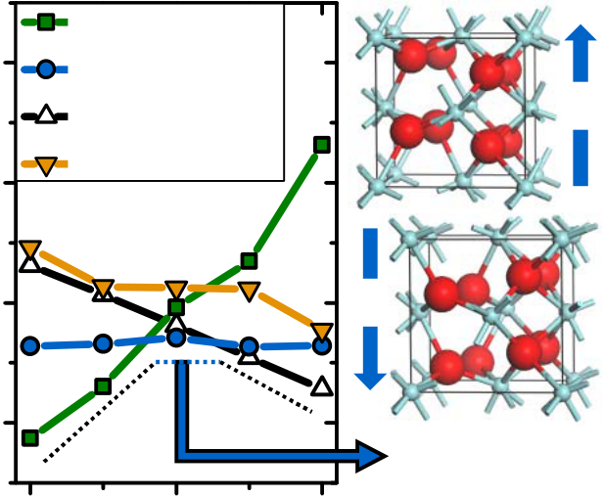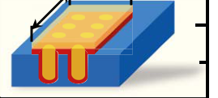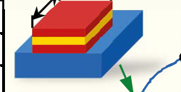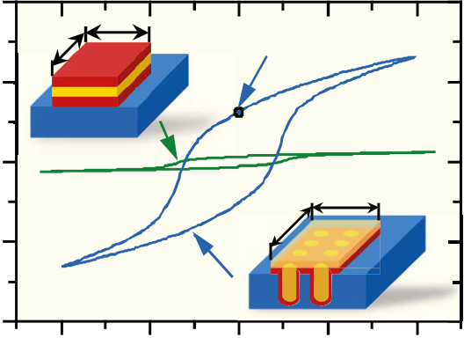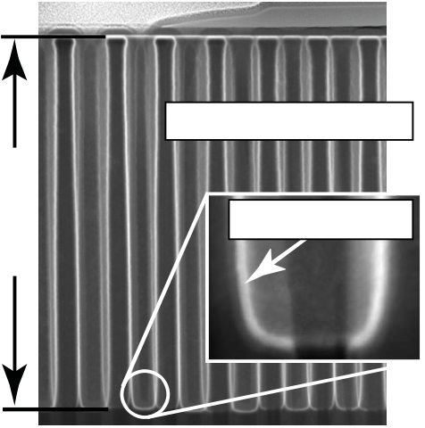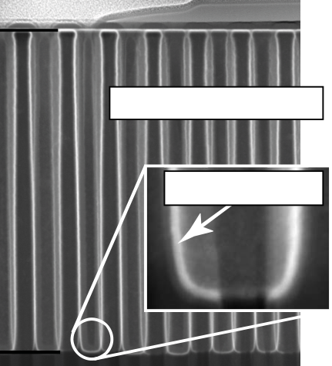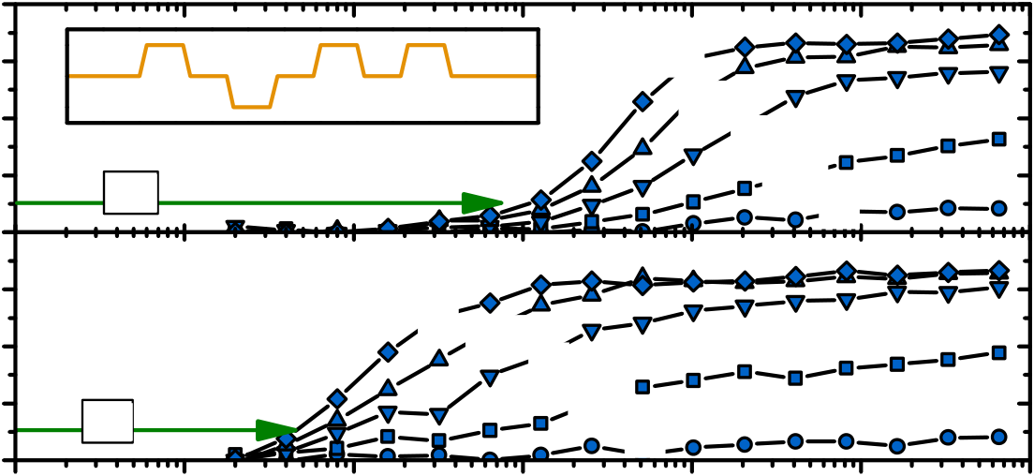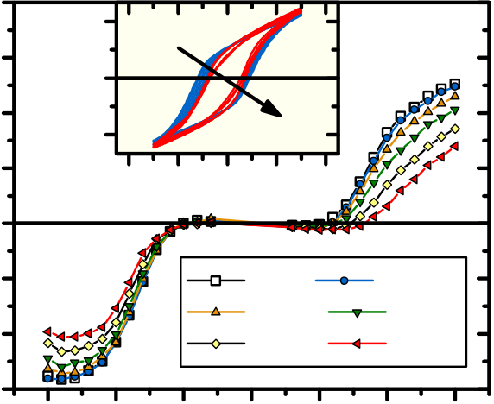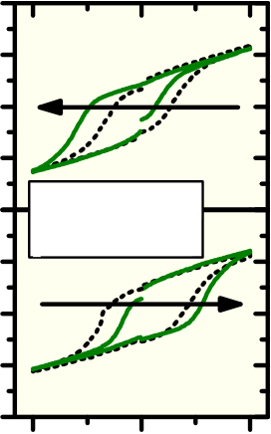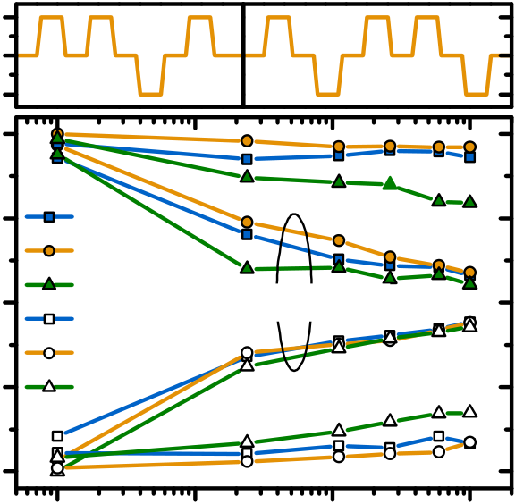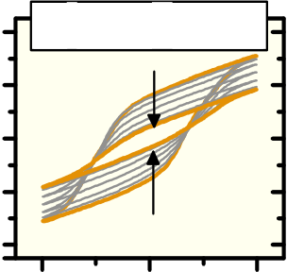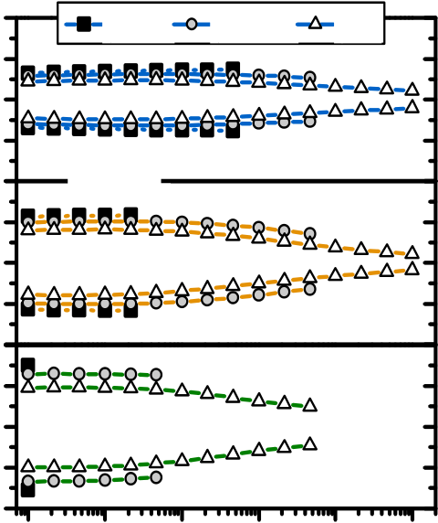

|  |  |  |  |  |  |  |  |  |  |  |  |  |  |  |  |  |  |  |  |  |  |  |  |  |  |  |  |  |  |  |
| --- | --- | --- | --- | --- | --- | --- | --- | --- | --- | --- | --- | --- | --- | --- | --- | --- | --- | --- | --- | --- | --- | --- | --- | --- | --- | --- | --- | --- | --- | --- |
| log counts (a.u.) | **m o**  **t** | **100m** | **011m** | **111m** | **200m** | **-211m** | **211m** | | **220m** | **202m**  **013m**  **310m**  **-302m** | | | **311m** | **222m** | GIXRD | | | | **HfO2** | | 4 | 30 | 2) | free Energy (meV/unit) | 80 | ZrO2 | tetragonal *P42/nmc* | HfO2 | **P** | **P** |
| 0 |
| **-111m** | |
| orthorhombic *Pbc21* |
| polarization (µC/cm |
| **100o** | **110o** | **111o** | | **021m** | **-322m** | **041m** | | | **HfZrO4** | | -30 | 70 | monoclinic *P21/c* |
| 30 | orthorhombic *Pbca* |
| **112o** | | **220o**  **022o** | | | | **131o**  **311o**  **222o** | |
| **020o**  **200o** | | **132o** | **004o** | | | **133o**  **313o**  **204o** | **300 K** |
| 0 |
| **221o**  **130o** | | | |
| 20 | **110t**  **002t** | | **012t** | | **013t**  **121t**  **202t** | | | | | | **004t**  **220t** | | **123t**  **031t** | | **ZrO2** | | -30 | 60 | HfZrO4 | ***Pbc21*** |
| 30 |
| **011t** | | **112t**  **020t** | | | | | | | | 50 |
| 0 |
| 80 | | | |
| -4 | E (MV/cm) | -30 |
| 40 | | 2Θ (°) | | | 60 | | |
| **polarization** |

**Fig 3** GIXRD of the monoclinic (m) - tetragonal (t) transition in HfO2-ZrO2 solid solutions reveal an intermediate FE-phase best matched to an orthorhombic (o) diffraction pattern. Related PE-hysteresis complement structural data. A detailed description is given in (8).

**Fig. 4** Composition dependent free energy of cryst. phases in HfO2-ZrO2 solid solutions (ab initio). A polar, orthorhombic phase is predicted in HfZrO4.

|  |  |  |  |  |  |  |  |  |  |  |  |  |  |  |  |  |  |  |  |  |  |  |  |  |  |  |  |  |  |  |  |  |  |  |  |  |  |  |  |  |  |  |  |  |  |  |  |
| --- | --- | --- | --- | --- | --- | --- | --- | --- | --- | --- | --- | --- | --- | --- | --- | --- | --- | --- | --- | --- | --- | --- | --- | --- | --- | --- | --- | --- | --- | --- | --- | --- | --- | --- | --- | --- | --- | --- | --- | --- | --- | --- | --- | --- | --- | --- | --- |
| electrodes | | | | **perovskite based** | | | | **FE-HfO2 based MFM capacitors for 1T/1C FRAM** | | | | | | | | | | | | | | | | | | | | | | | | | | | | | | | | | | | | | | | |
| **FE-HfO2 based** | | | | | | | | 1,6 µm | aspect ratio 13:1 | | | | | | | | | 2**)** | | 500 | | | | **A** | | | **B** | | | | | **Pr** 150 µC/cm 2 | | | | | | | |
| **-(1,2,9)-** | | | | **-this work-** | | | | | | | |
| polarization **(**µC/cm  (projected area A*B) | |
| non std (Ir, IrO2,…) | | | | metal nitrides | | | | | | | |
| layer thickness dFE | | | | 70-150 nm | | | | < 10 nm | | | | | | | | 250 | | | |
| coercive field Ec | | | | < 100 kV/cm | | | | ~ 1 MV/cm | | | | | | | | **2D** | | | | | | | | | | | | | | | |
| 0 | | | |
| operating voltage | | | | < 3Vat dFE ~ 100 nm | | | | < 3Vat dFE ~ 10 nm (Fig 7) | | | | | | | |
| scalability (3D- | | | | challenging (currently: | | | | first demonstration (Fig 5) | | | | | | | |
| integration) | | | | 130 nm, planar) | | | | ALD processes available | | | | | | | | 10nm FE-HfO 2 | | | | | | | | | **B** | | | | | | | | | | | | | | | |
| 10y Data Retention | | | | validated by 125°C | | | | validated by 125°C | | | | | | | | -250 | | | | **A** | | | | | | | | | | | | | | | |
| (85°C) | | | | 1000 h bake | | | | 1000 h bake (Fig 8) | | | | | | | |
| FE-speed | | | | ns range | | | | ns range (Fig 6) | | | | | | | | -500 | | | | **3D** | | | | | | | | | | | | | | | |
| endurance | | | | > 1017 | | | | 108-1010(Fig 9) | | | | | | | |
| manufacturability | | | | -4 | | | | -2 | | | | | | 0 | | 2 | | | 4 |
| poor (buffer layers, Pb- | | | | similar to DRAM capacitor, | | | | | | | |
| based, thermal budget, | | | | BEOL stability of FE-HfO2 | | | | | | | |
| electrodes) | | | | electric field (MV/cm) | | | | | | | | | | | | | | | |
| confirmed (18) | | | | | | | |
| **Fig 5** Prospects of FE-HfO2-based capacitors are contrasted to state of the art FRAM (table). STEM cross sections of an Al:HfO2–based trench capacitor array (#30k, 1.6 µm depth). P-E-Hysteresis reveal a stable Pr of 14 µC/cm2 (planar: 15 µC/cm2) in 3D-cpacitors enabling a Pr of 150 µC/cm2 in planar area projection. | | | | | | | | | | | | | | | | | | | | | | | | | | | | | | | | | | | | | | | | | | | | | | | |
| 2) | 20 | | | **variable** | | | | | | | | | | 0 | | **3V** | | | | | | | -3  10 | | | | 20 | | | | 2) | | | 15 | | **-100°C** | | | | | | | | | | 105 °C | |
| 15 | V | | 15 | | | |
| P (µC/cm | | |
| **initial** | | **sensing PSW** | | | | | | | |
| **2.5V** | | | | | | | 0 | | | | | | | | | | | |
| 10 | | |
| ***RC*** | | **200x250** μ**m** | | | | | | | | **2V** | | | | | | | 2) | | 10 | |
| 5 | | | -15 | | | | | **+200°C** | | | | | | |
| PSW (µC/cm | **1.5V** | | | | | | |
| PSW (µC/cm | | | 5 0-5 |
| 0 | | | **1V** | | | | | | | -4 | | | | -2 0 2  E (MV/cm) | | | | | | | 4 |
| 15 | | | **capacitor area:** | | | | | **3V** | | | **2.5V**   **2V** | | | | | | | | | | |
| 85 °C | | | | | | | | | | | |
| 10 | | | **50x100** μ**m** | | | | |
| -10 | | | | 125 °C | | | | | | | | | | | | 145 °C | |
| 5 | | | ***RC*** | | **1.5V**   **1V** | | | | | | | | | | | | | | | | | -3 | | | 165 °C | | | | | | | | | | | | 185 °C | |
| -15 | | | |
| 0 | | |
| -2 | | | -1 0 1  read pulse (V) | | | | | | | | | 2 | 3 |
| -9  10 | | | -8  10 | | -7  10 | | | | | -6  10 | | | | | -5  10 | | -4  10 | | | | |
| variable pulse width (s) | | | | | | | | | | | | | | | | | | |
| **Fig. 6** Pulsed characterisation (inset: variable pulse length and amplitude) of PSW in | | | | | | | | | | | | | | | | | | | | | | | | | | | **Fig 7** Temperature dependence of PSW for read | | | | | | | | | | | | | | | | | | | | |
| TiN/ Si:HfO2 /TiN capacitors. A FE-typical time and field dependent switching kinetic is observed: field- | | | | | | | | | | | | | | | | | | | | | | | | | | | pulses up to ±3V (Si:HfO2).PE-hystereses indicate | | | | | | | | | | | | | | | | | | | | |
| accelerated polarization reversal (limited to ns-regime by RC-time). | | | | | | | | | | | | | | | | | | | | | | | | | | | FE-phase stability over broad temperature range. | | | | | | | | | | | | | | | | | | | | |
| 3 | | cap1 | | | | cap2 | | | | | | | **SS+ = 21 - 11**   **NSS+ = 23 - 12**  30 **OS+ = 14 - 24** | | | | | | | | | 20 | | 5 10 | 2.5V | | 2.25V | | | | | | 2V | | | | | | | | 20 | | 10 5 to 10 10 cycles | | | | |
| V | 0 | 10 | | 2) | | | | | | | | | | | | | | | |
| **11** | **12** | | **14** | **21** | **23 24** | | | | | | 10 | |
| -3 | | 0 | |
| Si:HfO2 | | **650°C RTA** | | | | | | | | | | P (μC/cm | | | |
| 1.0 | | **±3V** | | | | | | | | | | | -10 | | 0 | | **800°C RTA** | | | | |
| 2) | | 15 | **±3V** | | | | | |
| ±20 2) Pr (μC/cm   10  0  -10  ±20 | | -10 | |
| 0.5 norm. PSW (1)   0.0  -0.5 | | Polarization (μC/cm | |
| 0 |
| **SS+** | | | | | | | | | | | -20 | |
| **NSS+** | | | | | | | | | | | -15 | **OS+** | | | | | | 2) leakage (A/cm **800°C RTA**  **1000°C RTA**  6 7 8 9 10  10 10 10 10 10  fatigue cycles (1) | | | | | | | | | | | | | | | | -2 | | | 0 | 2 |
| -2 10  -4 10 | |
| **OS+**  **SS-** | | | **±1.5V sub loop** | | | | | | | |
| ±30 | **Imprint after** | | | | | | -5 0 5  E (MV/cm) | | | | |
| **1000 h bake** | | | | | |
| 15 |
| **NSS-** | | | | | | | | | | |
| 10 | | -6 10 | |
| **OS-** | | | | **±3V** | | | | | | | 0 |
| 0 | | -8 10 | |
| -15 |
| -1.0 | | 0 10 | | 1  10 | | 2  10 | | | | 3  10 | | | **OS-** | | | | | | -10 | | -10 10  -12 10 | |
| -30 |
| -20 | |
| -3 | 0 | | 3 | | |
| bake time at 125°C (h) | | | | | | | | | | | E (MV/cm) | | | | | | | | |
| **Fig. 8** Same-(SS), new-same-(NSS), and opposite state (OS) retention of | | | | | | | | | | | | | | | | | | | | **Fig. 9** Endurance of SiHfO2 shows a transition from FE-fatigue (P-E, right) | | | | | | | | | | | | | | | | | | | | | | | | | | | |
| Si:HfO2 for up to 103 h bake at 125°C. P-E illustrate OS imprint degradation. | | | | | | | | | | | | | | | | | | | | | to hard BD (RTA temperature vs. leakage, right) with increasing voltage. | | | | | | | | | | | | | | | | | | | | | | | | | | |
| 10.8.3 | | | | | | | | | | | | | | | | | | | | | | | | | | | IEDM13-282 | | | | | | | | | | | | | | | | | | | | |

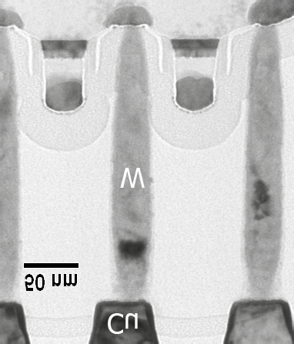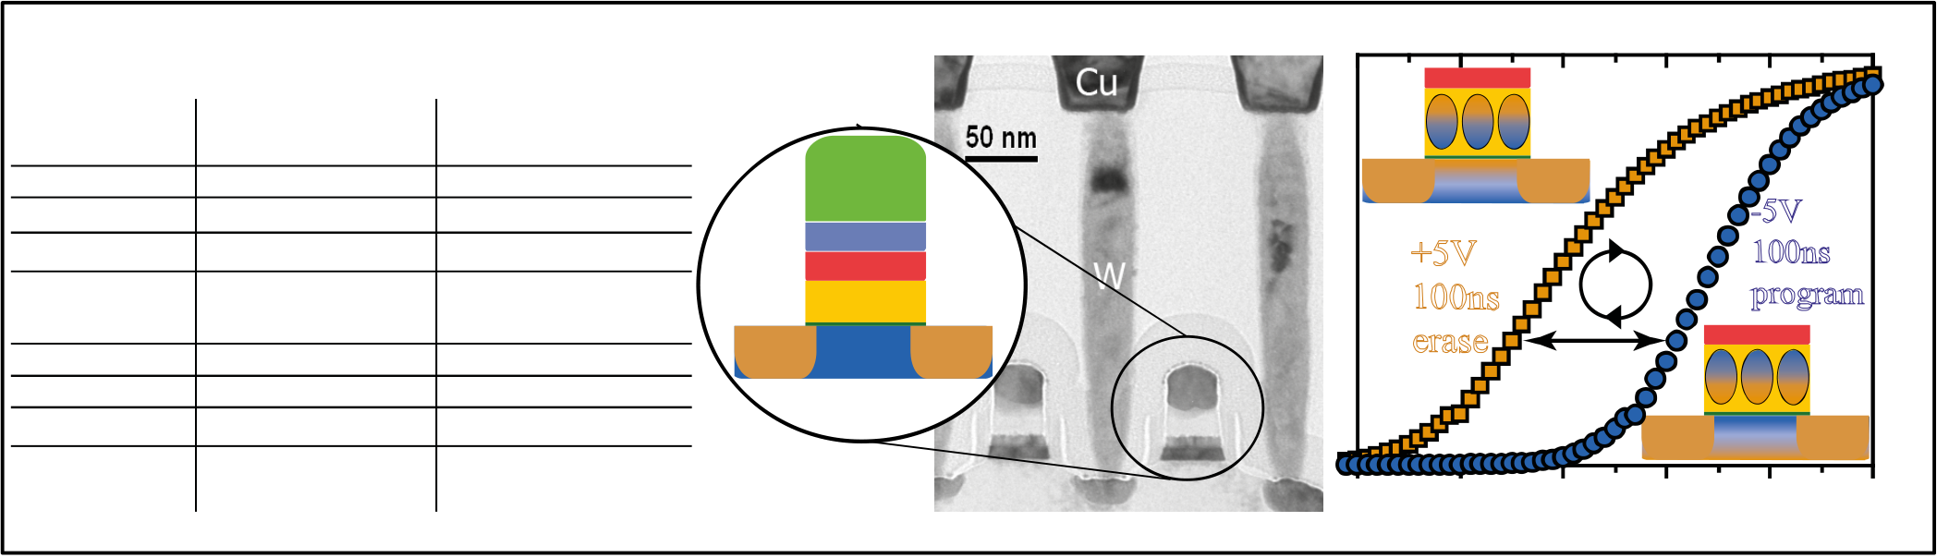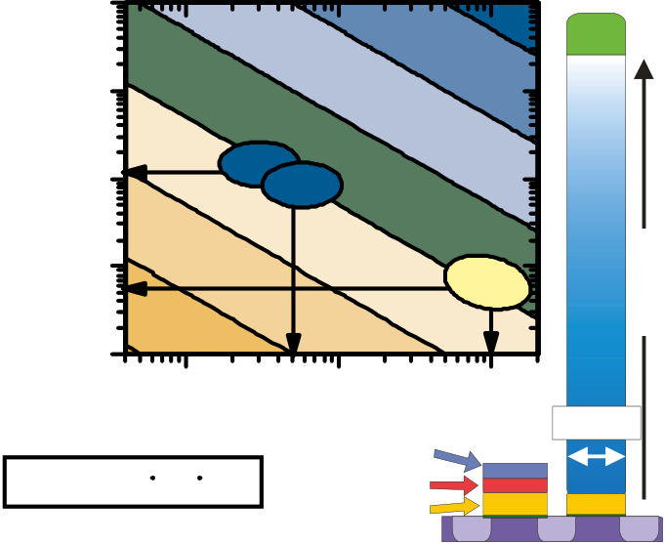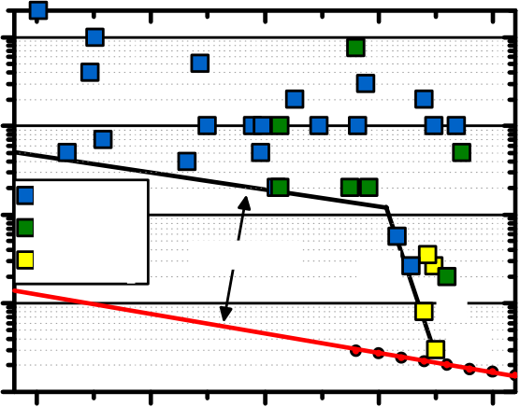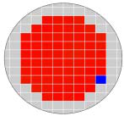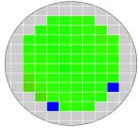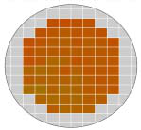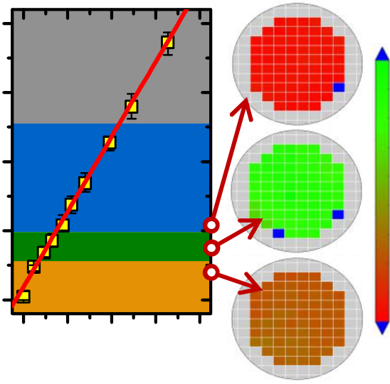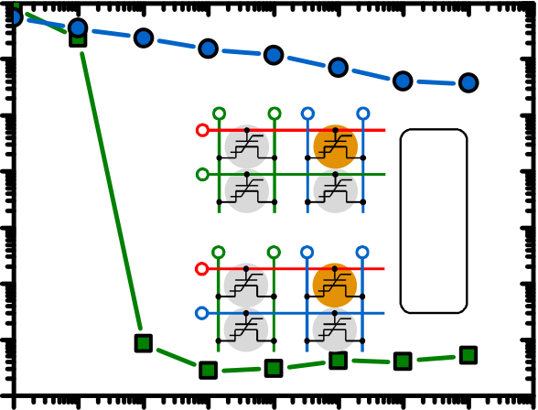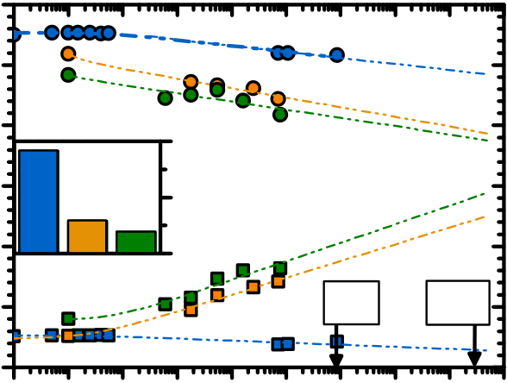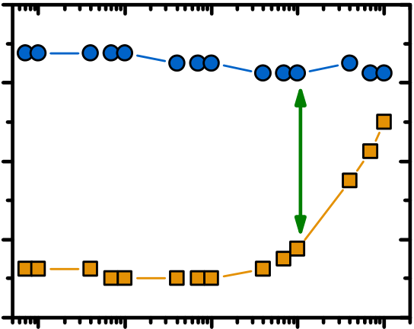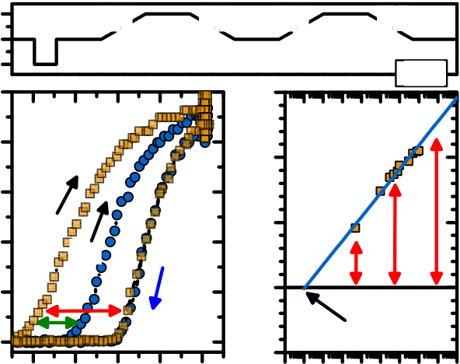

**FE-HfO2 based MFIS-Stack for 1T FRAM**

|  |  |  |  |  |  |  |  |  |  |  |  |  |  |
| --- | --- | --- | --- | --- | --- | --- | --- | --- | --- | --- | --- | --- | --- |
| **perovskite based** | | | **FE-HfO2 based** | **n** | **NiSi** | **n** | **+** | -0,5 | **n +** --- | **+**  **n** | | | drain current (a.u.) |
| **-(15)-** | | |
| **-this work-** |
| Gate electrode | Pt | | metal nitrides |
| Layer thickness | 200 nm | | 10 nm | **poly-Gate** | 0,0 | **M W** | +-+-+-  **n +** +++ | |
| Interface to | 7 nm Al:HfO2 | | < 1 nm SiON or SiO2 |
| **TiN** |
| Scalability (gate | 260 nm (low Ec requires | | 28 nm (high Ec maintains |
| **FE-HfO 2** |
| length) | large dFE, Fig 11) | | manufacturability, Fig 11) |
| **+ p- Bulk** |
| Data Retention | > 10 y expected | | > 10 y expected (Fig 16) |
| Switching Speed | | < 1 µs | < 20 ns (Fig 14) |
| Endurance | 109 | | 104-105(Fig 17) | **+**  **n** |
| Manufacturability poor (special integration | | | similar to HKMG |
| 0,5 1,0  gatebias (V) | | 1,5 | 2,0 |
| schemes required) | | |

**Fig 10** Utilization of FE-HfO2 in MFIS-FETs is contrasted to a state of the art perovskite-based approach (table). TEM cross section illustrates implementation of

FE-HfO2 into highly scaled HKMG. Proof of concept: counter-clockwise, FE IdVg-hysteresis is observed for ±5V 100 ns pulsing of a n-type Si:HfO2-FeFET.

**10µm**

**Pt**  2 reported FeFETs in literature 20 **1.1 V**  SiO2 content in HfO2 (mol%) Ion/Ioff (1)   
thickness ferroelectric   
 **1µm**  10 **trapping**  Memory Window (ΔVt) physical gate length (μm)   
 15

1

**100 nm**  PZTSBT 10

**10 nm**

**1 nm**   
 HfO2

10   
10

-1   
0 perovskite

organic

FE-HfO2 scaling gap **(15)**

**(3)**   
 10

5

FE-phase   
 **t-HfO2**

**switching**  **FE**  **ferroelectric**   
**perovs kite**   
 **200 nm**

**10 kV/cm**

coercive field E **c**   
 **100 kV/cm 1 MV/cm**

**28 nm**  10 -2   
 **(16)**

0 **m-HfO2**

**trapping**

**MW = 2 E dFE**  **TiN gate**

**FE-HfO2**   
**poly-Si**

**n**

**+**

**n**

**+**

**n**

**+**   
 1995 2000

publication year   
 2005 2010 2015

ALD cycle ratio Hf/Si   
HfO2 0.0 0.1 0.2 0.3 0.4 **-0.3 V**

**Fig 11** Scaling dilemma of the perovskite-based **Fig 12** Gate length scaling of MFIS-FET **Fig 13** ALD cycle ratio controls Si-content and FE-

MFIS-FET. The high Ec and scalable dFE of FE- concepts compared to HP-logic. Si:HfO2- FeFET phase stability. For insufficient FE-properties ΔVt

HfO2 preserve manufacturability of the gate stack. closes the scaling gap at the 28 nm node. of the FeFET is dominated by charge injection.

trapping pulse width (s)

10  
 -3

0.60 10   
 6

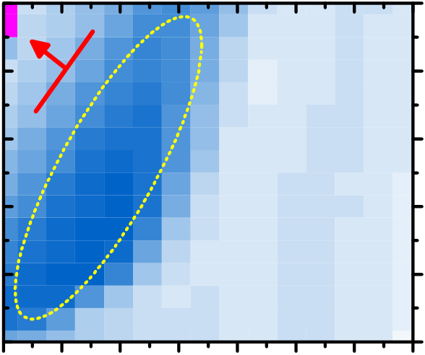10

10

10  
 -6

-7

-8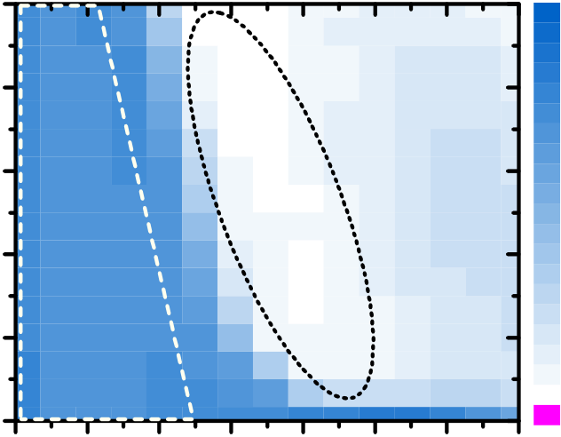-0.30 10 10

10

10

-1

10   
1

0

-1 10   
 **Vdd/2**

0 10   
 **VDD**

1 10   
**0 V**   
 **VDD/2**

2 10 3 10   
**0 V**

4 10 5 10 6 10 7   
10 5 **Vdd/3**

-4

threshold voltage (V)   
10 10 4

**VDD**   
 **2VDD/3**  **0 V**

10 -5 10 3

**VDD/3**

2

-7 -6 -5 -4 -3 -2 -1 0 0 1 2 3 4 5 6 7 < -0.3 disturb cycles (1)

program level (V) erase level (V)

**Fig 14** Program and erase pulse matrix (width & amplitude) of a Si:HfO2-FeFET. The time and field dependence of FE-switching (Fig 6) and the concurrent charge injection yield bands of optimal memory operation. The fast FE-switching has to be utilized to minimize charge injection. Like in perovskite-FeFETs (15) asymmetric program and erase conditions for optimal MW were extracted (+4V, -6V).

**Fig 15** Ion/Ioff ratio degradation of a Si:HfO2-FeFET for disturb cycles of worst case write scenarios in a Vdd/2 and Vdd/3 AND-scheme. Disturb resilience is only given for Vdd/3 scheme.

|  |  |  |  |  |  |  |  |  |  |  |  |  |  |  |  |  |  |  |  |  |  |  |  |  |  |  |  |
| --- | --- | --- | --- | --- | --- | --- | --- | --- | --- | --- | --- | --- | --- | --- | --- | --- | --- | --- | --- | --- | --- | --- | --- | --- | --- | --- | --- |
| 1.0 | | | | | | | | 1,2 | | | | | | | Vg | 5  0 -5  25 | program | | **Vt1** | erase | | **Vt2** | | **Vt3** | erase | **Vt4** | |
| threshold voltage (V) | 0,8 | **program** | | | | |
| 0.8 | | | | | | | | 100µs | | | | | 3 | | 100µs | | | time |
| **FE-switching** | | | | |
| Vt (V) | 0.6 | after 10 y | | | 1.0 | MV (V) | | Δ**Vt = Vt4-Vt3** | | | |
| 20 | |
| **trapping** | | | | | 2 ΔVt (V)   1 | |
| 0.4 | **30 °C** | **150°C** | **200°C** | 0,4 | **residual MW: 0.9 V** | | | | | Id (mA)   15  10 | | **Vt3** | **Vt1** | | **Vt2** | | **trapping** | | | |
| 0.5 |
| 0.2 | 0.0 | 0,0 |
| **Vt4** | |
| 0.0 | | 10d | | | | | 10 y | 5 | | 0 | |
| -0,4 | | **erase** | 2 10 | 3  10 | 4  10 | 5  10 |
| 0 | | 1 | 2 3  Vg (V) | | | 4 | 5 | **~ 100 ps**  -1  10-11 10-8 10-5 10-2  pulse width (s) | | | | |
| -0.2  10 0 10 1 10 2 10 3 10 4 10 5 10 6 10 7 10 8 10 9  time (s) | | | | | | | |
| 1  10 |
| program/erase cycles (1) | | | | | | |
| **Fig 16** Extrapolated data retention in Si:HfO2- | | | | | | | | **Fig 17** Endurance of Si:HfO2-FeFETs is currently | | | | | | | **Fig 18** Pulsed IdVg-hysteresis reveal severe fast | | | | | | | | | | | | |
| FeFETs for RT, 150, and 200°C. A residual memory | | | | | | | | limited to 104-105 pgm/ers cycles. Further cycling | | | | | | | transient charging effects in Si:HfO2-FeFETs. FE- | | | | | | | | | | | | |
| window after 10 years is extrapolated up to the | | | | | | | | degrades IdVg- and Ion/Ioff-characteristics due to | | | | | | | Switching without parasitic charge injection is | | | | | | | | | | | | |
| highest temperature tested. | | | | | | | | charge injection following the bipolar stress. | | | | | | | extrapolated to the sub-ns regime. | | | | | | | | | | | | |
| IEDM13-283 | | | | | | | | 10.8.4 | | | | | | |