

Letter

pubs.acs.org/NanoLett

Ferroelectricity in Simple Binary ZrO2 and HfO2   
Johannes Müller,*,†Tim S. Böscke,‡,¶Uwe Schröder,‡,§Stefan Mueller,§Dennis Bräuhaus,∥,▽Ulrich Böttger,∥Lothar Frey,⊥and Thomas Mikolajick§,#

†Fraunhofer Center for Nanoelectronic Technology, Dresden, Germany  
‡Qimonda GmbH, Dresden, Germany  
§Namlab gGmbH, Dresden, Germany  
∥RWTH Aachen, Aachen, Germany  
⊥Fraunhofer Institute of Integrated Systems and Device Technology, Erlangen, Germany #Chair of Nanoelectronic Materials, University of Technology Dresden, Dresden, Germany

|  |
| --- |
| * S Supporting Information |
| ABSTRACT: The transition metal oxides ZrO2 and HfO2 as well as their  successfully introduced into microelectronics, were never considered to be more than simple dielectrics possessing limited functionality. Here we report the discovery of a field-driven ferroelectric phase transition in pure, sub 10 nm ZrO2 thin films and a composition- and temperature-dependent transition to a stable ferroelectric phase in the HfO2−ZrO2 mixed oxide.  solid solution are widely researched and, like most binary oxides, are expected to exhibit centrosymmetric crystal structure and therewith linear dielectric characteristics. For this reason, those oxides, even though  These unusual findings are attributed to a size-driven tetragonal to  orthorhombic phase transition that in thin films, similar to the anticipated tetragonal to monoclinic transition, is lowered to room temperature. A structural investigation revealed the orthorhombic phase to be of space group Pbc21, whose noncentrosymmetric nature is deemed responsible for the spontaneous polarization in this novel, nanoscale ferroelectrics. |

|  |  |  |  |  |  |
| --- | --- | --- | --- | --- | --- |
| KEYWORDS: Ferroelectric, hafnium oxide, zirconium oxide, phase transition, thin film | | | | | |
| T he binary oxides HfO2 and ZrO2 have been extensively studied for more than a century. Especially their martensitic phase transition from tetragonal to monoclinic and its implications on the mechanical properties of the material system have always been and still are of great scientific | | | temperature for HfO2 is still higher compared to the one of ZrO2. In sub 20 nm films this usually leads to tetragonal, undoped ZrO2 and partially monoclinic HfO2 thin films14that  still require, similar to stabilized bulk ceramics, small amounts of group III,15IV,16or rare earth element17−20dopants to reach | | |
| and commercial interest. The mechanical strain released during | | | a full stabilization of the high temperature polymorphs. | | |
| the volume expanding transformation to the monoclinic phase (P21/c) can be directly utilized in the transformation toughening of “ceramic steel”.1To avoid this defect generating mechanism when using the pure oxides, stabilization of the high temperature polymorphs of tetragonal (P42/nmc) or cubic (Fm3̅m) symmetry is usually pursued.2−4   Only in recent years, driven by microelectronic scaling and the industry’s strive to find a suitable “high-k” replacement for integrated gate and capacitor dielectrics, extensive research has been conducted on HfO2 and ZrO2 based thin films.5,6In the course of this material development it was found that for thin layers in the range of several nanometers the tetragonal to monoclinic transition temperatures, as estimated from ceramic bulk samples, are significantly lowered.7−9This size-induced phase transition is frequently observed in the context of free as well as confined ZrO2 nanoparticles and was attributed to the lower surface energy developed by the high temperature polymorphs of HfO2 and ZrO2.10−12However, as in the bulk phase diagram,13the tetragonal to monoclinic transition | | | | Recently, however, we reported that, until a complete stabilization of those theoretically predicted21,22and exper-imentally confirmed16,23“higher-k” polymorphs in HfO2 thin films is reached, those phase transitions are accompanied by the occurrence of ferroelectricity.24Several dopants such as Si,24,25 Y,26and Al27as well as the admixture of 50 mol % ZrO2 28 were identified to provoke ferroelectricity in HfO2 that due to its centrosymmetric phase relation (P21/c − P42/nmc − Fm3̅m) was widely believed to be paraelectric. The occurrence of ferroelectricity in binary oxides is of high scientific interest and has so far theoretically been predicted only for alkaline oxides.29 The discovery of ferroelectricity in thin films of the broadly  commercialized binary oxides of hafnium and zirconium is unexpected and affects multiple fields of application. Especially  in the context of ferroelectric memories, which since their | |
| Received: | May 30, 2012 |
| Revised: | July 12, 2012 |
| Published: July 19, 2012 | |
|  | © 2012 American Chemical Society | 4318 | dx.doi.org/10.1021/nl302049k | Nano Lett. 2012, 12, 4318−4323 | | |

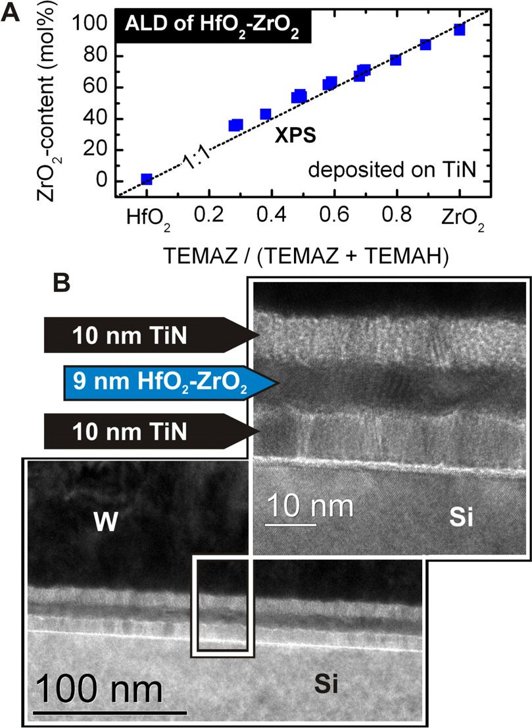

|  |  |  |
| --- | --- | --- |
| Nano Letters | |  | | --- | | Letter | |

introduction strongly rely on the challenging integration of   
perovskite-based materials, these fully CMOS compatible and   
highly scalable HfO2-based ferroelectrics have the potential to   
offer a novel and much simpler approach.30,31   
 Here we report the discovery of a composition- and   
temperature-dependent ferroelectric phase transition covering   
the full mixing range of HfO2−ZrO2 thin films. A stable   
ferroelectric phase is observed for the solid solution at room   
temperature, whereas a field driven transition is observed in   
pure ZrO2. A structural investigation by grazing incidence X-ray   
diffraction (GI-XRD) suggests a composition-dependent   
tetragonal to orthorhombic to monoclinic phase change in   
HfO2−ZrO2 thin films when starting from Zr-rich composi-  
tions. As further revealed by in situ high temperature GI-XRD,   
confinement of the thin films by a TiN electrode assists in the   
suppression of the tetragonal to monoclinic transition during   
cooling, resulting in an alternative tetragonal to orthorhombic   
pathway. This noncentrosymmetric, orthorhombic, and thereby   
potentially ferroelectric Pbc21 phase of the mixed oxide was   
found to further stabilize with decreasing temperature. This led   
to a stable ferroelectric phase at 80 K in Zr-rich samples that   
exhibited only field-driven ferroelectric transition at room

temperature. Those nonlinear and temperature-dependent dielectric characteristics found in pure ZrO2 and in its solid solution with HfO2 confirm the existence of a tetragonal to orthorhombic phase transition and further underline the assumption that the occurrence of ferroelectricity in HfO2 and ZrO2 based thin films is an intrinsic property of those material systems and cannot be explained by doping related defect dipoles or ionic mobility.

We utilized atomic layer deposition (ALD) to prepare a set of 9 nm HfO2−ZrO2 thin films on TiN, spanning a wide composition range of the solid solution starting and ending with the pure oxides (Figure 1A). All films crystallized during deposition of a TiN top electrode at 500 °C. The polycrystal-line nature was confirmed by high-resolution transmission electron microscopy (HR-TEM; Figure 1B). Polarization−voltage (PV) as well as small signal capacitance−voltage (CV) characteristics of TiN-based metal−insulator−metal (MIM) capacitors of those films are depicted in Figure 2A.

Just as expected from the centrosymmetry of its monoclinic structure, the pure HfO2 film shows a linear relation between the displacement current and the applied electric field as well as a fairly constant capacitance in this field range. However, as ZrO2 content increases, characteristic ferroelectric PV and CV hysteresis evolve until for a nearly equal mixture of ZrO2 and HfO2 a remanent polarization of 17 μC/cm2is reached. The coercive field of this sample was approximately 1 MV/cm. Further increasing the ZrO2-content in the solid solution leads to a thinning of the hysteresis loop at zero bias, phenomenologically best described as superimposed antiferro-electric-like characteristics. This thinning continues until for pure ZrO2 the remanent polarization has completely vanished and only a distinct double-loop hysteresis remains. When taking a direct look at the current flowing on and off the capacitor during a triangular voltage excitation, as depicted in Figure 2B, the polarization switching can clearly be separated from leakage current contributions that often lead to a confusion of simple paraelectric materials with ferroelectrics.32   
 A summary of the composition-dependent phase transition witnessed in Figure 2A and B is given in Figure 2C. The remanent polarization, the dielectric constant, and the monoclinic phase fraction estimated from the peak area relation

4319 dx.doi.org/10.1021/nl302049k | Nano Lett. 2012, 12, 4318−4323

|  |  |  |
| --- | --- | --- |
| Nano Letters | |  | | --- | | Letter | |

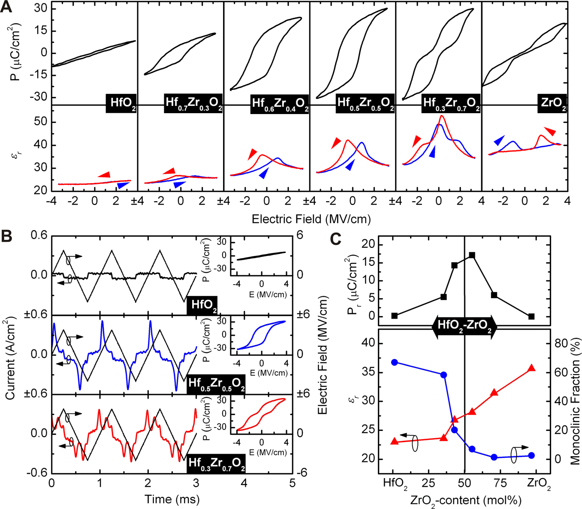

Figure 2. (A) PV hysteresis at 1 kHz and small signal CV hysteresis at 10 kHz (50 mV level) of 9 nm thin HfO2−ZrO2 based metal−insulator−metal capacitors at room temperature. An evolution from paraelectric HfO2 to ferroelectric HfO2−ZrO2 to an antiferroelectric-like behavior in ZrO2 can be observed in PV as well as in CV characteristics. (B) Current response to a triangular voltage excitation reveals polarization switching to be clearly separable from leakage current contributions at high fields. (C) Remanent polarization, dielectric constant, and monoclinic phase fraction in the HfO2−ZrO2 solid solution with respect to the mixing ratio of the oxides. With increasing ZrO2 content the dielectric constant increases due to a reduction in monoclinic phase fraction, whereas the remanent polarization is maximized in the transition region.

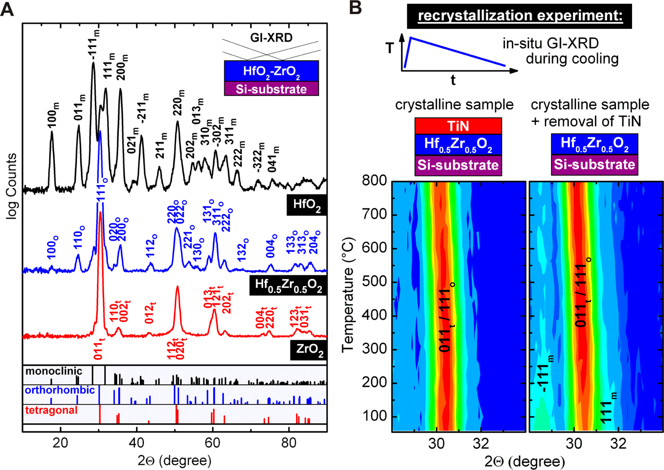

Figure 3. (A) GI-XRD diffractograms of 9 nm ZrO2, Hf0.5Zr0.5O2, and HfO2 thin films at an incident angle of 0.55°. Starting from ZrO2 a composition-dependent tetragonal to orthorhombic to monoclinic transition is observed. Strong reflections are labeled in the graph. Reference powder patterns for HfO2 and ZrO2 were calculated from the literature (P42/nmc, Málek et al.;33Pbc21, Kisi et al.;37P21/c, Ruh et al.38). (B) In situ GI-XRD measurements allow the direct observation of a suppressed tetragonal to monoclinic transformation during cooling in samples confined by a

TiN electrode.

of the pure ZrO2 can be identified as the tetragonal P42/nmc phase frequently reported in literature.33−36However, it has to

4320 dx.doi.org/10.1021/nl302049k | Nano Lett. 2012, 12, 4318−4323

|  |  |  |
| --- | --- | --- |
| Nano Letters | |  | | --- | | Letter | |

rather challenging, usually resulting in an ambiguous interpret-ability of the published results.23In this work the absence of diffractions from the TiN electrode (see sample preparation in Supporting Information) and the high signal-to-noise ratio allow for the identification of the tetragonal phase by the 012t reflection at 42° originating from the slightly distorted oxygen lattice in the tetragonal modification.

Unexpected diffractions on the other hand appear for the equal mixture of ZrO2 and HfO2 that was found to exhibit the highest remanent polarization at room temperature. Several reflections are indicated that cannot be explained by a simple phase mixture of P21/c and P42/nmc, suggesting the presence of a third phase stable during the transition from m-HfO2 to t-ZrO2. Similar to in the doped HfO2 systems that were found to exhibit ferroelectricity, this phase best matches the diffraction pattern of an orthorhombic phase with Pbc21 symmetry.24,28,27 The existence of this noncentrosymmetric phase in ZrO2, unfortunately published without data on its dielectric proper-ties, was first and solely reported by Kisi et al.37in 1989. In a neutron diffraction study they observed the Pbc21 phase in small particles of Mg stabilized ZrO2 confined in a cubic matrix. A martensitic tetragonal to orthorhombic phase transition induced by a displacement of the Zr and O1 ions against the O2 ion was suggested. This tetragonal to orthorhombic transformation eventually circumvents the volume expanding tetragonal to monoclinic transformation not favorable in a highly constrained environment, such as in a cubic matrix or in our case of a thin film additionally confined by a metal electrode.

The supporting nature of the mechanical confinement provided by the TiN electrode in this process can be demonstrated by in situ GI-XRD measurements recorded during cooling. As shown in Figure 3B, a thin film crystallized into the orthorhombic phase is stable toward any further heat treatment above 800 °C as long as the TiN electrode is still in place. However, if this mechanical encapsulation is removed, a transformation to the monoclinic phase can be observed, strongly increasing when temperature drops below 200 °C. These findings are in accordance to the assumption of a reversible, temperature-dependent tetragonal to orthorhombic transition. In the constrained system the orthorhombic phase transforms to the tetragonal phase during heat up and back into the orthorhombic phase during cooling. If the encapsulation is removed, the orthorhombic phase is still stable at room temperature, as depicted in Figure 2A, but after renewed heating into the tetragonal phase part of the system undergoes the well-established tetragonal to monoclinic transformation. As already mentioned, compared to this well-established transition very little research has been conducted on the less common polymorphs of HfO2 and ZrO2. Nevertheless, for pure HfO2 and ZrO2 the stability of the Pbc21 phase was calculated from ab initio by Lowther et al.,39indicating that the relative stability of this phase with respect to the monoclinic phase lies within a narrow range of only ∼10 meV/atom. The calculated and experimental lattice parameters as well as our results estimated from the HfO2−ZrO2 diffractograms in Figure 3A are summarized in Table 1. Considering the different preparation methods the estimated lattice parameters of this work are in good agreement with these previous results.

In this context it is interesting to add that already in 1985

|  |
| --- |
| Suyama et al.40published the synthesis of an HfO2−ZrO2 solid solution, which exhibited pure orthorhombic symmetry. |

Additionally orthorhombic phases have been observed in

4321 dx.doi.org/10.1021/nl302049k | Nano Lett. 2012, 12, 4318−4323

|  |  |  |
| --- | --- | --- |
| Nano Letters | |  | | --- | | Letter | |

stabilized with increasing temperature.25Especially for the ZrO2 system this observation is in good agreement with the reports on the appearance of an orthorhombic phase in ZrO2 at cryogenic temperatures and confirms the temperature depend-ence of the related tetragonal to orthorhombic transition suggested by those authors.37,45   
 Further measurements, especially to higher temperatures, were conducted to determine the Curie temperature of the system. The results are given in the Supporting Information. Due to high leakage contributions at elevated temperatures as well as the technical setup, measurements were limited to 400 K. Within this temperature range no paraelectric behavior in PV measurements and therewith no characteristic permittivity signatures indicating the Curie temperature were observed. Nevertheless, the characterization of the Curie temperature as well as its frequency dispersion would be of great value for a deeper understanding on the nature of the underlying phase transitions.

|  |
| --- |
| Ferroelectricity originating from a rarely witnessed, non-centrosymmetric modification of HfO2 and ZrO2, namely, the orthorhombic Pbc21 phase, seems reasonable and has proven to be highly reproducible independent of the system investigated. |

Especially the ferroelectric transition in the ZrO2−HfO2 solid solution described in this work underlies this assumption, since due to the equally sized and completely mixable cations no effect on the oxygen vacancy density is expected and therewith on ionic conductivity. Even though we believe that true, structure-related ferroelectricity is also responsible for the nonlinear dielectric characteristics in the trivalent and tetravalent doped HfO2 systems we reported earlier, the contribution of ionic conduction in these undersized and oversized substituted systems might not be negligible. Recent experiments using electrochemical strain microscopy revealed that the local O-vacancy distribution, density, and mobility can be precisely controlled by an electrical field yielding a surprising electromechanical responds in otherwise nonpiezoelectric systems like, for example, yttria-stabilized ZrO2.46The authors do not want to rule out the significant involvement of O-

|  |
| --- |
| vacancies to the observed phenomena, especially since the |
| stability of those defects are believed to play an important role |

in the stabilization of the individual phases in HfO2 and ZrO2.47 Nevertheless, given the structural data and the compositional effects observed, we believe that the ever-present O-vacancies might be actively involved but are unlikely the root cause for the formation of the polarization in those systems.

On the other hand, a true antiferroelectric nature of pure ZrO2 and its origin in the tetragonal phase remains questionable. Nevertheless, our earlier work indicates that the appearance of this field-driven transition is closely linked to the appearance of the tetragonal phase. This antiferroelectric-like behavior was observed in Si-24and Al-doped-27HfO2 thin films as well. Both systems are stabilized into the tetragonal P42nmc structure with sufficient dopant content. The same is true for the pure ZrO2 layers investigated in this work. Only ferroelectric, Y-doped HfO2 26 did not exhibit such a field-driven transition and as proven by experiments48as well as from a theoretical point of view47favors the cubic structure over the tetragonal at high doping levels. In the context of the tetragonal to orthorhombic phase transition described earlier, this leads to the assumption that this transition is not only temperature-dependent but can further be induced by an electric field alone. However, without further experiments as already suggested earlier, the possibility of a relaxor ferro-

4322 dx.doi.org/10.1021/nl302049k | Nano Lett. 2012, 12, 4318−4323

|  |  |  |
| --- | --- | --- |
| Nano Letters | |  | | --- | | Letter | |

(7) Ushakov, S. V.; Navrotsky, A.; Yang, Y.; Stemmer, S.; Kukli, K.;

Ritala, M.; Leskelä, M. A.; Fejes, P.; Demkov, A.; Wang, C.; Nguyen, B. Y.; Triyoso, D.; Tobin, P. Phys. Status Solidi B 2004, 241 (10), 2268−

2278.

(8) Böscke, T. S.; Hung, P. Y.; Kirsch, P. D.; Quevedo-Lopez, M. A.; Ramirez-Bon, R. Appl. Phys. Lett. 2009, 95 (5), 052904−3.

(9) Müller, J.; Böscke, T. S.; Schröder, U.; Reinicke, M.; Oberbeck,

L.; Zhou, D.; Weinreich, W.; Kücher, P.; Lemberger, M.; Frey, L. Microelectron. Eng. 2009, 86 (7−9), 1818−1821.

(10) Shen, P.; Lee, W. H. Nano Lett. 2001, 1 (12), 707−711. (11) Shukla, S.; Seal, S.; Vij, R.; Bandyopadhyay, S.; Rahman, Z. Nano Lett. 2002, 2 (9), 989−993.

(12) Navrotsky, A. J. Mater. Chem. 2005, 15, 1883−1890.

(13) Ruh, R.; Garrett, H. J.; Domagala, R. F.; Tallan, N. M. J. Am. Ceram. Soc. 1968, 51 (1), 23−28.

(14) Kim, H.; McIntyre, P. C.; Saraswat, K. C. J. Mater. Res. 2004, 19 (2), 643−650.

(15) Park, P. K.; Kang, S.-W. Appl. Phys. Lett. 2006, 89 (19), 192905.

(16) Tomida, K.; Kita, K.; Toriumi, A. Appl. Phys. Lett. 2006, 89 (14),

142902.

(17) Kita, K.; Kyuno, K.; Toriumi, A. Appl. Phys. Lett. 2005, 86 (10),

102906.

(18) Ushakov, S. V.; Brown, C. E.; Navrotsky, A. J. Mater. Res. 2004, 19 (3), 693−696.

(19) Losovyj, Y. B.; Ketsman, I.; Sokolov, A.; Belashchenko, K. D.;

Dowben, P. A.; Tang, J.; Wang, Z. Appl. Phys. Lett. 2007, 91 (13),

132908.

(20) Wiemer, C.; Lamagna, L.; Baldovino, S.; Perego, M.; Schamm-

Chardon, S.; Coulon, P. E.; Salicio, O.; Congedo, G.; Spiga, S.; Fanciulli, M. Appl. Phys. Lett. 2010, 96 (18), 182901−182903. (21) Zhao, X.; Vanderbilt, D. Phys. Rev. B 2002, 65 (23), 233106.

(22) Zhao, X.; Vanderbilt, D. Phys. Rev. B 2002, 65 (7), 75105.

(23) Kim, S. K.; Hwang, C. S. Electrochem. Solid-State Lett. 2008, 11 (3), G9−G11.

(24) Böscke, T. S.; Müller, J.; Bräuhaus, D.; Schröder, U.; Böttger, U.

Appl. Phys. Lett. 2011, 99 (10), 102903.

(25) Böscke, T. S.; Teichert, S.; Bräuhaus, D.; Müller, J.; Schröder,

U.; Böttger, U.; Mikolajick, T. Appl. Phys. Lett. 2011, 99 (11), 112904. (26) Müller, J.; Schröder, U.; Böscke, T. S.; Müller, I.; Böttger, U.;

Wilde, L.; Sundqvist, J.; Lemberger, M.; Kücher, P.; Mikolajick, T.;

Frey, L. J. Appl. Phys. 2011, 110 (11), 114113.

(27) Müller, S.; Müller, J.; Singh, A.; Riedel, S.; Sundqvist, J.; Schröder, U.; Mikolajick, T. Adv. Funct. Mater. 2012, 22 (11), 2412−

2417.

(28) Müller, J.; Böscke, T. S.; Bräuhaus, D.; Schröder, U.; Böttger, U.;

Sundqvist, J.; Kücher, P.; Mikolajick, T.; Frey, L. Appl. Phys. Lett. 2011,

99 (11), 112901.

(29) Bousquet, E.; Spaldin, N. A.; Ghosez, P. Phys. Rev. Lett. 2010,

104 (3), 37601.

(30) Böscke, T. S.; Müller, J.; Bräuhaus, D.; Schröder, U.; Böttger, U. Tech. Dig. IEDM 2011, 547−550.

(31) Müller, J.; Böscke, T. S.; Schröder, U.; Hoffmann, R.;

Mikolajick, T.; Frey, L. IEEE Electron Device Lett. 2012, 33 (2), 185.

(32) Scott, J. F. J. Phys.: Condens. Matter. 2008, 20 (2), 21001.

(33) Málek, J.; Beneš, L.; Mitsuhashi, T. Powder Diffraction 1997, 12 (2), 96−98.

(34) Heuer, A. H.; Ruhle, M.; Marshall., D. B. J. Am. Ceram. Soc. 1990, 73, 1084−1093.

(35) Bouvier, P.; Djurado, E.; Lucazeau, G.; Le Bihan, T. Phys. Rev. B

2000, 62 (13), 8731.

(36) Kisi, E. H.; Howard, C. J. Key Eng. Mater. 1998, 153 - 154, 1−

36.

(37) Kisi, E. H.; Howard, C. J.; Hill, R. J. J. Am. Ceram. Soc. 1989, 72 (9), 1757−1760.

(38) Ruh, R.; Corfield, P. W. R. J. Am. Ceram. Soc. 1970, 53 (3), 126−129.

(39) Lowther, J. E.; Dewhurst, J. K.; Leger, J. M.; Haines, J. Phys. Rev.

B 1999, 60 (21), 14485.

4323 dx.doi.org/10.1021/nl302049k | Nano Lett. 2012, 12, 4318−4323