**Characterization and model of ferroelectrics based on experimental Preisach density**

[Lionel Cima](http://aip.scitation.org/author/Cima%2C+Lionel), [Eric Laboure](http://aip.scitation.org/author/Laboure%2C+Eric), and [Paul Muralt](http://aip.scitation.org/author/Muralt%2C+Paul)

Citation: Review of Scientific Instruments**73**, 3546 (2002);

View online: <https://doi.org/10.1063/1.1505659>

View Table of Contents: <http://aip.scitation.org/toc/rsi/73/10>

Published by the [American Institute of Physics](http://aip.scitation.org/publisher/)

**Articles you may be interested in**

[First-order reversal curves diagrams for the characterization of ferroelectric switching Applied Physics Letters](http://aip.scitation.org/doi/abs/10.1063/1.1623937) **[83](http://aip.scitation.org/doi/abs/10.1063/1.1623937)**[, 3767 (2003); 10.1063/1.1623937](http://aip.scitation.org/doi/abs/10.1063/1.1623937)

[About the deformation of ferroelectric hystereses](http://aip.scitation.org/doi/abs/10.1063/1.4902396)   
[Applied Physics Reviews](http://aip.scitation.org/doi/abs/10.1063/1.4902396) **[1](http://aip.scitation.org/doi/abs/10.1063/1.4902396)**[, 041103 (2014); 10.1](http://aip.scitation.org/doi/abs/10.1063/1.4902396)063/1.4902396

[Evidence for oxygen vacancies movement during wake-up in ferroelectric hafnium oxide Applied Physics Letters](http://aip.scitation.org/doi/abs/10.1063/1.4940370) **[108](http://aip.scitation.org/doi/abs/10.1063/1.4940370)**[, 032903 (2016); 10.1063/1.4940370](http://aip.scitation.org/doi/abs/10.1063/1.4940370)

[Ferroelectricity in hafnium oxide thin films](http://aip.scitation.org/doi/abs/10.1063/1.3634052)   
[Applied Physics Letters](http://aip.scitation.org/doi/abs/10.1063/1.3634052) **[99](http://aip.scitation.org/doi/abs/10.1063/1.3634052)**[, 102903 (2011](http://aip.scitation.org/doi/abs/10.1063/1.3634052)); 10.1063/1.3634052

[Preisach model for the simulation of ferroelectric capacitors Journal of Applied Physics](http://aip.scitation.org/doi/abs/10.1063/1.1335639) **[89](http://aip.scitation.org/doi/abs/10.1063/1.1335639)**[, 3420 (2001); 10.1063/1.133](http://aip.scitation.org/doi/abs/10.1063/1.1335639)5639

[Stabilizing the ferroelectric phase in doped hafnium oxide](http://aip.scitation.org/doi/abs/10.1063/1.4927805)   
[Journal of Applied Physics](http://aip.scitation.org/doi/abs/10.1063/1.4927805) **[118](http://aip.scitation.org/doi/abs/10.1063/1.4927805)**[, 072006 (2015); 10.1063/](http://aip.scitation.org/doi/abs/10.1063/1.4927805)1.4927805



|  |  |  |
| --- | --- | --- |
| REVIEW OF SCIENTIFIC INSTRUMENTS | VOLUME 73, NUMBER 10 | OCTOBER 2002 |

**Characterization and model of ferroelectrics based on experimental Preisach density**

Lionel Cimaa)and Eric Laboure   
*Syste`mes et Applications des Technologies de l’Information et de l’Energie, CNRS UMR 8029, Ecole Normale Supe´rieure de Cachan, 61 Avenue du Pre´sident Wilson, 94234 Cachan, France*

Paul Muralt   
*Laboratory of Ceramics, Swiss Federal Institute of Technology-EPFL, 1015 Lausanne, Switzerland*

�Received 20 February 2002; accepted for publication 21 June 2002�

In this article an experimental method of characterization and modeling of ferroelectric materials is presented. The reversible and irreversible contributions of polarization are separated. The measurements of these effects are performed simultaneously giving a perfect separation. Investigations on switching behavior under different electric field strengths permit final representation of totally irreversible effects by a two-dimensional �2D� function. This function, a Preisach-type density, allows us to extract traditional information such as remanent polarization, coercive field and so on. Then, this curve is fitted to a 2D Gaussian distribution in order to provide easy implementation in simulators. Finally, a physical model is considered to interpret this experimental function in terms of switching mechanism, leading to a powerful tool for future investigation, e.g., the origin of aging. © *2002 American Institute of Physics.*

�DOI: 10.1063/1.1505659�

**I. INTRODUCTION**

Macroscopically, ferroelectric materials are character-ized by hysteresis loops of the polarization *P(E)* as a func-tion of the applied electric field *E*. The electric field is swept up and down between two extreme values, ��*E*max�. The loops depend on *E*max, or formulated in a more general way, *P*(*E*�) depends on the history, mostly on previous *E*�*E*�when sweeping up, or *E*�*E*� when sweeping down. There is also a memory for all previously acquired maximal values, as long as these are below a certain threshold value that is able to wipe out the previous history. One speaks of hyster-etic behavior with nonlocal memory.1On the microscopic level, various phenomena contribute to the measured polar-ization. There is first of all the switching of ferroelectric domains. Considering a single domain in the down state�*P*0 and sweeping up the *E* field, embryonic domains of�*P*0 have to be nucleated first at some critical field before domain walls can propagate through the entire volume and eliminate the remaining �*P*0 volume fractions. This nucle-ation process, and the introduction and destruction of domain walls, is said to be irreversible, for these phenomena make up the hysteretic behavior, and—when stopping this switch-ing process in some intermediate state—cannot be cancelled by simply reducing the field a little bit �nonlocal behavior�. The response to small changes in the *E* field, i.e., the small signal response, is the reversible part, and is due to the di-electric response of the crystalline lattice2and of oscillations of domain walls, the so-called reversible domain wall contri-butions. In real materials, the above picture has to be modi-fied to include defects in the bulk and the interfaces that are able to pin domain walls below threshold fields. Such pin-

a�Author to whom correspondence should be addressed; electronic mail: cima@lesir.ens-cachan.fr

ning introduces further irreversible phenomena for fields that are larger than the thresholds. Pinning also contributes to nonlinear behavior of the dielectric constant and other prop-erties as a function of an ac electric field.3,4The fields needed to nucleate domains, to move domain walls, or to de-pin domain walls, are scattered in a more or less wide interval. The irreversible hysteretic part is conveniently described by the Preisach model, a mathematical model that takes into account a statistical density of rectangular hysteresis loops. The Preisach model was originally introduced for ferromag-netic materials,5however its general applicability for hyster-etic behavior can be used for ferroelectrics.6   
 In this article, the parameters for the Preisach-type model are experimentally determined without requiring sta-tistical assumptions, and a testing benchmark is developed for measurement of switching density. First, the process used to separate the reversible effect due to electronic and ionic polarization and the locally irreversible effect due to domain switching is described. The elementary switching model and its basic assumptions are presented, and experimental results are analyzed leading to a Preisach-type model. Finally, a method for experimental Preisach density �EPD� determina-tion is presented. EPD is modeled with a two-dimensional�2D� Gaussian distribution based on physical considerations. Some examples of the possible use of EPD are given by the calculation and the simulation of remanent polarization and electric field thresholds under different peak voltage con-straints. Finally, we present a physical interpretation of switching mechanism and an improved modeling.

**II. INSTRUMENTATION**

Measurement of current flow in a sample under a well-controlled electric field is performed. If generator impedance or current is low, a simple virtual ground method can be

|  |  |  |
| --- | --- | --- |
| 0034-6748/2002/73(10)/3546/7/$19.00 | 3546 | © 2002 American Institute of Physics |

|  |  |  |  |  |  |  |
| --- | --- | --- | --- | --- | --- | --- |
| Rev. Sci. Instrum., Vol. 73, No. 10, October 2002 | Experimental Preisach density | | | | | 3547 |
| FIG. 2. Global system instrumentation. | | | | | |
| *IES* | *dD*�*E*� | *S* | *dP*�*E*� | . | �2� |
|  | ��� | *dt* | � | *dt* |  |

FIG. 1. System measurement principle.

implemented. The testing bench measurement principle de-picted in Fig. 1 permits the elimination of the influence of generator impedance. The current flowing in the sample is provided by an operational transductance amplifier. This de-vice is controlled by a feedback loop which performs the control of the sample voltage. The controller is designed in order to provide a closed-loop bandwidth greater than 50 kHz. It is not necessary to implement an integration in the voltage controller due to the integrator behavior of the sample. Thus, the control devices operate in such a manner that the electric field *E* applied to the device is equal to the reference *E*ref for low frequency transients. The current is measured by using a current viewing resistor connected in series upstream from the sample under test. The measure-ment resistance varies in a range of 1 k�–100 M� so that an accurate measurement can be performed over more than 6 frequency decades.

In the feedback loop, the sample voltage is measured using a field effect transistor input follower. The input im-pedance of this device can be modeled by a capacitor con-nected in parallel with the sample. The corresponding ca-pacitance will be taken into account in measuring the reversible effect of the sample and thus eliminated. There-fore, in this testing bench, voltage applied to the sample is perfectly controlled while the electric current is measured. The electric displacement *D* is approximately equal to *P*, as�0*E*�*P*. *P* is composed of a local reversible part *P*rev �lattice and reversible small signal domain wall contributions�, and an local irreversible effect *P*irr which is due to domain switching �Eq. �1��

The reversible effect can be measured by applying a low level ac voltage around either a dc or a slowly varying voltage.7This effect can be modeled by a field dependent capacitance *C(E)*. Using *C(E*�, the sample current, *I(E)*, can be written as Eq. �4�, where *h* is the thickness of the sample

|  |  |  |  |
| --- | --- | --- | --- |
| �*P*rev�*E*�*I*�*E*��*S*  �*E*  *I*�*E*���*hC*�*E*��*S* | *dE* �*P*irr�*E*�  *dt*�*S* �*E*  �*P*irr�*E*��*E*�*dE*  *dt*. | *dE*  *dt*, | �3� |
| �4� |

The separation of reversible and irreversible effects is per-formed by applying a low level sinusoidal voltage added to a slowly varying triangular voltage. A lock-in amplifier syn-chronized on the high frequency �10 kHz� low level signal is used to extract the current generated by this voltage. The measuring principle is depicted in Fig. 2.

**III. DOMAIN SWITCHING EFFECTIVE DENSITY**

When a hysteresis loop *P*irr(*E*) for which *P*sat is the maximum irreversible polarization is considered, the domain switching effective density �DSED� denoted by *H(E)* is de-fined as

|  |  |  |  |  |
| --- | --- | --- | --- | --- |
| *HE* | 1 | �*P*irr�*E*� | , | 5 |
|  |
| ��� | 2.*P*sat | �*E* |  | � |

where *H*(*E*)*dE* gives the amount of switching that occurs when the electric field varies from *E* to *E*�*dE*. Thus the current in the sample is given by the following expression:

|  |  |  |
| --- | --- | --- |
| *I*�*E*���*C*�*E*�*h*�2*SP*sat*H*�*E*�� | *dE*  *dt*. | �6� |

|  |  |  |
| --- | --- | --- |
| *D*�*E*���0*E*�*P*�*E*��*P*rev�*E*��*P*irr�*E*�. | �1� | The DSED can be experimentally evaluated by using the |
| testing bench previously described. |

As the current is proportional to the time derivative of elec-tric displacement, it is possible to evaluate the polarization variations in the sample electrodes, leading to Eq. �2�, in which sample current *I(E)* is linked to total polarization *P*, and where *S* is the surface area of the sample electrodes. The electrical conductivity of the sample is assumed small enough to be neglected. If this is not the case, conductivity effects must be subtracted in order to obtain an accurate hys-teresis loop

**IV. EXPERIMENTAL RESULTS**

Measurements were performed at room temperature us-ing PZT samples. The sample are 1 �m thick �*h*� with circu-lar electrodes of 2.8�10�7m2�*S*�. A high frequency �10 kHz� low level sinusoidal voltage �a few �V� added to a slow �40 Hz� high level triangular voltage ��10 V� is applied to the sample. The high level signal shape is chosen triangu-lar for two reasons: �1� The time derivative is never null. �If

|  |  |  |
| --- | --- | --- |
| 3548 | Rev. Sci. Instrum., Vol. 73, No. 10, October 2002 | Cima, Laboure, and Muralt |

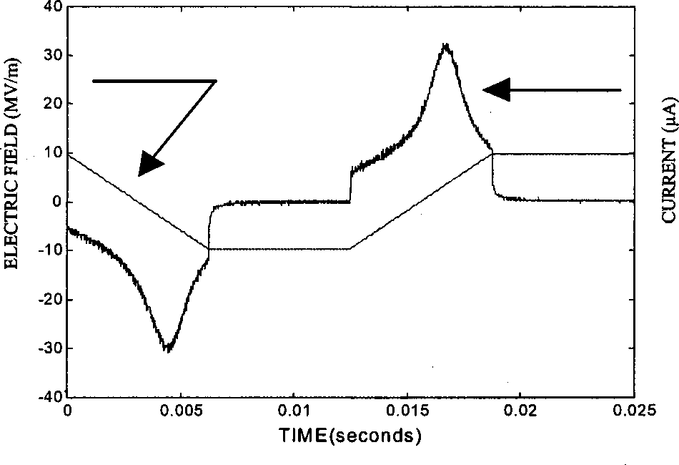

FIG. 3. Temporal evolution of current and electric field.

it was, the calculation of the inverse function could not be possible� and �2� inverse function can be calculated easily.

It can be noticed here that a transient effect occurs when the derivative of electric field changes from a positive value to a negative one. These transient problems can be reduced by adding a floor step when electric field rises to either the maximum or the minimum voltage level. In this case, tran-sient effects will not have any influence on the DSED calcu-lation.

The current measured in the sample using such a voltage wave form is shown in Fig. 3. The plot of Fig. 4 giving the polarization versus the electric field strength is obtained by integration of the sample current with respect to time and then by plotting this value divided by *S* as a function of the electric field �voltage divided by *h*�. At the same time, the low level capacitive effect is measured using the lock-in am-plifier. The two effects are compared in Fig. 5. This figure shows the evolution of the derivative of polarization with respect to sample voltage versus the electric field strength and leads to the butterfly hysteresis representation.

According to Eq. �6� DSED �*H(E)*� is calculated by sub-traction of the reversible contribution to the total effect. Then, the ferroelectric loop due to irreversible switching can be calculated by integration of Eq. �5� �see Fig. 6�. The 1/2 *P*sat factor in Eq. �5� serves to normalize this integral. For the previously presented sample the following value is obtained:

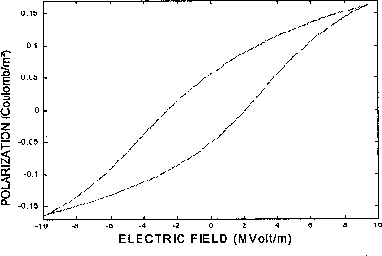

FIG. 4. Total ferroelectric loop, *P*(*E*).

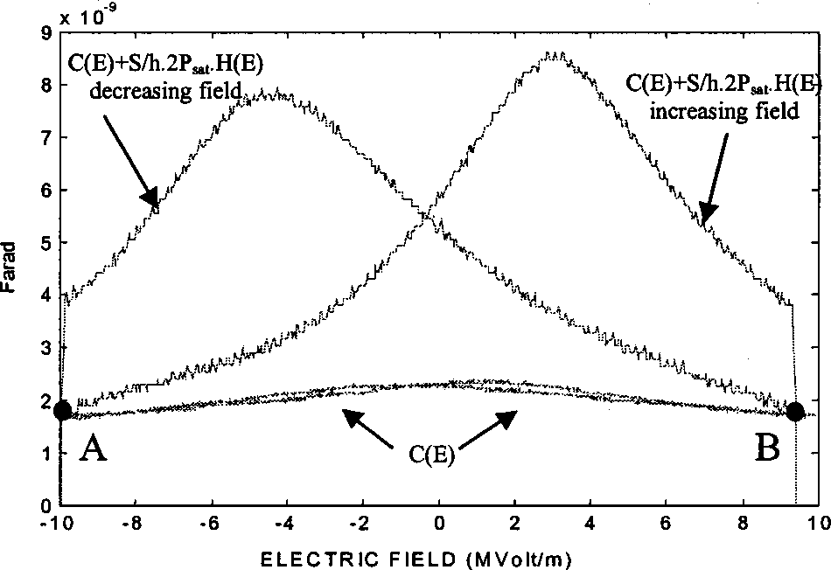

FIG. 5. Comparison between the two effects.

*P*sat�0.1 C/m2. From Fig. 5, it can be noticed that DSED is null, as predicted with theoretical behavior, when the deriva-tive of electric field changes from a positive value to a nega-tive one �points A and B�. If there were significant depen-dence of low level capacitive effects on our frequency range, then measurements with two different methods �by applica-tion of a high frequency low level sinusoidal voltage and a slow frequency high level triangular voltage� would have not led to similar results at these points. Thus frequency depen-dence of the low level capacitive effect can be neglected.

On the other hand DSED is different from zero when the electric field reaches an extreme value, meaning that satura-tion is not achieved. *P*sat is thus underestimated and a maxi-mal polarization rather than polarization at saturation should be considered to be achieved.

Figure 6 shows that maximal polarization �at *E*max) is different from remanent polarization �at *E*�*0*�, exhibiting a back switching mechanism.

**V. PREISACH-TYPE MODEL**

As shown in Fig. 7, the elementary loop of a single domain is not symmetrical with respect to the vertical axis. Using this assumption and the macroscopic hysteretic loop *P*irr(*E*), the 2D domain switching density, i.e., the experi-mental Preisach density EPD denoted by *N*(*X*,*Y*), is defined in such a way that *N*(*X*,*Y*)*dX dY* gives the fraction of do-

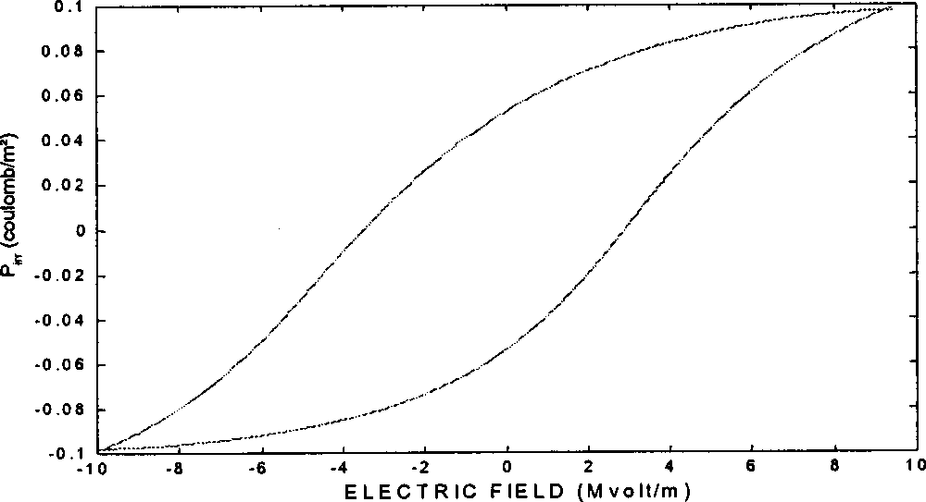

FIG. 6. Ferroelectric loop due to irreversible domain switches, *P*irr(*E*).

|  |  |  |
| --- | --- | --- |
| Rev. Sci. Instrum., Vol. 73, No. 10, October 2002 | Experimental Preisach density | 3549 |

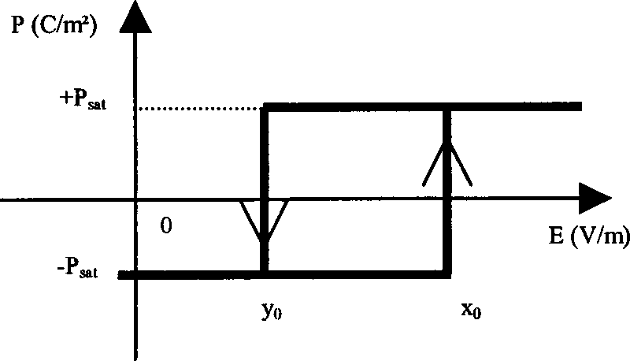

FIG. 7. Elementary nonsymmetrical loop.

|  |  |  |  |  |
| --- | --- | --- | --- | --- |
| mains having both an increasing electric field threshold be-tween *X* and *X*�*dX* and a decreasing one between *Y* and *Y*�*dY*.  Physical considerations lead to a null value of EPD for *X*�*Y* �reverse elementary cycles are assumed to be impos-sible�. EPD is also null beyond the macroscopic electric satu-ration raised for *E*sat electric field strength. This density can thus be drawn inside an isosceles triangular shape as shown in Fig. 8. Note that the upper triangular part of the shape corresponds to elementary cycles having two positive thresh-olds, whereas the lower triangular shape corresponds to two negative thresholds, i.e., back switches. Finally, cycles placed in the last square part of the shape have a positive and a negative threshold. EPD evaluation can be done using DSED and measured as described in the previous section.  For example, during electric field periodic variation be-tween *E*min and *E*max, switching will occur for domains placed in a triangular shape given by *Y*�*E*min and *X*�*E*max. In the case of an electric field increase (*dE*�0), the variable *X* is taken to be equal to the applied electric field strength, which varies from *E*min to *E*max. In that case, DSED corresponds to the EPD projection on the *X* axis �Eq. �7��1: | | | | |
| 1 | �*P*irr�*E*� | |  |  | | --- | --- | |  | *E* |   � | *N*�*E*,*Y* �*dY*�*Hi*�*E*,*E*min�, | |
| 2*P*sat |
| �*E* | |  |  | | --- | --- | | � | *E*min | |
| *dE*�0. | | | | �7� |

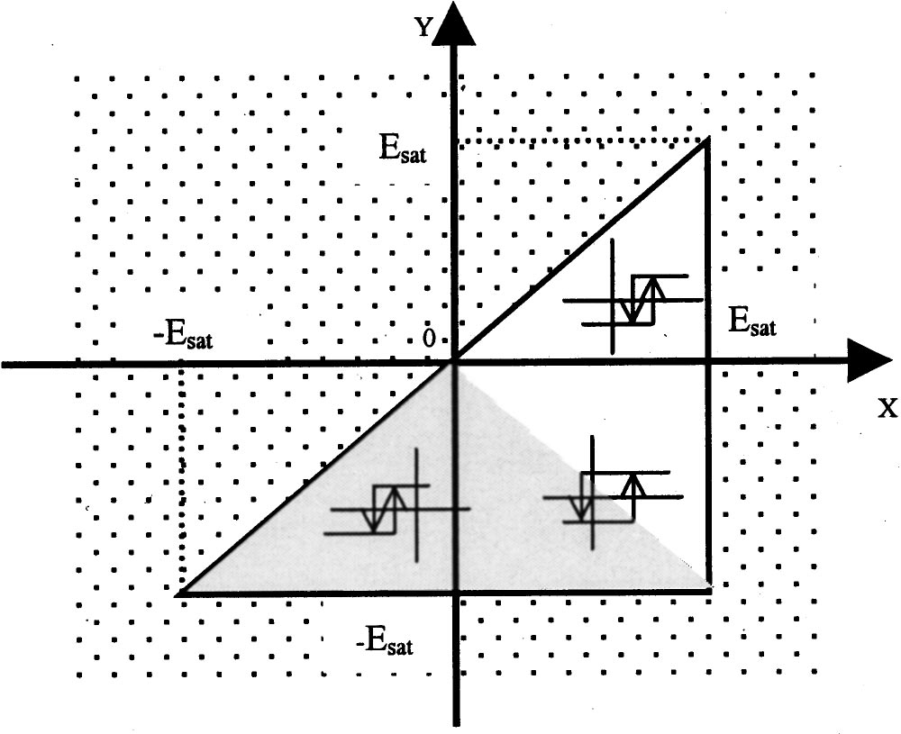

FIG. 8. Different types of switches in Preisach plane, EPD is null in pointed zone.

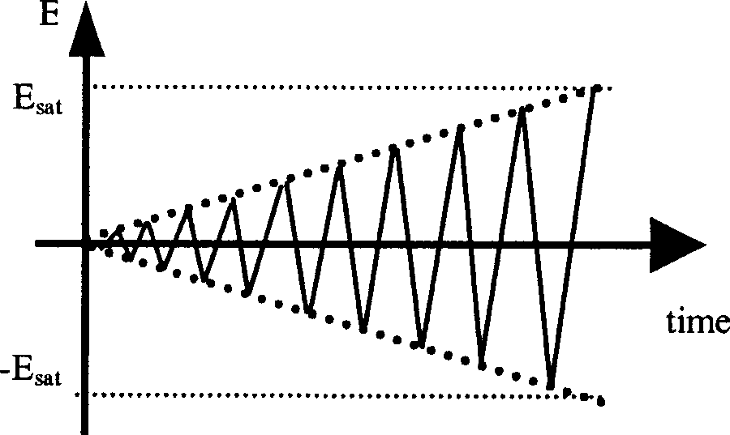

FIG. 9. Electric field temporal evolution for symmetrical EPD evaluation.

|  |  |  |  |
| --- | --- | --- | --- |
| Note that in this expression, DSED depends on *E* and *E*min  and therefore becomes a two-variable function called  *Hi*(*E*,*E*min).  In a similar way, for an electric field decrease (*dE*  �0), the variable *Y* is taken equal to the applied field vary-  ing from *E*max to *E*min and DSED, called *Hd*(*E*max,*E*), is  defined as the projection of EPD on the *Y* axis �Eq. �8��: | | | |
| 1 | �*P*irr�*E*� | ��*E E*max*N*�*X*,*E*�*dX*�*Hd*�*E*max,*E*�, | |
| 2*P*sat | �*E* |
| *dE*�0. | | | �8� |

Finally, EPD can be linked with DSED by using Eqs. �9� and�10�.

|  |  |  |  |  |  |  |
| --- | --- | --- | --- | --- | --- | --- |
| *NE*,*E* | �*Hd*�*E*max,*E*� | | , | | *dE*�0, | 9 |
| �max�� | �*E*max | | �� |
| *N*�*E*,*E*min��� | | �*Hi*�*E*,*E*min� | | , | *dE*�0. | �10� |
| �*E*min | |
| By definition, polarization at saturation *P*sat is determined by Eq. �11�. Using Eq. �7� it can then be shown that EPD is  normalized �Eq. �12��. | | | | | | |
| ��*E*sat *E*sat �*P*irr�*X dX*�2*P*sat,  ��*E*sat *E*sat ���*E*sat *X*  *N*�*X*,*Y* �*dY*�*dX*�1. | | | | | | �11�  �12� |

Note that EPD is only known by its projection either on the *X* or *Y* axis. The main difficulty consists therefore in the choice of electric loading, which must provide enough inde-pendent measures to calculate each value of EPD. The way of operating such measurements is described in Sec. VI.

**VI. EPD DETERMINATION**

EPD can be calculated by the derivative of DSED mea-sured for different values of maximal or minimal electric field strength �Eqs. �9� and �10��. It is interesting to imple-ment a method in which the mean value of the electrical field remains null. This condition is fulfilled when the electric field, drawn in Fig. 9, is applied to the sample. In this wave form, note that *E*max and *E*min vary both in the same way.

With the electric field increasing, EPD can be calculated in a triangular shape with boundaries defined by *Y*��*X*,

|  |  |  |
| --- | --- | --- |
| 3550 | Rev. Sci. Instrum., Vol. 73, No. 10, October 2002 | Cima, Laboure, and Muralt |

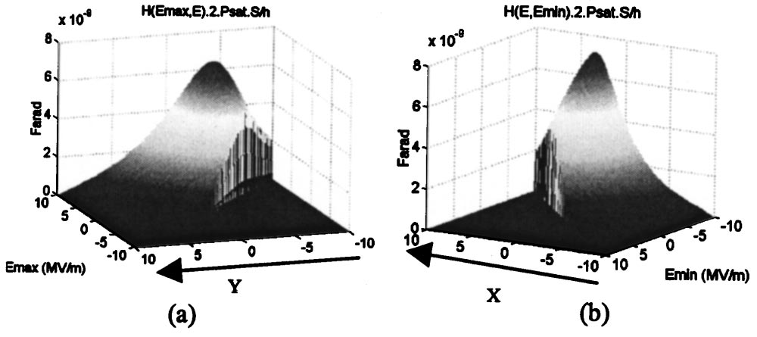

FIG. 10. DSED measured for symmetrical determination: decreasing phase�a� and increasing phase �b�.

*Y*�*X*, and *Y*�*E*sat �gray zone in Fig. 8�. With decreasing fields, EPD can be calculated in the upper triangular shape.

DSED results are shown in Fig. 10. On the left hand side DSED is represented as evaluated during decreasing electric field strength, with respect to *E*max. In this case, the decreas-ing field *E* is equal to *Y*. On the right hand side DSED is represented as evaluated during increasing electric field strength, with respect to *E*min. In this case, increasing field *E* is equal to *X*. EPD can then be evaluated in the gray zone defined in Fig. 8 by the derivative of *Hi*(*E*,*E*min) with respect to *E*min for increasing field and in the white zone defined in Fig. 8 by the derivative of *Hd*(*E*max,*E*) with respect to *E*max for the decreasing field. Note that calculation is difficult near the *Y*��*X* axis. To overcome this problem, the number of measurements is increased and a linear interpolation is used around this axis. EPD �drawn in Fig. 11� is normalized as-suming that saturation is almost achieved. This gives a dif-ferent method for determination of polarization at saturation. A value close to the first evaluation is found: *P*sat�0.109 C/ m2.

EPD is then easily fitted with a 2D Gaussian function, which is the usual distribution in Preisach-type modeling for simulation.8,9

**VII. PHYSICAL INTERPRETATION OF EPD**

Turik describes a physical significance10–12for the sta-tistical Preisach model,5considering that crystallites in the polycrystalline ceramic are subjected to a local electric field different from the macroscopic electric field. Each crystallite is characterized by an inner coercive field *Ec* . The local electric field is modified by the surrounding crystallites, in-troducing a local internal field *Ei* , different for each crystal-lite. He introduces two variables *Vi* and *Vc* representing re-

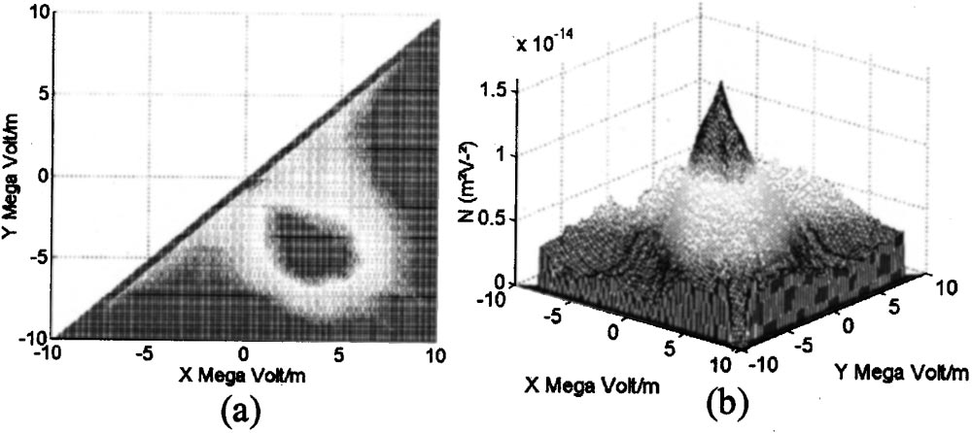

FIG. 11. EPD determined with a symmetrical method �top view on left hand side�.

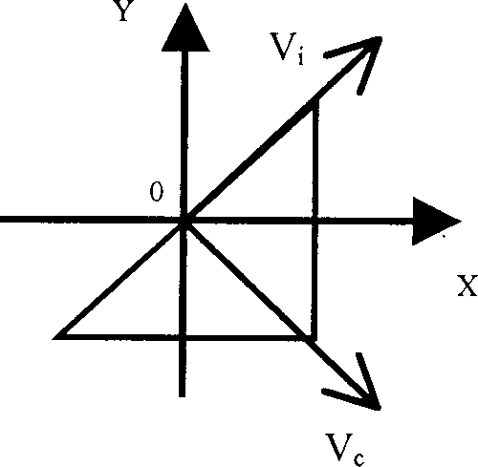

FIG. 12. Definition of *Vi* and *Vc* .

spectively, *Ei* and *Ec* , defined from *X* and *Y* by Eqs. �13� and�14� and shown in Fig. 12 in the Preisach plane

|  |  |  |  |  |  |
| --- | --- | --- | --- | --- | --- |
| *V*�2*E* | *X*�*Y* | | , | | �13� |
| *i*�*i*� | �2 | |
| *Vc*��2*Ec*� | | *X*�*Y* | | . | �14� |
| �2 | |
| These variables are assumed to be independent and described by a Gaussian distribution. Thus only four parameters are necessary to completely characterize such a model: the mean values: *mi* and *mc* , and the standard deviations �*i* and �*c* . Finally EPD can be identified with the 2D Gaussian function *N*est as described in Eq. �15�.  *N*est�*X*,*Y* ��2��*i*�*c*  1 exp���  *X*�*Y*  �2  2�*i* �*mi*�2��exp���  *X*�*Y*  �2  2�*c* �*mc*�2� . �15� | | | | | |

The negative values of *Vc* are assumed to have no physical significance and are therefore not considered in this distribu-tion. Then a proportional coefficient has to be introduced to normalize the estimated Preisach density *N*est. Such a coef-ficient can be neglected when *mc* is large enough. Note that saturation is mathematically never reached with this model. The mean values *mc* and *mi* can easily be found through Eqs.�13� and �14� by finding corresponding *X* and *Y* with the maximum value of the EPD in the Preisach plane �see Fig. 11�a��. The ratio of standard deviation can also be estimated. Finally, the parameters defined to obtain a precise fit to the maximum value of EPD �16e�15 V2/m2) are

�*i*�2.5 MV/m, �*c*�3.75 MV/m,

*mi*��0.7 MV/m, *mc*�5.5 MV/m.

Figure 13 gives a comparison of EPD and the fitted positive region of the 2D Gaussian distribution. It shows good agree-ment between the experimental data and the fit.

|  |  |  |
| --- | --- | --- |
| Rev. Sci. Instrum., Vol. 73, No. 10, October 2002 | Experimental Preisach density | 3551 |

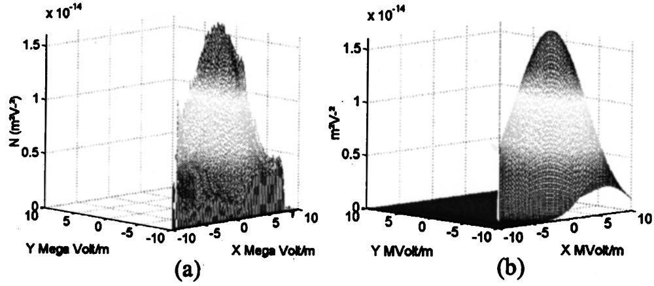

FIG. 13. Comparison of EPD �a� and fitted 2D Gaussian truncated �b�.

**VIII. USING EPD FOR CHARACTERIZATION AND SIMULATION**

EPD can provide useful information about the material properties of a sample being studied. For example, it can be used to calculate the remanent polarization, coercive field, bias electric field, which appears in the imprint effect, and ferroelectric losses, each one depending on maximum elec-tric field *E*max. Direct measurement and calculation using the EPD �*N*� and the estimated Preisach density (*N*est) are now compared. Direct measurement data are extracted from cur-rent measurement while a symmetrical electric field varying between �*E*max and *E*max is applied to the sample.

**A. Remanent polarization**

�*P* is defined as the difference between positive and negative remanent polarization. �*P* can be calculated from the EPD by integration on a square area, excluding back switching, delimited by the maximal electric field strength�Fig. 14 and Eq. �16��:

�*P*�*E*max��2*P*sat�0 *E*max���*E*max *N*�*X*,*Y* �*dY*�*dX*. �16� 0

As shown in Fig. 15, the predicted and measured values are in good accord. This shows that the EPD seems to be an accurate representation of material behavior and that the 2D Gaussian function a good approximation of the Preisach den-sity. However, calculation from *N*est leads to overestimated values, suggesting that the internal field standard deviation,�*i* must be increased to amplify the back switching mecha-nism.

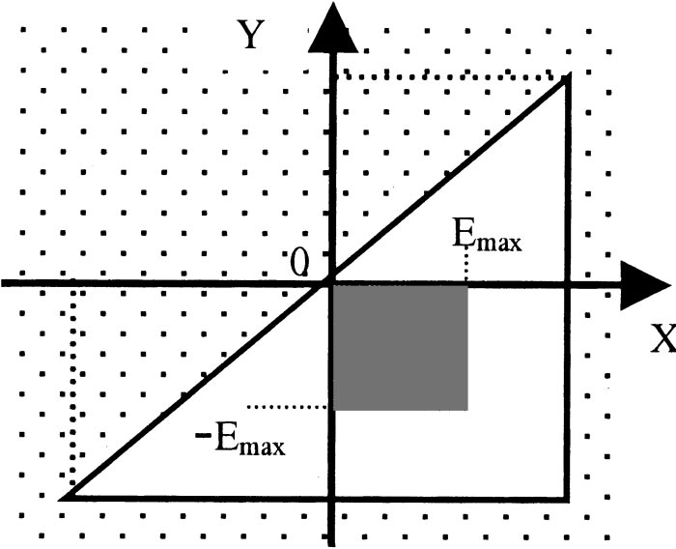

FIG. 14. Switching area taken into account in remanent polarization for symmetrical loop (�*E*max*→E*max).

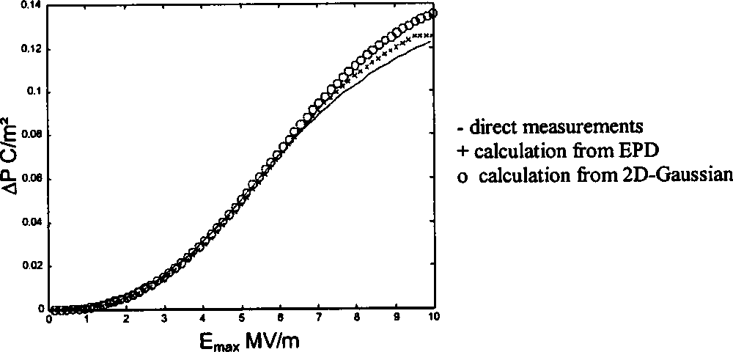

FIG. 15. Comparison of remanent polarization obtained by different ways.

**B. Threshold electric field**

A hysteresis loop is traditionally characterized by a posi-tive and a negative threshold, respectively, *E*� and *E*� �elec-tric fields that permit the cancellation of polarization during each phase subsequent to a change of direction�. Calculation of these thresholds from Preisach density �experimental or estimated� requires first the calculation of the maximal po-larization. Maximal polarization, depending on *E*max, is eas-ily calculated by integration on a triangular area �gray tri-angle shown in Fig. 16 and described by Eq. �17��. Positive threshold is shown in Fig. 16 as the electric field applied during an increasing phase when polarization calculated by integration on the lined triangular surface area reached *P*max. This corresponds to the solution of Eq. �18�. Negative thresh-old is determined with a similar method

2*P*max�*E*max��2*P*sat��*E*max *E*max ���*E*max *X*  *N*�*X*,*Y* �*dY*�*dX*, �17�

*P*max�2*P*sat��*E*max *E*� ���*E*max *X*  *N*�*X*,*Y* �*dY*�*dX*. �18�

It is easier to compare coercive field *Ec* and internal field *Ei* deduced from Eqs. �13� and �14� than threshold fields. In this case *Ec* and *Ei* must tend to *mc*/�2 �3.9 MV/m� and *mi*/�2��0.5 MV/m�, respectively, for calculations obtained from *N*est. As shown in Fig. 17, the measured and calculated val-ues �with EPD and *N*est) of coercive field are in good agree-ment. The measured values relative to internal field are simi-lar to those calculated from EPD and it can be concluded that

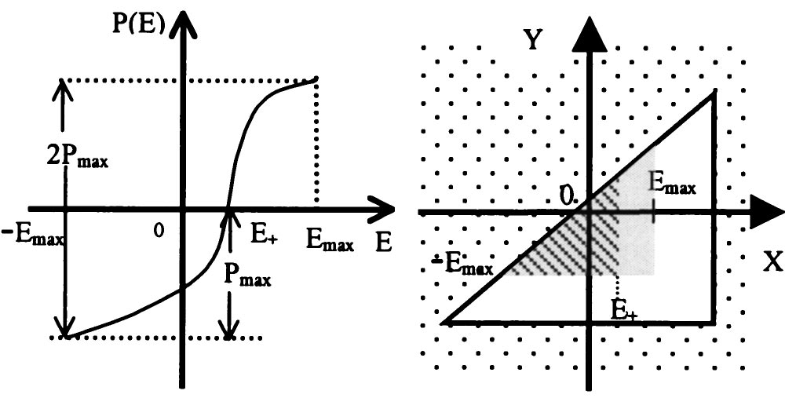

FIG. 16. Definition of positive threshold *E*� and switching area taken into account in its determination.

|  |  |  |
| --- | --- | --- |
| 3552 | Rev. Sci. Instrum., Vol. 73, No. 10, October 2002 | Cima, Laboure, and Muralt |

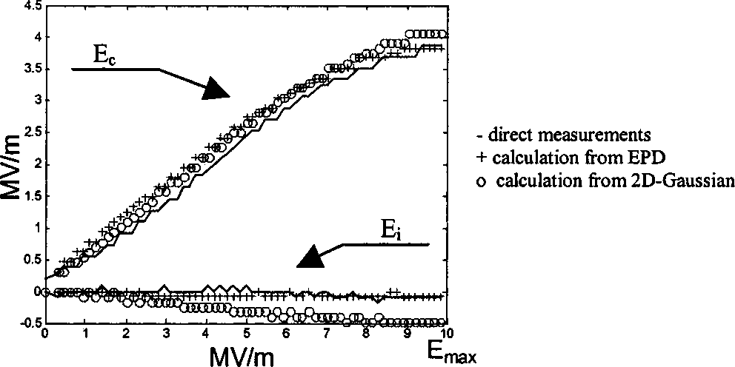

FIG. 17. Comparison of coercive and internal fields obtained by different ways.

EPD gives a reliable description of all ferroelectric proper-ties. Thus EPD can be directly implemented in a ferroelectric simulator.

On the other hand it can be observed in Fig. 17 that the mean value of internal field *mi* , used for 2D Gaussian fitting, gave an overestimation. It was previously noted that the stan-dard deviation �*i* was underestimated. This requires an im-provement of the theoretical model chosen to represent Prei-sach density that will be discussed in Sec. IX.

**IX. DISCUSSION**

In this article, the EPD method has been introduced as well as the testing bench developed in order to perform its measurement. It was assumed that a macroscopic loop can be decomposed into an elementary nonsymmetrical rectangular cycle. This yields a two-variable model in which the positive and negative thresholds have to be defined for each elemen-tary cycle, leading to the EPD, a 2D domain switching den-sity. A physical model was considered, associating each el-ementary cycle with a single domain crystallite characterized by both a local bias field and a coercive field. Thus EPD allows observation of the switching mechanism via the dis-tribution of these local fields. Gondro *et al.*13assumes that trapped charges at the electrode interface generate a local bias field in these regions. This internal bias field locally modifies the switching criteria and could be responsible for fatigue. This electrode effect is modeled in EPD by the pres-ence of three different 2D Gaussian distributions: one for each electrode effect with average bias field of opposite signs and one for the inner region. We confirm these assumptions by measurements of EPD before poling of the sample �Fig. 18�.

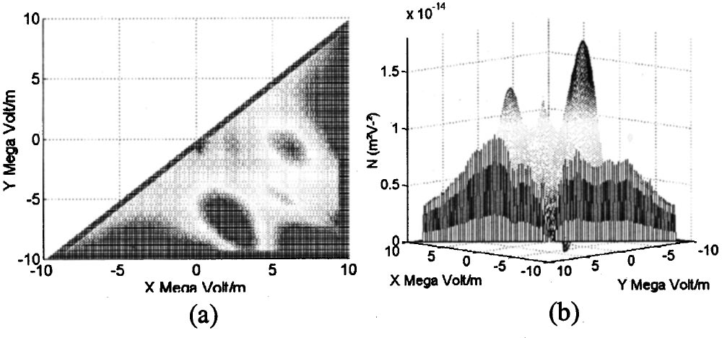

FIG. 18. EPD determined before poling. �a� top view and �b� side view.

It appears clearly that two opposite, nonsymmetrical, in-ternal bias field exist in the sample. These internal fields, and the trapped charges they represent, seem to disappear after poling �Fig. 11�. However, it can be postulated that these internal bias fields have just been decreased, thus perhaps superimposing two or three different 2D Gaussian functions might provide a more accurate modeling of Preisach density. This may also justify previous errors introduced by the *N*est calculation. Improvement of the model fitting to the Preisach density in a ferroelectric simulator is an important challenge because it greatly affects the values of the parameters in-volved. In addition, EPD is potentially a very useful way to characterize ferroelectric ceramic behavior and properties, such as temperature, pressure, frequency, and aging effects on domain switching mechanisms.

1Isaac Mayergoyz, *Mathematical Models of Hysteresis* �Springer, New York, 1991�.

2S. Hiboux, P. Muralt, and T. Maeder, J. Mater. Res. **14**, 4307 �1999�.

3T. Nattermann, Y. Shapir, and I. Vilfan, Phys. Rev. B **42**, 8577 �1990�. 4D. Damjanovic, Z. Kighelman, D. Damjanovic, and N. Setter, J. Appl. Phys. **9**, 4682 �2001�.

5F. Preisach, Z. Phys. **94**, 277 �1935�.

6G. Robert, D. Damjanovic, N. Setter, and A. V. Turik, J. Appl. Phys. **89**, 5067 �2001�.

7D. Bolten, U. Bo¨ttger, T. Schneller, M. Grossman, O. Lhose, and R. Waser, Appl. Phys. Lett. **77**, 23 �2000�.

8A. Bartic, D. Wouters, H. Maes, J. Rickes, and R. Waser, J. Appl. Phys. **89**, 6 �2001�.

9B. Jiang *et al.*, Symposium on VLSI Technology, Honolulu, 1997, pp. 141–142.

10A. V. Turik, Sov. Phys. Solid State **5**, 885 �1963�.

11A. V. Turik, Sov. Phys. Solid State **5**, 2141 �1964�.

12A. V. Turik, Sov. Phys. Solid State **5**, 1751 �1964�.

13E. Gondro, C. Ko¨hn, F. Schuler, and O. Kowarik, in Proceedings of the 12th IEEE International Symposium on Applications of Ferroelectrics, Kyoto, 2000.