

|  |  |
| --- | --- |
|  | SUPPLEMENTARY INFORMATION **https://doi.org/10.1038/s41563-018-0196-0** |

In the format provided by the authors and unedited.

**A rhombohedral ferroelectric phase in epitaxially strained Hf0.5Zr0.5O2 thin films**

**Yingfen Wei1, Pavan Nukala1,2, Mart Salverda1, Sylvia Matzen3, Hong Jian Zhao 4, Jamo Momand 1, Arnoud S. Everhardt1, Guillaume Agnus3, Graeme R. Blake1, Philippe Lecoeur3, Bart J. Kooi1,**   
**Jorge Íñiguez4, Brahim Dkhil2 and Beatriz Noheda 1\***

1Zernike Institute for Advanced Materials, University of Groningen, Groningen, the Netherlands. 2Laboratoire Structures, Propriétés et Modélisation des Solides, CentraleSupélec, CNRS-UMR8580, Université Paris-Saclay, Gif-sur-Yvette, France. 3Center for Nanoscience and Nanotechnology, CNRS-UMR 9001, Université Paris-Saclay, Palais[eau, France.](mailto:b.noheda@rug.nl) 4[Ma](mailto:b.noheda@rug.nl)terials Research and Technology Department, Luxembourg Institute of Science and Technology (LIST), Esch/Alzette, Luxembourg. *e-mail: [b.noheda@rug.nl](mailto:b.noheda@rug.nl)

**NAtuRE MAtERiALS** | [www.nature.com/naturematerials](http://www.nature.com/naturematerials)

**1. SAED simulations of the polar orthorhombic phase (*Pca21*):** SAED simulations of the orthorhombic phase commonly reported in literature were obtained through multislice method using JEMS software. From these simulations (Fig. S1a), we note that in the <110> zone, one of the {001} or {1-10} spots are forbidden. However, in Fig S1b, when compared with the fast-fourier transform of the cross-sectional HAADF-STEM image of a [001] domain, we see that both the {001} and the {1-10} spots are present, reinforcing the conclusion that our films, which are polar, exhibit a different symmetry to the commonly reported polar o-phase.

**2. Interfacial tetragonal phase**: Using a combination of EDS and HAADF-STEM (Fig. S3, HAADF-simulation in Fig. S3c), we deduced that the first couple of monolayers belong to a tensile strained tetragonal phase.

**3. Evolution to a monoclinic (bulk) phase with thickness**: HAADF-STEM image simulations were performed on all the phases (*P21/c*, rhombohedral phases obtained from our theoretical results, *Pca21*). On the 9 nm thick sample, using these simulations, we could clearly deduce the evolution from an r-phase to a bulk m-phase with increasing thickness (Fig. S4). Thus, our STEM results indicate the existence of non-polar monoclinic crystals in the 9 nm thick samples, rationalizing our observations of lower polarization values as compared to thinner films .

**4. PUND measurement (positive up negative down):** As shown in Fig. S5, the first pulse is the pre-write pulse. After the preset pulse, the first read pulse is a positive switching pulse, the second is an unswitched pulse, the third is a negative switched pulse, and the last is a negative unswitched pulse. IrealFE (the current from the real ferroelectricity switching) = Is (the current from the switching pulse) - Inon (the current from the unswitched pulse). The current (blue) in Fig. 4 combines positive (I1-I2) and negative (I3-I4) parts and is plotted as a function of electric field. Polarization (P) is calculated from the formula ∫ 𝐼𝑑𝑡 𝐴⁄ (I :current; t: time; A: electrode area).

**5. Additional details on the predicted rhombohedral phases:** In the table below we detail the crystallographic structures that were obtained from our first-principles simulations and are representative of the polar rhombohedral phases discussed in this work. We give the structures obtained from HfO2 simulations; obtaining the corresponding structures for the HZO composition is trivial, by performing the corresponding substitution of atoms and completing a further structural relaxation. Finally, Fig. S8 shows two views of the *R3m* and *R3* phases of HfO2.

|  |
| --- |
| Bulk HfO2, *R3* (No. 146)  a=b=7.106 A; c=9.016 A; =90o; =90o; =120o |
| Hf 9b 0.86366 0.67270 0.24007 Hf 3a 0.00000 0.00000 0.55493 O 9b 0.13334 0.32314 0.14948 O 9b 0.39917 0.24614 0.01541 O 3a 0.00000 0.00000 -0.08408 O 3a 0.00000 0.00000 0.32548 |
| Bulk HfO2, *R3m* (No. 160)  a=b=7.134 A; c=8.741 A; =90o; =90o; =120o |
| Hf 9b 0.83335 0.16665 0.25089 Hf 3a 0.00000 0.00000 0.58415 O 9b 0.14966 0.85034 0.15904 O 9b 0.48699 0.51301 0.32788 O 3a 0.00000 0.00000 0.85998 O 3a 0.00000 0.00000 0.35364 |

|  |
| --- |
| HfO2, compressed in-plane, *R3m* (No. 160)  a=b=6.683 A; c=10.041 A; =90o; =90o; =120o |
| Hf 9b 0.82944 0.17056 0.27065 Hf 3a 0.00000 0.00000 0.55278 O 9b 0.14881 0.85119 0.15456 O 9b 0.48218 0.51782 0.32402 O 3a 0.00000 0.00000 0.86126 O 3a 0.00000 0.00000 0.34948 |

**6. Particle size estimation:** Particle size statistics on the 9 nm thick HZO film were obtained from plane view bright-field TEM images (Fig. S9a). We utilized the particle analysis procedure prescribed by digital micrograph to obtain a median particle area of 84 nm2 (or diameter of ~10 nm), similar to the film thickness. Similarly, in a 4 nm film, we found grain sizes of 3-4 nm (Fig. 3c in the main manuscript).

**Supplementary figures**

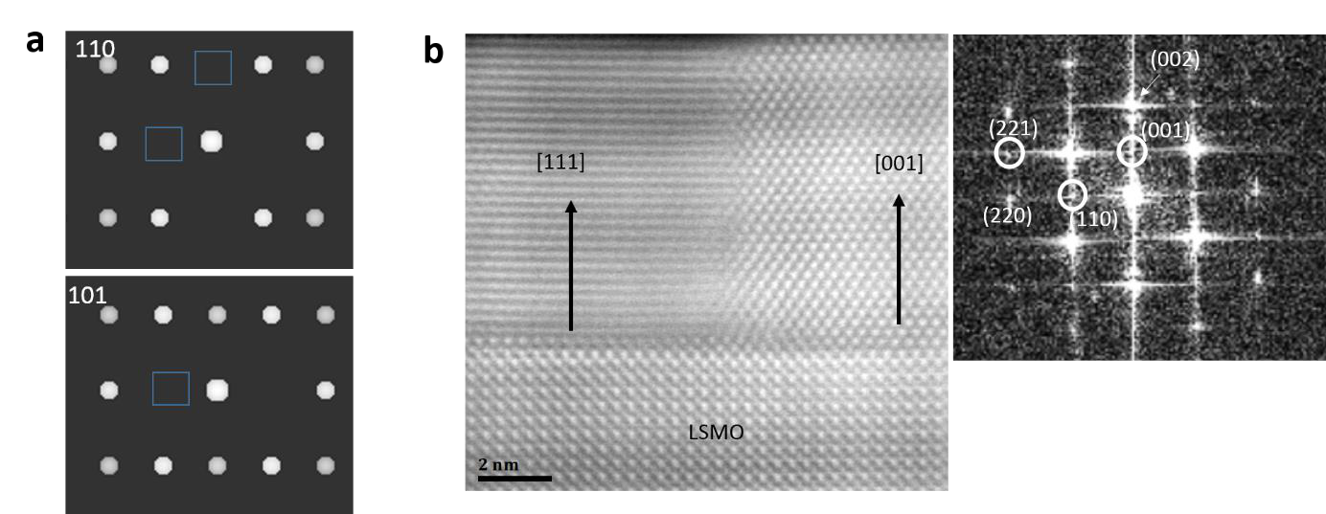

**Figure S1. SAED simulations of the polar orthorhombic phase (*Pca21*). a,** SAED diffraction simulations of *Pca21* phase, along the [110] and [101] zone axes. Along the [110] zone, we note that both the (001) and the (1-10) spots are forbidden. Along the [101] zone, (10-1) is forbidden, and along [011] (not shown), the (100) spots are forbidden. **b,** x-HAADF-STEM image from a 9 nm thick sample in the with zone axis: [100]STO. Domain coexistence (majority c-axis= [111], and minority c-axis= [001] can be clearly observed. Inset on the right shows FFT in which some spots from the 001 domain are indexed and circled. In an orthorhombic *Pca21* phase, one of the (001) or the (110) spots should be forbidden (by symmetry). However, we see both of them, clearly suggesting that we have a different ferroelectric phase than the commonly reported *Pca21* phase.

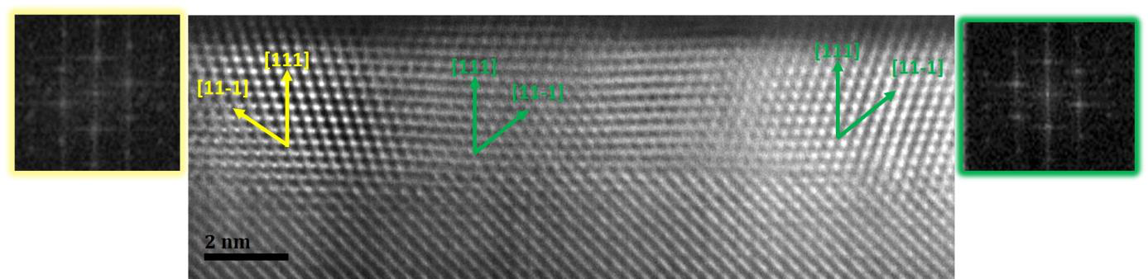

**Figure S2. Domains in 4nm thick sample.**Representative HAADF-STEM image from a 4 nm thick sample (Fig. 3c of the manuscript), with zone axis defined by *φ*=15o. At least two domains (green and yellow, 180o rotated), with out of plane [111] can be seen. The [001] out of plane domains in this sample were very rarely found (as opposed to the 9 nm thick sample). Insets on the left and right show FFTs of the yellow and green domains respectively. *d111*~2.95-3.01 Å, *d11-1*~2.93-2.97 Å in both the domains.

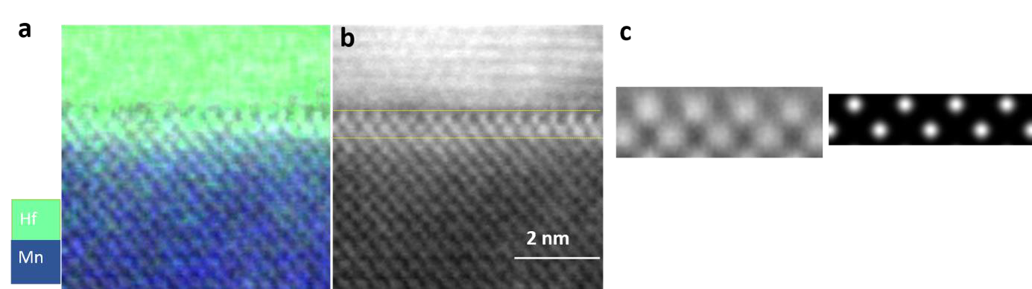

**Figure S3 : Interfacial tetragonal phase. a,** Hf and Mn chemical maps obtained via energy dispersive spectroscopy in a 9 nm thick sample. **b,** Corresponding HAADF-STEM (*φ*=0o) image. Comparing (a) with (b) clearly shows that interfacial phase is indeed chemically HZO, fully strained with respect to the substrate, and in a different phase compared to the rest of the HZO film. It can be matched to an ~8% in-plane tensile strained t-phase of HZO, simulated in **c.**

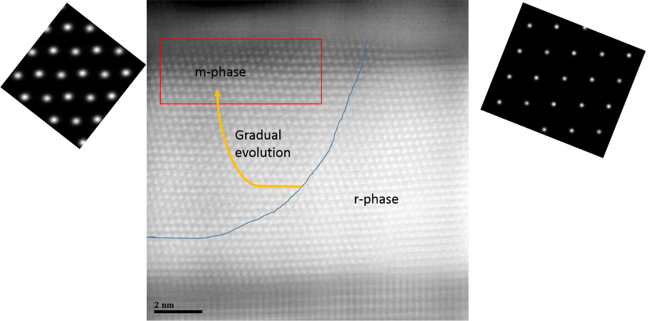

**Figure S4**: **Evolution to a monoclinic (bulk) phase with thickness.** HAADF-STEM cross-section image (ZA, *φ*=45o) of a 9 nm HZO sample showing a gradual evolution of r-phase into bulk-m phase with increasing thickness. **(inset left)**, HAADF-STEM simulation of an m-phase clearly showing the zig-zag atomic positions along [112] (horizontal direction), **(right)** HAADF-STEM image simulation of the r-phase. Renditions of various rhombohedral structures obtained from our structural search are shown in Fig. S8.

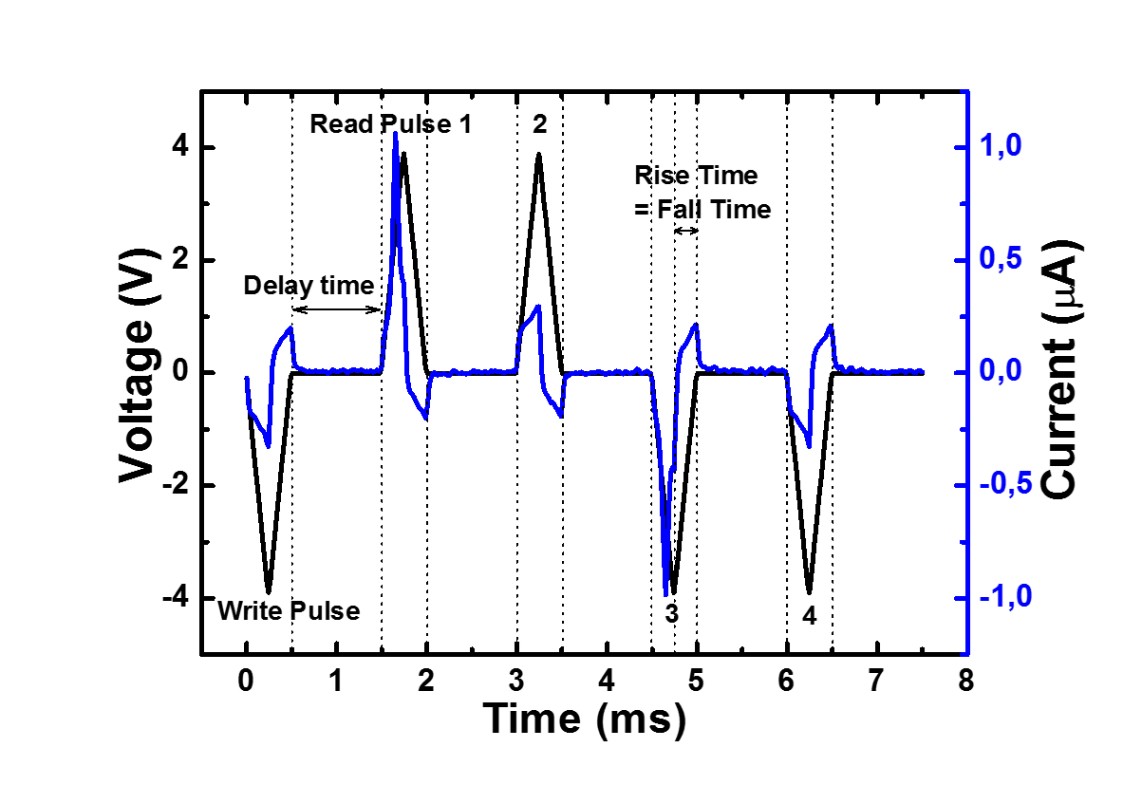

**Figure S5: PUND (Positive up negative down) measurements.** PUND (positive up negative down) measurement on a 5 nm thick film with 1 kHz electric field frequency. Voltage pulse scheme applied is shown in black, and the current response is shown in blue.

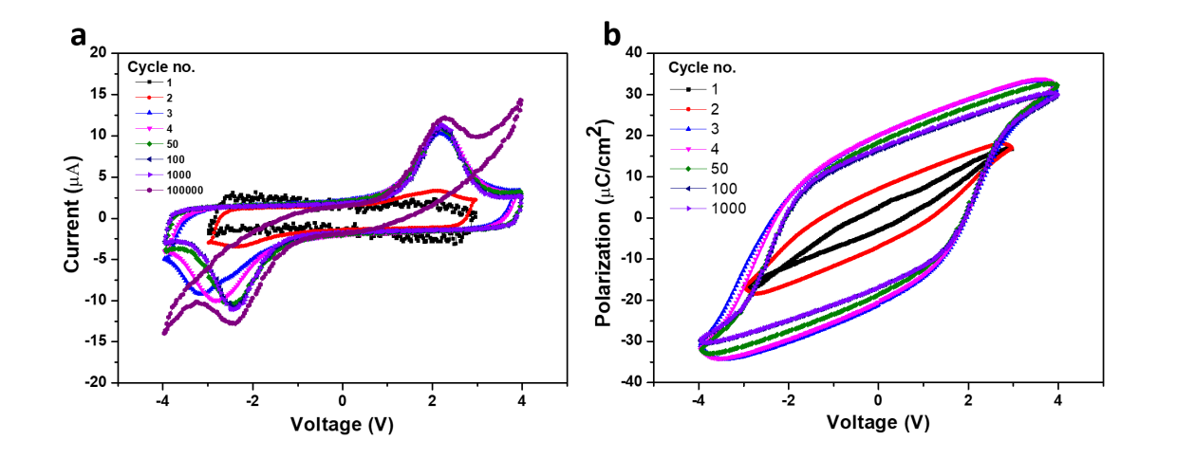

**Figure S6**: **I-V and corresponding P-V loops of 9 nm film upon cycling**. **a**, Raw Current-Voltage loops of a LSMO/HZO/LSMO stack with a 9 nm HZO film performed at a frequency of 1 kHz (electrode size 50 um x 50 um). A relatively safe voltage of 3V is chosen for the first two cycles. However 3V is not sufficient driving voltage to switch the films. Thus we then increased the applied voltage from 3 to 4 V.**b,** P-V hysteresis loops corresponding to (a). Notice that there is not much leakage atleast upto first 1000 cycles. Also notice that the *P*r in the 4th cycle (first cycle with applied voltage of 4V), is almost the same as *P*r in the 1000 cycle, suggesting negligible wake-up effect. The device becomes leaky after 100000 cycles. Thus it is necessary to optimize the device endurance performance through domain/interfacial engineering.

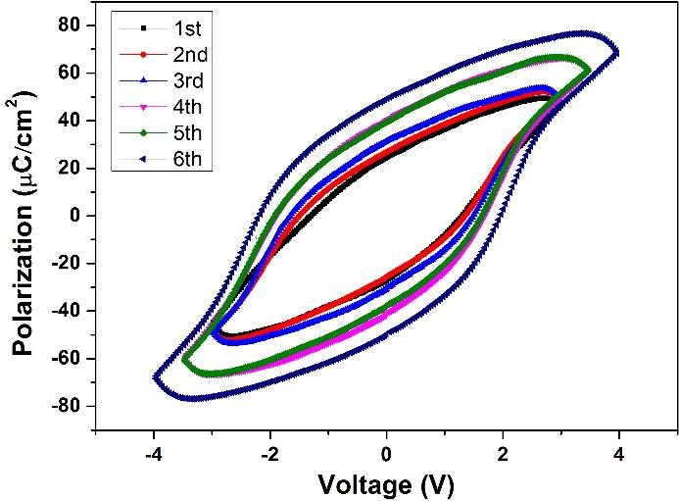

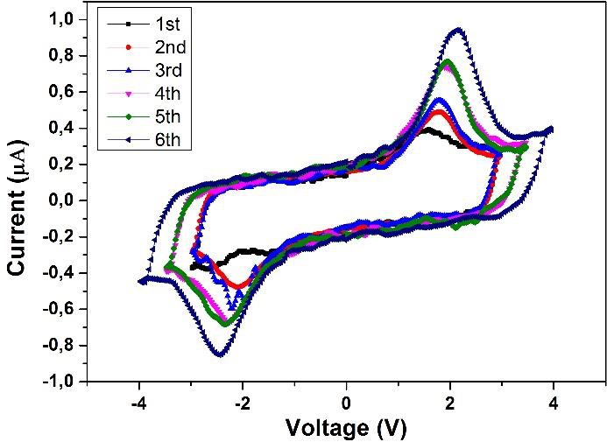

8

**Figure S7: P-V (left) and I-V (right) loops of 5 nm films under different electric field at 1kHz.** Raw polarization-voltages loops of a LSMO/HZO/LSMO stack with a 5 nm HZO film performed at a frequency of 1 kHz (electrode size 10 um x 10 um). The applied voltage is increased sequentially from 3 to 4 V. Under 4 V of applied voltage, *P*r=50 µA/cm2. Robust ferroelectricity shows up without double switching (no wake-up), different from other HfO2-based polycrystalline films.

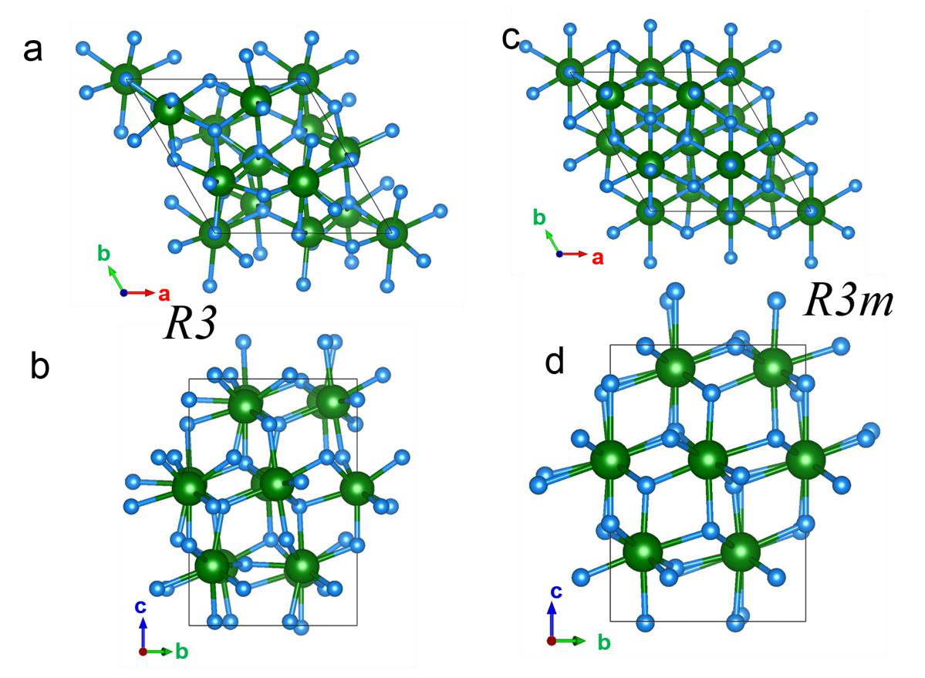

**Figure S8: Rhombohedral polar phases of bulk HfO2 obtained in our structural search. a,b,** show two views of the *R3* phase, while **c,d** show two views of the *R3m* phase. Hexagonal axes are shown as reference. Hf and O atoms are represented by green and blue spheres, respectively.

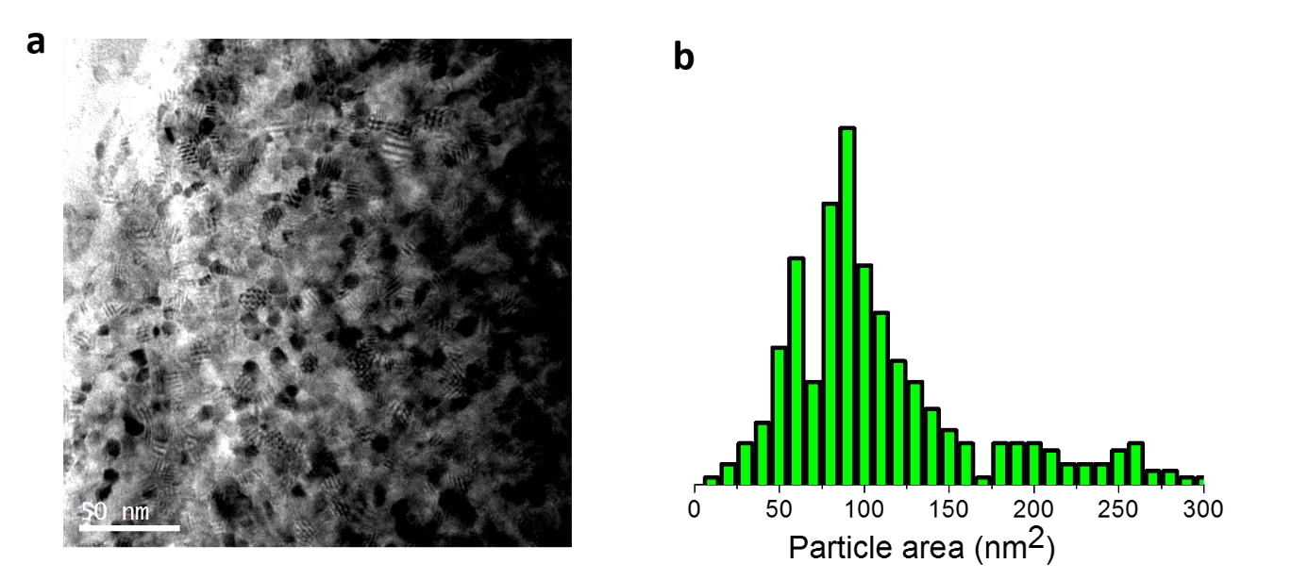

**Figure S9. Particle size estimation. a,** Plane view bright-field TEM image of a 9 nm HZO sample. **b,** Grain size distribution from the image in (a) revealing a median grain size of ~10 nm (median grain area of 84 nm2).

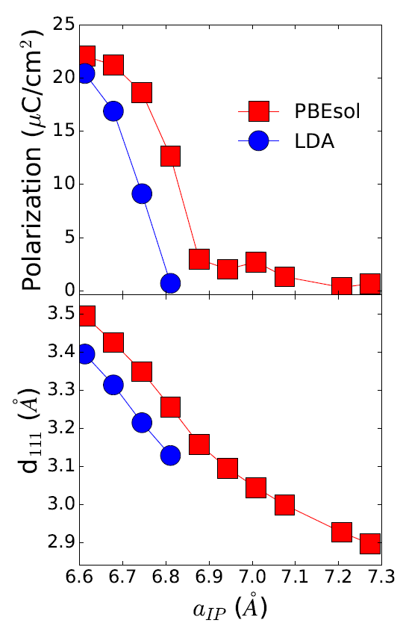

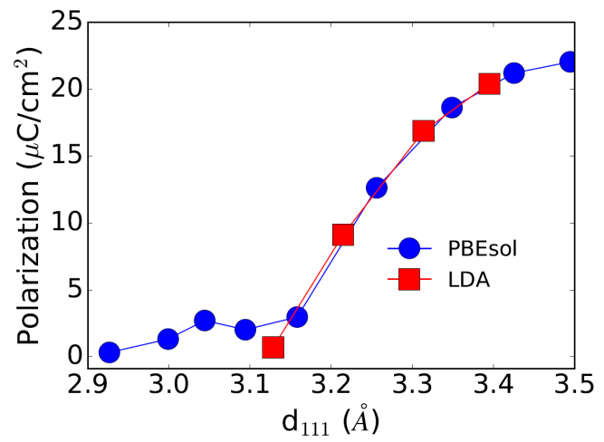

**Figure S10. Comparison of LDA and PBEsol functionals.** We have solved our polar rhombohedral phase, as a function of in plane lattice constant aIP, using both LDA and PBEsol functionals. The quantitative differences are clear, and in line with our expectations: the LDA curves for the polarization and *d111* are shifted towards smaller aIP values when compared with their PBEsol counterparts. This is a direct consequence of LDA’s well-known over-binding error: for a fixed imposed value of the in-plane lattice constant aIP, LDA yields a smaller volume than PBEsol, and thus a smaller out-of-plane lattice parameter and out-of-plane polarization. Note also that, when we plot the evolution of the polarization as a function of the out-of-plane interplanar distance *d111*, the PBEsol and LDA results fall on top of each other, showing that the obtained qualitative behavior for the polar *R3m* phase does *not* depend on the functional used.