|  |
| --- |
| **RAPID COMMUNICATIONS** |

PHYSICAL REVIEW B **72**, 020102�R� �2005�

**Strain gradients in epitaxial ferroelectrics**

G. Catalan,1,* B. Noheda,1J. McAneney,2L. J. Sinnamon,2and J. M. Gregg2   
1*Materials Science Center, University of Groningen, Groningen 9747AG, The Netherlands*   
2*Department of Pure and Applied Physics, Queen’s University Belfast, Belfast BT7 1NN, United Kingdom*�Received 23 May 2005; published 14 July 2005�

X-ray analysis of ferroelectric thin layers of Ba1/2Sr1/2TiO3 with different thicknesses reveals the presence of strain gradients across the films and allows us to propose a functional form for the internal strain profile. We use this to calculate the influence of strain gradient, through flexoelectric coupling, on the degradation of the ferroelectric properties of films with decreasing thickness, in excellent agreement with the observed behavior. This paper shows that strain relaxation can lead to smooth, continuous gradients across hundreds of nanom-eters, and it highlights the pressing need to avoid such strain gradients in order to obtain ferroelectric films with bulklike properties.

DOI: [10.1103/PhysRevB.72.020102](http://dx.doi.org/10.1103/PhysRevB.72.020102)

PACS number�s�: 77.55.�f, 61.10.�i, 68.55.�a, 77.80.�e

Interest in ferroelectric thin films is rapidly expanding due x-ray diffraction, revealing that vertical long-range gradients

to the recent development of experimental techniques and develop in the films. These gradients have been then intro-

calculation tools that allow an exploration of ferroelectric duced in a thermodynamic model of the transition, and the

phenomena at the atomic level.1,2The incorporation of real- predictions of the model have been compared with the actual

istic mechanical and electrical boundary conditions in the dielectric properties for the same set of films. The results

first-principles formulations is generating insight into the show that the measured strain gradients account for most of

mechanisms limiting the ferroelectric response in thin ferro- the reduction of dielectric constant. The crystallographic

electric layers.3–5But while the evidence suggests that ferro- tools described here can also be applied to other material

electricity may indeed be stable in films of only a few systems with strain gradients, whether caused by dislocations

monolayers,1–3the sharp peak in the dielectric constant usu- or by distributions of impurities or vacancies. Showing a link

ally associated with the ferroelectric transition is systemati- between strain relaxation and strain gradients thus has wider

cally depressed even in films of hundreds of nanometers in implications beyond ferroelectricity and is an important re-

thickness. This obviously limits the technological impact that sult for thin-film epitaxy.

would arise from the ability to maintain ferroelectricity and The films studied in this paper are Ba0.5Sr0.5TiO3 �BST�

large dielectric constants down to the nanoscale in real dielectric layers with thickness between 110 and 660 nm,

devices. with SrRuO3 �SRO� bottom electrodes. The films were

Recent theoretical works address this issue. Glinchuk grown by pulsed laser deposition onto single crystal MgO

and Morozovska6look at the effect of a different polarization

is also an important factor affecting the properties of

ferroelectric films. Strain can modify the phase diagram,8,9

change the order of the transition,9,10and shift transition

temperatures.9,11However, strain alone does not generally

account for the observed smearing of the dielectric peak,

as a sharp anomaly is still expected at the strain-modified

transition

hand, are known to couple to the polarization via the

flexoelectric   
 temperature.

effect,12–14   
 Strain

and could,   
 *gradients*,

in   
 on

theory,   
 the

cause other 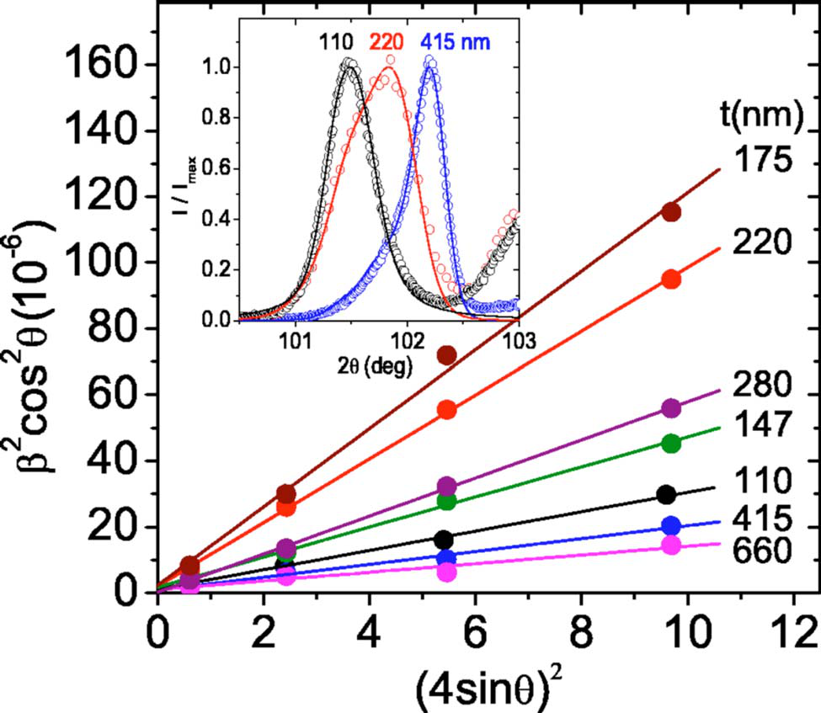

of a thin �1–10 Å� surface layer with respect to that

inside the film, showing that for very thin films �a few

nanometers� a dielectric smearing is predicted. For

thicker films, Bratkovsky and Levanyuk7have proposed two

different mechanisms: a compositional gradient and a

difference between work functions when the electrodes are

dissimilar.

Strain, caused by lattice mismatch with the substrate,

significant dielectric peak smearing in inhomogeneously

strained films.15Unfortunately, to date no direct experimental FIG. 1. �Color online� Williamson-Hall plots, showing maxi-

evidence has provided quantitative insight into such mum slope for films of intermediate thickness. Inset: 004 diffraction

gradients. peaks; peak shapes are well fitted �solid lines� assuming an expo-

In this paper, a set of lattice-mismatched epitaxial thin nential strain profile. The peaks at �103° correspond to the SRO

films of different thicknesses have been examined using electrode.

1098-0121/2005/72�2�/020102�4�/$23.00 020102-1 ©2005 The American Physical Society

|  |  |  |
| --- | --- | --- |
|  | |  | | --- | | **RAPID COMMUNICATIONS** | |
| CATALAN *et al.* | PHYSICAL REVIEW B **72**, 020102�R� �2005� |

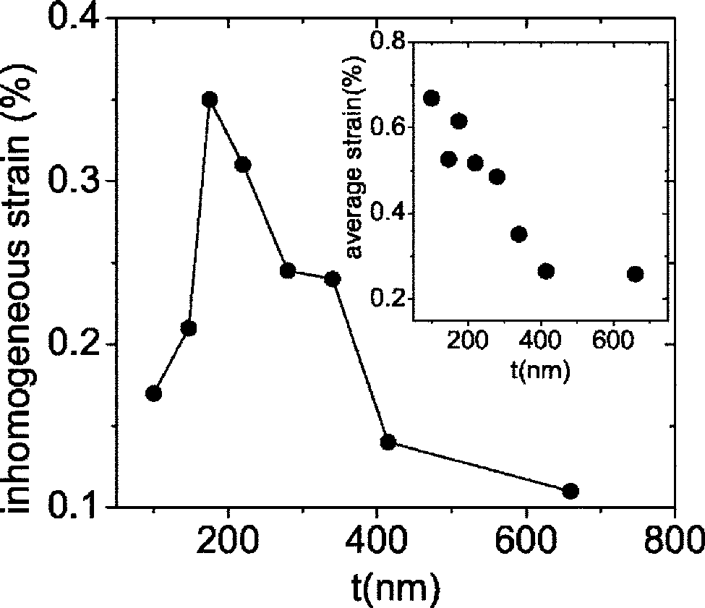

FIG. 2. Inhomogeneous strain as a function of film thickness.

The solid line is a visual guide. Inset: average out-of-plane

strain.

substrates. Epitaxy was verified by cross-sectional high-resolution transmission electron microscopy �TEM�. Details of the growth and TEM characterization are published elsewhere.11In the present paper, the crystallographic analy-sis has been performed using a Philips X’pert MRD diffrac-tometer with Cu *K*�1 radiation ��=1.540 Å�.

The lattice parameters are extracted from the perovskite pseudocubic 00*l* diffraction peaks �inset of Fig. 1�.16This allows the calculation of the average out-of-plane strain in each film, given by �*¯*�*t*�=*c¯*�*t*�/*c*0−1, where *c¯* is the average out-of-plane lattice parameter, c0 is the bulk lattice parameter�c*BST*=3.95 Å�, and *t* is the film thickness. The average strain for each film is shown in the inset of Fig. 2. There is an out-of-plane expansion for the thinnest films that decreases with thickness, indicating relaxation of the in-plane compres-sion induced by the smaller lattice parameter of the bottom electrode �c*SRO*=3.93 Å�.

Similar to what is known for semiconductor and metallic epitaxial layers, ferroelectric oxides are known to relieve strain as film thickness is increased.11,17The strain-relieving mechanism is thought to be mainly the formation of misfit dislocations. It is generally implied that this strain relaxation takes place at or very near the interface, and thus the strain state should be essentially homogeneous across the film�save for the first few monolayers� and depend only on the film’s total thickness: �=��*t*�. However, recent work shows strain that misfit dislocations are associated with   
distributions.18,19Furthermore, strain may also be relaxed by other mechanisms, such as vertical segregation of different-sized cations.20Thus, rather than a quantity dependent only on the thickness *t*, strain should be described as an internal profile dependent also on the distance *z* to the film-substrate interface: �=��*z*,*t*�. The homogeneous versus inhomoge-neous scenarios of strain relaxation have major consequences for the functional properties. Inhomogeneous strain fields around dislocations18,21and impurities22affect the polariza-tion and critical temperatures of ferroelectric thin films. Cru-

cially, also, inhomogeneous strain is necessarily associated with strain gradients.

In order to calculate the vertical strain gradients, x-ray diffraction peak broadening has been analyzed as a function of film thickness. There are three main contributions to peak broadening: the finite thickness of the sample, the inhomo-geneous strain, and the instrumental resolution of the diffrac-tometer. When the peak profile is Gaussian, the integral breadth �area of the peak divided by its height� is related to the partial breadths by �*measured*  2 =�*strain*  2 +�*size* 2 +�*instrument* .23 The instrumental contribution is calibrated separately using a reference single crystal, and the other two contributions have different angular dependences, so they can be separated

|  |
| --- |
| by looking at the peak width for different reflections and  fitting the results using a Williamson-Hall-type �W-H�  relation;24  �� cos ��2=�*K*�*D*� + �4�*i* sin ��2, �1� 2  where �2=�*measured*−�*instrument*  2 , *D*  is the coherence  length along the scattering vector �perpendicular to the  film’s surface in our case�, � is the x-ray wavelength, � is  the diffraction angle, and *K* is a geometrical constant close |

to 1.

The inhomogeneous strain �*i* is extracted from the slope of linear fits of �� cos ��2vs �4 sin ��2.25We have performed least-square fits for the pseudocubic �00*l*� �*l*=1–4� reflec-tions, finding the linear dependence excellent for all our samples �*r*2�0.9� �Fig. 1�. It is nevertheless worth mention-ing that, although one of the simplest, the W-H approach is not the only existing strategy to separate size and strain broadening. Quantitative results for �*i* may therefore vary somewhat depending on the approach used.26   
 Figure 2 shows the inhomogeneous strain as a function of film thickness. The existence of a maximum in �*i* is consis-tent with the presence of a monotonically decreasing internal strain profile as a function of *z* in the films: for very thin films there is a small dispersion in lattice parameters; con-versely, for very thick films there may be a larger dispersion, but the volume fraction of totally relaxed material is large and dominates the diffraction peak, so that again the variance is small. In between, there must be a thickness where the inhomogeneous strain is maximum.

Extracting quantitative values for the internal strain pro-

|  |  |  |
| --- | --- | --- |
| file from this analysis requires solving the integral equations | | |
| for the average ��*¯*� and inhomogeneous ��*i*� strain, �*¯*�*t*� = 1 *t*�0 ��*z*,*t*�*dz*,   *t* | | �2� |
| �*i* 2�*t*� = 1 *t*�0  *t* | ��2�*z*,*t*� − �*¯*2�*t*��*dz* = �2− �*¯*2, | �3� |

where �*¯*, �*i* are extracted from peak position and the W-H analysis, respectively, and ��*z*,*t*�=*c*�*z*,*t*�/*c*0−1 is the internal strain profile.

The easiest way to resolve these equations is to assume a certain shape for the internal strain, solve the integrals �2�

020102-2

|  |
| --- |
| **RAPID COMMUNICATIONS** |

STRAIN GRADIENTS IN EPITAXIAL FERROELECTRICS

and �3�, and modify the functional parameters to achieve a good match with the experimental results. This method relies on the correct choice of functional dependence for ��*z*,*t*�. Furthermore, since they are integral equations the value of the integrand is very sensitive to errors in the measured strains. As such, the results of the quantitative analysis should be treated as approximations.

A general model for the strain profile, independent of the actual relaxation mechanism, reflects that strain relaxation should be proportional to the strain itself, which yields an exponential dependence on *z*,27

�*z*= − ��⇒ ��*z*� = �0*e*−*z*/�, �4�

where �0 is the strain at the film-substrate interface and � is a measure of the penetration depth of the strain. If misfit dislocations are considered as the main relaxation mecha-nism, a recent strain-gradient theory19predicts the vertical

|  |  |
| --- | --- |
| profile in the layers to be given by  ��*z*,*t*� = �0�cosh*z*�− tanh *t*�sinh *z*��. | �5� |

It is worth noticing that Eq. �4� is a limiting case of �5�when the film thickness is larger than the strain penetration depth �*t*���.

Either of these expressions can be integrated to yield �*¯*�*t*�and �*i*. In principle, though, the fitting parameters �0 and �may depend on the total thickness of the film, so one cannot directly use a single value of these parameters to fit all the

|  |  |  |
| --- | --- | --- |
| results. In order to calculate the thickness dependence of�0�*t*� and ��*t*� we note that there are two parameters and two equations to describe �*¯* and �*i*, so it is possible to calculate �0 and � for each film separately. We have done this for the exponential strain profile �4�. Combining the Eqs. �2� and �3�we can eliminate �0 | | |
| 2� *t*  ��*i* 2 + �*¯*2�= tanh� | 2��. | �6� |

This is solved for each film in order to find ��*t*�, which is then used to calculate �0�*t*�.

Another way to calculate the strain profile consists of us-ing a convolution of the exponential distribution of lattice parameters with the instrumental peak shape in order to fit the measured diffraction peaks �for other approaches see Refs. 29 and 30�. We have done this �solid lines in the inset of Fig. 1� and found values for �0�*t*� and ��*t*� similar to those extracted from the W-H approach, with ��*t*� between 100 and 200 nm and �0�*t*� decreasing with thickness from about 1% to 0.6%. In practice, peak fitting is more precise for very thin films displaying thickness fringes in the diffraction pattern�Laue oscillations�. When the films are relatively thick, like ours, the W-H strategy is more robust.

Once the internal strain profile ��*z*,*t*� is known, the strain-gradient contribution to the functional properties can be cal-culated using an elastodielectric free energy expansion incor-porating the flexoelectric contribution15

PHYSICAL REVIEW B **72**, 020102�R� �2005�

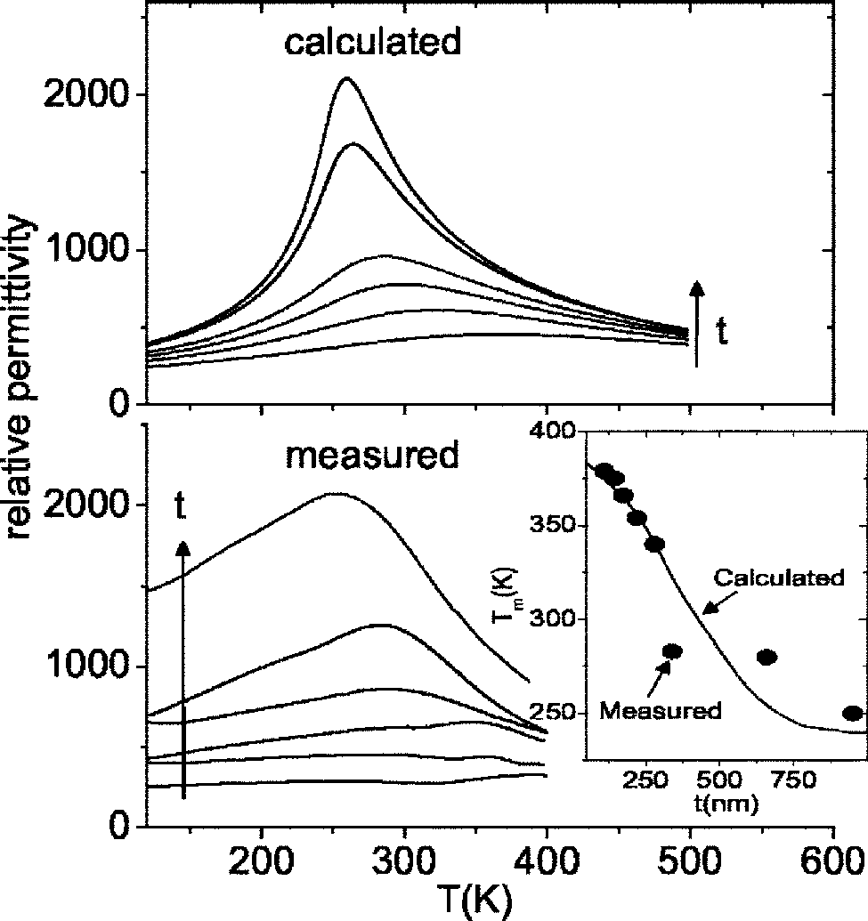

FIG. 3. Calculated and measured dielectric constant as a func-tion of temperature for films of thickness 950, 660, 340, 280, 220, and 145 nm. Inset: The temperature of maximum permittivity, ex-perimental �dots� and calculated �solid line�.

|  |
| --- |
| *G* =�0 *t*�2*aP*2 + 1 4*bP*4 − 1 2�*s*11 + *s*12��2 − *Q*13�*P*2 − �*P*��  − ���*P*�*z*+ 1 2*E*��*P*�*z*� 2 + *F*��*z*�2�*dz*, �7� |

where *P* is the out-of-plane polarization; *sij* the elastic compliances; � the in-plane stress �related to the measured out-of-plane strain by the Young’s modulus and Poisson’s ratio: �=�*Y*�−2���; *Q*13 is the transverse electrostrictive coefficient, *E* and *F* are the constants related to the energy contributions from polarization and stress gradient, and � and � are, respectively, the direct and converse flexoelectric coefficients.31*P* is calculated through varia-tional minimization of the thermodynamic potential, while the second derivative of *G* with respect to *P* yields the in-verse permittivity. This is averaged over the thickness of the film to yield the effective value.

The relative dielectric constants calculated using the strain gradient extracted from our crystallographic analysis are shown in Fig. 3, along with those experimentally measured for the same set of films.11The predicted and measured temperatures of maximum permittivity �*Tm*� are shown in the inset.28Clearly, the decrease in the dielectric constant and upward shift of *Tm* are well reproduced. Quantitatively, the agreement between calculated and mea-sured *Tm* as a function of thickness is very good, given that the calculations are not a best fit but a prediction using bulk Landau coefficients and the strain gradient extracted from our crystallographic analysis. The calculated dielectric constant is similar to, though somewhat larger than that

020102-3

|  |  |  |
| --- | --- | --- |
|  | |  | | --- | | **RAPID COMMUNICATIONS** | |
| CATALAN *et al.* | PHYSICAL REVIEW B **72**, 020102�R� �2005� |

experimentally measured. This was expected, as our

model does not take into consideration any other

permittivity-depressing factors.6,7The results nevertheless

show that the flexoelectric contribution to the depression

in permittivity with decreasing thickness is enormous. This

is particularly valid when comparing with the huge permit-

tivities recently measured in gradient-free ferroelectric

films.32

The dielectric constant is lowest for the thinnest films in

spite of the relatively small value of �*i*. This is a natural

consequence of the fact that the size effect is *not* caused

by the inhomogeneous strain itself, but by the strain

gradient, which, when the profile is exponential, is largest for

the thinnest films. We note also that while compressive

in-plane strain can be used to stabilize the ferroelectric

state, this can come at the expense of reducing the permit-

tivity if strain gradients are not avoided. Finally, we note

that while the methods described here can be used to esti-

mate strain gradients caused by oxygen vacancy

distributions,33dislocations,19,21or cation segregation,20they

do not directly allow us to establish which of these mecha-nisms is actually responsible for the gradient. Further research into the microscopic origin of the gradients is therefore needed.

In summary, x-ray analysis of peak broadening and shape as a function of thickness shows that relaxation of strain in epitaxial films is associated with the appearance of internal strain gradients that, contrary to common belief, can span hundreds of nanometers. The dielectric properties calculated using these strain gradients are close to those experimentally measured, clearly showing the fundamental role played by flexoelectric coupling in decreasing the dielectric constant. This paper highlights the urgent need to avoid strain gradi-ents in order to prevent degradation of the ferroelectric re-sponse in thin films.

Fruitful discussions with D. Balzar, D. Boer, T. Hibma, T. Palstra, S. Szilard, E. Van der Giessen, and J. F. Scott are gratefully acknowledged.

*Electronic address: g.catalan.bernabe@rug.nl   
1R. Ramesh and D. G. Schlom, Science **296**, 1975 �2002�.

2C. H. Ahn, K. M. Rabe, and J.-M. Triscone, Science **303**, 489 �2004�, and references therein.

3J. Junquera and P. Ghosez, Nature �London� **422**, 506 �2003�. 4I. Kornev, H. Fu, and L. Bellaiche, Phys. Rev. Lett. **93**, 196104 �2004�.

5C. Bungaro and K. M. Rabe, Phys. Rev. B **71**, 035420 �2005�. 6M. D. Glinchuk and A. N. Morozovska, J. Phys.: Condens. Matter **16**, 3517 �2004�.

7A. M. Bratkovsky and A. P. Levanyuk, Phys. Rev. Lett. **94**, 107601 �2005�. Note that the samples analyzed in this paper were strain-free, which allowed us to neglect the strain gradient

term.

8O. Dieguez *et al.*, Phys. Rev. B **69**, 212101 �2004�.

9N. A. Pertsev, A. G. Zembilgotov, and A. K. Tagantsev, Phys. Rev. Lett. **80**, 1988 �1998�.

10C. Basceri *et al.*, J. Appl. Phys. **82**, 2497 �1997�.

11L. J. Sinnamon, R. M. Bowman, and J. M. Gregg, Appl. Phys. Lett. **81**, 889 �2002�.

12Sh. M. Kogan, Sov. Phys. Solid State **5**, 2069 �1964�.

13W. Ma and L. E. Cross, Appl. Phys. Lett. **79**, 4420 �2001�; **81**, 3440 �2002�.

14A. K. Tagantsev, Phys. Rev. B **34**, 5883 �1986�.

15G. Catalan, L. J. Sinnamon, and J. M. Gregg, J. Phys.: Condens. Matter **16**, 2253 �2004�.

16Due to the peaks’ asymmetry, the average lattice parameters are

obtained from the peaks’ centers of mass rather than from the

maxima.

17C. L. Canedy *et al.*, Appl. Phys. Lett. **77**, 1695 �2000�.

18M.-W. Chu *et al.*, Nat. Mater. **3**, 87 �2004�.

19L. Nicola, E. Van der Giessen, and M. E. Gurtin, J. Mech. Phys.

Solids **53**, 1280 �2005�.

20J.-L. Maurice *et al.*, Philos. Mag. **83**, 3201 �2003�.

21S. P. Alpay *et al.*, Appl. Phys. Lett. **85**, 2044 �2004�.

22D. Balzar, P. A. Ramakrishnan, and A. M. Hermann, Phys. Rev. B

**70**, 092103 �2004�.

23The addition is quadratic for Gaussian peaks and linear for

Lorentzian. For Pseudovoigt peaks the two components must be

deconvoluted and analyzed separately.

24G. K. Williamson and W. H. Hall, Acta Metall. **1**, 22 �1953�. 25In general the coherence length *D* can be extracted from the in-

tercept at the origin. However, we note that since in our case the

lattice parameter changes as a function of *z*, *D* is not determined

by *t* but by the strain profile.

26J. G. M. Van Berkum *et al.*, Acta Crystallogr., Sect. A: Found. Crystallogr. **52**, 730 �1996�.

27H. Joon Kim, S. Hoon Oh, and Hyun M. Jang, Appl. Phys. Lett. **75**, 3195 �1999�.

28The tetragonal-orthorhombic transition ��50 K below the cubic-tetragonal one in bulk� is visible as a shoulder or small peak in the thinner films. By symmetry our thermodynamic model is

restricted to reproduce only the cubic-tetragonal transition, cor-

responding to the high *Tm*.

29I. Vartanyants *et al.*, Appl. Phys. Lett. **77**, 3929 �2000�.

30A. Boulle *et al.*, J. Appl. Crystallogr. **36**, 1424 �2003�.

31The values for the Landau coefficients are *Y* =197.6 GPa,

�=0.35, ��−��=10−9m3C−1, *a*=9.1�105�*T*−*TC*� �S.I�, *b*=4��796+2,16��*T*−273���106�S.I�, *TC*=235 K, and *E* and *F* can be ignored �Ref. 15�.

32M. M. Saad *et al.*, J. Phys.: Condens. Matter **16**, 451 �2004�. 33J. F. Scott, *Ferroelectric Memories* �Springer-Verlag, Berlin, 2000�, pp. 158–159.

020102-4