

APPLIED PHYSICS LETTERS 101, 082905 (2012)

[Co-sputtering yttrium into hafnium oxide thin films to produce ferroelectric properties](http://dx.doi.org/10.1063/1.4747209)

T. Olsen,1,2,a)U. Schr€oder,1S. M€uller,1A. Krause,1D. Martin,1A. Singh,1J. M€uller,3 M. Geidel,4and T. Mikolajick1,4   
1NaMLab gGmbH, 01187 Dresden, Germany   
2Department of Electrical and Computer Engineering, University of Alberta, Edmonton T6G 2V4, Canada 3Fraunhofer CNT, 01099 Dresden, Germany   
4Institute of Semiconductors and Microsystems, Technische Universit€at Dresden, 01062 Dresden, Germany

(Received 9 July 2012; accepted 6 August 2012; published online 22 August 2012)

Thin film capacitors were fabricated by sputtering TiN-Y doped HfO2-TiN stacks on silicon substrates. Yttrium was incorporated into the HfO2 layers by simultaneously sputtering from Y2O3 and HfO2 sources. Electric polarization and relative permittivity measurements yield distinct ferroelectric properties as a result of low yttrium dopant concentrations in the range of 0.9-1.9 mol. %. Grazing incidence x-ray diffraction measurements show the formation of an orthorhombic phase in this range. Compared to atomic layer deposition films, the highest remanent polarization and the highest relative permittivity were obtained at significantly lower doping concentrations in these sputtered films. V C 2012 American Institute of Physics. [<http://dx.doi.org/10.1063/1.4747209>]

Ferroelectricity is the property of materials that can sus-tain an electrical polarization after the inducing electric field is removed.1Although many applications of ferroelectric materials have been proposed, a widespread approach has been replacing the dielectric in memory devices with ferro-electric thin films to produce non-volatile memory devices such as the ferroelectric field-effect transistor (FeFET),2–5or ferroelectric random access memory (FeRAM).6Other than non-volatile data retention, these technologies have addi-tional benefits such as the fast writing speeds, low required powers, and high read-write endurance. Up until recently, lead zirconate titanate (PZT) has been the main compound used for ferroelectric memories. A major difficulty with PZT, however, is the integration into CMOS devices7and the device scaling. Alternative materials are therefore being investigated. A method of stabilizing HfO2 thin films into a ferroelectric state could be very useful for ferroelectric mem-ory applications because HfO2 is already fully integrated into standard CMOS processing in contemporary technology nodes.8   
 High permittivity crystalline phases in HfO2 have been shown to be the result of techniques such as mechanical con-fined crystallization9and doping with various metals such as yttrium.10Crystallization-altering techniques such as these may also induce ferroelectricity in previous paraelectric materials, forming so-called incipient ferroelectrics.11,12 At room temperature HfO2 crystallizes into a mono-clinic phase (P21/c),13but at elevated temperatures it is trans-formed into tetragonal and then cubic phases.14Moderate doping can cause HfO2 to crystallize and stabilize in these other phases at significantly lower annealing temperatures. This has been shown in doped thin films fabricated by atomic layer deposition (ALD). Grazing incidence x-ray diffraction (GIXRD) scans have shown that the dopants Si,15Y,16and Al17can all facilitate this lower temperature crystallization

a)Author to whom correspondence should be addressed. Electronic mail: trevor.olsen@ualberta.ca.

in thin films. These films were monoclinic at low dopant

|  |
| --- |
| concentrations, and transformed into cubic or tetragonal |

phases at higher dopant concentrations. Yttrium stabilizes

|  |
| --- |
| the cubic phase, whereas Al and Si stabilize the tetragonal |
| phase.18In contrast to Al or Si, whose atomic radius is 40% smaller than hafnium’s, yttrium’s atomic radius is �15% larger.  For all three of the tested dopants (Si,15Y,16and Al17), |

a transitional region was observed by GIXRD at moderate dopant concentrations. In this region, polarization hysteresis loops indicated ferroelectricity. The origin of this ferroelec-

|  |
| --- |
| tricity was attributed to a non-centrosymmetric orthorhombic |

phase transition of space group Pbc21. The strongest ferro-electric properties were reported when the dopant concentra-tion was in the range of 4–7 mol. %. However, at higher concentrations Al and Si induce anti ferroelectricity whereas Y doped films stay ferroelectric. The purpose of this study is

|  |
| --- |
| to shed light on the role of Y doping in stabilizing the coexis- |

|  |
| --- |
| tence of the cubic and orthorhombic crystalline phases in |

Y:HfO2 thin films. Using yttrium as a dopant is of great in-terest because it has so far shown the highest remanent polar-ization (up to 24 lC/cm2)16of the three previously tested dopants.

In this study, physical vapor deposition (PVD) was used to fabricate yttrium-doped HfO2 thin films. This was done in order to exclude ALD specific process parameters as the source of ferrroelectricity. Moreover, choosing a deposition method which typically has different contaminants (Ar, Fe, Cr at very low levels) than ALD (C) as well as a more kinetic deposition process makes an interesting comparison to ear-lier ALD based work.

Since the doping concentrations which induce these effects are very low, it is important to have a high level of certainty about film contamination and the influence of the deposition parameters. Additionally, using ALD may be disadvantageous due to its low deposition rates and rather high costs. Metal-insulator-metal (MIM) capacitor structures were deposited onto a silicon substrate in a three chamber

|  |  |  |
| --- | --- | --- |
| 0003-6951/2012/101(8)/082905/4/$30.00 | 101, 082905-1 | V C 2012 American Institute of Physics |



|  |  |  |
| --- | --- | --- |
| 082905-2 | Olsen et al. | Appl. Phys. Lett. 101, 082905 (2012) |

ultra-high vacuum (UHV) sputter cluster. In this machine, it is possible to deposit the entire MIM stack without breaking vacuum, avoiding film and interface contamination. The 12 nm thick TiN bottom and top electrodes were deposited in a designated metal deposition chamber at 300�C at a pressure of 1.2 � 10�3mbar.

The yttrium-doped HfO2 dielectric layer was deposited in a designated oxide deposition chamber. In this chamber,

using the shared bottom TiN electrode as the second electri-cal contact. Polarization hysteresis loops were measured using an aixACCT TF Analyzer 1000 measurement system and capacitance measurements were taken using a Keithley SCS-4200 measurement system.

For consistent comparison of hysteresis loops between samples of different yttrium concentrations, the same posi-tive and negative peak voltage of 5 V was used for each mea-

|  |  |  |  |  |  |  |
| --- | --- | --- | --- | --- | --- | --- |
| 3-in. sputter sources were arranged confocally to enable co- | surement. | Also | for | consistency, | 5000 | bipolar |

sputtering of a variety of different oxide compositions onto a rotating substrate. The targets used for these dielectric films were HfO2 and Y2O3. They were sputtered at room tempera-ture with an Ar pressure of 1.1 � 10�3mbar. To vary the yt-trium content between samples, the HfO2 source power was kept constant (at 150 W) while the Y2O3 source power was varied from 16 W to 80 W. X-ray photoelectron spectroscopy (XPS) calibrated by Rutherford backscattering spectrometry (RBS) was used to determine the molar concentrations of

preconditioning “wake up” cycles were applied (at a peak voltage of 4 V) before each 5 V measurement. The cycling effects of this “wake up” have been seen before in PZT experiments,20but their effects appear to be quite substantial in doped HfO2.

The crystal structure of each sample was characterized by GIXRD scans performed on a Bruker D8 Discover XRD system (Cu Ka radiation source) equipped with a G€obel mir-ror on the primary side and a lynxeye line detector on the

each sample. secondary side. These scans helped to identify different crys-

|  |
| --- |
| The purpose of the top TiN layer is to mechanically con- |

fine the HfO2 film when it is crystallized by annealing (RTP). This mechanical confinement during crystallization was identified to be mandatory to achieve ferroelectricity in Si-doped HfO2 samples made by ALD.15Similar ALD sam-ples made using Y16and Al17as a dopant found that mechan-ical confinement was not mandatory, but that it produced improved ferroelectric properties. Only mechanically con-fined samples were tested within this study.

|  |
| --- |
| After sputtering, crystallization was induced in the sam- |

ples by rapid thermal processing (RTP) in nitrogen for 1 s at 1000�C. This annealing temperature yielded the best electri-cal results, so it was used for all measurements provided in this study. Even though the yttrium content between different samples was varied, it has been reported that this yttrium content should have no significant influence on the required crystallization temperature.19   
 To form individual capacitor structures, 55 nm thick cir-

tal phases between samples based on the angles of peak dif-fraction intensity. X-ray reflectivity (XRR) scans were also performed on the same Bruker system to verify the thickness and density of different HfO2/TiN sample stacks after the top TiN films were etched away.

Figure 1 shows GIXRD measurements that were taken on a set of samples that were fabricated with varying yttrium concentrations. The measurements were taken using constant incidence angle of 0.5�and the detector angle was varied from 15�to 100�.

Figure 1(a) shows that as the yttrium concentration is increased from sample to sample, the monoclinic phase of pure HfO2 (characterized by two large reflections around 30�) transforms into a clean tetragonal/cubic phase. The tet-ragonal/cubic phase is characterized by a set of well-defined sharp reflections, which can all be easily identified with a tet-ragonal/cubic powder diffraction pattern known for bulk pol-ycrystalline HfO2.14More interesting, however, are the

|  |  |  |  |  |  |  |  |  |  |  |
| --- | --- | --- | --- | --- | --- | --- | --- | --- | --- | --- |
| cular probing pads were deposited onto the top TiN layer | reflections | |  | | --- | | from | | |  | | --- | | the | | |  | | --- | | transitional | | |  | | --- | | doping | | concentrations |
| using an evaporation chamber and a shadow mask. The evap- | (0.2 mol. % to 1.9 mol. %), where additional reflections are | | | | | |



50 nm platinum layer. The circular pads were used as a hard mask for the top TiN layer, which was etched in a 5:1:1 H2O:H2O2:NH4OH solution (RCA SC-1) for 5 min.

Electrical characterization was performed in an electri-cal probing station by probing one of the top Pt pads and

or the tetragonal/cubic phases. A zoomed in look at the 80–90�2H range (Fig. 1(b)) shows an additional reflection at 83.5�which disappears for higher yttrium concentrations. The same is observed for reflections around 39�and 54�

(zoomed areas not shown here). These three reflections fit

|  |  |  |  |  |  |  |  |  |  |  |  |  |
| --- | --- | --- | --- | --- | --- | --- | --- | --- | --- | --- | --- | --- |
|  | | | | | | | | | FIG. 1. (a) GIXRD scans on HfO2 samples with varying yttrium contents as indicated  by the yttrium sputtering power and XPS/ | | | |
| RBS | concentration | measurement. | The |
| reflections marked with short solid lines indicate the non-centrosymmetric Ortho-rhombic phase, which appears only between 0 mol. %–1.9 mol. %. (b) Closer look at the 80�–90�range shows the orthorhombic tri-plet observed at 1.9 mol. % change into a tetragonal/cubic duplet as yttrium concentra-tion increases. | | | |
|  |  |  |  |  |  |  |  |  |
|  | | | | |  | | | |

|  |  |  |
| --- | --- | --- |
| 082905-3 | Olsen et al. | Appl. Phys. Lett. 101, 082905 (2012) |

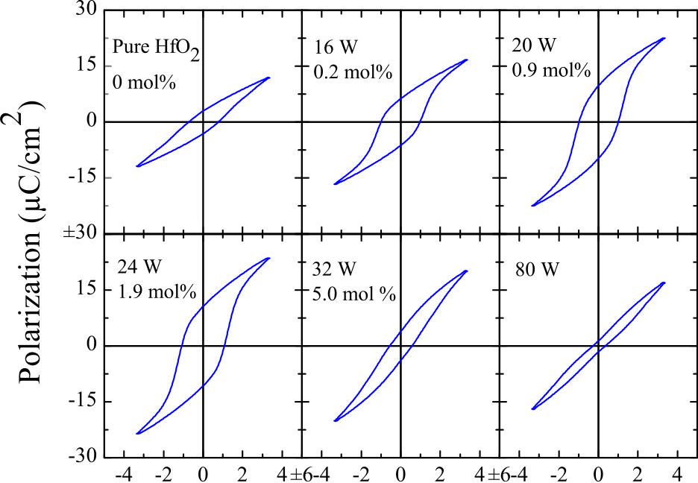



FIG. 2. Dependence of ferroelectric hysteresis properties on the concentra-tion of yttrium dopant. For sputtering powers in the range of 20 W, clear fer-roelectric hysteresis is visible. For lower and higher doping concentrations, a transition to paraelectric behaviour occurs.

well to the non-centrosymmetric orthorhombic Pbc21 phase. It should be noted that there are signs of this orthorhombic phase appearing in the pure HfO2 sample, which was pre-pared in the same way as the other samples, but with the yt-trium sputtering source turned off. This indicates the existence of asymmetric phase structures in the sputtered

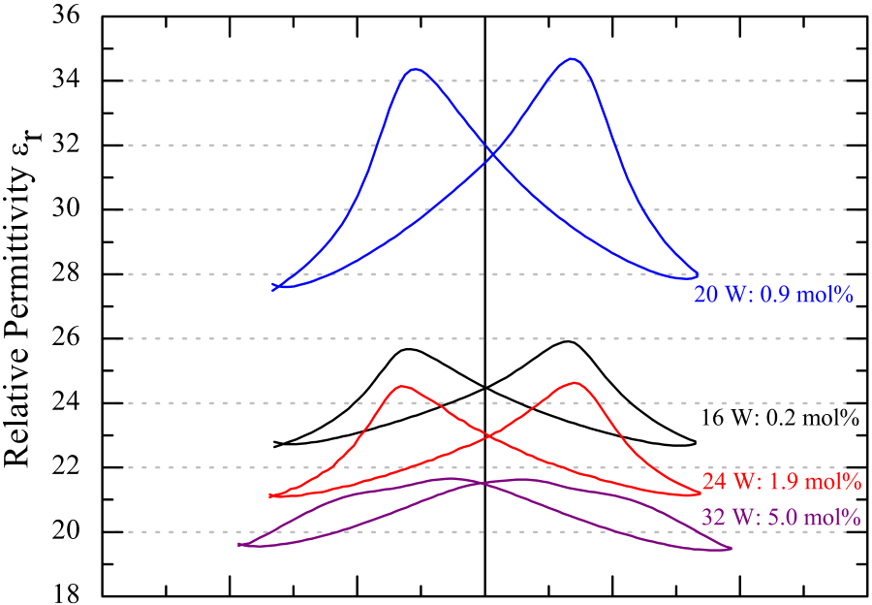

|  |  |  |  |  |  |  |
| --- | --- | --- | --- | --- | --- | --- |
|  |  |  |  |  |  |  |



FIG. 3. Comparison of relative permittivity (from CV measurements) of 12 nm thick HfO2 capacitor structures with varying yttrium dopant concen-trations (labeled by yttrium sputtering power and XPS/RBS concentration measurements).

values in the figure. The occurrence of two capacitance max-ima as shown in the figure is an indicator for ferroelectricity. These maxima have been attributed to maximum domain wall motion at the points where the polarization reaches zero (at the coercive electric fields).21This gives further evidence that the hysteretic charge-voltage behavior is indeed origi-nating from an intrinsic non-centrosymmetry of the stabi-

|  |  |  |  |  |  |  |
| --- | --- | --- | --- | --- | --- | --- |
| HfO2. | lized | crystalline | phase. | Such | a | non-centrosymmetric |

Figure 2 shows how the polarization hysteresis curves of the yttrium-doped HfO2 capacitor structures change as the doping concentration of each dielectric layer is changed. Electrical measurements revealed that between 16 and 24 W of yttrium sputtering power (yttrium concentration between 0.2 and 1.9 mol. %), the hysteresis plots were most pro-nounced. Higher amounts of incorporated yttrium led to a transition to the tetragonal/cubic phase, which is centrosym-metric and therefore paraelectric. However, the transition is not abrupt. A gradual change from ferroelectric curves to paraelectric curves was observed because in the transitional region the film represents a mixture of grains of different

orthorhombic phase was predicted for HfO2 by Lowther et al.,22using an ab initio approach. In such a material, the remanent polarization is due to the displacement of the O atoms against the Hf atoms in the crystal lattice. Further-more, Figure 3 shows the dependence of the relative permit-tivity on the amount of incorporated yttrium, with the highest results occurring in the 0.9 mol. % sample.

In Figure 4, the remanent polarizations and the mini-mum relative permittivities from Figures 2 and 3 are plotted against the yttrium concentration. It should be noted that the remanent polarizations are not at their maximum values because the samples were not driven all the way to satura-

crystalline phases. tion, but to a common near-saturation voltage for consistent

|  |
| --- |
| It is, however, interesting to note that even pure hafnium |

|  |  |  |  |  |  |
| --- | --- | --- | --- | --- | --- |
| oxide thin films (which were mechanically confined by a top | | | | | |
| |  | | --- | | TiN | | |  | | --- | | electrode | | |  | | --- | | during | | |  | | --- | | high | | |  | | --- | | temperature | | |  | | --- | | crystallization) | |

|  |
| --- |
| showed some signs of hysteresis which cannot be explained |

by leakage current. This observation is in agreement with the GIXRD measurements for pure HfO2, which showed signs of an orthorhombic phase already starting to stabilize. This is

|  |
| --- |
| an important finding because it has not been previously |

reported in pure HfO2 thin film capacitors fabricated by ALD deposition. Further investigation is required to deter-mine whether this is a material property of pure HfO2 or if it is a side effect from the sputtering process such as contami-nation or sputter damage.

Capacitance-voltage (CV) measurements were also per-formed to further validate the occurrence of ferroelectricity in the Y-doped HfO2 thin films. Figure 3 shows the depend-ence of small signal CV characteristics on the amount of yt-trium dopant. CV measurements were taken at a frequency of 50 kHz and were used to calculate the relative permittivity

comparison. The figure shows that the highest values of

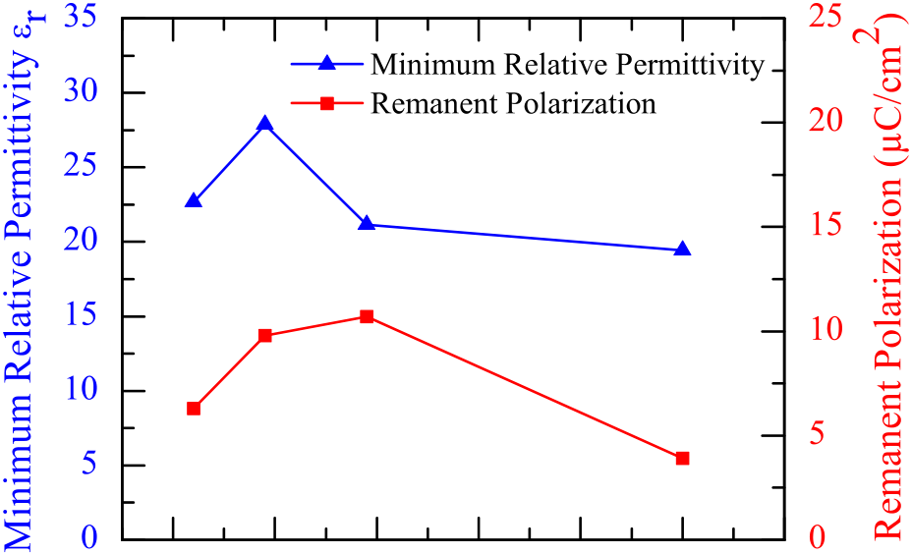

|  |  |  |  |  |  |  |
| --- | --- | --- | --- | --- | --- | --- |
|  |  |  |  |  |  |  |



FIG. 4. Remanent polarizations and minimum relative permittivities of capaci-tors with varying yttrium concentrations, extracted from Figures 2 and 3.

|  |  |  |
| --- | --- | --- |
| 082905-4 | Olsen et al. | Appl. Phys. Lett. 101, 082905 (2012) |

relative permittivity and remanent polarization occur at slightly different yttrium concentrations (0.9 and 1.9 mol. %, respectively). In ALD-deposited yttrium-doped HfO2 films, the highest values of relative permittivity and remanent polarization were found at a much higher yttrium dopant concentration of 5.2 mol. %.16There are many differences

|  |
| --- |
| between the two processes that could cause this, but a likely |

|  |
| --- |
| very important difference is the uniformity of the dopant dis- |

|  |
| --- |
| tribution in each process. |

In conclusion, yttrium-doped HfO2 thin film (12 nm) capacitors were fabricated by co-sputtering from HfO2 and Y2O3 sources. The samples were characterized by electrical polarization, capacitance-voltage, XPS/RBS, and GIXRD measurements. It was demonstrated that sputtered HfO2 thin

|  |
| --- |
| films show ferroelectric properties when light yttrium dopant |

concentrations (0.9–1.9 mol. %) are incorporated. Electrical

|  |  |  |  |  |  |
| --- | --- | --- | --- | --- | --- |
| polarization | and | CV | measurements | both | demonstrated |

ferroelectric characteristics while GIXRD measurements validated that, as proposed for ALD-deposited films, a non-centrosymmetric transitional phase between the lower sym-metry monoclinic and the higher symmetry cubic phase might be the origin for the observed ferroelectric properties. The fact that HfO2 can be stabilized into a ferroelectric state by PVD co-sputtering enhances the understanding of ferroe-lectricity in doped HfO2 and gives a higher degree of free-dom in the optimization of ferroelectric thin film devices, opening the door to additional device applications that can-not be addressed using ALD.

This work was financially supported by the Free State of Saxony and the European Union EFRE fund (HEIKO project 100064806).

1M. E. Lines and A. M. Glass, Principles and Applications of Ferroelec-

trics and Related Materials (Clarendon, University of Michigan, 1977). 2D. H. Looney, U.S. patent no. 2791758 (1957).

3N. Setter, D. Damjanovic, L. Eng, G. Fox, S. Gevorgian, S. Hong, A.

Kingon, H. Kohlstedt, N. Y. Park, G. B. Stephenson, I. Stolitchnov, A. K.

Taganstev, D. V. Taylor, T. Yamada, and S. Streiffer, [J. Appl. Phys.](http://dx.doi.org/10.1063/1.2336999) 100,

51606 (2006).

4S. Y. Wu, [IEEE Trans. Electron Devices](http://dx.doi.org/10.1109/T-ED.1974.17955) ED-21, 499 (1974).

5J. Hoffman, X. Pan, J. W. Reiner, F. J. Walker, J. P. Han, and C. H. Ahn,

[Adv. Mater.](http://dx.doi.org/10.1002/adma.200904327) 22, 2957 (2010).

6H. Koike, U.S. patent no. 5600587 (1997).

7K. Kim and S. Lee, [J. Appl. Phys.](http://dx.doi.org/10.1063/1.2337361) 100, 51604 (2006).

8M. T. Bohr, R. S. Chau, T. Ghani, and K. Mistry, [IEEE Spectrum](http://dx.doi.org/10.1109/MSPEC.2007.4337663) 44(10),

29 (2007).

9S. Migita, Y. Watanabe, H. Ota, H. Ito, Y. Kamimuta, T. Nabatame, and

A. Toriumi, [Dig. Tech. Pap.-Symp. VLSI Technol.](http://dx.doi.org/10.1109/VLSIT.2008.4588599) 2008, 152.

10J. Y. Dai, P. F. Lee, K. H. Wong, H. L. W. Chan, and C. L. Choy, [J. Appl.](http://dx.doi.org/10.1063/1.1585116)

[Phys.](http://dx.doi.org/10.1063/1.1585116) 94, 912 (2003).

11K. A. M€uller and H. Burkard, [Phys. Rev. B](http://dx.doi.org/10.1103/PhysRevB.19.3593) 19, 3593 (1979).

12E. A. Eliseev, M. D. Glinchuk, and A. N. Morozovska, [Phys. Status Solidi](http://dx.doi.org/10.1002/pssb.200743159)

|  |
| --- |
| B 244, 3660 (2007). |

13X. Zhao and D. Vanderbilt, [Phys. Rev. B](http://dx.doi.org/10.1103/PhysRevB.65.233106) 65, 233106 (2002).

14J. Wang, H. P. Li, and R. Stevens, [J. Mater. Sci.](http://dx.doi.org/10.1007/BF00541601) 27, 5397 (1992).

15T.S. B€oscke, J. M€uller, D. Br€auhaus, U. Schr€oder, and U. B€ottger, [Appl.](http://dx.doi.org/10.1063/1.3634052)

[Phys. Lett.](http://dx.doi.org/10.1063/1.3634052) 99, 102903 (2011).

16J. M€uller, U. Schr€oder, T. S. B€oscke, I. M€uller, U. B€ottger, L. Wilde, J.

Sundqvist, M. Lemberger, P. K€ucher, T. Mikolajick, and L. Frey, [J. Appl.](http://dx.doi.org/10.1063/1.3667205)

[Phys.](http://dx.doi.org/10.1063/1.3667205) 110, 114113 (2011).

17S. M€uller, J. M€uller, A. Singh, S. Riedel, J. Sundqvist, U. Schr€oder, and T.

Mikolajick, [Adv. Funct. Mater.](http://dx.doi.org/10.1002/adfm.201103119) 22(11), 2412–2417 (2012).

18C. K. Lee, E. Cho, H. S. Lee, C. S. Hwang, and S. Han, [Phys. Rev. B](http://dx.doi.org/10.1103/PhysRevB.78.012102) 78,

012102 (2008).

19S. V. Ushakov, C. E. Brown, and A. Navrotsky, [J. Mater. Res.](http://dx.doi.org/10.1557/jmr.2004.19.3.693) 19, 693

|  |
| --- |
| (2004). |

20N. Menou, Ch. Muller, I. S. Baturin, V. Y. Shur, and J.-L. Hodeau, [J.](http://dx.doi.org/10.1063/1.1870098)

[Appl. Phys.](http://dx.doi.org/10.1063/1.1870098) 97, 064108 (2005).

21D. Bolten, O. Lohse, M. Grossmann, and R. Waser, [Ferroelectrics](http://dx.doi.org/10.1080/00150199908016462) 221,

251 (1999).

22J. E. Lowther, J. K. Dewhurst, J. M. Leger, and J. Haines, [Phys. Rev. B](http://dx.doi.org/10.1103/PhysRevB.60.14485) 60,

14485 (1999).