|  |  |
| --- | --- |
| Please do not adjust margins |  |
| **Journal of Materials Chemistry C** |  |
|  | |

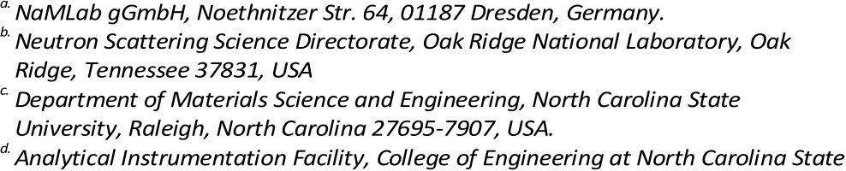

|  |
| --- |
| ARTICLE |

**A comprehensive study on the structural evolution of HfO2 thin films doped with various dopants**

|  |  |
| --- | --- |
| Received 00th January 20xx, Accepted 00th January 20xx  DOI: 10.1039/x0xx00000x  **www.rsc.org/** | M. H. Park,a,* T. Schenk,a C. M. Fancher,b E. D. Grimley,c C. Zhou,d C. Richter,a J. M. LeBeau,c J. L. Jones,c T. Mikolajicka,e and U. Schroedera  The origin of the unexpected ferroelectricity in doped HfO2 thin films is now considered to be the formation of a non-centrosymmetric *Pca21* orthorhombic phase. Due to the polycrystalline nature of the films as well as their extremely small thickness (~10 nm) and mixed orientation and phase composition, structural analysis of doped HfO2 thin films remains a |

challenging task. As a further complication, the structural similarities of the orthorhombic and tetragonal phase are difficult to distinguish by typical structural analysis techniques such as X-ray diffraction. To resolve this issue, the changes in the grazing incidence X-ray diffraction (GIXRD) patterns of HfO2 films doped with Si, Al, and Gd are systematically examined. For all dopants, the shift of *o111*/*t101* diffraction peak is observed with increasing atomic layer deposition (ALD) cycle ratio, and this shift is thought to originate from the orthorhombic to *P42/nmc* tetragonal phase transition with decreasing aspect ratio (2a/(b+c) for orthorhombic and c/a for the tetragonal phase). For quantitative phase analysis, Rietveld refinement is applied to the GIXRD patterns. A progressive phase transition from *P21/c* monoclinic to orthorhombic to tetragonal is confirmed for all dopants, and a strong relationship between orthorhombic phase fraction and remanent polarization value is uniquely demonstrated. The concentration range for the ferroelectric properties was the narrowest for the Si-doped HfO2 films. The dopant size is believed to strongly affect the concentration range for the ferroelectric phase stabilization, since small dopants can strongly decrease the free energy of the tetragonal phase due to their shorter metal-oxygen bonds.

**Introduction**

Since the first report on ferroelectricity in Si doped HfO2 in 2011,1 ferroelectricity in pure HfO2,2-4 HfO2 doped with various dopants,5-13 and solid solution14-17 or nanolaminate18-20 of HfO2

and ZrO2 as well as pure ZrO2 21-23 have been intensively studied by numerous researchers.13 The origin of the unexpected

ferroelectric properties is now believed to be the formation of

the non-centrosymmetric orthorhombic phase (space group P*ca*21,No. 29).1,25,26 It should be noted that this orthorhombic

phase is different from the centrosymmetric orthorhombic

phases which are previously known as high pressure phases of bulk HfO2 and ZrO2.27,28 Although this non-centrosymmetric

This journal is © The Royal Society of Chemistry 20xx

phase was reported before by both experimental and theoretical works, its ferroelectricity was not checked at the time.27,28 The ferroelectric and field-induced ferroelectric properties of HfO2-based films are considered promising for various applications including nonvolatile memories, negative capacitance field-effect-transistors, energy storage/harvesting, and solid-state cooling based on its properties that distinguish it from conventional ferroelectrics based mostly on the perovskite or layered perovskite structures.9,24,29-35 Above all, HfO2 itself is highly scalable and Si-compatible, and it has been used in the semiconductor industry since its first adoption by Intel.36 As ferroelectrics have been downscaled for use in devices, a so-called “size effect” appeared which limits, or eliminates entirely, functional properties at ultra-thin thicknesses. This has been a critical problem for downscaling of conventional ferroelectrics.37 In contrast, ferroelectric properties with remanent polarizations (Pr) larger than 15 µC/cm2 are confirmed for doped HfO2 films that are 10 nm-thick or even thinner. This has enabled the fabrication of the first 28 nm ferroelectric gate field-effect transistors (FeFET).9,24,29,30 According to the extrapolated retention test, the two memory states are expected to remain for 10 years, and these FeFETs are believed to be superior to those prepared with conventional ferroelectrics based on the perovskite structure.9,24,29,30,38 Theoretical work from Ma *et al.* suggests that the ferroelectric doped HfO2 films have longer retention because of their relatively low relative permittivity er and their high coercive field compared to those of conventional ferroelectrics.39

*J. Name*., 2013, **00**, 1-3 | **1**

|  |
| --- |
| Please do not adjust margins |

|  |  |  |
| --- | --- | --- |
| Please do not adjust margins | |  |
| **ARTICLE** | | **Journal Name** |
| Despite the fact that the promising ferroelectric properties of | **Sample preparation** |



doped HfO2 films have been confirmed by intense research, the dependence of structure on dopant concentration remains to

|  |  |  |  |  |  |
| --- | --- | --- | --- | --- | --- |
| be | systematically | characterized. | Starschich | et | al. |

comprehensively examined the effect of dopant species on ferroelectric properties of their chemical solution deposited (CSD) HfO2 films,11 but there are critical differences between CSD and ALD HfO2 films. From Grazing incidence X-ray diffraction (GIXRD) patterns of CSD HfO2 films, the dominant crystalline phase is believed to be cubic phase, and their Pr values before wake-up field cycling were quite small.11 After wake-up field cycling, however, the CSD HfO2 films could show Pr values as large as those of ALD HfO2 films. Therefore, it is believed that the phase evolution during wake-up field cycling is more critical for CSD HfO2 films than ALD HfO2 films. Therefore, the ALD HfO2 films are considered to be more appropriate for structural analysis, since they might have more ferroelectric phase before wake-up field cycling than CSD films. The most serious hindrance for structural analysis may be the

|  |  |  |  |  |  |
| --- | --- | --- | --- | --- | --- |
| structural | similarity | between | the | orthorhombic | and |

tetragonal/cubic phase, which are believed to be the origin of ferroelectric and field-induced ferroelectric properties, respectively.15,24,25 Thus far, the identification of a non-centrosymmetric phase (required to enable ferroelectricity) in doped HfO2 thin films has been successfully conducted only by scanning transmission electron microscopy (STEM) based methods,24,40,41 rather than by structural analysis such as XRD.42,43 The symmetries of the zone axes are quite distinct for the Hf positions between the orthorhombic phase and the tetragonal/cubic phase using STEM, but broadening of the diffraction peaks due to the small thickness of the sample makes diffraction (both Bragg-Brentano and grazing incidence) non-ideal for clearly distinguished these phases. According to several calculations and experimental works, there is a very small difference between the lattice parameters of the ferroelectric orthorhombic and tetragonal/cubic phase.25,26 Furthermore, polycrystalline doped HfO2 films are mixtures of multiple orientations, which both weakens peak intensities and further broadens them.44 As a result, a very small film volume is aligned along the direction appropriate for the Bragg-Brentano geometry. In most cases only grazing incidence XRD (GIXRD) patterns have yielded the best results for polycrystalline HfO2 films doped with various dopants. Though considerable steps towards epitaxial and/or highly textured HfO2 films have been reported recently,41,45,46 polycrystalline films are relevant for device application and thus require an adequate structural analysis. Despite the aforementioned difficulties with X-ray techniques and this material, macroscopic structural analysis via GIXRD is one of the most useful approaches to understand the structural evolution in doped HfO2-based films. In this study, therefore, the macroscopic and microscopic structural properties are systematically examined using GIXRD, and the obtained results are discussed in the context of the STEM results.

**Experimental**

**2** | *J. Name*., 2012, **00**, 1-3

The doped HfO2 films were deposited using a thermal ALD process on TiN electrode on p-type *100* Si substrates. The TiN bottom electrode was deposited via reactive magnetron sputtering at room temperature using a Ti target within an N2 atmosphere for Si- and Al-doped HfO2 films, and via plasma enhanced ALD for Gd-doped HfO2 films. For the deposition of Si-

|  |  |  |  |
| --- | --- | --- | --- |
| doped | HfO2 | films, | tetrakis(ethylmethylamino)hafnium |

(TEMAHf) and N, N, N',N'-Tetraethyl Silanediamine (SAM.24) were used as precursors, and H2O and O2 plasma were used as oxygen sources, respectively. The Si dopant concentration within films could be controlled by changing the HfO2:SiO2 ALD cycle ratio. For the deposition of Al-doped HfO2 films, hafnium tetrachloride (HfCl4) and trimethyl aluminium (TMA) were used as precursors, respectively, and H2O was used as an oxidant both for Hf and Al. The deposition temperature was 300 °C. For the deposition of Gd-doped HfO2 films, hafnium tetrachloride (HfCl4) and Gd(iPrCp)3 were used as precursors, and H2O was used as an oxidant both for Hf and Gd. After deposition of the doped HfO2 films, a top TiN capping layer was deposited via reactive magnetron sputtering using a Ti target within an N2 atmosphere, and the post-metallization-annealing (PMA) process was conducted at 800 °C for 20 s in N2 atmosphere for the crystallization of the films. After the PMA process, Pt electrodes were deposited via e-beam evaporation, and the Pt electrodes were patterned using a shadow mask. Patterned Pt top electrodes were used as a hard mask during the subsequent TiN wet etch process using a SC1 solution containing NH4OH, H2O2, and H2O.

**Physical and Chemical Analyses**

The X-ray reflectivity (XRR) and GIXRD were carried out using a X-ray diffractometer (D8 Discover, Bruker). For GIXRD, the incidence angle was fixed at 0.45°, and the diffraction patterns were analyzed within a 2q range of 15 - 90°. For the quantitative structural analysis, a commercial software for Rietveld refinement (TOPAS, Bruker) was used. For the Rietveld refinement, fundamental crystal structures of monoclinic, tetragonal, and orthorhombic HfO2 and cubic TiN taken from Crystallographic Information File (CIF)47 were used as input. The crystallographic information was taken from Powder Diffraction File (PDF) card numbers 00-034-010448, 04-005-559749, and 04-011-882050 for monoclinic, orthorhombic, and tetragonal phase HfO2, while the PDF number for cubic TiN was 00-038-142051. The details of PDF used for the phases of HfO2 and TiN can be found in the thesis by Schenk.41 For the background fitting, a 5th order Chebychev polynomial combined with 1/x function was used. To consider preferred orientation, the March-Dollase model52,53 was used. The preferred orientation of (111) and (101) were considered for orthorhombic and tetragonal HfO2, respectively. Scale factors for all phases were also controlled during the fitting process. The role of scale factors is to scale the calculated intensities of diffraction patterns, so they should be strongly related with various external factors including X-ray beam intensity and measurement time. One of the fitting

This journal is © The Royal Society of Chemistry 20xx

|  |
| --- |
| Please do not adjust margins |

|  |  |  |
| --- | --- | --- |
| **Journal Name** | Please do not adjust margins | **ARTICLE** |

parameters named ‘zero error’, which shows the shift of the 

whole diffraction pattern due to some external causes, was not automatically controlled for fitting in this study, since unreasonably large shift could be observed in some refinement results with fitting zero error. Thus, this term was fixed at zero. A ferroelectric tester (TF analyzer 3000, Aixacct systems) was used to examine the ferroelectric properties of doped HfO2 films. A triangular double pulse was applied to the top electrode while the bottom electrode was connected to virtual ground, and a measurement frequency of 1-10 kHz was used. The Pr values for doped HfO2 films were taken from the polarization-electric field curves achieved with 3.9-4.0 MV/cm pulse height. For fair comparison, the Pr values in pristine states were compared with the structural data. The XRD footprint is several cm2 large. Such large area cannot be subjected to field cycling without dielectric break down.

A TOF SIMS V (ION TOF, Inc. Chestnut Ridge, NY) instrument, which was equipped with a Bi*n m*+ (n = 1 - 5, *m* = 1, 2) liquid metal ion gun, Cs+ sputtering gun and electron flood gun to compensate charge, was used for TOF-SIMS analyses. The orientation of both the Bi and Cs ion columns was fixed at 45° with respect to the sample surface normal. The instrument vacuum system consists of an analysis chamber and an adjacent load lock for rapid sample loading, and they were separated by the gate valve. To avoid contamination of the surfaces, the pressure of analysis chamber was maintained below 5.0 x 10-9 mbar. 1 keV low energy Cs+ with 10 nA current was used for the depth profiles acquired in this study to create a 140 µm by 140 µm area. The middle 50 µm by 50 µm area was analyzed using 0.3 pA Bi3 + primary ion beam. The standard HfO2 film used for quantification was doped with 1 x 1016 ions/cm2 Si4+ and 5 x 1015 ions/cm2 Al3+. The depth of the crater generated by sputtering was measure with a Tencor P-20 long scan profiler. The depth resolution obtained using the experiment setting is between 2-3 nm. The negative secondary ion mass spectra were calibrated using H-, C-, O-, Hf-, HfO- and HfO2-. Experimental details of XRF can be found in a previous study.54,55   
Lamella were prepared for STEM by a focused ion beam, using an FEI Quanta to prepare the 27 nm-thick Gd-doped HfO2 (annealed at 650 oC for 20 s in N2 atmosphere) and 10 nm-thick Si-doped HfO2 (annealed at 1000 oC for 1s in N2 atmosphere) thin film and using an FEI Helios nanolab 600i to prepare the 10 nm Si-doped HfO2 thin film. A probe-corrected FEI Titan G2 60-300 kV was operated at 200 kV with a beam current of approximately 80 pA. For high-angle annular dark-field scanning transmission electron microscopy (HAADF-STEM), the detector inner semi-angle was approximately 77 mrad and the probe semi-convergence angle was 19.6 mrad. The RevSTEM imaging technique was used to remove distortion due to thermal drift14 using forty 1024 pixel by 1024 pixel image frames acquired with a dwell time of 2 µs / pixel and a rotation angle of 90° between each successive image frame.

**Results and discussion**

**Origin of ferroelectricity in fluorite structure based ferroelectrics**

This journal is © The Royal Society of Chemistry 20xx

**Fig. 1** The schematic diagram for the evolution of phases in doped HfO2 films and

|  |
| --- |
| resulting electrical characteristics. The remanent polarization (Pr) and dielectric constant values (er) were taken from Ref. 26. Reproduced with permission. 26 Copyright |

2015, AIP Publishing LLC.

Figure 1 summarizes the phase dependence upon various driving factors (doping, surface energy, stress…) reported in HfO2 thin films. Referring to the figure, a phase change from the monoclinic (space group P21/*c*, No. 14), to the orthorhombic, and tetragonal (space group P42/*nmc*, No. 137) phase is visible for increasing dopant content. The stable phase of bulk HfO2 is the monoclinic phase which is centrosymmetric and thus incapable of supporting ferroelectricity. Another important metastable phase in bulk or thin film HfO2 is the tetragonal phase, and it is well-known that this metastable phase can be stabilized for various dopants or due to surface/interfacial energy effects.24,26,56,57 In 2011, the unexpected ferroelectricity was first reported at the morphotrophic phase boundary of the two phases.1 Various factors affecting the formation of the orthorhombic phase have been reported. Materlik et al. reported that the large free energy difference between the stable monoclinic phase and orthorhombic phase within bulk form can be compensated by the difference between the surface or interfacial energy of the two phases in a polycrystalline thin film structure.26 In addition to size effects, various factors such as dopant concentration, the stress/strain in thin films, electrode materials, and the upper capping layer are reported to affect the polymorphism in doped HfO2 films.24

|  |  |  |  |  |  |  |
| --- | --- | --- | --- | --- | --- | --- |
| However, | the | structural | changes | induced | by | the |

aforementioned factors are not clearly understood yet.

To date, perovskite-structure-based ferroelectrics have been the most intensively studied among the various ferroelectric materials, and the structural origin of the spontaneous polarization in perovskite materials is well understood based on the distortion of the oxygen octahedra.56 The upper row of figure 2 compares the distortion of the oxygen octahedron in cubic and tetragonal perovskite structures. Generally, ABO3-type perovskites consist of two different cations (A and B) and oxygen ions (O). There are six oxygen ions (each oxygen ion is shared by two adjacent unit cells) in a unit cell, and they are located at the six face centers, while the B-site cation is located at the body center of the unit cell. In the cubic phase, the charge

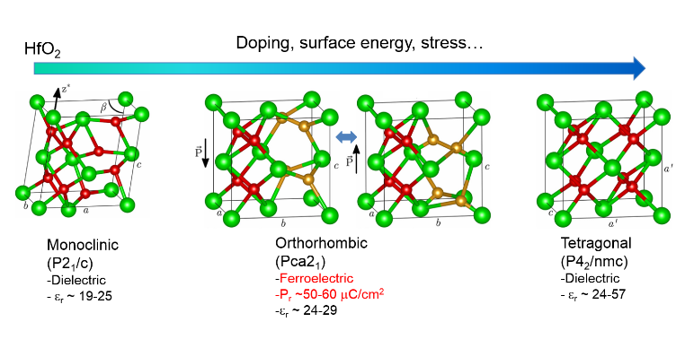

centroids of the cations and anions in a unit cell are equivalent due to the existence of inversion symmetry, meaning that the phase cannot be ferroelectric. When there is an elongation

*J. Name*., 2013, **00**, 1-3 | **3**

|  |
| --- |
| Please do not adjust margins |

|  |  |  |
| --- | --- | --- |
| **ARTICLE** | Please do not adjust margins | **Journal Name** |

coordination), but they amount to less than 1 % of the c lattice   
parameter. 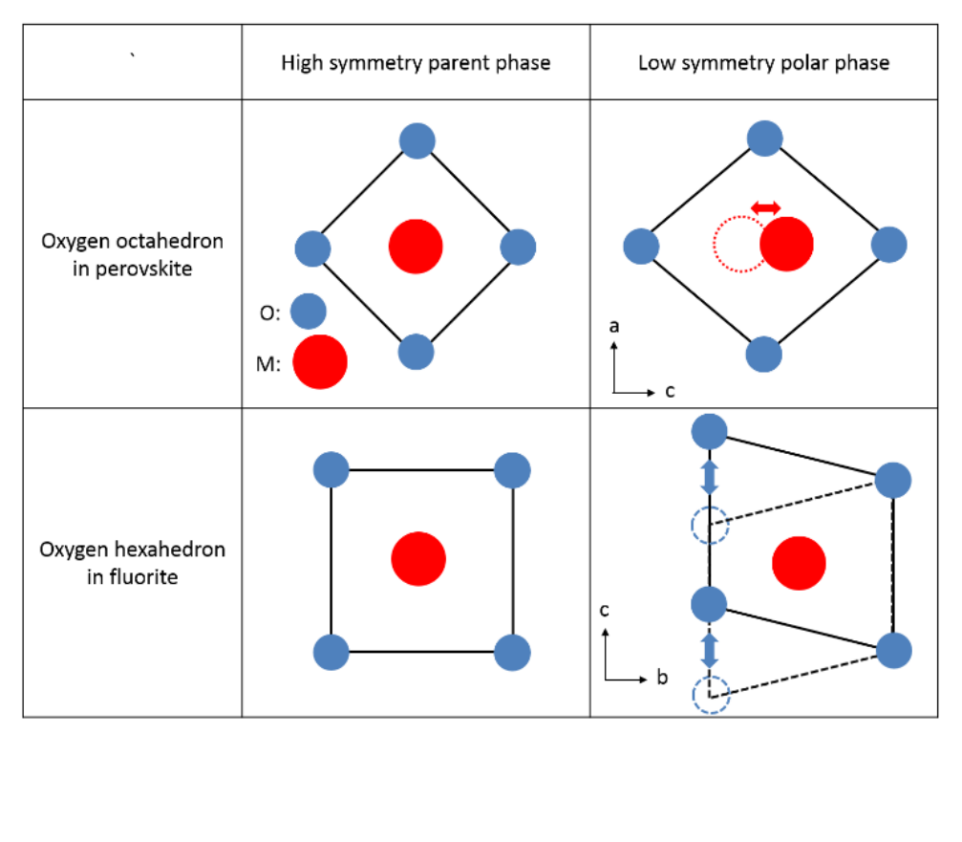

Direct experimental observation of a small tilt of oxygen   
polyhedra is difficult even with state-of-the-art experimental   
tools and techniques. However, the aforementioned discussion   
is beneficial for understanding the structural evolution in

|  |  |  |  |  |  |
| --- | --- | --- | --- | --- | --- |
| fluorite | ferroelectrics. | In | perovskite | ferroelectrics, | the |

tetragonality or c/a ratio is frequently used to simply describe   
the structural distortion.57-59 The polar axis (c-axis) of the   
tetragonal perovskite phase is generally larger by a few percent   
compared to the nonpolar axis (a-axis), so the tetragonality   
should be strongly related to the distortion of oxygen   
octahedron. The structural evolution in a fluorite ferroelectric   
might be also qualitatively similar to perovskite ferroelectrics.   
The crystal structure of the monoclinic phase is clearly different

**Fig. 2** A schematic for the structural origin of the ferroelectricity in perovskite and fluorite ferroelectrics.

along the c-axis, however, the oxygen octahedron is distorted resulting in a formation of the tetragonal phase. Therefore, the stable location of the B-site cation is displaced away from the center, and there are now two stable eccentric positions. This is the origin of the two stable spontaneous polarization states in a tetragonal perovskite material. An analogous discussion can be also derived for fluorite-structure-based ferroelectrics, and the bottom row of figure 2 shows the distortion of oxygen hexahedron (cubic coordination) in these ferroelectrics (see also unit cells in figure 1). There are four metal and eight oxygen ions in a unit cell of the fluorite structure. Metal ions are located at eight corners and six face centers, while oxygen ions are located at the eight tetrahedral sites. One tetrahedron can be constructed with one corner and three face centered metal ions. For the cubic phase, the oxygen hexahedron with body centered metal ion can be found in two adjacent unit cells. When there is an elongation along the a-axis of the cubic phase, the ferroelectric orthorhombic phase can be formed. In this case, the location of four oxygen ions (whose coordination number is three, yellow oxygen ions in figure 1) is significantly shifted (~13.8 % of c lattice parameter26) from the stable position in a cubic phase, and each of them has two stable positions. There are also slight shifts in the position of the other four oxygen ions (red oxygen ions in figure 1 with four-fold

from the tetragonal or orthorhombic phase. However, distinguishing the orthorhombic from the tetragonal phase is very challenging especially given the fact that the Cu-Kα radiation used in standard lab equipment is hardly sensitive to the oxygen in the presence of heavy atoms like Hf. It is reported that there is a large difference between the relative ratio of the longer axis to shorter axes of the orthorhombic and tetragonal phase.15,24 Table I summarizes the lattice parameters of both phases as reported in literature15 , without considering lattice parameters obtained from polycrystalline thin films, since the values might be a lattice parameters average of mixed phases. In summary, two important points should be noticed. First, the aspect ratio (ra, specified as 2a/(b+c) for the orthorhombic and c/a for the tetragonal phase) of the orthorhombic phase is much larger than for the tetragonal phase. The 2a/(b+c) of the orthorhombic phase was in the range of 1.035-1.040,15 while the c/a value of the tetragonal phase was in the range of 1.011-1.027.15 This difference in ra was first pointed out by Park et al. in 2013, and more recent results also showed a similar trend.15 Accordingly, the change of the ra could serve as an indirect evidence for the phase evolution. Second, the difference between b and c lattice parameters in the orthorhombic phase was smaller than 0.4 %. Even from the structural analysis on epitaxial Y-doped HfO2 films, the diffraction peaks from (020) and (002) planes could not be distinguished from each other possibly due to the broadening of the diffraction peaks.44,46

**Table I** Lattice parameters of orthorhombic and tetragonal HfO2. For the sake of convenience, the lattice parameters from double sized unit cells were taken for the tetragonal phase.

|  |  |  |  |  |  |  |  |
| --- | --- | --- | --- | --- | --- | --- | --- |
| Phase | a [Å] | | b [Å] | c[Å] | ra | V[Å 3] | References |
| 5.10 | | | 4.90 | 4.92 | 1.041 | 123.19 | Zeng et al.[66] |
| orthorhombic | | 5.07 | 4.88 | 4.89 | 1.038 | 120.99 | Reyes-Lillo et al.[67] |
| 5.23 | | | 5.04 | 5.06 | 1.036 | 133.38 | Materlik et al.[26] |
| 5.06 | | |  | 5.20 | 1.027 | 133.29 | Zeng et al.[66] |
| tetragonal | | 4.89 | 4.95 | 1.012 | 118.52 | Reyes-Lillo et al.[67] |
| 5.05 | | | 5.14 | 1.018 | 131.02 | Materlik et al.[26] |
| **4** | *J. Name*., 2012, **00**, 1-3 | | |  |  |  | This journal is © The Royal Society of Chemistry 20xx | |

|  |
| --- |
| Please do not adjust margins |

|  |  |  |
| --- | --- | --- |
| **Journal Name** | Please do not adjust margins | **ARTICLE** |

**Table II**The atomic layer deposition (ALD) cycle ratio and resulting doping concentrations for doped HfO2 films.ALD cycle ratio refers to relative cycle ratio between Hf and dopant. (XPS: X-ray photoelectron spectroscopy, TOF-SIMS: time of flight secondary ion mass spectrometry, TOF-ERDA: time of flight elastic recoil detection analysis, and PIXE: particle induced X-ray emission, XRF: X-ray fluorescence) 

|  |  |  |  |  |  |  |  |  |
| --- | --- | --- | --- | --- | --- | --- | --- | --- |
| Dopant |  | Sample#1 | Sample#2 | Sample#3 | Sample#4 | Sample#5 | Sample#6 | Sample#7 |
| Si | ALD cycle ratio [CR%] | 2.1 | 3.2 | 3.7 | 4.0 | 4.8 | 5.3 | 5.9 |
| (Hf:Si) | (46:1) | (30:1) | (26:1) | (24:1) | (20:1) | (18:1) | (14:1) |
|  | [50]  XPS [%] | - | - | - | - | - | - | 5 |
| TOF-SIMS [%] | - | - | 2.0 | - | - | 2.8 | - |
|  | ALD cycle ratio [CR%] | 3.0 | 3.6 | 4.3 | 5.6 |  |  |  |
| (Hf:Al) | (32:1) | (27:1) | (22:1) | (17:1) |
| Al | [62] from growth rate [%] | 4.9 | 5.8 | 6.9 | 8.8 |  |  |  |
| TOF-SIMS [%] | 1.0 | - | - | 2.0 |
| TOF-ERDA [%] | - | - | - | 7.4 |
|  | ALD cycle ratio [CR%] | 3.6 | 4.2 | 5.0 | 6.7 | 9.1 | 10.0 | 11.1 |
| (Hf:Gd) | (27:1) | (23:1) | (19:1) | (14:1) | (10:1) | (9:1) | (8:1) |
| Gd | from growth rate/[%] | 3.5 | 4.2 | 5.0 | 6.7 | 9.1 | 10.0 | 11.1 |
| [63]  GR/XPS [%] | 2.0 | - | 3.0 | 7 | 9 | 6.0 | 11 |
| [7]  XPS [%] |
| - | - |
| [61]  PIXE [%] | 3.4 | - |
| XRF [%] | 2.2 |

**Structural and chemical analysis based on STEM and secondary ionic mass spectrometry**

To examine the structural and chemical properties of doped HfO2 films, Si-, Al-, and Gd-doped HfO2 films with various atomic layer deposition (ALD) cycle ratios (CR% = dopant/[dopant + Hf] x 100) were used. The detailed sample fabrication process and analysis techniques are included in the experimental procedure section. Measurements of correlation between ALD cycle ratio and the resulting dopant concentration by time of flight secondary ion mass spectrometry (TOF-SIMS) (for Si- and Al-doped HfO2 films), X-ray photoelectron spectroscopy (XPS) (for Si-60 and Gd-doped HfO2 films7), time of flight elastic recoil detection analysis (TOF-ERDA) (for Al-doped HfO2 films), particle induced X-ray emission (PIXE) method (for Gd-doped HfO2 films61), and X-ray fluorescence (XRF) are presented in table II. However, every method possesses unique issues for accurately estimating dopant concentrations within doped HfO2 thin films, and the results from different chemical analyses yield similar, though not equivalent, results. Therefore, the ALD cycle ratio is used herein as the described independent variable (instead of dopant concentration from the chemical analyses). The targeted doping concentrations of Al- and Gd-doped HfO2 films in table II were estimated from the growth rate of HfO2 and dopant oxide in previous studies.62,63 In those papers, the growth rate of HfO2 and dopant oxide was systematically examined by controlling ALD cycle ratio and film thickness. Ferroelectric doped HfO2 films are reported to have a columnar

This journal is © The Royal Society of Chemistry 20xx

grain structure with monoclinic, tetragonal, and orthorhombic phase fractions. The crystalline structures of each grain can be distinguished using probe-corrected STEM (detailed techniques descriptions can be found in previous reports).25,40 From the STEM analysis of various regions of the films, mixed monoclinic, orthorhombic, and tetragonal phase regions are determined. In addition, the various orientations of each of these phases are present in thin films. Figure 3a and b show cross sectional STEM images of 27 nm-thick Gd-doped and 10 nm Si-doped HfO2 layers between top and bottom TiN electrodes of a capacitor. In figure 3a, the Gd-doped HfO2 film shows a coherent interface between an orthorhombic grain and a monoclinic grain, where the O-[100] and M-[001] directions are oriented parallel to each other along the viewing direction. The arrow indicates the boundary of the interface between the two phases, which is along the O-[010]//M-[010] directions. The inset in figure 3a highlights the change in symmetry of the phases across the boundary (scale bar 1 nm). For Si-doped HfO2 films in figure 3b, on the other hand, an orthorhombic grain viewed down the [001] zone axis spans the thickness of the film, and relaxes towards tetragonal symmetry at the electrode interfaces. The existence of an interfacial tetragonal phase was suggested to exist in doped HfO2 and HfO2-ZrO2 solid solution films,64 and its transition to ferroelectric orthorhombic phase was described as one of the mechanisms behind the so-called wake-up effect.40 From these STEM images, the columnar grain structure are

*J. Name*., 2013, **00**, 1-3 | **5**

|  |
| --- |
| Please do not adjust margins |

|  |  |  |
| --- | --- | --- |
| **ARTICLE** | Please do not adjust margins | **Journal Name** |

confirmed and the presence of different phases in HfO2 thin   
films are verified. 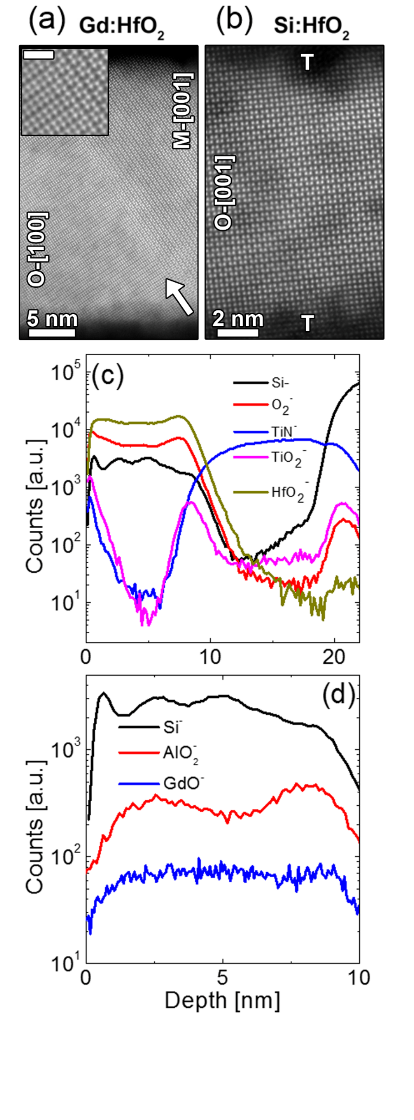

Figure 3c shows the depth profiles of ions of interest for 10 nm-  
thick Si-doped HfO2 (ALD cycle ratio 1:26) film, which is the cycle   
ratio that achieves the highest Pr for Si-doped HfO2, using TOF-  
SIMS. Figure 3d shows the secondary ion counts of dopants as a   
function of depth in 10 nm-thick Si- (ALD cycle ratio 1:26), Al-   
(cycle ratio 1:32), and Gd-doped HfO2 (cycle ratio 1:27) layers   
deposited on a TiN bottom electrode with or without TiN top   
electrode, respectively. The depth was measured using a   
profilometer after TOF-SIMS analysis. For Si- and Al-doped HfO2   
thin films, modulations in the secondary ion counts from the   
dopants are clearly observed through the entire depth of doped   
HfO2 thin films. In the case of the Si-doped HfO2, the distance   
between peaks in the Si- signal corresponds well to expected   
depths of high SiO2 concentration in the film based on the   
chosen HfO2/SiO2 cycle ratio, which includes 4 dopant layers for   
a 10 nm thick film. The 30 nm-thick Si-doped HfO2 film with the   
equivalent ALD cycle ratio was also examined by TOF-SIMS and   
a similar modulation of Si content could be observed (data not   
 -  
shown). For the Al-doped HfO2 film, on the other hand, the AlO2   
ion counts were constant in the bulk of the HfO2 grains, but   
higher at the interface between HfO2 and TiN electrodes, which   
may be caused by Al3+ ion diffusion to the interfacial regions.   
For the Gd-doped HfO2 film, the ion counts of GdO- were   
relatively low compared to those of Si- and AlO2- in Si- and Al-  
doped HfO2 due to lower secondary ion yield of GdO-. No sign   
of a modulation of GdO- ion counts could be observed, but it   
does not necessarily mean that the Gd dopants are distributed   
uniformly across the whole film. The modulation strength might   
be influenced by the relatively low counts and/or spatial   
inhomogeneity in the sputtering process of the relatively thick   
TiN electrode. In addition, unlike the Si- and Al-doped HfO2   
samples, the TiN top and bottom electrodes in the Gd-doped   
HfO2 sample were significantly oxidized. Strong TiO2- and O2-

counts are observed in both top and bottom TiN electrodes via   
TOF-SIMS. However, this result does not mean that TiN was   
oxidized into TiO2, and the existence of TiO2 interfacial layer   
near Gd-doped HfO2 thin film could not be detected by using   
STEM and GIXRD. Although an inhomogeneous distribution of   
dopants is observed for Si- and Al-doped HfO2 films from TOF-  
SIMS, no sign of the formation of a second phase could be   
observed in the highly doped regions of the Si-doped sample   
from TEM. Further studies would be required to examine the   
dopant impact on diffusion within the dielectric, but this topic   
is not the main focus of this paper.

**Structural analysis based on diffraction peaks in GIXRD**   
Several changes in GIXRD patterns with increasing ALD cycle   
ratio and resulting dopant concentration have been   
reported.15,24,65,66,67 J. Müller and Park independently reported

**Fig. 3** High angle annular dark field scanning transmission electron microscopy **(**HAADF-

STEM) images of (a) 27 nm-thick Gd-doped HfO2 (Gd:HfO2) and (b) 10 nm-thick Si-

doped HfO2 (Si:HfO2) thin films, respectively. Time of flight secondary ion mass spectra

of (c) 10 nm-thick Si-doped HfO2 for various secondary ions and (d) Si-, AlO2-, and GdO-

counts for dopant ions in 10 nm-thick Si-, Al-, and Gd-doped HfO2 films, respectively.

**6** | *J. Name*., 2012, **00**, 1-3

the orthorhombic *221* diffraction peak as a fingerprint of the ferroelectric orthorhombic phase for Si-doped HfO2 and (Hf,Zr)O2 films, respectively, in their dissertations.68,69 However, the intensity of this diffraction peak was quite weak even with synchrotron X-ray radiation, and it could not be employed to quantitatively extract the orthorhombic phase fractions of the

This journal is © The Royal Society of Chemistry 20xx

|  |
| --- |
| Please do not adjust margins |

|  |  |  |
| --- | --- | --- |
| **Journal Name** | Please do not adjust margins | **ARTICLE** |



films. Another structural change observed in literature was the shift of the *111* diffraction peak to higher 2q region with increasing ALD cycle ratio in Si-doped HfO2 and (Hf,Zr)O2.15,24 Although the shift of the diffraction peak is believed to be strongly related to the phase evolution with increasing ALD cycle ratio and resulting dopant concentration, this shift could not be systematically and quantitatively examined. In this study, the shifts of the *o111* and *o002* peaks are co-analyzed. Although the *o002* peak is in reality formed by overlap of the *o020* and *o002* peaks, it will be called *o002* for the sake of convenience. Here, *xhkl* peak refers to the diffraction peak from *hkl* planes of the *x* phase, and *x* can be *m* (monoclinic P21/*c*), *o* (orthorhombic P*ca*21), and *t* (tetragonal P42/*nmc*). The changes in *o111* and *o002* peak location can be seen in figure 4a and b, respectively. The shift of the *o111* peak towards higher 2 q region with increasing ALD cycle ratio is confirmed for all dopants, while the shift of *o002* is rather weak. This means that both the d111 distance(dhkl denotes the interplanar distance of the *hkl* planes) and the unit cell volume decreases with increasing ALD cycle ratio. This phenomenon could be related either to phase evolution or to generation of internal stress effects dependent on the dopant size. It should be noted that the radius of both Si4+ and Al3+ ions are smaller compared to an Hf4+ ion, while the Gd3+ ion is larger.65 If the change in d111 and the unit cell volume relate to an internal stress effect derived from the dopant size within the Hf lattice, then both values should increase with increasing ALD cycle ratio for Gd-doped HfO2 thin films. This is experimentally not the case. Therefore, the change of d111 and unit cell volume is expected to relate to a phase change rather than an internal stress effect. However, it is also noticed that the 2q value of the *o111*/*t101* peak for Gd-doped HfO2 films is generally lower than that of Si- and Al-doped HfO2 films,

meaning that the size of the dopant does also affect the d111 and the unit cell volume.

On the other hand, it should be mentioned that the strain from (local) epitaxial relation between TiN bottom electrode and doped HfO2 thin films could be neglected. The interface formed between TiN and doped HfO2 thin films is believed to be disordered rather than epitaxial. The lattice parameter of cubic TiN is about 0.424 nm51, while those of orthorhombic HfO2 is in the range of 0.509 – 0.535 nm49. Therefore, their differences are in the range of 20 – 26 %, which are believed to be too large to expect an epitaxial relation between them. Schenk examined the texture of 30 nm-thick Si-doped HfO2 thin film and TiN electrode in his dissertation, and reported that the strongest texture is only three multiples of random distribution for both Si-doped HfO2 and TiN.44 There might be an orientation relationship, but this relationship is not believed to be of a prototypical epitaxial type that gives rise to a certain strain in a specific crystallographic direction that can be easily argued to promote or inhibit the polar character of the polymorphs of doped HfO2 thin films as in epitaxial films. Therefore, the epitaxial stress effect from TiN electrodes is not considered in this work.

From the locations of the *o111* and *o002* peaks, d111 and d002 can be calculated. In addition, the lattice parameters of the longest axis (a-axis for orthorhombic and c-axis for tetragonal phase) and shorter axes (b- and c-axis for orthorhombic and a-axis for tetragonal phase) could be determined using the following assumptions: First, the diffraction peak at 35.4 – 35.9 degrees is caused by a diffraction of *o020*/*o002*/*t110* planes without contribution from the *o200*/*t002* planes. Second, b and c lattice parameters of the orthorhombic phase are assumed to be equal to simplify analysis. In the introduction, it is discussed

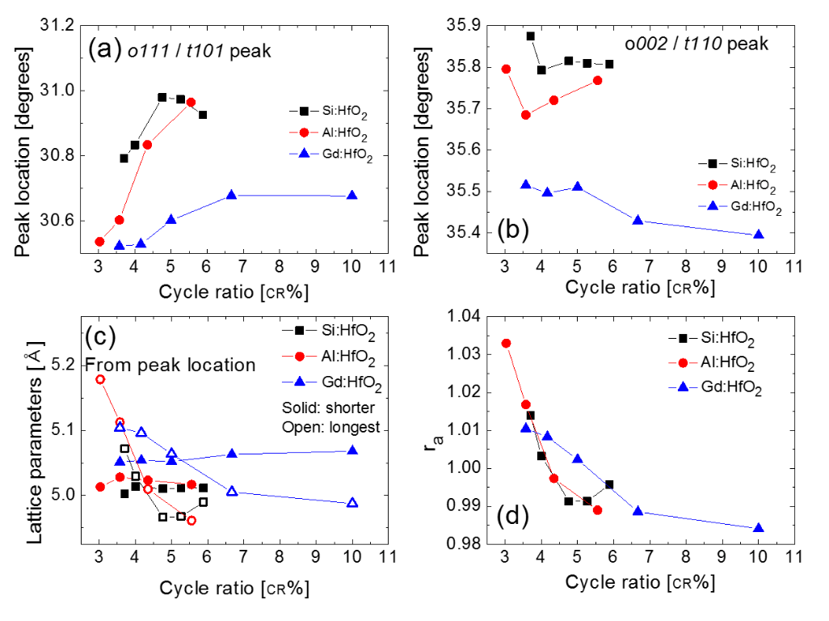

**Fig. 4** 2q values for (a) *o111*/*t101* and (b) *o020*/*o002*/*t110* diffraction peaks as a function of cycle ratio. (c)The lattice parameters calculated from the peak locations and (d) their relative ratio (ra) as a function of cycle ratio**.** Cycle ratio (CR%) refers to ALD cycle number of dopants/(ALD cycle number of dopants + ALD cycle number of HfO2) x 100.

|  |  |
| --- | --- |
| This journal is © The Royal Society of Chemistry 20xx | *J. Name*., 2013, **00**, 1-3 | **7** |

|  |
| --- |
| Please do not adjust margins |

|  |  |  |
| --- | --- | --- |
| **ARTICLE** | Please do not adjust margins | **Journal Name** |

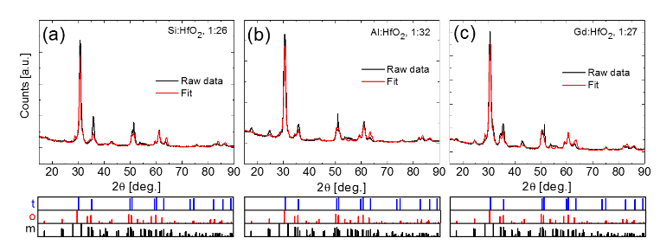

**Fig. 5** GIXRD patterns with Rietveld refinement results for (a) Si- (3.7 CR%), (b) Al- (3.0 CR%), and (c) Gd- (3.6 CR%) doped HfO2 thin films.Bottom panels show diffraction patterns for tetragonal (t), orthorhombic (o), and monoclinic (m) phases from crystallographic information files. The intensities of diffraction peaks in reference patterns in bottom panels are plotted in log scale (from 1 to 100 %) to clearly show the locations of weak diffraction peaks.

that the difference within b and c lattice parameters was smaller than 0.4 % in a previous study,15 and these two diffraction peaks are indistinguishable even for the case of epitaxial films.26,44-46 Figure 4c shows the lattice parameters of doped HfO2 films as a function of ALD cycle ratio. For Si-doped HfO2 films, the GIXRD patterns from samples with 2.1 and 3.2 CR% ALD cycle ratio were not considered in this analysis, since the films predominantly crystallized in the monoclinic phase. The relative fraction of the monoclinic phase will be determined later based on the Rietveld refinement results in the next section. Since the monoclinic phase possesses clearly distinguishable GIXRD patterns, quantitative analysis of its structure has been successfully conducted in literature.6 In this

and 1.010, respectively, and they decreased to 0.991 and 0.984 with increasing ALD cycle ratio to 4.8 and 10 CR%, respectively. This decrease in ra values is believed to be strongly related to the phase evolution in the HfO2 based films. According to previous reports, doped HfO2 films are polycrystalline with columnar grains, and multiple phases such as monoclinic, tetragonal, and monoclinic are simultaneously present in the layers.24,25 Although the change in ra values qualitatively shows that there might be phase change from orthorhombic to tetragonal phase occurring with respect to CR%, the phase evolution cannot be quantitatively analyzed solely based on the shift of diffraction peaks. Therefore, a Rietveld refinement70 was conducted to quantitatively examine the phase evolution

study, the structural changes observed during the phase in doped HfO2 films.

transition from orthorhombic to tetragonal phase are

intensively studied. The lattice parameters obtained for Gd- **Results of Rietveld refinement and comparison to the ferroelectric**

doped HfO2 thin films from GIXRD patterns were slightly smaller **properties**

than those for the orthorhombic phase measured using STEM in a previous study25. However, it should be noted that the lattice parameters taken from GIXRD patterns are averages of lattice parameters of orthorhombic and tetragonal phases, whereas the lattice parameters of specific crystalline phase in nanoscale grains can be measured using STEM.25 As expected from figure 4b, the shorter axis of Gd:HfO2 films are generally larger than those of Si- and Al-doped HfO2 films, and the length of the shorter axis is generally found to increase with dopant size. With variations in ALD cycle ratio, the changes in the two shorter lattice parameters are negligible for all the dopants. The changes in the longest lattice parameters are much stronger than that of the two shorter axes lattice parameters. With increasing ALD cycle ratio, the longest lattice parameter decreases for all dopants. From these lattice parameters, ra is calculated and plotted versus the dopant content (figure 4d). The largest ra value of 1.033 is observed for the smallest ALD cycle ratio for Al-doped HfO2 films (3 CR%). However, the value decreases to 0.989 with increasing ALD cycle ratio to 5.6 CR%. The largest ra values for Si- and Gd-doped HfO2 films were 1.014

**8** | *J. Name*., 2012, **00**, 1-3

Figure 5a, b, and c show the GIXRD patterns and fitted curves using Rietveld refinement of 3.7 CR% Si-, 3.0 CR% Al-, and 3.6 CR% Gd-doped HfO2 thin films. Bottom panels of figures 5a-c show the diffraction patterns of monoclinic, tetragonal, and orthorhombic phase. The details of Rietveld refinement using TOPAS software are included in the experimental section. The weighted profile R-factor (Rwp), which shows the quality of refinement quantitatively,71,72 lies within 20 – 31, 20 – 26, and 17 – 21.5 % for Si-, Al-, and Gd-doped HfO2 thin films, respectively. Rwp values were the largest (26 – 31 %) for Si-doped HfO2 films with CR% higher than 4.8, which might be related to the effect of dopant size and concentration on lattice parameters of the crystalline phases of HfO2. The effect of dopants will be discussed in more detail later in the next section 5. For Si-doped HfO2 thin films with CR% lower than 4.8, the Rwp values are within 20 – 26%. From the fitted diffraction patterns and resulting Rwp values, it could be concluded that the diffraction patterns were fitted with errors within reasonable range via Rietveld refinement. The Rwp values seem rather higher compared to the typical values (< 10 %) in Rietveld

This journal is © The Royal Society of Chemistry 20xx

|  |
| --- |
| Please do not adjust margins |

|  |  |  |
| --- | --- | --- |
| **Journal Name** | Please do not adjust margins | **ARTICLE** |

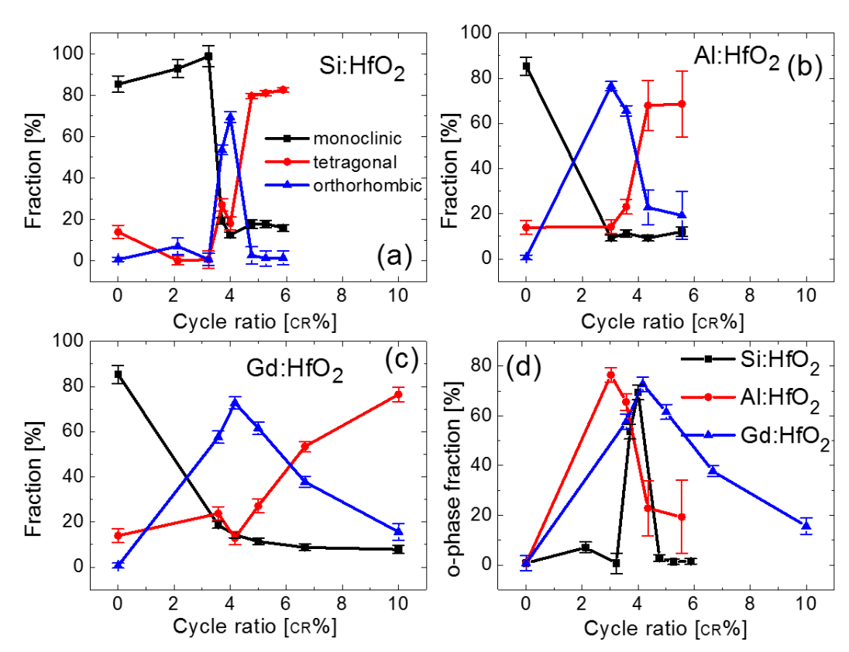

**Fig. 6** Relative fraction of monoclinic, tetragonal, and orthorhombic phase in (a) Si-, (b) Al-, and (c) Gd-doped HfO2 films as a function of cycle ratio. (d) Comparison of the relative portion of the orthorhombic phase taken from (a), (b) and (c).The calculated errors in phase fractions are added as error bars. Cycle ratio (CR%) refers to ALD cycle number of dopants/(ALD cycle number of dopants + ALD cycle number of HfO2) x 100.

|  |  |
| --- | --- |
| refinements of single crystals or polycrystalline ceramics.72 | CR%. However, with an increasing ALD cycle ratio beyond 4.3 |

However, for the case of doped thin polycrystalline films in this study, numerous factors including film stress, doping, and preferred orientation, can make an ideal fit impossible, thus increasing the Rwp values.72 It should be noted that the Rwp values in this study is quantitatively similar with those in previous Rietveld refinement results conducted on thin or thick films63-66 and some powders77-81.

Figures 6a-c show the changes in the relative fraction of the monoclinic (rmono), tetragonal (rtetra), and orthorhombic (rortho) phase as a function of cycle ration in Si-, Al-, and Gd-doped HfO2 films, respectively. For the case of pure HfO2 and 2.1 - 3.2 CR% Si doped HfO2 films, more than 85 % of the films are of monoclinic phase, which is in good agreement with previous results.24,65 However, the fraction of the monoclinic phase is less than 20 %, when the ALD cycle ratio is higher than 3.7, 3.0, and 3.6 CR% for Si-, Al-, and Gd-doped HfO2 films, respectively. Above these ALD cycle ratios, the ferroelectric orthorhombic phase is the most prominent phase in doped HfO2 films. The changes in the relative phase fraction of the orthorhombic phase and pristine Pr values with variation in ALD cycle ratio will be discussed in figure 7 and the corresponding text in greater detail. For the case of Si-doped HfO2 films, the ALD cycle ratio range where the relative fraction of orthorhombic phase is higher than 20 % is very narrow. Only 3.7 and 4.0 CR% Si-doped films showed an rortho value larger than 50 %, and the rortho value abruptly decreased to 2.7 % when ALD cycle ratio increased to 4.8 CR%. For the case of Al-doped HfO2 films, the largest fraction of orthorhombic phase (~77 %) is observed for an ALD cycle ratio of 3 CR%, and it is still about 66 % for an ALD cycle ratio of 3.6

This journal is © The Royal Society of Chemistry 20xx

CR%, the rortho value decreases to about 23 %. For the case of Gd-doped HfO2 films, rortho is higher than 57 % within the ALD cycle ratio range of 3.6 - 4.2 CR%, and the largest fraction is about 73 % for a 4.2 CR% ALD cycle ratio. However, rortho decreased to 38 and 16 % when the ALD cycle ratio increases to 6.7 and 10.0 CR%, respectively. The changes in rortho are summarized for doped HfO2 films in figure 6d. As seen in the figure 6d, the CR% for the largest orthorhombic phase fraction is in the range of 3 – 4.2 %, and similar for all the three dopants used in this study. Even though the exact dopant content could not be clearly determined by the characterization methods used in table II, we would conclude that the maximum ferroelectric properties are reached in a dopant range of about 2-3 mol% for all three dopants. However, it does not necessarily mean that this cycle ratio range is universal for all potential dopants. In fact, the cycle ratio of 50 % and 2.6 % were reported for Zr6 and Sr8 doping in previous studies.

As mentioned before, the ALD cycle ratio range for a high orthorhombic phase fraction is narrower for Si-doped HfO2 in comparison to Al- and Gd-doped HfO2 films. In fact, the monoclinic to orthorhombic phase transition is difficult to analyze since even small dopant amounts already reduce the monoclinic phase fraction drastically. Here, one ALD cycle of dopant oxide every 30 - 40 HfO2 cycles has a strong impact. However, the phase evolution from the orthorhombic to tetragonal phase is the most abrupt in the Si-doped HfO2 films among the three dopants used in this study. This trend is consistent with the trend in pristine Pr values shown in figure 7a. It should be noted that the pristine Pr values in this study are

*J. Name*., 2013, **00**, 1-3 | **9**

|  |
| --- |
| Please do not adjust margins |

|  |  |  |
| --- | --- | --- |
| **ARTICLE** | Please do not adjust margins | **Journal Name** |

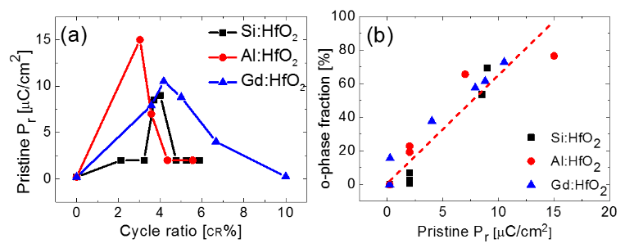

**Fig. 7** (a) Pristine Pr before wake-up and field cycling as a function of cycle ratio. (b) Pristine Pr versus orthorhombic phase portion. The red dashed line shows the linear fit. Cycle ratio (CR%) refers to ALD cycle number of dopants/(ALD cycle number of dopants + ALD cycle number of HfO2) x 100.

rather low compared to those in literature, since the Pr value is taken before the common wake-up field cycling.64,82-89 The Pr values of doped HfO2 films have been reported to strongly relate to phase evolution during electric field cycling.84-90 For the case of Si-doped HfO2 films, a pristine Pr value larger than 5 µC/cm2 is observed only for 3.7 and 4.0 CR% ALD cycle ratios. For the case of Al- and Gd-doped HfO2 films, on the other hand, a Pr value larger than 5 µC/cm2 is detected within an ALD cycle ratio range of 3.0-3.6 and 3.6 - 5.0 CR%, respectively. Although the ALD cycle ratio ranges for Pr larger than 5 µC/cm2 seem similar for Si- and Al-doped HfO2 films, the actual dopant concentration range in Al-doped HfO2 film for Pr larger than 5 µC/cm2 might be much wider when a higher growth rate of TMA is considered.62,63 (See targeted doping concentrations in table II.) The largest pristine Pr value observed amongst all dopants and films here is that of the 3.0 CR% ALD cycle ratio Al-doped HfO2 film, which also possesses the largest ra value in figure 4d. From figure 6d and 6a, a strong relationship between rortho and pristine Pr is expected, which can be confirmed in figure 7b. From a linear fitting, the expected Pr value of 100 % orthorhombic fraction was ~15.4 µC/cm2, which was smaller than the theoretical value (~35 µC/cm2) expected for randomly oriented orthorhombic HfO2 films.53 However, it should be noted that the pristine Pr can also be affected by other factors such as film texture,90 dead layer thickness,91 film thickness,92 grain size,93 degree of crystallinity,94 and the distribution of defects including oxygen vacancies.95 Despite these various factors, however, a strong linear relation implies that the ferroelectricity in doped HfO2 films is fundamentally governed by the polymorphism of the films.

**Comparison between dopants**   
Based on rortho and pristine Pr data, the change from orthorhombic to tetragonal phase occurs most abruptly for Si-doped HfO2 films. This means that the Si dopant effectively accelerates the phase change from the orthorhombic to tetragonal phase and could be related to the relatively large decrease in unit cell volume due to the small ionic radius of Si. Figure 8 shows the unit cell volume of the orthorhombic and tetragonal phase in doped HfO2 films. The unit cell volume of

**10** | *J. Name*., 2012, **00**, 1-3

the orthorhombic phase was calculated for films with the largest Pr value, whereas that of the tetragonal phase was taken from an ALD cycle ratio with Pr values below 3 µC/cm2. For both orthorhombic and tetragonal phases, the unit cell volume decreases with smaller dopant size. The trend of decreasing cell volume for smaller dopants is in good agreement with STEM measurements, though the volumes obtained by GIXRD are slightly smaller than those measured via STEM (134.4 Å3 for Gd-doped HfO2 based on volume = abc using a = 5.24, b = 5.06, and c=5.07, and 132.1 Å3 for Si-doped HfO2 based on volume = ab2 using a = 5.22 Å and b = 5.03 Å as measured from the center of the grain in Fig 3 b)). For all dopants, the unit cell volume of the tetragonal phase is smaller than for the orthorhombic phase, which is well-matched with previous studies.26,66,67 Therefore, the free energy of the tetragonal phase might further decrease with Si doping compared to the Al and Gd doping case. This can be understood based on the change in metal-oxygen bond length. Lee et al. examined the change of free energy for the monoclinic, tetragonal and cubic phases in HfO2 doped with various dopants using first principle calculations.96 In their report, the relative free energy of the tetragonal phase compared to the stable monoclinic phase could be reduced by doping with ions smaller than Hf.96 Especially of note, Si doping could decrease the relative free energy of the tetragonal phase significantly compared to that of the monoclinic phase.96 The relative free energy of the cubic phase also decreased with Si doping, but the magnitude of the decrease was much smaller than for the tetragonal phase.96 A similar but weaker trend could be observed for Al doping.96 For Gd doping on the other hand, the decrease of the free energy of the cubic phase was larger than for the tetragonal phase.96 The different behavior for the examined dopants could be understood based on changes in the metal-oxygen bond length.96 Table III shows the metal-oxygen bond length of tetragonal and orthorhombic HfO2, which were calculated based on computational results.26 For the case of the tetragonal phase, two different metal oxygen bond lengths of 2.08 and 2.34Å are determined. When an Si4+ ion replaces one Hf4+ ion, the Si-O bond length can decrease to 1.69Å, which is very similar with the ideal Si-O bond length (1.63 Å) in a quartz SiO2 structure.96 Moreover, the O-Si-O angle

This journal is © The Royal Society of Chemistry 20xx

|  |
| --- |
| Please do not adjust margins |

|  |  |  |
| --- | --- | --- |
| **Journal Name** | Please do not adjust margins | **ARTICLE** |



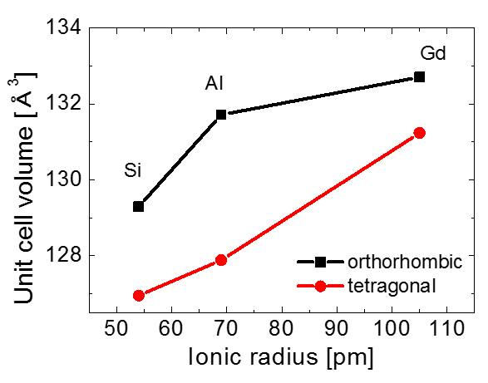

**Fig. 8**Unit cell volume as a function of ionic radius of dopants. The ionic radii were taken from Ref. 88 and 89. For the case of Si and Al, the ionic radii for eight fold coordination were calculated from extrapolation.

values (105.4° or 117.9°) are also very similar to that in the quartz lattice (108.9° – 110.5°).96 As a result, the relative free energy of the tetragonal phase can decrease significantly compared to the monoclinic or cubic phases.96 As seen in table III, the bond lengths of the orthorhombic phase are very different from the tetragonal phase, and the coordination numbers of oxygen ions are also different: all fourfold in tetragonal and half fourfold and half threefold in the orthorhombic phase.26 In fact, the coordination number of oxygen ions in the orthorhombic is similar compared to those in the monoclinic phase. Although the lattice parameters of the orthorhombic phase are very similar to those of the tetragonal phase, the coordination numbers of Hf4+ and O2- ions in the orthorhombic phase are similar to those in the monoclinic phase. In the orthorhombic phase, the metal-oxygen bond lengths of threefold oxygen ions are 2.24, 2.72, and 2.72Å, while the metal-oxygen bond lengths of fourfold oxygen ions are 2.23, 2.24, 2.32, and 2.33Å. Different from the tetragonal phase, the smallest bond length is 2.23Å with no short metal-oxygen bonds. The shortest bond length is even larger than for the cubic phase (~2.18Å), and it might not be decreased more significantly than for Si:HfO2 in the tetragonal phase. Therefore, the ALD cycle ratio region for ferroelectric properties in Si doped HfO2 films might be quite narrow. A similar effect is expected for Al-doped HfO2, with an ideal Al-O bond length in corundum Al2O3 (1.92Å) being about 14 % smaller compared to the Hf-O bond length in cubic HfO2. Therefore, the ALD cycle ratio range for ferroelectric properties with Al doping might be larger than for Si doping. For the case of Gd3+, the ideal Gd-O bond length should be even larger than for Al-O due to the larger ionic radius of Gd3+ (105 pm) in relation to Al3+ (69 pm) and Si4+ (54 pm).97,98 The ionic radii were taken from a previous study by Shannon for eight fold coordination condition.97 For the cases of Al and Si, there was no ionic radius data within eight

This journal is © The Royal Society of Chemistry 20xx

fold coordination, so the values were estimated by extrapolating the ionic radii in four to six fold coordination.98 As a result, the orthorhombic phase can be formed within an even larger ALD cycle ratio range compared to Al-doped HfO2 films. Other possible causes for a dopant dependence of ALD cycle ratio range for strong ferroelectric properties were also examined. The difference in the spatial distribution of dopants might be another possible reason. From TOF-SIMS results in figure 3d, the diffusion of Si seems weaker compared to those of Al and Gd. For the case of Al-doped HfO2 films, the homogeneous distribution of Al was reported in some previous studies from TOF-SIMS results and Auger electron spectroscopy.99,100 The diffusion of Al toward interfacial region could not be observed in these studies.99,100 The ALD and annealing process in the studies from 99,100 was very similar to those in this study, but different results were observed possibly attributed to a different electrode. In those papers, a Si or Mo electrode was applied while a TiN electrode was used in our study.99,100 The TiN electrode is expected to partially scavenge oxygen atoms from the HfO2 in interfacial regions introducing a higher oxygen vacancy concentration, which might affect diffusion of Al dopants. It is well known that the TiN top electrode can reduce the interfacial SiO2 layer between HfO2 and the Si substrate.101 Moreover, partial oxidation of the TiN bottom electrode was reported for TiN/Hf0.5Zr0.5O2/TiN capacitor structures.102 Overall, the Si diffusion seems much weaker in HfO2 thin films compared to the Al and Gd diffusion. Differences in the diffusivity of Si4+ and Al3+/Gd3+ might be attributed to a different valence number of the dopants and resulting different oxygen vacancy concentration.103 Si4+ is a tetravalent ion, while Al3+ and Gd3+ are trivalent. Therefore, one oxygen vacancy might be included into the HfO2 lattice for every two Al3+ or Gd3+ dopant ions, and the oxygen vacancies might facilitate the diffusion of dopants by lowering the kinetic barrier.103 Due to the relatively low diffusivity of Si, some heavily doped regions might be formed in Si-doped HfO2, and they might be detrimental for the formation of the ferroelectric orthorhombic phase. However, further studies are needed to examine the effect of diffusivity. Varying oxygen vacancy levels for trivalent dopants are also considered as one potential cause for the effect of dopants on the ALD cycle ratio range for ferroelectric phase formation. However, the narrowest ALD cycle ratio range in Si-doped HfO2 cannot be understood by the direct effect of oxygen vacancies. Oxygen vacancies are reported to further stabilize the tetragonal phase compared to the orthorhombic phase.61 Therefore, the additional oxygen vacancy doping with Al and Gd doping is expected to decrease the ALD cycle ratio range for ferroelectric orthorhombic phase, which is the opposite from what is experimentally observed.

*J. Name*., 2013, **00**, 1-3 | **11**

|  |
| --- |
| Please do not adjust margins |

|  |  |
| --- | --- |
| Please do not adjust margins |  |
| **Journal of Materials Chemistry C** |  |
|  | |



|  |
| --- |
| ARTICLE |

**Table III** Hf-O bond length in orthorhombic and tetragonal HfO2. The bond length was calculated from the lattice parameters and relative ionic locations in Ref. 26. O3 and O4 refer

to threefold and fourfold bounded oxygen, respectively.

|  |  |  |  |  |  |
| --- | --- | --- | --- | --- | --- |
| Phase | Oxygen type | I | II | III | IV |
| orthorhombic | O3 | 2.243 Å | 2.721 Å | 2.773 Å | - |
| 2.231 Å | 2.238 Å | 2.324 Å |
| O4 | 2.334 Å |
| tetragonal | O4 | 2.078 Å | 2.078 Å | 2.336 Å | 2.336 Å |

DRESDEN Fellowship Program of the TU Dresden is part of its

**Conclusions**

In conclusion, the structural changes within HfO2 thin films doped with Si, Al, and Gd were systematically examined. To quantitatively investigate changes in the GIXRD patterns, Rietveld refinement was first conducted. Here, a strong linear relationship between the orthorhombic phase fraction and the pristine remanent polarization value is confirming the original hypothesis, demonstrating that the underlying ferroelectric response is strongly coupled to the orthorhombic phase fraction of the fluorite crystal structure. The methodology used in this study provides a framework for the newly reported nanoscale fluorite ferroelectrics. Although the HfO2 thin films doped with Si, Al, and Gd were studied here, this structural analysis is believed to be widely applicable even to the fluorite ferroelectrics with different matrix and dopant materials. The largest Pr and orthorhombic phase fraction can be observed within the cycle ratio range of 3 – 4.2 CR%, which is believed to be the doping concentration range of 1 – 3 cat% for all the three dopants. The ALD cycle ratio region for ferroelectric properties was the narrowest for Si-doped HfO2, and increased with increasing dopant size. This can be qualitatively understood based on a metal-oxygen bond length model. The shorter Hf-O bond length in the tetragonal phase is much smaller than in the orthorhombic phase. Therefore, Si doping might decrease the relative free energy of tetragonal phase more significantly compared to the orthorhombic phase. This effect may become weaker with increasing dopant size.

**Acknowledgements**

Authors gratefully acknowledge funding from the Army Research Office through contract number W911NF-15-1-0593. M.H.P. is supported by DRESDEN Junior Fellowship. The

This journal is © The Royal Society of Chemistry 20xx

Institutional Strategy, funded by the Excellence Initiative of the German Federal and State Governments. T.S., U.S. and T.M. gratefully acknowledge the German Research Foundation (Deutsche Forschungsgemeinschaft) for funding part of this research in the frame of the “Inferox” project (MI 1247/11-2). E.D.G. and J.M.L. gratefully acknowledge funding from the National Science Foundation (Award No. DMR-1350273). E.D.G. acknowledges support for this work through a National Science Foundation Graduate Research Fellowship (Grant DGE-1252376). This work was performed in part at the Analytical Instrumentation Facility (AIF) at North Carolina State University, which is supported by the State of North Carolina and the National Science Foundation (award number ECCS-1542015). The AIF is a member of the North Carolina Research Triangle Nanotechnology Network (RTNN), a site in the National Nanotechnology Coordinated Infrastructure (NNCI). The authors thank C. Adelmann and his group at Imec for the deposition of Al- and Gd-doped HfO2 films and PIXE analysis. The authors thank P. Hoenicke at Physikalisch-Technische Bundesanstalt (PTB) for XRF analysis.

References   
1T. S. Böscke, J. Müller, D. Bräuhaus, U. Schroeder and U. Böttger, *Appl. Phys. Lett.,* 2011, **99**, 102903.

2P. Polakowski and J. Müller, *Appl. Phys. Lett.,* 2015, **106**, 232905.

3K. D. Kim, M. H. Park, H. J. Kim, Y. J. Kim, T. Moon, Y. H. Lee, S.

D. Hyun, C. S. Hwang, *J. Mater. Chem. C,* 2016, **4**, 6864-6872. 4A. Pal, V. K. Narahimhan, S. Weekd, K. Littau, D. Pramanik, T. Chiang, *Appl. Phys. Lett.*, 2017, **110**, 022903.

5S. Mueller, J. Mueller, A. Singh, S. Riedel, J. Sundqvist, U.

Schroeder and T. Mikolajick, *Adv. Funct. Mater.,* 2012, **22**, 2412-2417.

6J. Müller, U. Schröder, T. S. Böscke, I. Müller, U. Böttger, L.

Wilde, J. Sundqvist, M. Lemberger, P. Kücher, T. Mikolajick and L. Frey, *J. Appl. Phys.,* 2011, **110**, 114113.

*J. Name*., 2013, **00**, 1-3 | **12**

|  |
| --- |
| Please do not adjust margins |

|  |  |  |
| --- | --- | --- |
| **Journal Name** | Please do not adjust margins | **ARTICLE** |



*7*S. Mueller, C. Adelmann, A. Singh, S. Van Elshocht, U.

Schroeder and T. Mikolajick, *ECS J. Sol. St. Technol.,* 2012, **1**, N123-N126.

8T. Schenk, S. Mueller, U. Schroeder, R. Materlik, A. Kersch, M.

Popovici, C. Adelmann, S. Van Elshocht and T. Mikolajick, *Proceedings of the European Solid-State Device Research Conference (ESSDERC)*, 2013, 260-263.

9J. Müller, T. S. Böscke, S. Müller, P. Polakowski, J. Paul, D.

Martin, T. Schenk, K. Khullar, A. Kersch, W. Weinreich, S.

Riedel, K. Seidel, A. Kumar, T. M. Arruda, S. V. Kallinin, T.

Schlosser, R. Boschke, R. van Bentum, U. Schroeder and T.

Mikolajick, *IEEE International Electron Devices Meeting (IEDM)*, 2013.

10S. Starschich, D. Griesche, T. Schneller and U. Boettger, *ECS J.*  *Sol. St. Sci. Technol.,* 2015, **4**, P419-P423.

11S. Starschich, U.Boettger, *J. Mater. Chem. C,* 2017, **5**, 333-338. 12L. Xu, T. Nishimura, S. Shibayama, T. Yajima, S. Migita, A. Toriumi, *Appl. Phys. Express*, 2016, **9**, 091501.

13L. Xu, S. Shibayama, K. Izukashi, T. Nishimura, T. Yajima, S.

Migita, A. Toriumi, IEEE International Electron Devices Meeting (IEDM), 2016, 25.2.1-25.2.4. (DOI: 10.1109/IEDM.2016.7838477)   
14J. Müller, T. S. Böscke, U. Schröder, S. Mueller, D. Bräuhaus, U. Böttger, L. Frey and T. Mikolajick, *Nano Lett.*, 2012, **12**, 4318-4323.

15M. H. Park, H. J. Kim, Y. J. Kim, W. Lee, T. Moon and C. S. Hwang, *Appl. Phys. Lett.* 2013, **102**, 242905.

16T. Shimizu, T. Yokouchi, T. Shiraishi, T. Oikawa, P. S. Sankara Rama Krishnan, H. Funakubo, *Jpn. J. Appl. Phys.*, 2014, **53**, 09PA04.

17A. Chernikova, M. Kozodaev, A. Markeev, D. Negrov, M.

Spiridonov, S. Zarubin, O. Bak, P. Buragohain, H. Lu, E.

Suvorova, A. Gruverman, A. Zenkevich, *ACS Appl. Mater. Interfaces*, 2016, **8**, 7232-7237.

18M. H. Park, Y. J. Kim, H. J. Kim, T. Moon, K. D. Kim, Y. H. Lee, C.

S. Hwang, Presented at ISAF-ISIF-PFM-2015, The Ferroelectric Properties of HfO2/ZrO2 Nanolaminate Systems, Singapore, May 24−27, 2015.

19Y. W. Lu, J. Shieh, F. Y. Tsai, *Acta Mater. 2016*, **115**, 68-75. 20S. L. Weeks, A. Pal, V. K. Narahimhan, K. A. Littau, T. Chiang, *ACS*  *Appl.*  *Mater.*  *Interfaces*, 2017, DOI: 10.1021/acsami.7b00776.

21Z. Fan, J. Deng, J. Wang, Z. Liu, P. Yang, J. Xiao, X. Yan, Z. Dong, J. Wang and J. Chen, *Appl. Phys. Lett.,* 2016, **108**, 012906.

22B.-T. Lin, Y.-W. Lu, J. Shieh, M.-J. Chen, *J. Eur. Ceram. Soc.*, 2017, **37**, 1135-1139.

23S. Starshich, T. Schenk, U. Schroeder, U. Boettger, Appl. Phys. Lett., submitted.

24M. H. Park, Y. H. Lee, H. J. Kim, Y. J. Kim, T. Moon, K. D. Kim, J.

Müller, A. Kersch, U. Schroeder, T. Mikolajick and C. S. Hwang, *Adv. Mater.,* 2015, **27**, 1811-1831.

25X. Sang, E. D. Grimley, T. Schenk, U. Schroeder and J. M. LeBeau, *Appl. Phys. Lett.* 2015, **106**, 162905.

26R. Materlik, C. Künneth and A. Kersch, *J. Appl. Phys.,* 2015, **117**, 134109   
27E. H. Kisi and C. J. Howard, *Key Eng. Mater.* 1998, **153**, 1-36. 28J. E. Lowther, J. K. Dewhurst, J. M. Leger and J. Haines, *Phys.*  *Rev. B,* 1999, **60**, 14485.

29J. Müller, T. S. Böscke, U. Schröder, R. Hoffmann, T. Mikolajick and L. Frey, *IEEE Electron. Dev. Lett.,* 2012, **33**, 185-187.

30S. Mueller, J. Müller, U. Schroeder and T. Mikolajick, *IEEE*  *Trans. Dev. Mater. Reliab.,* 2013, **13**, 93-97.

31M. H. Park, H. J. Kim, Y. J. Kim, T. Moon, K. D. Kim and C. S. Hwang, *Adv. Energy Mater.* 2014, **4**, 1400610.

32M. H. Park, H. J. Kim, Y. J. Kim, T. Moon, K. D. Kim and C. S. Hwang, *Nano Energy,* 2015, **12**, 131-140.

This journal is © The Royal Society of Chemistry 20xx

33M. Hoffmann, U. Schroeder, C. Künneth, A. Kersch, S.

Starschich, U. Böttger and T. Mikolajick, *Nano Energy,* 2015, **18**, 154-164.

34M. H. Park, H. J. Kim, Y. J. Kim, T. Moon, K. D. Kim, Y. H. Lee, S.

D. Hyun and C. S. Hwang, *Adv. Mater.,* 2016, **28**, 7956-7961. 35M. Hoffmann, M. Pešić, K. Chatterjee, A. I. Khan, S.

Salahuddin, S. Slesazeck, U. Schroeder and T. Mikolajick, *Adv. Funct. Mater.,* 2016, **20**, 8643-8649.

36M.T. Bohr, R.S. Chau, T. Ghani and K. Mistry, *IEEE Spectr.* 2007, **44**, 29.

37S. Li, J. A. Eastman, C. M. Foster, R. E. Newnham and L. E. Cross, *Phys. Lett. A,* 1996, **212**, 341-346.

38T. Mikolajick, S. Müller, T. Schenk, E. Yurchuk, S. Slesazeck, U.

Schröder, S. Flachowsky, R. van Bentum, S. Kolodinski, P.

Polakowski and J. Müller, *Adv. Sci. Technol.*, 2014, **95**, 136-145.

39N. Gong and T. P. Ma, *IEEE Electron. Dev. Lett.,* 2016, **37**, 1123- 1126.

40E. D. Grimley, T. Schenk, X. Sang, M. Pešić, U. Schroeder, T.

Mikolajick and J. M. LeBeau, *Adv. Electron. Mater.,* 2016, **2**, 1600173.

41T. Shimizu, K. Katayama, T. Kiguchi, A. Akama, T. J. Konno and H. Funakubo, *Appl. Phys. Lett.,* 2015, **107**, 032910.

42C. M. Fancher, L. Zhao, M. Nelson, L. Bai, G. Shen and J. L. Jones, *J. Appl. Phys.* 2016, **117**, 234201.

43L. Zhao, M. Nelson, H. Aldridge, T. Iamsasri, C. M. Fancher, J.

S. Forrester, T. Nishida, S. Moghaddam, J. L. Jones, *J. Appl. Phys.,* 2016, **115**, 034104.

44T. Schenk, PhD thesis, TU Dresden, 2016.

45K. Katayama, T. Shimizu, O. Sakata, T. Shiraishi, S. Nakamura, T. Kiguchi, A. Akama, T. J. Konno, H. Uchida and H. Funakubo, *Appl. Phys. Lett.* 2016, **109**, 112901.

46T. Shimizu, K. Katayama, T. Kiguchi, A. Akama, T. J. Konno, O.

Sakata and H. Funakubo, *Sci. Rep.,* 2016, **6**, 32931I   
47S. Hall and B. McMahon, International Tables for Crystallography Volume G: Definition and exchange of crystallographic data, 2005, Springer,   
48The International Center for Diffraction Data (ICDD), PDF card No. 00-034-0104.

49The International Center for Diffraction Data (ICDD), PDF card No. 04-005-5597.

50The International Center for Diffraction Data (ICDD), PDF card No. 04-011-8820.

51The International Center for Diffraction Data (ICDD), PDF card No. 00-038-1420.

52A. March, *Z. Kristallogr.,* 1932, **81**, 285-297.

53W. A. Dollase, *J. Appl. Cryst.,* 1986, **19**, 267-272.

54M. Müller, P. Hönicke, B. Detlefs, C. Fleischmann, *Materials*  2014, **7**, 3147-3159.

55P. Hönicke, B. Beckhoff, M. Kolbe, D. Glubertoni, J. van den Berg and G. Pepponi, *Anal. Bioanal. Chem.***2010**, 396, 2825- 2832   
56M. E. Lines and A. M. Glass, Principles and Applications of Ferroelectrics and Related Materials, Oxford University Press, New York, USA 2001.

57D. G. Schlom, L.-Q. Chen, C.-B. Eom, K. M. Rabe, S. K. Streiffer and J.-M. Triscone, *Annu. Rev. Mater. Res.,* 2007, **37***,* 589-626. 58C. Ederer and N. A. Spaldin, *Phys. Rev. Lett.* 2005, **95**, 257601. 59J. H. Haeni, P. Irvin, W. Chang, R. Uecker, P. Reiche, Y. L. Li, S.

Choudhury, W. Tian, M. E. Hawley, B. Craigo, A. K. Tagantsev, X. Q. Pan, S. K. Streiffer, L. Q. Chen, S. W. Kirchoefer, J. Levy and D. G. Schlom, *Nature,* 2004, **430**, 758-761.

60C. Richter, T. Schenk, M. H. Park, F. A. Tscharnkte, E. D.

Grimley, J. M. LeBeau, C. Zhou, J. L. Jones, T. Mikolajick, U. Schroeder, *Adv. Electron. Mater.,* 2017, *submitted*.

61M. Hoffmann, U. Schroeder, T. Schenk, T. Shimizu, H.

Funakubo, O. Sakata, D. Pohl, M. Drescher, C. Adelmann, R.

*J. Name*., 2013, **00**, 1-3 | **13**

|  |
| --- |
| Please do not adjust margins |

|  |  |  |
| --- | --- | --- |
| **ARTICLE** | Please do not adjust margins | **Journal Name** |



Materlik, A. Kersch and T. Mikolajick, *J. Appl. Phys.,* 2015, **118**, 072006.

62L. Nyns, A. Delabie, G. Pourtois, S. Van Elshocht, C. Vinckier and S. De Gendt, *J. Electrochem. Soc.,* 2010, **157**, G7-G12.

63C. Adelmann, H. Tielens, D. Dewulf, A. Hardy, D. Pierreux, J.

Swerts, E. Rosseel, X. Shi, M. K. Van Bael, J. A.Kittl and S. Van Elshochta, *J. Electrochem. Soc.,* 2010, **157**, G105-G110.

64H. J. Kim, M. H. Park, Y. J. Kim, Y. H. Lee, T. Moon, K. D. Kim, S. D. Hyun and C. S. Hwang, *Nanoscale,* 2016, **8**, 1383-1389.

65U. Schroeder, E. Yurchuk, J. Müller, D. Martin, T. Schenk, P.

Polakowski, C. Adelmann, M. I. Popovici, S. V. Kalinin and T. Mikolajick, *Jpn. J. Appl. Phys.,* 2014, **53**, 08LE02.

66Q. Zeng, A. R. Oganov, A. O. Lyakhov, C. Xie, X. Zhang, J. Zhang, Q. Zhu, B. Wei, I. Grigorenko, L. Zhang and L. Cheng, *Acta Crystallogr. C,* 2014, **70**, 76–84.

67S. E. Reyes-Lillo, K. F. Garrity and K. M. Rabe, *Phys. Rev. B*  2014, **90**, 140103.

68J. Mueller, PhD thesis, TU Dresden, Germany, 2014.

69M. H. Park, PhD thesis, Seoul National University, Republic of Korea, 2014.

70H. M. Rietveld, *Acta Crystallogr.,* 1967, **22**, 151–152.

71B. H. Toby, *Powder Diffr.,* 2006, **21**, 67-70.

72L. B. McCusker, R. B. Von Dreele, D. E. Cox, D. Louer and P.

Scardi, Rietveld Refinement Guidelines. *J. Appl. Cryst.* 1999, **32**, 36-50.

73Z. Matěj, R. Kužel and L. Nichtová, *Powder Diffr.*, 2010, **25**, 125–131.

74M. K. Jeon, S. I. Woo, Y.-I. Kim and S.-H. Nahm, *J. Korean Phys.*  *Soc.*, 2004, **45**, 1240-1243.

75M. A. Togliente, M. Penza, M. Gusso and A. Quirini, *Thin Solid*  *Films*, 1999, **353**, 129-136.

76S. Murugesan, P. Kuppusami, N. Parvathavarthini and E. Mohandas, *Surf. Coat. Technol.* 2007, **201**, 7713-7719.

77J. Hegab, I. S. Ahmed Farag, A. M. El-Shabiny, A. M. Nassaar and A. A. Ramadan, *J. Ovonic. Res.*, 2015, **11**, 235-241.

78J. S. Kim, C. I. Cheon, Y. N. Choi and P. W. Jang, *J. Appl. Phys.*, 2003, **93**, 9263-9270.

79G. Peleckis, X. L. Wang and S. X. Dou, *Appl. Phys. Lett.,* 2006, **88**, 132507.

80D.-S. Kim, C. Kim, J.-K. Kim, J.-H. Kim, H.-H. Chun, H. Lee and Y.-T. Kim, *J. Catalysis*, 2012, **291**, 69-78.

81P. Pahuja, R. Sharma, C. Prakash and R. P. Tandon, *Ceram. Int.*, 2013, **39**, 9435-9445.

82K. Carl and K. H. Hardtl, Ferroelectrics, 1977, **17**, 473−486. 83M. I. Morozov and D. Damjanovic, J. Appl. Phys., 2008, **104**, 034107.

84U. Robels, L. Schneider-Störmann and G. Arlt, Ferroelectrics, 1995, **168**, 301−311.

85M. Pešić, F. Fengler, L. Larcher, A. Padovani, E. D. Grimley, X.

Sang, J. M. LeBeau, S. Slesazeck, U. Schroeder and T. Mikolajick, *Adv. Funct. Mater.,* 2016**,26**, 4601-4612.

86M. H. Park, H. J. Kim, Y. J. Kim, Y. H. Lee, T. Moon, K. D. Kim, S.

D. Hyun, F. Fengler, U. Schroeder and C. S. Hwang, *ACS Appl. Mater. Interfaces,* 2016, **8**, 15466–15475.

87D. Zhou, J. Xu, Q. Li, Y. Guan, F. Cao, X. Dong, J. Müller, T.

Schenk and U. Schröder, *Appl. Phys. Lett.,* 2013, **19**, 192904. 88T. Schenk, U. Schroeder, M. Pešić, M. Popovici, Y. Pershin, V and T. Mikolajick, *ACS Appl. Mater. Interfaces,* 2014, **6**, 19744–19751.

89T. Schenk, M. Hoffmann, J. Ocker, M. Pešić, T. Mikolajick and U. Schroeder, *ACS Appl. Mater. Interfaces,* 2014, **6**, 20224–20233.

90J. Wu and J. Wang, *J. Appl. Phys.,* 2009, **106**, 104111.

91C. Zhou and D. M. Newns, *J. Appl. Phys.,* 1997, **82**, 3081-3088.

92J. Junquera and P. Ghosez, *Nature,* 2003, **422**, 506-509. 93Z. Zhao, V. Buscaglia, M. Viviani, M. T. Buscaglia, L. Mitoseriu, A. Testino, M. Nygren, M. Johnsson and P. Nanni, *Phys. Rev.*  *B,* 2004, **70**, 024107.

**14** | *J. Name*., 2012, **00**, 1-3

94Q. M. Zhang, H. Xu, F. Fang, Z. Y.Cheng, F. Xia and H. You, *J.*  *Appl. Phys.,* 2001, **89**, 2613-2616.

95J. F. Scott and M. Dawber, *Appl. Phys. Lett.* 2000, **76**, 3801. 96C.-K. Lee, E. Cho, H.-S. Lee, C. S. Hwang and S. Han, *Phys. Rev.*  *B,* 2008, **78**, 012102.

97R. D. Shannon, *Acta. Cryst.,* 1976, **A32**, 751.

98G. S. Rohrer, Structure and Bonding in Crystalline Materials.

The Press Syndicat of the University of Cambridge, The Pitt Building, Trumpington Street, Cambridge, United Kingdom 2004.

99T. Park, J. H. Kim, J. H. Jang, C.-K. Lee, K. D. Na, S. Y. Lee, H.-S.

Jung, M. Kim, S. Han and C. S. Hwang, *Chem. Mater.,* 2010, **22**, 4175–4184.

100 Y. W. Yoo, W. Jeon, W. Lee, C. H. An, S. K. Kim and C. S.

Hwang, *ACS Appl. Mater. Interfaces,* 2014, **6**, 22474–22482. 101 P. D. Lomenzo, P. Zhao, Q. Takmeel, S. Moghaddam, T.

Nishida, M. Nelson, C. M. Fancher, E. D. Grimley, X. Sang, J. M.

LeBeau and J. L. Jones, *J. Vac. Sci. Technol. B,* 2014, **32**, 03D123.

102 M. H. Park, H. J. Kim, Y. J. Kim, W. Jeon, T. Moon, C. S. Hwang, *Phys. Status Solidi RRL,* 2014, **8**, 532-535.

103 D.-J. Kim, *J. Am. Ceram. Soc.,* 1989, **72**, 1415-1421.

This journal is © The Royal Society of Chemistry 20xx

|  |
| --- |
| Please do not adjust margins |