JOURNAL OF APPLIED PHYSICS 120, 024101 (2016) 

[Effect of top electrode material on radiation-induced degradation of ferroelectric thin film structures](http://dx.doi.org/10.1063/1.4955424)

Steven J. Brewer,1,2Carmen Z. Deng,2Connor P. Callaway,2McKinley K. Paul,1,3   
Kenzie J. Fisher,1,4Jonathon E. Guerrier,5Ryan Q. Rudy,6Ronald G. Polcawich,6   
Jacob L. Jones,5Evan R. Glaser,7Cory D. Cress,7and Nazanin Bassiri-Gharb1,2   
1G.W. Woodruff School of Mechanical Engineering, Georgia Institute of Technology, Atlanta, Georgia 30332, USA   
2School of Materials Science and Engineering, Georgia Institute of Technology, Atlanta, Georgia 30332, USA 3Woodward Academy, College Park, Georgia 30337, USA   
4Riverwood International Charter School, Atlanta, Georgia 30328, USA   
5Department of Materials Science and Engineering, North Carolina State University, Raleigh,   
North Carolina 27695, USA   
6Army Research Laboratory, Adelphi, Maryland 20783, USA   
7Naval Research Laboratory, Washington, DC 20375, USA

(Received 11 April 2016; accepted 23 June 2016; published online 11 July 2016)

The effects of gamma irradiation on the dielectric and piezoelectric responses of Pb[Zr0.52Ti0.48]O3 (PZT) thin film stacks were investigated for structures with conductive oxide (IrO2) and metallic (Pt) top electrodes. The samples showed, generally, degradation of various key dielectric, ferroelectric, and electromechanical responses when exposed to 2.5 Mrad (Si)60Co gamma radiation. However, the low-field, relative dielectric permittivity, er, remained largely unaffected by irradiation in samples with both types of electrodes. Samples with Pt top electrodes showed sub-stantial degradation of the remanent polarization and overall piezoelectric response, as well as pinching of the polarization hysteresis curves and creation of multiple peaks in the permittivity-electric field curves post irradiation. The samples with oxide electrodes, however, were largely impervious to the same radiation dose, with less than 5% change in any of the functional character-istics. The results suggest a radiation-induced change in the defect population or defect energy in PZT with metallic top electrodes, which substantially affects motion of internal interfaces such as domain walls. Additionally, the differences observed for stacks with different electrode materials implicate the ferroelectric–electrode interface as either the predominant source of radiation-induced effects (Pt electrodes) or the site of healing for radiation-induced defects (IrO2 electrodes).

Published by AIP Publishing. [<http://dx.doi.org/10.1063/1.4955424>]

I. INTRODUCTION

Perovskite ferroelectrics offer large dielectric, piezo-electric, and pyroelectric response, which can be simultane-ously leveraged to create multifunctional devices and enable miniaturization in various applications.1Among such devi-ces are concepts for autonomous, millimeter-scale robotics where the ferroelectric components fulfill multiple tasks; these include environmental energy harvesting, logic ele-ments, acoustic and optical sensors and transducers, and pre-cision positioners and locomotion units, all performed by the ferroelectric material.2Such units are of particular interest for performing duties in hostile environments that are either difficult to reach or otherwise dangerous for humans. Space is a quintessential example of one such environment, along with facilities that use or process radioisotopes. Thus, it is necessary to characterize the multifunctional properties of ferroelectric oxides as a function of radiation exposure, in order to evaluate device performance and functionality in harsh environments.

Prior work studying radiation effects on ferroelectric materials has primarily concentrated on applications in mem-ory devices and capacitors, showing radiation-induced degra-dation of dielectric and polarization responses in ferroelectric

thin films.3–9While degradation of functional properties due to high doses of X-rays, gamma rays, neutrons, and protons has been previously reported, ferroelectric thin films behave largely as radiation-hard materials (retaining critical function-ality in the material) at radiation doses up to hundreds of krad, and often several Mrad.10–14However, there is evi-dence, even at the lowest doses, that radiation exposure cre-ates defects or activates existing defects, causing measurable changes in the fundamental material properties.

Radiation transfers energy to a material via electron exci-tation and ionization, generating electron-hole pairs; or through nuclear interactions, giving rise to lattice vibrations and atomic displacements. Low energy (below �75 keV) pho-tons (X-rays, gamma rays) and electrons do not have suffi-cient energy to directly create atomic displacements and therefore interact with materials by exciting electrons, ulti-mately leading to trapping at defect centers.15At higher ener-gies, these particles ionize the material with which they interact and have sufficient energy either directly (electrons) or indirectly (gamma ray Compton scattered electrons) to form Frenkel defects, i.e., vacancies and interstitial pairs.16 The displaced atom, or recoil, will also lose energy through ionization and may have sufficient energy to create additional

|  |  |  |
| --- | --- | --- |
| 0021-8979/2016/120(2)/024101/9/$30.00 | 120, 024101-1 | Published by AIP Publishing. |

Reuse of AIP Publishing content is subject to the terms at: https://publishing.aip.org/authors/rights-and-permissions. Download to IP: 143.215.20.68 On: Mon, 22 Aug 2016 13:11:25

|  |  |  |
| --- | --- | --- |
| 024101-2 | Brewer et al. | J. Appl. Phys. 120, 024101 (2016) |

defects, forming a defect cascade. Charged particles, includ-ing protons and ions, similar to electrons, transfer energy to the material via electron and nuclear interactions, yet their greater mass and concomitantly lower velocities increase their interaction time with the material, yielding much higher rates and more localized tracks of ionizing energy transfer. The larger mass also increases the probability of displacement events and subsequent defect cascades, ultimately leading, in some cases, to defect clustering and amorphization for high doses.17   
 In a ferroelectric material, defects are of particular im-portance, as the elastic and electric energies associated with defects (point, line, surface, or volume) are responsible for changes in the energy landscape and resulting motion of in-ternal interfaces across this landscape.18,19The substantial ferroelectric and electromechanical responses in ferroelectric thin films, such as lead zirconate titanate (PZT), are in large part due to extrinsic contributions of hysteretically and nonli-nearly mobile internal interfaces, such as domain walls and phase boundaries (see Figure 1).18,20The mobility of these interfaces is determined by the internal energy landscape of the material, owing to electric and elastic fields associated with lattice defects, including vacancy and dopant point defects, grain boundaries, and other internal interfaces (such as other domain walls), as well as hetero-interfaces with the electrodes and/or the substrate.21,22To simplify the follow-ing discussion, domain walls will be considered as the repre-sentative internal interfaces responsible for the extrinsic contributions, while noting that motion of phase boundaries or defect dipoles can similarly contribute to the functional response in ferroelectrics.

Radiation-induced ionization and displacement events can potentially provoke deleterious effects in ferroelectrics

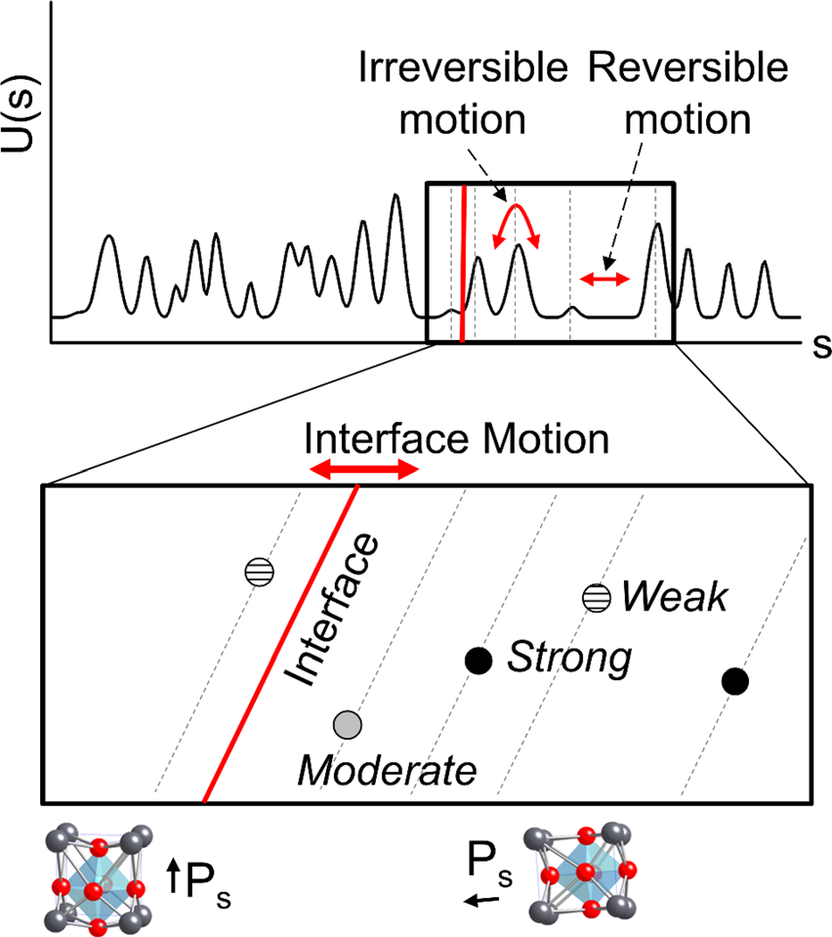

FIG. 1. Representation of reversible and irreversible interface motion in fer-roelectrics, such as the PZT thin films studied here. U(s) represents potential energy as a function of interface (domain wall) position s, while Ps shows polarization direction. Reversible motion contributes to the low-field response, while irreversible motion of interfaces over pinning centers is mostly observed at increasing fields (larger activation energy).

by increasing defect concentrations and leading to changes in the defect energy landscape of the material. Changes in both concentration and energy of defects can increase pin-ning of internal boundaries and interfaces, thereby restricting their mobility and ultimately the functional response of the material. Bastani et al. and Proie et al. demonstrated substan-tial degradation in polarization response and changes in permittivity-electric field (er-E) characteristics in PZT thin films, due to trapped charges introduced by X-rays, protons, and gamma irradiation.11,12Neutron irradiation, which pre-dominantly transfers energy through nuclear interactions, has been shown to introduce defect dipoles, and results in measureable increases in O and Pb vacancies in ferroelectric PZT.13,14   
 Of particular interest for studies of defect accumulation and their effects is the interface between PZT and the electro-des. In studies of fatigue and retention loss in PZT thin films, the role of the ferroelectric–metal electrode interface has been previously highlighted: defects can move, accumulate, and self-order near the interface, resulting in large volumes of domain wall pinning and inhibited ferroelectric response.23–26Prior research also supports formation and/or thickening of existing non-ferroelectric layers near the PZT–metal electrode interface, the presence of which is a pri-mary source of degradation of response in ferroelectric thin films via restriction of domain nucleation and switching.27–31 Conversely, using conductive transition metal oxides as elec-trodes helps to reduce fatigue in ferroelectric thin films, sup-pressing polarization back-switching.32The improvement has been attributed to the reduced concentration of charged defects at the oxide–oxide (ferroelectric–conductor) interface compared with oxide–metal interfaces.24,27,28,31,33–35   
 While the interface between either the top or bottom electrode and the ferroelectric material can act as a site for defect accumulation and fatigue, the bottom electrode acts as a building block for film orientation. For instance, Pt is typi-cally employed due to its compatibility with the high temper-ature crystallization of the PZT thin films and can serve as template layer for (111)-textured PZT. Alternatively, the Pt layer enables thin seed layers to be used to induce a (001) texture in PZT thin film crystallization.36As such, studying various top electrode materials presents a convenient method to investigate the effects of defect accumulation at the PZT–electrode interface while decoupling the experiment from any changes in film texture. Here we discuss the role of top electrode material on the radiation-induced degradation of ferroelectric properties of PZT thin film stacks by compar-ing the effects of gamma radiation on films with IrO2 and Pt top electrodes.

II. EXPERIMENTAL PROCEDURE

Pb[Zr0.52Ti0.48]O3 (PZT) thin films were fabricated at the US Army Research Laboratory using 150 mm diameter plati-nized (100) silicon wafers consisting of 100 nm Pt/35 nm TiO2/500 nm of SiO2/Si. A PbTiO3 seed layer was used to induce (001) texturing of the PZT films, which were prepared via chemical solution processing and spin coating deposition. The films were 529 nm and 527 nm thick (for samples with

Reuse of AIP Publishing content is subject to the terms at: https://publishing.aip.org/authors/rights-and-permissions. Download to IP: 143.215.20.68 On: Mon, 22 Aug 2016 13:11:25

|  |  |  |
| --- | --- | --- |
| 024101-3 | Brewer et al. | J. Appl. Phys. 120, 024101 (2016) |

IrO2 and Pt, respectively) and showed strong (001) crystallo-graphic texturing. Further details for the substrate and film processing are reported elsewhere.36,37IrO2 or Pt top elec-trodes were 100 nm-thick and sputter-deposited onto the wa-fer at 500�C. The IrO2 electrodes were also processed with a post-deposition furnace anneal at 650�C in flowing O2 for 30 min. The electrode and PZT were patterned through argon ion milling, followed by a series of additional metalli-zation steps for creating proper interconnects to device structures. The overall process flow for creation of the test devices is discussed by Proie et al.12Figure 2 shows base-line characterization of the PZT thin films with IrO2 and Pt top electrodes via time of flight secondary ion mass spec-trometry (ToF-SIMS) (Figures 2(a) and 2(d)), scanning

electron microscopy (SEM) (Figures 2(b) and 2(e)), and X-ray diffraction (XRD) (Figures 2(c) and 2(f)).

All samples were irradiated with 2.5 Mrad (equivalent Si dose), using a60Co gamma radiation source at a dose rate of approximately 600 rad(Si)/s at the Naval Research Laboratory (NRL). The electrodes were left floating during radiation ex-posure. The dielectric and electromechanical responses of the samples were fully characterized before and after irradiation and are summarized in Table I. The measurements included, in order, low-field permittivity, polarization response (to iden-tify the coercive field), nonlinear dielectric response, DC elec-tric field-dependent permittivity response, and DC electric field-dependent electromechanical response, followed by irra-diation, and repeat of all experiments. Early experiments to

|  |  |
| --- | --- |
|  | FIG. 2. Baseline characterization of PZT thin film stacks with IrO2 and Pt top electrodes. ToF-SIMS characteriza-tion for PZT films with (a) IrO2 and (d) Pt top electrodes, respectively; SEM images of PZT microstructure near an electrode for (b) IrO2 and (e) Pt, respec-tively; and crystallographic phase iden-tification via XRD for stacks with (c) IrO2 and (f) Pt top electrode, respec-tively. The presence of Cs in ToF-SIMS is noted due to the use of Csþ ions in the depth profile analysis, lead-ing to implantation and bonding in the material, often with heavy metals, such as Pb and Pt in PZT.38 |

Reuse of AIP Publishing content is subject to the terms at: https://publishing.aip.org/authors/rights-and-permissions. Download to IP: 143.215.20.68 On: Mon, 22 Aug 2016

13:11:25

|  |  |  |
| --- | --- | --- |
| 024101-4 | Brewer et al. | J. Appl. Phys. 120, 024101 (2016) |

TABLE I. Quantitative data for ferroelectric and electromechanical response of virgin and irradiated samples with IrO2 and Pt top electrodes, with percent

change (from before to after irradiation) noted. Uncertainties expressed represent standard error expressed to one significant figure, except in some cases when

the first significant digit is a 1, in which case uncertainty is expressed to two significant figures for consistency between measurements. Measurement values

are reported to the same decimal place as uncertainty for said measurement.40

|  |  |  |  |  |  |
| --- | --- | --- | --- | --- | --- |
|  | IrO2 |  |  | Pt |  |
| Virgin | 2.5 Mrad | % change | Virgin | 2.5 Mrad | % change |

Low-field dielectric

|  |  |  |  |  |  |  |
| --- | --- | --- | --- | --- | --- | --- |
| er | 954 6 1 | 946 6 1 | �1 �5 | 998 6 9 | 986 6 7 | �1 �20 |
| 1.7 6 0.1 | 1.6 6 0.1 | 3.0 6 0.2 | 2.4 6 0.1 |
| tan(d) |
| Rayleigh analysis |
| einit | 1100 6 40 | 1130 6 10 | þ3 �8 �12 | 920 6 70 | 1020 6 20 | þ11 �37 �45 |
| 52 6 2 | 48 6 1 | 35 6 3 | 22 6 1 |
| a (cm/kV) |
| a/einit � 10�3(cm/kV) Polarization | 49 6 4 | 43 6 2 | 40. 6 7 | 22 6 1 |
| Pr (lC/cm2) | 20.4 6 0.2 | 19.6 6 0.4 | �4 … | 16.6 6 1.6 | 10.7 6 0.4 | �36 �2 �32 |
| Psat (lC/cm2) | 48.1 6 0.1 | 48.1 6 0.2 | 48.7 6 0.6 | 46.6 6 0.1 |
| Ec (kV/cm) | 28.6 6 0.3 | 27.4 6 0.3 | �4 | 41.8 6 1.2 | 28.5 6 1.4 |
| C-V response |
| % tunability | 75.6 6 0.2 | 73.5 6 0.2 | �3 | 68.1 6 0.4 | 67.4 6 0.2 | �1 |
| Electromechanical |
| d33,f,saturation (pm/V) | 45.5 6 0.7 | 46.1 6 0.8 | þ1 | 68.2 6 3.3 | 61.1 6 1.2 | �10 |

pole the samples with DC bias at 2 to 3 times Vc (coercive voltage) for extended periods of time resulted in no change in polarization, dielectric, or electromechanical responses, and were therefore abandoned for this research, effectively con-firming that experiments on virgin samples would have no effect on experiments taken after irradiation due to changes in the material. Low-field dielectric permittivity (er) measure-ments were performed at 100 mV and 1 kHz, using an Agilent 4284A precision LCR meter. Polarization-electric field (P-E) hysteresis experiments were carried out at 1 kHz at fields up to 400 kV/cm using a P-PM2 Radiant ferroelectric test sys-tem. er-Edc measurements were performed up to 200 kV/cm AC electric field with an overlapping small signal AC voltage of 500 mV. DC-dependent permittivity measurements were taken at 1 kHz and VAC ¼ 0.1Vc with AC electric field up to 200 kV/cm, or approximately equal to twice the coercive volt-age of all samples. Measurements to probe the converse, effective longitudinal piezoelectric response (d33,f) were per-formed on an aixACCT double-beam laser interferometer (DBLI) system at 1 kHz and VAC ¼ 0.25Vc with DC electric field up to 200 kV/cm. All reported measurements are subject to up to 3%–5% total experimental error, due to sample vari-ability. These errors are independent and in addition to those shown in the experimental values reported in Table I.

Synchrotron XRD was performed using beamline 33-BM-C with an energy of 15 keV (k ¼ 0.82613 A˚ ) at the Advanced Photon Source (APS) at Argonne National Laboratory. The samples were mounted on the standard beam-line stage and electrical signals were applied via tungsten microprobes in contact with the top and bottom electrodes of the sample, with the voltage being driven through the bottom electrode. The voltage through the micro-probes was applied using a Keithley 2450, 200 V source meter. A Keysight E4980A LCR meter was used to ensure electrical contact with the samples (by measuring capacitance) and to monitor the leakage current in the sample throughout the experiments. The beam size used

was 0.3 mm in the horizontal direction by 1.0 mm in the verti-cal direction. Alignments were performed for the x, y, and z positions to ensure that the diffraction patterns were obtained solely from PZT experiencing the electric field. Diffraction data were measured on a Pilatus100K area detector using h-2h scans, with the incident angle (h) being kept to half of the dif-fracted angle (2h) throughout the measurements. Line scans (Intensity vs. 2h) were extracted from the area data by integrat-ing through the azimuthal angle of the detector image. Data presented in results (Figure 8) are the section of the scattering data containing the (002) and (200) PZT reflections.

It should be noted that comparisons in results and dis-cussion do not offer conclusions with respect to either top electrode material or the PZT thin film in isolated conditions, but rather the whole material stack (PZT, similar bottom electrode stack and substrate, and differing top electrode ma-terial), as described above, and include any inherent and nec-essary differences in processing conditions.

III. EXPERIMENTAL RESULTS

The low-field, relative dielectric permittivity of virgin PZT films with IrO2 and Pt electrodes was approximately 950 and 1000, respectively. A representative sampling of the dis-persion of the measured relative dielectric permittivity for vir-gin and irradiated samples with Pt and IrO2 electrodes is shown in Figure 3. Exposure to irradiation resulted in a negli-gible degradation of relative permittivity for samples with both IrO2 and Pt electrodes: only 1%. We note that while these changes are statistically relevant, they were within the range of measurement error. The reduction of dissipation fac-tor (tan d) upon irradiation was more substantial: from 1.7% to 1.6% (�6% reduction) for samples with IrO2 electrodes, and from 3% to 2.4% (�20% reduction) for samples with Pt electrodes (Table I). Reduction in dissipation factor indicates a reduction in the overall conductivity of the dielectric

Reuse of AIP Publishing content is subject to the terms at: https://publishing.aip.org/authors/rights-and-permissions. Download to IP: 143.215.20.68 On: Mon, 22 Aug 2016 13:11:25

|  |  |  |
| --- | --- | --- |
| 024101-5 | Brewer et al. | J. Appl. Phys. 120, 024101 (2016) |

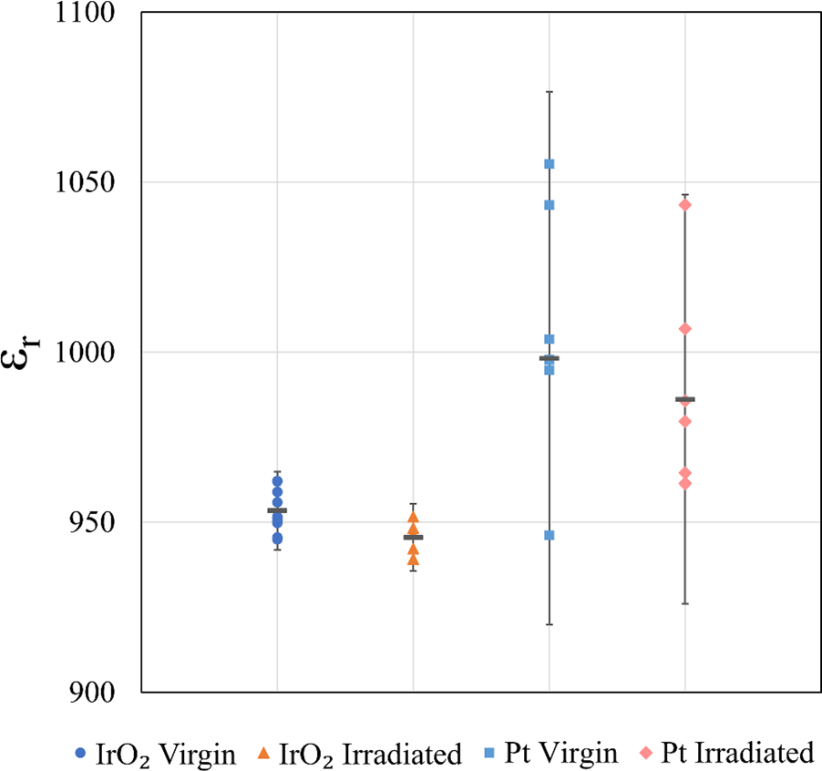

FIG. 3. Dot plot showing distribution of low-field relative permittivity (er) for samples with either oxide or metal top electrodes, both before and after irradi-ation. Points shown represent measurements taken on different electrodes. Error bars indicate 95% confidence interval from the mean for all measure-ments. Mean is shown as dark horizontal bar for each set of measurements. Measurements taken at 100 mV, 1 kHz.

material or reduced amounts of free charges, and could poten-tially indicate reduced domain wall motion, as such motion contributes to both dielectric permittivity and dielectric losses.39   
 The nonlinear dielectric response of the samples is shown in Figure 4. To quantify potential changes in extrinsic contributions, the nonlinear dielectric response was analyzed through the Rayleigh formalism.41Specifically, of interest are the reversible Rayleigh parameter, einit, the intercept of linear field-dependent relative dielectric permittivity, and the irreversible Rayleigh parameter, a, i.e., the slope of the field-dependent permittivity. einit describes mostly contributions

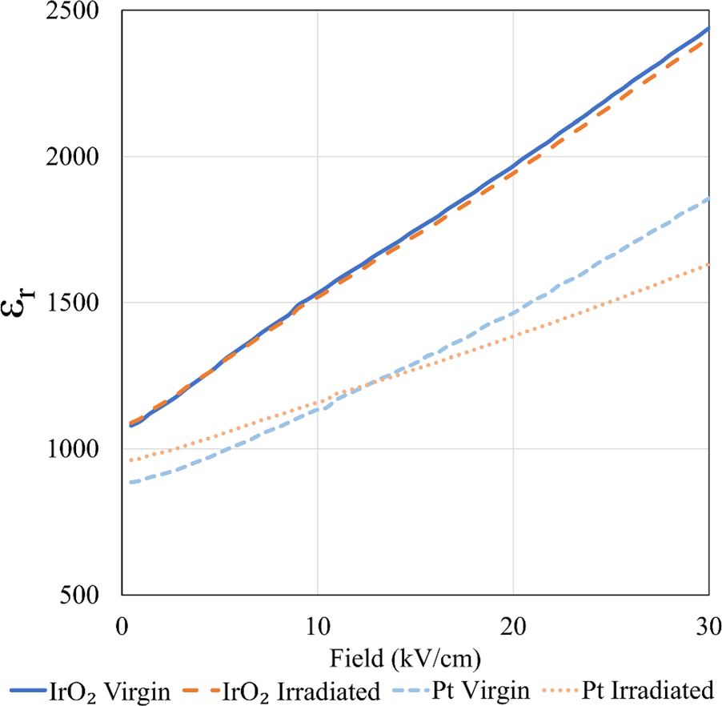

FIG. 4. Nonlinear dielectric response at low to intermediate fields, probed with 1 kHz AC waveform. Rayleigh analysis fits a line to the linear region of the plots (from 10 kV/cm up to 30 kV/cm for these samples) to extract einit (intercept) and a (slope).

from the intrinsic lattice deformation and reversible motion of internal interfaces, while irreversible contributions (repre-sented by a) describe larger-scale, irreversible domain wall motion. Therefore, a and the ratio of the irreversible to re-versible Rayleigh parameters are considered a quantitative measure of the extrinsic contributions to the functional response.42   
 Irradiation of film stacks with either electrode material resulted in degradation of a. However, films with Pt electro-des showed degradation in excess of four times (37% vs. 8% degradation) the degradation observed in samples with IrO2 electrodes (Table I). This implies that the irreversible motion of internal interfaces is severely reduced by irradia-tion, with greater effects seen in samples with Pt electrodes. Conversely, einit, or reversible contributions to the response, showed enhancements of �3% (within experimental error, Table I) and 11% for samples with IrO2 and Pt electrodes, respectively (Table I). The above results suggest that intrin-sic response and/or reversible domain wall motion were augmented at the expense of irreversible domain wall mo-bility, which will be discussed hereafter. Finally, the ratio of a/einit showed reduction for samples with both electrode compositions, although the reduction was smaller for sam-ples with IrO2 electrodes (12%) compared with Pt electrodes (45%) (see Table I for details).

The effects of irradiation on the polarization-electric field (P-E) hysteresis curves are shown in Figure 5. Saturation polarization remained largely unaffected for samples with IrO2 electrodes, while those with Pt electrodes resulted in a modest 4% reduction, which is similar to the range of sample variability (Table I). The remanent polarization was reduced by over 35% in samples with Pt top electrodes after irradia-tion, compared with essentially no change for films with oxide electrodes (Table I). Additionally, at lower fields, a slight pinching of the hysteresis loops is observed in irradiated sam-ples with Pt electrodes (Figure 5).

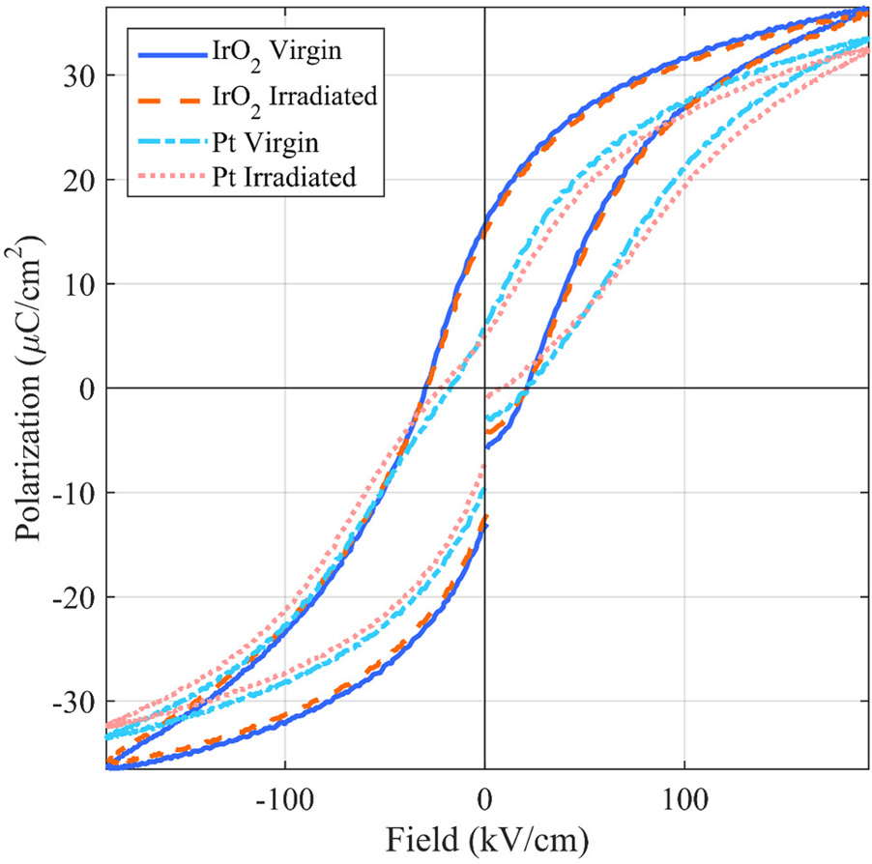

FIG. 5. Ferroelectric response of virgin and irradiated samples with oxide and metallic electrodes, illustrating radiation-induced pinching of loops in samples with Pt electrodes. The measurements were performed at 1 kHz.

Reuse of AIP Publishing content is subject to the terms at: https://publishing.aip.org/authors/rights-and-permissions. Download to IP: 143.215.20.68 On: Mon, 22 Aug 2016 13:11:25

|  |  |  |
| --- | --- | --- |
| 024101-6 | Brewer et al. | J. Appl. Phys. 120, 024101 (2016) |

Figure 6 shows the permittivity vs. DC electric field (er-E) tunability curves for films with both electrode compo-sitions. The tunability suffered minor degradation in both samples upon irradiation. However, the changes were once again within the experimental error, at �3% and �1% for samples with IrO2 and Pt top electrodes, respectively.

|  |  |  |  |  |  |
| --- | --- | --- | --- | --- | --- |
| Furthermore, | irradiated | samples | with | metal | electrodes |

showed a slight horizontal peak shift as well as creation of a new peak, which will be discussed in the following section.

Negligible changes in electromechanical response, d33,f, were observed in samples with oxide electrodes, while sam-ples with metallic electrodes suffered 10% degradation in saturation electromechanical response and 48% degradation in remanent electromechanical response. For samples with Pt electrodes, a reduction of approximately 66% in the disper-sion of d33,f values was seen post-irradiation (Figure 7). It

|  |  |  |  |  |  |  |
| --- | --- | --- | --- | --- | --- | --- |
| should | be | noted | that | the | measured | electromechanical |

response was, on average, approximately 20% lower for samples with IrO2 top electrodes compared with samples with Pt top electrodes, possibly due to tool limitations or sample variances. It should also be noted that the application of DC field to measure electromechanical response can result in lower d33,f values when compared with AC-field measure-ments of similar parameters, due to possible time depend-ence of nonlinear domain wall behavior.43,44   
 Finally, in order to further analyze the effects of gamma irradiation on ferroelectric PZT film stacks and the process by which degradation of functional properties occurs, syn-chrotron XRD and electron spin resonance (ESR) were per-formed on virgin and irradiated samples with IrO2 top electrodes after exposure at 10 Mrad (Si). Prolonged expo-sure experiments were undertaken in an effort to enhance the changes that could be observed using these techniques.

The diffraction data from the virgin sample are shown in Figures 8(a) and 8(b). While the two reflections cannot be seen independently in the diffraction profile, profile fitting to

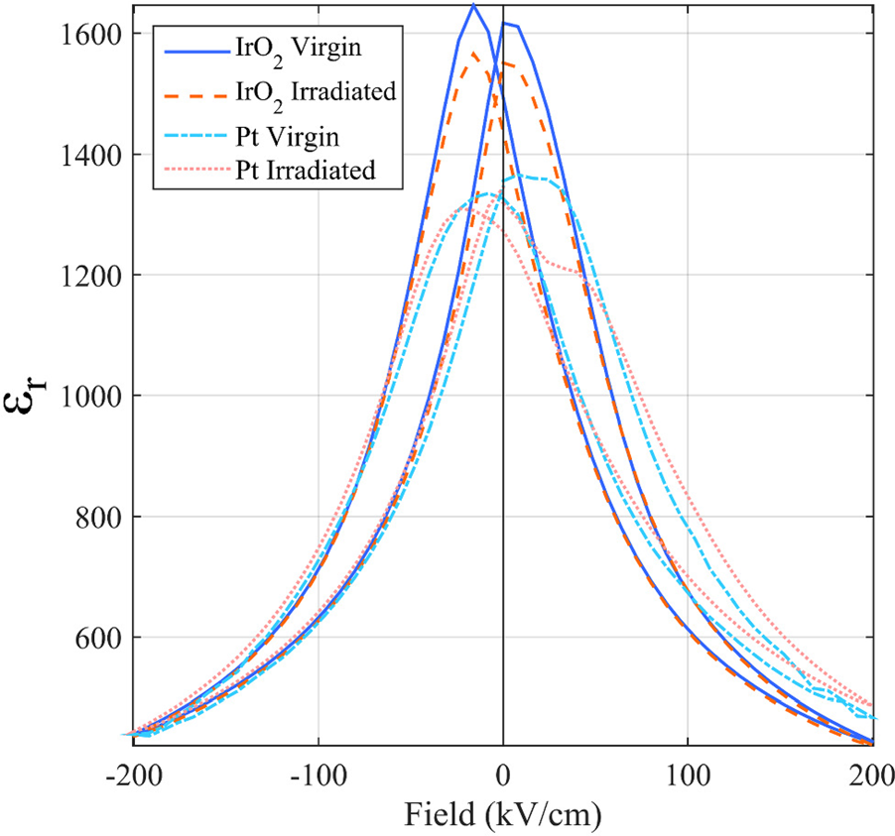

FIG. 6. DC electric field-dependent permittivity curves for virgin and irradi-ated samples with IrO2 and Pt top electrodes, showing horizontal peak shift and creation of a new peak in samples with Pt top electrodes. The measure-ments were performed up to 200 kV/cm DC field with overlapping 500 mV, 1 kHz AC voltage.

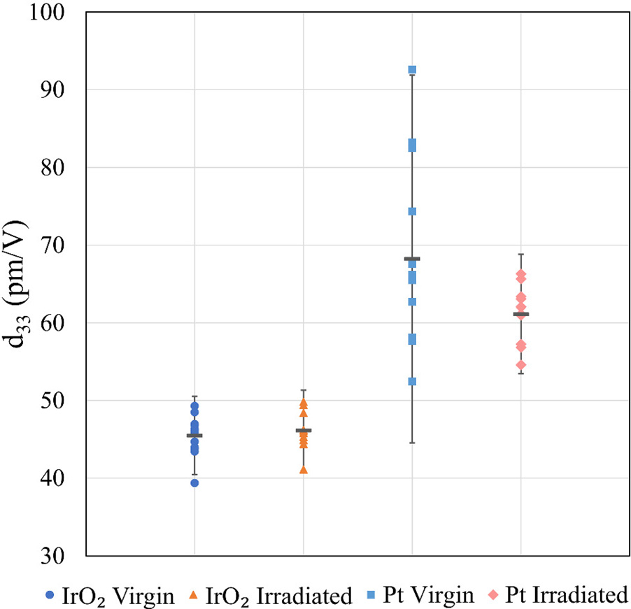

FIG. 7. Dot plots showing distribution of saturated electromechanical response (d33,f,sat) for virgin and irradiated samples with both IrO2 and Pt top electrode. Points shown represent measurements taken on different elec-trodes. Error bars indicate 95% confidence interval from the mean for all measurements. Mean is shown as dark horizontal bar for each set of meas-urements. The measurements were performed at up to 200 kV/cm DC field with overlapping 1 V AC voltage.

the pattern was successful at extracting the respective contri-butions of the (002) and (200) reflections to the overall dif-fraction profile. Profile fitting was completed using a least squares refinement approach and two pseudo-Voigt func-tions, allowing for the extraction of peak positions (2h). Using the extracted peak positions, lattice strain was calcu-lated for the (200) reflection using the following equations and plotted in Figure 8(c):

|  |  |  |  |
| --- | --- | --- | --- |
| dn ¼ | k  2 sin h ð Þ; | | (1)  (2) |
| e200 ¼d1 ~~�~~ d0 | | : |

There are consistencies in the (200) lattice strain between virgin and irradiated samples: similar hysteresis is observed in both samples, similar maximum values at maxi-mum field, and similar remanent strain values after removal of the field. The data show that there are no significant differ-ences in the (200) lattice strain between the virgin and irradi-ated samples within the error of the peak position. This indicates that the high electric fields utilized in this experi-ment may overcome any influence of weak pinning centers that are induced by radiation (e.g., defect creation, domain wall pinning by weak pinning centers).

Electron spin resonance (ESR) is a well-established microwave technique used to identify and quantify native and radiation-induced defects in a variety of materials. Experiments at 9.5 GHz on virgin PZT samples reveal a signal with Zeeman splitting g-value of �2.005 and full width at half maximum (FWHM) of �10 G (Figure 9). These parameters are very similar to those for resonances attributed to oxygen vacancy-related defects in PZT powder

Reuse of AIP Publishing content is subject to the terms at: https://publishing.aip.org/authors/rights-and-permissions. Download to IP: 143.215.20.68 On: Mon, 22 Aug 2016 13:11:25

|  |  |  |
| --- | --- | --- |
| 024101-7 | Brewer et al. | J. Appl. Phys. 120, 024101 (2016)  FIG. 8. (a) and (b) Representative in-tensity vs. 2h XRD profiles acquired from the non-irradiated sample and (c) (200) lattice strain plotted as a function of voltage for both non-irradiated and irradiated samples, both with IrO2 top electrodes. |
|  | |

samples.45After application of 10 Mrad (Si) gamma irradia-tion, this ESR signal is observed to be approximately twice as broad, indicating differences in the defect-energy land-

samples with IrO2 compared with Pt top electrodes: PZT thin films with oxide top electrodes show a higher tolerance to

ionizing radiation-induced degradation than films with

scape, which will be discussed hereafter. metallic top electrodes.

A radiation-induced reduction in motion of the internal

interfaces is highlighted by the reduction of the irreversible

IV. DISCUSSION

Gamma irradiation of PZT thin films with both oxide and metal top electrodes resulted in degradation of functional properties. However, a clear trend is observed in the dielec-

|  |  |  |  |  |  |
| --- | --- | --- | --- | --- | --- |
| tric, | ferroelectric, | and | electromechanical | responses | for |

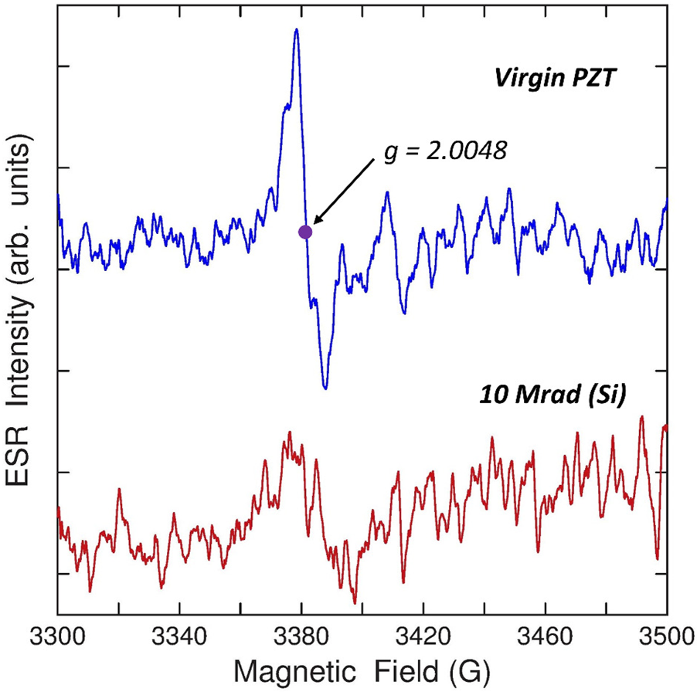

FIG. 9. Electron spin resonance (ESR) spectra at 9.5 GHz for virgin and irra-diated (10 Mrad (Si)) PZT samples, displaying a broadening of the signal at g � 2.005 observed post-irradiation.

Rayleigh parameter (a), counterpointed by the increasing re-

|  |  |  |  |  |  |
| --- | --- | --- | --- | --- | --- |
| versible | Rayleigh | component | (einit), | indicating | either |

enhanced vibration of the same interfaces or intrinsic lattice strain (assuming that a subset of domain walls are com-pletely pinned after irradiation).46However, results from XRD analysis show consistent strain profiles for virgin and irradiated films, suggesting that the lattice strain response change with irradiation is low. It is therefore unlikely that the lattice strain response changes significantly after irradia-tion and, therefore, the change in einit is more likely due to domain wall motion contributions.

These observations suggest radiation-induced, “high energy” pinning sites (defects) for the motion of the internal interfaces, resulting in increased vibration and decreased over-all motion of these interfaces, in terms of contributions to the dielectric response. We note that such higher-energy defects are consistent primarily with radiation-induced creation of trapped charges as a consequence of ionization events, i.e., deepening of the potential energy wells corresponding to pre-existing defects. These trapped charges can result in stabiliza-tion of domain walls at pinning sites or accumulation of charges trapped at grain boundaries, thereby resulting in addi-tional pinning.47   
 The above observations are also consistent with the appearance of a new maximum in the post-irradiation er-E curves for samples with Pt electrodes (Figure 6). The local maxima in er-E curves correspond to the average switching DC fields. Therefore, the appearace of a new peak can be

Reuse of AIP Publishing content is subject to the terms at: https://publishing.aip.org/authors/rights-and-permissions. Download to IP: 143.215.20.68 On: Mon, 22 Aug 2016 13:11:25

|  |  |  |
| --- | --- | --- |
| 024101-8 | Brewer et al. | J. Appl. Phys. 120, 024101 (2016) |

associated with the creation of a new family of defects or change of the energy of a subset of the defects already present in the samples. If the energy change in defects affected by radiation differs substantially from the pre-existing defects, the switching fields associated with the defects will also be

ordering) at the interface will be viable at lower total ionization doses, resulting in negative consequences on the ferroelectric and electromechanical responses of the samples.14   
 In addition to degradation induced by defect ordering and accumulation, the presence or enlargement of ferroelec-

|  |  |  |  |  |  |  |  |  |
| --- | --- | --- | --- | --- | --- | --- | --- | --- |
| different and will appear as a separate peak in the er-E curves. | trically | inactive | | layers is pertinent | | here. | The defect- | |
| Similarly, the pinching observed in the P-E loops (Figure 5) | stimulated | | formation/enlargement | | of | ferroelectric | | dead |

for samples with metallic electrodes—exacerbated after irra-diation—is consistent with pinning of internal interfaces and presence of oriented defect dipoles. Various defects, such as domain wall pinning due to diffusion of charged defects and alignment of dipolar defects, are typically associated with pinching of hysteresis loops in previous studies.48–53It is also possible that irradiation locally disrupts polarization through the generation of electron-hole pairs. When these unbiased pairs equilibrate, the domain polarization randomly orients, leading to effects similar to those in aging of unpoled PZT.48 This proposed mechanism is further corroborated by the ESR data presented in Figure 8, at elevated levels of irradiation.45 The broadening of the ESR spectrum in irradiated PZT samples may indicate changes to oxygen vacancies already present in the system, where the gamma irradiation excites electrons that subsequently become trapped at these sites ( i:e: ; V��more mobile; therefore, their formation could lead to domain O! V�O).47 The singly charged V�Oare known to be

depolarization via strain-driven reorientation, even if the charged state is short-lived.47At longer time scales, these newly reoriented defects can move toward the top electrode interface where they will play a particularly critical role on the functional properties of the PZT thin films studied here. However, as point defects, they are not strong enough to affect large-scale domain wall motion, as evidenced by the in situ XRD results.

The overall electrode-dependence of the radiation-induced degradation suggests that the PZT–electrode hetero-interface is particularly susceptible to changes in the population and/or energy of defects that act as pinning sites. In general, any inter-face in the sample is likely to act as a pinning site and affect do-main wall motion.19The effect of the top electrode on the overall functional response of the ferroelectric material has been addressed by various hypotheses in the literature, includ-ing through movement and ordering of defects at interfa-ces.23–26,28,31,54Specifically, oxygen vacancies can become mobile and/or V��sufficiently-strong applied electric field, toward the ferroelectri-O� V00 Pbdefect dipoles reorient under a

c–electrode interface. As oxygen vacancies accumulate and self-order at the interface, they pin domain wall motion, sup-press nucleation, and inhibit polarization.23,26Prior studies for ferroelectric capacitor and memory applications have reported a more closely matching work-function of PZT with oxide elec-trodes compared with metallic ones, resulting in improved con-ductivity at the interface and potential for oxygen vacancy migration and annihilation.33,55–57For samples with oxide top electrodes, ion conduction and partial annihilation of defects

layers results in decreased ionic motion and thereby exacer-bates defect accumulation and domain wall pinning near the interface.27,29,30These ferroelectric dead layers will theoreti-cally become increasingly more prevalent with compounding defect motion and accumulation stimulated, in this research, by irradiation. The deleterious effects of irradiation on the polarization response of samples with Pt electrodes support the presence of a ferroelectric dead layer, characterized by non-switchable regions near the interface.30Incorporation of oxide electrodes has previously shown increased fatigue re-sistance and superior ferroelectric switching behavior due to reduced defect formation in the PZT.27   
 Finally, the difference in density and electron concen-tration between IrO2 and Pt must be considered: the greater density of metallic electrodes could lead to a radiation dose enhancement near the PZT–Pt electrode interface, further exacerbating the effects of oxygen vacancy ordering and aging.58Based on available data from NIST, the mass energy attenuation coefficients (in units of cm2/g) for Pt metal, Ir metal, and lead glass are all within approximately 10% of each other for 1 MeV and 100 keV photons, respec-tively. However, since Pt is approximately twice as dense as IrO2 (21.5 vs. 11.7 g/cm3) and nearly three times as dense as PZT (7.5 g/cm3), one would estimate a significant dose enhancement in excess of 50% in the region beneath the Pt electrode as compared with the PZT covered by the IrO2 electrode.59,60The greater total ionizing dose at the metal electrode–PZT interface may contribute to the greater radiation-induced degradation observed in devices with Pt electrodes.

V. CONCLUSIONS

PZT thin films with metallic Pt and metal-oxide IrO2 top electrodes were exposed to 2.5 Mrad (Si)60Co gamma radia-tion. For material stacks with both types of electrodes, mini-mal changes in low-field relative permittivity (�1%), saturated polarization (<5%), and electromechanical response (�10%) were observed. However, irradiated sam-ples with IrO2 electrodes showed substantially smaller changes of dielectric and electromechanical responses than those with Pt electrodes, suggesting that the hetero-interface between the PZT thin film and electrode plays a critical role in either the radiation–material interaction or in the subse-quent stages for reaching a new equilibrium. The degradation in response was associated with the deepening of the present defects’ potential energy wells that resulted in increased re-

|  |  |  |  |  |  |  |  |  |  |  |  |  |  |  |
| --- | --- | --- | --- | --- | --- | --- | --- | --- | --- | --- | --- | --- | --- | --- |
| result | in | reduced | susceptibility | of | the | ferroelectric | to | versible | contributions | to | the | dielectric | response | and |

degradation-induced defect accumulation, domain wall pin-ning, and polarization switching restriction. Conversely, sam-ples with metal electrodes do not offer sites for healing of defects. Therefore, defect accumulation (and subsequent

decreased motion of internal interfaces (e.g., domain walls, phase boundaries, etc.), as well as pinching of the polariza-tion hysteresis loops and appearance of new peaks in the er-E curves for platinized samples. Changes in the defect

Reuse of AIP Publishing content is subject to the terms at: https://publishing.aip.org/authors/rights-and-permissions. Download to IP: 143.215.20.68 On: Mon, 22 Aug 2016 13:11:25

|  |  |  |
| --- | --- | --- |
| 024101-9 | Brewer et al. | J. Appl. Phys. 120, 024101 (2016) |

landscape are less damaging to the functional response of ferroelectric films and material stacks incorporating a metal-oxide top electrode, due to the closer match of the work function of the oxide vs. metal conductor with the ferroelec-tric, as well as the oxide nature of the IrO2, which allows for partial annihilation of oxygen defects at the film/conductor hetero-interface. These results suggest a promising avenue for creation of radiation-hard devices based on ferroelectric materials.

ACKNOWLEDGMENTS

21M. Dawber, K. M. Rabe, and J. F. Scott, [Rev. Mod. Phys.](http://dx.doi.org/10.1103/RevModPhys.77.1083) 77, 1083

(2005).

22M. Stengel, D. Vanderbilt, and N. A. Spaldin, [Nat. Mater.](http://dx.doi.org/10.1038/nmat2429) 8, 392 (2009). 23J. F. Scott and M. Dawber, [Appl. Phys. Lett.](http://dx.doi.org/10.1063/1.126786) 76, 3801 (2000).

24S. Kim, J. Koo, S. Shin, and Y. Park, [Appl. Phys. Lett.](http://dx.doi.org/10.1063/1.2135898) 87, 212910 (2005). 25K. M. Lee, H. G. An, J. K. Lee, Y. T. Lee, S. W. Lee, S. H. Joo, S. D.

Nam, K. S. Park, M. S. Lee, S. O. Park, H. K. Kang, and J. T. Moon, [Jpn.](http://dx.doi.org/10.1143/JJAP.40.4979)

[J. Appl. Phys., Part 1](http://dx.doi.org/10.1143/JJAP.40.4979) 40, 4979 (2001).

26L. F. Schloss, P. C. McIntyre, B. C. Hendrix, S. M. Bilodeau, J. F. Roeder,

and S. R. Gilbert, [Appl. Phys. Lett.](http://dx.doi.org/10.1063/1.1516628) 81, 3218 (2002).

27Y. Chen and P. C. McIntyre, [Appl. Phys. Lett.](http://dx.doi.org/10.1063/1.2822419) 91, 232906 (2007).

28B. S. Kang, D. J. Kim, J. Y. Jo, T. W. Noh, J. G. Yoon, T. K. Song, Y. K.

Lee, J. K. Lee, S. Shin, and Y. S. Park, [Appl. Phys. Lett.](http://dx.doi.org/10.1063/1.1710715) 84, 3127 (2004). 29M. Stengel, P. Aguado-Puente, N. A. Spaldin, and J. Junquera, [Phys. Rev.](http://dx.doi.org/10.1103/PhysRevB.83.235112)

|  |  |  |  |  |  |  |  |  |
| --- | --- | --- | --- | --- | --- | --- | --- | --- |
| This | work | was | supported | by | the | Defense | Threat | [B](http://dx.doi.org/10.1103/PhysRevB.83.235112) 83, 235112 (2011). |
| 30Y. Wang, M. K. Niranjan, K. Janicka, J. P. Velev, M. Y. Zhuravlev, S. S. |

Reduction Agency, Basic Research Award No. # HDTRA1-15-1-0035, to Georgia Institute of Technology. The contents do not necessarily reflect the position or the policy of the federal government, and no official endorsement should be inferred. The authors acknowledge the contributions of Joel Martin and Brian Power of the Army Research Laboratory and Steven Isaacson of General Technical Services for their roles in the fabrication of the PZT thin films and MEMS devices.

|  |  |  |  |  |  |  |  |  |  |
| --- | --- | --- | --- | --- | --- | --- | --- | --- | --- |
| They | also | acknowledge | | the | use | of | the | Analytical | |
| Instrumentation | | | Facility | (AIF) | at | North | Carolina | | State |

University, which is supported by the State of North Carolina and the National Science Foundation.

1S. Trolier-McKinstry and P. Muralt, [J. Electroceram.](http://dx.doi.org/10.1023/B:JECR.0000033998.72845.51) 12, 7 (2004).

2G. L. Smith, J. S. Pulskamp, L. M. Sanchez, D. M. Potrepka, R. M. Proie, T. G. Ivanov, R. Q. Rudy, W. D. Nothwang, S. S. Bedair, C. D. Meyer, and R. G. Polcawich, [J. Am. Ceram. Soc.](http://dx.doi.org/10.1111/j.1551-2916.2012.05155.x) 95, 1777 (2012).

3D. D. Glower, D. L. Hester, and D. F. Warnke, [J. Am. Ceram. Soc.](http://dx.doi.org/10.1111/j.1151-2916.1965.tb14780.x) 48, 417 (1965).

4J. Gao, L. Zheng, X. Duo, J. Huang, L. Yang, C. Lin, and R. Yan, [Thin Solid Films](http://dx.doi.org/10.1016/S0040-6090(98)01368-6) 340, 132 (1999).

5J. Gao, L. Zheng, Z. Song, L. Wang, L. Yang, D. Zhu, and C. Lin, [Philos. Mag., Part B](http://dx.doi.org/10.1080/13642819908214843) 79, 829 (1999).

6S. A. Yang, B. H. Kim, M. K. Lee, G. J. Lee, N.-H. Lee, and S. D. Bu, [Thin Solid Films](http://dx.doi.org/10.1016/j.tsf.2014.04.038) 562, 185 (2014).

7I. Baturin, N. Menou, V. Shur, C. Muller, D. Kuznetsov, J. L. Hodeau, and A. Sternberg, [Mater. Sci. Eng., B](http://dx.doi.org/10.1016/j.mseb.2005.02.024) 120, 141 (2005).

8N. Menou, A.-M. Castagnos, C. Muller, D. Goguenheim, L. Goux, D. J. Wouters, J.-L. Hodeau, E. Dooryhee, and R. Barrett, [J. Appl. Phys.](http://dx.doi.org/10.1063/1.1851598) 97, 044106 (2005).

9J. F. Scott, C. A. Araujo, H. B. Meadows, L. D. McMillan, and A. Shawabkeh, [J. Appl. Phys.](http://dx.doi.org/10.1063/1.344419) 66, 1444 (1989).

10B. H. Kim, S. A. Yang, S. W. Kang, G. P. Choi, S. Y. Cho, J. K. Han, G. J. Lee, M. K. Lee, H. J. Seog, I. W. Kim, and S. D. Bu, [Curr. Appl. Phys.](http://dx.doi.org/10.1016/j.cap.2016.01.009) 16(5), 539–544 (2016).

11Y. Bastani, A. Y. Cortes-Pena, A. D. Wilson, S. Gerardin, M. Bagatin, A.

Paccagnella, and N. Bassiri-Gharb, [Appl. Phys. Lett.](http://dx.doi.org/10.1063/1.4805045) 102, 192906 (2013). 12R. M. Proie, R. G. Polcawich, C. D. Cress, L. M. Sanchez, A. D. Grobicki, J. S. Pulskamp, and N. J. H. Roche, [IEEE Trans. Nucl. Sci.](http://dx.doi.org/10.1109/TNS.2013.2282261) 60, 4505 (2013).

13J. T. Graham, G. L. Brennecka, P. Ferreira, L. Small, D. Duquette, C. Apblett, S. Landsberger, and J. F. Ihlefeld, [J. Appl. Phys.](http://dx.doi.org/10.1063/1.4795869) 113, 124104 (2013).

14A. Henriques, J. T. Graham, S. Landsberger, J. F. Ihlefeld, G. L. Brennecka, D. W. Brown, J. S. Forrester, and J. L. Jones, [AIP Adv.](http://dx.doi.org/10.1063/1.4902179) 4, 117125 (2014).

15J. F. Fowler, [Proc. R. Soc. London, Ser. A](http://dx.doi.org/10.1098/rspa.1956.0149) 236, 464 (1956).

16O. S. Oen and D. K. Holmes, [J. Appl. Phys.](http://dx.doi.org/10.1063/1.1735307) 30, 1289 (1959).

17K. Sickafus, R. Grimes, J. Valdez, A. Cleave, M. Tang, M. Ishimaru, S. Corish, C. Stanek, and B. Uberuaga, [Nat. Mater.](http://dx.doi.org/10.1038/nmat1842) 6, 217 (2007).

18D. Damjanovic, [Rep. Prog. Phys.](http://dx.doi.org/10.1088/0034-4885/61/9/002) 61, 1267 (1998).

19T. M. Shaw, S. Trolier-McKinstry, and P. C. McIntyre, [Annu. Rev. Mater.](http://dx.doi.org/10.1146/annurev.matsci.30.1.263)  [Sci.](http://dx.doi.org/10.1146/annurev.matsci.30.1.263) 30, 263 (2000).

20W. J. Merz, [Phys. Rev.](http://dx.doi.org/10.1103/PhysRev.95.690) 95, 690 (1954).

Jaswal, and E. Y. Tsymbal, [Phys. Rev. B](http://dx.doi.org/10.1103/PhysRevB.82.094114) 82, 094114 (2010).

31A. Gruverman and M. Tanaka, [J. Appl. Phys.](http://dx.doi.org/10.1063/1.1334938) 89, 1836 (2001).

32T. Nakamura, Y. Nakao, A. Kamisawa, and H. Takasu, [Appl. Phys. Lett.](http://dx.doi.org/10.1063/1.112031)

65, 1522 (1994).

33A. J. Hartmann, M. Neilson, R. N. Lamb, K. Watanabe, and J. F. Scott,

[Appl. Phys. A](http://dx.doi.org/10.1007/s003390050041) 70, 239 (2000).

34J. S. Lee and S. K. Joo, [Jpn. J. Appl. Phys., Part 1](http://dx.doi.org/10.1143/JJAP.40.229) 40, 229 (2001).

35S. Aggarwal, I. G. Jenkins, B. Nagaraj, C. J. Kerr, C. Canedy, R. Ramesh,

G. Velasquez, L. Boyer, and J. T. Evans, [Appl. Phys. Lett.](http://dx.doi.org/10.1063/1.124820) 75, 1787

(1999).

36L. M. Sanchez, D. M. Potrepka, G. R. Fox, I. Takeuchi, K. Wang, L. A.

Bendersky, and R. G. Polcawich, [J. Mater. Res.](http://dx.doi.org/10.1557/jmr.2013.172) 28, 1920 (2013).

37K. D. Budd and D. A. Payne, Inst. Phys. Conf. Ser. 13, 13–22 (1989). 38C. Magee, W. Harrington, and E. Botnick, [Int. J. Mass Spectrom. Ion](http://dx.doi.org/10.1016/0168-1176(90)80015-U)

[Processes](http://dx.doi.org/10.1016/0168-1176(90)80015-U) 103, 45 (1990).

39B. Jaffe, W. R. Cook, and H. L. Jaffe, Piezoelectric Ceramics (Academic

|  |  |  |  |  |  |  |  |  |  |  |
| --- | --- | --- | --- | --- | --- | --- | --- | --- | --- | --- |
| Press, London, New York, 1971). | | | | | to | Error | Analysis: | The | Study | of |
| 40J. | R. | Taylor, | An | Introduction |

Uncertainties in Physical Measurements, 2nd ed. (University Science

Books, Sausalito, California, 1997).

41N. Bassiri-Gharb, I. Fujii, E. Hong, S. Trolier-McKinstry, D. V. Taylor,

and D. Damjanovic, [J. Electroceram.](http://dx.doi.org/10.1007/s10832-007-9001-1) 19, 49 (2007).

42S. P. Li, W. W. Cao, and L. E. Cross, [J. Appl. Phys.](http://dx.doi.org/10.1063/1.347616) 69, 7219 (1991). 43S. Sherrit, D. Vannice, J. Graham, B. Mukherjee, H. Wiederick, M. Liu,

A. Safari, A. Kingon, and G. Haertling, in ISAF 92: Proceedings of the

Eighth IEEE International Symposium on Applications of Ferroelectrics

(1992), p. 167.

44A. Masys, W. Ren, G. Yang, and B. Mukherjee, [J. Appl. Phys.](http://dx.doi.org/10.1063/1.1587008) 94, 1155

(2003).

45V. Longo, M. Silva, A. de Figueiredo, R. Franco, C. Vila, M. Cilense, J.

Varela, E. Longo, and J. Andres, [Chem. Phys. Lett.](http://dx.doi.org/10.1016/j.cplett.2009.05.026) 475, 96 (2009).

46A. Pramanick, D. Damjanovic, J. Daniels, J. Nino, and J. Jones, [J. Am.](http://dx.doi.org/10.1111/j.1551-2916.2010.04240.x)

[Ceram. Soc.](http://dx.doi.org/10.1111/j.1551-2916.2010.04240.x) 94, 293 (2011).

47C. Park and D. Chadi, [Phys. Rev. B](http://dx.doi.org/10.1103/PhysRevB.57.R13961) 57, R13961 (1998).

48D. Damjanovic, The Science of Hysteresis (Academic Press, Oxford,

2006), p. 337.

49Y. Genenko, J. Glaum, M. Hoffmann, and K. Albe, [Mater. Sci. Eng., B](http://dx.doi.org/10.1016/j.mseb.2014.10.003)

192, 52 (2015).

50S. Pandey, O. Thakur, A. Kumar, C. Prakash, R. Chatterjee, and T. Goel,

[J. Appl. Phys.](http://dx.doi.org/10.1063/1.2209725) 100, 014104 (2006).

51G. Robert, D. Damjanovic, and N. Setter, [Appl. Phys. Lett.](http://dx.doi.org/10.1063/1.1332824) 77, 4413

(2000).

52M. Kohli, P. Muralt, and N. Setter, [Appl. Phys. Lett.](http://dx.doi.org/10.1063/1.121554) 72, 3217 (1998). 53Q. Ke, A. Kumar, X. Lou, K. Zeng, and J. Wang, [Appl. Phys. Lett.](http://dx.doi.org/10.1063/1.3678636) 100,

042902 (2012).

54I. K. Yoo and S. B. Desu, [Mater. Sci. Eng., B](http://dx.doi.org/10.1016/0921-5107(92)90135-V) 13, 319 (1992).

55M. Dawber and J. F. Scott, [Jpn. J. Appl. Phys., Part 1](http://dx.doi.org/10.1143/JJAP.41.6848) 41, 6848 (2002). 56M. C. Chen, T. C. Chang, C. T. Tsai, S. Y. Huang, S. C. Chen, C. W. Hu,

S. M. Sze, and M. J. Tsai, [Appl. Phys. Lett.](http://dx.doi.org/10.1063/1.3456379) 96, 262110 (2010).

57S. Aggarwal, S. R. Perusse, S. Madhukar, T. K. Song, C. L. Canedy, R.

Ramesh, S. Choopun, R. P. Sharma, T. Venkatesan, and S. M. Green,

[J. Electroceram.](http://dx.doi.org/10.1023/A:1009922816030) 2, 171 (1998).

58J. Wall and E. Burke, [IEEE Trans. Nucl. Sci.](http://dx.doi.org/10.1109/TNS.1970.4325810) 17, 305 (1970).

59V. Trimble, Scientist 1, 19 (1987); ISBN 9781482260977.

60J. H. Hubbell and S. M. Seltzer, “Tables of X-Ray Mass Attenuation

Coefficients and Mass Energy-Absorption Coefficients from 1 keV to

20 MeV for Elements Z ¼ 1 to 92 and 48 Additional Substances of Dosimetric Interest” (U.S. Secretary of Commerce, 1996).

Reuse of AIP Publishing content is subject to the terms at: https://publishing.aip.org/authors/rights-and-permissions. Download to IP: 143.215.20.68 On: Mon, 22 Aug 2016 13:11:25