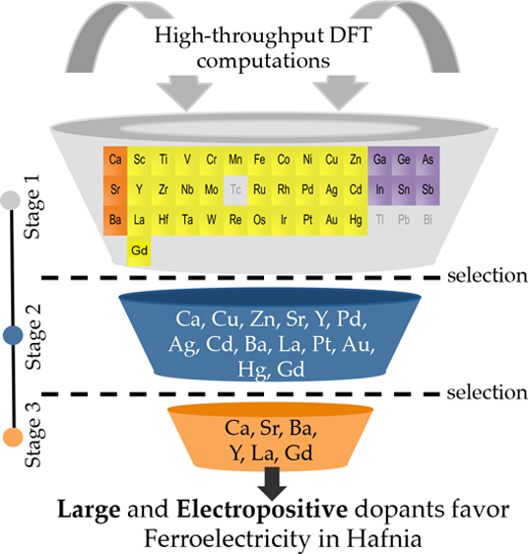

Article Cite This: [Chem. Mater. 2017, 29, 9102-9109](http://pubs.acs.org/action/showCitFormats?doi=10.1021/acs.chemmater.7b02835)  pubs.acs.org/cm

Dopants Promoting Ferroelectricity in Hafnia: Insights from a comprehensive Chemical Space Exploration

|  |  |  |
| --- | --- | --- |
| Rohit Batra, | Tran Doan Huan, | George A. Rossetti, Jr., and Rampi Ramprasad* |

Department of Materials Science & Engineering, University of Connecticut, Storrs, Connecticut 06269, United States

|  |  |  |  |  |  |  |
| --- | --- | --- | --- | --- | --- | --- |
| * S Supporting Information | | | | | | |
| ABSTRACT: Although dopants have been extensively employed to promote ferroelec-tricity in hafnia films, their role in stabilizing the responsible ferroelectric nonequilibrium Pca21 phase is not well understood. In this work, using first-principles computations, we investigate the influence of nearly 40 dopants on the phase stability in bulk hafnia to identify | | | | | | |
| dopants that can favor formation of the polar Pca21 phase. Although no dopant was found to   |  | | --- | | stabilize this polar phase as the ground state, suggesting that dopants alone cannot induce |   ferroelectricity in hafnia, Ca, Sr, Ba, La, Y, and Gd were found to significantly lower the | | | | |  |  |
| energy of the polar phase with respect to the equilibrium monoclinic phase. These results are consistent with the empirical measurements of large remnant polarization in hafnia films | | | | |  |
|  |
| doped with these elements. Additionally, clear chemical trends of dopants with larger ionic radii and lower electronegativity favoring the polar Pca21 phase in hafnia were identified. For this polar phase, an additional bond between the dopant cation and the second nearest oxygen neighbor was identified as the root-cause of these trends. Further, trivalent dopants | | | | |
| (Y, La, and Gd) were revealed to stabilize the polar Pca21 phase at lower strains when  compared to divalent dopants (Sr and Ba). On the basis of these insights, we predict that the lanthanide series metals, the lower  half of alkaline earth metals (Ca, Sr, and Ba) and Y as the most suitable dopants to promote ferroelectricity in hafnia. | | | | | | |
| ■INTRODUCTION  Intentionally added impurities, i.e., dopants, can completely alter the physical properties of the host material. While in some cases, the additional electrons or holes contributed by the dopants dramatically modify the electronic structure, thereby changing properties like the electrical conductivity1and magnetism,2in other cases, the small doping-induced perturbation is enough to alter the atomic arrangement (crystal structure) of the host system (e.g., yttrium stabilized zirconia). Hafnia (HfO2), a well-known linear dielectric material,3−7is likely an example of the latter, as doped thin films of this material have been recently observed to exhibit ferroelectric (FE) behavior through the formation of a nonequilibrium polar phase.8,9Despite a great number of experimental and theoretical studies,10−13the origin of this novel functionality, which finds applications in FE-field effect transistors14and FE-random access memories,15has not been completely under-stood.  In the most likely mechanism, some “suitable” combination of surface energy, mechanical stresses, oxygen vacancies, dopants, and the electrical history of the hafnia film is postulated to stabilize the polar orthorhombic Pca21 (P-O1) phase over the equilibrium monoclinic (M) phase of hafnia, thus enabling the FE behavior.16−19The disappearance of ferroelectricity in the absence of a capping electrode and with increasing film thickness suggests the critical role of the mechanical stresses8 , 2 0 − 2 4 and surface ener-gies,11−13respectively. Similarly, the demonstration of the“wake-up effect” (on application of external electric fields) | | | hints at the role that the electrical history of the film plays in stabilizing the FE phase.25−27Dopants, too, have been found to increase the stability “window” of the P-O1 phase as reflected in an increase in both the magnitude of the measured polarization and the critical thickness of the hafnia film (below which FE behavior is observed).9Some insight into the role of dopants has emerged from recent empirical studies,17,18which have indicated the trend of dopants with higher ionic radii leading to enhanced polarization. Nevertheless, the true role of the dopants in the formation of the P-O1 phase remains unclear, given that traditionally doping is known to stabilize the high-temperature tetragonal (T) or the cubic phases of hafnia.28−30 Two critical questions, important from both application and theoretical standpoints, that these recent studies8,18,23,24,31on FE-doped hafnia raise are (1) which dopant favor the polar phase the most and at what concentration?, and (2) do dopants play a critical role in stabilizing this polar phase in hafnia films, and if yes, which attributes of a dopant (chemical or physical) are relevant?  In this contribution, we address these questions using high-throughput first-principles density functional theory (DFT) computations. In order to address the first question, we follow a three-stage down-selection strategy, illustrated in Figure 1, wherein we examine the influence of nearly 40 dopants on the energetics of the relevant low-energy phases of hafnia, including | | | |
| Received: | July 7, 2017 | | |
| Revised: | October 12, 2017 | | |
| Published: October 13, 2017 | | | |
|  | © 2017 American Chemical Society | 9102 | | | DOI: [10.1021/acs.chemmater.7b02835](http://dx.doi.org/10.1021/acs.chemmater.7b02835) Ch[em. Mater. 2017, 29, 9102−9109](http://dx.doi.org/10.1021/acs.chemmater.7b02835) | |

|  |  |  |
| --- | --- | --- |
| Chemistry of Materials | |  | | --- | | Article | |

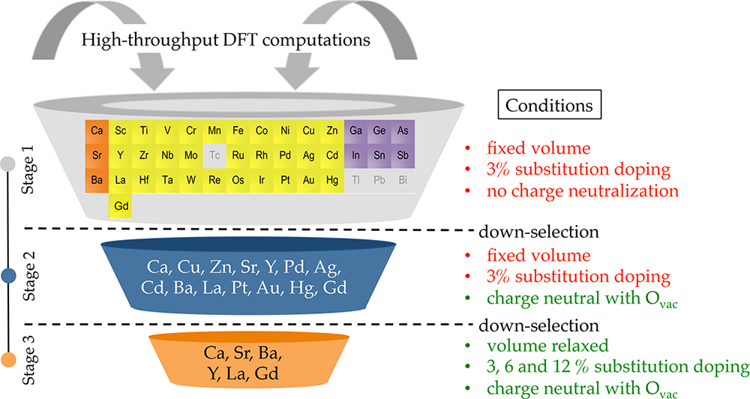

Figure 1. Overall scheme of this work illustrating the three-stage selection process and the modeling conditions imposed in each stage.

M (P21/c), T (P42/nmc), P-O1 (Pca21), another polar P-O2 (Pmn21), and high-pressure OA (Pbca) phases. On the basis of these energy changes, the initial set of nearly 40 dopants in Stage 1 is down-selected to 14 dopants in Stage 2, and finally, to the 6 most promising dopants, i.e., Ca, Sr, Ba, Y, La, and Gd, in Stage 3. In agreement with empirical observations,17,18our study revealed that these 6 dopants favor the stabilization of the P-O1 phase of hafnia. To answer the second question, the computational data obtained in Stage 3 was analyzed. Clear trends illustrating that dopants with higher ionic radii and lower electronegativity stabilize the P-O1 phase the most were found, also consistent with the experimental observations.18The root-cause of these trends is traced to the formation of an additional bond between the dopant and the second nearest-neighbor oxygen atom. On the basis of these findings, we search the entire periodic table, predicting the lanthanides, the lower half of the alkaline earth metals (i.e., Ca, Sr, Ba) and Y as the most favorable dopants to promote ferroelectricity in hafnia.

Theoretical Methods. Our work is based on electronic structure DFT calculations, performed using the Vienna Ab Initio Simulation Package32(VASP) employing the Perdew−Burke−Ernzerhof exchange-correlation functional33and the projector-augmented wave methodology.34A 3 × 3 × 3 Monkhorst−Pack mesh35for k-point sampling was adopted and a basis set of plane waves with kinetic energies up to 500 eV was used to represent the wave functions. For each doped phase, spin polarized computations were performed and all atoms were allowed to relax until atomic forces were smaller than 10−2eV/Å.

To determine the energy ordering of phases in doped hafnia, we define the relative energy of a phase α with respect to the equilibrium M phase in the presence of a dopant D as

Δ *E* D *α*−M = *E* D *α*−*E* D M (1)

where ED α and ED M are the DFT computed energies of the doped α and M phases, respectively. To highlight the direct role of a dopant in stabilizing the phase α, we subtract from eq 1 a term corresponding to the energy of dopant-free pure phases:

Δ *E* D *α*− − M Pure = ( *E* D *α*−*E* D M )−( *E* Pure *α* −*E* Pure M ) (2)

where EPure α and EPure M are the DFT computed energies of pure α and M phases, respectively. ΔED−Pure α−M represents the change in the relative energy of the phase α with respect to the M phase solely due to the introduction of the dopant D. Thus, a dopant with negative ΔED−Pure α−M favors (or stabilizes) the phase α over the M phase more than in the dopant-free pure case. Further, if

9103 DOI: [10.1021/acs.chemmater.7b02835](http://dx.doi.org/10.1021/acs.chemmater.7b02835)

|  |  |  |
| --- | --- | --- |
| Chemistry of Materials | |  | | --- | | Article | |

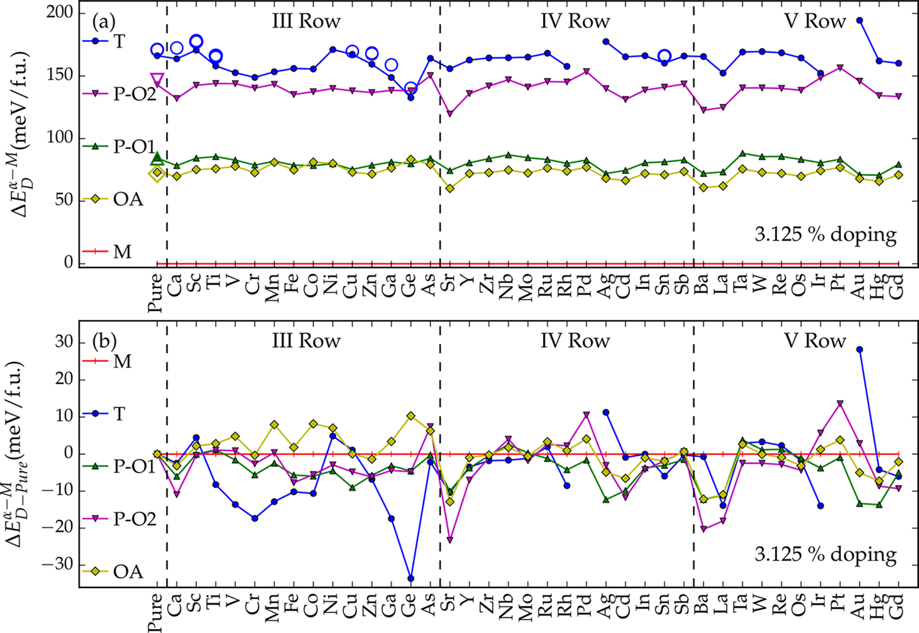

Figure 2. Phase stability of hafnia in the presence of different dopants and under the constraints of Stage 1, as computed using (a) eq 1 and (b) eq 2. In panel a, solid symbols represent the data from this work whereas open symbols signify results from previous studies.10,28The lines are guide to the eyes.

studies.10,11,37This energetic proximity is a manifestation of the remarkable structural similarity between the two phases. As captured in Figure 2a, the M phase remains the equilibrium phase for all the dopants considered at 3.125% doping concentration, although the energy differences among the hafnia phases change significantly. The relative energy of T phase alters substantially more with the choice of the dopant (e.g., Ge, Au, etc.) in comparison to that of the P-O1, P-O2, and OA phases, possibly due to the different coordination environment experienced by a dopant cation in the T (coordination number = 8) versus the other phases (coordination number = 7) considered here. Interestingly, the T phase of Pd- and Pt-doped hafnia collapse into the P-O1 phase (see Supporting Information for details) upon atomic relaxation (resulting in absence of these data points in Figure 2). An important implication of this finding is that even small perturbations can possibly result in T to P-O1 phase transformations, and can be a potential pathway of formation of the P-O1 phase in hafnia. We will continue to encounter this collapse of the T phase to the P-O1 phase in later stages of this work as well.

Owing to the large energy scale and the small doping level, the influence of dopants on the phase stability appears feeble in Figure 2a. This picture, however, changes substantially when we replot it using eq 2 as shown in Figure 2b. We again caution here that the quantity ΔED−Pure α−M plotted in Figure 2b only helps us identify the phase(s) a dopant prefers over the M phase, and not the lowest energy ground state of hafnia, which is indeed determined by the quantity ΔED α−M. Two key trends to be observed in Figure 2b are (1) row IV and row V dopants follow very similar phase stability trends when moving from left to right across the periodic table, with the row V dopants inducing larger energy variations, and (2) dopants from alkaline earth, and group 3, 10, 11, and 12 of the periodic table tend to favor the P-O1 and/or the P-O2 phases in hafnia, leading to the

9104 DOI: [10.1021/acs.chemmater.7b02835](http://dx.doi.org/10.1021/acs.chemmater.7b02835)

|  |  |  |
| --- | --- | --- |
| Chemistry of Materials | |  | | --- | | Article | |

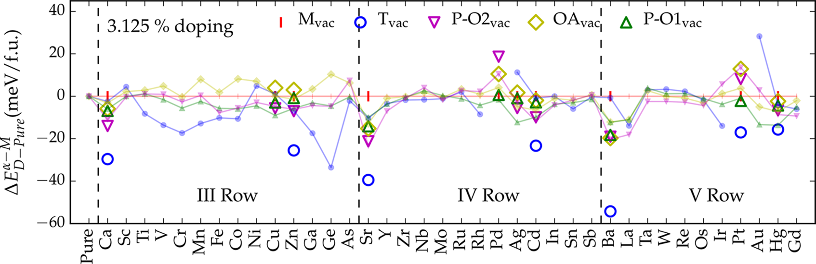

Figure 3. Relative energies of 3.125% doped hafnia for the limited set of 10 divalent dopants of Stage 2 in the presence of a charge neutralizing Ovac. For ease of comparison, the results of Stage 2 (open symbols) are overlaid on top of that of Stage 1 (lighter solid symbols).

hafnia systems, energies for all possible configurations (i.e., 7 for the M, P-O1, and OA, 5 for the O2, and 2 for the T) were computed and it was found that Ovac sites involving 3 broken Hf−O bonds are always energetically preferred, with the exception of the T phase, which has only one type of Ovac site that involves breaking 4 Hf−O bonds. Thus, we further reduce our configurational space to cases which involve breakage of only 3 Hf−O bonds in the M, P-O1, OA, and P-O2 phases. This leaves us with 3 different choices for the M, P-O1, OA phases, and 2 choices for each of the O2 and T phases. For each phase, only the configuration with lowest energy was considered in order to obtain the phase stability trends presented in Figure 3. To summarize, in Stage 2 we computed the phase stability of hafnia at dopant concentration of 3.125% for the case of the 10 shortlisted divalent elements, and with the restrictions of Ovac being in nearest-neighbor site of the dopant and occupying an O site with 3 Hf−O bonds in the case of M, P-O1, OA, and O2 phases. The volume of the supercell was also assumed to be fixed.

The findings of Stage 2 are overlaid on the results of Stage 1 for the selected set of 10 divalent dopants in Figure 3. The transition metals that favored the polar phase(s) in Stage 1, do not substantially stabilize the polar phase(s) with the α−M of both the polar phases can introduction of Ovac as ΔED−Pure   
be seen to shift up after the Ovac introduction (e.g., compare the open and solid symbols for the case of Cu and Zn in Figure 3). On the other hand, the T phase is consistently favored with the addition of Ovac due to the lowering of the coordination number of the vacancy neighboring Hf atoms from 8 to 7, which is energetically preferred, and is also the reason why the M phase is the equilibrium phase of hafnia. This behavior is consistent with the past study.38The Cu- and Ag-doped T phase was, however, found to collapse into the polar P-O1 phase. Further investigations are necessary to identify what triggers this collapse of the T phase into the P-O1 phase. Nevertheless, the important trend to be observed in Figure 3 is that the alkaline earth metals like Ca, Sr, and Ba favor the polar phase(s) substantially more than the remaining 7 divalent dopants (e.g., Cu, Zn, Pd) considered in Stage 2. Thus, these 3 alkaline earth metals, along with the previously selected trivalent dopants (Y, La, Au, and Gd), were selected to form the final set of 7 most promising candidates to be comprehensively studied in Stage 3.

Stage 3. From the initial set of ∼40 dopants, we are now left with the 7 most promising candidates in Stage 3 that favor the polar phase(s) in hafnia. Owing to the lesser number of dopants involved, we now lift the modeling constraints imposed

9105 DOI: [10.1021/acs.chemmater.7b02835](http://dx.doi.org/10.1021/acs.chemmater.7b02835)

|  |  |  |
| --- | --- | --- |
| Chemistry of Materials | |  | | --- | | Article | |

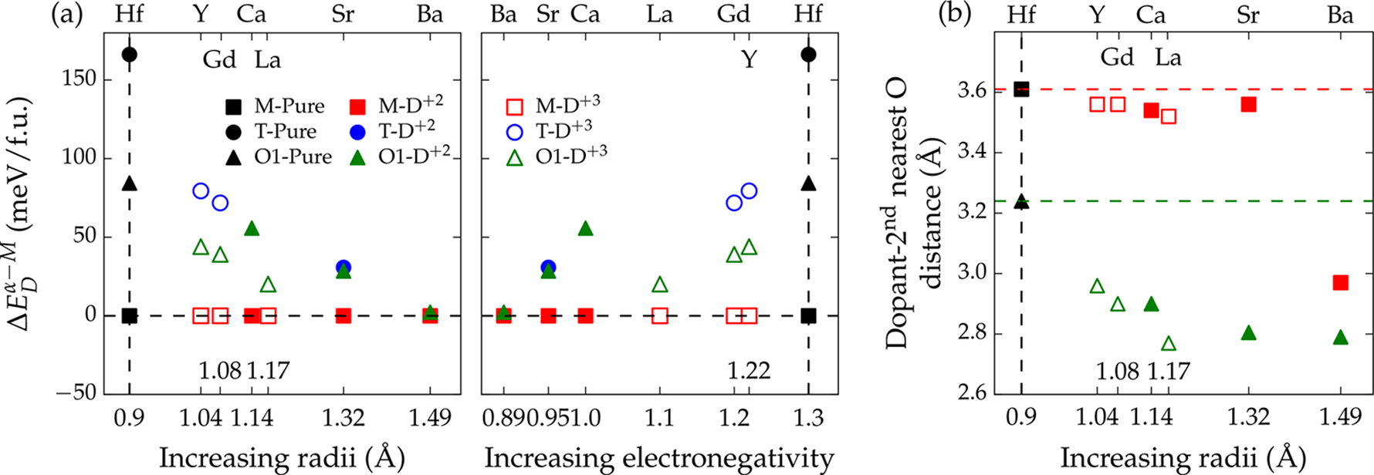

Figure 5. (a) Chemical trends in the relative energies of the M, T, and P-O1 phases of hafnia with (a) ionic radius and electronegativity of a divalent (solid symbols) and trivalent (open symbols) dopant at 6.25% doping concentration. Some cases of the T phase collapsed into the P-O1 phase upon relaxation and are omitted here for cleanliness. (b) Distance between the dopant and the closest second nearest oxygen in the case of 6.25% doped P-O1 and M phases.

and/or the P-O2 phases with increasing doping concentration, (2) whereas at 3.125% doping level, there exists substantial energy difference between the polar phases and the equilibrium M phase, at 6.25% doping level, the P-O1 phase becomes extremely close in energy to that of the M phase, (3) at high doping concentration of 12.5% no conclusive statements about the ground state of hafnia can be made as hafnia phases loose their structural identity at such high doping level, (4) for some doped cases, the T and even the P-O2 phase collapsed into the P-O1 phase upon relaxation, suggesting that these dopants prefer to form the relatively low energy polar P-O1 phase, and (5) between the two polar phases considered, i.e., P-O1 and P-O2, the former is clearly favored over the latter, consistent with the experimental observations of this phase.19   
 One important limitation/assumption of the above study pertaining to the dopant and Ovac arrangement should be mentioned here. Higher doping concentration (6.25% and 12.5%) leads to a rather challenging modeling problem of expansion of the configurational space. For instance, for the case of 6.25% Sr-doped hafnia, the two Sr atoms would lie on any two sites of the cation sublattice and the associated two Ovac on any two sites of the anion sublattice. Even after discounting for the symmetry of the system, a huge number of such permutations (or configurations) are possible and it is not at all trivial to determine which among them would be energetically preferred. Further, to finally determine the phase stability of doped hafnia, one would have to ascertain the lowest energy configuration of each phase. Although methods, such as, cluster expansion,39etc., can be used to surmount this problem of large configurational space, these approaches are extremely computationally demanding. Nevertheless, we get some estimate of the scale of energy variations expected in our doped hafnia systems owing to the different possible configurations by computing energies of 10 diverse config-urations of 6.25% Sr-doped P-O1 phase at various dopant−dopant distances. A standard deviation of just ∼8 meV/f.u. in the energies of these configurations was found, suggesting that the scale of energy variations owing to different possible configurations of dopants is rather small as compared to that of the relative energies among the different phases of hafnia. Thus, we expect the trends observed in the Figure 4 and the conclusions made in the previous discussion to hold even when multiple possible configurations of doped hafnia phases are considered.

9106 DOI: [10.1021/acs.chemmater.7b02835](http://dx.doi.org/10.1021/acs.chemmater.7b02835)

|  |  |  |
| --- | --- | --- |
| Chemistry of Materials | |  | | --- | | Article | |

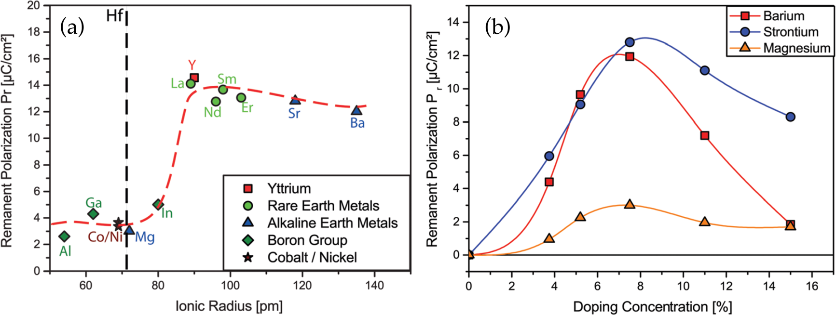

Figure 6. Trends in the measured remnant polarization of doped hafnia films with (a) dopant ionic radii and (b) doping concentration. The results are reproduced from ref 18. with permission from The Royal Society of Chemistry.

suggest formation of an energy lowering bond between the dopant cation and the second nearest oxygen neighbor in the case of the P-O1 phase as the root-cause of its stabilization with respect to the M phase upon doping.

On the basis of the aforementioned findings and the observed chemical trends, we search the entire periodic table to find dopants with low electronegativity and large ionic radii that will potentially favor the polar Pca21 phase in hafnia. Excluding the elements studied in this work and those that are radioactive, the lanthanide series elements emerge as good dopant candidates matching these criteria. Thus, combining all the findings, results or observations from our computations we finally predict that the lanthanide series elements, the lower half of the alkaline earth metals (Ca, Sr, and Ba) and Y are the most favorable dopants to promote ferroelectricity in hafnia.

Connection with Experiments. On the basis of the results on changes dopants cause on the energetics of different phases of hafnia, one can expect that the larger the stabilization of the P-O1 phase due to a dopant, the higher the expected volume fraction of the P-O1 phase in the hafnia films, and thus the higher the measured remnant polarization. Using this, some noteworthy agreements between the theoretical predictions made in this study and the empirical observations made by Starschich et al.18(major results reproduced in Figure 6) and Schroeder et al.17can be drawn; (1) the dopants that showed substantial polarization in the empirical studies, such as Sr, Ba, Gd, Y, La were also found to stabilize the polar P-O1 phase significantly, (2) the trend of dopants of larger ionic radii stabilizing the polar P-O1 phase matches well with the experimental observation of high remnant polarization in larger dopants (see Figure 6a), and (3) in agreement with the experiments, we also found that the doping concentration of 6.25% to be most appropriate to stabilize the polar phase. As reproduced in Figure 6b, with increasing doping concentration, the measured polarization in hafnia films first increases, reaches a maxima around 5−8% doping level, and then gradually decreases. Similar results are evident from this study as well. With increasing doping concentration, the polarization would initially rise due to enhanced stabilization of the polar P-O1 phase. However, after a critical doping concentration the distortions introduced in the structure would diminish the polarization of the polar phase, thus, resulting in gradual decrease in the measured polarization. Overall, the remarkable similarities between our computations and empirical observa-

9107 DOI: [10.1021/acs.chemmater.7b02835](http://dx.doi.org/10.1021/acs.chemmater.7b02835)

|  |  |  |
| --- | --- | --- |
| Chemistry of Materials | |  | | --- | | Article | |

and Y are the most favorable dopants to promote ferroelectricity in hafnia. These insights can be used to tailor the ferroelectric characteristics of hafnia films by selecting dopants with appropriate combination of ionic radius and electronegativity.

■ASSOCIATED CONTENT * Supporting Information

The Supporting Information is available free of charge on the [ACS Publications website](http://pubs.acs.org) at DOI: [10.1021/acs.chemma-ter.7b02835](http://pubs.acs.org/doi/abs/10.1021/acs.chemmater.7b02835).

Discussion on the need of oxygen vacancy introduction in doped hafnia using electronic structure studies and the methodology adopted to characterize different phases of doped hafnia ([PDF](http://pubs.acs.org/doi/suppl/10.1021/acs.chemmater.7b02835/suppl_file/cm7b02835_si_001.pdf))  
■AUTHOR INFORMATION   
Corresponding Author   
*R. Ramprasad. E-mail: [rampi.ramprasad@uconn.edu](mailto:rampi.ramprasad@uconn.edu).

ORCID

Rohit Batra: [0000-0002-1098-7035](http://orcid.org/0000-0002-1098-7035)   
Tran Doan Huan: [0000-0002-8093-9426](http://orcid.org/0000-0002-8093-9426)

Notes   
The authors declare no competing financial interest.

■ACKNOWLEDGMENTS   
Financial support of this work through Grant No. W911NF-15-1-0593 from the Army Research Office (ARO) and partial computational support through a Extreme Science and Engineering Discovery Environment (XSEDE) allocation number TG-DMR080058N are acknowledged.

■REFERENCES   
(1) Wilson, A. H. The Theory of Metals; Cambridge University Press, 1965.

(2) Wang, Z. L. Zinc oxide nanostructures: growth, properties and applications. J. Phys.: Condens. Matter 2004, 16, R829.

(3) Zhu, H.; Tang, C.; Fonseca, L. R. C.; Ramprasad, R. Recent progress in ab initio simulations of hafnia-based gate stacks. J. Mater. Sci. 2012, 47, 7399−7416.

(4) Wilk, G. D.; Wallace, R. M.; Anthony, J. M. High- gate dielectrics: Current status and materials properties considerations. J. Appl. Phys. 2001, 89, 5243−5275.

(5) Robertson, J. High dielectric constant gate oxides for metal oxide Si transistors. Rep. Prog. Phys. 2006, 69, 327.

(6) Ramprasad, R.; Shi, N. Dielectric properties of nanoscale HfO2 slabs. Phys. Rev. B: Condens. Matter Mater. Phys. 2005, 72, 052107. (7) Tang, C.; Ramprasad, R. Oxygen defect accumulation at Si:HfO2 interfaces. Appl. Phys. Lett. 2008, 92, 182908.

(8) Böscke, T. S.; Müller, J.; Bräuhaus, D.; Schröder, U.; Böttger, U. Ferroelectricity in hafnium oxide thin films. Appl. Phys. Lett. 2011, 99, 102903.

(9) Polakowski, P.; Müller, J. Ferroelectricity in undoped hafnium oxide. Appl. Phys. Lett. 2015, 106, 232905.

(10) Huan, T. D.; Sharma, V.; Rossetti, G. A.; Ramprasad, R. Pathways towards ferroelectricity in hafnia. Phys. Rev. B: Condens. Matter Mater. Phys. 2014, 90, 064111.

(11) Materlik, R.; Kunneth, C.; Kersch, A. The origin of ferroelectricity in Hf1xZrxO2: A computational investigation and a surface energy model. J. Appl. Phys. 2015, 117, 134109.

(12) Batra, R.; Tran, H. D.; Ramprasad, R. Stabilization of metastable phases in hafnia owing to surface energy effects. Appl. Phys. Lett. 2016, 108, 172902.

9108 DOI: [10.1021/acs.chemmater.7b02835](http://dx.doi.org/10.1021/acs.chemmater.7b02835)

|  |  |  |
| --- | --- | --- |
| Chemistry of Materials | |  | | --- | | Article | |

(32) Kresse, G.; Furthmüller, J. Efficient iterative schemes for ab   
initio total-energy calculations using a plane-wave basis set. Phys. Rev.   
B: Condens. Matter Mater. Phys. 1996, 54, 11169−11186.

(33) Perdew, J. P.; Burke, K.; Ernzerhof, M. Generalized gradient   
approximation made simple. Phys. Rev. Lett. 1996, 77, 3865−3868.   
(34) Blöchl, P. E. Projector augmented-wave method. Phys. Rev. B:   
Condens. Matter Mater. Phys. 1994, 50, 17953−17979.

(35) Monkhorst, H. J.; Pack, J. D. Special points for Brillouin-zone   
integrations. Phys. Rev. B 1976, 13, 5188−5192.

(36) Ohtaka, O.; Fukui, H.; Kunisada, T.; Fujisawa, T.; Funakoshi,   
K.; Utsumi, W.; Irifune, T.; Kuroda, K.; Kikegawa, T. Phase relations   
and volume changes of hafnia under high pressure and high   
temperature. J. Am. Ceram. Soc. 2001, 84, 1369−1373.

(37) Kang, J.; Lee, E.-C.; Chang, K. J. First-principles study of the   
structural phase transformation of hafnia under pressure. Phys. Rev. B:   
Condens. Matter Mater. Phys. 2003, 68, 054106.

(38) Hoffmann, M.; Schroeder, U.; Schenk, T.; Shimizu, T.;   
Funakubo, H.; Sakata, O.; Pohl, D.; Drescher, M.; Adelmann, C.;   
Materlik, R.; Kersch, A.; Mikolajick, T. Stabilizing the ferroelectric   
phase in doped hafnium oxide. J. Appl. Phys. 2015, 118, 072006.   
(39) Sanchez, J.; Ducastelle, F.; Gratias, D. Generalized cluster   
description of multicomponent systems. Phys. A 1984, 128, 334−350.   
(40) Shannon, R. D. Revised effective ionic radii and systematic   
studies of interatomic distances in halides and chalcogenides. Acta   
Crystallogr., Sect. A: Cryst. Phys., Diffr., Theor. Gen. Crystallogr. 1976, 32,   
751−767.

(41) Pauling, L. The nature of the chemical bond. IV. The energy of   
single bonds and the relative electronegativity of atoms. J. Am. Chem.   
Soc. 1932, 54, 3570−3582.

|  |  |
| --- | --- |
| 9109 | DOI: [10.1021/acs.chemmater.7b02835](http://dx.doi.org/10.1021/acs.chemmater.7b02835) Ch[em. Mater. 2017, 29, 9102−9109](http://dx.doi.org/10.1021/acs.chemmater.7b02835) |