**Supplemental Material: Pathways Towards Ferroelectricity in Hafnia** Tran Doan Huan,1Vinit Sharma,1George A. Rossetti, Jr.,1and Rampi Ramprasad1, *∗*1*Department of Materials Science & Engineering and Institute of Materials Science,*   
*University of Connecticut, 97 North Eagleville Rd., Unit 3136, Storrs, CT 06269-3136, USA*

TABLE I: Crystallographic information of the low-energy structures of hafnia discovered in this work. For each structure, cell parameters are given while for each atom, Wyckoff possition and coordinates (*x*, *y*, and *z*) are given. Data are calculated at *P* = 0GPa.

|  |  |  |  |  |
| --- | --- | --- | --- | --- |
| *Pmn*21 *a* (˚A) *b* (˚A) *c* (˚A) *α* (*◦*) | | | *β* (*◦*) | *γ* (*◦*) |
| (31) | 3*.*415 5*.*182 3*.*834 | 90 | 90 | 90 |
| Atom | *x* | *y* |  | *z* |

|  |  |  |  |
| --- | --- | --- | --- |
| Hf (1a) | 0*.*561145 | 0*.*719476 | 0*.*122273 |
| Hf (1a) | 0*.*438855 | 0*.*280524 | 0*.*877727 |
| Hf (1a) | 0*.*807632 | 0*.*758522 | 0*.*615329 |
| Hf (1a) | 0*.*192368 | 0*.*241478 | 0*.*384671 |
| O (1a) | 0*.*603608 | 0*.*345585 | 0*.*207160 |
| O (1a) | 0*.*396392 | 0*.*654415 | 0*.*792840 |
| O (1a) | 0*.*808026 | 0*.*366125 | 0*.*616133 |

|  |  |  |  |  |  |  |  |
| --- | --- | --- | --- | --- | --- | --- | --- |
| Hf (2a) | 0*.*00000 | *−*0*.*26306 0*.*07198 | *−*0*.*24442 0*.*41230 | O (1a) | 0*.*191974 | 0*.*633875 | 0*.*383867 |
| O (2a) | 0*.*00000 | O (1a) | 0*.*676170 | 0*.*974592 | 0*.*352351 |

|  |  |  |  |  |  |  |
| --- | --- | --- | --- | --- | --- | --- |
| O (2a) | 0*.*00000 *−*0*.*44299  *a* (˚A) *b* (˚A) *c* (˚A) *α* (*◦*) | | | 0*.*26207 | | |
| *Pm* | *β* (*◦*) | *γ* (*◦*) | |
| (6) | 5*.*364 3*.*072 6*.*674 | | 90 | 84*.*035 | | 90 |
| Atom | *x* | *y* | | *z* | | |
| Hf (1a) Hf (1b) Hf (1b) Hf (1b) O (1b)  O (1a)  O (1a)  O (1b)  O (1b)  O (1b)  O (1a)  O (1a) | 0*.*36880 | 0*.*00000 | | *−*0*.*44219 0*.*36370 | | |
| *−*0*.*11913 0*.*32687 | 0*.*50000 | |
| 0*.*50000 | | 0*.*04966 | | |
| *−*0*.*15689 0*.*48014 | 0*.*50000 | | *−*0*.*18305*−*0*.*25367*−*0*.*43264 0*.*27744 | | |
| 0*.*50000 | |
| *−*0*.*23142 0*.*16687 | 0*.*00000 | |
| 0*.*00000 | |
| *−*0*.*06142 0*.*11456 | 0*.*50000 0*.*50000 | | 0*.*08486*−*0*.*42294 0*.*34220*−*0*.*14779 0*.*00050 | | |
| *−*0*.*48718 0*.*12953 | 0*.*50000 0*.*00000 | |
| *−*0*.*40497 0*.*00000  *a* (˚A) *b* (˚A) *c* (˚A) *α* (*◦*) | | |
| *Cc* | *β* (*◦*) | *γ* (*◦*) | |
| (9) | 7*.*282 7*.*317 6*.*104 | | 90 122*.*891 | | | 90 |
| Atom | *x* | *y* | | *z* | | |
| Hf (4a) Hf (4a) O (4a)  O (4a)  O (4a)  O (4a) | *−*0*.*15563 0*.*33641 | 0*.*14828 | | 0*.*40261 | | |
| 0*.*13000 | | 0*.*39879 | | |
| *−*0*.*48544*−*0*.*30707 0*.*48426 | 0*.*29636 | | *−*0*.*28442 0*.*18080 | | |
| 0*.*38646 | |
| 0*.*09847 | | 0*.*17835 | | |
| *−*0*.*18951 0*.*10203  *a* (˚A) *b* (˚A) *c* (˚A) *α* (*◦*) | | | *−*0*.*28632 *β* (*◦*) *γ* (*◦*) | | |
| *P*1 |
| (1) | 3*.*244 5*.*674 6*.*832 91*.*24 | | | 103*.*73 89*.*99 | | |
| Atom | *x* | *y* | | *z* | | |

|  |  |  |  |
| --- | --- | --- | --- |
| O (1a) | 0*.*323830 | 0*.*025408 | 0*.*647649 |
| O (1a) | 1*.*000000 | 0*.*000000 | 1*.*000000 |
| O (1a) | 0*.*000000 | 0*.*500000 | 1*.*000000 |

TABLE II. A short summary of the lowest-energy structures

of hafnia. References (as shown in the main text) are given

|  |
| --- |
| for data originated from other works while dagger symbols (*†*) indicate our calculated data.  Structure *P*(GPa) *a*(˚A) *b*(˚A) *c*(˚A) *β*(*◦*) Ref. *P*� *µ*C  *Pnma*  *Pbca*  38*.*5 38*.*5 0 0   0   0   0 5*.*12   5*.*08 10*.*03 5*.*27 5*.*06 10*.*02 5*.*23 5*.*54 5*.*57 5*.*37   5*.*41   5*.*17 5*.*29 99*.*2  3*.*31 6*.*55 3*.*30 6*.*45 3*.*17 6*.*29  3*.*18 6*.*28   90   90 90   90   90 90 [17]  [19]  [19]  [14] *†*  *†*  *†*  *−*  *−*  *−* *−* *−* *cm*2  0  0  �  *P*42*/nmc*  *Pmn*21 *P*21*/m Pca*21 0   0   0 0   0   0 0 3*.*58 3*.*58 5*.*29 5*.*10 3*.*87 3*.*82 3*.*41 3*.*58 5*.*28 3*.*58 5*.*20 5*.*01 5*.*08 4*.*90 4*.*92 3*.*46 5*.*43 104*.*7 3*.*43 5*.*38 104*.*5 [33] 5*.*18 3*.*83   90 90 90   90  90   [33]  [33] *†*  *†*  *†*  *†*  52  56 *−*  *−*  *−* 0  0 |

*∗* [rampi@ims.uconn.edu](mailto:rampi@ims.uconn.edu)

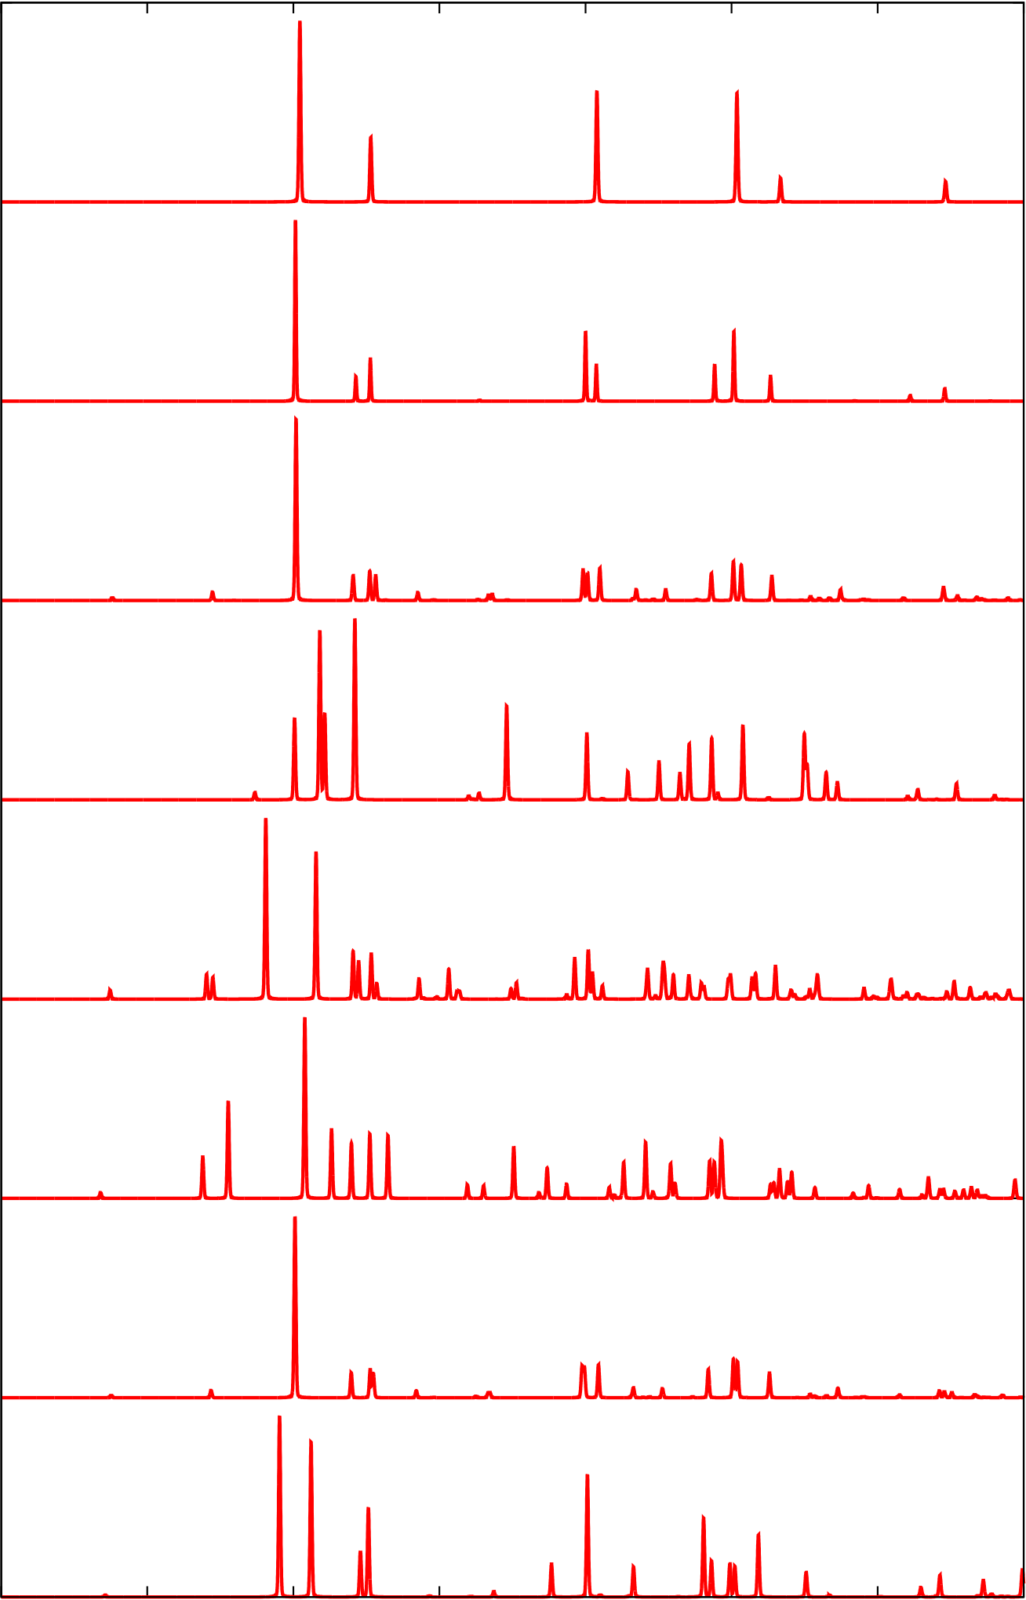

2

Fm−3m

P42/nmc

Pbca

|  |  |
| --- | --- |
| Intensity (arb. units) | Pnma  P21/c |

P21/m

Pca21

Pmn21

|  |  |  |  |  |  |  |  |
| --- | --- | --- | --- | --- | --- | --- | --- |
| 10 | 20 | 30 | 40 | 50 | 60 | 70 | 80 |

2θ (degrees)

|  |  |  |
| --- | --- | --- |
| FIG. 1. | Simulated x-ray diffraction patterns of the low-energy structures of hafnia examined in this work. | The Cu K*α* |
| (wavelength *λ* = 1*.*54˚A) is used for calculations. | |

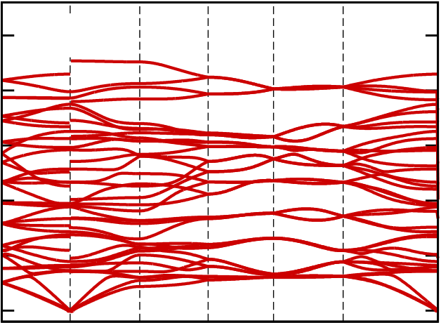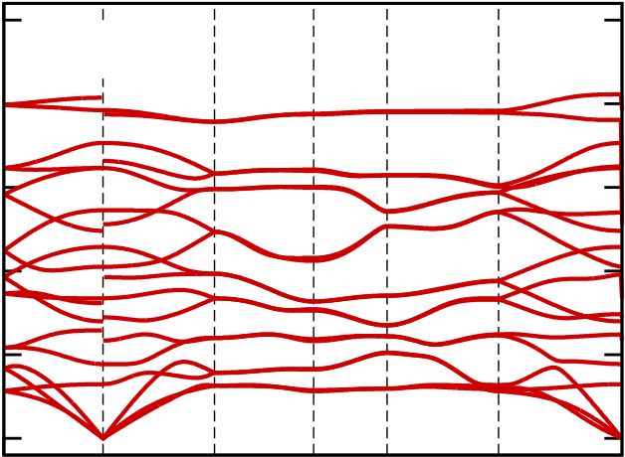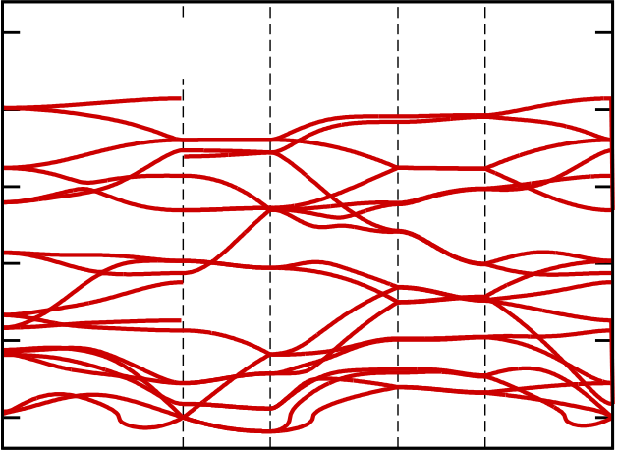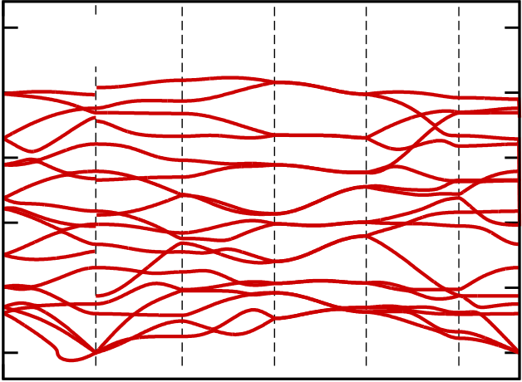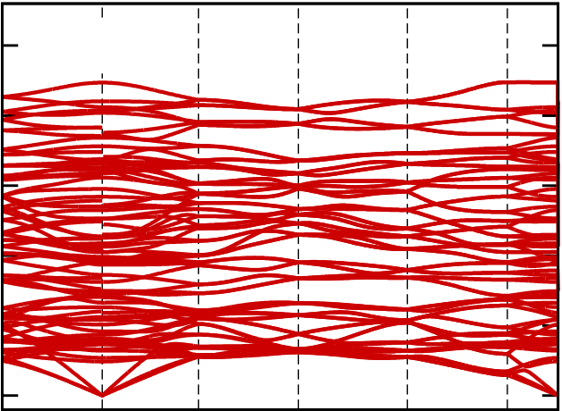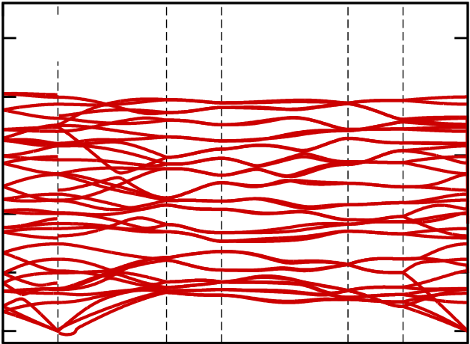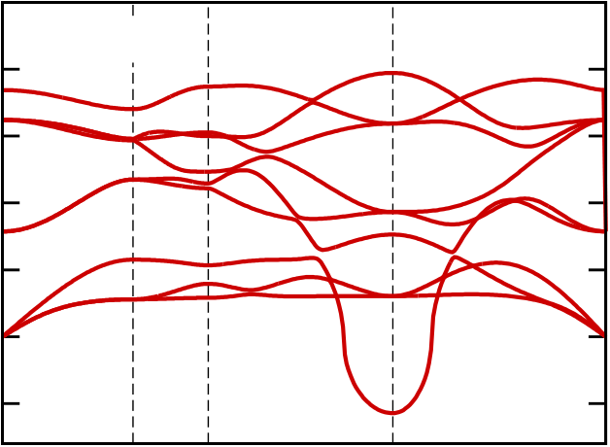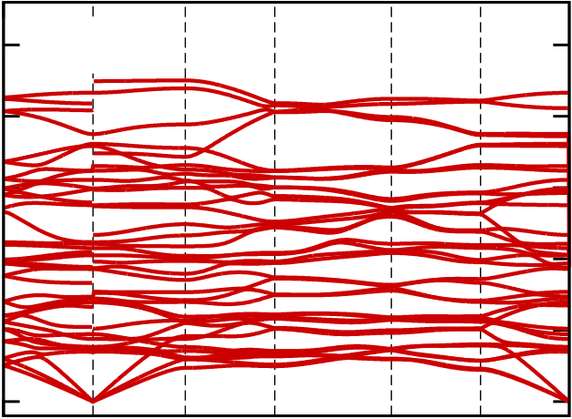

3

|  |  |  |  |  |  |  |  |  |  |  |  |  |  |  |  |  |  |  |  |
| --- | --- | --- | --- | --- | --- | --- | --- | --- | --- | --- | --- | --- | --- | --- | --- | --- | --- | --- | --- |
| Frequency (THz) | 20 | | Fm−3m | | Z | T | L | U | Γ | Frequency (THz) | 25 | | P21/c | Y | C | R | D | B | Γ |
| 20 | |
| 15 | |
| 10 | | 15 | |
| 5 | | 10 | |
| 0 | |
| 5 | |
| −5 | |
| Frequency (THz) | X | W | 0 | Z | Γ |
| Γ | |
| Frequency (THz) |
| 25 | | Pcba | | 25 | | Pnma |
| 20 | | 20 | |
| 15 | | 15 | |
| X Γ | Y | T | U | X | Γ |
| 10 | | 10 | |
| Γ | Y | Γ |
| 5 | | 5 | |
| 0 | Z | 0 | Z |
| Frequency (THz) | 25 | | R | X | Frequency (THz) | 25 | | Y | C | D | B |
| P42/nmc | | P21/m |
| 20 | | 20 | |
| 15 | | 15 | |
| Γ | Γ |
| 10 | | 10 | |
| Γ | | Γ |
| 5 | | 5 | |
| 0 | | 0 | |
| M | | Z | |
| Frequency (THz) | 25 | | Pca21 | | T | R | U | Γ | Frequency (THz) | 25 | | Pmn21 | X | U | T | Γ |
| 20 | |
| 20 | |
| 15 | |
| 15 | |
| 10 | |
| 10 | |
| Γ | Y | Γ |
| 5 | |
| 5 | |
| 0 | | 0 | |
| Z | | Z | |

FIG. 2. Phonon band structures at *P* = 0 GPa of eight low-energy structures of hafnia, plotted along the high-symmetry paths.

For convenience, bands with imaginary frequencies are shown as those with *negative* frequencies.