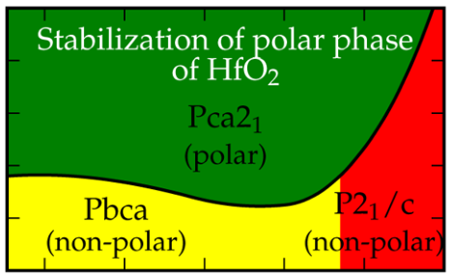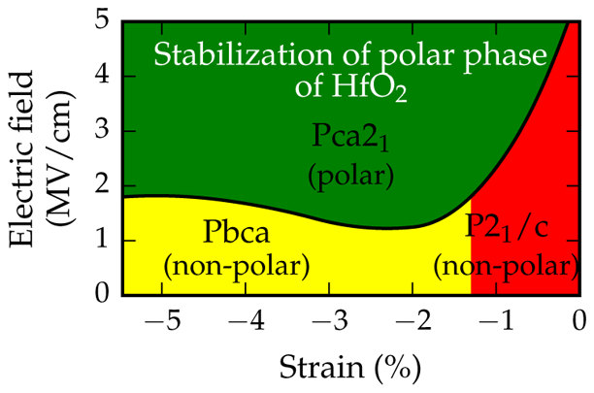

Article   
pubs.acs.org/JPCC

Factors Favoring Ferroelectricity in Hafnia: A First-Principles   
Computational Study   
Rohit Batra,†Tran Doan Huan,†Jacob L. Jones,‡George Rossetti, Jr.,†and Rampi Ramprasad*,††Department of Materials Science & Engineering, University of Connecticut, Storrs, Connecticut 06269, United States‡Department of Materials Science and Engineering, North Carolina State University, Raleigh, North Carolina 27695, United States

|  |  |  |  |  |  |  |  |
| --- | --- | --- | --- | --- | --- | --- | --- |
|  | * S Supporting Information | | | | | | |
| LOGY on January 15, 2020 at 20:48:31 (UTC).  ns on how to legitimately share published articles. | ABSTRACT: The surprising ferroelectricity displayed by hafnia thin films has been | | | | | |  |
| attributed to a metastable polar orthorhombic (Pca21) phase. Nevertheless, the conditions under which this (or another competing) ferroelectric phase may be | | | | | |  |
| stabilized remain unresolved. It has been hypothesized that a variety of factors, including strain, grain size, electric field, impurities and dopants, may contribute to the observed ferroelectricity. Here, we use first-principles computations to examine the influence of mechanical and electrical boundary conditions (i.e., strain and electric field)  on the relative stability of a variety of relevant nonpolar and polar phases of hafnia. We find that although strain or electric field, independently, do not lead to a ferroelectric phase, the combined influence of in-plane equibiaxial deformation and electric field  results in the emergence of the polar Pca21 structure as the equilibrium phase. The results provide insights for better controlling the ferroelectric characteristics of hafnia thin films by adjusting the growth conditions and electrical history. | | | | | | |
| ■INTRODUCTION  Although hafnia is a well-known and well-studied high dielectric constant (“high-k”) material,1−7there has been renewed excitement about this material due to recent empirical observations of ferroelectricity in thin hafnia films, in both pure and doped forms.8−10These ferroelectric (FE) measure-ments along with excellent Si compatibility, easy complemen-tary metal oxide semiconductor (CMOS) integration, and high scalability make hafnia a promising candidate for future nonvolatile memory applications over conventional perov-skite-based materials.10However, these FE property observa-tions are rather surprising since all the known equilibrium phases of hafnia, namely, the room temperature monoclinic (M) P21/c phase, the high temperature tetragonal (T) P42/nmc and cubic (C) Fm3̅m phases, and the high-pressure orthorhombic (OA) Pbca and (OB) Pnma phases, are centrosymmetric and hence nonpolar.11Grazing incidence and θ−2θ X-ray diffraction investigations on these thin FE hafnia films have suggested the presence of a polar orthorhombic (P-O1) Pca21 phase as the origin of this unexpected FE behavior.10In fact, Sang et al.12in a combined TEM and nanoscale electron diffraction study were able to identify the polar P-O1 phase in a FE hafnia film. However, remarkable structural similarity between different phases of hafnia, especially the P-O1 and the OA phases, and limited statistics owing to the small film thicknesses (<20 nm) lead to some degree of uncertainty in these conclusions.  Several first-principles theoretical studies have also com-plemented these experimental findings.13−16The energy difference between the P-O1 and the known equilibrium | | | | competing, though higher in energy, polar orthorhombic (P- | | |
| Downloaded via GEORGIA INST OF TECHNO  See https://pubs.acs.org/sharingguidelines for optio | O2) Pmn21 phase has also been suggested as a potential phase responsible for the observed FE behavior. More importantly, a shallow kinetic energy barrier between the T and the aforementioned polar phases was also reported, suggesting their possible formation from the T phase. The fact that all FE thin films of hafnia have been reported to contain some volume fraction of the T phase17makes this finding even more intriguing with respect to the formation pathway of the FE phase(s). Figure 1 portrays the low-energy M, T, OA, P-O1, and P-O2 phases discussed above, for unit cells oriented in an equivalent manner. The equivalent orientations of different phases are discussed in later sections.  Besides identifying the potential FE phase(s) in hafnia films, many efforts, both empirical and theoretical, have been made to determine extrinsic factors which may stabilize a polar phase. Among various factors, the grain size is undoubtedly a critical one.10Almost all studies on FE hafnia films have demonstrated a monotonic decrease in the spontaneous polarization of films with increasing film thickness, which is proportional to the hafnia grain size. A critical grain size of ∼20 nm was identified above which the FE behavior eventually disappears.10The increasing volume fraction of M phase with increasing film thickness (or grain size) was ascribed as the reason for this observation. Although finite size effects are known to stabilize the nonpolar T phase in hafnia (and its twin oxide, zirconia) at small length scales,15,18we have suggested in the past that surface orientations and grain size may lead to a stabilization of | | |
|  | Received: | November 28, 2016 | |
| phases of hafnia has been predicted to be small over wide temperature and pressure ranges.13Additionally, another | | | Revised: | | January 23, 2017 | |
| Published: February 2, 2017 | | | |
|  | © 2017 American Chemical Society | 4139 | DOI: [10.1021/acs.jpcc.6b11972](http://dx.doi.org/10.1021/acs.jpcc.6b11972)  J. Phys. Chem. [C 2017, 121, 4139−4145](http://dx.doi.org/10.1021/acs.jpcc.6b11972) | | | |

|  |  |  |
| --- | --- | --- |
| The Journal of Physical Chemistry C | |  | | --- | | Article | |

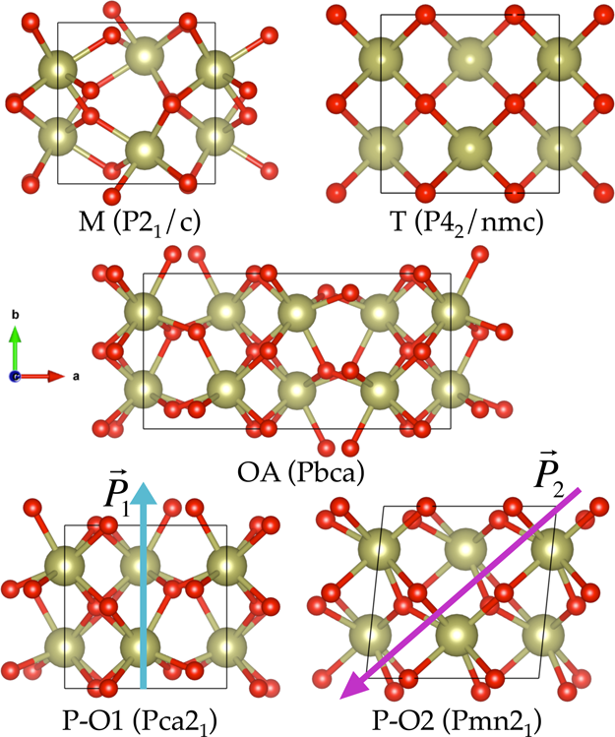

Figure 1. The (001) projections of the low-energy phases of hafnia. The polarization directions of the two polar phase are represented by P⃗1 and P⃗2. Hf and O atoms are shown in green and red colors, respectively.

the P-O2 or the T phase in hafnia.14Observations of distinct FE behavior in pure hafnia thin films (6−10 nm) further strengthen the notion that surface energy plays a vital role in the stabilization of the FE phase.19Furthermore, on the basis of a phenomenological model of the surface energies of different polymorphs of hafnia, Materlik et al.20were able to explain the origins of ferroelectrcity and antiferrolectricity in HfZrO2 and ZrO2 thin films, respectively.

Another important factor is the residual stresses in these films. One source of stress is from the mechanical barrier provided by the capping of the top and the bottom electrodes during crystallization of the films. Additionally, there is an anisotropic stress introduced due to the lattice and thermal coefficient mismatch between the film and the substrate. Studies from Kisi et al.21and Park et al.22have suggested the possibility of the T to P-O1 transformation due to in-plane compressive and out-of-plane tensile stresses in the (a, b) plane and along the c-direction, respectively, of the T phase.

Observations of antiferroelectricity, the “wake-up effect”, and“fatigue” behavior in hafnia films have also insinuated the possibility of electric field induced stabilization of the hafnia FE phases.17,23Particularly interesting, and relevant to this work, is the “wake-up effect”. This term was coined to describe the phenomenon of improving (and/or inducing) FE loops of hafnia films, which displayed no apparent ferroelectricity in their pristine form, through electric field cycling. Dopants present in these films are yet another important factor.10While it is generally agreed upon that their presence enhances the thermodynamic window to stabilize the FE phase, whether they have any principal role in the appearance of the FE phase remains uncertain. Although thermal effects are known to stabilize the tetragonal and the cubic phases of hafnia at high temperatures of ∼2000 and ∼2800 K,11they are not expected to have a significant role at room temperatures at which these ferroelectric measurements are made.

From the previous discussion, one may conclude that the important factors responsible for FE behavior in hafnia films are (1) surface energy due to the small grain sizes, (2) nonhydrostatic stresses associated with the electrodes and the substrate, (3) applied electric field, and (4) dopants. The surface energy factor has been studied extensively in past

4140 DOI: [10.1021/acs.jpcc.6b11972](http://dx.doi.org/10.1021/acs.jpcc.6b11972)

|  |  |  |
| --- | --- | --- |
| The Journal of Physical Chemistry C | |  | | --- | | Article | |

Table 1. Lattice Parameters and the Spontaneous Polarization of Reoriented Equivalent Supercells of the Five Phases of Hafniaa

|  |  |  |  |  |  |  |  |
| --- | --- | --- | --- | --- | --- | --- | --- |
| phase | a (Å) | b (Å) | c (Å) | β (deg) | γ (deg) | V (Å3/HfO2) | P (μC/cm2) |
| M | 5.15 | 5.20 | 5.33 | 99.7 | 90 | 35.15 | 0 |
| T | (5.14,b5.12c) | (5.20,b5.17c) | (5.31,b5.29c) | (99.8,b99.2c) | (90,b90c) | 33.78 | (0b) |
| 5.08 | 5.08 | 5.23 | 90 | 90 | 0 |
| P-O1 | (5.08,b5.08d) | (5.08,b5.08d) | (5.28,b5.20d) | (90,b90d) | (90,b90d) | 33.90 | (0b) |
| 5.06 | 5.09 | 5.27 | 90 | 90 | 50 |
| P-O2 | (5.01,b4.90d) | (5.08,b4.92d) | (5.29,b5.10d) | (90,b90d) | (90,b90d) | 33.90 | (52b) |
| 5.13 | 5.13 | 5.18 | 90 | 84.07 | 56 |
| OA | (5.12b) | (5.12b) | (5.18b) | (90b) | (83.51b) | 33.64 | (56b) |
| 10.07/2 = 5.03 | 5.09 | 5.25 | 90 | 90 | 0 |
| (10.03,b10.02e) | (5.08,b5.06e) | (5.27,b5.23e) | (90,b90e) | (90,b90e) | (0b) |

aUnit cells containing four HfO2 formula units of the different phases were reoriented such that their a- and c-axes correspond to the smallest and the largest crystallographic axes, respectively. For example, the a- and b-axes of the standard P-O1 phase were reoriented as c- and a-axes, respectively. The findings of the past studies (within parentheses) have also been modified appropriately for comparison.bReference 13.cReference 31.dReference 32.eReference 33.

thus resulting in an in-plane stress condition. Such constrained relaxation produced a uniform deformation of the cell and thus allowed us to simulate in-plane stresses while preserving the space group symmetry of a phase. Further remarks rationalizing the restriction to equibiaxial deformations to model anisotropic stresses will be made in later sections.

In order to understand the impact of electric field on the phase stability of hafnia, energies of different phases under the influence of an electric field were also computed. The energy of a phase α with volume V0 α and under an electric field E⃗ was calculated using the expression28

*E α* = *E* DFT *α* −*V* 0 *α* ( ***ϵ*** r *α* ϵ 0 *E*⃗ + *P*  *α*  ) *E*  (1)

where EDFT α is the DFT computed energy, P⃗αand ϵr α are the spontaneous polarization and matrix representation of the relative permittivity of the phase α, respectively, and ϵ0 is the permittivity of vacuum. Since E⃗is a vectorial quantity, its effect is dependent on its magnitude as well as direction. From eq 1 it is evident that the effect of electric field on the energy of a phase is maximized when the dot product P⃗α·E⃗is maximum, i.e., when the electric field is oriented parallel to the polarization direction of a polar phase. Thus, two important orientations of electric fieldparallel to the polarization vectors P⃗1 and P⃗2 of the polar phases P-O1 and P-O2, respectively (see Figure 1)were studied in this work. Further, for each orientation, we consider the phase stability under three different states, i.e., the stress-free, the hydrostatic, and the in-plane stress states. The density functional perturbation theory and the Berry phase evaluation were respectively employed to obtain the relative permittivity matrix and the spontaneous polarization of the different phases of hafnia. Spontaneous polarization computa-tions were repeated using the ABINIT29package to further verify the VASP computed values.

■RESULTS AND DISCUSSION   
 Hydrostatic Pressures and Equibiaxial Deformations. Table 1 lists the lattice parameters of the five phases of hafnia, as predicted from our DFT computations. We make a note that the reported cell parameters of each phase are chosen such that minimal cell strains and atom shuffles reduce a phase to the four formula unit T phase (see caption of Table 1). An excellent agreement between the findings of this work and the past studies is apparent from the table. One comment about the choice of density functional should be made in reference to the

4141 DOI: [10.1021/acs.jpcc.6b11972](http://dx.doi.org/10.1021/acs.jpcc.6b11972)

|  |  |  |
| --- | --- | --- |
| The Journal of Physical Chemistry C | |  | | --- | | Article | |

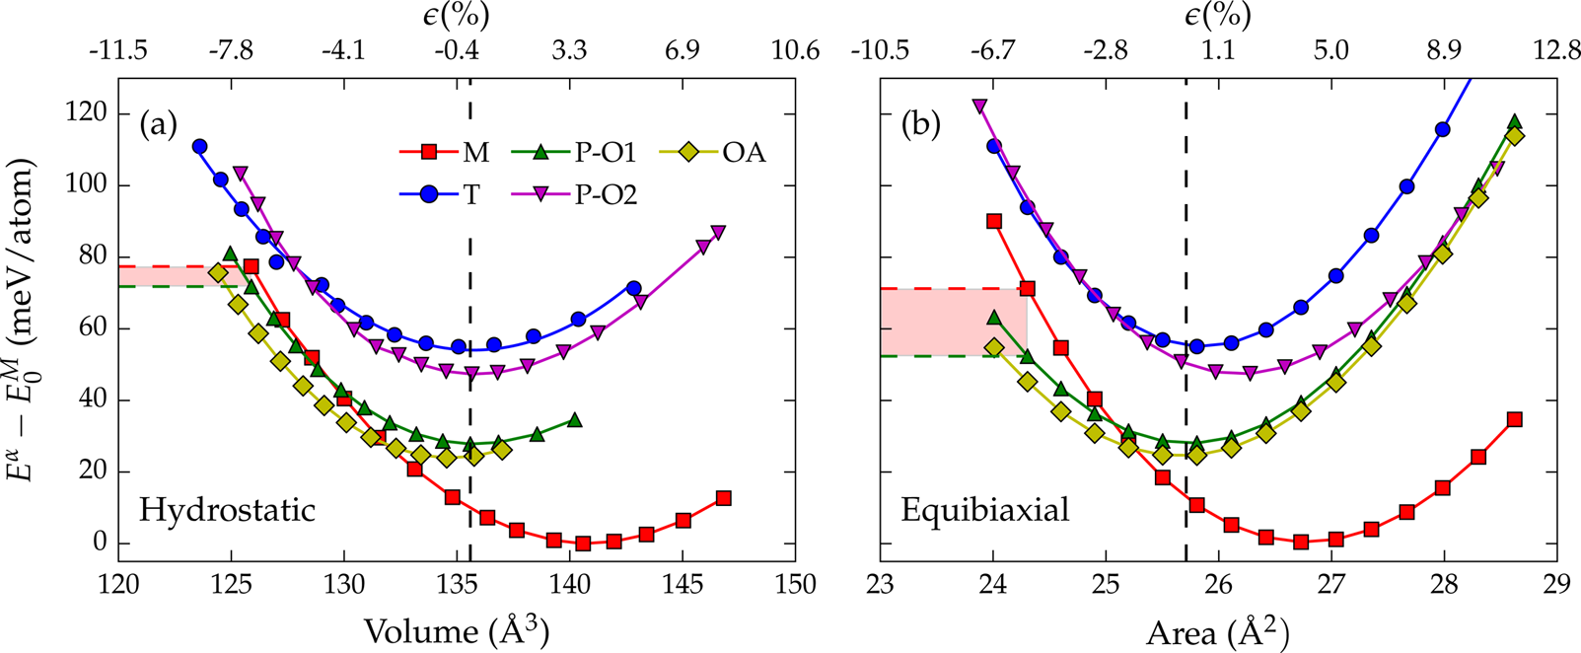

Figure 2. Energy variation of different phases of hafnia under (a) hydrostatic pressure and (b) equibiaxial deformation, referenced to the energy of

the equilibrium bulk M phase. Percentage strain are reported in reference to the equilibrium P-O1 phase.

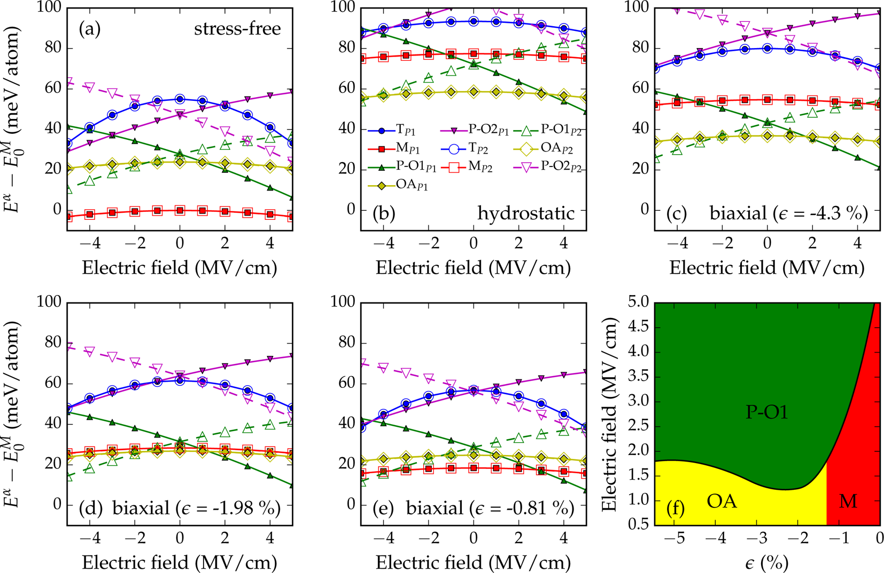

Figure 3. Influence of electric field on the free energy (using eq 1) of different phases of hafnia under (a) stress-free, (b) hydrostatic compression,

and in-plane compressive stress states corresponding to strain (in reference to the equilibrium P-O1 phase) of (c) 4.3%, (d) 1.98%, and (e) 0.81%. Results for two special orientations of electric field, parallel to the polarization directions P⃗1 (solid symbols) and P⃗2 (open symbols) of the P-O1 and the P-O2 phases, respectively, are presented. The free energy of the 0 K bulk M phase is set to zero. Panel (f) represents the computed phase diagram of hafnia under the influence of electric field and in-plane stresses. The green, red, and yellow colors signify regions where the P-O1, the M, and the OA phase, respectively, are the ground state. Electric fields above about 4 MV/cm are unrealistically high and may not be physically

realizable without adversely damaging the material.

are expected to be observed in this direction due to large differences between the (a, b) lattice parameters of the M phase compared to those of the other phases.

We first discuss the results of phase stability in hafnia under hydrostatic compression and tension. From Figure 2a it is evident that at higher volumes the M phase is lowest in energy and corresponds to the equilibrium phase at 0 K. However, under a state of compression, i.e., at lower volumes, the high-pressure OA phase has the lowest energy and becomes the most stable phase, in agreement with the experimental phase diagram11and several computational studies.13,20,30Interest-ingly, the P-O1 phase also becomes stable relative to the M phase at lower volumes, although it is always higher in energy

4142 DOI: [10.1021/acs.jpcc.6b11972](http://dx.doi.org/10.1021/acs.jpcc.6b11972)

|  |  |  |
| --- | --- | --- |
| The Journal of Physical Chemistry C | |  | | --- | | Article | |

P-O1 phase, relative to the M phase, is significantly larger under the state of equibiaxial compression as compared to that of the hydrostatic compression. This is graphically illustrated in Figure 2 by the difference in the height of the shaded region for the two cases. Furthermore, the energy difference between the P-O1 and the OA phases is smaller under equibiaxial stress state as compared to that under hydrostatic compression state. Nonetheless, the results show no evidence of stabilization of a FE phase under both the hydrostatic and biaxially deformed stress-state scenarios considered here.

Electric Field. As discussed earlier, several empirical observations of a “wake-up effect” have been encountered in FE hafnia films.23,34−36Electric field induced phase trans-formation37is one proposed explanation for this behavior. Figure 3a presents the effect of electric field on the phase stability of hafnia using eq 1. Two special orientations of electric field, i.e., parallel to the direction of spontaneous polarization of the two polar phases, were considered. This allows us to estimate the maximum influence the electric field could have on the phase stability in hafnia. Here, the computations are restricted to an electric field with magnitude smaller than 5 MV/cm to be consistent with electric field range explored experimentally. Assuming orientational independence

|  |
| --- |
| of dielectric response in the case of nonpolar phases, the second  term on right side of eq 1 can be reduced to −*V* 0 *α* ( ϵ *α* r ) ϵ | ⃗| 2,  where ϵ*α* rrepresents the average of the trace of the dielectric tensor, ϵr α. This term represents the effect of induced  polarization on the free energy, is always negative, and varies parabolically with the applied electric field E⃗. Thus, among the  nonpolar phases, the phase with highest relative permittivity (ϵr α), i.e., the T phase, shows maximum parabolic change in the free energy with the applied electric field. In the case of polar phases, however, the dot product −V0 αP⃗·E⃗ forms the dominant term, particularly when the electric field is oriented parallel to  the direction of spontaneous polarization of a polar phase. Thus, one can observe significant stabilization (destabilization) |

of the P-O1 or the P-O2 phase, relative to the M phase, when the applied electric field is oriented parallel (opposite) to the direction of polarization. We also note that the polarization directions of the two polar phases subtend an angle of 138°, leading to P⃗·E⃗terms with opposite signs and thus contrary changes in the free energy. From Figure 3a we conclude that electric field (<5 MV/cm) cannot stabilize any of the two metastable polar phases in bulk hafnia; however, it can significantly reduce their energies closer to the equilibrium M phase, especially in the case of the P-O1 phase.

Given this observation, one may reasonably suppose that under the combined effect of electric field and other relevant factors, such as stress, dopants, oxygen vacancies, etc., pervasive in hafnia films, the P-O1 phase becomes the most stable phase. Particularly, the factors that destabilize the M phase can be expected to produce such conditions. On the basis of our previous findings, we already know that compressive stress (hydrostatic or in-plane) is one such factor that stabilizes OA and P-O1 phase relative to the M phase. Thus, we consider next the combined effect of compressive stresses and electric field on the phase stability of hafnia.

Panels b and c of Figure 3 present the variation of free energy of hydrostatically compressed (with volume ∼126 Å3) and equibiaxially deformed (along the (001) plane with a, b = 4.96 Å) phases of hafnia. For ease of comparison with Figure 3a, we set the energy of the bulk M phase as the reference energy.

4143 DOI: [10.1021/acs.jpcc.6b11972](http://dx.doi.org/10.1021/acs.jpcc.6b11972)

|  |  |  |  |  |
| --- | --- | --- | --- | --- |
| The Journal of Physical Chemistry C | |  | |  | | --- | | Article | |
| destabilize the equilibrium M phase, the other (such as electric field) may favor the FE phase, thus cumulatively resulting in stabilization of a FE phase. Therefore, it maybe worthwhile, though complex, to study the cumulative effect of surface energy, stresses, electric field, and defects on the phase stability in hafnia to develop a comprehensive understanding of the interaction or cooperation of these phenomena.  ■CONCLUSIONS  In summary, we explored the independent as well as the combined influence of mechanical and electrical boundary conditions toward stabilization of a FE phase in hafnia. Two variants of mechanical boundary conditions; i.e., hydrostatic and in-plane stress states were examined. While hydrostatic compressive stresses were shown to stabilize the high pressure orthorhombic (Pbca) phase, in agreement with the empirical phase diagram of bulk hafnia, an even more significant finding of this work is that compressive stresses, both hydrostatic and in-plane, stabilize the polar orthorhombic (Pca21) phase of hafnia with respect to the equilibrium monoclinic phase. In fact, in-plane compressive stresses, which are particularly relevant in thin films, stabilize this polar phase relatively more than the hydrostatic pressures.  Two variants of electrical conditions, with an applied electric field parallel to the polarization directions of the polar Pca21 and Pmn21 phase of hafnia, were also studied. They too were found to significantly reduce the relative energies of the two polar phases of hafnia. However, neither the mechanical nor the electrical boundary conditions independently lead to the stabilization of a FE phase of hafnia as the equilibrium phase. Nonetheless, under the combined influence of compressive stresses and electric field, we found that the polar Pca21 phase can, indeed, become the equilibrium phase in bulk hafnia. Interestingly, the predicted magnitude of electric field at which this polar phase becomes stable falls well within the empirical range wherein the “wake-up effect” has been observed in hafnia films. These findings not only suggest compressive stresses and electric field as possible control parameters to better tune the FE characteristics of hafnia films, but more importantly, they show that multiple factors, operating in concert, may be responsible for the formation of the ferroelectric phase in hafnia films.  ■ASSOCIATED CONTENT | | ■ACKNOWLEDGMENTS |  |
| Financial support of this work through Grant No. W911NF-15-1-0593 from the Army Research Office (ARO) and partial computational support through a Extreme Science and Engineering Discovery Environment (XSEDE) allocation number TG-DMR080058N are acknowledged.  ■REFERENCES  (1) Robertson, J. High dielectric constant gate oxides for metal oxide Si transistors. Rep. Prog. Phys. 2006, 69, 327.  (2) Wilk, G. D.; Wallace, R. M.; Anthony, J. M. High-κ gate dielectrics: Current status and materials properties considerations. J. Appl. Phys. 2001, 89, 5243−5275.  (3) Zhu, H.; Tang, C.; Fonseca, L. R. C.; Ramprasad, R. Recent progress in ab initio simulations of hafnia-based gate stacks. J. Mater. Sci. 2012, 47, 7399−7416.  (4) Zhu, H.; Ramanath, G.; Ramprasad, R. Interface engineering through atomic dopants in HfO2-based gate stacks. J. Appl. Phys. 2013, 114, 114310.  (5) Shi, N.; Ramprasad, R. Local dielectric permittivity of HfO2 based slabs and stacks: A first principles study. Appl. Phys. Lett. 2007, 91, 242906.  (6) Tang, C.; Ramprasad, R. Oxygen defect accumulation at Si:HfO2 interfaces. Appl. Phys. Lett. 2008, 92, 182908.  (7) Ramprasad, R.; Shi, N. Dielectric properties of nanoscale HfO2 slabs. Phys. Rev. B: Condens. Matter Mater. Phys. 2005, 72, 052107. (8) Böscke, T. S.; Müller, J.; Bräuhaus, D.; Schröder, U.; Böttger, U. Ferroelectricity in hafnium oxide thin films. Appl. Phys. Lett. 2011, 99, 102903.  (9) Schroeder, U.; Yurchuk, E.; Müller, J.; Martin, D.; Schenk, T.; Polakowski, P.; Adelmann, C.; Popovici, M. I.; Kalinin, S. V.; Mikolajick, T. Impact of different dopants on the switching properties of ferroelectric hafnium oxide. Jpn. J. Appl. Phys. 2014, 53, 08LE02. (10) Park, M. H.; Lee, Y. H.; Kim, H. J.; Kim, Y. J.; Moon, T.; Kim, K. D.; Müller, J.; Kersch, A.; Schroeder, U.; Mikolajick, T.; et al. Ferroelectricity and antiferroelectricity of doped thin HfO2-based films. Adv. Mater. 2015, 27, 1811−1831.  (11) Ohtaka, O.; Fukui, H.; Kunisada, T.; Fujisawa, T.; Funakoshi, K.; Utsumi, W.; Irifune, T.; Kuroda, K.; Kikegawa, T. Phase relations and volume changes of hafnia under high pressure and high temperature. J. Am. Ceram. Soc. 2001, 84, 1369−1373.  (12) Sang, X.; Grimley, E. D.; Schenk, T.; Schroeder, U.; LeBeau, J. M. On the structural origins of ferroelectricity in HfO2 thin films. Appl. Phys. Lett. 2015, 106, 162905.  (13) Huan, T. D.; Sharma, V.; Rossetti, G. A.; Ramprasad, R. Pathways towards ferroelectricity in hafnia. Phys. Rev. B: Condens. Matter Mater. Phys. 2014, 90, 064111.  (14) Batra, R.; Tran, H. D.; Ramprasad, R. Stabilization of metastable phases in hafnia owing to surface energy effects. Appl. Phys. Lett. 2016, 108, 172902.  (15) Reyes-Lillo, S. E.; Garrity, K. F.; Rabe, K. M. Antiferroelectricity in thin-film ZrO2 from first principles. Phys. Rev. B: Condens. Matter Mater. Phys. 2014, 90, 140103. | |
| * | Supporting Information |
| The Supporting Information is available free of charge on the [ACS Publications website](http://pubs.acs.org) at DOI: [10.1021/acs.jpcc.6b11972](http://pubs.acs.org/doi/abs/10.1021/acs.jpcc.6b11972). | |

Data on relative permmitivity and the spontaneous polarization of different phases of hafnia used to

construct Figure 3 ([PDF](http://pubs.acs.org/doi/suppl/10.1021/acs.jpcc.6b11972/suppl_file/jp6b11972_si_001.pdf))■AUTHOR INFORMATION

Corresponding Author   
*E-mail: [rampi.ramprasad@uconn.edu](mailto:rampi.ramprasad@uconn.edu) (R.R.).

ORCID

Rohit Batra: [0000-0002-1098-7035](http://orcid.org/0000-0002-1098-7035)

Notes   
The authors declare no competing financial interest.

4144 DOI: [10.1021/acs.jpcc.6b11972](http://dx.doi.org/10.1021/acs.jpcc.6b11972)

|  |  |  |
| --- | --- | --- |
| The Journal of Physical Chemistry C | |  | | --- | | Article | |

(21) Kisi, E. H.; Howard, C. J.; Hill, R. J. Crystal structure of   
orthorhombic zirconia in partially stabilized zirconia. J. Am. Ceram. Soc.   
1989, 72, 1757−1760.

(22) Hyuk Park, M.; Joon Kim, H.; Jin Kim, Y.; Moon, T.; Seong   
Hwang, C. The effects of crystallographic orientation and strain of thin   
Hf0.5Zr0.5O2 film on its ferroelectricity. Appl. Phys. Lett. 2014, 104,   
072901.

(23) Schenk, T.; Yurchuk, E.; Mueller, S.; Schroeder, U.; Starschich,   
S.; Böttger, U.; Mikolajick, T. About the deformation of ferroelectric   
hystereses. Appl. Phys. Rev. 2014, 1, 041103.

(24) Kresse, G.; Furthmüller, J. Efficient iterative schemes for ab   
initio total-energy calculations using a plane-wave basis set. Phys. Rev.   
B: Condens. Matter Mater. Phys. 1996, 54, 11169−11186.

(25) Perdew, J. P.; Burke, K.; Ernzerhof, M. Generalized gradient   
approximation made simple. Phys. Rev. Lett. 1996, 77, 3865−3868.   
(26) Blöchl, P. E. Projector augmented-wave method. Phys. Rev. B:   
Condens. Matter Mater. Phys. 1994, 50, 17953−17979.

(27) Monkhorst, H. J.; Pack, J. D. Special points for Brillouin-zone   
integrations. Phys. Rev. B 1976, 13, 5188−5192.

(28) Souza, I.; Íñiguez, J.; Vanderbilt, D. First-Principles Approach to   
Insulators in Finite Electric Fields. Phys. Rev. Lett. 2002, 89, 117602.   
(29) Gonze, X.; Amadon, B.; Anglade, P.-M.; Beuken, J.-M.; Bottin,   
F.; Boulanger, P.; Bruneval, F.; Caliste, D.; Caracas, R.; Côté, M.; et al.   
ABINIT: First-principles approach to material and nanosystem   
properties. Comput. Phys. Commun. 2009, 180, 2582−2615.

(30) Kang, J.; Lee, E.-C.; Chang, K. J. First-principles study of the   
structural phase transformation of hafnia under pressure. Phys. Rev. B:   
Condens. Matter Mater. Phys. 2003, 68, 054106.

(31) Ruh, R.; Corfield, P. W. R. Crystal structure of monoclinic   
hafnia and comparison with monoclinic zirconia. J. Am. Ceram. Soc.   
1970, 53, 126−129.

(32) Zeng, Q.; Oganov, A. R.; Lyakhov, A. O.; Xie, C.; Zhang, X.;   
Zhang, J.; Zhu, Q.; Wei, B.; Grigorenko, I.; Zhang, L.; et al.   
Evolutionary search for new high-k dielectric materials: methodology   
and applications to hafnia-based oxides. Acta Crystallogr., Sect. C: Struct.   
Chem. 2014, 70, 76−84.

(33) Ohtaka, O.; Yamanaka, T.; Kume, S. Synthesis and x-ray   
structural analysis by the rietveld method of orthorhombic hafnia.   
Nippon Seramikkusu Kyokai Gakujutsu Ronbunshi 1991, 99, 826−827.   
(34) Park, M. H.; Kim, H. J.; Kim, Y. J.; Lee, Y. H.; Moon, T.; Kim,   
K. D.; Hyun, S. D.; Fengler, F.; Schroeder, U.; Hwang, C. S. Effect of   
Zr content on the wake-up effect in Hf1-xZrxO2 films. ACS Appl.   
Mater. Interfaces 2016, 8, 15466−15475.

(35) Starschich, S.; Menzel, S.; Böttger, U. Evidence for oxygen   
vacancies movement during wake-up in ferroelectric hafnium oxide.   
Appl. Phys. Lett. 2016, 108, 032903.

(36) Starschich, S.; Boettger, U. An extensive study of the influence   
of dopants on the ferroelectric properties of HfO2. J. Mater. Chem. C   
2017, 5, 333−338.

(37) Moriwake, H.; Konishi, A.; Ogawa, T.; Fisher, C. A. J.;   
Kuwabara, A.; Fu, D. The electric field induced ferroelectric phase   
transition of AgNbO3. J. Appl. Phys. 2016, 119, 064102.

|  |  |
| --- | --- |
| 4145 | DOI: [10.1021/acs.jpcc.6b11972](http://dx.doi.org/10.1021/acs.jpcc.6b11972) J. Phys. Chem. [C 2017, 121, 4139−4145](http://dx.doi.org/10.1021/acs.jpcc.6b11972) |