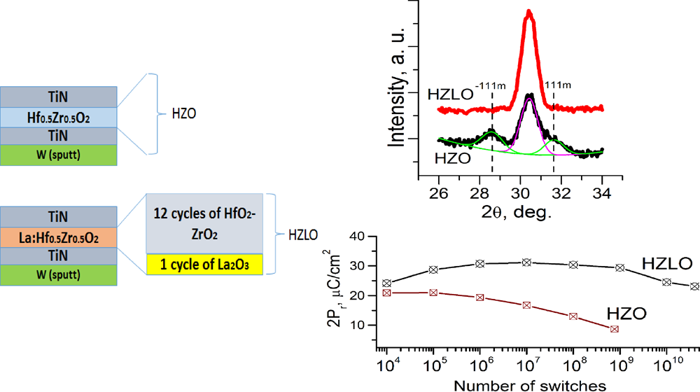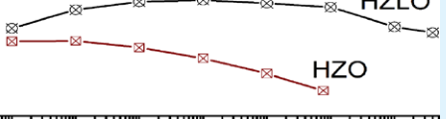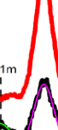

Research Article

Cite This: [ACS Appl. Mater. Interfaces 2018, 10, 2701−2708](http://pubs.acs.org/action/showCitFormats?doi=10.1021/acsami.7b15110)  www.acsami.org

Improved Ferroelectric Switching Endurance of La-Doped Hf0.5Zr0.5O2

Thin Films

Anna G. Chernikova,†Maxim G. Kozodaev,†Dmitry V. Negrov,†Evgeny V. Korostylev,†

Min Hyuk Park,‡Uwe Schroeder,‡Cheol Seong Hwang,†,§and Andrey M. Markeev*,†

†Moscow Institute of Physics and Technology, Institutskii per. 9, 141700 Dolgoprudny, Moscow Region, Russia

‡NaMLab gGmbH/TU Dresden, Noethnitzer Strasse 64, 01187 Dresden, Germany

§Department of Materials Science and Engineering and Inter-University Semiconductor Research Center, Seoul National University,

Seoul 08826, Republic of Korea

|  |  |  |  |  |  |
| --- | --- | --- | --- | --- | --- |
| TC).  articles. | * S Supporting Information | | | | |
| Downloaded via GEORGIA INST OF TECHNOLOGY on March 7, 2022 at 00:53:33 (UTC).  See https://pubs.acs.org/sharingguidelines for options on how to legitimately share published articles. | ABSTRACT: Hf0.5Zr0.5O2 thin films are one of the most  appealing HfO2-based ferroelectric thin films, which have been  researched extensively for their applications in ferroelectric  memory devices. In this work, a 1 mol % La-doped  Hf0.5Zr0.5O2 thin film was grown by plasma-assisted atomic  layer deposition and annealed at temperatures of 450 and 500 °C to crystallize the film into the desired orthorhombic phase.  Despite the use of a lower temperature than that used in  previous reports, the film showed highly promising ferro- electric propertiesa remnant polarization of ∼30 μC/cm2  and switching cycle endurance up to 4 × 1010. The  performance was much better than that of undoped  Hf0.5Zr0.5O2 thin films, demonstrating the positive influence    of La doping. Such improvements were mainly attributed to the decreased coercive field (by ∼30% compared to the undoped film), which allowed for the use of a lower applied field to drive the cycling tests while maintaining a high polarization value. La doping also decreased the leakage current by ∼3 orders of magnitude compared to the undoped film, which also contributed to the strongly improved endurance. Nonetheless, the La-doped film required a larger number of wake-up cycles (∼106cycles) to  reach a saturated remnant polarization value. This behavior might be explained by the increased generation of oxygen vacancies  and slower migration of these vacancies from the interface to the bulk region. However, the maximum number of wake-up cycles was less than 0.01% of the total possible cycles, and therefore, initializing the film to the maximum performance state would not  be a serious burden.  KEYWORDS: hafnium oxide, multicomponent oxide, thin films, ferroelectricity, nonvolatile memory, atomic layer deposition | | | | |
| ■INTRODUCTION  Hf0.5Zr0.5O2 (HZO) thin films are the leading candidate material among the various cation-doped HfO2-based ferro-electric (FE) thin films for semiconductor memory applica-tions. This is mainly due to the lower processing temperature in the film deposition and annealing of the material (less than 500°C for annealing is required for crystallization1−3) compared to other films, such as Si- or Al-doped HfO2 films, which require at least ∼800 °C for sufficient crystallization.4−6The most feasible film deposition method is atomic layer deposition (ALD), which offers high reproducibility, precise thickness control, and conformal coverage over extreme three-dimensional structures. Moreover, it can be applied not only for growth of functional FE layers but also for CMOS-compatible electrodes, including TiN, Ru, Ir, and so forth.7,8ZrO2 thin films have a lower crystallization temperature compared to HfO2, making the crystallization of HZO films feasible at such a low temperature. | | | metal−ferroelectric−metal (MFM) structure, where the typical electrode metal is TiN, into the back-end-of-line process, which requires a low temperature (preferably <500 °C). In addition, a higher annealing temperature drives an undesirable phase transition from an orthorhombic phase (o-phase, space group Pca21), which is the FE phase, to a monoclinic phase (m-phase, space group P21/c),2which largely deteriorates the FE performance. Therefore, low-temperature postdeposition an-nealing or postmetallization annealing (PMA), which corre-sponds to annealing after the top electrode (TE) fabrication, is desirable.  Researchers recently reported that annealing at temperatures as low as 400−450 °C could result in crystallization of HZO films and good FE behavior.9,10Nevertheless, a minor | |
|  | Received: | October 6, 2017 |
| Accepted: | December 28, 2017 |
| The low processing temperature is critical for integrating the | | Published: December 28, 2017 | | |
|  | © 2017 American Chemical Society | 2701 | | DOI: [10.1021/acsami.7b15110](http://dx.doi.org/10.1021/acsami.7b15110) ACS Appl. Mater. Interfa[ces 2018, 10, 2701−2708](http://dx.doi.org/10.1021/acsami.7b15110) |

|  |  |  |
| --- | --- | --- |
| ACS Applied Materials & Interfaces | |  | | --- | | Research Article | |

formation of the m-phase could not be completely ruled out, which slightly deteriorated the FE performance. Another problem was the relatively low cycling endurance, which is a general problem for this material system. Cycling endurance degradation, which is also called fatigue, corresponds to a decrease of the remnant polarization (Pr) during repeated cycling, while ensuring the exploitation of the full Pr of the film. This issue has been significantly dealt with in conventional perovskite-based FE films, in which the general origin is ascribed to domain pinning by the generation and accumulation of defects, typically oxygen vacancies (VO), within or at the electrode interface of the film. However, fatigue in HZO (also in other cation-doped HfO2-based FE films) is usually accompanied by electrical breakdown, which was not the case for conventional perovskite FE films. This can be ascribed to the much higher coercive field (Ec) of these materials (∼1 MV/ cm) compared to that of conventional perovskites (∼0.1−0.2 MV/cm). For a 10 nm thick HfO2 film, 1 MV/cm of Ec requires 2−3 V of driving voltage, which corresponds to 2−3 MV/cm, to exploit the full Pr values. This driving field is close to the breakdown field (typically, 3.5−5 MV/cm) of the material,11so repeated cycling usually induces breakdown before the genuine fatigue performance is evaluated. In contrast to conventional FE materials, the origin of ferroelectricity in HZO films is ascribed to size effects, that is, the lower grain boundary energy of the o-phase compared to that of the m-phase and high kinetic barriers for the phase transitions from the tetragonal phase (t-phase, space group P42/nmc) and the o-phase to the m-phase.12−14In addition, the polarization directions of the crystallized grains in polycrystalline films are not favorably oriented along Eext. Therefore, HZO films have a wide distribution of apparent Ec, which requires a much higher driving field compared to the nominal Ec. A lower Ec is, therefore, desirable. Breakdown could be also accelerated by the leakage current because of the possible impact ionization by electrons and progressive thermal defect generation by Joule heating. This means that a lower leakage current is another critical ingredient to suppress breakdown and to improve endurance.

La3+is a trivalent dopant ion that plays the role of an

|  |
| --- |
| acceptor with a relatively deep trap position within the band |

gap in HZO films.15HfO2 and ZrO2 are vulnerable to reduction, forming VO, and thus, HZO is also vulnerable, making the undoped film n-type. Therefore, doping HZO films with an acceptor center would shift the Fermi level of the film to the midgap position, which would largely decrease the leakage current with a given relatively low work function of the TiN electrode in this work (∼4.5 eV). La is a feasible dopant to induce ferroelectricity in HfO2 by increasing the tendency for o-phase formation,16,17and therefore, a similar effect can be expected in HZO, as will be shown in this work. However, La is also known as an amorphizer in HfO2,18,19so it could adversely interfere with the crystallization if its concentration is not appropriately controlled. In a previous work,17the crystal-lization of La-doped HfO2 with 2.6 mol % La did not occur after annealing at temperatures lower than 550 °C. Therefore, in this work, a low La content (only 1 mol %) was selected to ensure an early crystallization. The higher tendency of forming the o-phase in HZO films compared to that in HfO2 renders the adoption of such a low La concentration feasible, which would not be the case in HfO2.

In this work, the evolution of the structural and electrical properties of a 1 mol % La-doped HZO film (HZLO) was

2702 DOI: [10.1021/acsami.7b15110](http://dx.doi.org/10.1021/acsami.7b15110)

|  |  |  |
| --- | --- | --- |
| ACS Applied Materials & Interfaces | |  | | --- | | Research Article | |

was then utilized to measure the FE responses of the MFM capacitors. Particularly, switching current versus electric field (Is−E) and remnant polarization versus electric field (Pr−E) hysteresis were measured by applying triangular voltage sweeps with frequencies ranging from 100 Hz to 1 kHz. Voltage pulses with different amplitudes and a 600 ns duration (200 ns rise and 200 ns fall times) were utilized to measure the cycle endurance characteristics. Small-signal capacitance−voltage (C−V) measurements were used to estimate the dielectric constant (k) with an ac signal frequency of 10 kHz and amplitude of 50 mV.

■RESULTS AND DISCUSSION   
First, the influence of La doping on the crystalline structure of the annealed HZLO films was investigated by GIXRD, as shown in Figure 1a, where reference patterns for o-, t-, and c-

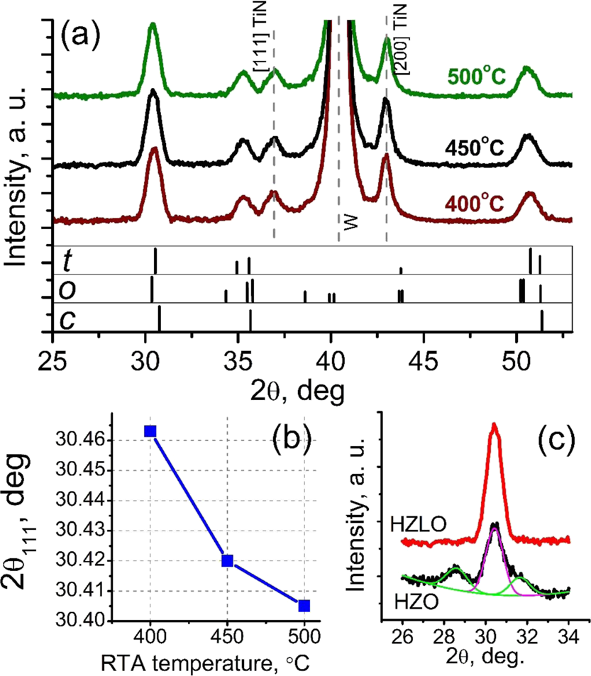

Figure 1. (a) GIXRD spectra collected from the HZLO films after RTP at different temperatures with reference patterns for the o-, t-, and c-phases of HZO; (b) [111] peak position, extracted from GIXRD spectra of the HZLO films, as a function of the RTP temperature; and (c) GIXRD spectra in the 2θ range = 26°−34° of the HZLO and HZO films after RTP at 450 °C.

phases, calculated from the previously reported data,1,2were added for clarity. The diffraction peaks at 2θ values of ∼30°, 35°, 50°, and 60°−63° suggest that all HZLO films were crystallized even after RTP at 400 °C, despite the well-known amorphization effect of La doping.18,19However, it has been reported that the precise determination of the present crystalline phases is quite challenging because the major peaks from the t- and o-phases overlap. Moreover, stabilization of the cubic phase (c-phase, space group Fm3m) with very close peak positions cannot be excluded. The most intense diffraction peak near ∼30°, which may consist of [111]o, [111]t, and [111]c reflections, where the subscripts o, t, and c refer to the o-, t-, and c-phases, respectively, may be informative to identify the structural evolution with an increasing RTP temperature. The peak position showed a monotonic shift from ∼30.46° to∼30.40° with an increasing annealing temperature from 400 to 500 °C (Figure 1b). According to the appended reference patterns in the lower portion of Figure 1a, this shift may indicate a more preferred o-phase formation with an increasing RTP temperature. Similar shifts were observed previously for

2703 DOI: [10.1021/acsami.7b15110](http://dx.doi.org/10.1021/acsami.7b15110)

|  |  |  |
| --- | --- | --- |
| ACS Applied Materials & Interfaces | |  | | --- | | Research Article | |

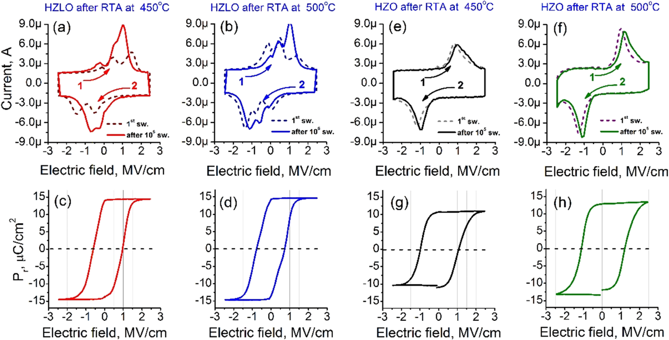

Figure 3. Is−E curves in response to an applied first voltage sweep and after 105switching cycles for stacks based on HZLO films after RTP at 450 (a) and 500 °C (b) and for stacks based on HZO films after RTP at 450 (e) and 500 °C (f); related Pr−E hysteresis loops extracted by PUND (c,d,g,h).

increase of the RTP temperature (data not shown). The increased grain size in the HZLO film compared to that in the HZO film is not consistent with the previous report on the

suppression of the grain growth by the incorporation of La into HZO.26The reason for such an abnormal behavior is not

clearly understood at this moment, but it is quite notable that the HZLO film contains almost no m-phase despite its larger grain size. This is a demonstration of the positive effect of La

doping, which may suppress m-phase formation by decreasing the bulk free energy difference between the m- and o-phases. Next, the FE properties of the HZLO films were evaluated. Figure 3a,b shows the Is−E curves for HZLO after RTP at 450 and 500 °C, respectively, in response to the application of a voltage sweep at 100 Hz to the pristine sample (first switch, dotted line) and after 105switching cycles (solid line) with a 2.5 MV/cm amplitude. The resulting Pr−E curves are presented in Figure 3c,d. To make a clear comparison, the same experiments were performed on the HZO film annealed

under the same conditions, and the results are shown in Figure 3e,f (for Is−E) and Figure 3g,h (for Pr−E). The HZO films showed a relatively well-defined single peak in the negative E region in their Is−E curves for both the pristine (first switch) and awakened states (after 105switching cycles). However,

there was certainly an involvement of additional peaks making

the peak shape asymmetric in the positive E region. These findings suggest that the film possesses nonuniform Ec values. The peak intensity does not change considerably with

increasing switching cycles, suggesting that the wake-up was not significant in this case. The only notable finding is the

increased peak height with an increased RTP temperature, suggesting greater o-phase formation, which was confirmed by the higher 2Pr value (∼25 μC/cm2) in Figure 3h compared to the 2Pr value of ∼21 μC/cm2in Figure 3g.

By contrast, HZLO films showed quite distinctive Is−E curves compared to those of the HZO films. There are multiple

switching peaks both in positive and negative E regions, suggesting that HZLO films annealed at both temperatures contain several types of grains with different Ec values. Here, the positive and corresponding negative E values, where the observed peaks correspond to the switching field (Es) and back-

2704 DOI: [10.1021/acsami.7b15110](http://dx.doi.org/10.1021/acsami.7b15110)

|  |  |  |
| --- | --- | --- |
| ACS Applied Materials & Interfaces | |  | | --- | | Research Article | |

Table 1. Calculated Coercive Fields of the Two Domain Groups of the HZLO and HZO Films Annealed at 450 °C in the Awakened State (after 105Switches)

|  |  |  |
| --- | --- | --- |
| film | Ec1, MV/cm | Ec2, MV/cm |
| HZLO | 0.80 | 0.75 |
| HZO | 1.2 | 0.95 |

films by ∼30%, which explains a significant increase in the 2Pr value.

To achieve insight into the observed wake-up phenomenon in HZLO, the well-known FORC measurements within the frame of the Preisach model were utilized,27which were applied previously for HfO2-based FE thin films.28,29Here, the switching density ρ was obtained from the numerical solution of the integral equation which connects the total capacitor charge and switching density during the applied voltage ramping. The details of the utilized procedure are presented in the [Supporting Information](http://pubs.acs.org/doi/suppl/10.1021/acsami.7b15110/suppl_file/am7b15110_si_001.pdf) section S2 FORC Measure-ments.

The HZLO film after RTP at 450 °C was taken as a representative sample and investigated in detail. Because the HZO films did not show notable wake-up, they were not examined using this method. In Figure 4, the switching density (ρ) is plotted as a function of Ebias and Ec for different numbers of wake-up cycles, that is, after 103, 104, 105, and 106switches. Here, pulses with a 2.5 MV/cm amplitude were applied for switching. If there were no notable internal Ebias and dispersed Ec values among the different regions, a ρ value with a single bright intensity would appear at Ebias = 0 and a given Ec. Therefore, the appearance of two bright spots with a rather wide range along the Ec axis and location off of Ebias = 0 suggests that there are wide variations in Ec among the different HZLO grains and internal Ebias. These bright regions (representing groups of domains) move toward each other during the wake-up process but do not merge completely even after the full wake-up (106cycles). The first group of domains, which are termed “stable” domains, showed a positive Ebias1 of∼0.5 MV/cm for the maximum ρ from the low cycle numbers, which almost did not change during the wake-up. However, the second group of the domains, which are termed “unstable”domains, initially had an Ebias2 of ∼−0.5 MV/cm and showed noticeable shifts toward the positive Ebias direction during cycling before saturating at an Ebias2 of ∼0.1−0.15 MV/cm. At the same time, an increase of the integrated magnitude of ρ with cycling was observed, which is in good accordance with the increased 2Pr value during wake-up (shown later). Interestingly, the increased ρ was seen mostly for the unstable domain group, while the stable group appeared to be much less sensitive to cycling. Such behavior of the unstable domains coincides with the previously discussed trend of the disappearance of the built-in field and depinning of the pinned domains during the wake-up cycles.26,28,29This effect could be due to defect (VO) redistribution from the FE/electrode interface toward the bulk, which is also accompanied with a phase transformation from the non-FE phase to the FE phase near the interface during cycling, as suggested by Grimley et al.30It is also notable that there are stable domains during the wake-up cycling process in the HZLO film, suggesting that there are FE domains free from the adverse influence of defects and their distribution. The Ec distributions for both groups of domains remained rather wide, that is, from 0.5 to 1.5 MV/cm, during wake-up. These behaviors reveal the complicated FE

2705 DOI: [10.1021/acsami.7b15110](http://dx.doi.org/10.1021/acsami.7b15110)

|  |  |  |
| --- | --- | --- |
| ACS Applied Materials & Interfaces | |  | | --- | | Research Article | |

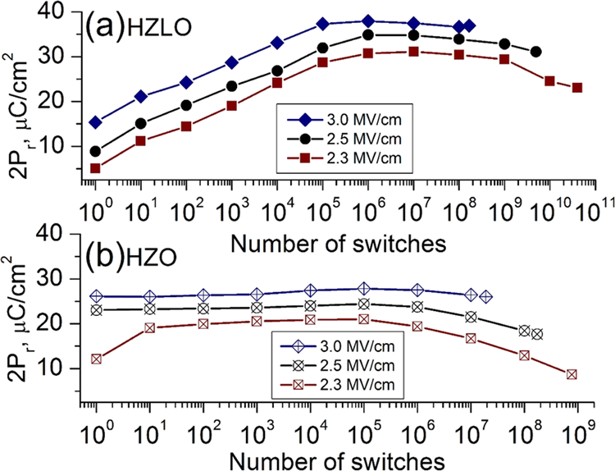

Figure 5. Endurance characteristics of the HZLO (a) and HZO (b)

films after RTP at 450 °C measured by PUND with different pulse

amplitudes and a constant pulse duration (0.6 μs). After the maximum

switching cycles, the samples showed hard breakdown (excluding 2.3

MV/cm case for the HZLO film).

Figure 4. A similar increase in the maximum 2Pr with an increasing Es can also be observed for the HZO film (Figure

5b). However, the relative drop of 2Pr in HZLO with a decreased applied electric field from 3.0 to 2.3 MV/cm was

∼20%, whereas it was ∼25% for HZO.

The improved endurance characteristics for the HZLO film

due to its low Ec value were confirmed experimentally. The HZLO film can endure up to ∼4 × 1010cycles for 2.3 MV/cm,

while maintaining considerably high 2Pr (30 μC/cm2up to 108

cycles) and displaying no breakdown. The decreased Ec value by La doping allowed for the use of a lower cycling field, which

largely mitigates the risk of breakdown. Therefore, genuine

fatigue behavior can be observed, and there was a decrease in

the 2Pr value by 25% at the end of the endurance cycling test.

Such degradation might have a similar origin as that for

conventional perovskite-based FE materials, that is, domain

pinning by defect generation and accumulation.31Even for the

HZLO film, the adoption of a higher cycling field (3.0 MV/cm)

also increases the risk of breakdown, and the film can only be

cycled up to 2 × 108cycles. However, the same field results in a cycle endurance of only 2 × 107cycles for HZO. The HZO film also showed serious fatigue behavior at ∼109cycles even for a lower field (2.3 MV/cm). Therefore, the overall cycle endurance performance was greatly improved by 1 mol % La doping. The reasons for such improvement seem to be twofold: (1) the lowered Ec value, which allowed using a lower cycling field and (2) the lower leakage current. Indeed, as was expected, the dc current density−electric field (J−E) character-istics of the HZLO and HZO films after RTP at 450 °C (the related image is presented in the [Supporting Information](http://pubs.acs.org/doi/suppl/10.1021/acsami.7b15110/suppl_file/am7b15110_si_001.pdf) section S3 dc-IV Characteristics of HZLO and HZO Films) revealed that the HZLO film has a current density considerably lower (in fact, by almost 3 orders of magnitude) than that of HZO at 1 MV/cm. Although identifying the precise origin for such a high J improvement requires further study, such as conduction mechanism analysis and band structure identi-fication by XPS, it is evident that the lower leakage current considerably contributed to the improved reliability and endurance of the HZLO film.

The prolonged wake-up behavior in the HZLO films might be understood from the literature, where the wake-up mechanism has been elucidated. It has been suggested that a very high defect density (mostly VO) region, especially at the boundary between the FE HfO2 and TiN electrodes, adversely interferes with FE switching in the pristine state.32The presence of such a defective layer results in a built-in Ebias in the film, leading to noticeable nonswitched areas inside the film. This is consistent with the observations of the finite Ebs and multiple values of Ec in Figure 4. During multiple switching cycles, the diffusion of VO occurs from the interface to bulk regions, which can considerably diminish the VO concentration gradient, leading to a relaxation of the built-in field and thus wake-up completion.28In this case, the PAALD process for the HZLO film growth ending with La−O layer deposition can lead to a higher defect density at the top interface, as La is known as an effective VO-generating dopant.15,33Thus, many switching

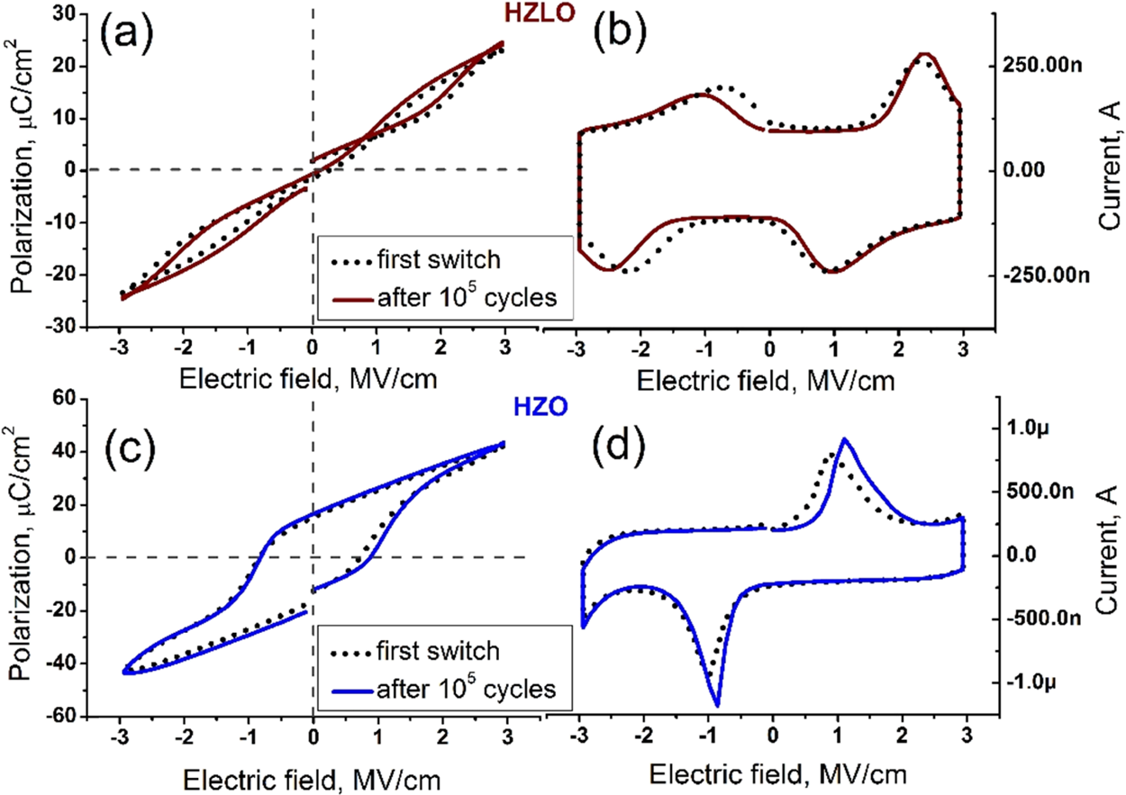

Figure 6. Hysteresis loops with the corresponding current (Is−E) curves for stacks based on ternary HZLO (a,b)/HZO (c,d) films after RTP at 400°C in response to the first voltage sweep (first switch) and after 105switches by application of bipolar voltage pulses with a 0.6 μs and 3 MV/cm duration and amplitude, respectively.

|  |  |
| --- | --- |
| 2706 | DOI: [10.1021/acsami.7b15110](http://dx.doi.org/10.1021/acsami.7b15110) ACS Appl. Mater. Interfa[ces 2018, 10, 2701−2708](http://dx.doi.org/10.1021/acsami.7b15110) |

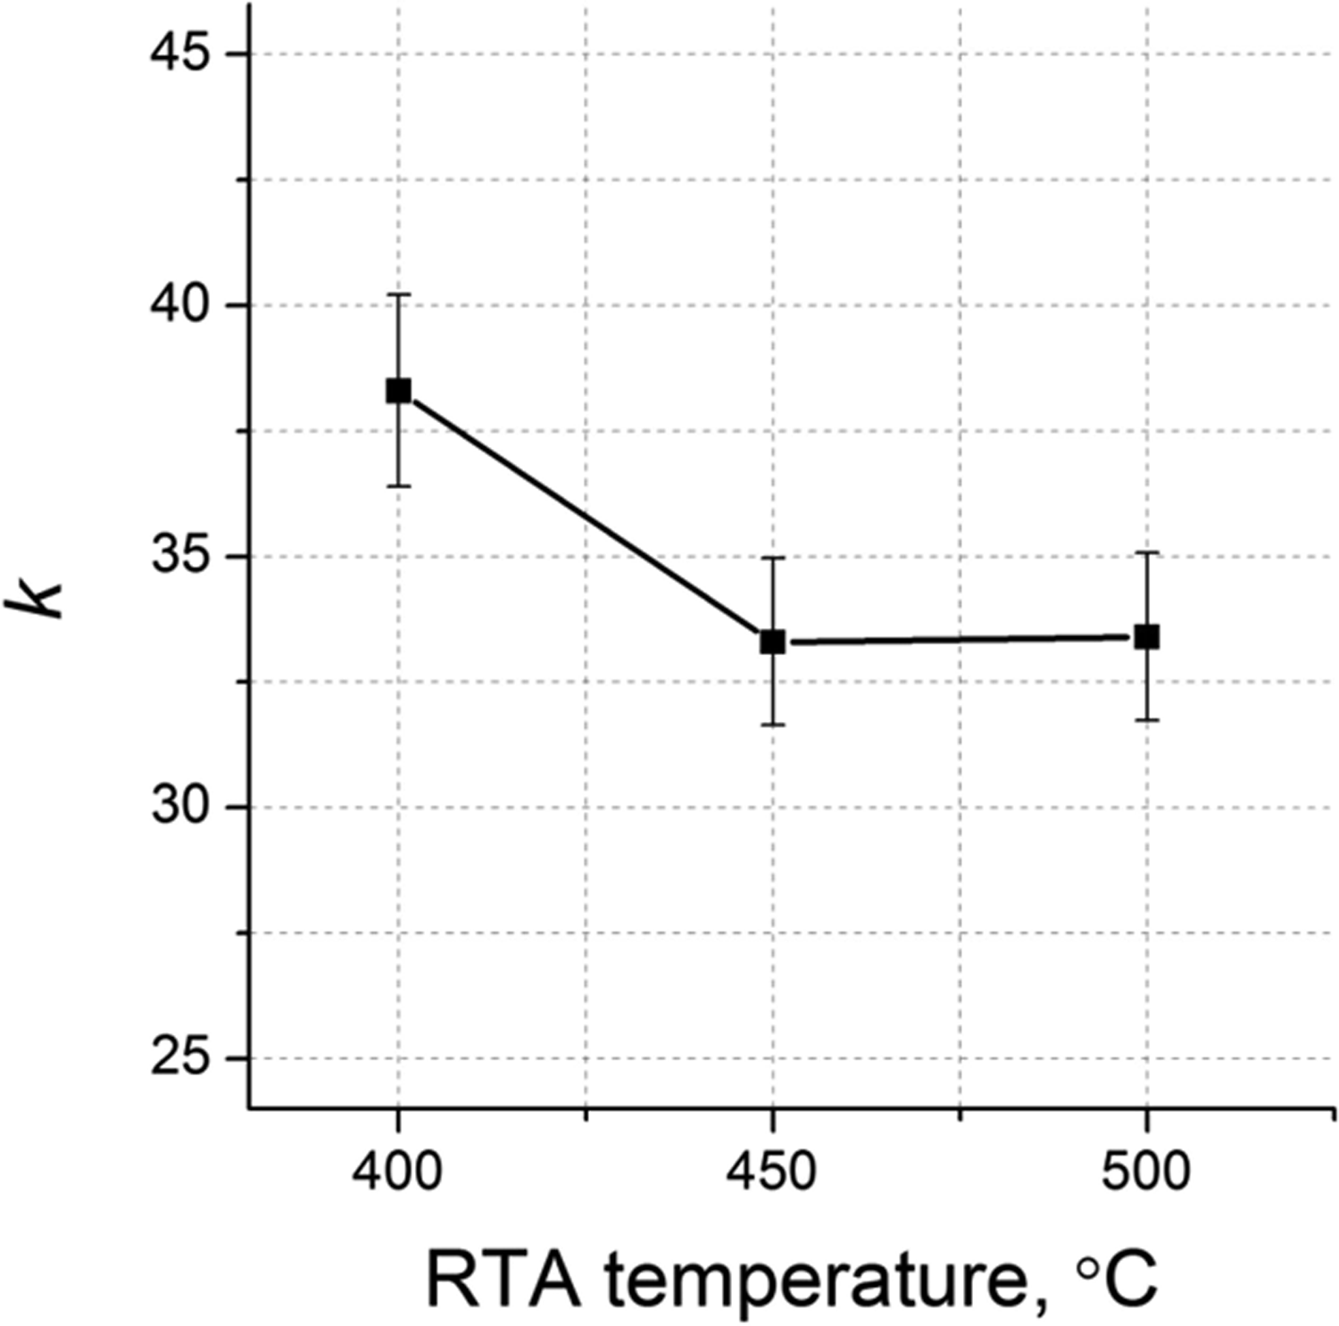

|  |  |  |
| --- | --- | --- |
| ACS Applied Materials & Interfaces | |  | | --- | | Research Article | |

cycles are required to fully wake-up the HZLO film, which was not necessary for the HZO film.

On the other hand, the nonemergence of such a significant wake-up effect in the HZO film might be ascribed to a much higher charge injection compared with the HZLO film case during the wake-up cycles, as could be inferred from the J−E

curves shown in Figure S3 of the [Supporting Information](http://pubs.acs.org/doi/suppl/10.1021/acsami.7b15110/suppl_file/am7b15110_si_001.pdf). The

injected charge carriers could pin the FE domains of the HZO film, and the 2Pr cannot be increased to the value it should have if there were no charge injections. However, this is unlikely because of the following reason. When the J−E curve of the HZLO film was extrapolated to the E value of 3.0 MV/cm, the J level of the film becomes similar to that of the HZO film at 2.3−2.5 MV/cm. Thus, if the charge injection caused the 2Pr suppression, the wake-up should not be observed for the case of the HZLO film at 3.0 MV/cm, which was obviously not the

case. Therefore, this possibility can be ruled out.

Finally, the effect of La doping was examined after RTP at 400 °C. Figure 6a,b shows the P−E and Is−E curves of the HZLO film, respectively. They correspond to an antiferro-

electric (AFE)-like behavior, and such behavior did not vary up to 105switching cycles (dotted and solid lines). However, the HZO film, annealed under the same conditions, demonstrated a pure FE response from the first switching cycle (Figure 6c,d) with a 2Pr value as high as 25 μC/cm2. Such AFE-like behavior of HZLO after RTP at 400 °C may be related to a t-phase

formation, which is consistent with the GIXRD spectra

presented in Figure 1. Indeed, it has been suggested previously that reversible t−o field-induced transformation can account for the AFE-like behavior.32Figure 7 shows the variation of the k

Figure 7. k values of the HZLO film as a function of the RTP temperature in the temperature range of 400−500 °C.

value of the HZLO film estimated from the C−V measure-

ments, as a function of the RTP temperature. Here, k values

were taken outside the switching regions, that is, at 2.5 MV/cm,

to represent only the linear dielectric contribution. The k value was ∼38 at 400 °C and decreased to ∼33 at 450 and 500 °C. It

is well-known that higher-symmetry crystalline phases of HfO2 are characterized by higher k values. For example, k ≈ 30 and k≥ 35 have been reported for the o- and t-phases, respectively, in Hf0.5Zr0.5O2 thin films.1,2Therefore, the observed trend in Figure 7 is consistent with the assumption of a higher t-phase fraction after the RTP at 400 °C. Therefore, activation by La

2707 DOI: [10.1021/acsami.7b15110](http://dx.doi.org/10.1021/acsami.7b15110)

|  |  |  |  |
| --- | --- | --- | --- |
| ACS Applied Materials & Interfaces | |  |  | | --- | --- | | |  | | --- | | Research Article | | |
| ■REFERENCES  (1) Müller, J.; Böscke, T. S.; Schröder, U.; Mueller, S.; Bräuhaus, D.; Böttger, U.; Frey, L.; Mikolajick, T. Ferroelectricity in Simple Binary ZrO2 and HfO2. Nano Lett. 2012, 12, 4318−4323.  (2) Park, M. H.; Kim, H. J.; Kim, Y. J.; Lee, W.; Moon, T.; Hwang, C. S. Evolution of phases and ferroelectric properties of thin Hf0.5Zr0.5O2 films according to the thickness and annealing temperature. Appl. Phys. Lett. 2013, 102, 242905.  (3) Chernikova, A.; Kozodaev, M.; Markeev, A.; Matveev, Y.; Negrov, D.; Orlov, O. Confinement-free annealing induced ferroelectricity in Hf0.5Zr0.5O2 thin films. Microelectron. Eng. 2015, 147, 15−18.  (4) Böscke, T. S.; Müller, J.; Bräuhaus, D.; Schröder, U.; Böttger, U. Ferroelectricity in hafnium oxide thin films. Appl. Phys. Lett. 2011, 99, 102903.  (5) Starschich, S.; Boettger, U. An extensive study of the influence of dopants on the ferroelectric properties of HfO2. J. Mater. Chem. C 2017, 5, 333−338.  (6) Park, M. H.; Lee, Y. H.; Kim, H. J.; Kim, Y. J.; Moon, T.; Kim, K. D.; Müller, J.; Kersch, A.; Schroeder, U.; Mikolajick, T.; Hwang, C. S. Ferroelectricity and Antiferroelectricity of Doped Thin HfO2-Based Films. Adv. Mater. 2015, 27, 1811−1831.  (7) Mattinen, M.; Hämäläinen, J.; Vehkamäki, M.; Heikkilä, M. J.; Mizohata, K.; Jalkanen, P.; Räisänen, J.; Ritala, M.; Leskelä, M. Atomic Layer Deposition of Iridium Thin Films Using Sequential Oxygen and Hydrogen Pulses. J. Phys. Chem. C 2016, 120, 15235−15243.  (8) Egorov, K. V.; Lebedinskii, Y. Y.; Soloviev, A. A.; Chouprik, A. A.; Azarov, A. Y.; Markeev, A. M. Initial and steady-state Ru growth by atomic layer deposition studied by in situ Angle Resolved X-ray Photoelectron Spectroscopy. Appl. Surf. Sci. 2017, 419, 107−113. (9) Park, M. H.; Kim, H. J.; Kim, Y. J.; Moon, T.; Kim, K. D.; Lee, Y. H.; Hyun, S. D.; Hwang, C. S. Study on the internal field and conduction mechanism of atomic layer deposited ferroelectric Hf0.5Zr0.5O2 thin films. J. Mater. Chem. C 2015, 3, 6291−6300. (10) Zarubin, S.; Suvorova, E.; Spiridonov, M.; Negrov, D.; Chernikova, A.; Markeev, A.; Zenkevich, A. Fully ALD-grown TiN/ Hf0.5Zr0.5O2/TiN stacks: Ferroelectric and structural properties. Appl. Phys. Lett. 2016, 109, 192903.  (11) Park, I.-S.; Ryu, K.-m.; Jeong, J.; Ahn, J. Dielectric stacking effect of Al2O3 and HfO2 in metal−insulator−metal capacitor. IEEE Electron Device Lett. 2013, 34, 120−122.  (12) Materlik, R.; Künneth, C.; Kersch, A. The origin of ferroelectricity in Hf1‑xZrxO2: A computational investigation and a surface energy model. J. Appl. Phys. 2015, 117, 134109.  (13) Huan, T. D.; Sharma, V.; Rossetti, G. A., Jr.; Ramprasad, R. Pathways towards ferroelectricity in hafnia. Phys. Rev. B: Condens. Matter Mater. Phys. 2014, 90, 064111.  (14) Park, M. H.; Lee, Y. H.; Kim, H. J.; Kim, Y. J.; Moon, T.; Kim, K. D.; Hyun, S. D.; Mikolajick, T.; Schroeder, U.; Hwang, C. S. Understanding the formation of the metastable ferroelectric phase in hafnia−zirconia solid solution thin films. Nanoscale 2018, 10, 716−725.  (15) Zhang, H.; Gao, B.; Yu, S.; Lai, L.; Zeng, L.; Sun, B.; Liu, L.; Liu, X.; Lu, J.; Han, R.; Kang, J. Effects of ionic doping on the behaviors of oxygen vacancies in HfO2 and ZrO2: A first principles study. International Conference on Simulation of Semiconductor Processes and Devices (SISPAD), 2009.  (16) Muller, J.; Boscke, T. S.; Muller, S.; Yurchuk, E.; Polakowski, P.; | (18) Duran, P. Phase relationships in the systems HfO2-La2O3 and HfO2-Nd2O3. Ceram. Int. 1975, 1, 10−13.  (19) Ushakov, S. V.; Brown, C. E.; Navrotsky, A. Effect of La and Y on Crystallization Temperatures of Hafnia and Zirconia. J. Mater. Res. 2004, 19, 693−696.  (20) Kozodaev, M. G.; Lebedinskii, Y. Y.; Chernikova, A. G.; Polyakov, S. N.; Markeev, A. M. Low temperature plasma-enhanced ALD TiN ultrathin films for Hf0.5Zr0.5O2-based ferroelectric MIM structures. Phys. Status Solidi A 2017, 214, 1700056.  (21) Park, M. H.; Schenk, T.; Fancher, C. M.; Grimley, E. D.; Zhou, C.; Richter, C.; LeBeau, J. M.; Jones, J. L.; Mikolajick, T.; Schroeder, U. A comprehensive study on the structural evolution of HfO2 thin films doped with various dopants. J. Mater. Chem. C 2017, 5, 4677−4690.  (22) Chernikova, A.; Kozodaev, M.; Markeev, A.; Negrov, D.; Spiridonov, M.; Zarubin, S.; Bak, O.; Buragohain, P.; Lu, H.; Suvorova, E.; Gruverman, A.; Zenkevich, A. Ultrathin Hf0.5Zr0.5O2 Ferroelectric Films on Si. ACS Appl. Mater. Interfaces 2016, 8, 7232−7237.  (23) Chouprik, A.; Chernikova, A.; Markeev, A.; Mikheev, V.; Negrov, D.; Spiridonov, M.; Zarubin, S.; Zenkevich, A. Electron transport across ultrathin ferroelectric Hf0.5Zr0.5O2 films on Si. Microelectron. Eng. 2017, 178, 250−253.  (24) Islamov, D. R.; Chernikova, A. G.; Kozodaev, M. G.; Markeev, A. M.; Perevalov, T. V.; Gritsenko, V. A.; Orlov, O. M. Charge transport mechanism in thin films of amorphous and ferroelectric Hf0.5Zr0.5O2. JETP Lett. 2015, 102, 544−547.  (25) Nečas, D.; Klapetek, P. Gwyddion: an open-source software for SPM data analysis. Cent. Eur. J. Phys. 2012, 10, 181−188.  (26) Kozodaev, M. G.; Chernikova, A. G.; Korostylev, E. V.; Park, M. H.; Schroeder, U.; Hwang, C. S.; Markeev, A. M. Ferroelectric properties of lightly doped La:HfO2 thin films grown by plasma-assisted atomic layer deposition. Appl. Phys. Lett. 2017, 111, 132903. (27) Preisach, F. Über die Magnetische Nachwirkung. Z. Phys. 1935, 94, 277−302.  (28) Pešić, M.; Fengler, F. P. G.; Larcher, L.; Padovani, A.; Schenk, T.; Grimley, E. D.; Sang, X.; LeBeau, J. M.; Slesazeck, S.; Schroeder, U.; Mikolajick, T. Physical Mechanisms behind the Field-Cycling Behavior of HfO2-based Ferroelectric Capacitors. Adv. Funct. Mater. 2016, 26, 4601−4612.  (29) Schenk, T.; Hoffmann, M.; Ocker, J.; Pešić, M.; Mikolajick, T.; Schroeder, U. Complex Internal Bias Fields in Ferroelectric Hafnium Oxide. ACS Appl. Mater. Interfaces 2015, 7, 20224−20233.  (30) Grimley, E. D.; Schenk, T.; Sang, X.; Pešić, M.; Schroeder, U.; Mikolajick, T.; LeBeau, J. M. Structural changes Underlying Field-Cycling Phenomena in Ferroelectric HfO2 thin films. Adv. Electron. Mater. 2016, 2, 1600173.  (31) Warren, W. L.; Dimos, D.; Tuttle, B. A.; Nasby, R. D.; Pike, G. E. Electronic domain pinning in Pb(Zr,Ti)O3 thin films and its role in fatigue. Appl. Phys. Lett. 1994, 65, 1018.  (32) Richter, C.; Schenk, T.; Park, M. H.; Tscharntke, F. A.; Grimley, E. D.; LeBeau, J. M.; Zhou, C.; Fancher, C. M.; Jones, J. L.; Mikolajick, T.; Schroeder, U. Si Doped Hafnium Oxide-A “Fragile” Ferroelectric System. Adv. Electron. Mater. 2017, 3, 1700131.  (33) Gao, B.; Zhang, H. W.; Yu, S.; Sun, B.; Liu, L. F.; Liu, X. Y.; Wang, Y.; Han, R. Q.; Kang, J. F.; Yu, B.; Wang, Y. Y. Oxide-Based RRAM: Uniformity Improvement Using A New Material-Oriented Methodology. Digest of Technical PapersSymposium on VLSI Technology, Kyoto, 2009; pp 30−31. |

Paul, J.; Martin, D.; Schenk, T.; Khullar, K.; Kersch, A.; Weinreich, W.;   
Riedel, S.; Seidel, K.; Kumar, A.; Arruda, T. M.; Kalinin, S. V.;   
Schlosser, T.; Boschke, R.; van Bentum, R.; Schroder, U.; Mikolajick,   
T. Ferroelectric hafnium oxide: A CMOS-compatible and highly   
scalable approach to future ferroelectric memories. Electron Devices   
Meeting (IEDM); IEEE International: Washington, 2013; pp 10.8.1−  
10.8.4.

(17) Chernikova, A. G.; Kuzmichev, D. S.; Negrov, D. V.; Kozodaev,   
M. G.; Polyakov, S. N.; Markeev, A. M. Ferroelectric properties of full   
plasma-enhanced ALD TiN/La:HfO2/TiN stacks. Appl. Phys. Lett.   
2016, 108, 242905.

|  |  |
| --- | --- |
| 2708 | DOI: [10.1021/acsami.7b15110](http://dx.doi.org/10.1021/acsami.7b15110) ACS Appl. Mater. Interfa[ces 2018, 10, 2701−2708](http://dx.doi.org/10.1021/acsami.7b15110) |