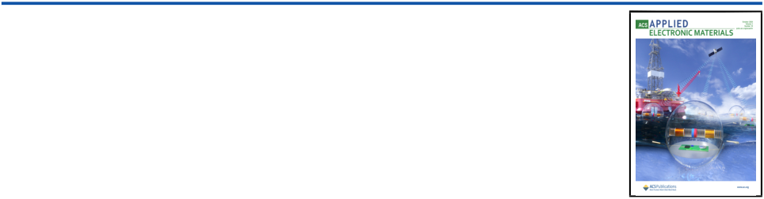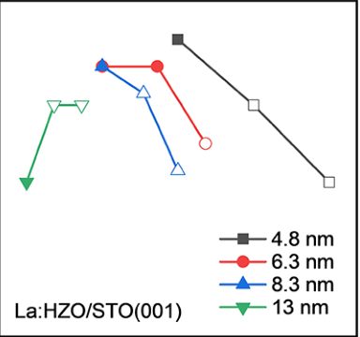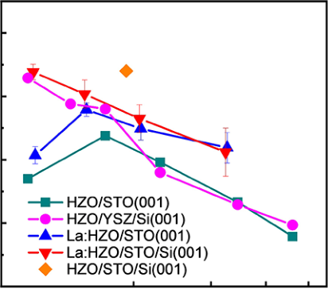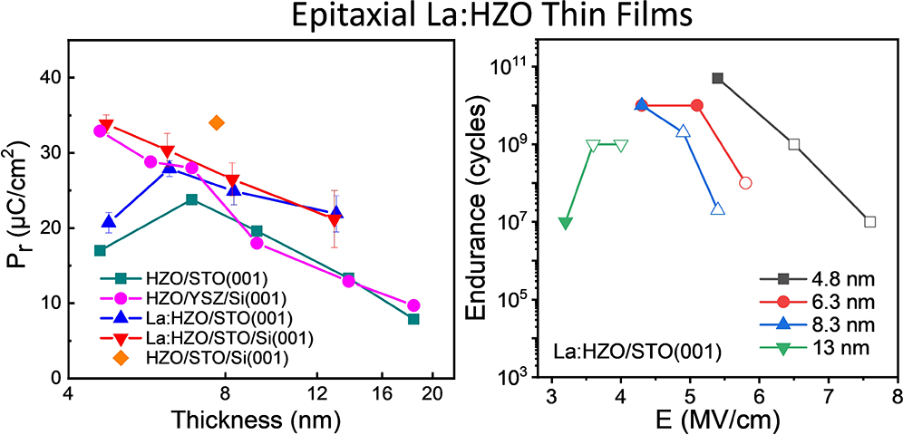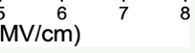

|  |  |
| --- | --- |
| pubs.acs.org/acsaelm | Article |

Epitaxial Ferroelectric La-Doped Hf0.5Zr0.5O2 Thin Films [Tingfeng Song,](https://pubs.acs.org/action/doSearch?field1=Contrib&text1="Tingfeng+Song"&field2=AllField&text2=&publication=&accessType=allContent&Earliest=&ref=pdf) [Romain Bachelet,](https://pubs.acs.org/action/doSearch?field1=Contrib&text1="Romain+Bachelet"&field2=AllField&text2=&publication=&accessType=allContent&Earliest=&ref=pdf) [Guillaume Saint-Girons,](https://pubs.acs.org/action/doSearch?field1=Contrib&text1="Guillaume+Saint-Girons"&field2=AllField&text2=&publication=&accessType=allContent&Earliest=&ref=pdf) [Raul Solanas,](https://pubs.acs.org/action/doSearch?field1=Contrib&text1="Raul+Solanas"&field2=AllField&text2=&publication=&accessType=allContent&Earliest=&ref=pdf) [Ignasi Fina,](https://pubs.acs.org/action/doSearch?field1=Contrib&text1="Ignasi+Fina"&field2=AllField&text2=&publication=&accessType=allContent&Earliest=&ref=pdf)*

[and Florencio Sa](https://pubs.acs.org/action/doSearch?field1=Contrib&text1="Florencio+Sa%CC%81nchez"&field2=AllField&text2=&publication=&accessType=allContent&Earliest=&ref=pdf)́[nchez](https://pubs.acs.org/action/doSearch?field1=Contrib&text1="Florencio+Sa%CC%81nchez"&field2=AllField&text2=&publication=&accessType=allContent&Earliest=&ref=pdf)[*](https://pubs.acs.org/action/doSearch?field1=Contrib&text1="Romain+Bachelet"&field2=AllField&text2=&publication=&accessType=allContent&Earliest=&ref=pdf)

|  |  |  |  |  |  |  |  |  |  |  |  |  |  |
| --- | --- | --- | --- | --- | --- | --- | --- | --- | --- | --- | --- | --- | --- |
|  | Cite This: [ACS Appl. Electron. Mater. 2020, 2, 3221−3232](https://pubs.acs.org/action/showCitFormats?doi=10.1021/acsaelm.0c00560&ref=pdf) | | | | [Read Online](https://pubs.acs.org/doi/10.1021/acsaelm.0c00560?ref=pdf) | | | | | | | | |
|  | ACCESS |  | [Metrics & More](https://pubs.acs.org/doi/10.1021/acsaelm.0c00560?goto=articleMetrics&ref=pdf) | | | | [Article Recommendations](https://pubs.acs.org/doi/10.1021/acsaelm.0c00560?goto=recommendations&?ref=pdf) | | | | * | | [Supporting Information](https://pubs.acs.org/doi/10.1021/acsaelm.0c00560?goto=supporting-info&ref=pdf) |
| F TECHNOLOGY on March 7, 2022 at 01:19:21 (UTC).  es for options on how to legitimately share published articles. | ABSTRACT: Doping ferroelectric Hf0.5Zr0.5O2 with La is a promising route to improve endurance. However, the beneficial  effect of La on the endurance of polycrystalline films may be | | | | | | |  | |  |  |  |  |
| accompanied by degradation of retention. We have investigated the endurance−retention dilemma in La-doped epitaxial films. Compared to undoped epitaxial films, large values of polarization are obtained in a wider thickness range, whereas the coercive fields  are similar, and the leakage current is substantially reduced.  Compared to polycrystalline La-doped films, epitaxial La-doped  films show more fatigue, but there is no significant wake-up effect  and endurance−retention dilemma. The persistent wake-up effect,      common to polycrystalline La-doped Hf0.5Zr0.5O2 films, is limited  to a few cycles in epitaxial films. Despite fatigue, endurance in epitaxial La-doped films is more than 1010cycles, and this good property is accompanied by excellent retention of more than 10 years. These results demonstrate that the wake-up effect and endurance−retention dilemma are not intrinsic in La-doped Hf0.5Zr0.5O2.  KEYWORDS: ferroelectric HfO2, ferroelectric oxides, Hf0.5Zr0.5O2, epitaxial HfO2, epitaxial oxides on silicon | | | | | | | | | | | | |
| Downloaded via GEORGIA INST O  See https://pubs.acs.org/sharingguidelin | 1. INTRODUCTION  Stabilization of the metastable orthorhombic (o) ferroelectric phase in doped HfO2 films1can have a great technological impact. HfO2 films can be grown by atomic layer deposition, a process compatible with CMOS technology, and can overcome the lack of scalability of conventional ferroelectric oxides.2−4 Ferroelectric hafnia holds promise not only for nonvolatile random access devices but also for emerging ferroelectric memories such as tunnel junctions and field effect transistors. However, the endurance of HfO2 capacitors, which is a critical property for memory devices, is moderately low. The low endurance of ferroelectric HfO2 is perhaps the consequence of a large coercive field (Ec), >1 MV/cm, around 1 order of magnitude greater than that of perovskite oxides. The electric field required to cycle HfO2 is very high, close to the breakdown field, and endurance of HfO2 capacitors is generally limited by hard breakdown that usually occurs well below 1010 cycles.  Doping with trivalent La atoms has allowed a significant improvement. In particular, Hf0.5Zr0.5O2 (HZO) films doped with 1 mol % La show increased polarization and an endurance of up to 4 × 1010cycles.5This was accomplished by reducing Ec and leakage current by around 30% and 3 orders of magnitude, respectively.5Optimizing the amount of La has allowed a further enhancement.6HZO capacitors doped with 0.7 mol % La remained operational after 1011cycles and without polarization reduction (fatigue).6However, optimiza- | | | | | | severe degradation of polarization retention.7The endurance of films doped with 2.5 mol % La, the optimal amount by considering all ferroelectric properties, was only 107cycles. On the other hand, a common detrimental effect of La doping is the highly increased wake-up effect up to 105to 107cycles.5−7 Studies on the effects of doping with La have been carried out with polycrystalline films. Ferroelectricity has been reported for epitaxial films of HfO2 doped with several atoms, including Y,8,9Zr,10−24and Si.25The remanent polarization (Pr) in epitaxial films can exceed 20 μC/cm2, and the Ec is greater than that in polycrystalline samples.10−17,22−25In addition, the usual Ec−thickness (t) scaling in conventional ferroelectric perovskites, Ec ∝ t−2/3,26,27 elusive in polycrystalline HZO or other doped HfO2 films, is observed in epitaxial HZO films.15,22Endurance of epitaxial HZO films can be high in spite of their enormous Ec of 3−4 MV/cm.10,14,16,22Indeed, endurance of 1011cycles has been measured in sub-5 nm HZO films by applying a very large electric field above 5 MV/cm.22Further improvement could be  achieved by decreasing leakage and the huge Ec of epitaxial | | | | | | |
| Received: | June 29, 2020 | | | | | |
| Accepted: | | September 15, 2020 | | | | |
| Published: September 15, 2020 | | | | | | |
| tion of endurance by La doping can be accompanied by a | | | | | | | | | | | | |
|  | | | © 2020 American Chemical Society | | 3221 | | | | [https://dx.doi.org/10.1021/acsaelm.0c00560](https://dx.doi.org/10.1021/acsaelm.0c00560?ref=pdf) AC[S Appl. Electron. Mater. 2020, 2, 3221−3232](https://dx.doi.org/10.1021/acsaelm.0c00560?ref=pdf) | | | |

|  |  |  |
| --- | --- | --- |
| ACS Applied Electronic Materials | pubs.acs.org/acsaelm | Article |

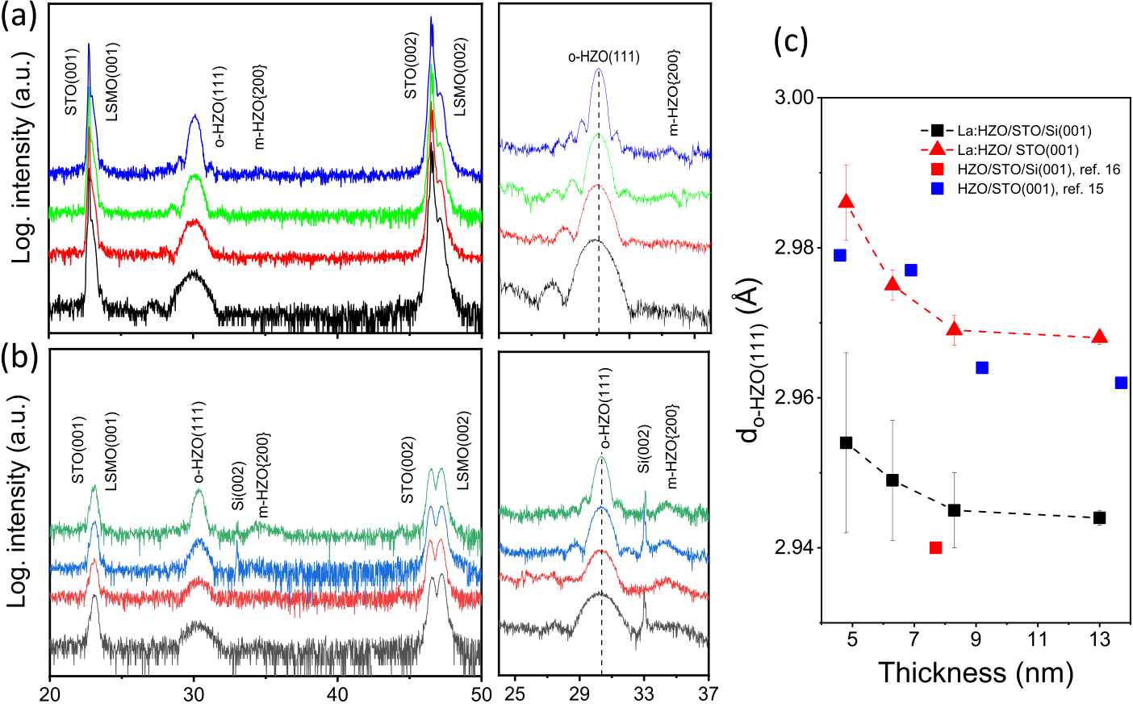

 

Figure 1. XRD θ−2θ scans of La:HZO films on (a) LSMO/STO(001) and (b) LSMO/STO/Si(001). Right panels: scans acquired with a longer time. (c) Out-of-plane o-HZO(111) lattice distance of La:HZO films on LSMO/STO(001) (red triangles) and LSMO/STO/Si(001) (black squares), plotted as a function of thickness. Out-of-plane lattice distance values of epitaxial undoped HZO on LSMO/STO(001) (blue squares)15 and LSMO/STO/Si(001) (red square)16are plotted for comparison.

films. By doping with La, an acceptor dopant for HZO, it has been possible to reduce leakage and Ec in polycrystalline HZO films, and, therefore, it is of great interest to stabilize the o-phase in epitaxial La-doped HZO (La:HZO) films and measure ferroelectric polarization, endurance, and retention. In order to investigate the effects of La doping in epitaxial films, we fixed the La content to the same amount (1 mol % La) as that in the pioneering study by Chernikova et al.,5and La-doped HZO epitaxial films were deposited using growth conditions, substrates, and the bottom electrode suitable to stabilize the o-phase in undoped HZO films.

Epitaxial La:HZO films of thickness (t) in the 4.5−13 nm range were deposited on (001)-oriented SrTiO3 (STO) substrates buffered with a La2/3Sr1/3MnO3 (LSMO) electrode. The o-phase is epitaxially stabilized, and the films have a Pr of up to ∼28 μC/cm2and Ec that scales with thickness according to the ∝ t−2/3dependence. Compared to undoped HZO epitaxial films of the same thickness, Ec values are similar, while leakage current reduces by around 1 order of magnitude. Endurance improves over equivalent undoped epitaxial films, with strong thickness dependence in both doped and undoped films. Moreover, the wake-up effect (100 cycles), hardly observed in epitaxial undoped HZO films, is evident in films thinner than around 8 nm, although being much less than that for polycrystalline La:HZO. Films of t < 10 nm show 2Pr > 2 μC/cm2after 1010cycles at a field of 4−5 MV/cm. Remarkably, high endurance is accompanied by long retention of more than 10 years using the same poling field. This demonstrates that high endurance and long retention can be attained simultaneously in La:HZO films on LSMO/ STO(001). However, because Si wafers are required for applications, epitaxial La:HZO films were also grown on LSMO/STO/Si(001). LSMO and STO were grown by pulsed laser deposition (PLD) and molecular beam epitaxy (MBE), respectively. We note that STO and other perovskites can also be integrated epitaxially on Si(001) by atomic layer deposition, allowing for conformal deposition.28The epitaxial HZO films

3222 [https://dx.doi.org/10.1021/acsaelm.0c00560](https://dx.doi.org/10.1021/acsaelm.0c00560?ref=pdf)

|  |  |  |
| --- | --- | --- |
| ACS Applied Electronic Materials | pubs.acs.org/acsaelm | Article |

tion. Endurance was measured by cycling the sample at a frequency of

100 kHz using bipolar square pulses of indicated amplitude and

measuring polarization loops at 1 kHz. Retention was measured by

poling the sample using a triangular pulse of 0.25 ms and determining the Pr from the first polarization curve of the polarization loop measured at 1 kHz using the PUND protocol after a delay time.31

3. RESULTS

Figure 1a shows the XRD θ−2θ scans of the La:HZO/LSMO/

STO(001) samples. For clarity, the scans are vertically shifted,

increasing HZO thickness from the bottom to the top. Besides the (001) and (002) reflections of the STO substrate and the LSMO electrode, there is a peak at 2θ around 30°, coincident with the position of the o-HZO(111) reflection in epitaxial undoped HZO films.15A zoomed 2θ range around this peak,

scanned with a longer acquisition time, is in the right panel of

Figure 1a. By increasing thickness, the o-HZO(111) peak

becomes narrower and Laue oscillations are evident. The thickness of the thickest film, calculated by simulation of the

Laue oscillations ([Supporting Information S1](http://pubs.acs.org/doi/suppl/10.1021/acsaelm.0c00560/suppl_file/el0c00560_si_001.pdf)), is 13.1 nm. The

simulation shows an asymmetry, with the satellites being more

intense at lower angles than at higher angles with respect to the

o-HZO(111) peak. Asymmetry is observed in similar undoped epitaxial HZO(111) films.13,15Laue oscillations around LSMO reflections are not observed because of the LSMO thickness

(25 nm) and the measurement with Cu Kα radiation that included Cu Kα[1 and Cu](http://pubs.acs.org/doi/suppl/10.1021/acsaelm.0c00560/suppl_file/el0c00560_si_001.pdf) Kα2 components. Pole figures ([Supporting Information S2](http://pubs.acs.org/doi/suppl/10.1021/acsaelm.0c00560/suppl_file/el0c00560_si_001.pdf)) confirm epitaxy, with four in-

plane crystal variants and the same epitaxial relationship as the films without La.10,15,17,21Very low intensity peaks barely distinguished at 2θ = 34°, in Figure 1a, are likely monoclinic (m)HZO{200} reflections. XRD 2θ-χ frames ([Supporting](http://pubs.acs.org/doi/suppl/10.1021/acsaelm.0c00560/suppl_file/el0c00560_si_001.pdf)

[Information S3](http://pubs.acs.org/doi/suppl/10.1021/acsaelm.0c00560/suppl_file/el0c00560_si_001.pdf)) show intense o-HZO(111) spots, while the monoclinic re[f](http://pubs.acs.org/doi/suppl/10.1021/acsaelm.0c00560/suppl_file/el0c00560_si_001.pdf)lections are not detected. This signals a very low amount of monoclinic phase in epitaxial La:HZO films, smaller

than that observed in equivalent epitaxial undoped HZO films.15,17,21Similar reduction of the monoclinic phase was observed in polycrystalline La-doped HZO films.5,7In summary, XRD confirms that the orthorhombic phase present in the La-doped HZO films has grown epitaxially but exhibits

crystal variants and coexists with a minority monoclinic phase. Therefore, the films are not monocrystalline: the majority

orthorhombic phase presents crystal variants and coexists with

the minority monoclinic phase, existing grain boundaries

between crystal variants and between the two phases.

XRD θ−2θ scans of the La:HZO/LSMO/STO/Si(001) samples (Figure 1b) confirm that the orthorhombic phase is

also stabilized on Si(001). There are Laue oscillations around

the o-HZO(111) peak (see the right panel in Figure 1b and

[Supporting Information S1](http://pubs.acs.org/doi/suppl/10.1021/acsaelm.0c00560/suppl_file/el0c00560_si_001.pdf)). Traces of m-HZO{200} re[f](http://pubs.acs.org/doi/suppl/10.1021/acsaelm.0c00560/suppl_file/el0c00560_si_001.pdf)lections are more evident in these films than on

STO(001), and the 2θ-χ frames ([Supporting Information S3](http://pubs.acs.org/doi/suppl/10.1021/acsaelm.0c00560/suppl_file/el0c00560_si_001.pdf)) recorded for the thicker films show elongated low intensity

m-HZO{200} spots. Next, we determined the out-of-plane

(oop) lattice parameter of the orthorhombic phase, do‑HZO(111), from the position of the o-HZO(111) peak in the θ−2θ scans

(Figure 1a,b). The dependence of do‑HZO(111) on thickness is represented in Figure 1c, for films on STO(001) (red

triangles) and Si(001) (black squares). In both series, the oop parameter decreases slightly with t up to t ∼ 8 nm, and the value remains constant in the thicker film (t ∼ 13 nm). Similar dependence (blue squares) was found for undoped HZO films on STO(001).15The smaller do‑HZO(111) values of the films on

3223 [https://dx.doi.org/10.1021/acsaelm.0c00560](https://dx.doi.org/10.1021/acsaelm.0c00560?ref=pdf)

|  |  |  |
| --- | --- | --- |
| ACS Applied Electronic Materials | pubs.acs.org/acsaelm | Article |

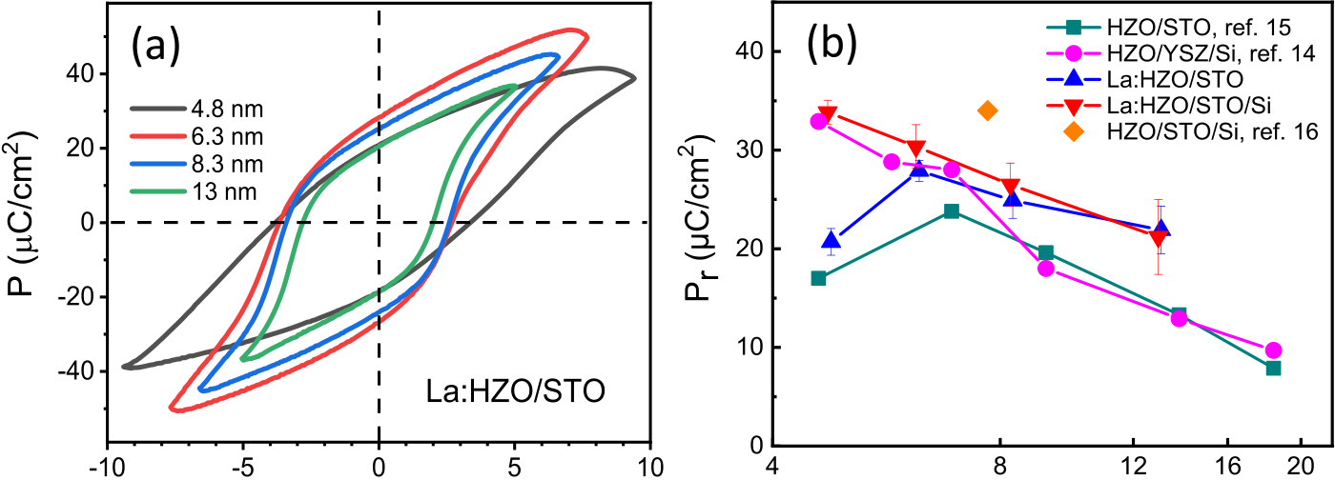

 

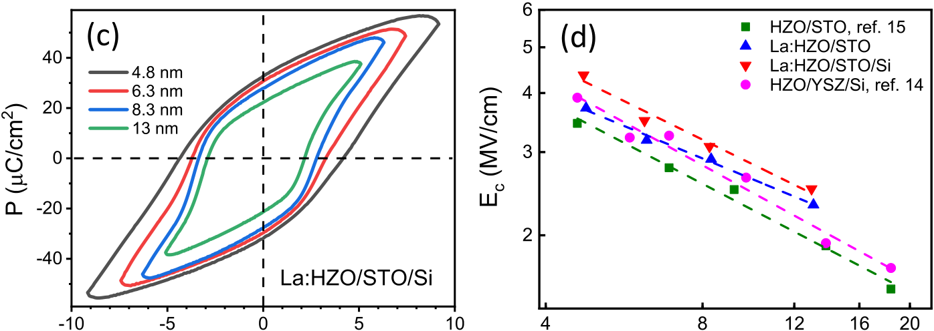

 

Figure 3. Polarization loops of La:HZO films on STO(001) (a) and Si(001) (c). Dependence of remanent polarization (b) and coercive field (d) on thickness for La:HZO films on STO(001) (blue up triangles) and Si(001) (red down triangles). Data reported for epitaxial undoped HZO films on STO(001) (green squares) and YSZ-buffered Si(001) (pink circles) are included. The error bar on remanent polarization corresponds to the standard deviation among around 10 different measured capacitors.

twofold: it can add to switching current and polarization can be overestimated, but in contrast, it does not allow full saturation of the loop, and therefore, the polarization is underestimated. Polarization loops measured at increasing voltage ([Supporting Information S6](http://pubs.acs.org/doi/suppl/10.1021/acsaelm.0c00560/suppl_file/el0c00560_si_001.pdf)) confirm that leakage is less prominent while increasing thickness and the loops are saturated for high-applied voltage. In addition, residual leakage subtraction performed using reported equations32shows that its contribution is 2 μC/cm2, which is taken as a sensitivity limit ([Supporting Information S7](http://pubs.acs.org/doi/suppl/10.1021/acsaelm.0c00560/suppl_file/el0c00560_si_001.pdf)). Remanent polarization is represented in Figure 3b (blue solid up triangles) as a function of thickness. Pr is ∼20 μC/cm2in the thinner film, t = 4.8 nm, increases to ∼28 μC/cm2in the t = 6.2 nm film, and, for thicker films, reduces with a thickness of up to ∼21 μC/cm2in the t = 13 nm film. Figure 3b includes Pr values (green squares) of equivalent epitaxial undoped HZO films on STO(001)15Both series show the same dependence on thickness, with a maximum polarization for films thinner than 10 nm, and La-doped films have slightly higher Pr than undoped films. Both series show the same dependence on thickness, with a maximum polarization for films thinner than 10 nm, and La-doped films have higher Pr than undoped films. The polarization loops of the films on Si(001) are presented in Figure 3c. Loops corresponding to thinner films are not saturated because of leakage (see measurements at varying maximum voltage in [Supporting Information S8](http://pubs.acs.org/doi/suppl/10.1021/acsaelm.0c00560/suppl_file/el0c00560_si_001.pdf)). Remanent polarization Pr decreases monotonically with thickness (solid red down triangles in Figure 3b) from >30 to 21 μC/cm2. Similar high Pr in t < 10 nm films was reported for undoped HZO films integrated epitaxially on Si(001) using yttria-stabilized zirconia (YSZ) buffer layers (pink open circles in

3224 [https://dx.doi.org/10.1021/acsaelm.0c00560](https://dx.doi.org/10.1021/acsaelm.0c00560?ref=pdf)

|  |  |  |
| --- | --- | --- |
| ACS Applied Electronic Materials | pubs.acs.org/acsaelm | Article |

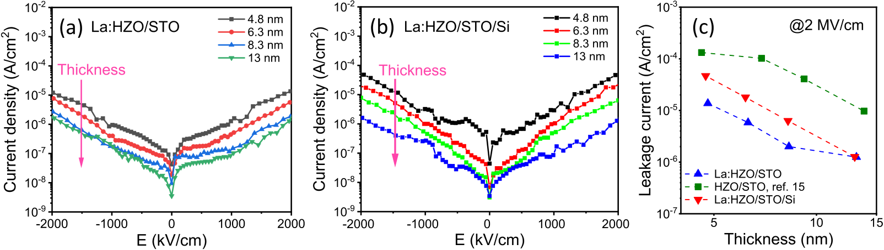

Figure 4. Leakage current of La:HZO films on (a) STO(001) and (b) Si(001). (c) Dependence of leakage current on thickness for La:HZO films on STO(001) (blue up triangles) and Si(001) (red down triangles). Reported data for epitaxial undoped HZO films on STO(001) (green squares)

are included.

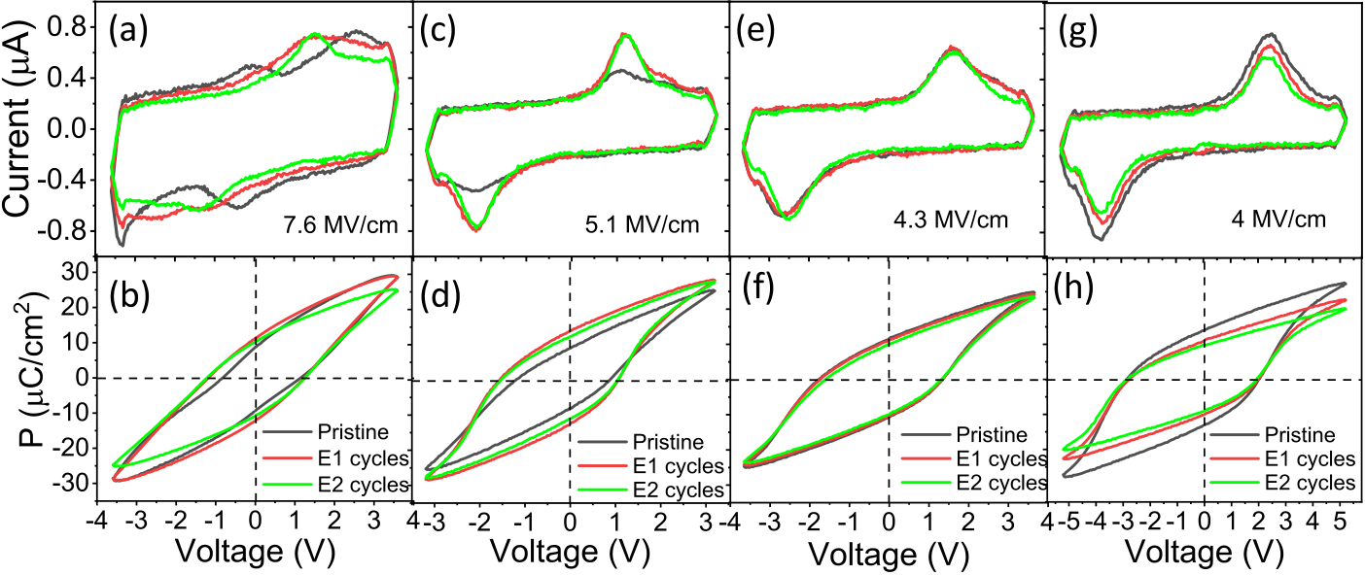

Figure 5. (a) Current−voltage (I−V) curves measured in the pristine state and after 10 and 100 cycles and (b) the corresponding polarization−voltage (P−V) loops for the t = 4.8 nm film on STO(001). I−V curves and P−V loops for the t = 6.3, 8.3, and 13 nm films are shown in panels

(c,d), (e,f), and (g,h), respectively.

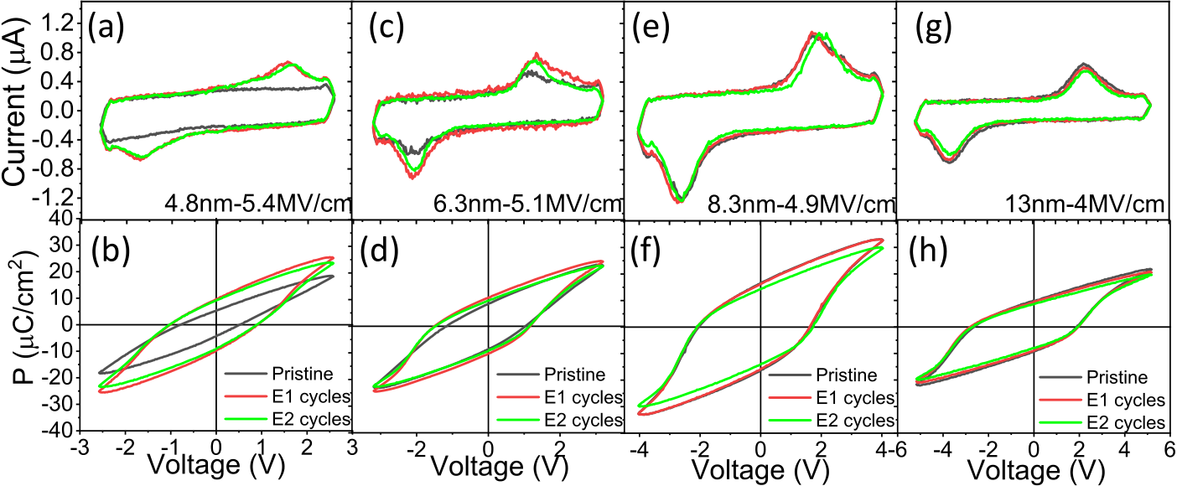

Figure 6. (a) Current−voltage (I−V) curves measured in the pristine state and after 10 and 100 cycles and (b) the corresponding polarization−voltage (P−V) loops for the t = 4.8 nm film on Si(001). I−V curves and P−V loops for the t = 6.3, 8.3, and 13 nm films are shown in panels (c,d),

(e,f), and (g,h), respectively.

reduction of Ec by approximately 30% in polycrystalline HZO films doped with the same 1% mol La content.5,6Although the cause of Ec reduction in polycrystalline La-doped films is unknown, the possible presence of the tetragonal phase was suggested,6but this phase apparently is not present in the epitaxial films on LSMO(001) electrodes.

Leakage current curves for La-doped HZO films on

STO(001) are shown in Figure 4a. Leakage is low, even in the sub-5 nm film, which is around 10−6A/cm2at 1 MV/cm and 10−5A/cm2at 2 MV/cm. Leakage decreases with film thickness, and the values in the t = 13 nm film are about 1 order of magnitude less than those in the t = 4.8 nm film. Films

3225 [https://dx.doi.org/10.1021/acsaelm.0c00560](https://dx.doi.org/10.1021/acsaelm.0c00560?ref=pdf)

|  |  |  |
| --- | --- | --- |
| ACS Applied Electronic Materials | pubs.acs.org/acsaelm | Article |

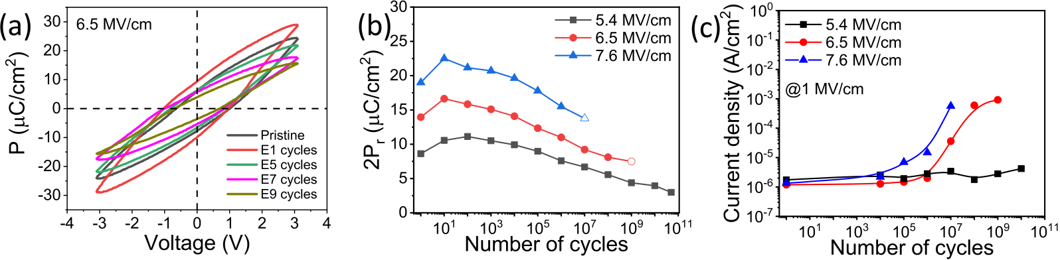

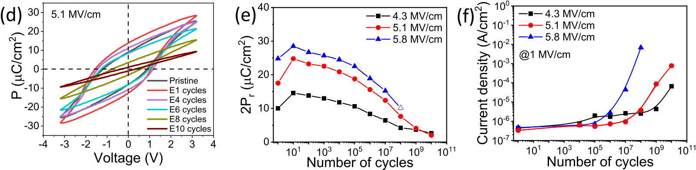

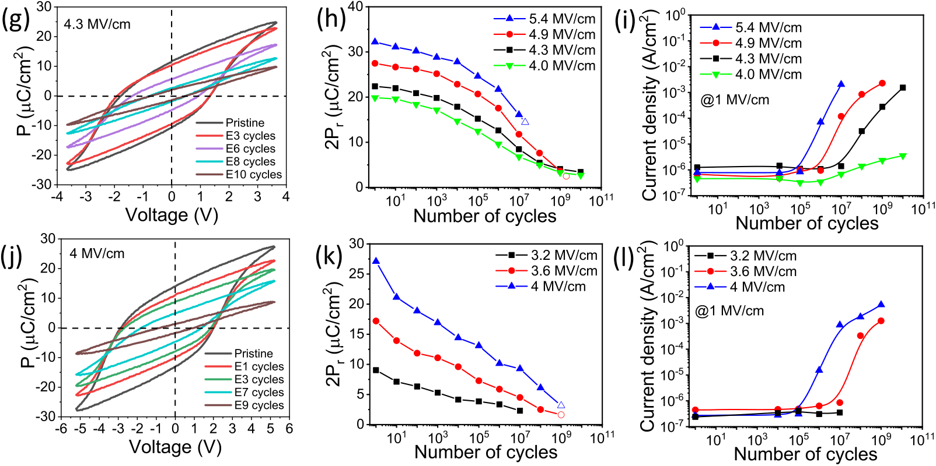

Figure 7. (a) Polarization−voltage P−V loops, (b) endurance, and (c) evolution of current leakage with the number of cycles for the t = 4.8 nm film on STO(001). The P−V loops, endurance, and evolution of current leakage with the number of cycles corresponding to the t = 6.3 nm, 8.3 nm, and 13 nm films are shown in panels (d−f), (g−i), and (j−l), respectively. Empty symbols indicate the last measured data point before breakdown.

Figure 5 shows the current−voltage (I−V) curves and the polarization loops of the films on STO(001), in the pristine state and measured after 10 and 100 cycles. The t = 4.8 nm film shows a double peak in the I−V curve (Figure 5a) and a pinched polarization loop (Figure 5b) in the pristine state. The two peaks get closer after 10 cycles, and after 100 cycles, they merge into a single narrower peak, and the corresponding polarization loop is not pinched. In the t = 6.3 nm film (Figure 5c), the two peaks are closer in the pristine state, and after 10 pulses, only a small secondary peak on the positive axis is distinguished at a higher voltage than the main peak. With more cycles, the amplitude of the main peak has not changed, while the second peak has disappeared. The corresponding ferroelectric loops (Figure 5d) show a significant increase in polarization with respect to the pristine state. In contrast, no differences in the I−V curves were observed between the pristine state and the 10 times cycled t = 8.3 nm film (Figure 5e). There is a single peak that features a shoulder on the higher voltage side. The switching peak has a similar amplitude after 100 cycles, but without a shoulder. Consistent with this, the polarization loops (Figure 5f) show no significant differences, and there is only a very slight reduction in

3226 [https://dx.doi.org/10.1021/acsaelm.0c00560](https://dx.doi.org/10.1021/acsaelm.0c00560?ref=pdf)

|  |  |  |
| --- | --- | --- |
| ACS Applied Electronic Materials | pubs.acs.org/acsaelm | Article |

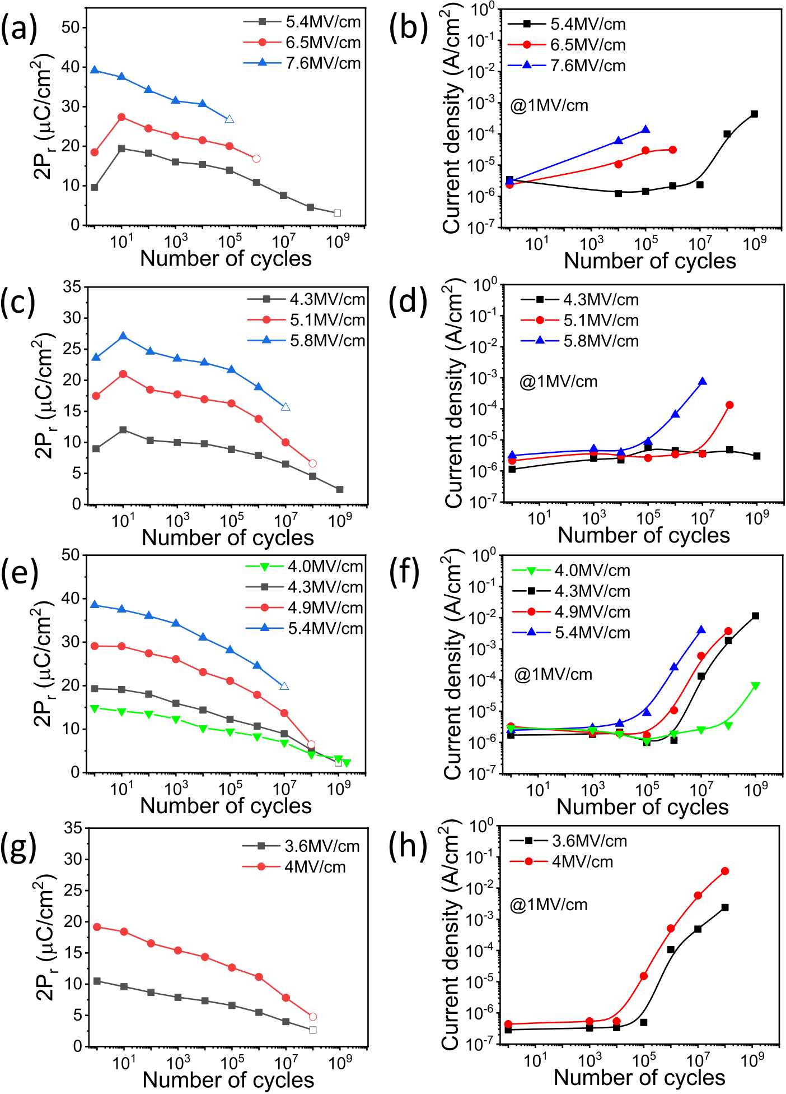

Figure 8. (a) Endurance and (b) variation of current leakage measured at 1 MV/cm with the number of cycles for the t = 4.8 nm film on Si(001). The endurance and variation of current leakage with the number of cycles corresponding to the t = 6.3 nm, 8.3 nm, and 13 nm films are shown in panels (c,d), (e,f), and (g,h), respectively.

Next, we investigate the endurance of the films. The capacitors were cycled, up to a maximum number of 5 × 1010 cycles or until breakdown (denoted by empty symbols) or until a fatigued state with remanent polarization reduced to below 1.5 μC/cm2. A set of endurance measurements was carried out for each sample by cycling the capacitors with pulses of different amplitudes. Figure 7a presents the polarization loops of the t = 4.8 nm film on STO(001), measured at 6.5 MV/cm. The initial polarization increases after 10 cycles because of the wake-up effect discussed above, and additional cycling progressively reduces the polarization. 2Pr is plotted against the number of cycles in Figure 7b (red circles). The maximum 2Pr = 16.6 μC/cm2after 10 cycles decreases to 7.5 μC/cm2after 109cycles, before the capacitor breaks.

3227 [https://dx.doi.org/10.1021/acsaelm.0c00560](https://dx.doi.org/10.1021/acsaelm.0c00560?ref=pdf)

|  |  |  |
| --- | --- | --- |
| ACS Applied Electronic Materials | pubs.acs.org/acsaelm | Article |

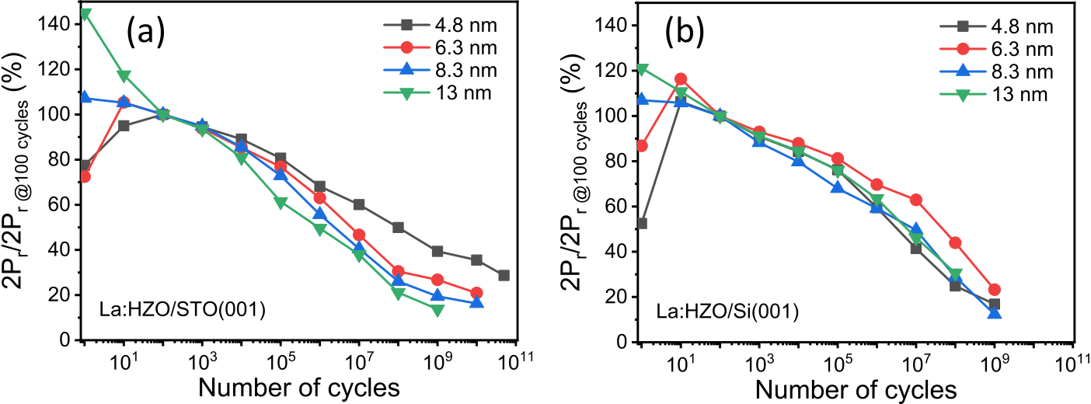

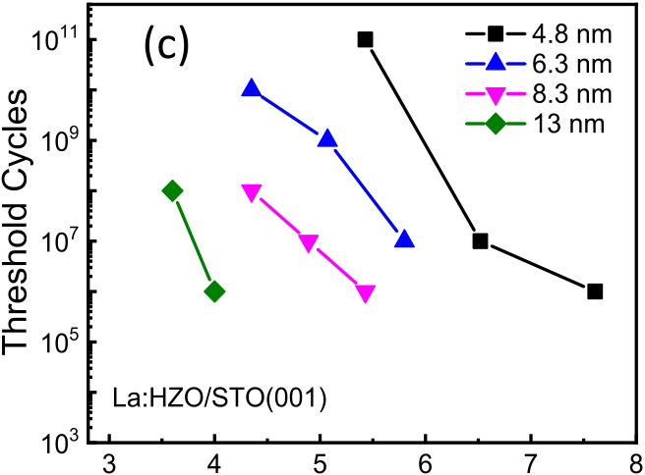

 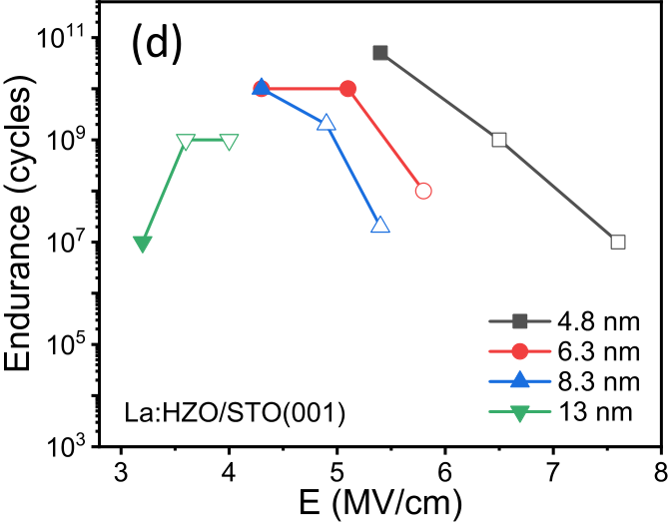

Figure 9. Endurance data normalized to 2Pr at 100 cycles of films on (a) STO(001) and (b) Si(001). (c) Map of the threshold of the number of cycles for an abrupt leakage increase as a function of electric field and thickness of films on STO(001). (d) Map of endurance as a function of electric field and thickness of films on STO(001). Empty symbols denote breakdown.

wake-up effect is more persistent under these conditions, while

there is no wake-up for high enough poling voltage. This is in agreement with the improved oxygen diffusion and the reduction of the wake-up effect in polycrystalline HfO2-based films with increasing amplitude35or applied field duration.36,37 The polarization loops (Figure 7d) of the t = 6.3 nm film, measured at 5.1 MV/cm, show the wake-up effect during some cycles, and the maximum 2Pr = 24.8 μC/cm2after 10 cycles is reduced with more cycles to 2Pr = 2 μC/cm2after 1010cycles. Endurance is similar for a switching field of 4.3 MV/cm (Figure 7e). By increasing the field to 5.8 MV/cm, the initial polarization increases, but hard breakdown occurs after 107 cycles. Thicker films do not show wake-up, and polarization

decreases continuously with cycling. Hard breakdown takes place in the t = 8.3 nm film (Figure 7g,h) after 2 × 107cycles at 5.4 MV/cm or 2 × 109cycles at 4.9 MV/cm. Breakdown did not occur using a lower switching field of 4.3 or 4.0 MV/cm, but 2Pr decreased to 3.4 μC/cm2after 1010cycles. Finally, the t = 13 nm film (Figure 7j,k) shows breakdown after 109cycles at 4.0 or 3.6 MV/cm, while for a lower applied field of 3.2 MV/ cm, the polarization decreased to 2Pr = 2.3 μC/cm2after 107 cycles. Similar strong robustness against breakdown when the switching field is reduced was reported for polycrystalline doped HfO2 films.38Breakdown in epitaxial films, however, occurs at much higher fields than in polycrystalline films. The endurance measurements of the La:HZO films on Si(001) are summarized in Figure 8. The influence of the switching voltage on endurance follows the observed dependences of the films on STO(001), although the maximum endurance of films on Si is limited to around 109cycles.

Figure 7 shows that La:HZO films on STO(001) suffer from

fatigue at all switching voltages, and similar behavior is observed in films on Si(001) (Figure 8). We have investigated

3228 [https://dx.doi.org/10.1021/acsaelm.0c00560](https://dx.doi.org/10.1021/acsaelm.0c00560?ref=pdf)

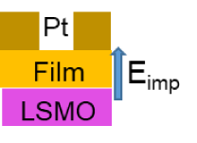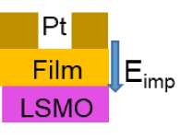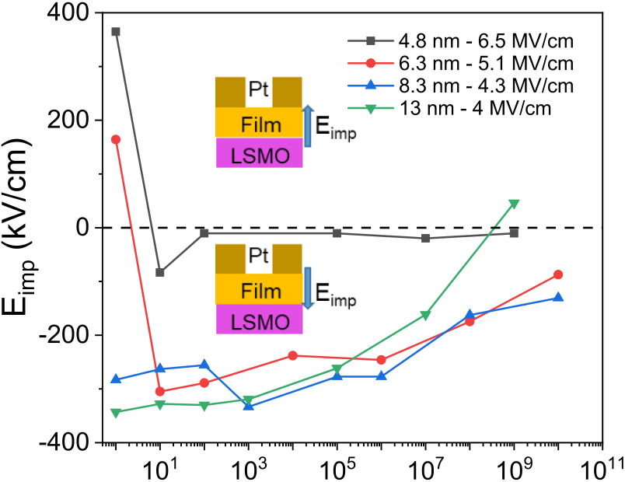

|  |  |  |
| --- | --- | --- |
| ACS Applied Electronic Materials | pubs.acs.org/acsaelm | Article |

accumulate at the boundaries between the grains and the crystal variants. The observed threshold in the number of cycles suggests that the new defects only have an impact on the leakage when their density is high enough to allow percolation. The threshold occurs in each sample at a lower number of cycles as the switching voltage is higher (Figure 9c). Moreover, the leakage current increases after fewer cycles with a similar electric field as the film becomes thicker. On the other hand, the dependence of 2Pr on the number of cycles, in Figure 7, shows that hard breakdown (marked with empty symbols) occurs after fewer cycles and a smaller switching electric field as the films becomes thicker. This is evidenced in Figure 9d, where the endurance of the four films is plotted as a function of the switching field. A similar thickness dependence had been observed in polycrystalline HZO films,44although breakdown fields in epitaxial films are much higher. In epitaxial La:HZO films, endurance was limited by hard breakdown (open symbols), in most tested capacitors. However, in capacitors switched with a low electric field, the low polarization of fatigued capacitors (solid symbols) limits endurance.

Polarization loops generally show different Ec on the negative and positive axes. The imprint field (Eimp) of the films on STO(001) is represented as a function of the number of cycles in Figure 10. The dependences indicate that Eimp is



Figure 10. Variation of the imprint field (Eimp) with the number of cycles for the films on STO(001).

not only caused by the different work functions of the Pt and LSMO electrodes. An inhomogeneous distribution of oxygen vacancies can create an internal field that would increase the Schottky barrier height at one interface and decrease it at the other. The loops of the two thickest films (t = 8.3 nm and 13 nm) are displaced toward the negative axis of the electric field, with the Eimp directed from the upper Pt toward the lower LSMO electrode. The Eimp, around 300 kV/cm, decreases with the number of cycles, up to 130 kV/cm in the t = 8.3 nm film (blue up triangles) and up to negligible imprint in the t = 13 nm film (green down triangles). The behavior clearly differs in the two thinnest films, in which the Eimp in the pristine state is directed from the lower LSMO toward the upper Pt electrode, its magnitude being close to 400 and 200 kV/cm in t = 4.8 and 6.3 nm films, respectively. After 10 cycles, the Eimp reverses its direction. In the t = 6.3 nm film (red circles), Ei ∼ 300 kV/cm decreases to less than 100 kV/cm after 1010cycles, while in the t = 4.8 nm film, (black squares) the smallest Ei ∼ 80 kV/cm quickly decreases to almost vanish during additional cycling.

3229 [https://dx.doi.org/10.1021/acsaelm.0c00560](https://dx.doi.org/10.1021/acsaelm.0c00560?ref=pdf)

|  |  |  |
| --- | --- | --- |
| ACS Applied Electronic Materials | pubs.acs.org/acsaelm | Article |

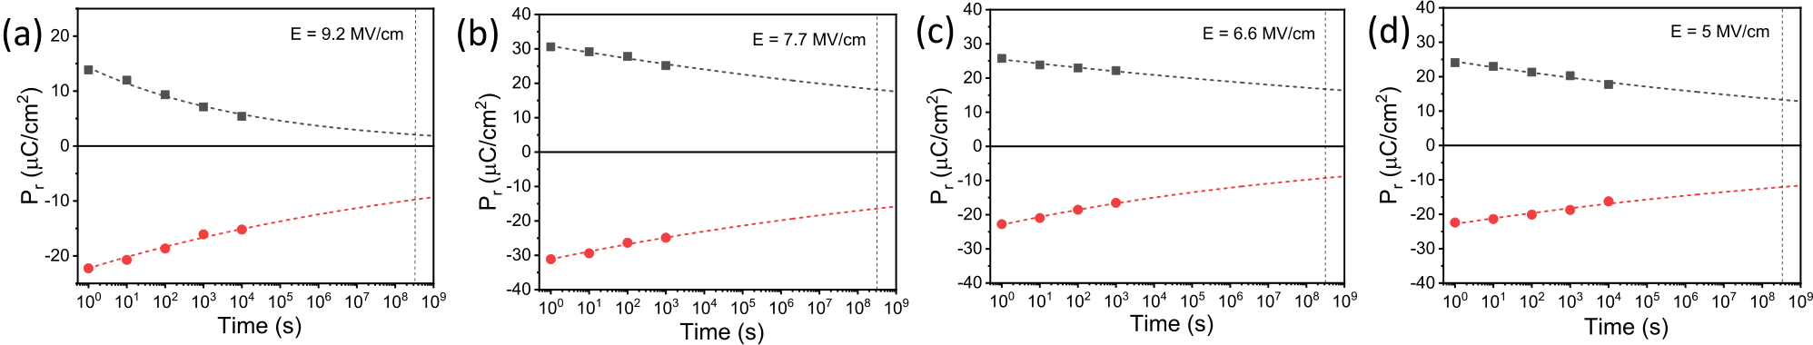

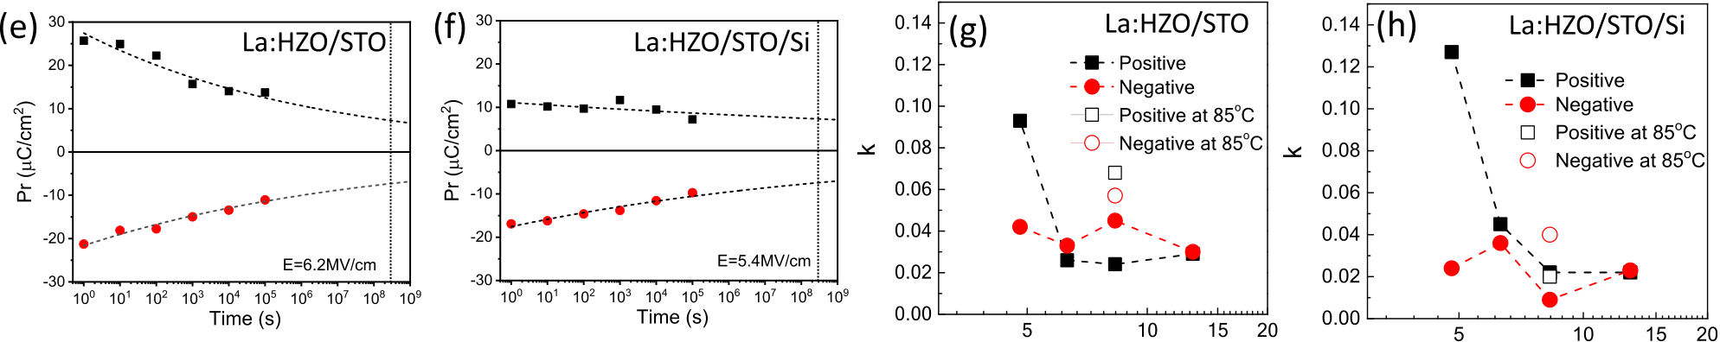

|  |  |  |  |  |  |
| --- | --- | --- | --- | --- | --- |
|  | |  | | | |
| Figure 11. Polarization retention at room temperature of (a) t = 4.8 m, (b) t = 6.3 nm, (c) t = 8.3 nm, and (d) t = 13 nm films on STO(001). Polarization retention at 85 °C of films with t = 8.3 nm on (e) STO(001) and (f) Si(001). Lines are fits to the Pr = P0 td−k equation for positive and  negative poling. The vertical dashed lines mark a time of 10 years. The k parameter plotted for positive and negative poling as a function of thickness for films on (g) STO(001) and (h) Si(001).  under the same poling voltage ([Supporting Information S11](http://pubs.acs.org/doi/suppl/10.1021/acsaelm.0c00560/suppl_file/el0c00560_si_001.pdf)). ■AUTHOR INFORMATION  A poling voltage of around 3 V can allow the use of the Corresponding Authors  capacitors in a ferroelectric random access memory.52 Ignasi Fina − Institut de Ciència de Materials de Barcelona (ICMAB-CSIC), 08193 Barcelona, Spain; Email: [if](mailto:ifina@icmab.es)i[na@](mailto:ifina@icmab.es) 4. CONCLUSIONS [icmab.es](mailto:ifina@icmab.es)  In conclusion, orthorhombic La-doped HZO films have been Florencio Sánchez − Institut de Ciència de Materials de  epitaxially grown on STO(001) and Si(001) substrates, and  Barcelona (ICMAB-CSIC), 08193 Barcelona, Spain;  [orcid.org/0000-0002-5314-453X](http://orcid.org/0000-0002-5314-453X); Email: [fsanchez@](mailto:fsanchez@icmab.es) their main ferroelectric properties (polarization, endurance, [icmab.es](mailto:fsanchez@icmab.es)  and retention) have been determined. Doping does not reduce | | | | | |
| the Ec of HZO epitaxial films, but the leakage current is substantially reduced. Ferroelectric polarization, particularly in films over 10 nm thick, is greater than that of undoped films. The wake-up effect, a serious drawback in polycrystalline La-doped films, is limited to approximately 100 cycles in epitaxial films and only occurs in thinner films. The films exhibit fatigue, but endurance exceeds 1010cycles, and the films simulta-  neously exhibit very high retention for more than 10 years. | Authors   Tingfeng Song − Institut de Ciència de Materials de Barcelona (ICMAB-CSIC), 08193 Barcelona, Spain   Romain Bachelet − Institut des Nanotechnologies de Lyon (INL-CNRS UMR 5270), Université de Lyon, Ecole Centrale | | | | |
| de Lyon, 69134 Ecully, France; |  | [orcid.org/0000-0002-2910-](http://orcid.org/0000-0002-2910-0449) | | |
| [0449](http://orcid.org/0000-0002-2910-0449)  Guillaume Saint-Girons − Institut des Nanotechnologies de  Lyon (INL-CNRS UMR 5270), Université de Lyon, Ecole | | | | |
| This demonstrates that there is no intrinsic dilemma between | Centrale de Lyon, 69134 Ecully, France; | | |  | [orcid.org/0000-](http://orcid.org/0000-0002-3669-3406) |
| endurance and retention in La-doped HZO films.■ASSOCIATED CONTENT  * sı Supporting Information  The Supporting Information is available free of charge at | [0002-3669-3406](http://orcid.org/0000-0002-3669-3406)  Raul Solanas [−](http://orcid.org/0000-0002-3669-3406) Institut de Ciència de Materials de Barcelona (ICMAB-CSIC), 08193 Barcelona, Spain  Complete contact information is available at: [https://pubs.acs.org/10.1021/acsaelm.0c00560](https://pubs.acs.org/doi/10.1021/acsaelm.0c00560?ref=pdf) | | | | |
| [https://pubs.acs.org/doi/10.1021/acsaelm.0c00560](https://pubs.acs.org/doi/10.1021/acsaelm.0c00560?goto=supporting-info). | Author Contributions | | | | |

Simulation of Laue oscillations; XRD pole figures and

2θ-χ frames; topographic AFM images and height profiles; polarization loops measured at increasing voltage of films on STO(001) and Si(001); determi-

nation of residual leakage contribution to the polar-ization loops; influence of the cycling voltage on fatigue of films on STO(001) and Si(001); polarization retention of the films on Si(001); and polarization retention of films on STO(001) poled at a varying field

([PDF](http://pubs.acs.org/doi/suppl/10.1021/acsaelm.0c00560/suppl_file/el0c00560_si_001.pdf))

3230 [https://dx.doi.org/10.1021/acsaelm.0c00560](https://dx.doi.org/10.1021/acsaelm.0c00560?ref=pdf)

|  |  |  |
| --- | --- | --- |
| ACS Applied Electronic Materials | pubs.acs.org/acsaelm | Article |

(2017 SGR 1377). China Scholarship Council (CSC), grant no. 201807000104.

Notes   
The authors declare no competing financial interest.

■ACKNOWLEDGMENTS   
Financial support from the Spanish Ministerio de Ciencia e Innovación, through the “Severo Ochoa” Programme for Centres of Excellence in R&D (SEV-2015-0496) and the MAT2017-85232-R (AEI/FEDER, EU), PID2019-107727RB-I00 (AEI/FEDER, EU), and MAT2015-73839-JIN projects, and from Generalitat de Catalunya (2017 SGR 1377) is acknowledged. I.F. acknowledges Ramón y Cajal contract RYC-2017-22531. T.S. is financially supported by China Scholarship Council (CSC) with no. 201807000104. T.S. work has been carried out as a part of his Ph.D. program in Materials Science at Universitat Autònoma de Barcelona.

■REFERENCES   
(1) Böscke, T. S.; Müller, J.; Bräuhaus, D.; Schröder, U.; Böttger, U. [Ferroelectricity in Hafnium Oxide Thin Films.](https://dx.doi.org/10.1063/1.3634052) Appl. Phys. Lett. 2011, 99, 102903.

(2) Park, M. H.; Lee, Y. H.; Kim, H. J.; Kim, Y. J.; Moon, T.; Kim, K. D.; Müller, J.; Kersch, A.; Schroeder, U.; Mikolajick, T.; Hwang, C. S. [Ferroelectricity and Antiferroelectricity of Doped Thin HfO2-Based Films.](https://dx.doi.org/10.1002/adma.201404531) Adv. Mater. 2015, 27, 1811[−](https://dx.doi.org/10.1002/adma.201404531)1831.

(3) Mikolajick, T.; Slesazeck, S.; Park, M. H.; Schroeder, U. [Ferroelectric Hafnium Oxide for Ferroelectric Random-Access Memories and Ferroelectric Field-Effect Transistors.](https://dx.doi.org/10.1557/mrs.2018.92) MRS Bull. 2018, 43, 340[−](https://dx.doi.org/10.1557/mrs.2018.92)346.

(4) Park, M. H.; Lee, Y. H.; Mikolajick, T.; Schroeder, U.; Hwang, C. S. [Review and Perspective on Ferroelectric HfO2-Based Thin Films for Memory Applications.](https://dx.doi.org/10.1557/mrc.2018.175) MRS Commun. 2018, 8, 795[−](https://dx.doi.org/10.1557/mrc.2018.175)808.

(5) Chernikova, A. G.; Kozodaev, M. G.; Negrov, D. V.; Korostylev, E. V.; Park, M. H.; Schroeder, U.; Hwang, C. S.; Markeev, A. M. [Improved Ferroelectric Switching Endurance of La-Doped Hf0.5Zr0.5O2 Thin Films.](https://dx.doi.org/10.1021/acsami.7b15110) ACS Appl. Mater. Interfaces 2018, 10, 2701[−](https://dx.doi.org/10.1021/acsami.7b15110)2708.

(6) Kozodaev, M. G.; Chernikova, A. G.; Korostylev, E. V.; Park, M. H.; Khakimov, R. R.; Hwang, C. S.; Markeev, A. M. [Mitigating Wakeup Effect and Improving Endurance of Ferroelectric HfO2-ZrO2 Thin Films by Careful La-Doping. J. Appl. Phys. 2019, 125, 034101.](https://dx.doi.org/10.1063/1.5050700) (7) Mehmood, F.; Hoffmann, M.; Lomenzo, P. D.; Richter, C.; Materano, M.; Mikolajick, T.; Schroeder, U. [Bulk Depolarization Fields as a Major Contributor to the Ferroelectric Reliability Performance in Lanthanum Doped Hf0.5Zr0.5O2 Capacitors.](https://dx.doi.org/10.1002/admi.201901180) Adv. Mater. Interfaces 2019, 6, 1901180.

(8) Katayama, K.; Shimizu, T.; Sakata, O.; Shiraishi, T.; Nakamura, S.; Kiguchi, T.; Akama, A.; Konno, T. J.; Uchida, H.; Funakubo, H. [Growth of (111)-Oriented Epitaxial and Textured Ferroelectric Y-Doped HfO2 Films for Downscaled Devices.](https://dx.doi.org/10.1063/1.4962431) Appl. Phys. Lett. 2016, 109, 112901.

(9) Mimura, T.; Shimizu, T.; Uchida, H.; Sakata, O.; Funakubo, H. [Thickness-Dependent Crystal Structure and Electric Properties of Epitaxial Ferroelectric Y2O3-HfO2 Films.](https://dx.doi.org/10.1063/1.5040018) Appl. Phys. Lett. 2018, 113, 102901.

(10) Lyu, J.; Fina, I.; Solanas, R.; Fontcuberta, J.; Sánchez, F. [Robust Ferroelectricity in Epitaxial Hf1/2Zr1/2O2 Thin Films.](https://dx.doi.org/10.1063/1.5041715) Appl. Phys. Lett. 2018, 113, 082902.

(11) Li, T.; Zhang, N.; Sun, Z.; Xie, C.; Ye, M.; Mazumdar, S.; Shu, L.; Wang, Y.; Wang, D.; Chen, L.; Ke, S.; Huang, H. [Epitaxial Ferroelectric Hf0.5Zr0.5O2](https://dx.doi.org/10.1039/c8tc02941e) [Thin Film on a Buffered YSZ Substrate through Interface Reaction.](https://dx.doi.org/10.1039/c8tc02941e) J. Mater. Chem. C 2018, 6, 9224[−](https://dx.doi.org/10.1039/c8tc02941e)9231. (12) Yoong, H. Y.; Wu, H.; Zhao, J.; Wang, H.; Guo, R.; Xiao, J.; Zhang, B.; Yang, P.; Pennycook, S. J.; Deng, N.; Yan, X.; Chen, J. [Epitaxial Ferroelectric Hf0.5Zr0.5O2 Thin Films and Their Implemen-](https://dx.doi.org/10.1002/adfm.201806037)

3231 [https://dx.doi.org/10.1021/acsaelm.0c00560](https://dx.doi.org/10.1021/acsaelm.0c00560?ref=pdf)

|  |  |  |
| --- | --- | --- |
| ACS Applied Electronic Materials | pubs.acs.org/acsaelm | Article |

(29) Sánchez, F.; Ocal, C.; Fontcuberta, J. [Tailored Surfaces of Perovskite Oxide Substrates for Conducted Growth of Thin Films.](https://dx.doi.org/10.1039/c3cs60434a) Chem. Soc. Rev. 2014, 43, 2272[−](https://dx.doi.org/10.1039/c3cs60434a)2285.

(30) Meyer, R.; Waser, R.; Prume, K.; Schmitz, T.; Tiedke, S. [Dynamic Leakage Current Compensation in Ferroelectric Thin-Film Capacitor Structures.](https://dx.doi.org/10.1063/1.1897425) Appl. Phys. Lett. 2005, 86, 142907.

(31) Fina, I.; Fàbrega, L.; Langenberg, E.; Martí, X.; Sánchez, F.; Varela, M.; Fontcuberta, J. [Nonferroelectric Contributions to the Hysteresis Cycles in Manganite Thin Films: A Comparative Study of Measurement Techniques.](https://dx.doi.org/10.1063/1.3555098) J. Appl. Phys. 2011, 109, 074105.

(32) González-Casal, S.; Fina, I.; Sánchez, F.; Fontcuberta, J. [Direct Reversible Magnetoelectric Coupling in a Ferroelectric/Ferromag-netic Structure Controlled by Series Resistance Engineering.](https://dx.doi.org/10.1021/acsaelm.9b00427) ACS Appl. Electron. Mater. 2019, 1, 1937[−](https://dx.doi.org/10.1021/acsaelm.9b00427)1944.

(33) Dawber, M.; Chandra, P.; Littlewood, P. B.; Scott, J. F. [Depolarization Corrections to the Coercive Field in Thin-Film Ferroelectrics.](https://dx.doi.org/10.1088/0953-8984/15/24/106) J. Phys.: Condens. Matter 2003, 15, L393.

(34) Migita, S.; Ota, H.; Yamada, H.; Shibuya, K.; Sawa, A.; Toriumi, A. [Polarization Switching Behavior of Hf−Zr−O Ferro-electric Ultrathin Films Studied through Coercive Field Character-istics.](https://dx.doi.org/10.7567/jjap.57.04fb01) Jpn. J. Appl. Phys. 2018, 57, 04FB01.

(35) Fengler, F. P. G.; Nigon, R.; Muralt, P.; Grimley, E. D.; Sang, X.; Sessi, V.; Hentschel, R.; LeBeau, J. M.; Mikolajick, T.; Schroeder, U. [Analysis of Performance Instabilities of Hafnia-Based Ferroelectrics Using Modulus Spectroscopy and Thermally Stimulated Depolariza-tion Currents.](https://dx.doi.org/10.1002/aelm.201700547) Adv. Electron. Mater. 2018, 4, 1700547.

(36) Starschich, S.; Menzel, S.; Böttger, U. [Evidence for Oxygen Vacancies Movement During Wake-up in Ferroelectric Hafnium Oxide.](https://dx.doi.org/10.1063/1.4940370) Appl. Phys. Lett. 2016, 108, 032903.

(37) Starschich, S.; Menzel, S.; Böttger, U. [Pulse Wake-up and Breakdown Investigation of Ferroelectric Yttrium Doped HfO2.](https://dx.doi.org/10.1063/1.4981893) J. Appl. Phys. 2017, 121, 154102.

(38) Schroeder, U.; Mueller, S.; Mueller, J.; Yurchuk, E.; Martin, D.; Adelmann, C.; Schloesser, T.; van Bentum, R.; Mikolajick, T. [Hafnium Oxide Based Cmos Compatible Ferroelectric Materials.](https://dx.doi.org/10.1149/2.010304jss) ECS J. Solid State Sci. Technol. 2013, 2, N69[−](https://dx.doi.org/10.1149/2.010304jss)N72.

(39) Pawlaczyk, C.; Tagantsev, A. K.; Brooks, K.; Reaney, I. M.; Klissurska, R.; Setter, N. [Fatigue, Rejuvenation and Self-Restoring in Ferroelectric Thin Films.](https://dx.doi.org/10.1080/10584589508012569) Integr. Ferroelectr. 1995, 9, 293[−](https://dx.doi.org/10.1080/10584589508012569)316. (40) Colla, E. L.; Tagantsev, A. K.; Kholkin, A. L.; Setter, N. [Dc-Voltage and Cycling Induced Recovery of Switched Polarisation in Fatigued Ferroelectric Thin Films.](https://dx.doi.org/10.1080/10584589508012285) Integr. Ferroelectr. 1995, 10, 289[−](https://dx.doi.org/10.1080/10584589508012285)294.

(41) Tagantsev, A. K.; Stolichnov, I.; Colla, E. L.; Setter, N. [Polarization Fatigue in Ferroelectric Films: Basic Experimental Findings, Phenomenological Scenarios, and Microscopic Features.](https://dx.doi.org/10.1063/1.1381542) J. Appl. Phys. 2001, 90, 1387[−](https://dx.doi.org/10.1063/1.1381542)1402.

(42) Huang, F.; Chen, X.; Liang, X.; Qin, J.; Zhang, Y.; Huang, T.; Wang, Z.; Peng, B.; Zhou, P.; Lu, H.; Zhang, L.; Deng, L.; Liu, M.; Liu, Q.; Tian, H.; Bi, L. [Fatigue Mechanism of Yttrium-Doped Hafnium Oxide Ferroelectric Thin Films Fabricated by Pulsed Laser Deposition.](https://dx.doi.org/10.1039/c6cp07501k) Phys. Chem. Chem. Phys. 2017, 19, 3486[−](https://dx.doi.org/10.1039/c6cp07501k)3497.

(43) Liu, X.; Zhou, D.; Guan, Y.; Li, S.; Cao, F.; Dong, X. [Endurance](https://dx.doi.org/10.1016/j.actamat.2018.05.033)

(47) Yu, P.; Chu, Y.-H.; Ramesh, R. [Oxide Interfaces: Pathways to Novel Phenomena.](https://dx.doi.org/10.1016/s1369-7021(12)70137-2) Mater. Today 2012, 15, 320[−](https://dx.doi.org/10.1016/s1369-7021(12)70137-2)327.

(48) Kim, Y.-M.; Morozovska, A.; Eliseev, E.; Oxley, M. P.; Mishra, R.; Selbach, S. M.; Grande, T.; Pantelides, S. T.; Kalinin, S. V.; Borisevich, A. Y. [Direct Observation of Ferroelectric Field Effect And vacancy-Controlled Screening at the BiFeO3/LaxSr1‑xMnO3 Interface.](https://dx.doi.org/10.1038/nmat4058) Nat. Mater. 2014, 13, 1019[−](https://dx.doi.org/10.1038/nmat4058)1025.

(49) Tian, B. B.; Liu, Y.; Chen, L. F.; Wang, J. L.; Sun, S.; Shen, H.; Sun, J. L.; Yuan, G. L.; Fusil, S.; Garcia, V. [Space-Charge Effect on Electroresistance in Metal-Ferroelectric-Metal Capacitors.](https://dx.doi.org/10.1038/srep18297) Sci. Rep. 2015, 5, 18297.

(50) Kim, D.; Jo, J.; Kim, Y.; Chang, Y.; Lee, J.; Yoon, J.-G.; Song, T.; Noh, T. [Polarization Relaxation Induced by a Depolarization Field in Ultrathin Ferroelectric BaTiO3 Capacitors.](https://dx.doi.org/10.1103/physrevlett.95.237602) Phys. Rev. Lett. 2005, 95, 237602.

(51) Jo, J.; Kim, D.; Kim, Y.; Choe, S.-B.; Song, T.; Yoon, J.-G.; Noh, T. [Polarization Switching Dynamics Governed by the Thermody-namic Nucleation Process in Ultrathin Ferroelectric Films.](https://dx.doi.org/10.1103/physrevlett.97.247602) Phys. Rev. Lett. 2006, 97, 247602.

(52) Eshita, T.; Wang, W.; Nomura, K.; Nakamura, K.; Saito, H.; Yamaguchi, H.; Mihara, S.; Hikosaka, Y.; Kataoka, Y.; Kojima, M. [Development of Highly Reliable Ferroelectric Random Access Memory and Its Internet of Things Applications.](https://dx.doi.org/10.7567/jjap.57.11ua01) Jpn. J. Appl. Phys. 2018, 57, 11UA01.

[Properties of Silicon-Doped Hafnium Oxide Ferroelectric and](https://dx.doi.org/10.1016/j.actamat.2018.05.033)   
[Antiferroelectric-Like Thin Films: A Comparative Study and](https://dx.doi.org/10.1016/j.actamat.2018.05.033)   
[Prediction.](https://dx.doi.org/10.1016/j.actamat.2018.05.033) Acta Mater. 2018, 154, 190[−](https://dx.doi.org/10.1016/j.actamat.2018.05.033)198.

(44) Walters, G.; Shekhawat, A.; Rudawski, N. G.; Moghaddam, S.;   
Nishida, T. [Tiered Deposition of Sub-5 nm Ferroelectric Hf1‑xZrxO2](https://dx.doi.org/10.1063/1.5027516)   
[Films on Metal and Semiconductor Substrates. Appl. Phys. Lett. 2018,](https://dx.doi.org/10.1063/1.5027516)   
112, 192901.

(45) Park, M. H.; Kim, H. J.; Kim, Y. J.; Moon, T.; Kim, K. D.; Lee,   
Y. H.; Hyun, S. D.; Hwang, C. S. [Study on the Internal Field and](https://dx.doi.org/10.1039/c5tc01074h)   
[Conduction Mechanism of Atomic Layer Deposited Ferroelectric](https://dx.doi.org/10.1039/c5tc01074h)   
[Hf0.5Zr0.5O2 Thin Films.](https://dx.doi.org/10.1039/c5tc01074h) J. Mater. Chem. C 2015, 3, 6291[−](https://dx.doi.org/10.1039/c5tc01074h)6300.   
(46) Pešić, M.; Fengler, F. P. G.; Larcher, L.; Padovani, A.; Schenk,   
T.; Grimley, E. D.; Sang, X.; LeBeau, J. M.; Slesazeck, S.; Schroeder,   
U. [Physical Mechanisms Behind the Field-Cycling Behavior of HfO2-](https://dx.doi.org/10.1002/adfm.201600590)  
[Based Ferroelectric Capacitors.](https://dx.doi.org/10.1002/adfm.201600590) Adv. Funct. Mater. 2016, 26, 4601[−](https://dx.doi.org/10.1002/adfm.201600590)  
4612.

|  |  |
| --- | --- |
| 3232 | [https://dx.doi.org/10.1021/acsaelm.0c00560](https://dx.doi.org/10.1021/acsaelm.0c00560?ref=pdf) AC[S Appl. Electron. Mater. 2020, 2, 3221−3232](https://dx.doi.org/10.1021/acsaelm.0c00560?ref=pdf) |