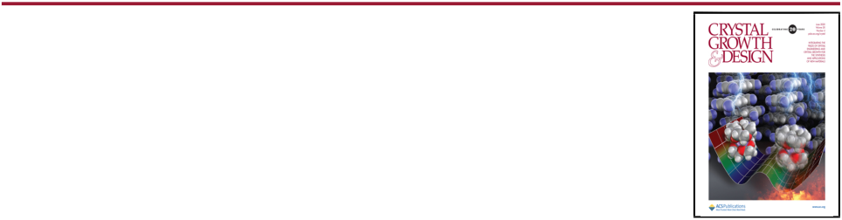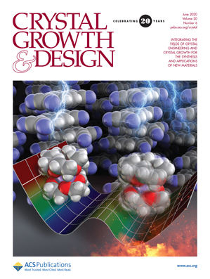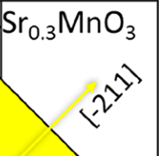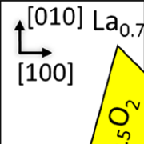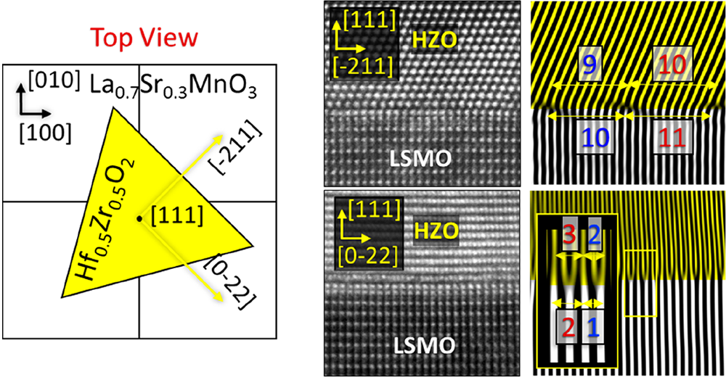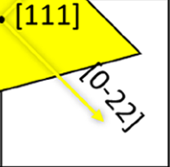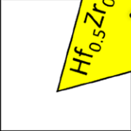



|  |  |
| --- | --- |
| pubs.acs.org/crystal | Article |

Domain-Matching Epitaxy of Ferroelectric Hf0.5Zr0.5O2(111) on La2/3Sr1/3MnO3(001)   
[Saul Estandía,](https://pubs.acs.org/action/doSearch?field1=Contrib&text1="Saul+Estandi%CC%81a"&field2=AllField&text2=&publication=&accessType=allContent&Earliest=&ref=pdf) [Nico Dix,](https://pubs.acs.org/action/doSearch?field1=Contrib&text1="Nico+Dix"&field2=AllField&text2=&publication=&accessType=allContent&Earliest=&ref=pdf) [Matthew F. Chisholm,](https://pubs.acs.org/action/doSearch?field1=Contrib&text1="Matthew+F.+Chisholm"&field2=AllField&text2=&publication=&accessType=allContent&Earliest=&ref=pdf) [Ignasi Fina,](https://pubs.acs.org/action/doSearch?field1=Contrib&text1="Ignasi+Fina"&field2=AllField&text2=&publication=&accessType=allContent&Earliest=&ref=pdf) [and Florencio Sa](https://pubs.acs.org/action/doSearch?field1=Contrib&text1="Florencio+Sa%CC%81nchez"&field2=AllField&text2=&publication=&accessType=allContent&Earliest=&ref=pdf)́[nchez](https://pubs.acs.org/action/doSearch?field1=Contrib&text1="Florencio+Sa%CC%81nchez"&field2=AllField&text2=&publication=&accessType=allContent&Earliest=&ref=pdf)*

|  |  |  |  |  |  |  |  |  |  |  |  |
| --- | --- | --- | --- | --- | --- | --- | --- | --- | --- | --- | --- |
|  | Cite This: [Cryst. Growth Des. 2020, 20, 3801−3806](https://pubs.acs.org/action/showCitFormats?doi=10.1021/acs.cgd.0c00095&ref=pdf) | | | | [Read Online](https://pubs.acs.org/doi/10.1021/acs.cgd.0c00095?ref=pdf) | | | | | | |
|  | ACCESS |  | [Metrics & More](https://pubs.acs.org/doi/10.1021/acs.cgd.0c00095?goto=articleMetrics&ref=pdf) | | | | [Article Recommendations](https://pubs.acs.org/doi/10.1021/acs.cgd.0c00095?goto=recommendations&?ref=pdf) | | | * | [Supporting Information](https://pubs.acs.org/doi/10.1021/acs.cgd.0c00095?goto=supporting-info&ref=pdf) |
| HNOLOGY on April 20, 2021 at 13:27:57 (UTC).  ptions on how to legitimately share published articles. | ABSTRACT: Epitaxial ferroelectric HfO2 films are the most  suitable to investigate intrinsic properties of the material and for  prototyping emerging devices. Ferroelectric Hf0.5Zr0.5O2(111)  films were epitaxially stabilized on La2/3Sr1/3MnO3(001) electro- des. This epitaxy, considering the symmetry dissimilarity and the  huge lattice mismatch, is not compatible with conventional  mechanisms of epitaxy. To gain insight into the epitaxy  mechanism, scanning transmission electron microscopy character- ization of the interface was performed, revealing arrays of  dislocations with short periodicities. These observed periodicities  agree with those expected for domain matching epitaxy, indicating  that this unconventional mechanism could be the prevailing factor  in the stabilization of ferroelectric Hf0.5Zr0.5O2 with (111)  orientation in the epitaxial Hf0.5Zr0.5O2(111)/La2/3Sr1/3MnO3(001) heterostructure. | | | | | | | | | | |
| Downloaded via GEORGIA INST OF TEC  See https://pubs.acs.org/sharingguidelines for o | 1. INTRODUCTION | | | | ment of polycrystalline ferroelectric HfO2, the development of | | | | | | |
| The robust ferroelectricity in doped hafnia and zirconia nanometric thin films, first reported in 2011,1is causing huge scientific and technological interest.2−6The observation of ferroelectricity was unexpected, since the crystal structure of bulk HfO2 and ZrO2 oxides at room temperature and ambient pressure is nonpolar monoclinic (space group number 14, P21/ c).7−10Varying temperature and pressure, they can be tetragonal (137, P42/nmc), cubic (225, Fm3m), or ortho-rhombic (oI phase: 61, Pbca or oII phase: 62, Pnma). All these phases are nonpolar. However, other metastable polar polymorphs whose energy is close to the stable phases exist, | | | | | | epitaxial HfO2 is of major relevance.  Polycrystalline ferroelectric HfO2 is typically obtained by annealing amorphous nanometric films. The mechanisms of formation of the metastable phase are under discussion. Surface and interface energy contributions, and changes in energy caused by lattice strain in the crystallized films, can be a very relevant fraction of the total energy due to the nanometric sizes.9,25Moreover, even if the monoclinic phase is thermodynamically stable at room temperature, the trans-formation from another phase, when the film is cooled, could be kinetically suppressed.26A different method to form the | | | | |
| and among them, there are two orthorhombic structures (oIII: 29, Pca21, and oIV: 31, Pmn21),8,9,11and recently a polar rhombohedral phase (160, R3m) has been also reported.12,13 The interest in ferroelectric HfO2 emerges from the full compatibility with complementary metal oxide semiconductor (CMOS) technology of the chemical composition and the deposition processes to obtain polycrystalline ferroelectric HfO2 films.14However, the current knowledge on ferroelectric hafnia needs to be improved. In this regard, epitaxial films15−19 can be useful to reveal the underlying mechanisms governing HfO2 properties, as well as to prototype nanometric HfO2-based devices. Examples of the usefulness of epitaxial films include observation of coercive electric field (Ec) scaling with thickness (t) according to the Ec ≈ t−2/3dependence (elusive for polycrystalline HfO2),20absence of wake-up effect,21−23 and disentanglement and control of ionic and electronic transport contributions in tunnel devices.24Since these significant advances may be crucial for the further improve- | | | | | | metastable phase is epitaxial growth, generally by pulsed laser deposition (PLD) at high temperature. In this deposition process, contrary to the annealing of amorphous films, crystallization of the atoms that arrive from the gas phase occurs in a very short time scale.27In the early growth stage, the contribution of the substrate/film interface energy is larger than the bulk energy. The energy of an incoherent interface is much higher than that of a coherent or semicoherent one, and thus a particular polymorph will form if the crystal surface of the used substrate permits (semi)coherent growth.28The | | | | |
| Received: | January 22, 2020 | | | |
| Revised: | April 20, 2020 | | | |
| Published: April 20, 2020 | | | | |
|  | | | © 2020 American Chemical Society | | 3801 | | | [https://dx.doi.org/10.1021/acs.cgd.0c00095 Cryst. Growth Des. 2020, 20, 3801−3806](https://dx.doi.org/10.1021/acs.cgd.0c00095?ref=pdf) | | |

|  |  |  |
| --- | --- | --- |
| Crystal Growth & Design | pubs.acs.org/crystal | Article |

|  |
| --- |
| phenomenon is usually named epitaxial stabilization when the formed phase is not the one having the lower energy in bulk.29 Epitaxial ferroelectric doped-HfO2 capacitors were first obtained with Y:HfO2 and indium tin oxide electrodes on single-crystalline yttria-stabilized zirconia (YSZ) substrates.15 Later, high-polarization epitaxial Hf0.5Zr0.5O2 (HZO) films, (111)-oriented, were deposited on SrTiO3(001) substrates buffered with La2/3Sr1/3MnO3 (LSMO) electrodes.12,21The ferroelectric phase was proposed to correspond to ortho-rhombic Pca21 21 or rhombohedral R3m12 phases. The monoclinic phase coexists in these films, and the deposition parameters allow controlling the relative amount of phases and polarization.20The ferroelectric capacitors show high polar-ization, endurance, and retention.21On the one hand, epitaxial HZO films were also epitaxially integrated with Si(001), using La0.7Sr0.3MnO3 (LSMO) as electrode and either YSZ or SrTiO3 as buffer layers.22,23On the other hand, the selection of the substrate allows selection of the growing HfO2 phase (pure monoclinic, pure orthorhombic, or a mixture of both), as has been recently demonstrated in HZO/LSMO heterostructures grown on a set of oxide single crystals that exerts varying epitaxial stress.19   Epitaxial HZO/LSMO is thus a very useful platform to investigate properties of ferroelectric HfO2 and to fabricate emerging devices such as ferroelectric tunnel junctions. However, the epitaxy mechanism of this functional hetero-structure, HZO(111)/LSMO(001), is intriguing and still unknown. Indeed, epitaxy was unexpected considering the symmetry dissimilarity and the large lattice mismatch between orthorhombic HZO(111) on LSMO(001). How does (111)-oriented orthorhombic HZO grow epitaxially on LSMO(001)? Covalent epitaxy requires crystal matching at the interface between film and substrate (or lower layer). Cube-on-cube epitaxy is common when lattice mismatch is low. Other simple cases, as 45° in-plane unit-cell rotation, are frequent.30 However, these simple mechanisms of epitaxy are not feasible when substrate and film are more dissimilar. In these cases, films are generally polycrystalline, although some less usual mechanisms can permit epitaxy. Examples include tilted epitaxy31and coincidence lattice epitaxy,32also called domain matching epitaxy (DME).33   We investigated the mechanism of epitaxy studying HZO/ LSMO bilayers deposited on GdScO3(001) (for the sake of simplicity, the scandate substrate is indexed here using pseudocubic setting). GdScO3(001) substrates are optimal to stabilize the orthorhombic phase, and HZO films on LSMO(001)/GdScO3(001) are free of the paraelectric monoclinic phase.19Semicoherent interfaces between HZO and LSMO are observed by scanning transmission electron microscopy (STEM). It is found that the large lattice mismatch, ca. −10% along [−211]HZO/[110]LSMO and∼58% along [0−22]HZO/[110]LSMO, is accommodated by DME. In DME, m lattice planes of the upper layer match with |
| n lattice planes of the lower layer, instead of the one-to-one |
| matching of conventional epitaxy. The formation of domains, with m/n values of ∼9/10 along [−211] and 3/2 along [0−22]  HZO directions, permits the relief of the epitaxial stress and the growth of high crystal quality orthorhombic films. The DME mechanism is effective in stabilizing the metastable  orthorhombic instead of the monoclinic phase and results in high-quality epitaxial films, unlike the usually defective films  grown by conventional epitaxy, when lattice mismatch is  moderately high. |

3802 [https://dx.doi.org/10.1021/acs.cgd.0c00095](https://dx.doi.org/10.1021/acs.cgd.0c00095?ref=pdf)

|  |  |  |
| --- | --- | --- |
| Crystal Growth & Design | pubs.acs.org/crystal | Article |

growth of orthorhombic HZO, with (111) orientation and absence of monoclinic phase. In agreement with the stabilization of the orthorhombic phase, the film is ferro-electric. The polarization loop (Figure 1c) shows a remnant polarization of ∼20 μC/cm2and a coercive field of ∼3 MV/ cm.

The epitaxial relationship between the crystal variants of o-HZO(111) film and the GdScO3(001) (or the coherently strained LSMO(001) electrode) are sketched in Figure 2a. It is

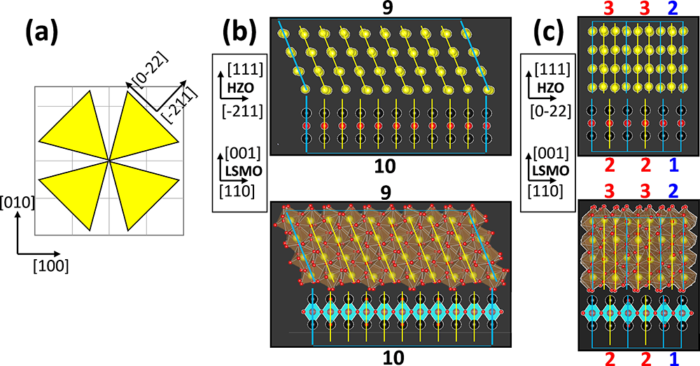

Figure 2. (a) Schematic showing a top view of HZO crystallites on the LSMO(001) surface. The four existing in-plane orientation variants of HZO crystallites are schematized with four yellow triangles. (b, c) Predicted optimal domains for [−211] and [0−22] HZO variants, respectively. For it, (−111) (for [−211] variants) and (0−22) (for [0−22] variants) HZO planes and LSMO(110) planes are marked. Only cations are shown in the sketches at the top, while both cations and oxygen atoms with the corresponding polyhedral sides are shown at the bottom. Planes delimiting the border of a domain are in light blue, while planes inside a domain are in yellow. In (b), 9 (−111) matching 10 (110) planes is shown as the domain with smaller residual strain, while combinations of 3/2 (red) and 2/1 (blue) (0−22)/(110) matching of planes is shown in (c) for [0−22] variants.

not obvious how lattice matching between the approximately fourfold and threefold symmetries of LSMO(001) and o-HZO(111) surfaces occurs. Figure 2b depicts the simulated structures of LSMO and o-HZO across the interface,37 projected on the HZO plane containing [111]op/[−211]ip (op and ip subindices indicate out-of-plane and in-plane, respectively) and, correspondingly, the [001]op/[110]ip plane of LSMO. The same structure projected on the in-plane orthogonal direction of HZO, [111]op/[0−22]ip, and [001]op/ [110]ip of LSMO, i[s presented in](http://pubs.acs.org/doi/suppl/10.1021/acs.cgd.0c00095/suppl_file/cg0c00095_si_001.pdf) Figure 2c (additional details can be found in [Supporting Information S2](http://pubs.acs.org/doi/suppl/10.1021/acs.cgd.0c00095/suppl_file/cg0c00095_si_001.pdf)). The atomic arrangement of LSMO implies an in-plane distance between cation columns parallel to the interface of ∼2.807 Å, corresponding to the (110) interplanar distance. On the one hand, this distance is determined by the GdScO3 substrate, since the LSMO layer grows fully strained on it.19On the other hand, the atomic arrangement of o-HZO, somewhat more complex, has been simulated using VESTA software consid-ering calculated lattice constant for orthorhombic (Pca21) HfO2.37,38Our STEM results are in agreement with the simulations done considering the Pca21 space group. The HZO cation columns appear positioned along the HZO[−211] direction at a distance of ∼3.118 Å. To analyze the lattice matching of HZO on LSMO, HZO(−111) and LSMO(110) planes were used; see Figure 2b. The lattice mismatch (f) with LSMO (f (%) = 100·(dLSMO − dHZO)/dHZO, where dLSMO and dHZO are the horizontal distances between consecutive

3803 [https://dx.doi.org/10.1021/acs.cgd.0c00095](https://dx.doi.org/10.1021/acs.cgd.0c00095?ref=pdf)

|  |  |  |
| --- | --- | --- |
| Crystal Growth & Design | pubs.acs.org/crystal | Article |

are more clearly visualized in the FFT filtered image than the location where best matching of HZO and LSMO planes occurs. The STEM image (Figure 3b) after FFT filtering (the FFT is presented in the inset) is shown in Figure 3d, displaying distances between adjacent additional planes of 9/10 and 10/ 11, indicating the presence of domains with the same periodicities. Domains with m/n ratios of 9/10 are found in all [−211] crystal variants examined, with the presence of domains of close size, such as 6/7 or 11/12 (see S3, [Supporting Information](http://pubs.acs.org/doi/suppl/10.1021/acs.cgd.0c00095/suppl_file/cg0c00095_si_001.pdf)). Approximately three or four such domains [f](http://pubs.acs.org/doi/suppl/10.1021/acs.cgd.0c00095/suppl_file/cg0c00095_si_001.pdf)it within one single crystallite, given the domains and grain sizes, the latter being ∼10−12 nm (see S3, [Supporting Information](http://pubs.acs.org/doi/suppl/10.1021/acs.cgd.0c00095/suppl_file/cg0c00095_si_001.pdf)).

The STEM characterization of HZO[0−22]/LSMO[1−10] interfaces is summarized in Figure 4. The cross-sectional

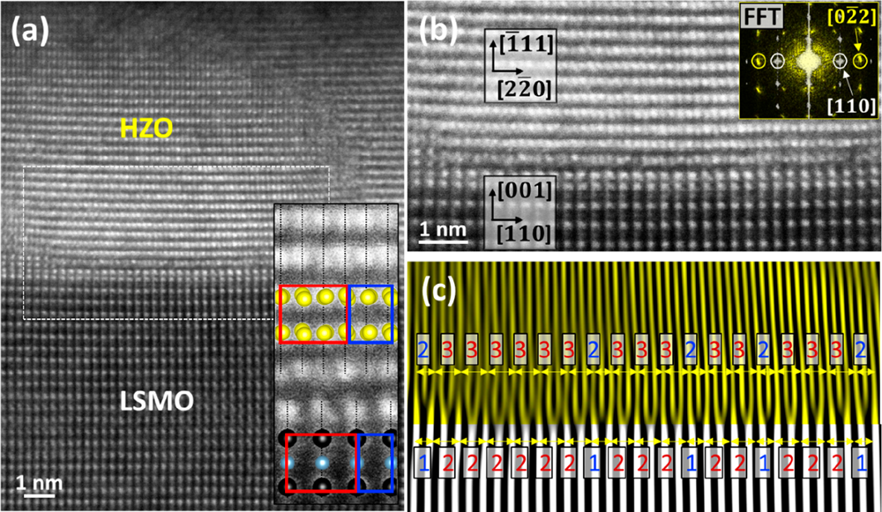

Figure 4. (a) Cross-sectional HAADF image of the HZO/LSMO heterostructure showing crystal variants of the [0−22] type. Bottom right inset shows an enlarged region around the interface with superimposed structural models of [0−22] HZO and [110] LSMO, showing two adjacent 3/2 (red) and 2/1 (blue) domains. (b) Enlarged image extracted from the region marked in white in (a) and FFT of HZO layer (yellow) and LSMO (white) in the top right inset. (c) Equivalent filtered image extracted from (b) by only considering the FFT marked reflections in the inset in (b). 3/2 (red) and 2/1 (blue) domains are visible. From first 2/1 domain on the left to last 3/2 on the right there is a total ratio of 18 domains (14 of which are 3/2 and 4 are 2/1), indicating that ∼77% of the present domains are 3/2, while ∼23% are 2/1.

STEM view in Figure 4a shows a [0−22] grain variant occupying most of the imaged HZO film. There is also a second [0−22] grain at its right. The enlargement of the main [0−22] grain shows a semicoherent discontinuity. Here, the contrast between atomic columns across the interface also suggests, as in the [−211] grain presented in Figure 3, that the semicoherent interface develops after one monolayer of pseudomorphic HZO. The analysis of the semicoherent interface (Figure 4b,c) shows much smaller domains compared to [−211] variants. Here, most of the domains correspond to the matching of three atomic Hf/Zr planes and two La/Sr planes. The FFT filtered image (Figure 4c) also reveals the presence of an important number of 2/1 domains, appearing approximately 4 times less frequently than 3/2 domains. The observed mechanism of DME of HZO(111) on LSMO(001) results in an effective lattice mismatch f* (%) = 100·(n·dLSMO − m·dHZO)/n·dHZO that is much smaller than the lattice mismatch f of direct accommodation of one-to-one lattice planes. In the case of HZO(111)/LSMO(001), the m/n values that minimize f* are 3/2 and 9/10 for HZO[0−22]/

3804 [https://dx.doi.org/10.1021/acs.cgd.0c00095](https://dx.doi.org/10.1021/acs.cgd.0c00095?ref=pdf)

|  |  |  |  |  |
| --- | --- | --- | --- | --- |
| Crystal Growth & Design | | pubs.acs.org/crystal | | Article |
| directions or combining ferroelectric HfO2 with other functional oxides.  4. EXPERIMENTAL SECTION  Thin Films Deposition. Epitaxial heterostructures integrated by HZO (top layer, t = 10 nm) and LSMO (bottom layer, t = 25 nm) were grown on GdScO3(001). The heterostructures were deposited in a single process by pulsed laser deposition (KrF excimer laser). Detailed information on growth conditions and ferroelectric proper-ties is reported elsewhere.19   Structural Characterization. The crystal phases of HZO and epitaxial relationships were determined by X-ray diffraction using Cu Kα radiation. A Siemens D5000 diffractometer with point detector was used to measure symmetric 2θ scans. A Bruker D8, equipped with two-dimensional (2D) detector Vantec 500, was used to acquire pole figures around o-HZO (−111) asymmetric reflections. Character-ization of the interface was done by scanning transmission electron microscopy using a Nion UltraSTEM 200, operated at 200 kV and equipped with a fifth-order Nion aberration corrector. HAADF images of cross-sectional specimens were recorded as-viewed along the [110] zone axes of the GdScO3 substrate.  Ferroelectric Characterization. Top Pt contacts, 19 μm diameter and 20 nm thick, were deposited through a stencil mask by magnetron sputtering. Ferroelectric loops were measured using AixACCT TFAnalyser2000 platform at 1 kHz, using the dielectric leakage current compensation (DLCC) method to reduce the leakage current.47,48 ■ASSOCIATED CONTENT  *  sı Supporting Information The Supporting Information is available free of charge at [https://pubs.acs.org/doi/10.1021/acs.cgd.0c00095](https://pubs.acs.org/doi/10.1021/acs.cgd.0c00095?goto=supporting-info).  Laue fringes around (111) HZO reflection in θ−2θ scan, top view of HZO(111) on LSMO(001), matching of planes in [−211] grains, and residual mismatch for different domains ([PDF](http://pubs.acs.org/doi/suppl/10.1021/acs.cgd.0c00095/suppl_file/cg0c00095_si_001.pdf)) ■AUTHOR INFORMATION  Corresponding Author   Florencio Sánchez − Institut de Ciència de Materials de Barcelona, Campus UAB, Bellaterra 08193, Barcelona, Spain; | | Programme for Centres of Excellence in R&D (SEV-2015-0496) and the MAT2015-73839-JIN (MINECO/FEDER, EU) and MAT2017-85232-R (AEI/FEDER, EU) projects, and from Generalitat de Catalunya (2017 SGR 1377), is acknowledged. I.F. acknowledges Ramón y Cajal Contract No. RYC-2017-22531. S.E. acknowledges the Spanish Ministry of Economy, Competitiveness and Universities for his Ph.D. contract (SEV-2015-0496-16-3) and its cofunding by the ESF. S.E.’s work has been done as a part of his Ph.D. program in Materials Science at Universitat Autònoma de Barcelona. The electron microscopy performed at ORNL was supported by the Materials Sciences and Engineering Division of Basic Energy Sciences of the Office of Science of the U.S. Department of Energy. We also thank J. Gázquez for his assistance with the STEM characterization.  ■REFERENCES  (1) Böscke, T. S.; Müller, J.; Bräuhaus, D.; Schröder, U.; Böttger, U. [Ferroelectricity in Hafnium Oxide Thin Films.](https://dx.doi.org/10.1063/1.3634052) Appl. Phys. Lett. 2011, 99, 102903.  (2) Yurchuk, E.; Müller, J.; Hoffmann, R.; Paul, J.; Martin, D.; Boschke, R.; Schlösser, T.; Müller, S.; Slesazeck, S.; Van Bentum, R.; Trentzsch, M.; Schroeder, U.; Mikolajick, T. In HfO2-Based Ferroelectric Field-Effect Transistors with 260 nm Channel Length and Long Data Retention, Proceedings of the 4th IEEE International Memory Workshop, Milan, Italy, May 20−23, 2012; IEEE, 2012.  [DOI: 10.1109/IMW.2012.6213620](https://dx.doi.org/10.1109/IMW.2012.6213620?ref=pdf)  (3) Muller, J.; Boscke, T. S.; Muller, S.; Yurchuk, E.; Polakowski, P.; Paul, J.; Martin, D.; Schenk, T.; Khullar, K.; Kersch, A.; Weinreich, W.; Riedel, S.; Seidel, K.; Kumar, A.; Arruda, T. M.; Kalinin, S. V.; Schlösser, T.; Boschke, R.; van Bentum, R.; Schroeder, U.; Mikolajick, T. In Ferroelectric Hafnium Oxide: A CMOS-Compatible and Highly Scalable Approach to Future Ferroelectric Memories, Proceedings of the IEEE International Electron Devices Meeting, Washington, DC, Dec 9−11, 2013; IEEE, 2013. [DOI: 10.1109/IEDM.2013.6724605](https://dx.doi.org/10.1109/IEDM.2013.6724605?ref=pdf) (4) Mikolajick, T.; Slesazeck, S.; Park, M. H.; Schroeder, U. Ferroelectric Hafnium Oxide for Ferroelectric Random-Access [Memories and Ferroelectric Field-Effect Transistors.](https://dx.doi.org/10.1557/mrs.2018.92) MRS Bull. 2018, 43, 340.  (5) Mueller, S.; Müller, J.; Schroeder, U.; Mikolajick, T. [Reliability Characteristics of Ferroelectric Si:HfO2 Thin Films for Memory Applications.](https://dx.doi.org/10.1109/TDMR.2012.2216269) IEEE Trans. Device Mater. Reliab. 2013, 13, 93.  (6) Park, M. H.; Lee, Y. H.; Mikolajick, T.; Schroeder, U.; Hwang, C. S. [Review and Perspective on Ferroelectric HfO2-Based Thin Films for Memory Applications.](https://dx.doi.org/10.1557/mrc.2018.175) MRS Commun. 2018, 8, 795.  (7) Ushakov, S. V.; Navrotsky, A.; Yang, Y.; Stemmer, S.; Kukli, K.; Ritala, M.; Leskelä, M. A.; Fejes, P.; Demkov, A.; Wang, C.; Nguyen, B. Y.; Triyoso, D.; Tobin, P. [Crystallization in Hafnia- and Zirconia-based Systems.](https://dx.doi.org/10.1002/pssb.200404935) Phys. Status Solidi B 2004, 241, 2268.  (8) Huan, T. D.; Sharma, V.; Rossetti, G. A.; Ramprasad, R. [Pathways Towards Ferroelectricity in Hafnia.](https://dx.doi.org/10.1103/PhysRevB.90.064111) Phys. Rev. B: Condens. Matter Mater. Phys. 2014, 90, 064111.  (9) Park, M. H.; Lee, Y. H.; Kim, H. J.; Kim, Y. J.; Moon, T.; Kim, K.; Muller, J.; Kersch, A.; Schroeder, U.; Mikolajick, T.; Hwang, C. S. [Ferroelectricity and Antiferroelectricity of Doped Thin HfO2-Based Films.](https://dx.doi.org/10.1002/adma.201404531) Adv. Mater. 2015, 27, 1811.  (10) Sharma, G.; Ushakov, S. V.; Navrotsky, A. [Size Driven Thermodynamic Crossovers in Phase Stability in Zirconia and Hafnia.](https://dx.doi.org/10.1111/jace.15200) J. Am. Ceram. Soc. 2018, 101, 31.  (11) Qi, Y.; Singh, S.; Rabe, K. M. Stabilization of Competing Ferroelectric Phases of HfO[2 und](https://arxiv.org/abs/2001.08692v2)er Epitaxial Strain. arXiv 2020. <https://arxiv.org/abs/2001.08692v2> (accessed 2020-02-14).  (12) Wei, Y.; Nukala, P.; Salverda, M.; Matzen, S.; Zhao, H. J.; Momand, J.; Everhardt, A. S.; Agnus, G.; Blake, G. R.; Lecoeur, P.; Kooi, B. J.; Íñiguez, J.; Dkhil, B.; Noheda, B. [A Rhombohedral Ferroelectric Phase in Epitaxially Strained Hf0.5Zr0.5O2 Thin Films.](https://dx.doi.org/10.1038/s41563-018-0196-0) Nat. Mater. 2018, 17, 1095. | | |
|  | [orcid.org/0000-0002-5314-453X](http://orcid.org/0000-0002-5314-453X); Email: [fsanchez@](mailto:fsanchez@icmab.es) |
| [icmab.es](mailto:fsanchez@icmab.es)  Authors   Saul Estandía − Institut de Ciència de Materials de Barcelona, Campus UAB, Bellaterra 08193, Barcelona, Spain   Nico Dix − Institut de Ciència de Materials de Barcelona, Campus UAB, Bellaterra 08193, Barcelona, Spain   Matthew F. Chisholm − Center for Nanophase Materials Sciences, Oak Ridge National Laboratory, Oak Ridge 37831- 6064, Tennessee, United States   Ignasi Fina − Institut de Ciència de Materials de Barcelona, Campus UAB, Bellaterra 08193, Barcelona, Spain; | |
|  | [orcid.org/0000-0003-4182-6194](http://orcid.org/0000-0003-4182-6194) |
| Complete contact information is available at: [https://pubs.acs.org/10.1021/acs.cgd.0c00095](https://pubs.acs.org/doi/10.1021/acs.cgd.0c00095?ref=pdf)  Notes  The authors declare no competing financial interest.  ■ACKNOWLEDGMENTS  Financial support from the Spanish Ministry of Economy, Competitiveness and Universities, through the “Severo Ochoa” | |
| 3805 | [https://dx.doi.org/10.1021/acs.cgd.0c00095 Cryst. Growth Des. 2020, 20, 3801−3806](https://dx.doi.org/10.1021/acs.cgd.0c00095?ref=pdf) | |

|  |  |  |
| --- | --- | --- |
| Crystal Growth & Design | pubs.acs.org/crystal | Article |

(13) Zhang, Y.; Yang, Q.; Tao, L.; Tsymbal, E. Y.; Alexandrov, V. Effects of Strain and Film Thickness on the Stability of the Rhombohedral Phase of HfO2. arXiv 2020. [https://arxiv.org/abs/ 2001.09192](https://arxiv.org/abs/2001.09192) (accessed 2020-01-24).

(14) Schroeder, U.; Mueller, S.; Mueller, J.; Yurchuk, E.; Martin, D.; Adelmann, C.; Schloesser, T.; Van Bentum, R.; Mikolajick, T. [Hafnium Oxide Based CMOS Compatible Ferroelectric Materials.](https://dx.doi.org/10.1149/2.010304jss) ECS J. Solid State Sci. Technol. 2013, 2, N69.

(15) Shimizu, T.; Katayama, K.; Kiguchi, T.; Akama, A.; Konno, T. J.; Funakubo, H. [Growth of Epitaxial Orthorhombic YO1.5-Substituted HfO2 Thin Film.](https://dx.doi.org/10.1063/1.4927450) Appl. Phys. Lett. 2015, 107, 032910.

(16) Yoong, H. Y.; Wu, H.; Zhao, J.; Wang, H.; Guo, R.; Xiao, J.; Zhang, B.; Yang, P.; Pennycook, S. J.; Deng, N.; Yan, X.; Chen, J. [Epitaxial Ferroelectric Hf0.5Zr0.5O2 Thin Films and Their Implemen-tations in Memristors for Brain-Inspired Computing.](https://dx.doi.org/10.1002/adfm.201806037) Adv. Funct. Mater. 2018, 28, 1.

(17) Mimura, T.; Shimizu, T.; Uchida, H.; Sakata, O.; Funakubo, H. [Thickness-Dependent Crystal Structure and Electric Properties of Epitaxial Ferroelectric Y2O3-HfO2 Films.](https://dx.doi.org/10.1063/1.5040018) Appl. Phys. Lett. 2018, 113, 102901.

(18) Li, T.; Ye, M.; Sun, Z.; Zhang, N.; Zhang, W.; Inguva, S.; Xie, C.; Chen, L.; Wang, Y.; Ke, S.; Huang, H. [Origin of Ferroelectricity in Epitaxial Si-Doped HfO2 Films.](https://dx.doi.org/10.1021/acsami.8b19558) ACS Appl. Mater. Interfaces 2019, 11, 4139.

(19) Estandía, S.; Dix, N.; Gazquez, J.; Fina, I.; Lyu, J.; Chisholm, M. F.; Fontcuberta, J.; Sánchez, F. [Engineering Ferroelectric Hf0.5Zr0.5O2 Thin Films by Epitaxial Stress. ACS Appl. Electron. Mater. 2019, 1,](https://dx.doi.org/10.1021/acsaelm.9b00256) 1449.

(20) Lyu, J.; Fina, I.; Solanas, R.; Fontcuberta, J.; Sánchez, F. [Growth Window of Ferroelectric Epitaxial Hf0.5Zr0.5O2 Thin Films.](https://dx.doi.org/10.1021/acsaelm.8b00065) ACS Appl. Electron. Mater. 2019, 1, 220.

(21) Lyu, J.; Fina, I.; Solanas, R.; Fontcuberta, J.; Sánchez, F. [Robust Ferroelectricity in Epitaxial Hf1/2Zr1/2O2 Thin Films.](https://dx.doi.org/10.1063/1.5041715) Appl. Phys. Lett. 2018, 113, 082902.

(22) Lyu, J.; Fina, I.; Fontcuberta, J.; Sánchez, F. [Epitaxial Integration on Si(001) of Ferroelectric Hf0.5Zr0.5O2 Capacitors with High Retention and Endurance.](https://dx.doi.org/10.1021/acsami.8b18762) ACS Appl. Mater. Interfaces 2019, 11, 6224.

(23) Lyu, J.; Fina, I.; Bachelet, R.; Saint-Girons, G.; Estandía, S.; Gázquez, J.; Fontcuberta, J.; Sánchez, F. [Enhanced Ferroelectricity in Epitaxial Hf0.5Zr0.5O2 Thin Films Integrated with Si(001) Using SrTiO3 Templates.](https://dx.doi.org/10.1063/1.5096002) Appl. Phys. Lett. 2019, 114, 222901.

(24) Sulzbach, M. C.; Estandía, S.; Long, X.; Lyu, J.; Dix, N.; Gàzquez, J.; Chisholm, M. F.; Sánchez, F.; Fina, I.; Fontcuberta, J. [Unraveling Ferroelectric Polarization and Ionic Contributions to Electroresistance in Epitaxial Hf0.5Zr0.5O2 Tunnel Junctions.](https://dx.doi.org/10.1002/aelm.201900852) Adv. Electron. Mater. 2020, 6, 1900852.

(25) Park, M. H.; Lee, Y. H.; Kim, H. J.; Schenk, T.; Lee, W.; Kim, K.; Fengler, F. P. G.; Mikolajick, T.; Schroeder, U.; Hwang, C. S. [Surface and Grain Boundary Energy as the Key Enabler of Ferroelectricity in Nanoscale Hafnia-Zirconia: a Comparison of Model and Experiment.](https://dx.doi.org/10.1039/C7NR02121F) Nanoscale 2017, 9, 9973.

(26) Park, M. H.; Lee, Y. H.; Mikolajick, T.; Schroeder, U.; Hwang, C. S. [Thermodynamic and Kinetic Origins of Ferroelectricity in Fluorite Structure Oxides.](https://dx.doi.org/10.1002/aelm.201800522) Adv. Electron. Mater. 2019, 5, 1800522. (27) Eres, G.; Tischler, J. Z.; Rouleau, C. M.; Zschack, P.; Christen, H. M.; Larson, B. C. [Quantitative Determination of Energy Enhanced Interlayer Transport in Pulsed Laser Deposition of SrTiO3.](https://dx.doi.org/10.1103/PhysRevB.84.195467) Phys. Rev. B: Condens. Matter Mater. Phys. 2011, 84, 195467.

(28) Gorbenko, O. Y.; Samoilenkov, S. V.; Graboy, I. E.; Kaul, A. R. [Epitaxial Stabilization of Oxides in Thin Films.](https://dx.doi.org/10.1021/cm021111v) Chem. Mater. 2002, 14, 4026.

(29) Wood, D. M.; Zunger, A. [Epitaxial Effects on Coherent Phase Diagrams of Alloys.](https://dx.doi.org/10.1103/PhysRevB.40.4062) Phys. Rev. B: Condens. Matter Mater. Phys. 1989, 40, 4062.

(30) Scigaj, M.; Dix, N.; Fina, I.; Bachelet, R.; Warot-Fonrose, B.; Fontcuberta, J.; Sánchez, F. [Ultra-flat BaTiO3 epitaxial films on Si(001) with large out-of-plane polarization.](https://dx.doi.org/10.1063/1.4798246) Appl. Phys. Lett. 2013, 102, 112905.

3806 [https://dx.doi.org/10.1021/acs.cgd.0c00095](https://dx.doi.org/10.1021/acs.cgd.0c00095?ref=pdf)