

**Wake-up effects in Si-doped hafnium oxide ferroelectric thin films**   
[Dayu Zhou](http://scitation.aip.org/search?value1=Dayu+Zhou&option1=author), [Jin Xu](http://scitation.aip.org/search?value1=Jin+Xu&option1=author), [Qing Li](http://scitation.aip.org/search?value1=Qing+Li&option1=author), [Yan Guan](http://scitation.aip.org/search?value1=Yan+Guan&option1=author), [Fei Cao](http://scitation.aip.org/search?value1=Fei+Cao&option1=author), [Xianlin Dong](http://scitation.aip.org/search?value1=Xianlin+Dong&option1=author), [Johannes Müller](http://scitation.aip.org/search?value1=Johannes+Müller&option1=author), [Tony Schenk](http://scitation.aip.org/search?value1=Tony+Schenk&option1=author), and [Uwe Schröder](http://scitation.aip.org/search?value1=Uwe+Schröder&option1=author)

Citation: [Applied Physics Letters](http://scitation.aip.org/content/aip/journal/apl?ver=pdfcov) **103**, 192904 (2013); doi: 10.1063/1.4829064   
View online: <http://dx.doi.org/10.1063/1.4829064>  
View Table of Contents: <http://scitation.aip.org/content/aip/journal/apl/103/19?ver=pdfcov>Published by the [AIP Publishing](http://scitation.aip.org/content/aip?ver=pdfcov)



T[his article is copyrighted as indicated in the article. Reuse of AIP content is subject to the terms at: http://scitation.aip.org/termsconditions. Download](http://oasc12039.247realmedia.com/RealMedia/ads/click_lx.ads/www.aip.org/pt/adcenter/pdfcover_test/L-37/1671338486/x01/AIP-PT/COMSOL_APLArticleDL_120413/2013_700-user-presentations_1640x440.png/5532386d4f314a53757a6b4144615953?x)ed to IP: 202.118.71.154 On: Fri, 06 Dec 2013 13:11:20

APPLIED PHYSICS LETTERS 103, 192904 (2013) 

[Wake-up effects in Si-doped hafnium oxide ferroelectric thin films](http://dx.doi.org/10.1063/1.4829064)

Dayu Zhou,1,2,3,a)Jin Xu,4Qing Li,1Yan Guan,1Fei Cao,5Xianlin Dong,5Johannes M€uller,6 Tony Schenk,7and Uwe Schr€oder7   
1School of Materials Science and Engineering, Dalian University of Technology, Dalian 116024, China 2Key Laboratory for Materials Modification by Laser, Ion and Electron Beams, Ministry of Education,

Dalian University of Technology, Dalian 116024, China   
3State Key Laboratory of Electronic Thin Films and Integrated Devices, University of Electronic Science and

Technology of China, Chengdu 610054, China   
4Department of Electronic Engineering, Dalian Neusoft University of Information, Dalian 116023, China 5Key Laboratory of Inorganic Functional Materials and Devices, Shanghai Institute of Ceramics,

Chinese Academy of Sciences, Shanghai 200050, China   
6Fraunhofer IPMS-CNT, Koengisbruecker Strasse 180, 01109 Dresden, Germany 7Namlab gGmbH/TU Dresden, Noethnitzer Strasse 64, 01187 Dresden, Germany

(Received 29 August 2013; accepted 19 October 2013; published online 5 November 2013)

Hafnium oxide based ferroelectric thin films have shown potential as a promising alternative

material for non-volatile memory applications. This work reports the switching stability of a Si-

doped HfO2 film under bipolar pulsed-field operation. High field cycling causes a “wake-up” in

virgin “pinched” polarization hysteresis loops, demonstrated by an enhancement in remanent

polarization and a shift of negative coercive voltage. The rate of wake-up is accelerated by either

reducing the frequency or increasing the amplitude of the cycling field. We suggest de-pinning of

domains due to reduction of the defect concentration at bottom electrode interface as origin of the

wake-up. V C 2013 AIP Publishing LLC. [<http://dx.doi.org/10.1063/1.4829064>]

HfO2-based ultrathin films, with a non-centrosymmetric orthorhombic phase of space group Pbc21 achieved by crys-tallization under top electrode encapsulation and by admix-ture with Si, Al, Y, and Gd, were reported to exhibit intrinsic, pronounced ferroelectricity. Electrical characteristics of dif-ferent compositions have been summarized and compared in the recently published review article of Schroeder et al.1 Additionally, a composition and temperature dependent ferro-

polarization under bipolar field cycling plays an essential role in realization of the ferroelectric memories on a commercial scale. Two stages of switchable polarization change have been reported for both PZT and SBT thin films during high field cycling.8–11The wake-up (de-ageing) stage corresponds to an increase of the remanent polarization existing up to a certain number of cycles. Subsequent cycling leads to a deg-radation of Pr, which is well known as polarization fatigue.

|  |  |  |  |  |  |  |  |
| --- | --- | --- | --- | --- | --- | --- | --- |
| electric | phase | transition | was | reported | for | HfO2-ZrO2 | Fatigue is considered as one of the critical reliability issues |
| solid-solution.2 | | for ferroelectric films and has therefore attracted great con- |

Non-volatile ferroelectric memory is potentially the most direct application for this type ferroelectric material, since as a leading high-k dielectric, HfO2 has received intensive stud-ies and long-term industrial practices in the context of replac-ing SiO2 as gate dielectric and storage capacitor dielectric.3,4 As compared to conventional perovskite-type oxides, e.g., Pb(Zr,Ti)O3 (PZT) and SrBi2Ta2O9 (SBT), HfO2-based ferro-electrics offer distinct advantages including good compatibil-ity to silicon semiconductor integration technology, mature high-productivity film growth processes by atomic-layer-de-position (ALD), adoption of common metal electrodes (e.g., TiN), tunable remanent polarization (Pr), and relatively low dielectric constant. These features may lead to a significant

cerns over the past two decades. It is of technological interest to note that a delay of the onset of fatigue has been observed for PZT thin films due to initial appearance of the wake-up effect.10   
 Polarization wake-up has been noticed by Mueller et al. in their pioneering reliability study for Si:HfO2 ferroelectric thin films annealed at different temperatures.12In this Letter, we report a detailed experimental investigation of the wake-up effects evoked by bipolar pulsed-field operation with different amplitudes and at different frequencies for the same composition. The results are crucial for understanding the domain kinetics and deemed essential for memory device applications which require a stable polarization reversal state.

|  |  |  |  |  |  |  |
| --- | --- | --- | --- | --- | --- | --- |
| breakthrough | in | both | performance | improvement | and | All measurements were performed on metal-ferroelectric- |

down-scaling of ferroelectric memories. Recent progress in data retention time of ferroelectric field effect transistors (FeFETs) fabricated using silicon doped HfO2 (Si:HfO2) has proved this expectation.5–7

metal (MFM) planar capacitors grown onto silicon substrates. In detail, the TiN bottom and top electrodes (10 nm) were formed by ALD using TiCl4 and NH3 precursors at 450�C. 10 nm thick Si:HfO2 thin films were grown by ALD at 280�C

|  |  |  |  |  |  |
| --- | --- | --- | --- | --- | --- |
| In memory devices, the ferroelectric thin films will be | with | Hf[N(CH3)C2H5]4 | (TEMAH) | and | Si[N(CH3)2]4 |

exposed to a rather high number of read-out and write-in pulse cycles. Thus, the long-term stability of the switchable

a)Author to whom correspondence should be addressed. Electronic mail: [zhoudayu@dlut.edu.cn](mailto:zhoudayu@dlut.edu.cn)

(4DMAS) as precursors, and ozone (O3) was used as an oxygen source. Sub-cycles of 4DMAS during HfO2 deposition resulted in a silicon dopant content of �5.0 mol. %. Crystallization of the Si:HfO2 films was induced by a 800�C/20 s RTP anneal in N2 after top TiN electrode deposition. Evaporated platinum

|  |  |  |
| --- | --- | --- |
| 0003-6951/2013/103(19)/192904/4/$30.00 | 103, 192904-1 | V C 2013 AIP Publishing LLC |

This article is copyrighted as indicated in the article. Reuse of AIP content is subject to the terms at: http://scitation.aip.org/termsconditions. Downloaded to IP: 202.118.71.154 On: Fri, 06 Dec 2013 13:11:20

|  |  |  |
| --- | --- | --- |
| 192904-2 | Zhou et al. | Appl. Phys. Lett. 103, 192904 (2013) |

dots with radius ranging from 55 lm to 225lm served as elec-trical contacts and as a hard mask in chemical etching of the

virgin hysteresis loops were constricted or pinched symmetri-cally along the electric field axis, and high-field cycling made

top TiN layer. their loops centered by identical relaxation of both negative

Janis ST-500 probe station was used for electrical prob-ing of the capacitor array with one of the Pt dots being

and positive coercive fields. Therefore, the de-ageing mecha-nisms proposed in Refs. 8 and 14, i.e., destabilization of indi-

|  |  |  |  |  |  |  |  |  |
| --- | --- | --- | --- | --- | --- | --- | --- | --- |
| stressed and the common bottom TiN electrode being | vidual | domains | or | de-pinning | of | domain | walls | by |

grounded. Fatigue measurement function of the aixACCT TF Analyzer 2000 system was employed to investigate the polarization switching characteristics of the as-prepared capacitors at room temperature. After measuring an initial polarization-voltage (P-V) hysteresis, the sample was sub-jected to bipolar rectangular-wave voltage pulses of 62.5, 3.0, or 3.5 V at frequencies of 0.1, 1.0, and 10 kHz. The time constant of the measuring circuit is about 1 ls. Thus, the rise-time for the excitation signal is neglectable compared to the pulse widths predefined for three applied frequencies. The changes of hysteresis shape, remanent polarization, and coer-cive voltage invoked by cycling stresses were monitored periodically by dynamic P-V measurements using triangular waves, the voltage amplitude, and frequency of which were fixed at 3.5 V and 1.0 kHz, respectively. Due to the use of high cycling voltages and low frequencies in this study, all measurements were terminated by breakdown before the appearance of degradation in polarization, i.e., fatigue. A study on the fatigue behavior of the Si:HfO2 films will be presented elsewhere.

Figure 1 presents the evolution of P-V hysteresis loops under 2.5 V bipolar cycling at 0.1 kHz. For the sample in fresh state, the hysteresis loop is characterized by a clear con-striction and polarity asymmetry of the coercive voltage (Vc). The jVþ voltage asymmetry has been observed in our previous cj (0.84 V) is twice as much as jV�cj. Similar coercive

capacitance-voltage (C-V) measurements as well.13Cyclic switching gives rise to an enhancement in both the positive and negative remanent polarization, however, only jV�shifted towards higher voltages, jVþ cj remains almost cj is

unchanged. After 104cycles, jVþ Asymmetric shifts of coercive voltages seen in Fig. 1 are cj and jV�cj become identical.

in contrast to the ageing and de-ageing effects reported for quite thick (1.0 lm) PZT films,8thermally depoled, acceptor-doped PZT ceramics,14and BaTiO3 single crystal,15whose

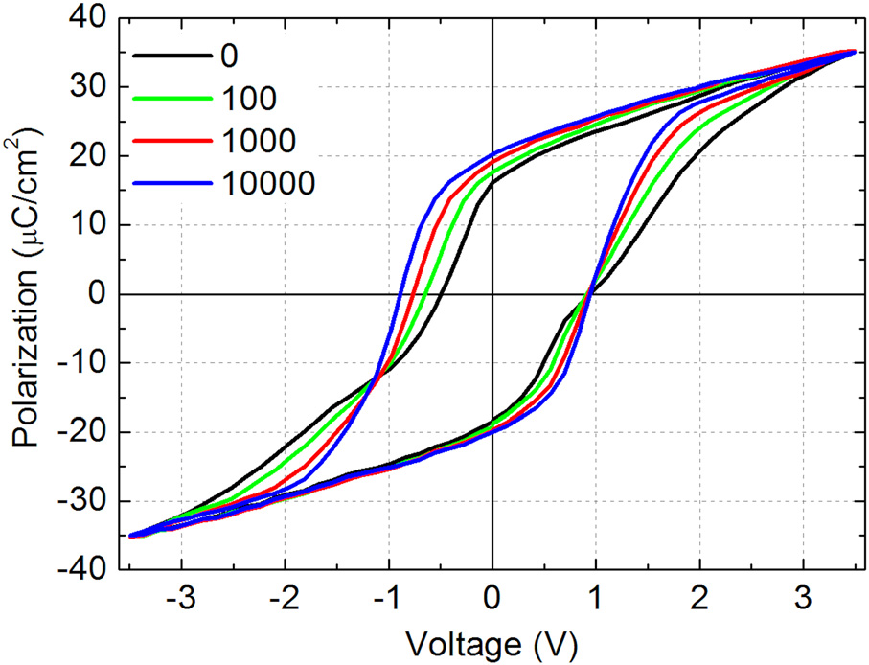

FIG. 1. Evolution of polarization-voltage (P–V) hysteresis with increasing number of bipolar pulse voltage cycling. The voltage amplitude and fre-quency of the cycling pulses were 2.5 V and 0.1 kHz, respectively.

randomizing of charged defects or defect dipoles inside the ferroelectrics (bulk effects), are inapplicable to the wake-up observed in our ultrathin Si:HfO2 films.

Mueller et al. have investigated the polarization switch-ing kinetics in ferroelectric Si:HfO2 thin films using pulse switching tests.16They found that, at various writing pulse voltages, the switched polarization exhibited a logarithmic dependence on the pulse-widths varied from 10ls to 100 ms. The results indicate the switching process follows the nucleation-limited switching (NLS) mechanism, which con-siders that the film consists of regions where the switching develops independently and polarization reversal in each region is limited by nucleation and growth of reversed domains rather than by domain wall motion.17As compared to massive bulks, the actual properties of ferroelectric thin films are strongly influenced by the electrode/ferroelectric interface-related effects. It has been widely accepted that especially charged defects in the nearby interfacial region act as nucleus suppression centers to inhibit the growth of domains of opposite polarity.18Accordingly, we attribute the observation of apparent polarity asymmetric wake-up in co-ercive voltages to significantly non-equivalent bottom and top electrode/ferroelectric interfacial states and the resultant different domain nucleation/growth scenarios.

There was microscopic evidence showing that, due to the use of ozone in the ALD process of dielectrics, the bot-tom TiN electrode was partially oxidized and the released N was incorporated into the high-k layer. The latter was expected to result in substantial oxygen vacancies aggre-gated in the bottom interface region. At the top interface, no titanium oxide formation was found. Nitrogen diffusion dur- top electrode deposition resulted in a interfacial ing   
TiON formation.13,19Recent work of Hildebrandt et al. indi-cates that highly oxygen deficient HfO2�x thin film shows p-type-like conductivity and its band-gap is reduced at the same time.20Therefore, it would be reasonable to consider our Si:HfO2 ferroelectric film in a certain region near the bottom interface as a p-type semiconductor. According to Scott,21high interfacial defect states associated with oxygen vacancies will lead to band bending and the formation of a depletion layer (see band profile and discussions on p. 82 of Ref. 21). As sketched in Fig. 2, the resultant so-called built-in electric field Ebi across the depletion layer is expected to cause local alignment of ferroelectric dipoles. We assume such a pronounced preference of a certain polarization state (i.e., local imprint effect) may be reduced significantly in the top electrode interfacial region due to much less aggregation of oxygen vacancies.

In our measurements, the bottom electrode is always being grounded and the external voltage is applied on top electrode. By applying a negative voltage, the built-in field and external field are pointing towards the same direction. Since a significant amount of dipoles/domains in bottom region have been aligned by the built-in field itself, the

This article is copyrighted as indicated in the article. Reuse of AIP content is subject to the terms at: http://scitation.aip.org/termsconditions. Downloaded to IP: 202.118.71.154 On: Fri, 06 Dec 2013 13:11:20

|  |  |  |
| --- | --- | --- |
| 192904-3 | Zhou et al. | Appl. Phys. Lett. 103, 192904 (2013) |

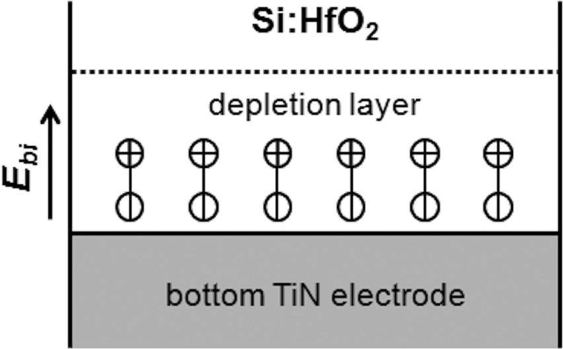

FIG. 2. Schematic of a depletion layer formed in Si:HfO2 ferroelectric film near bottom electrode interface and dipoles/domains pining due to the exis-tence of built-in electric field.

polarization reversal process develops mainly by the growth in size of pre-existing parallel domains through the film. Considering inhibition of opposite domain nucleation at bot-tom interface, we believe that, in the case of positive bias, top electrode interface is the most preferable site for nuclea-tion and growth of new domains anti-parallel to the built-in field.

Referring to the model on depletion-assisted nucleation of domains,22the built-in potential is given by

Ebi ¼ qNdt=e; (1)

where q is the electric charge, Nd is the concentration of charge carriers, e is the permittivity of the ferroelectric film, and t is the thickness of the depletion layer. Polarization switching starts when the external coercive field Ec plus the built-in field Ebi are equal to Ecn, which is defined as the field

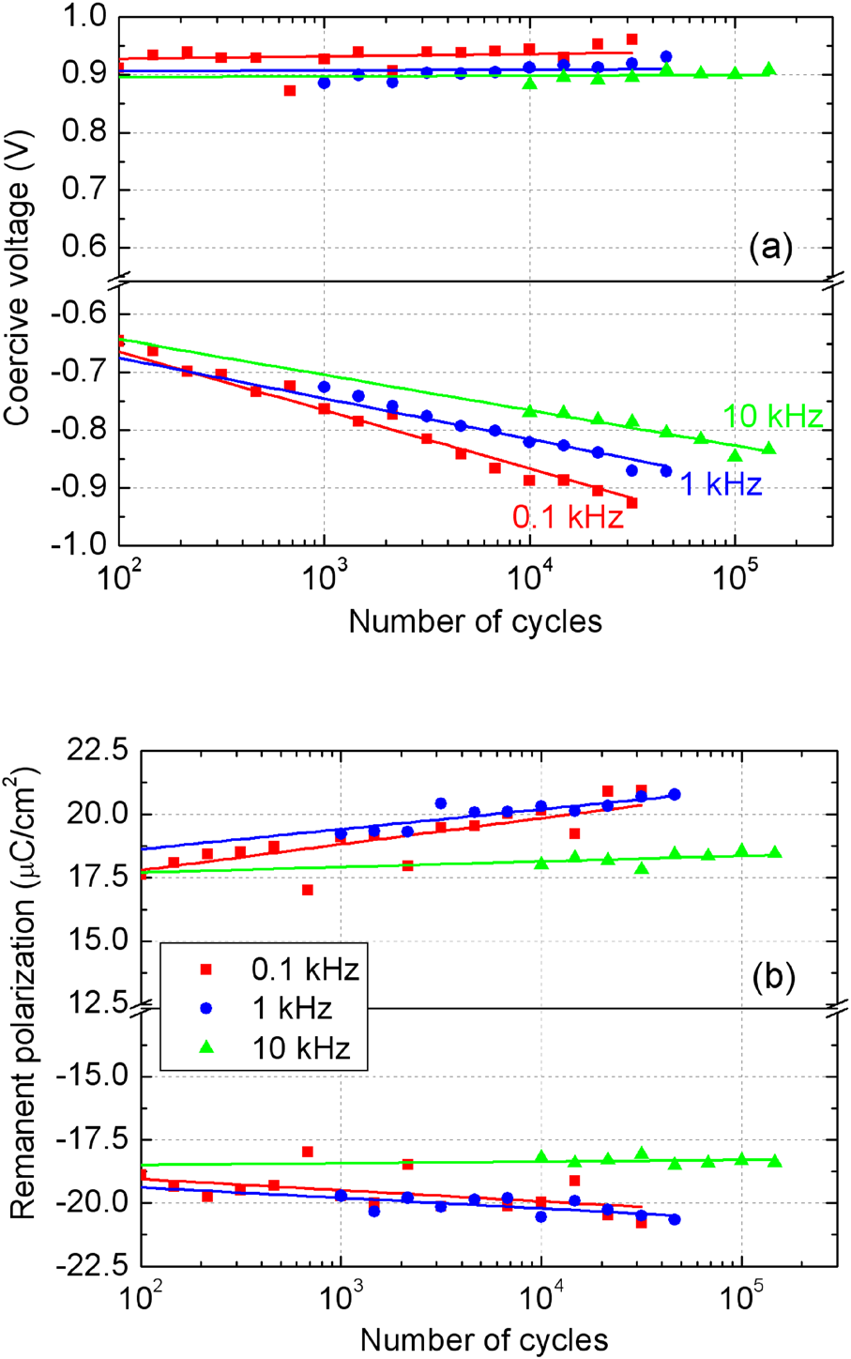

FIG. 3. Wake-ups in (a) coercive voltage and (b) remanent polarization measured at various frequencies of 2.5 V bipolar voltage cycling. The sym-bols represent experimental data and the solid lines represent a linear fit on a

necessary for nucleation and growth of oppositely oriented logarithmic scale.

domains at defect-free electrode/ferroelectric interfaces.

Thus, the coercive field Ec can be expressed as

Ec ¼ Ecn � qNdt=e: (2)

Assuming Ecn in Eq. (2) is same at bottom and top elec-trodes, one finds that much higher concentration of charge carriers at the bottom electrode/ferroelectric interface may account for the apparent polarity asymmetry of the coercive voltages seen in virgin P-V hysteresis loop. Subsequent cyclic switching causes a gradual removal or redistribution of mobile carriers mainly at the bottom interface, resulting in a reduction of the built-in field and de-pining or unlocking of more and more domains participating in polarization switch-ing. The former leads to an increase in negative coercive voltage and the latter leads to an enhancement in remanent polarization. The stability of the positive coercive voltage may be explained in the following way: even the domain pining effect at bottom interface becomes progressively weak during wake-up, top electrode always seems to be the preferable nucleation site for positive bias, and additionally, the defect states at top interface are insensitive to bipolar field cycling.

decrease in frequency will accelerate the enhancement in re-manent polarization, and especially, the increase in negative coercive voltage. Again hardly any shift is detected for the positive coercive voltage at various frequencies. Referring to the mechanism suggested for frequency dependent fatigue,23 we believe that time dependent migration/diffusion process of charge carriers in the nearby bottom interfacial region should account for the majority of the frequency impacts on wake-up.

Figure 4 displays the dependence of wake-up on the am-plitude of the cycling electrical stress, which represents the strength of driving force for migration/diffusion of the charge carriers. Higher pulse voltage gives rise to faster increases in remanent polarization and coercive voltage. It is worth noting that even the positive coercive voltage exhibits slight wake-ups at 3.0 and 3.5 V as well, indicating removal or redistribution of a small quantity of defect charges driven by very high cyclic fields at top electrode interface.

A logarithmic dependence of wake-ups in remanent polarization and coercive voltage on the number (n) of bipo-lar pulse cycles can be observed clearly in Figures 3 and 4.

The relationship is given by

|  |  |  |
| --- | --- | --- |
| The wake-up effect in Si:HfO2 is strongly dependent on | mðnÞ ¼ mn¼1 þ AlogðnÞ; | (3) |
| the frequency and amplitude of the bipolar cyclic field. With |

the same pulse amplitude of 2.5 V, the impact of cycling fre-quency on wake-up is shown in Figure 3. In general, a

where mn¼1 is the property (e.g., Pr or Vc) of the Si:HfO2 thin films in virgin state. The slope A represents the

This article is copyrighted as indicated in the article. Reuse of AIP content is subject to the terms at: http://scitation.aip.org/termsconditions. Downloaded to IP: 202.118.71.154 On: Fri, 06 Dec 2013 13:11:20

|  |  |  |
| --- | --- | --- |
| 192904-4 | Zhou et al. | Appl. Phys. Lett. 103, 192904 (2013) |

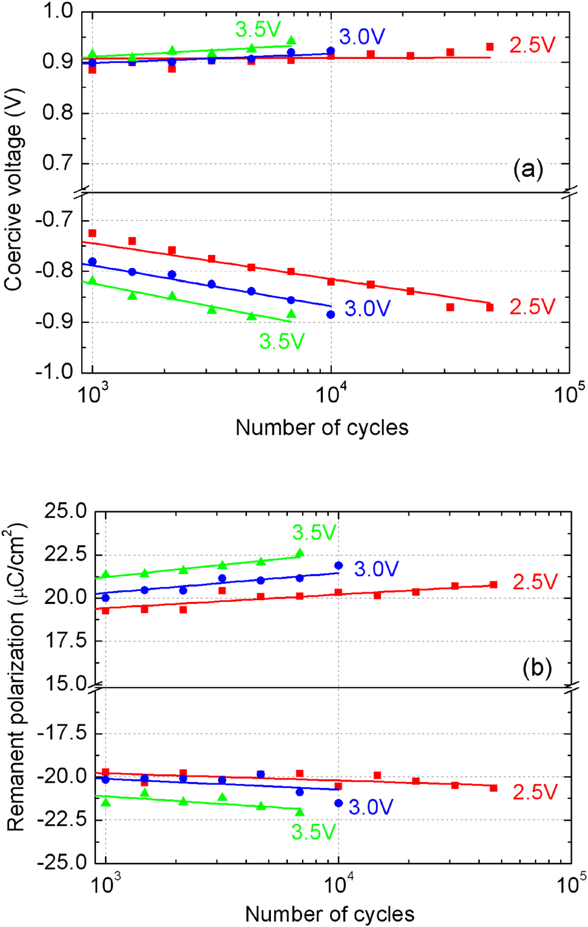

FIG. 4. Dependences of wake-ups in (a) coercive voltage and (b) remanent polarization on the voltage amplitude of bipolar cycling at 1.0 kHz. The symbols represent experimental data and the solid lines represent a linear fit on a logarithmic scale.

“wake-up rate” or “acceleration factor,” which is depending on the frequency and amplitude of the cycling stress. A simi-lar empirical equation has been used to describe the ageing of material properties with time for PZT ceramics.24It is necessary to emphasize that, since the wake-up cannot be in-finite; relation (3) should be valid only for a certain limit of cycling numbers. Our preliminary fatigue tests performed at the limit is between 106and 107cycles. Before this limit, fa-high frequencies (>10 kHz) and low voltages (�2.5 V) show tigue behavior is overshadowed by initial wake-up. Work is in progress to understand the exact relationship between the fatigue and wake-up.

In summary, we have shown that the Si:HfO2 ferroelec-tric thin films exhibit a “wake-up” effect in the polarization hysteresis, the rate of which depends on the voltage ampli-tude and frequency of the cyclic stress. The initial coercive voltages and their subsequent shifts exhibit pronounced po-larity asymmetry which is assumed to be due to highly dif-ferent concentration of charge carriers at the bottom and top electrode-ferroelectric interfaces. In nonvolatile memory

|  |  |  |  |  |  |  |
| --- | --- | --- | --- | --- | --- | --- |
| applications, | a | wake-up | treatment | with | an | essential |

prerequisite of avoiding breakdown is necessary to allow the

ferroelectric films to provide stable storage states.

Work of the authors in China was supported by the

Natural Science Foundation of China (Grant No. NSFC

51272034) and the Open Research Fund of State Key

Laboratory of Electronic Thin Films and Integrated Devices

(UESTC) (No. KFJJ201101). Authors in Germany were

financially supported by the European Fund for Regional

Development and the Free State of Saxony (HEIKO Project

No. 100064806).

1U. Schroeder, S. Mueller, J. Mueller, E. Yurchuk, D. Martin, C.

Adelmann, T. Schloesser, R. van Bentum, and T. Mikolajick, [ECS J. Solid](http://dx.doi.org/10.1149/2.010304jss)

[State Sci. Technol.](http://dx.doi.org/10.1149/2.010304jss) 2(4), N69–N72 (2013).

2J. M€uller, T. S. B€oscke, U. Schr€oder, S. Mueller, D. Br€auhaus, U. B€ottger,

L. Frey, and T. Mikolajick, [Nano Lett.](http://dx.doi.org/10.1021/nl302049k) 12, 4318 (2012).

3J. Robertson, [Eur. Phys. J.: Appl. Phys.](http://dx.doi.org/10.1051/epjap:2004206) 28, 265 (2004).

4J. H. Choi, Y. Mao, and J. P. Chang, [Mater. Sci. Eng. R](http://dx.doi.org/10.1016/j.mser.2010.12.001) 72, 97 (2011). 5J. M€uller, T. S. B€oscke, U. Schr€oder, R. Hoffmann, T. Mikolajick, and L.

Frey, [IEEE Electron Device Lett.](http://dx.doi.org/10.1109/LED.2011.2177435) 33, 185 (2012).

6J. M€uller, E. Yurchuk, T. Schl€osser, J. Paul, R. Hoffmann, S. M€uller, D.

Martin, S. Slesazeck, P. Polakowski, J. Sundqvist, M. Czernohorsky, K.

Seidel, P. K€ucher, R. Boschke, M. Trentzsch, K. Gebauer, U. Schr€oder,

and T. Mikolajick, in Proceedings of the VLSI Technology Symposium

(2012), pp. 25–26.

7E. Yurchuk, J. M€uller, R. Hoffmann, J. Paul, D. Martin, R. Boschke, T.

Schl€osser, S. M€uller, S. Slesazeck, R. van Bentum, M. Trentzsch, U.

Schr€oder, and T. Mikolajick, in Proceedings of the 4th IEEE International

Memory Workshop (IMW), May (2012), pp. 1–4.

8M. Kohli, P. Muralt, and N. Setter, [Appl. Phys. Lett.](http://dx.doi.org/10.1063/1.121554) 72, 3217 (1998). 9N. Menou, Ch. Muller, I. S. Baturin, V. Ya. Shur, and J.-L. Hodeau,

[J. Appl. Phys.](http://dx.doi.org/10.1063/1.1870098) 97, 064108 (2005).

10F. C. Kartawidjaja, C. H. Sim, and J. Wang, [J. Appl. Phys.](http://dx.doi.org/10.1063/1.2822472) 102, 124102

(2007).

11G. L. Yuan, J.-M. Liu, S. T. Zhang, D. Wu, Y. P. Wang, Z. G. Liu, H. L.

W. Chan, and C. L. Choy, [Appl. Phys. Lett.](http://dx.doi.org/10.1063/1.1644056) 84, 954 (2004).

12S. Mueller, J. M€uller, U. Schroeder, and T. Mikolajick, [IEEE Trans.](http://dx.doi.org/10.1109/TDMR.2012.2216269)

[Device Mater. Reliab.](http://dx.doi.org/10.1109/TDMR.2012.2216269) 13, 93 (2013).

13D. Zhou, J. M€uller, J. Xu, S. Knebel, D. Br€auhaus, and U. Schr€oder, [Appl.](http://dx.doi.org/10.1063/1.3688915)

[Phys. Lett.](http://dx.doi.org/10.1063/1.3688915) 100, 082905 (2012).

14K. Carl and K. H. Haerdtl, [Ferroelectrics](http://dx.doi.org/10.1080/00150197808236770) 17, 473 (1977).

15X. Ren, [Nature Mater.](http://dx.doi.org/10.1038/nmat1051) 3, 91 (2004).

16S. Mueller, S. R. Summerfelt, J. M€uller, U. Schroeder, and T. Mikolajick,

[IEEE Electron Device Lett.](http://dx.doi.org/10.1109/LED.2012.2204856) 33, 1300 (2012).

17I. Stolichnov, A. K. Tagantsev, E. Colla, N. Setter, and J. S. Cross,

[J. Appl. Phys.](http://dx.doi.org/10.1063/1.2112174) 98, 084106 (2005).

18N. Setter, D. Damjanovic, L. Eng, G. Fox, S. Gevorgian, S. Hong, A.

Kingon, H. Kohlstedt, N. Y. Park, G. B. Stephenson, I. Stolitchnov, A. K.

Taganstev, D. V. Taylor, T. Yamada, and S. Streiffer, [J. Appl. Phys.](http://dx.doi.org/10.1063/1.2336999) 100,

051606 (2006).

19W. Weinreich, R. Reiche, M. Lemberger, G. Jegert, J. M€uller, L. Wilde, S.

Teichert, J. Heitmann, E. Erben, L. Oberbeck, U. Schr€oder, A. J. Bauer,

and H. Ryssel, [Microelectron. Eng.](http://dx.doi.org/10.1016/j.mee.2009.03.070) 86, 1826 (2009).

20E. Hildebrandt, J. Kurian, M. M. M€uller, T. Schroeder, H.-J. Kleebe, and

L. Alff, [Appl. Phys. Lett.](http://dx.doi.org/10.1063/1.3637603) 99, 112902 (2011).

21J. [F. Scott, Ferroelectric Memories (Springer, Heidelberg, Germany,](https://www.researchgate.net/publication/263653384_Ferroelectric_Memories?el=1_x_8&enrichId=rgreq-00a8c7d3-d9ad-4609-aaf8-68e01e8bbf2d&enrichSource=Y292ZXJQYWdlOzI2MDcwNTQ1MTtBUzoxMDIxMTE5NTgyNzQwNTNAMTQwMTM1Njc5NjY3NA==)

[2000).](https://www.researchgate.net/publication/263653384_Ferroelectric_Memories?el=1_x_8&enrichId=rgreq-00a8c7d3-d9ad-4609-aaf8-68e01e8bbf2d&enrichSource=Y292ZXJQYWdlOzI2MDcwNTQ1MTtBUzoxMDIxMTE5NTgyNzQwNTNAMTQwMTM1Njc5NjY3NA==)

22A. K. Tagantsev, Cz. Pawlaczyk, K. Brooks, and N. Setter, [Integr.](http://dx.doi.org/10.1080/10584589408018654)

[Ferroelectr.](http://dx.doi.org/10.1080/10584589408018654) 4, 1 (1994).

23D. Wu, A. Li, T. Zhu, Z. Liu, and N. Ming, [J. Appl. Phys.](http://dx.doi.org/10.1063/1.1322387) 88, 5941

(2000).

24Y. Xu, Ferroelectric Materials and their Applications (North-Holland,

Amsterdam, 1991), p. 147.

This article is copyrighted as indicated in the article. Reuse of AIP content is subject to the terms at: http://scitation.aip.org/termsconditions. Downloaded to IP: 202.118.71.154 On: Fri, 06 Dec 2013 13:11:20