

**FULL PAPER**

**Memory Devices**  **www.afm-journal.de**

**Flexible Inorganic Ferroelectric Thin Films for Nonvolatile Memory Devices**

*Hyeonggeun Yu, Ching-Chang Chung, Nate Shewmon, Szuheng Ho,*   
*Joshua H. Carpenter, Ryan Larrabee, Tianlei Sun, Jacob L. Jones, Harald Ade, Brendan T. O’Connor, and Franky So\**

|  |
| --- |
| **Next-generation wearable electronics call for flexible nonvolatile devices for** |

**ubiquitous data storage. Thus far, only organic ferroelectric materials have shown intrinsic flexibility and processability on plastic substrates. Here, it is shown that by controlling the heating rate, ferroelectric hafnia films can be grown on plastic substrates. The resulting highly flexible capacitor with a film thickness of 30 nm yields a remnant polarization of 10 µC cm**−**2. Bending tests show that the film ferroelectricity can be retained under a bending radius below 8 mm with up to 1000 bending cycles. The excellent flexibility is due to the extremely thin hafnia film thickness. Using the ferroelectric film as a gate insulator, a low voltage nonvolatile vertical organic transistor is demon-strated on a plastic substrate with an extrapolated date retention time of up**

|  |
| --- |
| **to 10 years.** |

of several hundred nanometers to several microns[1a,4] and such a thick film will experience a large internal stress under flexure.[5] In addition, a high temperature crystallization process is typically required to process these films, significantly hin-dering their applications for flexible devices. To get around this issue, PZT films have been grown on Si substrates at high temperatures and subsequently transferred to plastic substrates using a polydimethylsiloxane (PDMS) elastomeric stamping process.[6] Although comparable piezoelectric properties were reported after the transfer, the process requires multiple etching and patterning steps, significantly increasing the process complexity.

|  |  |
| --- | --- |
| **1. Introduction**  Ferroelectric materials are widely used for nonvolatile memo- | Recently, HfO2-based ferroelectrics attract great attentions because of many advantages such as large polarization densities in ultrathin films, large band gap energy (>5 eV), and compat- |

ries, microelectromechanical systems (MEMS) devices, radio-frequency identification (RFID) chips, and piezoelectric sensors.[1] For the next-generation wearable electronics, flexible active elements are required for data storage, and thus far only ferroelectric polymers or organic crystals have been considered for these applications.[2] However, they have shown intrinsic performance limitations such as slow polarization switching times and high coercive fields.

While conventional inorganic ferroelectric materials such as lead zirconate titanate (PZT) exhibit a fast switching time and a high polarization density,[1c,2d,3] they require a film thickness

Dr. H. Yu, Dr. C.-C. Chung, Dr. N. Shewmon, S. Ho, R. Larrabee, Prof. J. L. Jones, Prof. F. So   
Department of Materials Science and Engineering North Carolina State University   
Raleigh, NC 27606, USA   
E-mail: fso@ncsu.edu

J. H. Carpenter, Prof. H. Ade   
Department of Physics   
North Carolina State University   
Raleigh, NC 27606, USA

T. Sun, Prof. B. T. O’Connor   
Department of Mechanical Engineering North Carolina State University   
Raleigh, NC 27606, USA

**DOI: 10.1002/adfm.201700461**

ibility with CMOS (complementary metal-oxide-semiconductor) processing.[7] In spite of the extremely thin hafnia film that would allow for its flexibility, growth of these films on plastic substrates has never been reported due to the high temperature annealing process required.

Here, we report a direct growth of ferroelectric hafnia thin films on plastic substrates by controlling the annealing rate to induce crystallization of the ferroelectric phase on plastic sub-strates. We found that the polarization of the hafnia films is a function of the annealing time, temperature, and the film thick-ness with a maximum remnant polarization (*P*r) of 10 µC cm−2. From our bending test, the ferroelectricity can be retained under a bending radius below 8 mm with bending cycles up to 1000 times. Finally, we developed a novel low voltage vertical ferroelectric transistor on a flexible substrate, demonstrating the feasibility of these materials for flexible memory applications.

**2. Results and Discussions**

**2.1. Growth of Hf*x*Zr1**−***x*O2 Thin Films on Glass Substrates**

Thin films of pure HfO2 with a monoclinic (*P*21/*c*) crystal structure are known to have a high dielectric constant. Hafnia ferroelectric films typically require a high crystallization temperature to form the ferroelectric phase which is known to be a polar orthorhombic phase (*Pca*21),[1a] and Si wafers are

|  |  |  |
| --- | --- | --- |
| *Adv. Funct. Mater.***2017**, *27*, 1700461 | **1700461 (1 of 8)** | © 2017 WILEY-VCH Verlag GmbH & Co. KGaA, Weinheim |

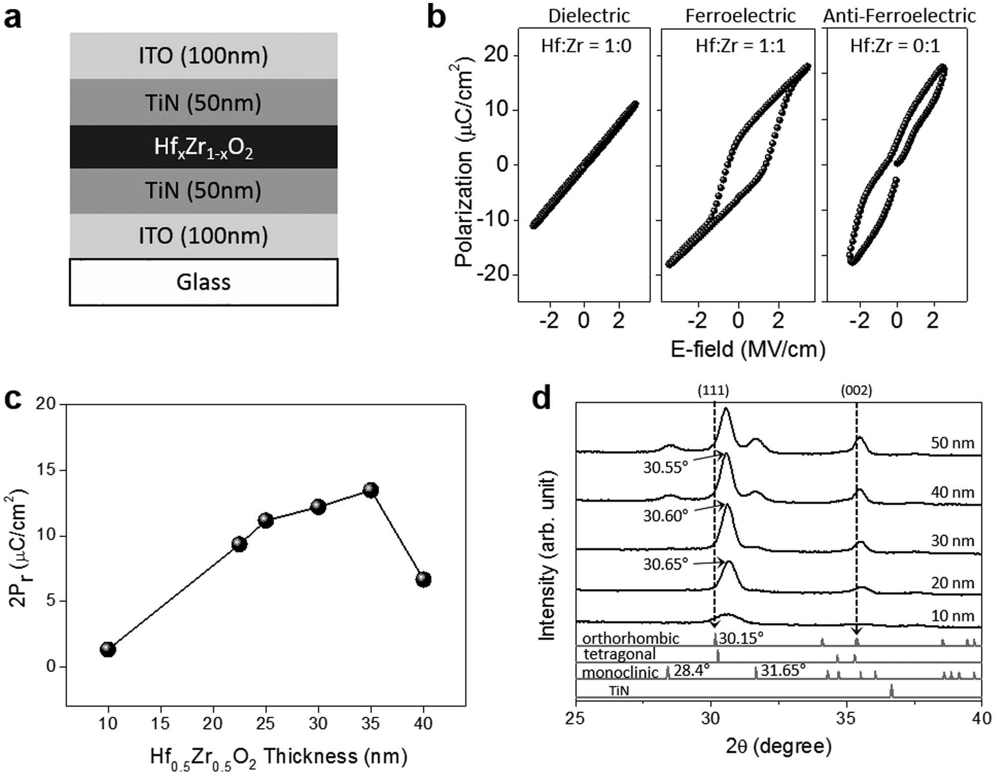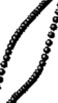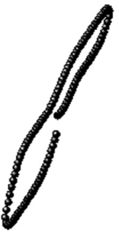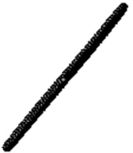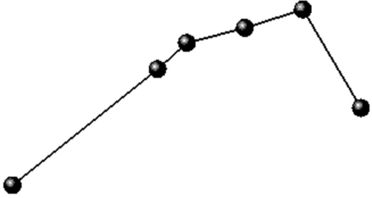



**www.advancedsciencenews.com**  **www.afm-journal.de**

adequate to match with the thermal budget. Formation of the polar orthorhombic phase in HfO2 films can be induced by vari- ous dopants such as Al, Ga, Co/Ni, Si, Gd, Sr, Er, Ba, La, Y, N, and Zr.[8] These dopants appear to contribute to the formation of a nonferroelectric tetragonal phase (*P*42/*nmc*) in HfO2 films which subsequently transform to the ferroelectric orthorhombic phase upon thermal annealing.[1a,9] In this work, Zr dopant was used because it requires a lower activation energy to transform to the orthorhombic phase compared to other dopant systems,[9] allowing lower processing temperatures.

Growth of thin hafnia films on a plastic substrate requires a different processing condition compared to processing on silicon substrates due to the noncrystalline nature of the plastic surface and a lower thermal conductivity of the plastic sub-strate. To understand the crystallization process of hafnia films on amorphous substrates, Hf*x*Zr1−*x*O2 films were grown on glass substrates and the structure of the capacitor used for the study is presented in **Figure1**a. Hf*x*Zr1−*x*O2 films were deposi- ted by atomic layer deposition and the details are given in the Experimental Section. To grow a hafnia ferroelectric thin film, TiN electrodes were used due to their mechanical confinement to suppress the formation of the nonferroelectric phases.[10] Indium tin oxide (ITO) films were used for the contact elec-trodes of the ferroelectric capacitor.

The polarization–electric field behavior of the Hf*x*Zr1−*x*O2 thin film capacitors are shown in Figure 1b with different Zr doping ratio. We found that the resulting capacitors reveal

the dielectric, ferroelectric, and antiferroelectric properties of the films depending on the composition, with a composition of Hf:Zr = 1:1 showing the largest ferroelectric polarization (Figure S1, Supporting Information). The polarization–electric field loop of the ferroelectric capacitor (Hf:Zr = 1:1) shows a shift to the positive bias region due to an asymmetric distribu-tion of charge such as oxygen vacancy across the ferroelectric layer.[11] This ferroelectric-to-nonferroelectric transition due to Zr doping is in agreement with the previous report on Hf*x*Zr1−*x*O2 films on Si substrates.[7a]   
 Figure 1c shows the remnant polarization of the ferroelec-tric capacitor as function of the Hf0.5Zr0.5O2 film thickness (Figure S2, Supporting Information). As seen in the figure, 2*P*r is only 1 µC cm−2 for the 10 nm thick film while 2*P*r> 10 µC cm−2 is observed for films thicker than 20 nm. This is different from the reported Hf0.5Zr0.5O2 ferroelectric films on Si substrates which exhibited the strongest polarization at thick-nesses below 10 nm.[9] The difference may be due to the fact that glass substrates have a much lower thermal conductivity and lower thermal expansion coefficient compared to Si sub-strates, leading to a different growth mechanism of the ferro-electric phase. It is reported that a tensile stress in the doped hafnia film might induce the formation of the ferroelectric orthorhombic phase.[10b] The large difference in thermal expan-sion coefficient between the glass substrate and the hafnia film may be beneficial for such a strain. To understand the phase distribution within the films, grazing incidence X-ray

**Figure 1.** Ferroelectric Hf*x*Zr1−*x*O2 capacitor on glass substrate. a) Device structure, b) polarization–electric field plot with different Zr doping ratios showing dielectric, ferroelectric, or antiferroelectric nature, c) the effect of the Hf0.5Zr0.5O2 film thickness on the remnant polarization (2*P*r), and d) GIXRD data for different Hf0.5Zr0.5O2 film thicknesses from 10 to 50 nm. The sample structure is TiN/Hf0.5Zr0.5O2/TiN/glass and the reference peaks at the bottom are from the powder diffraction peaks of HfO2.

|  |  |  |
| --- | --- | --- |
| *Adv. Funct. Mater.***2017**, *27*, 1700461 | **1700461 (2 of 8)** | © 2017 WILEY-VCH Verlag GmbH & Co. KGaA, Weinheim |

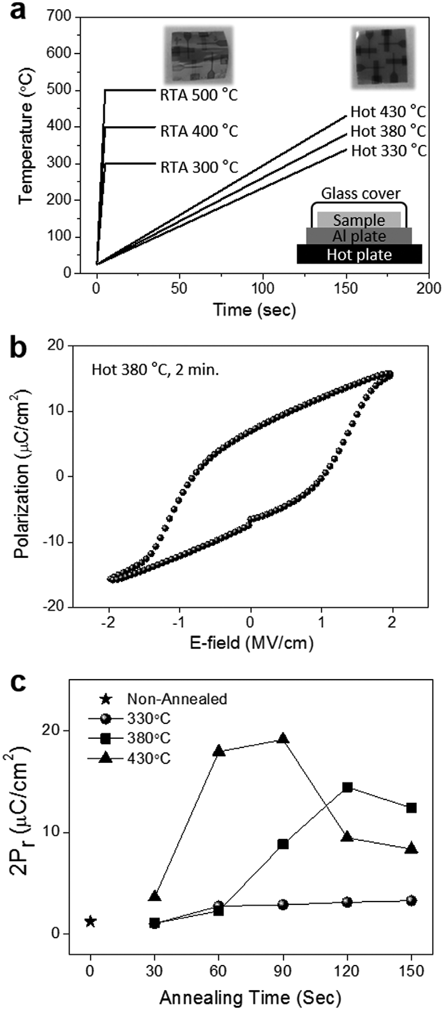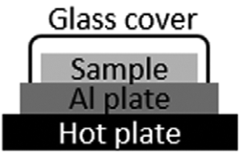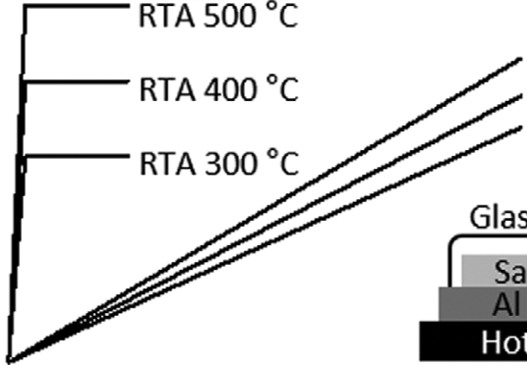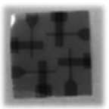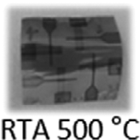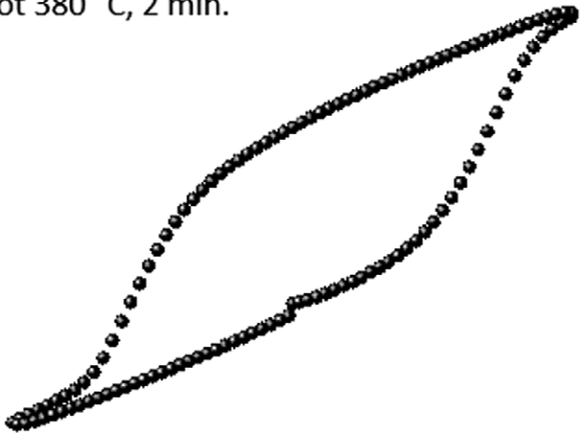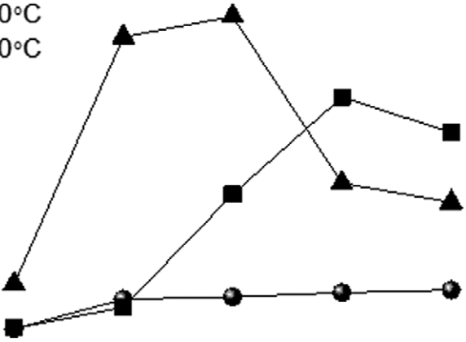



**www.advancedsciencenews.com**  **www.afm-journal.de**

diffraction (GIXRD) was performed on Hf0.5Zr0.5O2 films with   
different thicknesses. As observed in Figure 1d, distinct crys-  
talline peaks appear in the films with a thickness over 20 nm.   
More importantly, as the film thickness increases from 20 to   
40 nm, the diffraction peak at 30.65° shifts to 30.55°. The shift   
in diffraction peak may be due to the increased fraction of the   
ferroelectric orthorhombic phase (peaked at 30.15°) relative to   
the nonferroelectric tetragonal phase (peaked at 30.25°), which   
is also reflected from the data in Figure 1c where *P*r increases   
as the film thickness is increased from 22 to 35 nm. As the film   
thickness is further increased to 40 nm, the intensities of the   
peaks at 28.4° and 31.65° are increased, resulting in an increase   
of the fraction of the nonferroelectric monoclinic phase. In   
addition, for *P*–*E* measurements of the Hf0.5Zr0.5O2 capacitors   
with film thickness larger than 35 nm, the applied electric field   
was reduced from 3 to 2 MV cm−1 due to the electric break-  
down of the capacitors. The abrupt decrease in *P*r between   
35 and 40 nm might result from the lower applied field, sug-  
gesting that the ferroelectric properties can be retained even   
over 40 nm thickness. With a proper interfacial treatment to   
suppress the breakdown, the ferroelectricity of Hf0.5Zr0.5O2   
films thicker than 40 nm may be further improved.[12] From   
these results, we conclude that 30–35 nm is the optimum thick-  
ness for the films grown on glass substrates.

**2.2. Growth of Hf0.5Zr0.5O2 Thin Films on Flexible Substrates**

Using the optimized film described above, a flexible capacitor   
with the following structure of ITO (100 nm)/TiN (50 nm)/   
Hf0.5Zr0.5O2 (30 nm)/TiN (50 nm)/ITO (100 nm)/polyimide   
substrate was fabricated. For the ferroelectric capacitors on   
glass substrates shown in the previous section, rapid thermal   
annealing (RTA) at 500 °C for 30 s was used to crystallize the   
films. However, we observed that the polyimide films deformed   
during the RTA process even at 300 °C due to thermal shock   
as shown in the left inset of **Figure2**a. In order to alleviate   
this problem, the polyimide films were placed in a chamber   
consisting of an aluminum bottom plate and a cover glass   
petri dish with the chamber placed on a preheated hot plate   
as shown in the bottom inset of Figure 2a. The actual sample   
temperature was measured using a thermocouple. By con-  
trolling the heating rate in this setup, thermal degradation of   
the film was not observed even with the substrate heated to a   
temperature up to 430 °C as shown in the right inset of the

Figure 2a. Figure 2b shows the polarization versus electric field of a flexible capacitor after heated at 380 °C for 2 min. A clear hysteresis loop is observed with a 2*P*r value of 15 µC cm−2 at a coercive field of 1 MV/cm, showing a ferroelectric Hf0.5Zr0.5O2 film on the polyimide substrate.

*2.2.1. Effect of Annealing Times and Annealing Temperatures*

The polarization of the flexible capacitor depends on the annealing time and the annealing temperature as shown in Figure 2c (raw data in Figure S3, Supporting Information). The fact that the polarization increases with annealing time indi-cates that the fraction of ferroelectric phase in the Hf0.5Zr0.5O2

**Figure 2.** Ferroelectric Hf0.5Zr0.5O2 capacitor on a polyimide substrate. a) Annealing temperature as function of the annealing time for rapid thermal annealing (RTA) process and hot plate annealing process (HOT). Inset is the optical image taken after RTA at 300 °C for 30 s (left) and the image taken after hot plate annealing at 430 °C for 2 min (right). b) Polari-zation–electric field hysteresis loop for the sample annealed at 380 °C for 120 s, and c) the effect of annealing time and annealing temperature on the remnant polarization.

film increases with annealing time. At 330 °C, the polarization is weak due to insufficient annealing to form the ferroelectric phase. As the temperature is increased from 330 to 430 °C,

|  |  |  |
| --- | --- | --- |
| *Adv. Funct. Mater.***2017**, *27*, 1700461 | **1700461 (3 of 8)** | © 2017 WILEY-VCH Verlag GmbH & Co. KGaA, Weinheim |

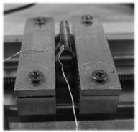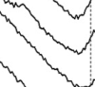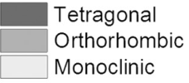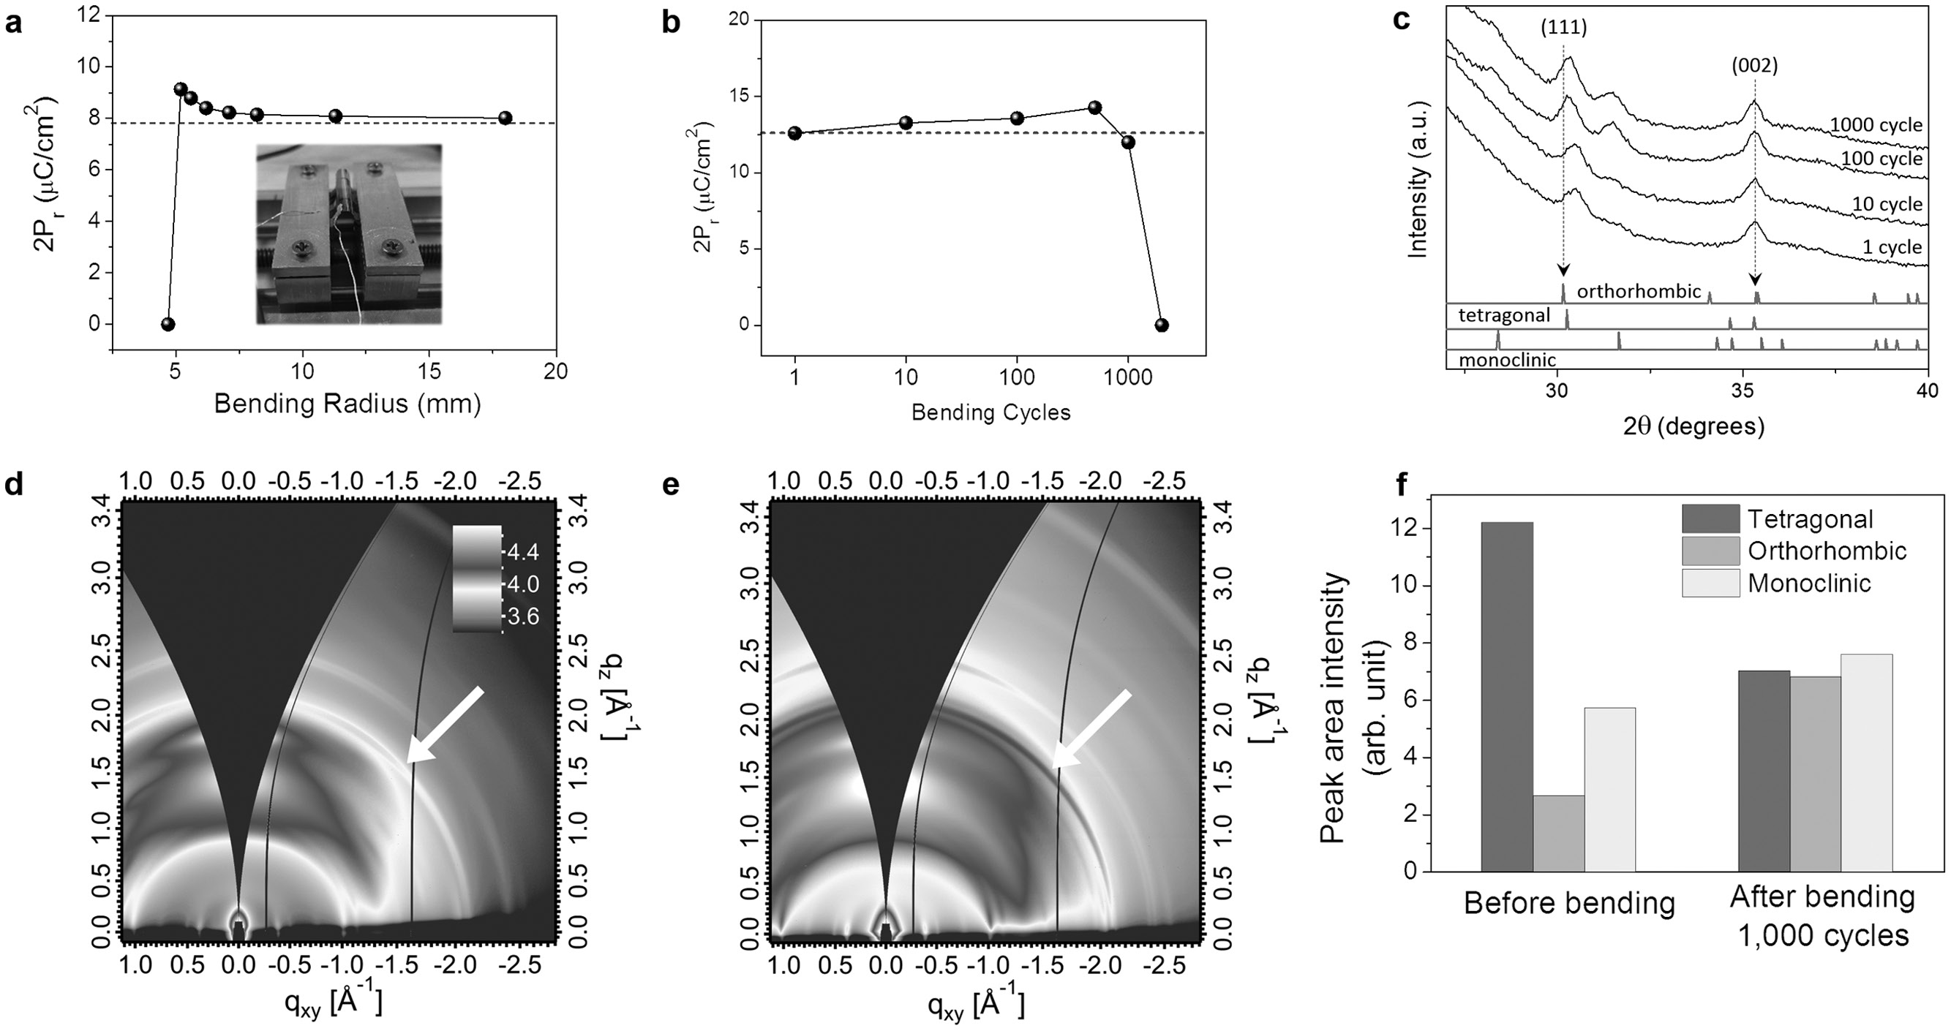



the 2*P*r value increases rapidly as a function of the annealing time, indicating a larger fraction of ferroelectric phase in the Hf0.5Zr0.5O2 film is formed at higher annealing temperatures. The maximum 2*P*r of 19 µC cm−2 observed at 430 °C for 90 s is comparable to the polarization density of the ferroelectric capac-itor on the glass substrates shown in Figure 1c, revealing that the ferroelectricity of the hafnia films does not degrade by the controlled annealing process on plastic substrates. The 2*P*r value of our flexible hafnia film is about 20% larger than the values reported from the flexible organic ferroelectric thin films.[2f,13] From this experiment, we found that the optimum annealing condition of this flexible ferroelectric capacitor is at 380–430 °C for 90–120 s. Temperatures higher than 430 °C could not be applied due to thermal degradation of the polyi-mide substrate. It is noted that compared to the ferroelectric capacitor on the glass substrate, a relatively longer annealing time is required for the polyimide substrates. However, pro-longed annealing to 150 s above 380 °C leads to a decrease in 2*P*r due to thermal degradation of the polyimide substrates.

*2.2.2. Effect of Bending Radius and Bending Cycles*

To test the flexibility of our hafnia films, a bending test was car-ried out. **Figure3**a illustrates the polarization of the capacitor as a function of the bending radius. The dashed line shows the 2*P*r values measured before the bending. The 2*P*r value shows no

degradation in ferroelectricity until the bending radius reaches 5 mm which is comparable as the minimum bending radius demonstrated in previous organic ferroelectric devices.[2b] At radii below 5 mm, extreme bending leads to electrical break-down and no ferroelectric polarization was observed. Figure 3b demonstrates the effect of repetitive bending on remnant polar-ization. Here, the radius for the bending cycle test was fixed at 8 mm. The ferroelectric capacitor endures repetitive bending up to 1000 cycles and bending beyond 2000 cycles resulted in shorting and complete loss of ferroelectricity. This excellent bending tolerance is due to the ultrathin thickness of the fer-roelectric Hf0.5Zr0.5O2 film. It should be noted that a slight increase in 2*P*r is observed as the bending cycle is increased up to about 700 cycles. To understand this effect, laboratory-based GIXRD was performed on samples with different bending cycles. Figure 3c shows the diffraction patterns for samples with different bending cycles. The overall increase of the intensity at 2 theta below 30° is due to the broad diffraction signal from the polyimide substrate (Figure S4, Supporting Information). We found that the diffraction peak at 30.5° is slightly shifted to 30.3° as the bending cycle is increased. This is probably due to an increased fraction of the ferroelectric orthorhombic phase (30.15°) resulting in a slight increase in 2*P*r up to 500 cycles. Park et al. reported that an in-plane tensile stress can elon-gate the *c*-axis of the tetragonal phase and triggers the forma-tion of the orthorhombic phase,[10b] which may account for the observed increase in the orthorhombic phase after a number

**Figure 3.** The effects of bending the flexible ferroelectric hafnia thin film. a) The effect of bending radius on the remnant polarization. The polariza-tion was measured under the bending, b) the effect of bending cycles on the remnant polarization. The bending radius was fixed at 8 mm and the polarization was measured after the cycles. c) GIXRD data for the Hf0.5Zr0.5O2 films with different bending cycles. d) 2D grazing-incidence wide-angle X-ray scattering (2D GIWAXS) data for samples before bending and e) for samples after 1000 of bending cycles. The color scales in both (d) and (e) are log intensity (a.u.) with the number of scale represented in the right upper corner in (d). f) Comparison of the peak area intensity for each phase decomposed from the peak at *q* of 2.1 Å−1 from the out-of-plane GIWAXS data for samples before and after bending 1000 cycles. The reference 2θ positions of the decomposed tetragonal, orthorhombic, and monoclinic phase are 30.25°, 30.15°, and 31.65°, respectively.

|  |  |  |
| --- | --- | --- |
| *Adv. Funct. Mater.***2017**, *27*, 1700461 | **1700461 (4 of 8)** | © 2017 WILEY-VCH Verlag GmbH & Co. KGaA, Weinheim |

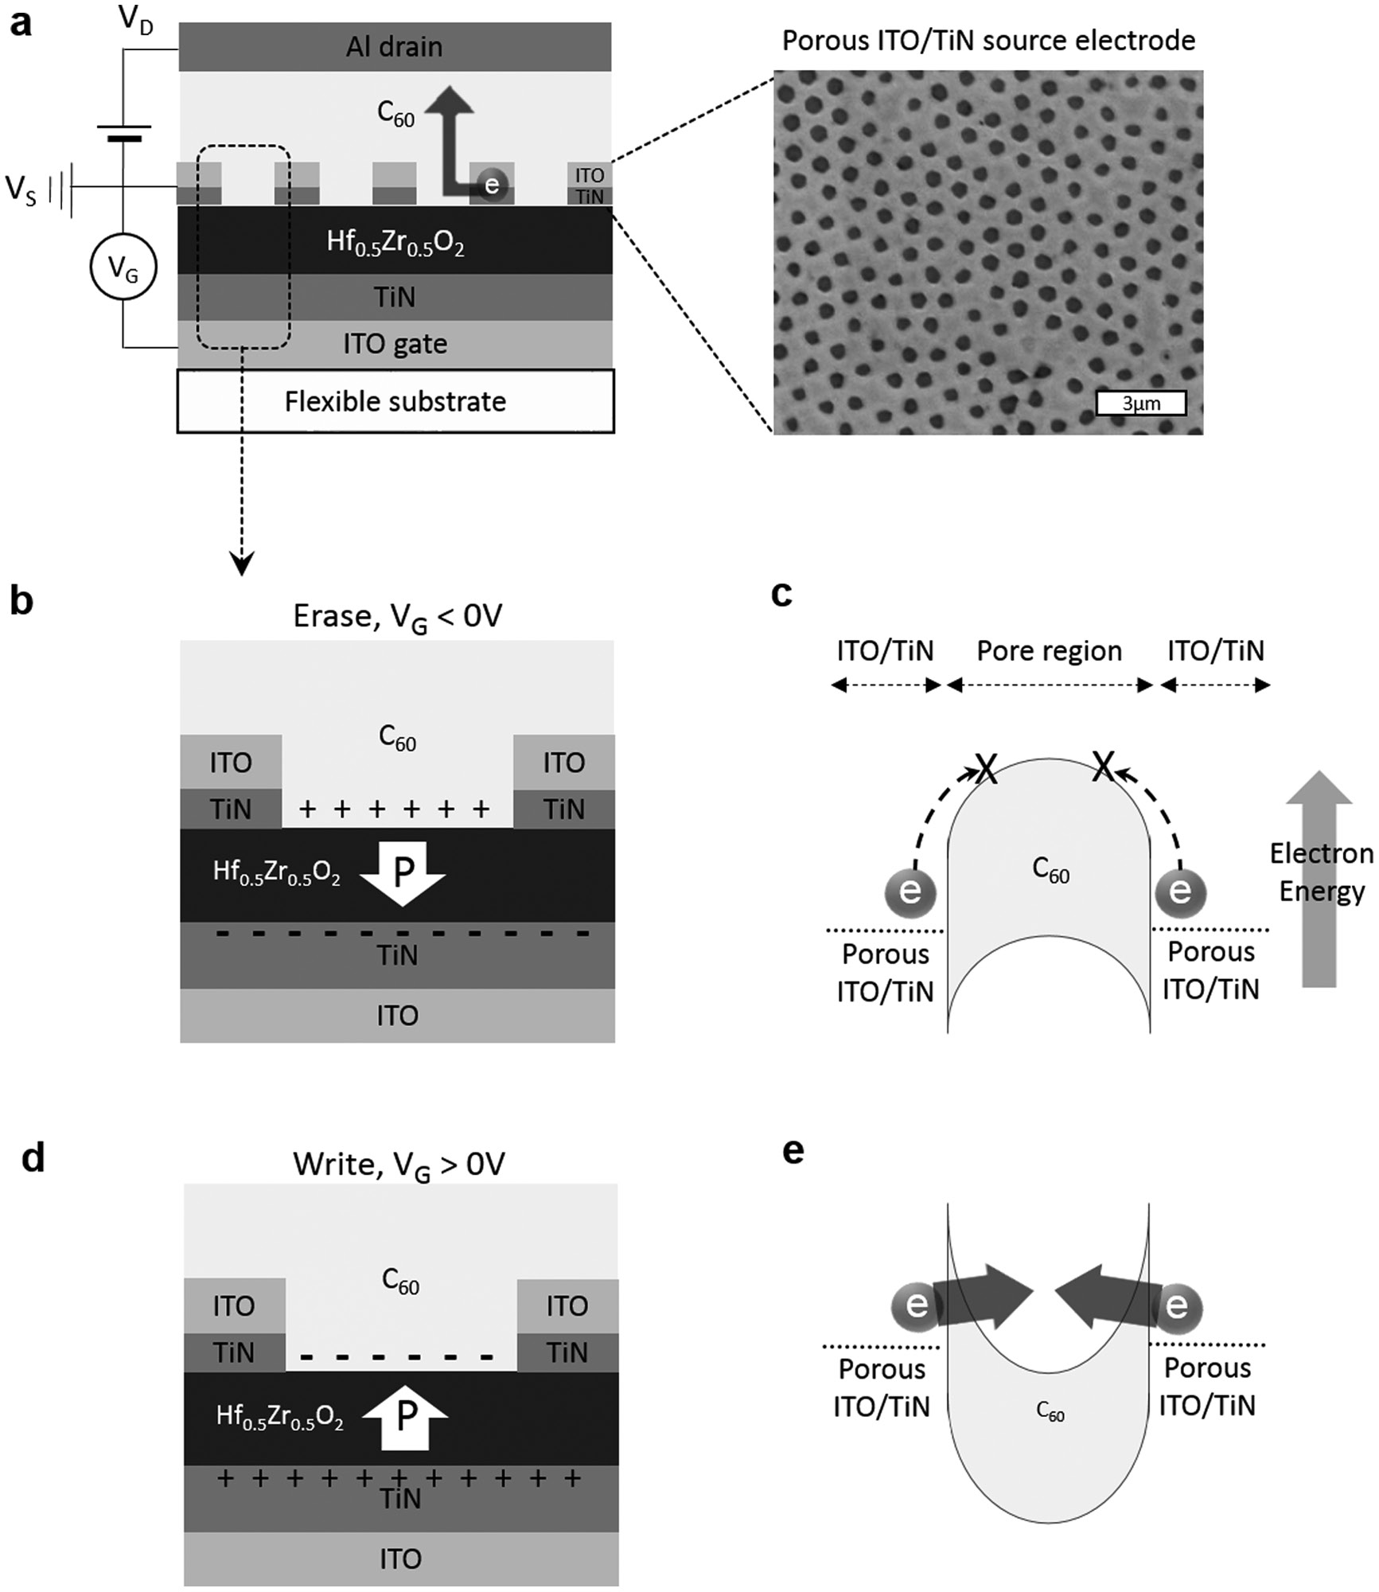



of bending cycles. The increase in 2*P*r was   
not due to an effect of the leakage cur-  
rent because the current in the device was   
unchanged until the electrical short occurs   
at 2000 cycles (Figure S5, Supporting Infor-  
mation). It is noted that the peak intensity at   
31.5° is also increased at bending cycles over   
100, indicating an increased fraction of non-  
ferroelectric monoclinic phase and accounts   
for the slight decrease in 2*P*r at 1000 cycles as   
observed in Figure 3b.

The phase distribution after the bending   
was further investigated by synchroton facility   
based 2D grazing incidence wide-angle X-ray   
scattering (2D GIWAXS) measurements.   
The 2D GIWAXS data for the sample before   
and after bending 1000 cycles are shown   
in Figure 3d,e, respectively. The feature at   
*q*≈ 2.1 Å−1 in both figures is equivalent to the   
diffraction peak at 30.5° in the GIXRD data   
shown in Figure 3c. The phase distribution   
along the out-of-plane direction was analyzed   
by decomposing the peaks about 2.1 Å−1 into   
the reference peaks of monoclinic, tetragonal,   
and orthorhombic phases and comparing   
the area intensity of each peak in 1D profile.   
As shown in Figure 3f, the fraction of the   
tetragonal peak decreases after 1000 bending   
cycles, while the fractions corresponding to   
the orthorhombic peak and the monoclinic   
peak increase. This semiquantitative analysis   
suggests that the tetragonal phase transforms   
to the orthorhombic phase and monoclinic

phase after bending which is consistent with our analysis in the previous section. From the 2D GIWAXS data, we also found there is an orientation preference for these features, with the peak intensity at 2.1 Å−1 being the highest at 45° in azimuthal angle both for bent and nonbent samples as indicated by the white arrows in the Figure 3d,e (see also

**Figure 4.** Device structure and mechanism of the nonvolatile vertical organic transistor on the flexible substrate. a) Device structure and scanning-electron microscope image of the porous ITO/TiN source electrode. b) Ferroelectric polarization of the porous electrode region after a negative gate voltage applied (erase). Arrow of “P” indicates the direction of the ferroelectric polarization in the Hf0.5Zr0.5O2 layer. c) Energy band diagram of the porous electrode region in (b). d) Ferroelectric polarization of the porous electrode region after a positive gate voltage applied (write). e) Energy band diagram of the porous electrode region in (d).

Figure S7, Supporting Information). This preferred orientation of the porous ITO/TiN electrode with the average pore size of

may be due to the effect of the capping electrodes that induce 800 nm.

mechanical strains during the growth of the hafnia films and

hence affect the crystallographic orientation.[14]

**3.1. Operation Mechanism**

**3. Nonvolatile Vertical Organic Field-Effect Transistors**

Making use of these ferroelectric Hf0.5Zr0.5O2 films as a gate insulator, we developed nonvolatile memory devices on flexi ble substrates. **Figure4**a illustrates the device structure of the

nonvolatile memory device based on a vertical field-effect tran-

sistor (VFET) architecture consisting of Al drain electrode/C60 channel/porous ITO/porous TiN source electrode/ferroelectric

Hf0.5Zr0.5O2/TiN gate electrode/ITO gate electrode/flexible substrate. The inset is the scanning electron microscope image

The operation mechanism of the nonvolatile memory is explained in Figures 4b,e. When a negative voltage pulse is applied to the TiN/ITO gate electrode, the ferroelectric domains of the Hf0.5Zr0.5O2 layer align in such a way that the polarization direction points downward as shown in Figure 4b. Hence, posi-

tive charges are retained in the C60 layer in the porous region and the potential energy of the C60 layer increases, leading to the upward band bending of the C60 layer as shown in Figure 4c. Due to the large difference between the work-function of ITO

(5.1 eV) and the lowest unoccupied molecular orbital level of

C60 (4.2 eV), the upward band bending significantly suppresses

|  |  |  |
| --- | --- | --- |
| *Adv. Funct. Mater.***2017**, *27*, 1700461 | **1700461 (5 of 8)** | © 2017 WILEY-VCH Verlag GmbH & Co. KGaA, Weinheim |

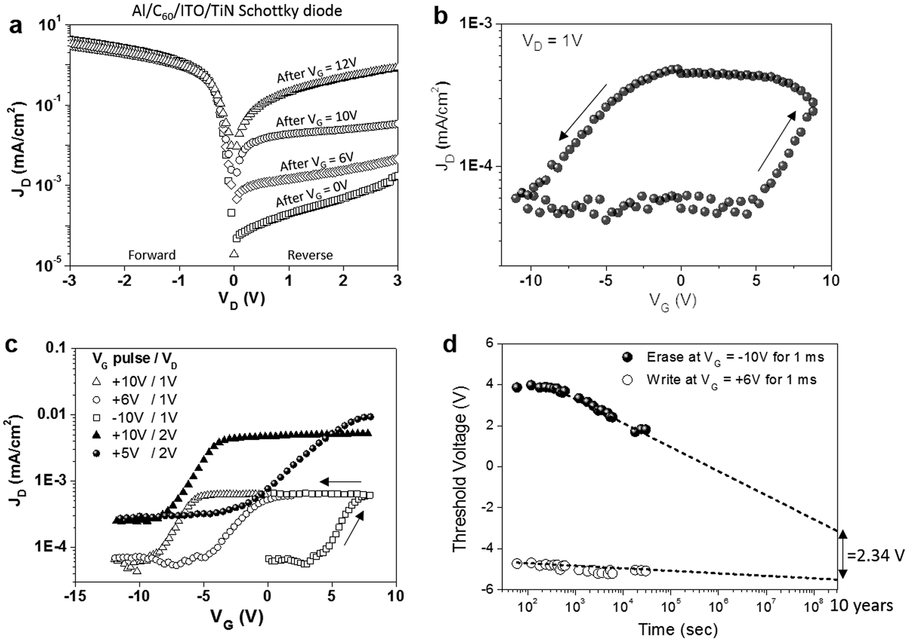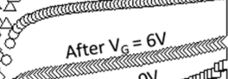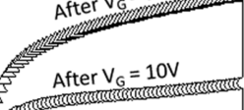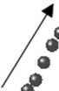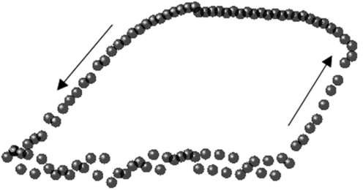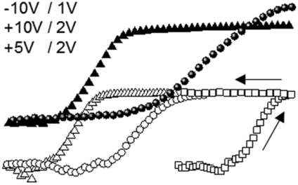



the electron injection from the porous electrode to the C60 layer, resulting in a negligible drain current. The nonvolatility of the ferroelectric polarization will suppress the drain current (erase state) even after removing the gate voltage. When a positive gate bias is applied, on the other hand, the ferroelectric domain in the Hf0.5Zr0.5O2 layer switches its polarity and negative charges accumulate at the C60/Hf0.5Zr0.5O2 interface, resulting in a decrease of the potential energy of the C60 layer. This, in turn, induces a strong downward band bending and electron tun-neling through the Schottky barrier leading to a high drain cur-rent (write state). We have reported VFETs using the HfO2 gate dielectric layer.[15] It is noted that the only difference between the reported VFETs with the HfO2 gate insulating layer and the nonvolatile VFET with Hf0.5Zr0.5O2 gate insulating layer in this work is that the Hf0.5Zr0.5O2 layer can retain the polarization after removing the gate voltage, whereas the polarization of the HfO2 dielectric layer in the reported VFETs disappears after removing the gate voltage.

**3.2. Device Performance**

**Figure5**a shows the diode plots measured from the Al/C60/ porous ITO/TiN Schottky diode after applying different gate voltages. Initial diode measurements without a gate bias reveal a high rectification of the Schottky diode. After applying a posi-tive gate pulse of 6 V where a positive gate bias was applied for 1 s and the gate voltage goes back to zero, the reverse current of the Schottky diode was increased. This is due to an increased electron injection from the porous ITO source electrode to the

C60 channel layer due to the ferroelectric effect. The reverse current was increased further after applying larger gate pulses

due to the stronger ferroelectric polarization of the Hf0.5Zr0.5O2 gate insulator. We also confirm that the programmed reverse

currents can return to the initial state by applying a negative gate voltage pulse of −12 V for 1 s. Figure 5b shows the cyclic transfer curve of the ferroelectric VFET. A gate voltage pulse of −10 V for 1 s was applied prior to the transfer measurement to reset the memory. The stronger negative threshold voltage of −10 V observed in the transfer curve compared to the coercive voltage of only −4 V shown from the capacitor in Figure 2b may be due to the effect of remnant charges in the C60 layer. If a positive gate voltage is applied and electrons are retained in the

C60 layer, a strong negative gate voltage is required to switch the polarity, whereas the capacitor structure being absent of the C60 layer has no such effect.

It should also be noted that by controlling the gate voltage

(*V*G), different threshold voltages can be programmed. Figure 5c presents transfer curves measured after applying dif-

ferent *V*G pulse and *V*D. The detailed mechanism is illustrated in Figure S8 (Supporting Information). When a *V*G pulse of 10 V is applied with *V*D= 1 V, the threshold voltage is −10 V because there are sufficient negative charges remaining in the

porous region to turn on the transistor. When a smaller *V*G pulse of 6 V is applied, on the other hand, the threshold voltage is increased to −5 V due to insufficient remnant charges in the porous region to turn on the transistor. When a *V*G pulse of −10 V is applied, the memory is fully reset and positive charges remain in the porous region. Therefore, a larger *V*G is required to turn on the transistor leading to the largest threshold voltage

**Figure 5.** Device performance of vertical ferroelectric field-effect transistor on the polyimide substrate. a) Current density–voltage characteristic of Al/C60/ITO/TiN Schottky diode after applying different gate voltage pulses, b) cyclic transfer curve of the transistor at a source–drain voltage of 1 V, c) transfer curve at different gate voltage pulses showing different programmed and erased states, and d) retention characteristic of the programmed and erased threshold voltages. Memory window extrapolated to 10 years is marked.

|  |  |  |
| --- | --- | --- |
| *Adv. Funct. Mater.***2017**, *27*, 1700461 | **1700461 (6 of 8)** | © 2017 WILEY-VCH Verlag GmbH & Co. KGaA, Weinheim |



of 4 V. The threshold voltage was not affected by changing the drain voltage from 1 to 2 V as shown in Figure 5c.

Retention or endurance characteristics are crucial para-meters in evaluating the feasibility of a memory device. We measured the threshold voltage of the transfer curve under pro-grammed bias (after applied bias of *V*G=+6 V for 1 ms) and reset (after reset bias of *V*G=−10 V for 1 ms) states for 30 000 s. As seen in Figure 5d, the initial memory window of 8.6 V (difference between the threshold voltages of program and reset) is decreased to 6.9 V after 30 000 s. Compared to the nearly con-stant threshold voltages programmed at *V*G=+6 V as a function of time, the threshold voltage at a reset *V*G of −10 V is slightly decreased. This endurance fatigue may be due to charge trap-ping effects at the ferroelectric/gate interface during the reten-tion period.[16,17] Nonetheless, the extrapolation of the retention characteristics to 10 years yields a memory window of 2.3 V.

It is noted that both the gate pulse of −10 V for 1 ms (Figure 5d) and for 1 s (Figure 5b) gave a similar threshold voltage of 4 V. It suggests that the effect of the gate pulse width on the threshold voltage is similar between 1 s and 1 ms. How-ever, Müller et al. reported that a gate pulse shorter than 1 ms gradually decreases the memory window.[18]

devices have an active area of 0.01 cm2. Finally, the whole device was annealed using a rapid thermal annealing at 500 °C for 30 s.

*Fabrication of Ferroelectric Capacitors on Flexible Substrates*: Polyimide substrates (Kapton, PI9101 from Dupont) were cleaned by isopropanol for 15 min in an ultrasonic bath. Then, the substrate was attached to a glass substrate of the same dimension by using a polyimide tape. Next, 100 nm thick ITO film and 50 nm thick TiN film were sputter-deposited on the substrate using a shadow mask as the bottom electrode. Immediately after the sputtering, the sample was moved to the ALD chamber for Hf0.5Zr0.5O2 film deposition at 250 °C. After the ALD film growth, 50 nm thick TiN film and 100 nm thick ITO film were deposited as the top electrode. Next, the sample was placed on an aluminum plate covered with a glass petri dish. The plate was then placed on a preannealed hot plate at 330–430 °C for up to 150 s in a glove box with nitrogen atmosphere.

*Fabrication of Ferroelectric VFET on Flexible Substrates*: After deposition of 30 nm thick Hf0.5Zr0.5O2 film on TiN/ITO/polyimide substrate in the previous section, colloidal lithography was used to make a porous ITO/ TiN source electrode. The detailed procedure is given in our previous work.[14] Monolayer polystyrene layer was formed by Langmuir–Blodgett technique on the Hf0.5Zr0.5O2 film surface. Then, TiN and ITO film were deposited using the polystyrene layer as a shadow mask. Next, removal of the polystyrene layer left a porous ITO/TiN electrode on the surface of the Hf0.5Zr0.5O2 film. Next, a 500 nm thick C60 film was thermal-evaporated on the porous structure for a vertical organic channel layer. To finish the device fabrication, a 100 nm thick Al film was deposited for the top drain electrode. The active device area is 0.01 cm2.

|  |  |  |  |  |  |
| --- | --- | --- | --- | --- | --- |
| *Film* | *and* | *Device* | *Characterization*: | Polarization–electric | field |

|  |  |
| --- | --- |
| **4. Conclusion** | measurements were performed using a Radiant Precision Multiferroic Tester. All hysteresis curves were acquired using a bipolar waveform with |

In summary, we have demonstrated ferroelectric hafnia thin films on plastic substrates by developing a nonrapid thermal annealing process. The formation of the ferroelectric phase and hence the polarization were prominent at the ferroelectric film thickness over 20 nm due to the usage of the amorphous plastic substrate. The ferroelectricity was retained at a bending radius below 8 mm and up to 1000 bending cycles. We also observed the evolution of the ferroelectric phase with increased bending cycles which was confirmed by 2D GIWAXS measurements. Finally, a novel, vertical, ferroelectric transistor was demon-strated with 10 years of retention characteristic extrapolated. The delineated work represents a new opportunity of flexible applications based on inorganic ferroelectric films for future

a frequency of 1 kHz. Before measuring the hysteresis, 10 000 cycles of sine wave electric field (2 MV cm−1 and 1 kHz) was applied to wake up the ferroelectric film. The performance of VFeFET was measured using Keithley 4200 where the gate voltage pulse was applied and the transfer characteristic was analyzed. For the bending test, a customized bending machine consisting of metal clamps to hold a flexible substrate on both sides and an automatic handle to vary the distance between the clamps to control the bending radius was used (Figure S9, Supporting Information). The bending radius was precisely controlled and calculated by comparing the distance before and after the bending. GIXRD was performed on the Hf*x*Zr1−*x*O2 films with a Rigaku SmartLab X-Ray Diffractometer with a grazing incidence angle of 0.5°, a 0.05° step size, and a 4 s count time per step. Details of the 2D GIWAXS measurements are in the Supporting Information.

|  |  |
| --- | --- |
| memory devices. | **Supporting Information** |

Supporting Information is available from the Wiley Online Library or **5. Experimental Section**  from the author.

*Fabrication of Ferroelectric Capacitors on Glass Substrates*: An ITO/

glass substrate was cleaned by acetone and isopropanol for 15 min, respectively, in an ultrasonic bath. Next, a 50 nm thick TiN film was deposited on the substrate by radiofrequency sputtering at 2 mTorr of chamber pressure and 50 sccm of Ar flow (Kurt J. Lesker PVD system, PRD036170) from a TiN target (purchased from Kurt J. Lesker). Immediately after sputtering, the sample was moved to an atomic layer deposition (ALD) chamber (Ultratech Savannah 200) for growth of Hf*x*Zr1−*x*O2 films. Tetrakis(dimethylamino)hafnium (Strem Chemical, Inc., 98-4021) was used for Hf precursor and tetrakis(dimethylamino) zirconium (Strem Chemical, Inc., 98-4012) was used for Zr precursor. Ozone was used for oxygen source in the ALD chamber. To control the Zr doping ratio, different cycles of HfO2 and ZrO2 recipe were used at a chamber temperature of 250 °C. For Hf:Zr = 1:1 doping ratio, alternative cycles of HfO2 and ZrO2 recipe were used where each cycle corresponds to 0.95 Å thick film. After deposition of the Hf*x*Zr1−*x*O2 film, 50 nm thick TiN and ITO films were sputter-deposited as the top electrode. All the

**Acknowledgements**

The authors appreciate the financial support from Nanoholdings LLC. This work was performed in part at the Analytical Instrumentation Facility (AIF) at North Carolina State University, which is supported by the State of North Carolina and the National Science Foundation (award number ECCS-1542015). The AIF is a member of the North Carolina Research Triangle Nanotechnology Network (RTNN), a site in the National Nanotechnology Coordinated Infrastructure (NNCI). C.-C.C. and J.L.J. also acknowledge support by the Army Research Office under Grant No. W911NF-15-1-0593. The authors appreciate Dr. Joo-Hyun Kim for her help and comments on the sample preparation for GIWAXS measurement. Work by J.H.C. and H.A. was supported by a Research Opportunity Grant by the UNC General Administration. All figures were replaced with optimized versions on June 6, 2017, following online publication.

|  |  |  |
| --- | --- | --- |
| *Adv. Funct. Mater.***2017**, *27*, 1700461 | **1700461 (7 of 8)** | © 2017 WILEY-VCH Verlag GmbH & Co. KGaA, Weinheim |



**Conflict of Interest**   
The authors declare no conflict of interest.

c) M. H. Park, H. J. Kim, Y. J. Kim, T. Moon, K. D. Kim, C. S. Hwang, *Adv. Energy Mater.***2014**, *4*; d) M. Hoffmann, U. Schroeder, C. Künneth, A. Kersch, S. Starschich, U. Böttger, T. Mikolajick, *Nano Energy***2015**, *18*, 154.

[8] a) U. Schroeder, E. Yurchuk, J. Müller, D. Martin, T. Schenk,

**Keywords**  P. Polakowski, C. Adelmann, M. I. Popovici, S. V. Kalinin,

T. Mikolajick, *Jpn. J. Appl. Phys.***2014**, *53*, 08LE02; b) L. Xu,

ferroelectric materials, flexible electronics, hafnia films, low-temperature T. Nishimura, S. Shibayama, T. Yajima, S. Migita, A. Toriumi, *Appl.*

processes, nonvolatile memory *Phys. Express***2016**, *9*, 091501; c) S. Starschich, U. Boettger, *J. Mater.*

Received: January 24, 2017 *Chem. C***2017**, *5*, 333.

Revised: March 10, 2017 [9] M. Hyuk Park, H. Joon Kim, Y. Jin Kim, W. Lee, T. Moon, C. Seong Hwang,

Published online: April 12, 2017

[1] a) M. H. Park, Y. H. Lee, H. J. Kim, Y. J. Kim, T. Moon, K. D. Kim, J. Müller, A. Kersch, U. Schroeder, T. Mikolajick, *Adv. Mater.***2015**, *27*, 1811; b) C. A.-P. de Araujo, J. Cuchiaro, L. McMillan, M. Scott, J. Scott, *Nature***1995**, *374*, 627; c) J. F. Scott, C. A. Paz de Araujo, *Science***1989**, *246*, 1400.

*Appl. Phys. Lett.***2013**, *102*, 242905.

[10] a) T. Böscke, S. Teichert, D. Bräuhaus, J. Müller, U. Schröder, U. Böttger, T. Mikolajick, *Appl. Phys. Lett.***2011**, *99*, 112904; b) M. Hyuk Park, H. Joon Kim, Y. Jin Kim, T. Moon, C. Seong Hwang, *Appl. Phys. Lett.***2014**, *104*, 072901.

[11] a) W. Warren, D. Dimos, G. Pike, B. Tuttle, M. Raymond, R. Ramesh, J. Evans Jr., *Appl. Phys. Lett.***1995**, *67*, 866; b) M. Pešic´, F. P. G. Fengler, L. Larcher, A. Padovani, T. Schenk, E. D. Grimley, X. Sang, J. M. LeBeau, S. Slesazeck, U. Schroeder, *Adv. Funct. Mater.*

[2] a) R. C. Naber, C. Tanase, P. W. Blom, G. H. Gelinck, A. W. Marsman, **2016**, *26*, 4601.

F. J. Touwslager, S. Setayesh, D. M. De Leeuw, *Nat. Mater.***2005**, [12] H. J. Kim, M. H. Park, Y. J. Kim, Y. H. Lee, W. Jeon, T. Gwon,

*4*, 243; b) S. K. Hwang, I. Bae, R. H. Kim, C. Park, *Adv. Mater.*  T. Moon, K. D. Kim, C. S. Hwang, *Appl. Phys. Lett.***2014**, *105*,

**2012**, *24*, 5910; c) C. Li, P.-M. Wu, S. Lee, A. Gorton, M. J. Schulz, 192903.

C. H. Ahn, *J. Microelectromech. Syst.***2008**, *17*, 334; d) I. Bretos, R. Jiménez, A. Wu, A. I. Kingon, P. M. Vilarinho, M. L. Calzada, *Adv.*

*Mater.***2014**, *26*, 1405; e) M. Owczarek, K. A. Hujsak, D. P. Ferris, A. Prokofjevs, I. Majerz, P. Szklarz, H. Zhang, A. A. Sarjeant, C. L. Stern, R. Jakubas, *Nat. Commun.***2016**, *7*, 13108; f) W. Gao, L. Chang, H. Ma, L. You, J. Yin, J. Liu, Z. Liu, J. Wang, G. Yuan, *NPG Asia Mater.***2015**, *7*, e189.

[3] a) A. K. Tagantsev, I. Stolichnov, N. Setter, J. S. Cross, M. Tsukada, *Phys. Rev. B***2002**, *66*, 214109; b) B. Melnick, C. P. de Araujo, L. McMillan, D. Carver, J. Scott, *Ferroelectrics***1991**, *116*, 79.

[4] J. F. Scott, *Ferroelectric Memories*, Springer Science & Business Media, New York **2013**.

[5] S. I. Park, J. H. Ahn, X. Feng, S. Wang, Y. Huang, J. A. Rogers, *Adv.*  *Funct. Mater.***2008**, *18*, 2673.

[6] a) J. Rho, S. J. Kim, W. Heo, N.-E. Lee, H.-S. Lee, J.-H. Ahn, *IEEE Electron Device Lett.***2010**, *31*, 1017; b) Y. Qi, N. T. Jafferis, K. Lyons Jr., C. M. Lee, H. Ahmad, M. C. McAlpine, *Nano Lett.***2010**, *10*, 524; c) W. Lee, O. Kahya, C. T. Toh, B. Özyilmaz, J.-H. Ahn, *Nanotechnology***2013**, *24*, 475202.

[13] a) Z. Lü, T. Pu, Y. Huang, X. Meng, H. Xu, *Nanotechnology***2015**, *26*, 055202; b) T. Sekine, R. Sugano, T. Tashiro, K. Fukuda, D. Kumaki, F. D. Dos Santos, A. Miyabo, S. Tokito, *Jpn. J. Appl. Phys.***2016**, *55*, 10TA18; c) D. Thuau, M. Abbas, G. Wantz, L. Hirsch, I. Dufour, C. Ayela, *Org. Electron.***2017**, *40*, 30; d) K. L. Kim, W. Lee, S. K. Hwang, S. H. Joo, S. M. Cho, G. Song, S. H. Cho, B. Jeong, I. Hwang, J.-H. Ahn, *Nano Lett.***2015**, *16*, 334.

[14] P. D. Lomenzo, P. Zhao, Q. Takmeel, S. Moghaddam, T. Nishida, M. Nelson, C. M. Fancher, E. D. Grimley, X. Sang, J. M. LeBeau, *J. Vac. Sci. Technol., B: Nanotechnol. Microelectron.: Mater., Process., Meas., Phenom.***2014**, *32*, 03D123.

[15] a) H. Yu, D. Kim, J. Lee, S. Baek, J. Lee, R. Singh, F. So, *Nat. Photo-nics***2016**, *10*, 129; b) H. Yu, Z. Dong, J. Guo, D. Kim, F. So, *ACS Appl. Mater. Interfaces***2016**, *8*, 10430.

[16] S. Mueller, J. Muller, R. Hoffmann, E. Yurchuk, T. Schlosser, R. Boschke, J. Paul, M. Goldbach, T. Herrmann, A. Zaka, *IEEE Trans. Electron Devices***2013**, *60*, 4199.

[17] P. D. Lomenzo, Q. Takmeel, C. Zhou, Y. Liu, C. M. Fancher, J. L. Jones, S. Moghaddam, T. Nishida, *Appl. Phys. Lett.***2014**, *105*,

[7] a) J. Müller, T. S. Böscke, U. Schröder, S. Mueller, D. Bräuhaus, 072906.

U. Böttger, L. Frey, T. Mikolajick, *Nano Lett.***2012**, *12*, 4318; b) S. Mueller, J. Mueller, A. Singh, S. Riedel, J. Sundqvist, U. Schroeder, T. Mikolajick, *Adv. Funct. Mater.***2012**, *22*, 2412;

[18] J. Müller, E. Yurchuk, T. Schlösser, J. Paul, R. Hoffmann, S. Müller, D. Martin, S. Slesazeck, P. Polakowski, J. Sundqvist, presented at Symp. on VLSI Technology (VLSIT), Hawaii, USA, June **2012**.

|  |  |  |
| --- | --- | --- |
| *Adv. Funct. Mater.***2017**, *27*, 1700461 | **1700461 (8 of 8)** | © 2017 WILEY-VCH Verlag GmbH & Co. KGaA, Weinheim |