**Chemical solution deposition of ferroelectric yttrium-doped hafnium oxide films on platinum electrodes**

[S. Starschich](http://aip.scitation.org/author/Starschich%2C+S), [D. Griesche](http://aip.scitation.org/author/Griesche%2C+D), [T. Schneller](http://aip.scitation.org/author/Schneller%2C+T), [R. Waser](http://aip.scitation.org/author/Waser%2C+R), and [U. Böttger](http://aip.scitation.org/author/B%C3%B6ttger%2C+U)

Citation: Appl. Phys. Lett.**104**, 202903 (2014); doi: 10.1063/1.4879283

View online: <https://doi.org/10.1063/1.4879283>

View Table of Contents: <http://aip.scitation.org/toc/apl/104/20>

Published by the [American Institute of Physics](http://aip.scitation.org/publisher/)

**Articles you may be interested in**

[Ferroelectricity in hafnium oxide thin films](http://aip.scitation.org/doi/abs/10.1063/1.3634052)   
[Applied Physics Letters](http://aip.scitation.org/doi/abs/10.1063/1.3634052) **[99](http://aip.scitation.org/doi/abs/10.1063/1.3634052)**[, 102903 (2011](http://aip.scitation.org/doi/abs/10.1063/1.3634052)); 10.1063/1.3634052

[Stabilizing the ferroelectric phase in doped hafnium oxide](http://aip.scitation.org/doi/abs/10.1063/1.4927805)   
[Journal of Applied Physics](http://aip.scitation.org/doi/abs/10.1063/1.4927805) **[118](http://aip.scitation.org/doi/abs/10.1063/1.4927805)**[, 072006 (2015); 10.1063/](http://aip.scitation.org/doi/abs/10.1063/1.4927805)1.4927805

[Ferroelectricity in yttrium-doped hafnium oxide](http://aip.scitation.org/doi/abs/10.1063/1.3667205)   
[Journal of Applied Physics](http://aip.scitation.org/doi/abs/10.1063/1.3667205) **[110](http://aip.scitation.org/doi/abs/10.1063/1.3667205)**[, 114113 (2011)](http://aip.scitation.org/doi/abs/10.1063/1.3667205); 10.1063/1.3667205

[Ferroelectricity in undoped hafnium oxide](http://aip.scitation.org/doi/abs/10.1063/1.4922272)   
[Applied Physics Letters](http://aip.scitation.org/doi/abs/10.1063/1.4922272) **[106](http://aip.scitation.org/doi/abs/10.1063/1.4922272)**[, 232905 (201](http://aip.scitation.org/doi/abs/10.1063/1.4922272)5); 10.1063/1.4922272

[Enhancing ferroelectricity in dopant-free hafnium oxide](http://aip.scitation.org/doi/abs/10.1063/1.4973928)   
[Applied Physics Letters](http://aip.scitation.org/doi/abs/10.1063/1.4973928) **[110](http://aip.scitation.org/doi/abs/10.1063/1.4973928)**[, 022903 (2017); 10.1063/1](http://aip.scitation.org/doi/abs/10.1063/1.4973928).4973928

[Co-sputtering yttrium into hafnium oxide thin films to produce ferroelectric properties Applied Physics Letters](http://aip.scitation.org/doi/abs/10.1063/1.4747209) **[101](http://aip.scitation.org/doi/abs/10.1063/1.4747209)**[, 082905 (2012); 10.1063/1.4747209](http://aip.scitation.org/doi/abs/10.1063/1.4747209)



APPLIED PHYSICS LETTERS 104, 202903 (2014) 

[Chemical solution deposition of ferroelectric yttrium-doped hafnium oxide films on platinum electrodes](http://dx.doi.org/10.1063/1.4879283)

S. Starschich,1D. Griesche,1T. Schneller,1R. Waser,1,2and U. B€ottger1 1Institut f€ur Werkstoffe der Elektrotechnik 2, RWTH Aachen University, Sommerfeldstraße 24, D-52074 Aachen, Germany   
2Peter Gr€unberg Institut 7, Forschungszentrum J€ulich GmbH, D-52425 J€ulich, Germany

(Received 17 April 2014; accepted 11 May 2014; published online 21 May 2014)

Ferroelectric hafnium oxide films were fabricated by chemical solution deposition with a remnant polarization of >13 lC/cm2. The samples were prepared with 5.2 mol.% yttrium-doping and the thickness varied from 18 nm to 70 nm. The hafnium oxide layer was integrated into a metal-insulator-metal capacitor using platinum electrodes. Due to the processing procedure, no thickness dependence of the ferroelectric properties was observed. To confirm the ferroelectric nature of the deposited samples, polarization, capacitance, and piezoelectric displacement measurements were performed. However, no evidence of the orthorhombic phase was found which has been proposed to be the non-centrosymmetric, ferroelectric phase in HfO2. V   
C 2014 AIP Publishing LLC. [<http://dx.doi.org/10.1063/1.4879283>]

Ferroelectric memories are promising candidates for future high density, low power, and nonvolatile memory technology. The perovskite structured lead zirconate titanate (PZT) is up to now the state-of-the-art material for ferroelec-tric memory fabrication.1The drawback of PZT and many other ferroelectric materials is the difficult integration into the CMOS technology and the partially toxic materials used, such as lead. As a consequence, the integration density is much lower compared to, e.g., NAND Flash.2Hafnium oxide is widely used as a dielectric in CMOS and DRAM devices and can overcome the common integration problems for fer-roelectric materials due to its CMOS compatibility.3 Recently, the ferroelectric nature of doped hafnium oxide was shown for several dopants (Si,4Y,5Zr,6Al,7Gd,8and Sr9) deposited by atomic layer deposition (ALD) and sputtering.10   
 In this Letter, we report our results on 5.2% yttrium doped hafnium oxide deposited by chemical solution deposition (CSD) using platinum electrodes. CSD is an inexpensive and flexible deposition technique with good adjustability of concentration and stoichiometry and is widely used for ferroelectric and piezoelectric ceramic thin films.11The dopant ratio was chosen, because it was reported to exhibit the highest remanent polarization in ALD deposited samples.5To confirm the ferroelectric prop-erties of the deposited films polarization-voltage (P-V), capacitance-voltage (C-V) and piezoelectric displacement measurements were performed.

Planar metal-insulator-metal (MIM) capacitors were manufactured on 1 in.2oxidized silicon substrates. 100 nm thick platinum bottom electrodes with a titanium dioxide ad-hesion layer were deposited by sputtering from a 6 in. target with 200 W at 150�C. For the preparation of the precursor solution, a hybrid-type routine was applied.12For the sol-gel-educt (hafnium ethoxide, Alfa Aesar, 99.9%), all prepa-rations were carried out under inert gas atmosphere by the use of standard Schlenk techniques and a glove box. The desired amount of hafnium ethoxide was weighted into a Schlenk flask and dry ethanol was added. After heating at

60�C for 30 min in an oil bath, a transparent solution was formed, which was stabilized by adding one equivalent of 2,4-pentanedionate (Sigma-Aldrich, GC-grade) per hafnium ion. Yttrium 2,4-pentanedionate (Sigma Aldrich, 99.95%) was dissolved in a mixture (5:1) of propionic acid (Merck, f. s.) and propionic anhydride (Merck, f. s.) at 100�C. The two solutions were combined and the concentration was adjusted to 0.1 mol with propionic acid. The resulting solu-tion was spin coated on the substrate and heated up in a RTP

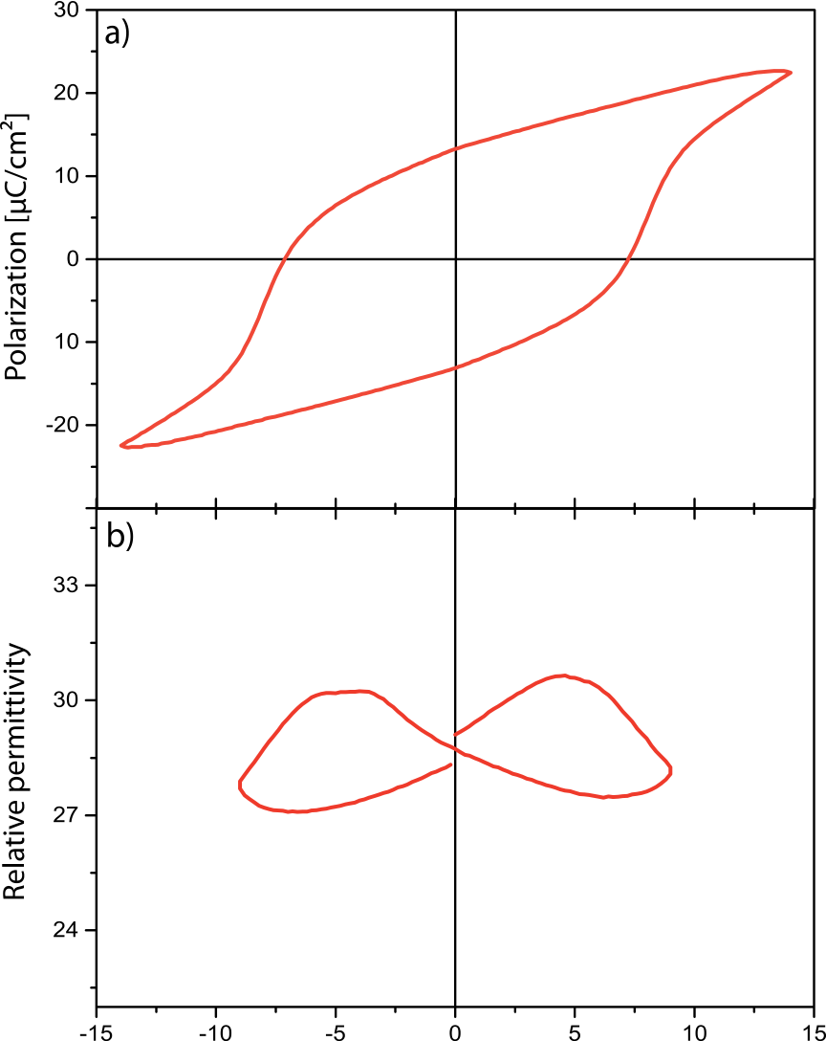



FIG. 1. Characteristic (a) polarization and (b) relative permittivity results for a Pt/HfO2(35 nm)/Pt sample measured after 1000 wake up cycles. The hysteresis shows a remanent polarization of >13 lC/cm2and a coercive voltage of 67:5 V. The er-curve exhibits the typical double peaks during fer-roelectric switching.

|  |  |  |
| --- | --- | --- |
| 0003-6951/2014/104(20)/202903/4/$30.00 | 104, 202903-1 | V C 2014 AIP Publishing LLC |

|  |  |  |
| --- | --- | --- |
| 202903-2 | Starschich et al. | Appl. Phys. Lett. 104, 202903 (2014) |

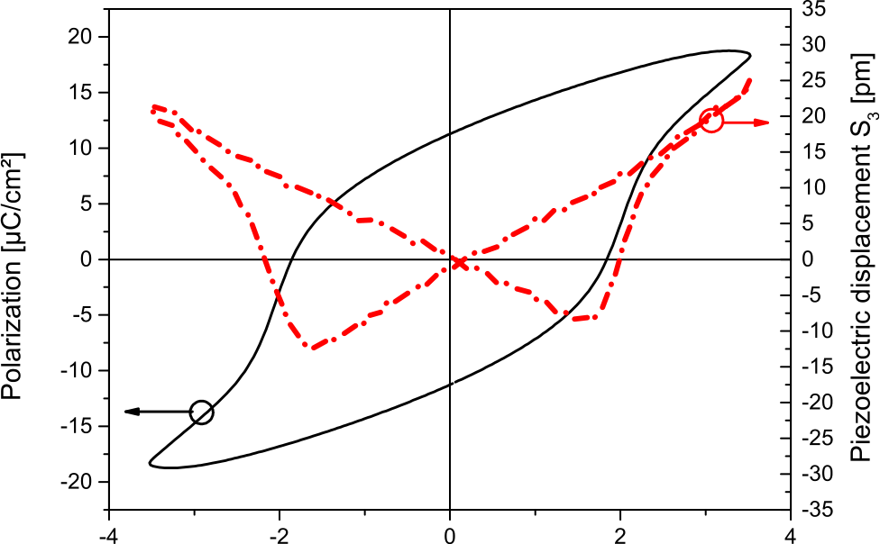



FIG. 2. Piezoelectric measurement (dashed line) with the corresponding P-V curve (straight line) for a 70 nm Y:HfO2 MIM capacitor clearly reveals a butterfly hysteresis for the mechanical displacement. The both minima of the displacement curve indicate the polarization switching. The linear behavior reveals the piezoelectric properties of the sample.

Fig. 1 shows characteristic P-V and C-V curves for a 35 nm thick Y:HfO2 layer with a remanent polarization of >13 lC/cm2(Fig. 1(a)) and the characteristic double peak for the relative permittivity er, calculated from the measured capacitance (Fig. 1(b)).14The so far reported HfO2 based fer-roelectric MIM structures used TiN as a bottom electrode. By the use of platinum electrodes, we can exclude that oxy-gen scavenging, as reported for TiNx/HfO2 interfaces,15is the primary cause for ferroelectricity in HfO2 based films. The results of a piezoelectric displacement measurement are shown in Fig. 2, in order to confirm the ferroelectric proper-ties of the deposited films. A butterfly loop is clearly visible with its minima at the ferroelectric switching points. Contrary to other reported displacement hysteresis,4,6a lin-ear behavior is observed outside the switching range unequivocally identifying the piezoelectric nature.

To achieve the maximum remanent polarization, an amount of “wake up” cycles is necessary as reported by Zhou et al.16for Si-doped HfO2. Fig. 3 shows the influence of cycling on the hysteresis for a 56 nm thick Y:HfO2 sam-

|  |  |  |  |  |  |  |  |  |  |
| --- | --- | --- | --- | --- | --- | --- | --- | --- | --- |
| at | 700�C | for | 5 | min | in | an | oxygen | atmosphere. | ple. At an initial sweep with a maximum voltage of 16 V, no |

Approximately, 7 nm Y:HfO2 was deposited by each spin coating step. The film thickness was adjusted by repeating the deposition steps. The patterned top 50 nm platinum elec-trodes were deposited by a negative lift-off process at room

ferroelectric hysteresis is observed (Fig. 3(a)). After 1000 cycles at the same conditions, a hysteresis occurs with clear current peaks during polarization switching (Fig. 3(b)). The remanent polarization can be further improved by more

temperature. cycles at a higher voltage shown in Figs. 3(c) and 3(d). Due

The P-V and piezoelectric measurements were per-formed using an aixACCT Systems TF Analyzer 2000 and an aixACCT Systems aixDBLI double beam laser interfer-ometer,13respectively. The capacitance measurements were recorded with a HP4284A LCR meter, whereas the grazing incidence x-ray diffractions (GI-XRD) and x-ray reflectivity (to determine the layer thickness) data were measured by¸  
PANalytical XoˆC Pert Pro. The P-V and C-V curves were measured at a frequency of 1 kHz with a 50 mV ac probing signal for the C-V measurements on device areas of

to the influence of the wake up cycles, an equal amount of cycles at the same electric field is performed for the samples shown in Fig. 4. For the reason of clarity, only three different Y :HfO2 thicknesses are shown in Fig. 4. Contrary to the ALD deposited samples,17the CSD samples show no reduc-tion of the remanent polarization with higher film thick-nesses. This is possibly attributed to the high temperature treatment after each layer deposition resulting in a step by step crystallization of the Y:HfO2.

The origin of the ferroelectricity is attributed to a non-

2:5 � 10�4cm2. centrosymmetric orthorhombic space group which is only

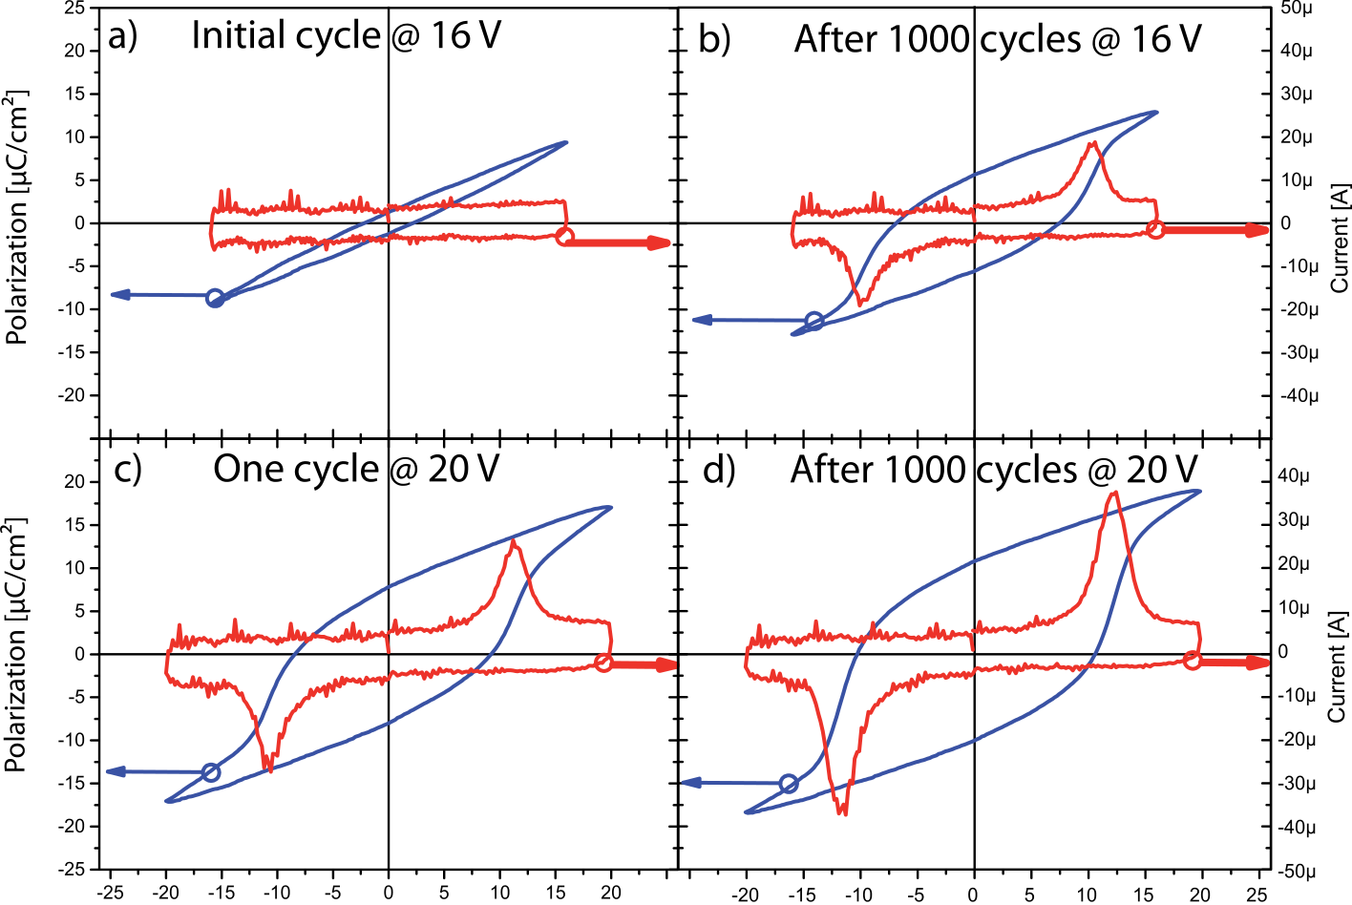 After 1000 cycles a hysteresis curve appears with distinctive current peaks, indicating the ferroelectric switching (b). Further cycling at higher voltages leads to an improvement of the rema- nent polarization (c) and (d). FIG. 3. The influence of “wake up” cycles are exemplarily shown for a 56 nm thick Y:HfO2 layer. Initially, no ferroelectric switching is observed (a).

 

|  |  |  |
| --- | --- | --- |
| 202903-3 | Starschich et al. | Appl. Phys. Lett. 104, 202903 (2014) |

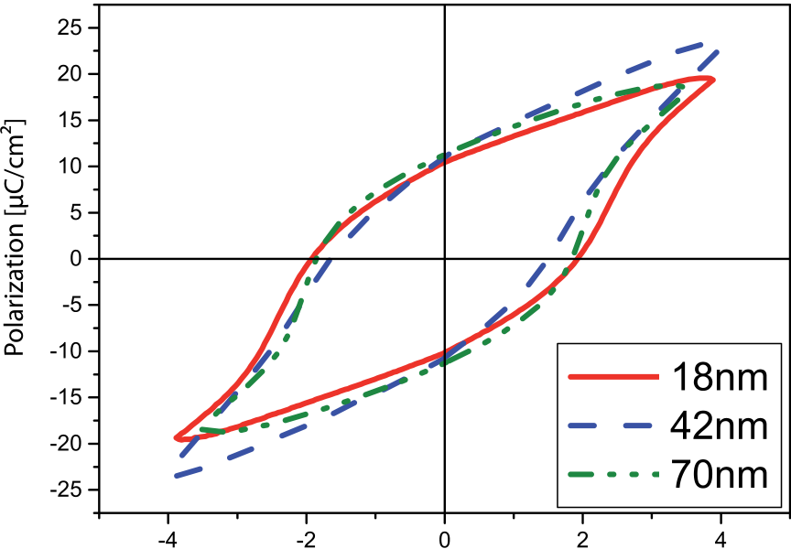

In summary, we have fabricated ferroelectric yttrium doped hafnium oxide films with chemical solution deposition using platinum electrodes. Due to the deposition procedure thicker films up to 70 nm were produced without showing any decrease of the polarization. This was attributed to the step by step annealing after each spinning of the solution resulting in a layered Y:HfO2 film. The deposition of thicker films has the potential for piezoelectric sensors and actuators based on hafnium oxide. It was shown that wake up cycles do not only improve the remanent polarization but are also essential for the forming of a hysteresis. This necessarily cy-cling was assumed to correlate with the fact that initially a cubic phase was found. Due to cycling a phase transition

 could occur to a ferroelectric non-centrosymmetric phase.

FIG. 4. P-V curves for different thicknesses of the Y:HfO2 layer. No signifi-cant influence of the layer thickness on the polarization is observed at all.

stable at particular conditions.4Fig. 5 shows the grazing inci-dence XRD diffractograms for two samples with a layer thickness of 18 nm and 70 nm, respectively. Both diffracto-grams reveal a clear cubic phase without any hints at an orthorhombic phase. An explanation could be correlated to the wake up cycles needed to obtain a hysteresis. During the cycling a field-driven phase transition might occur, leading to a non-centrosymmetric ferroelectric phase. Field induced phase transition to a ferroelectric phase is reported in Ref. 18. Such a transition was not found in GI-XRD spectra performed on the samples before and after the wake-up cycles. That could be due to the small cross section observed during the measurement.

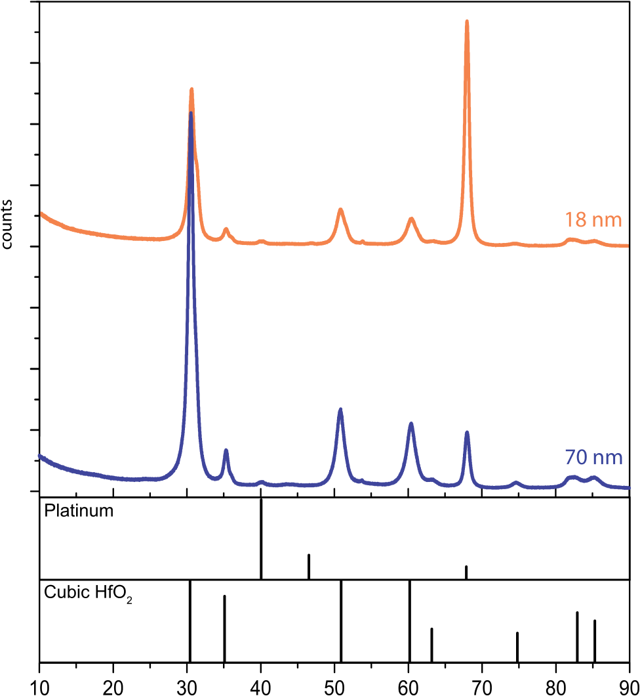



FIG. 5. GI-XRD patterns of 18 nm and 70 nm thick Y:HfO2 on platinum. Both samples show almost the same diffractograms with a definite cubic phase and no evidence measured of a monoclinic or orthorhombic phase. A grain size of approximately 10 nm was calculated for the 70 nm thick sample

Further work to prove this hypothesis is in progress.

This work was funded by the German Research Foundation (Deutsche Forschungsgemeinschaft) within the scope of the project “Inferox” (Project No. MI 1247/11-1).

1K. Kim and S. Lee, “Integration of lead zirconium titanate thin films for high density ferroelectric random access memory,” [J. Appl. Phys.](http://dx.doi.org/10.1063/1.2337361) 100, 051604 (2006).

2M. Qazi, M. Clinton, S. Bartling, and A. P. Chandrakasan, “A low-voltage 1Mb FRAM in 0.13 lm CMOS featuring time-to-digital sensing for expanded operating margin,” [IEEE J. Solid-State Circuits](http://dx.doi.org/10.1109/JSSC.2011.2164732) 47, 141–150 (2012).

3Nanoelectronics and Information Technology, 3rd ed., edited by R. Waser (Wiley-VCH, 2012).

4T. S. Boescke, J. Mueller, D. Braeuhaus, U. Schroeder, and U. Boettger,“Ferroelectricity in hafnium oxide thin films,” [Appl. Phys. Lett.](http://dx.doi.org/10.1063/1.3634052) 99, 102903 (2011).

5J. Mueller, U. Schroeder, T. S. Boescke, I. Mueller, U. Boettger, L. Wilde, J. Sundqvist, M. Lemberger, P. Kuecher, T. Mikolajick, and L. Frey,“Ferroelectricity in yttrium-doped hafnium oxide,” [J. Appl. Phys.](http://dx.doi.org/10.1063/1.3667205) 110, 114113 (2011).

6J. Mueller, T. S. Boescke, D. Braeuhaus, U. Schroeder, U. Boettger, J. Sundqvist, P. Kuecher, T. Mikolajick, and L. Frey, “Ferroelectric Zr(0.5)Hf(0.5)O(2) thin films for nonvolatile memory applications,” [Appl. Phys. Lett.](http://dx.doi.org/10.1063/1.3636417) 99, 112901-1–112901-3 (2011).

7S. Mueller, J. Mueller, A. Singh, S. Riedel, J. Sundqvist, U. Schroeder, and T. Mikolajick, “Incipient ferroelectricity in Al-doped HfO2 thin films,” [Adv. Funct. Mater.](http://dx.doi.org/10.1002/adfm.201103119) 22, 2412–2417 (2012).

8S. Mueller, C. Adelmann, A. Singh, S. Van Elshocht, U. Schroeder, and T. Mikolajick, “Ferroelectricity in Gd-doped HfO2 thin films,” [ECS J. Solid State Sci. Technol.](http://dx.doi.org/10.1149/2.002301jss) 1, N123–N126 (2012).

9T. Schenk, S. Mueller, U. Schroeder, R. Materlik, A. Kersch, M. Popovici, C. Adelmann, S. Van Elshocht, and T. Mikolajick, “Strontium doped haf-nium oxide thin films: Wide process window for ferroelectric memories,”in ESSDERC, 2013.

10T. Olsen, U. Schroeder, S. Mueller, A. Krause, D. Martin, A. Singh, J. Mueller, M. Geidel, and T. Mikolajick, “Co-sputtering yttrium into haf-nium oxide thin films to produce ferroelectric properties,” [Appl. Phys. Lett.](http://dx.doi.org/10.1063/1.4747209) 101, 082905-1–082905-4 (2012).

11T. Schneller, R. Waser, M. Kosec, and D. Payne, Chemical Solution Deposition of Functional Oxide Thin Films (Springer, 2013).

12T. Schneller and R. Waser, “Chemical solution deposition of ferroelectric thin films–state of the art and recent trends,” [Ferroelectrics, Switzerland](http://dx.doi.org/10.1080/00150190210989) 267, 293–301 (2002).

13P. Gerber, A. Roelofs, O. Lohse, C. Kugeler, S. Tiedke, U. Boettger, and R. Waser, “Short-time piezoelectric measurements in ferroelectric thin films using a double-beam laser interferometer,” [Rev. Sci. Instrum.](http://dx.doi.org/10.1063/1.1544415) 74, 2613–2615 (2003).

14D. Bolten, O. Lohse, M. Grossmann, and R. Waser, “Reversible and irre-versible domain wall contributions to the polarization in ferroelectric thin films,” [Ferroelectrics, Switzerland](http://dx.doi.org/10.1080/00150199908016462) 221, 251–257 (1999).

15V. V. Afanas’ev, A. Stesmans, L. Pantisano, S. Cimino, C. Adelmann, L. Goux, Y. Y. Chen, J. A. Kittl, D. Wouters, and M. Jurczak, “TiNx/HfO2 interface dipole induced by oxygen scavenging,” [Appl. Phys. Lett.](http://dx.doi.org/10.1063/1.3570647) 98,

using the Scherrer equation. 132901 (2011).

|  |  |  |
| --- | --- | --- |
| 202903-4 | Starschich et al. | Appl. Phys. Lett. 104, 202903 (2014) |

16D. Zhou, J. Xu, Q. Li, Y. Guan, F. Cao, X. Dong, J. Mueller, T. Schenk, and U. Schroeder, “Wake-up effects in Si-doped hafnium oxide ferroelec-tric thin films,” [Appl. Phys. Lett.](http://dx.doi.org/10.1063/1.4829064) 103, 192904 (2013).

17M. H. Park, H. J. Kim, Y. J. Kim, T. Moon, and C. S. Hwang, “The

0.5O 2 film on its ferroelectricity,” [Appl. Phys. Lett.](http://dx.doi.org/10.1063/1.4866008) 104, 072901 (2014).

18X. Tan, J. Frederick, C. Ma, W. Jo, and J. Roedel, “Can an electric field induce an antiferroelectric phase out of a ferroelectric phase?” [Phys. Rev.](http://dx.doi.org/10.1103/PhysRevLett.105.255702)

effects of crystallographic orientation and strain of thin Hf 0.5Zr [Lett.](http://dx.doi.org/10.1103/PhysRevLett.105.255702) 105, 255702 (2010).