Equivalent Oxide Thickness (EOT) Scaling With Hafnium Zirconium Oxide High-*κ*Dielectric Near Morphotropic Phase Boundary   
Kai Ni1, Atanu Saha2, Wriddhi Chakraborty1, Huacheng Ye1, Benjamin Grisafe1, Jeffrey Smith1, G. Bruce Rayner3, Sumeet Gupta2, Suman Datta1   
1University of Notre Dame, Notre Dame, IN, USA; 2Purdue University, West Lafayette, IN, USA; 3Kurt J. Lesker Co., PA, USA; email: kni@nd.edu

***Abstract*—**We demonstrate a novel strategy to scaling the equivalent oxide thickness (EOT) of MOSFETs by tuning the composition of Hf1-xZrxO2 thin-film near morphotropic phase boundary (MPB) between orthorhombic ferroelectric phase and tetragonal anti-ferroelectric phase. This approach can avoid the shortcomings of mobility and reliability degradation incurred in interlayer (IL) scaling approach and gate leakage increase from band gap reduction in traditional higher *κ* materials. Through comprehensive theoretical modeling and experimental characterization, we show that: 1) MPB exists in Hf1-xZrxO2 system due to phase transformation from orthorhombic phase to tetragonal phase with the increase of Zr concentration, in order to reduce the dipole-dipole interaction energy between the oxygen sub-lattices under compression; 2) *κ* is maximum (*κ*=38) near the MPB around 70% Zr as two phases co-exist and even a slight perturbation creates a large charge response; 3) Higher *κ* in advanced technology node FinFET improves the electrostatics and boosts drive current by 13%, suggesting that this strategy is a promising approach to designing high-*κ* dielectrics for the next generation CMOS.

**I.INTRODUCTION**   
 The relentless scaling of CMOS technology has left almost no space for further reduction of the physical thickness of gate dielectric, without incurring penalties of excessive gate leakage current. However, the thinner equivalent oxide thickness (EOT) gate dielectric has been persistently requested for high-*κ* metal gate (HKMG) high-performance transistors, because it can enable improved electrostatics, higher drive current, and lower gate leakage (Fig.1 (b) and (c)). To that end, generally two approaches exist to further reducing EOT. One is to decrease the equivalent interlayer thickness through either scavenging of the interlayer or increase its permittivity by forming metal silicate [1]. However, that comes with severe degradation in both carrier mobility and reliability due to closer proximity of the channel to the high-*κ* dielectric [2]. Therefore, it is preferred to take the other approach by pursuing higher-*κ* dielectrics.

It is generally known that the dielectric band gap inversely depends on the dielectric constant (*E*g~ κ-0 65) [2]. Therefore, the κ value has been limited to 20-30 to avoid the excessive direct tunneling current in higher *κ* material, which has lower band gap. To further boost the *κ* value, strategies without degrading the bandgap are highly desired. In this paper, we propose to design Hf1-xZrxO2 high-*κ* dielectric near the MPB between the orthorhombic ferroelectric phase (x<0.7) and tetragonal anti-ferroelectric phase (x>0.7). MPB is known as a transition

region in the compositional phase diagram, where the crystal structure changes [3][4]. It has been shown that materials exhibit maximum piezoelectric [3] and dielectric response [4] near the MPB, and thus of great interest for applications such as actuators and sensors. The response to external stimuli is significant near the MPB, since several phases (different phases have different charge response, like dielectric, ferroelectric, and anti-ferroelectric) co-exist and there is nearly no energy barrier separating different phases. As a result, a slight mechanical or electrical perturbation could induce a significant response in charge. Therefore, it provides an alternative approach to boost *κ* if the dielectric can be engineered near the MPB.

Zr doped HfO2 has triggered significant interest for its application as ferroelectric memory [5] and negative capacitance logic transistor [6]. In this material system, it exhibits MPB in its compositional phase diagram (Fig.2). On the one end (*x* = 0), it is monoclinic, and hence purely dielectric; while, on the other end (*x* = 1), it is tetragonal and purely anti-ferroelectric. In between, it exhibits an orthorhombic ferroelectric phase. Therefore, in this work, we demonstrate that *κ* exhibits a peak near MPB (*x* ~ 0.7 with *κ* = 38) in Hf1-xZrxO2. We employ a microscopic model to explain the phase evolution and existence of MPB in Hf1-xZrxO2 and perform a systematic experimental study of the *κ* evolution as a function of the composition. All these results suggest an alternative approach to engineer higher *κ* dielectric for high performance transistors.

**II.MICROSCOPIC MODELING OF MPB IN HZO**  The increase of Zr concentration in Hf1-xZrxO2 modulates the internal strain applied to the system by stretching the Hf-O and Zr-O bonds. The transformation from monoclinic to orthorhombic phase is induced by the increasing gliding strain tensor with the Zr ratio [7]. As a result, the polarization within a single sublattice becomes uniform (ferroelectric), instead of canceling each other (dielectric). In this work, we mainly focus on the phase transformation from orthorhombic to tetragonal as it is the MPB that is of interest for high-*κ*. With the increasing Zr ratio, the bonds between two sublattices are under compressive stress, which leads to an unfavorable increase in the dipole-dipole interaction energy, causing phase change from orthorhombic to tetragonal by flipping the polarization in one sublattice (Fig.3), though at the cost of elastic energy [8].

To capture the aforementioned physical mechanisms for phase transformation, we model a system composed of two sublattices and express the total energy (*Utot*) as a sum of energy local to each sublattice (*Ulocal* ) and the interaction energy

|  |  |  |
| --- | --- | --- |
| 978-1-7281-4032-2/19/$31.00 ©2019 IEEE | 7.4 .1 | IEDM19-150 |

Authorized licensed use limited to: Georgia Institute of Technology. Downloaded on March 23,2021 at 17:37:17 UTC from IEEE Xplore. Restrictions apply.

between the two. The local energy includes the electrostatic energy and the Landau free energy. The interaction energy includes the dipole-dipole interaction energy (*Up-p* ), which favors anti-parallel polarization between the two sublattices when under compression and the elastic energy due to bond stretch (*Ubond*). All the relevant expressions and parameters are listed in Fig.3. This framework elegantly captures the phase evolution with the increase of Zr concentration by comparing the predicted *Q*FE-*V*FE hysteresis loops and the experimentally measured ones (Fig.4).

The total system energy contour on the sublattice polarization (*P*1, *P*2) plane clearly exhibits phase transformation, as shown in Fig.5. The orthorhombic ferroelectric phase is favored if the energy minimum lies on the anti-diagonal line, where the sublattice polarization equals each other (*P*1=*P*2). On the other hand, if the energy minimum lies on the diagonal line, where the sublattice polarization is opposite to each other (*P*1 = -*P*2), the tetragonal anti-ferroelectric phase is energetically favorable. For 70% Zr concentration, it can be clearly seen that the total energy is minimum along both the diagonal and anti-

|  |  |  |  |  |  |
| --- | --- | --- | --- | --- | --- |
| diagonal | directions, | indicating | co-existence | of | both |

ferroelectric and anti-ferroelectric phases. The disappear of energy barrier separating the two phases (Fig.6(c)) indicating the MPB around this concentration. As shown in Fig.6(b), this transformation occurred because the compression significantly increases the dipole-dipole interaction energy through its coefficient, and hence favors anti-parallel alignment between the polarizations in the two sublattices. We also extracted *κ* value for various Zr concentration from experimentally measured ferroelectric capacitance, and confirm that a peak manifest around the MPB.

**III.EXPERIMENTAL VERIFICATION OF MAXIMUM *K***  **NEAR MPB**   
 To verify that *κ* is maximum near the MPB in a practical Si transistor, we fabricated multiple MOS capacitors with different thicknesses for different Zr concentration. The process starts with surface preparation and growth of 8 Å SiO2 interlayer (Fig.7(a-c)). Then the Hf1-xZrxO2 gate dielectrics are deposited via ALD, followed by tungsten (W) electrode sputtering. All the samples receive a 600 °C spike anneal to crystallize the film. Figs.7(d) and (e) show the measured *C*MOS-*V*G frequency dispersion characteristics at different Zr concentrations for 7.5nm and 2.5nm oxide sample, respectively. It is clearly seen that the accumulation capacitance exhibits a maximum around 70% Zr, irrespectively of the oxide thickness.

MOS capacitors of different oxide thicknesses are measured and their capacitance equivalent thickness (CET) values are linearly fitted as a function of physical thickness (Fig.8(a)). The CET is extracted from the measured capacitance data at a constant semiconductor charge (*Q*MOS=2 μC/cm2). From the slope, the *κ* value can be extracted as a function of Zr concentration (Fig.8(b)). Clearly, it exhibits a peak around the MPB, similar to Fig.6(a). Therefore, we can further boost the *κ* value through this engineering approach. The interface trap (*D*it) energy distribution profile is also extracted using conductance method (inset of Fig.9(a)) for different Zr concentration samples (Fig.9(a) and (b)). It suggests that 70% Zr sample

marginally affect the *D*it only towards the bottom half of the bandgap, while improve the *D*it in the upper half of the bandgap compared with the best HfO2 sample. These results suggest that Hf0 3Zr0 7O2 is a promising candidate for next generation high-*κ* dielectric to improve transistor performance.

**IV.PERFORMANCE PREDICTION OF ADVANCED**   
 **TECHNOLOGY NODE FINFET**   
 To predict the performance boost from the higher *κ* in Hf0 3Zr0 7O2 in advanced technology node, we built a FinFET TCAD model for 7(5) nm node with dielectric of varying *κ*. The electrostatics and transport parameters in TCAD model is calibrated utilizing the 10nm FinFET technology [9] (Fig.10(a)).

The transistor saturated *I*D-*V*G characteristics are shown in Fig.11(b). The off state current is matched in all the cases. The ON state drive current increases by 13% when *κ* increases from 21 to 40. The electrostatics also improve with higher *κ*, with SS decreased to 71 mV/dec from 77 mV/dec and DIBL reduced to 62 mV/V from 73 mV/V. These results suggest that engineering high-*κ* near the MPB could be a highly promising strategy for the next generation HKMG transistors.

**V.CONCLUSIONS**   
 In summary, we have demonstrated a new approach to design a higher *κ* gate dielectric by utilizing the morphotropic phase boundary (MPB) that exists in the compositional phase diagram of Hf1-xZrxO2. It relies on the effect that different phases with distinct charge characteristics (ferroelectric and anti-ferroelectric) co-exist at the phase boundary such that a small external perturbation gets amplified to a large charge response through phase transformation. The morphotropic phase boundary exists in Hf1-xZrxO2 system due to the phase transition between the orthorhombic ferroelectric phase and the tetragonal anti-ferroelectric phase. This transformation is induced as the system attempts to minimize the dipole-dipole interaction energy, which becomes dominant due to the compressive strain introduced with additional Zr. A maximum *κ* value of 38 is demonstrated at the phase boundary and can improve the electrostatics and boost drive current by 13% in advanced technology nodes. Therefore, this approach emerges as a promising candidate to engineer extremely thin EOT gate dielectric for future HKMG transistors.

**ACKNOWLEDGEMENT**   
 This work supported in part by ASCENT, one of six centers in JUMP, sponsored by DARPA and the Semiconductor Research Corporation (SRC).

**REFERENCES**   
[1]M M Frank, “High-k/metal gate innovations enabling continued CMOS scaling,” ESSCIRC 2011   
[2]T Ando, “Ultimate scaling of high-k gate dielectrics: higher-k or interfacial layer scavenging,” Materials 2012   
[3]S E Park, et al , “Ultrahigh strain and piezoelectric behavior in relaxor based ferroelectric single crystals,” J Appl Phys 1997   
[4]S W Choi, et al , “Dielectric and pyroelectric properties in the Pb(Mg1/3Nb2/3)O3- PbTiO3 system,” Ferroelectric 1989   
[5]K Ni, et al , “Critical role of interlayer in Hf0.5Zr0.5O2 ferroelectric FET nonvolatile memory performance,” IEEE Tran Electron Dev 2018   
[6]M H Lee, et al , “Physical thickness 1 x nm ferroelectric HfZrOx negative capacitance FETs,” IEDM 2016   
[7]S Clima, et al , “First-principles perspective on poling mechanisms and ferroelectric /antiferroelectric behavior of Hf1-xZrxO2 for FeFET applications,” IEDM 2018 [8]A K Saha, et al , “Microscopic crystal phase inspired modeling of Zr concentration effects in Hf1-xZrxO2 thin films,” VLSI 2019   
[9]C Auth, et al , “A 10nm high performance and low-power CMOS technology featuring 3rd generation FinFET transistors, self-aligned quad patterning, contact over active gate and cobalt local interconnects,” IEDM 2017

IEDM19-151 7.4 .2

Authorized licensed use limited to: Georgia Institute of Technology. Downloaded on March 23,2021 at 17:37:17 UTC from IEEE Xplore. Restrictions apply.

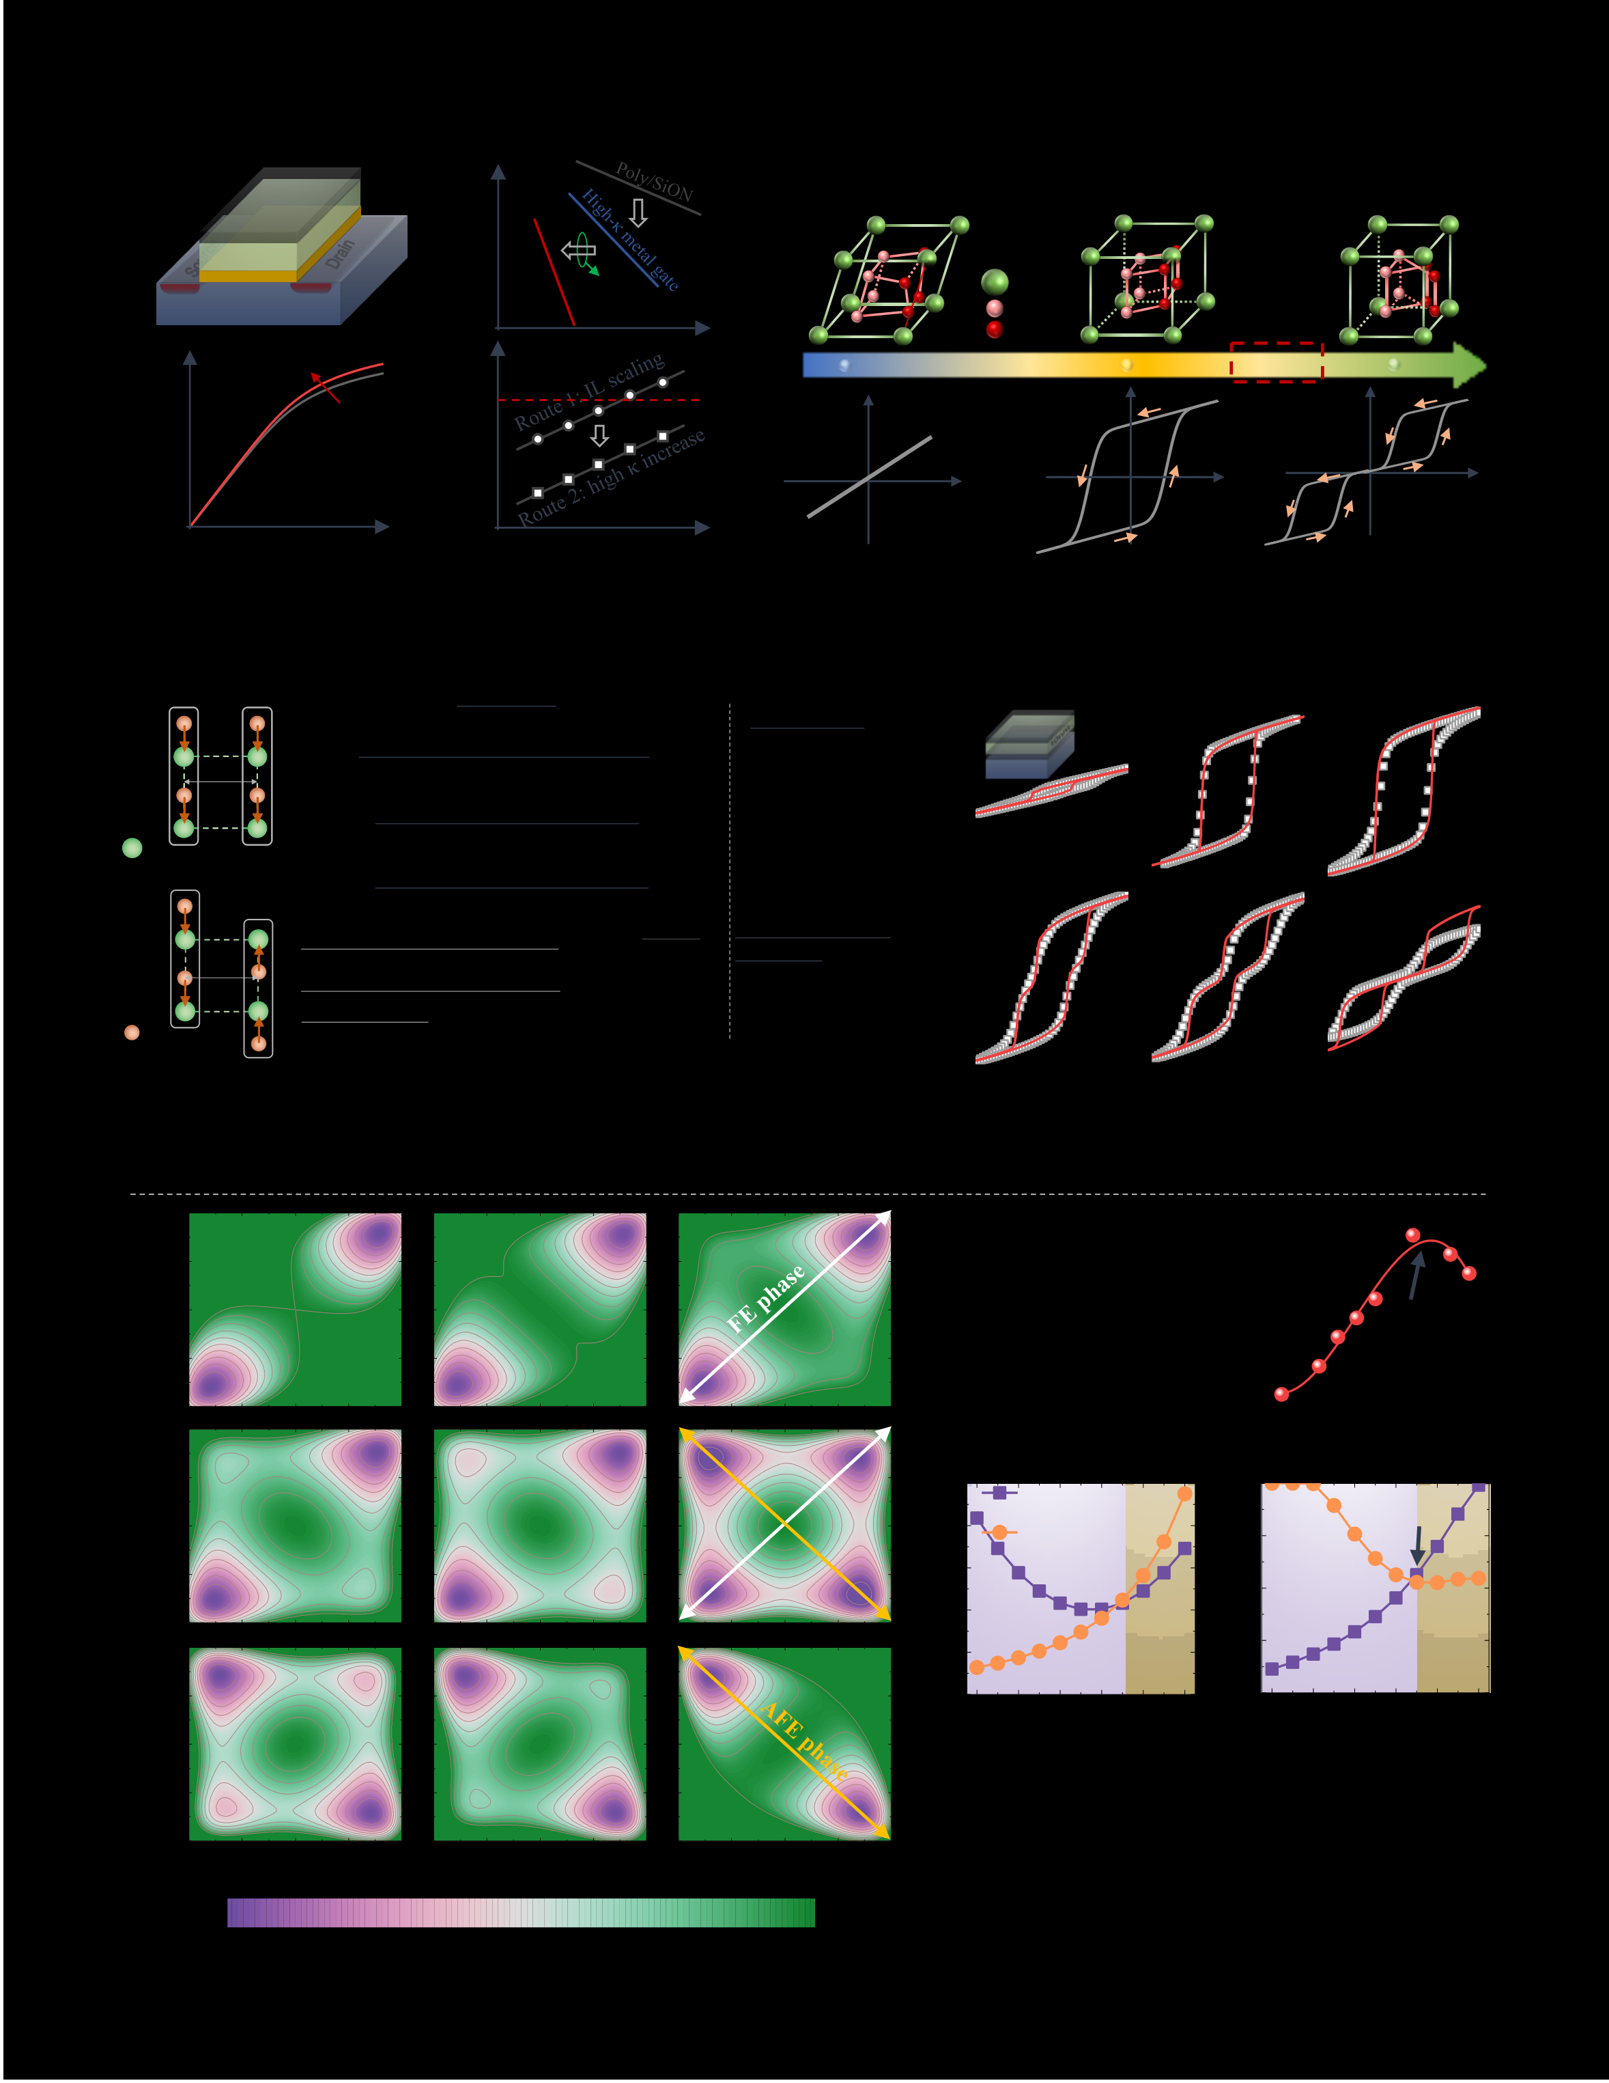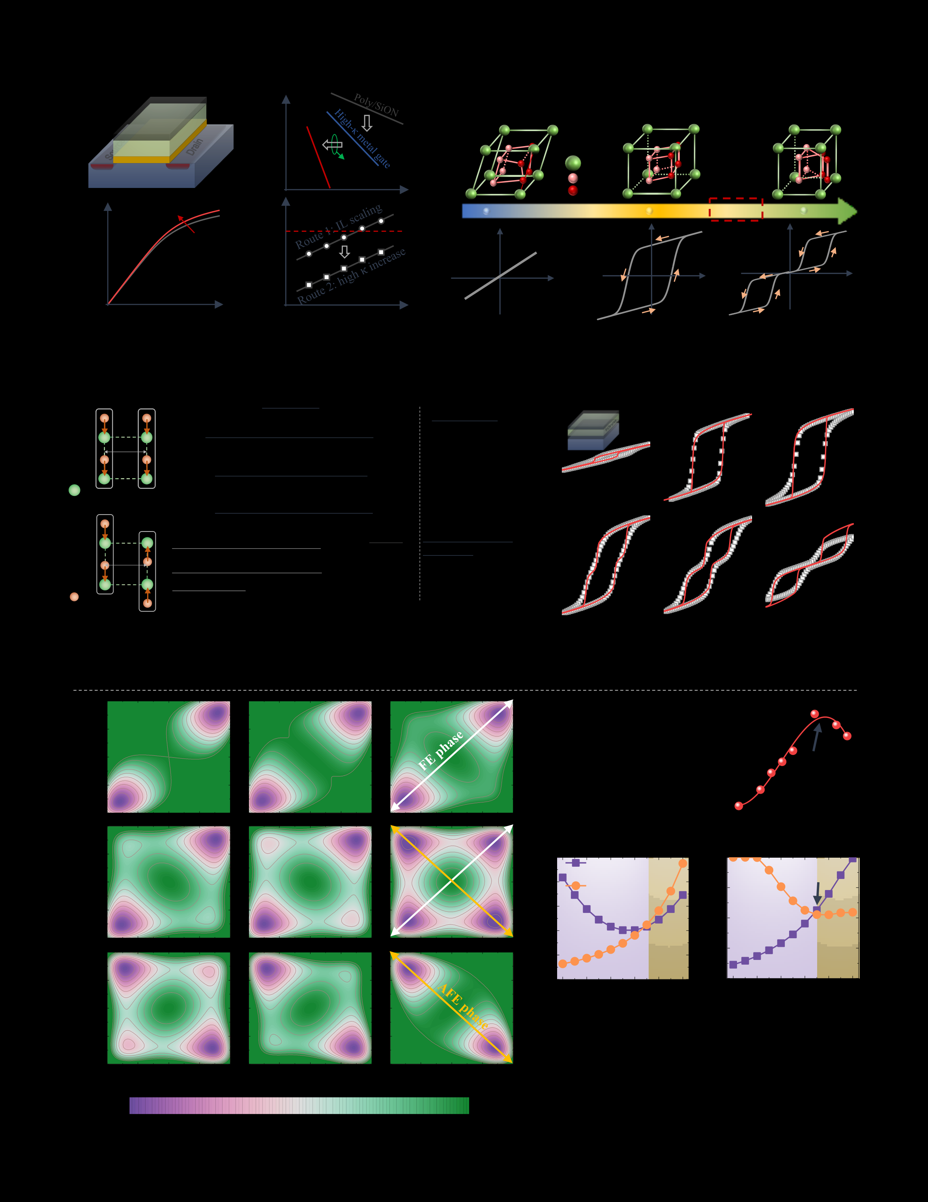

|  |  |  |  |  |  |  |  |  |  |  |  |  |  |  |  |  |  |  |  |  |  |  |  |  |  |  |  |  |  |  |  |
| --- | --- | --- | --- | --- | --- | --- | --- | --- | --- | --- | --- | --- | --- | --- | --- | --- | --- | --- | --- | --- | --- | --- | --- | --- | --- | --- | --- | --- | --- | --- | --- |
| n+ | Gate | | | | n+ | Gate Leakage | | | | target | | | | | Further | | | | | | | | | | | | **C** | Zr percentage | | Morphotrop c | |
| high-κ | | | | Phase | |
| nterlayer | | | | boundary for | |
| p-Si | | | | EOT scaling | | | | | | | | | | | | h gh κ | |
| d e ectr c | |
| κ increase | | | | | EOT  Maximum | | | | | | | | | | | | | | | | | | | | | | |
| Log(I DS) | boost current | | | | ΔVTH | | | | | | ΔVTH | | | | | | | | | | | | | | | | QFE | QFE | | QFE | |
| VGS | | | | | Log (stress time) | | | | | | | | | | | | | | | | | | | | | | | VFE | | VFE | VFE |
| **Orthorhombic** | | | | | **Total energy** | | | | | | | | | | | | | | | | | | | | | | | W E | | **Hf0.7Zr0.3O2** | **Hf0.5Zr0.5O2** |
| **(FE)** | | | | | **Parameter Set** | | | | | | | | | | | | | | | | | | | | | | |
| Sublattice 1 | ***P*1** | ro | ***P*2** | Sublattice 2 | **Free energy and electrostatic energy** | | | | | | | | | | | | | | | | | | | | | | | Hf1 xZrxO2  W BE | |
| 019p Si | |
| **Dipole-Dipole interaction energy** | | | | | | | | | | | | | | | | | | | | | | |
| **10nm** | **HfO2** |
| Increase of Zr, reduces rt, rt<ro **Tetragonal** | | | | | **Elastic energy due to bond stretch** | | | | | | | | | | | | | | | | | | | | | | |
| **Symbol: Exp.** | |
| Sublattice 1 | ***P*1** | **(AFE)** | | Sublattice 2 | **Dipole-Dipole interaction coefficient** | | | | | | | | | | *k r* ( ) | = | *k* 1 | + | | ( | *r* | *k* | *o* | | )  3 | **Landau-Devonshire** | |
| **Line: Sim.** | |
| rt | ***P*2** | - | *r eq* | | **Formalism** | | **Hf0.3Zr0.7O2** | |
| **Elastic energy interaction coefficient** | | | | | | | | | | *g r* ( ) | = |
| *g* | *o* | ( | *r* | - | *r* 1 | ) | 2 | |
| **Sublattice spacing** | | *r x* ( ) | | = -( 0 02 | | | *x* | + | 0 27 nm, ) | | | *x* : Zr percentage | | | | | | | | | **Hf0.2Zr0.8O2** | **ZrO2** |
| *r eq* | | | | | | | = | 0 233nm, | | | *r* 1 | = | 0 263nm | | | | | | | | | | | | | | |
| **HfO2** | | | | | **Hf0.8Zr0.2O2** | | | | | | | | | | | | | | **Hf0.7Zr0.3O2** | | | | | | | | |

Peak near

phase

boundary

|  |  |  |  |  |
| --- | --- | --- | --- | --- |
| **Hf0.6Zr0.4O2** | **Hf0.5Zr0.5O2** | **Hf0.3Zr0.7O2** | g [bonding | MPB |
| energy coe |
| k [dipole-dipole |

interaction coe

|  |  |  |  |  |  |  |
| --- | --- | --- | --- | --- | --- | --- |
| **Hf0.2Zr0.8O2** | **Hf0.1Zr0.9O2** | No barrier between | **FE phase** | **AFE phase** | **FE phase** | **AFE phase** |
| **ZrO2** |
| **min** | **System total energy** | **max** |

Authorized licensed use limited to: Georgia Institute of Technology. Downloaded on March 23,2021 at 17:37:17 UTC from IEEE Xplore. Restrictions apply.

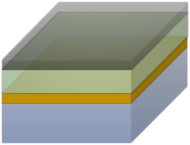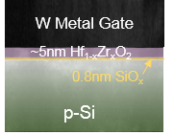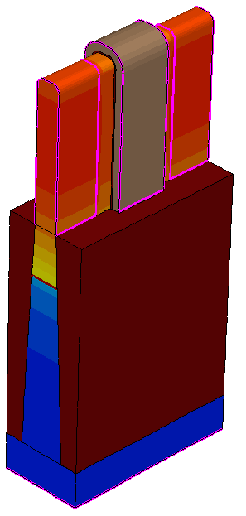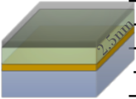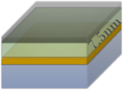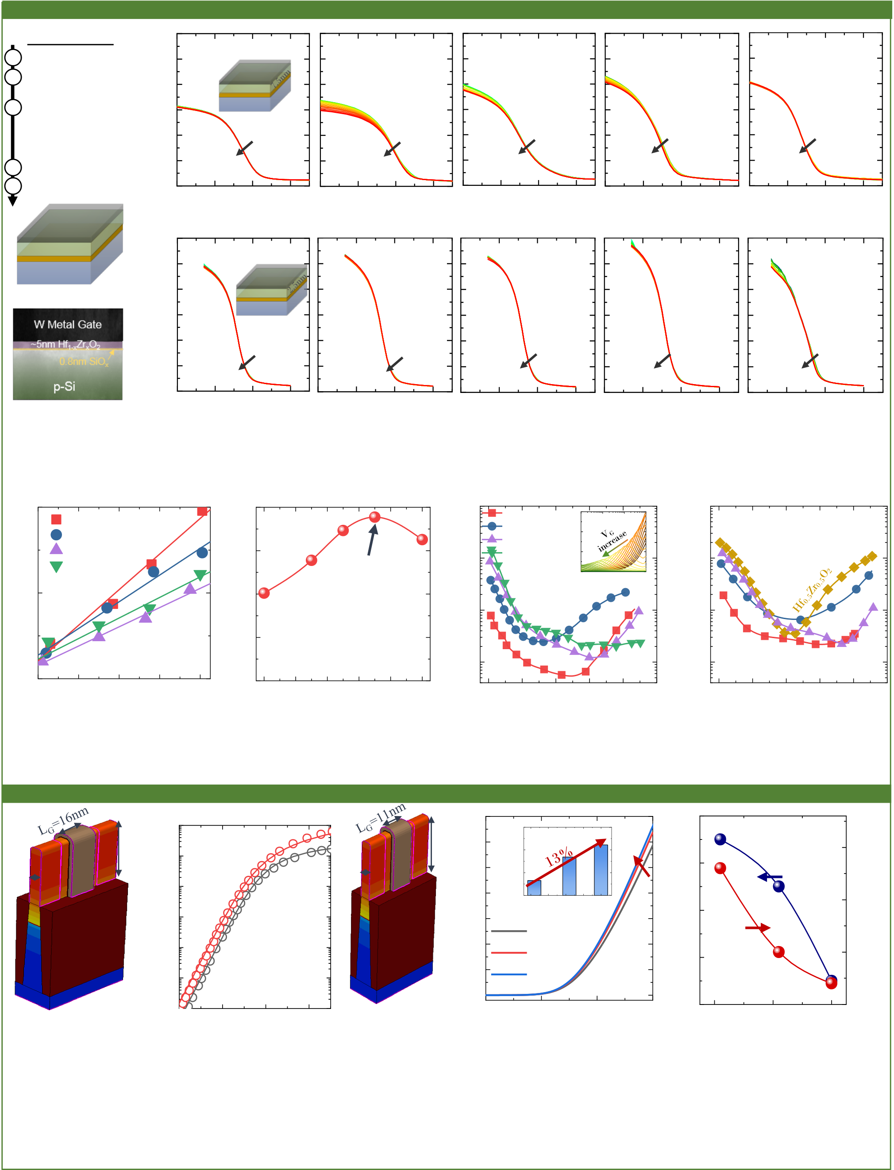

**Experimental Demonstration of Dielectric Constant Boost Near Phase Boundary**

(a) Process Flow (d) 3.0 **7.5nm oxide**

1 Surface preparation 2.5 **HfO2**  **Hf0.7Zr0.3O2**  **Hf0.5Zr0.5O2**  **Hf0.3Zr0.7O2**  **ZrO2**

W gate

CMOS (µF/cm2) CMOS (µF/cm2) ID (A/f n)   
2 SiO2 interlayer

growth (8 Å) 2.0 Hf1-xZrxO2

SiO2

3 Hf1-xZrxO2 ALD 1.5 p-Si

deposition

2.5nm, 5nm 1.0 50kHz-1MHz 50kHz-1MHz 50kHz-1MHz 50kHz-1MHz 50kHz-1MHz

4 Sputter 100 nm W 7.5nm, 10nm 0.5

5 600 °C spike anneal 0.0

2 1 0 1 2 1 0 1 2 1 0 1 2 1 0 1 2 1 0 1

(b) W gate VG (V) VG (V) VG (V) VG (V) VG (V)

(e) 3 0 **2.5nm oxide**

H

SiOx   
xZrxO2

2 5   
 **HfO2**  **Hf0.7Zr0.3O2**  **Hf0.5Zr0.5O2**  **Hf0.3Zr0.7O2**  **ZrO2**

p-Si W gate

(c) 2 0 Hf1-xZrxO2

SiO2

1 5 p-Si

1 0 50kHz-1MHz 50kHz-1MHz 50kHz-1MHz 50kHz-1MHz 50kHz-1MHz

0 5

0 0

2 1 0 1 2 1 0 1 2 1 0 1 2 1 0 1 2 1 0 1

VG (V) VG (V) VG (V) VG (V) VG (V)

**Fig. 7:** (a) Process flow for the fabrication of the MOS capacitor with Hf1-xZrxO2 as gate dielectric. Different thicknesses are designed. (b) and

(c) the schematic and false-colored cross-section TEM image of the device. (d) and (e) Measured small signal MOS capacitance for different

Zr concentration for 7.5nm and 2.5nm, respectively. The accumulation capacitance increases initially with Zr concentration up to 70% and

then falls down with further increase. This verifies that the dielectric constant is enhanced near the morphotropic phase boundary.

(a) 3

H O2 (b) 40 (a) 1014 HfO2

Hf0 7Zr0 3O2   
 300

200   
 (b) 1014

Gp/w(pF) H 0 7Zr0 3O2 Hf0 3Zr0 7O2

Dielectric constant  
 H 0 3Zr0 7O2

ZrO2   
 30

Peak near 1013 ZrO2 00

0   
 1013

Dit (cm-2eV-1) Hfin=45nm   
 Dit (cm-2eV-1) SS mV/dec CET (nm)   
 03 0 05 06

phase Freq (Hz)

2 20

boundary 1012 1012

10

1   
 CET *@Q*MOS=2*µ*C/cm2

0   
 1011

**10nm oxide**  1011 **5nm oxide**

2 4 6 8 10 0 20 40 60 80 100 0 0 0 2 0 4 0 6 0 8 1 0 0 0 0 2 0 4 0 6 0 8 1 0

Tox (nm) Zr concentration (%) E-EV (eV) E-EV (eV)

**Fig. 8:** (a) Extracted capacitance equivalent thickness (CET) as a **Fig. 9:** Interface trap (*D*it) energy profile for different Zr concentration

function of physical thickness for different HZO samples. CET is for (a) 10nm and (b) 5nm oxide samples. Conductance method is

extracted at *Q*MOS=2*µ*C/cm2. The extracted dielectric constant (b) applied for the *D*it extraction (inset shows the *G*p/ω vs. freq). 70% Zr

from the linear fit (a) shows a peak around 70% Zr concentration. slightly increases the *D*it compared with HfO2, but better than others.

**Advanced Node FinFET Performance Improvement with Scaled EOT**

(a) (b) 10-4 (a) (b) 70

70   
 (c) 78

Hfin=45nm   
 VDS = 0 05 0 7V 60 65 VDD=0 6 V

75 ON (µA/ in)   
10-5

50 60 76

DIBL (mV/V) Wfin=8nm 10-6 Wfin=5.5nm

40 55

20 25 30 35 40 70 ID (µA/f n)   
10-7 30 Dielectric constant 74

k=21

10-8 20 k=31 72 65

10-9 Symbol Exp 10 k=40

10 nm FinFET 10-10 0.0 0.2

VGS (V)   
0.4   
Line TCAD

0.6 7/5 nm FinFET

prediction   
 0

0.0 0.2

VGS (V)   
 IOFF=6nA/fin

0.4 0.6   
 70

20

D e ectr c constant   
 30 40   
 60

**Fig. 11:** (a) FinFET TCAD model for advanced technology node (*L*G=11 nm,

**Fig. 10:** (a) A FinFET TCAD model is calibrated to *W*fin=5.5 nm, *H*fin=45 nm) that is used to predict the transistor performance. (b)

10nm technology (*L*G=16 nm, *W*fin=8 nm, *H*fin=45 Transistor *I*D-*V*G characteristics (*V*D=0.6 V) for different dielectric constants. The off-

nm). The linear and saturation *I*D-*V*G characteristics state leakage is matched in all the cases (6nA/fin). By increasing the dielectric

agree well with experiments. The calibrated constant from 21 to 40, the ON-state drive current is enhanced by 13%, suggesting a

parameters are used to predict the transistor promising route for high-performance transistor. The subthreshold swing and DIBL

performance at advanced technology nodes (7/5nm) . values improve to 71 mV/dec and 62 mV/V, respectively.

IEDM19-153 7.4 .4

Authorized licensed use limited to: Georgia Institute of Technology. Downloaded on March 23,2021 at 17:37:17 UTC from IEEE Xplore. Restrictions apply.