T4-2   
 **Fundamental Understanding and Control of Device-to-Device Variation in Deeply**  **Scaled Ferroelectric FETs**   
 Kai Ni1, Wriddhi Chakraborty1, Jeffrey Smith1, Benjamin Grisafe1, and Suman Datta1 1University of Notre Dame, Notre Dame, IN; Email: kni@nd.edu

**Abstract:** In this work, we present a comprehensive Kinetic Monte Carlo (KMC) modeling based statistical framework to evaluate the device-to-device variation of thin-film HfO2 ferroelectric FET (FeFET). We conclude that the closing of the memory window in a FeFET array with device scaling can be attributed to: 1) limited number of domains; 2) variation among domains; 3) intrinsic stochasticity of individual domain switching. To enable further scaling of FeFET, co-optimization approaches from material, process, and device operation to control variation are proposed: i) increase the number of domains through material/process optimization (e.g. decrease of deposition temperature, etc.); ii) improve the uniformity of domains (e.g. minimizing the domain size variation and defect distribution, etc.); iii) increase the pulse amplitude/width to ensure deterministic switching of individual domains.

**Introduction:** FeFETs based on ferroelectric HfO2 are a promising candidate for embedded nonvolatile memory (NVM), due to its CMOS compatibility, scalability, and energy efficiency. Successful integration of HfO2 FeFET within an industrial scale advanced CMOS technology platform has been demonstrated[1]. Promising as it is, several key challenges remain. The first challenge is to mitigate the electron and hole trapping during write to improve the endurance[2]. The second challenge is to reduce the write voltage to a logic-compatible level[3]. This work focuses on the third challenge, the device-to-device variation, which increases with the FeFET device size scaling, ultimately causing the memory window collapse for aggressively scaled FeFET arrays[1] (Fig.1). In this work, we develop a comprehensive statistical framework to model and evaluate the variation of FeFET with the scaling, supported by experimental data, which guides co-optimization of material /process conditions and prescribes operating bias conditions. **KMC Simulation Framework:** The ferroelectric is assumed to contain *N* elementary domains (Fig.3) with each domain switching independently. The switching of an individual domain between two polarization states is modeled with a master equation[4] (Fig.2). The original framework treats the switching between two stable states as a double-well potential separated by an energy barrier[4]. This is not applicable for thin film HfO2[5], where polarization switching is nucleation limited. Therefore, the framework is adapted to capture the nucleation-limited switching dynamics by adjusting the transition rates. As the single domain switching is stochastic[5], the KMC simulation is a natural means to study the variation of FeFET (Fig.3). A Gaussian distribution of the activation field (*Ea*) is assumed. The equations governing the voltage division and the charge balance between the ferroelectric and the MOSFET are solved to obtain the ferroelectric electric field (*E*FE), which is then used to calculate the switching rates. Thereafter, the KMC algorithm is executed.

**Variation in Metal-Ferroelectric-Metal (MFM) Capacitor:** We validate this modeling approach using measured data from an MFM capacitor. Fig.4 shows the calibration of the *Q*FE-*V*FE saturation loop. The switching dynamics under various applied voltages are captured by the KMC model (Fig.5a). When the number of FE domains decreases from 1,000 to 20, the switching occurs in discrete steps and the variation increases

significantly (Fig.5b). This is due to the intrinsic stochastic nature of individual domain switching. The effect of single domain switching (of the order of 1/*N*) now becomes significant. Fig.6 quantifies the variation in the *P*FE after program/erase operation. With the reduction in the number of domains with device area scaling, the program and erase states start to overlap, which leads to memory window collapse. **Variation in Ferroelectric FET**: The switching dynamics is measured in a state-of-the-art 28nm high-κ metal gate FeFET technology[2] (Fig.7a). The device features an 8nm thick doped HfO2 with 1nm SiO2 interlayer (Fig.7c). The typical grain size in 10nm HfO2 is around 10-15nm[6], which means that there are approximately 1,000 switching elements for a 500nm by 500nm FeFET. The KMC model accurately reproduces the measured switching dynamics (Fig.7b). The evolution of the polarization charge during the write operation (Fig.7d) explains how the device-to-device variation increases as the number of domains decreases. The deviation of *P*FE from its expectation value originates from single domain switching events, which have a strong impact when limited number of domains participate in the switching process. The measured (Fig.7e) and modeled (Fig.7f) variation show the collapse of the memory window as a function of FeFET device dimensions. **Control of Variation in Ferroelectric FET:** With the insights from the modeling, several approaches controlling the variation in FeFET are explored. The first is to increase the number of ferroelectric domains through careful material /process co-optimization (Fig.8a). Effective fabrication techniques, such as lower deposition temperature[7], enhanced electrode surface roughness, higher annealing temperature[8], can be applied to reduce the grain size. The second method is to increase the domain uniformity. The decrease of the variance of the activation field improves the memory window (Fig.8b), which may be achieved by minimizing the size variation, defect distribution, etc. among the domains[5]. Another set of techniques involve the optimization of the write pulses, where increasing the pulse width (Fig.8c) or pulse amplitude (Fig.8d), decreases the measured variation. Through modeling, we confirm this dependence (Fig.8e and Fig.8f), as the switching becomes less stochastic under high *E*FE or large pulse width[5]. As the write in FeFET is voltage-driven with excellent energy efficiency, the increase in pulse amplitude or pulse width may be an acceptable compromise for improving variation.

**Conclusion:** We have developed a KMC statistical modeling framework capable of quantifying the device-to-device variation of FeFET and explaining the collapse of the memory window with the scaling of device dimensions. Several approaches to control device variation have been proposed, thereby providing guidelines for the future effective scaling of FeFET for nonvolatile embedded memory applications.

**References:** [1] S.Dünkel et al., *IEDM* 2017; [2] M.Trentzsch et al., *IEDM* 2016; [3] K.Ni et al., *IEDM* 2018; [4] M.Vopsaroiu et al., *PRB* 2010; [5] H. Mulaosmanovic et al., *Appl. Mater. Interfaces* 2018; [6] M.H.Park et al., *APL* 2014; [7] K.D.Kim et al., *J. Mater.Chem.C.*

2016; [8] J.Y.Lee et al. *CAP* 2017   
**Acknowledgment:** We would like to thank Globalfoundries Dresden, Germany for providing 28nm FeFET test devices. This work was supported in part by the Semiconductor Research Corporation (SRC) and DARPA.

|  |  |  |
| --- | --- | --- |
| T40 | 978-4-86348-717-8 ©2019 JSAP | 2019 Symposium on VLSI Technology Digest of Technical Papers |

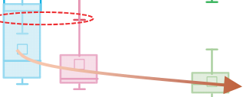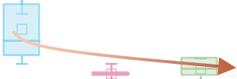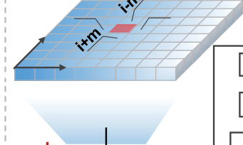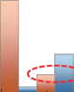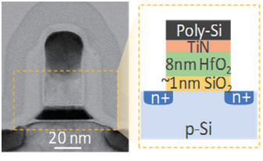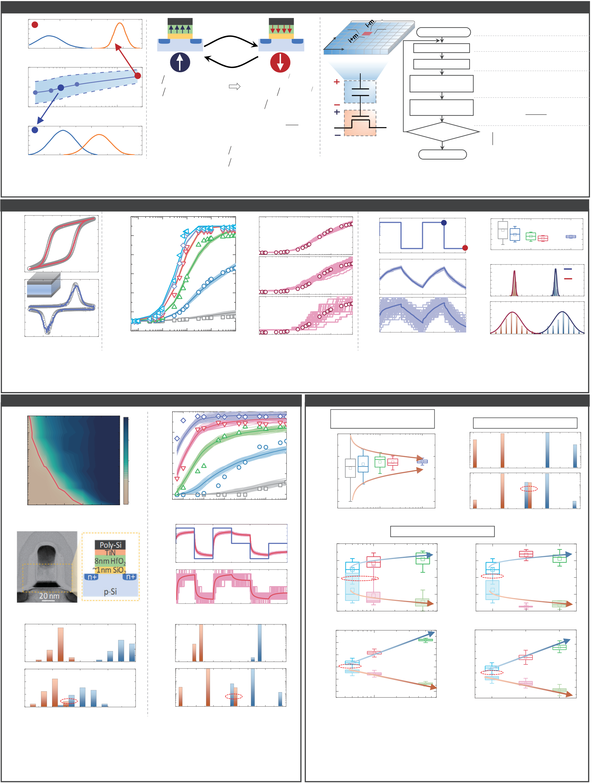

Motivation: Understanding the FeFET Variation Using Kinetic Monte Carlo (KMC) Simulation 0.06   
0.04   
0.02   
0.00

1.0   
 0.0   
 500nmx500nm

0.5 VTH (V)   
 1.0 1.5   
 *P*1   
 n+   
 Gate

p‐Si   
IL   
 n+   
 γ12

γ21   
 n+   
 Gate

p‐Si   
IL

*P*2   
n+   
 FE   
 y

x   
 **i-1**

VG   
 **i**  **i+1**   
 m t=0, Initialization

Calculate *n*   
Calculate *E*FE   
For a given VG

*TOT*   
 *P FE*   
 Randomly initialize all the *N*

*C V FE*  
   
 domain *P*i and (*E*a)i

*TOT n FE*    
 *Q*

*i*   
*MOS*

1  *V G**V FE*0 Prob. dist. Memory window (V) Prob. dist. QFE (C/cm2) IFE (A/cm2)   
 0.5 Shading area: 1 *dP dt*  *dP dt*  1 2      12 12 *P*  *P*  1 1     21 21 *P*  *P*  2 2 *P*  *P*  1 2   *C*  *C*  1 1  
 

12 *C e* 221*t t*  
*SW*

*C e* 2*t t SW*

VFE Select the domain   
 **i** to switch Get a uniform random number *u*∊[0,1] *TOT* 1 Find domain i for which, *TOT u**TOT* ,*TOT**TOT*  *N*

0.15   
0.10   
0.05   
0.00   
0.0

0.0   
 240nmx34nm

0.5   
104   
 Area (nm2)

VTH (V)   
 1.0   
 Symbol: mean   
 105

1.5 *P*1/*P*2: occupation probability *C*1/*C*2: constants to be determined   
 *t*SW: switching time constant   
 *τ*o, α: fitting parameters   
 *Ea*: activation field   
 *if E*  *if E*  *FE*  *FE*  0, 0,  12 21   1 1 *t*  *t*  *SW*  *SW*  , ,   
 *t*

  
  
*SW*

12   
21  
  


  
  
⧫  
1

  
  
*o*  


exp  


  
  
12

  
  
  
  
  


12   
21  


*E*   
*E*   
21

*FE a*  
     
  VMOS

*QMOS*=*QFE*=*PFE*+*CFEVFE*

Fig.3. KMC modeling framework of variation in FeFET. FE   
*VG*=*VFE*+*VMOS*   
 Update the time

t≥pulse width?   
 t=t+∆t

End   
 Yes   
 Get a uniform random number *v*∊[0,1]

*E FE*  
   

0   
12

log 

,  
, *TOT*

*i*  
 

*f P in state*   
*if P in state*

*i*

*i*

2   
 1   
No

Fig.1. Device-to-device variation Fig.2. Rate equation modeling of contains N domains, whose switching dynamics is modeled increases with scaling of FeFET[1]. polarization switching in individual domain. with rate equation shown in Fig.2.

Variation in Metal-Ferroelectric-Metal Capacitor

-20  
-40   
40   
20

20   
10   
0   
 Line: sim.   
 Symbol:

Hf0.5Zr0.5O2

exp.

10 nm   
 (a)

-10   
30

20

10

0Ea=0.6MV/cm  
   
 □s   
 3.0V 2.5V Symbol: Exp.

Line: Sim.

Ndomain = 1000   
Ndevice=50  
Ea=1.7MV/cm

1.5V

1.0V   
2.0V (b)

-10  
-20  
-10  
-20   
10   
10 Ndomain=1000,Ndevice=50 0

0   
VFE=1.0V   
Symbol: Exp

Ndomain=100,Ndevice=50   
Lines: 50 devices   
 (a)

-10   
20   
10  
-1  
-2   
2   
1   
0

0   
 Ndevice=200   
 Ndomain=1000   
 A

B

(c) 80 Ndomain=1000 60   
40   
20   
20   
15   
10

0   
5   
10 Domain number   
 100   
 (b) @A

1000 A B PFE (C/cm2) Count   
 VFE (V) PFE (C/cm2)   
 PFE (C/cm2)   
 PFE (C/cm2)   
 0 -20 Process flow and device structure -10 Ndevice=50 0 Ndomain=20 80 Ndomain=20 60 40  
 -10  
 -20-4 -2 VFE (V) 0 2 4 -30 10-7 10-6 Pulse width (s) 10-5 10-4 10-3 -20 10-7 10-6 Pulse width (s) 10-5 10-4 10-3 -10 0 10 Time (s) 20 30 40 20 -20-15-10 -5 0 0 PFE(C/cm2) 5 10 15 20 25 Fig.6. (a) *P*FE waveform during pulse switching; (b) *P*FE Fig.4. Calibration of *Q*FE- Fig.5. (a) Calibration of switching dynamics in a MFM   
 shows a wider distribution for reduced number of domains; *V*FE loop in a Hf0.5Zr0.5O2 capacitor; (b) switching dynamics variation increases (c) *P*FE distribution after program/erase overlaps when the (10nm) MFM capacitor. when the domain number decreases from 1,000 to 20. domain number reduces from 1,000 to 20.

Variation in Ferroelectric FET

(a) 10-2

500nmx500nm   
 Memory Window (V)

1.5   
 (b) 1.6

Memory window (V)

PFE (C/cm2) Count 10-3 1.2

1.1   
Pulse width (s) Count   
 10-4 0.8

0.7

10-5 Symbol: Exp.

0.4 Line: Sim.

10-6 0.3

10-7

2.0   
 Exp.

2.5 3.0 3.5 4.0 4.5  
 -0.1   
 0.0

10-710-610-510-410-310-2

(c)   
 Pulse amplitude (V)

(d) 8

4   
 Pulse width (s)

Ndomain=1000   
 VG (V)

4

2

0 0

-4

-8   
 =1000   
 Ndevice -2

-4

8

4 Ndomain=20

0

-4 Sim.

-8

0 1 2 3 4 5 6

Time (s)

(e) 30

20   
 500nmx500nm Exp. (f) 103

102 Ndomain=1000 Sim.

10 101 Pulse:

4V, 1s

0 100

30

20   
 240nmx60nm

Pulse:   
 103

102   
 Ndomain=20

overlap 10 overlap 4V, 1s 101

0.0   
0

0.5 1.0 1.5 2.0 100-0.5 0.0 0.5 1.0 1.5 2.0 2.5

VTH (V) VTH (V)

Fig.7. (a) Measured and (b) calibrated switching dynamics of FeFET shown

in (c). (*μEa*/*σEa*=2.2/0.4 MV/cm, *α*=3.6, *τ*o=100ns) (d) *P*FE waveform

variation in 1000 devices increases with reduced number of domains; (e)

Measured *V*TH distributions overlap when FeFET scales down; (f)

Simulated *V*TH distributions reproduce the observed phenomena.

Approaches: Variation Control in Ferroelectric FET

Increase number of domains

(a) through grain size engineering (b) Improve domain uniformity

2.5 103

102 Ea = 0.2 MV/cm

2.0 101   
 (VTH)pgm (V) VTH (V) VTH (V)   
 Count VTH (V) VTH (V)   
 Ndomain=20

100 103

1.5 Ea = 0.5 MV/cm

102

overlap 1.0 Pulse: -4V, 1s 101

10 100 1000 100

-0.5 0.0 0.5 1.0 1.5 2.0 2.5

Domain Number VTH (V)

Write pulse optimization

(c) 2.0

Exp. 500nmx500nm (d) 2.0

Exp. 500nmx500nm

1.6 1.6

1.2 overlap 1.2 overlap

Pulse amp.:3.5V Pulse width:50ns

0.8 0.8

0.4 0.4

50 100 500 3.5 4.0 4.5

(e) 2.0

1.6 Sim.

Pulse width (ns)

(f) 2.0

1.6   
 Sim.

Pulse amplitude (V)

1.2 overlap 1.2 overlap

0.8

Pulse amp.:3.5V 0.8 Pulse width:50ns

0.4 Ndomain=1000

0.0 0.4 Ndomain=1000

50 100 500 3.5 4.0 4.5

Pulse width (ns) Pulse amplitude (V)

Fig.8. FeFET variation control strategies: (a) increase the number of

domains through grain size engineering; (b) increase the uniformity

among the domains (reduce variance of *Ea*); (c),(d) measured *V*TH

variation for different write pulse width & amplitude; (e),(f)

simulated *V*TH variation under various pulse width & amplitude.

2019 Symposium on VLSI Technology Digest of Technical Papers T41