JOURNAL OF APPLIED PHYSICS 110, 114113 (2011)

[Ferroelectricity in yttrium-doped hafnium oxide](http://dx.doi.org/10.1063/1.3667205)

J. Mu¨ller,1,a)U. Schro¨der,2,b)T. S. Bo¨scke,3,b)I. Mu¨ller,4U. Bo¨ttger,4L. Wilde,1 J. Sundqvist,1,b)M. Lemberger,5P. Ku¨cher,1T. Mikolajick,2,6and L. Frey5,7   
1Fraunhofer Center Nanoelectronic Technologies (CNT), 01099 Dresden, Germany   
2Namlab gGmbH, 01187 Dresden, Germany   
3Lo¨berwallgraben 2, 99096 Erfurt, Germany   
4RWTH Aachen, Institut fu¨r Werkstoffe der Elektrotechnik, 52074 Aachen, Germany   
5Fraunhofer Institute for Integrated Systems and Device Technology (IISB), 91058 Erlangen, Germany 6Chair of Nanoelectronic Materials, University of Technology Dresden, 01062 Dresden, Germany 7Chair of Electron Devices, University of Erlangen-Nu¨rnberg, 91058 Erlangen, Germany

(Received 23 September 2011; accepted 5 November 2011; published online 7 December 2011)

Structural and electrical evidence for a ferroelectric phase in yttrium doped hafnium oxide thin

films is presented. A doping series ranging from 2.3 to 12.3 mol% YO1.5 in HfO2 was deposited by

a thermal atomic layer deposition process. Grazing incidence X-ray diffraction of the 10 nm thick

films revealed an orthorhombic phase close to the stability region of the cubic phase. The potential

ferroelectricity of this orthorhombic phase was confirmed by polarization hysteresis measurements

on titanium nitride based metal-insulator-metal capacitors. For 5.2 mol% YO1.5 admixture the remanent polarization peaked at 24 lC=cm2with a coercive field of about 1.2 MV=cm. Considering

the availability of conformal deposition processes and CMOS-compatibility, ferroelectric Y:HfO2

implies high scaling potential for future, ferroelectric memories. V C 2011 American Institute of

Physics. [doi:[10.1063/1.3667205](http://dx.doi.org/10.1063/1.3667205)]

INTRODUCTION well-known yttrium stabilized zirconia (YSZ),8successful sta-

Ferroelectric memories are an extremely interesting approach to nonvolatile data storage, since they show a unique combination of very fast, low power writing with nonvolatile retention that is unmatched by charge based and other emerging concepts like magnetoresistive RAM’s, phase change memories and resistive RAM’s. Up till now mainly lead zirconate titanate (PZT) was used for the fabri-cation of ferroelectric memories.1However, PZT is quite complicated to integrate into a CMOS process and therefore the scaling has been much slower than the scaling of conven-tional charge based memories. This results in much higher production cost for ferroelectric memories compared to com-peting charge based technologies.

Integrating thin layers of doped HfO2 on the other hand, has already become well-known to microelectronic engineer-ing, since stabilization of the higher-k cubic (Fm3 m) or tet-ragonal (P42=nmc) phase in the otherwise monoclinic (P21=c) HfO2 2 is of considerable interest to dielectric scaling in the manufacturing of CMOS3and DRAM4devices. Recently, it has been demonstrated that doping of HfO2 thin films with SiO2 5 or ZrO2 6 does not only stabilizes the tetrag-onal phase, but can also produce a spontaneous polarization at intermediate doping levels, that results in usable, ferro-electric hysteresis loops in these layers.

Phase stability in HfO2, however, can also be influenced by YO1.5 admixture. As predicted by first principles calcula-tions on trivalent dopants, stabilization of cubic HfO2 can be achieved for moderate yttrium doping.7Analogous to the

a)Author to whom correspondence should be addressed. Electronic mail: johannes.mueller@ieee.org.

b)T. S. Bo¨scke, U. Schro¨der, and J. Sundqvist were with Qimonda Dresden, Dresden, Germany while the initial experimental work was performed.

bilization of the cubic phase in epitaxial, as well as polycrys-talline Y:HfO2 thin films has been presented by several authors.9–17Reported doping levels for complete stabilization of the cubic phase in HfO2 range from 4 to 17 mol% YO1.5 admixture, thereby achieving k-values of about 18 to 32.

However, the exact nature of the crystalline phases that form close to the stability region of the cubic phase remains unclear. The bulk phase diagram allows for a monoclinic to cubic phase transition by passing through a coexistence region of both phases.18At temperatures above 1350 K, an intermediate tetragonal phase has to be considered. How-ever, when Y:HfO2 is crystallized by rapid thermal processes

|  |
| --- |
| (RTP) with fast cooling rates, such as those utilized in micro- |

|  |
| --- |
| electronic applications, the diffusion of dopant atoms is lim- |

|  |
| --- |
| ited and a number of metastable phases can be formed. |

Yashima et al.19and Fujimori et al.20observed metastable tetragonal phases (t’ and t’’) in quenched Y:HfO2 bulk sam-ples between 10 and 13 mol% YO1.5. Furthermore, they described the occurrence of two lower symmetry phases, c1 and c2, that were only identifiable by Raman Spectroscopy for lower YO1.5 admixture. In addition, recent publications report the existence of a possibly orthorhombic=monoclinic phase mixture that forms prior to complete stabilization of the cubic phase in Y:HfO2 thin films.21,22   
 In this paper we investigate the electronic properties of metastable crystalline phases in Y:HfO2 thin films, and report the observation of ferroelectricity. We demonstrate that a spontaneous polarization in HfO2 can be provoked by YO1.5 admixture, while at the same time easing some of the processing constrains present in the previously published systems. On the basis of a structural investigation we claim that

|  |
| --- |
| this crystal property originates from a non-centrosymmetric |

|  |
| --- |
| orthorhombic phase located close to the stability region of |

|  |  |  |
| --- | --- | --- |
| 0021-8979/2011/110(11)/114113/5/$30.00 | 110, 114113-1 | V C 2011 American Institute of Physics |

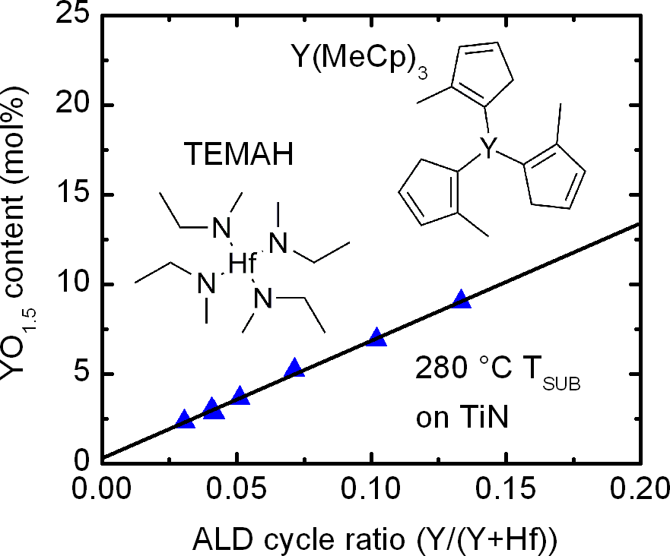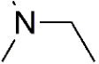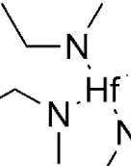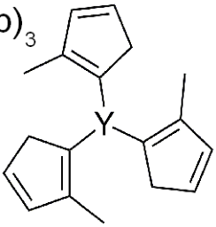

|  |  |  |
| --- | --- | --- |
| 114113-2 | Mu¨ller et al. | J. Appl. Phys. 110, 114113 (2011) |

the cubic phase. Y:HfO2 thin films have a large bandgap,11 are temperature stable,21CMOS compatible,23,24and due to the availability of mature atomic layer deposition (ALD) processes,13they are capable of conformal 3D integration. Therefore Y:HfO2 is considered a promising material for future, highly scaled ferroelectric memories.

EXPERIMENTAL

Y:HfO2 thin films were deposited by thermal ALD on 300 mm Si substrates that, prior to dielectric deposition, received a 18 nm chemical vapor deposited (CVD) TiN (TiCl4=NH3) bottom electrode in a batch furnace. The ALD process was based on the commercially available metal or-ganic precursors tetrakis(ethylmethylamino)hafnium (TEMAH) and tris(methylcyclopentadienyl)yttrium (Y(MeCp)3). Ozone

|  |
| --- |
| was used as the oxidant and argon as the purge and carrier |

gas. The YO1.5 content in HfO2 was defined by varying the cycle ratio of the precursors and monitored by inline X-ray photoelectron spectroscopy (XPS) and Rutherford backscat-tering (RBS). A constant thickness of 10 nm for all films was achieved by adjusting the number of Hf:Y super cycles, and was confirmed by inline spectral ellipsometry and HR-TEM. Crystallization of the as deposited amorphous Y:HfO2 thin films was induced by a 600�C=20 s=N2 RTP step, referred to in text as post deposition anneal (PDA). Samples annealed after room temperature deposition of a 4 nm physical vapor deposited (PVD) TiN top electrode are referred to in the text as samples treated with post metallization anneal (PMA). Samples with yttrium concentrations ranging from 2.3 to 12.3 mol% YO1.5 in HfO2 were manufactured using both schemes (Fig. 1(a)). This allowed access to the range of met-astable phases formed from almost pure hafnium oxide to fully cubic Y:HfO2. Grazing incidence X-ray diffraction (GI-XRD) on crystalline and high temperature X-ray diffrac-tion (HT-XRD) on as deposited Y:HfO2 thin films was meas-ured on a Bruker D8 Discover diffractometer using Cu K-alpha radiation from a Cu tube operated at 40 kV/40 mA. The incident angle was set to 0.5�. For HT-XRD analysis, samples were heated from room temperature to 650�C under constant nitrogen purging in a furnace covered with a hemi-spherical beryllium dome. During temperature ramp up, in situ GI-XRD measurements were performed.

For electrical measurements, Pt dots were evaporated on to the TiN top electrode, forming structured metal-insulator-metal (MIM) capacitors in a subsequent etching step. For samples that received PDA treatment, Pt dots were directly evaporated on top of the Y:HfO2 thin film. Polarization hys-teresis was characterized using an aixACCT TF Analyzer 2000 system and a custom built setup at a frequency of 1 kHz. The small signal capacitance-voltage characteristics of the MIM capacitors were determined with an Agilent 4284 LCR Meter. Typical measurement conditions were a fre-quency of 10 kHz and a 50 mV ac probing signal on device areas of 1.15*10�4cm2.

RESULTS AND DISCUSSION

The controlled incorporation of YO1.5 into HfO2 can be 12,13,17   
realized by the variation of the TEMAH to Y(MeCp)3

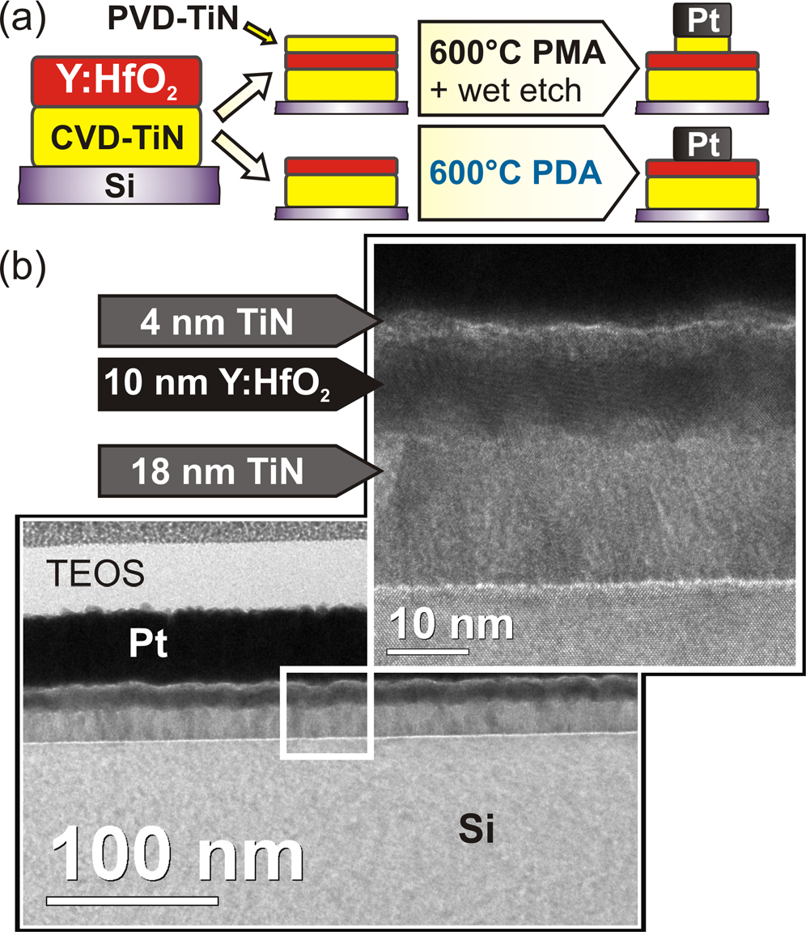

FIG. 1. (Color online) (a) Fabrication flow of MIM capacitors based on atomic layer deposited Y:HfO2 dielectrics with post deposition anneal (PDA) or post metallization anneal (PMA) in N2 atmosphere. (b) TEM micrograph and HRTEM enlargement of the fully crystalline TiN/Y:HfO2/ TiN MIM stack on silicon treated with PMA.

precursor pulsing ratio during the ALD process. RBS meas-urements on as deposited films reveal a linear correlation between precursor cycling ratio and YO1.5 incorporation (Fig. 2). Figure 1(b) shows a HR-TEM micrograph of the complete MIM stack after thermal treatment. The polycrys-talline structure of the Y:HfO2, as well as the TiN metal elec-trode, is clearly visible. Additional HT-XRD experiments confirmed no significant influence of YO1.5 content on the crystallization temperature (Fig. 3), which is in good

FIG. 2. (Color online) RBS measurements on 10 nm thick films reveal a lin-ear incorporation of YO1.5 into HfO2 with ALD cycle ratio of TEMAH and Y(MeCp)3 precursor. Structural drawings of the metal organic precursors are given.

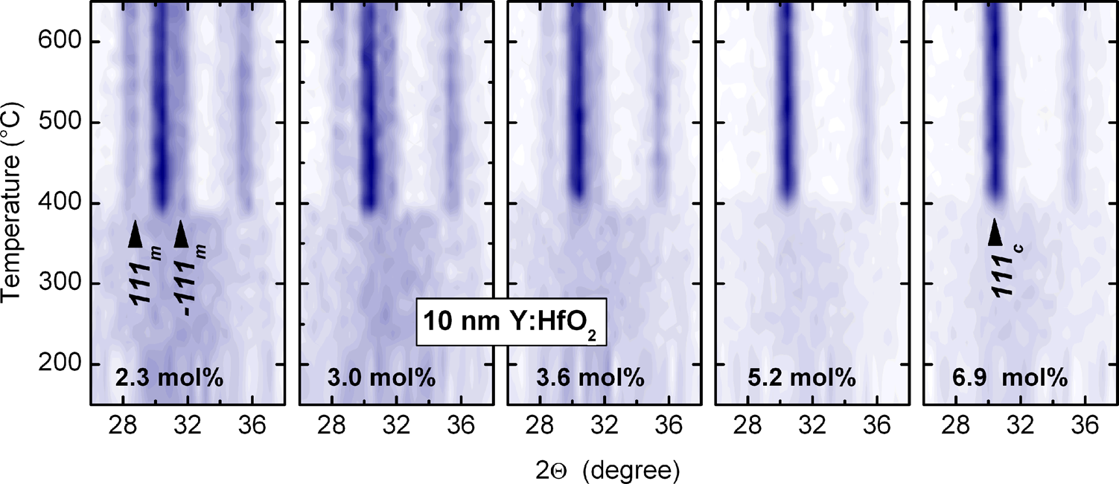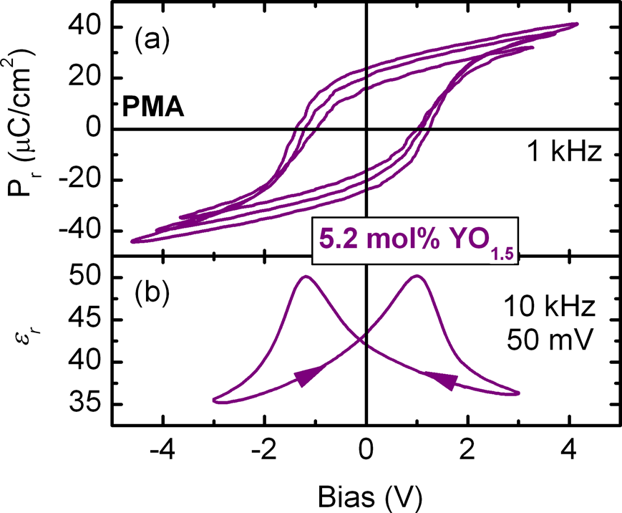

|  |  |  |
| --- | --- | --- |
| 114113-3 | Mu¨ller et al. | J. Appl. Phys. 110, 114113 (2011) |

agreement with literature data.9The crystallization tempera-  
ture was approximately 400�C for all of the YO1.5 concen-

|  |  |  |  |  |  |  |  |  |  |
| --- | --- | --- | --- | --- | --- | --- | --- | --- | --- |
| trations | investigated. | Based | |  | | --- | | on | | |  | | --- | | these | | data, | |  | | --- | | complete | |

crystallization of the as deposited amorphous dielectric was   
induced by a RTP step at 600�C in samples that were pre-  
pared for electrical characterization. This is a significant

improvement to the Hf1-xZrxO2 system that, depending on   
the ZrO2 content, suffers from premature crystallization dur-  
ing deposition, resulting in considerable interface roughen-  
ing.25Due to the higher crystallization temperature of

Y:HfO2, crystallization can either be induced before (PDA)

|  |
| --- |
| or after (PMA) top electrode deposition (Fig. 1(a)). |

Polarization-voltage hysteresis measurements of a 10

nm HfO2 sample with 5.2 mol% YO1.5 admixture are shown in Fig. 4(a). A remanent polarization Pr of 24 lC*cm�2and a coercive field of 1.2 MV*cm�1were observed. Unsatu-rated polarization hysteresis loops occur when excitation voltages below 4 V are used. This so called sub loop behav-ior is typical for ferroelectric materials and, as in this case, is usually accompanied by a drop in remanent polarization and coercive field with decreasing excitation signal.26   
 Further proof for the ferroelectric nature of Y:HfO2 thin films is given by their non-linear small signal capacitance-voltage response. Two capacitance maxima in the vicinity of the coercive field values are observed when a full hysteresis loop is swept (Fig. 4(b)). These maxima are a well-known property of ferroelectric capacitors and are attributed to an increased domain wall movement at the co-ercive fields.27   
 As can be seen from the polarization hysteresis measure-ments in Fig. 5 and the summarized polarization values in Fig. 6(a), a gradual transition from a linear dielectric to a fer-roelectric response can be observed with decreasing YO1.5 content in HfO2. When the YO1.5 content is lowered further, the polarization starts to decline and the coercive field increases. A similar trend is observed for the dielectric con-stant (Fig. 6(b)). Due to the stabilization of the higher-k cubic phase instead of the lower-k monoclinic phase with increasing YO1.5 content in HfO2, the dielectric constant increases with higher YO1.5 content. Once the cubic phase is fully stabilized, further addition of the lower-k YO1.5 decreases the effective permittivity of HfO2 again.

However, when directly comparing PMA against PDA samples, PDA samples exhibit lower Pr values and the Pr

FIG. 4. (Color online) A characteristic transformation from sub-loop behav-ior to saturation with increasing P-V sweep voltage (a), as well as ferroelec-tric capacitance peaks in dual sweep C-V (b) are observed for TiN/10 nm 5.2 mol% Y:HfO2/TiN MIM capacitors.

evolution slightly shifts to higher YO1.5 content. A similar shift is observed when comparing the dielectric constant at corresponding YO1.5 content. The mechanical confinement offered by the top electrode during the crystallization of the PMA samples can serve as an explanation. As can be seen from the weighing of the integral intensity of monoclinic against higher symmetry reflections in Fig. 6(c) and the direct comparison of GI-XRD diffractograms in Fig. 7, the monoclinic phase in HfO2 can effectively be suppressed uti-lizing PMA processing. This suppression mechanism of monoclinic HfO2 in thin films by a mechanically confined crystallization (e.g. reported for TiN=HfO2 gate stacks28) was identified to be the origin of the orthorhombic, ferroelec-tric, phase in SiO2-doped HfO2.5The increased Pr observed in PMA samples at low YO1.5 content suggests a larger fer-roelectric phase fraction due to the suppressed monoclinic phase. However, even though PDA samples exhibit lower Pr, they still show the presence of ferroelectricity, suggesting that the presence of a top electrode (“cap”) is preferred, but not mandatory, for the formation of the ferroelectric phase in Y:HfO2 thin films. This advantageous discrepancy to ferroe-lectricity in Si:HfO2,5for which PMA treatment was found to be necessary, may be explained by the difference in crys-tallization temperatures of both systems. The crystallization

FIG. 3. (Color online) HT-XRD analy-sis of 10 nm HfO2 thin films with YO1.5

|  |  |  |  |  |  |
| --- | --- | --- | --- | --- | --- |
| admixture | ranging | from | 2.3 | to | 6.9 |

mol%. With increasing YO1.5 content the monoclinic phase in HfO2 is sup-pressed, whereas crystallization temper-ature remains at approximately 400�C.

|  |  |  |
| --- | --- | --- |
| 114113-4 | Mu¨ller et al. | J. Appl. Phys. 110, 114113 (2011) |

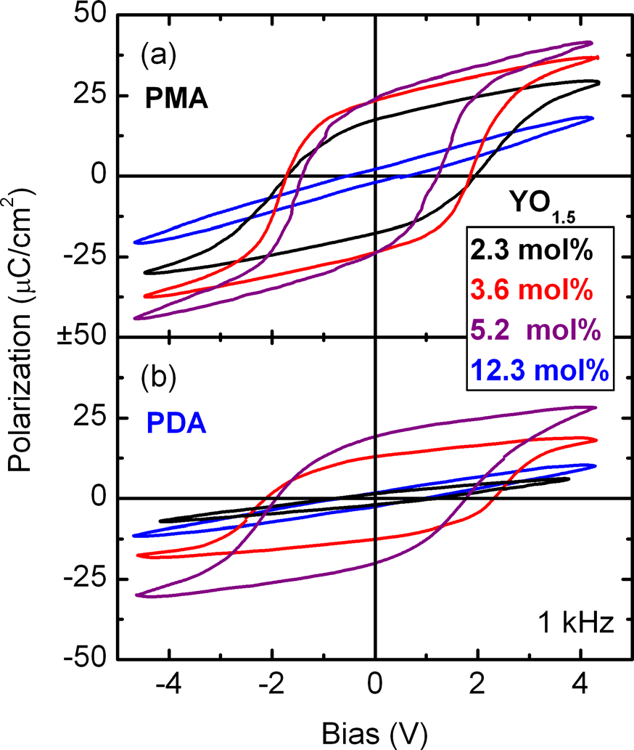

FIG. 5. (Color online) P-V hysteresis loops acquired on 10 nm Y:HfO2 MIM capacitors treated with PMA (a) and PDA (b) processing clearly ex-hibit ferroelectric nature. For PDA treated samples a linear dielectric response is observed at low YO1.5 content. For high YO1.5 admixture to HfO2 a linear dielectric response is observed for both processing schemes.

of Si:HfO2 requires temperatures in excess of 700�C and may therefore lead to a more rapid formation of stable

|  |  |  |  |  |  |
| --- | --- | --- | --- | --- | --- |
| crystalline | phases | instead | of | quenchable, | metastable |

intermediates.

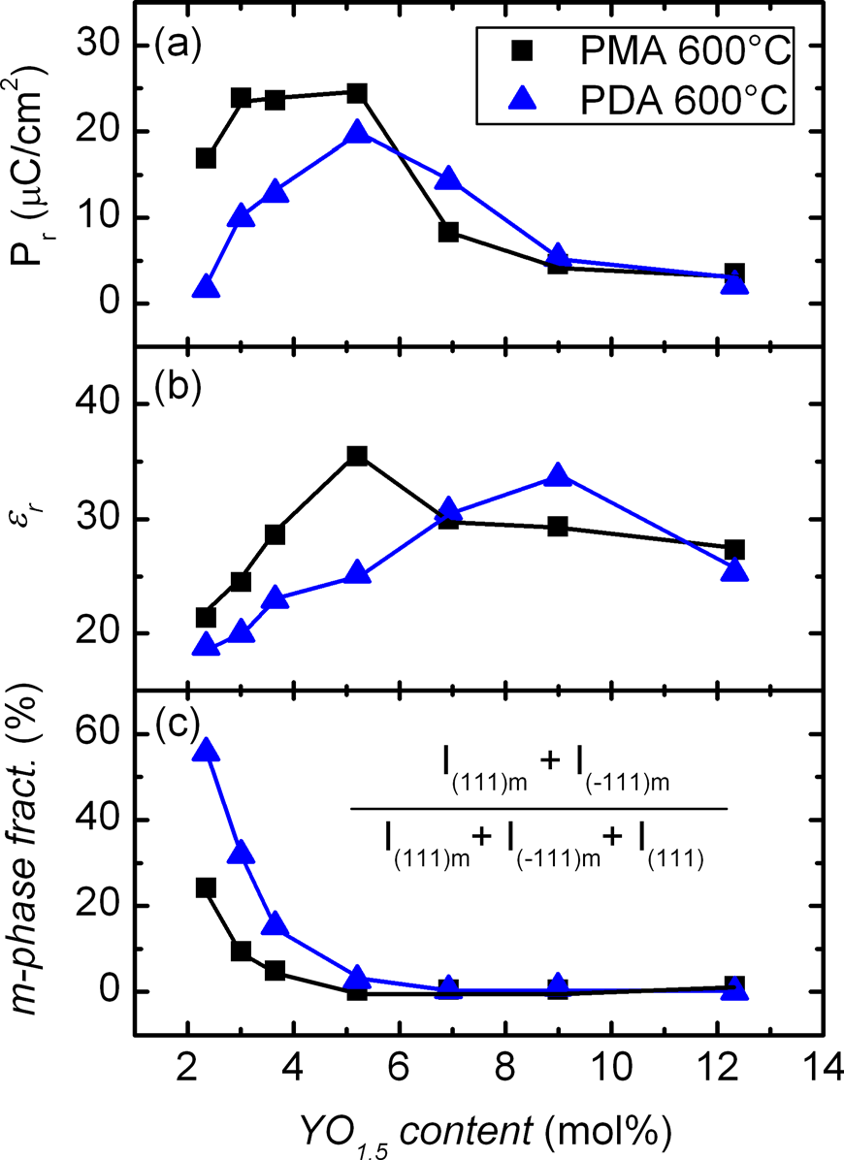

FIG. 6. (Color online) Remanent polarization (a) and dielectric permittivity (b) maxima for PMA and PDA treated Y:HfO2 MIM capacitors are con-trasted to the monoclinic phase fraction (c) evaluated from weighing the in-tegral intensity of monoclinic against higher symmetry reflections.

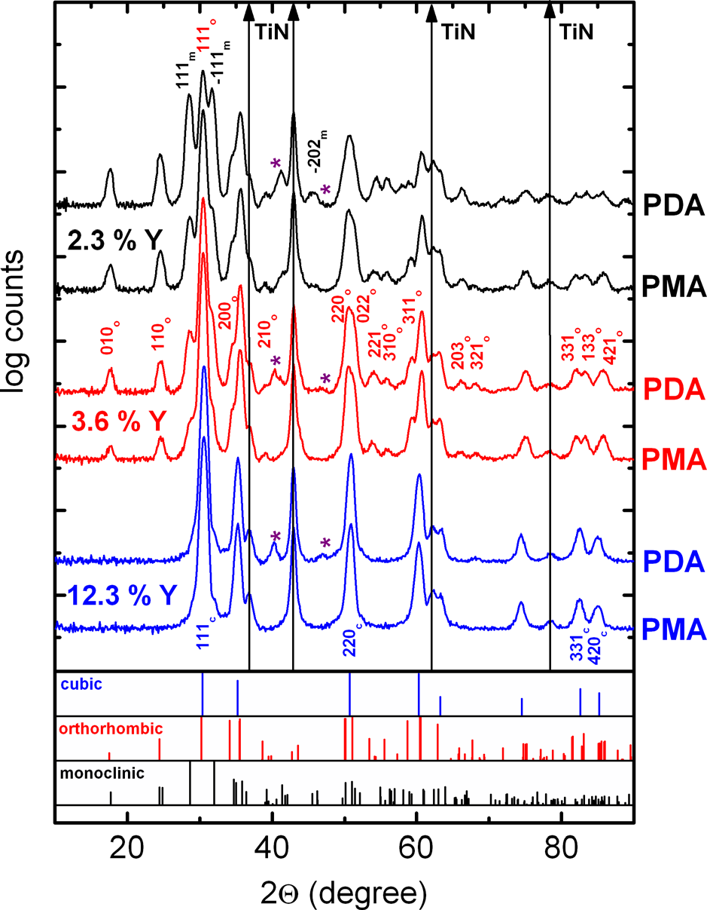

FIG. 7. (Color online) GI-XRD diffractograms of Y:HfO2 samples reveal the coexistence of monoclinic and orthorhombic phase for low YO1.5 doping and complete stabilization of the cubic phase for higher doping content. When directly comparing PMA against PDA treated samples a higher mono-clinic phase fraction for PDA samples is observed. Reference pattern are computed from ab initio calculations presented by Lowther et al.31on HfO2 phase stability (cubic Fm3m, orthorhombic Pbc21, monoclinic P21=c). D-spacing was adjusted. For better visibility, reference patterns were scaled to the 2ndhighest square root intensity (highest intensity for all patterns: 111 reflections). Stars indicate Pt reflections.

Stabilization of the cubic phase in the predominantly monoclinic HfO2 by YO1.5 admixture is widely accepted in literature and has been reported several times.9–17However, considering the occurrence of ferroelectricity in Y:HfO2 thin films, a simple monoclinic=cubic phase mixture or interme-diate tetragonal phases seem contradictory, since neither the cubic=tetragonal nor the monoclinic phases in HfO2 possess ferroelectric space groups.29A close examination of the GI-XRD diffractograms presented in Fig. 7 revealed the pres-ence of an orthorhombic phase, whose phase fraction increases against the monoclinic phase until a full stabiliza-tion of the cubic phase is reached for high YO1.5 content. These findings are in good agreement with data on Y:HfO2 thin films shown by Rauwel et al.21and Dubourdieu et al.,22 who observed a possibly orthorhombic phase coexisting with the monoclinic phase until a stable cubic phase is reached. This orthorhombic phase, however, was identified as centro-symmetric Pbca and was seemingly not tested for ferroelec-tric properties.

On the basis of the electrical data presented, it seems likely that this orthorhombic phase can be assigned to the non-centrosymmetric, and therefore potentially ferroelectric, space group Pbc21. This phase has already been observed in 31 by an the closely related PSZ30and was predicted for HfO2

|  |  |  |
| --- | --- | --- |
| 114113-5 | Mu¨ller et al. | J. Appl. Phys. 110, 114113 (2011) |

ab initio approach. It can be separated from the monoclinic and cubic phase by the characteristic features labeled in Fig. 7. This analogy to ferroelectric Si:HfO2 supports the hy-

|  |
| --- |
| pothesis that the structural origin of spontaneous polarization |

in doped HfO2 is linked to the stabilization of this particular phase and does not originate from the dopant itself.5   
 The anti-ferroelectric like behavior observed for the fully stabilized Si:HfO2, however, was not observed in the Y:HfO2 system within our experimental conditions. Tomida et al.16clearly distinguished the tetragonal Si:HfO2 from the cubic Y:HfO2 system. This further supports the hypothesis 2is that the field driven phase transition observed in Si:HfO5 related to the tetragonal phase stabilized for high SiO2 dop-ing and is not present in the cubic configuration favored by YO1.5 incorporation.

In the context of ferroelectricity being present in Y:HfO2, it is interesting to note that unusual threshold volt-age shifts have been observed for Y:HfO2 based transistors under constant voltage stress.23The phenomenon described in the present work could serve as an explanation, since even residual ferroelectricity being present in the gate stack would counteract the usual polarity correlation of threshold voltage shift and stress voltage by slow polarization reversal.

1K. Kim and S. Lee, [J. Appl. Phys.](http://dx.doi.org/10.1063/1.2337361) 100, 51604 (2006).

2X. Zhao and D. Vanderbilt, [Phys. Rev. B](http://dx.doi.org/10.1103/PhysRevB.65.233106) 65, 233106 (2002).

3K. Kita, K. Kyuno, and A. Toriumi, [Appl. Phys. Lett.](http://dx.doi.org/10.1063/1.1880436) 86, 102906 (2005). 4T. S. Bo¨scke, S. Govindarajan, P. D. Kirsch, P. Y. Hung, C. Krug, B. H. Lee, J. Heitmann, U. Schro¨der, G. Pant, B. E. Gnade, and W. H. Krautsch-neider, [Appl. Phys. Lett.](http://dx.doi.org/10.1063/1.2771376) 91, 72902 (2007).

5T. S. Bo¨scke, J. Mu¨ller, D. Bra¨uhaus, U. Schro¨der, and U. Bo¨ttger, [Appl. Phys. Lett.](http://dx.doi.org/10.1063/1.3634052) 99, 102903 (2011).

6J. Mu¨ller, T. S. Bo¨scke, D. Bra¨uhaus, U. Schro¨der, U. Bo¨ttger, J. Sundqvist, P. Ku¨cher, T. Mikolajick, and L. Frey, [Appl. Phys. Lett.](http://dx.doi.org/10.1063/1.3636417) 99, 112901 (2011). 7C.-K. Lee, E. Cho, H.-S. Lee, C. S. Hwang, and S. Han, [Phys. Rev. B](http://dx.doi.org/10.1103/PhysRevB.78.012102) 78, 12102 (2008); G. H. Chen, Z. F. Hou, X. G. Gong, and Quan Li, [J. Appl. Phys.](http://dx.doi.org/10.1063/1.2985908) 104, 74101 (2008).

8R. C. Garvie, R. H. J. Hannink, and R. T. Pascoe, [Nature](http://dx.doi.org/10.1038/258703a0) 258, 703 (1975). 9S. V. Ushakov, C. E. Brown, and A. Navrotsky, [J. Mater. Res.](http://dx.doi.org/10.1557/jmr.2004.19.3.693) 19, 693 (2004).

10J. Y. Dai, P. F. Lee, K. H. Wong, H. L. W. Chan, and C. L. Choy, [J. Appl.](http://dx.doi.org/10.1063/1.1585116)  [Phys.](http://dx.doi.org/10.1063/1.1585116) 94, 912 (2003).

11M. Komatsu, R. Yasuhara, H. Takahashi, S. Toyoda, H. Kumigashira, M. Oshima, D. Kukuruznyak, and T. Chikyow, [Appl. Phys. Lett.](http://dx.doi.org/10.1063/1.2364601) 89, 172107 (2006).

12J. Niinisto, K. Kukli, T. Sajavaara, M. Ritala, M. Leskela, L. Oberbeck, J. Sundqvist, and U. Schro¨der, [Electrochem. Solid-State Lett.](http://dx.doi.org/10.1149/1.3020763) 12, G1–G4 (2009).

13Q. Tao, G. Jursich, P. Majumder, M. Singh, W. Walkosz, P. Gu, R. Klie, and C. Takoudis, [Electrochem. Solid-State Lett.](http://dx.doi.org/10.1149/1.3156833) 12, G50–G53 (2009).

14L. Shi, Y. Zhou, J. Yin, and Z. Liu, [J. Appl. Phys.](http://dx.doi.org/10.1063/1.3277021) 107, 14104 (2010). 15Z. K. Yang, W. C. Lee, Y. J. Lee, P. Chang, M. L. Huang, M. Hong, K. L. Yu, M.-T. Tang, B.-H. Lin, C.-H. Hsu, and J. Kwo, [Appl. Phys. Lett.](http://dx.doi.org/10.1063/1.2816121) 91,

|  |  |
| --- | --- |
| CONCLUSION | 202909 (2007).  16K. Tomida, K. Kita, and A. Toriumi, [Appl. Phys. Lett.](http://dx.doi.org/10.1063/1.2355471) 89, 142902 (2006). 17T. Ro¨ssler, J. Gluch, M. Albert, and J. W. Bartha, [Thin Solid Films](http://dx.doi.org/10.1016/j.tsf.2009.12.058) 518, |

In conclusion, we have demonstrated the stabilization of a ferroelectric phase in 10 nm thick, atomic layer deposited Y:HfO2 thin films for doping levels below 8 mol% YO1.5. The origin of ferroelectricity was attributed to an orthorhom-bic phase of space group Pbc21, which was found to coexist with the monoclinic phase until complete stabilization of the cubic phase is reached. Given the vast industry experience integrating HfO2-based thin films, ferroelectricity in Y:HfO2 has the potential to enable high density ferroelectric memo-ries. Besides its thermal stability on contact with Si, Y:HfO2 offers excellent scaling potential due to its large bandgap and highly conformal deposition processes (3D integration capability), rendering it superior to commonly integrated fer-roelectrics in microelectronic devices.

ACKNOWLEDGMENTS

Prof. S. Teichert is acknowledged for RBS measure-ments and M. Mildner is acknowledged for TEM micro-graphs. We would like to thank Prof. K. Do¨rr and Prof. A. Kersch for helpful discussions. The work for this paper was supported within the scope of technology development by the EFRE fund of the European Community and by funding from the Free State of Saxony (Project MERLIN).

4680 (2010).

18D.W. Stacy and D. R. Wilder, [J. Am. Ceram. Soc.](http://dx.doi.org/10.1111/j.1151-2916.1975.tb11476.x) 58, 285 (1975); M. F. Trubelja and V. S. Stubican, [J. Am. Ceram. Soc.](http://dx.doi.org/10.1111/j.1151-2916.1988.tb06385.x) 71, 662 (1988).

19M. Yashima, H. Takahashi, K. Ohtake, T. Hirose, M. Kakihana, H. Arashi, Y. Ikuma, Y. Suzuki, and M. Yoshimura, [J. Phys. Chem. Solids](http://dx.doi.org/10.1016/0022-3697(95)00268-5) 57, 289 (1996).

20H. Fujimori, M. Yashima, S. Sasaki, M. Kakihana, T. Mori, M. Tanaka, and M. Yoshimura, [Chem. Phys. Lett.](http://dx.doi.org/10.1016/S0009-2614(01)00929-0) 346, 217 (2001).

21E. Rauwel, C. Dubourdieu, B. Hollander, N. Rochat, F. Ducroquet, M. D. Rossell, G. Van Tendeloo, and B. Pelissier, [Appl. Phys. Lett.](http://dx.doi.org/10.1063/1.2216102) 89, 12902 (2006).

22C. Dubourdieu, E. Rauwel, H. Roussel, F. Ducroquet, B. Hollander, M. Rossell, G. Van Tendeloo, S. Lhostis, and S. Rushworth, [J. Vac. Sci. Tech-nol. A](http://dx.doi.org/10.1116/1.3106627) 27, 503 (2009).

23S. Motoyuki, K. Satoshi, and M. Takeo, [Jap. J. Appl. Phys.](http://dx.doi.org/10.1143/JJAP.49.04DC24) 49, 04DC24 (2010).

24K. J. Hubbard and D. G. Schlom, [J. Mater. Res.](http://dx.doi.org/10.1557/JMR.1996.0350) 11, 2757 (1996).

25J. Mu¨ller, T. S. Bo¨scke, U. Schro¨der, M. Reinicke, L. Oberbeck, D. Zhou, W. Weinreich, P. Ku¨cher, M. Lemberger, and L. Frey, [Microelectronic En-gineering](http://dx.doi.org/10.1016/j.mee.2009.03.076) 86, 1818 (2009).

26S. L. Miller, R. D. Nasby, J. R. Schwank, M. S. Rodgers, and P. V. Dres- sendorfer, [J. Appl. Phys.](http://dx.doi.org/10.1063/1.346845) 68, 6463 (1990).

27D. Bolten, O. Lohse, M. Grossmann, and R. Waser, [Ferroelectrics](http://dx.doi.org/10.1080/00150199908016462) 221, 251 (1999).

28D. H. Triyoso, P. J. Tobin, B. E. White, J. R. R. Gregory, and X. D. Wang, [Appl. Phys. Lett.](http://dx.doi.org/10.1063/1.2357032) 89, 132903 (2006).

29D. B. Litvin, Acta Crystallogr. A42, 44 (1986).

30E. H. Kisi, C. J. Howard, and R. J. Hill, [J. Am. Ceram. Soc.](http://dx.doi.org/10.1111/j.1151-2916.1989.tb06322.x) 72, 1757 (1989).

31J. E. Lowther, J. K. Dewhurst, J. M. Leger, and J. Haines, [Phys. Rev. B](http://dx.doi.org/10.1103/PhysRevB.60.14485) 60,

The authors are responsible for the content of the paper. 14485 (1999).