IEEE TRANSACTIONS ON DEVICE AND MATERIALS RELIABILITY, VOL. 13, NO. 1, MARCH 2013 93

Reliability Characteristics of Ferroelectric Si:HfO2

Thin Films for Memory Applications

Stefan Mueller, Johannes Müller, *Graduate Student Member, IEEE*,

Uwe Schroeder, and Thomas Mikolajick, *Senior Member, IEEE*

***Abstract*—Reliability characteristics of ferroelectric thin films (10 nm) based on Si-doped HfO2 have been investigated with focus on potential memory applications. Extensive retention, imprint, and endurance data for this new type of ferroelectric material are presented for the first time. The variability of reliability characteristics in terms of capacitor annealing temperatures as well as excitation amplitude effects is analyzed. Stable ferroelectric switching behavior can be observed in a wide temperature range from 80 K up to 470 K. Bake tests at 125*◦*C show almost no retention loss for saturated polarization states up to cumulative testing times of 1000 h. In addition to the same-state retention, opposite-state retention was observed to be equally stable. Tradi-tional imprint behavior of the programmed state occurs after a few hours of baking time, and stable behavior could be verified until the end of the 1000-h retention test. Endurance characteristics of the ferroelectric thin films are shown to depend significantly on the annealing temperature of the capacitors and on the cycling voltage during testing. In thin films which had been annealed at 1000*◦*C, breakdown at 2 MV/cm limits endurance after 108 cycles. A lower annealing temperature of 650*◦*C could improve the breakdown-limited endurance to 1010cycles.**

|  |  |  |  |  |
| --- | --- | --- | --- | --- |
| ***Index*** | ***Terms*—Endurance,** | **ferroelectric** | **HfO2,** | **imprint,** |
| **retention, temperature stability.** | |

I. INTRODUCTION

**T** oxide thin films [1]–[5] has spurred the interest in its HE RECENT discovery of ferroelectricity in hafnium

suitability for memory applications like the ferroelectric field

effect transistor (FeFET) [6]–[8] or the ferroelectric random

access memory (FRAM) [9]. Instead of losing their functional

properties at small thicknesses as it is the case for traditional

ferroelectric materials like PZT or SBT [10], polycrystalline

hafnium oxide thin films rather obtain their optimal ferroelec-

tric properties at film thicknesses around 10 nm. This makes the

thin films very attractive for future technology nodes of highly

Manuscript received July 5, 2012; revised August 21, 2012; accepted August 24, 2012. Date of publication September 4, 2012; date of current version March 7, 2013. This work was supported in part by the EFRE fund of the European Commission within the scope of technology development and in part by the Free State of Saxony under project HEIKO.

S. Mueller and U. Schroeder are with NaMLab gGmbH, 01187 Dresden, Germany (e-mail: stefan.mueller@namlab.com).

J. Müller is with Fraunhofer CNT, 01099 Dresden, Germany (e-mail: johannes.mueller@ieee.org).

T. Mikolajick is with NaMLab gGmbH, 01187 Dresden, Germany, and also with the Institute of Semiconductors and Microsystems, Technische Universität Dresden, 01187 Dresden, Germany.

Color versions of one or more of the figures in this paper are available online at http://ieeexplore.ieee.org.

Digital Object Identifier 10.1109/TDMR.2012.2216269

scaled ferroelectric devices. Furthermore, the comparably small dielectric constant of HfO2 enables FeFET architectures with non-volatile retention and reasonable stack heights which could not be realized using SBT so far [11].

The following results demonstrate the potential of ferroelec-tric hafnium oxide to enable reliable ferroelectric memories in the deep sub-100 nm feature size range.

II. EXPERIMENTS

Reliability characterizations were carried out on planar metal–insulator–metal (MIM) capacitors using dielectrics man-ufactured by atomic layer deposition (ALD).

In detail, a TiN bottom electrode (10 nm) was deposited first onto HF cleaned silicon substrates inside an ALD batch furnace using TiCl4 and NH3 precursors at a temperature of 450*◦*C. The functional Si:HfO2 thin film (10 nm) was then deposited at 266*◦*C using a single wafer ALD furnace and tetrakisethyl-methylaminohafnium (TEMAH), tetrakisdi-methylaminosilane (4DMAS) as well as ozone as precursor gases. The pulsing ratio of TEMAH:4DMAS was chosen such as to achieve a molar concentration of 4.6% SiO2 within the HfO2 host lattice. Another TiN top electrode was deposited by the same process as used for the bottom electrode. After the MIM-stack formation, rapid thermal annealing in nitrogen environment was carried out either at 650*◦*C for 20 s, 800*◦*C for 20 s or 1000*◦*C for 10 s. Evaporated platinum dots (104*μ*m2) served as electrical contact as well as hard mask for etching the TiN top electrode defining the final capacitor geometries.

Hysteresis, retention, imprint and endurance measurements were carried out using an aixACCT TF Analyzer 1000 mea-surement system.

III. RESULTS AND DISCUSSION

As a first test, the initial poling dependence of the MIM capacitors was investigated by cycling the samples up to 103 times and measuring the hysteretic charge–voltage relationship in logarithmic steps (after 10, 102and 103cycles at 3 V ampli-tude). Fig. 1 shows the evolution of the polarization hysteresis with increasing amount of cycling as well as the final sub-loop (1.5 V) and saturated (3 V) behavior after this so called “wake-up” procedure [12]. It can be seen that neither the coercive field nor the remanent polarization is significantly affected by the initialization process. However, the annealing temperature seems to have strong influence on the remanent polarization since an increase from 8 *μ*C/cm2over 13 *μ*C/cm2up to

1530-4388/$31.00 © 2012 IEEE

94 IEEE TRANSACTIONS ON DEVICE AND MATERIALS RELIABILITY, VOL. 13, NO. 1, MARCH 2013

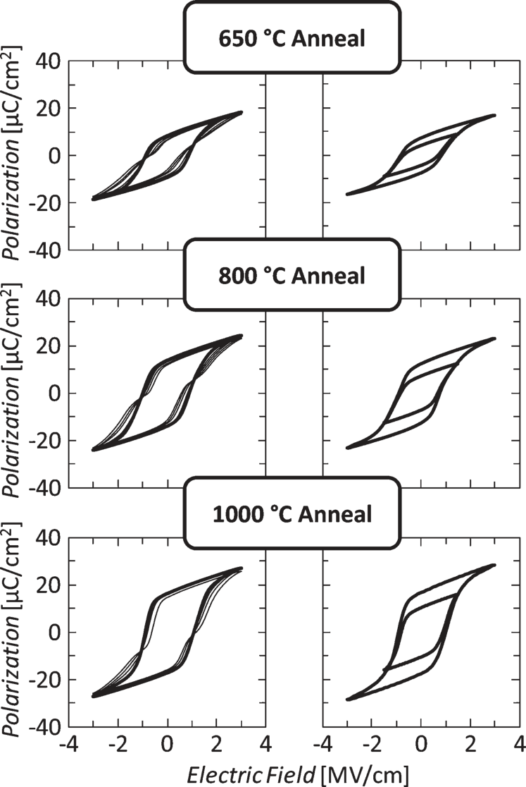

Fig. 1. Hysteresis behavior of the ferroelectric capacitors depending on the annealing temperature of the Si:HfO2 thin film. The left column shows the evolution of the polarization up to 1000 bipolar cycles at 3V. The right column shows the saturated and sub-loop behavior after the initialization process mentioned in the text.

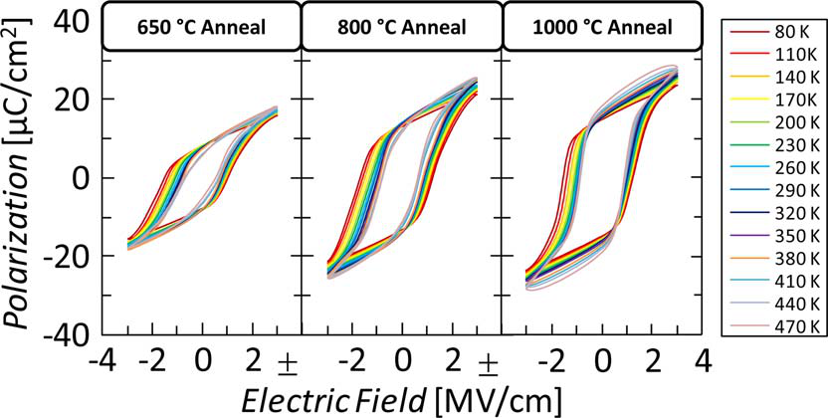

Fig. 2. Temperature dependent polarization characteristics for MIM capaci-tors annealed at different temperatures. Stable ferroelectric hysteresis can be observed in a wide temperature range.

17 *μ*C/cm2can be observed for annealing temperatures of 650*◦*C, 800*◦*C and 1000*◦*C, respectively.

In order to investigate the temperature stability of the ferro-electric capacitors, polarization hysteresis was also tested in a wide temperature range from 80 K up to 470 K (Fig. 2).

In comparison to previous publications on the thermal stabil-ity of ferroelectricSi:HfO2 [2], no transition to antiferroelectric-like behavior could be observed for the samples at hand. In fact, across the whole temperature range of almost 400 K only small deviations in remanent polarization were visible, mainly attributed to increased leakage current contributions at elevated temperatures. At lower temperatures a gradual increase in the coercive field as predicted by Landau-Ginzburg mean-field theory could be observed [13]. With respect to earlier studies on the temperature stability of Si:HfO2 thin films the authors would like to point out that these characteristics are

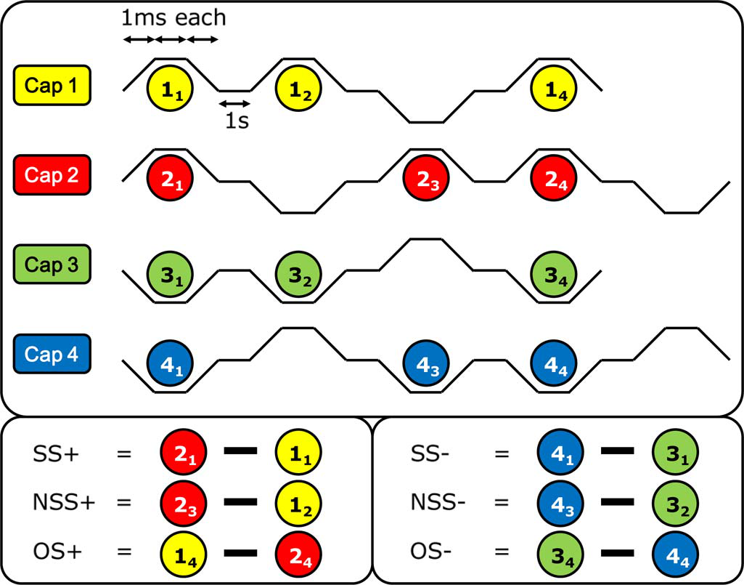

Fig. 3. Voltage pulse sequences used for same-state (SS), new same-state (NSS) and opposite-state (OS) retention tests. Calculation of the FRAM-specific retention values from the respective integrated current responses is shown below. Integration of the current response is performed across the complete transient range of the trapezoidal pulse.

highly affected by the proper choice of silicon content inside the HfO2 host lattice. Hence, due to the stable characteristics of the MIM capacitors the concentration of 4.6 mol% can be considered very appropriate for the chosen process flow.

Besides thermally stable switching characteristics, state re-tention is an essential necessity for any type of ferroelectric material used in non-volatile memory applications. Therefore, same-state (SS), new same-state (NSS) and opposite-state (OS) retention tests as known from state-of-the-art FRAM reliability characterizations [14] were performed for the Si:HfO2-based ferroelectric capacitors. The pulse schemes used for these tests are illustrated in Fig. 3.

In order to measure the mentioned retention values, four MIM capacitors were used (Cap 1–Cap 4) and exposed to different pulse sequences. The calculation of the respective parameters is also shown in Fig. 3. The resulting current responses always have to be understood with respect to their previously written state. As an example, pulse 11 will only yield a purely dielectric response since the previously written state using pulse 14 is the same. On the other hand, pulse 21 will yield a ferroelectric switching current as well as a dielectric displacement current since the capacitor (Cap 2) resided in a“1” state before (due to the negative voltage polarity at the end of the pulse sequence for Cap 2). In between those pulsed tests, the samples were placed inside a furnace and baked at 125*◦*C in order to accelerate the retention and imprint behavior, respectively. The results are shown in Fig. 4.

The retention tests were performed for samples annealed at different temperatures which were programmed/erased at either 1.5 V or 3 V. As mentioned before, states written at 1.5 V correspond to polarization sub-loops and states written at 3 V are fully saturated. In general, strong retention loss of non-saturated states could be observed after 1000-h bake time at 125*◦*C. This behavior was anticipated due to the fact that not fully polarized states are expected to be more prone to ther-mal depolarization than capacitors which had previously been

MUELLER *et al.*: RELIABILITY CHARACTERISTICS OF FERROELECTRIC Si:HfO2 FILMS 95

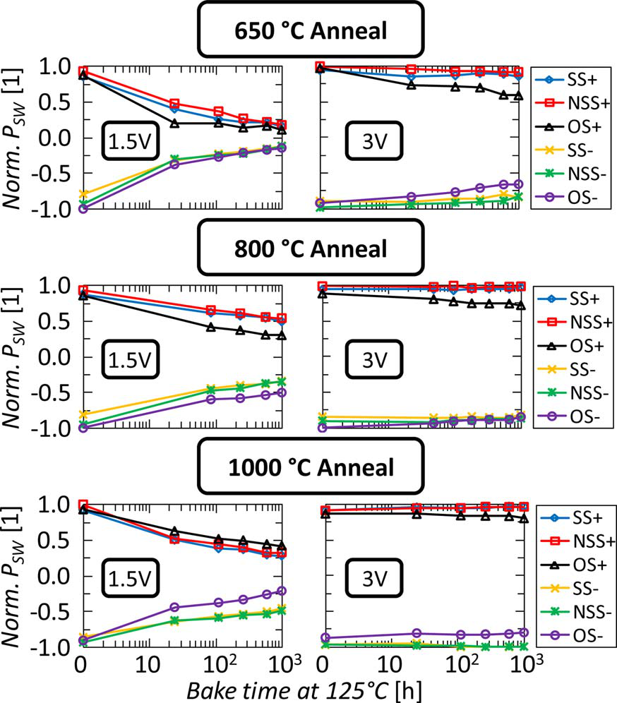 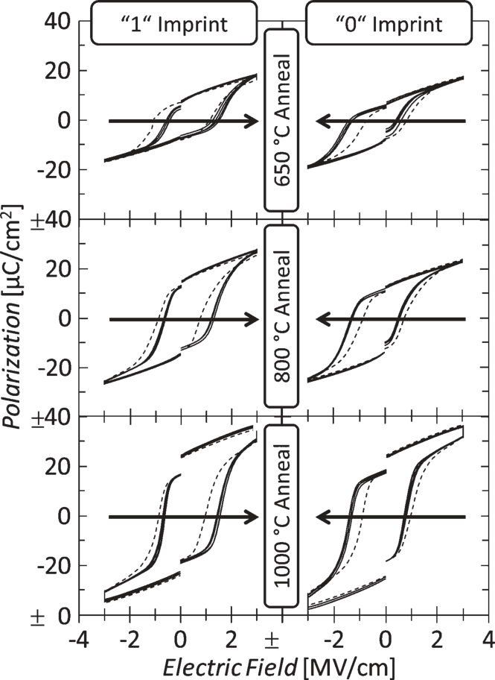

Fig. 5. Imprint behavior for capacitors annealed at different temperatures for

Fig. 4. Same-state and opposite-state retention tests performed for samples annealed at different temperatures and programmed/erased at voltage levels of either 1.5 V or 3 V. The degradation of sub-loop states (1.5 V) is much more severe than for fully saturated states (3 V). Retention is improved at elevated annealing temperatures. *PSW* was normalized with respect to the initially switched polarization.

written into a saturated state. Imprint behavior, as represented by opposite-state retention, showed no clear tendency for sub-loop states. Fully saturated states programmed/erased at 3 V showed a very clear and stable retention behavior up to 1000 h of bake time. Samples annealed at 650 *◦*C showed some degradation of the opposite state whereas higher annealing temperatures significantly improved opposite-state retention so that inverse states could achieve up to at least 75% of the initially switched polarization. Referring to recent PZT data [14], the same-state and opposite-state retention characteristics can be considered comparatively stable.

Regarding the suitability of ferroelectric Si:HfO2 thin films for different kinds of memory applications, the retention data was not only analyzed in terms of FRAM-based *PSW* but also with respect to FeFET-based characteristics. Therefore, a visualization of the shift in coercive fields (imprint) extracted from the retention tests is shown in Fig. 5.

An immediate shift of the coercive fields toward the im-printed state is visible already after the first baking period (which can be extracted from the second data point in Fig. 3). After that, no severe additional degradation can be observed with increasing bake times up to 1000 h. Due to the fact that trapezoidal pulses with a 1 ms slope and holding time were used for the imprint tests, the contribution of the constant voltage stress at 3 V to the polarization hysteresis originates solely from leakage currents. As shown in Fig. 5, for the capacitors annealed at 1000*◦*C this causes an additional vertical offset of the right and left hysteresis branch due to the increased leakage current contribution for these samples. Referring again to FeFET-based applications, imprint effects shifting the co-ercive voltage are much more important than reduced *PSW*

bake times up to 1000 h. Dashed lines represent initial polarization hysteresis and solid lines represent measurements after consecutive bake intervals as illustrated in Fig. 3. Clear imprint is visible within the first 100 h of baking. The offset of right and left hysteresis branch originates from the leakage current contribution occurring for the trapezoidal excitation signal.

because of the small dependence of the threshold voltage on the remanent polarization [15]. Changes in the coercive fields, however, affect both the absolute position as well as the size of the memory window. Both are essential for the proper operation of FeFET-based memories.

Another important measure for determining the suitability of ferroelectric materials for memory applications are the en-durance or sometimes also called fatigue characteristics. In materials like PZT severe fatigue will be observed during endurance tests if no oxide electrodes are used to construct the MIM capacitor. Therefore, the ferroelectric is exposed to a series of bipolar voltage cycles in order to emulate cumulative switching effects on the material characteristics. These tests were performed for samples annealed at the specified temper-atures and carried out at different voltages up to 1010cycles (Fig. 6).

As mentioned before, capacitors annealed at higher tem-peratures clearly show increased remanent polarization values and therefore a larger switchable polarization. However, during endurance tests breakdown of the functional layer was observed much earlier for those samples. For instance, capacitors an-nealed at 1000*◦*C could only be cycled 105times at 2.5 V until breakdown whereas capacitors annealed at 650*◦*C could endure up to almost 108bipolar cycles at the same amplitude. This behavior can be explained by stronger diffusion of defects and titanium/nitrogen into Si:HfO2 along the grain boundaries of the polycrystalline film. A larger amount of defects and vacan-cies leads to higher leakage currents and therefore to degraded reliability [16]. In comparison to ferroelectrics like PZT or SBT, which predominantly show fatigue, i.e., a gradual reduction of the remanent polarization with cycling. The cycling endurance for Si:HfO2 ferroelectrics is in contrast by hard breakdown.

96 IEEE TRANSACTIONS ON DEVICE AND MATERIALS RELIABILITY, VOL. 13, NO. 1, MARCH 2013

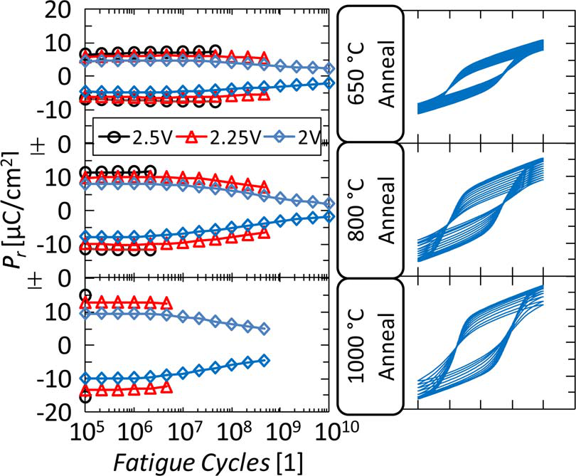

Fig. 6. Endurance characteristics of ferroelectric Si:HfO2 MIM capacitors. A clear correlation between switchable polarization and endurance until break-down is visible. Samples annealed at higher temperatures show larger remanent polarization but also earlier breakdown. On the right, the evolution of hysteresis (2 V amplitude) with cycling is shown.

However, considering the fact that the coercive field of these new type of ferroelectric material is significantly higher than the one of PZT or SBT, this behavior can be anticipated.

IV. CONCLUSION

Reliability characteristics of ferroelectric Si:HfO2 MIM ca-pacitors have been investigated. Stable operation in a wide tem-perature range between *−*200*◦*C and 125*◦*C could be proven. Retention and imprint characteristics at elevated temperature (125*◦*C) were investigated based on same-state and opposite-state retention tests and showed no severe degradation up to 1000 h of bake time. Furthermore, endurance characteristics for samples which also showed stable retention characteristics was in the range of 105to 106cycles at 2.5 V and for smaller am-plitudes, endurance without breakdown could be demonstrated up to 1010cycles.

The results show that depending on the right choice of silicon incorporation in the HfO2 host lattice as well as the right pro-cessing conditions, very stringent requirements for non-volatile memories can be met using this new type of ferroelectric. For the first time we were able to show that ferroelectric Si:HfO2 is not only interesting as a novel memory material in terms of its small layer thickness but also because of its promising reliability characteristics.

REFERENCES

[1] T. S. Böscke, J. Müller, D. Bräuhaus, U. Schröder, and U. Böttger, “Ferro-electricity in hafnium oxide thin films,” *Appl. Phys. Lett.*, vol. 99, no. 10, p. 102903, Sep. 2011.

[2] T. S. Böscke, St. Teichert, D. Bräuhaus, J. Müller, U. Schröder, U. Böttger, and T. Mikolajick, “Phase transitions in ferroelectric silicon doped hafnium oxide,” *Appl. Phys. Lett.*, vol. 99, no. 11, p. 112904, Sep. 2011.

[3] J. Müller, T.S. Böscke, D. Bräuhaus, U. Schröder, U. Böttger, J. Sundqvist, P. Kücher, T. Mikolajick, and L. Frey, “Ferroelectric Zr0*.*5Hf0*.*5O2 thin films for nonvolatile memory applications,” *Appl. Phys. Lett.*, vol. 99, no. 11, p. 112901, Sep. 2011.

[4] J. Müller, U. Schröder, T. S. Böscke, I. Müller, U. Böttger, L. Wilde, J. Sundqvist, M. Lemberger, P. Kücher, T. Mikolajick, and L. Frey, “Fer-roelectricity in yttrium-doped hafnium oxide,” *J. Appl. Phys.*, vol. 110, no. 11, p. 114113, Dec. 2011.

[5] S. Mueller, J. Mueller, A. Singh, S. Riedel, J. Sundqvist, U. Schroeder, and T. Mikolajick, “Incipient ferroelectricity in Al-doped HfO2 thin films,”*Adv. Funct. Mater.*, vol. 22, no. 11, pp. 2412–2417, Jun. 2012.

[6] T. S. Böscke, J. Müller, D. Brauhaus, U. Schroder, and U. Bottger, “Ferro-electricity in hafnium oxide: CMOS compatible ferroelectric field effect transistors,” in *Proc. IEEE IEDM*, 2011, pp. 24.5.1–24.5.4.

[7] J. Müller, T. S. Boscke, U. Schroder, R. Hoffmann, T. Mikolajick, and L. Frey, “Nanosecond polarization switching and long retention in a novel MFIS-FET based on ferroelectric HfO2,” *IEEE Electron Device Lett.*, vol. 33, no. 2, pp. 185–187, Feb. 2012.

[8] J. Müller, E. Yurchuk, T. Schlosser, J. Paul, R. Hoffmann, S. Muller, D. Martin, S. Slesazeck, P. Polakowski, J. Sundqvist, M. Czernohorsky, K. Seidel, P. Kucher, R. Boschke, M. Trentzsch, K. Gebauer, U. Schroder, and T. Mikolajick, “Ferroelectricity in HfO2 enables nonvolatile data storage in 28 nm HKMG,” in *Proc. VLSI Symp. Technol.*, 2012, pp. 25–26. [9] S. Mueller, S. Summerfelt, J. Müller, U. Schröder, and T. Mikolajick,“10 nm ferroelectric Si:HfO2 films for next generation FRAM capaci-tors,” *IEEE Electron Device Lett.*, vol. 33, no. 9, pp. 1300–1302, Sep. 2012.

[10] K. Kim and G. Koh, “The prospect on semiconductor memory in nano era,” in *Proc. 7th Int. Conf. Solid State Integr. Circuits Technol.*, 2004, pp. 662–667.

[11] X. Zhang, M. Takahashi, K. Takeuchi, and S. Sakai, “First 64 kb ferroelectric-NAND flash memory array with 7.5 V Program, 108en-durance and long data retention,” in *Proc. Int. Conf. Solid State Devices Mater.*, 2011, pp. 975–976.

[12] J. Wu, J. Wang, D. Xiao, and J. Zhu, “Compositionally graded bismuth ferrite thin films,” *J. Alloys Compd.*, vol. 509, pp. L319–L323, 2011.

[13] V. L. Ginzburg, “On the dielectric properties of ferroelectric (Seignette-electric) crystals and barium titanate,” *J. Phys.*, vol. X, pp. 107–115, 1946. [14] J. Rodriguez, K. Remack, J. Gertas, L. Wang, C. Zhou, K. Boku, K. R. Udayakumar, S. Summerfelt, T. Moise, D. Kim, J. Groat, J. Eliason, M. Depner, and F. Chu, “Reliability of Ferroelectric random access memory embedded within 130 nm CMOS,” in *Proc. IEEE IRPS*, 2010, pp. 750–758.

[15] M. Fitsilis, “Scaling of the ferroelectric field effect transistor and pro-gramming concepts for non-volatile memory applications (dissertation style),” Ph.D. dissertation, Fac. Elect. Eng. Inf. Tech., RWTH Aachen Univ., Aachen, Germany, 2005.

[16] C. Fachmann, L. Frey, S. Kudelka, T. Boescke, S. Nawka, E. Erben, and T. Doll, “Tuning the dielectric properties of hafnium silicate films,”*Microelectron. Eng.*, vol. 84, no. 12, pp. 2883–2887, Dec. 2007.

|  |  |
| --- | --- |
|  | **Stefan Mueller** received the B.S. degree in mechan-ical engineering and the Diploma degree in mecha-tronics and information technology from Technical University Munich, Munich, Germany in 2008 and 2011, respectively, and the M.S. degree in micro-electronics from the Technical University Munich in cooperation with Nanyang Technological University, Singapore, in 2011. Since 2011, he has been work-ing toward the Ph.D. degree at NaMLab gGmbH, Dresden, Germany, working on ferroelectric devices.  The areas of his research currently include electri- |

cal characterization, modeling, and simulation as well as cell concept develop-ment of ferroelectric field-effect transistors and capacitors.

**Johannes Müller** (S’11) received the Diploma de-

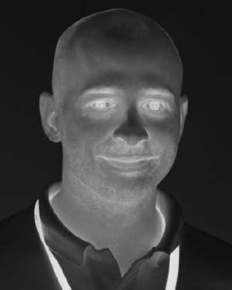 electronic Technologies, Dresden, Germany, former private public partnership of Qimonda, AMD, and the Fraunhofer Society, where he is currently leading the ferroelectric material and device activities and working toward the Ph.D. degree in this area. gree in applied natural science from the Tech- nical University Bergakademie Freiberg, Freiberg, Germany, in 2007. He is currently working toward the Ph.D. degree at the Fraunhofer Center Nano-

His research has been mainly directed on the de-velopment of next-generation high-*k* capacitor dielectrics and the investigation of ferroelectricity in hafnium and zirconium oxide.

|  |  |  |  |
| --- | --- | --- | --- |
| MUELLER *et al.*: RELIABILITY CHARACTERISTICS OF FERROELECTRIC Si:HfO2 FILMS | | | 97  **Thomas Mikolajick** (SM’09) received the Dipl.-Ing. degree in electrical engineering and the Ph.D. degree from the University of Erlangen–Nuremberg, Erlangen, Germany, in 1990 and 1996, respectively.  He then started to work in the semiconductor industry first with Siemens Semiconductor and later with Infineon and Qimonda. In that time, his work was focused around metal–oxide–semiconductor de-vices, device and material reliability, and nonvolatile memories. In late 2006, he moved back to academia, taking over a professorship for material science of |
|  | **Uwe Schroeder** received the Ph.D. degree from the |  |
| University of Bonn, Bonn, Germany. |
| He was a Visiting Researcher with the Univer- |
| sity of California, Berkeley, and a Postdoctoral Re- |
| searcher with the University of Chicago, Chicago, |
| Illinois. He joined Infineon, formerly Siemens Semi- |
| conductor, in 1997 for DRAM capacitor develop- |
| ment in the DRAM Development Alliance with |
| IBM and Toshiba in Hopewell Junction, NY, before |
| transferring to the Memory Development Center, |
| Infineon, Dresden, Germany, in 2000. Here, he con- |

tinued the research on high-*k* dielectric and its integration into DRAM capaci-tors. In 2009, he moved to NaMLab gGmbH, Dresden, and pursued his work on high-*k* dielectrics and ferroelectric HfO2 layers in semiconductor devices. He is (co)author on more than 100 papers and conference contributions and more than 25 patents.

electron devices and sensors with the Technical University Bergakademie Freiberg, Freiberg, Germany, and since October 2009, he has been with Technische Universitresden, Dresden, Germany, were he currently holds a professorship for nanoelectronic materials in combination with the position of Scientific Director with NaMLab gGmbH, Dresden. He is author or coauthor of about 80 publications in scientific journals or at scientific conferences and inventor or coinventor of about 50 patent families.