Sub-nm EOT Ferroelectric HfO2 on p+Ge with Highly Reliable Field Cycling Properties

X. Tian1, L. Xu1, S. Shibayama1, T. Nishimura1, T. Yajima1, S. Migita2 and A. Toriumi1 1The University of Tokyo, Tokyo, Japan. e-mail: xuan@adam.t.u-tokyo.ac.jp   
2National Institute of Advanced Industrial Science & Technology (AIST), Tsukuba, Japan

***Abstract*—**5-nm-thick ferroelectric Y-doped HfO2 was intensively studied. The thickness dependence of ferroelectric properties indicates that stable ferroelectric characteristics are maintained down to 5-nm-thick by taking care of doping and capping effects. Furthermore, the cycling performance shows no wake-up behavior, no obvious degradation after 108 cycles. These results not only enable us to use ferroelectric HfO2 for practical application, but also point out intrinsic properties in ultrathin ferroelectric HfO2 film from materials science point of view.

**I.**  **INTRODUCTION**

Ferroelectric HfO2 attracts much attention just because nonvolatile functionality will be available by utilizing conventional high-k dielectric materials in place of perovskite ferroelectric materials [1, 2]. We studied ferroelectric HfO2 systematically in terms of doping induced ferroelectric phase stabilization, and reported a universal ferroelectric behavior irrespective of dopant species in the last IEDM [3]. The results pointed out that ferroelectric properties of doped-HfO2 were not originated from dopants but from intrinsic properties of HfO2. A number of problems, however, block the way to technical breakthroughs for real application, while they surely include interesting material science we should tackle. The points we have paid attention to in this paper are twofold. One is whether the functionality can be maintained in nano-size or not, and the other is whether such nano-size functionality is reliable or not.

Thus, the objective of this paper is to study the film thickness effect of HfO2 ferroelectricity from the viewpoint of ferroelectric phase formation and to demonstrate very thin HfO2 ferroelectric properties based on the understanding. The other is to study the reliability of thin ferroelectric HfO2, and to clarify the ferroelectric reliability/degradation origin particularly in the thin film region.

**II.EXPERIMENTAL DETAILS**

Heavily doped p-type Ge (5 10-3 cm) was used for the bottom electrode. 30~3-nm-thick doped HfO2 films were prepared by co-sputtering of doped-oxide and HfO2, followed by post deposition annealing (PDA) at 600°C in N2 for 30 s (650°C for below 4 nm films). Dopant concentration was adjusted by changing the sputtering power of doped-oxide. Film thickness was inspected by X-ray reflectivity (XRR) measurement. Cation ratio of dopant to Hf was estimated by

XPS. Two types of metals (Au and TiN) were used for top electrode. Au was deposited after PDA, while TiN was deposited on HfO2, followed by PDA. Ferroelectric properties of all films were measured by P-V and I-V using ferroelectric analyzer at 10 kHz. The double pulse-measurements were carried out to especially check the thin film ferroelectricity in order not to be misled by the leakage current with the pulse width down to 2 s [4]. The reliability test was carried out by applying the triangular pulse with 100 kHz at room temperature and 125°C.

**III.THICKNESS DEPENDENT FERROELECTRICITY**

We have studied rather thick (~30 nm) HfO2 to study intrinsic properties of ferroelectric HfO2 [3, 5]. From the results, we have pointed out universal behaviors of ferroelectric HfO2 structural phase transformation in terms of dopant concentration dependence of the remanent polarization [6], as shown in **Fig. 1**. This fact is the basis of the present research. Namely the ferroelectricity in HfO2 is derived from intrinsic structural instability irrespective of dopant species.

**Fig. 2** shows typical P-V, I-V curves of 30-nm-thick HfO2 with Au electrode. It shows a clear and typical ferroelectric characteristic. **Figs. 3** and **4** show the thickness dependence of the switchable polarization (*Psw*) and the crystalline structure indicator measured by XRD in Y2O3-doped HfO2 with a fixed Y concentration (8w, ~2.1%). The *rc* was defined by the high symmetric phase (tetra, cubic and orthorhombic phases) ratio to total structural phase including monoclinic one as *rc*=Isym/Isym+Imono, at 2 ~30 degree.

Both curves show sharp decreases near 10 nm (since it is not clear whether the abrupt increase observed around 9-nm-thick HfO2 was due to some noise or not, we will not discuss about it in this paper). **Fig. 5** shows the relationship between *Psw* (=*Pr*++*Pr*-) and *rc* as a parameter of the HfO2 thickness. It shows a good correlation, which means that *Psw* decrease in the ultra-thin region should be due to a strong suppression of the ferroelectric phase formation. Since by decreasing the thickness, it is obvious that both interface and grain size effects become more significant, we will not be able to utilize very thin ferroelectric HfO2 if a thing is left as it is.

As we have mentioned, HfO2 ferroelectricity comes from HfO2 properties. Therefore, in case that external effects such as interfacial and/or grain size effects become dominant, we have to adjust the doping effect corresponding to the thickness. This is critically important in this paper. We made efforts to find out the optimum Y concentration in HfO2 only by

|  |  |  |
| --- | --- | --- |
| 978-1-5386-3559-9/17/$31.00 ©2017 IEEE | 37.1.1 | IEDM17-816 |

changing the sputtering power of Y2O3 target. **Fig. 6** shows P-V characteristics of 5-nm-thick HfO2 with different doping concentration of Y2O3. **Fig. 7** shows XRD patterns of these samples. It is clearly seen that *Psw* and *rc* are both significantly improved by increasing the doping concentration from 8 to 15 W. Besides, the capping layer also plays a critical role for the ferroelectric properties in case of keeping the doping concentration (8 W), as shown in **Figs. 8 (a)** and **(b)**. *Psw* and *rc* are plotted as a function of Y2O3 sputtering power both for 30 nm and 5 nm samples in **Fig. 9**. It is apparent that 5 nm film w/o cap needs more driving force for the ferroelectricity to be stabilized, no matter through higher doping or capping. This fact is understandable by considering that the internal effects on the ferroelectric stabilization are competing with external ones from the electrode (mechanically and/or chemically). The key point is that ferroelectric HfO2 is in the metastable state of HfO2 structural phases between tetragonal and monoclinic phases, as schematically shown in **Fig. 10** [3]. So, under the external forces, the stability point is likely to easily shift to the lower energy state. Thus, it is concluded that the sharp degradation of ferroelectric properties below 10 nm is not due to the so-called depolarization effect but structural stabilization one.

**IV.FIELD CYCLING TEST**

Another critical challenge is the reliability in ferroelectric devices [7]. Therefore, the field cycling test was carried out for 5-nm-thick HfO2 (EOT~0.7nm). **Fig. 11** shows the cycling test result in terms of doping concentration difference for films in case with the capping layer. In both samples, neither the wake-up nor severe fatigue is observed up to 108 cycles. Particularly, the sample (8 W) still holds 85% of the remanent polarization after 108 cycles. Although higher doping (15 W) shows visible fatigue, 65% of Psw is still sustained after 108 cycles. In contrast, 5nm HfO2 with open surface in PDA exhibited a clear wake-up and only 104 cycles lifetime. Now, it is clear that the capping layer has a significantly favorable effect on the field cycling test.

Next, effects of the electric field and measurement temperature were studied for the sample (8 W) with capping. By increasing the electric field, the device shows a slight wake-up, but stronger fatigue, as shown in **Fig. 12**. At 125°C,

ferroelectricity, including the wake-up effect [7]. We should also consider the stabilization of ferroelectricity by the mechanical strain. Because 5 nm is much smaller than the standard grain size (20~30 nm) in thicker films, the structural stability in one directional polarization switching is likely to be significantly affected. Through these interface effects, no wake-up, no degradation of the remanent polarization were maintained in 108 cycles.

Finally, we would like to discuss about further EOT scaling of HfO2. In ultrathin ferroelectric film, depolarization field (Ed) usually become nonnegligible. We simulated how is the depolarization effect by assuming that the film quality is maintained through all the film thickness. **Eq. (1)** is the free energy density of the system based on the Landau theory, in which A and B are the coefficient, *ls* is the screening length of electrode, and *F*, *e* are the dielectric constant of ferroelectric film and electrode, respectively [8].

|  |  |  |  |  |  |  |  |  |  |  |  |  |  |  |  |  |  |  |  |  |  |  |  |  |  |  |  |
| --- | --- | --- | --- | --- | --- | --- | --- | --- | --- | --- | --- | --- | --- | --- | --- | --- | --- | --- | --- | --- | --- | --- | --- | --- | --- | --- | --- |
| *F* |  | 1 | *AP* | 2 |  | 1 | *BP* | 4 |  |  | *l s* |  |  |  | *P* | 2 |  |  | *l l s* |  |  |  |  |  | *P* | 2 | (1) |
|  |  | 2 |  |  |  | 4 |  |  |  |  0 *F* | 2 *l s* |  | *l* |  |  |  |  | 4 0 *e* | 2 *l* | *s* |  | *l* |  | 2 |  |  |  |

By using eq. (1), *Psw* was calculated theoretically in ferroelectric HfO2 as a function of the film thickness as shown by the blue solid line in **Fig. 15**, in which only the depolarization field effect was taken into consideration. From calculated results, the depolarization effect becomes severe in 2~3 nm HfO2 thickness region, and ferroelectric properties are suddenly suppressed intrinsically. Above 2~3 nm, however, the intrinsic challenge due to the depolarization field will not come out in ferroelectric HfO2.

**V.**  **CONCLUSION**

We studied the thickness dependence of ferroelectric properties in HfO2, and demonstrated no ferroelectric suppresion in sub-nm EOT HfO2. Furthermore, 5-nm-thick HfO2 films with capping layer showed very high reliability in the field cycling test, with no wake-up effect observed. The present results in HfO2 down to 5nm size indicate its promising future in nano-scale ferroelectric HfO2 devices.

ACKNOWLEDGMENT

|  |  |  |  |  |  |  |  |
| --- | --- | --- | --- | --- | --- | --- | --- |
| no wake-up was observed but fatigue becomes heavier, as | This | work | was | supported | by | JST-CREST | Project |
| shown in **Fig. 13**. Psw was around 5 C/cm2 after 108 cycles. | (JPMJCR14F2). | | |
| The fact that no appreciable wake-up effect was observed in | REFERENCES | |
| both cases, the capping effect works very efficiently for |

aligning the polarization domains, resulting in the reduction of poor ferroelectric domain.

The good cycling performance and no wake-up effect for the sample with capping layer can be understood from the model schematically described in **Fig. 14**. In case with the capping layer during PDA, the interface bonding structure should be stabilized and the ferroelectric domain alignment might be improved rather than those in the open-PDA. The oxygen vacancy might be also relevant for the reliability, optimum Vo concentration is needed for stabilizing the

[1] T. S. Bӧscke et al., Appl. Phys. Lett. 99, 102903 (2011).

[2] J. Müller et al., ECS J. Solid State Sci. Technol. 4.5: N30-N35, (2015). [3] L. Xu et al., Tech. Dig. IEDM 2016, p. 608.

[4] S. Hong “Nanoscale Phenomena in Ferroelectric Thin Films,” (Springer, 2004).

[5] L. Xu et al., Appl. Phys. Exp. 9, 091501 (2016).

[6] L. Xu et al., to be published in J. Appl. Phys. (2017).

[7] M. Pešić et al., Adv. Funct. Mater. 26, 4601 (2016).

[8] D. Araujo, et al., Ferroelectric thin films: synthesis and basic properties. Vol. 10. Taylor & Francis US, 1996.

IEDM17-817 37.1.2

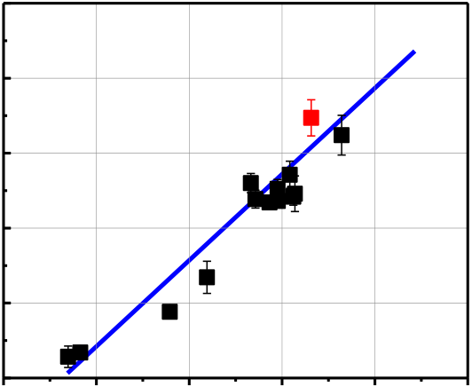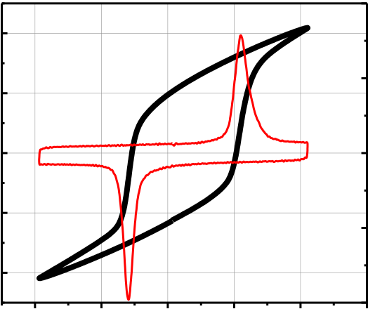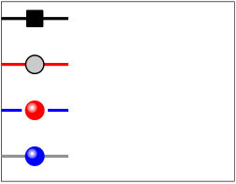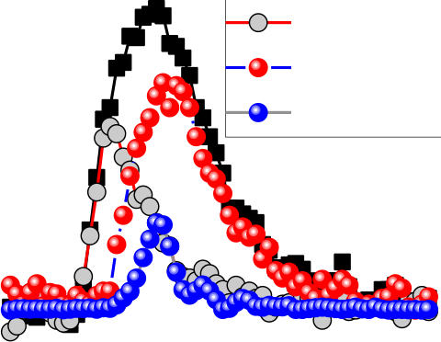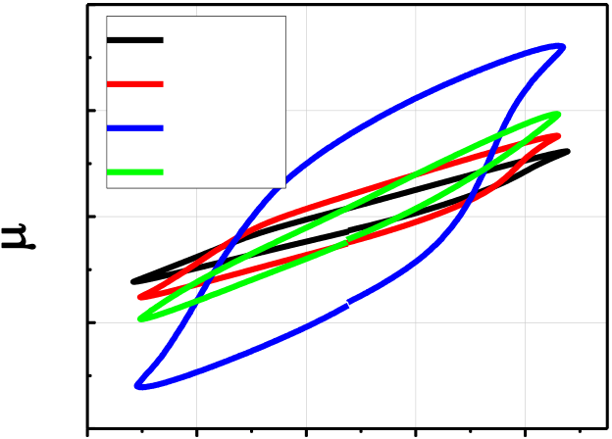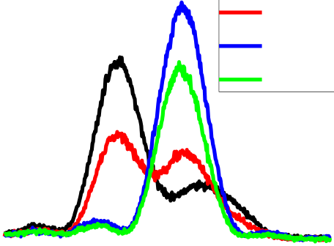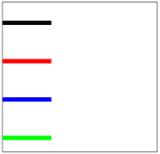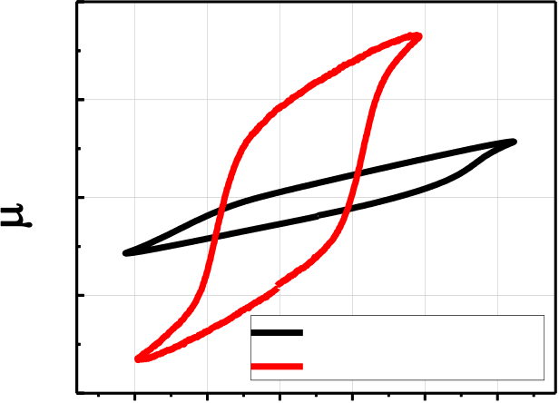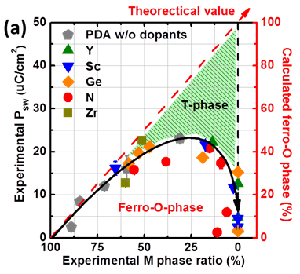

|  |  |  |  |  |  |  |  |  |  |  |  |  |  |  |  |  |  |  |  |  |  |  |  |  |  |  |  |  |  |  |  |  |  |  |  |  |  |  |  |  |  |  |  |  |  |  |  |  |  |  |  |  |  |  |  |  |  |  |  |  |  |  |  |  |  |  |  |  |  |  |  |  |  |  |  |  |  |  |  |
| --- | --- | --- | --- | --- | --- | --- | --- | --- | --- | --- | --- | --- | --- | --- | --- | --- | --- | --- | --- | --- | --- | --- | --- | --- | --- | --- | --- | --- | --- | --- | --- | --- | --- | --- | --- | --- | --- | --- | --- | --- | --- | --- | --- | --- | --- | --- | --- | --- | --- | --- | --- | --- | --- | --- | --- | --- | --- | --- | --- | --- | --- | --- | --- | --- | --- | --- | --- | --- | --- | --- | --- | --- | --- | --- | --- | --- | --- | --- | --- |
| **2)** | | | | | | | | | | **20** | | **-4** | | @10kHz | | | | | | | | **0.4** | **PSW (****C/cm2)** | | | **40**  **10**  **0**   |  |  |  |  |  |  |  |  | | --- | --- | --- | --- | --- | --- | --- | --- | |  |  |  |  |  |  |  |  | |  |  |  |  |  |  |  |  | |  |  |  |  |  |  |  |  | |  |  |  |  |  |  |  |  | |  |  |  |  |  |  |  |  | |  |  |  |  |  |  |  |  |   **30**  **20** | | | | | |
| **10** | | **0.2** |
| **P (****C/cm** | | | | | | | | | |
| **0** | | **0.0** |
| **-10** | | **-0.2** |
| **-20** | | **-0.4 6** |
| **-2** | **0** | | **2** | | **4** | | | **0** | **5** | **10 15 20 25 30 35** | | | |
| **E (MV/cm)** | | | | | | | | **Thickness (nm)** | | | | | |
| **Fig. 1.** The measured switchable polarization as | | | | | | | | | | | **Fig. 2.** P-E and I-E measurement for 30 nm Y- | | | | | | | | | | | | | **Fig. 3.** The experimentally obtained Psw | | | | | | | |
| a function of monoclinic phase ratio. This figure | | | | | | | | | | | doped HfO2, in which Pr is around 11 μC/cm2. | | | | | | | | | | | | | from the P-E measurement as a function | | | | | | | |
| shows the kinetic route of phase transition in | | | | | | | | | | | Ec is ~ 1.7 MV/cm. It shows a typical data for | | | | | | | | | | | | | of the film thickness. | | | | | | | |
| HfO2 is independent of dopants [3]. | | | | | | | | | prepared ferroelectric Y-doped HfO2 films. | | | | | | | | | | | | | | | | | | | | | | |
| **o/t/c phase ratio(%)** | **100 80**  **60**  **40**  **20**  **0** | |  | | | | | | **2)** | | | **50** | | | | | | | | | | | | **30** | | | **0 w Y** | | | | |
| **40** | **5.2nm with capping** | | | | | | | | | | | **P (****C/cm2)**   **15**  **0**  **-15** | | | **8 w Y** | | | | |
| **PSW (****C/cm** | | | **15 w Y** | | | | |
| **30** | **8.4nm** | | | | | | | | | | | **25 w Y** | | | | |
| @10kHz | | | | |
| **20** | **7.2nm** | | | | | | | | | | |
| **10** | **4.1nm** | | | **5.2nm** | | **6.2nm** | | | | | |
| **3.2nm** | | | **-30**  **-4** | | |
| **0**   **0** | | **20**  **40**  **60**  **80**  **100**  **o/t/c phase ratio (%)** | | | | | | | | | |
| **0** | | | **5** | **10 15 20 25 30 35** | | | | **-2** | | **0** | **2** | **4** |
| **Thickness (nm)** | | | | | | | | **Voltage (V)** | | | | |
| **Fig. 4.** High symmetric phase ratio is | | | | | | | | | **Fig. 5.** The relationship between Psw and *rc* in | | | | | | | | | | | | | | | **Fig. 6.** Polarization-voltage curve for 5 | | | | | | | |
| plotted with respect to the film | | | | | | | | | samples from 30 to 3 nm. Data point for below 9 | | | | | | | | | | | | | | | nm HfO2 with different Y doping | | | | | | | |
| thickness. In the ultrathin region, the | | | | | | | | | nm is particularly labeled. 5 nm sample (red | | | | | | | | | | | | | | | concentration. The W value is the RF | | | | | | | |
| peak deconvolution of overlapped | | | | | | | | | square) with capping is additionally added. The | | | | | | | | | | | | | | | power of dopant sputtering target. P-V | | | | | | | |
| peaks was carried out. | | | | | | | | | dependence of Psw on *rc* is approximately linear, as | | | | | | | | | | | | | | | measurement was done at 10 kHz. | | | | | | | |
| shown by blue line. | | | | | | | | | | | | | | |
| **Intensity (a.u.)** | | **24** | **26** | | **0 w Y** | | | **40** | | | | | **(a)** | | | | | | | | | | **Current (mA)** | **6** | **(b)** | | **Is**  **Ins** | | | | |
| **8 w Y** | | | **P (****C/cm2)**   **20**  **0**  **-20** | | | | |
| @10kHz | | | | | | | | | | **4** |
| **15 w Y** | | | **Ip (w/ cap)** | | | | | | |
| **25 w Y** | | | **Ip (w/o cap)** | | | | | | |
| **28**  **30**  **32**  **2** **(degree)** | **34** | **36** | **5nm w/o capping** | | | | | | | | | | **2** | **0.0 0.5 1.0 1.5 2.0 2.5 Time (****s)** | | | | | | |
| **-40** | | | | | **0** |
| **5nm with capping** | | | | | | | | | |
| **-3.0 -1.5 0.0** | | | | | **1.5** | | **3.0** | **4.5** | |
| **Voltage (V)** | | | | | | | | | |

**Fig. 7.** GIXRD result for 5 nm HfO2 with different Y doping concentration. Only 2θ=25~35 is shown, where the strongest monoclinic and symmetric

**Fig. 8. (a)** Polarization-voltage measurement and **(b)** double pulse measurement for 5 nm Y-doped HfO2 with and without the capping. Doping concentration was 8 W. Is and Ins are the transient current peak with (black) and without (grey) polarization switching, respectively. Ip = Is-Ins is the deduced polarization switching current with the capping (red).

phases are detected. Is and Ins for 5 nm Y-doped HfO2 without capping are not shown in (b), only Ip (blue) is

shown for the comparison.

37.1.3 IEDM17-818

|  |  |  |  |  |  |  |  |  |  |  |  |  |
| --- | --- | --- | --- | --- | --- | --- | --- | --- | --- | --- | --- | --- |
| **2) Psw (****C/cm** | **50** | **0 w** | **8 w** | **30nm w/o cap** | | **100** |  | | **20** | | | |
| **75** |
| **2)** | **10** | | |
| **50** |
| **25** |
| **Pr (****c/cm**   **0**  **-10** | | **+Pr (8 w)** | **+Pr (15 w)** |
| **5nm w/o cap** | | **0** | **-Pr (8 w)** | **-Pr (15 w)** |
| **40** | **5nm with cap** | |
| **30** |
| **20** | **15 w** | **25 w** | **-20**  **10 010 110 210 310 410 510 610 710 8**  **Cycles** | | | |
| **10** |
| **0** |
| **Fig. 9.** The dependence of doping | | | | | | **Fig. 10.** The phase transition between m, | | **Fig. 11.** The cycling property of 5nm Y- | | | |
| o, t, c phases is driven by universal | | doped HfO2 films both with capping layer. | | | |
| concentration for *rc* (top) and Psw (bottom) | | | | | |
| driving force, which could be element | | Here Y doping concentration is different. | | | |
| in 30 nm (w/o cap), and 5 nm Y2O3 doped | | | | | |
| doping, external stressing or thermal | | Cycling pulse was set to be 1.5V at 100 kHz. | | | |
| HfO2 w/ and w/o capping. | | | | | |
| treatment [3]. | |
| **Psw****C/cm2)** | | **40** | | | | | **20**  **-10**  **-20**  **0**   |  |  |  |  |  |  |  |  |  |  |  |  |  |  |  |  |  |  | | --- | --- | --- | --- | --- | --- | --- | --- | --- | --- | --- | --- | --- | --- | --- | --- | --- | --- | |  |  |  |  |  |  |  |  |  |  |  |  |  |  |  |  |  |  | |  |  |  |  |  |  |  |  |  |  |  |  |  |  |  |  |  |  | | | | | |
|  |  |  |  |  |
|  |  |  |  |  |
|  |  |  |  |  |
|  |  |  |  |  |
|  |  |  |  |  |
|  |  |  |  |  |
|  |  |  |  |  |  |  |  |  |  |