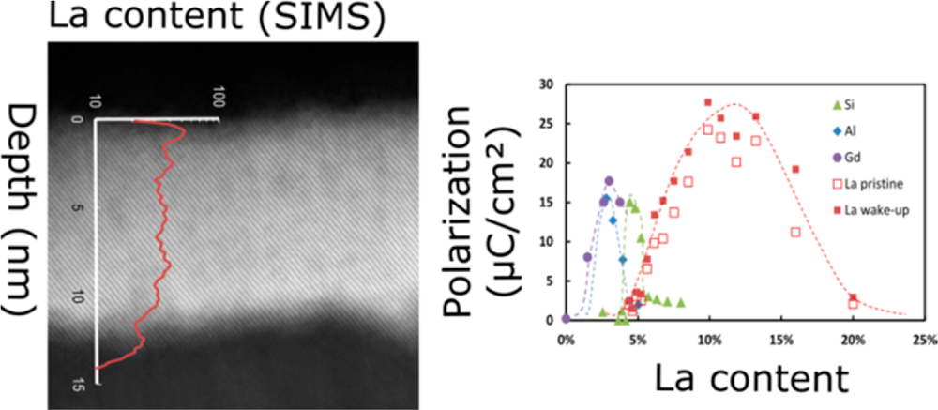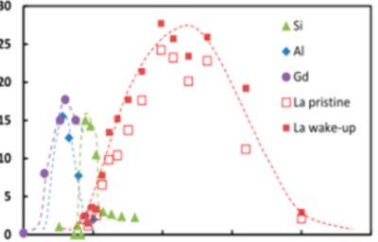

Article

Cite This: [Inorg. Chem. 2018, 57, 2752−2765](http://pubs.acs.org/action/showCitFormats?doi=10.1021/acs.inorgchem.7b03149)  pubs.acs.org/IC

Lanthanum-Doped Hafnium Oxide: A Robust Ferroelectric Material

Uwe Schroeder,*,†Claudia Richter,†Min Hyuk Park,†Tony Schenk,†Milan Pešić,†

Michael Hoffmann,†Franz P. G. Fengler,†Darius Pohl,‡Bernd Rellinghaus,‡Chuanzhen Zhou,§

Ching-Chang Chung,§Jacob L. Jones,§and Thomas Mikolajick†,∥

†NaMLab gGmbH, Noethnitzer Straße 64, 01187 Dresden, Germany

‡IFW Dresden, Helmholtz Straße, Dresden, Germany

§Department of Materials Science and Engineering, North Carolina State University, Raleigh, North Carolina 27695-7907, United

States

Analytical Instrumentation Facility, College of Engineering, North Carolina State University, Raleigh, North Carolina 27695-7531,

United States

∥Chair of Nanoelectronic Materials, TU Dresden, 01062 Dresden, Germany

|  |  |
| --- | --- |
| * S Supporting Information | |
| ABSTRACT: Recently simulation groups have reported the |  |
| lanthanide series elements as the dopants that have the  strongest effect on the stabilization of the ferroelectric non-  centrosymmetric orthorhombic phase in hafnium oxide. This  finding confirms experimental results for lanthanum and | |
| gadolinium showing the highest remanent polarization values of all hafnia-based ferroelectric films until now. However, no  comprehensive overview that links structural properties to the electrical performance of the films in detail is available for |  |
| lanthanide-doped hafnia. La:HfO2 appears to be a material  with a broad window of process parameters, and accordingly,  by optimization of the La content in the layer, it is possible to improve the performance of the material significantly. Variations of the La concentration leads to changes in the crystallographic structure in the bulk of the films and at the interfaces to the electrode materials, which impacts the spontaneous polarization, internal bias fields, and with this the field cycling behavior of the  capacitor structure. Characterization results are compared to other dopants like Si, Al, and Gd to validate the advantages of the  material in applications such as semiconductor memory devices. | |

1. INTRODUCTION

For material scientists, the new class of inorganic HfO2-based ferroelectrics are of special interest, because they are lead-free, simple binary oxides, and exhibit a nonperovskite structure with a remarkably low relative permittivity (∼20−30) compared to∼300 or greater permittivity of conventional ferroelectrics like Pb(Ti,Zr)O3.1Since the discovery of ferroelectricity in doped HfO2,2a variety of different dopants (e.g., Si,3Al,4Y,5Gd,6La,7 Sr8) have been examined to discover the dopant material with best properties for applications in semiconductor, piezo-, and pyroelectric devices. Dopants with an ionic radius smaller than Hf typically showed ferroelectric and anti-ferroelectric charac-teristics in a narrow dopant range. Larger dopants exhibited only ferroelectric behavior but have a wider process window.9 The polar orthorhombic phase (Pca21) was suggested as the origin of the ferroelectric properties.2,10Nonetheless, there is a substantial mismatch between the exciting material aspects of this new ferroelectric together with the proven application potential on one hand and the significant lack of basic studies on how to influence material properties and perturbing effects on the other hand. Lanthanum-doped HfO2 is the perfect

example to highlight this point. Simulation groups11reported that the lanthanide series elements (in addition to other dopants: Ca, Sr, Ba) are the dopants in hafnium oxide that have the strongest effect on the stabilization of the ferroelectric non-centrosymmetric orthorhombic phase. This result is confirmed by first experimental results for lanthanum and gadolinium showing the highest remanent polarization values of all hafnia-based ferroelectric films reported so far (Pr > 30 μC/cm2),13 good endurance properties (1 × 109field cycles without fatigue), and complementary metal-oxide-semiconductor (CMOS) back-end compatibility for low La concentrations.12 While initially reported Pr values of 45 μC/cm213could not be reproduced in later studies,12,14values similar or higher compared to other dopants have been consistently achieved. However, a comprehensive overview that links structural properties to the electrical performance of the films in detail is still missing for this important class of larger dopants. La-Doped HfO2 appears to be a material with a broad process

|  |  |
| --- | --- |
| Received: | December 19, 2017 |

Published: February 15, 2018

|  |  |  |  |
| --- | --- | --- | --- |
|  | © 2018 American Chemical Society | 2752 | DOI: [10.1021/acs.inorgchem.7b03149](http://dx.doi.org/10.1021/acs.inorgchem.7b03149) In[org. Chem. 2018, 57, 2752−2765](http://dx.doi.org/10.1021/acs.inorgchem.7b03149) |

|  |  |  |
| --- | --- | --- |
| Inorganic Chemistry | |  | | --- | | Article | |

window with respect to doping concentration, and accordingly, by optimization of the La content in the layer, it is possible to improve the performance of the material significantly. Because of this broad process window, a detailed and robust study of the impact of different dopant contents on the ferroelectric properties can be performed. The resulting changes in the crystallographic structure in the bulk of the films and at the interfaces to the electrode materials can impact the spontaneous polarization, internal bias fields, and with this the field cycling behavior of the capacitor structure. By putting these results into perspective of results obtained with other dopants in previous studies, new insight into the general issue of stabilizing the ferroelectric phase in doped hafnia is developed.

Therefore, to gain new understandings, this study focuses on the detailed characterization of La-doped HfO2 films with fine steps in a much broader La concentration range compared to previous studies.12−14Results of structural characterization methods (electron microscopy, X-ray diffraction, secondary ion mass spectrometry) are very well-correlated with the electrical properties. A close comparison of different dopants, especially the difference between Si as a dopant with smaller atomic radius resulting in a fragile ferroelectric material3and La as a larger dopant resulting in a robust ferroelectric phase, is performed to gain more insights into the root causes for ferroelectricity in HfO2.

2. EXPERIMENTAL SECTION

For electrical characterization, the La:HfO2 films were integrated in a capacitor structure ref 3 with 12 nm thick titanium nitride bottom and top electrodes sputtered in a BESTEC physical vapor deposition (PVD) tool at room temperature. The capacitor areas were defined by evaporating 10 nm of titanium and 25 nm of platinum through a shadow mask and etching the titanium nitride top electrode afterward in a diluted standard clean 1 (H2O/H2O2/NH4OH in a ratio of 50:2:1 at 50 °C). Lanthanum-doped hafnium oxide films were deposited in an Oxford Instruments OpAL ALD tool by atomic layer deposition (ALD). Tetrakis[ethylmethylamino]hafnium (TEMAHf, Hf(N(CH3)-(C2H5))4) and tris(isopropyl-cyclopentadienyl)lanthanum (La-(iPrCp)3) were chosen as metalorganic precursors. Previous results15 showed that HfO2 deposited with H2O as the oxygen source yields the best electrical properties compared to other oxygen sources, and it was therefore chosen for this work. La2O3 ALD deposition is impacted by the low volatility and decomposition temperature of the La precursor,16which usually results in lower film quality of the deposited films. To improve the film properties, an inductively coupled O2 plasma was used for La2O3 deposition. Similar samples were processed in comparison with an H2O precursor for La2O3 deposition, but lower remanent polarization and endurance results were observed. For all processes, the deposition temperature was held at 280 °C. The growth rate of the pure HfO2 and La2O3 ALD processes were determined as 0.11 and 0.09 nm/cycle, respectively. The films were doped by replacing single HfO2 cycles by La2O3 cycles, which allows the adjustment of the La content by varying the ratio of HfO2 cycles to La2O3 cycles. In this study cycle ratios in the range between 1:1 and 30:1 were investigated. The absolute number of ALD cycles defines the thickness of the film. Here, we focused mainly on samples with a thickness of 10−15 nm. All dielectric films were amorphous after deposition, requiring a crystallization anneal to achieve ferroelectric behavior, which was performed in an AST rapid thermal processing tool under N2 atmosphere for typically 20 s. To find the optimum annealing conditions, the temperature was varied from 600 to 1000°C.

For structural film analysis, a Bruker D8 Discover X-ray diffraction (XRD) tool (Cu Kα radiation: 0.154 nm wavelength) was used to determine the crystallographic structure in addition to film thickness and density by X-ray reflectometry (XRR). Rietveld refinements of the

2753 DOI: [10.1021/acs.inorgchem.7b03149](http://dx.doi.org/10.1021/acs.inorgchem.7b03149)

|  |  |  |
| --- | --- | --- |
| Inorganic Chemistry | |  | | --- | | Article | |

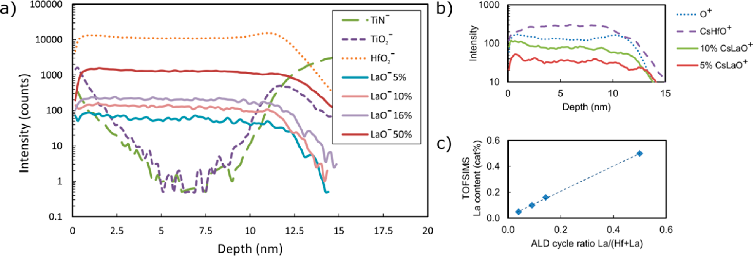

Figure 2. (a) TOF-SIMS results in negative ion mode for samples with different La content ranging from 5 to 50 cat%. (b) TOF-SIMS results in positive ion mode for a sample with 5 and 10 cat% La content. (c) TOF-SIMS La content as a function of ALD cycle ratio.

the HfO2 layer, the anneal condition reaching the highest remanent polarization value without increasing the leakage current beyond 1 × 10−6A/cm2at 1 V (to a level, where the leakage current impacts the shape of the hysteresis loop) was chosen (800 °C 20 s) for further experiments. Optimization of the capacitor stack for memory applications would lead to a different assessment of optimal annealing temperature. Since memory capacitors are formed in a back-end of line (BEOL) process, the thermal budget would need to be decreased as much as possible and typically would need to be in the temperature range from 400 to 500 °C.19To achieve this target, Kozodaev et al. revealed that a reduction of the La content would further decrease the crystallization temperature at reasonable polarization values.12Besides La:HfO2, HfxZr1−xO2 or Gd:HfO2 were shown to exhibit ferroelectricity at such low annealing temperatures.20,21   
 3.2. Structural Characterization. La-doped HfO2 films are deposited within a TiN/14 nm La:HfO2/TiN capacitor structure using a variety of different ALD Hf/La super cycling ratios from 30:1 to 1:1. TOF-SIMS characterization is performed on a selection of these film stacks to determine the material composition changes within the structure. Here, the La composition in the dielectric layer after annealing at 800°C for 20 s in N2 was the main interest as discussed in the previous section. An almost uniform LaOx content in the HfO2 bulk is visible as shown in Figure 2a. Plotting the resulting La content as a function of the ALD cycle ratio results in a linear relationship with a slope of 1.01 indicating a very similar growth rate and comparable growth behavior of LaOx with increasing HfO2 thickness (Figure 2c). These results fit nicely to the comparable growth rate of both films as determined for the pure LaOx and HfO2 growth (0.09 nm/cycle for La2O3 and 0.11 nm/cycle for HfO2).

With a closer look at the composition close to the electrode interfaces, the following observations can be made. A thin TiOx interlayer is formed at the interface between the TiN electrode and the La:HfO2 due to an interface reaction during the crystallization anneal.22,23Furthermore, a higher HfO2−

intensity is visible at the interface between the TiN electrode and La:HfO2 for all measured samples (Figure 2a only shown for one sample). In general, secondary ion yield of many species in SIMS experiments can be enhanced by O content and other carbon-containing contaminations at the interface, which do not reflect their true concentration. To elucidate this,

2754 DOI: [10.1021/acs.inorgchem.7b03149](http://dx.doi.org/10.1021/acs.inorgchem.7b03149)

|  |  |  |
| --- | --- | --- |
| Inorganic Chemistry | |  | | --- | | Article | |

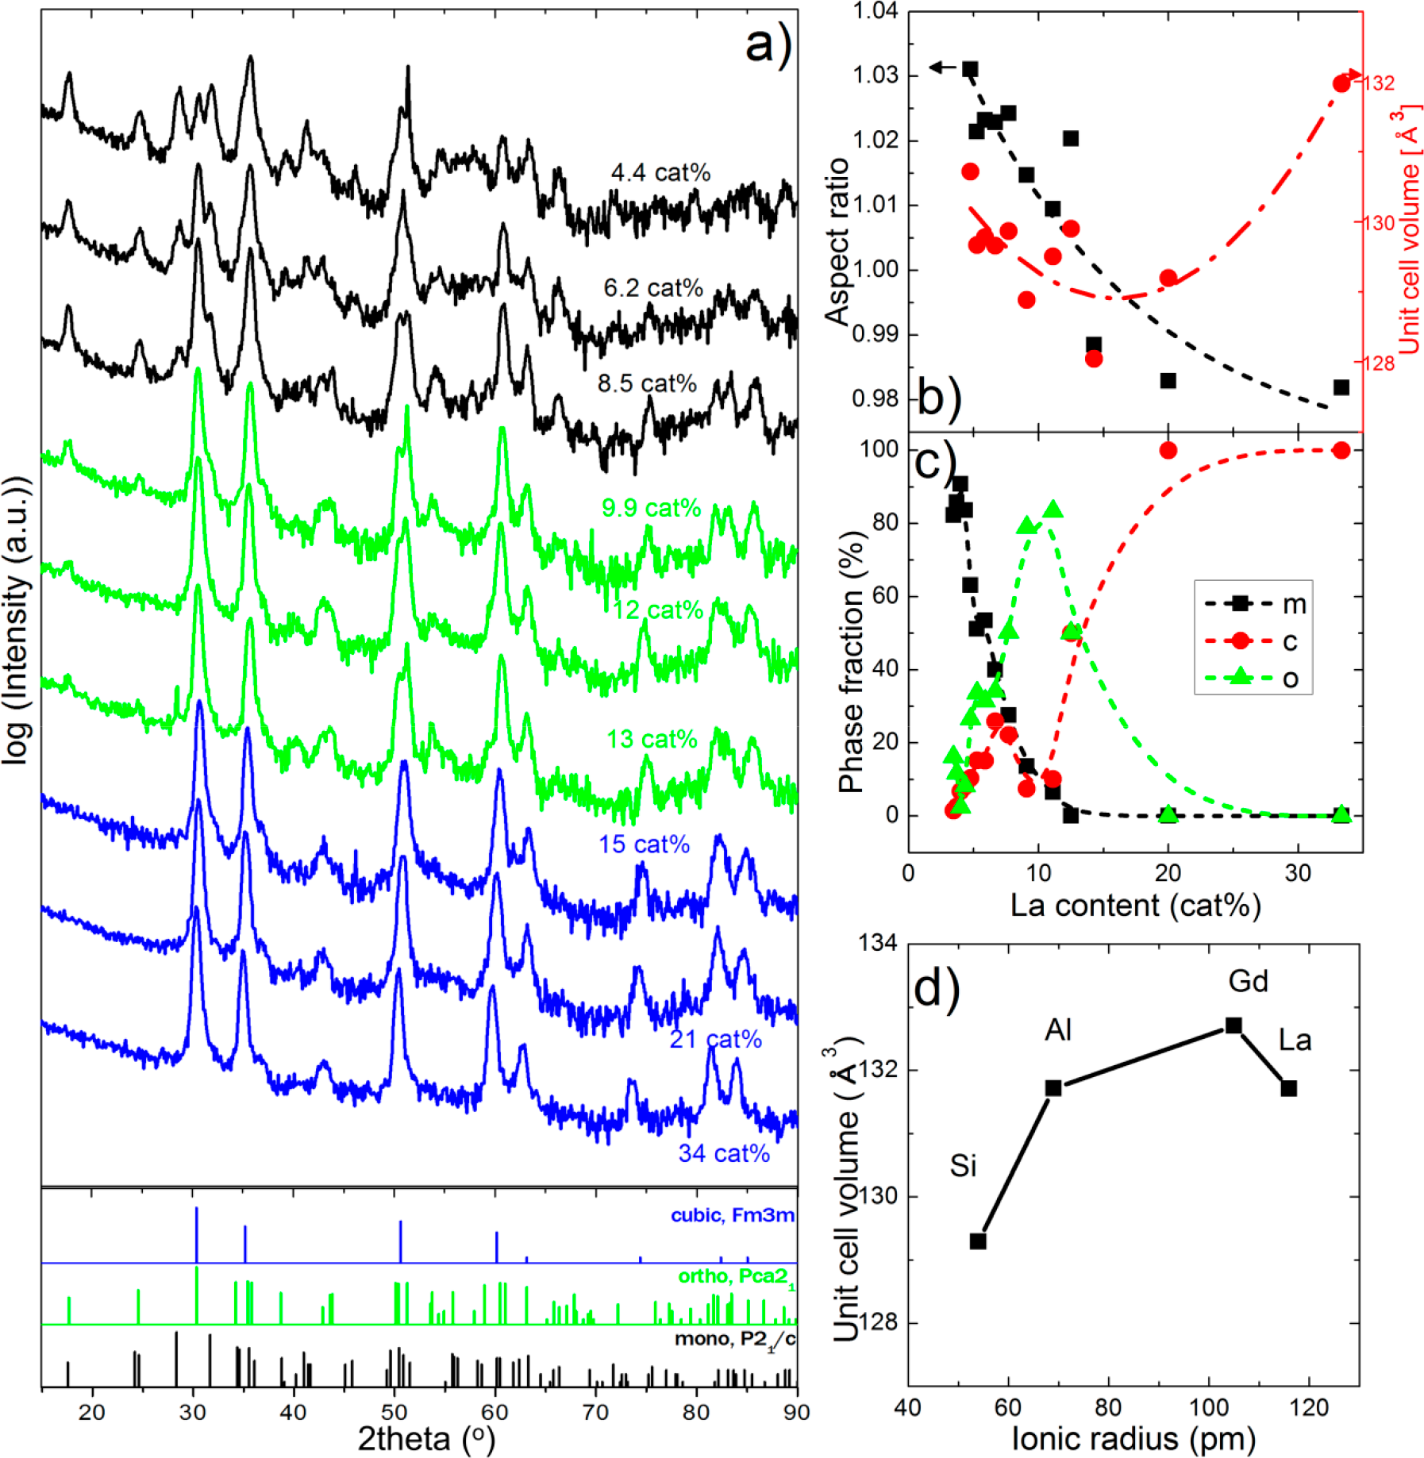

Figure 3. (a) GIXRD patterns for La-doped HfO2 annealed at 800 °C for 20 s. (b) Aspect ratio (2a/(b + c) for the orthorhombic phase of the unit cell and the unit cell volume as a function of the La content. (c) Relative phase fractions as determined by refinement of GIXRD patterns from Figure 3a. (d) Unit cell volume of the orthorhombic phase for Si, Al, Gd, and La doping in HfO2 as a function of ionic radius for the dopant concentration with the highest orthorhombic phase fraction. Lines are a guide.

cat% doped film. The 100 and 110 diffraction peaks at 18 and 25° can be observed up to 13 cat% La-doped HfO2 film, but they cannot be detected when the La content increases beyond 15 cat%. These peaks can be observed for the monoclinic and the orthorhombic phase, but they are forbidden for the tetragonal and the cubic phase. Such changes can be attributed to the transition from the orthorhombic to the cubic phase. Shimizu et al.25reported that the 110 diffraction peak at 18°disappeared when the dominant crystalline phase of epitaxial Y-doped HfO2 film changes from the orthorhombic to the tetragonal phase with increasing Y content. Within the GIXRD pattern of the 20 cat% doped film, the split of diffraction peaks at 51° disappears, suggesting that the predominant crystalline phase is the cubic phase. Moreover, only two cubic diffraction peaks could be observed within the 2θ range of 80−90°, which can be clearly distinguished from the tetragonal, orthorhombic, or monoclinic phase. The GIXRD pattern of the 30 cat%

2755 DOI: [10.1021/acs.inorgchem.7b03149](http://dx.doi.org/10.1021/acs.inorgchem.7b03149)

|  |  |  |
| --- | --- | --- |
| Inorganic Chemistry | |  | | --- | | Article | |

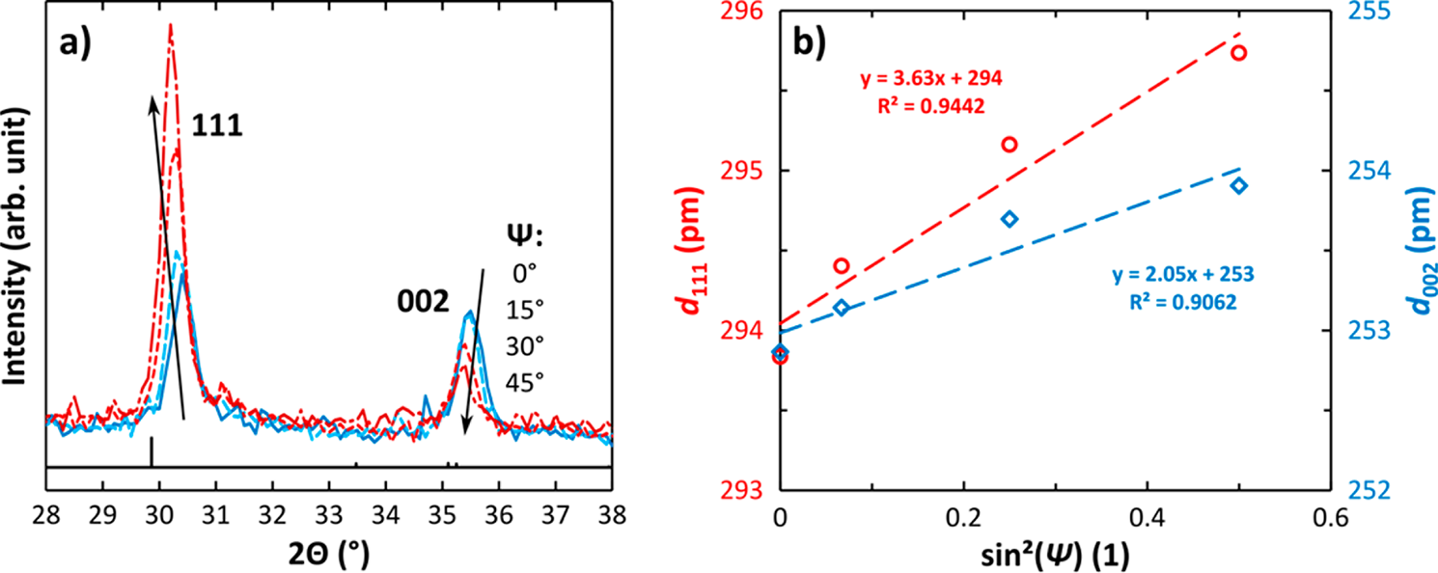

Figure 4. (a) XRD results for a 20 nm thick La:HfO2 sample with 10 cat% La annealed at 800 °C for 20 s measured in Bragg−Brentano geometry for different angles Ψ (angle between surface normal and scattering vector). The reference pattern of the orthorhombic phase is added below in black (PDF No. 04-005-5597). The intensity of the 002 peak, which represents the polar axis of the ferroelectric unit cell, decreases for increasing Ψ, while that of the 111 peak increases. This gives evidence for a prominent 002 texture, which is favorable to achieve a high Pr value. (b) Peak shift as a function of sin2(Ψ) to extract internal strain. Any nonlinearity indicates that the stress is more complex than just a simple uni- or biaxial stress state, which is another result of the sin2(Ψ) method31,32

crystalline phase was the monoclinic phase; thus, the aspect ratio was not calculated. For a La content of 5 cat%, the aspect ratio is 1.03, which is believed to be associated with the dominant orthorhombic phase. With increasing La doping concentration from 5 to 13 cat%, the aspect ratio decreases reaching a value of 1.02 at the highest orthorhombic phase content of 10 cat%. At 13 cat% La doping, the aspect ratio becomes even smaller than 0.99, and with further increasing La content the aspect ratio saturates. The aspect ratio of 0.99 is smaller than the ideal one for the cubic phase (1.00). This observation can be attributed to in-plane tensile stress, which was reported for atomic layer deposited ferroelectric Si-doped HfO2 and Hf0.5Zr0.5O2 thin films.18,26The aspect ratio smaller than 1 in Si-, Al-, and Gd-doped HfO2 thin films in Park et al.’s previous study17might also originate from the effect of tensile stress. The stress in the La-doped HfO2 thin films will be discussed in more detail in Figure 4 and the related text. The change of the unit cell volume also shows an interesting dependence on the La content. The unit cell volume of the orthorhombic (or cubic phase) portions decreases with increasing La content up to the doping concentration of 14%. It increases with further increasing La content up to 33 cat%. As previously mentioned, the GIXRD patterns of 20 and 33 cat% La-doped films show only diffraction peaks from the cubic phase instead of the tetragonal phase, as it was considered for other doped HfO2 thin film in Park et al.’s previous study.17 Therefore, the cubic phase will be referred to as the dominant phase for highly La-doped HfO2 thin films in the following text. This result agrees on one hand with theoretical predictions that dopants larger than Hf generally stabilize the cubic phase instead of the tetragonal phase,27but on the other hand, it is different from what is seen in bulk materials that are not subject to size, strain, or interface effects. In bulk counterparts, it is expected that a La2Hf2O7 secondary phase is formed at these concentrations.28,29   
 In the present work, there was no evidence of this secondary La2Hf2O7 phase in XRD and moreover not in the TEM study, which is discussed in the later part of this section. The ionic radius of La3+(116 pm) is by 40% larger than that of Hf4+(83 pm);30therefore, the lattice parameters and the interplanar distances are expected to increase for higher La doping concentration. Thus, the unit cell volume is assumed to

2756 DOI: [10.1021/acs.inorgchem.7b03149](http://dx.doi.org/10.1021/acs.inorgchem.7b03149)

|  |  |  |
| --- | --- | --- |
| Inorganic Chemistry | |  | | --- | | Article | |

For the macroscopically effective values of Pr and Ec, the texture of the thin film, that is, a preferential orientation of the grains, plays an important role. As La:HfO2 shows quite promising electrical characteristics, the question arises whether this might be related to a favorable texture. With Bragg−Brentano instead of grazing incidence geometry, the scattering vectors of all crystallographic planes that contribute to the signal in the diffractogram have the same direction. Thus, comparing the resulting intensity ratios to the reference pattern of the powder diffraction file (PDF) allows conclusions on the texture of the film.

Figure 4 shows nearly the same intensities for the 111 and the 002 peaks, which is not the case for the reference pattern. Moreover, when tilting the scattering vector away from the sample normal by increasing the angle Ψ of the goniometer, the intensity of the 002 peak decreases, while it increases for the 111 peak. This gives evidence of a comparably prominent 002 fiber-like (uniaxial) texture along the substrate-normal direction. Moreover, the peak positions in Figure 4a allow the analysis of the residual strain in the films via the sin2(Ψ) method.31,32The corresponding analysis of the 111 and 002 peaks is shown in Figure 4b. From the (extrapolated) dhkl values at sin2(0°) = 0 and sin2(90°) = 1, the interplanar distances for out-of- and in-plane directions can be obtained. Out-of-plane interplanar distances of d111 = 294 pm and d002 = 253 pm are found, while their in-plane counterparts are larger by 1.2% and 0.8%, respectively. The corresponding in-plane stress can be estimated based on some assumptions. First, we assume Young’s modulus of 284 GPa and Poisson ratio of 0.3, as reported in ref 33. For the calculation of in-plane stress, we further set the out-of-plane component of strain as zero to make a simplified calculation for in-plane stress. In reality, there is a finite out-of-plane strain, since the loading condition is plane stress. Under these assumptions, we determine ∼2 GPa of tensile stress for the in-plane directions. Though only an estimate for the order of magnitude of the stress effect, it reveals the large values of stresses that are apparent in the films. A more rigorous treatment of the stress state would account for the nonzero, out-of-plane strain, though it would also require a stress-free reference lattice constant as was shown by Nino et al.34With a stress-free reference state, the hydrostatic component of strain can also be extracted. Unfortunately, identifying a stress-free reference for orthorhombic HfO2 is not straightforward, since powders that are typically used as references are in the monoclinic phase for HfO2. This large internal stress amplitude is thought to be the reason for the low aspect ratio and increasing unit cell volume for high La contents. The reason for the different strain values calculated from the 111 and 002 diffraction peaks may be attributed to the crystal’s elastic anisotropy. Furthermore, for the case of the 002 peak, there might be an overlap of diffraction peaks from 200, 020, and 002, and effects of the orientation dependence of Young’s modulus or the effects of film texture are not clearly understood yet. Thus, it is believed that the strain estimated from the 111 diffraction peak is more reliable.

Of the whole sample set, the films with 10 and 16 cat% La content were chosen for a more detailed structural analysis by transmission electron microscopy (TEM). According to Figures 3c and 6c, the 10 cat% sample has the highest remanent polarization and highest orthorhombic phase fraction with some monoclinic portions. The orthorhombic phase is clearly verified (see also ref 10) within the layer (Figure 5a) with a uniform lattice structure from one TiN electrode to the other.

2757 DOI: [10.1021/acs.inorgchem.7b03149](http://dx.doi.org/10.1021/acs.inorgchem.7b03149)

|  |  |  |
| --- | --- | --- |
| Inorganic Chemistry | |  | | --- | | Article | |

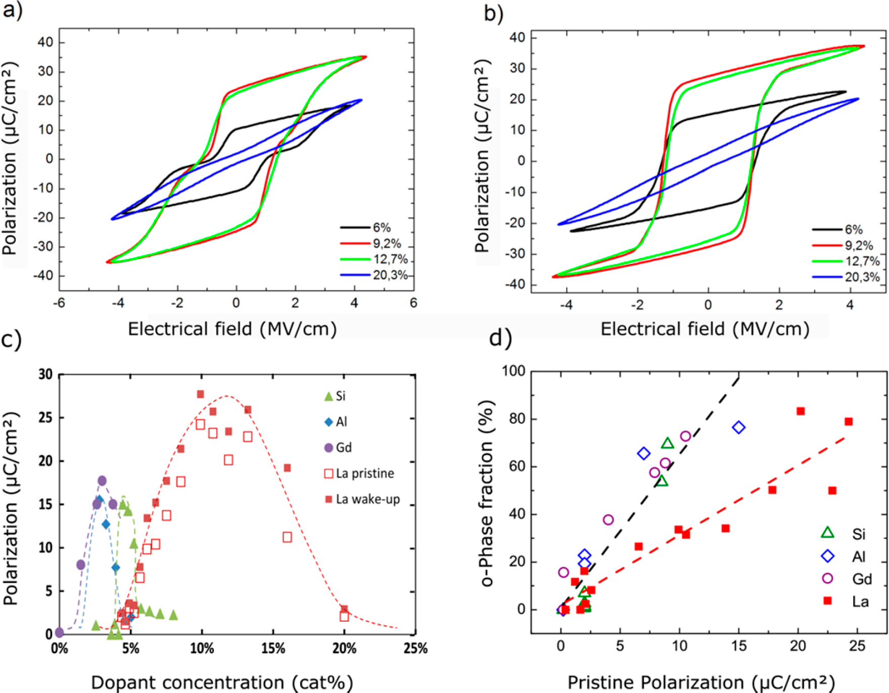

Figure 6. (a) Polarization hysteresis for ∼10 nm thick pristine samples with different La dopant contents from 6 to 20 cat% annealed at 800 °C for 20 s. (b) Polarization hysteresis for samples with different La dopant contents from 6 to 20 cat% after wake-up cycling. (c) Remanent polarization Pr values for ∼10 nm thick Si, Al, Gd, and La-doped HfO2 films with different dopant content annealed at 800 °C for 20 s. For La:HfO2 values for a“pristine” and “after wake-up” sample are included. (d) Pristine remanent polarization Pr values as a function of the orthorhombic phase fraction as determined by refinement of GIXRD patterns for samples shown in (c). Lines are a guide.

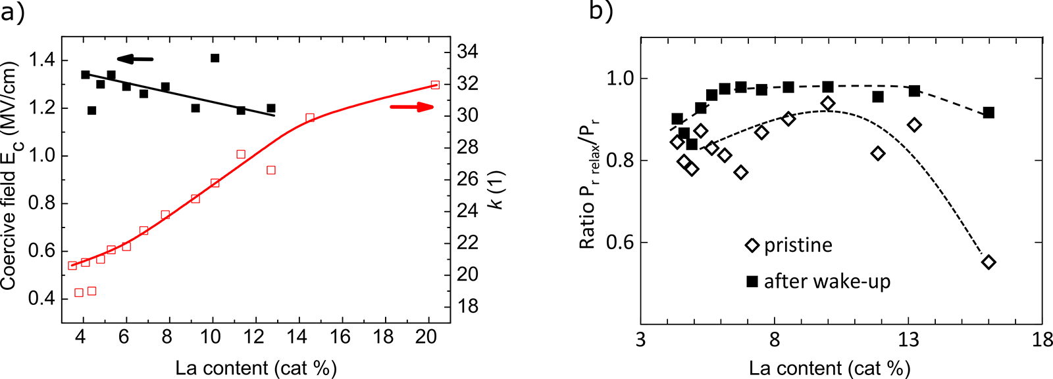

Figure 7. (a) Change of the coercive field Ec (after wake-up) and the dielectric constant k for ∼10 nm thick HfO2 films with different La content. (b) Normalized relaxed remanent polarization after 1 s Pr, relax (divided by remanent polarization Pr) for different La content for the pristine sample and after wake-up cycling. Lines are a guide.

on the pristine samples and after wake-up cycling (∼1 × 106 field cycles at 100 kHz). Compared to other dopants, ferroelectric properties are observed in a much broader dopant concentration range (Figure 6c) of 12 cat% compared to Si ref 3, Al ref 4, or Gd ref 6 doping with a lower range of 2−4 cat%. Only a mixed Hf1−xZrxO2 is showing an even larger window of more than 40 cat%.5,21In addition, the region of ferroelectric properties is shifted to higher doping concentrations. For Si, Al, and Gd some ferroelectric properties could be reached starting

2758 DOI: [10.1021/acs.inorgchem.7b03149](http://dx.doi.org/10.1021/acs.inorgchem.7b03149)

|  |  |  |
| --- | --- | --- |
| Inorganic Chemistry | |  | | --- | | Article | |

From the structural point of view, a phase transformation from a centrosymmetric nonpolar monoclinic (P21/c) to a ferroelectric orthorhombic (Pca21) to a nonpolar cubic phase (Fm3m) is characterized by XRD and TEM for increasing La content as described in the previous sections. Parallel to a structural transition a change of the dielectric constant k is expected37(see Figure 7). According values are determined by small signal capacitance−voltage measurements indicating an increase of the k-value from 20, as expected for mostly monoclinic films,38to 28 for the orthorhombic phase,38and to 32 for the cubic phase38with increasing La content. These results correlate nicely to the measured remanent polarization values. Only in the La dopant range that showed orthorhombic properties in XRD a remanent polarization is detected. Polarization-electric field (P-E) measurements reveal a clear linear dielectric behavior for a low La content less than 4 cat% La. At 4−5 cat% La the hysteresis loop is opening, and the remanent polarization is steadily increasing to a maximum Pr value of 27.7 μC/cm2for 10 cat% La. Beyond 13 cat% La, the Pr value is decreasing again until ∼20 cat%, when almost no ferroelectric properties are visible anymore. In most cases, a pinched hysteresis is visible for pristine samples implying the presence of internal bias fields (Figure 6a).52This pinching of the hysteresis disappears during field cycling indicating a reduction of the internal bias (Figure 6b; see also Section 3.4). This effect was described before39,37as a nonuniform distribution of oxygen vacancies at the TiN/HfO2 interface or domain boundaries, which are trap sites that can be charged and likely impact polarization switching and domain pinning. Field cycling could lead to a more equal distribution of these charged O vacancies and thus cause a reduction or disappearance of the internal bias fields. Another explanation would be that vacancy positions and other trap sites are locally fixed and that only a redistribution of trapped electrons cause depinching of the hysteresis. Only for the La:HfO2 sample with 16 cat% La, a pinched P-E loop was measured, which remained during field cycling. Only a slight depinching is visible, which is discussed in more detail in Section 3.4. Accordingly, none of the samples showed a strong field-induced ferroelectric behavior as reported for Si- and Al-doped HfO2 as well as for a HfxZr1−xO2 mixed oxide. Only at 20 cat% La a small field-induced hysteresis might be present. Differences to smaller dopants could be related to a change in phase transition. For Si: and Al:HfO2 and mixed HfxZr1−xO2 a transition from the orthorhombic to the tetragonal phase occurs when enhancing the dopant content. For La as for other dopants larger than Hf, a transition to the cubic phase is suggested (see Section 3.2). It is believed that field-induced ferroelectric behavior can mainly occur in predominantly tetragonal samples.

A clear linear relation between the o-phase fraction and the pristine Pr value is found similar to other dopants like Si, Al, or Gd (Figure 6d) indicating a content independent texture of the film.

Extrapolation of the relation is implying a maximum remanent polarization value of ∼30 μC/cm2for a 100% orthorhombic phase fraction. This value is higher than expected for a random orientation of the grains. Theoretical calculations for pure HfO2 determined a maximum remanent polarization of 50−52 μC/cm240,41for the orthorhombic HfO2 phase leading to a Pr value of ∼26 μC/cm2for a random grain orientation.42 XRD results in Section 3.2 suggest a stronger texture of La:HfO2 in polarization direction, and accordingly a higher remanent polarization value is expected compared to other

2759 DOI: [10.1021/acs.inorgchem.7b03149](http://dx.doi.org/10.1021/acs.inorgchem.7b03149)

|  |  |  |
| --- | --- | --- |
| Inorganic Chemistry | |  | | --- | | Article | |

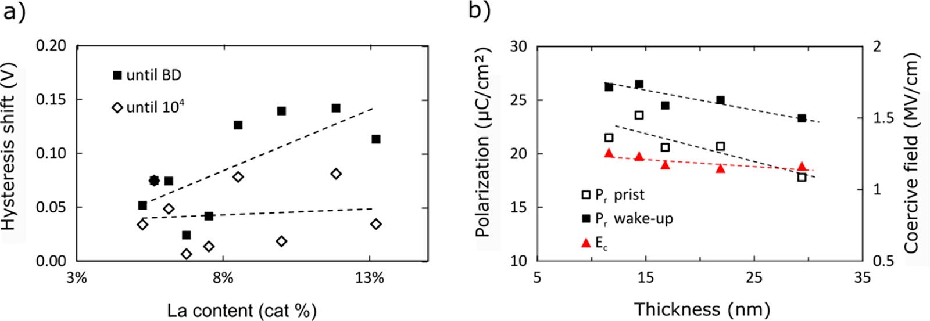

Figure 8. (a) Shift of the hysteresis curve after 1 × 104field cycles for capacitors with ∼10 nm thick HfO2 films having different La content and before breakdown compared to the pristine case. (b) Thickness dependence of the remanent polarization Pr for pristine samples (□) and after wake-up cycling (■, left axis) and coercive field Ec (▲, right axis) after wake-up for La:HfO2-based capacitor structures with 10 cat% La content. Lines are a guide.

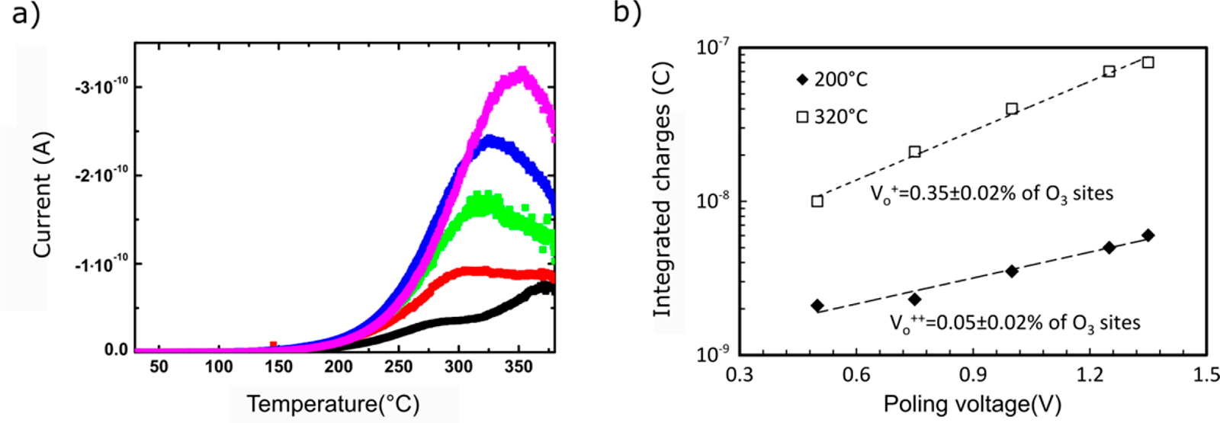

Figure 9. (a) Thermally stimulated depolarization current measurement of 20 nm thick TiN-La:HfO2−TiN capacitors with 10 cat% La after poling with voltages between 0.5 and 1.35 V for 800 s at 380 °C. (b) Extracted charges of the depolarization current measurements using 200 and 320 °C as poling temperatures (see [Supporting Information](http://pubs.acs.org/doi/suppl/10.1021/acs.inorgchem.7b03149/suppl_file/ic7b03149_si_001.pdf) for details).

content an intersection value change up to ±0.4 V is detected, which completely disappears for a La content of more than 10 cat% and increases again for 16 cat% La. This trend is similar for both polarity directions, indicating that only in the La content region between 10 and 13 cat% stable ferroelectric properties exist. This is consistent with a high orthorhombic phase portion in this concentration region. Furthermore, an average shift of the hysteresis along the electric field axis typically descript as imprint (change of the difference between the positive and negative intersection value) of 30 ± 3 mV after 1 × 104field cycles compared to the pristine case is calculated for all different La/Hf compositions indicating no clear composition dependent behavior (Figure 8a). Since a hysteresis biasing is typically related to charge trapping in the interfacial regions to the electrodes,43a stable shift of the hysteresis to a certain positive bias reveals a higher amount of negative charge at the interface to the top electrode, indicating a different interface property at the top and bottom electrodes. Since this shift is already visible at room temperature an even stronger behavior is expected for elevated temperatures. More detailed studies are needed to characterize this behavior. Furthermore, in Figure 8a the voltage shift for the last measurement point before breakdown is plotted as a function of the La content. Since the field cycles to breakdown increase for higher La content, also a stronger voltage shift is expected, assuming the shift is caused by charge trapping during field cycling.43,44 Indeed this is observed in Figure 8a, where the voltage shift

2760 DOI: [10.1021/acs.inorgchem.7b03149](http://dx.doi.org/10.1021/acs.inorgchem.7b03149)

|  |  |  |
| --- | --- | --- |
| Inorganic Chemistry | |  | | --- | | Article | |

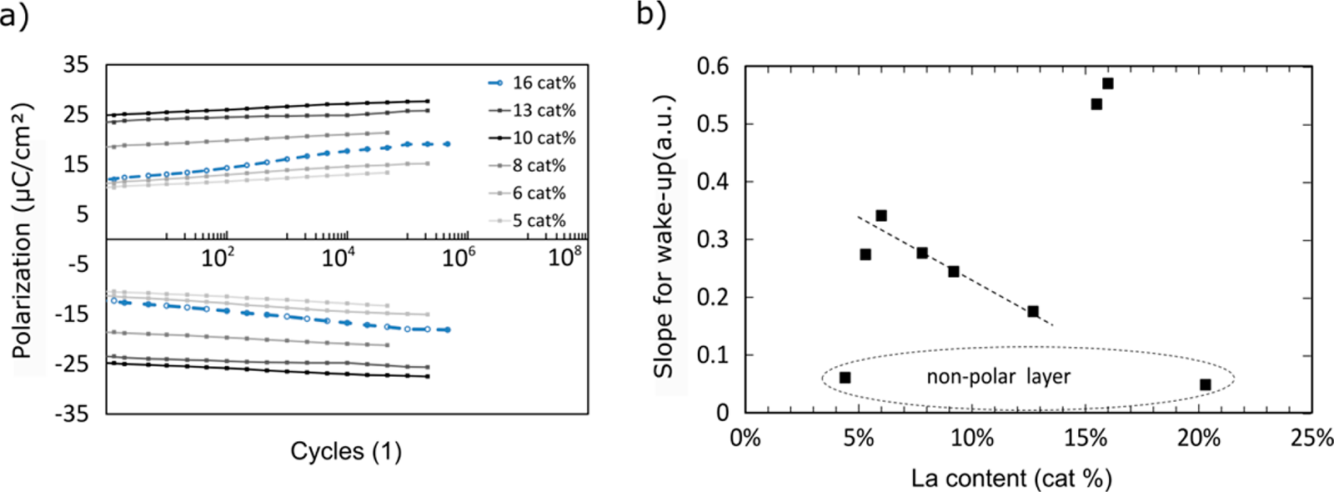

Figure 10. (a) Polarization as a function of electrical field cycling showing the wake-up behavior for ∼10 nm thick HfO2 films with different La contents from 5 cat% to 16 cat%. Samples were cycled with rectangular pulses of 4 MV/cm at 100 kHz. (b) Slope of the logarithmic change of the remanent polarization as a function of La content. The lines are a guide.

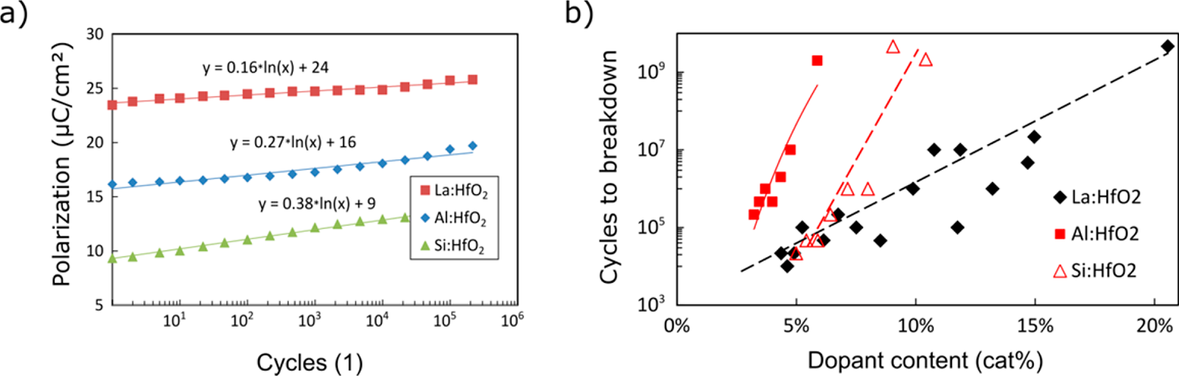

Figure 11. (a) Polarization as a function of electrical field cycling showing the wake-up behavior for ∼10 nm thick HfO2 films with La, Al, and Si dopant for samples with the highest remanent polarization value. (b) Cycles to breakdown as a function of the La, Al, and Si dopant concentrations. Lines are a guide.

at 320 °C is achieved by poling the sample at 350 °C and cooling it to 250 °C, while applying the same poling voltage and holding the temperature for 800 s without application of the bias voltage to allow relaxation of charges with lower activation energy (see [Figure SI 8a](http://pubs.acs.org/doi/suppl/10.1021/acs.inorgchem.7b03149/suppl_file/ic7b03149_si_001.pdf)). The current peak at 275°C is separated by poling only at 200 °C, which does not allow charges with higher activation energy to move (see [Figure SI 8b](http://pubs.acs.org/doi/suppl/10.1021/acs.inorgchem.7b03149/suppl_file/ic7b03149_si_001.pdf)). The activation energies are determined by using the initial rise method46as 0.45−0.51 eV (see [Figure SI 8c](http://pubs.acs.org/doi/suppl/10.1021/acs.inorgchem.7b03149/suppl_file/ic7b03149_si_001.pdf)) and 1.23−1.46 eV (see [Figure SI 8d](http://pubs.acs.org/doi/suppl/10.1021/acs.inorgchem.7b03149/suppl_file/ic7b03149_si_001.pdf)) depending on the applied poling voltage. Those values are similar to reported values in literature determined by simulation for singly (1.2 eV)47and doubly charged oxygen vacancies (0.7 eV)47,48and experimental determined values of 0.51−0.62 eV and 1.06−1.25 eV by TSDC in ferroelectric Hf0.5Zr0.5O2.50The voltage dependence of the amount of diffused charges should follow a sinh relation49

|  |  |  |  |  |
| --- | --- | --- | --- | --- |
| *Q* TSDC | = | *Q* | 0 | *eaV b*  sinh 2 *k Td* B *b* |

where QTSDC denotes the charges calculated from integration of the TSDC current peak, e is the elementary charge, a is the valence of the ion, Vb is the used bias voltage, kB is the Boltzmann constant, and d is the thickness of the film. Similar to a former study50this function is fitted to the measurement data to extract the amount of mobile charge carriers per volume for both peaks (see Figure 9b). Values of 0.35% singly and 0.05% doubly charged oxygen vacancies are approximately a factor 2 higher compared to reported values for Hf0.5Zr0.5O2,

2761 DOI: [10.1021/acs.inorgchem.7b03149](http://dx.doi.org/10.1021/acs.inorgchem.7b03149)

|  |  |  |
| --- | --- | --- |
| Inorganic Chemistry | |  | | --- | | Article | |

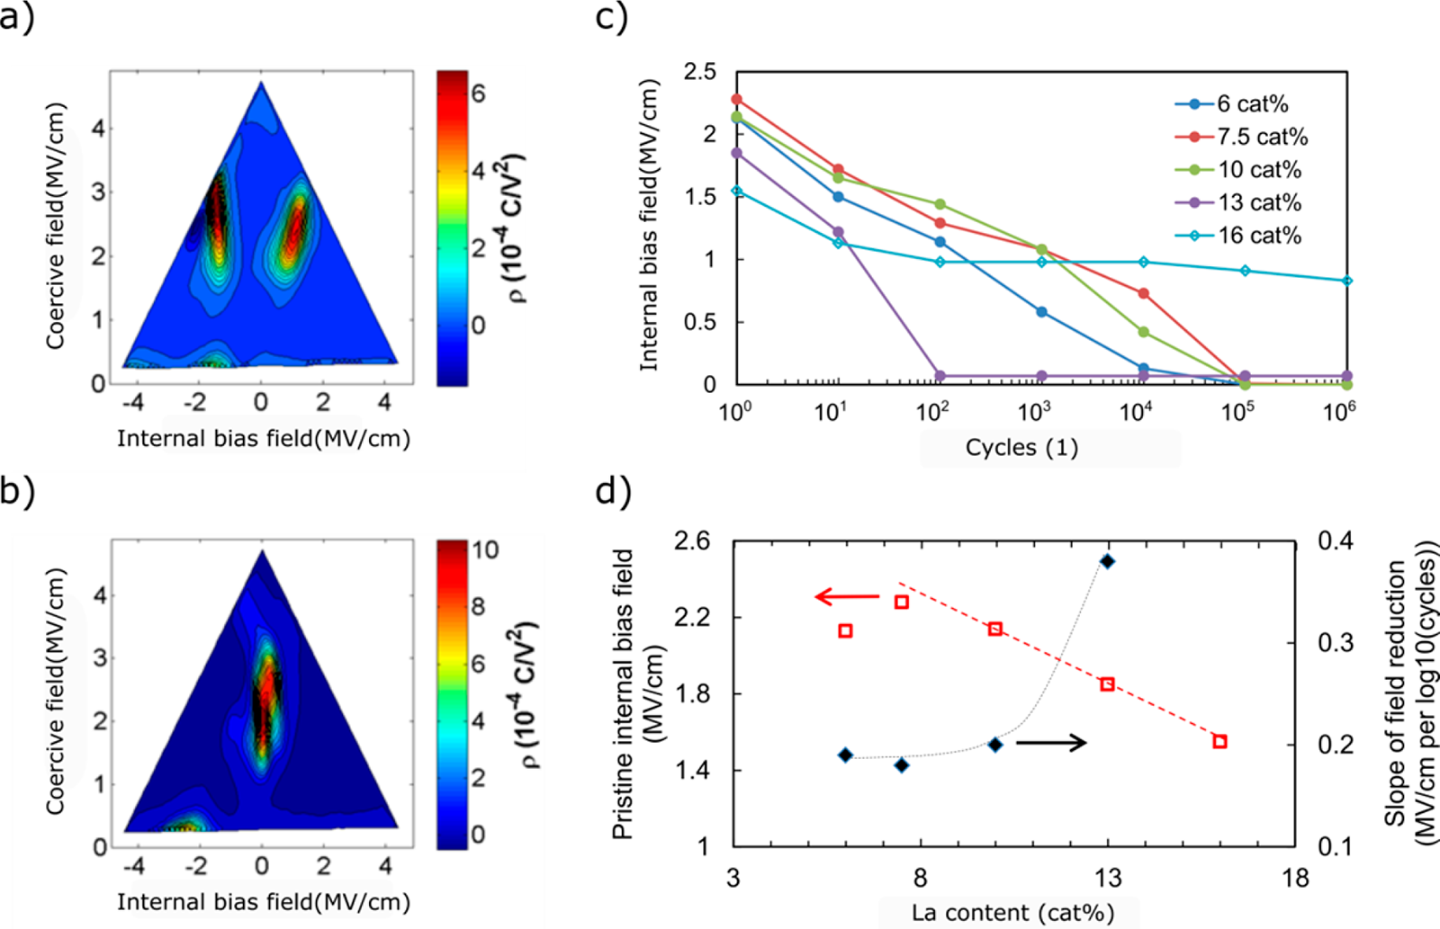

Figure 12. FORC measurement results of ∼10 nm thick HfO2 films with 10 cat % La content in capacitors (a) before cycling and (b) after 1 × 106 rectangular pulses with 100 kHz at 4 MV/cm. (c) Internal bias field defined as the difference in Ebias of the FORC maxima from the pristine and the cycled sample as a function of the number of field cycles. (d) Pristine internal bias field (red□, left axis) and slope m of the decrease in internal bias field m × log10(cycles) (black◆, right axis) as extracted from (c). Lines are a guide.

compared to a monoclinic to orthorhombic phase change below 10 cat% La. Above 20 cat% La mainly cubic phase portions are detected (see Figure 3c), and applied electric fields are not able to transform the film into the polar phase. Pešić et al. explained the wake-up behavior by field-induced oxygen vacancy movement from the electrode interfaces to the HfO2 bulk causing a phase transformation of nonpolar monoclinic phase portions to the polar orthorhombic phase.37Since oxygen vacancy movement could not be confirmed with certainty in the former sections, a pure field-driven phase change without oxygen vacancy movement might be an alternative explanation. Similar processes might occur for cubic phase portions for a La content greater than 13 cat%. Since the field drop over the monoclinic domains (with lower dielectric constant) is expected to be higher compared to the one over the cubic domains, a different wake-up slope might be expected when a different ion vacancy movement or field-driven phase change is assumed in the effective field, resulting in a stronger wake-up for monoclinic phase portions containing samples in contrast to cubic counterparts.

Compared to other dopants like Si and Al processed in a similar metal−insulator−metal capacitor structure and using the same TiN electrodes and annealing conditions, La shows a similar wake-up slope ranging from 0.2 to 0.4 μC/cm2per decade. However, overall samples with a La content of 13 cat% have the lowest wake-up slope as shown in Figure 11a. This behavior indicates less pinching in the pristine case, which suggests that the charge distribution in the highly La-doped sample is more uniform, and less domain pinning is present. Higher crystallization anneal temperatures for a 10 cat% La sample improved the wake-up properties due to the enhanced orthorhombic phase for annealing temperatures of 800−1000°C ([Figure SI 2](http://pubs.acs.org/doi/suppl/10.1021/acs.inorgchem.7b03149/suppl_file/ic7b03149_si_001.pdf)).

All samples show a dielectric breakdown after a certain number of field cycles. This hard breakdown event occurs for a

2762 DOI: [10.1021/acs.inorgchem.7b03149](http://dx.doi.org/10.1021/acs.inorgchem.7b03149)

|  |  |  |
| --- | --- | --- |
| Inorganic Chemistry | |  | | --- | | Article | |

tal Section) on pristine samples that decreased during field cycling.52As a model, a redistribution of charges37from the TiN electrode interfaces toward the HfO2 bulk and within the interface and domain boundary regions is suggested. As discussed in the beginning of the Electrical Characterization section, these charges can pin domains, thus causing a pinched hysteresis loop.

During field cycling, a redistribution of charges at trap sites (e.g., oxygen vacancies) within the HfO2 could lead to a phase transformation and more uniform distribution of pinning centers, which consequently results in the opening of the hysteresis (Figure 12a).37Similar to previous investigations on HfO2-based materials,52,53FORC measurements are performed on HfO2 samples with different La content ranging from 6 to 16 cat%. In all cases, a reduction of the internal bias field (defined as the difference in Ebias of both FORC maxima) with field cycling is verified (Figure 12a−c). The initial value decreases from ∼2.4 MV/cm for 7.5 cat% to 1.6 MV/cm for 16 cat% La. These Ebias values follow an exponential reduction with the number of cycles Ebias ≈ −m·log10(cycles), resulting in a vanishing of the internal bias field after 1 × 106field cycles for all samples except the 16 cat% case. The slope m improves from 0.16 to 0.38 MV/cm per decade with higher La content below 13 cat%, similar to the improvement in wake-up behavior with increasing La content, as discussed in the beginning of this section. Again, only the sample with 16 cat% La is not following the general trend. The internal bias field of 1.5 MV/cm is lower for the pristine sample with 16 cat% and changes much less with cycling (slope m ≈ 0.2 MV/cm per decade). The linear reduction of the internal bias field (Figure 12d) with increasing La content could be related to a reduced amount of trap sites with enhanced La concentration, which would not be expected for a higher amount of trivalent La in HfO2. A lower amount of trap sites would improve the wake-up behavior as indicated by the slope for field reduction. As mentioned before, only for samples with significant cubic portions the wake-up behavior is modified. Overall, the distribution of the coercive field as determined by the FORC method during cycling is almost constant with a mean value of 2.3 ± 0.5 MV/cm. This value is higher than results reported in Figure 7, which is caused by a higher effective measurement frequency to avoid sample degradation during FORC measurement. For FORC plots, an effective frequency of 16 kHz is used with respect to 1 kHz used in the P-E measurement as described in Figure 7. Variations of the coercive field are discussed to be related to the distribution in grain sizes by Hoffmann et al.22   
 Comparing structural and electrical results, the following trends are visible. La shows an almost uniform dopant distribution within the HfO2 bulk, with the exception of an enrichment at the oxide/TiN electrodes interfaces. Former studies22,23revealed an interfacial reaction during crystallization anneal of the capacitor stack, which results in O diffusion into the TiN and Ti/N diffusion into the HfO2 interfacial regions causing a higher amount of oxygen vacancies at these interfaces. A similar behavior could be verified in the TOF-SIMS analysis indicating a clear TiOx interface formation similar to reports for Gd:HfO2.22Hereby generated oxygen vacancies can act as trap sites, which can be singly and doubly charged with a trap depth of 0.5 and 1.1 eV similar to other dopants.50Higher La amounts seem to reduce the oxygen vacancy content and improve the uniformity throughout the HfO2 bulk, because wake-up and breakdown behavior of the layer is improved. On the one hand, a constant imprint behavior for different La

2763 DOI: [10.1021/acs.inorgchem.7b03149](http://dx.doi.org/10.1021/acs.inorgchem.7b03149)

|  |  |  |
| --- | --- | --- |
| Inorganic Chemistry | |  | | --- | | Article | |

(XRD, SEM, TEM, TOFSIMS) and more figures concerning detailed electrical characterization ([PDF](http://pubs.acs.org/doi/suppl/10.1021/acs.inorgchem.7b03149/suppl_file/ic7b03149_si_001.pdf))■AUTHOR INFORMATION   
Corresponding Author   
*E-mail: [uwe.schroeder@namlab.com](mailto:uwe.schroeder@namlab.com).

ORCID

Uwe Schroeder: [0000-0002-6824-2386](http://orcid.org/0000-0002-6824-2386)   
Min Hyuk Park: [0000-0001-6333-2668](http://orcid.org/0000-0001-6333-2668) Tony Schenk: [0000-0003-2933-1076](http://orcid.org/0000-0003-2933-1076)   
Michael Hoffmann: [0000-0001-6493-3457](http://orcid.org/0000-0001-6493-3457) Thomas Mikolajick: [0000-0003-3814-0378](http://orcid.org/0000-0003-3814-0378)

Author Contributions

The manuscript was written through contributions of all authors. All authors have given approval to the final version of the manuscript.

Notes   
The authors declare no competing financial interest.

■ACKNOWLEDGMENTS   
Authors gratefully acknowledge E. Grimley for intensive discussion and T. Sturm and A. Poehl from Leibniz IFW Dresden, Germany, for preparing the TEM lamella. This work was supported in part by funding from Army Research Office (Contract No. W911NF-15-1-0593). T.S. gratefully acknowl-edges the German Research Foundation (Deutsche For-schungs-Gemeinschaft) for funding part of this research in the frame of the “Inferox” project (MI 1247/11-2). M.P. and C.R. are supported by the EFRE fund of the European Commission and by the Free State of Saxony (Germany). M.H.P. is supported by Humboldt postdoctoral fellowship from Alexander von Humboldt Foundation. This work was performed in part at the Analytical Instrumentation Facility (AIF) at North Carolina State Univ., which is supported by the State of North Carolina and the National Science Foundation (Award No. ECCS-1542015). The AIF is a member of the North Carolina Research Triangle Nanotechnology Network (RTNN), a site in the National Nanotechnology Coordinated Infrastructure (NNCI). M.H. has received funding from the Electronic Component Systems for European Leadership Joint Undertaking under Grant No. 692519. This Joint Undertaking receives support from the European Union Horizon 2020 research and innovation program and Belgium, Germany, France, Netherlands, Poland, and United Kingdom.

■REFERENCES   
(1) Ihlefeld, J. F.; Harris, D. T.; Keech, R.; Jones, J. L.; Maria, J. P.; Trolier-McKinstry, S. Scaling Effects in Perovskite Ferroelectrics: Fundamental Limits and Process-Structure-Property Relations. J. Am. Ceram. Soc. 2016, 99 (8), 2537−2557.

(2) Böscke, T. S.; Müller, J.; Bräuhaus, D.; Schröder, U.; Böttger, U. Ferroelectricity in hafnium oxide thin films. Appl. Phys. Lett. 2011, 99, 102903.

(3) Richter, C.; Schenk, T.; Park, M. H.; Tscharntke, F. A.; Grimley, E. D.; LeBeau, J. M.; Zhou, C.; Fancher, C. M.; Jones, J. L.; Mikolajick, T.; Schroeder, U. Si Doped Hafnium OxideA “Fragile” Ferroelectric System. Adv. Electron. Mater. 2017, 3, 1700131.

(4) Mueller, S.; Mueller, J.; Singh, A.; Riedel, S.; Sundqvist, J.; Schroeder, U.; Mikolajick, T. Incipient Ferroelectricity in Al-Doped HfO2 Thin Films. Adv. Funct. Mater. 2012, 22, 2412.

(5) Müller, J.; Böscke, T. S.; Bräuhaus, D.; Schröder, U.; Böttger, U.; Sundqvist, J.; Kücher, P.; Mikolajick, T.; Frey, L. Ferroelectric

2764 DOI: [10.1021/acs.inorgchem.7b03149](http://dx.doi.org/10.1021/acs.inorgchem.7b03149)

|  |  |  |
| --- | --- | --- |
| Inorganic Chemistry | |  | | --- | | Article | |

J−V and C−V polarity asymmetry of MIM capacitors with amorphous and crystalline Zr(1−x)AlxO2 films. Microelectron. Eng. 2009, 86, 1826. (24) Gao, Y. A new secondary ion mass spectrometry technique for III-V semiconductor compounds using the molecular ions CsM+. J. Appl. Phys. 1988, 64, 3760.

(25) Shimizu, T.; Katayama, K.; Funakubo, H. Epitaxial Growth of YO1.5 Doped HfO2 films on (100) YSZ Substrate with Various Concentrations. Ferroelectrics 2017, 512, 105−110.

(26) Shiraishi, T.; Katayama, K.; Yokouchi, T.; Shimizu, T.; Oikawa, T.; Sakata, O.; Uchida, H.; Imai, Y.; Kiguchi, T.; Konno, T. J.; Funakubo, H. Impact of mechanical stress on ferroelectricity in (Hf0.5Zr0.5)O2 thin films. Appl. Phys. Lett. 2016, 108, 262904.

(27) Lee, C.-K.; Cho, E.; Lee, H.-S.; Hwang, C. S.; Han, S. First-principles study on doping and phase stability of HfO2. Phys. Rev. B: Condens. Matter Mater. Phys. 2008, 78, 012102.

(28) Duran, P. Phase relationships in the systems HfO2-La2O3 and HfO2-Nd2O3. Ceramurgia Int. 1975, 1, 10.

(29) Komissarova, L. N.; Wang, K. S.; Spitzyn, V. I.; Simanov, Y. P.

The HfO2-La2O3 System. Russ. J. Inorg. Chem. 1964, 9, 383−386. (30) Shannon, R. D. Revised effective ionic radii and systematic studies of interatomic distances in halides and chalcogenides. Acta Crystallogr., Sect. A: Cryst. Phys., Diffr., Theor. Gen. Crystallogr. 1976, 32, 751−767.

(31) Macherauch, E. X-ray stress analysis. Exp. Mech. 1966, 6, 140. (32) Noyan, I. C.; Huang, T. C.; York, B. R. Residual stress/strain analysis in thin films by X-ray diffraction. Crit. Rev. Solid State Mater. Sci. 1995, 20, 125−177.

(33) Dole, S. L.; Hunter, O.; Wooge, C. J. Elastic properties of monoclinic hafnium oxide at room temperature. J. Am. Ceram. Soc. 1977, 60, 488−490.

(34) Nino, J. C.; Qiu, W.; Jones, J. L. Strain state of bismuth zinc niobate pyrochlore thin films. Thin Solid Films 2009, 517, 4325−4328. (35) Böscke, T. S.; Teichert, St.; Bräuhaus, D.; Müller, J.; Schröder, U.; Böttger, U.; Mikolajick, T. Phase transitions in ferroelectric silicon doped hafnium oxide. Appl. Phys. Lett. 2011, 99, 112904.

(36) Park, M. H.; Schenk, T.; Richter, C.; Grimley, E. D.; LeBeau, J. M.; Tallarida, M.; Mariani, C.; Simonelli, L.; Fancher, C. M.; Jones, J. L.; Materlik, R.; Künneth, C.; Kersch, A.; Mikolajick, T.; Schroeder, U. Structural Root Causes of Ferroelectricity in Doped Hafnium Oxide. In International Symposium on Applications of Ferroelectrics (ISAF); Darmstadt, Germany, Aug 21−25, 2016; IEEE, 2016.

(37) Pešić, M.; Fengler, F. P. G.; Larcher, L.; Padovani, A.; Schenk, T.; Grimley, E. D.; Sang, X.; LeBeau, J. M.; Slesazeck, S.; Schroeder, U.; Mikolajick, T. Physical Mechanisms behind the Field-Cycling Behavior of HfO2-Based Ferroelectric Capacitors. Adv. Funct. Mater. 2016, 26, 4601−4612.

(38) Materlik, R.; Künneth, C.; Kersch, A. The origin of ferroelectricity in Hf1−xZrxO2: A computational investigation and a surface energy model. J. Appl. Phys. 2015, 117, 134109.

(39) Grimley, E. D.; Schenk, T.; Sang, X.; Pešic, M.; Schroeder, U.; Mikolajick, T.; LeBeau, J. M. Structural Changes Underlying Field-Cycling Phenomena in Ferroelectric HfO2 Thin Films. Adv. Electron. Mater. 2016, 2, 1600173.

(40) Clima, S.; Wouters, D. J.; Adelmann, C.; Schenk, T.; Schroeder, U.; Jurczak, M.; Pourtois, G. Identification of the ferroelectric switching process and dopant-dependent switching properties in orthorhombic HfO2: A first principles insight. Appl. Phys. Lett. 2014, 104, 092906.

(41) Materlik, R.; Künneth, C.; Kersch, A. The origin of ferroelectricity in Hf1−xZrxO2: A computational investigation and a surface energy model; J. Appl. Phys. 2015, 117, 134109.

(42) Jones, J. L. The effect of crystal symmetry on the maximum polarization of polycrystalline ferroelectric materials. Mater. Sci. Eng., B 2010, 167 (1), 6−11.

(43) Pešić, M.; Fengler, F.; Slesazeck, S.; Schroeder, U.; Mikolajick, T.; Larcher, L.; Padovani, A. Root cause of degradation in novel HfO2-based ferroelectric memories. In 2016 IEEE International Reliability Physics Symposium (IRPS); Pasadena, CA, Apr 17−21, 2016; [10.1109/ IRPS.2016.7574619](http://dx.doi.org/10.1109/IRPS.2016.7574619).

2765 DOI: [10.1021/acs.inorgchem.7b03149](http://dx.doi.org/10.1021/acs.inorgchem.7b03149)