Highly Reliable Ferroelectric Hf0.5Zr0.5O2 Film with Al Nanoclusters Embedded by   
Novel Sub-Monolayer Doping Technique

T. Yamaguchi1, T. Zhang1, K. Omori1, Y. Shimada2, Y. Kunimune2, T. Ide2, M. Inoue1, and M. Matsuura1 1Device Technology Div., Renesas Electronics Corp., Hitachinaka, Ibaraki, Japan, email: tadashi.yamaguchi.pz@renesas.com 2Renesas Semiconductor Manufacturing Co., Ltd., Hitachinaka, Ibaraki, Japan

***Abstract*�**Highly reliable ferroelectric (FE) Hf0.5Zr0.5O2 (HZO) film with Al nanoclusters embedded by sub-monolayer doping technique is demonstrated for the first time. Al nanoclusters increase the remnant polarization (Pr) and reduce the voltage necessary for polarization switching. Furthermore, the program and erase endurance at the cycle of more than 250k and the Pr retention at 85ºC for 10 years are achieved. Al nanoclusters are formed by the partial oxidation of sub-monolayer metallic Al embedded in HZO films. Al nanoclusters enhance the large grain growth of orthorhombic-phase HZO during FE-HZO crystallization annealing. The reduction of grain boundaries caused by the large grain growth with Al nanoclusters effectively reduces the leakage current in the HZO film. As a result, reliability of the FE HZO film is significantly improved.

nanoclusters, and Al nanoclusters enhance the coalescence of FE HZO grains and enlarge the grain size. Reduction of grain boundaries due to the large grain growth and localization of Al nanoclusters at the grain boundary interrupt the leakage current pass. As a result, program and erase (P/E) endurance and retention characteristics can be significantly improved.

**II.EXPERIMENTAL**

Figure1 shows process flow of metal ferroelectric metal (MFM) capacitor. 10-nm-thick TiN film was deposited on B implanted Si wafers at the dose of 5×1015 cm-2 with 10 keV. 5-nm-thick HZO film (Hf : Zr = 1 : 1) was deposited by ALD system at 300ºC. Hafnium chloride (HfCl4) and zirconium chloride (ZrCl4) were used as precursors of Hf and Zr, respectively. H2O was used as a source of oxidizer. Sub-monolayer Al was doped at the dose ranging from 1×1013 to

|  |  |  |
| --- | --- | --- |
| **I.** | **INTRODUCTION** | 1×1014 cm-2. Figure 2 shows the dose rate of Al using the doping |

Recently, ferroelectric (FE) orthorhombic-phase HfO2 film is one of the most attractive materials for future emerging memory because of high compatibility of CMOS integration together with high versatility as high-k gate dielectrics for CMOS devices. A lot of additives to enhance the ferroelectricity, such as Si, Y, Zr, Al, N, etc., have been examined [1-3]. In particular, Zr has advantages of large composition range showing ferroelectric behavior and the high remnant polarization (Pr) [3]. Furthermore, it has been reported that the Hf and Zr composition ratio of 50% shows high Pr [4]. The Hf0.5Zr0.5O2 (HZO) film is one of promising candidates for the application to memory devices. On the other hand, although there were few papers on reliability of HZO films, the degradation of endurance and retention characteristics due to the depolarization was revealed [5, 6]. From the viewpoint of materials engineering, the orthorhombic phase formation and the grain size control in FE HZO films are key issues to improve the reliability. Indeed, the grain size engineering in thick HZO films by the laminated HZO structure using the insertion of the Al2O3 interlayer has been reported [7, 8]. However, the distinct fatigue was observed due to the formation of additional charge trap sites at the Al2O3/HZO interface [8]. Further novel and attractive methods to improve reliability of HZO films are strongly required for highly reliable FE memory.

In this paper, we demonstrate highly reliable HZO films with partially oxidized Al nanoclusters embedded by sub-monolayer metallic Al doping instead of inserting a layer. Precise control of Al doping ensures the stable formation of Al

system designed for a low dose. The quite low dose rate of 2.4 ×1012 cm-2/sec can precisely control Al dose. Then, 5-nm-thick HZO film was deposited again. After 10-nm-thick TiN film was formed as a capping layer, rapid thermal annealing (RTA) at 600ºC for 60s was carried out to form the FE crystal phase. After 100-nm-thick poly-crystalline silicon was deposited, P implantation at the dose of 5×1015 cm-2 with 10 keV and activation annealing were conducted. The high resolution TEM image of the HZO film after FE-HZO crystallization annealing is shown in Fig. 3. Al nanoclusters in the middle of the film are confirmed. P-V measurement characterized Pr and coercive voltage (Vc). C-V and I-V were also measured. P/E endurance and retention characteristics were evaluated as the reliability of HZO films. The condition of the endurance cycle test was fixed at ±2V with the frequency of 10kHz. For physical analyses, the distribution of grain size and crystal direction in HZO films with Al nanoclusters were characterized by scanning precession electron diffraction. The profile of Al and the binding energy of Al nanoclusters in HZO films were also measured by STEM-EDS system and XPS, respectively.

**III.RESULTS AND DISCUSSION**

*A.Electrical properties of HZO films with Al nanoclusters*

Figure 4 shows P-V hysteresis curves with and without Al nanoclusters. Pr with the Al nanocluster is larger than that without one. In addition, Vc with the Al nanocluster is lower than that without one. Pr and Vc as a function of Al dose are summarized in Fig. 5 and 6, respectively. Pr increases with

|  |  |  |
| --- | --- | --- |
| 978-1-7281-1987-8/18/$31.00 ©2018 IEEE | 7.5.1 | IEDM18-165 |

increasing Al dose. At the Al dose of 5×1013 cm-2, Pr shows maximum, then Pr drastically decreases with increasing Al dose. On the other hand, Vc monotonically decreases with increasing Al dose, which indicates lowering the voltage necessary for polarization switching. Figure 7 shows C-V characteristics of the HZO film with and without Al nanoclusters. Maximum capacitance (Cmax) with Al nanoclusters is higher than that without one, and the voltage of Cmax with Al nanoclusters is lower than that without one. Cmax as a function of Al dose is shown in Fig. 8. Cmax increases with increasing Al dose and the peak of Cmax is shown at 5×1013 cm-2. Resulting from the enhancement of Pr (or Cmax) and the reduction of Vc, precise optimization of Al doping was found to be required. The Al dose of 5×1013 cm-2 was chosen in the following reliability study. Figure 9 shows P/E endurance of the HZO film with and without Al nanoclusters. Pr without Al nanoclusters monotonically decreases with the P/E cycle. Meanwhile, Pr with Al nanoclusters is stable up to 10k cycle. Pr window keeps about 12�����2 after 250k cycle. Furthermore, the retention characteristic of the HZO film with Al nanoclusters at the room temperature (RT) is superior to that without one, as shown in Fig. 10. Al nanoclusters can ensure the extrapolated Pr window ����������2 after 10 years. Moreover, retention characteristics after the P/E cycle of 10k and 200k indicate not only the window margin but also no change in the decay rate between 10k and 200k cycles, as shown in Fig. 11. The HZO film with Al nanoclusters also exhibits the retention characteristic at elevated temperature (85ºC), as shown in Fig. 12. The extrapolated Pr window can be confirmed after 10 years, which should be contrasted to the reported value of 100s at 85ºC for the single HZO film [5].

To understand the cause for the improvement of reliability in HZO films with Al nanoclusters, I-V characteristics are compared, as shown in Fig. 13. The leakage current in the HZO film with Al nanoclusters decreases with increasing Al dose.It has been well-known that fatigue effect during cycle test is due to defects in FE films and injected charges that pin the domain walls while retention loss results from the leakage followed by charge trapping [8]. The injection of charges into HZO films with Al nanoclusters is strictly suppressed and reliability is improved.

*B.Physical properties of HZO films with Al nanoclusters*

To clarify the physical properties of the HZO film with Al nanoclusters, crystal grain maps and mean grain size as a function of Al dose are shown in Fig. 14 and 15, respectively. The mean grain size increases with increasing Al dose. This result is consistent with the reduction of the leakage current since grain boundaries as leakage passes decrease due to the increase of grain size. Figure 16 shows crystal direction maps of orthorhombic phase grains in HZO films with and without Al nanoclusters. Here, the grains of tetragonal phase are indicated by black areas. The crystal direction of orthorhombic grains with Al nanoclusters tends to align with [001] direction, as shown in Fig. 17. This result suggests Pr increase and Vc decrease (see Figs. 5 and 6).

To understand the feature of Al nanoclusters after the FE-HZO crystallization annealing, STEM-EDS maps and the line

profile are shown in Fig. 18. Most of Al are located at the middle of the HZO film despite 600ºC annealing. Moreover, the detail analysis of Al nanoclusters was carried out with XPS. Figure 19 shows XPS spectra of Al 2p and 2s before and after FE-HZO crystallization annealing. Sub-monolayer Al was partially oxidized after top HZO deposition, and oxidation of Al might proceed during FE-HZO crystallization annealing. Metallic Al-Al bonds, however, remain. It is considered that nuclei of metallic Al are located at the center of Al nanoclusters. Although further study of Al nanoclusters is needed, creation of Al nanoclusters is a key to realize highly reliable FE films.

*C.Role of Al nanoclusters in HZO films*

To explain the cause for the improvement of reliability in the HZO film with embedded Al nanoclusters, feasible models are considered. Figure 20 shows schematic illustrations about the role of Al nanoclusters in HZO films. In the case of the HZO film without Al nanoclusters, during FE-HZO crystallization, poly-crystalline HZO grains grow on both TiN electrodes and contact each other, then grain boundaries are created. These grain boundaries increase leakage current, and charges are injected during cycle test. On the other hand, in the case of the HZO film with Al nanoclusters, Al are embedded in amorphous HZO films. During FE-HZO crystallization, clustering of Al proceeds. then, Al nanoclusters are surrounded by poly-crystalline FE HZO grains because of the grain growth. It is considered that micro-strain is generated at the interface between poly-crystalline HZO grains with Al nanoclusters due to the difference of the thermal expansion coefficient between Al nanocluster and HZO. The coalescence of FE HZO grains is enhanced to relax the strain energy. This coalescence causes the large HZO grain growth with a preferred [001] crystal direction. As a result, grain boundaries decrease. In addition, several of Al nanoclusters are localized at the grain boundary. These Al nanoclusters might interrupt leakage current.

**IV.CONCLUSION**

We demonstrated the highly reliable ferroelectric (FE) Hf0.5Zr0.5O2 (HZO) film with Al nanoclusters embedded by sub-monolayer Al doping for the first time. Al nanoclusters in HZO films ensure the reliability of program and erase endurance and retention characteristics due to the reduction of the leakage current in the HZO film. Furthermore, detail physical analyses with scanning precession electron diffraction, STEM-EDS and XPS led to the feasible model about the role of Al nanoclusters in HZO films. The HZO film with embedded Al nanoclusters is a promising material for highly reliable FE memory.

REFERENCES

[1] T. S. Boscke, *et al*., *Appl. Phys. Lett.***99**, 112904 (2011).

[2] P. D. Lemenzo, *et al*., *Appl. Phys. Lett.* **107**, 242903 (2015).

[3] J. Muller, *et al*., *Appl. Phys. Lett.* **99**, 112901 (2011).

[4] J. Muller, *et al*., *Nano Lett*. **12**, 4318 (2012).

[5] Y-C. Chiu, *et al*., *2015 Symposium on VLSI Technology Digest of Technical Papers*, T184.

[6] K-Y. Chen, *et al*., *2018 Symposium on VLSI Technology Digest of Technical Papers*, 119.

[7] H. J. Kim, *et al*., *Appl. Phys. Lett.***105**, 192903 (2014).

[8] S. Riedel and J. Muller, *AIP Advances*, **6**, 095123 (2016).

IEDM18-166 7.5.2

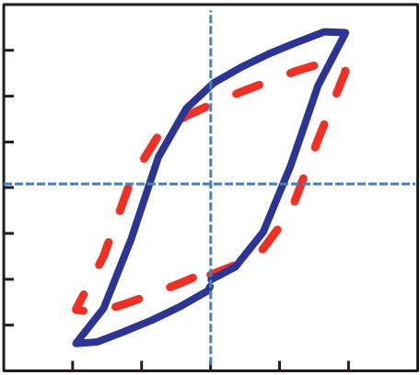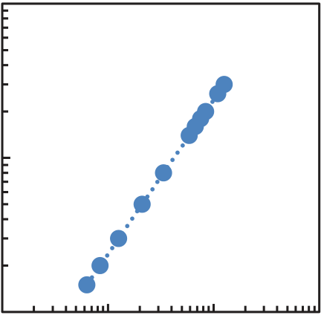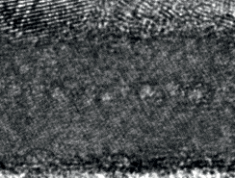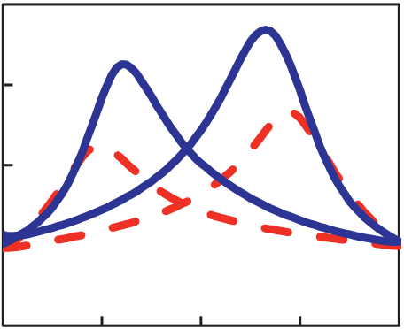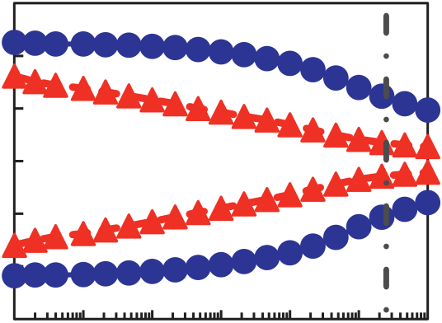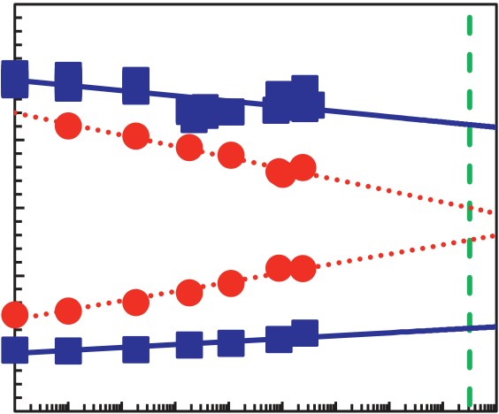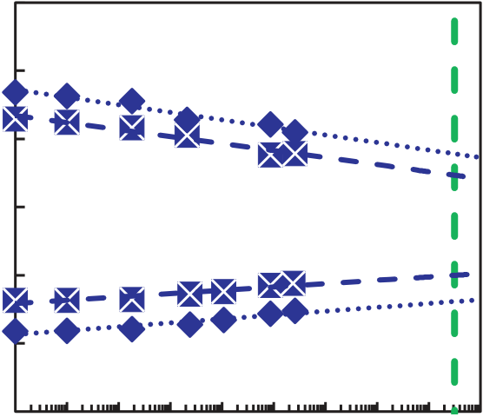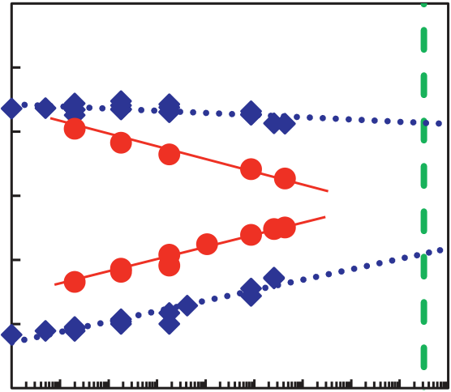

|  |  |  |  |  |  |  |  |  |  |  |  |  |  |  |  |  |  |  |  |  |  |  |  |  |  |  |  |  |  |  |  |  |  |  |
| --- | --- | --- | --- | --- | --- | --- | --- | --- | --- | --- | --- | --- | --- | --- | --- | --- | --- | --- | --- | --- | --- | --- | --- | --- | --- | --- | --- | --- | --- | --- | --- | --- | --- | --- |
| Process flow Al�  �-HZO�  Top TiN 10nm �-HZO 5nm  RTA 600 ºC 60s   cluster�    Ferroelectric HZO�Bottom TiN 10nm TiN�  Dose [cm-2]�-HZO 5nm  Al doping ~ 1×10 14 Al | | | | | | | | | | | | | | | 1015 | | | 2.4×1012 cm-2/sec | | | | | | | 1000 | | | | **TiN** | | | | | |
| **Al nanoclusters** | | | | | |
| 1014 | | | 10 | | | 100 | | | |
| **HZO** | | | | | |
| 1013 | | |
| 1 | | | Fig. 3. High resolution TEM image of Al | | | | | |
| Doping time [sec] | | | | | | | nanoclusters in HZO film after FE-HZO | | | | | |
| crystallization annealing. | | | | | |
| Fig. 1. Process flow of MFM capacitor with Al Fig. 2. Dose rate of Al doping system.  nanoclusters. 15 1.5  -10  -15  -20 -5  5  0  -3 -2 -1 0   without  Al doping  1   Vc  2 3  -10  -15  without Al  -5 0  Al dose [cm-2]   1013 1014  -0.5  -1.5  without Al  -1 0  1013 1014 20  with Al doping 10 1  15  Pr [�C/cm2]  10 10kHz Pr 5 0.5  P [�C/cm2]  Vc [V]  Vg [V] Fig. 5. Remnant polarization of HZO film as a Al dose [cm-2] | | | | | | | | | | | | | | | | | | | | | | | | | | | | | | | | | | |
| Fig. 4. P-V characteristics of HZO film with | | | | | | | | | | | function of Al dose. | | | | | | | | | | | | | | | Fig. 6. Coercive voltage of HZO film as a | | | | | | | | |
| 100  95 | | |  | | | | | | | | | | | |
| and without Al nanoclusters. | | | | | | | | | | | function of Al dose. | | | | | | | | |
| 10 | | | | ×1011 | | | Cmax | | | | 15 | | | | **Al: 5**�**1013** | | 250k | | |
| Pr [�C/cm2] | | 10 | | **without Al** | | | | |
| with Al doping | | | Cmax [pF] | | 90 |
| Capacitance [F] | | | 9 | | | without Al doping | | | | | 5 | |
| 8 | | |
| 0 | |
| 85  80 | | | -5 | |
| 7 | | | -10 | | | | | | | | |
| without Al | | | | | | | 1013 | | | | 1014 | | | | -15 | | | | | | | | |
| 6 | | | | | | | | | | |
| Al dose [cm-2] | | | | | | | | | | | | | | | 100 101 102 103 104 105 | | | | | | | 106 | |
| -2 | | | | | -1 | 0 | 1 | 2 | | |
| Fig. 8. Cmax of HZO film as a function of Al | | | | | | | | | | | | | | | P/E cycle | | | | | | | | |
| Vg [V] | | | | | | | | | | |
| Fig. 7 C-V characteristics of HZO film with and | | | | | | | | | | | | 15 | | **Al: 5×1013** | | | dose. | | | 10 years | | | | | Fig. 9. P/E endurance characteristics of HZO film | | | | | | | | | |
| 15  10 | | | without Al nanoclusters. | | | | | | | | | 15 | | | | with and without Al nanoclusters. | | | | | |
| **Al: 5**�**1013** | | | 10 years | | | | | | 10 | | 85ºC | | | 10 years | | |
| 10k | | | | | 10 | | | | | **Al: 5×1013** | | | | |
| 5 | |
| Pr [�C/cm2] | 5 | **without Al** | | | | Pr [�C/cm2] | | | | | |
| Pr [�C/cm2] | | | 5 | | **without Al** | | | | |
| 0 | 0 | | 200k | | | | | 0 | |
| -5 | | -5 | |
| -5 |
| -10 | | | | | | -10 | | | | | | | | -10 | | | | | | | | | | | | | | | | | | | | |
| -15   100 101 102 103 | | | | | | 104 105 106 107 108 | | | 109 | | -15   100 | | | 101 102 | | 103 104 | | | 105 106 107 | | | | 108 | 109 | | | -15   100 101 102 103 | | | | 104 105 | 106 107 | 108 | 109 |
| Retention time [sec] | | | | | | | | |
| Retention time [sec] | | | | | | | | | Retention time [sec] | | | | | |
| Fig. 10.Retention characteristics of HZO film | | | | | | | | | | Fig. 11.Retention characteristics of HZO film | | | | | | | | | | | | | | | | | Fig. 12.Retention characteristics of HZO film | | | | | | | |
| with Al nanoclusters after P/E endurance of 10k | | | | | | | | | | | | | | | | |
| with and without Al nanoclusters at RT. | | | | | | | | | | with Al nanoclusters at 85ºC. | | | | | | | |
| and 200k cycles at RT. | | | | | | | | | | | | | | | | |
| 7.5.3 | | | | | | | | | | | | | | | | | | | | | | | | | | | | | | IEDM18-167 | | | | |

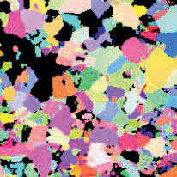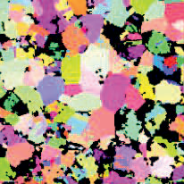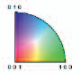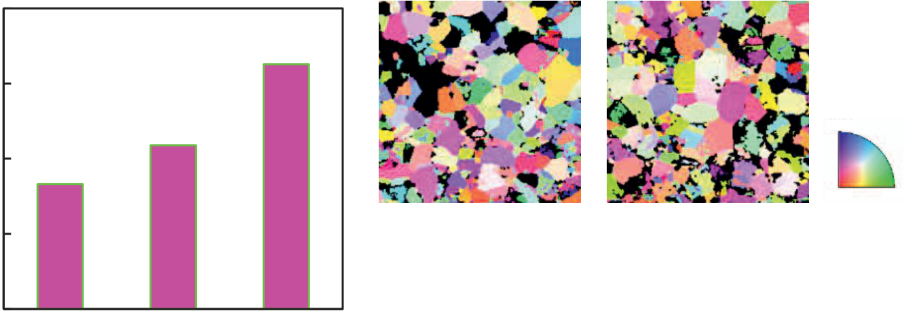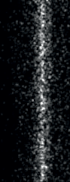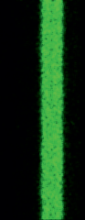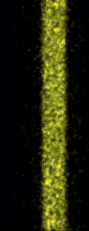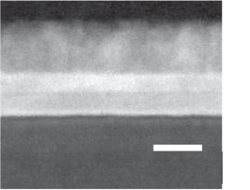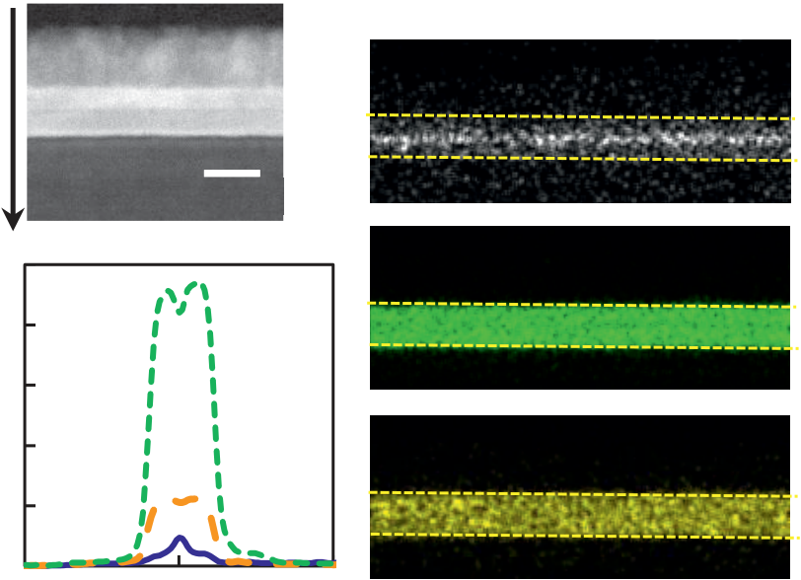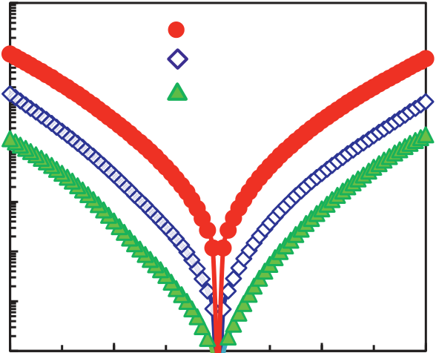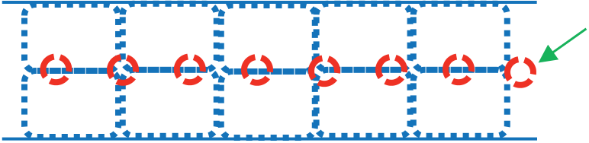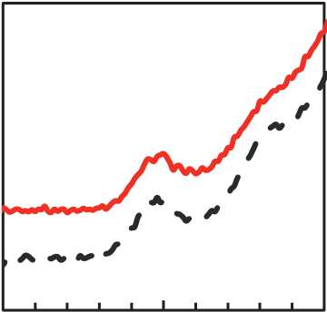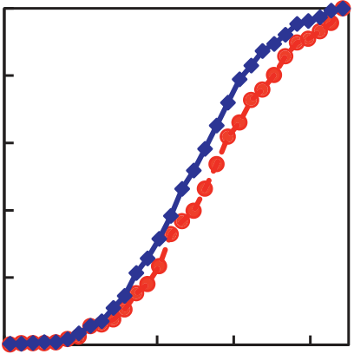

|  |  |  |  |  |  |  |  |  |  |  |  |  |  |  |  |  |
| --- | --- | --- | --- | --- | --- | --- | --- | --- | --- | --- | --- | --- | --- | --- | --- | --- |
| Ig [A/cm2] | 100 | | **without Al doping** | | | | | **without Al doping** | | | **Al: 5×1013 cm-2** | | **Al: 1×1014 cm-2** | | | 100 nm |
| 10-1 | |  | | |  | |  | | |
| **Al: 5×1013** | | | | |
| 10-2 | | **Al: 1×1014** | | | | |
| 10-3 | |
| 10-4 | |
| 10-5 | |
| 10-6 | |
| 10-7 | | | -1.0 | | 0.0 | 1.0 | | 2.0 | Fig. 14. Crystal grain maps of HZO film with and without Al nanoclusters. | | | | | | | |
| -2.0 | | | 1 | | | | | | | |
| Vg [V]   Cumulative frequency  Fig. 13 I-V characteristics of HZO film with and 0.8 **Al: 5×1013 cm-2**  (ortho-pahse HZO)   without Al nanoclusters. **without Al doping**  **Al: 5×1013 cm-2**  0.6  60  0.4  Mean grain size [nm]   50  0.2 **without**  010 **Al doping**  40 0  0 20 40 60 80  � � 001 100  30 Fig. 16. Crystal direction of orthorhombic grains in HZO Alignment against [001]  direction [deg.]  film with and without Al nanoclusters. Fig. 17. Cumulative frequency of  20 alignment angle against [001] direction in  without without 5.E+13 5×1013 1.E+14 1×1014 o-HZO grain. | | | | | | | | | | | | | | | | |
| Al dose [cm-2] | | | | | | | | | | Intensity [arb. units] | Al 2p | Al | | Intensity [arb. units] | |  |  |  |  |  |  |  |  |  |  |  |  |  |  |  |  |  |  |  |  |  | | --- | --- | --- | --- | --- | --- | --- | --- | --- | --- | --- | --- | --- | --- | --- | --- | --- | --- | --- | --- | --- | | |  |  |  | | --- | --- | --- | | Al 2s | AlxOy | Al |      |  |  |  |  |  | | --- | --- | --- | --- | --- | |  |  |  |  |  |      |  |  |  | | --- | --- | --- | |  |  |  | | | | | | | | | | | | |
| Fig. 15. Mean grain size of HZO film with and | | | | | | | | | | AlxOy |
| without Al nanoclusters. | | | | | | | | | |
| Position�(a) TEM image�  0nm� | | | | | | (b) EDS Mapping� Al� | | | | After |
| HZO� | | | | | | | | | | Before |
| Normalized Intensity | 40nm� | | 0 | 10 nm� | | 40 | Hf� | 80 75 70  Binding Energy [eV] | | | | | | 125 120 115  Binding Energy [eV] | | |
| (c) Profile� | |
| 1 | |
| **Hf**� | | Zr� | Fig. 19. XPS spectra of Al 2p and 2s for Al nanoclusters in HZO films | | | | | | | | |
| 0.8 | |
| before and after FE-HZO crystallization annealing at 600ºC for 60s. | | | | | | | | |
| [arb. units] | 0.6 |
| 0.4 0.2 | **Zr**� | |
| Amorphous HZO film� | | | | Partially  oxidized Al� | | | | |
| **Al**� | |
| 0 | |
| 20 | |
| Al nanocluster� | | | | | | | | |
| Position [nm] | |

Fig. 18. Z-contrast TEM image (a), EDS mapping of Al, Hf and

|  |  |  |  |  |  |  |  |
| --- | --- | --- | --- | --- | --- | --- | --- |
| Zr (b), and line profiles of Al, Hf and Zr (c). | FE HZO grain� | | | | | | |
| **without Al doping** � | Growth of Al nanoclusters and FE HZO grains� | | | | | | |
| Many grain boundaries due to small grains |  |  |  |  |  |  | |  | | --- | |  | |  | |
|  | Coalescence of FE HZO grains | | | | | | |

|  |  |
| --- | --- |
| Fig. 20. Schematic illustrations of feasible model about role of Al nanoclusters in HZO films | |
| IEDM18-168 | 7.5.4 |

Reduction of grain boundaries