|  |  |  |  |
| --- | --- | --- | --- |
|  | **Formation of polar phase in Fe-doped ZrO2 epitaxial thin films** | | |
|  | Cite as: Appl. Phys. Lett. **113**, 262903 (2018); <https://doi.org/10.1063/1.5063757> Submitted: 01 October 2018 . Accepted: 09 December 2018 . Published Online: 28 December 2018 | | |
|  | [S. Choi](https://aip.scitation.org/author/Choi%2C+S), [T. Shiraishi](https://aip.scitation.org/author/Shiraishi%2C+T), [T. Kiguchi](https://aip.scitation.org/author/Kiguchi%2C+T), [T. Shimizu](https://aip.scitation.org/author/Shimizu%2C+T) | , [H. Funakubo](https://aip.scitation.org/author/Funakubo%2C+H), and [T. J. Konno](https://aip.scitation.org/author/Konno%2C+T+J) | |
|  | **ARTICLES YOU MAY BE INTERESTED IN**  [Low-voltage operation and high endurance of 5-nm ferroelectric Hf0.5Zr0.5O2 capacitors](https://aip.scitation.org/doi/10.1063/1.5052012) Applied Physics Letters **113**, 182903 (2018); <https://doi.org/10.1063/1.5052012>  [Ferroelectricity mediated by ferroelastic domain switching in HfO2-based epitaxial thin films](https://aip.scitation.org/doi/10.1063/1.5055258) Applied Physics Letters **113**, 212901 (2018); <https://doi.org/10.1063/1.5055258>  [Evolution of ferroelectric HfO2 in ultrathin region down to 3nm](https://aip.scitation.org/doi/10.1063/1.5017094)  Applied Physics Letters **112**, 102902 (2018); <https://doi.org/10.1063/1.5017094> | | |
| Appl. Phys. Lett. **113**, 262903 (2018); <https://doi.org/10.1063/1.5063757> | | **113**, 262903 |
| © 2018 Author(s). | | |
|  | | | |

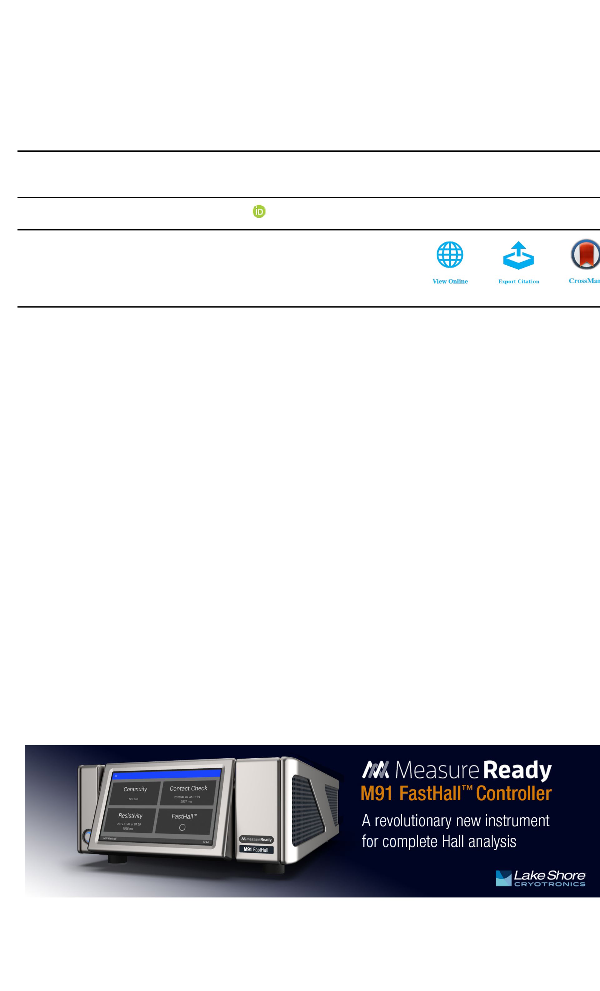

APPLIED PHYSICS LETTERS 113, 262903 (2018) 

[Formation of polar phase in Fe-doped ZrO2 epitaxial thin films](https://doi.org/10.1063/1.5063757)

S. Choi,1,a)T. Shiraishi,2T. Kiguchi,2T. Shimizu,3H. Funakubo,3and T. J. Konno2 1School of Engineering, Tohoku University, 980-8578 Sendai, Japan   
2Institute for Materials Research, Tohoku University, 2-1-1 Katahira, 980-8577 Sendai, Japan   
3School of Materials and Chemical Technology, Tokyo Institute of Technology, 226-8503 Yokohama, Japan

(Received 1 October 2018; accepted 9 December 2018; published online 28 December 2018)

The existence of a polar phase in epitaxially grown Fe-doped ZrO2 thin films has been demon-strated. The films were prepared on yttria-stabilized zirconia substrates by ion-beam sputtering and subsequent annealing, where the composition was controlled by changing the FeO1.5-ZrO2 ratio of the sputtering target. The chemical states of elements in the 30 nm-thick xFeO1.5-(1�x)ZrO2 thin films (x ¼ 0, 0.06, 0.10, and 0.14 nominal composition) have been measured by X-ray photoelec-tron spectroscopy, and the crystal structure has been examined by using X-ray diffraction and scan-ning transmission electron microscopy. These observations revealed that the undoped ZrO2 thin film (x ¼ 0) is dominated by the monoclinic phase (space group: P21/c), while the films containing Fe exhibit multi-domain structures consisting of monoclinic and orthorhombic (Pbc21) phases, the latter being a polar phase, showing that the orthorhombic phase is stabilized by the addition of Fe. Concurrently, the polarization-electric field loops of the Fe-doped films exhibited hysteresis for the film with x ¼ 0.06. Published by AIP Publishing. <https://doi.org/10.1063/1.5063757>

Stabilization of a polar phase in thin oxide films has been extensively studied to improve the electrical properties for applications.1–4Among them, hafnia (HfO2)- and zirco-nia (ZrO2)-based thin films, which are thermodynamically compatible with Si, have attracted much attention since the discovery of a polar phase in Si-doped HfO2 thin films.5 Dielectric properties of these oxide films are directly related to their crystal structures.6,7The basic phase transition scheme from a high to a low temperature is cubic (c-, a ¼ 0.507 nm), tetragonal (t-, a ¼ 0.509, c ¼ 0.518 nm), and monoclinic (m-, a ¼ 0.515, b ¼ 0.520, and c ¼ 0.532 nm, b ¼ 99.25�). The m-phase is non-polar and exhibits a simple dielectric behavior. On the other hand, the orthorhombic phase (o-, space group: Pbc21, a ¼ 0.507, b ¼ 0.526, and c ¼ 0.508 nm) is a polar phase having a noncentrosymmertric structure with the c-axis being the polarization axis, and much effort has been put forward toward the stabilization of the polar phase.5,8–11   
 Compared to the number of reports on HfO2-based thin films,5relatively little is known for systems based on ZrO2, even though conventional ZrO2 thin films have in fact been utilized in many devices.12–17It is known that these ZrO2 thin films assume m-, t-, or c-phase(s) depending on the type of dopants and the concentration.18–20On the other hand, t-to o-phase transition of bulk ZrO2 under a high pressure was studied by Kisi for Mg-doped partially stabilized zirconia (PSZ) using neutron diffraction.21,22He concluded that a coherent interface is the prerequisite for the aforementioned transformation at cryogenic temperatures under a large hydrostatic pressure.

The formation of the o-phase in ZrO2-based thin films has been reported by several researchers, but very little is known for the effects of dopants on electrical properties.23–26 Here, we demonstrate, by employing scanning transmission

electron microscopy (STEM),27that the Fe doped ZrO2 thin films consist of polar (o-) and non-polar (m-) phases, making a domain structure.

Epitaxial ZrO2 thin films have been formed on (100) yttria stabilized zirconia (YSZ) and (100) indium tin oxide (ITO)//(100) YSZ substrates (YSZ: yttria stabilized zirco-nia, ITO: indium tin oxide) by sputtering and postanneal-ing. The sputtering targets were prepared as follows. The mixture of Fe2O3 and ZrO2 powders was fabricated to a 20 mm-diameter pellet by pressing, and subsequently sin-tered at 1573 K for 4 h. In this report, the films are expressed as xFeO1.5-(1�x)ZrO2, where x is the nominal molar composition of FeO1.5 in the target. The films were deposited at room temperature by Ar-ion beam sputtering, where the base and deposition pressures were 2 � 10�4and 0.02 nm/s. The film thickness was fixed at approximately 5 � 10�3Pa, respectively, with the deposition rate being 30 nm, and the sputtered films were subsequently annealed at 1173 K for 10 min in a N2 atmosphere by rapid thermal annealing.

The chemical states of elements were examined by using X-ray photoelectron spectroscopy (XPS: AxIS-ULTRA-DLD, Al-Ka X-ray source, 1486.6 eV), where charge accu-mulation effects were corrected with aliphatic carbon as a reference at 284.6 eV. The crystal structure was investigated by using an X-ray diffractometer (XRD: Philips X’Pert MRD system, Cu-Ka1 radiation). The microstructure was observed by high-angle annular dark field-scanning transmis-sion electron microscopy (HAADF-STEM, JEM-ARM200F Cold FEG: JEOL Ltd.) operating at 200 kV, with the conver-gent semi-angle (a) and the acceptance semi-angle of the HAADF detector set to 20 and 90–175 mrad, respectively. Although this angle setting was selected for an optimum choice for Z-contrast imaging, the resultant images are also

|  |  |  |  |  |  |  |  |  |  |
| --- | --- | --- | --- | --- | --- | --- | --- | --- | --- |
| a)Author | to | whom | correspondence | should | be | addressed: | [csj3410@](mailto:csj3410@gmail.com) | subject to minor dynamical effects arising from the local | |
| [gmail.com](mailto:csj3410@gmail.com) | | | | | strain field. The obtained HAADF-STEM images were | | |
| 0003-6951/2018/113(26)/262903/5/$30.00 | | | | |
| 113, 262903-1 | | Published by AIP Publishing. |

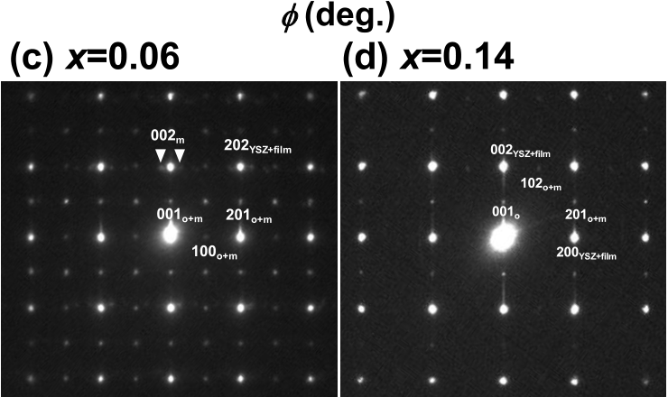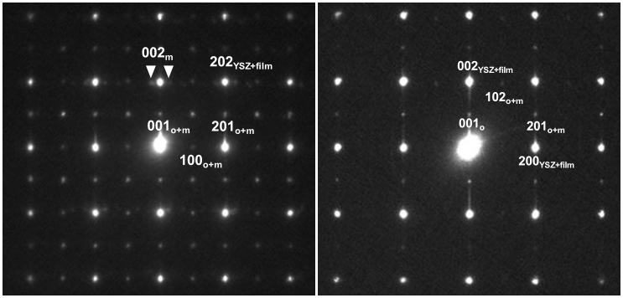

262903-2 Choi et al. Appl. Phys. Lett. 113, 262903 (2018)

deconvoluted with the probe function. Image simulation was chemical analyses indicate that doped Fe atoms exist as Fe3þ

conducted by using a multislice method (xHREMV R program: ions.

HREM Research Inc.).

For the evaluation of electrical properties, an ITO layer of 50 nm thickness was fabricated as a bottom electrode by a pulsed lased deposition method,28and subsequently a Pt top electrode of 50 nm thickness was deposited on the fabricated thin film by Ar-ion beam sputtering. The polarization-electric field (P-E) hysteresis loop was measured using a fer-roelectric tester (Toyo FCE: Toyo Technica Co., Ltd.).

Figures 1(a)–1(c) show the XPS spectra of Fe 2p, Zr 3d, and O 1s orbitals, respectively, taken for the 0.06FeO1.5-0.94ZrO2 thin film. The signal due to Fe 2p was deconvoluted to two peaks and assigned to Fe3þ(710.7eV) and the satellite of Fe3þ(719.2eV).29,30The Zr 3d profile was deconvoluted and assigned to Zr4þ(181.6 and 184.0eV).31,32The O 1s spec-trum was fitted with two peaks, i.e., the peaks arising from oxy-gen ions in the film (O2�, 529.3 eV) and chemisorbed surface oxygen such as the hydroxyl group (-OH, 531.4eV).33–35These

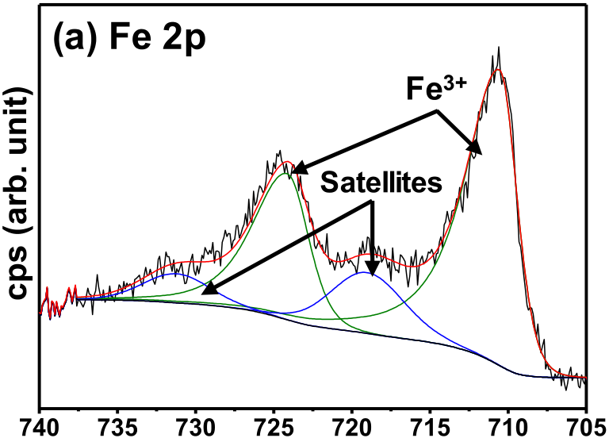

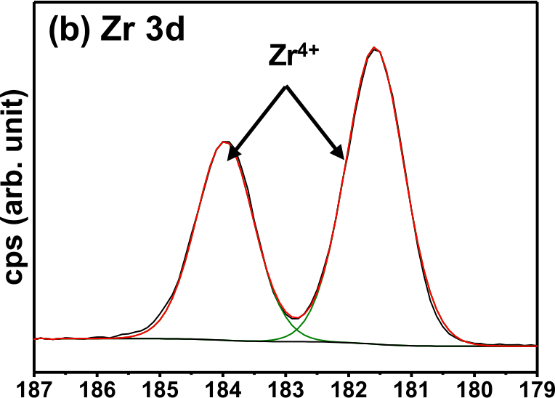

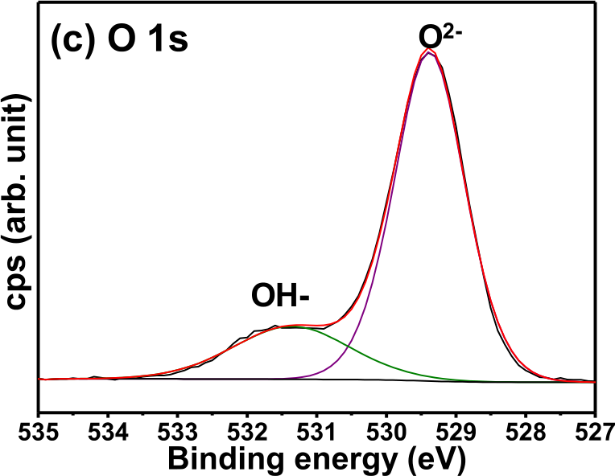

FIG. 1. XPS spectra of the 0.06FeO1.5-0.94ZrO2 thin film in the vicinity of (a) Fe 2p, (b) Zr 3d, and (c) O 1s peak positions. The peaks are deconvoluted and fitted to Fe3þ, Zr4þ, and O2�(and -OH) profiles.

Figure 2(a) shows XRD 2h-x patterns of the (100) YSZ substrate and the xFeO1.5-(1�x)ZrO2 thin films. The unit cell parameter of YSZ deduced from the XRD pattern was a ¼ 0.516 nm. The pattern of the undoped ZrO2 thin film (x ¼ 0) is essentially the same as that of the substrate. On the other hand, the patterns of doped-ZrO2 thin films (x ¼ 0.06, 0.10, and 0.14) exhibit extra diffraction peaks at around 35.2�and 74.6�. These peaks correspond to 200o/002o/200m and 400o/004o/400m positions, which have close d-spacings. Figure 2(b) shows the result of the /-scan, where 2h-x was set to the pseudo-cubic 211 position, which is prohibited for the c-phase but allowed for both o- and m-phases, thus confirming the presence of these phases as well as the epi-taxy. Figure 2(b) shows the / scan profile for x ¼ 0.06 with 2h (¼ 43.1�) and w (¼ 65.9�) fixed at the pseudo-cubic 211 diffraction peak position, and the specimen was rotated about the (211) plane normal, /. As is seen, fourfold peaks were observed, indicating that the films are epitaxially grown on the (100) YSZ substrates. Figures 2(c) and 2(d) show the selected area diffraction (SAD) pattern for x ¼ 0.06 and 0.14, respectively. As is seen, diffraction spots (super-spots) aris-ing from o- and/or m-phases indeed exist.

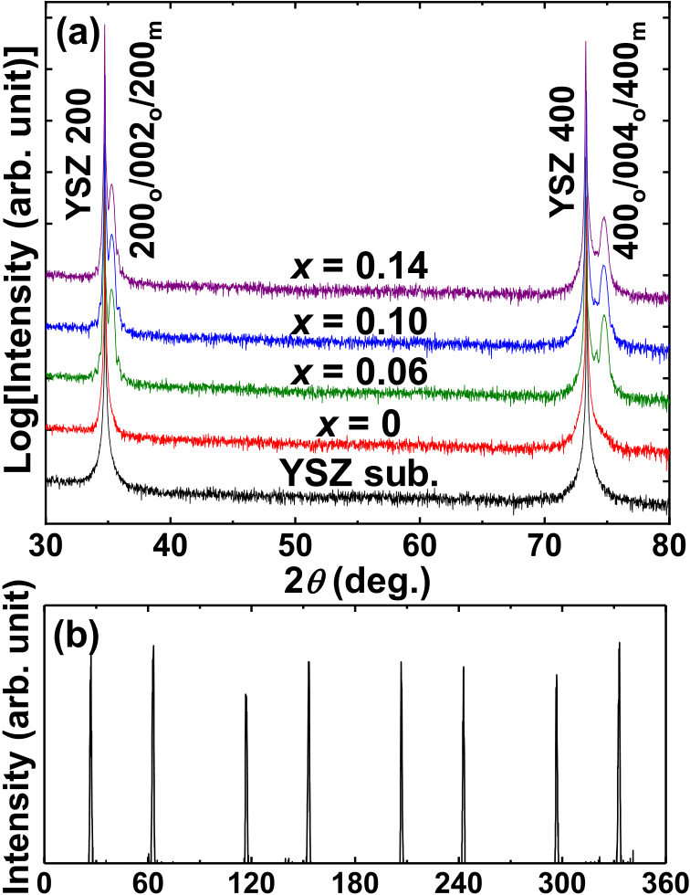

FIG. 2. (a) XRD 2h-x patterns for the YSZ substrate, the ZrO2 film (x ¼ 0) and Fe doped films [x denotes the nominal composition: xFeO1.5-(1�x)ZrO2]. (b) / scan measured for the pseudocubic 211 diffraction peak for the 0.06FeO1.5-0.94ZrO2 thin film. (c) and (d) SAD patterns observed along the [010] axis for x ¼ 0.06 and 0.14, respectively.

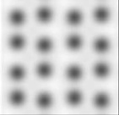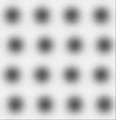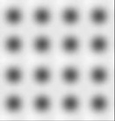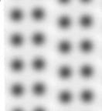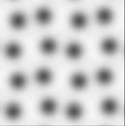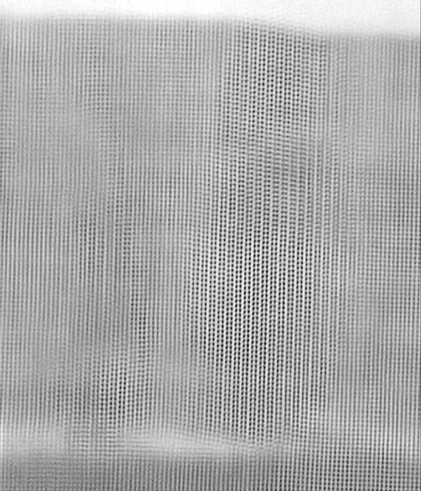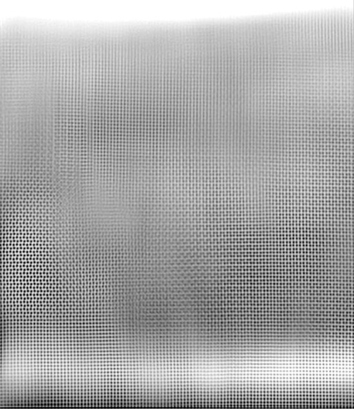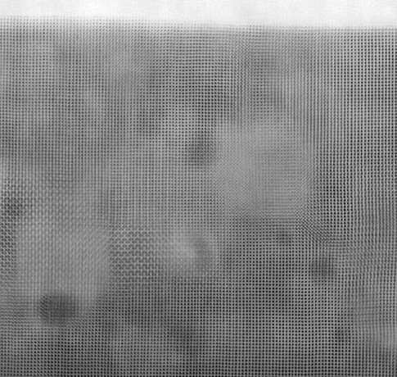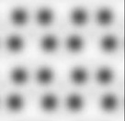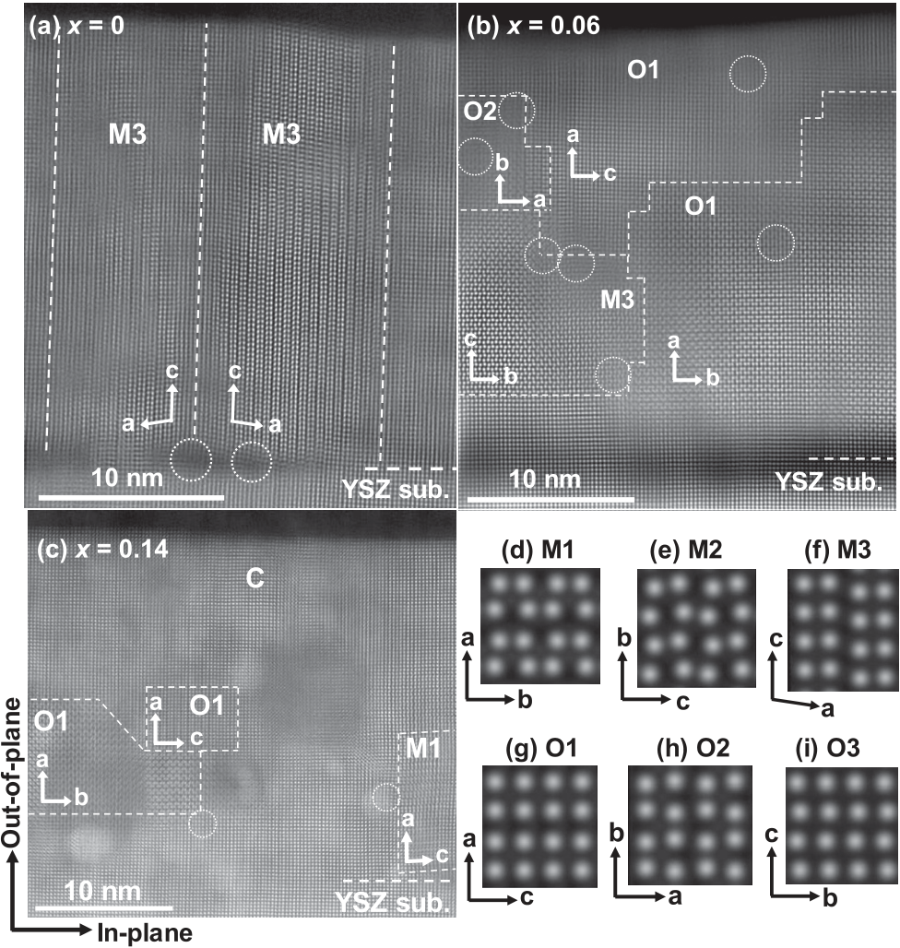

|  |  |  |
| --- | --- | --- |
| 262903-3 | Choi et al. | Appl. Phys. Lett. 113, 262903 (2018) |

To further confirm the existence of the o-phase, diffrac-  
tion intensity around the 211 peak position (2h ¼ 43.1�, w   
¼ 65.3�, and / ¼ 116.5�) was measured, by changing x and   
w angles, i.e., by rocking the specimen in all angles at each   
2h. The resultant intensity, integrated over x and w, is shown   
as a function of 2h in Fig. 3(a). As is seen, the pattern from   
the undoped ZrO2 thin film shows no 211 peak, while con-  
siderable diffraction intensities exist for the Fe-doped ZrO2   
thin films, suggesting that the o-phase is indeed formed.   
Figure 3(b) shows final integrated intensities, as a function   
of composition, showing that the intensity of the peak   
increases, as the Fe content in the film increases, with the   
maximum observed for x ¼ 0.06. These observations hence   
demonstrate that the doping of Fe to ZrO2 thin films can sta-  
bilize the o-phase.

Figures 4(a)–4(c) show the cross-sectional HAADF-  
STEM images of undoped-ZrO2 (x ¼ 0) and x ¼ 0.06 and 0.14 thin films, respectively, deposited on the (100) YSZ   
substrates. The bright spots indicate heavy atoms, i.e., cati-  
ons. As is seen, the films are composed of regions having dif-  
ferent crystallographic orientations, or domains. In this   
report, we designate these domains according to the phase

and the axes normal to the substrate surface. For example, M1 is the domain of the m-phase having the a-axis in the normal direction. (Each domain further possesses two var-iants depending on the orientation of other two axes.) Figures 4(d)–4(f) are examples of simulated HAADF-STEM images of the m-phase (P21/c, No. 14), while Figs. 4(g)–(i)

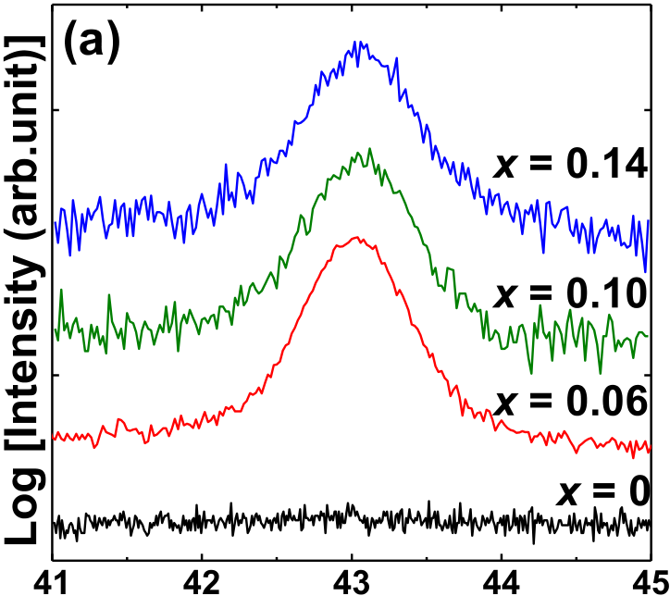

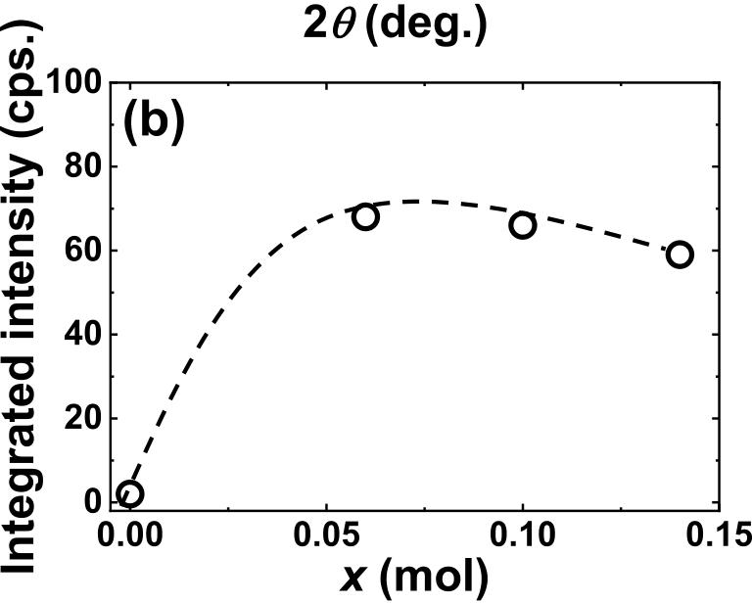

FIG. 3. (a) XRD intensity profiles, for xFeO1.5-(1�x)ZrO2 thin films inte-grated over x- and v-angles, and plotted as a function of 2h. (b) Overall inte-grated intensities of 211 diffraction profiles (integrated over 2h) as a function of x.

FIG. 4. (a) Cross-sectional HAADF-STEM images of the undoped ZrO2 and (b) and (c) doped ZrO2 thin films on YSZ substrates viewed along the 100 axis of the substrate, x ¼ 0.06 and 0.14, respectively. (d)–(f) Simulated HAADF-STEM images of the m-phase (P21/c) for M1, M2, and M3 domains, respectively, and (g)–(i) those for the o-phase (Pbc21). The circles indicate the presence of misfit dislocations.

are those of the o-phase (Pbc21, No. 29). Here, the choice of the a-, b-, and c-axes is consistent with the above-mentioned space group notation. It is thus clear that the m-phase exists with the c-axis in the out-of-plane direction [M3 domain, Fig. 4(a)]. We can suggest that a characteristic zigzag struc-ture observed on the film surface is caused by the presence of the M3 domains. Note that, in Fig. 4(a), misfit dislocations exist at the interface between the film and the substrate. It should also be pointed out that the M3 variants of the m-phase possess the c-axis, which is the longest axis in the unit cell, perpendicular to the (100) YSZ substrate, thereby reducing the coherent strain, although the overall dark con-trast in the vicinity of misfit dislocations suggests the pres-ence of strain fields.

misfit dislocation has been observed at the interface. Yet, the As for the doped ZrO2 thin film (x ¼ 0.06 and 0.14), no

dark contrast in its vicinity suggests the presence of coherent strain within the film, especially near the substrate. Inside the film, the m- and o-phases co-exist as indicated by the let-ters M3, O1, and O2, thereby forming a multi-domain struc-ture. Note that the contrasts in the vicinity of boundaries of these domains are generally dark, indicating the presence of strain fields. In addition, misfit dislocations exist at the domain boundaries, as indicated by the circles. For x ¼ 0.14, it can be seen that, in addition to the m- and o-phases, the c-phase exist, especially in the upper part of the film. The exis-tence of domains is in accord with the analysis in the recipro-cal space,28while the observed domain structure and the presence of misfit dislocations at domain boundaries are qualitatively similar to the ones reported for HfO2-ZrO2 films.27

|  |  |  |
| --- | --- | --- |
| 262903-4 | Choi et al. | Appl. Phys. Lett. 113, 262903 (2018) |

Figure 5(a) shows polarization-electrical field (P-E) hys-teresis loops of xFeO1.5-(1�x)ZrO2 thin films deposited on (100) ITO//(100) YSZ substrates taken at 10 kHz. The P-E loop for the undoped ZrO2 (x ¼ 0) thin film exhibits a linear dielectric behavior originating from the m-phase. On the other hand, the 0.06FeO1.5-0.94ZrO2 thin film displays pro-nounced hysteresis, indicating the presence of a polar phase. At the same time, the loop exhibits a round shape, also indi-cating the presence of some leakage current. We thus mea-sured the change of Pr as a function of maximum electric field for x ¼ 0.06, and the result is summarized in Fig. 5(b). As is seen, Pr increases with increasing electric field, and does not saturate even at 5 MV/cm. Thus, there is some con-tribution from the leakage current. As described below, dop-ing with Fe2O3 introduces defects in the ZrO2 matrix. We consider that these defects, as well as domain boundaries, are the possible sources of the leakage.

The phase transition scheme for oxides based on a fluo-rite type structure has been discussed from the viewpoints of symmetry reduction by Huan et al.36They showed that the centro-symmetric t-phase can be grouped into two groups: one with and the other without the inversion centers (point symmetry: mmm and mm2, respectively). The m-phase (P21/ c, No. 14) belongs to the former, while the polar o-phase (Pbc21, No. 29) belongs to the latter. Thus, the induction of a polar phase is tantamount to the introduction of symmetry breaking within the local atomic arrangements of ZrO2. In this respect, doping is an effective way to bring about asym-metry within the structure, as shown in the present study and by a number of studies carried out for HfO2-based films.6,37 Our XPS measurement showed that Fe in the ZrO2 film assumes trivalent states, whose ionic radius (Fe3þ, 65 pm) is about 17% smaller than that of Zr4þ(78 pm). There are sev-eral possibilities for Fe3þto be incorporated into ZrO2. Namely, Fe3þions can substitutionally occupy Zr sites or they can go to interstitial sites, or in fact the combination of the two. Considering electrical neutrality, site relation and mass balance, the possible reactions can be summarized as follows:

Fe2O3 �! ZrO2 2Fe0 Zrþ 3OO þ V��O;

Fe2O3 �! 2ZrO2 Fe0 Zrþ Fe���iþ V0000 Zrþ 3OO þ V��O;

Fe2O3 �! 2ZrO2 2Fe���iþ 2V0000 Zrþ 3OO þ V��O;

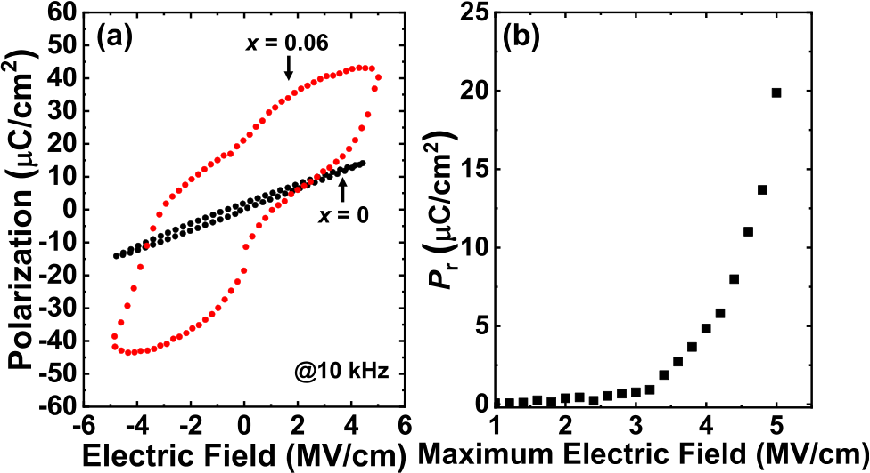

FIG. 5. (a) P-E hysteresis loops measured at 10 kHz for xFeO1.5-(1�x)ZrO2 thin films (x ¼ 0, 0.06). (b) Pr value as a function of maximum applied elec-tric field.

where we followed the Kroger-Vink notation. It can be seen that simple substitution of Zr4þby Fe3þrequires creation of an oxygen vacancy. On the other hand, in order for Fe3þto stay interstitially within ZrO2, Zr sites must become vacant, resulting in Schottky disorder, and if all the Fe3þoccupy interstitial sites, the crystal must contain Frenkel-like defects formed by cations. We may then propose that substitutional occupation of Zr sites by Fe3þions is energetically most favorable, although other possibilities cannot be excluded. In essence, these factors favor not only the breakdown of local symmetry, but also the introduction of a local strain field within the film, which needs to be accommodated. It should be mentioned here that the ionic radius of pentavalent Ta, which is reported to induce the o-phase,26is also smaller than that of Zr4þ.

In fact, a comparison of the interface between the undoped ZrO2 film and the YSZ substrate [Fig. 4(a)] with that of doped ZrO2 [Fig. 4(b)] indicates that the doping of Fe into ZrO2 removes misfit dislocation. That is, the interface between the substrate and the fabricated Fe-doped ZrO2 thin film is coherent, as opposed to the semi-coherent interface for the case of undoped ZrO2. This observation is consistent with the aforementioned contraction of the pseudo-cubic lat-tice upon doping. Yet, as evidenced by the dark contrasts in the bottom regions of the Fe-doped ZrO2 film, which arise from the dynamical effects experienced by the imaging elec-trons, there exists a strain field in the region. This finding led us to conclude that the Fe-doped ZrO2 thin films do experi-ence a global external strain field from the substrate, which also favors the formation of the o-phase.

In this study, the 0.06FeO1.5-0.94ZrO2 thin film exhib-ited a double hysteresis-like loop as shown in Fig. 5(a). There are some proposed mechanisms as to the emergence of a double hysteresis loop. One is antiferroelectricity caused by the t-phase, as reported for ZrO2 based thin films.9,38,39 However, the t-phase was not detected by HAADF-STEM [Fig. 4(b)]. The other possibility is a pinched loop by domain pinning. In order to check this possibility, we have cyclically applied electrical field and examined the response. The hys-teresis loop of the 0.06FeO1.5-0.94ZrO2 thin film did not change during field cycling (16 cycles), suggesting that the film indeed exhibits a pinched hysteresis loop. In fact, according to the previous reports, the electric field cycling (105–106cycles) has been known as one of the methods for demonstrating the domain pinning effects.40–49One cause of domain pinning is mobile defects such as oxygen vacan-cies.50–55As described above, the introduction of Fe3þinto ZrO2 led to the generation of various defects. We can there-fore put forward that the 0.06FeO1.5-0.94ZrO2 thin film exhibits the ferroelectricity arising from the polar o-phase, and the domain movement is prone to be inhibited to some degree by mobile defects, such as oxygen vacancies, doped Fe ions residing in Zr substitutional sites and/or interstitial sites. In summary, we have demonstrated that Fe doping into epitaxially grown ZrO2 thin films can stabilize the polar o-phase. HAADF-STEM showed that the Fe-doped ZrO2 thin film was character-ized by a multi-domain structure consisting of the o- and m-phases with misfit dislocations between them. The hysteresis was observed for the 0.06FeO1.5-0.94ZrO2 thin film, suggesting

|  |  |  |
| --- | --- | --- |
| 262903-5 | Choi et al. | Appl. Phys. Lett. 113, 262903 (2018) |

the existence of the polar phase. We therefore conclude that

Fe doping into ZrO2 thin films is an effective way to stabilize the polar o-phase.

This research was supported by Japan Society for the

|  |  |  |  |  |  |  |
| --- | --- | --- | --- | --- | --- | --- |
| Promotion | of | Science | (JSPS) | KAKENHI | Grant | Nos. |

17J03160, 16K18231, 16K14378, 16K14380, and 16H00882.

A part of this work was also supported by the Izumi Science

and Technology Foundation. Also, the support for XPS by K.

Ohmura in Cooperative Research and Development Center

for Advanced Materials in IMR is acknowledged.

1J. F. Scott and C. A. P. De Arauso, [Science](https://doi.org/10.1126/science.246.4936.1400) 246, 1400 (1989).

2R. Ramesh, T. Sands, V. G. Keramidas, and D. K. Fork, [Mater. Sci. Eng. B](https://doi.org/10.1016/0921-5107(94)90258-5)

22, 283 (1994).

3N. Setter, D. Damjanovic, L. Eng, G. Fox, S. Gevorgian, S. Hong, A.

Kingon, H. Kohlstedt, N. Y. Park, G. B. Stephenson, I. Stolitchnov, A. K.

Taganstev, D. V. Taylor, T. Yamada, and S. Streiffer, [J. Appl. Phys.](https://doi.org/10.1063/1.2336999) 100,

051606 (2006).

4Z. Fan, J. Chen, and J. Wang, [J. Adv. Dielectr.](https://doi.org/10.1142/S2010135X16300036) 6, 1630003 (2016).

5T. S. B€oscke, J. M€uller, D. Br€auhaus, U. Schr€oder, and U. B€ottger, [Appl.](https://doi.org/10.1063/1.3634052)

[Phys. Lett.](https://doi.org/10.1063/1.3634052) 99, 102903 (2011).

6U. Schroeder, E. Yurchuk, J. M€uller, D. Martin, T. Schenk, P. Polakowski,

C. Adelmann, M. I. Popovici, S. V. Kalinin, and T. Mikolajick, [Jpn. J.](https://doi.org/10.7567/JJAP.53.08LE02)

[Appl. Phys. Part I](https://doi.org/10.7567/JJAP.53.08LE02) 53, 08LE02 (2014).

7R. Materlik, C. K€unneth, and A. Kersch, [J. Appl. Phys.](https://doi.org/10.1063/1.4916707) 117, 134109

(2015).

8J. M€uller, U. Schr€oder, T. S. B€oscke, I. M€uller, U. B€ottger, L. Wilde, J.

Sundqvist, M. Lemberger, P. K€ucher, T. Mikolajick, and L. Frey, [J. Appl.](https://doi.org/10.1063/1.3667205)

[Phys.](https://doi.org/10.1063/1.3667205) 110, 114113 (2011).

9J. M€uller, T. S. B€oscke, U. Schr€oder, S. Mueller, D. Br€auhaus, U. B€ottger,

L. Frey, and T. Mikolajick, [Nano Lett.](https://doi.org/10.1021/nl302049k) 12, 4318 (2012).

10L. Xu, S. Shibayama, K. Izukashi, T. Nishimura, T. Yajima, S. Migita, and

A. Toriumi, IEEE Int. Electron Devices Meet. 16, 608 (2016).

11B. T. Lin, Y. W. Lu, J. Shieh, and M. J. Chen, [J. Eur. Ceram. Soc.](https://doi.org/10.1016/j.jeurceramsoc.2016.10.028) 37,

1135 (2017).

12P. K. Srivastava, T. Quach, Y. Y. Duan, R. Donelson, S. P. Jiang, F. T.

Ciacchi, and S. P. S. Badwal, [Solid State Ionics](https://doi.org/10.1016/S0167-2738(97)00248-8) 99, 311 (1997).

13A. Navrotsky, [J. Mater. Chem.](https://doi.org/10.1039/b417143h) 15, 1883 (2005).

14S. Ardizzone and C. L. Bianchi, [Surf. Interface Anal.](https://doi.org/10.1002/1096-9918(200008)30:1<77::AID-SIA771>3.0.CO;2-O) 30, 77 (2000).

15K. T. Wan, C. B. Khouw, and M. E. Davis, [J. Catal.](https://doi.org/10.1006/jcat.1996.0030) 158, 311 (1996). 16J. Zhu and Z. G. Liu, [Appl. Phys. A](https://doi.org/10.1007/s00339-002-2025-0) 78, 741 (2004).

17A. P. Huang, P. K. Chu, H. Yan, and M. K. Zhu, [J. Vac. Sci. Technol., B](https://doi.org/10.1116/1.1885011)

23, 566 (2005).

18A. H. Heuer, V. Lanteri, S. C. Farmer, R. Chaim, R. R. Lee, B. W. Kibbel,

and R. M. Dickerson, [J. Mater. Sci.](https://doi.org/10.1007/BF00660943) 24, 124 (1989).

19R. N. Patil and E. C. Subbarao, [Acta Crystallogr., Sect. A](https://doi.org/10.1107/S0567739470001389) 26, 535 (1970). 20A. Pucci, G. Clavel, M. Willinger, D. Zitoun, and N. Pinna, [J. Phys.](https://doi.org/10.1021/jp9029375)

[Chem. C](https://doi.org/10.1021/jp9029375) 113, 12048 (2009).

21E. H. Kisi, [J. Am. Ceram. Soc.](https://doi.org/10.1111/j.1151-2916.1998.tb02402.x) 81, 741 (1998).

22E. H. Kisi and C. J. Howard, [J. Am. Ceram. Soc.](https://doi.org/10.1111/j.1151-2916.1989.tb06322.x) 72, 1757 (1989).

23Z. Fan, J. Deng, J. Wang, Z. Liu, P. Yang, J. Xiao, X. Yan, Z. Dong, J.

Wang, and J. Chen, [Appl. Phys. Lett.](https://doi.org/10.1063/1.4939660) 108, 012906 (2016).

24S. L. Weeks, A. Pal, V. K. Narasimhan, K. A. Littau, and T. Chiang, [ACS](https://doi.org/10.1021/acsami.7b00776)

[Appl. Mater. Interfaces](https://doi.org/10.1021/acsami.7b00776) 9, 13440 (2017).

25Y. W. Lu, J. Shieh, and F. Y. Tsai, [Acta Mater.](https://doi.org/10.1016/j.actamat.2016.05.029) 115, 68 (2016).

26D. Lehninger, D. Rafaja, J. Wunsche, F. Schneider, J. Von Borany, and J.

27T. Kiguchi, S. Nakamura, A. Akama, T. Shiraishi, and T. J. Konno, [J. Ceram. Soc. Jpn.](https://doi.org/10.2109/jcersj2.16073) 124, 689 (2016).

28K. Katayama, T. Shimizu, O. Sakata, T. Shiraishi, S. Nakamura, T. Kiguchi, A. Akama, T. J. Konno, H. Uchida, and H. Funakubo, [J. Appl. Phys.](https://doi.org/10.1063/1.4945029) 119, 134101 (2016).

29A. P. Grosvenor, B. A. Kobe, M. C. Biesinger, and N. S. Mcintyre, [Surf.](https://doi.org/10.1002/sia.1984)  [Interface Anal.](https://doi.org/10.1002/sia.1984) 36, 1564 (2004).

30J. Mann, Y. Doluda, C. Leonard, Y. B. Losovyj, D. G. Morgan, S. S. Bukalov, Z. Shifrina, B. D. Stein, N. Cherkasov, E. V. Rebrov, Z. D. Harms, M. Pink, E. M. Sulman, and L. Bronstein, [RSC Adv.](https://doi.org/10.1039/C6RA19471K) 6, 75166 (2016).

31C. Reitz, P. M. Leufke, H. Hahn, and T. Brezesinski, [Chem. Mater.](https://doi.org/10.1021/cm500381g) 26, 2195 (2014).

32Y. Pan, Y. Gao, D. Kong, G. Wang, J. Hou, S. Hu, H. Pan, and J. Zhu, [Langmuir](https://doi.org/10.1021/la205104q) 28, 6045 (2012).

33A. A. Ali and M. I. Zaki, [Int. J. Inorg. Mater.](https://doi.org/10.1016/S1466-6049(01)00052-6) 3, 427 (2001).

34H. Kim, J. Park, S. Lee, G. Lee, and P. Song, [Electrochem. Solid-State](https://doi.org/10.1149/1.3613935)  [Lett.](https://doi.org/10.1149/1.3613935) 14, H411 (2011).

35D. Kim, H. Kim, J. Kwon, G. Lee, J. Park, and Y. Kang, [J. Non-Cryst.](https://doi.org/10.1016/j.jnoncrysol.2012.06.009)  [Solids](https://doi.org/10.1016/j.jnoncrysol.2012.06.009) 358, 2616 (2012).

36T. D. Huan, V. Sharma, G. A. Rossetti, and R. Ramprasad, [Phys. Rev. B](https://doi.org/10.1103/PhysRevB.90.064111)  90, 064111 (2014).

37S. Starschich and U. Boettger, [J. Mater. Chem. C](https://doi.org/10.1039/C6TC04807B) 5, 333 (2017).

38S. Starschich and U. B€ottger, [J. Appl. Phys.](https://doi.org/10.1063/1.4997681) 123, 044101 (2018).

39M. Pe�sic, M. Hoffmann, C. Richter, T. Mikolajick, and U. Schroeder, [Adv. Funct. Mater.](https://doi.org/10.1002/adfm.201603182) 26, 7486 (2016).

40M. Pesic, S. Slesazeck, T. Schenk, U. Schroeder, and T. Mikolajick, [Phys.](https://doi.org/10.1002/pssa.201532379)  [Status Solidi A](https://doi.org/10.1002/pssa.201532379) 213, 270 (2016).

41M. Hoffmann, U. Schroeder, T. Schenk, T. Shimizu, H. Funakubo, O. Sakata, D. Pohl, M. Drescher, C. Adelmann, R. Materlik, A. Kersch, and T. Mikolajick, [J. Appl. Phys.](https://doi.org/10.1063/1.4927805) 118, 072006 (2015).

42A. G. Chernikova, M. G. Kozodaev, D. V. Negrov, E. V. Korostylev, M. H. Park, U. Schroeder, C. S. Hwang, and A. M. Markeev, [ACS Appl. Mater. Interfaces](https://doi.org/10.1021/acsami.7b15110) 10, 2701 (2018).

43A. Chouprik, S. Zakharchenko, M. Spiridonov, S. Zarubin, A. Chernikova, R. Kirtaev, P. Buragohain, A. Gruverman, A. Zenkevich, and D. Negrov, [ACS Appl. Mater. Interfaces.](https://doi.org/10.1021/acsami.7b17482) 10, 8818 (2018).

44A. G. Chernikova, D. S. Kuzmichev, D. V. Negrov, M. G. Kozodaev, S.

N. Polyakov, and A. M. Markeev, [Appl. Phys. Lett.](https://doi.org/10.1063/1.4953787) 108, 242905 (2016). 45A. Wei, C. Chen, L. Tang, K. Zhou, and D. Zhang, [J. Alloys Compd.](https://doi.org/10.1016/j.jallcom.2017.09.264) 731, 546 (2018).

46T. Schenk, M. Hoffmann, J. Ocker, M. Pesic, T. Mikolajick, and U. Schroeder, [ACS Appl. Mater. Interfaces](https://doi.org/10.1021/acsami.5b05773) 7, 20224 (2015).

47D. Martin, J. M€uller, T. Schenk, T. M. Arruda, A. Kumar, E. Strelcov, E. Yurchuk, S. M€uller, D. Pohl, U. Schr€oder, S. V. Kalinin, and T. Mikolajick, [Adv. Mater.](https://doi.org/10.1002/adma.201403115) 26, 8198 (2014).

48S. Starschich, T. Schenk, U. Schroeder, and U. Boettger, [Appl. Phys. Lett.](https://doi.org/10.1063/1.4983031)  110, 182905 (2017).

49K. D. Kim, M. H. Park, H. J. Kim, Y. J. Kim, T. Moon, Y. H. Lee, S. D.

Hyun, T. Gwon, and C. S. Hwang, [J. Mater. Chem. C](https://doi.org/10.1039/C6TC02003H) 4, 6864 (2016). 50S. Starschich, S. Menzel, and U. B€ottger, [Appl. Phys. Lett.](https://doi.org/10.1063/1.4940370) 108, 032903 (2016).

51D. Zhou, J. Xu, Q. Li, Y. Guan, F. Cao, X. Dong, J. M€uller, T. Schenk, and U. Schr€oder, [Appl. Phys. Lett.](https://doi.org/10.1063/1.4829064) 103, 192904 (2013).

52P. D. Lomenzo, Q. Takmeel, C. Zhou, Y. Liu, C. M. Fancher, J. L. Jones, S. Moghaddam, and T. Nishida, [Appl. Phys. Lett.](https://doi.org/10.1063/1.4893738) 105, 072906 (2014). 53G. H. Chen, Z. F. Hou, X. G. Gong, and Q. Li, [J. Appl. Phys.](https://doi.org/10.1063/1.2985908) 104, 074101 (2008).

54Q. Tan, J. Li, D. Viehland, Q. Tan, J. Li, and D. Viehland, [Appl. Phys.](https://doi.org/10.1063/1.124394)  [Lett.](https://doi.org/10.1063/1.124394) 75, 418 (1999).

55M. Dawber, J. F. Scott, and M. Dawber, [Appl. Phys. Lett.](https://doi.org/10.1063/1.125938) 76, 1060

Heitmann, [Appl. Phys. Lett.](https://doi.org/10.1063/1.4990529) 110, 262903 (2017). (2000).