|  |  |  |  |
| --- | --- | --- | --- |
|  | **Identification of the ferroelectric switching process and dopant-dependent switching properties in orthorhombic HfO2: A first principles insight** | | |
|  | Cite as: Appl. Phys. Lett. **104**, 092906 (2014); <https://doi.org/10.1063/1.4867975> Submitted: 20 December 2013 . Accepted: 21 February 2014 . Published Online: 05 March 2014 | | |
|  | [S. Clima](https://aip.scitation.org/author/Clima%2C+S), [D. J. Wouters](https://aip.scitation.org/author/Wouters%2C+D+J), [C. Adelmann](https://aip.scitation.org/author/Adelmann%2C+C), [T. Schenk](https://aip.scitation.org/author/Schenk%2C+T), [U. Schroeder](https://aip.scitation.org/author/Schroeder%2C+U), [M. Jurczak](https://aip.scitation.org/author/Jurczak%2C+M), and [G. Pourtois](https://aip.scitation.org/author/Pourtois%2C+G) | | |
|  |  |  |  |
|  | **ARTICLES YOU MAY BE INTERESTED IN**  [Ferroelectricity in hafnium oxide thin films](https://aip.scitation.org/doi/10.1063/1.3634052)  Applied Physics Letters **99**, 102903 (2011); <https://doi.org/10.1063/1.3634052>  [Stabilizing the ferroelectric phase in doped hafnium oxide](https://aip.scitation.org/doi/10.1063/1.4927805)  Journal of Applied Physics **118**, 072006 (2015); <https://doi.org/10.1063/1.4927805>  [The origin of ferroelectricity in Hf1−xZrxO2: A computational investigation and a surface energy model](https://aip.scitation.org/doi/10.1063/1.4916707)  Journal of Applied Physics **117**, 134109 (2015); <https://doi.org/10.1063/1.4916707> | | |
| Appl. Phys. Lett. **104**, 092906 (2014); <https://doi.org/10.1063/1.4867975> | **104**, 092906 | |
| © 2014 AIP Publishing LLC. | | |

APPLIED PHYSICS LETTERS 104, 092906 (2014) 

[Identification of the ferroelectric switching process and dopant-dependent](http://dx.doi.org/10.1063/1.4867975)

[switching properties in orthorhombic HfO2: A first principles insight](http://dx.doi.org/10.1063/1.4867975)

S. Clima,1D. J. Wouters,1,2C. Adelmann,1T. Schenk,3U. Schroeder,3M. Jurczak,1 and G. Pourtois1,4   
1imec, Kapeldreef 75, B-3001 Leuven, Belgium   
2Katholieke Universiteit Leuven, B-3001 Leuven, Belgium   
3NaMLab/TU Dresden, Noethnitzer Str. 64, D-01187 Dresden, Germany   
4PLASMANT, University of Antwerp, Antwerpen B-2610, Belgium

(Received 20 December 2013; accepted 21 February 2014; published online 5 March 2014)

The origin of the ferroelectric polarization switching in orthorhombic HfO2 has been investigated

by first principles calculations. The phenomenon can be regarded as being the coordinated

displacement of four O ions in the orthorhombic unit cell, which can lead to a saturated polarization as high as 53 lC/cm2. We show the correlation between the computed polarization

reversal barrier and the experimental coercive fields. V C 2014 AIP Publishing LLC.

[<http://dx.doi.org/10.1063/1.4867975>]

The recent discovery of ferroelectricity (FE) in HfO2 (and ZrO2)-based high-j materials has spurred renewed in-terest in ferroelectric memory devices. Compared to typi-cal (layered) perovskite ferroelectrics used in commercial ferroelectric random access memory (FE-RAM) such as PbZrxTi(1�x)O3 and SrBi2Ta2O9, FE high-j material films can be much thinner (<10 nm). They are also compatible with CMOS standard processing conditions and do not require to be crystallized in an oxygen ambient at high temperature. Moreover, standard TiN was used instead of the more special electrode materials as Pt, Ir(Ox), or Ru(Ox). This does not only open the door for further (DRAM-like) scaling of FE capacitor based FE-RAM but also enables the fabrication of FE field effect transistor (FE-FET) based memory, combining the performance and the established reliability of FE-RAM with a small NAND-Flash cell.1   
 However, in contrast to the classical ferroelectrics, a detailed understanding of the ferroelectric polarization rever-sal phenomenon in Hf-based films is still lacking. Also, the maximum values of the attainable polarization and of the switching fields are still unknown. We aim at filling this gap by providing more insight by using first principles calcula-tions as this information is crucial to guide further material optimization.

To understand the relationship between the atomic struc-ture and the polarization reversal mechanism occurring in FE o-HfO2, we performed density functional theory (DFT) calculations within the local density approximation (LDA) formalism with the Quantum ESPRESSO package2and ultrasoft pseudopotentials. A kinetic energy cut-off of 540 eV has been used to truncate the planewave expansion and the Brillouin zone has been sampled with an 8 � 8 � 8 grid. The polarization of bulk systems has been calculated using the Berry phase approach,3–5 integrated over 16 k-point strings, each one containing eight k-points. The computations were performed without an explicit spin–orbit coupling. Finally, the barrier height associated with the fer-roelectric distortion has been evaluated by a nudged elastic band (NEB) approach using a climbing image algorithm,6in

which a chain of ten images coupled with a spring constant of 5 eV have been minimized.

HfO2 is polymorphic and can adopt a series of crystalline phases: monoclinic (P21/c), cubic (Pa3, Fm3m), tetragonal (P42/nmc), or an orthorhombic one (Pnma, Pbca, and closely related Pbc21).7The most stable one is the monoclinic phase, followed by the orthorhombic, tetragonal, and cubic ones. However, only the orthorhombic phase (Pbc21, henceforth denoted o-HfO2) is non-centrosymmetric, from which the FE originates. Experimentally, the non-centrosymmetric o-HfO2 phase is stabilized by applying extrinsic doping and thermal cycling treatments.8,9To gain insight into the atomistic roots of the FE, we took advantage of the fact that the spontaneous macroscopic polarization at finite temperature can be eval-uated by assuming that the nuclei are frozen in their time-averaged positions using a so-called frozen nuclei approach.10Given that the nature of the exchange-correlation functional used has a non-negligible impact on the computed distribution of the interatomic distances and on the material density, we fixed the dimension of the o-HfO2 unit cell to its experimental values, i.e., 5.05, 5.24, and 5.01 A˚ along the a, b, and c crystal axes, respectively.9The nature of the exchange-correlation functional used has, however, a weak influence on the computed polarization; we observe a devia-tion of 60.01 C/m2on the computed polarization, going from the local density approximation to a generalized gradient one Perdew-Burke-Ernzerhof (PBE). On the other hands, potential energy barriers are very sensitive to the convergence of the electronic density. Small deviations in the structure are there-fore expected to have large computation errors. The antici-pated changes do not change the resulting qualitative picture.

In contrast to perovskite FE materials, where there is a clear symmetry relation driving the atomic FE distortion, there is no obvious way to predict the local atomic arrange-ments responsible for the spontaneous polarization in the FE o-HfO2 phase. Ab initio simulations are indispensable to identify the two structural minima at the origin of the FE dis-tortion. We hence proceeded as follows: starting with the accepted picture11that the four O atoms present in the unit cell have to move out of their equilibrium position, going

|  |  |  |
| --- | --- | --- |
| 0003-6951/2014/104(9)/092906/4/$30.00 | 104, 092906-1 | V C 2014 AIP Publishing LLC |

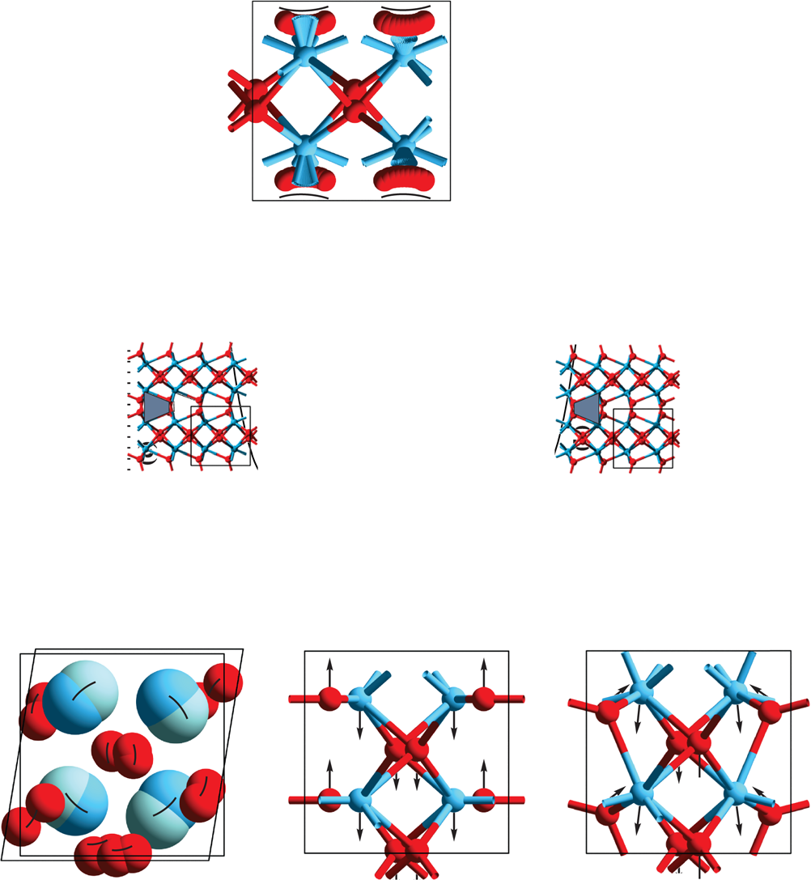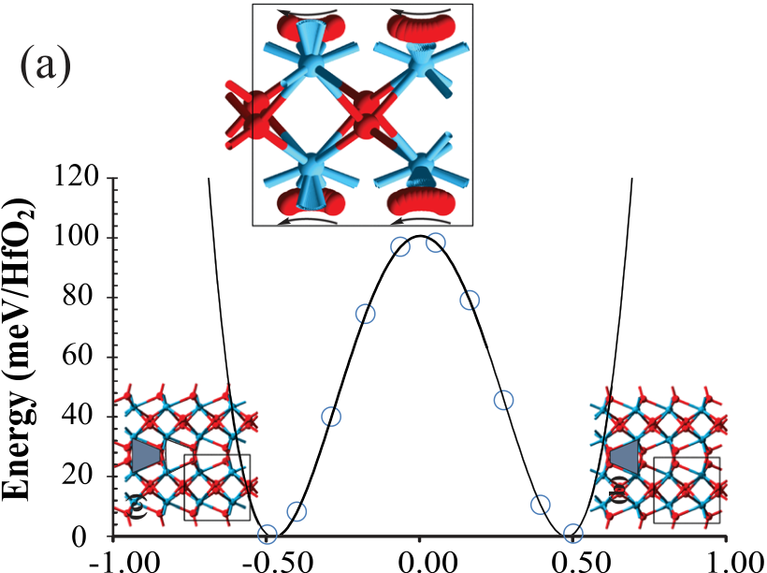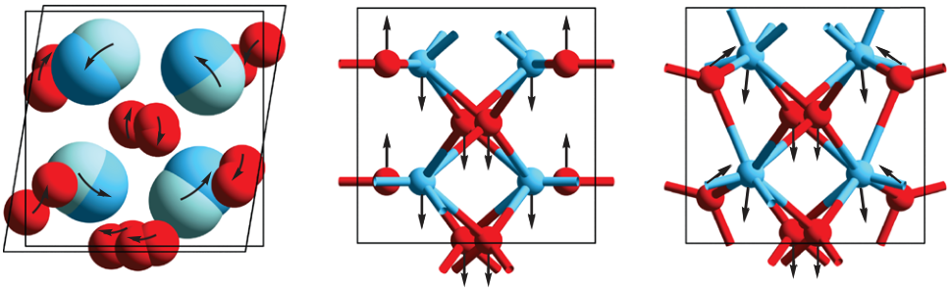

|  |  |  |
| --- | --- | --- |
| 092906-2 | Clima et al. | Appl. Phys. Lett. 104, 092906 (2014) |

soft mode at the origin of the ferroelectric distortion in   
perovskites.

The switch in ionic positions is accompanied with a   
change in total polarization of �102 lC/cm2, which corre-  
sponds to a saturation (spontaneous) polarization (Ps) of the   
o-HfO2 phase of Ps � 51 lC/cm2. The double well potential that defines the polarization reversal energy barrier (Ea) can   
be fitted well to a fourth order polynomial (consistent   
with the Landau–Ginzburg second order phase transition   
formalism12), as shown in Figure 1. It is interesting to note   
that the computed value is about twice the highest experi-  
mental one of the remanent polarization (Pr), observed for   
Y-doped HfO2 (24–25 lC/cm2).13Take note that the experi-  
mental remanent polarization is by definition smaller than   
the theoretical (saturation/spontaneous) one due to polycrys-  
tallinity and FE domains misalignment. Indeed, the X-ray   
diffraction measurements shows that the FE HfO2 films are   
randomly oriented polycrystals without any signs of tex-  
ture.13In this case, the Pr is the integrated projection of the   
polarization on the field direction over a half of the sphere   
and amounts to1=2Ps. This remarkable correspondence of the   
experimental and computed value for the polarization con-  
firms the validity of the proposed polarization reversal mech-

FIG. 1. (a) Evolution of the double well potential as a function of the polar-ization in o-HfO2, computed with (a)–(c) ¼ (5.05, 5.24, and 5.01 A˚ ) on the NEB trajectories (circles) (insets: the four O ions switch the polarization in the o-HfO2 unit cell by jumping in the same c direction over the potential barrier). The data points have been fitted with a y ¼ ax2þ bx4(line) expres-sion. The trapezoid atomic pattern active in o-HfO2 during the polarization swing is sketched on the left and right insets. (b) Monoclinic to orthorhombic atomic transition pattern to build the “centrosymmetric” structure characteris-tic to the saddle point. (c) Imaginary vibrational eigenvectors of the“centrosymmetric” unstable saddle point structure (i546 cm�1) and (d) of the soft phonon mode associated to the FE-distorted configuration (386 cm�1).

either upwards or downwards along the c axis (5.05 A˚ ) of the unit cell to induce FE, we quantified the minimum energy path needed for the process to occur using a Nudged Elastic Band approach.2The ten images of the NEB simulations are superimposed in the center inset of Figure 1(a) and illustrate the downwards and upwards movement of O ions with respect to the Hf atoms planes during the polarization rever-sal. The “centrosymmetric” crystal structure corresponding to the saddle point has its moving O atoms lying in the same plane with the Hf ones. It has a striking similarity in its atomic arrangement to a monoclinic HfO2 phase that under-went an orthogonalization of the unit cell. The monoclinic to orthorhombic atomic transformation vectors are shown in Figure 1(b). The parabolic shape of the trajectory results from the response of two strong bonds that exist with the nearest Hf atoms, forming a trapezoid atomic pattern. The change in topology on-going during the polarization reversal swing leads to a mirroring of this trapezoid pattern (see left/right insets of Figure 1(a)). In terms of vibrational eigenmodes, the imaginary signature characteristic of the“centrosymmetric” saddle point (i546 cm�1) (Figure 1(c)) is assisted by another imaginary frequency mode (i453 cm�1, not shown) in the polarization reversal process. This there-fore results in a parabolic trajectory for the O atoms. In the stable FE-distorted structure, the “soft mode” at 386 cm�1 (Figure 1(d)) resembles the “centrosymmetric” saddle imagi-nary one and is rather hard whenever compared to the typical

anism and of the used frozen-nuclei approach. It also suggests that Pr can still be improved by engineering the tex-ture of the deposited film.

The double well potential barrier height represents the energetic barrier to be crossed (Figure 1) for a coherent do-main reversal process, i.e., for the case when all the o-HfO2 unit cells change concomitantly their direction of polariza-tion. The (coercive) field (Ec) needed to reverse such an ideal-ized single domain can be order(s) of magnitude higher that the experimental one.14Based on the half depolarization field (Ed) Ec ¼1=2Ed ¼1=2Ps/(je0), the intrinsic coercive field is esti-mated to be �13.4 MV/cm, i.e., a value that lies far beyond the dielectric breakdown limit. In practice, the domain walls dynamics will reduce the coercive field to much lower values due to the grain sizes.15An additional possible source of devi-ation is the presence of a strain gradient to which the depos-ited film is subject due the processing conditions. Since the first principles investigations of the domain wall dynamics is not a viable option, we studied only the influence of the strain on the polarization reversal barrier. We illustrate the impact of 1% biaxial strain on the in-plane (polarization direction c ¼ [001]) and out-of-plane cell parameters (perpendicular to the polarization axis (110)) for both tensile and compressive strain in Figure 2. A compressive strain tends to decrease the barrier height, while a tensile one increases it with the volume of the unit cell. The distortions induced by the strain (and hence the Hf-O bonds responsible for the FE) are not paralle-l/orthogonal to the plane of the applied deformation, as it is the case in the perovskites. Therefore, the dependence is more complex, as illustrated by the permutation of the two smallest cell parameters in Figures 2(a) and 2(b) and the

|  |  |  |  |  |  |
| --- | --- | --- | --- | --- | --- |
| in-plane/out-of-plane | strain | effects | in | Figure | 2(c). |

Interestingly, this points towards the fact that it should be possible to tune the width of the hysteresis loop of the FE response using an engineered external source of stress.

Synthesizing the metastable o-HfO2 film proves not to be straight forward, requiring doping and/or stress/capping

|  |  |  |  |
| --- | --- | --- | --- |
| 092906-3 | Clima et al. |  | Appl. Phys. Lett. 104, 092906 (2014) |
|  | | FIG. 2. Evolution of the NEB barrier |
| (Ea) with cell volume for (a) (a, b, c) ¼ (5.01, 5.24, 5.05 A˚ ), (b) (a, b, c) ¼ (5.05, 5.24, 5.01 A˚ ) upon in-plane or |
|  | |  |
|  | |  |
| out-of-plane [001] 1% compressive (c) |

or tensile (t) applied strain, as com-

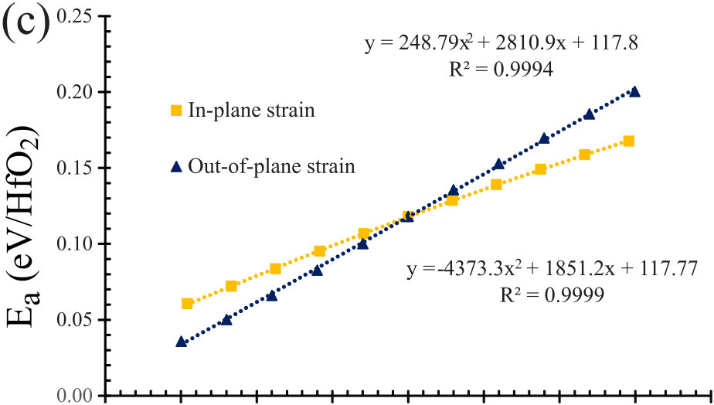

pared to the unstrained initial (ini) unit cell. (c) Ea vs in-plane and out-of-plane 63% strain for (a, b, c)¼ (5.05, 5.24, 5.01 A˚ ).





layers and special thermal cycles.11Literature reports that different extrinsic dopants can be used to stabilize the FE phase, as summarized in Table I together with their associ-ated FE dopant concentration, the resulting unit cell parame-ters, the remanent polarization, and the coercive fields.16,17 Assuming that a low doping concentration of extrinsic atoms has an uniform influence on the material (translated by varia-tions of the cell volume or its shape), we investigated these effects on the Ea, Ps for the undoped HfO2 system. For this, we used the experimental cell parameters extracted for dif-ferent dopants in HfO2 (Table I). Figure 3 shows the correla-tion obtained between the computed polarization reversal barrier height and the experimental coercive field as a func-tion of the unit cell volume and of the dopant atomic radius. The deformation induced by presence of the extrinsic dop-ants leads to a volume dependence similar to the case where the polarization direction is along the shortest unit cell pa-rameter (Figure 2(b) vs Figure 3(a)). If one compares the

evolution of the barrier height with the volume in a strained system (Figures 2(a)–2(c)) and the strain from the doped sys-tems (Figure 3(a)), one can conclude that the polarization direction is most probably in the direction of the shortest unit cell parameter. We also observe a consistent correlation of the coercive field and of the barrier height with the unit cell size and the dopant atom radius. The volume dependence can be split into three groups of elements: (Al, Si), (Y, Sr), and (Zr, Gd). Both Ea and Ec show qualitatively the same evolution within its group, i.e., an increase of the dopant ra-dius corresponds to an augmentation of both Ec and Ea (as schematically illustrated by the guiding lines in Figure 3). However, doping o-HfO2 with Zr and Gd leads to an inverted trend for Ec and Ea. We speculate that this difference is due to either some experimental uncertainties of the unit cell pa-rameters or to a different impact of the domain dynamics.

DFT simulations have allowed us identifying the mecha-nisms at the origin of the polarization reversal process in FE

TABLE I. Experimental ferroelectric dopants of HfO2 with unit cell parameters a, b, and c (A˚ ), FE dopant concentrations, measured remanent polarization and coercive fields, as reported in Refs. 13 and 16–18. The saturation polarization (Ps) and polarization reversal energy barrier (Ea) are computed on HfO2 with the dopant corresponding unit cell parameters.

|  |  |  |  |  |  |  |  |  |  |
| --- | --- | --- | --- | --- | --- | --- | --- | --- | --- |
| Dopant | a (A˚ ) | b (A˚ ) | c (A˚ ) | Unit cell volume (A˚ 3) | [Dopant] (mol. %) | Pr (C/m2) | Ec (MV/cm) | Ea (eV) | Ps (C/m2) |
| Si | 5.02 | 5.24 | 4.93 | 129.57 | 4.5–5.5 | 0.23 | 1 | 0.26 | 0.41 |
| Al | 4.99 | 5.10 | 5.02 | 127.88 | 5.0–7.0 | 0.15 | 1.3 | 0.39 | 0.48 |
| Zr | 5.05 | 5.24 | 5.01 | 132.57 | 30–50 | 0.18 | 1- | 0.50 | 0.50 |
| Y | 5.06 | 5.23 | 4.91 | 129.82 | 2.5–12 | 0.25 | 1.5 | 0.23 | 0.40 |
| Gd | 5.01 | 5.23 | 5.07 | 132.85 | 2.0–6.0 | 0.13 | 1.75 | 0.63 | 0.53 |
| Sr | 5.01 | 5.23 | 4.99 | 130.86 | 4.5–16 | 0.21 | 2 | 0.41 | 0.48 |

|  |  |  |
| --- | --- | --- |
| 092906-4 | Clima et al. | Appl. Phys. Lett. 104, 092906 (2014) |

|  |  |
| --- | --- |
|  |  |

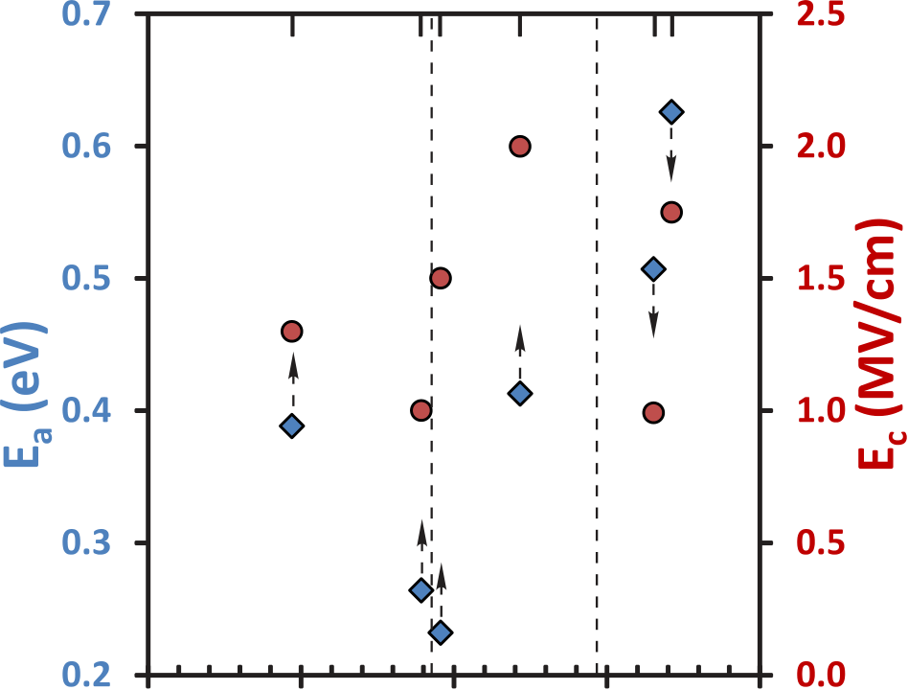

correlation between the coercive field and the polarization reversal energy barrier height with respect to the volume of the unit cell and to the radius of the doping element used to stabilize the o-HfO2 phase. The shape and the dimension of the unit cell of the crystal define the switching barrier poten-tial and the amplitude of the displacement of the oxygen sub network (i.e., the polarization). The application of a tensile strain results in an increase of the polarization reversal energy barrier.

This work was performed under the imec industrial affiliation program. The work conducted at NaMLab was financially supported by the European Fund for Regional Development and the Free State of Saxony (Heiko/Cool Memory project).

1D. Martin, E. Yurchuk, S. Muller, J. Muller, J. Paul, J. Sundquist, S. Slesazeck, T. Schlosser, R. van Bentum, M. Trentzsch, U. Schroder, and

|  |  |  |  |  |  |  |  |  |  |  |  |  |
| --- | --- | --- | --- | --- | --- | --- | --- | --- | --- | --- | --- | --- |
|  |  |  | T. Mikolajick, [Solid-State Electron.](http://dx.doi.org/10.1016/j.sse.2013.04.013) 88, 65 (2013). | | | | | | | | | |
| 2P. Giannozzi, S. Baroni, N. Bonini, M. Calandra, R. Car, C. Cavazzoni, D. | | | | | | | | | |
| Ceresoli, G. L. Chiarotti, M. Cococcioni, I. Dabo, A. Dal Corso, S. de | | | | | | | | | |
|  | Gironcoli, | S. | Fabris, | G. | Fratesi, | R. | Gebauer, | U. | Gerstmann, | C. |
| Gougoussis, A. Kokalj, M. Lazzeri, L. Martin-Samos, N. Marzari, F. | | | | | | | | | |
| Mauri, R. Mazzarello, S. Paolini, A. Pasquarello, L. Paulatto, C. Sbraccia, | | | | | | | | | |
| S. Scandolo, G. Sclauzero, A. P. Seitsonen, A. Smogunov, P. Umari, and | | | | | | | | | |

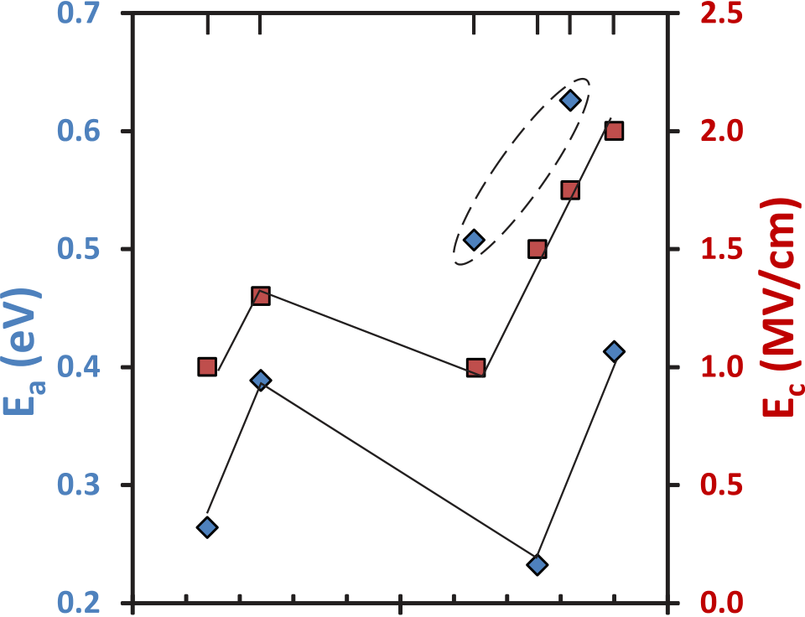



R. M. Wentzcovitch, [J. Phys.: Condens. Matter](http://dx.doi.org/10.1088/0953-8984/21/39/395502) 21, 395502 (2009).

3R. D. Kingsmith and D. Vanderbilt, [Phys. Rev. B](http://dx.doi.org/10.1103/PhysRevB.47.1651) 47, 1651 (1993).

4R. Resta, [Rev. Mod. Phys.](http://dx.doi.org/10.1103/RevModPhys.66.899) 66, 899 (1994).

5N. A. Spaldin, [J. Solid State Chem.](http://dx.doi.org/10.1016/j.jssc.2012.05.010) 195, 2 (2012).

6G. Henkelman, B. P. Uberuaga, and H. Jonsson, [J. Chem. Phys.](http://dx.doi.org/10.1063/1.1329672) 113, 9901

(2000).

7J. E. Lowther, J. K. Dewhurst, J. M. Leger, and J. Haines, [Phys. Rev. B](http://dx.doi.org/10.1103/PhysRevB.60.14485) 60,

14485 (1999).

8T. Olsen, U. Schroeder, S. Mueller, A. Krause, D. Martin, A. Singh, J.

Mueller, M. Geidel, and T. Mikolajick, [Appl. Phys. Lett.](http://dx.doi.org/10.1063/1.4747209) 101, 082905

(2012).

9J. Muller, T. S. Boscke, U. Schroder, S. Mueller, D. Brauhaus, U. Bottger,

L. Frey, and T. Mikolajick, [Nano Lett.](http://dx.doi.org/10.1021/nl302049k) 12, 4318 (2012).

10R. Resta, M. Posternak, and A. Baldereschi, [Phys. Rev. Lett.](http://dx.doi.org/10.1103/PhysRevLett.70.1010) 70, 1010

(1993).

11T. S. Boescke, J. Mueller, D. Braeuhaus, U. Schroeder, and U. Boettger,

[Appl. Phys. Lett.](http://dx.doi.org/10.1063/1.3634052) 99, 102903 (2011).

12V. M. Fridkin and S. Ducharme, [Phys. Solid State](http://dx.doi.org/10.1134/1.1386472) 43, 1320 (2001).

13J. Mueller, U. Schroeder, T. S. Boescke, I. Mueller, U. Boettger, L. Wilde,

J. Sundqvist, M. Lemberger, P. Kuecher, T. Mikolajick, and L. Frey,

[J. Appl. Phys.](http://dx.doi.org/10.1063/1.3667205) 110, 114113 (2011).

14S. P. Beckman, X. Wang, K. M. Rabe, and D. Vanderbilt, [Phys. Rev. B](http://dx.doi.org/10.1103/PhysRevB.79.144124)

 15R. Dittrich, T. Schrefl, D. Suess, W. Scholz, H. Forster, and J. Fidler, 79, 144124 (2009).

FIG. 3. Polarization reversal barrier height (unit cell Ea) and coercive field (Ec) evolution with the unit cell volume (a) and dopant atom radius (b).

o-HfO2. The phenomenon occurs through a coordinated dis-placement of four O ions in the orthorhombic unit cell. The

maximum saturation polarization computed using experi-mental cell parameters is 53 lC/cm2. There is a qualitative

[J. Magn. Magn. Mater.](http://dx.doi.org/10.1016/S0304-8853(02)00388-8) 250, 12 (2002).

16E. Yurchuk, J. Mueller, S. Knebel, J. Sundqvist, A. P. Graham, T. Melde,

U. Schroeder, and T. Mikolajick, [Thin Solid Films](http://dx.doi.org/10.1016/j.tsf.2012.11.125) 533, 88 (2013).

17T. Schenk, S. Mueller, U. Schroeder, R. Materlik, A. Kersch, M. Popovici,

C. Adelmann, S. Van Elshocht, and T. Mikolajick, in European Solid-

State Device Research Conference (Bucharest, 2013), p. 1046.

18J. Mueller, T. S. Boescke, D. Braeuhaus, U. Schroeder, U. Boettger, J.

Sundqvist, P. Kuecher, T. Mikolajick, and L. Frey, [Appl. Phys. Lett.](http://dx.doi.org/10.1063/1.3636417) 99,

112901 (2011).