First-Principles Perspective on Poling Mechanisms and Ferroelectric/ Antiferroelectric Behavior of Hf1-xZrxO2 for FEFET Applications

Sergiu Clima1*, S.R.C. McMitchell1, K. Florent1,2, L. Nyns1, M. Popovici1, N. Ronchi1, L. Di Piazza1, J. Van Houdt1,2, G. Pourtois1,3 1 imec, Kapeldreef 75, B-3001 Leuven, Belgium; 2 University of Leuven, B-3001 Leuven, Belgium;   
3PLASMANT, University of Antwerp, 2610 Antwerpen, Belgium *e-mail: sergiu.clima@imec.be

***Abstract*—** We investigate at the atomic level the most probable *phase transformations* under strain, that are *responsible for the ferroelectric/ antiferroelectric behavior in Hf1-xZrxO2* materials.

***lower the polarization barriers*** in these materials. The results show the importance of the defects, film morphology/strain control on the nm scale for designing high-performance FEFET

Four different crystalline phase transformations exhibit a polar/ devices.

non-polar transition: monoclinic-to-orthorhombic requires a

|  |  |  |  |
| --- | --- | --- | --- |
| gliding | strain | tensor, | orthorhombic-to-orthorhombic |

transformation does not need strain to polarize the material, whereas tetragonal-to-cubic cell compression and tetragonal-to-orthorhombic cell elongation destabilizes the non-polar tetragonal phase, facilitating the transition towards a polar atomic configuration, therefore changing the polarization-electric field loop from antiferroelectric to ferroelectric. *Oxygen vacancies can reduce drastically the polarization reversal barriers*.

**I.**  **INTRODUCTION**

The Ferroelectric Field Effect Transistor (FEFET) is one of intensely developed emerging memory concept [1]. The built-in spontaneous polarization of the FE insulating layer (Fig. 1 left) shifts the threshold voltage (Vt) in a positive or negative direction (hysteretic window Fig. 1 right), as a function of the polarization direction, which defines the memory window. Some FE films show during initial cycling (wakeup/ poling stage) a pinched hysteresis window (characteristic of antiferroelectric AFE materials) that opens-up to a single Polarization-Electric field (P-E) loop (characteristic of FE switching) with increased remanent polarization (Fig. 2). The origin of the poling in FE-HfZrOx is not clear. Since the typical film thicknesses are of the size of a single grain and correspond to a column of ~ 10 switching HfO2 unit cells between electrodes [2, 3], it is reasonable to investigate the process of single phase transformations from the atomic model point of view, before diving into complex domain dynamics.

The purpose of this study was to investigate the atomistic mechanisms that could be responsible for the wakeup/poling behavior in FE Hf1-xZrxO2. The polarization reversal process in FE/AFE materials is usually represented as a double/ triple-well potential energy curve (blue curves Fig. 3a-d and most of other figures presented here). Since the first derivative (dU/dP) is proportional to the electric field, the observed P-E loops will resemble the red loops in Fig. 3 (red area - the unstable region) [4]. The experimental evolution of the P-E loops is a strong indication that wakeup/poling should come from a AFE-FE phase transformation.

For the first time, we show how the evolution of the polarization reversal kinetic barriers with the applied strain, phase transformations kinetic barriers (*m* P21/c �*o* Pca21, *o* Pbca �*o* Pca21) and/or the (de)stabilization of the tetragonal atomic arrangement (P42nmc) with strain can explain the poling (AFE�FE) behavior. We discover *four different* ***phase transformations*** that ***can reproduce the AFE pinched P-E loop***. Also, we show that defects such as ***VO can significantly***

**II.TEST STRUCTURES AND METHODOLOGY**

Thin films ***down to 4nm thickness*** have been deposited and characterized in 100x100�m metal-insulator-metal (MIM) configuration between 10nm TiN electrodes for short-loop assessment of ferroelectric properties.

First-Principles simulations were carried out using Density Functional Theory in the QuantumEspresso package [5]. We combined ultrasoft pseudo-potentials with planewaves and PBE functional to compute the Nudged-Elastic Band kinetic barriers on 13 images with statically applied strain (mechanical from electrode interfaces or from piezoelectric response of the material) on the unit cell.

**III.HFXZR1-XO2FILM MORPHOLOGY**

HfxZr1-xO2 film morphology is rather rich in crystallographic phases. Lowest-energy structures for HfO2 are listed in Fig. 4a, labeled by their symmetry/energy ordering [6]. *o-I/o-III/t-I* phases do not show a low-energy transformation to a non-centrosymmetric system and most importantly, their diffraction pattern is distinctive and missing in the experimental measurements. Therefore, we will refer to the *o-II* (Pbca)/o*-IV* (FE Pca21) as *o* phase (their XRD patterns are difficult to distinguish), *t-II* (AFE P42nmc) as *t* and cubic/monoclinic as *c/m.* Strained systems can have several different atomic positions (*c/t/*FE) for the same cell shape (*c/t/o*). Thus, when discussing phase transformations, we will refer to cell shape changes under strain, but within each case, a FE↑ �FE↓ polarization reversal proceeds along A-path (Pbcm) or B-path (Fm3m or P42nmc centrosymmetric atomic arrangement, Fig.

4b)   
 By means of a XRD intensity fitting procedure (Fig. 5), we can estimate the approximate crystalline phase ratio in our films (Fig. 6). The amount of *c* phase is insignificant, only a hint of *o* phase, more *m* and predominantly *t* phase is found in the film (Fig. 6).

**IV.POLARIZATION REVERSAL PATHS**

Polarization pathways have been under scrutiny in recent years [7, 8]. Maeda et.al. identified six ferroelectric switching pathways in *o-IV* (Pca21) FE HfO2 [8], two of them have high energy barriers, the other four pass through three types of centrosymmetric structures: A-path (Pbcm) and B-path (tetragonal P42nmc and cubic Fm3m shown in Fig. 4b) during the switching of polarization. For the relaxed o-HfO2 structure, the B-path (P42nmc mechanism) is lowest in energy (Fig. 7), but is strongly influenced by the strain in the system: under in-plane compressive strain stabilizes the centrosymmetric

|  |  |  |
| --- | --- | --- |
| 978-1-7281-1987-8/18/$31.00 ©2018 IEEE | 16.5.1 | IEDM18-380 |

tetragonal structure (Fig. 13b). The A-path mechanism is the least influenced by the strain (not shown).

**V.**  **VO DEFECTS**

Defects in materials break the local symmetry, hence can dramatically change the energy landscape for the polarization reversal. Here we investigated the effect of ~ 2% oxygen vacancy on the kinetic barriers for polarization reversal following A/B-path (Fig. 8). The B-path (only P42nmc mechanismsFig. 8a-c) is energetically favored when VO is positively charged, with a 50-70% lower barrier. The A-path also shows reduced kinetic barriers with VO and charge injection (Fig. 8d-f), but the barriers are higher if compared to B-path.

**VI.PHASE TRANSFORMATION UNDER STRAIN**

Hf/Zr-O bonds in HfZrOx are very sensitive to the strain applied to the system, be that external (substrates/ interfaces) or internal (Hf:Zr ratio or other dopants). High-resolution TEM show several domains of different phases (*c*/*o*/*t*/*m*) in the same crystalline grain [2]. Here we computed the kinetic barriers for some of these phase transformations and polarization reversal barriers (where applicable) in the absence of external fields. All the described phase transformations are possible mechanisms for wakeup/poling.

*A.Monoclinic-orthorhombic (mP21/c*� *o Pca21)*

As experimentally observed, the *m*-*o* transformation can proceed with a gliding mechanism, given the right strain tensor (Fig. 9). This process requires less than 230meV/f.u., which is of the same order of magnitude with FE polarization reversal barrier (Fig. 10). The *m-o* transformation creates polarized phase, the potential energy curve resembles the triple-well AFE curve (nonpolar *m* between FE↑ and FE↓).

*B.Orthorhombic-Orthorhombic (o-II Pbca* � *o-IV Pca21 )*

The atomic configuration in the *o-I* structure was found to be incompatible with polarization of any type (FE or AFE). o-II, on the other hand, consists of two *o-IV* FE cells with the polarization anti-aligned (AFE phase). FE alignment of the two sub-cells must cross the same energy barrier as the normal FE switching, however, in this case the A-path mechanism is

*C.Tetragonal-Cubic*

A compressive strain along the C axis in the *t* phase destabilizes the centrosymmetric arrangement, leading to FE atomic arrangement (Fig. 12) [10]. In other words, a tensile strain on the tetragonal long axis leads to the stabilization of a non-polar system, but upon the strain relaxation, the FE atomic arrangement becomes more stable. The potential energy curve, corresponding to the experimentally fitted strain of the *t* phase shows two metastable local minima **(**Fig. 12brown arrows/ configurations) that are non-polar. Hence a strain relaxation process in the tetragonal P42nmc system or polarization of the nonpolar distorted *t/c* configuration can also account for the poling effect.

*D.Tetragonal-Orthorhombic*

Applying a uniaxial elongation of the tetragonal in-plane cell parameter, we can observe a strong destabilization of the P42nmc centrosymmetric atomic arrangement (Fig. 13a blue arrow) during polarization reversal along the B-path. It indicates that *t* phase under tensile in-plane strain would polarize (*t-o* transition). The Fm3m mechanism of the same strain shows reduction of the NEB barrier (Fig. 13b), whereas the A-path mechanism is not impacted (not shown). Since the deposited film show ~75% tetragonal (AFE) phase (Fig. 6), we conclude that this is the predominant mechanism for P-E loop wakeup.

The change in Hf/Zr ratio has a linear impact on the cell size (Fig. 13c), therefore an increase in Zr content in HfO2 leads to an internal strain: in our fixed-cell polarization reversal NEB simulations, the Zr content affects the barrier in the same way as the compressive strain does (Fig. 13d,a).

**VII.CONCLUSIONS**

The non-polar *m* phase under a gliding strain can transform into the FE *o-*Pca21 phase with a kinetic barrier, comparable to the A-path polarization reversal barrier. We also show that in the *o-II* (Pbca) and *t* (P42nmc) phases, the initial AFE atomic configuration can be transformed under certain strain into *o-*Pca21 FE and destabilizes the triple-well towards a double-well potential, which can explain the observed poling effect. Experimental film composition suggests the *tetragonal*�

|  |  |  |  |  |  |  |
| --- | --- | --- | --- | --- | --- | --- |
| expected to predominate over B-path ( Fig. 11a). The triple- | *orthorhombic* | phase | transformation | is | the | dominant |

well potential energy curve should experimentally exhibit P-E loops, resembling the FE ones (Fig. 3a-b) – after the first FE polarization switching under electric field, the AFE minimum will be in the unstable region, and hence is inaccessible. Spontaneous FE-AFE relaxation is prohibited by large kinetic barriers. Since it is difficult with XRD to discriminate between the two orthorhombic phases, it is reasonable to assume that both are present. The initially *o-II* (AFE) *o*-phase will transform into *o-IV* (FE) during the poling /strain relaxation stage, therefore increasing the total polarization of the film. Interestingly, an increase in size of the in-plane cell lattice of the model results in the stabilization of the FE alignment **(**Fig. 11b). We can regard the energy difference of the two phases as the lateral dipole coupling energy, which is very weak and disappears under small in-plane tensile strain.

mechanism.

Additionally, oxygen vacancies have the capability to break the symmetry and switch successively the O atoms instead of simultaneously, in some cases reducing the polarization reversal barriers by >50%. It highlights the important role of the O vacancies as domain nucleation centers, especially when positively charged.

In conclusion, strain/defect control is key to a stable FEFET operation. The described mechanisms show the possibility of an AFE pinched loop even before considering the domain-wall pinning/defect/interface/relaxation effects.

ACKNOWLEDGMENTS

This work was carried out in the framework of the imec Ferroelectric Program.

IEDM18-381 16.5.2

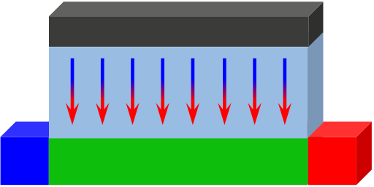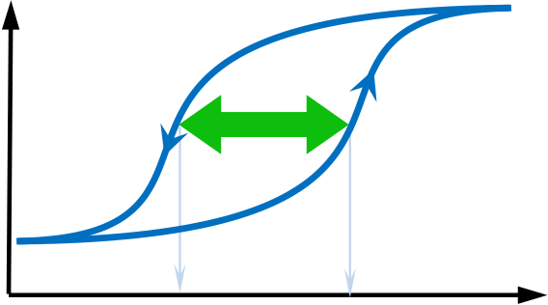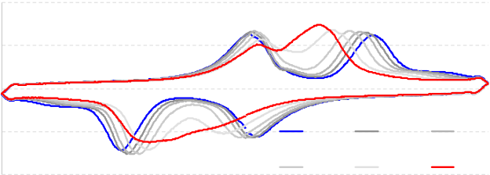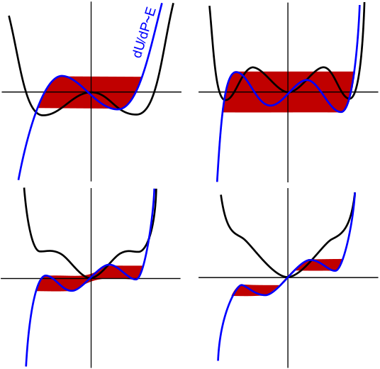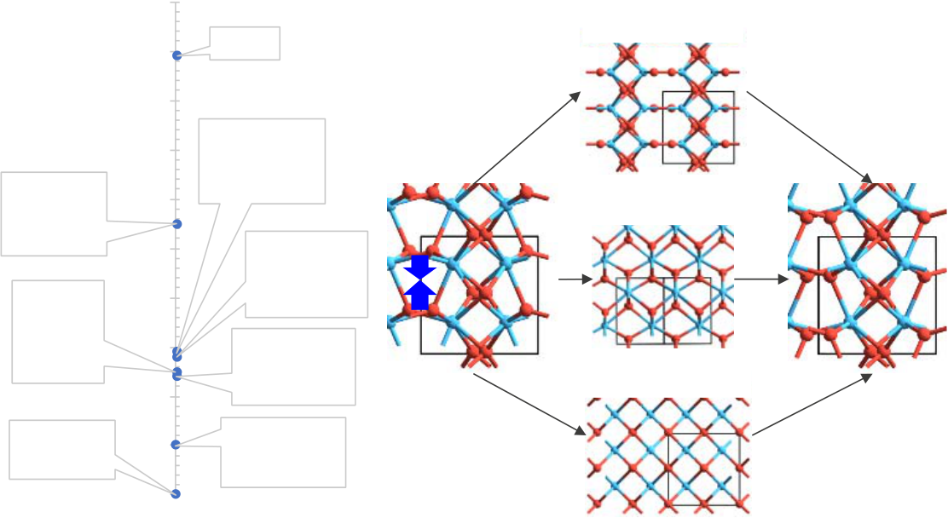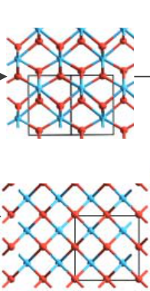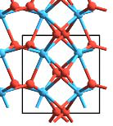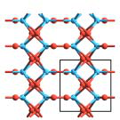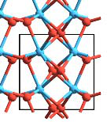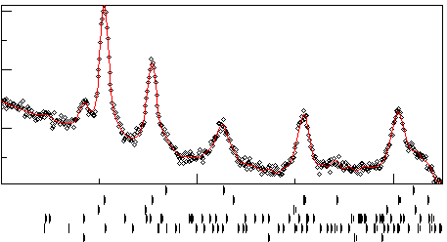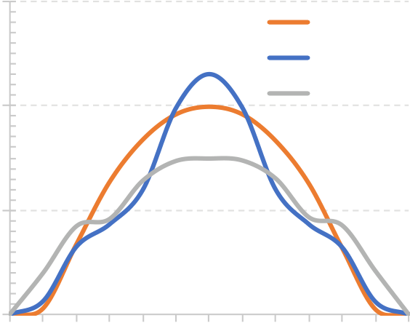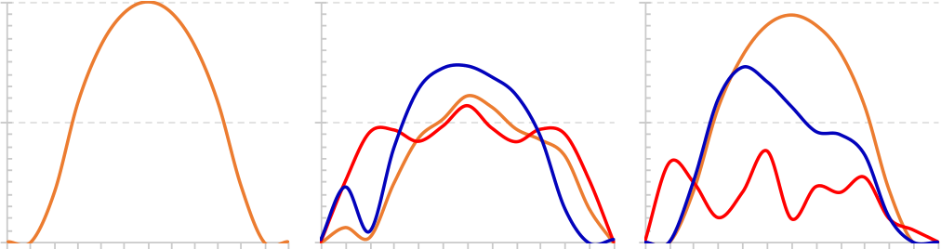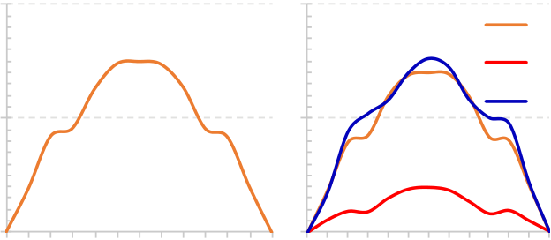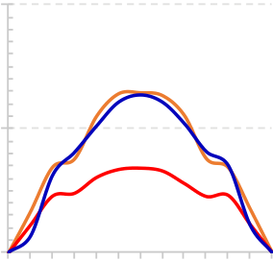

0.8

0.4

|  |  |  |  |  |
| --- | --- | --- | --- | --- |
| **FEFET** | I (mA)   0  -0.4 | 10E0 | 10E1 | 10E2 |
| -0.8 | 10E3 | 10E4 | 10E5 |

|  |  |  |  |  |  |  |  |  |  |  |  |  |  |  |
| --- | --- | --- | --- | --- | --- | --- | --- | --- | --- | --- | --- | --- | --- | --- |
| **S** | **e** | **e** | **e** | **G** | | **e** | **e** | **e** | **e** | **D** | I (A) | VtE | **MW** | VtP |
| **FE** | |
| **e** | **C** |

Fig. 1 FEFET device (left) and hysteretic memory window (MW) of the I-V characteristic (right).

|  |  |  |  |  |  |  |
| --- | --- | --- | --- | --- | --- | --- |
| P (�C/cm2) | 40 |  | | | | |
| 20 |
| 0 |
| -20 |
| -40 |
| -4 | -2 | 0  E (MV/cm) | 2 | 4 |

Fig. 2 Experimentally measured I-E (top) and extracted P-E loops (bottom) on a 5.4nm HfZrO2 film after 1-105 cycles.

|  |  |  |  |  |  |  |  |  |
| --- | --- | --- | --- | --- | --- | --- | --- | --- |
| (a) | U | (b) | U | (a) | 0.1 | cubic | (b) | A: Pbcm |
| 0.09 |

0.08

|  |  |  |  |  |  |  |  |  |  |
| --- | --- | --- | --- | --- | --- | --- | --- | --- | --- |
| P | | P | | Energy [eV/atom] | AFE | 0.07 | FE | **A** | B: P42nmc |
| orthorhombic |
| 0.06 | (o-IV) |
| tetragonal |
| (c) | U | (d) | U | (t-II) | 0.05 | orthorhombic | B: Fm3m |
| tetragonal | 0.04 | (o-III) | **B** |
| 0.03 | AFE |
| P | | P | | (t-I) |
| orthorhombic |
| 0.02 |
| (o-II) |
| Fig. 3 (a) Double-well potential energy – polarization (U- | | | | monoclinic | 0.01 | orthorhombic |
| (o-I) |
| 0 |

P) curves (black), dU/dP (blue) and unstable regions (red area, P-E loops), (b) triple-well comparable energy, (c-d) more and more stable central minimum (AFE)

Fig. 4 (a) Energy ordering of crystalline phases in HfO2. (b)Polarization reversal path in FE phase of HfZrOx can proceed through three centrosymmetric atomic arrangements: A-path: Pbcm and B-path: P42nmc, Fm3m.

|  |  |  |  |  |  |  |  |  |  |  |  |  |  |  |  |  |  |  |  |  |  |  |  |  |  |  |  |  |  |  |  |  |  |  |  |
| --- | --- | --- | --- | --- | --- | --- | --- | --- | --- | --- | --- | --- | --- | --- | --- | --- | --- | --- | --- | --- | --- | --- | --- | --- | --- | --- | --- | --- | --- | --- | --- | --- | --- | --- | --- |
| Intensity1/2 | | | | | | | | | | | | | Energy [eV/f.u.] | 0.2 | Composition [%] | | 100 | |  | | --- | | 75.1 | |  | |  | | 19.0 | | |  |  |  | | --- | --- | --- | | 5.2 | 0.7 |  | | | | | | | | | | | |
| 80 |
| 60 |
| 40 |
| |  |  |  |  |  |  | | --- | --- | --- | --- | --- | --- | | |  |  |  |  |  | | --- | --- | --- | --- | --- | | **TiN**  ***tcmo*Si** |  |  |  |  | | | | | | | | | | | | | | | 20 |
| 0 |
| 20 | | 30 40 50 60 2-� [deg] | | | | | | | | | | |
| *o* | | | | | | *m* | | | | | *c* | *t* |
| Fig. 5 XRD pattern fitting to a mixture of *t, c, m* and *o* phases. | | | | | | | | | | | | | Fig. 6 Crystalline phase composition of HfZrO2 film. | | | | | | | | | | | | |
| 0.30 | | Pbcm_PBE | | | | | | | | | | | (a) | No Defect | | 0.2 | | (b) | | VO | | 0.2 CH0 | | (c) | VOs |
| Energy [eV/f.u.] | 0.20 | Fm3m_PBE | | | | | | | | | | B-path | 0.1 | CH2 | |
| 0.1 | | | | | | | CH-2   0.1 | | | | | |
| P42nmc_PBE | | | | | | | | | |
| 0.10 | Energy [eV/f.u.] | 0 | 0 | | | | | | | | 0 | | | | |
| 0.2 | 0 1 2 3 4 5 6 7 8 9 10 11 12 0.2  Image # (d) | | | | 0 1 2 3 4 5 6 7 8 9 101112 Image #   (e) | | | | | | 0.2 | 0 1 2 3 4 5 6 7 8 9 101112 Image #   (f) | |
| 0.00 | | 0 | 1 | 2 | 3 | 4 | 5 | 6 | 7 | 8 | 9 10 11 12 | A-path | 0.1 | 0.1 | | | | 0.1 | | | | | | | | |

Image #   
Fig. 7 NEB kinetic barriers in *o*-HfO2 relaxed FE phase for A-path (Pbcm) and B-path (Fm3m and P42nmc) lowest-energy mechanisms (polarization in C direction)

|  |  |  |  |
| --- | --- | --- | --- |
| 0 | 0.0 | 0 | 0 1 2 3 4 5 6 7 8 9 10 11 12 Image # |
| 0 1 2 3 4 5 6 7 8 9 10 11 12 Image # | 0 1 2 3 4 5 6 7 8 9 10 11 12 Image # |

Fig. 8 NEB kinetic barriers for polarization reversal with 0/+/-2 charged (CH0/CH2/CH-2) systems in non-defective system (a,d), non-switching VO4 (b,e) and switching VO3 (c,f).

16.5.3 IEDM18-382

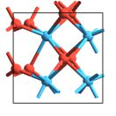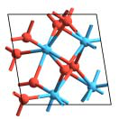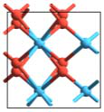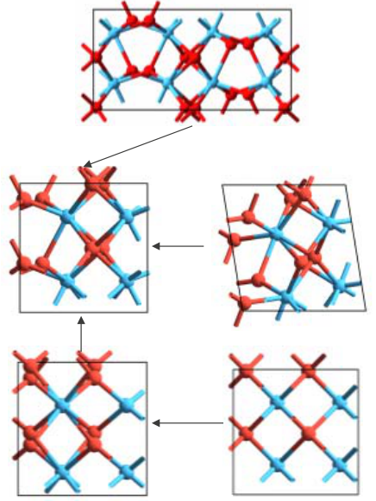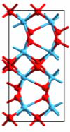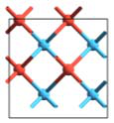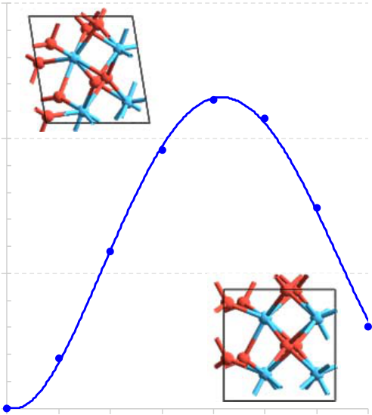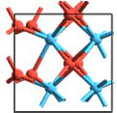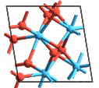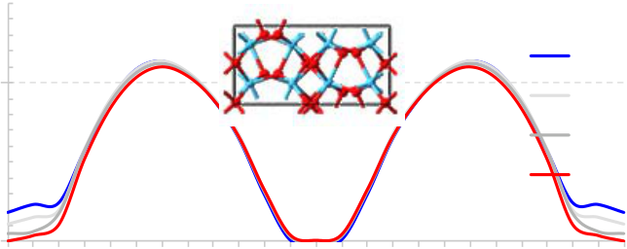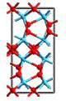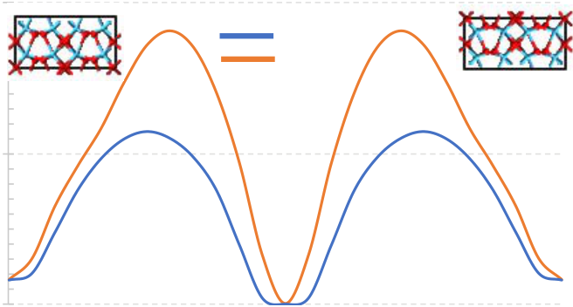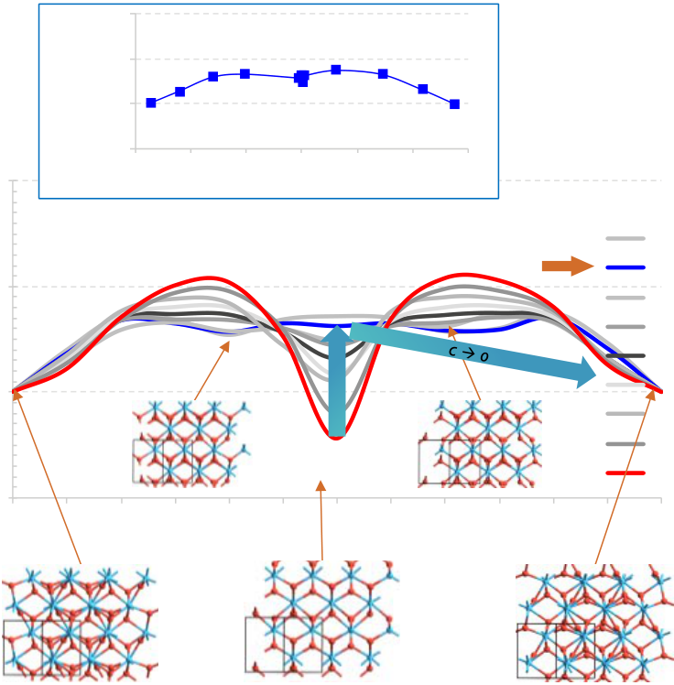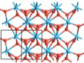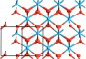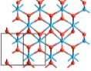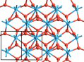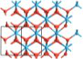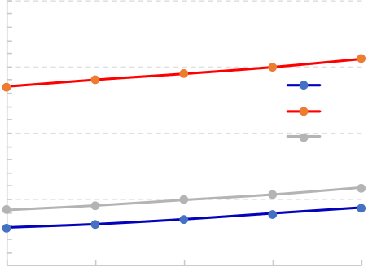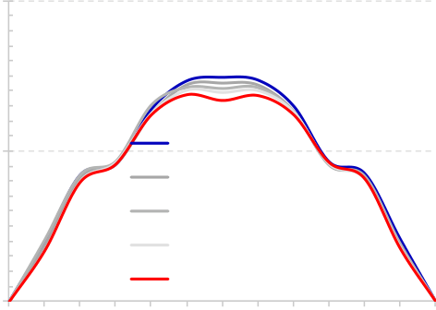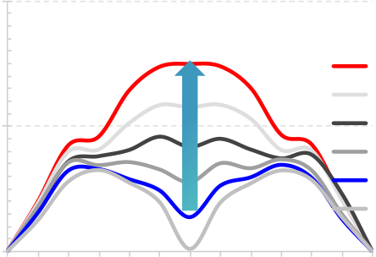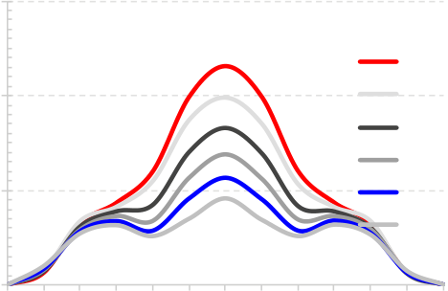

|  |  |  |  |  |  |  |  |  |  |  |  |  |  |  |  |  |  |  |  |  |  |  |  |  |  |  |  |  |  |  |  |  |  |  |  |  |  |  |  |  |  |  |  |  |  |  |  |  |  |  |  |  |  |  |  |  |  |  |  |  |
| --- | --- | --- | --- | --- | --- | --- | --- | --- | --- | --- | --- | --- | --- | --- | --- | --- | --- | --- | --- | --- | --- | --- | --- | --- | --- | --- | --- | --- | --- | --- | --- | --- | --- | --- | --- | --- | --- | --- | --- | --- | --- | --- | --- | --- | --- | --- | --- | --- | --- | --- | --- | --- | --- | --- | --- | --- | --- | --- | --- | --- |
| ***o-II*** | | | | | | | | | | | | | | | 0.3 | | | | | | | | | | | | | | | | | | | | | (a) | | | | | | 0.2 | | Pca21 | | **A-path** | | | | | | | | | Pca21 | | | | | |
| Energy [eV/f.u.] | | | | | | 0.1 | | | | **B-path** | | | | | | | | | | | | | | |
| ***o*** | | ***m*** | | | | | | | | | | | | | Energy [eV/f.u.] | | | | 0.2 | ***o*** | | | | | | | | | | | | | | | |
| (b) | | | | | | 0 | | | | Pbca | | | | | | In-Plane Strain [%] | | | | | | | | |
| 0.1 | Energy [eV/f.u.] | | | | | | 0.1 | | | |
| -0.34 | | | | | | | | |
| ***t*** | | ***c*** | | | | | | | | | | | | | 0.0 | | | | | ***m*** | | | | | | | | | | | | | | | | 0.65 | | | | | | | | |
| 1.65 | | | | | | | | |
| 2.64 | | | | | | | | |
| |  |  | | --- | --- | | 0 | 0 1 2 3 4 5 6 7 8 9 10 11 12 13 14 15 16 17 18 19 20 21 22 23 24 |   Image #  Fig. 11 NEB kinetic barriers for (a) Pbca (AFE) – Pca21 (FE) phase  transformation and (b) in-plane tensile strain stabilization of FE  phase. A-path mechanism is most probable. | | | | | | | | | | | | | | | | | | | | | | | | |
| Fig. 9 Schematics for the strain / phase | | | | | | | | | | | | | | | | | | 1 | | 2 | | 3 | | 4 | | 5 | | | 6 | | | 7 | | | 8 |
| Image # | | | | |
| transformations | | | | | | between | | | | | monoclinic | | | | | | |
| (*m*), orthorhombic (*o*), tetragonal (*t*) and | | | | | | | | | | | | | | | | Fig. 10 NEB kinetic barrier for the monoclinic- | | | | | | | | | | | | | | | | | | | |
| cubic (*c*) phases in Hf1-xZrxOx. | | | | | | | | | | | | | | | orthorhombic phase transition. | | | | | | | | | | | | | | | | | | | | |
| 0.2 | | **Energy [eV/f.u.]** | | 0.2 | | -0.6 | | -0.4 | | -0.2 | | 0 | 0.2 | | 0.4 | | 0.6 | | | Out-of-Plane | | | | | Energy [eV/f.u.] | | | 0.2 | | (a) | | | | | |
| P42nmc | | | | In-Plane | | | | | | 0.3 | (b) | | | | | Fm3m | | | X [Å] | | | | | |
| 0.1 | |
| Strain wrt *o* [%] | | | | | |
| 5.25 | | | | | |
| 0 | | 0.1 | | 0.0 | | | | | | 0.2 |
| 5.20 | | | | | |
| -1.0 | | | | | |
| -0.1 | | *t* � *o* | | | |
| 5.15 | | | | | |
| -1.9 | | | | | |
| 0.1 | 5.10 | | | | | |
| **Polarization [C/m2]** | | | | | -2.9 | | | | | |
| Strain wrt *t* [%] -4.2 | | | | | 5.05 | | | | | |
| -3.8 | | | | | |
| 5.00 | | | | | |
| -4.8 | | | | | |
| Energy [eV/f.u.] | 0.1 | 0 | 1 | | 2 | | 3 | | 4 | | *t* � *c* | | | 7 | 8 | | | | 9 | 10 | 11 | | -3.2 | | Cell dimension [A] | | | 0 | 0 | | 1 | | 2 | 3 | 4 |
| -2.3 | | 0 | | | | | | | | | | | | | | | | | | | | | | | | |
| -1.3 | | 5 | 6 | 7 | 8 | | 9 | | 10 | 11 | 12 | 0 | | 1 | 2 | 3 | 4 | 5 | 6 | 7 | 8 | 9 | 10 | 11 | 12 | |
| 0 | 5.4 | (c) | | | Image # | | | | | | | | | | 0.2 | (d) | | | | Image # | | | | | | | | | |
| -0.4 | |
| 0.6 | |
| P42nmc | | | | | | | | | |
| 1.5 | |
| -0.1 | P42nmc | | | 5.3 | a | | | | | | | | | | Energy [eV/f.u.]   0.1 | | | | | | Hf1.00Zr0.00 | | | | | | | | |
| 2.5 | |
| 3.5 | |
| b | | | | | | | | | |
| 5 6  Image # | | | 12 | | 5.2 | c | | | | | | | | | |
| 5.1 | Hf0.75Zr0.25 | | | | | | | | |
| Hf0.50Zr0.50 | | | | | | | | |
| Hf0.25Zr0.75 | | | | | | | | |
| |  |  | | --- | --- | | 0 | Hf0.00Zr1.00 | | | | | | | | | | | | | | | | | | | | | | | | | |
| 5 | | | | | | | | | | | | | | | | | | | | | | | | | | | | | | | | | | | |
| Fig. 12 NEB kinetic barriers in *t* phase for the FE↑ � FE↓ | | | | | | | | | | | | | | | | | | | | | | | | | | | 0 | | | | | 25 | | | | 50 | | | 75 | | | | | 100 | | 0 | | 1 | 2 | 3 | 4 | 5 | 6 | 7 | 8 | 9 | 10 | 11 | | 12 |
| Zr % | | | | | | | | | | Image # | | | | | | | | | | | | | | |
| polarization reversal process under compressive out-of-plane | | | | | | | | | | | | | | | | | | | | | | | | | | | | | | | | | | | |

strain on C-axis (positive for tensile) with B-path mechanism. Blue arrow: tetragonal destabilized to unstable cubic phase that polarize towards *o* phase. Top Inset: five central images have no polarization.

Fig. 13 B-path NEB kinetic barriers in *o* phase for the FE↑ � FE↓ polarization reversal process under B-axis strain (C-axis relaxed) for (a) P42nmc and (b) Fm3m mechanisms. (c) Increasing Zr % leads to a linear increase of equilibrium cell parameters and (d) slightly stabilizes tetragonal atomic arrangement (fixed cell).

REFERENCES

[1] S. Dunkel *et al.*, "A FeFET based super-low-power ultra-fast embedded NVM technology for 22nm FDSOI and beyond," (in English), *2017 Ieee*

*International Electron Devices Meeting (Iedm),* Proceedings Paper p. 4, 2017.

[2] E. D. Grimley, T. Schenk, T. Mikolajick, U. Schroeder, and J. M. LeBeau, "Atomic Structure of Domain and Interphase Boundaries in Ferroelectric

HfO2," (in English), *Advanced Materials Interfaces,* Article vol. 5, no. 5, p. 9, Mar 2018, Art. no. 1701258.

[3] H. Mulaosmanovic *et al.*, "Switching Kinetics in Nanoscale Hafnium Oxide Based Ferroelectric Field-Effect Transistors," *Acs Applied Materials &*

*Interfaces,* vol. 9, no. 4, pp. 3792-3798, Feb 2017.

[4] X. Y. Lu, H. Li, and W. W. Cao, "Landau expansion parameters for BaTiO3," (in English), *Journal of Applied Physics,* Article vol. 114, no. 22, p.

6, Dec 2013, Art. no. 224106.

[5] P. Giannozzi *et al.*, "QUANTUM ESPRESSO: a modular and open-source software project for quantum simulations of materials," (in English),

*Journal of Physics-Condensed Matter,* Review vol. 21, no. 39, p. 395502, Sep 2009.

[6] A. Jain *et al.*, "Commentary: The Materials Project: A materials genome approach to accelerating materials innovation," *Apl Materials,* vol. 1, no. 1,

Jul 2013, Art. no. 011002.

[7] T. D. Huan, V. Sharma, G. A. Rossetti, and R. Ramprasad, "Pathways towards ferroelectricity in hafnia," (in English), *Physical Review B,* Article

vol. 90, no. 6, p. 5, Aug 2014, Art. no. 064111.

[8] T. Maeda, B. Magyari-Kope, Y. Nishi, and Ieee, "Identifying Ferroelectric Switching Pathways in HfO2: First Principles Calculations Under Electric

Fields," (in English), *2017 Ieee 9th International Memory Workshop (Imw),* Proceedings Paper pp. 107-110, 2017.

[9] E. D. Grimley *et al.*, "Structural Changes Underlying Field-Cycling Phenomena in Ferroelectric HfO2 Thin Films," (in English), *Advanced Electronic*

*Materials,* Article vol. 2, no. 9, p. 7, Sep 2016, Art. no. 1600173.

[10] S. E. Reyes-Lillo, K. F. Garrity, and K. M. Rabe, "Antiferroelectricity in thin-film ZrO2 from first principles," (in English), *Physical Review B,*

Article vol. 90, no. 14, p. 5, Oct 2014, Art. no. 140103.

IEDM18-383 16.5.4