**Extraordinary tunability of high-frequency devices using Hf0.3Zr0.7O2 ferroelectric at very low applied voltages**

[Mircea Dragoman](http://aip.scitation.org/author/Dragoman%2C+Mircea), [Martino Aldrigo](http://aip.scitation.org/author/Aldrigo%2C+Martino), [Mircea Modreanu](http://aip.scitation.org/author/Modreanu%2C+Mircea), and [Daniela Dragoman](http://aip.scitation.org/author/Dragoman%2C+Daniela)

Citation: Appl. Phys. Lett.**110**, 103104 (2017); doi: 10.1063/1.4978032

View online: <http://dx.doi.org/10.1063/1.4978032>

View Table of Contents: <http://aip.scitation.org/toc/apl/110/10>

Published by the [American Institute of Physics](http://aip.scitation.org/publisher/)

**Articles you may be interested in**

Enhancing ferroelectricity in dopant-free hafnium oxide   
Appl. Phys. Lett. **110**, 022903022903 (2017); 10.1063/1.4973928

Pyroelectric response in crystalline hafnium zirconium oxide (Hf1-xZrxO2) thin films Appl. Phys. Lett. **110**, 072901072901 (2017); 10.1063/1.4976519

Tunneling electroresistance effect in a Pt/Hf0.5Zr0.5O2/Pt structure Appl. Phys. Lett. **110**, 093106093106 (2017); 10.1063/1.4977028

Enhanced strain effect of aged acceptor-doped BaTiO3 ceramics with clamping domain structures Appl. Phys. Lett. **110**, 102904102904 (2017); 10.1063/1.4977492

Ferroelectric, pyroelectric, and piezoelectric properties of a photovoltaic perovskite oxide Appl. Phys. Lett. **110**, 063903063903 (2017); 10.1063/1.4974735

Oxygen migration during resistance switching and failure of hafnium oxide memristors Appl. Phys. Lett. **110**, 103503103503 (2017); 10.1063/1.4974535



APPLIED PHYSICS LETTERS 110, 103104 (2017) 

[Extraordinary tunability of high-frequency devices using Hf0.3Zr](http://dx.doi.org/10.1063/1.4978032)0.7[O2](http://dx.doi.org/10.1063/1.4978032)

[ferroelectric at very low applied voltages](http://dx.doi.org/10.1063/1.4978032)

Mircea Dragoman,1,a)Martino Aldrigo,1Mircea Modreanu,2and Daniela Dragoman3,4 1National Institute for Research and Development in Microtechnology (IMT), P.O. Box 38-160,

023573 Bucharest, Romania   
2Tyndall National Institute, Lee Maltings Complex, Dyke Parade, Cork, Ireland   
3University Bucharest, Physics Faculty, P.O. Box MG-11, 077125 Bucharest, Romania 4Academy of Romanian Scientists, Splaiul Independentei 54, 050094 Bucharest, Romania

(Received 13 January 2017; accepted 13 February 2017; published online 7 March 2017)

This paper presents the applications of the Hf0.3Zr0.7O2 ferroelectric with a thickness of 10 nm for

tuning high-frequency devices such as filters, phase shifters, and phased antenna arrays in the X

band when the low bias voltages in the range �3 V–þ3 V are applied. In this respect, we show that a bandpass filter shifts its central frequency located at 10 GHz with 3 GHz, a phase shifter produces

a phase difference of about 60 degrees in the X band, while the antenna array formed by two

patched antennas is steering its lobe with 632�at 10 GHz. These results open the way for the tun-

ability of high frequency devices for very low power applications, which represent one of the most

challenging issues in applied physics. Published by AIP Publishing.

[<http://dx.doi.org/10.1063/1.4978032>]

The initial report on the ferroelectric behavior of doped hafnium oxide (HfO2) has used as doping material less than 4% mol. SiO2. The ferroelectric HfO2 has a 10 nm thickness, the ferroelectric phase being attributed to an orthorhombic crystalline structure.1The physical mechanisms for occur-rence of the ferroelectric phase in HfO2, as well as in ZrO2, are detailed in several papers.2,3   
 The discovery of ferroelectric HfO2 is of tremendous importance since, although ferroelectric materials are involved in many applications, only perovskite ferroelectrics such as Pb(Zr,Ti)O3 or PZT have been used up to now. In micro- or nanoelectronics, perovskite ferroelectrics are not fully compati-ble with CMOS technology and suffer from limited scalability. Therefore, ferroelectric random access memories,4ferroelec-tric transistors for low-power applications,5,6or high-mobility graphene transistors on ferroelectric substrates7show moderate developments or are in infancy. In deep contrast, HfO2 depos-ited via the atomic-layer-deposition (ALD) method is fully compatible with CMOS technologies and is commonly used as a high-k dielectric in widespread devices based on the CMOS technology, such as i-phones, laptops, computers, and TV-sets. So, ferroelectric HfO2 could enable various applications work-ing at low DC voltages.

In the case of high-frequency applications, the tunability of devices and circuits is a prerequisite for further development of radars, wireless communications, internet, and internet of things. All these high-frequency systems require a precise con-trol of the parameters of devices and circuits, which must quickly adapt to sudden changes in the communication envi-ronment. The electrical tunability of high-frequency devices implying specific materials such as ferroelectrics, polymers, and liquid crystals is a mature domain, recently reviewed in Ref. 8. In principle, all future spatial or terrestrial communica-tions will require Si-, GaAs-, or GaN-based circuits with

a)Author to whom correspondence should be addressed. Electronic mail: [mircea.dragoman@imt.ro](mailto:mircea.dragoman@imt.ro)

controllable parameters, which will integrate electrically tun-able materials working at high frequencies.

In addition, high-frequency devices based on perovskite ferroelectrics have another serious drawback, besides the integration issues with semiconductor technologies. Namely, the required DC voltage for tuning the frequency or the phase of such devices attains values of tens or even hundreds of volts, depending on the ferroelectric material.9   
 It is thus the role of this paper to show that high-frequency devices such as filters, phase shifters, and antennas can be tuned with only few volts when ferroelectric HfO2 is used. The results presented in this paper are based on two major advantages of the hafnium oxide ferroelectric, pointed out in Ref. 4: (i) HfO2 has a remanent polarization in the 1–45 lC/cm2range, depending on doping, still present up to 5 nm thickness, while in films of perovskite ferroelectrics thinner than tens of nm the remanent polarization is lost and (ii) ferroelectric HfO2 has a giant critical electric field of 1–2 MV/cm, which is one order of magnitude higher than in perovskite ferroelectrics.

Using the available data in Refs. 2 and 4 for the ferro-electric Hf0.3Zr0.7O2, we present first in the following the design and simulations of a tunable filter in the X band. The ferroelectric properties of Hf0.3Zr0.7O2 originate in the replacement of Hf atoms in HfO2 doped with Zr, which has a similar size and chemical valence to Hf.

The dielectric permittivity Hf0.3Zr0.7O2 as a function of the applied voltage, extracted from experimental data in Refs. 2 and 4, is represented in Fig. 1(a), while the T-like fil-ter configuration is displayed in Fig. 1(b).

In this filter, the capacitors are metal-insulator-metal (MIM) capacitors, consisting of 10 nm of Hf0.3Zr0.7O2 in a coplanar waveguide (CPW) configuration fabricated on high-resistivity Si, which is covered with Hf0.3Zr0.7O2. Each MIM capacitor has an area of 9.171 � 9.171 lm2, while the inductors have the following values: L1 ¼ 2 nH and L2 ¼ 0.1 nH. By changing the MIM capacitance via an applied

|  |  |  |
| --- | --- | --- |
| 0003-6951/2017/110(10)/103104/4/$30.00 | 110, 103104-1 | Published by AIP Publishing. |

|  |  |  |
| --- | --- | --- |
| 103104-2 | Dragoman et al. | Appl. Phys. Lett. 110, 103104 (2017) |

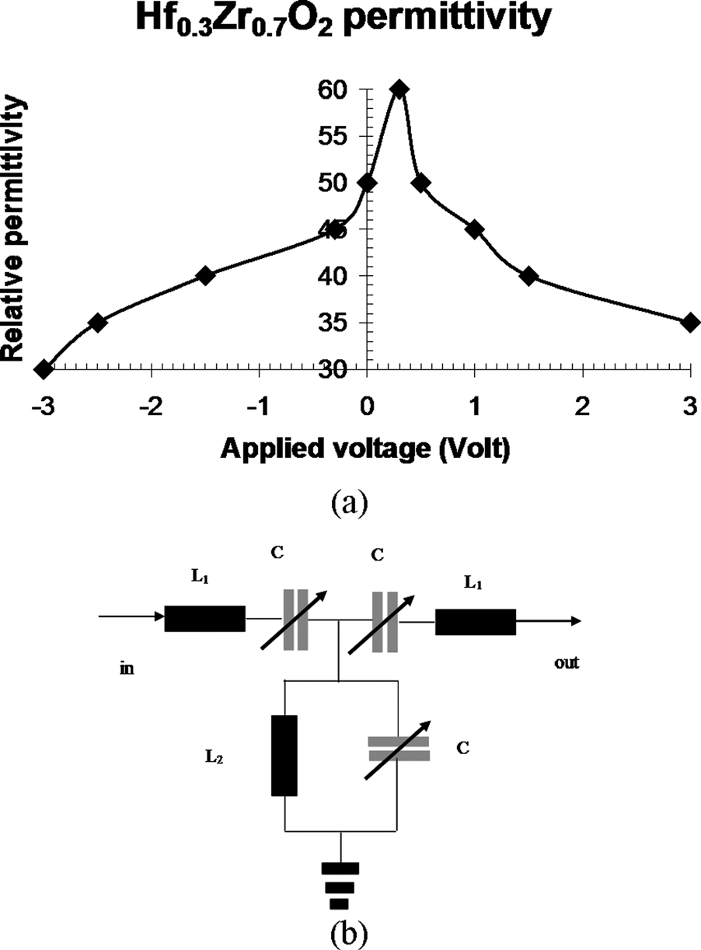

FIG. 1. (a) Dependence on the applied voltage of the dielectric permittivity of Hf0.3Zr0.7O2 and (b) the T-like filter configuration.

voltage in the range �3 V to þ3 V, the filter characteristics, i.e., the return loss (S11) and the transmission (S22), change significantly, as can be seen from Figs. 2(a) and 2(b), respec-tively. In particular, the filter is tuned from 7.83 GHz up to

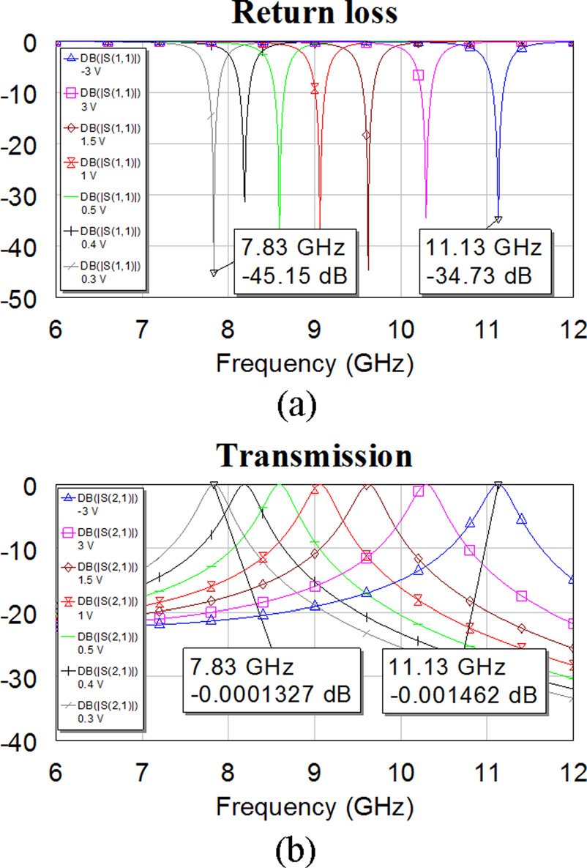

FIG. 2. (a) Frequency dependence of the return loss and (b) transmission of the filter based on Hf0.3Zr0.7O2 ferroelectric at various applied voltages.

11.13 GHz, i.e., by 3.3 GHz, as the DC voltage is tuned in the narrow range �3 V to 3 V. The filter has a bandwidth of 400 MHz and shows low losses. Low losses are expected since the measurements of the microwave behaviour of haf-nium oxide on high-resistive Si indicate in the X band tan d ¼ 0:05.10 Further, we have developed a phase shifter cell consisting of a gold interdigitated (IDT) capacitor integrated in a CPW configuration, as shown in Fig. 3(a). The CPW is composed of three gold electrodes (the yellow regions in Fig. 3(a)) with a thickness of 200 nm deposited over 10 nm Hf0.3Zr0.7O2 grown on 100 lm-thick high resistive Si. The central (signal) elec-trode of the CPW has a width of 100 lm, being separated from the ground electrodes by a gap of 50 lm. The IDT capacitor digit width is 5 lm, while the gap between two con-secutive digits is 10lm. The transition between the IDT capacitor and the CPW line is made by a taper.

The simulation results (not shown) indicate that the phase of S21 of the IDT capacitor based on the Hf0.3Zr0.7O2 ferroelectric changes with 3.55�at 10 GHz when the voltage is tuned from �3 V up to þ3 V. At the same time, the IDT capacitance changes in the range 1.714 pF up to 2.192 pF at 10 GHz showing a resonance between 11 GHz and 12 GHz. The IDT capacitance was calculated using the formula C ¼ Im Y11 These data are then used to design a phase shifter having Þ=x.

14 IDT capacitors connected in series, the distance between two consecutive capacitors being 1mm. The phase shifts of the CPW coplanar phase shifter, having a total length of 15mm, are represented in Fig. 3(b) at three voltages �3V, 0.3 V, and

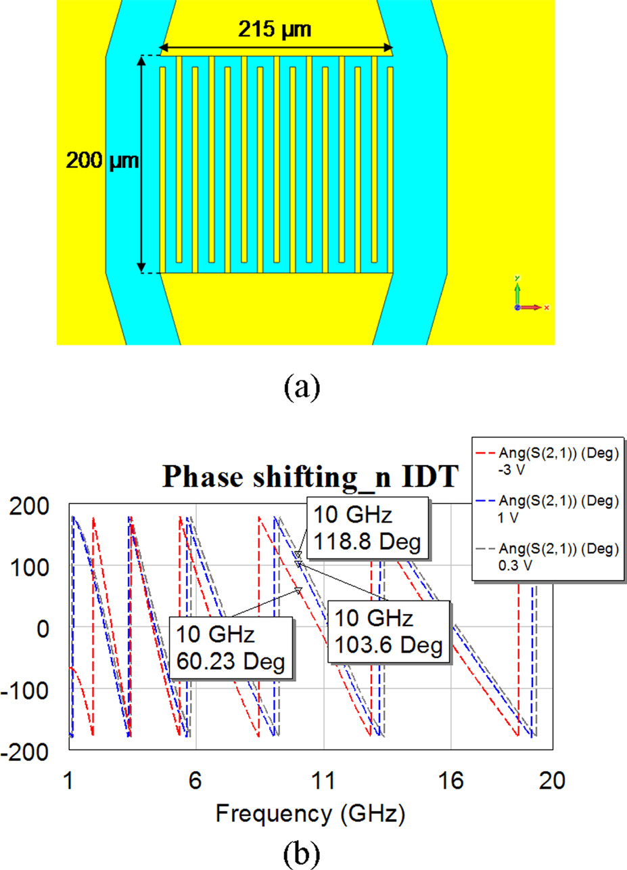

FIG. 3. (a) Phase shift cell and (b) phase shift of the CPW phase shifter formed from 14 IDT capacitors connected in series.

|  |  |  |
| --- | --- | --- |
| 103104-3 | Dragoman et al. | Appl. Phys. Lett. 110, 103104 (2017) |

1V. From these results, obtained with a CST simulator, it can be seen that the phase shift at 10 GHz between the phases at þ0.3 V and �3 V is about 58.57 degrees. In addition, from Fig. 3(b) it follows that there are certain frequencies at which a phase shift of even 360�is possible. Such a very large phase shift can be used for electronic scanning of the beam of an antenna array.

In this respect, we consider further an antenna array composed of two patch antennas on 10nm Hf0.3Zr0.7O2 ferroelectric deposited on top of 100 lm-thick high resistive Si, all dimensions being indicated in Fig. 4(a). Numerical simula-tions of this array performed using CST confirmed that the iso-lation between the two antennas at 10GHz is �44.72 dB, which is a very good value. Both antennas display jS11j ¼ jS22j ¼ �16.52dB at 10 GHz, i.e., a voltage standing If the previously studied phase shifter with 14 IDT wave ratio (VSWR) ¼ 1.352, which indicates a good matching. capacitors is introduced now between antennas 1 and 2, the phase varies continuously between 60.23�and 118.8�with a total phase shift of D/ ¼ 58.57�as the bias is swept from�3 V to þ0.3 V. As a result, the radiation pattern at 10 GHz is steered with 632�, as can be seen from Fig. 4(b). The radi-ation efficiency is 15% due to the fact that the substrate thickness, of about k0=300, is very thin compared with the corresponding wavelength at 10 GHz.

The experimental data we have used are the most accu-rate and among few available to date extracted from a MIM capacitor TiN/HfO2/TiN with the thickness of the TiN layer of 10 nm grown on Si (the conception of tunability of HfO2 ferroelectric MIM for RF applications is suggested also in Ref. 11). The choice of TiN as the electrode is justified by the fact that this n-type wide band gap semiconductor, with a resistivity of 0.4 X cm and bandgap of 3.4 eV, induces a mechanical stress in HfO2 preserving its ferroelectric state and suppressing the phase transition to the paraelectric phase. The workfunction of TiN is 4.6 eV, which is close to the corresponding value (4.7 eV) in polycrystalline Au in ambient conditions. Since the thickness of Au is twenty times larger than that of TiN and the free-space wavelength involved in this paper is of order of few cm, the TiN capping layer plays practically no role in the electromagnetic simula-tion. In addition, it was already shown that12the electrical and physical characteristics of TiN/HfO2/TiN and Si/HfO2/ TiN capacitors are very similar, which suggests that the dielectric values obtained from Refs. 2 and 4 can be used for simulating HfO2-based ferroelectric compounds on Si. This result is strengthened by another study (Ref. 13 and the refer-ences therein), which shows that Si has a similar role to TiN, namely, it prevents HfO2 to switch from the ferroelectric to the paraelectric phase due to thermal expansion mismatch

|  |  |
| --- | --- |
|  | FIG. 4. (a) Array consisting of two patch antennas and (b) beam steering of the antenna array as a function of the applied voltage. |

|  |  |  |
| --- | --- | --- |
| 103104-4 | Dragoman et al. | Appl. Phys. Lett. 110, 103104 (2017) |

between Si and HfO2, which produces a mechanical stress in the latter material.

In conclusion, the Hf0.3Zr0.7O2 ferroelectric is able to tune significantly high-frequency devices such as filters, phase shifters, and antenna arrays. If the applied voltage is swept in the range �3 V to 3 V at 10 GHz, the filter changes its central frequency with 3 GHz, the phase shifter produce a phase difference of about 60 degrees, while the antenna array is steering its lobe with 632�. Since a lot of space and terres-trial communications have the frequency bandwidth in the X band, the above results show that low-power devices with a high degree of tunability can be used to enhance the capabili-ties of important communication systems.

1T. S. B€oscke, J. M€uller, D. Br€auhaus, U. Schr€oder, and U. B€ottger,“Ferroelectricity in hafnium oxide thin films,” [Appl. Phys. Lett.](http://dx.doi.org/10.1063/1.3634052) 99, 102903 (2011).

2J. M€uller, T. S. B€oscke, U. Schr€oder, S. Mueller, D. Br€auhaus, U. B€ottger, L. Frey, and T. Mikolajick, “Ferroelectricity in simple binary ZrO2 and HfO2,” [Nano Lett.](http://dx.doi.org/10.1021/nl302049k) 12, 4318–4323 (2012).

3U. Schr€oder, S. Mueller, J. Mueller, E. Yarchuk, D. Martin, C. Adelmann, T. Schloesser, R. van Bentum, and T. Mikolajick, “Hafnium oxide based CMOS compatible ferroelectric materials,” [ECS J. Solid State Sci. Technol.](http://dx.doi.org/10.1149/2.010304jss) 2, N69–N72 (2013).

4Z. Fan, J. Chen, and J. Wang, “Ferroelectric HfO2-based materials for next

5C. H. Cheng and A. Chin, “Low-voltage steep turn-on pMOSFET using ferroelectric high-j gate dielectric,” [IEEE Trans. Electron Devices Lett.](http://dx.doi.org/10.1109/LED.2013.2291560) 35, 274–276 (2014).

6J. Jo, “Negative capacitance field effect transistor with hysteresis-free sub-60-mV/decade switching,” [IEEE Trans. Electron Devices Lett.](http://dx.doi.org/10.1109/LED.2016.2523681) 37, 245–248 (2016).

7X. Hong, A. Posadas, K. Zou, C. H. Ahn, and J. Zhu, “High-mobility few-layer graphene field effect transistors fabricated on epitaxial ferroelectric gate oxides,” [Phys. Rev. Lett.](http://dx.doi.org/10.1103/PhysRevLett.102.136808) 102, 136808 (2009).

8A. Ahmed, I. A. Goldhorpe, and A. K. Khandani, “Electrically tunable materials for microwave applications,” [Appl. Phys. Rev.](http://dx.doi.org/10.1063/1.4906255) 2, 011302 (2015). 9S. Gevorgian, Ferroelectrics in Microwave Devices, Circuits and Systems (Springer, 2009).

10T. T. Vo, T. Lacrevaz, B. Flechet, A. Farcy, Y. Morand, S. Blonkowski, and J. Torres, “In-situ microwave characterization of medium-k HfO2 and high-k STO dielectrics for MIM capacitors inte-grated in back-end of line of IC,” in IEEE Proceedings of Asia-Pacific Microwave Conference 2007 (Asia-Pacific Microwave Conference, 2007), pp. 1–4.

11J. M€uller, Ferroelektrizit€at in Hafniumdioxid und deren Anwendung in nicht-fl€uchtigen Halbleiterspeichern (Fraunhofer Verlag, Stuttgart, 2015), pp. 131–132.

12S. Cimino, A. Padovani, L. Larcher, V. V. Afanas’ev, H. J. Hwang, Y. G. Lee, M. Jurczac, D. Wouters, B. H. Lee, H. Hwang, and L. Pantisano, “A study of the leakage current in TiN/HfO2/TiN capacitors,” [Microelectron. Eng.](http://dx.doi.org/10.1016/j.mee.2011.03.009) 95, 71–73 (2012).

13M. H. Park, H. J. Kim, Y. J. Kim, W. Lee, T. Moon, and C. S. Hwang,“Evolution of phases and ferroelectric properties of thin Hf0.5Zr0.5O2 films according to the thickness and annealing temperature,” [Appl. Phys.](http://dx.doi.org/10.1063/1.4811483)

generation ferroelectric memories,” [J. Adv. Dielectrics](http://dx.doi.org/10.1142/S2010135X16300036) 6, 1630003 (2016). [Lett.](http://dx.doi.org/10.1063/1.4811483) 102, 242905 (2013).