**On the relationship between field cycling and imprint in ferroelectric Hf0.5Zr0.5O2** [F. P. G. Fengler](http://aip.scitation.org/author/Fengler%2C+F+P+G), [M. Hoffmann](http://aip.scitation.org/author/Hoffmann%2C+M), [S. Slesazeck](http://aip.scitation.org/author/Slesazeck%2C+S), [T. Mikolajick](http://aip.scitation.org/author/Mikolajick%2C+T), and [U. Schroeder](http://aip.scitation.org/author/Schroeder%2C+U)

Citation: Journal of Applied Physics**123**, 204101 (2018); doi: 10.1063/1.5026424 View online: <https://doi.org/10.1063/1.5026424>  
View Table of Contents: <http://aip.scitation.org/toc/jap/123/20>  
Published by the [American Institute of Physics](http://aip.scitation.org/publisher/)

**Articles you may be interested in**  
 [Static negative capacitance of a ferroelectric nano-domain nucleus](http://aip.scitation.org/doi/abs/10.1063/1.4989391)   
[Applied Physics Letters](http://aip.scitation.org/doi/abs/10.1063/1.4989391) **[111](http://aip.scitation.org/doi/abs/10.1063/1.4989391)**[, 152902 (2017); 10.1063/1.4989391](http://aip.scitation.org/doi/abs/10.1063/1.4989391)   
[Pyroelectricity of silicon-doped hafnium oxide thin films](http://aip.scitation.org/doi/abs/10.1063/1.5023390)   
[Applied Physics Letters](http://aip.scitation.org/doi/abs/10.1063/1.5023390) **[112](http://aip.scitation.org/doi/abs/10.1063/1.5023390)**[, 142901 (2018); 10.1063/1](http://aip.scitation.org/doi/abs/10.1063/1.5023390).5023390   
[Interplay between ferroelectric and resistive switching in doped crystalline HfO2](http://aip.scitation.org/doi/abs/10.1063/1.5015985)   
Journal of Applied Physics **123**, 134102 (2018); 10.1063/1.5015985   
[Effect of film thickness on the ferroelectric and dielectric properties of low-temperature (400°C) Hf0.5Zr0.5O2 films](http://aip.scitation.org/doi/abs/10.1063/1.5026715)   
[Appl](http://aip.scitation.org/doi/abs/10.1063/1.5026715)ied Physics Letters **112**, 172902 (2018); 10.1063/1.5026715   
[Tiered deposition of sub-5nm ferroelectric Hf1-xZrxO2 films on metal and semiconductor substrates](http://aip.scitation.org/doi/abs/10.1063/1.5027516) Applied Physics Letters **112**, 192901 (2018); 10.1063/1.5027516   
[Ferroelectric negative capacitance domain dynamics](http://aip.scitation.org/doi/abs/10.1063/1.5030072)   
[Journal of Applied Physics](http://aip.scitation.org/doi/abs/10.1063/1.5030072) **[123](http://aip.scitation.org/doi/abs/10.1063/1.5030072)**[, 184101 (2018); 10.1](http://aip.scitation.org/doi/abs/10.1063/1.5030072)063/1.5030072



JOURNAL OF APPLIED PHYSICS 123, 204101 (2018) 

[On the relationship between field cycling and imprint in ferroelectric Hf0.5Zr](https://doi.org/10.1063/1.5026424)0.5[O2](https://doi.org/10.1063/1.5026424)

F. P. G. Fengler,1M. Hoffmann,1S. Slesazeck,1T. Mikolajick,1,2and U. Schroeder1 1NaMLab gGmbH, Noethnitzer Str. 64, Dresden D-01187, Germany   
2Chair of Nanoelectronic Materials, TU Dresden, Dresden D-01062, Germany

(Received 19 February 2018; accepted 1 May 2018; published online 22 May 2018)

Manifold research has been done to understand the detailed mechanisms behind the performance instabilities of ferroelectric capacitors based on hafnia. The wake-up together with the imprint might be the most controversially discussed phenomena so far. Among crystallographic phase change contributions and oxygen vacancy diffusion, electron trapping as the origin has been dis-cussed recently. In this publication, we provide evidence that the imprint is indeed caused by elec-tron trapping into deep states at oxygen vacancies. This impedes the ferroelectric switching and causes a shift of the hysteresis. Moreover, we show that the wake-up mechanism can be caused by a local imprint of the domains in the pristine state by the very same root cause. The various domain orientations together with an electron trapping can cause a constriction of the hysteresis and an internal bias field in the pristine state. Additionally, we show that this local imprint can even cause almost anti-ferroelectric like behavior in ferroelectric films. Published by AIP Publishing.

<https://doi.org/10.1063/1.5026424>

I. INTRODUCTION

Ferroelectric random access memories suffer strongly from scaling issues.1The most commonly used perovskites such as lanthanum doped lead zirconate titanate are not com-plementary metal-oxide-semiconductor (CMOS) compatible and need diffusion barriers for their integration.2The discov-ery of ferroelectricity in doped hafnia films,3which allows a CMOS compatible 3D deposition via the well-developed ALD technique,4has initiated strong research efforts. However, until now, the electric field cycling behavior of this material class is not well understood. After the first cycles, an increase in remanent polarization—the so-called“wake-up” behavior—is often observed which saturates after a certain number of cycles.5Further field cycling causes a

|  |  |  |  |  |  |
| --- | --- | --- | --- | --- | --- |
| reduction | of | the | ferroelectric | response—the | so-called |

fatigue—which is often terminated by the dielectric break-down.6Manifold ideas were presented explaining all these phenomena such as a change in the crystallographic phase composition during cycling,7–9electron trapping,10,11and oxygen vacancy diffusion.7,12However, most of these approaches are based on a certain experimental result and the interdependencies between all mechanisms seem to be much more complex and require additional data. The field cycling phenomena were recently analyzed by Pe�sic´ et al.7 An approach focused on simulation was taken in that work. So far, it seems to be well established that an initial internal bias field caused by unequally distributed charges locally inhibits the ferroelectric domains of both polarities from switching.13This causes a constriction of the ferroelectric hysteresis.14These local internal bias fields are reduced dur-ing field cycling which is caused by a homogenization of the charge distribution.15An additional phenomenon observed in all ferroelectrics is the imprint.16The imprint results from the increase in the mean internal bias field (averaged over

the whole capacitor area) and manifests itself as a time- and temperature-dependent shift of the polarization-voltage (PV) hysteresis along the voltage axis.17This can induce a failure of the read out of the opposite state the ferroelectric memory device was stored in.

In this research, for the first time, we show that in hafnia based ferroelectrics, both phenomena—imprint and wake-up—can have the same root cause: The injection of electrons into the ferroelectric and the following trapping at oxygen vacancies into deep trap states. By the in-situ measurement of the time and temperature-dependent imprint of the hyster-esis, we reveal that electron trapping is an important cause. Furthermore, by using a two-step waveform,17we are able to reset the film into a pristine-like state by generating two oppositely biased switching distributions. The field cycling behavior of these films shows wake-up-like behavior again. Charges trapped in defects result in a local shift of the coer-cive field and are therefore proposed to be the cause of the reduced ferroelectric response in the pristine state. This can be described as a local imprint effect.

II. EXPERIMENTAL

10 nm thick Hf0.5Zr0.5O2 (HZO)-films were deposited in an atomic layer deposition (ALD) reactor using TEMA-Hf and TEMA-Zr at 260�C and water as an oxygen source. The Hf:Zr pulse ratio was 1:1 to achieve the most homogeneous distribution of hafnia and zirconia in the film. TiN electrodes were deposited before and after ferroelectric deposition using reactive sputtering from a Ti-target as reported before.18To achieve crystallization, the metal-ferroelectric-metal capacitors were annealed at 600�C for 20 s in a nitro-gen atmosphere. After annealing, metal contacts consisting of 10 nm Ti as an adhesion layer and 50 nm Pt were depos-ited via electron beam evaporation through a shadow mask.

|  |  |  |
| --- | --- | --- |
| 0021-8979/2018/123(20)/204101/8/$30.00 | 123, 204101-1 | Published by AIP Publishing. |

|  |  |  |
| --- | --- | --- |
| 204101-2 | Fengler et al. | J. Appl. Phys. 123, 204101 (2018) |

The TiN top electrode was etched between the metal con-tacts afterwards using a SC1 solution.18   
 The X-ray diffraction (XRD) analysis was done using a Bruker D8 Discover XRD tool with a Cu-Ka radiation of 0.154 nm wavelength and a fixed incidence angle of 0.45�for the 2H scan. The electrical characterization was per-formed on a Cascade Microtech RF Probe Station with a Keithley 4200 SCS and an aixACCT TF Analyzer 3000 mea-surement system.

III. RESULTS AND DISCUSSION

To characterize the crystal structure of the HZO films after annealing, grazing incidence XRD measurements were conducted. The resulting diffraction pattern (see Fig. 1) shows a high peak at about 30�. A closer analysis reveals that the films likely contain a high portion of the orthorhom-bic or tetragonal phase together with a small fraction of monoclinic grains (compare inset in Fig. 1).

To assess the ferroelectric endurance properties, the capacitor structures were cycled with 3 MV/cm using rectan-gular voltage pulses with 100 kHz. In between, the remanent polarization was measured using triangular voltage pulses with 10 kHz [see Fig. 2(a)]. The positive polarization state was achieved by applying a positive voltage to the top elec-trode, whereas the negative polarization state was achieved by applying a negative voltage to the top electrode while the bottom electrode remained grounded. Typical ferroelectric properties of the film were observed. The positive and nega-tive remanent polarization of 10 lC/cm2in the pristine state increased during the first 104cycles to 13 lC/cm2. Further field cycling led to a reduction of the ferroelectric response, which corresponds to the fatigue phenomenon.

For the pristine state, the woken up state (after 104 cycles), and the fatigued state (after 108cycles), capacitance-voltage (CV) measurements were conducted using an ac-signal of 70 mV and a dc bias ranging from �3 V to 3 V. As can be seen in Fig. 2(b), an asymmetry in the CV-hysteresis is

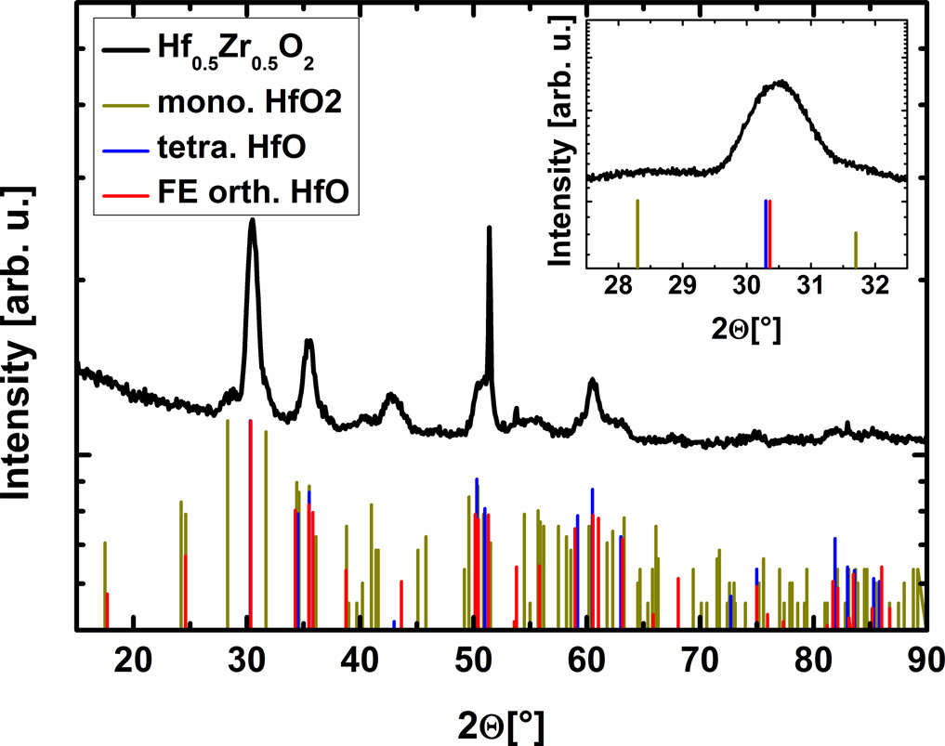

FIG. 1. Grazing incidence X-ray diffraction results for a 10 nm thick Hf0.5Zr0.5O2 thin film capacitor. The inset shows a magnification of the peak at 30.5�including reference patterns. The abbreviation FE (ferroelectric) refers to the observed polarization behavior.

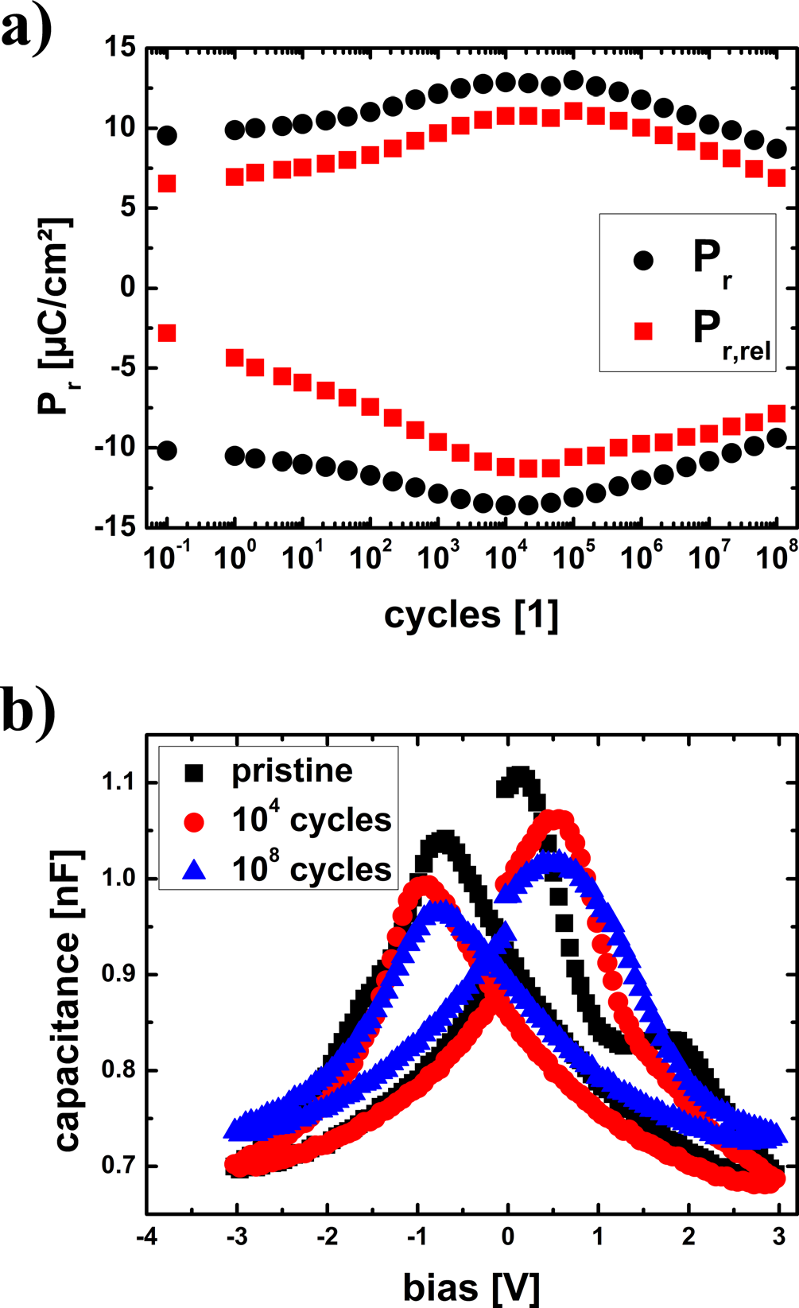

FIG. 2. (a) Evolution of the positive and negative remanent polarization (Pr) with electric field cycling using rectangular pulses with 3 MV/cm and

100 kHz for a 10 nm thick Hf0.5Zr0.5O2 thin film capacitor. The hysteresis measurements in between cycling pulses were performed at 10 kHz. (b) Capacitance-voltage measurement in the pristine state, after 104and 108

cycles as shown in (a) using 10 kHz with an ac-amplitude of 70 mV. Each

data point represents the average of 100 single measurements.

present, which hints at the existence of an asymmetry in the

stack as well. No significant change in capacitance for high

fields at 3 MV/cm was observed during wake-up. The missing

change in capacitance shows that either the contribution of the

phase change to the increased polarization is very low or the

involved phases have similar permittivities. Unlike for films doped, e.g., with Gd,19a strong contribution of the phase

change is not expected for hafnia zirconia due to the wider

process concentration window and the higher stability of the

orthorhombic phase compared to other doped HfO2 films. However, for the fatigued state, a clear increase in the capaci-

tance can be seen. Two different mechanisms could be respon-sible: A partial phase change to the tetragonal phase20or the domain wall pinning mechanism.21During field cycling, the concentration of charged oxygen vacancies increases,10which can stabilize higher symmetry phases of hafnia.22–24This

would lead to a higher permittivity, which increases the capac-

itance of the stack. However, it is also suggested that oxygen

|  |  |  |
| --- | --- | --- |
| 204101-3 | Fengler et al. | J. Appl. Phys. 123, 204101 (2018) |

vacancies accumulate at the grain boundaries in the fatigued state,25which might lead to domain wall pinning. These pinned domain walls bend during application of an external field causing an increase in capacitance as well.21Both mech-anisms would reduce the ferroelectric switching density and could play a role during fatigue. More research has to be done, e.g., by a TEM analysis or microspot XRD to distin-guish both effects.

With respect to the imprint mechanism, it is known that the shift of the hysteresis while storing in a specific polariza-tion state is enhanced for woken up films.17During electric field cycling, the unpinned domains are oriented into one switching direction. The subsequent storage causes a shift of the whole hysteresis along the voltage axis—the imprint.26 The reported dependence of the imprint on the temperature and time17showed a different slope of the hysteresis shift along the voltage axis as a function of time for room temper-ature compared to higher temperatures. However, the pub-lished extracted activation energy for the imprint in ferroelectric hafnia-zirconia films17contained an additional relaxation process and is therefore misleading: Since the sample was measured at room temperature after exposure to high temperature to determine the imprint, the thermal relax-ation of defects also played a role. The extracted activation energy of about 1 eV therefore represents more likely the thermal relaxation activation energy for an electron in a dou-bly positively charged oxygen vacancy which has a similar value.27   
 To be able to extract the activation energy that is charac-teristic purely for the imprint process itself, we measured the shift of the coercive voltage VC in situ at the respective tem-perature. To reach this result, TiN/HZO/TiN capacitors were preconditioned with 106cycles at room temperature at 100 kHz and 3 MV/cm to achieve a woken-up state (compare Fig. 2). Subsequently, the sample was heated up to the desired temperature and then cycled again for 104cycles to reset the already started imprint and shift the PV-hysteresis back into its initial position. Directly after cycling, a PV hys-teresis measurement was conducted and repeated after a cer-tain time delay. The imprint was then calculated from the shift of the PV hysteresis using the difference in coercive voltage of both measurements. This procedure was repeated for various times and temperatures. The corresponding mea-surement results are plotted in Fig. 3(a).

A clear shift of the hysteresis was observed for all tem-peratures. The direction of the shift to more negative vol-tages is typical for the sample in the positive polarization state while the shift towards more positive voltages would be expected for negatively polarized samples. Moreover, the slopes of the shift as a function of time in the Arrhenius plot of all temperatures were quite similar. Solely for room tem-perature, a slight remaining difference was observed. The obtained activation energies for the imprint were extracted as 0.099 6 0.01 eV including the 25�C data point and as 0.079 6 0.003 eV excluding it [see Fig. 3(b)]. This points towards electrons as responsible charge carriers since activa-tion energy is too low for ion diffusion.28,29This is in good agreement with thermally stimulated depolarization current (TSDC) results10which indicate that no oxygen vacancy

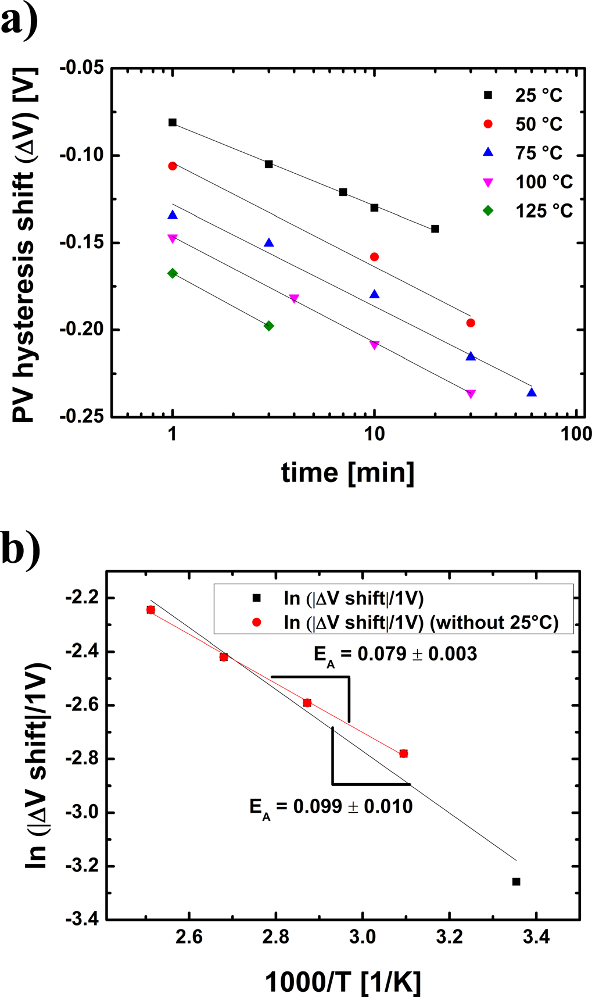

FIG. 3. (a) Voltage shift of the hysteresis as a function of temperature and time after pre-cycling the 10 nm thick Hf0.5Zr0.5O2 film with 3 MV/cm at 100 kHz for 106cycles. (b) Arrhenius plot of the hysteresis voltage shift after 10 min using the linear fits for the different temperatures from (a). The activation energies are extracted from the slope of the curves.

movement is present for temperatures below 100�C even after application of high fields at room temperature.

Three possible main mechanisms are discussed in the lit-erature as a cause for pinning of domains as it occurs during imprint: Volume effects, domain wall pinning, and seed inhi-bition. Volume effects describe the suppression of polariza-tion in the ferroelectric by reorientation of polar lattice defects.30On the contrary, domain wall pinning and seed inhibition both describe the suppression of ferroelectric switching by blocking single domains. This occurs either at domain seeds (seed inhibition)31or at the domains walls (domain wall pinning).21Colla et al.21showed that it is pos-sible to cause a strong reduction of polarization of PZT by cycling a sample with a two-step waveform [see Fig. 4(a)] that applies a voltage for 300 s which is close to the coercive field prior to switching. This method allowed distinguishing between domain wall pinning and the other two effects since it maximizes the number of domain walls. The same

|  |  |  |
| --- | --- | --- |
| 204101-4 | Fengler et al. | J. Appl. Phys. 123, 204101 (2018) |

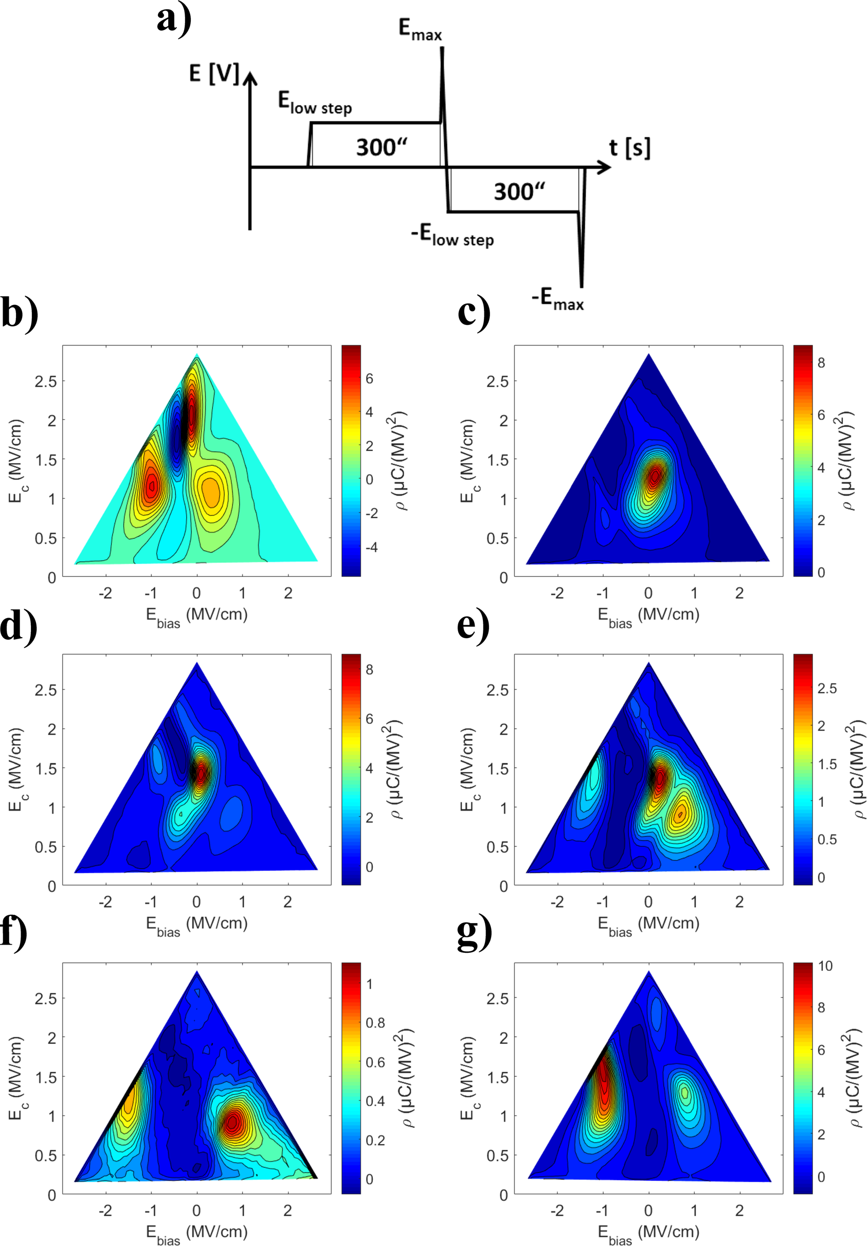

FIG. 4. Switching density distribution determined by FORC in a 10 nm thick Hf0.5Zr0.5O2 film for the (b) pristine state and (c) woken up state after 106cycles at 100 kHz with 3 MV/cm and 40 additional two-step cycles as shown in (a) and a 30 min bake at (d) 25�C, (e) 125�C, and (f) 200�C. (g) Internal bias field distribution determined by FORC in the 10 nm thick Hf0.5Zr0.5O2 film in the woken up state after 106cycles at 100 kHz with 3 MV/cm and a single pulse with 3 MV/cm for 100 ls and with �1.2 MV/cm for 100 ls followed by a 30 min bake at 125�C.

approach was recently applied to hafnia zirconia films by Fengler et al.17By using first order reversal curves (FORCs), which are related to the Preisach switching density,32it was possible to show that a split up of the switching density occurs which is caused by local internal bias fields. Due to

the missing change in capacitance,17it can be assumed that seed inhibition or volume effects rather than domain wall pinning are dominating. Since the seeds can be located close to the electrodes or within a grain at inter-grain phase bound-aries,33it is not possible to distinguish the effects further.

|  |  |  |
| --- | --- | --- |
| 204101-5 | Fengler et al. | J. Appl. Phys. 123, 204101 (2018) |

Considering the extracted activation energy of the imprint and the fact that both phenomena—the imprint and the wake-up—already occur at room temperature, it seems possible that the same mechanism can be responsible for both of them. During application of the low voltage step close to the coercive field, the domains with lower coercive field values are switched. This increases the chance to pin the domains in opposite directions. A local bias field is caused which shifts one half of the hysteresis towards nega-tive and the other half towards positive fields resulting in the observed split up of the switching density. However, due to the applied field during the low voltage step, some domains remain unpinned or are sequentially unpinned, which explains the remaining portion of domains without bias field in the FORC distribution.17   
 To further analyze this assumption, the pristine films were pre-cycled for 106cycles at 100 kHz with 3 MV/cm as shown in Fig. 2 to reach the woken up state. Subsequently, the two-step waveform as shown in Fig. 4(a) was applied 40 times using 3 MV/cm for the maximum field and 1.2 MV/cm for the low field step. In the last cycle, only the low positive field was applied to the capacitor to switch a portion of the domains into the opposite direction. The films were stored for 30 min at different temperatures, cooled down quickly to room temperature to measure the FORC distribution that can be compared to the one obtained before the treatment.

From Fig. 4(b), it is visible how the local internal bias fields of the pristine film diminish due to the electric field cycling into the woken up state [Fig. 4(c)]. The negative switching density and the positive values right next to them in the FORC distribu-tion (EC � 2MV/cm) in Fig. 4(b) are a measurement artifact caused by a shift of one of the switching current peaks during the FORC measurement. The reason for this is that in the calcu-lation of the FORC distribution, it is assumed that the switching current peaks do not shift during the measurement itself (see Ref. 15 for a detailed discussion of the FORC method). Nevertheless, all other FORC distribution peaks shown in Fig. 4 are related to the real response of the ferroelectric sample. After application of the two-step waveform, two local bias fields emerge [as shown in Fig. 4(d)]. These bias fields are strongly increasing with higher temperature during the bake [compare Figs. 4(d)–4(f)]. Clearly, it is visible how the remaining unpinned domains without bias field are imprinted with increas-ing temperature. Additionally, a capacitor was pre-cycled for 106cycles at 100kHz with 3MV/cm as before. Instead of a two-step waveform, just a single sub-cycling pulse was applied: First, all domains were switched with 3MV/cm for 100 ls in one direction and subsequently a portion was switched with�1.2MV/cm for 100 ls into the opposite polarization state. Afterwards, the sample was baked as before for 30min at 125�C. Similar bias field distributions as for the case with the two-step waveform cycled capacitor were achieved. Due to the opposite polarity of the poling voltages, opposite portions of peak maxima for the negative and positive bias fields were achieved compared to the two-step measurements before. Since no additional pulses were applied (in contrast to the two-step cycling), the split up was much clearer and almost no domains without bias field were present, as can be seen in Fig. 4(g). The overall dependence of the bias fields on the baking temperature

due to imprint shows strong similarities to the wake-up phenom-enon. Using a bake at 200�C for 30min even causes the unpinned domain portions to merge with the already imprinted portion with positive bias [see Fig. 4(f)]. This bias field distribu-tion is similar to the pristine distribution. However, it is not fully possible to go back into a truly pristine state due to the possibil-ity that during field cycling, 90�domains might re-orientate.33 This is possible since the a-axis and the c-axis of the unit cell have a similar length.20Therefore, a reorientation of domains without a significant volume change of the unit cell seems to be possible. In contrast, the local bias fields after the two-step waveform and the bake should contain highly oriented domains which are more strongly pinned.

To further assess the similarity between wake-up and imprint, capacitors that were backed for 30 min at 125�C and 200�C [as shown in Figs. 4(e)–4(g)] were cycled with 3 MV/cm at 100 kHz and the PV hysteresis was measured in

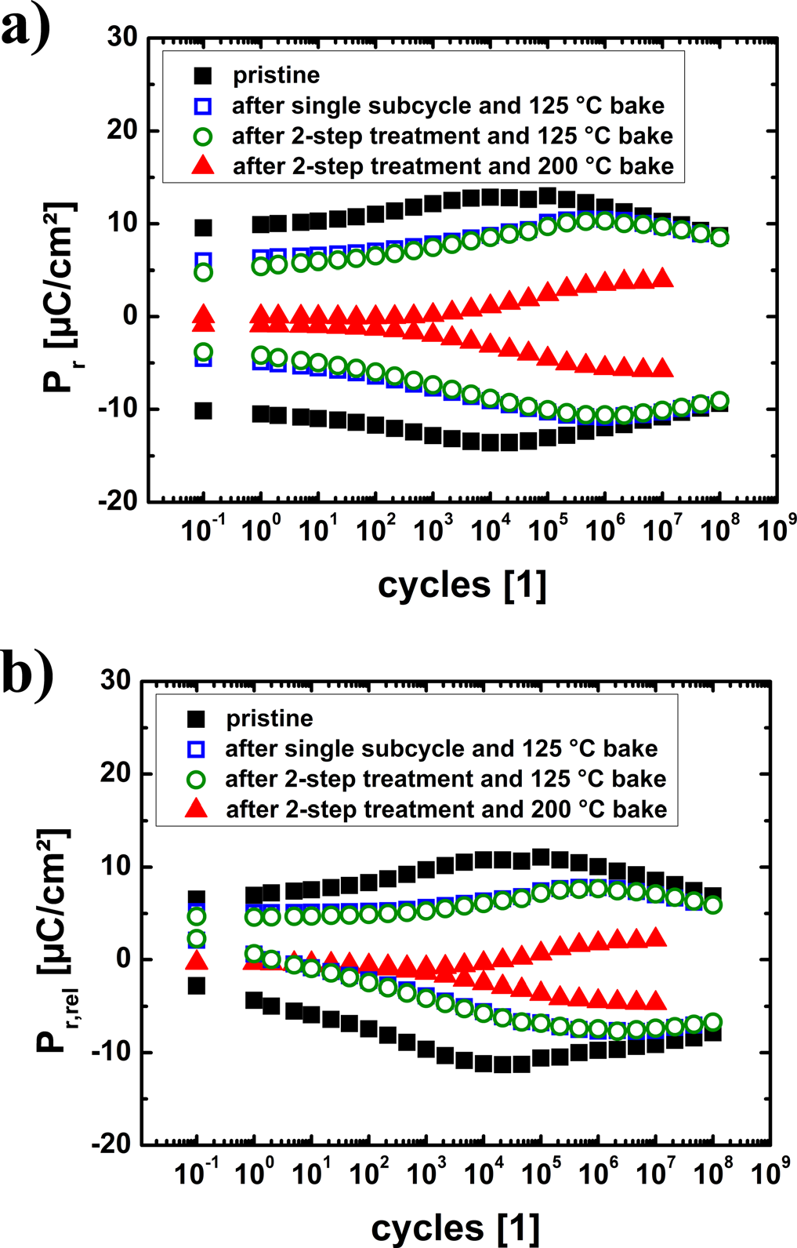

FIG. 5. (a) Evolution of positive and negative remanent polarization Pr and (b) of positive and negative remanent polarization after one second relaxa-tion time Pr,rel with electric field cycling using rectangular pulses with 100 kHz for 10 nm thick Hf0.5Zr0.5O2 thin film capacitors and 10 kHz for hysteresis measurements in between cycling pulses of a prior pristine state and after 2-step treatment and subsequent bake for 30 min at 125�C, 200�C, and after single sub-cycling pulse and a subsequent bake for 30 min at 125�C as shown in Fig. 4.

|  |  |  |
| --- | --- | --- |
| 204101-6 | Fengler et al. | J. Appl. Phys. 123, 204101 (2018) |

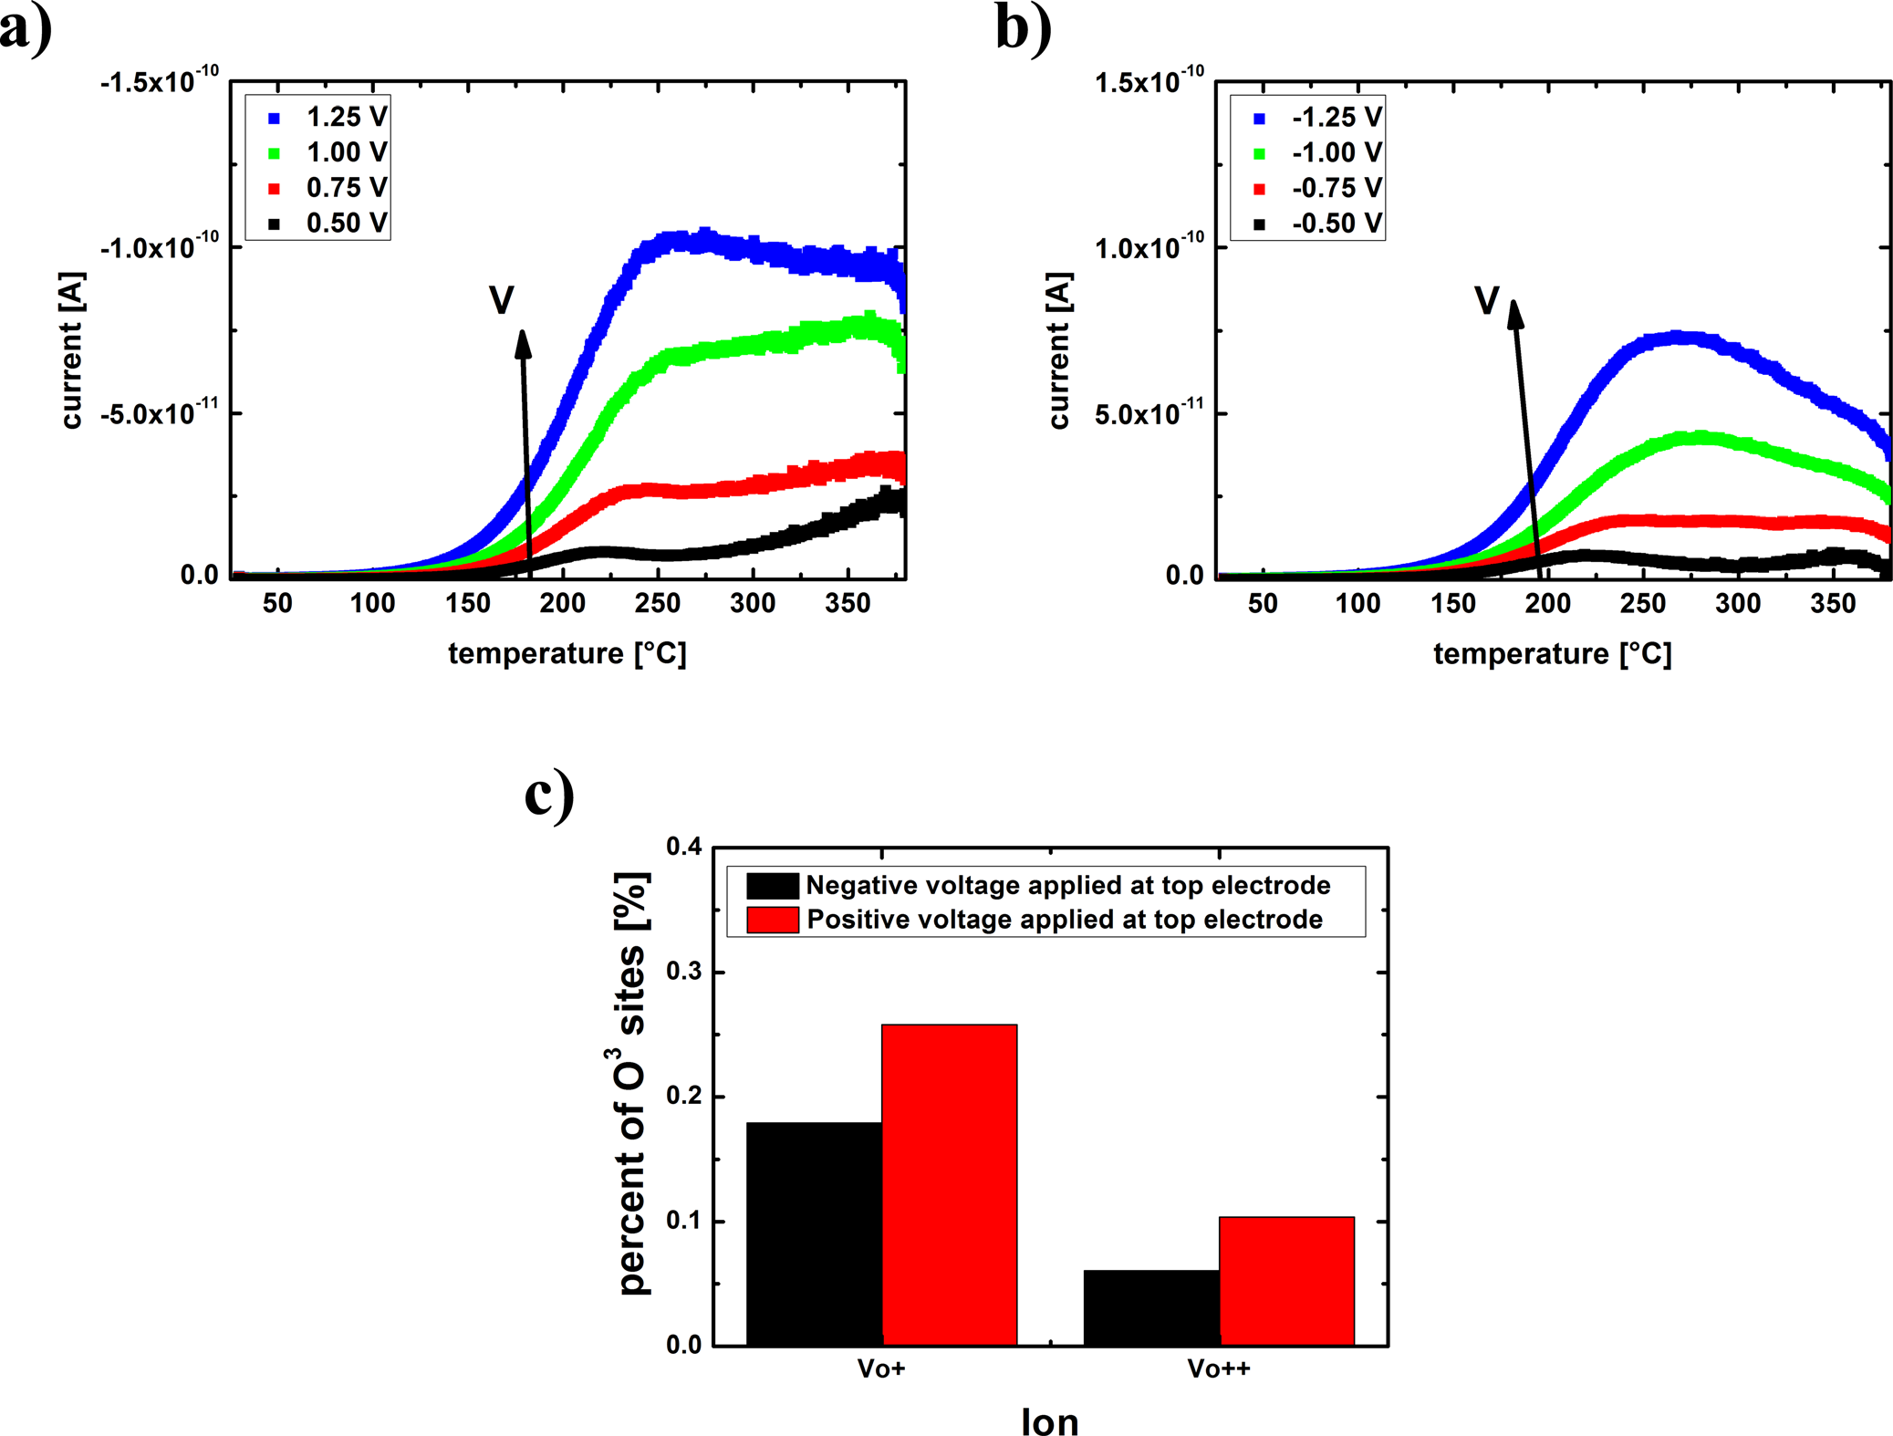

FIG. 6. Thermally stimulated depolarization current measurement of 10 nm thick TiN-Hf0.5Zr0.5O2-TiN capacitors using a ramp rate of 0.2 K/s after poling

with (a) voltages between 0.5 V and 1.25 V in steps of 0.25 V for 800 s at 380�C and (b) voltages between �0.5 V and �1.25 V in steps of 0.25 V for 800 s at 380�C. The different colors indicate the different polling voltages. (c) Extracted charged oxygen vacancies from (a) and (b) as percentage of the threefold

coordinated oxygen atoms.

between with 10 kHz. The resulting remanent polarization as a function of the number of cycles is shown in Fig. 5(a).

Clearly, an inhibition of the ferroelectric switching can be observed for all samples. However, the effect is more pronounced for the “artificial” local bias fields generated by the single sub-cycling pulse and two-step treatment com-pared to the pristine film. The “artificial” wake-up or de-pinning effect is strongly dependent on the temperature as shown before (see Fig. 3). Almost no difference between the field cycling of the two-step and the single sub-cycling can be observed after a bake at 125�C. As for the FORC distributions before, a strong temperature dependence of the local bias fields and therefore for the wake-up is observed. After the bake at 200�C for 30 min, a very stable local internal bias field leading to a constricted hysteresis was observed during the first 102cycles. In the literature, such behavior is sometimes misinterpreted as antiferroelec-tricity in the film. Here however, the origin clearly is a local internal bias field. The observed trapping mechanism is therefore definitely strong enough to cause a severe con-striction of the PV hysteresis and the suppression of ferro-electric switching in the pristine state. Possible ways to

distinguish between real anti-ferroelectrics and strongly imprinted ferroelectrics, as shown here, were recently dis-cussed by Hoffmann et al.34   
 The remaining question, however, is where the defects are located which are acting as trapping centers for the imprint. To further analyze this, thermally stimulated depo-larization measurements were conducted. To polarize the film, different bias voltages were applied ranging from 0.5 V to 1.25 V at 380�C for 800 s. The sample was subsequently cooled down quickly during application of the same bias. By this procedure, possible diffused ions and charges are trapped into their spatial and energetic positions and perma-nent dipoles are reoriented. Then, by slowly heating up the sample with a heating rate of 0.2 K/s, the charges are de-trapped, dipoles reoriented, and ions diffused back causing a current to flow which depends on energetic positions and concentrations. Although an exchange of oxygen with the atmosphere during the measurement is considered unlikely due to the top metal coating, every single measurement was conducted on a new small piece of the same film and a new capacitor to avoid any influence caused by possible film deg-radation. To subtract the pyroelectric current components

|  |  |  |
| --- | --- | --- |
| 204101-7 | Fengler et al. | J. Appl. Phys. 123, 204101 (2018) |

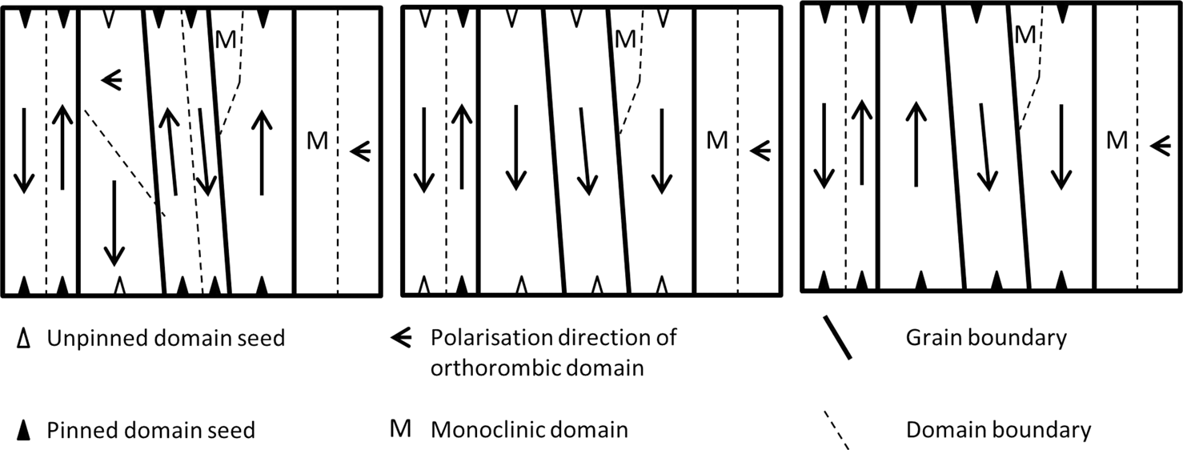

FIG. 7. Model for the different cycling states in hafnia-zirconia thin films: (a) pristine state—monoclinic phase portions present, which are not ferroelectric. Most domains are randomly oriented and domain seeds are pinned (b) woken up state—some monoclinic phase portions are still present. Domains are now more aligned, mostly unpinned, and poled into one direction as a result of the last switching. (c) Biased by imprint after wake-up due to sub-cycling. The domains are pinned again and oriented depending on their coercive voltage.

and disturbing signals caused by the heating circuit, this step was additionally repeated without prior poling. The resulting thermally induced current was subtracted from all shown results. The resulting thermally stimulated depolarization current as a function of the temperature [see Figs. 6(a) and 6(b)] reveals two strongly overlapping peaks with maxima at about 250�C and 350�C. Fengler et al.10already showed that the diffusion of singly and doubly positively charged oxygen vacancies can cause these peaks, whereas dipole reorientation or trapped charges as cause were excluded. It was also presented how to use the thermal cleaning method and estimate the amount of charged oxygen vacancies by fit-ting the dependence of the integrated charges on the applied poling voltage to a sinh function.10   
 The same method was applied to the 10 nm HZO films investigated here. Oxygen vacancy concentrations in a simi-lar range of �0.2% for the singly and �0.1% for the doubly positively charged oxygen vacancies as a portion of the threefold coordinated oxygen atoms O3in the film were extracted as in Ref. 10. The fact that no significant oxygen vacancy diffusion was observed for temperatures below 100�C under the measurement conditions [compare Figs. 6(a) and 6(b)] corroborates the assumption that ion migration is not the dominating factor for wake-up and imprint which occurs already at room temperature.10   
 Additionally, we measured the concentration of defects for both polarities of the poling voltage using the TSDC method and the described approach by utilizing a sinh fitting function. A higher amount of diffused charges was observed for positive voltage at the top electrode compared to a nega-tive voltage. Since a positive voltage should repel the posi-tively charged oxygen vacancies, this might hint at a higher concentration of the oxygen vacancies at the top electrode.

This is in good agreement with the observed asymmetry in the CV-measurements [compare Fig. 2(b)] and earlier publications claiming that an asymmetry should be caused by a stronger oxidation of the bottom electrode during the ALD compared to a minimal oxidation of the TiN top elec-trode during the crystallization anneal process.35During the high temperature anneal, the chemical reduction of the HZO is expected to generate a lower amount of oxygen vacancies at the bottom interface compared to the top interface.36

To describe our experimental results, the model illus-trated in Fig. 7 is suggested for the imprint and wake-up phe-nomenon in hafnia zirconia thin films.

Pristine State: The ferroelectric phase portion contains 90�and 180�domains with partly pinned domain seeds depending on the fabrication conditions like anneal, etc.6,10 Due to the different orientations of grains, different orienta-tions of domains within the sample are present. Different phases coexist depending on the processing conditions.6,23 Woken up: With electric field cycling, the domain orien-tations align and the domains are unpinned.

Imprinted: The aligned domains are pinned again due to pinned domain seeds and local internal bias fields emerge. Depending on the pinned domain orientation, the bias field can be positive or negative.

IV. CONCLUSION

The field cycling behavior of ferroelectric hafnia zirco-nia films was analyzed. During field cycling, typical wake-up and fatigue behavior was observed. The negligible change in the dielectric constant of the films with cycling suggests that during the wake-up, no pronounced phase change into a phase with a significantly different permittivity occurs. On the other hand, the capacitance change during fatigue remains unclear making the interpretation of the capacitance values without further structural or electrical data rather speculative. Due to an increased capacitance of the film, a phase change or a domain wall pinning is suspected. However, an asymmetry was observed in the capacitance-voltage curves, which hints towards an electrode dependent asymmetry in the capacitor stack. The analysis of the depen-dence of the thermally stimulated depolarization currents might point to a higher oxygen vacancy concentration at the top electrode compared to the bottom electrode; however, further analyses with other characterization techniques are necessary to confirm these data. An improved approach to investigate the cause of imprint showed, however, that elec-tron trapping at the defect sites—most likely oxygen vacan-cies—takes place. By application of a two-step waveform and a subsequent bake, we show that a similar state as the pristine one can be caused by just splitting up the domains

|  |  |  |
| --- | --- | --- |
| 204101-8 | Fengler et al. | J. Appl. Phys. 123, 204101 (2018) |

and imprinting them into different directions. A similar situ-ation is most likely the cause of the constricted hysteresis in the pristine state. Additionally, it was shown that the anti-fer-roelectricity of hafnia films must be analyzed in detail to not confuse it with a strong imprint mechanism.

1C. S. Hwang, “Prospective of semiconductor memory devices: From mem-ory system to materials,” [Adv. Electron. Mater.](https://doi.org/10.1002/aelm.201400056) 1(6), 1400056 (2015). 2H. Kohlstedt, Y. Mustafa, A. Gerber, A. Petraru, M. Fitsilis, R. Meyer, and R. Waser, “Current status and challenges of ferroelectric memory devices,” [Microelectron. Eng.](https://doi.org/10.1016/j.mee.2005.04.084) 80, 296–304 (2005).

3T. S. B€oscke, J. M€uller, D. Br€auhaus, U. Schr€oder, and U. B€ottger,“Ferroelectricity in hafnium oxide thin films,” [Appl. Phys. Lett.](https://doi.org/10.1063/1.3634052) 99(10), 102903 (2011).

4D. M. Hausmann and R. G. Gordon, “Surface morphology and crystallinity control in the atomic layer deposition (ALD) of hafnium and zirconium oxide thin films,” [J. Cryst. Growth](https://doi.org/10.1016/S0022-0248(02)02133-4) 249(1-2), 251–261 (2003).

5D. Zhou, J. Xu, Q. Li, Y. Guan, F. Cao, X. Dong, and U. Schr€oder,“Wake-up effects in Si-doped hafnium oxide ferroelectric thin films,”[Appl. Phys. Lett.](https://doi.org/10.1063/1.4829064) 103(19), 192904 (2013).

6T. Mittmann, F. P. Fengler, C. Richter, M. H. Park, T. Mikolajick, and U. ferroelectric capacitor performance,” [Microelectron. Eng.](https://doi.org/10.1016/j.mee.2017.04.031) 178, 48–51 Schroeder, “Optimizing process conditions for improved Hf1� xZrxO2 (2017).

7M. Pe�sic´, F. P. G. Fengler, L. Larcher, A. Padovani, T. Schenk, E. D. Grimley, and T. Mikolajick, “Physical mechanisms behind the field-cycling behavior of HfO2-based ferroelectric capacitors,” [Adv. Funct. Mater.](https://doi.org/10.1002/adfm.201600590) 26(25), 4601–4612 (2016).

8E. D. Grimley, T. Schenk, X. Sang, M. Pe�sic´, U. Schroeder, T. Mikolajick, and J. M. LeBeau, “Structural changes underlying field-cycling phenom-ena in ferroelectric HfO2 thin films,” [Adv. Electron. Mater.](https://doi.org/10.1002/aelm.201600173) 2(9), 1600173 (2016).

9M. H. Park, H. J. Kim, Y. J. Kim, Y. H. Lee, T. Moon, K. D. Kim, and C. S. Hwang, “Effect of Zr content on the wake-up effect in Hf1–xZrxO2 Films,” [ACS Appl. Mater. Interfaces](https://doi.org/10.1021/acsami.6b03586) 8(24), 15466–15475 (2016).

10F. P. Fengler, R. Nigon, P. Muralt, E. D. Grimley, X. Sang, V. Sessi, and U. Schroeder, “Analysis of performance instabilities of Hafnia-based fer-roelectrics using modulus spectroscopy and thermally stimulated depolari-zation currents,” [Adv. Electron. Mater.](https://doi.org/10.1002/aelm.201700547) 4(3), 1700547 (2018).

11F. Huang, X. Chen, X. Liang, J. Qin, Y. Zhang, T. Huang, and L. Zhang,“Fatigue mechanism of yttrium-doped hafnium oxide ferroelectric thin films fabricated by pulsed laser deposition,” [Phys. Chem. Chem. Phys.](https://doi.org/10.1039/C6CP07501K) 19(5), 3486–3497 (2017).

12S. Starschich, S. Menzel, and U. B€ottger, “Evidence for oxygen vacancies movement during wake-up in ferroelectric hafnium oxide,” [Appl. Phys. Lett.](https://doi.org/10.1063/1.4940370) 108(3), 032903 (2016).

13T. Schenk, U. Schroeder, M. Pes�ic�, M. Popovici, Y. V. Pershin, and T. Mikolajick, “Electric field cycling behavior of ferroelectric hafnium oxide,” [ACS Appl. Mater. Interfaces](https://doi.org/10.1021/am504837r) 6(22), 19744–19751 (2014).

14U. Schroeder, E. Yurchuk, J. M€uller, D. Martin, T. Schenk, P. Polakowski, and T. Mikolajick, “Impact of different dopants on the switching proper-ties of ferroelectric hafniumoxide,” [Jpn. J. Appl. Phys., Part 1](https://doi.org/10.7567/JJAP.53.08LE02) 53(8S1), 08LE02 (2014).

15T. Schenk, M. Hoffmann, J. Ocker, M. Pes�ic�, T. Mikolajick, and U.

17F. P. Fengler, M. Pe�sic´, S. Starschich, T. Schneller, C. K€unneth, U. B€ottger, and P. Muralt, “Domain pinning: Comparison of Hafnia and PZT based ferroelectrics,” [Adv. Electron. Mater.](https://doi.org/10.1002/aelm.201600505) 3(4), 1600505 (2017).

18C. Richter, T. Schenk, M. H. Park, F. A. Tscharntke, E. D. Grimley, J. M. LeBeau, and U. Schroeder, “Si doped hafnium oxide—A “fragile” ferro-electric system,” [Adv. Electron. Mater.](https://doi.org/10.1002/aelm.201700131) 3(10), 1700131 (2017).

19X. Sang, E. D. Grimley, T. Schenk, U. Schroeder, and J. M. LeBeau, “On the structural origins of ferroelectricity in HfO2 thin films,” [Appl. Phys. Lett.](https://doi.org/10.1063/1.4919135) 106(16), 162905 (2015).

20R. Materlik, C. K€unneth, and A. Kersch, “The origin of ferroelectricity in Hf1[�](https://doi.org/10.1063/1.4916707)xZrxO2: A computational investigation and a surface energy model,”[J. Appl. Phys.](https://doi.org/10.1063/1.4916707) 117(13), 134109 (2015).

21E. L. Colla, S. Hong, D. V. Taylor, A. K. Tagantsev, N. Setter, and K. No,“Direct observation of region by region suppression of the switchable polarization (fatigue) in Pb (Zr, Ti) O 3 thin film capacitors with Pt elec-trodes,” [Appl. Phys. Lett.](https://doi.org/10.1063/1.121083) 72(21), 2763–2765 (1998).

22C. K. Lee, E. Cho, H. S. Lee, C. S. Hwang, and S. Han, “First-principles study on doping and phase stability of HfO2,” [Phys. Rev. B](https://doi.org/10.1103/PhysRevB.78.012102) 78(1), 012102 (2008).

23M. Hoffmann, U. Schroeder, T. Schenk, T. Shimizu, H. Funakubo, O. Sakata, and A. Kersch, “Stabilizing the ferroelectric phase in doped haf-nium oxide,” [J. Appl. Phys.](https://doi.org/10.1063/1.4927805) 118(7), 072006 (2015).

24S. Fabris, A. T. Paxton, and M. W. Finnis, “A stabilization mechanism of zirconia based on oxygen vacancies only,” [Acta Mater.](https://doi.org/10.1016/S1359-6454(02)00385-3) 50(20), 5171–5178 (2002).

25M. Lanza, G. Bersuker, M. Porti, E. Miranda, M. Nafr�ıa, and X. Aymerich, “Resistive switching in hafnium dioxide layers: Local phenom-enon at grain boundaries,” [Appl. Phys. Lett.](https://doi.org/10.1063/1.4765342) 101(19), 193502 (2012).

26Y. Zhou, H. K. Chan, C. H. Lam, and F. G. Shin, “Mechanisms of imprint effect on ferroelectric thin films,” [J. Appl. Phys.](https://doi.org/10.1063/1.1984075) 98(2), 024111 (2005). 27L. Vandelli, A. Padovani, L. Larcher, R. G. Southwick, W. B. Knowlton, and G. Bersuker, “A physical model of the temperature dependence of the current through SiO2/HfO2 stacks,” [IEEE Trans. Electron Devices](https://doi.org/10.1109/TED.2011.2158825) 58(9), 2878–2887 (2011).

28C. Li, Y. Yao, X. Shen, Y. Wang, J. Li, C. Gu, and M. Liu, “Dynamic observation of oxygen vacancies in hafnia layer by in situ transmission electron microscopy,” [Nano Res.](https://doi.org/10.1007/s12274-015-0857-0) 8(11), 3571–3579 (2015).

29N. Capron, P. Broqvist, and A. Pasquarello, “Migration of oxygen vacancy in HfO2 and across the HfO2=SiO2 interface: A first-principles inves-tigation,” [Appl. Phys. Lett.](https://doi.org/10.1063/1.2807282) 91(19), 192905 (2007).

30P. V. Lambeck and G. H. Jonker, “The nature of domain stabilization in ferroelectric perovskites,” [J. Phys. Chem. Solids](https://doi.org/10.1016/0022-3697(86)90042-9) 47(5), 453–461 (1986). 31X. J. Lou, “Polarization fatigue in ferroelectric thin films and related mate- rials,” [J. Appl. Phys.](https://doi.org/10.1063/1.3056603) 105(2), 024101 (2009).

32A. Stancu, D. Ricinschi, L. Mitoseriu, P. Postolache, and M. Okuyama,“First-order reversal curves diagrams for the characterization of ferroelec-tric switching,” [Appl. Phys. Lett.](https://doi.org/10.1063/1.1623937) 83(18), 3767–3769 (2003).

33E. D. Grimley, T. Schenk, T. Mikolajick, U. Schroeder, and J. M. LeBeau,“Atomic structure of domain and interphase boundaries in ferroelectric HfO2,” [Adv. Mater. Interfaces](https://doi.org/10.1002/admi.201701258) 5(5), 1701258 (2018).

34M. Hoffmann, T. Schenk, M. Pe�sic´, U. Schroeder, and T. Mikolajick,“Insights into antiferroelectrics from first-order reversal curves,” [Appl. Phys. Lett.](https://doi.org/10.1063/1.5003612) 111, 182902 (2017).

35W. Weinreich, R. Reiche, M. Lemberger, G. Jegert, J. M€uller, L. Wilde, and U. Schr€oder, “Impact of interface variations on J–V and C–V polarity

|  |  |  |  |  |  |  |  |  |
| --- | --- | --- | --- | --- | --- | --- | --- | --- |
| Schroeder, “Complex internal bias fields in ferroelectric hafnium oxide,” | asymmetry | of | MIM | capacitors | with | amorphous | and | crystalline |

[ACS Appl. Mater. Interfaces](https://doi.org/10.1021/acsami.5b05773) 7(36), 20224–20233 (2015).

16J. Muller, T. S. Boscke, S. Muller, E. Yurchuk, P. Polakowski, J. Paul, and

W. Weinreich, “Ferroelectric hafnium oxide: A CMOS-compatible and

highly scalable approach to future ferroelectric memories,” in 2013

International Electron Devices Meeting (IEDM) (2013), pp. 10–18.

36F. P. Fengler, M. Pe�sic´, S. Starschich, T. Schneller, U. B€ottger, T. Schenk, Zr(1�x)AlxO2 films,” [Microelectron. Eng.](https://doi.org/10.1016/j.mee.2009.03.070) 86(7-9), 1826–1829 (2009).

and U. Schroeder, “Comparison of hafnia and PZT based ferroelectrics for

future non-volatile FRAM applications,” in 2016 46th European Solid-

State Device Research Conference (ESSDERC) (2016), pp. 369–372.