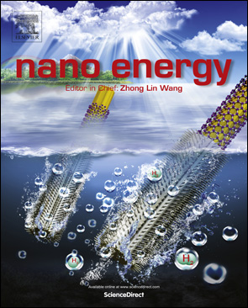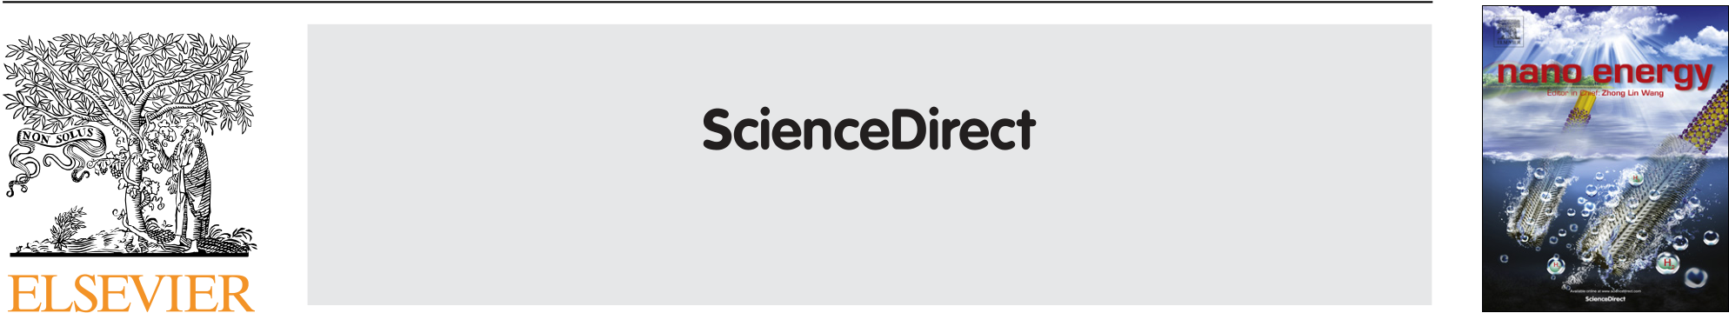

[Nano Energy (2015) 18, 154–164](http://dx.doi.org/10.1016/j.nanoen.2015.10.005)

Available online at www.sciencedirect.com

journal homepage: www.elsevier.com/locate/nanoenergy

RAPID COMMUNICATION

Ferroelectric phase transitions in nanoscale HfO2 films enable giant pyroelectric energy conversion and highly efficient   
supercapacitors

Michael Hoffmanna, Uwe Schroedera,n, Christopher Künnethb, Alfred Kerschb, Sergej Starschichc, Ulrich Böttgerc,   
Thomas Mikolajicka,d

aNaMLab gGmbH, Noethnitzer Str. 64, D-01187 Dresden, Germany   
bMunich University of Applied Sciences, Loth Str. 34, D-80335 Munich, Germany   
cInstitut für Werkstoffe der Elektrotechnik, RWTH Aachen University, Sommerfeldstr. 24, D-52074 Aachen, Germany   
dChair of Nanoelectronic Materials, TU Dresden, D-01062 Dresden, Germany

Received 16 July 2015; received in revised form 23 September 2015; accepted 8 October 2015 Available online 20 October 2015

|  |  |
| --- | --- |
| KEYWORDS  Pyroelectric;  Ferroelectric;  Hafnium oxide;  Supercapacitor;  Electrocaloric effect; Energy harvesting | Abstract  Temperature- and field-induced phase transitions in ferroelectric nanoscale TiN/Si:HfO2/TiN  capacitors with 3.8 to 5.6 mol% Si content are investigated for energy conversion and storage  applications. Films with 5.6 mol% Si concentration exhibit an energy storage density of �40 J/ cm3with a very high efficiency of �80% over a wide temperature range useful for super-capacitors. Furthermore, giant pyroelectric coefficients of up to �1300 mC/(m2K) are observed due to temperature dependent ferroelectric to paraelectric phase transitions. The broad |

transition region is related to the grain size distribution and adjustable by the Si content. This strong pyroelectricity yields electrothermal coupling factors k2of up to 0.591 which are more than one order of magnitude higher than the best values ever reported. This enables pyroelectric energy harvesting with the highest harvestable energy density ever reported of 20.27 J/cm3per Olsen cycle. Possible applications in infrared sensing are discussed. Inversely, through the electrocaloric effect an adiabatic temperature change of up to 9.5 K and the highest refrigerant capacity ever reported of 19.6 J/cm3per cycle is achievable. This might

nCorresponding author.

E-mail addresses: [michael.hoffmann@namlab.com](mailto:michael.hoffmann@namlab.com) (M. Hoffmann), [uwe.schroeder@namlab.com](mailto:uwe.schroeder@namlab.com) (U. Schroeder), [kuenneth@hm.edu](mailto:kuenneth@hm.edu) (C. Künneth), [akersch@hm.edu](mailto:akersch@hm.edu) (A. Kersch), [starschich@iwe.rwth-aachen.de](mailto:starschich@iwe.rwth-aachen.de) (S. Starschich), [boettger@iwe.rwth-aachen.de](mailto:boettger@iwe.rwth-aachen.de) (U. Böttger), [thomas.mikolajick@namlab.com](mailto:thomas.mikolajick@namlab.com) (T. Mikolajick).

<http://dx.doi.org/10.1016/j.nanoen.2015.10.005>  
[2211-2855/& 2015 Elsevier Ltd. All rights reserved.](http://dx.doi.org/10.1016/j.nanoen.2015.10.005)

|  |  |
| --- | --- |
| Ferroelectric phase transitions in nanoscale HfO2 films | 155 |

enable energy efficient on-chip electrocaloric cooling devices. Additionally, low cost fabrication

of these films is feasible by existing semiconductor process technology.

& 2015 Elsevier Ltd. All rights reserved.

|  |  |
| --- | --- |
| Introduction | systems was focused on ferroelectric (FE) capacitors [29] and field-effect transistors [27,30] for non-volatile mem- |

The ever increasing energy consumption and accompanying rise of greenhouse gases poses a serious challenge for the search of new material systems for efficient energy conver-sion and storage. Nanostructured materials can exhibit vastly enhanced properties for these applications compared to their bulk counterparts. Especially, thin film pyroelectrics can be used for efficient conversion of thermal into electrical energy and vice versa [1]. These materials with a temperature dependent spontaneous polarization PS can already be found in widespread applications particularly in infrared sensing [2,3]. However, a lot of recent research focuses on pyroelectric energy harvesting (PEH) [4] and the inverse effect of electrocaloric cooling [5,6]. Both phenom-ena are closely related and have already been studied for half a century [4,7]. While PEH is a promising method to convert the abundance of low-grade waste heat into electric energy [8], the electrocaloric effect (ECE) might be used in solid state cooling devices with high energy efficiency [9].

Achievable figures of merit (FOMs) for both applications as well as infrared sensing strongly depend on the intrinsic properties of the applied pyroelectric materials [2,4,5,10]. Especially ferroelectrics were shown to exhibit very strong pyroelectricity [2] near phase transitions to paraelectric [11,12] or antiferroelectric (AFE) phases [13]. Many of the materials investigated so far were bulk crystals or ceramics based on classical perovskite ferroelectrics [11,14–17]. Thin films were shown to exhibit remarkable properties as seen in the giant ECE for example in lead zirconate titanate (PZT) [7] and Pb0.8Ba0.2ZrO3 [12] or PEH using poly(vinylidene fluoride-trifluoroethylene) (P(VDF-TrFE)) [18]. This is mainly owed to the higher breakdown field strength compared to ceramics or bulk crystals [7]. AFE materials were also shown to have very favorable properties for electrostatic energy storage in supercapacitor applications [19,20]. Unfortu-nately, many of these complex thin films either contain lead which is toxic or deteriorate already at fairly low temperatures like polymers. Additionally, incompatibility with standard semiconductor process technology makes on-chip fabrication very complicated and therefore expensive.

Recently, ferroelectricity was first shown to occur in doped HfO2 [21,22] and HfxZr1�xO2 [23] thin films. While the ferroelectric phase has been identified as the non-centrosymmetric orthorhombic Pca21 phase [24], observed electric field-induced ferroelectric behavior seems to origi-nate from the tetragonal P42/nmc phase through a transi-tion to the aforementioned Pca21 phase [25]. These lead-free simple binary oxide films are temperature stable [26], highly compatible with silicon technology [27] and can be deposited on 3D nanostructures using atomic layer deposi-tion (ALD) [28]. So far, most research on these material

ories and low power computing applications. Beyond that, first studies showed the great potential of HfxZr1�xO2 films exhibiting field-induced ferroelectricity for energy storage supercapacitors [31] and electrocaloric cooling as well as PEH [32]. However, an in depth study of pyroelectricity and energy storage in doped HfO2 is still missing. Therefore, in this work we investigate the pyroelectric properties of Si: HfO2 thin films and assess their applicability for infrared detectors, PEH, electrocaloric cooling devices and electro-static supercapacitors.

Material and methods

Si:HfO2 films with a physical thickness of 9 nm were deposited by a metal organic ALD process based on Tetrakis-(ethylmethyla-mino)-hafnium (TEMAHf), Tetrakis-dimethylamino-silane (4DMAS) precursors and ozone. The Si content was defined by varying the cycle ratio of the precursors and monitored by secondary ion mass spectrometry and elastic recoil detection analysis on samples without thermal treatment. TiN bottom and top electrodes were deposited by a pulsed CVD process based on TiCl4 and NH3. Crystallization of the Si:HfO2 thin films (3.8 to 5.6 mol% Si) was induced by a 1000 1C/20 s anneal in nitrogen after TiN top electrode deposition. While all electrical measure-ments were performed on metal-insulator-metal (MIM) capacitors with an electrode area of 31,000 mm2, blanket wafers were used for physical characterization. To investigate the influence of the sample temperature with respect to polarization changes the samples were heated and cooled in a range between 80 K and 480 K. The polarization versus electric field dependencies were derived from integrating the displacement current for an applied triangular AC voltage signal using a virtual ground amplifier (AixACCT TF Analyzer 2000) at a frequency of 1 kHz. Capaci-tance–voltage measurements were carried out on a HP 4284 A Precision LCR Meter for extraction of the permittivity and loss factors of the films using frequencies from 20 Hz to 10 kHz and a small-signal amplitude of 50 mV. Pyroelectric currents were measured with a Keithley 6430 Sub-Femtoamp Remote Source-Meter at 0 V while increasing the sample temperature. Scanning electron microscopy (SEM) images were acquired on a Zeiss LEO 1560 microscope with an acceleration voltage of 0.8 kV. X-ray reflectivity (XRR) measurements were carried out on a Bruker D8 Discover (Cu-Kα radiation, λ=0.154 nm) to determine the thick-ness of the samples.

Theory

The following experimental results reported in this article give cause for a theoretical investigation. Especially the represented well known behavior of ferroelectrics to change

|  |  |
| --- | --- |
| 156 | M. Hoffmann et al. |

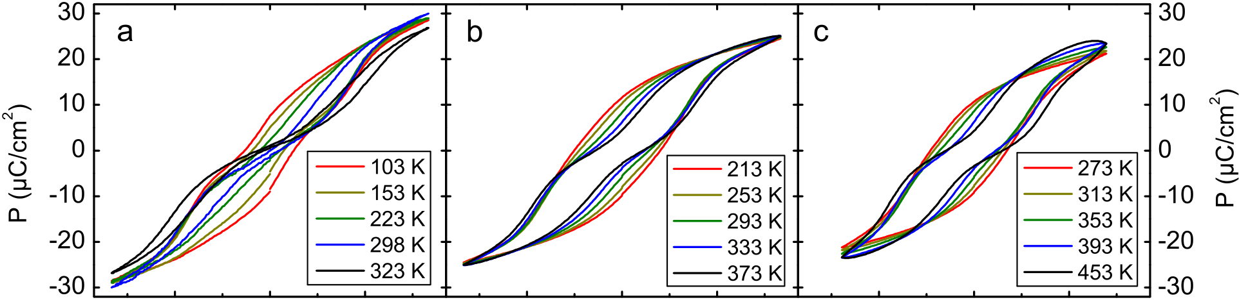

        

  

Figure 1 Temperature dependent polarization hysteresis measurements for MIM capacitor with a 9 nm Si:HfO2 layer containing

(a) 5.6 mol%, (b) 4.3 mol% and (c) 3.8 mol% of Si.

their structural phase by an electric field and temperature [7] should be further investigated and compared to the recent theoretical description. In addition, the effect of phase transitions on the pyroelectric properties should be discussed. Grindlay [33] describes the proper pyroelectric coefficient Π as a temperature T induced change of the

|  |  |  |  |  |  |  |  |  |  |  |  |  |
| --- | --- | --- | --- | --- | --- | --- | --- | --- | --- | --- | --- | --- |
| electric displacement field D=ε0E+P under the conditions of constant electric field E and stress s, which yields in our case | | | | | | | | | | | | |
| Π ¼ | �∂T∂D | � | E;s | ¼ | �∂T∂P | �s | þ | �∂s�T∂P | �∂T�∂s | s | ¼ Π1 þΠ2; | ð1Þ |

where P is the electrical polarization of the ferroelectric material and ε0 the vacuum permittivity. Π1 and Π2 are distinguishable quanta of the proper pyroelectric effect, whereby Π1 refers to a clamped and Π2 to an unclamped sample, respectively [3,34].

To estimate Π we use the linear thermal coefficient of monoclinic ZrO2 (1.3 � 10�5K�1[35]) which is chemically very similar to HfO2. We have calculated the relaxed atom positions and Born effective charges from first principles, using the thermal expansion for the displacements, and obtained Π�23 mC/(m2K), which is rather small compared to our experimental results (see Section 4.2). Therefore, the giant pyroelectricity we observed cannot only originate from the proper pyroelectric behavior but rather from a phase transition, which is consistent with the literature for other materials near the Curie temperature [7,12,13]. If the change of dielectric displacement is caused by a phase transition, we obtain a morphotropic contribution ΠM related to the change of concentration cf(T) of the ferro-electric phase depending on T. This gives cause to extend

|  |
| --- |
| Eq. (1) resulting in a giant pyroelectric coefficient as ΠG ¼�∂T cfD� ��E ¼ 0;s ¼ Π1 þΠ2 Þcf þ∂cf∂T P ¼ Πcf þΠM: ∂  ð2Þ cf is 1 if the sample exhibits only ferroelectric behavior and 0 for completely paraelectric behavior (0ocfo1). For polycrystalline ferroelectric materials like Si:HfO2 thin films investigated here, phase transitions do not always result in |

a macroscopic change of P, since a poling procedure might be necessary [36]. Considering an unpoled sample with randomly oriented grains, polarization of individual domains

Transitions of a poled ferroelectric to another crystallo-graphic phase on the other hand can result in a very high ΠG, because of the much greater change of P with T. This has to be considered when comparing ΠG determined by different measurement methods, for example with and without an applied electric field. Additionally, ΠG can depend strongly on the grain size distribution in such films due to different phase transition temperatures for different grain sizes, where smaller grains have a lower Curie temperature [37,38]. Different grain size distributions can therefore result in a broadened phase transition over a wider temperature range [39].

Results and discussion

Phase transitions and energy storage

Figure 1 shows the temperature dependent hysteresis loops measured on Si:HfO2 MIM capacitors with different Si content. For higher doping concentrations, a lower tem-perature is necessary to observe a change from a pure FE to a field-induced FE behavior as can be seen from the distinct pinched hysteresis loops at higher temperatures for all concentrations. This strong change of the hysteresis shape with temperature promises large capabilities of the mate-rial for pyroelectric energy harvesting as well as electro-caloric applications. The corresponding phase transitions of the samples with 3.8 and 4.3 mol% Si content have already been investigated by grazing-incidence X-ray diffraction (GIXRD) in Ref. [40]. These measurements revealed a more orthorhombic GIXRD pattern for 3.8 mol% Si and a more tetragonal one for 4.3 mol% Si at room temperature. Addi-

|  |  |  |
| --- | --- | --- |
| tional | temperature dependent GIXRD | patterns on the |

3.8 mol% Si sample showed the same trend of a higher tetragonal phase fraction at higher temperatures [40]. For this sample, which is shown in Figure 1(c), a significant leakage current increase at a temperature of 453 K can be seen from the convex curvature of the hysteresis at high positive fields around 2 MV/cm which limits the operation voltage range for PEH and electrocaloric cooling cycles at elevated temperatures. The highest Si concentration of 5.6 mol% in Figure 1(a) exhibits the strongest constriction of the hysteresis loop at room temperature as well as the

|  |  |  |  |  |  |  |  |  |  |  |  |  |  |
| --- | --- | --- | --- | --- | --- | --- | --- | --- | --- | --- | --- | --- | --- |
| might | compensate | each | other, | leading | to | small | ΠG. | highest | saturation | polarization | for | the | investigated |

|  |  |
| --- | --- |
| Ferroelectric phase transitions in nanoscale HfO2 films | 157 |

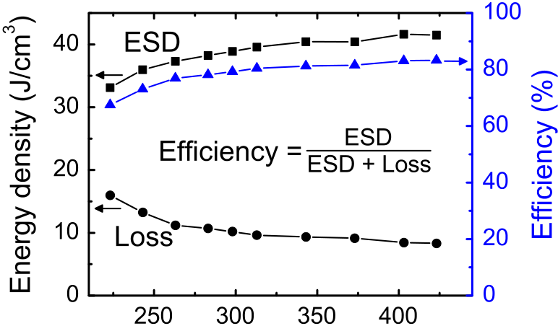



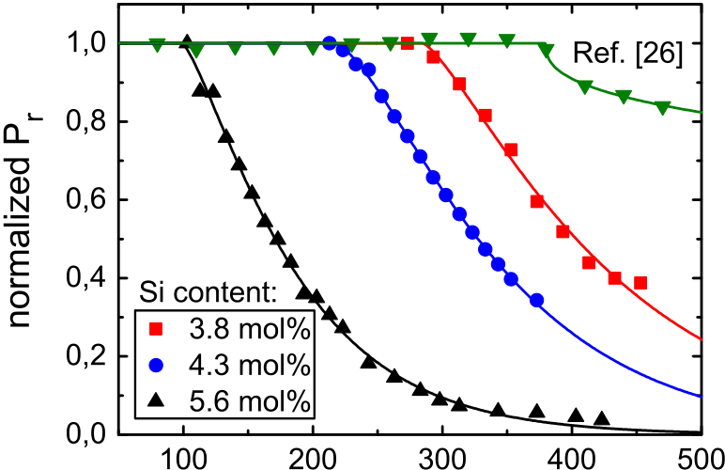

|  |  |  |
| --- | --- | --- |
| Figure 2 | Temperature dependent energy storage density |  |

(ESD) and loss of 5.6 mol% Si:HfO2 thin films showing field-induced ferroelectricity for electrostatic supercapacitors.

temperature range. These characteristics are very favorable for energy storage applications like electrostatic super-capacitors [31].

An important figure of merit for this electrostatic storage is the energy storage density (ESD), which is given by the area bounded by the upper loop of the hysteresis curve and a horizontal line corresponding to the maximum polarization from zero to the highest positive applied field [31]. The efficiency describes how much of the stored energy is lost to heat during cycling of the hysteresis loop. This loss is equivalent to the area inside the P–E loop for either positive or negative fields. Figure 2 shows the calculated ESD, loss and efficiency values of the 5.6 mol% Si sample as a function of temperature. For temperatures above 300 K both ESD and efficiency are rather stable and even increase for higher temperatures. Compared to the already very good proper-ties of Hf0.3Zr0.7O2 capacitors showing field-induced ferroe-lectricity reported in [31], our thin films exhibit about 30% higher ESD as well as 30% better efficiency at comparable electric fields over the same temperature range. Simulta-neously, Si:HfO2 possesses all the advantages of HfxZr1�xO2, like non-toxicity, high breakdown field strength and good 3D-integrability. By creating a dense array of deep trench capacitors within a Si substrate or stacked capacitors with a high aspect ratio above the transistor level, it should be possible to increase the ESD per projected area by more than one order of magnitude [28,41]. Additionally, easy integration into already existing semiconductor manufac-turing processes enables a cost effective way to produce capacitors with very high ESD directly on a Si chip [32]. Other potential material systems for supercapacitors like Pb0.92La0.08Zr0.95Ti0.05O3 (PLZT) [19] and P(VDF-TrFE) [20] on the other hand do not share these benefits and have much lower efficiency and ESD, respectively. While PLZT has a reported ESD as high as 53 J/cm3at room temperature this value drops to 37 J/cm3at 150 1C [19]. The efficiency is not calculated in ref. 19, however it is apparent from the hysteresis curves that it is much lower than 80%. P(VDF-TrFE) on the other hand shows good efficiency in the range of 70%, whereas the ESD is only about 14 J/cm3[20]. The large ESD of �40 J/cm3as well as very high efficiency of

attractive alternative to these perovskite and polymer�80% and temperature stability of Si:HfO2 makes it a very

based materials for supercapacitors.

Figure 3 Normalized remanent polarization Pr(T) values as a function of sample temperature for MIM capacitors with a 9 nm Si:HfO2 layer having a Si content of �3.4 to 5.6 mol%.

Pyroelectric properties

Remanent polarization values Pr were extracted from the dynamic hysteresis measurements in Figure 1 at zero external field and are summarized in Figure 3 as a function of temperature. The lines in Figure 3 show incomplete gamma functions which were fitted to the measured data points. A good agreement (χ2o0.006) was achieved for all fitted curves. One reference for even lower Si content [26] was added to display the wide phase transformation range. Remanent polarization values were normalized for easier comparison with the referenced lower Si concentration sample [26]. A clear transition from a pure FE behavior at liquid nitrogen temperature via a field-induced FE behavior to a paraelectric behavior with increasing temperature is visible for higher Si concentrations from Figure 3. For the lowest Si content the polarization is very stable over a wide temperature range up to 380 K. For the highest content of 5.6 mol% on the other hand the layer just reaches a maximum FE polarization at around 80 K. It seems possible to tune the phase transition temperature over this wide temperature range by carefully adjusting the Si concentra-tion in the HfO2 films which has already been proposed [40]. Here, we show that it is in fact possible to shift the phase transition temperature by more than 200 K through a

|  |
| --- |
| change of the Si content.  R R s is the shape parameter, R is the grain radius and Γ sð Þ is the gamma function. This was motivated by a grain size 0e�tts�1dt was fitted to the raw data in Figure 3, where The incomplete gamma function γ s; R ð Þ ¼ ΓðsÞ� 1 |

distribution analysis from SEM measurements after top electrode removal, which is shown in Figure 4 for a 5.6 mol% Si sample. It was found that the probability density function f(R) of the grain radii fits well to a Poisson distribution, whereby its cumulative density function is the incomplete gamma function. As already mentioned in the Section 3, such a grain size distribution could be the explanation for a broadened phase transition region, because of the grain size dependence of the Curie temperature TC [37]. The smallest grains undergo this transition at lower temperature and since the change of Pr with higher T gets smaller, the contribution of the larger grains to Pr has to be smaller overall. This also corresponds to a reduction of the pyro-coefficient ΠG with increasing temperature.

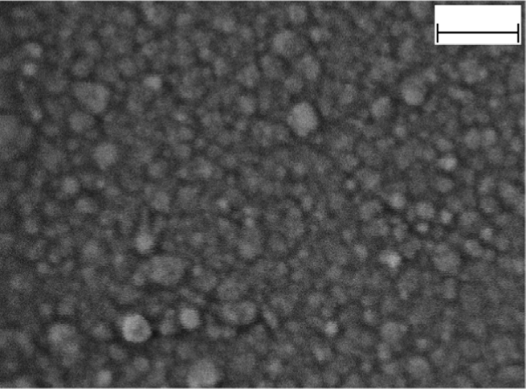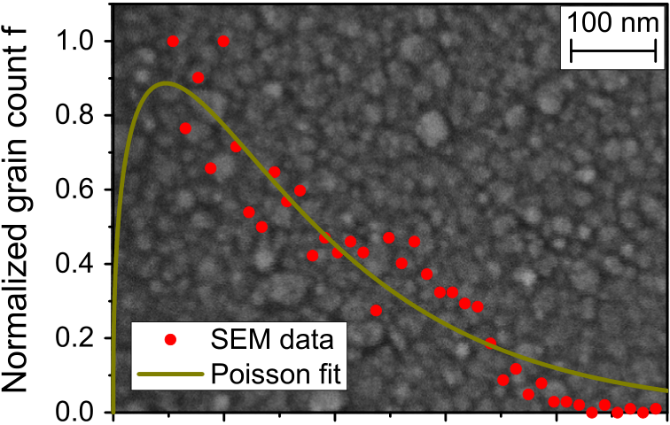

|  |  |  |  |  |  |  |  |
| --- | --- | --- | --- | --- | --- | --- | --- |
| 158 |  |  |  |  |  |  | M. Hoffmann et al. |
|  |  |  |  |  |  |  |  |
|  |
|  | | |

Figure 4 Frequency distribution of grain radii (red dots) extracted from SEM measurement (background). The Poisson fit of the data f(R) (yellow line) possesses the shape parameter s=1.377+/� 0.234 for the corresponding incomplete gamma function.

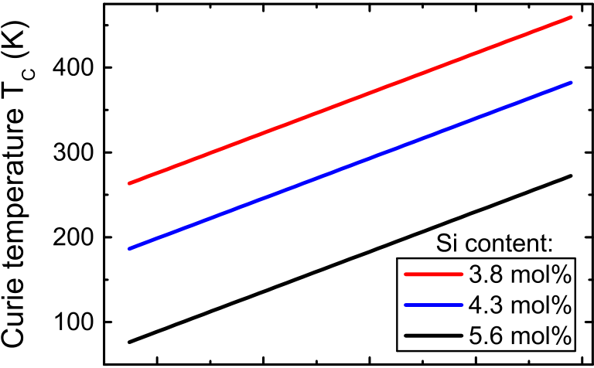

|  |  |  |  |  |
| --- | --- | --- | --- | --- |
|  |  |  |  |  |



Figure 5 Grain size dependent Curie temperature for Si:HfO2 thin films with different Si concentrations under the assumption of the grain size distribution in Figure 4.

We now assume that the spread of the phase transition over temperature in Figure 3 originates from the distribu-tion of grain radii [37,39]. We can then calculate the grain size dependent Curie temperature TC by transforming the distribution of Curie temperatures ΠG(T) with the distribu-tion of grain radii f(R) by

|  |  |
| --- | --- |
| dR ¼ΠG T ð ÞUdTC: ð Þ | ð3Þ |

The result is depicted in Figure 5 and shows that the Curie temperature increases linearly for small grain radii up to 25 nm, whereby the radii are independent of the Si con-centration. However, we cannot completely rule out possi-ble effects of the Si doping on the unit cell volume and grain size distribution within the statistical uncertainties of our analysis, where s was 1.373 +/� 0.333, 1.652 +/� 0.114 samples, respectively (see Figure 3). The trend of increasing and 1.408 +/� 0.141 for 3.8, 4.3 and 5.6 mol% Si.HfO2 TC with grain size is in accordance with results published for BaTiO3 by Glinchuk and Bykov [37].

For the Si concentrations ranging from 3.8 to 5.6 mol%, that showed a clear phase transition within the measured temperature range, the according pyroelectric coefficients

Figure 6 Pyroelectric coefficients as a function of sample temperature as calculated from Pr values in Figure 3 for MIM capacitors with a 9 nm Si:HfO2 layer having a Si content of 3.8 to 5.6 mol%.

ΠG were derived from Eq. (2) with the values from Figure 3 and are depicted in Figure 6. Since an incomplete gamma function was fitted in Figure 3, the derivative with respect to T again yields a Poisson distribution. Very high maximum pyroelectric coefficients of �950, �1100 and �1300 mC/ (m2K) can be extracted for 3.8, 4.3 and 5.6 mol% of Si, respectively. In accordance with Figure 3, the temperature at which maximum ΠG occurs depends strongly on the Si concentration and is lower for higher mol% of Si. These maximum values are considerably high [4,6] and stem mostly

|  |  |  |  |  |  |  |
| --- | --- | --- | --- | --- | --- | --- |
| from | the | orthorhombic | to | tetragonal | phase | transition |

(ΠG EΠM) rather than from the primary and secondary pyroelectric coefficients Π1 and Π2 [3], which coincides with our rather small estimate of 23 mC/(m2K) from section 3 and from Figure 3 where the slope of the curves for temperatures below the smallest phase transition temperatures is almost zero. For this reason, the normalized Pr(T) is the same as cf(T) in our case and the maximum value of ΠG is only determined by the maximum of Pr, as can be seen in Eq. (2).

To further elucidate the magnitude of the phase transi-tion contribution to ΠG, pyroelectric current measurements were carried out for 5.6 mol% Si:HfO2 without an applied electric field. The sample was first cooled down to 173 K and then heated up again to 333 K in two steps. For a tempera-ture change from 173 to 273 K and consecutively from 273 to 333 K, respective absolute values for the pyroelectric coefficients of 32 and 52 mC/(m2K) can be extracted by integration of the pyroelectric currents shown in Figure 7. Since the sample showed only a field-induced ferroelectric hysteresis (i. e. more tetragonal for E=0) at room tem-perature and was getting more orthorhombic during cool-down, but was not poled in this FE state, the measured ΠG during heating is rather small. This might be due to a compensation of the polarization of randomly oriented domains without poling [36]. This strong influence of the poling procedure becomes especially apparent when com-paring the rather small values from Figure 7 to the pyro-electric coefficients in Figure 6 between 173 to 333 K, since the absolute coefficients from Figure 6 are in a range between 150 and 1000 mC/(m2K). The small but non-zero ΠG values obtained from pyroelectric currents in Figure 7 might be explained by only partial residual poling of the layer from the initial hysteresis measurements at room

|  |  |
| --- | --- |
| Ferroelectric phase transitions in nanoscale HfO2 films | 159 |

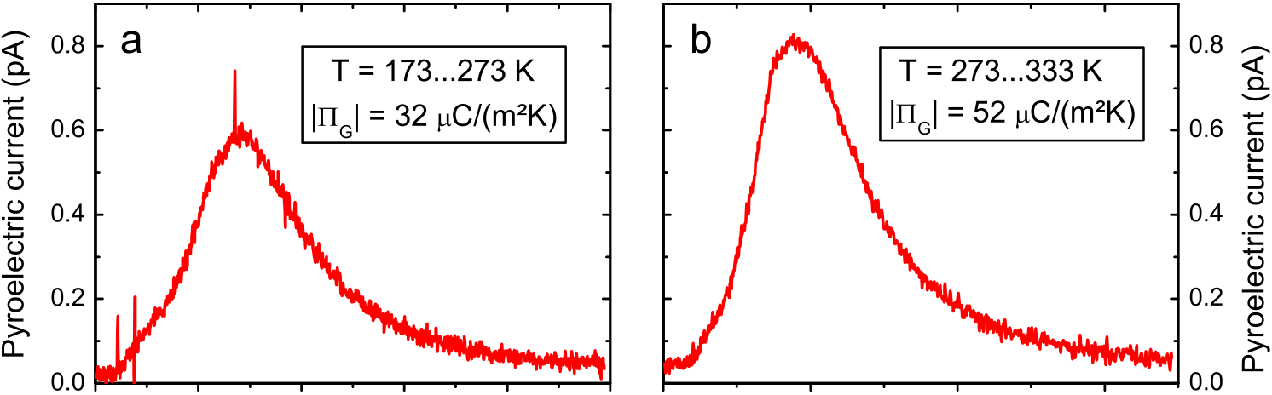

        

 

Figure 7 Pyroelectric coefficients extracted through integration of the current resulting from a temperature change without

applied electric field in Si:HfO2 with 5.6 mol% Si.

|  |  |  |  |  |  |  |  |  |  |  |
| --- | --- | --- | --- | --- | --- | --- | --- | --- | --- | --- |
| Table 1 | Comparison of pyroelectric figures of merit for various materials. | | | | | | |  |  |  |
| Material | ΠG | | T | εr | FV | | FI | FD | k2 | Ref. |
| [mC/(m2K)] | | | [K] | [V m2/J] | | | [10�10m/V] | [10�5m3/2J�1/2] |
| 3.8 mol% Si:HfO2 | | �950a �1100a �1300a �52 �254a �380 �25 �280 �1790 | 325 | 24 | | – | – | – | 0.522 | This work |
| 4.3 mol% Si:HfO2 | | 273 | 26 | | – | – | – | 0.591 | This work |
| 5.6 mol% Si:HfO2 | | 125 | 34 | | – | – | – | 0.504 | This work |
| Hf0.2Zr0.8O2 | | 300 | 38 | | 0.06 | 0.20 | 0.7 | 0.001 | [32] |
| 300 | 35 | | – | – | – | 0.024 |
| PZT | | 300 | 290 | | 0.06 | 1.50 | 5.8 | 0.007 | [10] |
| PVDF | | 300 | 9 | | 0.14 | 0.11 | 0.7 | 0.001 | [10] |
| TGS | | 300 | 38 | | 0.36 | 1.21 | 6.6 | 0.030 | [10] |
| PMN-0.25PT | | 300 | 2100 | | 0.04 | 7.16 | – | 0.021 | [4] |

|  |
| --- |
| aCalculated from polarization hysteresis measurements. |

temperature. This indicates that a poling procedure might be necessary to use these films in highly sensitive pyro-electric detectors. However, in contrast to HfxZr1�xO2 films [32], no constant applied field is mandatory to observe pyroelectricity in Si:HfO2. This enables feasible infrared detection with these new pyroelectric materials for the first time, because leakage currents would superimpose the small pyroelectric currents in HfxZr1�xO2 when a constant field is applied.

Pyroelectric energy harvesting and infrared detection

Several FOMs for pyroelectric devices like infrared detectors and PEH have been established over the years [2,4,10,18], most of which can be calculated from basic material

|  |  |  |  |  |  |  |
| --- | --- | --- | --- | --- | --- | --- |
| properties like the pyroelectric coefficient ΠG, the volume specific heat CE, the dielectric permittivity ε and the maximum working temperature Thot. Commonly used FOMs | | | | | | |
| for | infrared | sensing | include | the | voltage | responsivity |
| FV ¼ ðCEεÞ, the current responsivity FI ¼ ~~Π~~G ΠG CEand the signal-  to-noise FOM FD ¼ to be used, since highly hysteretic phase transitions as seen ðCEffiffiffiffiffiffiffiffiffiffiffiffiffiffi Þ. Here, ΠG from Figure 7 has | | | | | | |

in the P–E curves in Figure 1 are not suitable to build infrared sensors. For PEH on the other hand, the high values for ΠG shown in Figure 6 are applicable, since electric field-cycling of the films is necessary in this case. For such PEH applications, the electrothermal coupling factor k2¼ΠG2Thot is of importance. Table 1 shows the calculated values for the different Si:HfO2 samples investigated here in comparison to other pyroelectric materials reported in literature. Relative permittivity values εr and loss factors tanδ were extracted from temperature and frequency dependent

|  |  |  |  |  |  |
| --- | --- | --- | --- | --- | --- |
| capacitance–voltage | measurements. | For | all | samples | a |

tanδE0.025 was observed over a wide temperature range and even far below 100 Hz, which is the operating regime for many pyroelectric devices. The permittivity increased with increasing temperature and Si concentration, which is in accordance with reports on the electrical characteristics of 3.8 mol% Si:HfO2 [43]. CE values were taken from Ref. [44] and are 2.69, 2.44 and 1.39 MJ/(m3K) for 325, 273 and 125 K, respectively. Additionally, for the 5.6 mol% sample the FOMs were calculated with the pyro-coefficient from Figure 7(b) at 300 K to compare them fairly with other materials for infrared detection.

The very high pyroelectric coefficients of the Si:HfO2 films from hysteresis measurements are unique for lead-

|  |  |  |  |  |  |  |  |  |  |  |  |
| --- | --- | --- | --- | --- | --- | --- | --- | --- | --- | --- | --- |
| 160 | | | | | | | | | | | M. Hoffmann et al. |
| Table 2 | Comparison of achievable harvestable energy densities for different pyroelectric materials. | | | | | | | | | |  |
| Material | | ND [J cm�3] | Thickness | | | ΔE [MV/cm] | | | ΔTHL [K] | Method | Ref. |
| 5.6 mol% Si:HfO2 | | 20.27a | 9 nm | 3.33 | | | 320a | | | indirect | This work  This work  This work  [32]  [18]  [46] |
| 7.52 | | | 125 | | | | | | | |
| 4.3 mol% Si:HfO2 | | 5.74a | 9 nm | 1.89 | | | 160a | | | indirect |
| 3.61 | | | 80 | | | | | | | |
| 3.8 mol% Si:HfO2 | | 3.26 | 9 nm | 0.89 | | | 160 | | | indirect |
| Hf0.2Zr0.8O2 | | 11.55 | 9.2 nm | | 3.26 | | 150 | | | indirect |
| P(VDF-TrFE) | | 0.52 | 50 mm | | 0.30 | | | 85 | | direct |
| YbFO | | 7.57 | 60 nm | | 4.00 | | 285 | | | indirect |
|  | | | | | | | | | | | |

|  |
| --- |
| aCalculated for the whole temperature range, with TL below room temperature. |

thermal imaging with high resolution might be interesting,

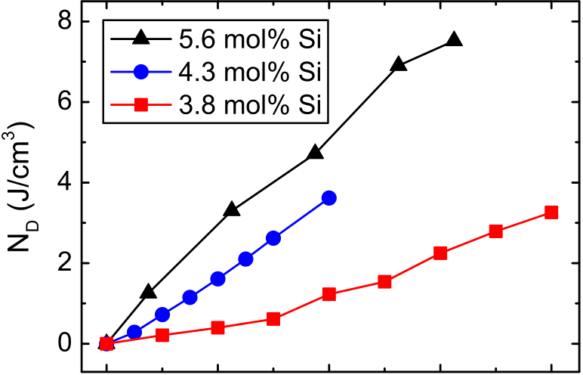

|  |  |  |  |  |
| --- | --- | --- | --- | --- |
|  |  |  |  |  |



Figure 8 Harvestable energy density per Olsen cycle ND as a function of ΔTHL with TL=298 K for different Si concentrations with different applied fields (see Table 2).

free, non-perovskite materials with a relatively low permit-tivity. This leads to exceptionally good k2values compared to other material systems. It should be noted, that the similar Hf0.2Zr0.8O2 films reported in [32] showed practically no pyroelectricity without an applied field, making them undesirable for pyroelectric sensor applications in the investigated temperature range. Additionally, they calcu-lated FV and FI values with ΠG from P–E measurements, which is not reasonable for infrared sensor applications. Therefore, these values were not included in Table 1. Our Si:HfO2 films on the other hand show for the first time pyroelectricity in HfO2 without an applied electric field only from a change in temperature.

FV is comparable to the values reported PZT [10] and single crystals of 0.75Pb(Mg1/3Nb2/3)O–0.25PbTiO3 (PMN-0.25PT) [4]. While FI is lower than most materials in Table 1 it is almost twice as high compared to PVDF [10]. Additionally, the signal-to-noise FOM FD is also comparable to PVDF [10]. The electrothermal coupling factors k2for Si: HfO2 calculated here are more than one order of magnitude higher compared to the best values reported so far and even two and a half orders of magnitude higher than for example PVDF and many other materials [4,10]. These characteris-tics show, that Si:HfO2 can in principle be applied in infrared detectors. Especially, an integration into arrays on a chip for

since the Si:HfO2 films are predestined for deposition and patterning on a semiconductor substrate.

The application of PEH on the other hand seems ideally suited for this material system. For PEH using the Olsen cycle (which is a modified Ericsson heat engine cycle [15]), the pyroelectric film between two electrodes is subjected alternately to a cold and a hot source at temperatures TL and TH, respectively, while applying either a low or a high electric field [18]. The first step in the Olsen cycle corresponds to isothermal increase of the electric field from E1 to E2 at TL. Subsequently, the material is heated to TH in an isoelectric process. This is followed by a reduction of E2 back to E1 at TH and finally the cycle is closed by reducing the temperature to TL again at constant field E1 [45]. It was shown that these types of Olsen cycles can be 100 times more efficient compared to other harvesting cycles [15]. The harvestable energy density per Olsen cycle ND for a given temperature change ΔTHL=TH – TL and applied electric fields can then be calculated as

|  |  |  |  |  |
| --- | --- | --- | --- | --- |
| ND ¼ | E1 ZE2 | h P TL ð | Þ�PðTHÞ i dE: | ð4Þ |

Figure 8 shows ND as a function of ΔTHL with TL=298 K, which is the most important operating condition for PEH of low grade waste heat. ND increases for larger ΔTHL and for the 5.6 mol% sample, almost 8 J/cm3can be achieved for ΔTHL=120 K. It should be noted, that ND was calculated with different ΔE=E2�E1 for the different samples, which is the main reason for the different slopes in Figure 8. In other applications, for example PEH in space, also tem-perature ranges far below 300 K are of interest. Therefore, we also calculated ND over the whole temperature range that was available from our measurement data.

Table 2 shows the ND values of our films compared to other publications together with the respective film thick-ness, the difference in the electric field ΔE and the temperature change ΔTHL. As can be seen, Si:HfO2 thin films enable high harvestable energy densities compared to other materials like P(VDF-TrFE). For room temperature applications, our samples are not as good as Hf0.2Zr0.8O2, which show the highest ND, but also at higher ΔTHL. Samples with reduced Si content have a lower ND, but ΔE was much smaller in these cases. For the highest concentration of Si

|  |  |
| --- | --- |
| Ferroelectric phase transitions in nanoscale HfO2 films | 161 |

we show here the largest ND value ever reported for ΔTHL=320 K, which is almost twice as big compared to Hf0.2Zr0.8O2 [32]. This would be very favorable for PEH in very low temperature environments such as space. It should be noted however, that these values were extracted by an indirect method from the P–E hysteresis curves, since direct measurements are much more difficult to perform. Never-theless, these results show the vast potential of Si:HfO2 thin films for PEH applications. In a similar argument as in Section 4.1 for the electrostatic energy storage, 3D integra-tion of these films might be used to enhance their harvest-ing capabilities per projected area even further [32]. Direct integration on a chip seems like an attractive option to generate electric energy in monolithic autonomous sensor applications.

Electrocaloric cooling

Since the ECE is the inverse of the pyroelectric effect, a look at the electrocaloric properties of these Si:HfO2 films is also of interest. Based on the Maxwell relation ð∂P a reversible adiabatic temperature change ΔT can be∂TÞE¼ ð∂S∂EÞT,

calculated from measured P(T) vs. E curves, the density ρ and the specific heat capacity Cp [7]:

|  |  |  |  |  |  |  |
| --- | --- | --- | --- | --- | --- | --- |
| ΔT ¼ �1 ρCp | E1 ZE2 | T | �∂T∂P | �E | dE: | ð5Þ |

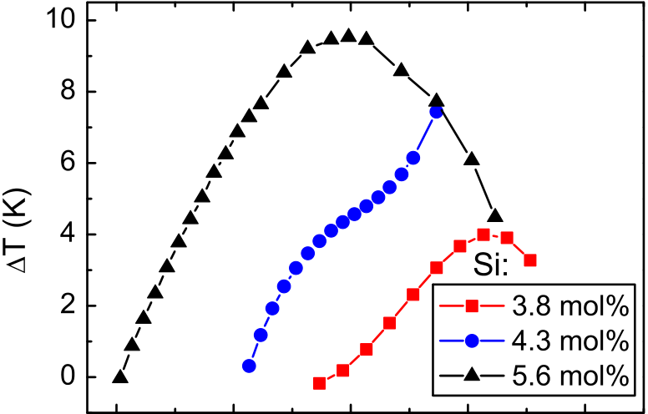

This adiabatic temperature change stems from an iso-thermal entropy change ΔS, which is caused by poling of a ferroelectric layer with an external electric field E:

|  |  |  |  |  |  |
| --- | --- | --- | --- | --- | --- |
| ΔS ¼ | E1 ZE2 | �∂T∂P | �E | dE: | ð6Þ |

For calculation of ΔT, temperature dependent specific heat capacity values were taken from ref. [44] and a density of 9.6 g/cm3was determined by X-ray reflectivity measure-ments. By using an inverse Olsen cycle on a MIM capacitor, this entropy change can be used in an electrocaloric cooling device. The calculated ΔT values for different temperatures and Si concentrations are shown in Figure 9. For higher Si content, the achievable ΔT is also higher and reaches a maximum of about 9.5 K for 5.6 mol% Si at room tempera-ture. Lower Si content leads to a shift of the maximum ΔT to higher temperatures corresponding to a higher phase transition temperature of the grains, which is in agreement with Figure 3. Table 3 gives an overview of the electro-caloric properties reported here in comparison to some of the best values reported in literature.

While the maximum ΔT is not as high compared to for example PbZr0.95Ti0.05O3 [7] or Pb0.8Ba0.2ZrO3 [12], our films are compatible with semiconductor fabrication technology, which is important for prospective applications like on-chip cooling. Nevertheless, ΔT values are superior to many monocrystals and bulk ceramics [5]. Examining ΔT divided

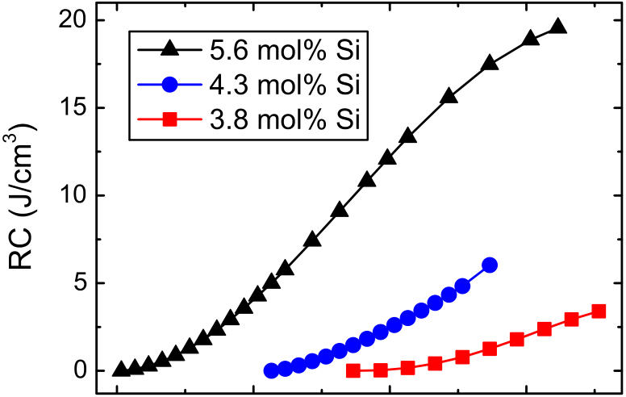

|  |  |  |  |  |  |  |  |  |  |  |
| --- | --- | --- | --- | --- | --- | --- | --- | --- | --- | --- |
| Figure 9 |  |  |  |  |  | Figure 10 |  |  |  |  |
|  | | | | |  | | | |
| Temperature change achievable through the giant | | | | | Refrigerant capacity RC as a function of TH | | | |

electrocaloric effect in Si:HfO2 thin films as a function of temperature and Si content.

calculated for different Si concentrations. TL is 103, 213 and 273 K for 5.6, 4.3 and 3.8 mol% of Si, respectively.

|  |  |  |  |  |  |  |  |  |
| --- | --- | --- | --- | --- | --- | --- | --- | --- |
| Table 3 | Comparison of electrocaloric material properties for various thin films. | | | | | |  |  |
| Material | | ΔTmax | at T | Thickness | ΔE | ΔSmax | ΔTmax/ΔE | Ref. |
| [K] | | | [K] | [nm] | [MV/cm] | [mJ/(K cm3)] | [K cm/kV] |
| 3.8 mol% Si:HfO2 | | 4 | 413 | 9 | 1.00 | 29.2 | 0.004 | This work |
| 4.3 mol% Si:HfO2 | | 7.4 | 373 | 9 | 2.33 | 59.3 | 0.003 | This work |
| 5.6 mol% Si:HfO2 | | 9.5 | 298 | 9 | 3.33 | 85.5 | 0.003 | This work |
| Hf0.2Zr0.8O2 | | 13.4 | 298 | 9.2 | 3.26 | 96 | 0.004 | [32] |
| Hf0.3Zr0.7O2 | | 8.9 | 448 | 9.2 | 3.26 | 49 | 0.003 | [32] |
| PbZr0.95Ti0.05O3 | | 12 | 495 | 350 | 0.71 | 66 | 0.017 | [7] |
| Pb0.8Ba0.2ZrO3 | | 45.3 | 290 | 320 | 0.59 | 361 | 0.076 | [12] |

|  |  |
| --- | --- |
| 162 | M. Hoffmann et al. |

by the field difference ΔE as a FOM, Si:HfO2 shows values comparable to HfxZr1�xO2 [32]. Another interesting FOM describing the amount of heat that can be extracted during

|  |  |  |  |  |
| --- | --- | --- | --- | --- |
| temperature- | and | field-induced | phase | transformations |

between the ferroelectric orthorhombic and the paraelec-tric tetragonal phase. The corresponding transition tem-

|  |  |  |  |  |  |  |  |  |  |  |  |
| --- | --- | --- | --- | --- | --- | --- | --- | --- | --- | --- | --- |
| one ideal cooling cycle is the refrigerant capacity RC [47]: | | | | peratures | can | be | adjusted | by | different | Si | doping |
| RC ¼ | TL ZTH | ΔSdT: | ð7Þ | concentrations over a wide temperature range. Si:HfO2 also has many advantages over other prospective materials for these applications: It is a lead-free, simple binary oxide that is highly compatible with standard semiconductor manufac- | | | | | | | |

The highest RC values calculated for 3.8, 4.3 and 5.6 mol-% Si:HfO2 were 3.4 (at 0.9 V for ΔTHL=160 K), 6.0 (at 2.1 V for ΔTHL=160 K) and 19.6 J/cm3(at 3 V for ΔTHL=320 K), respectively. These values are shown in Figure 10 and are considerably higher than values reported for magnetocaloric materials [47] and electrocaloric HfxZr1�xO2 [32] which are all below 7 J/cm3and 14 J/cm3, respectively. However, it should be noted that in these studies, only smaller tem-perature ranges were considered. The corresponding RC values for other temperature ranges can be easily calcu-lated as the difference of two RC values in Figure 10 at the corresponding TH and TL. Above room temperature, the highest value for 5.6 mol% of Si is about 8 J/cm3for ΔTHL=120 K. In fact, by shifting the curves in Figure 10 in such a way that TL=298 K, one would get a very similar picture as seen in Figure 8. This shows the great potential of Si:HfO2 thin films also for solid state cooling applications especially for integration on a chip, which might be used as an effective way to directly extract heat from highly integrated circuits. This could relax constraints put on circuit design because of very high areal power densities.

While the very small thickness of our films allows the use of low voltages, for an application in real devices it is necessary to scale up the film thickness without degradation of the material properties [32]. There are several different strategies that have been reported so far. The use of other dopants like Gd or Sm might be a viable option [48,49]. Gd: HfO2 samples prepared by ALD showed no reduction of Pr up to thicknesses of about 30 nm [48]. Other fabrication tech-niques like pulsed laser deposition [49] or chemical solution deposition [50] have been shown to yield film thicknesses of up to 60 nm and 70 nm, respectively and even thicker films should be easily achievable. Therefore, choosing the right dopant and deposition method will be critical for actual applications using HfO2 based ferroelectrics. Additionally, the use of thin interlayers of Al2O3 was shown to enable thicker ALD films by keeping the grain size of HfxZr1�xO2 small enough to stabilize the ferroelectric phase [51]. As already pointed out before, a smaller thickness of ferroelectric HfO2 films might also be compensated by using 3D integration and thus increasing of the effective area and volume of the films per projected substrate area.

turing and can be easily integrated into 3D-capacitor structures to significantly enhance its properties per pro-jected chip area.

Large ESD values of about 40 J/cm3were shown for 5.6 mol% Si:HfO2 films with a very high efficiency of 80% over a wide temperature range. This might enable highly efficient on-chip supercapacitors with a small footprint. Furthermore, giant pyroelectric coefficients of up to

ments which stem mainly from the aforementioned phase�1300 mC/(m2K) were extracted from hysteresis measure-

transition. The wide transition temperature range was related to the grain size distribution in the polycrystalline films, since smaller grains have a lower Curie temperature. The high pyro-coefficients combined with a relatively low permittivity lead to exceptionally high FOMs for PEH devices. Here, we calculated the to our knowledge highest value ever reported for k2=0.591. This electrothermal coupling factor is one to two orders of magnitude higher than the best values reported so far. In contrast to recently reported HfxZr1�xO2 films [32], giant pyroelectricity was observed at zero external fields. Additionally, harvestable energy densities ND of up to 20.27 J/cm3per Olsen cycle surpass the best results found in literature by a factor of two. The applicability of this material in infrared detectors was shown here for the first time in principle. Electrocaloric cooling applications also benefit from these giant pyro-electric properties of Si:HfO2 thin films. A maximum adia-batic temperature change ΔT=9.5 K was found for 5.6 mol% of Si at room temperature. Lower concentrations showed even better values of ΔT normalized to the applied field with up to 0.004 K cm/V. The refrigerant capacity was calculated to be higher than the best reported values with 19.6 J/cm3per inverse Olsen cycle.

In conclusion, Si:HfO2 is a unique material system for highly efficient supercapacitors, infrared detectors, giant pyroelectric energy harvesting and electrocaloric cooling. Its extraordinary properties stem from ferroelectric to paraelectric phase transitions that can be tailored to the desired application by adjusting the Si content. Further-more, manufacturing of these films is ideally suited for monolithic on-chip integration in 3D structures with existing semiconductor process technology.

|  |  |
| --- | --- |
| Conclusions | Acknowledgments |

The authors like to thank T. Boescke and G. Jaschke for

|  |  |  |  |  |  |
| --- | --- | --- | --- | --- | --- |
| The | only | recently | discovered | ferroelectric | nanoscale |

Si:HfO2 films are reported to exhibit remarkable pyroelec-tric and energy storage properties for a Si content between 3.8 and 5.6 mol%. We have shown that this stems from

capacitor processing as well as S. Piontek for SEM, D. Pohl for TEM, J. Gärtner for AFM measurements and the German Research Foundation (DFG) for funding within the Inferox project (Project no. MI 1247/11-1).

|  |  |  |
| --- | --- | --- |
| Ferroelectric phase transitions in nanoscale HfO2 films | | 163 |
| Appendix A. | Supplementary material | [31] [M.H. Park, H.J. Kim, Y.J. Kim, T. Moon, K.D. Kim, C.S. Hwang,](http://refhub.elsevier.com/S2211-2855(15)00384-5/sbref29) |

[Adv. Energy Mater. (2014) 1400610.](http://refhub.elsevier.com/S2211-2855(15)00384-5/sbref29)

Supplementary data associated with this article can be found in the online version at [http://dx.doi.org/10.1016/ j.nanoen.2015.10.005](http://dx.doi.org/10.1016/j.nanoen.2015.10.005).

[32] [M.H. Park, H.J. Kim, Y.J. Kim, T. Moon, K.D. Kim, C.S. Hwang,](http://refhub.elsevier.com/S2211-2855(15)00384-5/sbref30)  [Nano Energy 12 (2015) 131–140.](http://refhub.elsevier.com/S2211-2855(15)00384-5/sbref30)

[33] [J. Grindlay, An Introduction to the Phenomenological Theory](http://refhub.elsevier.com/S2211-2855(15)00384-5/sbref31)  [of Ferroelectricity, Pergamon Press Ltd, Oxford, 1970.](http://refhub.elsevier.com/S2211-2855(15)00384-5/sbref31)

|  |  |
| --- | --- |
| References | [34] [A.S. Bhalla, R.E. Newnham, Phys. Status Solidi A 58 (1980)](http://refhub.elsevier.com/S2211-2855(15)00384-5/sbref32)  [K19–K24.](http://refhub.elsevier.com/S2211-2855(15)00384-5/sbref32) |

[35] [R.N. Patil, E.C. Subbarao, J. Appl. Cryst. 2 (1969) 281–288.](http://refhub.elsevier.com/S2211-2855(15)00384-5/sbref33)

[1] [G. Sebald, E. Lefeuvre, D. Guyomar, IEEE Trans. Ultrason.](http://refhub.elsevier.com/S2211-2855(15)00384-5/sbref1)  [36] [J.Y. Li, Mech. Mater. 36 (2004) 949–958.](http://refhub.elsevier.com/S2211-2855(15)00384-5/sbref34)

[Ferroelectr. Freq. Control 55 (2008) 538–551.](http://refhub.elsevier.com/S2211-2855(15)00384-5/sbref1)  [37] M.D. Glinchuk, P.I. Bykov, arXiv:cond-mat/0406032 [cond-mat.

[2] [R.W. Whatmore, Rep. Prog. Phys. 49 (1986) 1335–1386.](http://refhub.elsevier.com/S2211-2855(15)00384-5/sbref2)  mtrl-sci], 2004.

[3] [S.B. Lang, Phys. Today 58 (2005) 31–36.](http://refhub.elsevier.com/S2211-2855(15)00384-5/sbref3)  [38] [R. Materlik, C. Künneth, A. Kersch, J. Appl. Phys. 117 (2015)](http://refhub.elsevier.com/S2211-2855(15)00384-5/sbref35)

[4] [C.R. Bowen, J. Taylor, E. LeBoulbar, D. Zabek, A. Chauhan,](http://refhub.elsevier.com/S2211-2855(15)00384-5/sbref4)  [134109.](http://refhub.elsevier.com/S2211-2855(15)00384-5/sbref35)

[R. Vaish, Energy Environ. Sci. 7 (2014) 3836.](http://refhub.elsevier.com/S2211-2855(15)00384-5/sbref4)  [39] [K. Keizer, A.J. Burggraaf, Phys. Status Solidi A 26 (1974)](http://refhub.elsevier.com/S2211-2855(15)00384-5/sbref36)

[5] [M. Ožbolt, A. Kitanovski, J. Tušek, A. Poredoš, Int. J. Refrig. 40](http://refhub.elsevier.com/S2211-2855(15)00384-5/sbref5)  [561–569.](http://refhub.elsevier.com/S2211-2855(15)00384-5/sbref36)

[(2014) 174–188.](http://refhub.elsevier.com/S2211-2855(15)00384-5/sbref5)  [40] [T.S. Böscke, St Teichert, D. Bräuhaus, J. Müller, U. Schröder,](http://refhub.elsevier.com/S2211-2855(15)00384-5/sbref37)

[6] [S.P. Alpay, J. Mantese, S. Trolier-McKinstry, Q. Zhang, R.](http://refhub.elsevier.com/S2211-2855(15)00384-5/sbref6)  [W. Whatmore, MRS Bull. 39 (2014) 1099–1111.](http://refhub.elsevier.com/S2211-2855(15)00384-5/sbref6)

[7] [A.S. Mischenko, Q. Zhang, J.F. Scott, R.W. Whatmore, N.](http://refhub.elsevier.com/S2211-2855(15)00384-5/sbref7)  [D. Mathur, Science 311 (2006) 1270–1271.](http://refhub.elsevier.com/S2211-2855(15)00384-5/sbref7)

[8] [S.R. Hunter, N.V. Lavrik, S. Mostafa, S. Rajic, P.G. Datskos,](http://refhub.elsevier.com/S2211-2855(15)00384-5/sbref8)  [Proc. SPIE 8377 (2012) 83770D–83771D.](http://refhub.elsevier.com/S2211-2855(15)00384-5/sbref8)

[9] [M. Valant, Prog. Mater. Sci. 57 (2012) 980–1009.](http://refhub.elsevier.com/S2211-2855(15)00384-5/sbref9)

[10] [B. Ploss, S. Bauer, Sens. Actuators A 25–27 (1991) 407–411.](http://refhub.elsevier.com/S2211-2855(15)00384-5/sbref10) [11] [G. Sebald, L. Seveyrat, D. Guyomar, L. Lebrun, B. Guiffard,](http://refhub.elsevier.com/S2211-2855(15)00384-5/sbref11)

[U. Böttger, T. Mikolajick, Appl. Phys. Lett. 99 (2011) 112904.](http://refhub.elsevier.com/S2211-2855(15)00384-5/sbref37)

|  |  |  |  |  |  |
| --- | --- | --- | --- | --- | --- |
| [41] [P.](http://refhub.elsevier.com/S2211-2855(15)00384-5/sbref38) | [Banerjee, I.](http://refhub.elsevier.com/S2211-2855(15)00384-5/sbref38) | [Perez,](http://refhub.elsevier.com/S2211-2855(15)00384-5/sbref38) | [L.](http://refhub.elsevier.com/S2211-2855(15)00384-5/sbref38) | [Henn-Lecordier, S.B.](http://refhub.elsevier.com/S2211-2855(15)00384-5/sbref38) | [Lee, G.](http://refhub.elsevier.com/S2211-2855(15)00384-5/sbref38) |

[W. Rubloff, Nat. Nanotechnol. 4 (2009) 292–296.](http://refhub.elsevier.com/S2211-2855(15)00384-5/sbref38)

[43] [D. Zhou, J. Müller, J. Xu, S. Knebel, D. Bräuhaus, U. Schröder,](http://refhub.elsevier.com/S2211-2855(15)00384-5/sbref40)  [Appl. Phys. Lett. 100 (2012) 082905.](http://refhub.elsevier.com/S2211-2855(15)00384-5/sbref40)

[44] [W. Zhou, Q. Shi, B.F. Woodf](http://refhub.elsevier.com/S2211-2855(15)00384-5/sbref41)i[eld, A. Navrotsky, J. Chem,](http://refhub.elsevier.com/S2211-2855(15)00384-5/sbref41)  [Thermodynamics 43 (2011) 970–973.](http://refhub.elsevier.com/S2211-2855(15)00384-5/sbref41)

[45] [I.M. McKinley, L. Pilon, Appl. Phys. Lett. 102 (2013) 023906.](http://refhub.elsevier.com/S2211-2855(15)00384-5/sbref42) [46] [G. Vats, H.S. Kushwaha, R. Vaish, Mater Res, Express 1 (2014)](http://refhub.elsevier.com/S2211-2855(15)00384-5/sbref43)

[S. Pruvost, J. Appl. Phys. 100 (2006) 124112.](http://refhub.elsevier.com/S2211-2855(15)00384-5/sbref11)  [015503.](http://refhub.elsevier.com/S2211-2855(15)00384-5/sbref43)

[12] [B. Peng, H. Fan, Q. Zhang, Adv. Funct. Mater. 23 (2013)](http://refhub.elsevier.com/S2211-2855(15)00384-5/sbref12)  [47] [K.A. Gschneider Jr, V.K. Pecharsky, A.O. Tsokol, Rep. Prog.](http://refhub.elsevier.com/S2211-2855(15)00384-5/sbref44)

[2987–2992.](http://refhub.elsevier.com/S2211-2855(15)00384-5/sbref12)  [Phys. 68 (2005) 1479–1539.](http://refhub.elsevier.com/S2211-2855(15)00384-5/sbref44)

[13] [X. Hao, J. Zhai, Appl. Phys. Lett. 104 (2014) 022902.](http://refhub.elsevier.com/S2211-2855(15)00384-5/sbref13)

[14] [F. Guo, B. Yang, S. Zhang, F. Wu, D. Liu, P. Hu, Y. Sun, D. Wang,](http://refhub.elsevier.com/S2211-2855(15)00384-5/sbref14)  [W. Cao, Appl. Phys. Lett. 103 (2013) 182906.](http://refhub.elsevier.com/S2211-2855(15)00384-5/sbref14)

[15] [G. Sebald, S. Pruvost, D. Guyomar, Smart Mater. Struct. 17](http://refhub.elsevier.com/S2211-2855(15)00384-5/sbref15)

[48] [M. Hoffmann, U. Schroeder, T. Schenk, T. Shimizu, H. Funakubo, O. Sakata, D. Pohl, M. Drescher, C. Adelmann, R. Materlik, A. Kersch, T. Mikolajick, J. Appl. Phys. 118 (2015) 072006.](http://refhub.elsevier.com/S2211-2855(15)00384-5/sbref45)

[49] [Y. Sharma, D. Barrionuevo, R. Agarwal, S.P. Pavunny, R.](http://refhub.elsevier.com/S2211-2855(15)00384-5/sbref46)

[(2008) 015012.](http://refhub.elsevier.com/S2211-2855(15)00384-5/sbref15)  [S. Katiyar, ECS Solid State Lett. 4 (2015) N13–N16.](http://refhub.elsevier.com/S2211-2855(15)00384-5/sbref46)

[16] [Y. Tongqing, L. Peng, X. Zhuo, Z. Liangying, Y. Xi, Ferro-](http://refhub.elsevier.com/S2211-2855(15)00384-5/sbref16) [electrics 230 (1999) 181–186.](http://refhub.elsevier.com/S2211-2855(15)00384-5/sbref16)

[17] [P.D. Thacher, J. Appl. Phys. 39 (1968) 1996–2002.](http://refhub.elsevier.com/S2211-2855(15)00384-5/sbref17)

[18] [A. Navid, L. Pilon, Smart Mater. Struct. 20 (2011) 025012.](http://refhub.elsevier.com/S2211-2855(15)00384-5/sbref18)

[50] [S. Starschich, D. Griesche, T. Schneller, R. Waser, U. Böttger,](http://refhub.elsevier.com/S2211-2855(15)00384-5/sbref47)  [Appl. Phys. Lett. 104 (2014) 202903.](http://refhub.elsevier.com/S2211-2855(15)00384-5/sbref47)

[51] [H.J. Kim, M.H. Park, Y.J. Kim, Y.H. Lee, W. Jeon, T. Gwon, T. Moon, K.D. Kim, C.S. Hwang, Appl. Phys. Lett. 105 (2014)](http://refhub.elsevier.com/S2211-2855(15)00384-5/sbref48)

[19] [B. Ma, D.-K. Kwon, M. Narayanan, U. Balachandran, J. Mater.](http://refhub.elsevier.com/S2211-2855(15)00384-5/sbref19)  [192903.](http://refhub.elsevier.com/S2211-2855(15)00384-5/sbref48)

[Res. 24 (2009) 2993–2996.](http://refhub.elsevier.com/S2211-2855(15)00384-5/sbref19)

|  |  |  |  |  |  |  |  |  |  |  |
| --- | --- | --- | --- | --- | --- | --- | --- | --- | --- | --- |
| [20] [J. Li, S. Tan, S. Ding, H. Li, L. Yang, Z. Zhang, J. Mater. Chem.](http://refhub.elsevier.com/S2211-2855(15)00384-5/sbref20) |  | Michael | Hoffmann | | received | | | his | | B.Sc. |
| [22 (2012) 23468.](http://refhub.elsevier.com/S2211-2855(15)00384-5/sbref20) | degree in Electrical Engineering and Infor- | | | | | | | | |
| [21] [T.S. Böscke, J. Müller, D. Bräuhaus, U. Schröder, U. Böttger,](http://refhub.elsevier.com/S2211-2855(15)00384-5/sbref21) | mation | Technology | | from | the | | Otto-von- | | |
| [Appl. Phys. Lett. 99 (2011) 102903.](http://refhub.elsevier.com/S2211-2855(15)00384-5/sbref21) | Guericke-University Magdeburg in 2013. He | | | | | | | | |
| [22] [U. Schroeder, E. Yurchuk, J. Müller, D. Martin, T. Schenk,](http://refhub.elsevier.com/S2211-2855(15)00384-5/sbref22) | is currently pursuing a M.Sc. degree in | | | | | | | | |
| [P. Polakowski, C. Adelmann, M.I. Popovici, S.V. Kalinin,](http://refhub.elsevier.com/S2211-2855(15)00384-5/sbref22) | Microelectronics at Technische Universität | | | | | | | | |
| [T. Mikolajick, Jpn. J. Appl. Phys. 53 (2014) 08LE02.](http://refhub.elsevier.com/S2211-2855(15)00384-5/sbref22) | Dresden | in | collaboration | | | with | | NaMLab | |
| [23] [J. Müller, T.S. Böscke, U. Schröder, S. Mueller, D. Bräuhaus,](http://refhub.elsevier.com/S2211-2855(15)00384-5/sbref23) | gGmbH. | His | current | research | | | interests | | |
| [U. Böttger, L. Frey, T. Mikolajick, Nano Lett. 12 (2012) 4318–4323.](http://refhub.elsevier.com/S2211-2855(15)00384-5/sbref23) | include ferroelectric HfO2 and ZrO2 based | | | | | | | | |
| [24] X. Sang, E.D. Grimley, T. Schenk, U. Schroeder, J.M. LeBeau, | thin films for low power computing, sensors | | | | | | | | |

[Appl. Phys. Lett. 106 (2015) 162905.](http://refhub.elsevier.com/S2211-2855(15)00384-5/sbref24)

[25] [S.E. Reyes-Lillo, K.F. Garrity, K.M. Rabe, Phys. Rev. B 90 (2014)](http://refhub.elsevier.com/S2211-2855(15)00384-5/sbref25)  [140103.](http://refhub.elsevier.com/S2211-2855(15)00384-5/sbref25)

and energy applications as well as the reliability of high-k dielec-trics in advanced nanoelectronic devices.

|  |  |  |  |  |  |  |  |  |
| --- | --- | --- | --- | --- | --- | --- | --- | --- |
| [26] [S. Mueller, J. Müller, U. Schroeder, T. Mikolajick, IEEE Trans.](http://refhub.elsevier.com/S2211-2855(15)00384-5/sbref26) |  | Uwe | Schroeder | | received | his | | doctoral |
| [Device Mater. Reliab. 13 (2013) 93–97.](http://refhub.elsevier.com/S2211-2855(15)00384-5/sbref26) | degree at University of Bonn, Germany | | | | | | |
| [27] J. Müller, E. Yurchuk, T. Schlösser, J. Paul, R. Hoffmann, S. | including a research visit at UC Berkeley | | | | | | |
| Müller, D. Martin, S. Slesazeck, P. Polakowski, J. Sundqvist, M. | and worked at University of Chicago as a | | | | | | |
| Czernohorsky, K. Seidel, P. Kücher, R. Boschke, M. Trentzsch, | post-doctoral researcher. He joined Infineon | | | | | | |
| K. Gebauer, U. Schröder, T. Mikolajick, Symposium on VLSI | formerly Siemens Semiconductor in 1997 for | | | | | | |
| Technology, June 2012, 25–26. | capacitor development in the DRAM Devel- | | | | | | |
| [28] P. Polakowski, S. Riedel, W. Weinreich, M. Rudolf, J. Sundqvist, | opment Alliance with IBM, before transfer- | | | | | | |
| K. Seidel, J. Müller, IEEE 6th International Memory Workshop, | ring | to | Infineon’s | Memory | | Development | |
| May 2014, 1–4. | Center in Dresden, Germany in 2000. There, | | | | | | |

|  |  |  |  |  |  |  |  |
| --- | --- | --- | --- | --- | --- | --- | --- |
| [29] [S.](http://refhub.elsevier.com/S2211-2855(15)00384-5/sbref27) | [Mueller,](http://refhub.elsevier.com/S2211-2855(15)00384-5/sbref27) | [S.R.](http://refhub.elsevier.com/S2211-2855(15)00384-5/sbref27) | [Summerfelt,](http://refhub.elsevier.com/S2211-2855(15)00384-5/sbref27) | [J.](http://refhub.elsevier.com/S2211-2855(15)00384-5/sbref27) | [Müller,](http://refhub.elsevier.com/S2211-2855(15)00384-5/sbref27) | [U.](http://refhub.elsevier.com/S2211-2855(15)00384-5/sbref27) | [Schroeder,](http://refhub.elsevier.com/S2211-2855(15)00384-5/sbref27) |

[T. Mikolajick, IEEE Electron Device Lett. 33 (2012) 1300–1302.](http://refhub.elsevier.com/S2211-2855(15)00384-5/sbref27) [30] [M.H. Lee, Y.-T. Wei, K.-Y. Chu, J.-J. Huang, C.-W. Chen, C.-C. Cheng, M.-J. Chen, H.-Y. Lee, Y.-S. Chen, L.-H. Lee, M.-](http://refhub.elsevier.com/S2211-2855(15)00384-5/sbref28)

he continued the research on high-k dielectrics and their integra-tion into DRAM capacitors. During this time the ferroelectric properties of HfO2 based dielectrics were found. In 2009 he moved to NaMLab and pursued his work on high-k dielectrics and ferro-

[J. Tsai, IEEE Electron Device Lett. 36 (2015) 294–296.](http://refhub.elsevier.com/S2211-2855(15)00384-5/sbref28)  electric HfO2-layers.

|  |  |  |  |  |  |  |  |  |  |  |  |  |  |  |
| --- | --- | --- | --- | --- | --- | --- | --- | --- | --- | --- | --- | --- | --- | --- |
| 164 | Christopher Künneth is a doctoral candi- | | | | | | |  | M. Hoffmann et al. | | | | | |
|  |  | Ulrich Böttger received his diploma degree | | | | | |
| date at the Technical University of Munich | | | | | | | in physics in 1988 and the Dr.-Ing. degree in | | | | | |
| and Munich University of Applied Sciences. | | | | | | | 1994, both from the Rheinisch-Westfälische | | | | | |
| He received his M.Sc. in Micro- and Nano- | | | | | | | Hochschule (RWTH) Aachen. After 4 years as | | | | | |
| technology from the Munich University of | | | | | | | project manager of SMEs he joined RWTH | | | | | |
| Applied | Sciences | in | 2014. | His | current | | Aachen again working in the field of "ferro- | | | | | |
| research | includes | the | ferroelectric | | | and | electric | and | dielectric | thin | films | and |
| pyroelectric behavior of HfO2 and ZrO2 | | | | | | | devices" at the Institute of Electroceramic | | | | | |
| based thin films for memory devices, elec- | | | | | | | Materials (IWE 2). He is author and co- | | | | | |
| tric sensors, energy harvesting and cooling | | | | | | | author of more than 100 scientific papers. | | | | | |

applications.

|  |  |  |  |  |  |  |  |
| --- | --- | --- | --- | --- | --- | --- | --- |
|  | Alfred Kersch received the Ph.D. degree in |  | Thomas Mikolajick received the Diploma and his Ph.D. in electrical engineering from the University Erlangen-Nuremberg in 1990 and 1996. From 1996 till 2006 he was in | | | | |
| theoretical physics from the University of |
| Mainz, Mainz, Germany, in 1990. He then |
| joined the Corporate Research of Siemens | various | positions | in | the | semiconductor |
| AG, the Memory Product Division of Infineon | industry. In late 2006 he moved to the University of Technology Freiberg. In Octo-ber 2009 he started at Technische Universi-tät Dresden were he holds a professorship for nanoelectronic materials together with | | | | |
| AG in 1999, and the Product Division of |
| Qimonda AG in 2006. Since 2009, he has |
| been with the Munich University of Applied |
| Sciences, Munich, Germany. His research |
| interests involve modeling and simulation | the position of scientific director at NaMLab gGmbH. Prof. Mikola- | | | | | |

of microstructures and nanostructures, the methods of fabrication, and the ab initio calculation of high-κ dielectric properties.

|  |  |
| --- | --- |
|  | Sergej Starschich received the M.Sc. degree in electrical engineering from Rheinisch-Westfälische Technische Hochschule Aachen University, Aachen, Germany, in 2012. He is currently working on his Ph.D. at the RWTH Aachen University, investigating the proper-ties of hafnium oxide based ferroelectrics. |

jick´s research interest is in materials for semiconductor devices. He is author or co-author of about 230 scientific publications and inventor or co-inventor of about 50 patents.