This article has been accepted for publication in a future issue of this journal, but has not been fully edited. Content may change prior to final publication. Citation information: DOI 10.1109/LED.2017.2653848, IEEE Electron

|  |  |
| --- | --- |
| Device Letters  > REPLACE THIS LINE WITH YOUR PAPER IDENTIFICATION NUMBER (DOUBLE-CLICK HERE TO EDIT) < | 1 |

HfO2-Based Highly Stable Radiation-Immune

Ferroelectric Memory

Fei Huang†, Yan Wang†, Xiao Liang, Jun Qin, Yan Zhang, Xiufang Yuan, Zhuo Wang, Bo Peng,

Longjiang Deng, Qi Liu*, *Member, IEEE*, Lei Bi*, and Ming Liu, *Senior Member, IEEE*

 

***Abstract*—In this letter, HfO2-based ferroelectric random access memory (FeRAM) with metal-insulator-metal structure is studied for the first time under radiation conditions. Y-doped HfO2-based FeRAM devices show high immunity to 60Co γ ray radiation. Basic FeRAM parameters such as leakage current, permittivity, remanent polarization, endurance and fatigue show almost no degradation after γ ray radiation with a total dose as high as 12.96 Mrad (SI). Furthermore, the ferroelectric hysteresis loops show no distortion after radiation. The high stability of Y-doped HfO2 FeRAM devices under radiation demonstrates their great potential for nuclear and aerospace applications.**

***Index Terms*—HfO2, radiation, ferroelectric random access memory (FeRAM), γ ray.**

I.INTRODUCTION   
F ERROELECTRIC random access memory (FeRAM) has attracted great attention as promising candidates for future high density, low power, and non-volatile memory technology in recent years [1], [2]. One application for FeRAM is to serve for space exploration and nuclear industry [3] due to their high radiation hardness. Up till now, many studies have shown the stability of FeRAM fabricated by lead zirconate titanate (PZT) under radiation environment [4], [5]. However, the scaling problem and poor CMOS compatibility of traditional

This work was supported in part by the National Natural Science Foundation of China under Grant 61475031, 51302027, 51522204 and 61404164, by the National 973 Program of China under Grant 2015CB654901, by the Fundamental Research Funds for the Central Universities under Grant ZYGX2014Z001, by the Science Foundation for Youths of Sichuan Province under Grant 2015JQO014, by the Austrian-Chinese Cooperative R&D Projects under Grant 172511KYSB20150006, by the Ministry of Education Program of Introducing Talents of Discipline (111 project) under Grant B13042, and by the National Research Foundation for the Doctoral Program of Higher Education of China under Grant ZYGX2013J028.

F. Huang, X. Liang, J. Qin, Y. Zhang, X. Yuan, Z. Wang, B. Peng, L. Deng, and L. Bi are with the National Engineering Research Center of Electromagnetic Radiation Control Materials, University of Electronic Science and Technology of China, Chengdu 610054, China, with the State Key Laboratory of Electronic Thin Films and Integrated Devices, University of Electronic Science and Technology of China, Chengdu 610054, China, and also with the Key Laboratory of Multi-spectral Absorbing Materials and Structures of Ministry of Education, University of Electronic Science and Technology of China, Chengdu 610054, China.

Y. Wang, Q. Liu, and M. Liu are with the Key Laboratory of Microelectronics Device & Integrated Technology, Lab of Nanofabrication and Novel Device Integration, IMECAS, Beijing 1000[29, China.](mailto:liuqi@ime.ac.cn)

*[Corresponding a](mailto:bilei@uestc.edu.cn)uthors: Q. Liu(e-mail: [liuqi@ime.ac.cn)](mailto:liuqi@ime.ac.cn) and L.

Bi[(bilei@uestc.edu.cn)](mailto:bilei@uestc.edu.cn) † These authors contribute[d equally to this w](mailto:liuqi@ime.ac.cn)ork.

ferroelectric materials impedes further development of high density, radiation hard FeRAM. HfO2 has been widely adopted as the industry standard gate dielectric in logic and memory devices [6]. Recently reported ferroelectric properties in doped HfO2 triggered the interest in application of these materials in ferroelectric memories [7], which may overcome the scaling problem of traditional ferroelectric memories such as PZT. However, up to now, there has been no report addressing the radiation effects to HfO2-based FeRAM devices. Understanding the radiation effect on HfO2 based FeRAM may promote their application in high radiation environments. In this letter, we report the radiation effect of 60Co γ ray on Y-doped HfO2-based (HYO) FeRAM with a TiN/HYO/TiN structure. Device parameters such as material structures, leakage current, permittivity, remanent polarization (*P*r), endurance and fatigue characteristics are analyzed before and after radiation conditions. We focus on the total ionizing dose (TID) effect in this letter [3], [4]. The device is found to be extremely resistant to γ ray radiations with almost no deterioration for most of the device parameters.

II.EXPERIMENTS

A metal-ferroelectric-metal (MFM) device structure is used for this study. A schematic of the device structure is shown in the inset of Fig. 1(b), which is consisted of a Au/TiN/HYO/TiN ferroelectric capacitor structure. The thickness of HYO, bottom and top TiN layers are 20 nm, 120 nm and 30 nm, respectively. The Y concentration in the HYO film is 3.8 mol%. The ferroelectric phase is crystallized by a post metallization annealing process [8]. The fabrication method of this device is reported in our previous work [8]. The radiation source of this work is 60Co γ ray and the radiation rate is 100 rad/s. During the radiation, devices are in open circuit state and the γ ray is perpendicular to the sample surface. For radiation experiments with electric field bias, a 1.6 V DC bias was applied on the devices. For hysteresis loop measurements, triangle pulses with a frequency of 2 kHz were applied by using a pulse generator unit (B1530A, Agilent). The field amplitude is in the range of 0 MV/cm to 2.5 MV/cm. The switching current was monitored by using a remote-sense and switch unit (RSU, Agilent). The current density-electric field (*J-E*) curves and the capacitance-voltage (*C-V*) curves were measured by using an Agilent B1500A semiconductor device analyzer. In the *C-V* measurements, the AC bias frequency was 50 kHz and the amplitude was 30 mV. The crystal structure of the HYO films

0741-3106 (c) 2016 IEEE. Personal use is permitted, but republication/redistribution requires IEEE permission. See http://www.ieee.org/publications_standards/publications/rights/index.html for more information.

This article has been accepted for publication in a future issue of this journal, but has not been fully edited. Content may change prior to final publication. Citation information: DOI 10.1109/LED.2017.2653848, IEEE Electron

|  |  |
| --- | --- |
| Device Letters  > REPLACE THIS LINE WITH YOUR PAPER IDENTIFICATION NUMBER (DOUBLE-CLICK HERE TO EDIT) < | 2 |

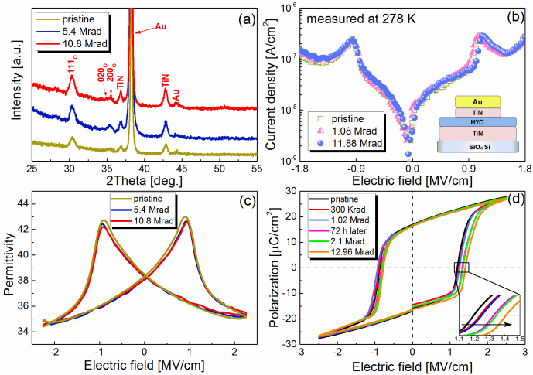

Fig. 1. X-ray diffraction spectrum (a), *J-E* curves (b), *C-V* curves (c), and hysteresis loops (d) of a device with various radiation total doses.

was analyzed by using an X-ray diffractometer (XRD, XRD-7000, SHIMADZU).

III.RESULTS AND DISCUSSION

We first characterized the crystal structure, *J-E*, *C-V* curves and ferroelectric hysteresis of the devices before and after radiation. Fig. 1(a) shows the XRD patterns of devices with various radiation total doses. At the pristine state, diffraction peaks from an orthorhombic phase of HfO2 which contributes to the ferroelectricity are observed. After 5.4 Mrad and 10.8 Mrad radiation, the peak positions and half peak widths are not significantly altered. No diffraction peaks from other phases emerge. The little intensity difference may be caused by the variation of sample position between tests. Therefore, the radiation causes no distinct effect on the crystal structures. The current density-electric field (*J-E*) curves of one device before and after radiation are shown in Fig. 1(b). The *J-E* curve was measured by ramping the voltage from 0 V to 3.6 V and then from 0 V to -3.6 V. Polarization switching current is observed at around ±1.1 MV/cm. After radiation, the leakage current density increases slightly from 1.29×10-7 A/cm2 to 1.56×10-7 A/cm2 at -1.8 MV/cm. It has been investigated that the O2− and

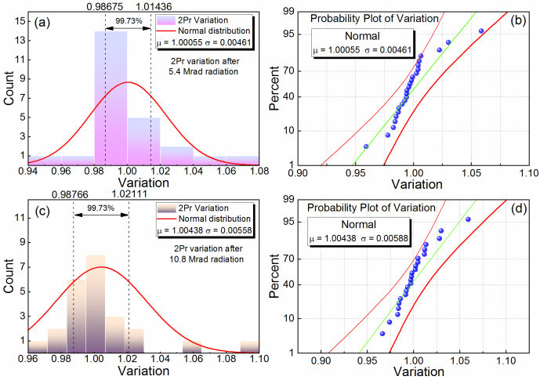

Fig. 2. The distribution of 2*P*r after (a) 5.4 Mrad and (c) 10.8 Mrad radiation, respectively. The probability plot after (b) 5.4 Mrad and (d) 10.8 Mrad radiation is also presented.

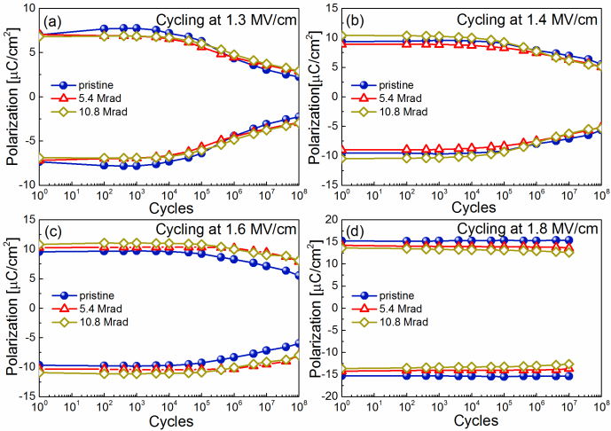

Fig. 3. Fatigue characteristics with various radiation total doses measured at (a) 1.3 MV/cm, (b) 1.4 MV/cm, (c) 1.6 MV/cm, and (d) 1.8 MV/cm, respectively. Devices broke down after 107 cycles when cycling at 1.8 MV/cm.

oxygen vacancies are induced in HfO2 thin films by the γ ray [9]. Therefore, an increase of leakage current can be induced by these defects. The leakage current is highly stable after exposure to γ ray radiation. This is quite different from previous reports in Bi3.25La0.75Ti3O12 (BLT) [10], and Bi3.15Nd0.85Ti3O12 (BNT) [ 11 ] FeRAM devices where the leakage current decreases or increases dramatically after radiation, respectively. The stable leakage current property of our device is beneficial for memory applications. There are also minor changes observed in the capacitance-voltage (*C-V*) curves after 5.4 Mrad and 10.8 Mrad radiation as shown in Fig. 1(c). A decrement of permittivity of about -0.4 % is observed, which is far less than that of BLT [10], PZT [4], and BNT [12] systems. Besides, the *C-V* curves do not display any distortion or asymmetry after the radiation, which is also better than previous reports [10]. Fig. 1(d) shows the ferroelectric hysteresis loops with various radiation total doses. The coercive field is about 1.2 MV/cm, which is slightly larger than that in our previous work [8]. This can be caused by the variation of deposition process conditions.After 1.02 Mrad irradiating, the device was stood for 72 hours to simulate the situation that it restarts after the last work. Although a slight “imprint” effect which were also observed in other reports [4], [13] can be observed in our devices after 72 hours, it does not change the 2*P*r remarkably. The value of 2*P*r remains almost the same as its pristine state even after 12.96 Mrad radiation. This stable performance is significantly better than other ferroelectric reported so far [4], [10]-[13]. materials

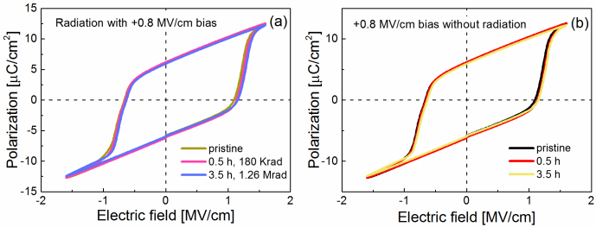

Fig. 4. (a) Characteristics of hysteresis loops before and after radiation with bias electric field. (b) Characteristics of hysteresis loops only with bias electric field.

0741-3106 (c) 2016 IEEE. Personal use is permitted, but republication/redistribution requires IEEE permission. See http://www.ieee.org/publications_standards/publications/rights/index.html for more information.

This article has been accepted for publication in a future issue of this journal, but has not been fully edited. Content may change prior to final publication. Citation information: DOI 10.1109/LED.2017.2653848, IEEE Electron

|  |  |
| --- | --- |
| Device Letters  > REPLACE THIS LINE WITH YOUR PAPER IDENTIFICATION NUMBER (DOUBLE-CLICK HERE TO EDIT) < | 3 |

TABLEI   
COMPARISON OF RADIATION-HARDENED PROPERTIES OF DIFFERENT MATERIALS

|  |  |  |  |  |  |  |  |  |  |  |  |  |
| --- | --- | --- | --- | --- | --- | --- | --- | --- | --- | --- | --- | --- |
| *Material* | *Thickness* | | *Radiation Source* | *TID (Mrad)* | | | *Variation of 2Pr*-28 %  -20 % ~ -30 % -3 %  -25 %  0.4 % | | *Variation of Permittivity* | | | |
| BLT10  PZT4  BNT12  SBT13  HYO (this work) | | 400 nm  400 nm  250 nm  330 nm  20 nm | 60Co γ ray  60Co γ ray  γ ray  60Co γ ray | 10  10  10  3  10.8 | | | About -43 %  About -8 %  N/A  N/A -0.4 % | | | |
| 60Co γ ray |
| To further verify that devices based on HYO ferroelectric thin films are highly stable under radiation, 25 devices are tested and analyzed using a statistical approach. The devices are all 20 μm by 20 μm square pad capacitors which were fabricated on the same wafer at the same time. The whole wafer was subjected to the same doses of radiation. The variation of 2*P*r is defined as 2*P*a/2*P*b. Where 2*P*b and 2*P*a are the 2*P*r value of the devices before and after radiation, respectively. The distribution of 2*P*r after 5.4 Mrad and 10.8 Mrad radiation is shown in Fig. 2(a) and Fig. 2(c). The mathematical expectation (μ) and the standard error of mean (σ) after 5.4 Mrad radiation is 1.00055 and 0.00461, respectively. After 10.8 Mrad radiation, μ and σ turn to 1.00438 and 0.00588, respectively, *i.e.* about 0.4 % variation of the 2*P*r. Compared to -30 % and -28 % variation of 2*P*r after 10 Mrad radiation in PZT [4] and BLT [10] based FeRAM devices, this variation of 2*P*r in HYO devices is very small. As can be seen in Fig. 2(a) and Fig. 2(c), most devices lie in the 99.73 % confidence band. Fig. 2(b) and Fig. 2(d) are the probability plot after 5.4 Mrad and 10.8 Mrad radiation, respectively. The red lines are lower and upper percentile of the 99.73 % confidence band. The green line is the expectation and most samples lie on it. It is reported that the radiation-induced loss in polarization of ferroelectric materials can be explained by the screening effects of the trapped charger carriers [11]. During the ionization process induced by radiation, a mass of electron-hole pairs were generated in the film and were separated by the local electrical field at grain boundaries. They could be captured by defects along the grain boundaries. The trapped charges could screen the switchable polarization. Different from other ferroelectric materials [4], [10]-[13], the driving electric field of HfO2-based ferroelectric films can reach a few MV/cm as the film thickness is much thinner. This field is larger than that in other ferroelectric materials by almost one order of magnitude. Although the grain boundaries may be screened by the charges, the electric domain may still be reversed under such a huge electric field. In this way, the remanent polarization can be slightly influenced by the radiation. However, further investigation is required to verify this speculation.  To verify whether the irradiated devices have cycling endurace variations, we measured the cycling endurace characteristics with various radiation total doses at 1.3 MV/cm, 1.4 MV/cm, 1.6 MV/cm, and 1.8 MV/cm, respectively. Cycling fatigue is observed in all devices. It is observed that higher electric field results in better fatigue endurance. This phenomenon can be explained as the sample contains the maximum concentration of domain walls at the coercive field (corresponding to lower cycling fields) and the wall pinning can take place more easily. The cycling field dependence of fatigue also conforms in our previous report [8]. As shown in | | | | Fig. 3, all devices show similar fatigue behavior as their pristine state after 10.8 Mrad radiation. The little 2*P*r difference is caused by the sample to sample variation. These observations indicate neglegible influence of  ray radiation on the cycling endurace of the device.  The characteristics of hysteresis loops under electric field bias during the radiation are shown in Fig. 4. Since devices were easy to break down at high electric fields after the bonding process, we chose a relatively lower electric field of 1.6 MV/cm to measure the hysteresis loop. The hysteresis loops show little distortion or shift after radiation, which indicates that defects induced by the radiation do not make distinct domain wall pinning in the films. This is in stark contrast to PZT [14] based FeRAM devices. To exclude the effect of applied bias electric field on the hysteresis loops, we also did a control test by only applying electric field but without radiation for the same time. The result is shown in Fig. 4(b). Similar to the result in Fig. 4(a), the hysteresis loops show no obvious changes. The characteristic parameters of our device before and after radiation are summarized in Table I. We also list the radiation-hardened properties of other ferroelectric materials. As can be seen in Table I, devices based on HYO ferroelectric | | | | | | | | |
| films | have | better | | scalability | | and | much | higher |
| radiation-hardened stability.  IV.CONCLUSION  In this letter, the Y-doped HfO2 devices are exposed to 60Co γ ray to investigate the radiation effect on FeRAM performances. The material structure, *J-E* curves, *C-V* curves, hysteresis loops with and without bias field, variation of 2*P*r, and fatige characteristics are tested before and after radiation. Compared to FeRAMs based on traditional ferroelectric materials, HYO based devices show highly stable radiation-hardened properties. Almost all of the basic parameters of FeRAM show very little changes after high dose radiation up to 10 Mrad(SI). The Y-doped HfO2 FeRAM devices demonstrate high immunity from γ ray radiation, providing great promises for future nuclear and aerospace applications.  REFERENCES  [1] J. F. Scott, “Applications of modern ferroelectrics,” *Science.*, vol. 315, no. 5814, pp. 954-959, Feb. 2007, DOI: 10.1126/science.1129564.  [2] S. T. Han, Y. Zhou, and V. A. L. Roy, “Towards the development of flexible non-volatile memories,” *Adv. Mater.*, vol. 25, no. 38, pp. 5425-5449, Oct. 2013, DOI: 10.1002/adma.201301361.  [3]S. Gerardin, and A. Paccagnella, “Present and future non-volatile memories for space,” *IEEE Trans. Nucl. Sci.*, vol. 57, no. 6, pp 3016-3039, Dec. 2010, DOI: 10.1109/TNS.2010.2084101.  [4] S. A. Yang, B. H. Kim, M. K. Lee, G. J. Lee, and N. H. Lee, “Gamma-ray irradiation effects on electrical properties of ferroelectric PbTiO3 and | | | | | | | | |

0741-3106 (c) 2016 IEEE. Personal use is permitted, but republication/redistribution requires IEEE permission. See http://www.ieee.org/publications_standards/publications/rights/index.html for more information.

This article has been accepted for publication in a future issue of this journal, but has not been fully edited. Content may change prior to final publication. Citation information: DOI 10.1109/LED.2017.2653848, IEEE Electron

|  |  |  |
| --- | --- | --- |
| Device Letters  > REPLACE THIS LINE WITH YOUR PAPER IDENTIFICATION NUMBER (DOUBLE-CLICK HERE TO EDIT) < | | 4 |
| [5]  [6] | Pb(Zr0.52Ti0.48)O3 thin films,” *Thin Solid Films.*, vol. 562, pp. 185-189, Jul.  2014, DOI: 10.1016/j.tsf.2014.04.038.  J. T. Graham, G. L. Brennecka, P. Ferreira, L. Small, D. Duquette, C.  Apblett, S. Landsberger, and J. F. Ihlefeld, “Neutron irradiation effects on  domain wall mobility and reversibility in lead zirconate titanate thin  films,” *J. Appl. Phys.*, vol. 113, no. 12, pp. 124104-1-9, Mar. 2013, DOI:  10.1063/1.4795869.  J. A. Kittl, K. Opsomer, M. Popovici, N. Menou, B. Kaczer, X. P. Wang,  C. Adelmann, M. A. Pawlak, K. Tomida, A. Rothschild, B. Govoreanu, R.  Degraeve, M. Schaekers, M. Zahid, A. Delabie, J. Meersschaut, W.  Polspoel, S. Clima, G.Pourtois, W. Knaepen, C. Detavernier, V. V. |
| Afanas’ev, T. Blomberg, D. Pierreux, J. Swerts, P. Fischer, J. W. Maes, D.  Manger, W. Vandervorst, T. Conard, A. Franquet, P. Favia, H. Bender, B.  Brijs, S. Van Elshocht, M. Jurczak, J. Van Houdt, and D. J. Wouters,  “High-k dielectrics for future generation memory devices,”  *Microelectron. Eng.*, vol. 86, no. 7-9, pp. 1789-1795, Jul-Sep. 2009, DOI:  10.1016/j.mee.2009.03.045.  [7] M. H. Park, Y. H. Lee, H. J. Kim, Y. J. Kim, T. Moon, K. D. Kim, J.  Müller, A. Kersch, U. Schroeder, T. Mikolajick, and C. S. Hwang,  “Ferroelectricity and Antiferroelectricity of Doped Thin HfO2-Based  Films,” *Adv. Mater.*, vol. 27, no. 11, pp. 1811-1831, Mar. 2015, DOI:  10.1002/adma.201404531.  [8] F. Huang, X. Chen, X. Liang, J. Qin, Y. Zhang, T. X. Huang, Z. Wang, B.  Peng, P. H. Zhou, H. P. Lu, L. Zhang, L. J. Deng, M. Liu, Q. Liu, H. Tian,  and L. Bi, “Fatigue mechanism of yttrium-doped hafnium oxide  ferroelectric thin films fabricated by pulsed laser deposition,” *Phys. Chem.*  *Chem. Phys.*, 2016, DOI: 10.1039/c6cp07501k.  [9] J. T. Ryan, P. M. Lenahan, A. Y. Kang, J. F. Conley, Jr., G. Bersuker, and   P. Lysaght, “Identification of the atomic scale defects involved in   radiation damage in HfO2 based MOS devices,” *IEEE Trans. Nucl. Sci.*,   2005, DOI: vol. 52, no. 6, pp. 2272–2275, Dec.  10.1109/TNS.2005.860665.  [10] Z. Wang, W. Jiang, S. X. Li, and J. S. Tong, “Effects of 60Co γ-ray   irradiation on microstructure and ferroelectric properties of   Bi3.25La0.75Ti3O12 thin films,” *Nucl. Instrum. Methods. Phys. Res. B.*, vol.   366, pp. 1-5, Jan. 2016, DOI: 10.1016/j.nimb.2015.10.005.  [11] Y. S. Li, Y. Ma, and Y. C. Zhou, “Polarization loss and leakage current  reduction in Au/Bi3.15Nd0.85Ti3O12/Pt capacitors induced by electron  radiation,” *Appl. Phys. Lett.*, vol. 94, no. 4, 042903, Jan. 2009, DOI:  10.1063/1.3075956.  [12] Q. J. Shi, Y. Ma, Y. S. Li, and Y. C. Zhou, “Drastic reduction of leakage  current in ferroelectric Bi3.15Nd0.85Ti3O12 films by ionizing radiation,”  *Nucl. Instrum. Methods. Phys. Res. B.*, vol. 269, pp. 452-454, Feb. 2011,  DOI: 10.1016/j.nimb.2010.12.066.  [13] D. Wu, A. D. Li, H. Q. Ling, T. Yu, Z. G. Liu, and N. B. Ming, “γ-ray  irradiation effect on hysteresis symmetry and data retention of  Pt*/*SrBi2Ta2O9*/*Pt thin-film capacitors,” *Appl. Phys. A.*, vol. 73, no. 2, pp.  255-257, Aug. 2001, DOI: 10.1007/s003390100905.  [14] J. R. Schwank, R. D. Nasby, S. L. Miller, M. S. Rodgers, and P. V.  Dressendorfer, “Total-dose radiation-induced degradation of thin film  ferroelectric capacitors,” *IEEE Trans. Nucl. Sci.*, vol. 37, no. 6, pp  1703-1712, Dec. 1990, DOI: 10.1109/23.101180. | |

0741-3106 (c) 2016 IEEE. Personal use is permitted, but republication/redistribution requires IEEE permission. See http://www.ieee.org/publications_standards/publications/rights/index.html for more information.