IEEE ELECTRON DEVICE LETTERS, VOL. 37, NO. 6, JUNE 2016 801

Switching Dynamics and Hot Atom Damage

in Landau Switches

K. Karda, *Student Member, IEEE*, Chandra Mouli, *Senior Member, IEEE*, and M. A. Alam, *Fellow, IEEE*

***Abstract*—Among the various sub-60 mV/decade transistors proposed to reduce the supply voltage (and thereby, power dissipation) of an integrated circuit, a Landau switch achieves this goal by amplifying the gate voltage by replacing the gate dielec-tric (DE) with a ferroelectric (FE) that exhibits negative capac-itance. The subthreshold swing (S) and power dissipation are indeed reduced, but one wonders if switching speed would suffer at the low operating voltage, and if the reliability would degrade due to polarization switching. Based on the coupled kinetics of FE–DE switching, and using the existing experimental data for the FE properties in doped HfO2, we predict that an FE Landau transistor would switch as fast as and would be more robust to hot atom damage-induced ac reliability degradation observed in the FE memory. These results encourage sustained development of this technology option.**

***Index***  ***Terms*—Field**  **effect**  **action,**  **body**  **factor,**  **negative capacitance, sub-60*mV/decade* switching, instability, two well energy landscape, high speed, Landau switch.**

I. INTRODUCTION   
**C** law of transistor scaling. Unfortunately, the supply voltage power (*P* ∼ *V*2 *D)* has been the enduring goal of Moore’s REATING faster transistors that consume very little

VD = *SBZ* log *(R)* is fundamentally limited by two factors: the desired ratio of the on-current to off-current, R ≡ Ion*/*Ioff, and the minimum subthreshold swing (SBZ = 60mV*/*dec*)* of a barrier-controlled Boltzmann switch. The inability to scale VD below this fundamental limit makes it difficult to reduce *dynamic* power of a classical transistor. Moreover, for channel length (LC*)* ≤ 10nm, the *static* power (due to gate leakage and DIBL) cannot be reduced either. Therefore, industry now desires a new transistor that operates at lower VD, without sacrificing *Ion* or R [1].

If subthreshold swing *(*S*)* could be reduced below *SBZ*, the desired *Ion* and *R* can be achieved at lower VD, and therefore, the conventional tradeoff between performance and power dissipation need not apply. For a classical transistor, S ratio of (positive) gate (CG*)* and substrate *(*Csub*)* capac-= m*(*CG*,* Csub*)* SBZ, with *m* ≥ 1 depending on the

itances. A number of groups have recently explored the intriguing potential of negative capacitors (NC) to amplify the gate voltage *(*VG*)* to enable m *<* 1 and thus achieve S *<* SBZ [2]–[10]. Since the NC arises from the double-well

Manuscript received March 24, 2016; revised April 24, 2016; accepted April 29, 2016. Date of publication May 3, 2016; date of current version May 20, 2016. This work was supported by the National Science Foundation and Semiconductor Research Corporation under Grant 1227020-EEC. The review of this letter was arranged by Editor X. Zhou.

K. Karda and M. A. Alam are with the Electrical and Computer Engineering Department, Purdue University, West Lafayette, IN 47907 USA (e-mail: alam@purdue.edu).

C. Mouli is with Micron Technology, Boise, ID 83706 USA.

Color versions of one or more of the figures in this letter are available online at http://ieeexplore.ieee.org.

Digital Object Identifier 10.1109/LED.2016.2562007

energy landscape (also known as Landau energy landscape) of ferroelectric (FE), antiferroelectric (AFE) and air-gap capacitors (or a combination thereof), collectively we call these transistors Landau switches [9]. Several groups have demonstrated that S is dramatically reduced in a FE Landau switch, constrained only by the limits of hysteresis-free (HF) switching needed for logic operation [8].

There has been a persistent concern, however, that high Ion in FE Landau switch may not translate to high switching speed (f*)*. In particular the *τ* used for transistors assumes the intrinsic response time of = CGVD*/*Ion delay metric

CG is limited by Debye relaxation time [11], which is more than order of magnitude smaller compared to *τ*. Unlike con-ventional gate oxide, the negative capacitance of FE arises from combination of both atomic and electronic movement between two positions of a unit cell, corresponding to the minima of the energy landscape. If this atomic transition is too slow, FE Landau switches would be irrelevant for high-speed logic operation, even if Ion is high. Now, experiments do show that nanosecond regime switching can be achieved in hysteretic FE memories [12]–[14] at voltages higher than the coercive voltage (V *>* Vc*)*. However, FE Landau switch operates at ∼ Vc*/*10 and the voltage drop inside the FE is opposite to externally applied voltage [2]–[10] resulting in electric field inside FE which is opposite to the direction of polarization switching. Since switching time in FE depends strongly on voltage [14] and is only possible in the same direction of electric field inside FE for bistable hysteretic (BH) mode used in FE-memory [12]–[15], it is unclear if sufficiently fast switching can ever be achieved in Landau switches.

Although the DC reliability of FE gate stack in a Landau switch can be ensured by restricting the maximum electric field in FE and series DE [10], the AC reliability is still a major concern. It has been validated with detailed characterization in [16] that amongst various mechanisms, the AC reliability is dictated by *hot atom damage* wherein transient overshoot of the high energy atoms (hot atom) in a FE lead to bond dissociation and the corresponding accumulation of broken bonds which results in increased gate leakage. A logic switch

must endure 1 × 1015to 1 × 1016cycles [17], far more than an FE-memory (operating in BH mode) can offer. Therefore, it is natural to ask whether Landau switches would be sufficiently reliable, or if they would require soft landing strategies similar to those implemented for FE [16] and NEMS [18]. In this work, we formulate the Landau-Khalatnikov theory for a series coupled FE-DE system (Sec. II) and provide a numerical framework to quantify and benchmark the switching speed (Sec. III) and reliability (Sec. IV) of a FE Landau switch with conventional hysteretic switching.

II. DYNAMICS: FE-DE SYSTEM

Landau–Khalatnikov (LK) theory has long been used to explain the time dynamics of FE-only switching and the results

0741-3106 © 2016 IEEE. Personal use is permitted, but republication/redistribution requires IEEE permission. See http://www.ieee.org/publications_standards/publications/rights/index.html for more information.



802 IEEE ELECTRON DEVICE LETTERS, VOL. 37, NO. 6, JUNE 2016

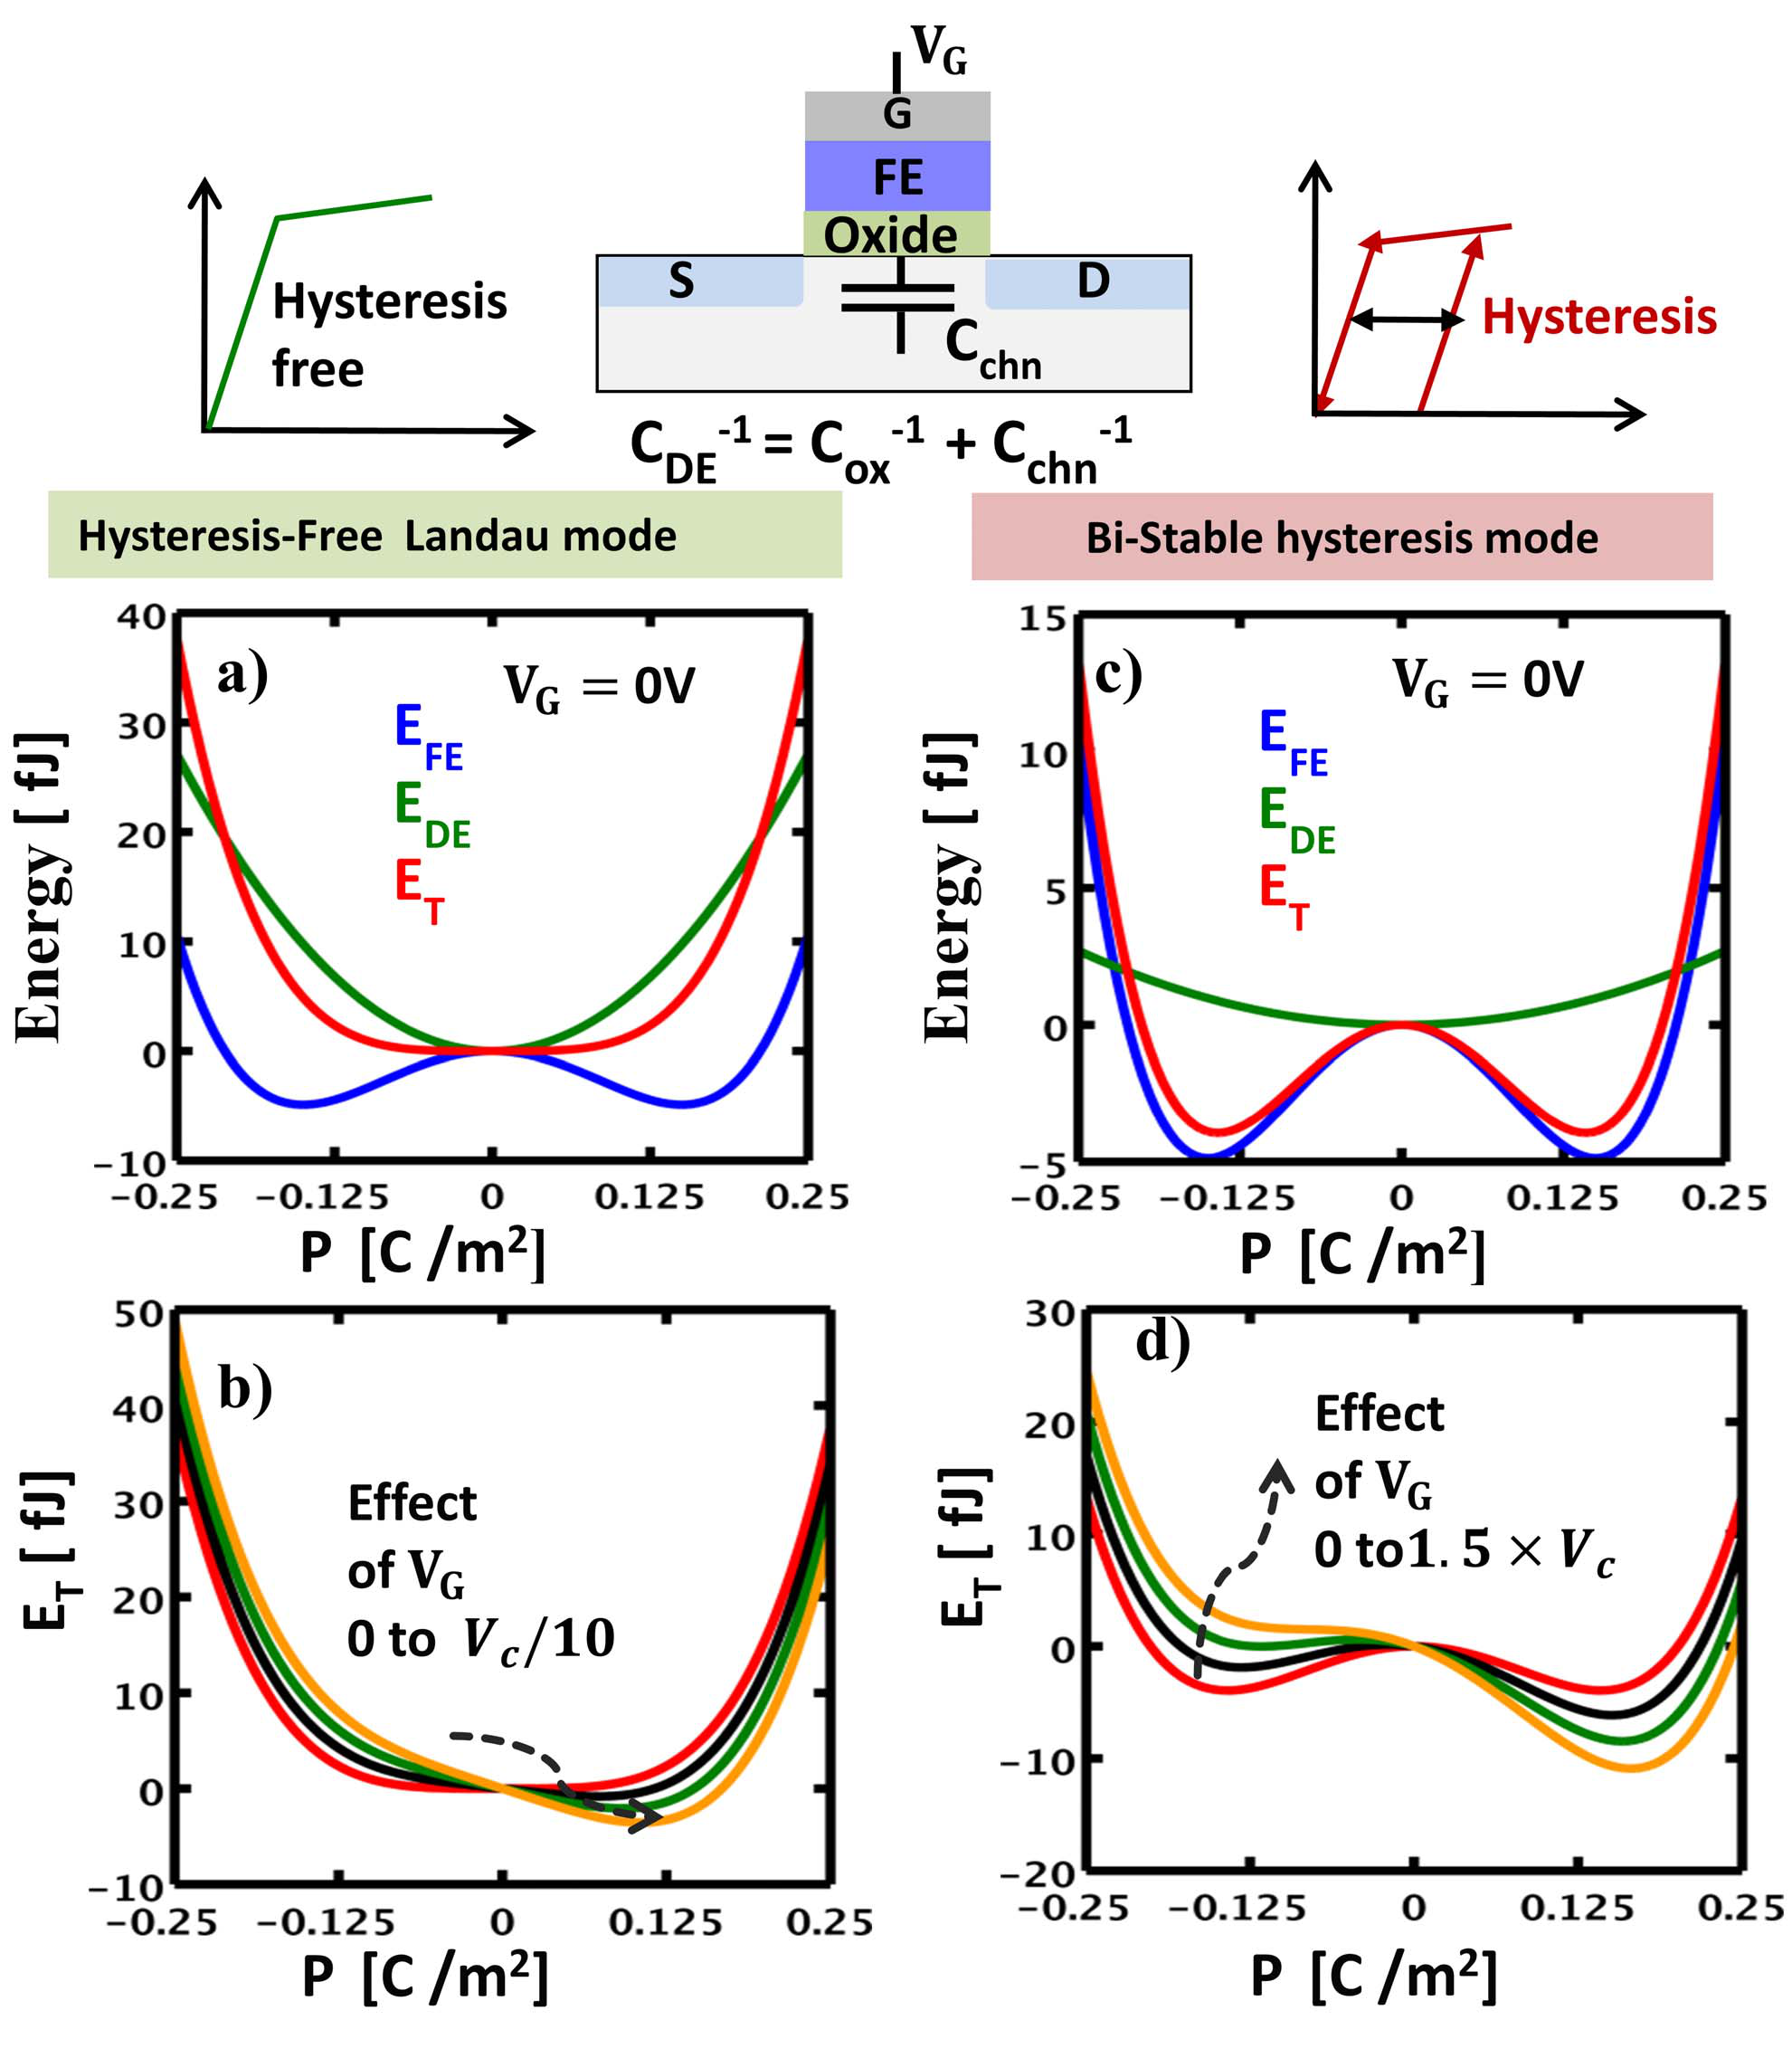

Fig. 1. individual contributions stabilized in (a) hysteresis-free mode, in (c) bi-stable Energy Landscape of CFE −CDE system at zero gate bias *(*VG*)* with

hysteresis mode; Impact of VG on total energy landscape for (b) hysteresis free mode and (d) Bi-stable hysteresis mode.

are consistent with experiments [19]. In essence, LK theory connects the rate of polarization (P*)* switching to the (negative) gradient of free energy density (F) landscape as follows,

Md2P dt2 +LdP dt= −dF dP*,*  (1)

where M and L represent the mass density and the damping coefficients, respectively, of the FE atoms switching between the energy minima. A FE Landau switch, however, includes a series combination of FE and a positive dielectric capac-itance, CDE. Eq. (1) is still valid, but the parameters must account for contributions from both capacitors. Since CDE involves fast switching of electronic charges of a typical positive capacitor, M and L are dictated by the slower atomic movement of FE. Moreover, the polarization in FE must equal the charge density on the CDE to ensure charge conservation. With these facts, the total system free energy density (F) can be written as

F = y0*α*P2+y0*β*P4+P2 2CDE−P×VG *(*t*),*  (2)

where *y*0 is the FE thickness and *α* and *β* are Landau coefficients, such that the first two terms define the energy density stored in the FE-capacitor; the third term is the energy density stored in the series capacitor, CDE, and the final term is the energy density supplied by the time-dependent gate voltage, VG*(*t*)*. A change in VG forces a transition in P, as expected. Eqs. 1 and 2 are solved self-consistently to evaluate P*(*t*)* as VG transitions from 0 to VD. For the Landau switch in Fig. 1, C−1 Cox is a constant dielectric capacitor (usually a thin SiO2 DE= C−1 ox+ C−1 chn, where

layer to isolate the FE from silicon and achieve a better matching with FE negative capacitance [10]) and Cchn is

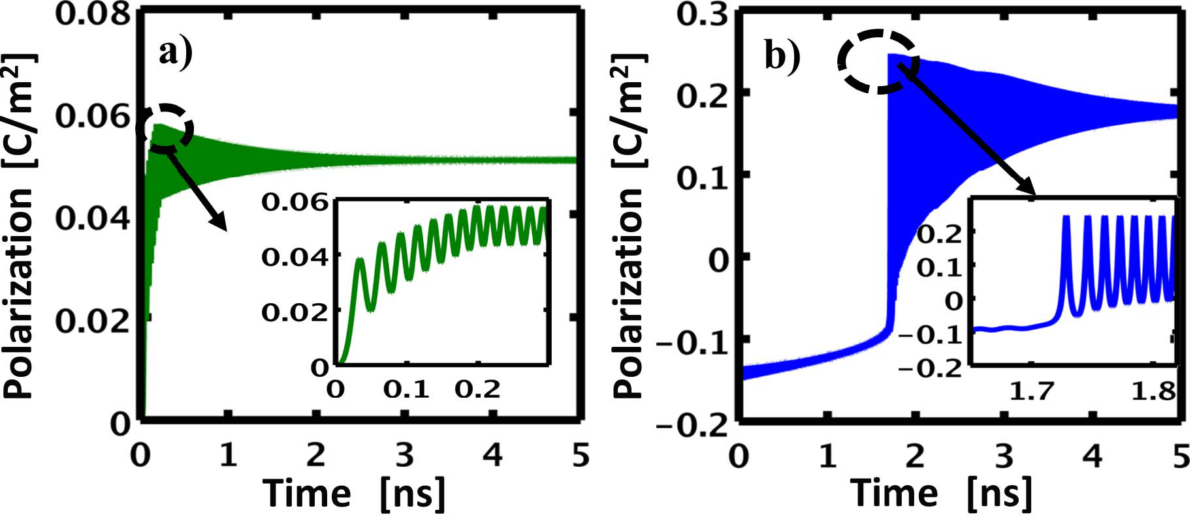

Fig. 2. Time evolution of polarization in (a) HF mode for applied VG of 0.1V and (b) BH mode for applied VG of 1.5V.

the total channel capacitance comprising channel-source/drain and channel to substrate capacitance. Assuming that CDE is approximately constant, the gate stack can be ana-lyzed as a series combination CFE (y0 = 10nm, width = 1*μ*m, length = 50nm) and CDE. We analyze two variants of this basic configuration with identical CFE: (1) For the HF mode, we set CDE =   
 |CFE *(*min*)*| = *(*−2*y*0*α)*−1= 0*.*057F/m2so that ET *(*P*)* = Area × F *(*P*)* = Area ×A single well defines the total free energy (ET*)* landscape�2CDE+ P2 2CFE�*>* 0 for all P at VG = 0 (see Fig. 1a).

of entire system, similar to series dielectric capacitor CDE energy (EDE*)* landscape. With the applied VG ramped from 0 to Vc*/*10, ET continues to be defined by a single-well energy landscape, but its minima shifts to a polarization consistent with the applied bias (see Fig. 1b). (2) For the BH mode, we set CDE = 10 CFE = 0*.*57F/m2: now, the positive energy contribution EDE from dielectric capacitor cannot fully com-pensate the FE energy *(*EFE*)*, so that the ET is characterized by a double-well energy landscape, see Fig. 1c. With the applied VG ramped from 0 to 1*.*5 ×*V c*, the polarization transitions between bi-stable states separated by a potential barrier, see Fig. 1d. The LK equation has been used extensively to study the switching/reliability of capacitors configured in the BH mode since the 1980s. Therefore, a comparison of HF vs. BH modes – using the same equations, but with different energy landscapes will allow us to predict the switching/reliability of a non-hysteretic Landau switch in reference to the hysteretic FE switching.

In this study, we will use the recently discovered doped-HfO2 as the FE material [10], [12], [14]. The Landau coeffi-cients *α* = −8*.*66×108(C−2Jm) and *β* = 1*.*93×1010(C−4Jm5*)* are derived based on the approach in [19] using experimentally reported values of coercive field Ec = 1 × 108(Vm−1*)* coefficient M has been derived using the physical approach and saturation polarization of Ps = 0*.*3 (Cm−2*)* [12]. The described in [20]. Specifically, P reflects the movement of the four oxygen atoms, as suggested by the first principles calculation [21]. The damping coefficient L is obtained exper-imentally from the characteristic decay time (2M/L) in BH mode operating at voltage V *>* VC [12].

III. SWITCHING TIME: FE-DE SYSTEM

Fig. 2 summarizes the polarization dynamics associated with HF and BH modes. The devices are switched by ramping VG at 0.5V/ns. The final voltage is *0.1V for HF mode*, representative of a low voltage steep slope Landau switch without hystere-sis, and *1.5V for BH mode* (representative of FE operated at 1*.*5 × *Vc)* to achieve fast switching from one stable state to the other. The time evolution of polarization in

KARDA *et al.*: SWITCHING DYNAMICS AND HAD IN LANDAU SWITCHES 803

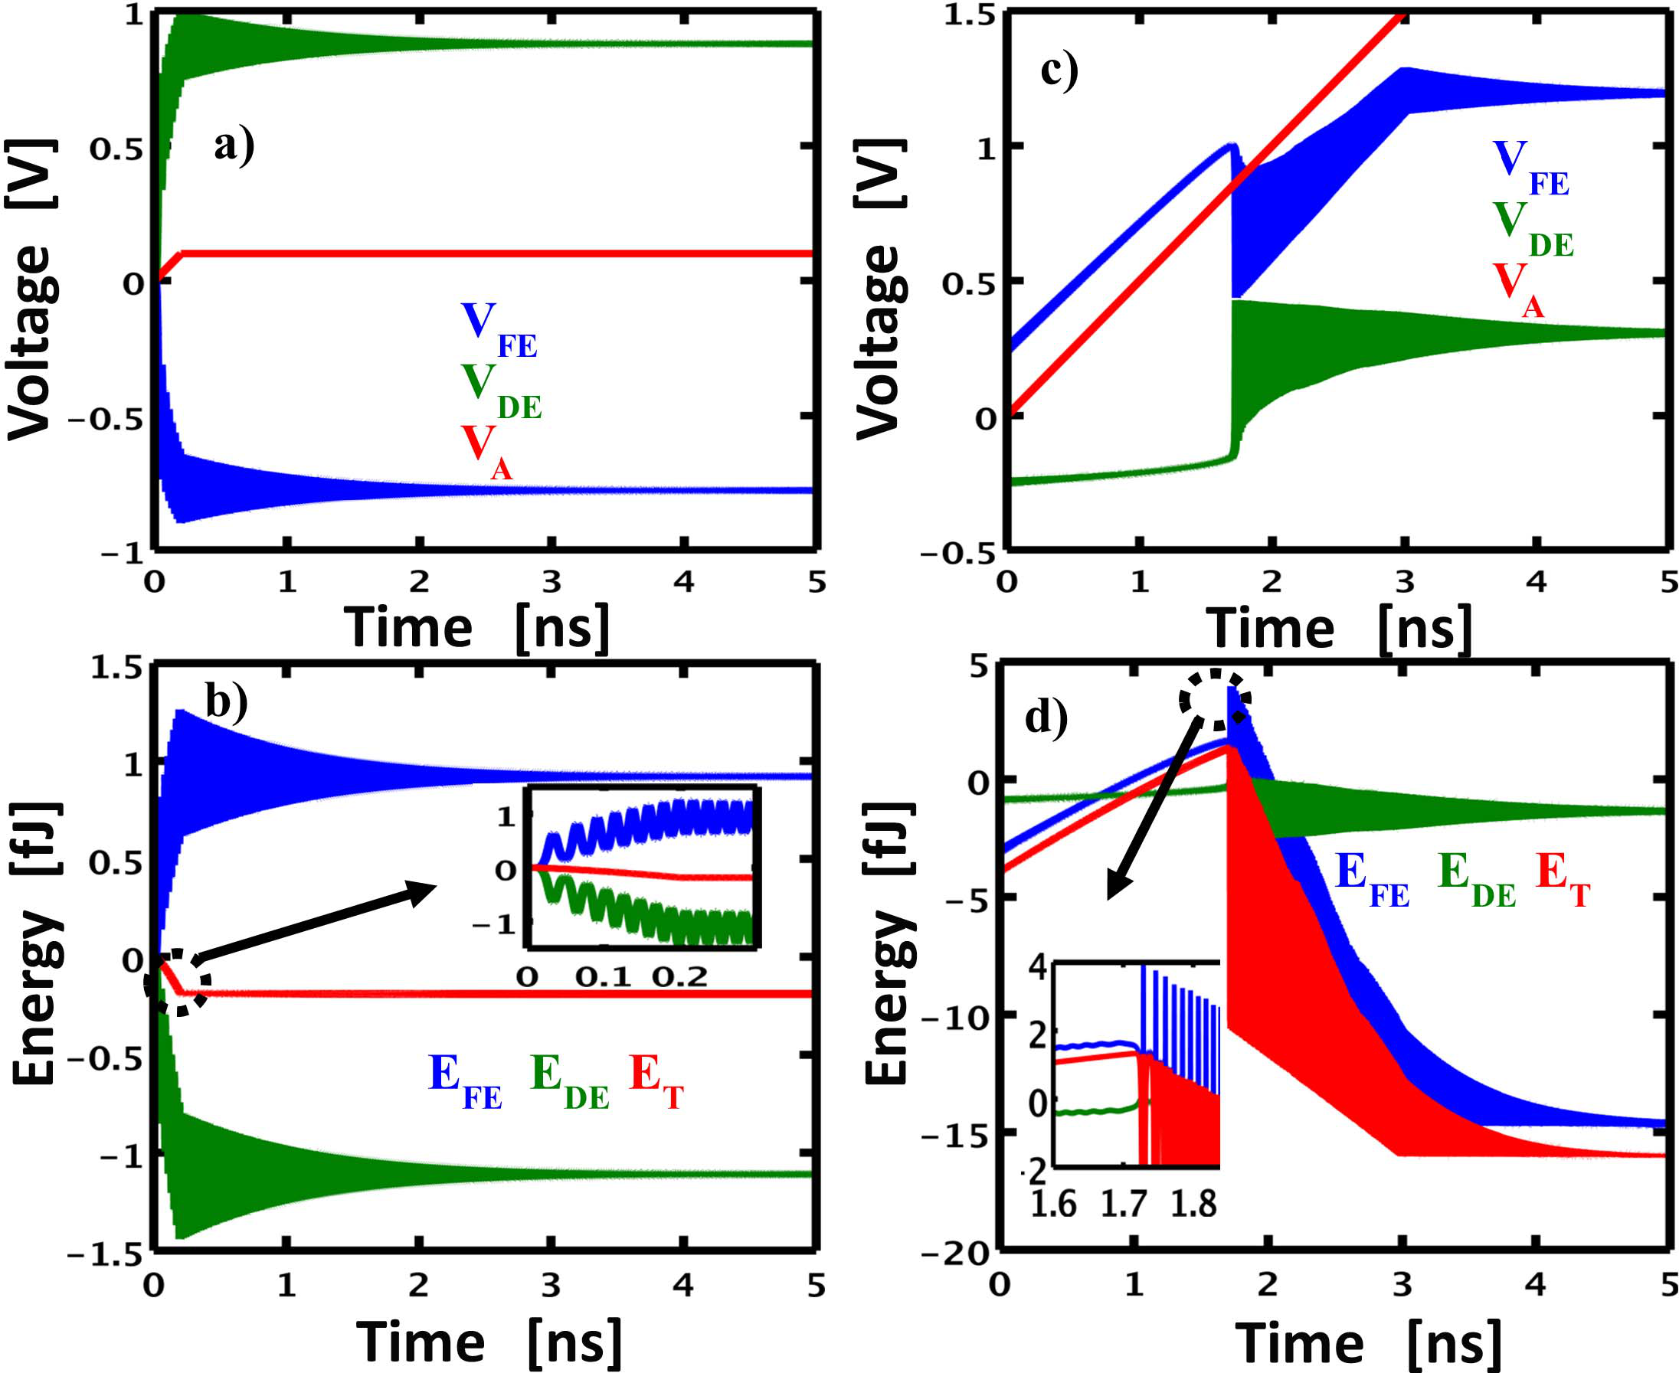

Fig. 3. Time evolution of voltage drop in FE, DE and applied voltage for (a) HF mode and (c) BH mode; Time evolution of energy in FE, DE and total system energy for (b) HF mode and (d) BH mode.

HF and BH mode are shown in Fig.2a and Fig.2b, respec-tively. The switching is gradual and continuous in HF mode, compared to an abrupt fast switching in BH mode. Thus, the switching rate in HF mode Landau switch is slower compared to that in the BH mode. However, the total change in P needed for a FE Landau switch is smaller than that of the HF mode [2]–[6]. This smaller polarization swing for a Landau switch can be achieved in a time comparable to that needed to switch from one stable state to the other in BH mode. Thus, although FE Landau switches have inherently degraded time response of polarization, the net switching time of the FE Landau switch is comparable to FE switching time in BH mode, *even though* Landau switch operates at 1/15 the voltage of a BH switch. Since the HfO2 based FE systems with switching times in the nanosecond (ns) regime have already been demonstrated in BH mode [12], we conclude that the HfO2 based FE Landau switches can achieve similar time-response, and therefore, are relevant for logic switches operating in ns regime. However the ultra-high performance (picoseconds) is still constrained by the inherent material switching limits in BH mode.

IV. ENERGY DYNAMICS: FE-DE SYSTEM

To understand the AC reliability of HF vs. BH modes, we compare their energy dynamics, as VG is ramped at 0.5V/ns. For HF mode, the time evolution of voltage across FE (VFE*)*, the voltage drop across series dielectric capacitor DE (VDE*)*, and the total applied voltage (VA*)* are shown in Fig. 3a. Similarly, the time evolution of EFE, EDE, and ET are shown in Fig.3b. The corresponding evolution of voltages and energies for BH mode are shown in Fig.3c and Fig.3d, respectively.

For the HF mode, Fig.3b shows that the system switches *even though EFE increases with time*, because the faster decrease in EDE ensures that the overall ET (red line) is reduced, so that the switching is energetically favorable. Note that ET changes gradually with VG*(*t*)*, implying that the system is stabilized at all intermediate energy steps (soft switching). As a result, the overshoot in polarization (and correspondingly that of EFE*)* is negligibly small. In contrast, as seen in Fig.3d, the energy in BH mode changes abruptly

once the energy supplied by external field is high enough to surpass the intrinsic barrier. At this point the system is highly out of equilibrium, causing a significant overshoot in polarization. The polarization overshoots, owing to increased energy of the stretched bond lead to exponential increase in the probability of bond dissociation and hence defect density generation rate *(d NT /dt)*. These defects accumulate over time resulting in increased leakage [17] through the FE. As a result, the AC lifetime of the FE (defined as time to reach a critical defect density *NBD* and corresponding threshold leakage) accordingly degrades with increasing number of cycles. This HAD related reliability for BH mode dictates the AC reliability of FE as shown in [16]. The extensive characterization in [16] has validated that the schemes which reduce polarization overshoots (for example, through reduced ramp rate and increased series external resistance) improve the HAD induced AC reliability by orders of magnitude. The total energy change in HF mode is 12× smaller than that of the BH mode, and the peak energy overshoot in HF mode is 3.2× lower than in BH mode. Thus, this reduced overshoot should make Landau switches significantly more robust to HAD induced reliability degradation compared to a FE-memory (operating in BH mode). Unlike the strategies adopted in [16], the reduction in the energy overshoot of a Landau switch is *intrinsic* to the stabilization of the system in single well energy landscape.

V. DISCUSSIONS AND CONCLUSION

This letter relies on a simple, qualitative theory of polar-ization switching to benchmark the speed and reliability of a Landau switch to the conventional hysteretic switching of FE. The assumptions made are critical to appreciate the validity of the model/conclusions: (i) FE is treated as a homogenous system. The gradient term, which accounts for the multi-domain polarization of a FE, has been neglected [22], and (ii) In practice CDE is VG dependent and impacts internal voltage gain in Landau switch [8]. However we have assumed that CDE is a constant as the primary focus of this study is dynamics and the switching speed of CDE at all bias conditions is significantly higher than CFE. Even with (future) refine-ments, the conclusions regarding speed and HAD induced AC reliability in HF mode relative to BH mode should hold because they rely on the general features of the FE-dynamics, not any specific parameterization thereof.

To summarize, we have formulated the LK theory for a coupled FE-DE system and studied the kinetics of FE Landau switch. This work demonstrates that switching and energy overshoot in FE Landau switches is gradual, as the system is stabilized at intermediate energy states. Thus FE Landau switches are inherently “soft”. Despite the “soft” switching, FE Landau switches operated at very low voltage switch“effectively” as fast as FE operated in hysteresis mode at high voltage. Hence FE Landau switches are relevant for high speed logic switches at speeds comparable to hysteretic ferroelectric switching in ns regime. The gradual change in energy results in 3× reduced overshoot in energy for FE Landau switches compared to hysteretic FE switching, implying fundamental improvement in switching endurance for FE Landau switches conventional bi-stable hysteretic switching compared to   
(FE-Memory). We conclude by noting that the results and numerical framework are general and would apply to a wide variety of Landau systems; FE, AFE, NEMS and others.

804 IEEE ELECTRON DEVICE LETTERS, VOL. 37, NO. 6, JUNE 2016

REFERENCES

[1] T. N. Theis and P. M. Solomon, “In Quest of the ‘Next Switch’:

Prospects for greatly reduced power dissipation in a successor to

|  |  |  |
| --- | --- | --- |
| the silicon field-effect | transistor,” | *Proc. IEEE*, vol. 98, no. 12, |

pp. 2005–2014, Dec. 2010, doi: 10.1109/JPROC.2010.2066531.

[2] S. Salahuddin and S. Datta, “Use of negative capacitance to provide

voltage amplification for low power nanoscale devices,” *Nano Lett.*,

vol. 8, no. 2, pp. 405–410, Feb. 2008, doi: 10.1021/nl071804g.

[3] A. Rusu, G. A. Salvatore, D. Jiménez, and A. M. Ionescu,

“Metal-ferroelectric-meta-oxide-semiconductor field effect transistor

with sub-60 mV/decade subthreshold swing and internal voltage

amplification,” in *IEDM*  *Tech.*  *Dig.*, Dec. 2010, pp. 395–398,

doi: 10.1109/IEDM.2010.5703374.

[4] G. A. Salvatore, A. Rusu, and A. M. Ionescu, “Experimental confirma-

tion of temperature dependent negative capacitance in ferroelectric field

effect transistor,” *Appl. Phys. Lett.*, vol. 100, no. 16, p. 163504, 2012,

doi: http://dx.doi.org/10.1063/1.4704179.

[5] D. J. R. Appleby, N. K. Ponon, K. S. K. Kwa, B. Zou, P. K. Petrov,

T. Wang, N. M. Alford, and A. O’Neil, “Experimental observation of

negative capacitance in ferroelectrics at room temperature,” *Nano Lett.*,

vol. 14, no. 7, pp. 3864–3868, Jul. 2014, doi: 10.1021/nl5017255.

[6] W. Gao, A. I. Khan, X. Marti, C. Nelson, C. Serrao, J. Ravichandran,

R. Ramesh, and S. Salahuddin, “Room-temperature negative capacitance

in a ferroelectric–dielectric superlattice heterostructure,” *Nano Lett.*,

vol. 14, no. 10, pp. 5814–5819, Oct. 2014, doi: 10.1021/nl502691u.

[12] J. Müller, T. S. Böscke, U. Schröder, R. Hoffmann, T. Mikolajick,

and L. Frey, “Nanosecond polarization switching and long reten-

tion in a novel MFIS-FET based on ferroelectric HfO2,” *IEEE*

*Electron Device Lett.*, vol. 33, no. 2, pp. 185–187, Feb. 2012,

doi: 10.1109/LED.2011.2177435.

[13] J. Li, B. Nagaraj, H. Liang, W. Cao, C. Lee, and R. Ramesh,

“Ultrafast polarization switching in thin-film ferroelectrics,”

*Appl.*  *Phys.*  *Lett.*, vol. 84, no. 7, pp. 1174–1176, 2004,

doi: http://dx.doi.org/10.1063/1.1644917.

[14] E. Yurchuk, J. Müller, J. Paul, T. Schlösser, D. Martin, R. Hoffmann,

S. Müeller, S. Slesazeck, U. Schröeder, R. Boschke, R. van Bentum, and

T. Mikolajick, “Impact of scaling on the performance of HfO2-based fer-

roelectric field effect transistors,” *IEEE Trans. Electron Devices*, vol. 61,

no. 11, pp. 3699–3706, Nov. 2014, doi: 10.1109/TED.2014.2354833.

[15] R. Gaynutdinov, M. Minnekaev, S. Mitko, A. Tolstikhina,

A. Zenkevich, S. Ducharme, and V. Fridkin, “Polarization

switching kinetics in ultrathin ferroelectric barium titanate film,”

*Phys.*  *B,*  *Condens.*  *Matter*, vol. 424, pp. 8–12, Sep. 2013,

doi: http://dx.doi.org/10.1016/j.physb.2013.04.056.

[16] M. Masuduzzaman, D. Varghese, J. A. Rodriguez, S. Krishnan, and

M. A. Alam, “Observation and control of hot atom damage in fer-

roelectric devices,” *IEEE Trans. Electron Devices*, vol. 61, no. 10,

pp. 3490–3498, Oct. 2014, doi: 10.1109/TED.2014.2347046.

[17] *International*  *Technology*  *Roadmap*  *for*  *Semiconductors*, accessed

on Sep. 11, 2015. [Online]. Available: http://www.itrs.net/ITRS

%2019992014%20Mtgs,%20Presentations%20&%20Links/2013ITRS/

|  |  |  |  |  |  |  |  |  |  |  |  |
| --- | --- | --- | --- | --- | --- | --- | --- | --- | --- | --- | --- |
| [7] A. I. Khan, K. Chatterjee, B. Wang, S. Drapcho, L. You, C. Serrao, | Summary2013.htm | | | | Nair, | and | M. | A. | Alam, | “Strategies | for |
| S. R. Bakaul, R. Ramesh, and S. Salahuddin, “Negative capacitance in | [18] A. | Jain, | P. | R. |

a ferroelectric capacitor,” *Nature Mater.*, vol. 14, no. 2, pp. 182–186, Feb. 2015, doi: 10.1038/nmat4148.

[8] A. Jain and M. A. Alam, “Stability constraints define the minimum subthreshold swing of a negative capacitance field-effect transistor,”*IEEE Trans. Electron Devices*, vol. 61, no. 7, pp. 2235–2242, Jul. 2014, doi: 10.1109/TED.2014.2316167.

dynamic soft-landing in capacitive microelectromechanical

switches,” *Appl. Phys. Lett.*, vol. 98, no. 23, p. 234104, 2011,

doi: http://dx.doi.org/10.1063/1.3598960.

[19] D. Ricinschi, C. Harnagea, C. Papusoi, L. Mitoseriu, V. Tura, and

M. Okuyama, “Analysis of ferroelectric switching in finite media as a

Landau-type phase transition,” *J. Phys. Condens. Matter*, vol. 10, no. 2,

|  |  |  |  |  |  |  |  |  |  |  |  |
| --- | --- | --- | --- | --- | --- | --- | --- | --- | --- | --- | --- |
| [9] A. Jain | and M. A. Alam, | | | “Prospects | | | of hysteresis-free | | | abrupt | pp. 477–492, 1998, doi: http://dx.doi.org/10.1088/0953-8984/10/2/026. |
| switching | (0 | mV/decade) | | in | Landau | switches,” | | *IEEE* | | *Trans.* | [20] A. K. Bandyopadhyay, P. C. Ray, and V. Gopalan, “Dynamical systems |
| *Electron* | *Devices*, | | vol. 60, no. 12, pp. 4269–4276, | | | | | | Dec. | 2013, | analysis for polarization in ferroelectrics,” *J. Appl. Phys.*, vol. 100, |
| doi: 10.1109/TED.2013.2286997. | | | | | | | | | | no. 11, p. 114106, 2006, doi: http://dx.doi.org/10.1063/1.2388124. |

[10] K. Karda, A. Jain, C. Mouli, and M. A. Alam, “An anti-ferroelectric gated Landau transistor to achieve sub-60 mV/dec switching at low voltage and high speed,” *Appl. Phys. Lett.*, vol. 106, no. 16, p. 163501, 2015, doi: http://dx.doi.org/10.1063/1.4918649.

[11] D. Barlage, R. Arghavani, G. Dewey, M. Doczy, B. Doyle, J. Kavalieros, A. Murthy, B. Roberds, P. Stokley, and R. Chau, “High-frequency response of 100 nm integrated CMOS transistors with high-*K* gate in *IEDM Tech. Dig.*, Dec. 2001, pp. 10.6.1–10.6.4, dielectrics,”  
 doi: 10.1109/IEDM.2001.979473.

[21] S. Clima, D. J. Wouters, C. Adelmann, T. Schenk, U. Schröeder, M. Jurczak, and G. Pourtois, “Identification of the ferroelectric switching process and dopant-dependent switching properties in orthorhombic HfO2: A first principles insight,” *Appl. Phys. Lett.*, vol. 104, no. 9, p. 092906, 2014, doi: http://dx.doi.org/10.1063/1.4867975.

[22] A. Cano and D. Jiménez, “Multidomain ferroelectricity as a lim-

|  |  |  |  |  |  |  |  |
| --- | --- | --- | --- | --- | --- | --- | --- |
| iting | factor | for | voltage | amplification | in | ferroelectric | field-effect |

transistors,” *Appl. Phys. Lett.*, vol. 97, no. 13, p. 133509, 2010, doi: http://dx.doi.org/10.1063/1.3494533.